

A study on Training and Development process at
Dutch Bangla Bank Limited in Bangladesh.

Supervised by:
Prof. Dr. Mohd. Hasanur Raihan Joarder
Professor
School of Business and Economics
United International University

Submitted by:
Sarmin Sultana Tinny
ID: 111161174
Program: BBA
Major: Human Resource Management

21st January 2021

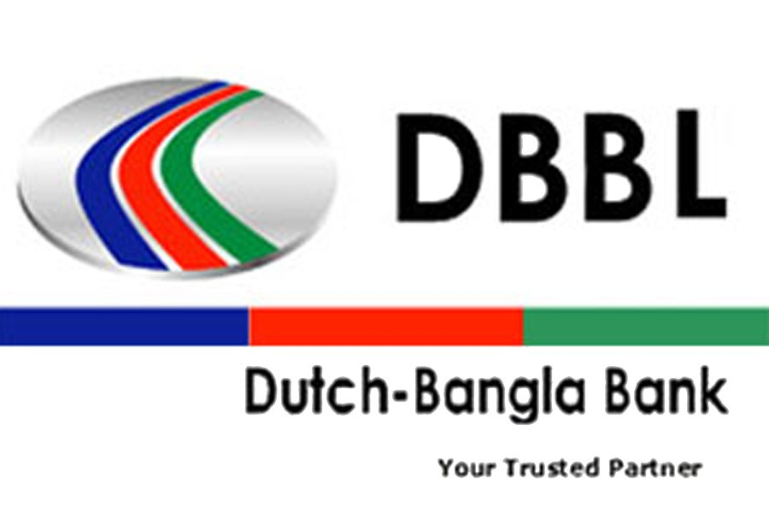
Letter of Transmittal
A study on Training and Development practice at Dutch Bnagla Bank Limited.

08th January 2021
Prof. Dr. Mohd. Hasanur Raihan Joarder
Professor
School of Business and Economics
United International University
Subject: Submission of the project paper on Training and Development process in Dutch Bangla Bank Limited.
Dear Sir,
With due respect and honor, me the undersigned student of BBA representing my project report. I would like to inform you that, I have completed my university project given by you on Training and Development practices in Dutch Bangla Bank Limited. In this project paper, I am representing my knowledge and experiences. I am very glad that I am able to present the project report after so many obstacles that I have gone throughout the project period. Finally I did it to complete my BBA program. Notwithstanding, I intend to show my gratitude, thank you sir for your help, support and guidance.
Therefore, your kind consideration and patience throughout the project and evaluation of my performance will truly appreciate me.
Sincerely Yours,
Sarmin Sultana Tinny
ID: 111161174
Program: BBA
Major: Human Resource Management

Acknowledgment
Every praises are for Almighty ALLAH, I do precise my gratefulness to ALLAH for showering me with blessings and giving me the opportunity to complete this project within required time. I would like to thank all the people who helped me for the completion of this project. I am thankful to my supervisor for the support and help for flourishing every part of this project. I am always grateful for his supportive supervision. It was a huge study experience.
Also I am thankful to Md. Sagir Ahmed, senior executive officer at Dutch Bangla Bank Limited, Head Office. Aminul Islam deputy Manager, Head office of Dutch Bangla Bank Limited and Nurul Amin, senior Officer , Human Resource Department. I am thankful to all of them for providing me information which was very helpful for making this project. They were very supportive and informative.
Finally, my sincere thanks to Prof. Dr. Mohd. Hasanur Raihan Joarder and I also express gratitude to all for providing information to prepare this project paper.

Table of Contents
Executive Summery 8
Chapter 1 9
Introduction 10
Background: 11
Objective of the study 11
Scope of the study: 12
Sources of information: 13
Data collection procedure: 14
Data collection period: 14
Sampling technique: 14
Data processing: 14
Limitations of the study: 14

Chapter 2 16
Literature review 16
The definition of training and development: 17
Importance of training 18
What is workplace Training: 19
Employee Development/Advancement: 19
IMPORTANCE OF TRAINING AND DEVELOPMENT 20
Designing effective training: 21
Necessity of training needs assessment 24
Elements of successful training and development program: 25
Methods of training : 25

Chapter 3 organizational oerview 27
Dutch-Bangla Bank 28
Mission 29
Vision 29
Center Objectives 29
Core value of dutch bangla bank 31
DBBL Training Centre: 32
Division and Branches: 32
Corporate Culture of DBBL: 32
Corporate Designation: 33
DBBL Management Hierarchy at a glance: 35
CSR activity of DBBL (Corporate Social Responsibility) 37

Chapter 4 41
Training and development practices in DBBL 41
Training objective of DBBL: 42
Dutch Bangla Bank Training Cycle: 42
Methods of training in Dutch Bangla Bank: 43
Department based training: 44
Training and Development policies in DBBL: 45
Training principles of DBBL: 48
Training effect inside bank 50
Identified problems: 51
Effect of COVID 19 in banking sector: 53

Chapter 5 55
Findings and analysis 55
Findings 56
Analysis: 56

Chapter 6 62
Recommendation and conclusion 62
Conclusion 64

Chapter 7 67
Bibliography 67
Reference 68

Chapter 8 69
Appendix 69

Executive Summery

The project report is fulfillment of my BBA program. This project paper describe about how the Training and Development functions in Dutch Bangla Bank Limited in Bangladesh is happening and what are those ways they can improve and add on situation and demand. This piece of research or study was directed to see an entire and clear idea of ​​DBBL training method and their exercises.
Howsoever, the main goal of building up this project is to examine the process and what needed to increase the development of the employee’s performance by giving training. The presentation of the report, which includes topics such as the backgrounds, objectives, methodologies, and limitations of the study, is in the first chapter. The second part contains literature review then third chapter contains organizational overview and their activities. The third chapter contains the significance of training and development practices. Chapter four includes some findings and the analysis of training and development process in DBBL. Chapter five contains findings and analysis. Chapter six contains recommendations and conclusion. Chapter 7 and last part is appendix.

Chapter 1



Introduction:
Training and development is a vital and obviously the most important part of Human Resource Management. Training and development refers to providing proper guideline about the organization and its work environment and how employee can rise their productivity using less resources on time. So from here we understand that employee get to learn work efficiency and effective work curriculum. The goal of providing training mechanism is to enhance people’s productivity so that overall wastage of resources can get reduced. This introduce us how to engage your employee with work and activities. These programs should arrange in such a method so that it enhances peoples understanding about any work in the organization. It helps to renew the condition of an organization. Training helps to acquire knowledge, new, recent, additional, modern ability to cope up with the changing and ultra-modern and fast world condition. In Bangladesh there is really not enough space or capacity to make the employees more efficient, Bangladeshi employees are less upgraded comparing with modern world. Providing training to employees is very familiar in developed country but in Bangladesh people think it’s not only waste of time but also waste of money. But now a day Dutch Bangla Bank kept knowledge about importance of training. They try to develop to increase their employee productivity through providing training. T & D plays an important role, so recognizing training necessity is important for an organization. It has many benefits that will be discussed in later in this paper. Different organization use different training and development method according to the need of their employee. Most importantly, training increase productivity and improve customer services. Training helps an organization to become more competitive in the market. It enables to establish competitive advantage. T&D increases employee satisfaction towards their job, enhance efficiency and effectiveness, and make the employees more knowledgeable and skillful.

Background:
The organization can conquer the quest only when their employee is productive and they are happy with the organization working environment and conditions. For that manager should appropriately manage the employees of the organization. In Human Resource term employee happiness just not bound in salary and bonus boundary, there have to be a healthy workplace and environment also which can only get ensured through a proper training program. Any organization can get their expected result or can reach their goal when the employees are motivated, productive towards work. When an employee have vast of knowledge full of skills, smart hand to solve any problem yet not able to do their job properly then there is a motivation issue which can be solved under taking him or her in a training program where the training is not about giving lectures but also full of activities that can refresh one’s mind so that employees feel fresh to do the job again in effective and efficient way. Any company wants to fulfill its task having best productivity in employees. But this is very difficult to keep employee in track with just giving remuneration there also have to be a pure connection with organization that can help to be with the workplace and engaged to the organization. Training can help the employee to do the job smoothly to track the goal. The proper training method can increase the employee’s effectiveness and efficiency. So, the employees will learn what they need to do in his workplace and gain the knowledge experiences to successfully fulfill his duties and responsibilities in the training period. The preparation assessment process is very much important for the employees. The representatives will come to think about his effectiveness in the work and tasks.

Objective of the study
The essential portion of this project analysis is to understand and catch the significance of courses and accomplish the course requirement during the BBA program. The purpose of this research is to know about training and development practices in DBBL. Here, I have selected DBBL bank to analyze training and development practices. The objectives are given below:
General objective: To prepare a project report on the given topic to analyze Training & Development practices in Dutch Bangla Bank Limited. The training and development process in DBBL, how they operate this and what are the benefits they are getting after accomplishing a program, how much time they offer, are the employees satisfied with those training, is it fruitful in DBBL or not, are there any specific training program for specifically individuals, or for groups etc. is the main objective of this whole study. This study will help me to complete the graduation. As training is an important part in HRM. This report primarily made due to the requirement of completion of my BBA program.it is constructed to identify the training and development importance in DBBL.
Specific Objectives:
- To analyze and asses the use of training program in DBBL.
- To recognize employees behavior in training sessions.
- To define any recent situation, find flaws in previous activity portion.
- To build accurate resources intend to the perfection in useful organizational
- To set a standard in the organization for changing the work environment.
- To know overall training and development practices in this bank
- To find out whether the employees are satisfied with overall treatment of training or not.
- To know about the employee evaluation process
- To know the efficiency of the sessions.
- To find the relevancy of the training sessions.
- To find out the process of present training program.
- To find out whether the training output is helping the employees.
- To find out whether the training learning increasing the ability and skills.
- To find out whether it’s improving the motivation power.

Scope of the study:

This project is mainly focuses on the training and development practices of DBBL. Dutch Bangla Bank Limited is one of the renowned commercial bank in Bangladesh. I have prepared this paper by the help of officials of DBBL bank. I had detailed discussion about this project. I had the chance to have information about their training program and practices.

Methodology:

This is a descriptive report. For preparing this project some research methods need to follow. This project paper constructed based on the training and development practices in DBBL. The main or constructive piece of this report was raised with the help of my supervisor and the Management courses like training and development course, performance appraisal, human resource planning, strategic human resource management etc. The basic element in this project is to understand the need for training in the DBBL. This project is a combination of sources from my study and research in DBBL and internet information’s. For some critical situation I had a very limited access to the company. I couldn’t visit the bank frequently during the COVID-19 pandemic, but still I have tried my level best to collect both primary and secondary sources.

Therefore I got some sources to accomplish this study given below;

Sources of information:

This examination secured two kinds of information, which are:

Primary sources:

Information got from supervisor

Conversation with bank personnel

Management courses

Questionnaire made for officials contains close ended question.

I gave my best effort to precise the information during this pandemic situation. I have collected information by interviewing over phone of the respective Human Resource Manager of the bank.
- Secondary sources:
- Article on training and development on DBBL.
- Annual report of DBBL.
- Publications from the internet.
- and from website of DBBL.

Data collection procedure:
Structured questionnaire was made for the officials. Questionnaire was the primary data collection element. Those were designed in a way so that they can easily mark their opinion. Every individual took part in it and this thing helped me a lot to my research paper.
(Questionnaire is attached in appendix section.)

Data collection period:
Since I have started my research on this topic the data were collected. It was approximately from August to December.

Sampling technique:
As mentioned earlier, DBBL employees were a bit busy in their own work, so interview were taken from available employee time to time, on their convenient time also.

Data processing:
This project paper was build up based on characteristics data and understanding based data are explored and examined by qualitative data, percentage shown in pie chart etc.

Limitations of the study:

The peoples in DBBL are very co-operative though they are very much engaged in their job; they have tried to consider giving individually personal chances to get information about the bank. In this pandemic situation everyone was so busy with their own life and all. So some limitations were there as it was a different work experience than before.
- Time was a major limitation as the authorities had not enough time to cooperate with some information for their busy job schedule.
- I have faced a few problems while collecting their data. They had a really hard office routine as they had to work from home and there were not any specific time to do their job so they were slightly unable to consider their time.
- Insufficient information, as people were so busy in COVID 19 pandemic.
- Some information were kind of secrete of the organization as I am a student they didn’t wanted to share much information on organizational purpose.
- Less accessibility to the core data due to organizational confidentiality.
- Mostly the research was based on the employee perception, so the output may become biased in little amount sometimes.
- The limitation of this research is the data were taken from only Dhaka division and branches located in Dhaka city.
- Some information was not in internet.
- I couldn’t visit the bank often due to COVID pandemic, here; I tried my level best to collect information over phone.

Chapter 2

Literature review

\
The topic of this report that is based on training and development subject is a most important function of human resources. Previously organizations never looked at it because they felt this function is unnecessary and time wastage. But now days people understand its importance people are more aware. Most developed country investing billion dollars to save trillion dollar money by giving training to the employees. In Bangladesh many organization is arranging this type of program .there was a myth that people do not enjoy the training but the truth is now peoples are more concern about their work and they try to develop their skills too. Training helps employee to gather knowledge and idea about recent banking system.

The definition of training and development:
Training is a systematic process, people understand how can do the job in the most effective way, training increase our efficiency and effectiveness. Training is not given for short term task; it is given to the employees for long term effect.it is about preparing employee for present and future work.
According to Professor Dr. Mohd. Hasanur Raihan Joarder, ‘Training will help employee to get the job done in a most efficient ways, training is learning about specific job issues. Especially training is very important in first world concept. People are investing millions of dollar in training. As the developed country, theme invests billions of dollars on human resource training and development to save trillions of dollars.”
Training is learning about specific job issues. Investment on people for training is the best investment, by this employee will be happy and will increase the productivity. Training makes a person’s work output in an organization more efficient, through training employee get to know in which situation what decision should be made. Which skill needed for particular issues? Training helps the employee to finish their job in time in a proper way that is more efficient and effective also.
According to the Michel Armstrong, “Training is systematic development of the knowledge, skills and attitudes required by an individual to perform adequately a given task or job”.
(Source: A Handbook of Human Resource Management Practice, Kogan Page, 8th Ed.,2001)
According to the Edwin B Flippo, “Training is the act of increasing knowledge and skills of an employee for doing a particular job.”
(Source: Personnel Management, McGraw Hill; 6th Edition, 1984) The term ‘training’ indicates the process involved in improving the aptitudes, skills and abilities of the employees to perform specific jobs. Training helps in updating old talents and developing new ones. ‘Successful candidates placed on the jobs need training to perform their duties effectively’. (Source: Aswathappa, K. Human resource and Personnel Management, New Delhi: Tata Mcgraw-Hill Publishing CompanyLimited,2000, p.189) The principal objective of training is to make sure the availability of a skilled and willing workforce to the organization. In addition to that, there are four other objectives: Individual, Organizational, Functional, and Social.

Importance of training:
Already we have got some idea that how important training is in an organization. There are lots of importance and benefits of training that we are going to discuss under this topic.
Benefits of training: there are lots of benefits of training given below,
- Helps to earn new skills
- Perform better
- Productivity increases
- Organizational activity increases
- Right way of using resources
- Decrease the wastage of resources etc.
Training is not only important thing for a new employee but most vital thing for an employee. Training will provide them greater understanding about their responsibilities within the organization. It increases employee productivity, working capacity etc. Training creates a supportive environment. It increases employee’s efficiency and productivity also. It teaches an employee to be respectful to the organization.

What is workplace Training:
The business world is changing rapidly. External and internal organization is changing so it requires adaptation with new processes and technologies. Training and development helps to adapt employee with new technologies and processes. Workplace training is a process of keeping an organization more competitive. Training is not only important thing for a new employee but most vital thing for an employee. Training will provide them greater understanding about their responsibilities within the organization. Basically training is about preparing employee for present and future work.

Employee Development/Advancement:
Training needs to enhance individual, group and team performances. Identifying employee individual responsibility and any gaps between group and teams is important. Generally the main target of giving training is to improve employees working capacity. Employee development is the most necessary part in today’s HRM function. Employee development is must to conquered expected outcome from the organization. Developed country invests billions of dollars just for development and advancement of employee that can save trillions of dollar and it’s not a myth but truth.
According to the Edwin B Flippo, "Preparing is the demonstration of expanding information and abilities of a worker for making a specific showing." (Source: Personnel Management, McGraw Hill; sixth Edition, 1984)
The term 'preparing' shows the cycle associated with improving the aptitudes, aptitudes and capacities of the representatives to perform explicit positions. Preparing helps in refreshing old abilities and growing new ones. 'Fruitful applicants set on the positions need preparing to play out their obligations successfully (Source: Aswathappa, K. Human resource and Personnel Management, New Delhi: Tata Mcgraw-Hill Publishing CompanyLimited,2000, p.189)

IMPORTANCE OF TRAINING AND DEVELOPMENT
- HR actually gives guarantees and the ideas of time quality managements out quality Management
- HR Department ascertains equal employment opportunity to all the male and female employees.
- HR basically tries to give training to new employees.
- HR work for employees advantages and disadvantages,
- HR work for employee’s remuneration, and bonuses.
- HR can serves with latest modules and references.
- Training and development helps HR to fasten new changing innovation and strategies in the organization.
- Training helps HR to build up KSAO to the employees,
- Build up progress.
- Training attempts to flourish the degree of executive employees
- Training helps to flourish employee’s ability in work or job.
- Training helps the employees to enhance the work efficiency and effectiveness.
- Lower cost, because trainees are able to make better and economic use of resources.
- Lower turnover, training ensure work security which reduse rurnover.
- Change management, training helps to manage internal and external cgange in the organization.
Types of training:

Designing effective training:
It determines a systematic process for developing program. It involves seven steps, given below:
- conducting needs assessment
- Organizational analysis
- Person analysis
- Task analysis
Organizational analysis: involves searching whether training is necessary for company’s strategic direction. Question may arise in organizational analysis like how the training affects employee’s relationship with their clients. What is the relationship of the training with strategic business need? What managers and peers can do to succeed the program? Is there any doubt that trainees will perceive this training as an opportunity? Etc. while doing organizational analysis something needs to be considered.
The company’s strategic direction: In organization training is expected to help the achievement of business goal and objectives. The amount of money, frequency of training will be higher.
Support of managers for training activities: if manager do not support employees they will not apply training content to their job. So it is very important for manager to give support and show friendly attitude and behavior.
Training resources: it is important to identify company resources. It’s important to have enough resources to build a training program.
Person analysis: It is necessary to determine who need training. It determines whether employee’s performance indicates poor productivity then they will need training. Poor performance can identify through customer feedback, performance ratings etc. Process for person analysis helps to understand employee knowledge, skills, abilities etc. It also includes age and generation. It involves basic skills, cognitive ability, reading ability, input, output, consequences, and feedback.
Task analysis: task analysis determines work activities include tasks performed by the employee. It identifies individuals work activities, and analyses the works. Task is employee’s activity in a job. In order to complete a task the person needs at least some knowledge and skill. There are some steps in task analysis.
- Select a specific job to analyze its work.
- Establish a list of tasks that will be performed in the job.
- Confirm the task.
- Identify the knowledge and skill to perform the job.

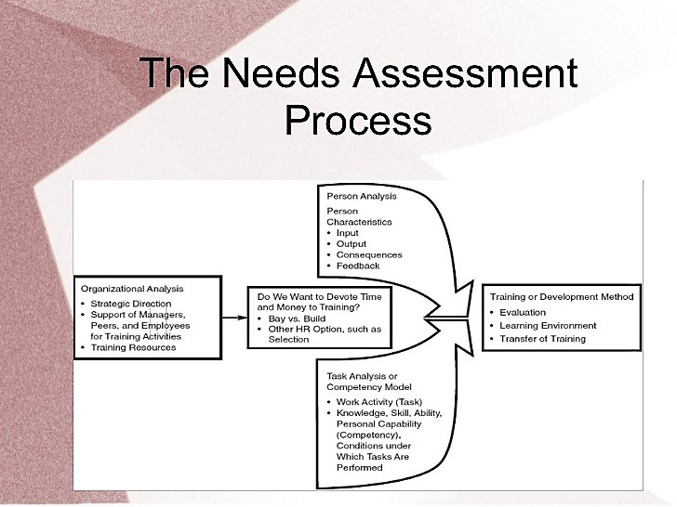
Things needed to consider while giving effective training:
1. Conducting needs assessment- it is important to identify where the training program need to conduct. Ensure employees have consent for training and they have basic knowledge which is necessary to conduct the program. These are includes organizational analysis, task analysis and person analysis.
2. Directing individuals - considering the developing rivalry there is a need in the relationship for information laborers; therefore the affiliations dependably search for person who can have such an effect.
3. Positive transfer of training- to ensure employees will apply their knowledge and contents to their work activity. Employee need to manage their work in most effective and efficient ways.
4. Methods need to follow- designing a proper training program includes what method is going to follow in order to give training. It is going to be a traditional way or online training method. Based on the objective and learning condition. Monitoring the program improve the program. To create a learning environment there need to have these features like, learning objectives, modern materials, honest feedback, practices, modeling etc.

Necessity of training needs assessment:
Assessing need of training is a primary part while organizing the training program. A manager needs to identify the need of the training before arranging specific training plan. The manager needs to determine if the training is appropriate solution for the problem. As I said it is a prerequisite plan of the final training program and also it is the first step in the instructional design process. It cannot be done on proper note at a very first trial. There may occur any situation like,
- Training may use incorrectly as a solution to a problem.
- Training may consist of wrong objectives
- Training may not deliver to the expected employee.
- Trainees may have lacking of skills which is prerequisite for the training.
Now the question is what the outcomes are or benefits can be in needs assessment?
It gives important input into the steps in training design. It results in information related to who needs training and what trainees need to learn. It helps to determine whether the organization will outsource its training.

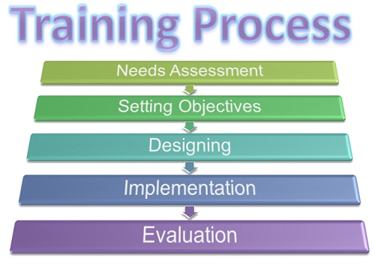
Competency model: competency models means sets of skills and abilities. It identifies the competencies which is necessary for all kind of jobs. It is used in performance management. It is strongly followed in every function of human resource management including training and development. It helps to identify best performed employee. The first step of competency model is to identify business goals, the second step is identifying jobs, then dealing interview, then develop competencies and again review the model. It is useful for training in various ways. For instance, they determine what is necessary to deal specific needs. They evaluate the relationship between the organizations training program and needs. They determine what skills and abilities needed for which job sector. They can evaluate who can be appropriate for managerial position. They set up common characteristics for employee for specific jobs.

Elements of successful training and development program:

Methods of training :
Any organization usually use combination of training methods so that employee can perform in a better way in the bank. They use two methods;
- On the Job Training
- Off the Job Training
On the job training usually given to newly recruited employee. Employees who are working for long time in the bank they also get this training. It is conducted inside the bank; here employee can easily and instantly transfer the learning from the training in their job. It means doing the job and participating the training at the same time, it is less costly for any organization. It refers to new or experienced employees who can observe and imitate the work at the same time. It is an old informal training process. OJT have different form including apprenticeship and self-directed learning program.
Apprenticeship is both on the job and classroom training. Self-directed learning, here trainees determine the training content on their own without any instructor.
Principles of OJT
- Preparing for training
- Actual communication
- Transfer of training
- Evolution.
Overseas Training:
In Dutch Bangla Bank Limited they have scope of doing oversees training. They don’t only give training in the country but also beyond the border. They sent their employee outside the country so that they understand the international arena of a bank. Bank sent an employee abroad to make them experience international workplace and to gather knowledge to perform better. Various abroad training institutes invite DBBL to participate in the training program. DBBL select the right employee for training and send them. Usually all kind of facilities have given by the bank to the employees in overseas training.

Chapter 3

Company Overview



Dutch-Bangla Bank

Anytime Anywhere

Your Trusted Partner
In my opinion, Dutch Bangla Bank is a very much convenient Private Commercial Bank in Bangladesh. DBBL is a very well known, a very renowned private bank in Bangladesh. This is the most innovative bank. They are technologically very much advanced bank. DBBL was the first bank who has introduced ATM automated teller machine. They have acquired the payment card industry data security standard (PCI DSS) certificate from NCC group. They provide many services like fast Track, ATM booth, call center, POS, payment Gateway, Core banking system, payment switching, Debit and credit cards, pin issuance system in Bangladesh. They have 201 branches all over the Bangladesh. Dutch-Bangla Bank is the most innovative and technologically advanced bank in Bangladesh. Dutch-Bangla Bank Ltd provides the most innovative and easy banking services to Bangladeshi citizens. Dutch-Bangla Bank is Bangladesh's generally imaginative and mechanically progressed bank. Dutch-Bangla Bank Ltd represents giving the most creative and fantastic financial administrations to Bangladeshi residents. They have sponsored many programs in BD, like in 2013 at Bangladesh Premier League cricket competition. Dutch Bangla Bank have done so many CSR activities in Bangladesh for that many of their competitors are now bound to do the CSR activity. Moreover DBBL is not more profit oriented they focus on CSR activity so that people of our country get a positive information from this bank. For their activity and technology based work they got award in title of the best bank of the world that ceremony was happened in Dubai. As said earlier DBBL is the first joint venture in Bangladesh they focuses on to finance big industry. This bank became the biggest social concern bank won the international award. DBBL have the largest ATM network. DBBL have achieved The Payment Card Industry Data Security Standard (PCI DSS) certificate. They have opened their 201st branch at Nilphamari, they have opened their 200th branch at Shariatpur.


Mission: “Dutch-Bangla Bank engineers endeavor and innovativeness in business and industry with a guarantee to social duty."Benefits alone" don't hold a focal concentration in the Bank's activity; since "man doesn't live by meat and potatoes alone”.
Vision: “Dutch-Bangla Bank longs for better Bangladesh, where expressions and letters, sports and games, music and amusement, science and instruction, wellbeing and cleanliness, clean and contamination free climate or more each of the a general public dependent on profound quality and morals make for our entire lives worth living. Dutch-Bangla Bank's embodiment and ethos lay on a universe of inventiveness and the wonder sorcery of an enchanted life that overflows with soul of life and undertakings that contributes towards human turn of events”.
Center Objectives: “Dutch-Bangla Bank listens to customer obligations to satisfy its client needs and wants and demands to turn into their banking in a best option in banking”. They believe in their uncompromised commitment to have customer trust. DBBL intends to become customer first choice in banking sector by providing core values to the customer. They are committed to fulfill customer satisfaction.

Internet banking
Internet payment gateway
2FA Registration
- 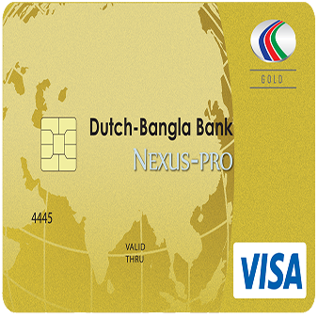

Core value of Dutch Bangla Bank LTD.
- Trustworthy
- Professional
- Dependable
- Accountability
- commitment

DBBL Training Centre:
DBBL training center is located at Rupayan Golden Age, Gulshan-2, Dhaka 1212. DBBL training institute organized 18 different training courses and workshop. The 45th foundation training held at DBBL training center

Division and Branches:
They have 121 branches all over the country in 55 districts. They have opened their last and 121st branch in Nilphamari.

Corporate Culture of DBBL:
Corporate culture refers to their norms, values, attitudes, behavior, mindset etc. that demonstrate its environment. DBBL have a very friendly environment and culture. DBBL and its manager ensure a good working environment and culture. It is one of the fair examples of corporate banks. They ensure healthy and safety of the employees. They work as a catalyst to keep the workplace safe, friendly, free from harassment, corruption and ensure good relationship among colleagues.
Basic Professional and Institutional Obligations:
Every employee must perform their assigned job with utmost honesty and integrity for attaining and upholding public attention and customer/users and stakeholders’ confidence, along with highest professional attitude and aptitude. Each member of all categories must be firm in their performance for the benefits of DBBL and must avoid conflict of interest, at all corner. DBBL employee shall not engage themselves in any commercial activity. DBBL encourage employee to uphold their image in national and international forum ensuring that they will not communicate any sensitive issue to anyone. It is clearly said that employee shall not accept any gift or reward from any other employee or customer. Employees are not allowed to share any confidential information to anyone.

Corporate Designation:
- They have six people in their board of director position. Designations are, chairman, nominee director, independent director, managing director & CEO who are elected by the shareholders.
- They have a management team including
- Senior executive vice president
- Executive vice president
- Senior vice president
- Vice president
- First assistant vice president
- Assistant vice president
Officer Grade:
Principle officer
Senior officer
Officer probationary officer
Junior officer
Assistant officer
Trainee officer

DBBL Management Hierarchy at a glance:

Management hierarchy | Cash hierarchy
Managing director
Deputy managing director
Senior executive vice president
Executive vice president
Senior vice president
First vice president
Vice president
Senior assistant vice president
First assistant vice president
Assistant vice president
Senior executive officer
Executive officer
Senior officer | Chief cash officer
Officer | Cash officer grade 1
Assistant officer | Cash officer grade 2
Trainee officer | Cash officer grade 3
 | Assistant cash officer
 | Junior cash officer
 | Trainee cash officer

Internee: from different educational institute student can get an internship opportunity for 3 or 4 months. Management decides to offer particular job in this bank. Student monthly allowance may vary from 3000 to 8000 taka. Student gets experience through the internship period.

Services of DBBL
- Personal Banking
- Electronic banking
- DBBL retail loan products
- Corporate Banking
- Corporate banking service
- LC trade
- Electronic banking
- Delivery Channel
- ATM location
- Branch location
- SME banking
- DBBL cash credit
- DBBL term loan
- DBBL property loan
- Customer Service
- Help line
- Customer awareness
- Deposits and advances
- Terms deposits
- Loans and advances
- Central customer service and complaint cell.
- Others.

CSR activity of DBBL (Corporate Social Responsibility)
DBBL have tremendous contribution in terms of CSR activity. They are one of the largest private banks who do CSR activity vastly. They are very responsible to the society.
They contribute to economy vastly. Their vision is to create social wellbeing for the customer, shareholder, and stakeholder. They do CSR activity to get recognition and familiarity into the people of this country. They come ahead for human development. From the time they started their banking in this country from that time they are time to time engaged in social activity for the well-being of the people. They do not only look for profit also they have concern about the people who need financial helps. Over the years they do some CSR activity.
They are playing a very important role in our society.
Their CSR activities given below;
- Scholarship program for meritorious student and who are in lack of financial ability.
- They donate to Ibrahim Cardiac Hospital. They donated 93600,000 taka for surgery equipment.
- They help people who are in health problem.
- They assist Acid Victims, they campaigned for social awareness.
- They spent about 1 crore to drug rehabilitation center.
- DBBL established 10 rural medical service centers.
- An amount of 1 crore taka was donated by them for AIDs prevention. And many more CSR activity.
DBBL also sponsored many program in Bangladesh like, for the first time DBBL is the first bank which is sponsored an entire ODI series. DBBL sponsored for aussie tigers test series. DBBL sponsored Bangladesh cricket in many series. In the BPL program they have sponsored. They are more popular for their CSR activities.
Awards and Achievement of DBBL:
DBBL was awarded by the Payment Card Industry Data security standard certificate by qualified NCC Group. This bank has got so many universal awards for its CSR activity and latest technology based banking system, service oriented approach and for competitive services.. DBBL has been awarded with “the best Mobile Banking of the World” for the best money program in banking industry.
DBBL at a glance:
Established | 1996
Head office | Sena kalian bhaban, Motijheel.
Total capital | US$350 million
Total asset | US$4.2 billion
Total Deposits | 145,233,205,246
Number of ATM booth | 4,930
Branches | 121
Clients | Day by day increasing, no exact data.

Different training and workshop program of DBBL:

Serial no. | Training course and workshop program
1 | - Foundation training
2 | - Training courses on foreign trade
3 | - Training on credit management
4 | - Consumer banking
5 | - Advanced credit management
6 | - Training Workshop on integrated supervision system ISS reporting.
 | Workshop program
7. | - Workshop on account opening
8 | - Workshop on prevention of money laundering.
9 | - Workshop on green banking policy and environmental risk management
10 | - Workshop on rationalized input templates for bank.
11 | - Workshop on SME market segmentation database system.
12 | Workshop on ICT security and safety
13 | Workshop on Credit risk management

Human Resource Division of DBBL:
Human resource division of DBBL has a vital role in employee management. They maintains employee recruitment, selection, training and development, performance appraisal, giving compensation, motivating, organizing employee work activity, human resource planning and all. Managers ensure monitoring, evaluation of their work. This division prepare employee for attending a training program, this division set up for training and development. They give employee incentives, bonus other facilities. They basically maintain employee benefit program. This division provides guideline for abiding human resource policies and procedures. This division work with labor law and their incentives benefits and all. They keep the employee work record. They also design training program where they analyze need assessment then they prepare employee for training then evaluate the learning outcome, employee behavior and attitude. They maintains human resource activity by recruiting, selecting, orienting ,training counseling etc. this division have to have a good relationship with the employees. They do counseling to the employee also keep employee in monitoring. They appraise employee job performance and plan with the situation.
In the division they have many sub division;
  - Resource planning unit
- Hiring
- Staffing
- Human resource information system, etc.
  - Learning and development unit
- training need assessment
- designing training
- Evaluation etc.
  - Performance management unit
- Performance evaluation
- Performance appraisal
- Promotion, etc.
  - Compensation management unit
- Benefits
- Salary
- Certificate, etc.
  - Career development unit
- Career planning

Chapter 4

Training and development practices in DBBL

Training objective of DBBL:
- Reduce turnover tendency of employees.
- Motivating employees to give their best effort at any level with enthusiasm.
- Setting up an equal environment.
- Establish moral values in employee.
- Retaining good and eligible employee in the bank.
- Establish healthy environment.
- Ensure peaceful work and good relationship among all.
- It helps to improve business performance.
- Sharpening and upgrading knowledge and skill of the employee.
- Improving attitude and behavior at workplace.
- Empower employees.

Dutch Bangla Bank Training Cycle:
A training program is successful when it is defined well to the employee. The structure of training is made by the learning and development department of DBBL.
The cycle consists:
- Training need assessment
- Training schedule
- Budget proposal
- Logistic support
- Training evaluation.
Training for individual employee: when the specific training is conducted only for the specific person of the organization, who are solely accountable and answerable for their given responsibility. DBBL follow this type of training to get better results.
Training for teams: Trainings designed for team members, when team work or a group performance is happening. It is important to provide team training to the entire team member. DBBL do that when needed.
Training for organizations: Organizational training comprise making definitely clear. DBBL organizational environment is fair.
Training needs assessment:
- Organizational task: DBBL visualize is training support organization decision? And determine what tools are available and what tools are need to assemble. Up level managers concern is how does training support DBBL business strategy? What are the threats to their talent base? Mid-level managers concern is, do they want to spend money on training, Trainers concern is, do they have the budget to buy training service? Will DBBL manager’s level support this program?
- Person analysis: DBBL emphasize on employees level of skill. To understand employees preparation for the training. Here, key concern of upper level manager is who need training. What employee can do to accomplish business goal. Mid-level manager’s concern is on which level training should be given. Trainers think how it will be possible to identify which employee need training.
- Task analysis: DBBL measures newly recruited employee’s activity to identify the employee’s competency. In task analysis upper level managers concern about people who can be competitive in the marketplace. Mid-level managers think about what jobs can be accomplished by training to create difference in product quality and customer service. Trainees think about what skill or ability is necessary.

Methods of training in Dutch Bangla Bank:
When talking about method there are two types of method that exist in training and development program are
1. Traditional training method
2. Technology based method.
DBBL follows two types of method at a time. Because they think now a days this two types of method is somehow mixed up with situation. We have learned from our book that there are some specific ways used in traditional method like standard lecture, teaching, a team, panels set up, presentations etc. these methods of training happens on a specific date on a specific time. on the other hand technology based training is a very convenient one where one can set for a training from anywhere they do not need to worry about attending the program. Employees have control over where or when they receive training. Employee can access knowledge on basis of their need. They can choose any media through which they want to attend. Their performance can be easily monitored. It is suggested that e-learning is more effective for a wide range of trainees. However, basically DBBL uses the blended method of traditional and technology based training method. Arranging classroom training method, Masterminding Arrange the homeroom at DBBL Bank, utilize the appraisal entryway in the availability work where a huge gathering of representatives can insight and build up their abilities utilizing Television video and slideshows identified with conversation content. It's a shockingly fundamental method of readiness that is particularly basic for new specialists with almost no thought regarding the subject. Utilizing the behavioral model, the expert can rapidly build up other significant branch that bodes well for employees.

Department based training: divided into three,
- General Banking Training: it is about giving training on the general work in the bank for instance, opening account, deposit money, giving information etc. Bank gives training to the employee so that they can do these jobs efficiently and can provide specific information to the clients. Here, employee get to know how all the general work can be done in more efficient way.
- Credit department training: this department deals with giving and taking loans. This department is assigned to manage the entire credit process. The function of selecting and assessing borrower’s information is a role of this department. Whatsoever, it provides training on how a customer can apply for loans, how a loan can be taken, conditions for loans etc.
- Foreign trade training: foreign exchange department is the international department of the bank. It deals globally and facilitates international trade. It deals with export and import. In this department overseas training is being provided. Training helps to maintain huge work in the department.

Training and Development policies in DBBL:
Dutch Bangla Bank limited accepts that training is a necessary function. Training enhance employee’s productivity levels and similarly increase the individual person, team and group performance while working, the more they recognize training importance the more they can progress.
Strategies of Dutch Bangla Bank in terms of training and development process:
- DBBL sets the arrangement for training, arranges financial plans for all the office’s needs.
- The trainer can be a in house personnel or an outsider expert trainer. HR actually gives guarantees and the ideas of time quality managements out quality Management.
- HR department basically focus on new employees to give them more knowledge about the organization system and morals and environments.
- HR work for employees advantages and disadvantages,
- HR work for employee’s remuneration, and bonuses.
- HR can serves with latest modules and references.
- Training and development helps HR to fasten new changing innovation and strategies in the organization.
- Training helps HR to build up KSAO to the employees,
- Build up progress.
- DBBL attempts to flourish the degree of executive employees
- Training helps to flourish employee’s ability in work or job.
- In DBBL training helps the employees to enhance the work efficiency and effectiveness.
How DBBL arranges program: In DBBL Improvement or advancement is an arranged activity. The HR department of the DBBL chooses the venture and everything considering their need and assessment. It will at that point be evaluated toward the beginning of each New Year by the tops of the applicable divisions. The DBBL preparing program is depicted up for each representative. The educational plan appreciates the quantity of routine trainings of every worker in various regions. The people what workers' distinction is picked for the readiness? Representatives will without a doubt go to the program; any kindness should have permitted by the different arranged official. Getting ready info would be produced using the individuals. The need assessment of preparing training measure held three ways. Legitimate examination it demonstrates choosing the business greatness of making any preparation. DBBL arranges program to educate the employees more to produce more. They design training program for the new bees to provide them more knowledge to prepare the selected employees. Training is more important to them. Then, if any individual is told to do specific job which he or she is doing for the first time that time training is needed to him or her. A group of employees also attend a training program to do their given job properly with almost effective and efficient ways. Sometimes DBBL arrange training program for individual sometime for a team work or a group work.
STEPS OF TRAINING AND DEVELOPMENT IN DUTCH BANGLA BANK LIMITED
- At first the manager identifies the organizational training and development needs.
- Secondly define a clear objective that is achievable and measurable and it should be relevant to the training.
- Thirdly manager evaluates the preparation needs of the representatives about the forthcoming projects.
- Manager analyzes training keeping in mind the need of employee.
- Manager breaks it into small segment. Ensure appropriate connection in training
- After amassing all the data of the preparation requires of the representative the HR director makes a preparation plan or creation.
- HR assembles all the suitable information, data, and devices to run the arrangement.
- Develop training program by creating and designing training material,manuals, power point presentation etc.
- Implementation of training program. Decide training date and time.
- Lastly, evaluate training program. Collect feedback about the program from the employees who participated in training program. Then evaluate and measure its effectiveness.
Designing training and development is a very important task for a manager in a bank. It is important to identify the needs and the gaps to give training to employee. In order to gain the maximum result from a training manager need to give full effort to make it successful. Those steps are followed by Dutch Bangla Bank managers.
- Training Requisition:
In all the departments supervisors are given a form for assessing the needs of the training programs for their employees. The supervisor and his team come up with a decision of which training and development program are needed. After getting requisitions the L&D wing determine what are the training learning should be given to the employee. It is only provided to update the productivity rate of the employee.

- Training approval:
Approval is given after observing the requisitions. If the requisition is sound and rational after that a proposal for training is made. The proposal is regarding the training program including budget, place, objects etc.
- Training authorization:
After all the evaluations HR department determine what should be done first and what should be done later. Employee can make them ready for the training after the authorization.

Training principles of DBBL:
DBBL try to ensure all employee will have relevant knowledge and skill to perform better. So they follow certain policies those are-
- Training and development activity must assist to achieve organizational strategic objectives.
- Before going for a training program, organization must analyze the need of the training program.
- Individual will be provided with specific training program depending on the needs and condition of their job role.
- All the employee of this bank will be equally treated.
- Ensure a good trainee will conduct the program.

Types of program conducted by DBBL
We know that employees are main resource for any organization. To make them more productive training and development plays a significant role. T&D enables employee to enhance skills and abilities. DBBL provides both on the job, off the job training.
Training programs are conducted on the basis of needs assessment for the group of employees differently. DBBL has some in general training program for all employees.
Orientation: Generally their first program is orientation. They introduce primary work with their employee. This introduction program makes an employee efficient and knowledgeable.
- Top management level:
This program designed for only the top management of the bank.it is conducted for top employees to be the future leader.
- Executive level: junior and senior executives are the main employee of this program. The motive of this program is to make new employee familiar with the basic information of the bank. It is basically done for the management employee. It teaches them how to get adapted easily with the new culture of the bank. This is a multiple learning program. Their objective is to develop attitude and behavior. In the first six months they stay in probationary period. This phase is about professional grooming and positive attitude.
- Non- management level: for the non-management level training DBBL conduct all the rankings in the group. So that all employee from higher to lower ranking can easily understand. It is designed in a way so that all employees from top to bottom can take the learning.
- Internship program: it is a year round program where newly graduates enter and they get 3 months’ work experience. It is called internship program.

Impact of training in the employee improvement:
- Reaction: the employees are very much satisfied with their trainer and training sessions. They showed positive attitude after training.
- Learning: employees were asked if they have learned anything from the training session.
- Behavior: employee behavior is noticed and remarkably changed said the manager. Training session helps to develop good behavior towards bank.
- Result: training result is very positive as shown on the table. HRD is satisfied with the training initiatives. Those programs contribute to the big success of the bank.
Aspects that didn’t match employee satisfaction:
- Nominating employee for Training: Well it’s really embarrassing when management design a program where entry level and mid-level along with high designated people do share same place at a time. It’s make some problem sometimes employee cant clear their confusion from the training as they feel embarrassed to make question in front all of them.
- Time duration: This is a vital issue because trainees are concern about the time duration. Employee thinks foundation training should be given for fifteen to one month but in organization this time of training period is restricted .that is why trainers tend to finish the topic fast to cover the content. Also sometimes employee feels some training period is getting long where that training doesn’t require much time.

Training effect inside bank
My project is about training and development in this bank, so when I talked with the employees who have attended in different training sessions. I wanted to know how different training is helping them for their current job and what would be the impact in future. After having a conversation I came on some point, they have both positive and negative experiences. Those things I have discussed earlier.
Every level from entry to upper, all employees need training to get idea about the bank and idea of different changes happening across outside and inside bank. In entry level, managers provide some basic knowledge about the bank to the newly recruited employee. This training is known as foundation training. Here all the employees who join as MTO, TO have to mandatorily attend the program. This training gives an idea about the culture and environment of the organization. Foundation training involves providing knowledge about banking system. Motivate employee in every division. It helps to build confident and appreciate employee work.
Training effect in mid-level:
For mid-level DBBL give various training program to balance workload. Training helps to manage the client in an effective and efficient way. It helps employee to easily solve the problem of a customer. It helps to work smoothly under pressures. The training helps to motivate employee so that they can work confidently. Training increases confidence level of employee and help to reduce confusion at work. Trainer provides technique and knowledge so that mid-level trainees work in an organized way.

Training record keeping:
The training record is placed in MS Excel by the training and development department of DBBL. This information considered as confidential information. Only the department personnel can access this server. The records consist of program type whether it is in house or external. Participants detail profile is recorded in the server.

Identified problems:
1. DBBL HR now and then discovers absence of labor for supporting preparing programs and the administration.
2. As an eminent association DBBL doesn't give diverse sort of preparing focal points to improve worker's work aptitudes, disciplines, inspiration and correspondence ability.
3. DBBL doesn’t organize adequate or enough program.
4. Insufficient practical training programs.
5. Most importantly, Less trainers are hired from outside.
6. Not enough TIME duration of training.
7. Mostly in-house training, they do not send outside of the organization.

Organization name | Training consequence | Advantage | Training period
Dutch Bangla Bank LTD. | The HR manager said that sometimes training is not that much effective but in most of the cases it have a huge effect on employee. Trainees feel motivated towards workplace. Be more productive and competitive in work. | Training saves time and resources of an organization. It helps to reduce cost in an efficient way. Training period is also important for employee because best performer gets more fascility, like they get extra remuneration for attending the program. | Well it depends on when, why, who question answer.  Those things depend on different situation. As training is not a function about giving it to all at a time. So it depends on the  Circumstances, yet they arrage such program after 2 or 3 months on average in a year.

Effect of COVID 19 in banking sector:
COVID impact on the banking sector: in 2020 it was every tough situation for every organization around the world. All on a sudden it was a big shock for the entire nation. Banking sector is one of the most important sectors which were also in stake in COVID 19 period. People whose bread and butter were depending on their job they were in difficult situation. Banking sector had to face loses. As there was low value in financial instruments and bonds. Banks lost demand for their various services, there were a few transaction happening which was really low comparative to previous time. They had to sale financial instruments to balance their liquidity and make up the losses.
First, firms that have stopped working miss out on revenues, and therefore might not be able to repay loans. Similarly, households with members who have lost their jobs or are furloughed have less income, and therefore might not be able to repay their loans. This will result not only in lost revenue but also in losses (if repayment capacity is permanently impaired), negatively affecting profits and bank capital. And as a swift recovery becomes less likely, banks can expect further losses, resulting in the need for additional provisions, further undermining their profitability and capital position.
Second, banks are negatively affected as bonds and other traded financial instruments have lost value, resulting in further losses for banks. There might also be losses from open derivative positions that have moved in unexpected directions due to the crisis.
Third, banks face increasing demand for credit, as especially firms require additional cash flow to meet their costs even in times of no or reduced revenues. In some cases, this higher demand has presented itself in the drawdown of credit lines by borrowers.
Various investigations have explored that the situation made unfavorable effect over all nation's GDP particularly when the pandemic began and make bad effect on our country and due to the large number of representatives bound to leave their job, millions of people in Bangladesh had to leave their job. The examination makes sure about that immense position disasters will happen all over the country, most remarkable sector in Bangladesh like RMG, Remittance, export and import, transport, movement business, specially banking sector, insurance, guidance those are in feeble situation because of the staggering effect of Corona disease. Not only as an organization banks faces difficulty but also who were employed in bank they have gone through much sleepless night worrying about their job security. As banks were in stake they were not able to keep all employees with giving salary and all the facilities. Some people lost their job without notice; people got unemployed for few of the months though the situation is improving subsequently people are going back to work.

Chapter 5

Findings and analysis

Findings
The findings I received was positive
Findings given below:
- Though training is a very important topic yet some people think doing training is waste of time.
- The employee training and development program is planned such a way that easily accomplish organizational goal.
- They design training and development program in an efficient way within budget and facilities.
- A training calendar is used for all program so that no date activity clash happen.
- Employee response to the study was positive .
- They try to follow all HR training practices.
- In DBBL the relationship among employees and management is very friendly.
- Comparing with other banks they are much advanced in terms of training and development.
- DBBL ensure effective feedback system. While doing this assessment I by and large found that they use strategy to gauge preparing program.
- Some individuals imagine that preparing for preparing is totally misuse of their time.
- They give great workplace and alluring pay advantage for their representatives
- The connection among worker and the executive’s level are generally excellent.
- This bank faces issue in assessing workers.
- DBBL follow a good strategy of preparing and accept customary preparing program is basic to create execution level and increment aptitude.

Analysis:

The manager said, in result of the training program representatives are more educated about their work now they are more productive, many employee think that their training session was very much helpful and favorable to fulfill their expectation from the training and development session. Additionally, they can cope up with the work challenges. According to the employee, they are satisfied with the training session, they are more productive and organized than before. They also said that training have a positive impact on their work. By receiving training they get motivated towards completion of their work and to do their task on a better way. However, some of the employees stated that they cannot cope up with the work pressure while doing training. Most interesting thing is employees get rewarded for the best response in training time.
Interpretation of data:
1.How all around prepared are your employees?
1Organizations agents marked that the employees are a lot of arranged and explain that different kinds of strategies are formed through utilizing various resource. It is important to see how much prepared an employee to attend the training. They all are very positive towards attending the training program in order to turn out their skill in a most effective way.
2. How it is understandable that the training program is successful?
When the participants gives positive feedback. Participants find something new to work along with the organization. Lastly work productivity is a big standard to measure the success in the organization. Employees working pattern and efficiency of their work can tell how much successful is the program.
3. Why Training and Development exercises are not being very much influential to all the employees?
In light of specialist discernments they said that, couple of individuals' decision probably not sufficient. Some representatives assume that working environment is not very much motivating them.
4. Are there any kind of behavior is changing after having a training session?
After attending a training employee feels refreshed as there are not only boring lectures but also some games and activities happen where employee willingly participate. They extend their work time in the organization. They look fresh and happy.

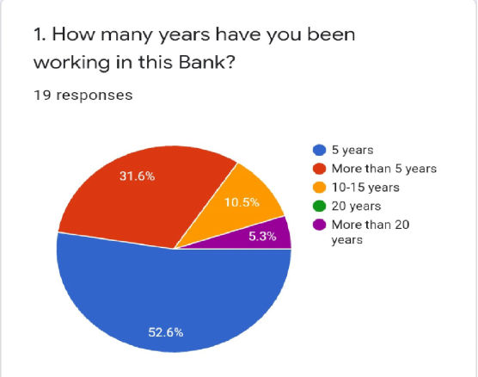
In this question answer, some employees stated 31.5% employees works here more than five years then they may have been switched to another company, remains here for more than 5 years, other10.5% are working here for 10 to 15 year, 5.3% says more than 20 years.
.

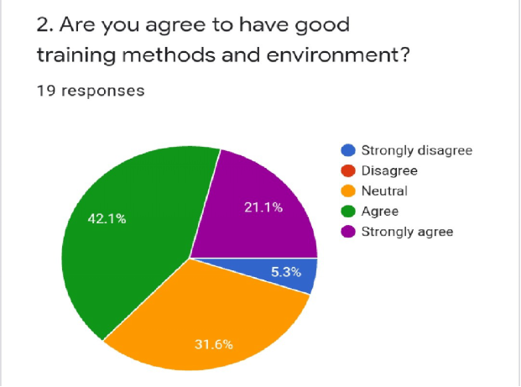

About maximum 42.1% employees agree on this. 5.3% of employees strongly disagreed on this point,and 31. 6% employees are neutral on this topic.

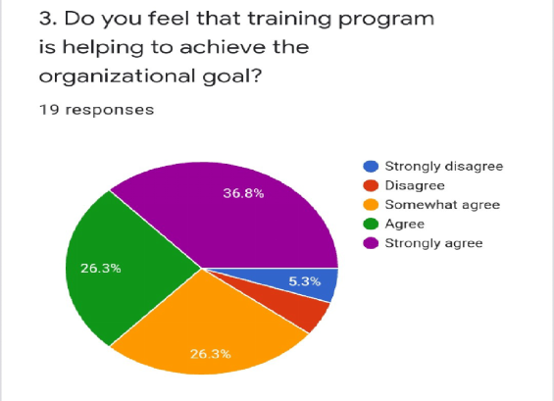

Most of the employee like 36.8% employees stated and they think that training program is helping in order to conquire the aim of the organization also and 26.3% says that they do agree to this topic, another 26.3% is neutral.

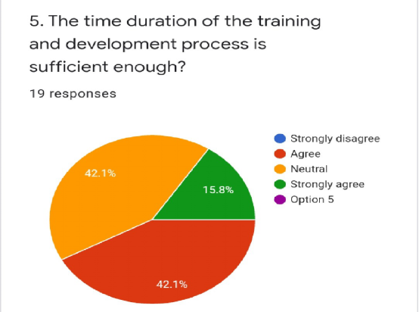

Under this chart we can comment that 42. 1% employees are not much agreeing or disagree with the timing issue. Less people like 15.8% individuals are strongly agree in terms of time they think their fixed time is appropriate. 42.1% employees agree that they are happy with the time duration.

Chapter 6

Recommendation and conclusion

Recommendations:
After evaluating all the aspect in training and development in Dutch Bangla Bank Limited, I would recommend them to keep up their work likewise their motto( Trusted Partner). Those training issues that I have mentioned should solve quickly. They should give more focus on employee development. They should show more attention to retain most effective ans efficient employee in the bank.
Recommendations are given below which will help them to develop their apathetic matters that I have found in this assessment;
- HRD should properly analyse needs assessment so that all employee equally can get the right knowledge.
- HRD can make a book on training program, as employee can’t get all the idea in short time training session. It will help them to clear any confusion.
- To make training evaluation form that gives a brief idea about trainee feedback on various training program
- Work with some renowned training institute it can be local or overseas. It can help in many aspects. They can offer different training program which will help to reach their goal.
- HRD have to determine the gaps in employee performance. So that they can provide necessary training to cover up the gaps.
- Program needs appraisal ought to be led all the more carefully.
- The authority of this bank should make a compelling prize framework which empowers representatives for going to the preparation.
- The association needs to zero in on external trainings more than in house trainings.
- DBBL needs to follow new preparing and progression system as opposed to using customary one
- Introduction of additionally preparing project will be powerful for supporting proficient development and improvement of representatives.
- Training should get estimated more carefully.
- More workforce needed for L&D department as training session is increasing.
- Employees have to show more responsible attitude towards their own organization.
- The training should result ineffective co-ordination among employees.
- More training needed for trainee to develop skills, abilities, knowledge and performances.
- Employee feedback should be considered more carefully so that training can be improved further to their expectation.
- Manager should motivate employee to attend training, rewards can be given who participate consistently.
- External programs and overseas program should be increased.
These recommendations can help them to organize the training program more efficiently; hopefully they will recognize it as a necessary recommendation. They must focus on new dimensions as the world is changing continuously to keep up with the changes they need to focus on every aspect. Lastly, retaining good employee is very important for them.

Conclusion
After all this analysis and findings and all the study we can summaries that DBBL is successfully operating this function in their possible way and they are trying to do it more familiar in all the branches all over the country. Though still there is more difficulty remains that they have to face. Training has not been recognized to all the organization. There are some advantage and disadvantage also. No association can achieve its targets or can be adequate, until it satisfies all. Training and development fulfillment in workers is higher. As yet satisfying working environment, advantage of DBBL is also acceptable. Finally, the bank should introduce a bleeding edge banking system, handle new unforeseen development. Banks are outstandingly important in Bangladesh. The accomplishment of a bank depends on the best customer help of the sellers. This can develop astoundingly able analysts who can turn out wonderfully for clients and achieve client trustworthiness through legitimate planning preparing an appropriate solution. Growth of banking in Bangladesh is the consequence of skilled work which is the result of providing training to the employees. The preparation information of DBBL is very hard for assembling. I was not allowed to have all the information that I have mentioned already which was in limitation part. I had to prepare this piece of project through online conversation and over phone for the pandemic situation. There was some restriction to collect some data which is also important for a bank to not reveal all the information outside. Though the administrators of DBBL bank was helpful. Last but not the least I really perceive that those data that I have gather from my endeavors would be acknowledged for my final project evaluation.

Chapter 7

Bibliography

Reference
Irish, K. (2019). A Guide to Creating an Employee Training and Development Program. Retrieved 28 November 2020, from https://www.ej4.com/blog/guide-to-creating-employee-training-and-development-program
UKEssays. (November 2018). Issues Related To Global Training And Development Management Essay. Retrieved from https://www.ukessays.com/essays/management/issues-related-to-global-training-and-development-management-essay.php?vref=1
Kang, H., & Shen, J. (2017). International Training and Development Policies and Practices. Retrieved 28 November 2020, from
Keenan McBride, C. (2020). Training and Development in a Post-COVID-19 Workplace. Retrieved 28 November 2020, from https://trainingindustry.com/blog/strategy-alignment-and-planning/training-and-development-in-a-post-covid-19-workplace/?fbclid=IwAR1GTH3v-
Mahmood, M., & Akhter, S. (2011). International Briefing 24: Training and Development in Bangladesh. Retrieved 28 November 2020, from https://www.researchgate.net/publication/228253694_International_Briefing_24_Training_and_Development_in_Bangladesh
http://dspace.uiu.ac.bd/bitstream/handle/52243/1961/MARZIA%20LAMIA%20111161289%20-final.docx?sequence=1&isAllowed=y
http://dspace.uiu.ac.bd/handle/52243/1673
http://dspace.uiu.ac.bd/bitstream/handle/52243/1673/Sumaiya-Project-On-Training-Development.docx?sequence=1&isAllowed=y
The Importance of Training & Development in the Financial Sector. (2017). Retrieved 28 November 2020, from https://bizfluent.com/about-6500249-importance-training-development-financial-sector.html
Ather& Shah. (2015, November). “Impact of Training on Employee Performance (Banking Sector Karachi)”, Journal of Business and Management (IOSR-JBM) Vol.17, Issue 11 .Ver. I PP 58-67.
Training and Development - A Key HR Function. Retrieved 28 November 2020, from https://www.managementstudyguide.com/training-development-hr-function.htm
Armstrong, M. (n.d.). Handbook of Human Resource Management Practice. Kogan Page.
Monappa, A., &Saiyadain, M. S. (1997). Personnel management. New Delhi: Tata McGraw-Hill.
Aswathappa, K. (2005). Human resource and personnel management: Text and cases. New Delhi: Tata
McGraw-Hill. https://www.coronavirusandtheeconomy.com/question/how-coronavirus-affecting-banking-sector.
https://www.vskills.in/certification/tutorial/process-of-designing-a-training-program-tutorial-train-the-trainer/
https://www.dutchbanglabank.com/social/corporate_social_activities_2007.pdf

Chapter 8

Appendix

A Questionnaire for Training and Development Practice in DBBL.

- How many years you are working in this bank?
- 5 years
- More than 5 years
- Less than 5 years
- Do you agree on ‘training is necessary for this bank employee?’
- Agree
- Neutral
- Disagree
- How much impact it has on your performance?
- Strong
- Neutral
- weak
- Do you think employees are satisfied with the training program?
- Some extent
- Greater extent
- Neutral
- Does trainer able to cover all the element of the training?
- Strongly agree
- Agree
- Disagree
- Do you think training is increasing the productivity of the work in bank?
- Agree
- Neutral
- Disagree
- How many time employees sent to training program?
- Once in a year
- Twice in a year
- Not more than 3 times in a year

- Training changed employee behavior?
- Some extent
- Greater extent
- neutral
- DBBL consider training as an important part to achieve the goal, do you agree?
- Does Training helps employee to increase productivity?
        - Yes
        - No
- What kind of training method do you prefer?
- On the job
- Off the job
- Both
- Foundation training is very important..
- Strongly agree
- Agree
- Disagree
- Does a training and development activity helps to build up sound and healthy relationship in the workplace?
- Yes
- No.
- Time for training is-
- Sufficient
- Need to extend
- Need to shorten
- manageable

Descriptive question:
1. How you measure the training success?
2. How you evaluate the needs assessment?
3. Do you think trainer is well trained?
4. How many days it takes to evaluate a training program
5. What do you think about a effective training program?
6. What are the difficulty you faced in training?

