Insight of Brokerage house and Share Market

Maliha Haider

This report is submitted to the school of Business and Economics, United International University as a partial requirement for the degree fulfillment of Bachelor of Business Administration

Insight of Brokerage house and Investor Behavior
Submitted to:
Name: Dr. Md. Qamruzzaman
Designation: Associate Professor
Major: Finance

Submitted by:
Name: Maliha Haider
Id:11118136
Major: Finance
Trimester: Spring 2022
School of Business and Economics
United international university


Date of submission: 23rd May, 2022

Letter of transmittal
23rd May, 2022
Dr. Md. Qamruzzaman
Associate Professor
School of Business and Economics United International University
Subject: Submission of the Internship report on the trading and business development department of Langkabangla Securities.
Dear Sir,
With due respect, I’m particularly pleased to present my internship report, which was covered a three-month internship at ‘Langkabangla Securities’ (Trade and Business development Department). This report includes in detail about my experience of working in a brokerage house and my entire insight about hare market I got from working in a brokerage house.
As I am in learning curve, this report helps me to gain the practical experience about the Brokerage house industry and share market. As I am new in this format of report, it becomes a challenging as well as interesting experience. I am thanking you from depth of my heart for supporting me from the beginning to end, not only just by giving the idea of the report, but also correcting me in every part of the report. Without your courageous inspiration this report won’t be done.
If anything in this report isn’t understood clearly, please feel free to contact to the following email and mobile number. Lastly, I would be thankful once again if you please give your precious advice on my effort.
Sincerely Yours’
Maliha Haider
ID: 111 181 036

Certification of similarity index

This is to certify that this report is a product of my sole learning and experience throughout my internship. The similarity level for the entire thesis is less than 10% with any available documents related to this topic.
Name of the student: Maliha Haider

Signature of the student

Signature of the Supervisor

Declaration of the student

I the undersigned solemnly declare that the project report is based on my own work carried out during the course of our study under the supervision of Dr. Md. Qamruzzaman Sir. I assert the statements made and conclusions drawn are an outcome of my research work. I further certify that
- The writings in this report is original and done by me under the supervision of my faculty.
- The report has not been submitted to any other Institution for any other degree/diploma/certificate in this university.
- We have followed the guidelines provided by the university in writing the report.
Maliha Haider
11118106

Acknowledgement

I wish to extend my heartiest thanks to my faculty for introducing me to this amazing report; Insight of Brokerage house and Share market. Due to this report writing, I got into more details about share market and tools used by traders here.

Abstract/ Executive summary

This report broadly includes my experience of working in a brokerage house as an intern and working for trade, digital transformation team. My learnings of technical analysis, market analysis of this industry, growth and trend of the industry, how this industry works as whole, the operation process of langkabangla securities, its digitally transformed work process all of these are described in the report in description.

Table of contents
Contents
Letter of transmittal III
Certification of similarity index IV
Declaration of the student V
Acknowledgement VI
Abstract/ Executive summary VII
Table of contents IX
CHAPTER I: INTRODUCTION 1
I.1 Background of the Report 1
I.2 Objectives of the Report 1
I.3 Motivation of the Report 1
I.4 Scope and limitations of the Report 1
I.5 Definition of Key terms 1
CHAPTER II: COMPANY PREVIEW 2
2.1 Company Analysis 2
2.2 Industry analysis 10
CHAPTER III: INTERNSHIP EXPERIECNE 14
4.1 Position, duties, and responsibilities 14
4.2 Training 15
4.3 Contribution to departmental functions 15
4.4 Skills applied 15
4.5 New skills developed 15
4.6 Application of academic knowledge 17
CHAPTER IV: CONCLUSIONS AND KEY FACTS 18
5.1 Conclusion 18

List of Tables
Table 1.1 Net Profit
Table 1.2 Ratios

List of Figures
Figure 1.1 Profit trend line
Figure 1.2 ROE
Figure 1.3 ROA
Figure 1.4 EPS
Figure 1.5 Debt to equity
Figure 1.6 Gross profit
Figure 1.7 Interest Coverage
Figure 1.8 Market Index
Figure 1.9 Sectoral trend

List of Abbreviation
CDBL: Central depository Bangladesh Limited
LBSL : Langkabangla Securities
DSE: Dhaka Stock Exchange
CSE: Chittagong Stock Exchange

CHAPTER I: INTRODUCTION

Background of the Report
This report is a short insight of the Bangladeshi stock market from an insider view, working in and for the mechanism runner the “brokerage houses”. Giving an idea about how the brokerage houses work and how are the investors behavior regarding

Objectives of the Report
Summing up the idea of working in a brokerage house; the most fascinating field of finance.

Motivation of the Report
Academic requirement.

Scope and limitations of the Report
Being an intern, there was a little less accessibility to various aspects of the house to some extend.

Definition of Key terms
Brokerage House: A brokerage firm or brokerage company is something that works as a middleman between buyers and sellers to complete a transaction for stock shares, bonds, options, and other financial instruments in exchange of fixed commission rate per transaction.

CHAPTER II: COMPANY PREVIEW

Company Analysis

- Overview and history
LBSL started its journey in 1997 as a joint venture FI in multinational collaboration by taking license from Bangladesh Bank under financial institution act-1993. It’s a subsidiary of country’s leading FI Langkabangla Finance which operate a huge umbrella of financial services and products. It has been listed as the best brokerage house by DSE in year 2021.

- Trend and growth
The very first criteria or to see a company’s growth is to look at its profit or revenue generation. Below here is a 4 years profit generating summary of Langkabangla Securities ;
YEAR | Net profit
2017 | 821,864,830
2018 | 284,722,233
2019 | 125,376,374
2020 | 138,698,843
Table 1.1 Net Profit

Figure 1.1 Profit Trend Line

Moving forward to check the growth and profitability trend of LBSL , to do so this report contains six ratio analysis which are primarily used;
 | 2017 | 2018 | 2019 | 2020
ROE | 0.177141272 | 0.05782 | 0.025028 | 0.026912
ROA | 0.076152832 | 0.025572 | 0.012127 | 0.012917
EPS | 3.05 | 1.06 | 0.46 | 0.54
Debt to Equity | 0.246791611 | 0.200045 | 0.152729 | 0.076441
Gross Profit | 2.10026709 | 4.708567 | 6.990888 | 5.825671
Interest Coverage | 3.490788545 | 1.018128 | 0.497 | 0.876602
Table 1.2 Ratios

Starting with the ROE, showing us a decreasing pattern. Even though after 2020 its seeming to go on a uptrend.

Figure 1.2 ROE

ROA is giving us a decreasing trend as well. Just like ROE, its seeming to go on a uptrend after the pandemic disaster in 2020.

Figure 1.3 ROA

EPS was on a downtrend but started to get back on up track in 2020, with a little increase.

Figure 1.4 EPS

The consistently decreasing D/E ratio Of LBSL is showing it becoming less dependent on lenders for financing, rather than getting more financing from the equity holders.

Figure 1.5 Debt to Equity
The gross profit was in an uptrend before pandemic brought its wrath, that’s why we can see an uptrend going downwards.

Figure 1.6 Gross Profit

The graph shows us that ,LBSL was in decreasing position in case of paying off its interest expense till 2019,but it got back to an increasing stand in 2020.

Figure 1.7 Interest Coverage

The mixed and volatile trend lines of various ratios of LBSL are somewhat representation of the volatility of the entire country’s stock market.

- Customer mix
The client portfolio of the company mostly includes middle aged clients, by bringing new gen technologies and attaching MFS’s and mobile, online banking facilities along with trade apps LBSL is on the peak of creating client of this generation.

- Product/service mix

- Brokerage service
- Client can trade from any geographical location around the world.
- Buy-sell orders can be placed via mail, phone or other online facilities.
- Application for IPO.
- Full repatriation of dividend and capital gain.

- Margin Loan Facility
- By checking client profile and risk taking ability LBSL provides margin loan facility according to regulatory requirement.
- The loan rate is subject to interest rate in the market.

- Investor relation service
- DP service
- Custodial Service
- Insurance policy upto lac

- Operations

The entire operation process of LBSL can be broadly divided into four parts;
I/Domestic trade: 19 branches (16 main,3 extension) around the country for domestic trade having a separate accounts department of each.
II/Foreign trade: It is conducted through only A.A Bhabhan branch for international clients.
III/Back Office:
- Settlement
- Compliance
- Finance
- Marketing
- CDBL relation maintaining
- Others
IV/Customer service point
The operation process of domestic trade, accounts and back office are run by various apps, software, portals. Those are;
OMS(Order Management System)
LBSL is the first brokerage house in the country to launch and successfully run this software. This system facilitates and manages execution of trade in a very efficient manner, allowing the traders to check and work on both DSE and CSE through same screen.
BOE(Back Office Enhancement)
A software used by backoffice for data storing relating to client profile and financial issues. Also by the accounts dept. for conducting transactions.

iBroker
A web portal by LBSL through which client can open their BO accounts and deposit, withdraw balance. Also the employees use it to do the online part of account opening at office.
TradeXpress
An app owned by LBSL for their clients to do their trading own their own.

- SWOT analysis
Strength
- Brand Value
- Commission system for individual traders, giving high end motivation to bring new client line-up
Weakness
- Mostly middle-aged clients at present, potential issue for a long run.
Opportunity
- Engaging RTGs, MFS might be a way of making itself a five generation brokerage house.
Threats
- To get the new gen investors, LBSL has to play the role of first mover taking up the responsibility of customer education. Whereas the other houses will get an educated potential client lineup without putting any effort

Industry analysis

- Specification of the industry

The brokerage house industry contains more than 300 houses in both DSE and CSE. And the industry is inseparable to DSE, CSE, CDBL, SEC at all. So while we try to speculate the stock market industry, we will be actually be talking about the entire stock market as a whole. DSE and CSE both are regulated and controlled by BSEC. The regulatory body has been taking steps to keep the market steady, less risky for individual investors, ensuring more long term funds and so on. Such as recently the regulatory body changed the circuit breaker to lowest of 2% and highest of 10%. To ensure the bears of the market cannot make the price very lower while making their own profit and putting the individual investors at high risk. And this action immediately impacted the index. Again when the regulatory made the limit of investment for banks higher in the stock market, it impacted the index. This shows how much information sensitive and attached to each regulatory decision this industry is. But along with this information sensitivity comes a downfall of rumors being heard and believed to much, letting the bulls and bears manipulate the market on their own benefit even without existing in the system. Thus, this industry and investing in here, working here is fascinating and leads to a broader way of financial literacy while keeping behavioral finance in mind.

- Size, trend, and maturity of the industry

The size, growth ,trend and maturity is mostly measured by its index. This industry’s growth and trend is highly depended on the sector wise position which are listed as public ltd companies.
The index chart, sectoral involvement and sectoral chart are the following:
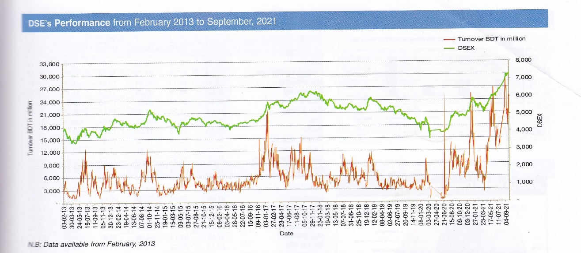
Figure 1.8 Index trend of market

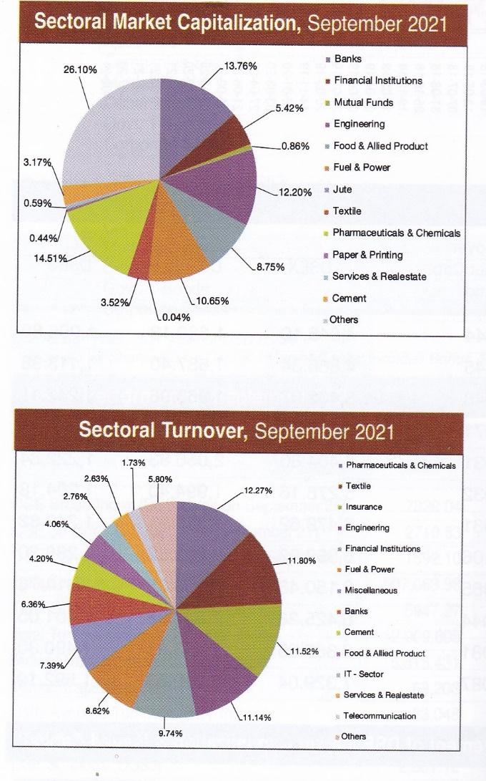
Figure 1.9 Sectoral Involvement and turnover chart

- External economic factors

The very common factors that impact stock market directly are GDP and interest rates. Let’s see how;
GDP and stock market has a positive relation when GDP increases the market index increases as well in turn bringing profit to investors and brokerage houses as well. When the GDP is in growth this means people and companies have more wealth, money, revenue in their hands. This makes both the investing capacity and share prices high. Because more revenue means more dividend option making shares more demanding and bringing an increase in the price. Also GDP growth means people have more money in hand by default increasing the level of investment.
Interest rate and stock market index has a negative relationship. A high interest rate makes money flow lower in the market, making investing capacity lower. Also due to higher interest expense companies face reduction in their net income, resulting the value of the firm going down and eventually falling the share price. In a falling market, with lower investing power investors don’t tend to invest and thus making the market index go lower.

- Technological factors

The industry highly depends on computers, trade software, internet banking, digital booths and to mention latest addition the industry also have engaged mobile banking, MFS, trading apps as well.

- Barriers to entry

There are no specific issues to enter in this industry rather than basic regulatory requirements. But the only concern here , a good amount of networking is needed inside the financial institute circuit to make a profit from this industry.

- Buyer Power

By buyer here means investors of stock market who are clients to brokerage houses. They can switch at any moment to other house in search of better service, trade consultancy, lesser commission rate. And as the entire shifting process isn’t that tough so clients need to be kept satisfied always. Commission rates usually get lower for big amount investors, ne clients tend to get more consultancy. On a whole the client base is dealt with a great interpersonal relationship with their respective traders.

- Industry rivalry

The top five players hold the biggest client bases in this industry. Those are by rank;
I) Langkabangla Securities II) UCB Capital III) IDLC Securities IV) Brac EPL
V)ICB Securities
DSE annually publishes which house has given best performance and this announcement is a great opportunity of making the brand value higher

CHAPTER III: INTERNSHIP EXPERIECNE

Position, duties, and responsibilities

My working position was an intern in the business development department officially , but I got the chance to explore many other working units such as trade, accounts and settlement for learning purpose.
My core responsibilities were broadly divided into two timeframes. In the first half my core responsibilities were;
- Account opening both online and offline formats.
- Attending new clients and brief them about BO forms and using iBroker.
- Listing out files that are not sent to the storage part of settlement.
- Listing out respective traders of those files, contacting the traders, collecting the files.
- Updating the client code list.
- Sending files after verifying all the necessary documents are present to the settlement department for scanning.
- Listing out client codes with negative balances, no shares. Notify to respective traders take note of the details and report it to my supervisor.
In the second half I was working with e-KYC project, responsibilities there;
- Draft the entire project.
- Giving project details to traders.
- Taking client approval.
- Taking weekly updates from branch wise operation managers about how many e-KYCs are filled from their branch.

Training
I got training from my seniors here who are authorized traders and also from accounts department. From the authorized traders, I got to learn about the OMS software and DSE trade software. Also they taught me about various Fundamental and technical analysis. From accounts department I was trained to do the online deposits and withdrawal through the BOE software.

Contribution to departmental functions
My work directly impacted the settlement and compliance department, that needs to preserve entire client data and provide those to CDBL.

Skills applied
My MS office and MS excl skills came to be real useful working here. Also the idea of group work and ability to work in a group came in handy too.

New skills developed
As the part of trading dept. I got to learn many technological analysis tools, which are skills that people use to invest, counsel investors. Those are;
Free Float
Says how much of the shares are publically traded.
- A stock with higher free float means less volatility
- A stock with less free float means high volatility
Stock with lower free float is more volatile because, there are limited numbers of shares that can bought or sold that only in major trading occasion. Share with high free float keeps the trade volume high, ensuring good bid-ask spread. Also it ensures the share can traded at any time, cause there will be buyer and seller for it easily, as more and more share are held by public.
Volume high, ensuring good bid-ask spread. Also it ensures the share can traded at any time, cause there will be buyer and seller for it easily, as more and more share are held by public.

Relative Strength Index (RSI)
RSI shows overbought situation when the line goes above 70 and oversold when it goes under 30. These traditional levels can also be adjusted if necessary to better fit the security. RSI also often forms charts patterns that may not show on the underlying price chart, such a double tops and bottoms and trend line.
Here the picture showing a downtrend or bear market. Because the RSI line staying under the 30. If the RSI tend to stay between the 10 to 60 range with the 50 to 60 zone acting as resistance. These ranges will vary depending on the RSI settings and the strength of the security’s or markets underlying trend
MACD
There are two indicator lines in MACD, signal line and MACD line.
When the MACD line goes above signal line the stock is in uptrend and the price will go up (bullish position).
When the MACD line goes under signal line the stock is in downtrend and the price will go down (bearish position).

Application of academic knowledge
Some of my previously learned fundamental analysis could be used as analysis tools for investment. Those are;
Price/NAV Ratio
Its more generally referred as price to book ratio. It tells us how much an investor have to pay for per 1tk asset. High price/NAV ratio says an investor has to pay a higher rate to posses per tk asset while comparing with any other stock that has a lower price/NAV.
P/E or Price Earnings ratio
The P/E ratio accounts for a company’s actual earrings instead of its projected earnings. It is considered one of the most accurate ways of determining how valuable a company or its stock actually is, it offers in a perfect market and a fair valuation of a stock, Determining the P/E ratio is important for investors because it helps them to get a better understanding of what they get for their investments, a good profit margin for a small price is bargain
EPS
A higher EPS would suggest that a company is more valuable. If investors are comfortable paying a higher price for shares, then that could reflect strong profits or expectations of high profits.
BETA
It measures the stock volatility in the overall market. It is a better indicator of short-term rather than long-term risk. It helps the investors to determine the stock’s risk profile. If beta is grate than 1.0 then it is volatile stock, if the beta is less than 1.0 it indicates a stock is lower volatile.

CHAPTER IV: CONCLUSIONS AND KEY FACTS

Conclusion
Working in brokerage house gives an overall idea of the entire financial position of the country, it was a great deal of opportunity for me to work there.

