An Economic Blind Assistance System Using Artificial Intelligence for Providing Audio Assistance in Bangla

Final thesis report submitted to the School of Business and Economics (SOBE) to receive a degree for the project under the Department of BBA.

Jenia Alam Juhe
ID: 111 172 055

Supervised by
Ahmed Imran Kabir
Lecturer in BBA
School of Business and Economics (SOBE)
United International University (UIU)



United International University (UIU)
United City, Madani Avenue, Badda, Dhaka 1212,
Bangladesh. 26thJanuary, 2023

DECLARATION

I, Jenia Alam Juhe bearing ID 111 172 055, at this moment declare that the thesis report entitled “An Economic Blind Assistance System Using Object Detection and Providing Audio Aid” is developed by myself under the supervision of Lecturer Ahmed Imran Kabir, School of Business and Economics (SOBE), Bachelor of Business and Administration (BBA), United International University (UIU) and submitted for the partial fulfillment of the degree required under BBA program. I also declare that no part of this thesis has previously created the basis for the award or degree in any institute.

Supervised by

______________________________
Ahmed Imran Kabir
Lecturer
Department of BBA, SOBE
United International University (UIU)

Submitted by:

____________________
Name: Jenia Alam Juhe
ID: 111172055
MIS (Management Information System)
Department of BBA

ABSTRACT

With the visionary sense, the brain combines several perceptions and transforms the mixture into something meaningful. The five senses of humans have strong relationships with one another. Another constantly supports one sensation. The sense of vision is most frequently affected due to various reasons. Sometimes the situation is catastrophic. Several causes may cause blindness, such as age, chronic vision problems, or accidents. Sometimes blindness could be by birth. Peoples with academic challenges encounter a variety of obstacles in their daily lives. Locomotion is one of them. A superfluity of research has been done to develop s system to guide the visually impaired person to get the everyday life possible. A device that will navigate and show locations and identify objects to alert the user of danger. As a result, several studies have been published on improving the navigation of blind or persons requiring visual assistance. Various publications offered various approaches and techniques to find their path. Many devices are available in the market. But outside the range of an ordinary person due to their expense. This paper shows a way to economically solve this problem by designing and developing a wearable device. We have used artificial intelligence (AI) and a very cost-friendly and lightweight dual-core microcontroller to create an embedded system that can detect an object and do natural language processing (NLP) in a native language to guide its users.
Keywords: blind assistance; wearable device; embedded system; virtual assistance; objects detection; visually challenged; path finder; natural language processing; IoT; navigation assistance;

ACKNOWLEDGEMENT

I want to give my warmest thanks and acknowledge my project supervisor Ahmed Imran Kabir who made this project possible to be accomplished. Throughout the projected interval, he guided and led every step of writing a thesis report with proper format and provided necessary resources and information on the time that will help and encourage me in the future. I also want to thank our department head of the panel of BBA, Professor Dr. Khandoker Mahmudur Rahman, for allowing me to take this valuable project and complete my degree.

I would also like to extend my heartfelt gratitude to my family members for their constant support during the write-up of this thesis paper and research. Their prayers have capacitated me to reach this far out of the project.

And lastly, I would like to thank Almighty Allah, the most Merciful and Powerful. Without him, it would not be possible to overcome all those barriers and challenges during the projects, and I could complete the degree for my future.

Table of Content
An Economic Blind Assistance System Using Artificial Intelligence for Providing Audio Assistance in Bangla i
APPROVAL i
DECLARATION ii
ABSTRACT iii
ACKNOWLEDGEMENT iv
List of tables viii
LIST OF FIGURES ix
LIST OF ACRONYMS: x
CHAPTER 1 2
INTRODUCTION: 2
1.1 Background of the research: 2
1.2 Aims and Objectives: 3
1.3 Problem Statement: 3
1.4 Methodology: 3
1.5 System Concept: 4
1.6 Conclusion: 5
CHAPTER 2 6
REQUIREMENT ANALYSIS: 6
2.1 Introduction: 6
2.2 Literature Review: 6
2.3 Conclusion: 7
CHAPTER 3 8
METHODOLOGY: 8
3.1 Introduction: 8
3.2 Model Design: 8
3.3 Process Flow: 10
3.4 Everywhereml: 10
3.5 HOG Classifier: 11
3.6 Image Processing Library: 13
3.7 Conclusion: 14
CHAPTER 4 15
SYSTEM IMPLEMENTATION: 15
4.1 Introduction: 15
4.2 Software Libraries and Packages: 16
4.3 Library: ESP32CameraHTTPVideoStreamingServer.h 16
4.4 Dataset Preparing: 19
4.5 Implementation: 20
4.6 Detection of Objects: 21
4.7 Hardware Implementation: 23
4.8 Output Scaling Process: 24
4.9 Approximate Distance Measurement and Alerting: 24
4.10 Conclusion: 26
CHAPTER 5 27
RESULTS and ANALYSIS: 27
5.1 Introduction: 27
5.2 Outcome: 27
5.3 Accuracy Rate: 28
5.4 Conclusion: 29
CHAPTER 6 30
SWOT ANALYSIS: 30
6.1 Introduction: 30
6.2 SWOT Analysis: 30
6.2.1 Strength Analysis: 30
6.2.2 Weakness Analysis: 30
6.2.3 Opportunity Analysis: 31
6.2.4 Threat Analysis: 31
6.3 Conclusion: 31
CHAPTER 7 32
BUSINESS IMPLICATION 32
CHAPTER 8 34
CONCLUSION: 34
8.1 Conclusion: 34
8.2 Future Scope: 34
REFERENCES: 35

List of tables

Tables 1 Implemented system files referred to page 17

Table 2 outcomes referred to page 30.

LIST OF FIGURES
Figure 1.1: diagram of the system……………………………………………………….…5
Figure1.2: Diagram of the system………………………………………………………………..5
Figure 3.1: Block diagram of the proposed mode .................................................................... 9 Figure 3.2: The flowchart of the proposed model ................................................................... 10 Figure 3.3: Level hierarchy of COCO dataset ......................................................................... 13 Figure 3.4: COCO dataset ........................................................................................................ 14 Figure 4.1: A sample of indexed training and validation data ................................................. 20 Figure 4.2: A sample of validation of indexing………………………………………………21 Figure 4.3: Taking input using webcam................................................................................... 23 Figure 4.4: Measuring relative distance ................................................................................... 24 Figure 4.5: Detected objected with different localization in frame ......................................... 25 Figure 5.1: Detected objects during the test ............................................................................. 29 Figure 5.2: Comparison of trained weight with pertained weight for detected objects (Higher
is better) ..................................................................................................................................... 31 Figure 5.3: Comparison of trained weight with pertained weight for detected objects (Lower is better ..................................................................................................................................... 31 Figure 5.4: Accuracy rate of the proposed model ................................................................... 32

LIST OF ACRONYMS:

OBC = On Board Computer
ML = Machine Learning
MCU = Micro Controller Unit
GPS = Global Positioning System
GSM = Global System for Mobile communication
SOS = Save Our Soul
HOG = Histogram of Oriented Gradients
ADC = Analog to Digital Converter

CHAPTER 1

INTRODUCTION:

1.1 Background of the research:

People who are blind or visually handicapped come from a variety of backgrounds. Some are young, but most are elderly. They may be athletes, sportsmen, housewives, attorneys, physiotherapists, social workers, or telephone operators. Despite their vision impairment or blindness, such people are capable and can do a lot, although there are times when they will value and welcome practical assistance. One of the phrases I use is to convey the strong bond between the mind and the eyes. Some people may have been born blind, while others might have suffered the loss of sight due to an illness or accident. According to experts, there are roughly 750,000 blind persons in Bangladesh, 253 million people with moderate to severe visual impairment and 36 million people who are completely blind. [1] When eyes lose their ability to see, they rely on other senses to carry out their duties in every area. With the proper instruction, blind persons may work with other substances, including their ability to smell or hear. Only a tiny percentage of those who suffer use the available technical tools to help themselves. As a result, there is a growing demand for navigational aids, even if some are unavailable or difficult for everyone to use. Trained dogs and the conventional white cane have historically been the easiest and least expensive aids for blind or some form of visually challenged people [2]. Although these technologies are highly well-liked, they must give users all the information necessary for safe road travel. According to the WHO, government assistance may cure 80% of visual impairment or blindness worldwide [3], as there are several technologies for treating and preventing blindness and other forms of visual impairment. Electronic Travel Aids (ETAs) are a popular assistive technology that employs sensor cameras, sonar scanners, or laser scanners to gather and transmit information about their surroundings to the user. This technique complies with National Research Council guidelines [4-6]. Electronic Orientation Aids (EOAs), another type of technology, train users in unfamiliar environments [7, 8]. GPS technology is applied as Position Locator Devices (PLD) to display the user's precise location. Wahab et al. investigated the object-detecting capabilities of the Smart Cane product development and created accurate navigational directions.

1.2 Aims and Objectives:

Following Our observation of previous literature, research, and other materials, we have decided to develop an economical device for blind or visually challenged persons that will aid them in their day-to-day locomotion, such as detecting light traffic color, zebra-crossing, vehicle, other obstacles, etc. It is not only practical but also simple for many types of individuals to access. A dynamic object and command detection system based on image processing by training and using TinyML is demonstrated in our project. This system is tailored to the demands of visually challenged or blind individuals in their daily lives. We have pre-trained potential threats or any obstructions or items in their path or angled at an angle. Our concept will transmit audio assistance since people who are blind rely more on their hearing sense. They will be led securely to their destination by that voice. Our goal is to disseminate the idea that blind individuals can equally perform any task with ease.

1.3 Problem Statement:

The main issue, in our opinion, is that blind individuals experience low expectations. For similar people, particularly those who have completely lost their vision, finding their way around is the biggest challenge. Traveling back and forth is difficult for employment, school, and other institutions. Blind or low-vision people have little to no opportunities to support themselves, which prevents them from being independent. It is challenging to maneuver in unfamiliar situations.

1.4 Methodology:

For the dynamic object detection model, a quicker RCNN technique was constructed using the Python GluonCV module to train the model to recognize all items. In the initial step of the procedure, video is used as the input data. Frames are then methodically processed to determine how far away an object is from blind individuals. The audio output is then produced following the measured value. Three cameras are being used here to capture from three-dimensional angles.

1.5 System Concept:

The hog classifier, which was implemented in the proposed system using the everywhere module, was used to train it to detect all objects. The system requires a procedure that uses the stream of images as input data, processes video input's frame data methodically, and estimates an object's distance from blind individuals. The audio output is then produced following the measured value. The suggested system's block diagram is shown in Figures 1.1 and 1.2. Figure 1.1 shows storage for images and videos with additional buttons for a start and stop (ON/OFF).

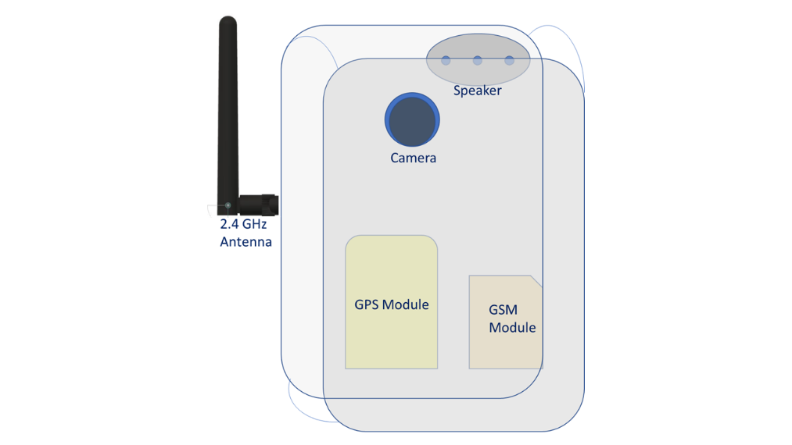

Fig 1.1: Product Abstraction.

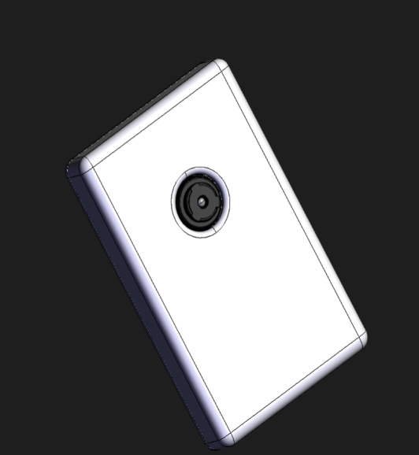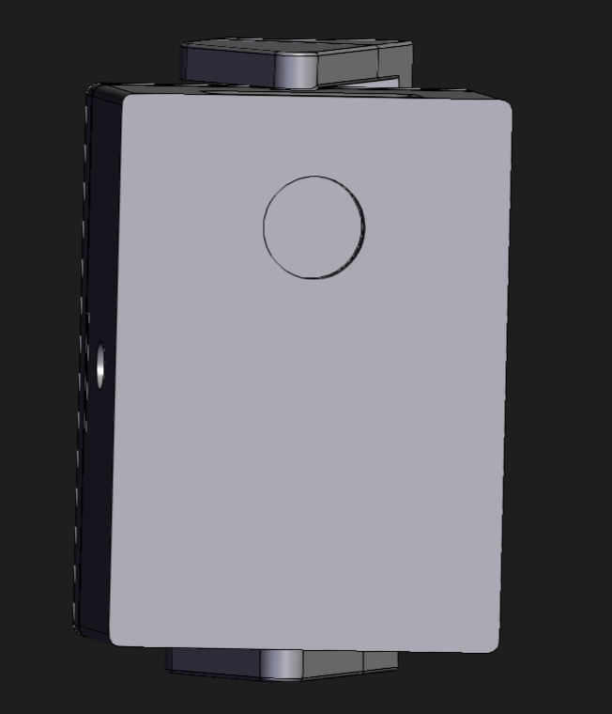

Fig 1.2 : CAD design of the product.

The fig. 1.2, I depict our suggested method using three camera lenses (front, right, and left). As a result, it recognizes three sides of a cover. This esp-cam module simultaneously detect recognition matrix that references pre trained objects.

1.6 Conclusion:

Here, we bring forth a solution to securely assist those who are visually impaired in traveling. Unlike unassisted equipment, a blind assistance system allows individuals to go faster, reduce the likelihood of minor collisions, maintain their bearings, and boost safety. The lens for blind technology created via this study helps persons who are vision impaired travel more easily indoors and outside.

CHAPTER 2

REQUIREMENT ANALYSIS:

2.1 Introduction:

Technology growth drives scientific progress and fuels revolutions in some industries. Different kinds of products and materials are needed to create a system. Researching the needs can help you create a stable and usable system for both the design and the users who will use it most frequently. In this regard, requirement analysis is crucial to make the system better and easier to use.

2.2 Literature Review:

There have been several ways and tools for helping those who are visually impaired or completely blind navigate in the past and now. Each of them has benefits and disadvantages. As a result, they suggested in a study a sensor module system worn in the user's head. The user can switch between the output types provided by this object detector, including buzzer and vibration. This gadget uses a stepper motor-mounted proximity IR sensor for detecting [12]. However, this system needs help from an Android cellphone. For blind persons, another research suggested an intelligent walking stick. This system utilizes a PCB unit consisting of a NEO M8M, Sim 800l, MAX232, ADC 0808, and an esp-32, esp-cam [13].
Additionally, they developed an Android application that outputs audio using an RFID sensor. However, this method is unable to cover the area around the head. Other studies on visually impaired persons have shown that intelligent sticks include a GPS that enables users to be aware of their surroundings. When an emergency happens, this system uses GSM to send a message to those who are allowed. Although this technology is challenging to use and only covers a small portion of outdoor space [14]. Research also provided a model for detecting the escalator and staircase using Gabor filtering, 2D picture capture, and RGB to grayscale image conversion. Additionally, Microsoft Kinect and quicker methods are used to help the blind. Their technology operates in various conditions, including sunshine, low light, fog, blur, and viewing angles.
They only aid those who cannot navigate stairways; nevertheless, they cannot deal with moving things [15]. A different study describes an aid that enables visually impaired people to navigate homes or other intricate interior passages safely and efficiently. They prepare the smart guiding glass using AR, depth sensors, and vision improvement algorithms. Because it cannot handle dynamic items, it can only assist blind individuals in moving around inside their house and not outside, such as on busy highways or in other locations [16]. Additionally, a project that uses the YOLO model to determine the relative distance and the precise direction. Then estimate depth using Microsoft Kinect, and they create 3D audio using a plug-in for a Unity-based gaming engine. Through 3D audio communications, their invention can identify a blind person in real-time and detect things. Because it only functions with static items and not dynamic ones, it is not helpful for exterior features like roadways [17]. These many studies and works gave me much inspiration for Our work. Additionally, it aids me in coming up with a well-studied idea for our system.

2.3 Conclusion:

The goal of an economically visually challenged or elderly assistance system in the native language is to give users the necessary and valuable information to bring them to their destination while tracking their location on previously modeled maps as I'll demonstrate technical solutions for the people requiring visual assistance population's demands for indoor and outdoor guiding still need to be improved, despite the efforts of researchers in this field.

CHAPTER 3

METHODOLOGY:

3.1 Introduction:

Our design of the economic artificial intelligence-based system for aiding visually challenged persons is described in this chapter's technique. It explains the dataset that will be used to put the model into practice and test it, and it tells how it recognizes dynamic objects and raises the alarm when it does. The quicker RCNN technique, which was developed using the Python GluonCV package, is also described along with each component of the suggested method. Our proposed model also uses a separate trained model-based dataset called COCO.

3.2 Model Design:

The quicker RCNN technique implemented in Python's suggested dynamic object detection model to detect all objects was used to train the model. We have created the model by first taking an image stream via esp-cam, processing the video input's frame data methodically, and using the images for classification. The audio output is then produced following the measured value. The process flow is given in Figure 3.1.

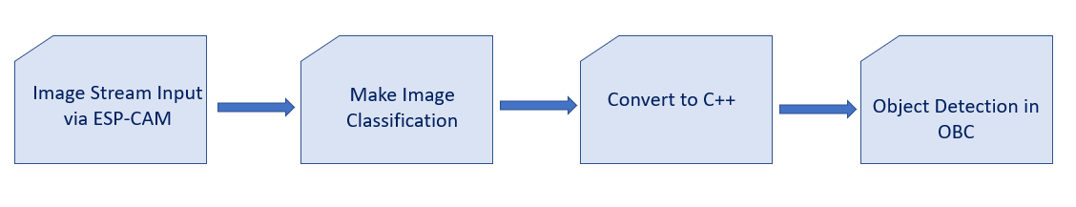

Figure 3.1: System Flow Diagram

Once more, the workflow of the entire suggested model is shown in Figure 3.2. The procedure is followed step by step by the model.
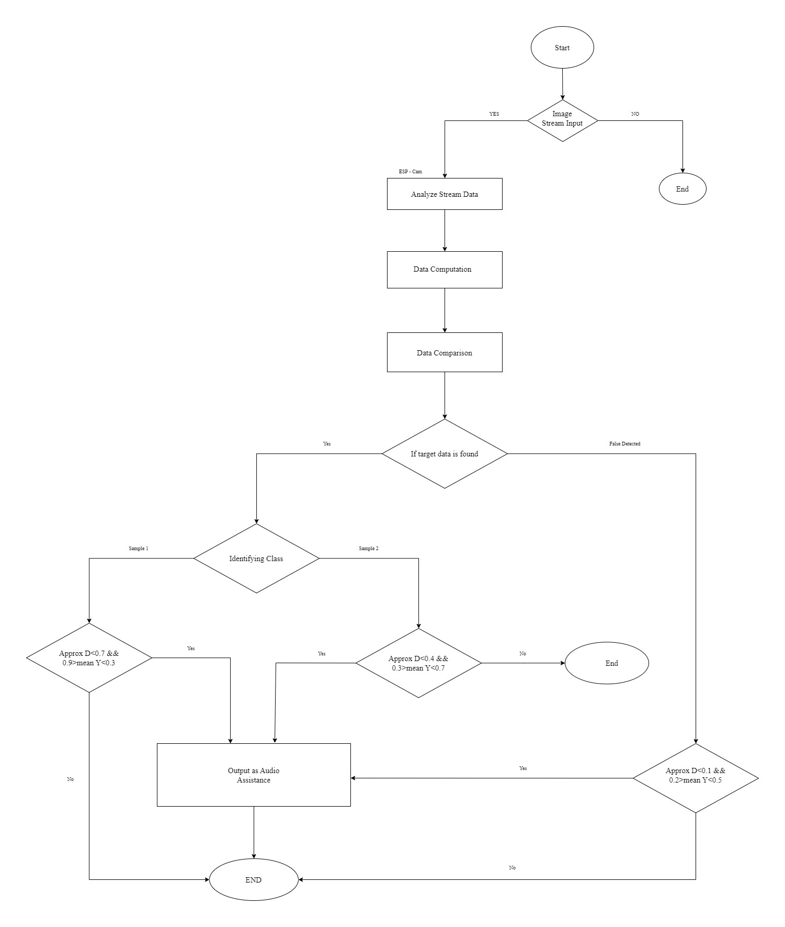
Figure 3.2: The flow chart of the proposed model

3.3 Process Flow:

For me to effectively detect our desired item and provide an alarm at the right moment, the designed system put through a few phases. The burst of images is captured before it can begin to function. When the video input is captured correctly, the objects are retrieved from individual video frames using the quicker RCNN method. Then everywhere library is used to do further processing.
Using the images, we create our custom image classifier. The thing can be a human, a dog, a cat, a car, a truck, or a bus. We'll take pictures in QQVGA quality to maintain a quick acquisition rate (160 x 120). The fraction of an object that genuinely resembles the image training dataset is defined by scores. So that by examining the percentage, I can establish which item is the real one in the video frame.
When measuring the approximate D and mean Y of an item whose data is received by the esp camera- and is either a vehicle, bus, or truck, I consider the camera's location. Following the compared computation, the model issues a warning. We get the pipeline description as ImagePipeline: HogPipeline, Resize(from=(160, 120), to=(40, 30), pixformat=gray), HOG(block_size=8, bins=9, cell_size=3).

3.4 Everywhereml:

It is a Python tool for training ml models that may be used practically anywhere suitable for embedded systems programming with C++, Javascript, PHP, Go or TinyGo, Python micro, and several other languages. This implies that you may use your models, Edge gadgets, Web browsers, web servers, and different environments.

Data visualization and loading processing before Pipeline Power transform BoxCox CrossDiff MinMaxScaler Standardizer PolynomialFeatures LimitRate Scaler Standard (Power transform) YeoJohnson Audio MelSpectrogram Optional feature RFE ChooseKBest Analysis of time series Diff Transform via Fourier swiveling window Fresh TSF Classification RandomForest Regression Logistic GaussianNB Bernoulli NB SVM (not evaluated) LinearSVM ChoiceTree XGBoost, Catboost. A regression, Linear Regression With no r minimal external dependencies, any of these components may be converted to any of the commonly used languages in embedded systems.

3.5 HOG Classifier:

The feature descriptor is the Histogram of Oriented Gradients (HOG). We will discover how OpenCV, MATLAB, and other programs determine this descriptor internally.
A feature descriptor represents an image or patch that strips away unnecessary information to create a more straightforward idea.

A feature descriptor typically turns an image with width x height x 3 (channels) dimensions into a feature vector or array with dimensions of length n. The input picture for the HOG feature descriptor is 64 x 128 x 3, and the resultant feature vector is 3780 in length.

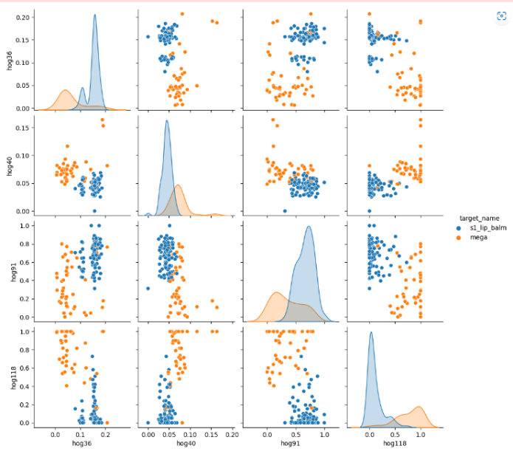

Figure3.3: Image Classification
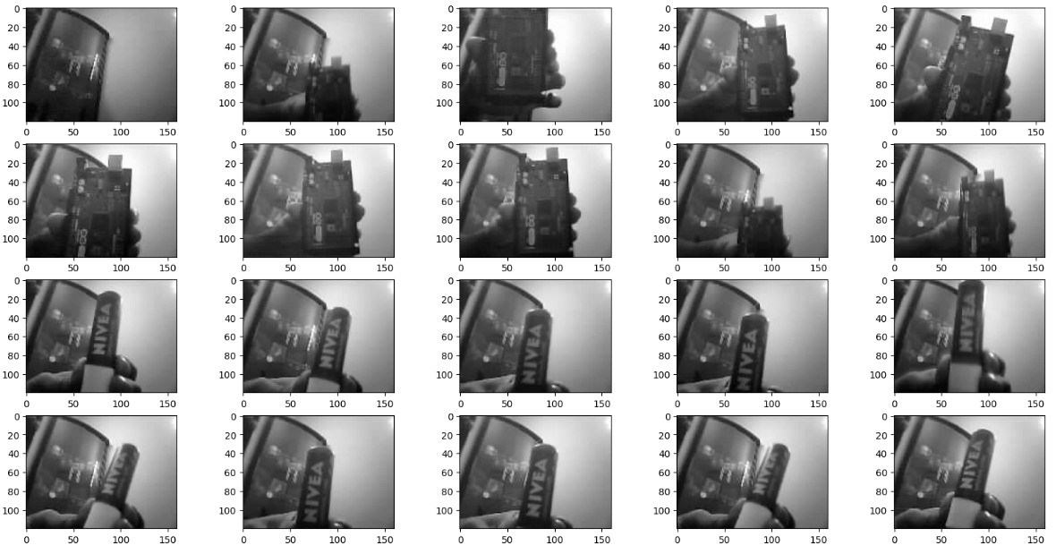
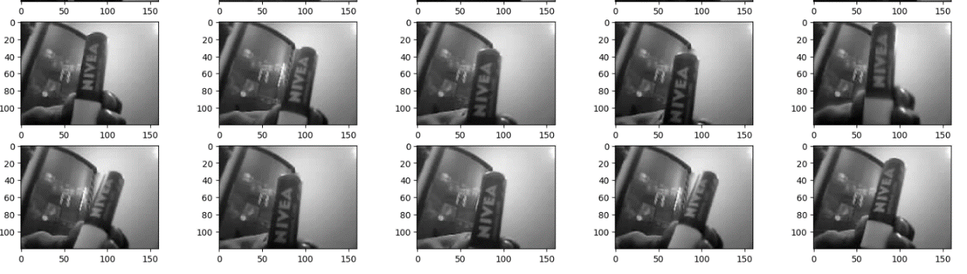
Figure3.4: Image Classification

3.6 Image Processing Library:

It is a library of pre-trained ml models. The GluonCV toolkit offers datasets of various types of objects for image and natural language processing. The usage of efficient components from several models in the user's training, design, or interface is made possible by modular APIs. The foundation of this library is Apache MXNet. Since GluonCV is implemented in Python and is compatible with Linux, OS, and Windows platforms, Python is a platform-neutral language. The fact that GluonCV has 100 contributors from around the world on GitHub is a benefit of adopting it. Because GluonCV can occasionally function without a GPU, I am utilizing it in Our project. Additionally, it is a lighting library and can be emulated by various computer languages, allowing developers to use it in any way they see fit.

3.7 Conclusion:

Here, Instead of producing photos, the function, as mentioned above, has a dataset made up of feature vectors. The machine learning models may now use these feature vectors. We may create a pair plot of the extracted characteristics to see visually how informative they are. Each element is compared to the others in a grid style using a pair plot. It can immediately determine whether the features can "isolate" a class by marking each one with a different color.

CHAPTER 4

SYSTEM IMPLEMENTATION:

4.1 Introduction:

Here we explain how the dynamic object detection system suggested for aiding blind persons has been put into practice. Three stages were taken to implement the strategy. First, an object detection model was trained. This model was then utilized for object localization and categorization. In the end, the system sent a warning under the circumstances. The quicker RCNN approach was used to train the object detection model, which was then implemented using the GluonCV module in Python [1]. A deep learning toolkit called GluonCV makes it possible to develop deep learning algorithms quickly. It is integrated with the open-source framework Apache MXnet [2].
MXnet supports all widely used deep learning methods and is a powerful tool for developing and deploying neural networks. The train faster RCNN.py file from the gluonCV docs was used to train Our model [3]. The system's findings after implementation are also provided in this chapter. The entire procedure is carried out using Anaconda Spyder.

4.2 Software Libraries and Packages:

Table 1. Software libraries and packages

Three files make up the suggested system for dynamic object identification to help the blind.
Table 1 lists the packages used.

Package | Use Case
everywhereml | It is python package that is used for easier implementation of ml (machine learning) models to SoCs or Microcontrollers.
eloquent.h | Arduino library to interact with the compressed pretrained ml models
Wifi.h | Arduino library to use the 2.4 GHz Wi-Fi capability of esp-32. This library is used in both the micro controllers.
RandomForestClassifier | This classifier is imported from Sklearn package for the purpose of classification.

The everywhereml library was chosen for its compatibility rather than TensorFlow. This library is open source. Moreover, this library makes it easier to classify and create new data sets.

4.3 Library: ESP32CameraHTTPVideoStreamingServer.h

We describe a new feature for the Arduino Eloquent library that makes it incredibly simple to broadcast video gathered from an esp-cam over HTTP protocol. The HTTPVideoStreamingServer presumes that your camera has already been set up. You can do this job however you like: This is simple to do with the ESP32Camera class. The listening port for the server is 81 in the local host. Execute the start() method after WiFi is established or the program has begun in AP mode.

OpenCV:
The method that enables us to comprehend how pictures and videos are stored, how to change them, and how to extract data from them is termed computer vision. The foundation or primary tool utilized in artificial intelligence is computer vision. Self-driving vehicles, robots, and photo-editing applications heavily rely on computer vision. OpenCV is a sizable open-source library for image processing, machine learning, and computer vision. It plays a significant part in real-time operation, which is crucial in modern systems. Using it, one may analyze pictures and movies to find people, objects, and even human handwriting. We analyze openCV array structures using python when combined with other libraries, such as NumPy. We employ vector space and apply mathematical operations to these characteristics to identify visual patterns and their different features.
Matplotlib:
A Python visualization package for 2D visualizations of arrays is called Matplotlib. This package is a data-visualization package that works on multi-platforms. Matplotlib was created to deal with the giant SciPy stack and is based on NumPy arrays. One of the visualization's most significant advantages is that it gives graphic access to vast volumes of data in simple forms. There are several plots in Matplotlib, including line, bar, scatter, histogram, etc. There are several plot types available in matplotlib.
Plots aid in recognizing trends, patterns, and relationships. They are primarily used for quantifying and reasoning with data analysis and visualization.
Numpy:
NumPy is a popular Python module for processing arrays. A general-purpose toolkit for handling collections is called NumPy. It offers a multidimensional array object with outstanding speed and capabilities for interacting with these arrays. It is the cornerstone Python module for scientific computing. The program is open-source. It has several features, like a substantial object for an N-dimensional array, advanced (broadcasting) features, Tools to integrate C/C++ and Fortran code, as well as functionalities for Fourier transform, practical linear algebra, and random number generation.
NumPy is a full multi-dimensional data container with several applications outside of science. Numpy's ability to declare any data type makes it possible for NumPy to quickly and easily interact with a broad range of databases.
driver/i2s.h:
Audio signals amplifiers or microphones up to whole audio systems with I2S communication are available as peripherals that adhere to the I2S standard. Several I2S peripherals, including the INMP441 Microphone Module and the MAX98357A I2S Amplifier Module, will be utilized in our design. I2S0 and I2S1 are the ESP32's two I2S peripherals. Each can be set up as a Controller or Target as well as a transceiver. Half-duplex communication is a mode of operation available to each I2S controller. Thus, full-duplex communication may be established by combining the two controllers.

The devices also offer a DMA (Direct Memory Access) mode, which can help high-quality stream audio since it enables sample data streaming without requiring the CPU to duplicate each data sample. Exploring the methods also gives flexibility to output audio directly to the need of additional I2S codecs by natively routing I2S0's output to the ESP32 DAC's input.

4.4 Dataset Preparing:

Using the HOG classifier, the object detection model was trained. Thanks to its extensive dataset, I can recognize as many objects as I can. A tool is available from OpenCV to integrate tinyML via everywhereml. The files were unpacked after being downloaded. There were three distinct folders: annotations, train2017, and val2017. The dataset of training and validation is contained in the first two files. Annotation files in JSON format may be found in the final folder. However, not all of the annotation folder's files were utilized. The only files utilized were the pictures stored from the esp-32 cam using the https protocol. In this stage, there was no metamorphosis. Here is the outcome of building an index and loading data. This image was taken from the Spyder IDE's Ipython terminal.

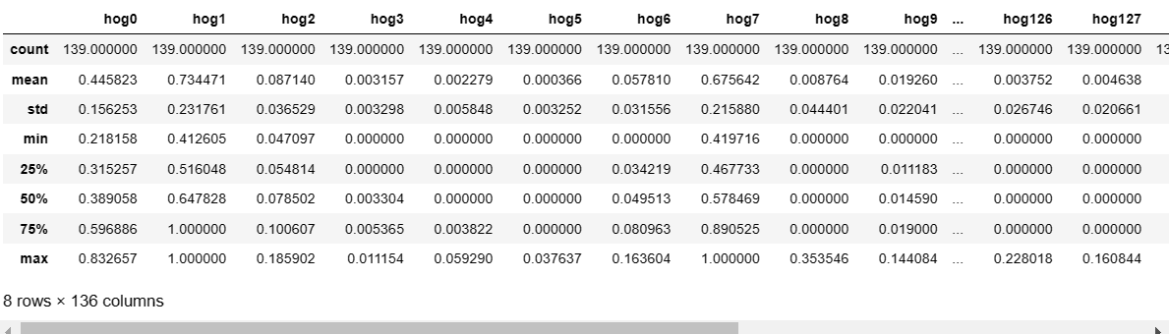
Figure 4.1: Feature dataset pipeline

Over 10000 image samples are considered in our sample data, and we used over 400 images as positives. After indexing, the accuracy of the indexing was verified. The training label yielded bounded boxes and class identifiers, indicating that indexing was successful. The trial objects used are identical to the trained pictures but in different lighting conditions.
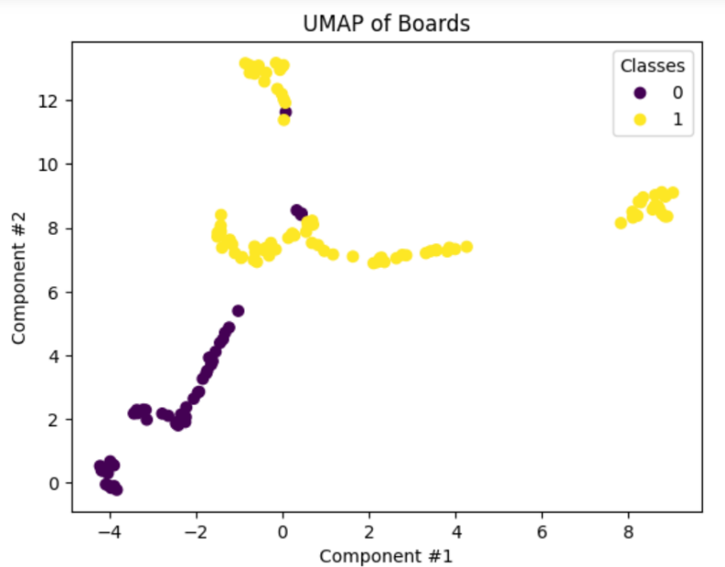
Figure 4.2: Positive sample images

4.5 Implementation:

Firstly the image has to be preprocessed to reduce the width-to-height ratio to 1:2. Preferably, the picture size should be 64 x 128. This is because, to extract the features, we will divide the image into 8*8 and 16*16 patches. Given the provided dimensions (64 x 128), all of our computations will be straightforward.
Secondly, the gradient for each pixel in the picture must then be calculated. The subtle shift of 2D coordinate axes is known as a gradient. I will compute the angles on a small portion of the image. The pixel values are Next, and we work with the patch. The pixel values are derived. Consider creating the following pixel matrix for the provided patch (note that this matrix is only being used as an example and that the original pixel values for the supplied patch are not being utilized): The pixel with the value 85 is highlighted. To determine the gradient, a subtraction operation is done on the matrix. Now that we can construct the matrix with the gradient magnitude rather than the frequency, we can build the histogram. After that, the gradients' histogram is computed and normalized. The feature of the whole image will then become available.

Opencv. Data. Batching. For this procedure, Append() is employed. Photos retain their original form and detail without being stacked or padded. The Dataloader() function was used to load data in tiny chunks so that the training process could repeatedly go through the whole dataset. RCNN returns class IDs, scores, and boxes in MXnet more quicker. The score indicates how accurately the anticipated object was made. Bounded boxes are the coordinates of an item detected in the frame. Faster RCNN performs differently from other algorithms during training. The generation of intermediate values is substantial. RPN's convolutional layer's raw outputs, rpn score, and rpn box were produced as the model was trained.
Four different types of losses were used during the training process to train the model for object detection. When developed using various equations, these loss functions were built-in into the MXNet gluoncv classes. Huber's formula was used to compute RPN box losses, whereas the sigmoid binary cross entropy loss function was used to calculate RPN class losses. Huberloss was used to add RCNN box loss and Softmax Cross Entropy Loss to calculate RCNN class loss.

4.6 Detection of Objects:

The python script extracts the matrices of the trained images. Then the files are converted and integrated into the microcontroller code written in c++. The video was captured using the OpenCV library, and the frames were obtained. Preprocessing of the structures was done here. If the camera sees false images, it does nothing. On the other hand, if a trained positive image is detected, it takes necessary actions. And the while loop continues.
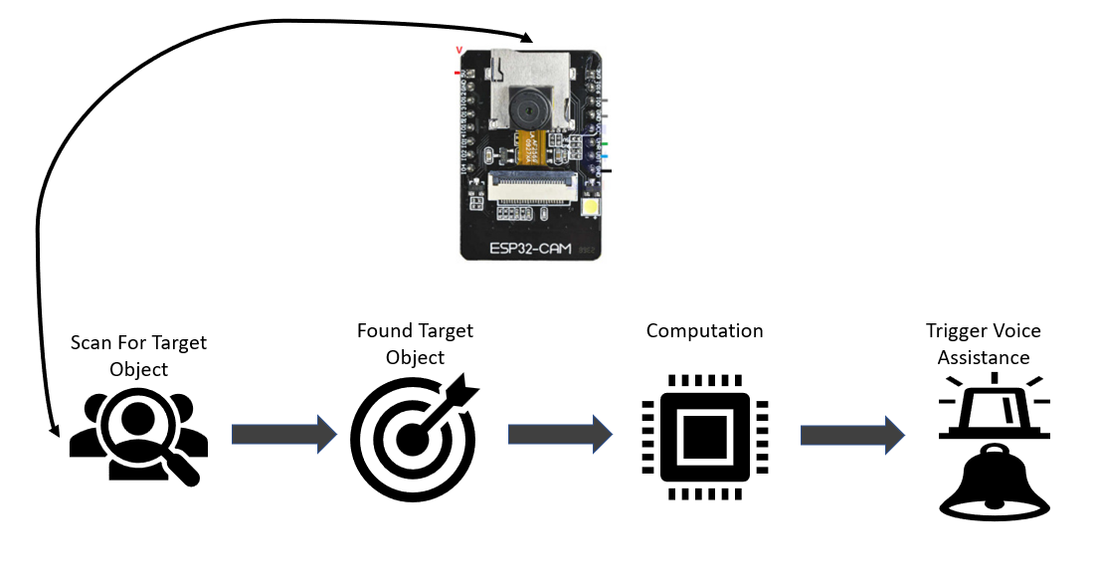

Figure 4.3: Input from esp-cam and process flow.

4.7 Hardware Implementation:

Throughout the process, one primary obc (onboard computer) (essp-32) and one secondary microcontroller (esp-cam) were used for computation purposes. These cameras have a spectacle attached to them. One camera was positioned at the front of the glasses for the front view. The other two were employed to obtain pictures of the left and right sides. With this eyewear equipped with three cameras, it is safe to cross the street at a stoplight. Neo M8N is used as a GPS module and a 2s lipo battery to power the system. A buck converter to step down the voltage to 5.5v. SIM 800L as gsm module, other necessary components like logic level converter, micro sd card reader and I2S peripherals are used.

Figure 4.4: Hardware Setup

4.8 Output Scaling Process:

TinyML works on gray-scaled color space, while RGB is the required format for object detection. As a result, the RGB design was applied to each frame. Frames that are less than 256 pixels are enlarged to 256 pixels, and the maximum size was set to 512 pixels because the image's longest side is still less than 512 pixels. The network then receives the frame and returns and saves it to a local directory. The output frame containing the bounding boxes, scores, and classes was plotted using the cv plot box () function from glucons, and the output frame with these values was plotted using the cv plot image().

4.9 Approximate Distance Measurement and Alerting:

The actual distance of an item that was identified could not be determined in our suggested system. Because focal length varies between cameras, manually calculating focal length every time you use a new camera could be better. Instead of using accurate distance to address this problem, approximation distance was employed, and this approach functioned well.

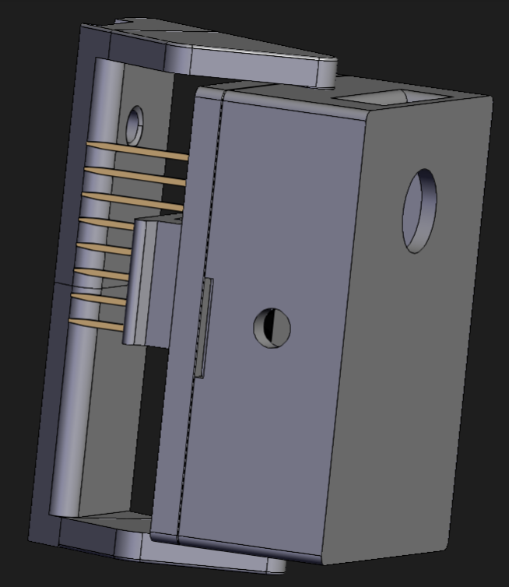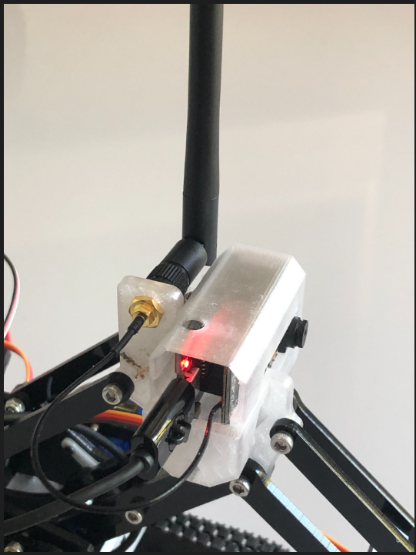
Figure 4.5: Measuring relative distance.

An identified item with bounding boxes is shown in Figure 4.4. Four numbers represent the coordinates of the bounding box on the frame for each bounding box: Ymin, Xmin, Ymax, and Ymin. The direction and the magnitude of each pixel value will now be determined using the gradients we computed in the previous phase. The Pythagoras theorem will be applied in this stage. Here, the perpendicular and the base are the gradients. Gx and Gy were thus given the values 13 and 11 in the preceding example. Let's determine the overall gradient magnitude using the Pythagoras theorem.

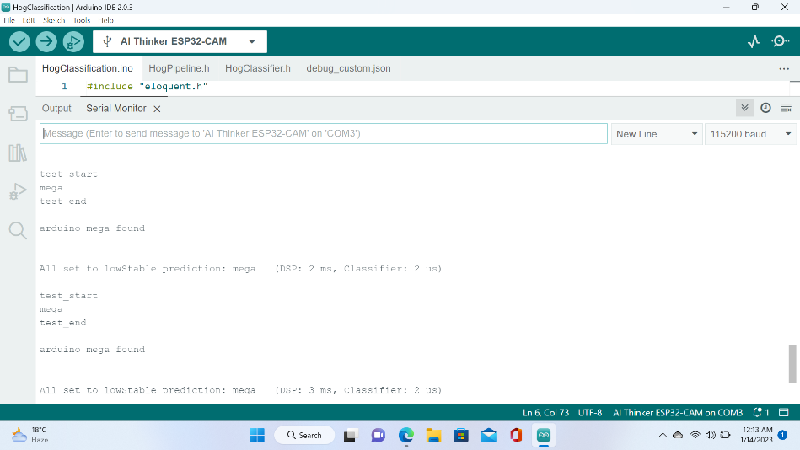

Figure 4.6: Matching matrices of the detected objects.

Total Magnitude of Gradient = $\sqrt{{(Gx)}^{2}+{(Gy)}^{2}}$

= $\sqrt{{(13)}^{2}+{(11)}^{2}}$ = 17.02

Next, determine the same pixel's orientation (or direction). We are aware that we can express the angles' tans:

$\tan{φ}$ = $\frac{G_{y}}{G_{x}}$
As a result, the angle's value would be:

= $\tan^{-1}{(\frac{G_{y}}{G_{x}})}$

When we enter the data, result obtained is 36. We now get the overall gradient (magnitude) and orientation for each pixel value (direction). The histogram must be produced based on the orientation and gradients found.

4.10 Conclusion:

In three stages, the system was implanted. First, an object detection model was trained. This model was then applied for localization and classification. The system file model is shown in (Table1-). There are three files in the set of files utilized in the model. I like the Gluon CV library over others like TensorFlow since it is more straightforward. The RCNN params file was fed into the network (see fig. 1). I used a camera to perform the detection procedure for testing purposes. An identified item with bounding boxes is described in (fig. 2). Another (fig. 3) indicates that although the left and right cars are pretty near to the camera, there is no chance of a collision. As a result, the system issues false notifications.

CHAPTER 5

RESULTS and ANALYSIS:

5.1 Introduction:

While integrating the hardware and the software, we test-running the system. Using the I2S library, each item identified is presented in an mp3 codec. This chapter shows a comparison between train weight and pre-train weight. I also created an accuracy rate test.

5.2 Outcome:

Each identified object's final output is provided in audio form, and the audio was played using the python ffplayer module. I had created a test to verify correctness using our weight that had

Figure 5.1: Object recognition and Output Serial Data

been trained. Then, using the weights from the RandomForestClassifier pre trained model, I performed the same action.

Table 2: Test run of the project produced the following outcome

Sample | Lighting Condition | Correctly Recognized | Wrong Recognition
ESP-32 | Daylight | 11 | 4
Arduino Uno | LED light | 13 | 2

The test is done on 15 iterations. ESP-32 is used as a sample during daylight and Arduino at night time respectively. Overall we found satisfactory rest of more than 73.3% accuracy for esp-32 at daylight and 86.6% accuracy.

5.3 Accuracy Rate:

More and more times performing this test has improved the effects on our desired outcome. I get to improve the model's accuracy every time. At the conclusion of 100 epochs, our model provided accuracy of above 86%, which can be increased further with more training.

5.4 Conclusion:

We want to make the life of every person more comfortable. Thus we designed this system with the hope that this device will be able to help with particular visual following the result analysis. Our suggested system had a 74.65% accuracy rate. At this level, it's good.

CHAPTER 6

SWOT ANALYSIS:

6.1 Introduction:

Different areas should be the emphasis of the system development before beginning to construct a system, research potential construction strategies, and problem-solving strategies. Finding out a system's strengths, weaknesses, opportunities, and threats are simple with the help of a SWOT analysis. SWOT analysis makes it simpler to identify these factors and identify the system's focal point before construction begins.

6.2 SWOT Analysis:

A SWOT analysis evaluates a project, research, or system under development regarding its strengths, weaknesses, opportunities, and threats. The system must address issues when it is developed, which is the basis for the SWOT analysis. It will assist in identifying the areas needing more concentrated needs and system strength. Additionally, SOWT aids in arranging a system's operation. Determine the system's effectiveness by routinely assessing the process [10] [11].

6.2.1 Strength Analysis:

Disabled persons utilize this system to aid in their daily tasks, simplify life, and be safer. We have used a camera to get environment data as input. It is a portable gadget with assistance in the native language.

6.2.2 Weakness Analysis:

As technology develops, new and improved technologies are explicitly created for blind people. Low memory storage is available on our device for system training. Additionally, it was not feasible to determine the precise distance of an item that had been spotted, just its approximation.

6.2.3 Opportunity Analysis:

A straightforward, mobile technology that may help the blind identify moving objects and issue voice commands is the subject of our study. Due to weak signals, GPS may only be available in developing nations. As a result, Our method, which employs three camera lenses, produces a more sophisticated and user-friendly tool to aid blind individuals in path identification.

6.2.4 Threat Analysis:

In today's world, technology is advancing at a breakneck pace. Different issues also arise with new technology. Our system is unable to determine an object's actual distance. As a result, it poses one of the most significant risks to blind users of these gadgets

6.3 Conclusion:

SWOT analysis makes it simple to understand the system. Every person has the right to enjoy ease and comfort. So. I'm attempting to use our suggested model to awaken their daily route detection. I hope that this approach will assist blind folks.

CHAPTER 7

BUSINESS IMPLICATION

This device is in the initial development phase, with much testing to be implemented successfully. At the beginning of this project, establishing a market is essential. In that case, many factors that make a platform to target a need were identified: the demographics as it is a device that will guide and navigate a visually impaired patient, so the whole concept was developed for a medical product. To assist a visually impaired person, it is imperative what does a blind person wants when they get to know about a device and how they want to enhance their mobility accurately instead of being dependent on a handheld stick and a nearby person all the time research was conducted to introduce a product that will perform the job of being dependent upon someone who will guide them. In the demographic study, there are visually impaired people ranging from almost all ages, from children to adults to old age, and challenges arose when the blind victim differed among different segments, such as patients from a higher class, middle class, and lower class. This was a challenge because the literacy rate varies between these classes know to operate an electronic product. Also, the income fact was considered to analyze the possibility of affordability of the product. To afford a consequence, the product distribution brings along the geographical factor where the product will be distributed. These are the demographics considered while developing this electronic system. Once the information is gathered, project developers will arrange a formal meeting to study and analyze the data on customer needs, problems, and demographics.

The engineers will consider extracting a plan and designing the product using various components, parts, modules, and configurations in the research and development phase. And in that case, it is essential to find any existing product that assists blind individuals and sort out the gap analysis for risk minimization. This gap analysis will help the engineers to work on new features. The product will go through various tests, and results will be recorded. Once the device is completed, the technology and the design will be patented. The product will then be introduced as a sample and examined the performance. If the outcome is satisfactory, the device will go for mass production. This will require investment to locate a plant and find suppliers at a reasonable cost for the parts and components. As the product is designed to be affordable, the production and operational expenditure are brought to nimble calculation, and innovation is set as a priority for ROI, NPV, and IRR. The product will then be observed for a periodic term to analyze to record the user feedback and complaints (if any). And the lead project manager will work on improving the features and introduce new ones. This will reduce the deviation between the actual performance and the expected business growth.

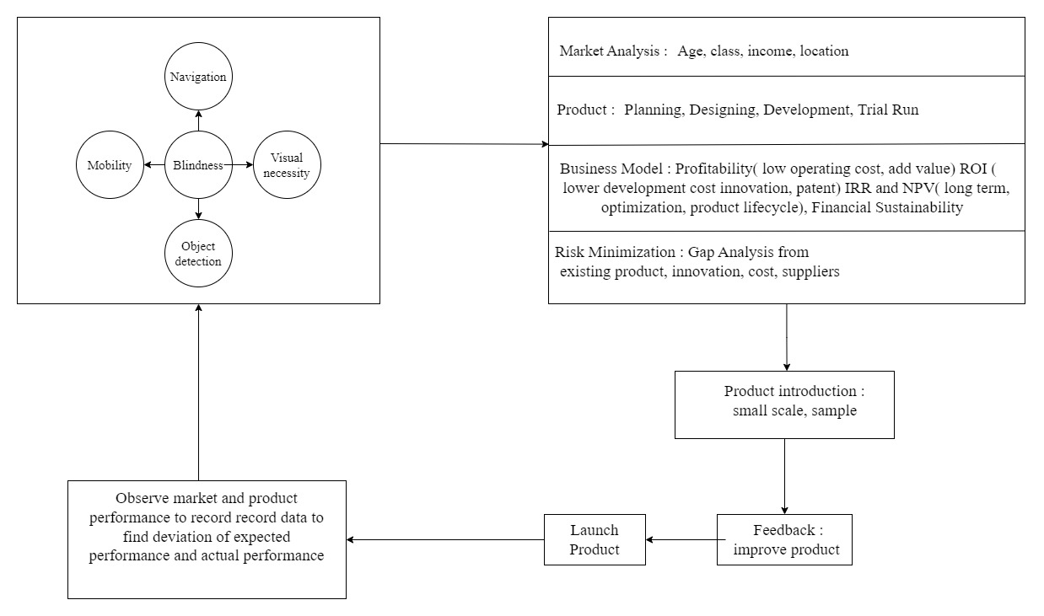

CHAPTER 8

CONCLUSION:

8.1 Conclusion:

We developed a system at an economical price that can help with mobility and security for a person that needs special visual assistance. The item's size, form, or distance must be known to the system beforehand. As a consequence of Our effort, a straightforward, portable system that can help the blind identify moving objects and provide voice commands has been created. Based on visual and auditory feedback, it is a mobile gadget. Several testing findings in indoor and outdoor settings show how beneficial this technology is for this user group.
Additionally, the lack of flawless route detector equipment is causing more and more impaired individuals to suffer daily. Particularly in Bangladesh, this system has yet to advance significantly. Due to weak signals, GPS may not be accessible everywhere. As a result, the gadget I propose in our research is more sophisticated and user-friendly and helps blind persons recognize paths. To develop our anticipated model, I constructed the system in various ways, allowing me to propose a more effective and error-free model. With 100 epochs, the suggested approach has an accuracy of around 87 percent. Since everyone has the right to a comfortable and easy life, it is stated that when the mind is blind, even the sight is worthless. As a result, I've tried to awaken their senses using our model's audio output to open their eyes to a better world.

8.2 Future Scope:

I'm hoping that our first steps will be fruitful and beneficial for persons who are blind. Our ability to progress depends on our training dataset expansion. For the time being, I warn the blind individual when a car is approaching from a distance. Although this system can be taught in two different ways, for the time being, I am calculating the distance between an automobile and a human. To achieve this, I will save 1000 images of a car's front side in one folder and 1000 images of a car's backside in a different directory. For the AI to determine. The more images I save to teach the system, the more precisely it will be able to warn me. In addition, I'll construct the prototype of our suggested model using three webcams and a Jetson Nano in the Raspberry Pi manner. This particular esp-cam is a powerful, reasonably priced microcontroller. This project can be scaled using a computer like Raspberry Pi 3.

REFERENCES:

- https://www.who.int/news-room/fact-sheets/detail/blindness-and-visual-impairment http://dspace.bracu.ac.bd/xmlui/bitstream/handle/10361/8365/14366004_MSc%20in%20CSE.pd f?sequence=1&isAllowed=y
- HOG Classification. [Online]. https://towardsdatascience.com/hog-histogram-of-oriented-gradients-67ecd887675f
- Blasch B.B., Wiener W.R., Welsh R.L. Foundations of Orientation and Mobility. 2nd ed. AFB
Press; New York, NY, USA: 1997
- TinyML. [Online]. https://www.imagimob.com/
- everywhereml. [Online]. https://github.com/eloquentarduino/everywhereml
- Prof. Seema Udgirkar1, Shivaji Sarokar2, Sujit Gore3, Dinesh Kakuste4, Suraj Chaskar. Object
Detection System for Blind People. International Journal of Innovative Research in Computerand Communication Engineering; Vol. 4, Issue 9, September2016.
- Kher Chaitrali S., Dabhade Yogita A., Kadam Snehal K., Dhamdhere Swati D., Deshpande Aarti V. An Intelligent Walking Stick for the Blind. International Journal of Engineering Research and
General Science Volume 3, Issue 1, January-February, 2015.
- Train Faster RCNN. [Online]. https://gluon- cv.mxnet.io/build/examples_detection/train_faster_RCNN_voc.html
- Bai, J., & Lian, S., & Liu, Z., & Wang, K., & Liu, D. (2016). Smart Guiding Glasses for Visually Impaired People in Indoor Environment [PDF file]. China, DC: Author. Retrieved from
https://arxiv.org/ftp/arxiv/papers/1709/1709.09359.pdf

- A.Sangami1, M.Kavithra2, K.Rubina3, S.Sivaprakasam. Obstacle Detection and Location Finding For Blind People. International Journal of Innovative Research in Computer and Communication Engineering; Vol. 3, Special Issue 2, March 2015.
- Farcy R., Leroux R., Jucha A., Damaschini R., Grégoire C., Zogaghi A. Electronic travel aids and electronic orientation aids for blind people: Technical, rehabilitation and everyday life points of view;
Proceedings of the Conference & Workshop on Assistive Technologies for People with Vision & Hearing Impairments Technology for Inclusion; Los Alamitos, CA, USA. 9–11 July 2006.
- Liu J., Liu J., Xu L., Jin W. Electronic travel aids for the blind based on sensory substitution;
Proceedings of the 2010 5th International Conference on Computer Science and Education (ICCSE); Hefei, China. 24–27 August 2010.
- Bharambe S., Thakker R., Patil H., Bhurchandi K.M. Substitute Eyes for Blind with Navigator
Using Android; Proceedings of the India Educators Conference (TIIEC); Bangalore, India. 4–6 April 2013; pp. 38–43.
- Jiang, R., & Lin, Q., & Qu, S. (2016). Let Blind People See: Real-Time Visual Recognition with Results Converted to 3D Audio [PDF file]. UK, DC: Author. Retrieved from http://cs231n.stanford.edu/reports/2016/pdfs/218_Report.pdf
- White C.E., Bernstein D., Kornhauser A.L. Some map matching algorithms for personal navigation assistants. Trans. Res. C Emerg. Tech. 2000;8:91–108. doi: 10.1016/S0968- 090X(00)00026-7.
- Kammoun S., Marc J.-M., Oriola B., Christophe J. Toward a better guidance in wearable electronic orientation aids; Proceedings of the IFIP Conference on Human-Computer Interaction; Lisbon, Portugal. 5–9 September 2011.

- Sánchez J., Elías M. Guidelines for designing mobility and orientation software for blind children; Proceedings of the IFIP Conference on Human-Computer Interaction; Janeiro, Brazil. 10–14
September 2007.
- Wahab A., HelOur M., Talib A.A., Kadir H.A., Johari A., Noraziah A., Sidek R.M., Mutalib
A.A. Smart Cane: Assistive Cane for Visually-impaired People. Int. J. Comput. Sci. Issues.2011;8:4.
- Vision impairment and blindness. (n.d.). Retrieved from https://www.who.int/news-room/fact- sheets/detail/blindness-and-visual-impairment.
- Hossain, E. (2010) „Terrain detection and hardware implementation for walking support system‟, Masters thesis, International Islamic University, Malaysia.
- Prasun Shrivastava, Akash Singh, Praveen Anand , V Sagar , "Medico Stick :An Ease to Blind & Deaf
"IEEE Sponsored 2nd International Conference On Electronics And Communication System (ICECS 2015)”.

