

AN INTERNSHIP REPORT ON

CONSUMER RELATIONSHIP MANAGEMENT IN CODERSTRUST BANGLADESH

30th March 2020
UNITED INTERNATIONAL UNIVERSITY
DHAKA, BANGLADESH
AN INTERNSHIP REPORT ON
CONSUMER RELATIONSHIP MANAGEMENT IN CODERSTRUST BANGLADESH

SUPERVISED BY
S.M. ASIF-UR-RAHMAN
ASSISTANT PROFESSOR - MARKETING
SCHOOL OF BUSINESS AND ECONOMICS
UNITED INTERNATIONAL UNIVERSITY

PREPARED BY
S.M. KAWSHIK RAHMAN
ID: 111 152110
BBA PROGRAM
UNITED INTERNATIONAL UNIVERSITY

Date of Submission
30th March 2020

UNITED INTERNATIONAL UNIVERSITY
Internship Authorization Letter

Letter of Transmittal

To
S.M. Asif-Ur-Rahman
Assistant Professor - Marketing
School of Business and Economics (SoBE)
United International University
Subject: Submission of Internship report.
Dear Sir,
You will be happy to know that I have successfully completed my internship from Coderstrust Bangladesh and at the meantime, I have prepared my internship report as well under the title ‘Consumer Relationship Management in Coderstrust Bangladesh’. As a marketing student we are very familiar with the term CRM that refers a method of managing the interaction of an organization with current and potential customers.
CodersTrust is a Danish institution, works particularly between early children and girls, with the aim of connecting disadvantaged and marginalized businesses with school and the online job market, thus increasing the opportunities for workers with higher incomes and greater financial independence. CodersTrust is an institution that carries out by educated trainers. Through the trainers, Coderstrust provides technical and social training to university students from southern countries and emerging markets so that students can improve their skills and earn a living through independent online projects. Moreover, Coderstrust gives high priority to its students and consumer, the organization use to maintain its relationship with its consumer through the Zoho CRM Software which is highly popular among the existing CRM software.
However, the report has been prepared to be a unique one and therefore, no information are taken from irrelevant sources or not copied directly from any published articles. In addition the report has been prepared following the report guidelines and few changes were made according to the necessities of the title.
I, therefore, pray and hope that your honour would be kind enough to accept my report and oblige thereby.
Sincerely yours,
S.M. Kawshik Rahman
ID: 111 152110
BBA Program
United International University

Executive Summary

Customer relationship management (CRM) is not only a technological application, but it is also a strategy that can learn more about customers' needs and behaviors in order to build stronger relationships with them. In this way, it is more a business and marketing concept than a technical solution that effectively addresses the customer. In today's highly competitive environment, with so many products and services to choose from, customers are demanding, and loyalty seems to be a valuable thing. In just a few months from the moment a new product is launched on the market, the product or service suddenly becomes a commodity, which means that changing companies was very easy. Although the company may consider it, not all customers are the same. Other clients often do purchase, often buy new products and services, and can even be major influencers in their market. In this case, CRM helps prioritize sales and marketing efforts when dealing with different groups of customers. It allows companies to better anticipate the needs of their customers and thus meet their needs. The effective use of customer relationship management can also provide strategic benefits. Well-organized customer data helps companies choose the right recipients for promotions and new products. Additionally, CRM improves business efficiency by organizing and automating certain aspects of the business. From sales processes to marketing activities, business analytics, and customer data, CRM automates and streamlines these processes for businesses. This enables organizations to organize these processes into simpler and more understandable data. CRM software enables companies to optimize customer interactions. By simplifying and streamlining many of the more complex customer interaction processes, CRM can increase customer satisfaction. The study aims to analyse the concept of CRM and how Coderstrust Bangladesh, a training and skills development institute, manages its customer relationships. Finally, some suggestions are provided based on some proven areas that need to be improved to help CoderTrust Bangladesh recover their CRM practices.

(Unnecessarily theoretical rather than summarising the whole report)

Table of Contents

Chapter One: Introduction
1.1 Origin 2
1.2 Background 2
1.3 Purpose Statement 3
1.3.1 Broad objectives: 3
1.3.2 Specific Objectives: 3
1.4 Scope and Limitations 4
1.4.1 Scope 4
1.4.2 Limitations 4
1.5 Methodology 5
1.5.1 Research Type 5
1.5.2 Data Type 5
1.5.3 Data Collection Method 5
a. Primary data sources: 5
b. Secondary data sources: 5
1.5.4 Data Analysis Method 6
1.5.5 Data Presentation Method 6
1.6 List of Abbreviation 6
1.7 Technical Terms 6
Chapter Two: Literature Review
2.1 Consumer Relationship Management 8
2.2 Available Tools for CRM 8
2.2.1 Zoho CRM 9
2.2.2 Salesforce Essentials 9
2.2.3 IPIX CRM 9
2.2.4 FreshSales 10
2.2.5 HubSpot CRM 10
2.3 Advantages of using CRM software 11
a. Easy to use 11
b. Helps to attract potential customers 11
c. Better customer satisfaction. 11
d. Helps to build positive internal communication 11
e. Flexibility 12
f. Report generation 12
g. Increase revenue 12
Chapter Three: Overview of CodersTrust Bangladesh
3.1 About Coderstrust Bangladesh 14
3.1.1 Mission 14
3.1.2 Vision 15
3.2 Trainings of CodersTrust 15
3.4 CodersTrust Organogram 15
3.5 CoderTrust’s Services 16
3.5.1 Short Duration Courses 16
3.5.2 Diploma Courses 16
Chapter Four: Findings and Analysis
4.1 Customer Relationship Management in CodersTrust 18
4.2 The use of Zoho CRM in CodersTrust 19
a. Agreements / Deals 20
b. Price book 21
c. Online purchases 21
d. Campaign 21
e. Supplier’s information 21
f. Quotation 21
g. Sales order 21
h. Invoice 22
i. Potential customer list / leads 22
j. Contacts 23
k. Account 24
l. Forecasting 24
m. Modules 24
n. Recording 24
4.3 Other elements that contribute to improve relationship with the customers 25
4.3.1 24/7 Student Support System 25
4.3.2 Designed courses with qualified mentors 25
4.3.3 Make friendly calls 26
Chapter Five: Recommendations and conclusion
5.1 Recommendations 28
a. Provide live assistance as real-time support to increase customer engagement 28
b. Improve customer satisfaction 28
c. Continuous customer involvement 29
d. Automated customer responsiveness 29
e. remaining ubiquitous 30
5.2 Conclusion 30
Reference

CHAPTER ONE INTRODUCTION



1.1 Origin
The Internship program at United International University (UIU) is a pre-requirement of achieving the BBA degree. Students are required to take the internship program when they complete all their BBA courses that are designed to improve their professional skills theoretically. Here, the lack of practical experience is meet through the internship program. Students who participate in the internship have to join an organization as an intern and work there for three months. These may help to improve their practical knowledge of real-life work environments. During the internship period, students also have to prepare an internship report based on their study field of concentration that summarizes the internship experience that many employers must complete in their organization. The internship report is important because it tells our internship supervisor about what we have learned and the skills and opportunities we have applied.
Getting the opportunity to work as an intern in CodersTrust was a very good opportunity for me because it is difficult to get a chance in foreign organization for the BBA fresher’s. However, after joining the organization, as a marketing student, I decided to communicate with my internship supervisor about my report topic and finally we both come a point that the report should be prepared on ‘Consumer Relationship Management in CodersTrust Bangladesh’ as customer

1.2 Background
The report is prepared to analyse the context of customer relationship management (CRM). To understand the CRM for a marketing student, we need to focus on the role of marketing in CRM. Marketing implies everything a company does to affect its current (and future) products or services. Marketing uses their knowledge of the market to inform, persuade, advertise, educate, and invite customers and potential customers to respond. In this case, when people respond internally to what they see, hear, think, understand or point of contact is an opportunity to build relationships. The more marketing activities indicate that the focus is focused on the demands, concerns, and challenges of the target audience, the more likely the seller will be viewed positively, which is the first step in building relationships with them.

What marketers do to create positive impressions can vary. They can communicate in person or online, ask the right questions, speak and produce meaningful messages. Marketing is the development of information that respects the company's brand and demonstrates leadership, competence, qualifications and an organizational success story. In this way, potential customers will start to know and have confidence in the organization. By increasing awareness, credibility and market visibility, marketing can help sellers deepen relationships that led to higher offers and revenue targets for the organization.

Therefore, strong customer relationships plays a vital role in the company's success. However, they will not be built overnight. Like personal relationships, nurturing and cultivating customer relationships is also important. This can lead to positive word of mouth, loyalty, and increased sales when the organization builds solid customer relationships. At the same time, if meaningful relationships take effort and time to build, they can quickly disintegrate. The relationship taken for granted deteriorated in an instant. The main philosophy to remember is to build strong relationships to make others feel important.

Acknowledging all these, the report is prepared on the customer relationship management of CodersTrust to conceptualize how the company is concentrating on its customers and future success.

1.3 Purpose Statement
The purpose of this internship is to develop professional skills in a practical environment. Because an internship program is providing learning opportunities, it is important to evaluate the skills developed during the time I have spent in the organization. During the internship program, a report has to be prepared based on the organization. In this part, the purpose or objectives of this internship report are described in two parts below:

1.3.1 Broad objectives:
a. To share my learnings and practical experience on consumer relationship management of Coderstrust.
b. To prepare a report based on the actual applications of marketing that contains the theoretical knowledges on CRM with the practical experiences.
c. To achieve the Bachelor of Business Administration (BBA) certificate from United International University.

1.3.2 Specific Objectives:
a. To analyse the concept of Consumer Relationship Management (CRM).
b. To analyse the CRM practices of CodersTrust Bangladesh.
c. To suggest recommendations to improve CRM practices of CodersTrust Bangladesh.

1.4 Scope and Limitations

1.4.1 Scope
The field of customer relationship management is extremely valuable to any company, as it involves all the activities, techniques as well as strategies that a company uses to manage interactions with current and potential customers. A phrase that is often heard and spoken in many companies is "the customer is king". CRM knowledge helps companies build customer relationships, which in turn creates customer retention, trust, and loyalty. Because customer retention and loyalty directly affect a company's growth. After preparing the report on CRM procedures of CodersTrust, other companies can learn how CodersTrust manages its CRM strategy, which helps to generate higher profits for the organization. Once the report is ready, any company can learn about Zoho CRM software, which can be used as a tool to create simple user interfaces for data collection to help companies identify and communicate with customers in a scalable way.

1.4.2 Limitations
Usually limitations are the difficulties that the author of study passed through while preparing the study. The difficulties may be vary based on different study and by the limitations author usually present his or her shortcomings, since no study is completely perfect or includes all possible aspects. In this report, there are several difficulties I had faced while preparing the report. They are listed below:
- Complexity of CRM tools: The Zoho CRM software offers several companies at a time and different companies use the CRM practice in different ways. The use of Zoho CRM is also a complex task. Therefore, explaining all the ways of CRM activities found difficult.
- Limitations for privacy: The report is only prepared on Zoho CRM customer records as CodersTrust doesn’t allow to call or send mails to its customers to collect their opinion.
- Secrecy: CodersTrust maintains high secrecy to disclose its customer information and organizational information are maintained with high confidentiality.
- Time of Study: The report has been prepared within three months during my internship program, therefore, preparing such an extensive report in this short period were difficult.

1.5 Methodology
The methodology is the specific process or method used to process, select, identify and analyse data on a subject. In this report, the methodology section allows any reader to critically assess the overall validity and reliability of a study.

1.5.1 Research Type
The report has been prepared following the exploratory research technique which is defined as the report used a discussion on customer relationship management of CodersTrust that is not clearly discussed before. Therefore, the report has been prepared for better understanding on the existing CRM practices of CodersTrust, but will not provide conclusive results.

1.5.2 Data Type
Both qualitative and quantitative data are going to be used according to the study requirements. The report is mainly based on qualitative data as qualitative data is descriptive and conceptual. Qualitative data can be classified based on traits and characteristics. On the other hand, quantitative data can be counted, measured, and expressed using numbers.

1.5.3 Data Collection Method
The data are collected from primary and secondary sources. Here, primary data are accumulated directly by the researcher himself for a specific purpose. On the other hand, secondary data is accumulated by someone or from an external source (e.g. the Internet) in another way for some other purpose (but the researcher uses it for another purpose).
The data collection methods of this report are:

Primary data sources:
- Though personal experience of using Zoho CRM Software at CodersTrust Bangladesh.
- Though the Marketing knowledge. ???
- Though formal and informal communication with the customer representatives.
- From the annual publications of CodersTrust Bangladesh.

Secondary data sources:
- From various published articles and books of Consumer Relationship Management.
- From internet (Google Scholars) and blogs.
- From several brochures of CodersTrust Bangladesh.

1.5.4 Data Analysis Method
After collecting any information from any source, the relevance of the data was verified, logical and analytical reasoning was carefully examined by each component of the data collected or provided so that no data can alter the objectives of the report. ???

1.5.5 Data Presentation Method
The report has been prepared based on the exploratory research techniques that contains discussion of the Customer Relationship Management practices by Coderstrust Bangladesh. Therefore, the presentation of data is mainly textual in the report, but graphical and tabular presentation can also added in few parts according to the report demands.

1.6 List of Abbreviation
UIU | United International University
BBA | Bachelor of Business Administration
CRM | Consumer Relationship Management
CMS | Content Management System
KYC | Know Your Customer
B2C | Business to Consumer
C2C | Consumer to Consumer
ELMS | Enterprise Learning Management System

1.7 Technical Terms
- Customer Relationship Management (CRM) is a method of managing the interaction of an organization with current and potential customers.
- Zoho CRM software solution is based on Sass, designed to manage marketing, sales, customer support, contacts and other commercial activities.
- A content management system (CMS) is an application used to manage web content, allowing multiple contributors to create, modify and publish.
- The Know Your Customer (KYC) Guidelines in Financial and Marketing Services require professionals to make an effort to verify the identity, relevance, and risks of maintaining a business relationship.

Chapter Two
Literature Review



2.1 Consumer Relationship Management
Customer relationship management (CRM) is a systematic way that used to manage all the company's relationships and interactions with customers and prospects. The purpose is to improve trade relations. CRM systems help companies stay in touch with customers, streamline processes to increase profitability.

CRM is basically a system or a tool that helps sales management, contact management, productivity, etc. CRM solutions enable companies to centrally organize relationships with individuals throughout the lifecycle, including serving users, customers, suppliers or colleagues, especially by finding new customers, winning your business, and providing additional support throughout the relationship and service.

Visibility and easy access to data make it easier to collaborate and increase productivity. Everyone in your business can see how customers communicate, what they buy, when they last bought it, what they paid, and more. CRM can help businesses of all sizes to drive growth, especially for small businesses, which often require teams to find ways to do more with less.

CRM systems provide everyone in the areas of sales, customer service, business development, recruitment, marketing or any other area of ​​activity with a better way to manage the interactions and external relationships that lead to success. CRM tools enable companies to store lead and lead contact information, identify sales opportunities, record service issues, and manage marketing activities in one central location. Moreover, it provides information about every customer interaction to anyone in the company who needs it.

2.2 Available Tools for CRM
Customer Relationship Management (CRM) tools are improving the business and achieving its goals by connecting to the best practices and technologies covered in the software package as there is a huge potential success for the business organizations if they can build successful long-term customer relationships. This combination includes CRM tools with various features to help an organization to understand its customer's needs. Here is a list of the five very useful CRM software tools that are carefully selected based on features, usability, functionality and other factors.

2.2.1 Zoho CRM
Zoho CRM is one of the best CRM software from software located in India, Zoho Software Development Company. You can take advantage of web-based CRM to serve your customers and grow your business. The key functions of Zoho CRM contain purchase control, vendor automation, sales leadership, and communications management, sales channel management, etc. These tools are suitable for individual entrepreneurs, small and medium businesses. With Zoho CRM, companies can track sales, automate day-to-day business accountability and attract customers across different platforms. The app turns website users into leads and import leads from events such as seminars, trade shows, and direct emails. Opportunity tracking tools will inform the company's customers about the stage of their purchase and the contact history, transaction size and competitors. And later, the company can use these data to generate specific messages.

2.2.2 Salesforce Essentials
Salesforce Essentials is another of the best CRM software offered by a cloud-based software development company in the United States, which allows its registered companies to track the details of all customers in one place to achieve multiple goals. Each company can use its main modules (such as sales data, marketing automation, partner management, and contract managers) to track leads and turn them into valuable transactions. One of the highlights is that any company can use this application to improve productivity in the office. Mobile apps for Android and iOS allow real-time information from the dashboard. The Contact Manager module allows a complete view of customer details, such as discussions, exchanges and activity history. Via the commercial collaboration form, companies can track sales data and search for information. In addition, dashboards and reporting features allow companies to collect data for reporting and analysis.

2.2.3 IPIX CRM
IPIX CRM is one of the best CRM software solutions for start-up companies, small and medium-sized businesses, and large companies. IPIX CRM is a technology software known as IPIX Tech Services in India which is headquartered in Dubai, UAE and has branches in the United States with IPIX CRM is one of the most popular advanced CRM software used at affordable prices for all types of business worldwide. It is a cloud-based solution that enables team members to access, communicate and collaborate on information, regardless of time and space. CRM software is a centralized cloud-based application, and the team can easily understand customer projects and requirements through their mobile devices. This product is completely customizable and can be used in a variety of sectors. It has the unique feature of allowing the upload of documents, which is usually not seen in the CRM software. This product provides complete integration with other third-party software such as project management software, biometrics, human resource management solutions or anything else. Like any good CRM software, a product enables a company to better understand and get to know their customers, showing them that the company really care about them. That way, the company can better serve customers.

2.2.4 FreshSales
FreshSales is a unique Content Management System (CMS) that helps any business to manage their multiple potential customers. This product allows standard equipment for CRM solutions. The product has advanced features integrated with call recording, call routing, affiliate management, and auto-dial. The product not only attracts potential customers, but it also helps companies use different communication channels for verification and distribution. Organizational sales personnel can track emails to see if their email is open. Another benefit is that companies can follow up on previous discussions about their prospects and use them to plan/prepare future communications.

2.2.5 HubSpot CRM
HubSpot CRM is a CRM software tool developed in the United States, featuring social media management, custom views, and phone, corporate databases, drag and drop communication, email, and website integration. Companies can get started with this software anytime as it does not need to change their current workflow. This software provides the necessary basic functionality and does not bother users with complex connections. Because of this, it is suitable for small and large companies in any sector. With HubSpot CRM companies can create a complete contact and organization profile when communicating the program with all the data they receive from their customers. It provides a single dashboard that members of the group can access to stay up to date on business activities. One of the main benefits is that the companies can attach this product to all areas where they conduct their sales process.

2.3 Advantages of using CRM software
Managing a good relationship with the customer is not an easy task as companies can have a huge number of customers depending on the size of that company. Registering under any CRM software may reduce a lot of burden for the companies from this perspective. Therefore, there are multiple functions that make CRM Software very valuable for any company. Here are some of the appropriate advantages of using CRM software listed below:

Easy to use
A company should look for the CRM software that is easy to use. Since the CRM tools will use a large number of employees, the company must ensure that the CRM system is user friendly and easy to handle.

Helps to attract potential customers
CRM software helps organizations to distinguish between different target customers. Moreover, it gives the opportunity to design and develop to attract more customers. By providing companies with a better customer base idea, CRM software can go a long way in helping companies retain existing customers and attract new ones.

Better customer satisfaction.
CRM Software is a customer management platform that simplifies the customer management of multiple departments. It is designed for managers and uses a smart project management approach. The best thing about this software is customization. Companies have full control over how the software is viewed and managed. The developers do their best to make the user interface attractive and enjoyable.

Helps to build positive internal communication
When choosing the best CRM software for a company, look for a platform that can provide the company with a complete platform to increase communication between different departments. Through a CRM system, the entire company can work more smoothly and successfully by accessing the status of each customer. Convenient access will allow all departments to play the role required to complete sales targets.

Flexibility
Each company is different and each company has different needs. CRM systems have a series of tools that are used in almost all business cases. Choosing a tool that gives the company flexibility and can be customized to the company's needs is crucial. For example, when it comes to building customer relationships, CRM that prepared for a small company can't meet all the needs of a large company.

Report generation
Accessing CRM reporting tools can greatly help a company to understand and prepare effective reports. These automated reports save time and provide the company with quick access to new methods of data analysis.

Increase revenue
CRM software also allows a company to track different customer buying patterns. This is valuable because it provides information on the steps the company needs to take to do more with their existing customers. Moreover, the company can use CRM software to monitor these models and look for opportunities to cross-sell or increase revenue.
CHAPTER THREE
OVERVIEW OF CODERSTRUST BANGLADESH



3.1 About Coderstrust Bangladesh
CodersTrust is a soft skills and technology training company supported by the Danish International Development Agency or the Daniela Development Fund and aims to provide skills development education and microcredit to the students from emerging countries who want to improve their programming skills. The CodersTrust's headquarters are located in Copenhagen, Denmark. The City's work is supported by the Danish International Development Agency, the United Nations Development Program, and the capital funding of several major ventures around the world. The founder of CodersTrust is a Copenhagen businessman named “Ferdinand Kjærulff”, who realized that these deprived or underprivileged students have the ability to sell their work internationally through independent portals such as Upwork. The team currently operates in Dhaka, Bangladesh, and works with Grameen Bank, known for its role in the revolution in the microfinance industry. Skype funder, Morten Lund, invested in the company in March 2014 and described it as a "profitable charity”. Kjærulff announced details of his partnership in ‘Elance’ in an interview with Sir Richard Branson at the Virgin Solidarity event at the Hotel D'Angleterre in Copenhagen, Denmark, in April 2014. The increase is 190%, while the additional standard course of three years increases by 38%. CodersTrust has three business models: loans, joint ventures, and pay-as-you-go models. The co-investment and loan model stipulates that CodersTrust will collect 10% of its earnings as a commission within three years after the end of the research plan. Kjærulff said CodersTrust was born in 2005 when he was an Iraqi reconstruction officer responsible for ICT training programs for Iraqi officials. Before that, he co-founded software companies Cylindo.com and AirHelp, which were developed using recruited employees from independent portals. The service was launched in Bangladesh in 2014 and represents approximately 12% of the entire self-employed market. There are over 250,000 registered freelancers who make around $ 15 an hour for technical work and $7 an hour for non-technical work. With 19.3 million users on the three largest online portals, 10% of them have access to the CodersTrust programs. In late fall 2014, CodersTrust launched the program with 20 student pilots. The first 100 students in Bangladesh started their courses in March 2015. CodersTrust, in association with local partner Grameen Bank, plans to raise 100,000 absolute funds in Bangladesh over the next three years.

3.1.1 Mission
CodersTrust trusts that the combination of education and job creation will create a unique balance in which the world will truly connect to mutual goals and benefits, therefore, it aims to increase access to vulnerable, marginalized, and deprived people, especially young people, in the online education and job markets, thus increasing higher income opportunities and strengthening the economy.

3.1.2 Vision
The vision CodersTrust is to strengthen a trustworthy ecosystem of coders for education and job creation globally, where every user will have the opportunity to take advantage of CodersTrust services to learn relevant skills, designed to provide a market for qualified clients to earn a living in the digital workspace where freelancers hire.

3.2 Trainings of CodersTrust
- Train to become a freelancer;
- A kick-starter to start working independently;
- Train to work freelancing on Fiverr or Upwork;
- Helps to find a job from Freelancer, Fiver, Upwork;
- Train to earn money from home by doing homework;
- Train to resolve queries on request;
- Teach to understand the best independent websites;
- Helps to start small online businesses in Bangladesh;
- Training on creating an outsourced BD profile as a freelancer and get approval.

3.4 CodersTrust Organogram

3.5 CoderTrust’s Services
CodersTrust has designed a lot of skill development programs that place high demand in the freelance market and provide competitive earnings possibilities for unemployed students. Depending on the content and difficulty level of the program, CodersTrust proposes a total of nine programs, ranging from three months to ten months, and the organization offers exclusive individual courses and seminars to encourage young people to participate in their plans. To maximize the facilities of employees, people with disabilities, housewives, and others, the company offers online methods, reduces service fees by 50%, and especially offers free programs to trusted programmers on a regular basis. Before picking one of the courses offered, CoderTrust evaluates students to understand their true potential and ability and proposes courses accordingly. Furthermore, the organization offers regular courses as well as diploma courses including web design, graphic design, and digital marketing to meet the growing demand for social marketing and online activities. Listed below are the courses offered by the CodersTrust.

3.5.1 Short Duration Courses
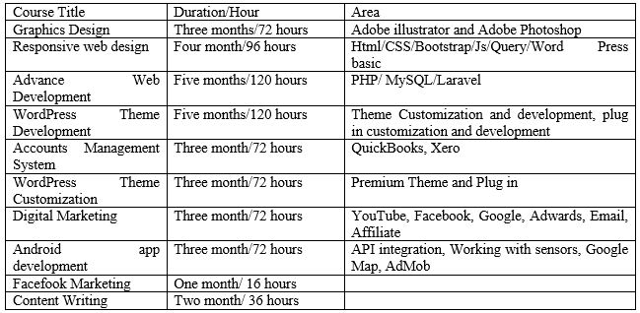

3.5.2 Diploma Courses
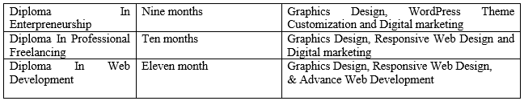

CHAPTER FOUR
FINDINGS AND ANALYSIS



4.1 Customer Relationship Management in CodersTrust
As noted earlier, CRM practices are an important part of an organization's position and help any organization to maintain a close relationship with their target customers, in addition, they simplify strategies and increase profitability.

Coderstrust Bangladesh continues its CRM practice by the help of Zoho CRM to attract potential students and retain former students and to collect various student documents from spreadsheets and update their data in Zoho CRM. Throughout this process, CodersTrust record the following information of students:

- Collect through inquiry the key customer information known as KYC (Know Your Customer) from Facebook and websites such as the student's name, email address, phone number, current address, etc.
- Inserts the KYC data into Zoho CRM spreadsheets.
- Double-Check the information to avoid duplication and mistakes.
- Correct information if any duplication or mistakes are found.
- Finally, insert a green checkmark on the student worksheet file, if the information are not duplicated.

Once all the information has been obtained correctly, the business developer will report it to the sales manager. When the head of the department checks all customer information and finds appropriate, he authorizes to work with these students. Therefore, the responsibilities of business developers are listed below:

- Communicate with the customers first by calling who have registered through the website and Facebook page.
- Understand their wishes through warm greetings and know whether they are still interested in taking this course that they registered.
- If the answer is negative, indicate it as a student who is not interested in Zoho CRM

- If the answer is positive, business developers note down the student's academic background.
- Inquire from the students that whether they are suitable for the course, as most courses require specific basic knowledge.
- Next, the business developer should let customers know the details of the course, and so if these customers are less interested in the course, he shares the successes to the confidence of the programmers and try to give them courage.
- Business developers usually ask whether customers are interested in coming to the office so they can properly introduce them to courses and resources, then make an appointment with them.
- If customers don't agree to come to the office, the adviser gives them appropriate advice. Then the business development, as well as, adviser tell them the costs of online and offline courses.
- Finally, a few days are given to the customers to take decision and say that representatives from CodersTrust will call them back to understand their decision.

At the orientation program, when the students come to the CodersTrust office in Bangladesh for the first time, the tutor will provide them appropriate course-oriented training and inform them of the positive memories of their former students and how they have worked in the independent market. Some students have reported that they are experiencing financial difficulties and cannot provide full registration at the same time. They offer the possibility of paying the admission fees in the first instalment before the start of the section and two instalments in the last instalment after one month. The student then completes all their contact details with a reference by filling out the online admission form with their personal registration form. After completing all documents and procedures, CodersTrust includes the statistical information in the list of winning offers and updates them in Zoho CRM software and generates cash income to fill the admission forms, charge them for the admission fees and provide receipts. The places in the final phase are reserved for new students.

4.2 The use of Zoho CRM in CodersTrust
CodersTrust make it business profitable by building a good understanding with its customers. The services it provides to its customers, start from the Zoho CRM software from the very beginning and the software helps a lot to maintain the good relationship with their customers as the software offer a lots of benefits. The uses of Zoho CRM in CodersTrust is listed below:
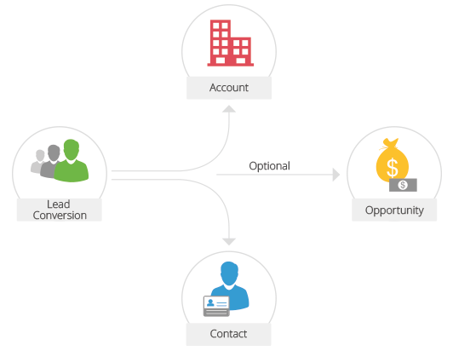

Agreements / Deals
The agreements/ deals are commercial agreements with people (B2C) or with organizations (B2B) that generate real income for CodersTrust. Go through different stages of sales, such as demand analysis, qualification, leads, value proposition, etc., before facing a real deal, loss or victory. Leads that show interest in CodersTrust activities can translate directly into opportunities that represent leads.

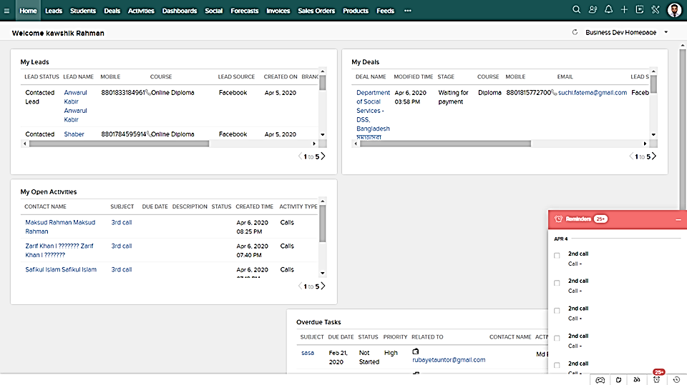
Image: Deals of Kawshik Rahman through Zoho CRM at CodersTrust

Price book
A price catalogue is an agreed price for the sale of products to customers. Depending on the agreed terms, prices may also differ for different clients. You can view the unit price as the manufacturer-determined price for the product and the list price as the seller price in the price table. In addition, discount ranges can be defined.

Online purchases
A purchase order is a legally binding order document used to purchase a product or service from a supplier. Each product can have a different order level to trigger the creation of a new order.

Campaign
Zoho CRM provides a platform to arrange and record the total cost of marketing activities. It allows you to mark different stages, correlate all activities, events, import target contacts and calls related to CoderTrust's campaign. In addition, it provides a detailed view of all marketing activities in which a single customer participates.

Supplier’s information
Suppliers are companies, individuals, or subcontractors that the CodersTrust trusts in products and services. Vendor details stored in Zoho CRM may offer sellers or vendors better visibility for future product purchases.

Quotation
A quotation is a legal agreement between a customer and a supplier, designed to deliver the requested product at the agreed price within a specified time. With a single click, offers can be converted to sales orders or invoices. You can also create a template based on the details of the quote and send it to the customer.

Sales order
A sales order is a sales confirmation after a customer has placed an order based on a CodersTrust quote. Convert offers to customer orders with a single click.

Invoice
An invoice is a demand from a seller to provide goods or services to a customer to receive payment. With a single click, offers can be converted to sales orders or invoices.

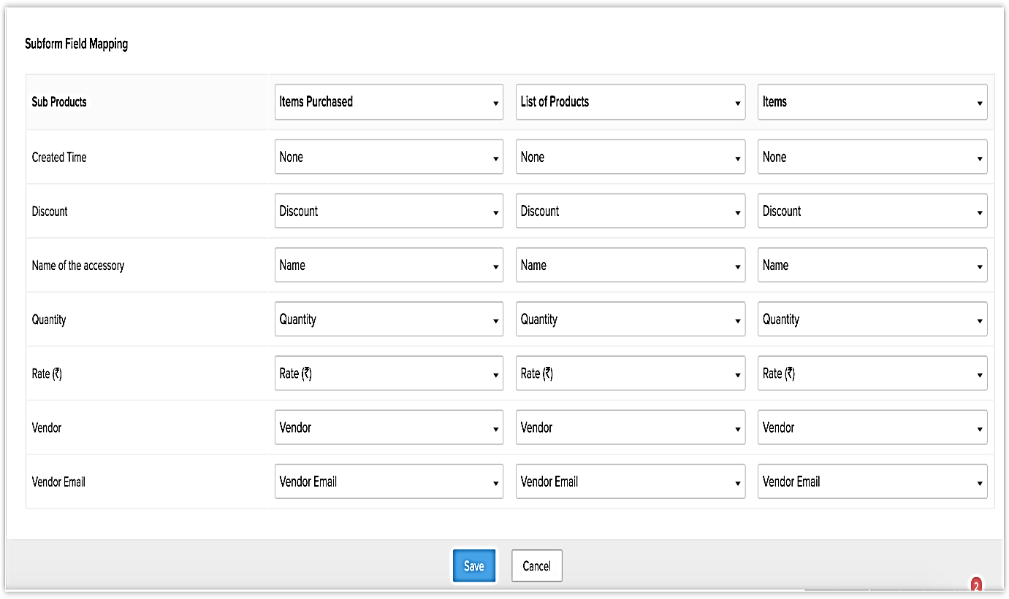
Image: Invoice page of Zoho CRM

Potential customer list / leads
Potential customers list helps to create sales opportunities for CodersTrust. These are rough information about individuals or organizational representatives gathered from fairs, seminars, advertising, and other marketing activities. Leaders will be followed up by sales representatives, and when they qualify, they will become contacts, customers, and transactions (opportunities) in Zoho CRM.
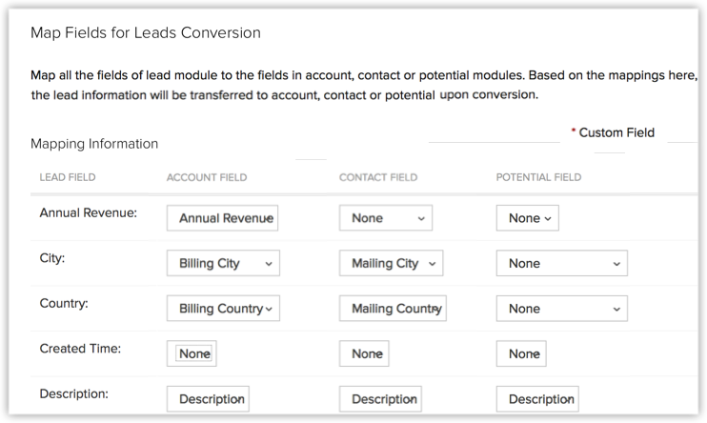
Image: Leads Conversion page of Zoho CRM
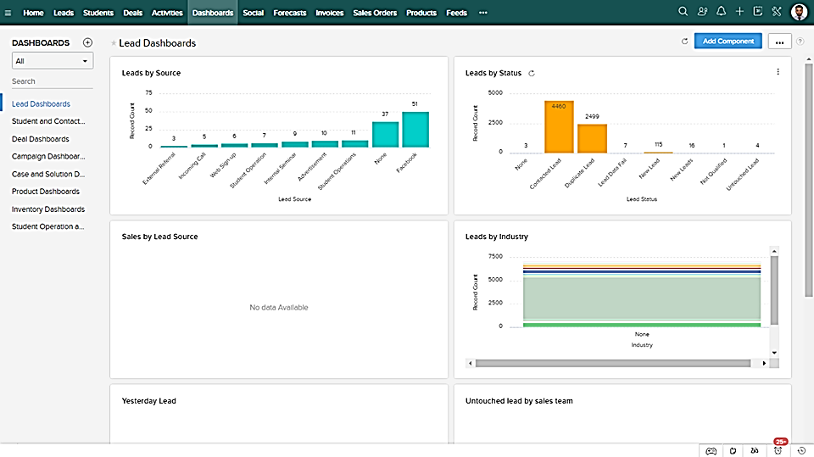
Image: Leads Dashboard of Zoho CRM

Contacts
Contacts are trusted programmers, and companies (such as Upwork, Fiverr) communicate with them to find work opportunities. Some of these contacts may belong to different departments or maybe from multiple contacts of the same company. CRM contacts are usually converted from qualified leads, imported from an existing list or added separately based on a business relationship with CodersTrust.

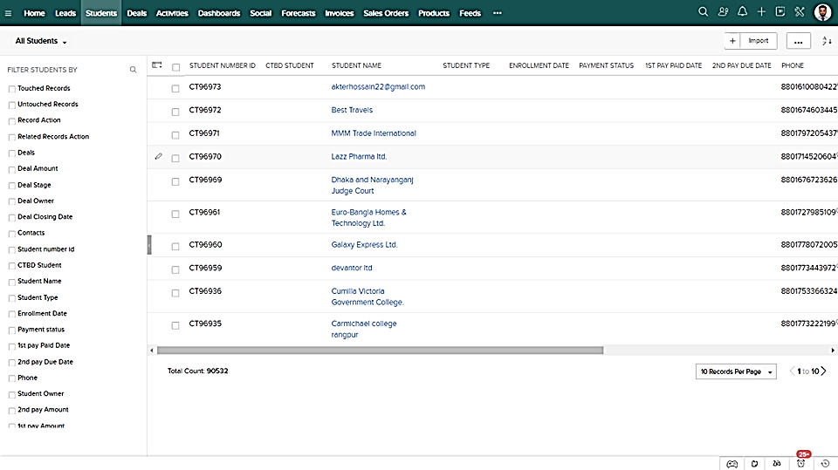
Image: Customer’s Contact Details

Account
An account is a company or department of a company that does business with CodersTrust. In Zoho CRM, the company can associate single or multiple contacts with an account. In a typical B2B scenario (a company that sells products or services to another company), an account plays an important role in tracking important information about that company.

Forecasting
Forecasting is the true insight needed to make informed business decisions and predict future sales. They provide a personalized, real-time view of the CodersTrust business to track and improve sales processes within the organization.

Modules
In Zoho CRM, data is divided into groups based on their similarity. Any department with similar data is called a "table." For instance, a lead is a module that contains all the details of a business leads. Customers, contacts, quotes, quotes, etc. are other examples of modules. In addition, in Zoho CRM, there are two main types of modules: predefined modules and custom (or user-generated) modules.

Recording
The recording is a common name assigned to any entry on the module. For example, if there are ten leads in the Leads module, each lead is a record. If there are 10 contacts in the Contacts module, each contact is a record, and so on.

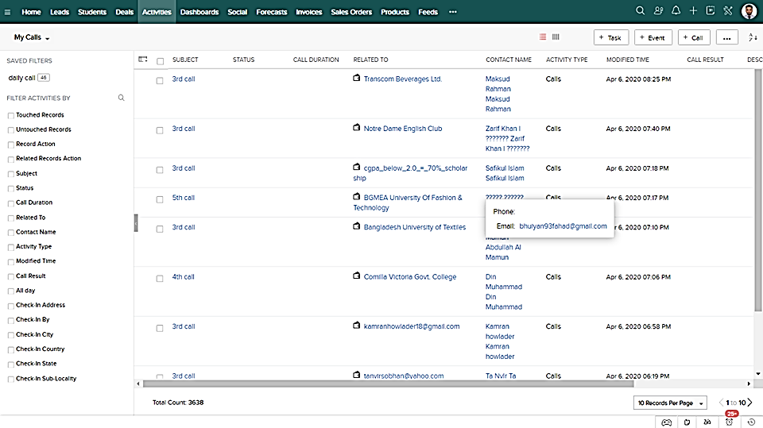
Image: Customer’s records of leads

4.3 Other elements that contribute to improve relationship with the customers
Depending only on CRM software can’t make an organization successful as using CRM software has several disadvantages, for instance, CRM Software increase cost, requires training, increase overhead cost and customers details may lost or misused. The organization must consider several other elements to achieve their long term goals and improve relationship with their customers. Often organizational strengths and position plays here a great role to establish good relationship with their customers. Therefore, the strengths that helps CodersTrust to manage customer relationship are listed below:

4.3.1 24/7 Student Support System
Coder Trust has a strong support system for the students of Bangladesh. The way the organization is providing students support are listed below:
- 24/7 Online Student Support,
- Talent ELMS,
- Facebook Group,
- Batch-wise Facebook Group,
- Corner for success stories Blog,

From the above channels, students can communicate for their queries and get different types of services from those different support systems at no hidden cost. The channels look after all types of problem CodersTrust Bangladesh students 24/7 hours. This channel is supported by experts who are carefully selected and trained by the company. They can solve any type of problem, even new situations, based on their experience and company policies. The experts are very kind and friendly to the students. They can also identify students' psychology and respond accordingly.

4.3.2 Designed courses with qualified mentors
CodersTrust Bangladesh has highly qualified tutors for various courses (online and offline) based on various criteria. The organization includes several criteria:

- Superior teaching and training experience,
- Understand employment conditions between different angels,
- Hold professional knowledge and skills in specific areas,
- Have a clear understanding of freelancing works and practical skills;
- Dedication to channelize the ability of students at all levels,
- The ability and performance of independent professionals to get a professional job;
- Have work experience in critical situations;

The consultant's adherence standards include proactive skills and abilities, teamwork capabilities, ability to work in a dynamic environment, working under pressure and schedules, gender and cultural awareness, and so on.

4.3.3 Make friendly calls
CodersTrust has compiled a list of potential customers and is making calls to improve customer service based on customer needs. In the process, they first create a simplified strategy before calling. Then, make a conversation with each customer and focus on their time and needs. Although it is usually part of a sales promotion, a phone call can help them to understand the customers' queries, needs, and demands in the process.

Chapter Five
Conclusion and Recommendations

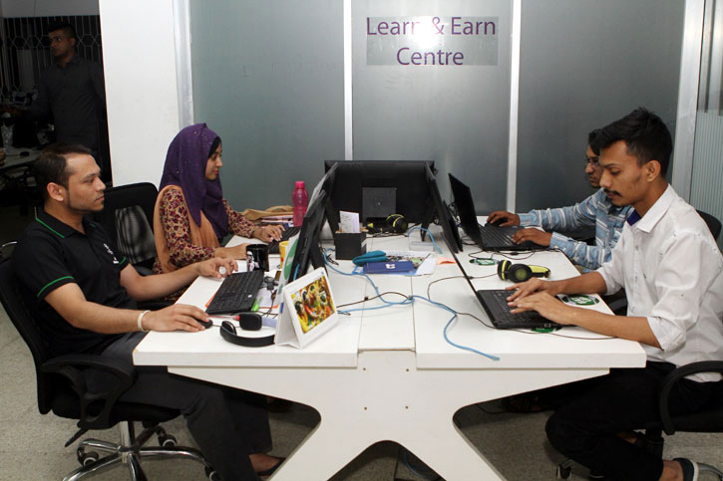

5.1 Recommendations
The report focuses on the marketing concept of customer relationship management which analyses how a company maintains relationships with its customers in Bangladesh. CodersTrust is a training and skills development institute in Bangladesh that trains its students to develop their skills for online job search, work skills development, and home-based earnings. To retain its students and attract potential students, the organization offers various training courses aimed at developing students' knowledge and skills. CodersTrust uses the Zoho CRM software to store all the elementary information of the students in their files. Using the Zoho CRM software, CodersTrust communicates with its students and sends them notifications about their course updates. In addition, CoderTrust helps its students meet their needs by providing professional tutors, instructors, and business experts. CodersTrust helps its students get 24/7 support from Talent ELMS, Facebook groups, and 24/7 online help centre. Also, to improve student motivation, CodersTrust constantly shares a number of success stories of their alumni on their Facebook pages and websites to help current and potential students learn how successful students have utilized their teachings from CodersTrust. Here are some suggestions, based on a few proven areas of improvement, to help CoderTrust to recover its customer relationship management in this competitive business world:

a. Provide live assistance as real-time support to increase customer engagement
Research by the Aberdeen Group shows that companies using visualization tools have identified an annual revenue growth of 83% and a 2.7-fold (reduction) in customer workload scores. The real-time vulnerability platform provides face-to-face video chat support to protect customers from direct financial conversations to manage their finances. Co-navigation solutions have a significant impact on an agent's ability to access a customer's browser and the ability to provide online customer support by filling out help or forms on the correct page. The CodersTrust Bangladesh should provide real-time as real-time supports like live-streaming is an important communication channel for training institutions to improve its communication with their students and trainers. For Coders Trust Bangladesh, setting up many customer journey environments and increasing customer satisfaction can be very helpful.

b. Improve customer satisfaction
According to Forrester's research, customer service expectations are linked to three main factors: the ease of the service process, the emotions in the service process and the success of the service process. The process of providing a good experience for CodersTrust customers starts from the moment they visit the CodersTrust website in Bangladesh and runs until the time they become customers. Therefore, putting customer expectations in the first place and working hard to meet them can increase CodersTrust Bangladesh's customer satisfaction.

c. Continuous customer involvement
CodersTrust Bangladesh's lack of listening and replying to the customer can have a negative impact on the company in the future. Though maintaining continuous interaction with customers to promote and improve the customer relationship can be a daunting task, strategies might be implemented to avoid such problems come from dissatisfied customers and after-sales services. The general rules of marketing must be followed by CodersTrust Bangladesh to improve the condition which is: the happier the customer, the better the commitment and if customers are properly involved, they are more likely to retain, recommend and buy more products. Therefore, effective customer implementation strategies can have a positive impact on CodersTrust’s key performance indicators.

d. Automated customer responsiveness
Late response is the risk that causes the customers to leave CodersTrust Bangladesh. There is nothing that can make the customers more satisfied and happy if an organization doesn't provide a response immediately. According to the Ubisend survey, 21% of consumers consider a chat-bot to be the easiest way to communicate with a company. As a result, CodersTrust can redefine customer satisfaction in Bangladesh by automatically reducing customer response times, interactions and interests with the best chat bots as real-time services are invaluable in maintaining current relationships and prospects.

In addition, the Chat-bots can further help CodersTrust Bangladesh by:
- Receiving the simple and common questions and replying them with relevant answers so that the answers follow the same pattern to serve customers in the future.
- Directing customers to the previous answers on the same topic and can help to manage websites' spaces.

e. Remaining universal
With the development of technology, the number of communication channels has also greatly increased. Enterprises can now use multiple channels to communicate with customers through offline and online. For businesses, having multiple communication channels is a good thing because it enhances the ability to interact and serve customers. CodersTrust Bangladesh must rely on universal support to integrate text, instant messaging and social media to provide a unified brand experience so customers can always switch between channels.

5.2 Conclusion
The purpose of preparing the study are to analyse the concept of customer relationship management, to analyse the CRM practices performed by the CodersTrust Bangladesh and suggesting some recommendations to improve the CRM practices of CodersTrust Bangladesh. After the analysis, it is found that Customer Relationship Management (CRM) is a combination of strategies, practices, and technologies that CodersTrust Bangladesh use to manage their customer interactions and data throughout their lifecycle, with the aim of improving relationships with customer service and helping customers to maintain and drive sales growth.
CodersTrust is a Danish company operating its branch in Bangladesh to develop skills and online knowledge to the deprived and underprivileged students of Bangladesh. The organization is offering a variety of training courses designed to develop students' knowledge and skills so that it can retain its students and attract more potential students. CodersTrust uses Zoho CRM software to store all basic student information in its files. With the software, CodersTrust communicates with students and informs them of course updates. Additionally, CoderTrust helps students meet their needs by providing professional tutors, teachers, and business experts. Moreover, it helps students get 24/7 support from Talent ELMS, the Facebook group, and the 24/7 online help centre. Furthermore, CodersTrust shares many alumni success stories on its Facebook page and website to help current and potential students learn how successful students use CodersTrust's teachings. However, to improve the CRM practices to compete in the current competitive market, the organization should create universal customer support system, live streaming, automated chat-bots, and involve its customer with all the stories and updates about the organization.

Reference
(a) Organizational overview. Retrieved 20 February 2020, from https://coderstrustbd.com/ about- coderstrustbangladesh/
(b) Services of the CodersTrust. Retrieved 22 February 2020, from https://coderstrustbd.com/ all-courses;
(c) "Management Tools - Customer Relationship Management - Bain & Company". Www.bain.com. Retrieved 28 February 2020;
(d) Lakshman Jha (2008). Customer Relationship Management: A Strategic Approach. ISBN 9788190721127. Retrieved 28 February 2020;
(e) Avery, Jill. (2014). "Unlock the Mysteries of Your Customer Relationships", Harvard Business Review. August 2014. https://hbr.org/2014/07/unlock-the-mysteries-of-your-customer-relationships Retrieved: 2nd March 2020;
(f) The Forrester Wave: CRM Suites for Enterprise Organizations, Q4 2016, Forrester, 21 November 2016, retrieved 3rd March 2020;
(g) "Gartner Announces Customer Relationship Management Summit 2009". Gartner.com. 5 August 2009. Retrieved 4th March 2020;
(h) Greenberg, Paul (13 February 2017). "How customer data platforms can benefit your business";
(i) Bolton, Ruth N. (1998), “A Dynamic Model of the Duration of the Customer's Relationship with a Continuous Service Provider: The Role of Satisfaction,” Marketing Science, 17 (1), 45–65.
(j) "The story behind successful CRM - Bain & Company". Www.bain.com. Retrieved 15th March 2020.

