
Project Report on “Accounting fraud and ethics – an overview on the Banking and other sectors of Bangladesh”

Submitted To:
Dr. James Bakul Sarkar
Professor
School of Business & Economics
United International University

Submitted By:
Maisha Amdad Chowdhury
114 183 009
Accounting & Information Systems
United International University

Date of Submission: 28th December, 2024

Certificate of Supervisor

This is to certify that Maisha Amdad Chowdhury is a student of BBA (Hon’s), successfully completed her “Final Year Project” titled “Accounting fraud and ethics – an overview of the Banking and other sectors of Bangladesh” under my supervision as the partial fulfillment for the award of BBA in AIS degree.

She has done his job according to my supervision and guidance. He has tried his best to do this successfully. I think his program will help him in the future to build up his career. I wish his success and prosperity.

Dr. James Bakul Sarkar
Professor
School of Business & Economics
United International University

Declaration

I do hereby declare that this report title “Accounting fraud and ethics- an overview of the Banking and other sectors of Bangladesh” has been written by me during year of 2024 under the valuable guidance of School of Business & Economics, United International University in fulfillment of the requirement for the award of BBA.

I am also declaring that I have not submitted this report for any degree, diploma and title recognition before.

Maisha Amdad Chowdhury
114 183 009
BBA in AIS Program
School of Business & Economics
United International University

Letter of Acceptance

This final year project report entitle “Accounting fraud and ethics- an overview of the Banking sectors of Bangladesh” is prepared with thoughtful and relevant documents and ideas. This report submitted by Maisha Amdad Chowdhury, ID: 114 183 009, BBA Program, School of Business & Economics, Department Accounting Information System, United International University has been acknowledging as it is acceptable.

I wish every success in her life.

_____________________
Dr. James Bakul Sarkar
Professor
School of Business & Economics
United International University

Letter of Transmittal

December 28, 2024

Dr. James Bakul Sarkar
Professor
School of Business & Economics
United International University

Subject: Submission of Project Report on “Accounting fraud and ethics- an overview of the Banking and other sectors of Bangladesh”

Greetings, Sir
It gives me great pleasure to turn in my Final Year project, "Accounting fraud and ethics: an overview of the banking sectors of Bangladesh: A study on recent financial frauds in Bangladesh and economic breakdown related to these frauds." Information regarding current financial fraud in Bangladesh and its impact on the country's economy should be included in this article, in my opinion.
For this reason, I am really appreciative of your invaluable guidance, time, work, and assistance during the report preparation process. Working on it has even been enjoyable, so the things I've learned will be useful to me going forward.

Sincerely yours,

Maisha Amdad Chowdhury
ID: 114 183 009
BBA in Accounting & Information Systems
School of Business & Economics
United International University

Acknowledgement

I want to start by thanking and honoring Almighty Allah, who has given me the strength to successfully finish the study report. I am grateful for Allah's bounties in my everyday existence, including my good health, sound mind, and creative ideas. The theoretical portion of my studies is enhanced by this research work, which is regarded as an honest attempt to expand my personal and practical expertise.
Professor Dr. James Bakul Sarkar of United International University's School of Business & Economics has assigned me with writing this project. I therefore want to sincerely thank him for providing me with such a fascinating subject and for his insightful counsel. He has occasionally assisted by pointing me in the right path and offering suggestions. I owe him a great deal for his careful mentoring.

Abstract
Forensic accounting plays a crucial role in identifying and investigating various types of fraud within corporations. Despite the presence of both internal and external audits, business scandals continue to occur across industries, thereby increasing the demand for forensic accounting services on both a national and international scale. In Bangladesh, corruption and financial mismanagement have been prevalent in both government and private sectors, leading to significant challenges in financial oversight. This study aims to explore the specific types of fraud that occur within the country and emphasizes the growing importance of developing forensic accounting practices to address these issues effectively. To achieve the objectives of this research, a questionnaire was distributed to gather insights from a diverse group of professionals, including accountants, external auditors, and internal auditors working in both public and private banks, as well as manufacturing firms. The results of the study reveal notable differences in the perspectives of these experts regarding the role and effectiveness of forensic accounting in detecting and preventing fraud.

Key Words:
Fraud, Ethics, Banks, Financial Statements, Forensic Accountants, Corruption, Extortion, Assets, Business Expenditures, Loan

Preface
The last 20 years have seen a sharp rise in accounting fraud, or the falsification of financial statements, which has caused the demise of supposedly stable businesses, exacerbated a severe worldwide recession, and left people with little faith in the integrity of financial statements and financial markets. This book offers a useful and instructive examination of the financial statements.
Top 20 Methods of Fictitious Financial Reporting that lists the most frequently used methods of overstating earnings and assets and understating debt in financial statements. The book also presents a detailed examination of the main
Signals indicating possible fictitious reporting in financial statements. Taking the viewpoint that no book on accounting fraud would be complete without an examination of the breakdown in ethics that underlies the fraud, this text examines the three major
Theories of Ethics, as well as ethical decision-making models that are applicable to the business world in general and to students of accounting in particular.

Table of Contents

Certificate of Supervisor ii
Declaration iii
Letter of Acceptance iv
Letter of Transmittal v
Acknowledgement vi
Abstract vii
Preface viii
Chapter One: Introduction 1
1.1 Background of the Report 1
1.2 Scope of the Report 9
1.3 Objective of the report 10
1.4 Limitation of the report 10
Chapter Two: Literature Review 11
2.1 Literature review 11
Chapter Three: Research Methodology 17
3.1 Data Collection 17
3.2 Methodology 17
Chapter Four: Findings and Analysis 31
4.1 Findings: 31
4.2 Loan Default: Prominent Cause of Bank Frauds: 35
4.3 Analysis 36
4.4 Research Problem 38
4.5 Related Literature 39
Chapter Five: Recommendation and Conclusion 44
5.1 Recommendations 44
5.2 Conclusion: 44
Reference 47

Chapter One: Introduction

1.1 Background of the Report
Bank fraud can be defined as either the fraudulent practice of defrauding investors of their money through dishonest means or the fraudulent practice of posing as a bank or other financial institution in order to steal funds, resources, or other property that should belong to a financial institution. Financial institution fraud is the subset of these two practices. Misrepresenting oneself to a bank is prohibited in some situations. The phrase "bank extortion" is not used to describe specific elements of financial fraud legislation, but rather to describe crimes including a scheme or inventiveness. The more often used terms "bank robbery" and "bank burglary" conflict with this. As a consequence of this, misrepresentation committed by a bank might occasionally be seen as an instance of professional misconduct.
South Asia is home to the country of Bangladesh. At almost 10 of the nation's most prominent banks, there is a cash crunch. The increasing dependence of the banks on their central capital is directly contributing to the problem's worsening. [Result and cause] They rely on taxpayer-provided funds in large numbers. These banks have historically used a large amount of their funds to lend money to the market, even though some of that money has been used to cover routine business expenditures. But as things are right now, more of their central capital is being added, which has resulted in a circumstance in which the principal objective is to prevent these banks from conducting business. Over the course of the past few years, Bangladesh has experienced a continuous growth in the number of reports of financial fraud.
Since the financial sector of Bangladesh has been liberalized, the number, complexity, and underlying costs of frauds have increased by a factor of three, which has resulted in a very major cause of anxiety for the authorities. Banking frauds have long been considered a cost of doing business in Bangladesh.
In the most recent few years, several of the most significant factors that contribute to fraud have been identified as delays in legal processes for reporting as well as various weaknesses in the 8 system. The value of frauds has climbed drastically, indicating that scams involving larger sums of money have been more widespread in recent years. Despite the fact that the number of scams has increased just little over time, the value of frauds has increased significantly. The profitability of the banking system in Bangladesh has suffered as a result of an increase in the number of advances, which has been accompanied by an increase in the number of frauds as well as nonperforming assets. The only way forward is for the relevant authorities to take decisive action while simultaneously devising creative strategies for the reduction and prevention of fraud. The faith of the banking industry can only be restored in this way, and only then will the nation's financial sector be given a much-needed facelift.
Over the past few years, the business world has seen numerous ups and downs. There are numerous business scandals, including stock market crashes. Accounting fraud is typically the primary cause of many corporate or company scandals. In order to reduce corporate scandals, both internal and external audits are crucial. Internal auditors look into information on the risks and business operations of the organization. External auditors, on the other hand, look into the company's financial records and problems and offer their insight on the financial statements. Although both internal and external auditors are extremely cautious and serve crucial roles in keeping an eye on the operations and financial reporting of the organization by offering an objective, holistic assessment, it’s not always possible for them to identify all the fraudulent activities. They basically analyze the consistency of the statements with the predefined specification.
There have been numerous audit failures worldwide that have led to the collapse of major corporations. Examples include the Enron scandal, Kmart, Lehman Brothers (USA), Adelphia Communication, 2G, Royal Bank of Scotland, Nortel (Canada), and MG Rover Group (UK), among others.
Enron, once a financially strong company in the U.S., became infamous for its fraudulent activities. It is widely considered the biggest audit failure in history, which led the U.S. government to pass the Sarbanes-Oxley Act (SOX). This law was introduced to control and prevent illegal corporate activities.
In Bangladesh, auditors' roles have also been questioned due to several high-profile business scandals, such as the Janata Bank Loan Scandal (2018), Destiny 2000 Ltd (2010), Hallmark-Sonali Bank Scandal (2012), Jubok (2011), and Dolancer (2011).
Forensic accounting is a specialized branch of accounting that investigates financial records to uncover evidence for criminal prosecution or lawsuits related to financial crimes.
Purpose:
The purpose of this paper is to review, critique, and integrate certain trends, events, and research streams involving earnings management, fraudulent financial reporting, corporate governance and ethics.
Methodology:
The article gives a synopsis of significant occasions and developments in financial reporting from 1987 to 2007. Financial reporting and earnings quality are examined from both an academic and practitioner perspective within this historical framework. An integrated examination of academic and practitioner perspectives on earnings management and false financial reporting is presented, including the impact of corporate governance and the role of ethics and behavior. Final remarks and suggestions for additional research are included in the paper's concluding section.
Findings:
The paper concludes that academic research on earnings management and fraudulent financial reporting has become increasingly focused on a narrow range of issues, failing to address broader, practical problems in the field.
Research Limitations/Implications:
The study is limited in how deeply it analyzes each specific research area due to the wide scope of research covered and the time period addressed. However, it suggests that future research could benefit from combining various research streams related to earnings management and fraudulent financial reporting to create a more comprehensive understanding.
Practical Implications:
This paper could be helpful for regulators and policymakers by providing insights into the relevance and importance of academic research. It can assist them in understanding how research findings can be applied in real-world scenarios to improve financial reporting practices and policy development.
Originality/Value:
The paper introduces and emphasizes the role of ethics and behavior in understanding earnings management and fraudulent financial reporting. It adds value by highlighting these often-overlooked aspects, which are crucial for a more holistic understanding of these issues.

The Present condition of forensic accounting in Bangladesh:
In comparison to other countries such as Australia, Canada, and the United States, Bangladesh's use of forensic accounting is quite low. We must use efficient instruments to recognize and quantify the aforementioned inconveniences in order to fight corruption and fraud in our nation. Fraud is defined by law as the deliberate use of deception to get unfair or illegal advantages or to defraud others by violating their legal rights. Receiving bribes, making false statements, stealing funds from the business, etc., are a few instances of fraud.

Some major categories of frauds are:
Corruption: Corruption occurs when someone abuses their position or manipulates business transactions for personal gain, often at the expense of others' rights. Examples of corruption include accepting bribes and creating conflicts of interest.
Asset Misappropriation: Asset misappropriation involves the theft or misuse of an organization’s assets. This can include activities like payroll fraud, stealing assets or inventory, and skimming revenue.
Fraudulent Statements: Fraudulent statements refer to the intentional misrepresentation of financial or non-financial information, which misleads others who rely on it for making financial decisions. Examples include inflating revenue, underreporting expenses, or hiding liabilities.
Fraud is a harmful act that should be prevented. Due to the widespread occurrence of fraudulent activities, forensic accounting has become essential to detect and address these issues.
Many people believe that the Hallmark Group fraud involving Sonali Bank's Ruposhi Bangla Branch, which resulted in Tk.3,607 crores being stolen (Tk.2,668 crores by Hallmark), is the biggest scandal in recent banking history. However, not everyone agrees. There have been other major frauds, such as the Tk.622 crores stolen by Nurunnabi in Chittagong in 2007 through fake letters of credit, the Tk.596 crores embezzled from Oriental Bank in 2006 (which some say had links to Hawa Bhaban), and Tk.300 crores fraudulently transferred from five banks by Om Prokash in 2002. These cases, while serious, may not be as damaging as frauds directly involving banks themselves. Even more troubling is the case of the Destiny Group, where over Tk.4,500 crores were transferred into personal accounts, even though banking authorities were aware of the illegal activities for months but did nothing about it.
It is shocking that those whose culpability was established and whose activities had the potential to seriously harm the banking system were not given definitive, exemplary, and severe punishment. Fortunately, the public still has faith in the banking system because it is the guardian of deposits, or amanat, the highest symbol of trust. The public may have to deal with anarchy if the political elites and society at large—including the courts, civil society, and the media—do not reject complacency and implement significant changes in banking management.
There are several other incidents that show how serious issues have been ignored. For example, writing off loans and interest from defaulters—especially when the bank has already set aside enough funds—reduces the default rate but creates a moral risk, encouraging more defaults by powerful people. One of the most concerning changes happened in 2009, when the long-standing practice of promoting Deputy Managers (DGMs) in nationalized banks (NCBs) and development finance institutions (DFIs) through a fair, competitive process by Bangladesh Bank was stopped. Now, promotions are decided by each bank's board, which is less transparent. There has also been an increase in the number of Deputy Managing Directors (DMDs) in some banks, but their roles are not clearly defined, causing confusion and poor management.
The recent problems in the stock market are mainly due to banks misusing funds that were meant for industrial loans and small businesses by investing them in the stock market. This led to big profits for the banks’ shareholders. Another missed opportunity happened in 2007-2008, when the nationalized banks were turned into limited companies but without transferring at least 50% of the shares to the public. This kept the government in control, as it continued to appoint the entire board of directors and top executives of these banks. This lack of ownership reform has created a gap in how the central bank oversees nationalized and private banks, which may be leading to poor management in the nationalized banks today.
The question of who is primarily to blame for the Hall-Mark scandal—Bangladesh Bank, Sonali Bank, or the government—is still up for debate. It is reasonable to assume that the problems will be reduced in the long run if the government chooses to tighten the screws and tie the loose ends in a transparent and efficient manner while operating the financial system through a responsible apparatus. However, there is an urgent need for Bangladesh Bank to replace its reactive approach to crises with a proactive strategy that anticipates and guards against vulnerabilities and an agile system of inspection. Drawering these at home or at the office as soon as possible must be replaced by the fundamental principle of acting on the recommendations of the inspection report on the day of the inspection. It may also be wise to review the frequency of travelling abroad by the senior executives of the central bank.
The Hallmark Group's fraud at the Ruposhi Bangla Branch of Sonali Bank went on for two years, and the illegal activities were first discovered in three branches by a General Manager in January 2012. Although the MD verbally approved an inspection in January, it didn't begin until April, allegedly due to resistance from a Deputy Managing Director. The manager of the Ruposhi Bangla branch, who was supposed to be transferred two years ago, stayed on longer, possibly to help facilitate the fraud. His continued stay couldn’t have happened without approval from Sonali Bank's top management. Regardless of any excuses, the top management of Sonali Bank is primarily responsible for the Hallmark fraud. If they were under pressure from the Board or powerful politicians, the MD or DMD should have taken a strong stand and acted according to the law, unless they were involved in the fraud themselves. Legally, the Board is responsible for setting policy, while the management, led by the MD, is in charge of running the bank according to the rules. So, the Board’s responsibility is secondary in this case.
The question is, why did Bangladesh Bank recommend the dissolution of the Sonali Bank Board only two weeks before its term ended? Bangladesh Bank had the right to make this recommendation under the Banking Company Act, but it’s hard to understand why Bangladesh Bank's own inspection team didn’t catch the illegal activities earlier and why the initial recommendation didn’t hold the top management of Sonali Bank, who were mostly responsible, accountable.
Whatever the stance the government may be taking it is well nigh impossible to accept that such a fraud could take place without the connivance and blessings of some powerful political bosses. In the interest of long term and the approaching general election, government would do well to dissociate itself with the corrupt and bring them to book after due process of law.
In light of one of the biggest banking scandals, the following steps may be considered:
- Those in charge of economic management should follow the principle of "speak less, do more" and ensure that if they do speak, they do so with a unified voice.
- Major reforms are urgently needed in the financial and banking sectors, and a commission should be formed to address these reforms.
- Bangladesh Bank’s ability to supervise banks effectively, transparently, and accountably should be strengthened, which may involve increasing the professional staff, expanding its authority over Nationalized Commercial Banks (NCBs), and implementing a separate pay scale.
- The policy of suspending individuals as scapegoats must change. Instead, suspects should remain in their positions for a set time under strict instructions to recover the defrauded money or provide credible collateral.
- Society should discourage media trials and instead focus on prompt and thorough investigations to identify the guilty parties.
- When appointing members to the boards of NCBs and Development Financial Institutions (DFIs), at least 40% of the positions should be reserved for non-political professionals.
- The roles, responsibilities, and powers of a bank's Board and management must be clearly defined and enforced.

1.2 Scope of the Report
The many forms of financial fraud that take place in Bangladesh and their impact on the national economy are the main topics of this study. The country's economy has suffered greatly as a result of many financial institutions in Bangladesh falling victim to fraud in recent years. Consequently, our study will make it possible to determine the pertinent causes of these frauds and the economic collapse caused by these crimes.

1.3 Objective of the report
There are a number of specific goals that this research is being conducted with. This study will help us determine the factors that lead to bank fraud and offer suggestions for preventing it from happening. This will not only help us draw attention to the economic collapse caused by bank fraud, but it will also help us cause it. Give a brief explanation of how fraudulent financial practices and the economy's collapse are related. It will also be useful in identifying the types of companies that commit the majority of bank fraud. It is anticipated that the results of this investigation will yield some helpful recommendations for anti-fraud measures that can be implemented in the financial sector.

1.4 Limitation of the report
The research that has been done is subject to a number of restrictions at this point. This research will help us understand more about bank fraud, but it won't be able to stop people from committing bank fraud. During the process of collecting data, there may be a lack of security or the chance that information is being misrepresented due to the fact that the majority of the data is acquired from secondary sources. due to the extremely delicate nature of the topic at question.

Chapter Two: Literature Review

2.1 Literature review
Green and Choi (1994) conduct an investigation into 114 examples of legitimate corporate fraud that took place between the years 1986 and 1990. The findings of the survey indicated that in 45 percent of the cases, employees from the professional and management sectors were involved.
To analyze "the reasons that contributed to the failure of Barring Bank," Wilson (2006) utilized a case study methodology. This breakdown was the result of weaknesses in the internal controls that Baring Banks had on management, financial, and operational operations, among other things. In the Bangladeshi banking business, the findings of a case study (Huq & Bhuiyan, 2012) indicated a variety of difficulties with the practices of corporate governance. According to a report on the banking industry in Bangladesh, the difficulties that pertain to the banking sector in Bangladesh are widespread and are not confined to the banking system alone. The governing body bears responsibility, but at the same time, it must maintain its autonomy.
Mustafa (2017) did a study in which he uncovered "unhealthy rivalry" among new banks for the acquisition of loans from incumbent banks. His research team discovered that the competition was motivated by ill motives in the majority of the instances. Mustafa (2017) published his findings. A study titled "Most banks embrace centralized systems" (2017), which is an introduction to centralized core banking systems, may be a better alternative for preventing fraud, saving expenses, and offering real-time services to customers over the internet. The research was conducted in 2017.
PYMNTS.com (2019) published an article titled "SWIFT to Assist Bangladesh Bank After $81M Hack" that discussed the fraud perpetrated by the Bangladesh Bank. In the article, it is discussed how 81 million dollars worth of money was stolen from the bank through fraud. In this journal, it is said that there would be no litigation or legal trouble arising out of any part performed by the network in this hack, regardless of the conditions. This is declared to be the case despite the fact that there was a part performed by the network that involved hacking. The New York Fed, which is also known as SWIFT, and the economy of Bangladesh would both thrive in the event that there were no instances of fraudulent activity on the internet.
The failure of Sonali Bank is one of the most concerning instances of bank fraud to have taken place in Bangladesh in the recent past. According to an article written by Uddin (2018), Sonali Bank has been unsuccessful in selling the mortgaged asset of HallMark after more than 50 attempts over the course of the past few years, which has led to the collapse of their business. In order to accomplish this objective, Sonali Bank submitted a request to the minister in charge of the nation's finances requesting that the entire starting capital of Tk. 500 crore be set aside for the businesses.
Ali (2019) presents a bank loan as if it were a potential economic bomb that could go off at any moment. The sum of non-performing loans according to Bangladesh Bank was over nine hundred billion at the end of 2018, which is a significant increase from the approximately seven hundred fifty billion that was outstanding at the end of 2017. About ten percent of the total sum that the country had borrowed was equivalent to this particular portion of the debt. According to the reports of some other establishments in the financial industry, there is also a sizeable quantity of other types of loans available.
The need for forensic accounting arises due to the limitations of traditional fraud detection tools. Currently, internal and external audits are the primary methods used to detect fraud, but they have some shortcomings, which forensic accounting aims to address. Forensic accountants are responsible for uncovering about $600 billion in fraud and theft within U.S. companies. According to Weygand, J.J. et al. (2012), forensic accounting is considered one of the top twenty careers of the future. Many organizations, including insurance companies and law firms, hire forensic accountants to monitor and investigate their activities. Forensic accountants often have experience working with the IRS (Internal Revenue Service), the FBI (Federal Bureau of Investigation), or other government agencies.
In our country, both internal and external auditors are working diligently to prevent business and corporate scandals. Internal auditors focus on investigating the management and risks within a company. They can also provide valuable advice and consulting services when necessary. Internal audits are crucial because they are an ongoing process within the company. External auditors, on the other hand, offer independent opinions on a company's financial statements and typically report their findings to the organization's shareholders.
The process of audit cycle is given below:
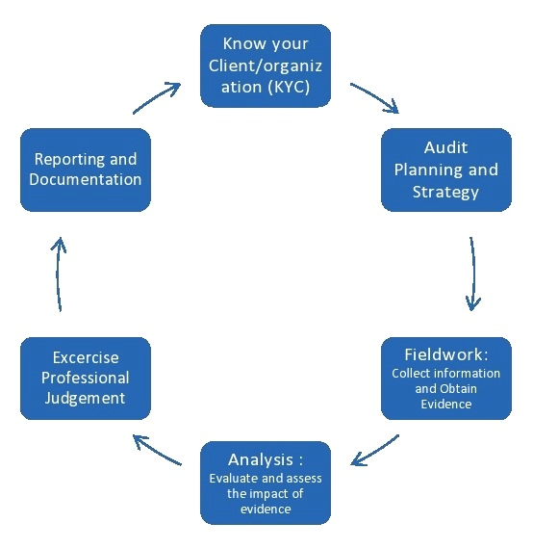
Source: Wikipedia
When auditors face limitations or have trouble finding all the fraud in an organization, forensic accounting can be very helpful. Forensic accountants play a key role in detecting fraud and need special skills for this. They are involved in finding things like tax evasion, money laundering, and theft. Their tasks include reviewing documents and evidence to uncover fraud, using auditing techniques, calculating financial losses, assessing the value of assets and businesses, applying accounting rules and standards, supporting legal cases, understanding criminal behavior, identifying different types of financial crimes, knowing local and international laws, writing investigation reports, and knowing which court to take cases to.
Here are some brief examples of some recent fraudulent activities:
Janata Bank Loan Scandal (2018): A major financial scandal was uncovered at Janata Bank, revealing a fraud of about Tk. 5000 crore. This scandal paints a very poor picture of the country’s banking sector. The irregularities were discovered after the Comptroller and Auditor General (CAG) office analyzed the documents of the state-owned bank. The scandal involved issuing loans that broke the terms of agreements (Memorandum of Understanding), creating fake export bills, purchasing these bills from organizations that only existed on paper, taking on liabilities without proper checks, and increasing loans against trust receipts (LTR) without enough collateral or security.
Stock Market Crash (1996): In December 1996, the Securities and Exchange Commission (SEC) set up a committee to investigate the stock market activities between July and November of that year. The committee, led by the Vice-Chancellor of Jahangirnagar University, looked into companies and brokers involved in stock market manipulation (rigging the sale or prices of shares). Based on the investigation, arrest warrants were issued for 32 people from seven brokerage firms and eight listed companies. The SEC also filed 15 cases in the Supreme Court related to the stock scam. However, in April 1997, the High Court granted bail to the accused, including nine others, which weakened the case.
Destiny 2000 Ltd: Destiny started as a multi-level marketing company but later faced accusations of operating a bank without permission from the Bangladesh Government. The company claimed to sell trees, promising high returns, but it turned out that the trees didn’t exist. About 1.7 million people invested in these fake trees, and only 5.3% of them were real. Destiny managed to collect around US$7 billion (about 50,000 crore Tk.) from these investors, making it one of the biggest scams in the country.
Jubok: Jubok was a big cooperative society. The government shut it down in 2011 for its’ illegal banking. The clients of Jubok lost approximately thousand crores taka. Probably they won’t be able to get back their money.
Unipay2u: Unipay2u was a multi-level marketing company that dealt with gold. A case was filed against the managing director and chairman of the company after they made false promises of high profits to unsuspecting people, only to disappear with their money.
Sonali Bank-Hallmark Loan Scandal: The Sonali Bank and Hallmark loan scandal is one of the largest banking frauds in Bangladesh. In 2012, Bangladesh Bank revealed that Sonali Bank had illegally given out loans totaling 36.48 billion taka (around 340 million US dollars). The Hallmark group received the largest share, worth 26.86 billion taka. Other companies, including DN Sports, Paragon Group, Khanjahan Ali, T and Brothers, and Nakshi Knit, were also involved in the fraud.
Stock Market Debacle: Bangladesh’s stock market had been thriving until the end of 2011 when it suddenly crashed. The market’s downfall resulted in losses for around 2 million investors, totaling nearly Tk. 20 thousand crores.
These fraudulent activities highlight the growing need for forensic accounting. Many of these crimes happen due to failures in auditing. Skilled and trustworthy auditors can help reduce such fraud and misconduct in organizations.

Chapter Three: Research Methodology

3.1 Data Collection
There are two kinds of sources of information:
Primary Data:
- I have experienced the inside data of the national banks.
- I have visited some banks and checked their annual reports.
- I have gathered some articles from top business analytics of Bangladesh.
- I have a visit on the subject with the individuals.
Secondary Data:
- I have visited Bangladesh Bank site.
- I have gathered some significant reports and documents from web.
- I have gathered data from paper and magazine.
- I have analyzed the rate of banking frauds from the past few years.
- I have gathered information about the funding and investments of some individual banks.

3.2 Methodology

Methodology is the set of techniques used to carry out a task or lead activities to complete an assignment. Information and data, report design, and other related techniques were used to guide this effort. This report was created using subjective processes. The data was examined and presented. The best effort was made to look into the findings. The information that makes up the study paper is the main focus. Similarly, the paper's speculative part has been used as the main argument. I looked at the various facets of the Bangladeshi banking scam. I also gathered a lot of information to create this research article.

I've gathered some important information about the funding and investment areas of banks, which are linked to fraud. Some banks are taking money from people with fake policies, promising high returns on savings and investments, but failing to deliver on those promises. I’ve identified some of these institutions, many of which have a strong presence in annual reports. I also visited several national banks and learned about their general, investment, and remittance sections. National banks make less profit from remittance services compared to private banks. They also tend to give out loans without thorough checks, leading to losses. Another cause of banking fraud is political influence. National banks are sometimes giving money to politically connected individuals or businesses, which reduces the overall profit of the national banking sector. I've collected this information from various sources, which show the main reasons behind banking frauds.

Research Design:
A pertinent research plan aids in the effective completion of the research article. This framework was developed in order to determine the answers to the research question. The necessary data, the study outline, the creation of a survey or other information-gathering structure, the indication of the processes, and the construction of the overall arrangement for the information investigation are typically components of a research design.
Sample Selection:
As the main objective of the paper is to signify the importance of forensic accounting and to determine the types of frauds occurring in Bangladesh, different private and public banks and manufacturing companies are selected as sample. The survey involves 30 professionals from different organizations.
Data Collection:
The main objective of the study is to outline the importance of forensic accounting and to determine the types of frauds occurring in Bangladesh. To work for this purpose, a structured questionnaire of 5-point Likert scale is developed for gathering primary data and secondary data are collected from online books, periodicals, journals, newspapers, websites etc. After collecting the data from these sources the results are analyzed and discussed.

Analysis and Findings:
We have conducted two kinds of studies since our study's goals are to identify the many kinds of frauds that are taking place in our nation and to highlight the significance of forensic accounting. These analyses will aid in comprehending the many forms of fraud, their severity, and the significance of forensic accounting.
The following are the analyses. First, a table listing the ten types of fraud that are prevalent in our nation is provided. The percentages represent the opinions of several experts from various organizations. The following are the outcomes:
Categories of Fraud occurring in our Country:
Categories of Fraud | Low | Medium | High | Doesn’t exist
1.The level of tax evasion (illegal attempt of minimizing tax liability) in your organization is- | 42.3% | 42.3% | 3.9% | 11.5%
2.The level of forgery of cheque (illegal money withdrawal from bank) in your organization is- | 42.3% | 26.9% | 3.9% | 26.9%
3.The level of misuse of fund in your organization is- | 26.9% | 53.8% | 3.9% | 15.4%
4.The level of asset misappropriation (stealing assets by the parties who are entrusted to handle the assets) in your organization is- | 46.2% | 34.6% | _ | 19.2%
5.The level of false information about share prices in your organization is- | 46.2% | 26.9% | 11.5% | 15.4%
6.The level of bribery (offering money illegally to make something done) in your organization is- | 30.8% | 34.6% | 3.8% | 30.8%
7.The level of terrorism finance (providing financial support to criminal or terrorist groups i.e; smuggling of goods or weapons, drug trade, kidnapping etc.) in your organization is- | 7.7 % | 26.9% | 3.9% | 61.5%
8.The level of misdeeds of loan (providing loan without analyzing credit worthiness) in your organization is- | 46.2% | 26.9% | 3.8% | 23.1%
9.The level of fraud in land documentation (bribery, fraud in land registration) in your organization is- | 26.9% | 46.2% | _ | 26.9%
10.The level of financial fraud (deceiving others for company's financial gain) in your organization is- | 34.6% | 42.3% | _ | 19.2%
Source: Primary Data
As can be seen from the table, the majority of professionals believe that our nation has low rates of check fraud, asset theft, share price fraud, and loan fraudulent activity. According to their assessments, our nation has a medium level of tax evasion, financial fraud, property fraud, bribery, and fund misuse. The majority of them believe that our nation is devoid of the amount of money used to sponsor terrorism. This indicates that our nation has very little funding for terrorism.
As it was stated before that the opinions of 30 professionals were taken through a questionnaire, the results of their opinions about the importance of forensic accounting in controlling financial fraud and crimes are analyzed and discussed with the statements below:
Question no. 1: You have the idea about forensic accounting.
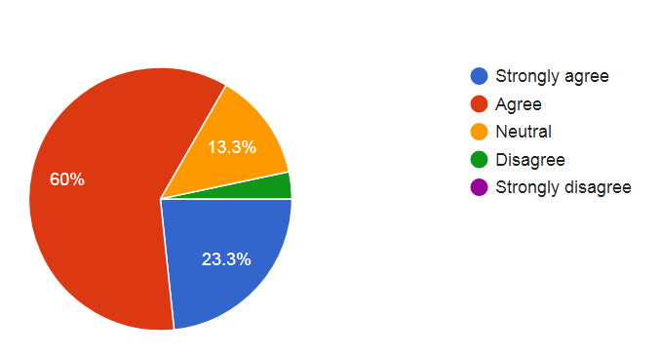
Source: Primary data
According to the report, 83.3% of organizations are aware of forensic accounting. Of them, 23.3% strongly agreed with the remark, and 60% agreed with it. Other organizations don't know anything about forensic accounting or are impartial.
Question no. 2: There are enough forensic accountants in your organization.
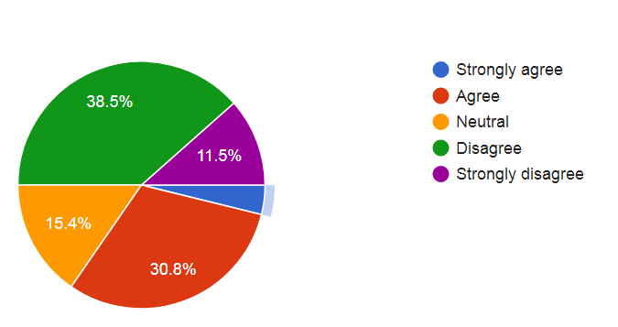
Source: Primary data
About 50% of organizations, according to the survey, lack enough forensic accountants. Fifteen percent are neutral or lack sufficient knowledge about forensic accountants. 3.8% strongly agreed with the statement, whereas just 30.8% agreed.

Question no. 3: F/S auditor is able to scrutinize and prevent tax evasion.
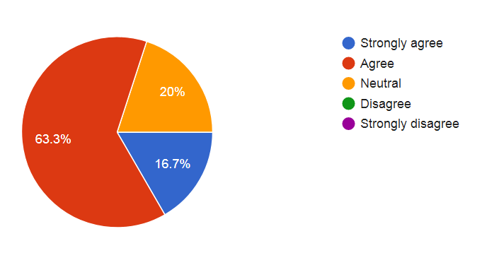
Source: Primary data
The survey's findings indicate that 63.3% of organizations agree with this statement, while 16.7% strongly agree. 20% more are neutral. This indicates that tax evasion can be examined and stopped by the majority of our nation's F/S auditors.

Question no. 4: F/S auditor is able to scrutinize and prevent forgery of cheque.
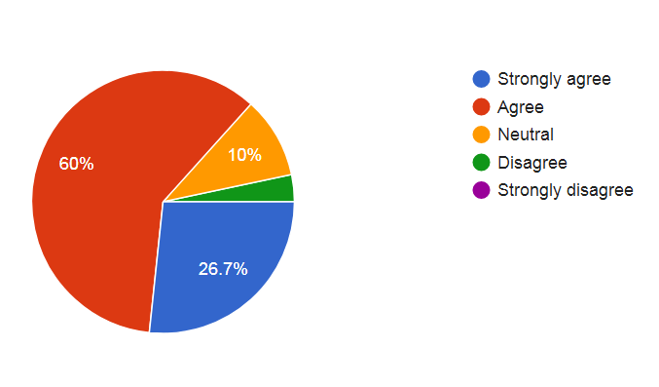
Source: Primary data
This survey's results show that 60% of respondents agree with this statement, and 26.7% strongly agree. This implies that the majority of F/S statement auditors are capable of closely examining and stopping check fraud. A small percentage disagree with the assertion, while only 10% are neutral.

Question no. 5: F/S auditor is able to scrutinize and prevent misuse of fund.
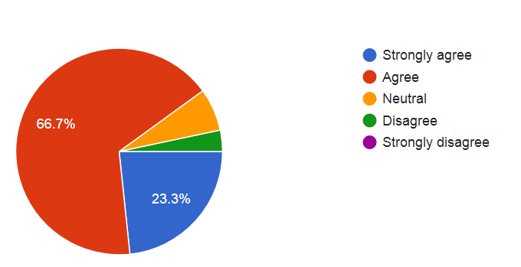Source: Primary data
This survey result shows that 23.3% organizations are strongly agreed and 66.7% are agreed with this statement. Other are neutral or disagreed. This means most of the F/S auditors of our country are able to scrutinize and prevent misuse of fund.

Question no. 6: F/S auditor is able to scrutinize and prevent asset misappropriation.
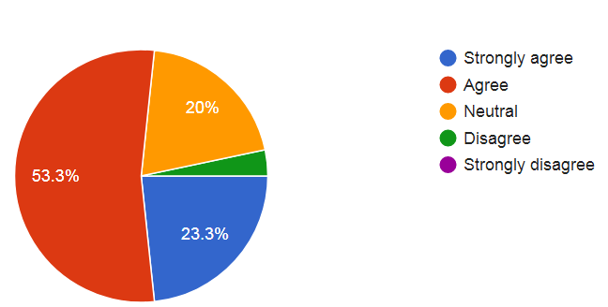
Source: Primary data

This survey result shows that 23.3% organizations are strongly agreed and 53.3% are agreed with this statement. 20% are neutral and very few are disagreed. This means most of the F/S auditors of our country are able to scrutinize and prevent asset misappropriation.
Question no. 7: F/S auditor is able to scrutinize and prevent false information about share price.
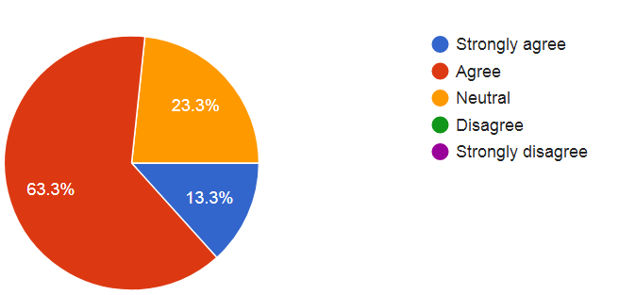
Source: Primary data
We can see from this survey result that 63.3% organizations are agreed and 13.3% are strongly agreed with this statement. Other 23.3% are neutral. This means most of the F/S auditors of our country are able to scrutinize and prevent false information about share price.
Question no. 8: F/S auditor is able to scrutinize and prevent bribery in the organization.
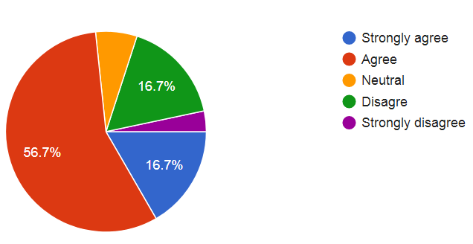
Source: Primary data
56.7% of professionals agreed with this statement, and 16.7% strongly agreed, according to the study results. This statement is disagreed with by 16.7%. There are very few who are firmly opposed or neutral. This indicates that the majority of F/S auditors in our nation are capable of examining and stopping bribery within their departments.

Question no. 9: F/S auditor is able to scrutinize and prevent terrorism finance.
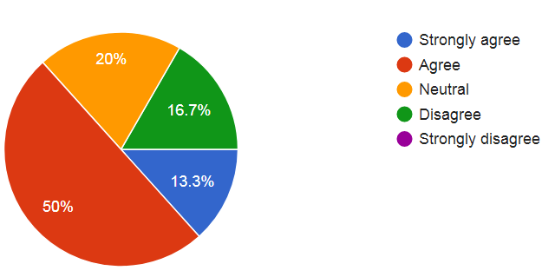
Source: Primary data

This survey result shows that 13.3% professionals are strongly agreed and 50% are agreed with this statement. 20% are neutral and 16.7% are disagree. This means most of the F/S auditors of our country are able to scrutinize and prevent terrorism finance.
Question no. 10: F/S auditor is able to scrutinize and prevent misdeeds of loan.
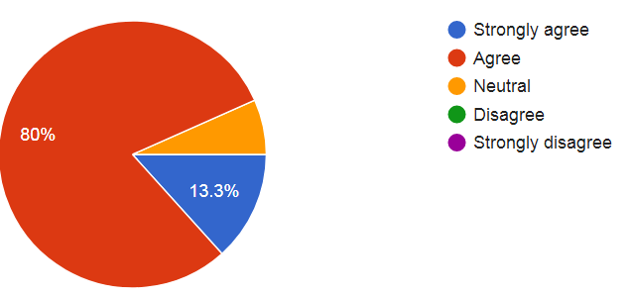
Source: Primary data
This survey result shows that 13.3% professionals are strongly agreed and 80% are agreed with this statement. Only 6.7% are neutral about this statement. This means the amount of misdeeds of loan is very low in our country and most of the F/S auditors are able to scrutinize and prevent misdeeds of loan.
Question no. 11: F/S auditor is able to scrutinize and prevent fraud in land documentation or illegal land registration.
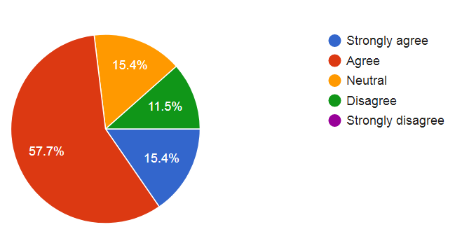
Source: Primary data
This survey result shows that 15.4% professionals are strongly agreed and 57.7% are agreed with this statement. 15.4% are neutral and only 11.5% are disagree. This means most of the F/S auditors of our country are able to scrutinize and prevent fraud in land documentation or illegal land registration.
Question no. 12: F/S auditor is able to scrutinize and prevent financial fraud.
Source: Primary data
According to the study results, 66.7% of professionals agree with this statement, and 23.3% strongly agree. There are very few who disagree or are neutral. We can therefore conclude that the majority of our nation's F/S auditors are capable of examining and stopping financial wrongdoing.
The survey's findings also show that our nation's F/S auditors are essential in identifying and thwarting these kinds of scams. The majority of them are competent to identify frauds or crimes in businesses.

Chapter Four: Findings and Analysis

4.1 Findings:
Based on my research, the Bangladesh Bank, Sonali Bank (Hallmark), and Basic Bank are involved in some of the biggest financial frauds in recent years. The scams at Basic Bank and Hallmark Group are among the most serious in the banking industry over the past decade. Together, these two institutions lost about 9,000 billion Bangladeshi taka. While legal battles continue, the government has been working to help banks stay profitable by putting money into them. The Ministry of Finance estimates that it will cost around Tk. 19,000 crore to recapitalize these banks over the next ten years, not including the Tk. 1,500 crore set aside for this year. Below is a brief overview of some of these frauds.
Bangladesh Bank Scam in brief:
The Bangladesh Bank was set up as a legal entity on December 16, 1971, following the Bangladesh Bank Order of 1972. It became the country's central bank and the main authority in charge of Bangladesh's financial and monetary systems. Today, the bank has ten offices in cities across Bangladesh, including Motijheel, Sadarghat, Chittagong, Khulna, and others. By March 31, 2015, the bank employed a total of 5,807 people, with 3,981 officers and 1,826 support staff.
Over the years, Bangladesh Bank has been involved in some major financial crimes. One of the most infamous was a gold theft in 2018, where gold stored in the bank's vault was stolen and tampered with. But the biggest incident was the 2016 digital heist, where hackers managed to send fraudulent orders through the SWIFT network to steal one billion dollars from Bangladesh Bank's account at the Federal Reserve Bank of New York.
These weren’t isolated incidents. In 2015, there were two other major hacking attempts. One was a $12 million robbery from Ecuador's Banco del Austro, and another was an attack on Vietnam's Tien Phong Bank. In all these cases, it’s believed that people within the banks helped the hackers take advantage of weaknesses in the system, giving them access to the global payment network, SWIFT.

Sonali Bank Scam :
In an article published on August 30, 2012, in The Daily Star, Manik, J. A. (2012) reported that the Anti-Corruption Commission (ACC) informed the Prime Minister's advisor, Syed Modasser Ali, that he might be involved in the controversial illegal loans taken by the Hallmark Group at the Sonali Bank branch in Ruposhi Bangla Hotel. It was reported that Modasser Ali allegedly pressured senior officials at Sonali Bank to approve a large loan of Tk. 3,547 crore for the Hallmark Group (Ahad A. 2012).
The Hallmark Group alone received Tk. 2,686.14 crore. Other companies involved included T and Brothers, which received Tk. 609.69 crore, Paragon Group with Tk. 146.60 crore, Nakshi Knit with Tk. 66.36 crore, DN Sports with Tk. 33.25 crore, and Khanjah & Ali with Tk. 4.96 crore. The Bangladesh Bank discovered that the Hallmark Group and five other companies managed to get loans from Sonali Bank by using fake records.
The ACC was told that Modasser Ali tried to stop an investigation into these loans that the Bangladesh Bank had planned with a review team. The Bangladesh Bank's investigation found that 32 Sonali Bank officials were responsible for the loan fraud. These officials are now being questioned.
The Hallmark Group scandal is just one example of many banking frauds happening worldwide, which are often the result of failures in supervision and control. In many cases, those involved are encouraged to commit fraud because they know there are people within the organizations who will help them deceive others.
Basic Bank scandal in brief :
Basic Bank, once a successful state-owned bank, began facing major problems within just a few years. The bank became overwhelmed with complaints from customers, including accusations of theft amounting to 45 billion Tk. Unfortunately, the government didn’t take strong action against those responsible. Sheikh Abdul Hye Bacchu, the head of Basic Bank, stopped investigating claims that he misused money by approving large, questionable loans worth tens of thousands of crores. These allegations were made by a former employee.
The amount of bad loans at Basic Bank increased significantly, rising from Tk. 1,417 crore in February to Tk. 2,557 crore in March. As a result, the Bangladesh Bank (BB) sent a representative to monitor the situation at Basic Bank.
One unusual situation involved Basic Bank paying 45.31 lakh taka to Barrister Kamrujamman’s legal advisor for handling a case. This amount was much higher than what other legal advisors typically receive, which is usually only around 4 to 5 lakh taka. Additionally, during a meeting of the bank's executive committee, members 316, 317, 318, and 319 approved a larger loan, including a funding of Tk. 117 crore, even though other board members didn’t participate in the decision.

Janata Bank loan scam:
Between January 2017 and February 2018, Janata Bank, another state-owned bank, became a victim of fraud by a corporate group. By June 2020, the bank's non-performing loans (NPLs) totaled Tk. 14,005.79 crore, which accounted for 26.76% of all the loans the bank had given out. This made Janata Bank the bank with the highest amount of bad loans in the entire industry. By the end of 2017, the figure was much lower, at Tk. 5,818 crore.
A large part of the increase in bad loans came from businesses like Crescent Group and Anon Tex, which failed to repay their debts. The situation became widely discussed when it was revealed that Crescent Group was the second-largest loan defaulter on a list presented to Parliament by the Finance Minister in 2020. According to the Bangladesh Bank’s inspection report, Janata Bank broke its own rules by lending more than Tk. 10,000 crore to Crescent Group and Anon Tex, exceeding the limit set for loans to single borrowers.
Farmers Bank (now Padma bank) loan scam:
Major issues were discovered when the Bangladesh Bank examined the Farmers Bank's loan distribution practices three years after it began in 2013. Some dishonest borrowers used the board of directors to steal about Tk 3,500 crore from the bank, according to a Bangladesh Bank probe. Both Md. Mahbubul Haque Chisty, the head of the audit committee, and Muhiuddin Khan Alamgir, the bank's chairman, were compelled to resign in November 2017. The bank attempted to repair its negative reputation after the incident by changing its name to Padma Bank in February 2019. At the end of June 2020, the bank owed Tk 3,709.41 crore in unpaid debts. This represented 66.33% of all loans provided by the bank.

4.2 Loan Default: Prominent Cause of Bank Frauds:
Loan default happens when a borrower fails to pay back a loan on time, whether it’s the interest or the principal amount. It can also happen if the borrower doesn't follow the terms of the loan agreement. In Bangladesh, loan defaults have reached alarming levels in recent years. According to Bangladesh Bank, unpaid loans amounted to Tk. 22,481 crore in 2009. However, by 2018, this figure had skyrocketed to Tk. 99,370 crore, more than quadrupling in just 10 years.
Between 2003 and 2018, Tk. 49,745 crore worth of loans were written off, and Tk. 11,879 crore was recovered from those written-off loans. So, the real amount of loan defaults is likely much higher than what is officially reported. In 2018, nine state-owned commercial banks had Tk. 49,434 crore in default loans, while 41 private banks and nine foreign banks had Tk. 49,936 crore in defaults. This highlights the serious problem faced by state-owned commercial banks.
While Bangladesh Bank’s official data shows the amount of loan defaults, many bank employees believe the actual numbers are much higher. It’s difficult for banks to decide which large loans to classify as bad debts or ordinary loans, making it hard to show the full extent of defaults. Additionally, banks face different penalties for weak lending practices, which only adds to the problem.
In 2003, Bangladesh Bank introduced a rule requiring banks to write off bad debts that hadn't been paid for over five years. But recently, this was changed to three years to reduce the number of default loans. Previously, banks could write off up to Tk. 50,000 without legal action, but now they can write off up to Tk. 2,00,000 without suing the borrower. While Bangladesh Bank believes this will help reduce defaults, it may actually make the problem worse. By allowing more loans to be written off without legal action, it could create more opportunities for borrowers to game the system.
In an interview with The Daily Prothom Alo, Jahid Hosen, the chief economist at the World Bank’s Dhaka office, compared loan defaults to cancer for the economy. He warned that once loan defaults spread in the economy, they can affect all other parts of it.

4.3 Analysis
Effect of banking scandals in the economy of Bangladesh:
Bangladesh's economy has taken a serious setback due to the financial crisis. They are investigated below ground. From 2010-2019, the government pumped a total of Tk. 17,521 crore into state-owned banks to help them weather liquidity crises. The government has budgeted Tk. 1,500,000,000 for recapitalization in the 2020 fiscal year.
Gross Domestic Product Development:
Economic growth is significantly affected by the Banking Scam. As of June 30, 2018, the Ministry of Planning said that the per capita income in Bangladesh had climbed from $1,602 to $1,610 and that the country's monetary growth had accelerated to 7.28 percent. Meanwhile, FY2017 saw Bangladesh's development rate at 7.11 percent, with a per capita income of $1,465, as reported by the Bangladesh Bureau of Statistics (BBS).
Inflation
As a result of the financial fraud, food price increases became a key topic of controversy in 2018, even though the central bank has been successful in controlling the overall inflation rate at approximately 5.5%.

Investment
We are aware that a genuine bank robbery occurred at the Bangladesh bank in the year 2016, and the Bangladesh bank had to cope with it. According to the quarterly report on money and trade rates published by the Bangladesh Bank, banks have extended a total of Tk. 7,97,789 crores in loans as of the end of September this year. This figure represents an increase from the Tk. 6,75,139 crores that banks had extended as of the end of September 2016. In any case, a number of people who specialize in finance are worried by the fact that the borrowers' interests in the offered credit were not clear, which raises the question of whether or not the funds were being transferred out of the country.
Infrastructure
However, the rate of growth for related activities, particularly first-track operations like Special Economic Zones (SEZs), was slow. The country had a great performance in the segment devoted to improving the infrastructure, but the rate of growth was slow for other duties. It is possible that the projected costs of the ventures will go up as a result of this postponement.
Exports and Imports
Because of bank deception, the country has become import dependent, which is a bad indicator for the economy.
Income
In 2017, the legislature failed to implement the new VAT law for the fifth year in a row, despite pressure from the business community, causing income collection challenges. However, the costto-GDP ratio was also approximately 10%, as direct-duty revenue was not increased above the usual level.
Remittances
In 2017, the influx of remittances to Bangladesh decreased by 10%, owing to the "Computerized Hundi." The pointer, on the other hand, has made a positive impression in the last few months of the year.
Poverty
The bank has a strong commitment to reducing poverty. However, a banking ruse exacerbates the situation.
Unemployment
I understand that the business is based on guesswork. Due to a banking ruse, speculators are discouraged from contributing, resulting in a jobless crisis.

4.4 Research Problem
Advancements in technology, along with globalization and international regulations, have introduced concepts like the "new economy," "e-commerce," and "new accounting." These developments have made it easier for businesses to save time and money by speeding up transactions and communication. As a result, financial transactions are increasingly being conducted electronically through methods like e-commerce and electronic data exchange, moving away from traditional paper-based systems. This shift has affected all aspects of accounting, such as recording, organizing, reporting, and analyzing financial information.
These changes have also impacted essential accounting tasks, including maintaining financial records, preparing reports for taxes, and auditing. Consequently, the accounting profession has had to adapt to these new technologies and practices. These changes have raised the expectations society has for accounting professionals. In this paper, the authors highlight the importance of accounting information systems in developing countries, particularly in Iran.

4.5 Related Literature
Computers are now a key resource in accounting and financial information processing. Furthermore, major advances in information technology (Seligman, 2000) as well as the existence of observable and tangible economic benefits (Botosan, 1997 and Seligman, 2000) have driven traditional auditing and financial reporting ever closer to being real-time tasks. Companies like Cisco Systems have made significant progress in making real-time financial reporting a reality (Seligman, 2000). Seligman (2000, p.148) reports that “Cisco Systems is one of the rare companies today in which the boss can clap his hands and get the books closed within an hour.”
Real-time financial reporting:
While real-time financial reporting has advantages for investors and financial analysts, there are also concerns about the technology needed to make it happen. In 1989, Cushing discussed the potential of the SEC's EDGAR (Electronic Data Gathering, Analysis, and Retrieval) system, which aimed to bring financial reporting closer to real-time. At that time, the internet and modern web technologies like HTML didn’t exist, so Cushing was exploring the idea of using a database approach for corporate financial reporting. This database method eventually evolved into today’s internet-based client/server portals.
Cushing’s analysis is still relevant today and raises important questions about how we teach accounting information systems. He concluded that the database approach was technically possible for financial reporting, but it would have different economic impacts on various groups in the economy. He speculated that certain groups would support this new system, while others would oppose it. For instance, Cushing believed that government agencies responsible for enforcing regulations, accounting researchers, and the data processing industry would likely back the database approach. On the other hand, corporate management, corporate accountants, financial analysts, and investors with insider information might resist it.
One reason corporate management might oppose the database approach is that it would make it harder for them to manipulate financial information to suit their own interests. Cushing argued that this transparency could reduce the ability of managers to control how financial data is presented, potentially damaging their ability to hide or mislead stakeholders for personal or corporate gain.
Cushing believed that using a database approach for financial reporting would allow for detailed monitoring and evaluation of management's accounting decisions. He thought this would likely limit management’s ability to manipulate earnings and make choices that serve their personal interests. A similar argument can be made today regarding real-time financial reporting. It could increase transparency and improve the monitoring of how companies handle their accounting methods.
Since 1989, advances in technology, especially the rise of the World Wide Web, have changed how people access financial information. Corporations, through their websites, have started to provide more timely information, though selectively. The World Wide Web has also made nearly real-time financial reporting more accessible and affordable for individual investors. Regularly updated websites have shown investors that they can now access financial information much more quickly, often in real-time.
While companies may hesitate to disclose information in real time due to the potential costs and concerns about revealing sensitive information to competitors, there are benefits to timely reporting. Studies, like one by Botosan (1997), show that companies that provide more detailed and timely financial information tend to have lower capital costs, especially smaller companies. This suggests that the advantages of real-time financial reporting, such as reducing the cost of capital, could outweigh the potential downsides.
Assurance services for real-time reporting
The quality and effectiveness of real-time financial reporting is contingent upon the ability to provide real-time, continuous financial auditing. Continuous auditing has been defined as "a methodology that enables independent auditors to provide written assurance on a subject matter using a series of auditors' reports issued simultaneously with, or a short period of time after, the occurrence of events underlying the subject matter" (CICA/AICPA, 1999). Continuous auditing requires a high degree of automation. It is also dependent upon (a) precise definitions of the data underlying the items to be audited, (b) use of real-time controls to signal errors and irregularities, and (c) automated integrated audit agents and other technologies that enable collection, analysis, summarization, and reporting of audit evidence and opinions. Like real-time financial reporting, real-time, continuous auditing also creates a need for a new breed of accounting information systems professionals, who are not only well-versed in traditional audit and accounting methods, but also information technology (IT).
Changing nature of financial information systems and enabling technologies:
The ability to share up-to-date financial information on the web has led to significant changes in how financial reporting is done, and these changes have gained strong support from businesses. One of the key innovations in this area is XBRL (Extensible Business Reporting Language), which is an updated version of XML (Extensible Markup Language). XBRL is designed to make it easier to find, retrieve, and use financial data that is published on the web, allowing for more efficient access to information. This is important because it helps both businesses and investors stay updated with real-time data, improving decision-making processes.
In addition, the SEC's fair disclosure ruling has added more motivation for real-time reporting by penalizing companies that give exclusive financial information to select groups, like analysts or investment bankers, before sharing it publicly. The ruling encourages companies to provide timely information to all market participants rather than just a few insiders. This change promotes transparency and ensures that everyone, not just a limited group of people, can access important financial data.
To implement real-time financial reporting and auditing on a wide scale, companies need advanced network technology and web-based systems. This includes the use of sophisticated software and platforms that can handle the demands of constantly updating financial information. As these technologies advance, a new generation of accounting professionals and scholars may start to question some of the fundamental principles and assumptions that were based on traditional manual systems that have been used for many decades.
Systems like the SEC’s EDGAR, which allows for the electronic filing and retrieval of corporate financial data, and other web-based platforms, have shown that financial communication can no longer be confined to static, time-bound reports. In the modern world, financial information can be updated and shared dynamically, meaning the assumptions that underpinned the accounting practices of the past century may need to be rethought. In this post-modern era, where data can be accessed in real time, financial transactions can involve a much more flexible and instantaneous flow of information, creating new opportunities for transparency and efficiency in the financial world.

Chapter Five: Recommendation and Conclusion

5.1 Recommendations
To help avoid falling victim to banking scams, several strategies should be considered. First, the national bank must operate independently without political interference, and its senior management should be chosen without outside influence. The security infrastructure needs to be digitized as soon as possible to stay ahead of cyber threats. In the case of representative enrollment, the bank should maintain its specialization and expertise. It is also important to establish a strong internal control system, improve the grading process, and enhance the efficiency of management and administration. Banking policies should be adaptable to changing circumstances, and the process for granting new bank licenses must be transparent. Additionally, banks should develop security architecture for vaults and holdings and make a concerted effort to prevent fraud. The government should pursue legal action against board members involved in scams and improve the expertise of the Anti-Corruption Bureau to combat these issues. Recovering stolen funds from those involved should be a priority. Fraud has become a widespread concern in both public and private sectors, but forensic accounting offers a way to combat it. This accounting method can help detect fraud in organizations, and it is recommended that every organization implement it. Professionals in the accounting field must be more aware of forensic accounting practices to prevent fraud, and their commitment to transparency will help achieve better results. By paying attention to this emerging field, the government can help reduce the number of frauds in the country.

5.2 Conclusion:
The situation is concerning, as while the Bangladesh Bank might eventually recover from its current issues, the priority must be to recover the missing funds. To do so, the government must take legal action against the loan applicants who misrepresented their financial situations, as well as the Chairman and other executives involved in the fraudulent activities. These individuals need to be held accountable, and the government must identify the culprits who misled the bank. If the administration acts decisively and takes the necessary precautions, these fraudulent schemes will be curtailed. However, the Bangladesh Bank, which is supposed to be the leading financial regulatory body in Bangladesh, has been facing challenges in maintaining control over the financial system. The bank’s role is crucial in ensuring the stability of the country’s economy, especially considering its focus on macroeconomics. However, in recent years, the Bangladesh Bank has been involved in a series of scams that have tested its ability to effectively monitor the financial sector.
The root cause of this instability can be traced back to poor leadership, weak financial oversight, political interference, and a lack of independence from the government. This has led to an environment where the Bangladesh Bank’s regulatory authority is diminished, and its ability to take corrective actions is undermined by political pressure. Despite experts calling for urgent reforms to address these issues, the government has been slow to act, allowing the situation to worsen. There is a lack of political will to implement necessary changes to safeguard the financial system. This political weakness means that the bank cannot act effectively against the growing number of scams, and there seems to be an increasing number of new fraudulent schemes emerging.
The consequences of this ongoing crisis are severe. The financial system’s instability is directly impacting Bangladesh's economy, with negative effects on key economic indicators such as gross domestic product (GDP), business growth, and income generation. If the current situation persists, the economy will face significant challenges, with the potential for long-term damage to economic growth and stability. The opportunity to secure the economy by revising financial norms, updating security frameworks, and ensuring greater self-sufficiency for the Bangladesh Bank is rapidly closing. If these issues are not addressed soon, the country’s financial system will continue to suffer, and the broader economy will remain at risk.

Reference
Huq, B. I. A., & Bhuiyan, M. Z. H. 2012, “Corporate Governance-Its Problems & Prospects in Banking Industry in Bangladesh”,
World Review of Business Research, Vol. 2. No. 2, pp. 16-31. Mustafa, M. S. 2017,
“Unhealthy competition rife among new banks: study” 2017, The Daily Star, 24 November, p. B1.
“Most banks adopt centralised systems‟,2017, The Daily Star, 24 December, p. B1 PYMNTS.com. (2020).
SWIFT To Assist Bangladesh Bank After $81M Hack | PYMNTS.com. [online] Available at: https:// www.pymnts.com/ news/security-andrisk/2019/swift-bangladesh-bank-hack/ [Accessed 10 Feb. 2020].
Uddin, A. (2018). Sonali proposes company to buy defaulters' assets.
The Daily Star. [online] Available at: https:// www. thedailystar.net/ business/hallmark-sonalibankloan-scam-1678606 [Accessed 10 Feb. 2020].
Ali, S. (2019). Default bank loans: A potential time bomb. The Financial Express, [online] 27.
Available at: https://thefinancialexpress.com.bd/views/default-bank-loans-apotential-time-bomb1552403026 [Accessed 10 Feb. 2020].
Rahman, M. and Rana, S. (2018). Present Crisis of the Banking Industry of Bangladesh: Causes and Remedial Measures. IOSR Journal of Business and Management (IOSRJBM),Volume 20(Issue 4), pp 13-21.
Adamu, G. Z. (2012), The Relevance of Forensic Accounting Education in Financial Accounting, retrieved at :http://ssrn. com/abstract=2193962
Albrecht, W, Albrecht, S & Albrecht, CC 2006, ‘Fraud examination’ (2nd ed.), Mason, OH: Thomson South-Western.
Bologna, G & Robert, J 1985, ‘Fraud Auditing and Forensic Accounting’, 2d Ed. New York: Wiley.
Crumbly, D.L (2001).Forensic Accounting: older than you think, Journal of Forensic Accounting, 2:181-202.
Crumbley, DL, Heitger, LE & Smith, GS 2005, ‘Forensic and Investigative Accounting’, CCH Group. ISBN 0-8080-1365-3
Fenton, D & Isaacs, P 2012, ‘Preparing Deposition Questions: The Critical Role of the Forensic Accountant’, Journal of Forensic & Investigative Accounting, Vol. 4, Issue 2,
Gerson, J. S., Brolly, J. P. and Skalak, S. L. 2015, ‘The Roles of the Auditor and the Forensic Accounting Investigator’, John Wiley & Sons, Inc.
Gray,D. (2008) "Forensic Accounting and Auditing: Compared and Contrasted to Traditional
Accounting and Auditing". American Journal of Business Education, 1(2):115-126.
Islam, MJ, Rahman, MH, & Hossan, MT 2011, ‘Forensic Accounting as a Tool for Detecting Fraud and Corruption: An Empirical Study in Bangladesh’, ASA University Review, Vol. 5 No. 2, July–December, 2011
Management , Vol. 4, No11, November 2009 pp 145-149 Largay, J 2002, Lessons from Enron’, Accounting Horizons, Vol. 16, No. 2, p.154
Moris, B. Rilley, R. A. Robertson J. Wells, J. Houck M. M., and Kranacher, M. (2006), Forensic Accounting as an Investigative Tool. The CPA Journal, 76(8):68-70.
Oworojori, A.A. and Asaolu, T.O. (2009) The Role of Forensic Accounting in Solving the Vexed
Problem of Corporate World, European Journal of Scientific Research,29 (2):183-187.
Rasmussen, D.G and Leauaunge J.L (2004). Expert witness qualification and selection, Journal of financial crime,12:165-172.
Shah M.A. & Shah A. A. (2012), "Corporate Scandals and Forensic Accounting", Indian Journal of Accounting, XLIII (1), 52-70.
Weygandt, J.J. Kimmel, P.D. and Kieso, D.E. (2012). Accounting Principles, 10th edition, John Wiley & Sons, Inc. USA.

