

An Analysis on the Activities of
Human Resource Management Department of Aarong

INTERNSHIP REPORT

An Analysis on the Activities of Human Resource Department of Aarong

Supervised By:
Ms. Farhana Rashid
Assistant Professor
School of Business & Economics
United International University

Submitted By:
Farzana Zaman
ID No: 111 141 183
School of Business & Economics
United International University

Date of Submission: October 10, 2018
Letter of Transmittal
10th October, 2018
Ms. Farhana Rashid
Assistant Professor
School of Business & Economics
United International University

Subject: Submission of Internship Report.

Dear Madam,
I am very pleased to submit my internship report on “An Analysis on the Activities of Human Resource management Department of Aarong” which is written on the basis of my internship program. It is also a prerequisite requirement for the completion of my BBA course. This report includes all the detailed information of my practical experiences that I have gained through my internship period.
I am confident that, this report will help you to obtain an insight into the activities of Human Resource department of Aarong. It also developed my analytical thinking ability and I was able to suggest some recommendations for Aarong, in my report.

I am really very grateful to you for your great support during my report writing. May I therefore hope that you would be kind enough to accept my report and oblige thereby.

Sincerely yours,

Farzana Zaman
ID: 111 141 183
School of Business & Economics
United International University

Acknowledgement

First of all I would like to thank Aarong Human Resource department for selecting me as an intern. I consider myself lucky because I was able to work with such amazing people who provided me with immense knowledge and made the beginning of my corporate life very contended. It is undeniable that completion of this report would not be possible without their kind help.
I am very thankful to my supervisor S.M. Zahidul Islam (Manager, HRD) for helping me to understand the corporate norms and etiquettes in Aarong. I would also like to thank my colleagues Monjori Monica Drong (Senior Officer, HRD), Rutaba Fairuz (Officer, HRD) and Tahmina Hossain (Executive, HRD) for helping me in each and every step during my internship program. They helped me to understand the entire function of Human Resource department of Aarong, so that I could apply those learning in my future career.
I would also like to express my gratitude toward my academic internship supervisor Ms. Farhana Rashid (Assistant Professor) who has patiently deal with all my queries and guided me to achieve the objectives of the internship report. It would never be possible for me to complete this report without her instruction.

Table of Content

Part 1 8
Introduction 8
1.1 Objective 10
1.2 Methodology 10
1.3 Scope 11
1.4 Limitation 11

Part 2 12
The Organization 12
2.1 History 13
2.2 Logo 17
2.3 Mission Statement 18
2.4 Vision Statement 18
2.5 Values 18
2.6 Contribution in Export 20
2.7 Rewards 21
2.8 Product Line 22
2.9 Taaga and Taaga Man 23

Part 3 24
Internship Journey 24
3.1 Regular Activities 25

Part 4 36
Analysis of HR Activities 36
4.1 Recruitment and Selection Team 38
4.1.1 Recruitment & Selection Process of Aarong and AAF 38
4.1.2 Recruitment and Selection Process of Sales Associate 43
4.2 Compensation Management 51
4.3 Job Separation and Grievance Management team 54
4.4 Support and HRIS Team 56
4.5 Performance Appraisal of Aarong 58
4.6 Other Activities 60

Part 5 61
5.1 Critical Observation 62
5.2 Recommendation 64

Part 6 66
6 Conclusion 66
7. Bibliography 68
8. Appendix 71

Executive Summary

This report is an analysis of the activities conducted by Aarong, Human Resource department. Aarong is a huge organization operating with thousands of employees where Aarong HR department operates as a strong force to manage those thousands of human resources with their tough grind. First part of this report includes small introduction about the report, objective, methodology, scope and limitation of the report.

The second part describes about the organization, their history, mission and vision statement. It also provides brief description of Ayesha Abed Foundation, Aarong’s product line, awards owned by Aarong, Aarong’s logo etc. This part of the report gives the reader background knowledge about Aarong’s identity, their journey and enormous endeavor to establish themselves as Bangladesh’s number one lifestyle retail chain.

The third part explains my regular activities as a part of Aarong recruitment and selection team. The fifth part of the report describes the HR department’s overall activities. The HR department has performance appraisal team, grievance and separation team, compensation management team and Human Resource Information System team. Each team has their own assigned work. Those work are described properly in this part. The recruitment and selection process for Aarong, A.A.F. and outlet is also explained with the process chart. This part also discusses about performance appraisal and some other activities that are conducted in in HR department.

The fifth part discusses about some critical observations, which is gathered during the internship period. Then some recommendations are given based upon the critical observations. The sixth part is the last part where the conclusion of the report is provided. Then the references of all the information and appendix are also provided.

Part 1

Introduction
Introduction

This report is an analysis of the activities that are conducted by the Human Resource department of Aarong. The report will focus on the recruitment and selection process of the overall organization as well as the recruitment and selection process of the Sales Associate for different Aarong outlet. The Sales Associates of Aarong are considered as the “Front Line Fighter” for their organization.

Other than the recruitment and selection process the HR department of Aarong has to deal with some other HR activities such as –

- Performance appraisal
- Grievance and separation
- Compensation management and
- Human Resource Information System.

This report includes a brief discussion of these activities. Mentioning that, it was really difficult to have a really in depth knowledge about all the activities of the HR department because of the time period of internship program. So these other HR activities are described based on observation and learning from colleagues and supervisor. The authenticity of the HR activities is highly maintained in the explanations.

Ayesha Abed Foundation is also a concern of BRAC, some Human Resource activities of this foundation is embedded with Aarong HR department. So some idea about Ayesha Abed Foundation has been discussed in this report.

Objective

There are two types of objectives in this internship report. One is broad objective and the other is specific objective. Both are given below:

- Broad Objective:
The broad objective of this report is to get an experience of the actual professional process of an organization and learning through practical work environment.

- Specific Objective:
There are some specific objectives of this report, those are given below-
- To gather thorough knowledge on recruitment and selection process of Aarong.
- To create an analysis of human resource activities of Aarong.
- To fulfill the requirement of submitting internship report.

Methodology

The sources of information and data which are being used in this report are primary and secondary sources. They are given below-

Primary Sources:
Primary sources were used to do the analysis of recruitment and selection process and several other human resource activities. To gather primary information discussion with colleagues were done. Some information were also taken through questionnaire which were answered by the HR colleagues. Other than that most of the primary sources were collected from my practical observations and experiences of job duties and responsibilities during the internship period.

Secondary Sources:
Secondary data were used for information such as background, history, mission, vision, objective, logo, Ayesha Abed Foundation and other information regarding the product lines of Aarong. Some other information were collected from the reports of previous interns who have worked in Aarong. The secondary data sources were mostly collected from official website of Aarong which has been mentioned in the reference section of this report.

Scope

The report focuses on the Human Resource activities of Aarong, so there are some confidential information of Human Resource department that they do not want to reveal. During the joining period an appointment letter is provided to the new interns, where some rules and regulation is provided. One of them is that the intern has to maintain the confidentiality of internal information which they may come across while working in Aarong and they have to give their signature and fulfill the joining formality. So confidentiality of internal matters are strictly maintained in this report.

Limitation

This report has some limitations, which are provided below-

- This report discusses on the recruitment and selection process of Aarong but the organization follows different processes for different positions according to their need. So all the processes are not described to keep the repot more precise.
- Revealing any internal confidential information regarding the recruitment and selection process or any other HR activity is highly prohibited according to the rules of Aarong. So, the internal information are not discussed in this report.
- Aarong has a very strong Human Resource department with a lot of functionality. The internship period of three months is a really very short time to properly understand each and every activities of the Human resource department. So everything regarding the Human Resource activities are discussed as per my understanding. There are some very critical issues of a Human Resource department to which I could not reach during my internship period or I could not get an in depth knowledge, so those things are briefly discussed in this report.

Part 2

The Organization

2.1 History

Aarong is an iconic brand in Bangladesh, who started their journey in 1978.They are a concern of BRAC (Building Resources Across Communities).They started their journey with a great vision to empower rural artisans and to help them rise on top of financial condition. Today they have twenty retail stores across the country supporting sixty five thousand artisans and they have more than one hundred fashion product lines. The word Aarong stands for “Village Fair” which symbolizes fairness in the global village. The brand has revolutionized the retail industry in a unique way than any other retail brand in Bangladesh.

Figure 1: Nakshi Katha
The iconic brand is a symbol of high quality product for customers and fair trade for their artisans. Quality, uniqueness and originality are three basic characteristics of Aarong. Most of the people in Bangladesh live in rural areas. They lack capital, marketing and development support for good employment so Aarong provides a ground for these underprivileged people and gives them capital, marketing and development support. Nearly 65000 rural artisans and handicraft producers work for Aarong, where 85% of them are women. At present Aarong has 13 production centers and 653 sub-centers in Bangladesh. (About Aarong, 2017)

Aarong is loved by Bangladeshi people due to their unique design taste of products. Their product design is a mix of Bangladeshi tradition and contemporary style which highly appeals to Bangladeshi people. Aarong focuses on textures and patterns that has been practiced by the rural artisans from generation to generation.

Birth of Aarong:

In the 1970s, BRAC was examining any and all possibilities for alternative forms of productive livelihood, especially for women, and the proper commercialization of arts and crafts turned out to be a promising option. In 1976, Ayesha Abed, the wife of Sir Fazle Hasan Abed, founder of BRAC (NGO), initiated many of the major activities of Aarong by identifying and experimenting with various crafts that women could produce at home such as nakshi kantha, embroidered goods, baskets, mats and items made of cane, bamboo and jute. However, the two main obstacles to turning craft production into a worthwhile enterprise were maintaining good quality and proper marketing. (Aarong, 2018)
In 1978, BRAC entered into a joint venture with the Mennonite Central Committee, the international development arm of the Mennonite Church, to open a shop in Dhaka called Aarong meaning 'village fair.' The Mennonites had a long experience of producing handicraft to generate income and had established a programme called Ten Thousand Villages, which worked with artisan groups around the world and sold their products through catalogues and retail shops in the US and Canada. In the first year the Mennonites assisted with the business side of the operation while BRAC worked to develop the skills of village women and their products. During the late 1970s and early 1980s, BRAC focused on developing Aarong's product lines and production capabilities. They began to study and catalogue the designs and motifs of traditional art forms by visiting museums, elderly craft masters and private collectors. They experimented with indigenous forms and materials, adapting them to possible new lines. They hired master craftsperson to help train village women and created a textile design and service workshop in Manikganj to experiment with materials and technologies in stitching, weaving and dyeing. BRAC also started producing historically imported items such as, men's Panjabi. (Aarong, 2018)

Relationship between BRAC and Aarong

Aarong is a concern of BRAC and it works as the marketing arm of BRAC. As BRAC has a vision of alleviating the poverty and empowering the poor people so Aarong created a platform for those people to rise above the poverty by selling their handmade products. All the disadvantaged women working for Aarong is also beneficiary of BRAC’s multifaceted development program. As Aarong is a concern of BRAC, a significant portion of Aarong goes directly for the NGO’s programs to support healthcare, economic and social development.

Ayesha Abed Foundation

In 1982, the Ayesha Abed Foundation (AAF) was established by family and friends to commemorate the memory and work of the late Ayesha Abed who died leaving behind her newborn son, Shameran, and young daughter, Tamara. The foundation was created to develop women's skills in various crafts through an appropriate working environment, financial and technical assistance and training. Initially it was registered with the government to receive foreign charitable donations and raise funds, but now operates exclusively as a part of Aarong. The AAF board comprises the eight family and friends of the late Ayesha Abed. Its budget is part of the Aarong initiative under BRAC. The AAF workers are all members of BRAC's village organization groups or the family of the members. (Aarong, 2018)

AAF's first project, the Manikganj center, was opened on 3 September 1983. The foundation buys handicrafts made by the village women, other NGOs and handicraft producers. In addition to starting the AAF, Aarong opened four retail outlets and began exporting a small percentage of goods to fair-trade organizations during the 1980s. By the mid to late 1980s Aarong began to emerge as a fashion brand despite the fact that Bangladesh was still new to the fashion industry. Aarong was the first brand to start organizing photo shoots along with fashion shows, exhibitions and other forms of media-focused events. (Aarong, 2018)Through these groundbreaking marketing initiatives, Aarong was able to expand its popularity and brand identity within the country. By the early 1990s, Aarong became the leading fashion house in Bangladesh and had created a one-stop destination for middle to upper class urban shoppers. At the same time, Aarong's product designs brought consumer attention back to the products and styles that are indigenous to Bangladesh. Its designers blended the traditional with the contemporary in a way that catered to consumers and started a revolution in trends, adopted by countless other boutiques and stores. During the 1990s, Aarong continued to build brand equity through fashion shows and media publicity events. The emerging prominence of fashion in Bangladeshi society played a catalyzing role in doing this. Aarong also continued to expand its production capacity with the addition of three new AAF centers. (Aarong, 2018)
However, by the late 1990s and early 2000s, Aarong faced a financial setback as a result of mediocre management and a lack of innovation. Between 2001 and 2004, the company was restructured to improve everything from costing, pricing, design and marketing to new product introductions and brand innovations. In 2004, its sales totaled almost USD 14 million. Aarong earned a profit of USD 1.96 million for BRAC which was distributed among its agriculture, education, and health programmes, with the majority going to a special programme for the ultra-poor. In 2013, Aarong had crossed USD 50 million in sales. (Aarong, 2018)

2.2 Logo
(Chowdhury, 2010)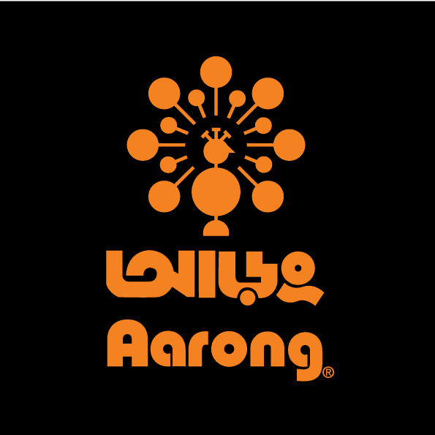

Figure 2: Aarong Logo

Aarong has a very unique and sophisticated logo. It has a color combination of black and orange. There is a black background and an orange colored peacock in the middle. Below the peacock the brand name “Aarong” is written in both Bangla and English with bold orange colored font. The eye-catching peacock symbolizes natural, echo-friendly, colorful and diversified product line. The logo is very luminous and attractive because of the color combination and the peacock with its tail. Here the black represents professionalism and belief of tradition and trend together. The orange represents energy.

2.3 Mission Statement:

The mission statement of Aarong is-
“To make Aarong the best in the world in providing a unique Bangladeshi lifestyle experience which promotes Bangladeshi pride while empowering people and protecting the environment.”

2.4 Vision Statement

Aarong’s vision is a just, enlightened, healthy and democratic Bangladesh free from hunger, poverty, environment degradation and all forms of exploitation based on age, sex, religion and ethnicity.
It also has a vision to establish itself as world’s one of the famous fair trade fashion house and to remain market leader throughout its business.

2.5 Values

Aarong has always been striving for creating better opportunities for poor and underprivileged people of Bangladesh just like BRAC. So its values are made in such a way that it meets Aarong’s mission, vision and goals perfectly. The values of Aarong are as follows -

- Integrity
- Inclusive
- Innovative
- Effectiveness

The four key values are shown in the diagram-

Values of Aarong

Key Values of Aarong
Their key values are described here-

- Innovation: Innovation is the most important value of Aarong. Because innovation is the only thing with which the poor people of Bangladesh can find their way out of poverty. Moreover Aarong has always shown a ground breaking history of innovation for Global leadership in development initiatives for poor and underprivileged people of Bangladesh. (Our Values, 2017)

- Integrity: Integrity means honesty, sincerity, truthfulness. Aarong follows strong moral principles in all their policies and procedures. Their policies are very transparent which holds their honesty toward their ethics. They have a very genuine history of dealing all financial procedures in a very honest manner. (Our Values, 2017)

- Inclusiveness: Aarong is the epitomic example of inclusiveness. They are inclusive toward each and every member of Aarong family regardless of their gender, color, religion, ethnicity, financial status and other differences. (Our Values, 2017)

- Effectiveness: Aarong thinks it is important to face challenges in their work so that they can perform better, make improvement on their work and go deeper for solution. (Our Values, 2017)

2.6 Contribution in Export

Aarong exports both textile and non-textile products to more than 15 countries around the world. Aarong has started their exporting journey in 1986. They mainly export knitwear, woven apparel, home décor and fashion accessories, jute and leather products, candles and other novelty items made of metal, terracotta, brass and paper. (Export, 2017)

2.7 Rewards

In 2015 Aarong own the Best Brand Award in the Fashion Boutique category at Bangladesh
Brand Forum’s Annual Award Ceremony. Aarong own the Marketing 3.0 award on September
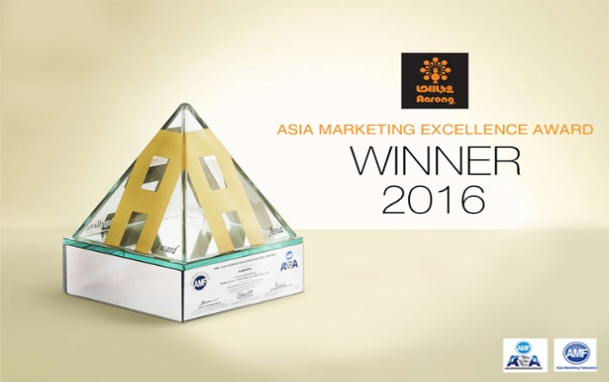

23rd, 2016 and they were competing among 19 other member companies of The Asian Marketing Federation (AMF). Md Abdur Rouf the COO of Aarong received the award in South Korea. (Aarong - Marketing 3.0 Award Winner 2016, 2017)Aarong also own the 2012, UNESCO Award of Excellence for handicraft in South-East Asia for the famous Jamdani. (Hasan, n.d.) The famous Nakshi Katha of Bangladesh was also praised by the UNESCO panel for its fine execution on color, design and mix of tradition with contemporary design. (Hasan, n.d.)

2.8 Product Line

Aarong is the largest retail brand in Bangladesh with more than 100 product line. People like Aarong’s product due to their exclusive collection and unique mix of traditional and contemporary design. Aarong has product for all age and all gender. Here the product line is divided into some categories and shown in the figure below-

Aarong

Jewelry
Women’s
Item
Kids
Item
Men’s
Item

Others
Dairy
Items
Home
Decor

Figure 3 : Aarong Product Line

2.9 Taaga and Taaga Man

Taaga and Taaga man are Aarong’s sub-brand. Taaga is targeted specially toward women. Taaga has its own outlet in Saat Masjid Road where they display their exclusive products. Taaga Man is for men and they specially target people who wants to dress classy. Products of Taaga Man are also available at some Aarong outlets.
Aarong has more than 100 product line but sale ratio of all the product category is not the same. They sale in different ratios which is given below-

Figure 4: Sale Ratio of Different Products

Part 3

Internship Journey

Internship Journey

In the previous part of the report the organization overview has been discussed, in this part I would discuss about my internship journey and my duties and responsibilities at Aarong. I was assigned in the recruitment and selection team of Human Resource department at Aarong. So most of my work were related to the recruitment and selection process. I would try my best to discuss all my duties and responsibilities in a clear manner.
During the internship journey I was assigned with some duties and responsibilities by my supervisor at Aarong. Those could be categorized into two parts-
- Regular activities
- Project task

3.1 Regular Activities:

- Attending Phone Calls:
Attending phone calls was another part of my regular job duties. Sometimes the employees of the HR department may get busy in a meeting or may visit other department colleagues for work issues, so during that time if they get any call then I had to attend it. If the person from the other side had any important message then I had to note it down on a sticky note and also ask their name and department. When my senior HR colleagues would return from their respective work I had to deliver the message with proper accuracy to them. Sometimes I would attend the call and the person calling may ask for some quarries, if I knew the answers than I would reply to them and if it was very important issue than I would note that and ask my senior colleagues for the answer.

2. Preparing Lists:
One of my daily work at Aarong was to prepare the lists of candidates whose CV’s were shortlisted for interview. There were two types of lists-
- Single list
- Detail list.

- Single list:
It would contain the serial number, name, fathers name, contact number, space for signature and a space for remarks. I had to put all the information in a excel sheet for the single list. Other than that the list also includes the name of the position for which the applicant has applied, date of the interview along with the time and venue of the interview where the interview would take place.
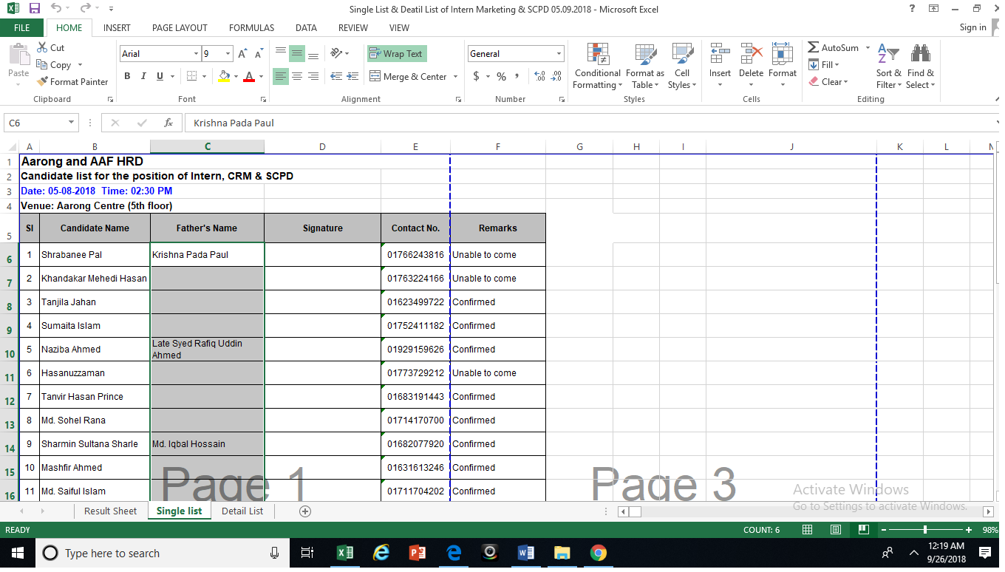

Figure 5: Single List

- Detail list:
Detail list is mainly used for the interview purpose. It includes the serial number, name of candidate, present or last designation, Year of experience, academic institution name and other different categories on the basis of which the candidate is judged during the interview, such as basic knowledge, flexible mindset, time management, logical approach, learning attitude etc. The detail lists are different for different grade of employee. During the interview the board members would give marks to the candidates based on different aspects. There is one detail list for 1 to 4 grade of employees and another for 4 and above grade. There is also a different detail list for service grade employees such as drivers, office assistant etc.
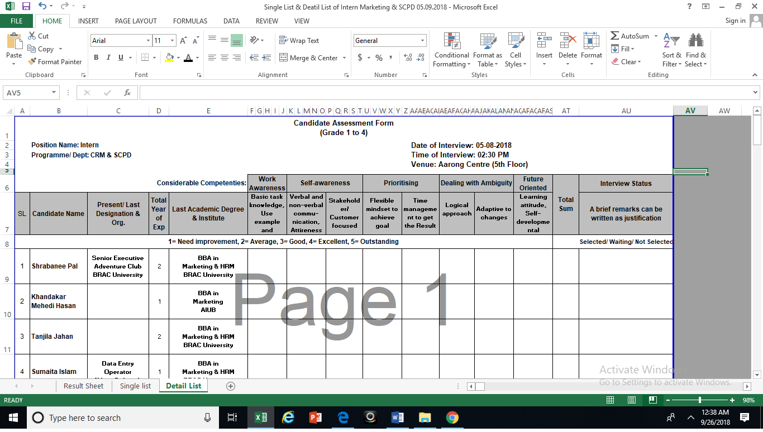
Figure 6: Detail List

3. Co-coordinating Interview:
Another very important task was to co-ordinate interview. Co-ordinating interview basically means assisting while the interview of the candidates took place. I had to prepare the attendance list of the candidates and when the candidates would come they had to provide their signature beside their name. After signing the attendance list I had to take them to the waiting room where they would wait before the interview takes place. While the candidates used to wait I had to provide them the initial information form where they had to fill up some important information about them. If the candidates were for high positions (i.e. Manager) then it was very important to keep an eye on their comfort. The office assistant would offer them tea or coffee, it was my job to ensure that all the waiting candidates were offered tea or coffee by the office assistant. I also had to plan the serial of the candidates who would go first and who would go later. It takes place according to their serial in the attendance form most of the time. When the board members would get ready and order me to send the candidate inside the board room, I had to provide them the filled up initial information form and then send the candidate to board room. I also had to attend any queries asked by the interview board members during the interview. Sometimes the board members would ask about the number of candidates or number of waiting candidates because they had to manage the time and finish the interview within a specific time frame. Sometimes the interview of one candidate might take time in that case I had to politely inform the waiting candidates to wait for a while. It was very important to keep the information properly which candidates attended the interview and who did not. If any candidate did not come for the interview then I had to write absent as remarks in the attendance list. After interview gets finished I had to make sure that all the files were properly collected from the interview board and handover the files to my Senior HR Officer.

4. Shortlisting Applicants CV:

When there is a vacant position in Aarong centre or any outlet they would give advertisement in online media (www.bd.jobs.com) and renowned newspapers. Applicants may send their hardcopy CV directly to Aarong or they may also apply through BD jobs website or they may email CV to Aarong. It was my duty to shortlist those CV from CV bank or email. Every position has some predetermined qualifications that an applicant must meet such as education, experience, age, salary expectation etc. So my Senior HR Officer would give me all the requirement that an applicant must have and according to that I would shortlist the CVs from the CV bank of BD jobs and Aarong’s email. I also had to shortlist hardcopy of CV which were sent by the applicants at the Aarong Centre, HR department. There were also some internal employees CV and referred CV which needed to be sorted. If an applicant’s CV met all the qualities and requirement then I had to download those CVs from the CV bank and email. After that I had to make a different folder for those CVs and save them. Afterwards my Senior HR officer would check those CVs and if they think it is important to reject any CV then they would do that and go for further shortlisting. After the completion of the CV shortlisting process the Senior HR Officer would give me the final CVs and order me to prepare a single list and detail list for those applicants. She would also give me the date and time of the interview and according to that I would prepare the list. It was also very important to keep the hard copies of the CVs safe in a file at a specific place.

5. Phone Calls and Messaging:
After preparing the single and detail list properly, I had to call the interview candidates and inform them about the interview and written test related information. Some position would require both written and viva test. So if a position would require both written and viva test then I had to provide them with the proper information regarding the date, time and place/address, where the tests would take place. Sometimes few candidates would miss our phone calls, in those cases we had to mark their name and call them later again. Generally the calling session would take place 2/3 days before the interview/written test. Some candidates would call at our office for information regarding the interview date, time, address of office and I had to attend their calls and make sure that they get all the needed information properly. It was also very important to attend the calls in a very polite manner because our behavior shapes the image of our organization and Aarong HR department always tries to make their best impression at the very first sight/contact. During the calling session I might find candidates who would not be able to come for the interview at the specific date , in such cases I had to keep remarks of that and inform about it to my Senior HR Officer.
After the calling session comes the messaging session. After calling all the shortlisted candidates it was my duty to create a note pad folder. The notepad file would contain the contact numbers of the candidates. Then we would message each and every candidate the detailed information regarding the written test or interview. The calling session takes place for the second time at the day of interview and it is called the reminder call. It was my duty to give a reminder call to the candidates at the day of the interview and confirm that all the candidates are coming to attend the interview.

6. Compiling Result:

After the interview finishes it was my duty to make sure that all the candidates have signed the attendance sheet. Then I had to collect all the interview file from the interview board members and make sure all the necessary papers are inside the file. The interview file would contain the detail list, board members list, requisition paper and code of conduct. In most of the cases the board member would consist of HR department, third department and concerned department. In many cases there could be four board members also.
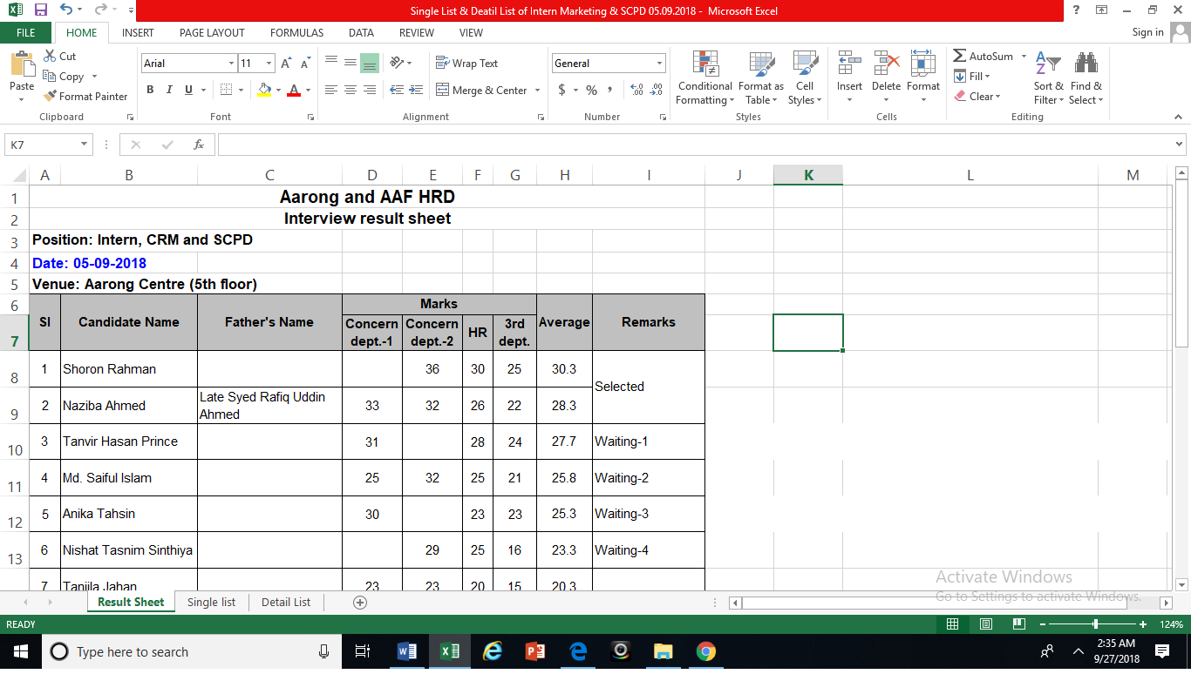

Figure 7: Result Sheet

I had to collect the third, HR and concern department’s interview file and compile the marks in a excel sheet. First I had to put the candidate’s serial number, name, father’s name, marks given by different department and remarks along with the position name, department, date, time and venue. The marks of the three departments are put in separate columns and the total and average marks of each candidate is calculated. For the written test I had to do the same thing such as counting the exam paper marks, making sure there is no miscalculation of the marks. If I found any miscalculation then I would inform my Senior HR Officer and she would solve the problem and correct the marks, and later on I would compile the marks in a excel sheet. The candidate who gets the highest marks is usually the selected one. Those who get the second and third highest marks are kept in first and second waiting list. I had to make sure the marks are properly compiled and there is no mistake in the calculation. Another important thing that I had to check is the signature of the board members in detail list. I had to make sure that all the necessary papers have all the necessary signature in the right place by the right person. So I had to check and recheck it.

7. Assist in fulfilling joining formalities:

After the written test and interview when a candidate is selected they had to come to HR department with some important papers for joining formalities. My duty was to assist new employees in their joining formalities. During the joining formality new employee had to fill-up their history form, joining form, ID card form, nominee form and sign the code of conduct. They also had to bring real and photocopy of some important documents such as-
- Curriculum vitae
- 5 copies of passport size photo
- Educational certificates
- Blood group report
- National ID card/ Birth Certificate
- Nominee National ID Card
- Nominee Photo (Studio Copy)
- Photo for guardian form (Studio Copy)

My responsibility was to check the documents properly and make sure the educational certificates are real. We would often check via the internet and check the authenticity of the certificates. After checking the certificates, we would check the employees NID and his/her nominee’s NID and make sure that the NID card name matches with the education certificate’s name. Then we would collect the CV with his/her signature with date and photos. Then the person would fulfill the ID card, history, joining, nominee and guardian form with proper information. In the forms they had to provide their references names, addresses, contact numbers and other detail information. I had to make sure they are doing it properly. If they have any queries they would ask me and I would answer them. After all the formalities are done we would return them the real certificates and only keep the photocopies. In many cases employees may not bring all the documents in those cases the Senior HR Officer gives them another date within which they must submit all the necessary documents. After joining every employee gets an employee pin number.

8. Preparing Files:
When all the important documents are submitted by the newly joined employee, I had to keep the documents in a file. The Senior HR Officer would write the name, joining date, outlet name (in case of a sales associate) or department name of employee and pin number on the file cover. Then I had to compile the documents according to their serial. I had to attach a checklist of the documents on the file and put a tick mark beside the documents name which had been submitted by the newly joined employee. If any document is not submitted then I had to write on the checklist that the document needs to be collected. On the checklist a photo of the employee is attached. Then one by one the appointment letter, history form, joining letter, CV, educational certificates, employee NID, nominee form, nominee NID, guardian form and code of conduct are attached with photo and punched in the file. If all the necessary information and documents are properly provided by the employee then those files are sent for scanning because the scanned information are kept in the HR database. So we had to make sure all the documents and necessary information are properly given in a file. If any document is missing or if any information is not provided then I had to note it in a sticky note and stuck it on the file and give those files to my Senior HR Officer. Such file are called the “Problematic Files”. Then she would call the department and ask them to inform that employee to submit the necessary documents and information to HR department. After collecting the documents and proper information if everything is fine then I would submit the files to my Senior HR Officer and she would verify everything. If she finds everything is okay then she would send those file for scanning.

8. HRMS and ERP entry:
When all the document of an employee is properly collected and the manual file is created then we would go for the ERP, HRMS (Human Resource Management System) and EDMS (Electronics Document Management System) entry. My responsibility was to give data input for the ERP and HRMS software. Every employee is given a specific pin number, I had to put that pin number in the ERP and his information window would get logged in. In ERP I had to give input of the education, references, address, nominee and children information. At the time of inputting all the information in the ERP I had to make sure I was giving accurate information according to the documents. In case of inputting the references information I had to make sure all the information regarding the reference is available such as name, address, and contact number and occupation information. It was also important to make sure that the reference actually qualifies as a reference. For example a student who is under 18 years can not be a viable source of reference. So it was also important to check the viability of a reference. I had to input their address information such as the permanent and current address, education information, name of the institutions, result, passing year etc. Then there were also the nominee information and children information where I had to input the nominee name, address, age, NID number etc. If a person is married and he has children then I had to input his children information too. After inputting the ERP information my duty was to log into that employee’s HRMS and put some specific information for which I was assigned. I had to input the contact number, permanent and present address of the employee. I had to make sure that the district, post office, police station, house number etc. are properly and correctly provided.

9. Some Other Activities:
There were some other activities that I got the chance to perform and which increased my knowledge in some other fields. These activities were not performed on a regular basis by me but the HR department enabled me to do those tasks so that I could learn about such things.
- Preparing Appointment letter:

An appointment letter is basically an agreement between Aarong and the newly joined employee regarding the terms, conditions and other facts of the employment. I had the opportunity to prepare the appointment letter of the newly joined Manager of the SCPD (Social Compliance and Producers Development) department. In the appointment letter the name, fathers name, pin number, joining date, salary, department name and other terms and conditions are described.
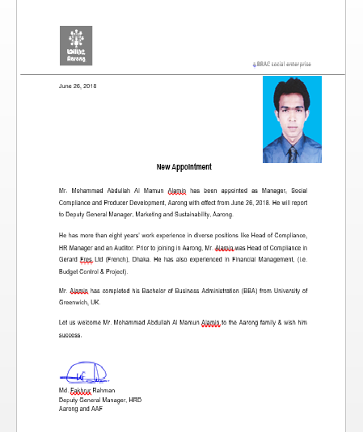

Figure 8: Appointment letter

- PMS form:

I also got the chance to do some work related to performance management system of the outlet employees. My main duties were to input page number in the PMS form because those forms are scanned and then uploaded to the HR database software. I also had to check that the HR Manager signature has been provided in the form and other important seals are properly placed in the form.

- Issuing Access Card:
When a sales associate is selected by Aarong for a specific outlet they are asked to bring their necessary document to the HR department for submission. On the given date the new sales associates bring their documents such as educational certificates, photo, NID card etc. They also have to fill up a form. If all the documents are submitted then the sales associate gets an access card. In the access card the candidate’s name, fathers name, stamp size photo, signature, serial number, signature of Executive, HRD (Aarong and AAF), shift name, outlet name along with the official seal of Aarong is attested. Only after getting the clearance card from the head office he/she can join the outlet.

Part 4

Analysis of HR Activities

(Project Task)

Aarong center is the head office of Aarong and Ayesha Abed foundation. So all the recruitment and selection process for Aarong and Ayesha Abed foundation takes place here. Apart from the recruitment and selection process, the HR department of Aarong is responsible for some other very important work. Aarong has a lot of outlets around Bangladesh and maintaining all the human resources of all the outlets along with the head office staff and Ayesha Abed foundation employees is a huge challenge. Aarong has one of the strongest HR department in Bangladeshi corporate world.
During my internship period I was assigned in the recruitment and selection team. So I was able to learn each and every step of the recruitment and selection process. It was very hard for me to learn about all the human resource activities performed by Aarong within the short period of three months. But I was lucky enough and my senior colleagues were very helpful to teach me about the overall activities of the HR department. Other than that I have also gained knowledge by observing the other activities. So here I will do an analysis of the overall HR activities based on my practical experience, learning and observation.
The Aarong Human Resource department consists of four teams and each of the teams are responsible for each area of work. The teams’ are-
Figure 9: HRM Department Teams
Support &HRIS team
Grievance &
Separation
Compensation
Management
Recruitment &
Selection team
Aarong
HRD

4.1 Recruitment and Selection Team:

Recruitment and selection team is responsible for appointing the best qualified match for a vacant position in Aarong and Ayesha Abed Foundation. The recruitment and selection process is a very important process for any Human Resource department. Aarong recruits for Aarong head office staff, Ayesha Abed Foundation and the different outlets. So here I would like to discuss the overall recruitment and selection process of Aarong and Ayesha Abed Foundation first, and then I would discuss the recruitment and selection process of the Sales Associates for outlets.

4.1.1 Recruitment & Selection Process of Aarong and AAF:

The HR department of Aarong follows the recruitment and selection process step by step. Here, a flow chart has been used to make it more precise along with the description. Aarong follows both internal and external recruitment process. They take CV from both the internal and external candidates. But it does not mean that they favor the internal candidates, Aarong strongly focuses to choose the best qualified candidate for a particular position. For the highest management positions most of the time Aarong and AAF follows the internal recruitment because they want a person who already has experience about Aarong. They use the external recruitment process for mid-level and management level positions. Some departments where Aarong needs new, innovative and fresh ideas they go for external recruitment, such as marketing or design department.
The process mainly starts from requisition from different departments. The process is described below-
- Requisition from different department to HRD:
This is the first step of recruitment and selection process of Aarong and AAF. In this step the HR department accepts the requisition from other department. Then they have to collect the approval of the COO and other authority. After collecting the approval the HR department prepares the job description and specification for thst specific position.
Recruitment & Selection Process

Internal
External
Requisition Accept & Approval

JD & JS prepare

Advertisement in different media
Newspaper, Bd jobs, Postering.

Fixing date for written test & interview

CV receive & screening

Calling & texting session
Deploy Employee
Joining & Appointment Letter
Preparing Single & Detail list, Other Formalities
Preparing Question
Prepare File & ERP, EDMS Entry
Job Offer to Selected Candidate
Written test, Interview & Result Finalize
Figure 10: Recruitment & Selection Process
Entry Punch & CS Visit
Detail Form, Life Insurance, Guardian Form Fill-up, Reference Check
- Advertisement in Different Media:

After the approval of the requisition leads to the second step which is advertisement. Between the first and second step the preparation for creating the job description and job specification also starts. After preparing the job description and specification the advertisement part starts. Aarong basically prefers the renowned newspapers, online media (BD Jobs.com) and postering job circular in different area. In all the job circular they provide a specific deadline and applicants must apply within that deadline.

- CV Receive and Screening:

After the deadline a lot of CV is collected via email, bd job CV bank, hardcopy CVs from Aarong CV box, internal CVs and referred CVs. After collecting the CVs the screening of CVs takes place. CVs are sorted on the basis of some specific criteria such as education qualification, result, experience, age limit and salary expectation. In most of the cases the written test takes place first then the selected candidates from the test takes place for the interview. After the interview the most qualified candidate is selected.
Date Fixation: At the time of CV screening a specific date is fixed for the written and viva test/interview.
Preparing Question: After fixing the date for written test and interview the question preparing part starts. An assigned HR Officer prepares the question according to the position for which the recruitment and selection would take place. After preparing the question it must get the approval from DGM and if any necessary changes need to be made then it is done.
The question is made on the basis of some criteria-
- Job related knowledge
- Analytical ability
- General knowledge/English

- Calling and Messaging Session :

In this step we call the selected candidate and inform them about the written test date, time and location of the office. During the phone call the caller must maintain a very polite tone and handle the situation very professionally. Because it creates the impression of Aarong to an outsider. During the phone call the candidate may seek for some other information such as they might ask about the written test and what will be the written test criteria etc. or they might ask for the required documents that they need to bring. We have to provide them with all the necessary information that they ask for. We also have to make sure whether the candidate is interested for the position or whether they will come for the written test or not. After the calling session we get the confirmed candidate lists and those candidates are sent message which includes the name of the position, date, time and address of Aarong. Sometimes email is also sent for some higher level positions.

- Preparing List and Other Formalities:

In this step the single and detail list is prepared along with the board members list. The single list includes serial number, the candidate and their father’s name, contact number, space for their signature and remarks. The detail list includes their name, name of current or past organization, experiences, educational qualification and name of institution. This list contains considerable competencies on the basis of which a candidate is given viva status. So this list is very important, through this list the interview board members gets to know all the information at a glance about the candidate. So this list is prepared very carefully.
Other Formalities: There are also some other formalities such as inviting the board members, booking room for written test-interview and confirming the agreement of invigilator.
- Test and Finalizing Result:
In this step the written test takes place. After the written test the candidates are asked to wait for a while and the HR department starts to check the answer sheet. After checking the answer sheets, passed candidates are selected for the interview. After successfully completing the interview test, the HR department compiles the result on the basis of the interview file marks and the best candidate is selected for the position. For some position there could be some practical tests such as computer literacy. It basically depends on the position for which the recruitment and selection is taking place. However the best candidate who gets the highest marks are selected by the HR department.

- Job Offer:

The selected candidate gets a call from the HR department and they are informed about their selection. Then the candidates are informed about the policies and benefits of the job offer. If the candidate agrees and confirms their joining then they are given a specific joining date on which they must join and fill-up their joining formalities. During the phone call the selected candidate is informed about their basic salary, mobile allowances, holidays and other benefits which they will get as an Aarong employee.

- Joining and Appointment Letter:

On the joining date the new employee has to fulfill some formalities such as submitting their educational certificates, Photo, CV, NID, nominee NID, photo and other relevant documents. Then the candidate has to fulfill some form such as-

- History Form
- Joining Form
- Nominee Form
- Guardian Form
- Signing Code of Conduct
- Reference Check

After fulfilling all the formalities the new employee is given the appointment letter and he signs it. The HR team also clarifies him about his duties-responsibilities, rules-regulations and norms of Aarong.

- Preparing File & Software Entry:
After the employee joins Aarong, a file is created with all the document submitted by him. The employee gets his/her PIN (Personal Identity Number) number. Then all information regarding the employee is input in the ERP and HRMS software. Information such as name, father’s-mother’s name, birth date, permanent, present address, reference information, education information, nominee information, children information(if any) are input in ERP.

- Deployment of Employee:
In this stage the person already becomes an employee of Aarong. He/she has their own pin which is their identity in Aarong. After confirming their entry exit punch the employee is finally deployed to his/her respected department. Then the manual file is given to compensation management team. And they work for his/her salary preparation.

4.1.2 Recruitment and Selection Process of Sales Associate:

Aarong is the largest lifestyle retail chain in Bangladesh who manages outlets around the country. These outlets require a lot of manpower who serves the customer in the best possible way. Moreover, Aarong has such a huge image in market which needs to be maintained always in every aspects of their business. So Aarong is very cautious in case of choosing the manpower for their outlets. Recruiting and selecting the best possible person who could represent the brand at its best to the customers is very important for Aarong. Because customers impression is created through the sales associates who co-ordinate them while shopping. Before discussing about the recruitment and selection of sales associates in Aarong, it is important to understand the operational network diagram of Aarong.

Head of Retail & Infrastructure

Outlet Manager

Floor Manager
Floor Manager

Supervisor

Supervisor
Supervisor

Sales
Associates
Sales
Associates

Sales
Associates

Sales
Associates

Sales
Associates

Sales
Associates

Figure 11: Operational Network Diagram

Mainly the operation network of Aarong starts from producing the products at Ayesha Abed Foundation. It has 653 sub-centers across Bangladesh. Other than the 13 production centers there are also independent artisans who sells their products through Aarong. (Our Artisans, 2017)
The management of operation of the overall outlet is done by the outlet Manager. Under the Outlet Manager there are the floor Manager. Under the Floor Manager there are Supervisors. They are responsible for the supervision of the Sales Associates. The outlet manager supervises the overall outlet performance and directly reports to the Chief Cooperative Officer of Retail and Infrastructure.

Recruitment & Selection:
For the recruitment and selection process of Sales Associates, Aarong follows a very systematic process. Which will be discussed in this session.

In human resource management, “recruitment” is the process of finding and hiring the best and most qualified candidate for a job opening, in a timely and cost-effective manner. It can also be defined as the “process of searching for prospective employees and stimulating and encouraging them to apply for jobs in an organization”. (Martin, 2016)

Selection is the process of picking individual out of a pool of job applicant with required qualifications and competence to fill job positions in the organization. The formal definition of selection is, selection is the process of differentiating between applicants in order to identify and hire those with a greater likelihood of success in a job. (Sarkar, 2016)

So, here we can see that there is a slight difference between recruitment and selection process. Recruitment is a positive process, where an organization wants to attract as much as pool of candidates. Whereas selection is a negative process where an organization only chooses the best qualified candidate for a specific position.

In case of Aarong they also attract a huge pool of candidate to apply for a position and finally selects the most qualified person for the vacant position. As Aarong uses a very structured recruitment and selection process for their Sales Associates, it will be discussed in the next part.

Requisition from outlets
Figure 12: Recruitment & Selection Process of Sales Associate Aarong
- Job Circular
- Internal
- External
- Employee Referrals
Selection
Recruitment
Performance Appraisal
- CV Sorting
- Calling for Interview
- Screening Interview
- Providing Training
- Final Selection
- Documents Checking
- Issuing Access Card
- Preparing Appointment Letter
- Updating HRMS
- Handover File to HR Employee file Store

- Requisition from Outlets to HR Department:

This is the first step of the recruitment and selection process for Sales Associates. At the very beginning the outlet Manager of a specific outlet finds out their requirement for Sales Associate. If there is a need for more Sales Associates in his/her outlet then he would send a requisition to the HR Department of Aarong. Here requisition means a formal demand to the HR Department for recruitment and selection of Sales Associates. Then the requisition form has to be approved by the Director and Head of the Retail Department of Aarong. The number of Sales Associate for which shift whether male or female etc. information are precisely described in the requisition form. After this step the second step starts with posting job circular.

- Recruitment:

As it is discussed earlier that in the recruitment process an organization wants to attract as much pool of candidates as they can. Aarong uses both internal and external sources for recruitment. They also recruit from employee referrals.

- Job Circular/ Advertisement (External Source):
After getting the requisition from different outlets the Senior Officer of HR department posts job circular in different media. It is the first step of recruitment process. Job circular is posted in notice board, outside of the organization, outside of the outlet for CV collection. They also post job circular in BD Jobs.com and renowned newspapers.

- Internal Source:

If there are qualified existing employee within the organization who matches the requirements for the position then they can apply for the position. They sends their CV directly to the HR department.

- Employee Referrals:

Employee referral is an internal method for finding job candidates. By definition, employee referral is a structured program that companies and organizations use to find talented people by asking their existing employees to recommend candidates from their existing networks. (Definition of Employee Referral, n.d.). Aarong uses employee referrals to find candidates for Sales Associate position.

- Selection Process:

- CV Sorting:
After collecting CV from online media, internal sources and CV drop boxes outside outlets and Aarong Centre, the CV sorting process starts. CVs are shortlisted on the basis of some criteria such as the candidate should not be from madrasha Background, they must have completed SSC, HSC, and running student/ enrolled in Honors level study etc. For the Sales Associate position there are some other very important criteria such as age, grooming etc. The age of a candidate must be within the range of 18 to 26. Candidates must be smart and must have the ability to speak clearly for customer service. So the candidate must meet the requirements.

- Calling for Interview and Creating List:
After shortlisting the CVs, the shortlisted candidates are given call and informed about the date, time, address and other information related with interview. After the call they are sent message with all necessary information. Then the single list, detail list and board members list is prepared.

- Screening Interview:
During the interview a candidate is judged on the basis of some qualities such as their smartness, speaking ability, smartness, dress up, customer handling power, analytical ability etc. After interview the best candidates are selected for training session. They are provided with the information regarding training such as training time, date etc. in a paper. The list of candidates who are selected for the training is sent to the Training Officer of Training department.

- Providing Training:
In the training session for Sales Associates master module is followed. They are provided knowledge regarding the HR policies, products, sales policies, customer services and other information regarding the organization. The training follows various methods such as –question answer, interactive discussion, lecture etc. The main objective of this training is to prepare a Sales Associate in such a way who can deliver their best service to the customer and try their best to satisfy the customer and maintain the legacy of the brand “Aarong”.

- Final Selection:

During the training session the candidates are judged on qualitative basis by observing their behavior, learning capability, sincerity, concentration etc. And after the training the candidates appear in a written test. The written test includes questions related to the training session. If a candidate gets total 60% marks combining both the tests then he is regarded as passed. However the best performers are selected as Sales Associates.

- Documents Checking:
The selected candidates are given a specific date on which the candidates are required to submit some documents. After checking all the references, certificates and national ID card and collecting the photo they are provided with an access card.

- Issuing Access Card:

If all the documents are submitted properly and information are accurate then the selected candidate gets an Issuing Card. Which is a clearance from Aarong, Head Office. The issuing Card contains the name, father’s name, outlet name, position, signature, stamp size photo, Executive, HRD (Aarong & AAF) signature and a seal of the Aarong HR department. Then the person has to report to the Manager of the outlet with the issuing card.

- Preparing Appointment Letter:

The new Sales Associate is provided with an appointment letter by the HR department which includes his/her PIN number, terms–conditions, policies of job, outlet name, shift and other necessary information. The PIN number is the personal identity of that new Sales Associate. Two copies of the appointment letter is made and send to the outlet.

- Updating HRMS:

Finally all the information regarding the employee from the submitted documents are input in HRMS database. It is the current status of the employee.

- Handover File to HR Employee file Store:

In this stage a file is created for the employee. Which contains the photocopies of his educational certificates, references, NID photo copy, joining date, personal information, code of conduct, photos etc. After attaching all the necessary papers and documents the HR Officer/ Senior Officer signatures the file, checks everything and then sends to the Employee file store.
- Performance Appraisal:
The probation for Sales Associate is six months. After six months a performance appraisal takes place and if a Sales Associate’s performance appraisal report is satisfactory then he becomes a permanent Sales Associate.

So these are the proper steps which is followed by Aarong for the recruitment of their Sales Associates. As already mentioned earlier that Aarong has a very strong Human Resource department who are very active, enthusiastic and strict to comply with the vision, mission and goals of the organization. One of the very important thing about Aaong’s recruitment and selection process is that they believe in equal opportunities for all. They do not discriminate between male-female candidates or the minority groups. Which is an incredible initiative taken by Aarong.

4.2 Compensation Management

Compensation refers to what a business offers to its employees in exchange for their hard work. Compensation includes the money they pay to their employees, including base pay, overtime pay, and bonuses. It comprises group insurance, which includes health and dental insurance. It also includes pension, group registered retirement savings plans (GRRSPs), and deferred profit sharing plans (DPSPs). Long-term disability insurance, tuition reimbursement, vacation days, sick days, daycare and even flexible work arrangements all fall under the umbrella of compensation. (Lang, What Is Compensation Management?, 2017)
Compensation Management simply means that an organization is strategically managing employees’ compensation. The goal of compensation management is to ensure that organization is spending their compensation in the right areas and getting the maximum returns from its employees.(Lang, What Is Compensation Management?, 2017)

Aarong has a strong compensation management team who deals with compensation and pay system. This team’s work areas are-

- Loan: The compensation management team looks after the loan sanctioning process. For financial security the management staff can take loans. The management staff in Aarong can take car loan from the organization. There are some loans for staff such as staff loan, special loan, welfare fund loan, higher education loan, provident fund loan (only for BRAC staff), home-motorcycle-mobile loan etc. The team sanctions loans. As well as takes care of the approval of the loans. First they provides the employee with a form and they have to fill-up it properly and submit some documents. The compensation management team checks with the employee personal information file and verifies reasons why the employee needs loan. Then the team check the accounts and takes approval from necessary authorities (i.e. Director). After all the necessary steps are performed according to the rules, regulation and policy of the organization the loan is sanctioned. All the information are updated in the EDMS (Employee Database Management System).

- Travel Authorization: This team also works for travel authorization issue. Whenever employee travels for office work purpose this team approves the travel authorization. Whenever staff of Aarong travels for official purpose it incurs some cost, the cost is borne by the organization. So the employees are given a travel authorization form and they fill-up the form properly. Then they have to take permission from the Director or Head of department and the HR department calculates the costs. Accounts Department is informed about it and the staff gets the allowance.

- Salary: This team has a huge responsibility of salary management and adjustment. Aarong has permanent employee, management employee, part time employee, project based employee etc. So this team fixes the salary for different type of employees based on their grade and slab. Other than this salary adjustment is another very important role of this team. Due to the inflation and rise in the living standard adjustment in salary is done. Mainly salary adjustment is done for the confirmed employees. This team does all the calculation regarding the adjustment of salary and also takes care of other formalities that is related to it. After all the formalities are fully done then the employees and Account department gets the letter regarding the new adjusted salary. Increment is another very important issue. Employees can achieve a pay raise by showing a good performance. So, this team is responsible for calculation of the increment and adjusting it. Advance salary is another important issue that is taken care of by this team. In cases one employee may go out of town for important work purpose and he might not get back within that month in that case the employee gets advance salary.

- Fund: This team also looks after the important issues such as the fund. So the compensation management team is responsible for proper management of the gratuity fund, provident fund, health care insurance etc.

- Gratuity:

To gain gratuity an employee’s employment with Aarong can not be less than three years. An employee is eligible for gratuity at the rate of their last month’s salary for each completed year and if he has been working for Aarong for more than three years and he has not been dismissed by Aarong.

- Provident Fund:

When an employee of Aarong becomes a confirmed employee then he has to give 10% of his salary for contributory compulsory provident fund. Arong also gives the same amount of money for provident fund for that employee. An employee would only get his portion of money but nothing from Aarong if he leaves job before the completion of three years. An employee gets full portion of his money and half from Aarongs contribution if he leaves job after three years but before the completion of five years. An employee will receive full amount of his own contribution and Aarong’s contribution if he leaves job after the completion of five years employment.

- Allowances: Employees of Aarong enjoys house, mobile, hospital, overtime, special, transfer, distance, entertainment, transport, conveyance, accommodation and food allowance etc. So the compensation management team looks after those allowances calculation and recording them properly.

4.3 Job Separation and Grievance Management team

- Job Separation: Job separation is a very important task of this team. It means both ending the job by the employee or termination of job by the employer. Separation can be-

- Retirement
- Resignation
- Dismissal

- Retirement: Basically retirement means withdrawal from an active working life by the employee. According to Aarong the age of retirement is 60 years or if an employee has been working for Aarong for 20 years he can take retirement. Retirement must occur according to Aarong’s policy.

- Resignation: If an employee wants to leave his job he could do that but it must comply with Aarong’s rules and regulation.

- Termination and Dismissal: Dismissal means termination of employee against his will. Aarong has some general discipline, rules-regulation and code of conduct which is strictly maintained by them. Unethical work is strictly prohibited in Aarong. But if an employee is found to be involved in any kind of unethical work or anything that breaks the rules-regulation, code of conduct of Aarong then he is dismissed. But Aarong follows a systematic procedure for their dismissal of employees. If it is found to be not highly harmful then they warn him/her by sending a warning letter. But if the case is highly harmful then investigation takes place. If evidence proof that the employee is guilty then he is terminated.

Some procedures of termination are-
- An appeal is made to the HR department about why an employee should be dismissed.
- Aarong HRD forms an investigation team who digs deep into the matter and goes for full-fledged investigation. And submits a report to the HRD based on the findings of the investigation.
- After the assessment of the HRD the report is sent to the Director of Aarong.
- The Director of Aarong finalizes the decision whether the employee should be terminated or not.
If an employee is terminated then he is notified about his termination by the HR department. In case of termination an employee is not provided with facilities which were promised by Aarong. Such as insurance money, provident fund etc. are not provided to him/her.

- Grievance Management Team:
Grievance management is a very important issue that is carefully managed by the HR team of Aarong. It is very important to find a solution to any grievance related issue in an organization or it may create other conflict in the organization. First the victim sends a written complaint or reports the incident to the Human Resource department of Aarong. Then an investigation team is created who sends a show case letter to the accused party. After accepting the reply within one week the investigation team prepares a report. Then the investigation committee reaches a final decision regarding the case. The accused party is informed about the decision. All the files regarding the investigation are carefully recorded, maintained and secured.

4.4 Support and HRIS Team:

Support and HRIS team has a lot of important work such as- attendance, leave, id card issue, HRIS etc. Here these works would be discussed.

- Attendance:
The Head Office of Aarong and outlets uses different attendance register method. For the regular staff at Head Office, they have to punch their id card when everyday they enter and leave the office. The timing of each employee’s arrival and leave time is pulled through a software. It is the duty of the HR department to keep the track of all this information from the software (HRMS). Attendance is a very important issue in Aarong because it is related to other issues such as salary, performance etc. The regular staffs have to punch their id card in the punching machine for attendance. A regular employee can punch their id card up to 8:45 am and it would be counted as present on time but from 8:46 am to 9:30 am would be counted as a late attendance. And if any staff punches their id card after 9:30 am then it would be counted as a half day.
Figure 13: Software Attendance Status
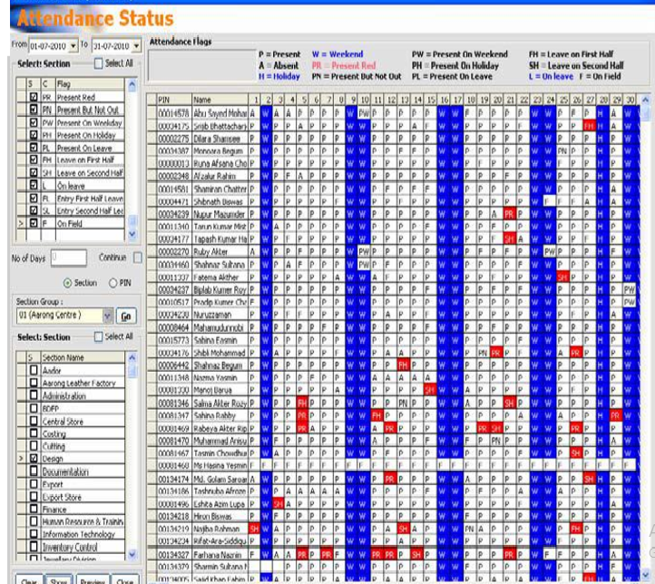
If someone comes late in the office for three days then salary of one day would be cut and for seven days a warning letter would be issued to them. So punching id card at the proper time is quite a big issue at Aarong. It is also an example of their disciplined corporate culture. All the outlet employees and temporary employees at head office still uses manual register book to record their attendance.

- Leave:

Leave is another very important issue of the support team. Properly recording and updating of such leave is very important and it also helps to calculate the compensation properly. There are different type of leave such as-paternity leave, earned leave, sick leave, paternity leave, extraordinary leave, higher study leave etc. There are different rules for different leaves. Such as- Administrative staffs can have 20 days of regular or earned leave and outlet and field employees can have 24 days of earned leave. Whereas, service staff can have 42 days of earned leave. The confirmed employees of Aarong can have 7 days of leave with pay but it must be taken within a month. And for the staffs who are not confirmed they can have 7 days of leave without pay, it must be taken within one month. Another very important rule regarding the paternity leave is that it can be enjoyed for only two children. The confirmed female can enjoy 4 months of maternity leave with full payment. They can also take advance salary in case of maternity leave. If someone wants to take more than 4 moths’ maternity leave but in that case for the extra leave no payment would be given, it would be a leave without pay. Maternity leave can be taken for two children only.

The procedure of approving leave is a very important issue of Aarong HR department. If a staff wants to take leave then the HRD gives them a leave form, he has to fill up the form. Then they takes permission from the head of department. Every month end the HR department updates the attendance status of employees, the software records the leave with pay and lave without pay for each employee for every month. So all the record is send to the Account and Finance department so that they can adjust the salary according to it and pay the employee’s salary.

- Issuing ID Card and Visiting Card:

It is another very important task of the support team. Whenever a new employee joins Aarong they ensure that they are provided with the ID card. Another very important thing that they have to deal with is to ensure that staff entry punch is working properly. If there is any problem regarding the punching of ID card the support team solves the problem. The staffs of different department requires vising card. So first the staff takes approval from their department head and sends requisition to the HR department. The HR department takes approval from the head of HR department and orders for the visiting card. After receiving the cards they sends it to the staff.

- Human Resource Information System:

To keep all the employee related information up to date Aarong uses HRIS system. They have some software which they use to make their recording of information database easier such as EDMS, ERP, HRMS. After the recruitment of a new employee the initial information is input by the recruitment and selection team but there are a lot of other information that needs to be input. Those detail information are input by the support team.

4.5 Performance Appraisal of Aarong:

A performance appraisal is regular review of an employee's job performance and overall contribution to a company. Also known as an "annual review," "performance review or evaluation," or "employee appraisal," a performance appraisal evaluates an employee’s skills, achievements and growth, or lack thereof. Companies use performance appraisals to give employees big-picture feedback on their work and to justify pay increases and bonuses, as well as termination decisions. They can be conducted at any given time but tend to be annual, semi-annual or quarterly. (Investopedia, LLC, 2018)
Performance appraisal is a very important factor of Aarong Human Resource Department. It is done once in a year. For different grade of employees Aarong has different type of performance appraisal form for different level of employees such as –
- Appraisal form A- for top-level.
- Appraisal form B- for mid-level.
- Appraisal form C- for lower-level.
- Appraisal form for Sales Associate.
In total of 100 each employee gets marks, and each range of mark has a meaning. Such as-
- 20- 32 - Unsatisfactory
- 33-52 - Improvement Needed
- 53-72 - Good
- 73-86 - Very Good
- 87-94 - Excellent
- 95-100 - Outstanding

Evaluation are done on the basis of some competencies such as- job knowledge, integrity, time management, quality of work, creativity, leadership, analytical ability, communication, decision making skill, positive attitude etc. After the appraiser gives marks they also give comments about employee for each competencies such as- areas where he should make improvement. Then the appraiser writes employee’s strengths and weaknesses. Then the employee answers some questions such as-
- What do you consider to be your most important achievement of this year?
- What element of your job do you find most difficult?
- What element of your job do you find most interesting?
- What sort of training would benefit you?
- What action could be taken to improve your performance in your current position by you or by Aarong?
Then the employee gives their observation about the evaluation whether they agree or disagree.
The appraiser gives recommendation for promotion, change of designation, training, termination, regularization, dismissal etc. Then he gives the reason for recommendation. Then the appraisal form is checked by the reviewing supervisor then Director and Managing Director. They give their signature, comments and approves the appraisal form. Then it is documented manually and in the software. (Noor, Performance Appraisal of Aarong, n.d.) The performance appraisal for sales associates is slightly different. All the files are manually stored too.

4.6 Other Activities:

- Knowledge Sharing:
The Deputy General Manager of Aarong HRD has taken a new initiative for knowledge sharing among the employees. Each month he assigns each employee with a specific topic and a time frame. The employee has to prepare a full presentation on that topic. Then on a specific date he/she presents the topic in front of the HRD team in the meeting room and shares his/her knowledge. Meanwhile other employees listen to the lecture and ask question if they want to clarify something. Then after the presentation everyone shares their knowledge, discusses in group, asks questions and gives replies to other employee’s questions. As a result on each presentation they learn new topics and increases their area of knowledge.

- Newsletter:
Aarong HRD has another very fun activity which is their newsletter post. Employees can pin any good motivational quote, informative knowledge, advice of renowned people, photos of their different meetings, birthday ceremonies, and good moments in the newsletter. Each week the newsletter pins are changed and safely kept in file.

- Birthday Celebration:
Aarong HRD employees always keeps track of birthdays of their colleagues. On an employee’s birthday other co-workers arrange small celebration party together. They cut cake, eat light snacks, share jokes and take photos to make their colleague feel special and create special moments in their busy working life.

Part 5

Critical Observation

& Recommendation

5.1 Critical Observation:

After the overall analysis of the Human Resource activities of Aarong HR department I have come across some observations.
- Aarong HR department follows an unbiased recruitment and selection process. They want to recruit the real talented people from the pool of candidates.

- During my recruitment and selection activities I noticed that Aarong HR department does not have any room allocated only for the examination purpose of the candidates. Most of the times the examinations were held in the canteen room, conference room or training room. Not having a specific examination room can create a negative impression about Aarong on the candidates.

- My duties and responsibilities were mostly related with the recruitment and selection process. I had to input a newly joined employee’s personal information in the ERP and HRMS software. During the information input process I found out that the software were a bit outdated and they were very slow. In times it would take minutes for the software to load and login which was an obstacle to work fast during days with high work load.

- Aarong HRD does not practice succession planning in full force yet. They are still working to create a proper succession planning process in the Human Resource department.

- The recruitment and selection team of Aarong consisted of 6 employees, where there were two permanent, one probationary employee and 3 interns. Aarong recruitment and selection team is responsible for both the head office and outlet employee recruitment and selection. So it is a huge pressure for the team to work with only six employees.

- Aarong follows a very structured recruitment and selection process. After the recruitment and selection process there are joining formalities where a new employee has to submit their educational certificates, other relevant documents and fill up the joining, insurance and guardian form. But in many cases the new employees fail to submit all the documents at once. In that case the HR department gives them another date to submit the documents. As a result it hampers the documentation process. Because as long as the new employee does not submits all the documents and information properly then necessary inputs can not be given in the HRMS and ERP. And the manual file can not be fully created.

- Though the job location for some position would be outside of Dhaka, the candidates had to come to Dhaka head office from different location of Bangladesh only to attend the written and viva test. This hustle could be solved by taking proper measures for the candidates who come from a long distance. It would even make the recruitment and selection process swifter.

- A lot of information are manually handled in the HR department such as- for interview purpose they print out all the candidates CV, the attendance of the candidates are taken in a paper by manual process. Even the interview board members writes down the candidates’ interview status in interview file. Then recruitment and selection team again compiles the number in a excel sheet. But if all this manual works could be replaced by a handheld PDF or any other digital device then it would take less time and make the process more digitalized. It would also reduce the paper waste.

- Aarong does both internal and external recruitment but they are mostly traditional system. They should try other sources for recruitment it may produce better result for Aarong.

- Aarong has a very strong performance appraisal system. Which is equal to any international level performance appraisal system used in multinational corporations.

- During my internship I was lucky enough to experience a training program on performance appraisal of Aarong and A.A.F. In the training program they covered topics such as- performer types, bell curve, year beginning objective settings, mid-year objective setting, year-end objective setting, development plan, mid-year review, performance evaluation, uses of different matrix etc. But during that training session I found out most of the outlet managers are not fully aware of the proper system of performance appraisal. It seemed very confusing to them. But the training program helped them to give the solution by answering and describing their queries.

5.2 Recommendation:

This report also has some recommendation for Aarong HR department, which are described below-
- The HR department should allocate a room only for the examination purposes. So that when there will be a lot of candidates for written test it would not create any hustle for the sitting arrangement.

- HR department should take proper steps to introduce HRIS system which are up to date, fast and increases productivity.

- Succession planning is very important for any organization because of it the HR department can choose the best employee for a specific position within themselves as well as prepare and train them in advance. So, Aarong HR needs to focus on their succession planning process.

- As the recruitment and selection team of HR department handles the overall recruitment and selection for Aarong head office, outlets and AAF, so they need to hire more employees for that team.

- The submission of documents during joining should be more strictly practiced for new employees.

- Aarong could take online examination for candidates whose job location would be outside of Dhaka and who are applying from a distant place from Dhaka. It would reduce both the time and hustle.

- HR department needs to adopt more digital measures and reduce the application of manual processes. They should go for more digitalization and use digital hand held PDF or other smart devices and reduce the usage of paper.

- Aarong should use other sources of recruitment, one very important recruitment source is “Campus recruitment”. Campus recruitments provides organizations with innovative and fresh graduates.

- Aarong should provide more training on performance appraisal system. Because most of the employees who are appraiser still lacks knowledge on the appraisal system. They should give training to the employees who are being appraised by the appraisers, so that they know how they are being evaluated.

- Aarong should take more initiatives for flexible employee training programs such as- customized training, continuous training need assessment, encouraging to apply training learning etc.

- Aarong should provide more training on performance appraisal system. Because most of the employees who are appraiser still lacks knowledge on the appraisal system. They should give training to the employees who are being appraised by the appraisers, so that they know how they are being evaluated.

- Aarong HRD should try to bring some creativity to their work. They should motivate their employees to come up with new ideas that can make their work more fun and improve productivity. They need to provide some autonomy to their employees too.

Part 6

Conclusion
Conclusion

After the analysis on the overall HR activities of Aarong, the report finally discusses about some critical observations as well as some recommendations to reach a conclusion. The analysis clearly proves that the activities of Human Resource department of Aarong is not limited within the recruitment and selection process only. It consists of a lot of other activities which are really important for the overall management of human resource in Aarong. Surely it is a great challenge for the department to manage huge number of human resource all around Bangladesh. The department is very well structured with specific goals and determination. They also thrives for future improvement and continuously working on the process. There are still a lot of areas where they need to explore such as the succession planning which would make the selection process more reliable and easier for Aarong. Digitalization would be another very clever move for Aarong if they can implement it in their work process. Digitalized work process is used in a lot of world renowned organization because it makes work easier and faster. Aarong HR department plays a very important role to make their employees aware about the corporate image of the organization as well as train and develop them, so that they can maintain that image. In case of Aarong they have successfully maintained both the corporate and as well as the brand image with equal integrity and pride.

7. Bibliography

Arong. (2017). Aarong - marketing 3.0 award winner 2016. Retrieved from Aarong: http://www.aarong.com/news/aarong-marketing-3-0-award-winner-2016/
Aarong. (2017). About nakshi kantha. Retrieved from Aarong: http://www.aarong.com/nakshi-kantha/about-nakshi-kantha
Aarong. (2018, August 12). Retrieved from Wikipedia, the free encyclopedia: https://en.wikipedia.org/wiki/Aarong
About Aarong. (2017). Retrieved from Aarong: http://www.aarong.com/about-aarong/
BRAC Enterprise. (2016, April 17). Aarong. Retrieved from BRAC: https://www.brac.net/brac-enterprises/item/878-aarong
Chowdhury, S. (2010, June 10). File:Aarong logo 2010.png. Retrieved from Wikimedia Commons: https://commons.wikimedia.org/wiki/File:Aarong_Logo_2010.png
Drong, M. M. (2012, May 23). Employee satisfaction on Aarong’s compensation. Retrieved from dspace.bracu.ac.bd: http://dspace.bracu.ac.bd/xmlui/handle/10361/1977
Definition of employee referral. (n.d.). Retrieved from Tlentlyft: https://www.talentlyft.com/en/resources/what-is-employee-referral
Export. (2017). Retrieved from Aarong: http://www.aarong.com/export/
Hasan, M. M. (n.d.). HR policies and practice of Aarong. Retrieved from Academia.edu: https://www.academia.edu/21328719/_HR_Policies_and_Practice_of_Aarong_
Halim, I. (2016, February 16). The recruitment and selection process of Aarong. Retrieved from dspace.bracu.ac.bd: http://dspace.bracu.ac.bd/xmlui/handle/10361/5401

Investopedia, LLC. (2018). Performance appraisal. Retrieved October 5, 2018, from Investopedia: https://www.investopedia.com/terms/p/performance-appraisal.asp-0
Jahan, N. (2011, September 22). Performance appraisal system of Aarong. Retrieved from dspace.bracu.ac.bd: http://dspace.bracu.ac.bd/xmlui/bitstream/handle/10361/1681/07104121.pdf?sequence=20&isAllowed=y
Lang, D. (2017, April 19). What is compensation management? Retrieved from JungoHr: https://www.jungohr.ca/blog/what-is-compensation-management
Martin. (2016, November 26). What is recruitment. Retrieved from Cleverism: https://www.cleverism.com/what-is-recruitment/
Munna, M. H. (2013, April 3). The recruitment and selection procedure of Aarong. Retrieved from dspace.bracu.ac.bd: http://dspace.bracu.ac.bd/xmlui/handle/10361/3203
Moushumi, N. A. (2016, August 22). A study on recruitment, selection, training and development and critical challenges of Aarong- BRAC social enterprise. Retrieved from dspace.bracu.ac.bd: http://dspace.bracu.ac.bd/xmlui/handle/10361/7822
Noor, A. I. (n.d.). Performance appraisal of Aarong. Retrieved October 2018, from Academia.edu.
Our artisans. (2017). Retrieved from Aarong.com: http://www.aarong.com/artisan/
Our values. (2017). Retrieved from Aarong: http://www.aarong.com/our-values/
Sarkar, P. (2016, July 2). Define selection process ? Retrieved from Tuturself.com: https://www.tuturself.com/posts/view?menuId=108&postId=487
Shefa, B. Z. F. (2017, April 19). Effectiveness of recruitment and selection process of Aarong & Ayesha Abed Foundation (A study on management staff). Retrieved from dspace.bracu.ac.bd: http://dspace.bracu.ac.bd/xmlui/bitstream/handle/10361/8442/12104083_BBA.pdf?sequence=1&isAllowed=y

8. Appendix:

1) Organogram of Aarong HRD
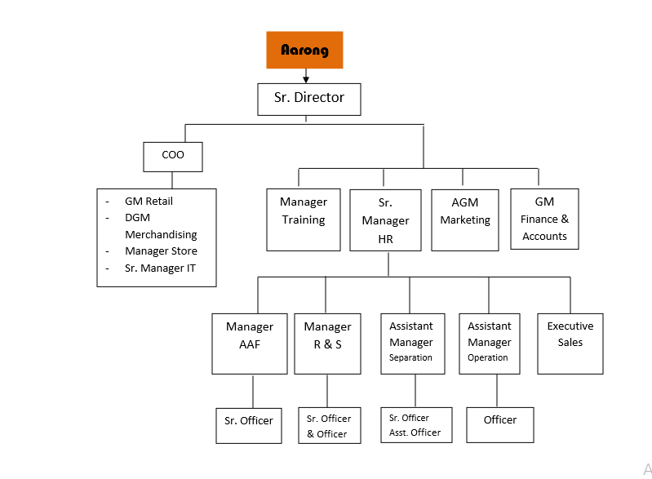
2) Job Circular Published in bdjobs.com

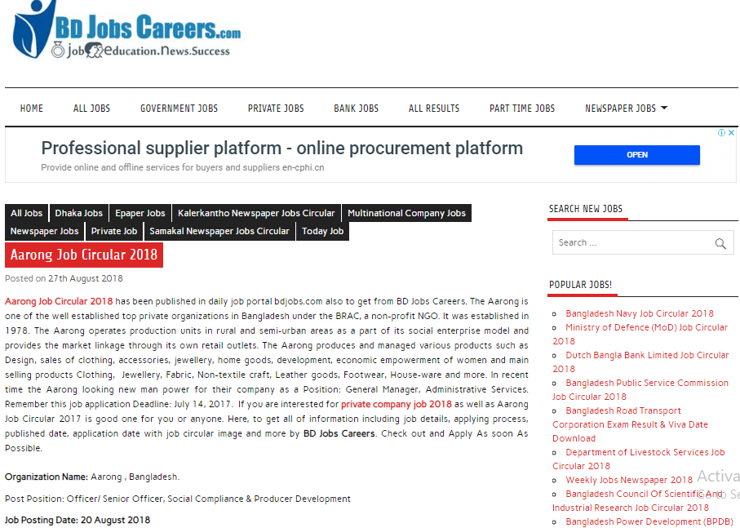

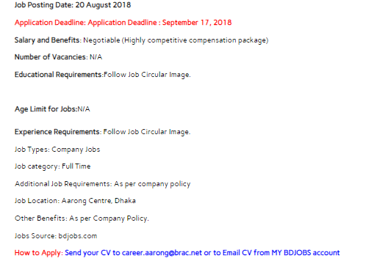

3) Job circular in Online Newspaper

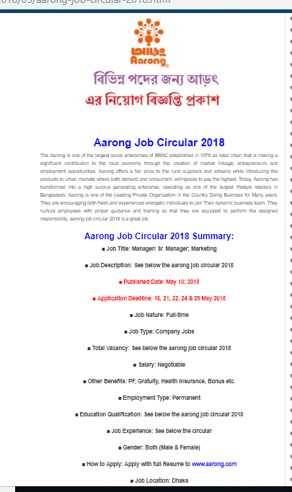

4) HRMS Software Record:

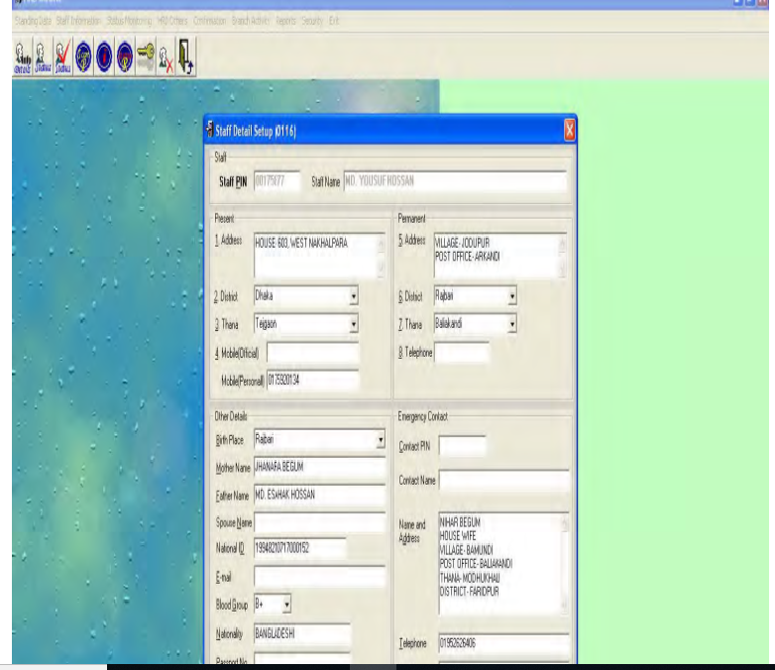

5) Questionnaire

- The organization places the right person on the right place-

- Strongly Agree b) Agree c) Disagree d) Strongly Disagree

- Selection of a candidate in Aarong is unbiased-

- Strongly Agree b) Agree c) Disagree d) Strongly Disagree

- The recruitment and selection system effective-

- Strongly Agree b) Agree c) Disagree d) Strongly Disagree

- “I am satisfied with my supervisor’s behavior” –

a) Strongly Agree b) Agree c) Disagree d) Strongly Disagree

- Arong has full-fledged succession planning system-

a) Strongly Agree b) Agree c) Disagree d) Strongly Disagree

- Aarong has a formal policy of career planning and development-

a) Strongly Agree b) Agree c) Disagree d) Strongly Disagree

- In case of recruitment and selection, Aarong prefers-

a) Merit b) Experience c) Extra Curricular-activities d) All of them

- How much a full recruitment and selection process cost?

- 5 K to 15K b) 16 K to 25 K c) 26K to 35K d) 36K to 45K

- What type of recruitment system is followed by Aarong?

- Internal b) External c) Both d) Others _________________

- How do you judge Aarong’s Performance Appraisal System? (From Employer Perspective)

- Satisfactory b) Good c) Better d) Best

- What type of performance appraisal is followed by Aarong?

- Graphic Rating Scale b) MBO c) 360 Degree Feedback d)Others ________

- What type of employee contract is preferred by Aarong?

- Permanent b) Temporary/Part-time/Contractual c) a+b d) Others

- In case of training need analysis Aarong focuses on-

- Individual b) Group(department/team/function) c)Organizational d) Others

- Aarong conducts performance appraisal-

- One in a year b)Twice in a year c)Thrice in a year d) Others

- What is the compensation policy of Aarong?

- Pay above market b) Pay with market c)Pay below market d)Flexible policies

- Do you enjoy autonomy in your work?

- Yes b) No

- The Aarong HRIS needs to be upgraded?

- Yes b) No

- Aarong’s salary and other benefits are attractive comparing to other organization-

- Yes b) No

- Are you satisfied with Aarong’s Leave Policy?

a) Yes b) No

- Does Aarong take exit interview-

a) Yes b) No

- Assign importance to the following criteria used in Aarong for evaluation of training-
(1= not all relevant, 5= fully relevant)

1 | 2 | 3 | 4
1 | 2 | 3 | 4
1 | 2 | 3 | 4
1 | 2 | 3 | 4
- Learners Reaction
- Knowledge Acquired
- Behavioral Change
- Measurable Results

- Whether following are relevant in Aarong’s preferred choice of employee separation? Rate it- (1= not all relevant, 5= fully relevant)

1 | 2 | 3 | 4
1 | 2 | 3 | 4
1 | 2 | 3 | 4
1 | 2 | 3 | 4

- Layoff
- Voluntary inducement
- Hiring freeze
- Preferential hiring of ex-employees

- Basic objective of Aarong’s induction program-
(1= not all relevant, 5= fully relevant)

1 | 2 | 3 | 4
1 | 2 | 3 | 4
1 | 2 | 3 | 4
1 | 2 | 3 | 4
a) Increase commitment
b) Settling new employees well
c) Reducing cost of early leavers
d) Just a ritual

- How the performance appraisal result are used-
(1= not all relevant, 5= fully relevant)

1 | 2 | 3 | 4
1 | 2 | 3 | 4
1 | 2 | 3 | 4
1 | 2 | 3 | 4
- For Human Resource planning
- For employee development
- Determining reward and compensation
- Increase motivation

25) Who are responsible for assessing performance in Aarong?
(1= not all relevant, 5= fully relevant)
1 | 2 | 3 | 4
1 | 2 | 3 | 4
1 | 2 | 3 | 4
1 | 2 | 3 | 4
1 | 2 | 3 | 4

- Immediate Supervisor
- Peers
- Subordinates
- Self
- Customers

Abbreviations:
- HR - Human Resource
- HRD - Human Resource Department
- A.A.F. – Ayesha Abed Foundation
- C.E.O – Chief Executive Officer
- C.O.O – Chief Operation Officer
- J.D – Job Description
- J.S – Job Specification
- HRIS – Human Resource Information System
- EDMS – Electronics Documents Management System

