Internship Report on “Accounts Receivable Management of Akij Group”

Name of the Student:
Sanaur Rahman Sanji ID: 111 171 095

This report is submitted to the school of Business and Economics, United International University as a partial requirement for the degree fulfillment of Bachelor of Business Administration

Internship Report on “Accounts Receivable Management of Akij Group”

Submitted to:
Md. Mofijul Hoq Masum Assistant Professor
United International University (UIU)

Submitted by:
Sanaur Rahman Sanji ID: 111 171 095


School of Business and Economics
United International University

Date of Submission:
24rd June, 2022

ACKNOWLEDGEMENT
I would like to give gratitude to all those helpful people who help me a lot to complete my internship report. Without their Mental and physical support, it will not be possible for me to complete my internship report. I also like to thank my honorable supervisor Md Mofijul Hoq Masum who give me guidance all the time throughout this process. Whenever I face any type of problem, he was available for counseling. His coordination helps me a lot to complete this report. I have experienced a great three-month internship journey with Akij group on that time I have an opportunity to experience a great corporate environment within this short period. I am also thankful to my reporting boss “Mufti Md Atik” who trained me in my first week of working period and that training help me a lot to be easily adapted with my assigned work. There is another person whom I like to convey gratitude my honorable reporting supervisor Raihan Kabir sir, Whenever I face any type of work-related problem, he was there for help me. At last, I would like to thank our Career counselling department for arranging me a great internship opportunity in Akij Group.

24th June, 2022

LETTER OF TRANSMITTAL

To
Md. Mofijul Hoq Masum Assistant Professor
United International University
Subject: Submission of Intern report on “Account receivable management of Akij Group”

Dear sir,
It’s been a great honor for me to represent my intern report on Akij Group Account receivable management. This report is really important for me to graduate from United International University as it’s a part of our education program. The purpose of this report is to describe the receivable management procedure of Akij Group. I try my best to gather all the relevant information regarding my assigning topic so that my supervisor can get enough information about the topic. I try to write the report by following all the requirement that you assign me. It helps me to write the report in a structural way. My internship journey also helps me to learn the accounting procedure of a group. It's also enhanced my knowledge about Accounts and Finance department. By considering my effort, it will be really helpful for me if you could share your opinion about my report and give me your valuable suggestion about my work. I also pray to Almighty Allah for the safe health of yours and your family person in this pandemic situation.

Sincerely Yours, Sanaur Rahman Sanji Department: BBA ID: 111 171 095

DECLARATION
I, Sanaur Rahman Sanji, declared that this internship report is on “Accounts Receivable Management of Akij Group” which is prepared by myself after the completion of the internship program of three months’ period at “Akij Group”. The internship period was a very valuable time for me to achieve knowledge regarding the “Accounts Receivable of Akij Group”.
I have collected lots of information for preparing the report. I am assuring that this internship report is well prepared by me. I also assure that this report is one of the unique reports for a BBA program.

TABLE OF CONTENTS

Contents

ACKNOWLEDGEMENT 3
LETTER OF TRANSMITTAL 4
DECLARATION 5
TABLE OF CONTENTS 6
ABSTRACT 8
CHAPTER 1: INTRODUCTION 9
  - Introduction of the Study 9
  - Objective of the Study 9
    - General Objective 9
    - Specific Objective 9
  - Rational of the Study 10
  - Scope of the Study 10
  - Limitation of the Study 10
CHAPTER 2: METHODOLOGY OF THE STUDY 12
  - Types of Data 12
  - Data Design 12
  - Sample Design 12
  - Analytical Tools 12
  - Variable Design 13
CHAPTER 3: LITERATURE REVIEW/ ORGANIZATIONAL BACKGROUND & INDUSTRY PERSPECTIVE 14
  - Accounts Receivable Management 14
    - Objectives of Accounts Receivable Management 15
    - Accounts Receivable Tools 16
  - Industry Scenario 17
  - Historical Background of Akij 18
    - Akij Products and Service Lines 18
    - Akij Group Departments 21
    - Akij Group Payment Management 22
    - Akij Group Management Process 22
  - SWOT Analysis of Akij 23
    - Strengths of Akij 23
    - Weaknesses of Akij 23
    - Opportunities of Akij 23
    - Threats of Akij 24
CHAPTER 4: ANALYSIS & FINDINGS OF THE STUDY 25
  - Accounts Receivable Management Process of Akij Group 25
  - Findings from the Firm’s Operation 27
  - Findings from the Firm’s Technology 27
  - Findings from the Marketing Operation 27
  - Findings from the Production Process 27
CHAPTER 5: CONCLUSION & RECOMMENDATIONS 28
  - Conclusion 28
  - Recommendations 28
CHAPTER 6: INTERNSHIP EXPERIENCE 30
APPENDIX 32
References 32
Tables, Graphs and Charts 33

ABSTRACT
The main purpose of this report is to describe the Account Receivable Management process of Akij Group. In this report, several numerical data has been used to generate the idea about the total volume of monthly accounts receivable of Akij. For the confidentiality of the Akij group, many data used in this report are approximate data. As Akij is a big corporation so it is quite impossible to cover all their operation process in this report. During the data collection process, many problems have been occurred due to the software related issue in the receivable process. As they launched their own software in their operating process, so many employees are not totally adapted with the new process. Sometimes the operating process is hampered because of the internal coordination problem between the Sales team and the Accounts team. It is found that the company faced serious problem in the early month of 2022. A hacking team hacked their system and for that reason the Akij group lost many of their previous data and their operating system was stuck on those days and that incident had created huge loss for the company. It is also found that their operational part has major lacking in receivable management. It is expended that in the future the company will develop their operational process so that they can easily maintain their receivable process in more organized way.

Keywords: Accounts receivable management, Accounts receivable process, Akij Group business operations.

CHAPTER 1: INTRODUCTION

Introduction of the Study:

This report is basically prepared by the proper analysis of the Akij Group. Akij Group is one of the reputed industries in Bangladesh. Akij Group is a very profitable industry since so many years. There are lots of companies under Akij Group. Akij Group has plenty of products. Almost all of the products of Akij Group earn good profit from their business. The companies of Akij Group are given here with proper discussion. The accounts receivable management of the Akij Group is also given here with details which is the main focus of this report.

Objective of the Study:

General Objective:

The principal goal of this report is to give a broad concept about receivable management procedure of Akij Group which work I was assigned during my internship period. Those things that I have learned from my internship period I hope it will be going to help me in my future period. As you know I am a fresh graduate so this three-month journey helps me to adapt with corporate world.

Specific Objective:

The specific objectives of this report are given below:

- To understand how the company is maintaining their accounts activities and the credit terms policy.
- To identify the processes which they use in order to maintain the business operations during the critical periods.
- To realize about how the accounts department makes coordination with another team.
- To identify the strategies of the company for achieving the goal congruence throughout the year.
- To understand about how they maintain their accounts manually when the software doesn’t work properly.

Rational of the Study:

As you know internship is a part of Bachelor of Business Administration academic program. If someone want to complete their BBA program, they must go through internship or project program. It helps a student to learn the real corporate world operation process. In this business world you cannot know everything if you only have bookish knowledge for adapt with the business era a student needs to have both practical knowledge and bookish knowledge. In the practical world their knowledge helps them to adapt with the corporate operation but for operating the operation a person needs practical knowledge. So, this internship program helps a student to have practical knowledge about business operations. In my BBA program I get lucky to have an internship in Akij Group. Akij is a big industry among our local industry their operation process is really a big so it is quite impossible for an intern to adapt all their operating process within this short period. Though I have an opportunity to involves in their business operation partly. Through this program I get practical knowledge about how they maintain their Accounts and Finance activities. How they book keeping their all-accounts data. In this internship period I get an opportunity to utilize my theoretical knowledge in business field.

Scope of the Study:

The initial purpose of this study is to know the Account receivable process of Akij group. How they maintain their receivable. How they make contract with their creditors to have their money receive on time. How they make coordination with their sales team and credit authorize team. If any creditor did not give their due payment on time how the receivable will be going to handle that problem. If any type of transaction occurs twice for systematic fault how the receivable team handle that problem. How they control their credit sales, how they do creditor reconcile, after ensuring the receivable how the product disbursement occurs. How they maintain their cash flow management. In this report one can also know on which area Akij need some changes what are those things that create problem on their daily operation.

Limitation of the Study:

Akij is a big industry, there operation process is beyond thought. So, it is quite impossible for me as an intern to know all of their operation process thoroughly and deeply. For their operation safety purpose, they didn’t share all of their working process with an intern. As they have to maintain some confidentiality in their operating process. In my internship journey they just share

some of their basic information with me. I just maintain some of their particular operation in those three months. There are many sisters concern company under Akij Group so one people is not assigning to do all receivable management. Different software and different operation process is used for different cluster works. As a result, I was only assigning to do the receivable management for Akij cement, Akij poly fiber and Akij Essential department. May be in this report I cannot describe all the operation process of Akij Group. But I just try my best to describe their receivable management process as far as I can.

CHAPTER 2: METHODOLOGY OF THE STUDY

Types of Data:

There are two types of data, primary data and secondary data. Primary data are those data which are taken by the researcher. The examples of primary data are personal interview, statistical data, works of art, survey, observation, experiment etc. Secondary data are those data which are collected by the other users. The examples of secondary data are books, newspapers, websites, reports & statements, journal articles, print media etc. In this study, personal interview & statistical data are used as the primary data and websites, reports & statements are used as the secondary data.

Data Design:

To make this report more informative and in a structural format I have used both the primary sources of data and the secondary sources of data. I talked with my senior officer and some other employees who have much knowledge about this organization. I have collected data from the annual reports, the official website of Akij and the other websites. By collecting the financial data from the financial statement, I have prepared the statistical analysis.

Sample Design:

For making this report more understandable I have provided some samples about the receivable management process of Akij Group. I have given clarification about my collected data. So that my supervisor or whoever will read this report will have some basic knowledge about Akij Group data collection process.

Analytical Tools:

In this report, the accounts receivable of Akij Group of the last five years (year 2017 to year 2021) with 12 months is shown by a chart in the analysis & findings part. The total accounts receivable amount of each year is calculated in the chart. In the chart, the accounts receivable growth of each year compared to the previous year is also determined. The accounts receivable turnover is also calculated and shown in the chart. After presenting the chart, the chart is discussed with details. The total accounts receivable amount of every year is compared with the total accounts receivable amount of the previous year.

Variable Design:

In receivable management process there are both independent and dependent variable are there. Some data dependent on other data to make the operation process error free and more accurate. Like if you don’t receive the money on the right time or if you don’t do the manual voucher entry then how it going to hit on the customer ledger account and if that work is not done on time, then there will be show due on customer account. So, in this process one data is dependent on other. (See figure 1 in Appendix)

CHAPTER 3: LITERATURE REVIEW/ ORGANIZATIONAL BACKGROUND & INDUSTRY PERSPECTIVE

Accounts Receivable Management:

Accounts receivable is a legally binding payment claim held by a business for goods delivered and/or benefits received by customers that have been tried to order but not paid for. Accounts receivable management has more to do with ensuring that clients pay their invoices. Good debt management helps to avoid late payment or default. It is therefore a quick and effective way to strengthen the company's financial or liquidity position. This explains the importance of managing receivables, the rewards and how to start preparing a solid strategy for receivables. Account receivable part is really important for every organization. If they can't receive the due amounts from their creditor within a particular time, then it will be really impossible for them to run their operation. Every corporation must need to control their credit sales and have to ensure that they collect their due amounts from the creditor on the exact time. Cause in an organization every department are interrelated.
There are many important parts interrelated with account receivable management. To calculate the account receivable management, we have to understand those things. Those parts are given below:
- Adding up all Charges: For calculate account receivable you have to add all those charges that your creditor owes from the corporation. Here you also need assumption about the bad debt. Account receivable count on different time frames like monthly or yearly.
- Finding up the Average: By add the beginning receivable amount with the ending receivable amount and divided it by two we can find the Average receivable it helps a corporation to know their yearly average collection and to know the credit sales collection process.
- Account Turnover Ratio: To know about the company collection process and to know the rate of effectiveness of collection process Account turnover ratio is really important. If the receivable turnover ratio is high that means their creditor are really good, they paid due amounts on the exact time. The company receivable collection team are efficient but low turnover ratio is really a matter of great concern for the corporation it may cause to end up an organization operation process.

- Invoicing: For right time issuance and for error fee and for easily understandable invoice is an important part of Account Receivable management. For making the bill receivable more accurate invoicing is much important.
- Statement: Statement must be sent by the customer within their payment date without the statement person who is responsible for receivable management cannot receive the payment properly. Statement makes the operation more accurate and error free.
- Asking for payment: For making payment more accurate and faster sales team always get in touch with their customer. If the customer didn’t pay properly and they take their goods in time the credit team put pressure on receivable team. It’s been a great liability for the company if they can't collect all their debt in right time.
- Can’t pay vs won’t pay: One of the abilities that a successful credit controller develops is the ability to say the difference between a debtor who has the resources to pay a debt but refuses to pay and a debtor who actually cannot afford to pay a debt. Credit controller team must identify their reliable customer and not reliable customer according their customer reliability they must set a credit limit to their customer. (See figure 2 in Appendix)

Objectives of Accounts Receivable Management:

Accounts Receivable Management has many objectives. Some of the objectives of the accounts receivables management are below:
- Helps improve cash flow: Generally, a proper accounts receivable management helps a company to keep flexible cash inflow in the organization. It actually maintains a clear cash flow in the organization. It allows the company to spend money in daily transactions. So the company does not need to face any problem while maintaining the transactions.
- Reduces losses incurred due to bad debts: A proper accounts receivable management helps a company to decrease the losses that happen because of bad debts. Actually a business organization should keep sufficient money in its cash for different business transactions. If there is insufficient money in the cash of an organization, it will suffer a lot. The receivable of an organization that results from bad debts can be lost. So, the receivable should be managed effectively.
- Improved customer satisfaction: A well receivable management improves customer satisfaction and builds a strong relationship between the company and the customers. By

providing discounts & offers to the customers the business organizations are able to receive the payment early and satisfy the customers. Through which a good relationship is made between the business organization and the customers.
- Boost up sales volume: The receivable management increases the sales volume for the companies. The business organizations can provide the opportunity of purchasing on credit to the customers in order to increase the sales. If the business organizations provide this opportunity to the customers, then the customers will be pleased and purchase more products than before. After that, the revenue will increase and the profit will also increase.

Accounts Receivable Tools:

- Updated Credit and Collections Policy: The rules and regulations of credit and collection are very important for a company. Every business organization should establish an updated credit and collection policy for business development. This is a very important tool of accounts receivable management. The people who are involved in the sales and the payment collection should follow the laws and rules of credit and collection established by the company in order to increase sales and customers.
- Automation Software: The automation system is necessary for a business organization. It’s because the automatic system is useful to operate the business activities accurately in a short time. By using different types of software, the business organizations are now able to maintain the business operations automatically in a short time. The business organizations are now maintaining the accounts receivable procedures and laws automatically using the software. So, they are correctly maintaining every rule of receivable management in less time than before.
- Electronic Invoice Delivery and Payment: After the launch of digitalization, the business organizations are now maintaining the business operations in easier way than before. Previously, the business organizations were used to send invoices to the customers and collect the payments from them in traditional way. But after the launch of digitalization, the business organizations are now conducting electronic invoices and payments which allows to send invoices to the customers and collect payments from them through the online. It is faster, easier and less expensive for the business organizations.
- Customer Self-Service Options: Actually, nowadays many customers prefer the self-service process in terms of purchasing products from the organizations. Because the customers can

be busy with their works and may not be able to go to the shopping malls for buying their necessary things. So, that’s why they prefer the self-service process. By using the online portal, the customers can interact with the business organizations regarding the invoices, bill payment related issues and communicate with them regarding different issues. It is very convenient to the customers.

Industry Scenario:

Akij Group established on 1940s they started their business with jute trading. On that time this business was one of the most popular businesses in our county. By doing this business they earn a lot of foreign currency on that time. In later time they expand their business move into manufacturing handmade cigarette on that time this item was called Akij Biri. And that business gives them a huge prosperity on local market they earned lots of revenue from their tobacco industry. By using that brand name in later part, they expand their business in different sector like textile, cement, ready mix, poly fiber, bakers, plastic board, printing and packaging, food and beverage, flour mills, ceramics, Motors, shipping line. In 2020 they open their new industry Akij Bakers limited, on that cluster they bring different type of product like biscuit, cake, and bread, toast etc. in 2021 they launched another cluster Akij Essential limited their product item was rice, wheat, sugar. They also launch another department Akij tableware limited. Akij launch their own software Iboss in 2021, Nowadays they run maximum department operation in this platform. They also sell iboss software service to other companies. Akij receive green factory award in 2020 for reducing carbon emission and maintain environment friendly factory environment. In July 2020-June 2021 they paid 420.61 crore BDT in vat and for that reason National board revenue give Akij Group the highest tax payer award on that year. For exporting jute in international market Akij Jute mills got the jute industry award on 6 march 2020. By their jute mills industry, they make the country tradition alive and also make a huge contribution on the income of our local farmers. Now Akij group have almost 35000 employees on different sector. that means they help our government by reducing the unemployment problem. Akij welfare contribution is huge every year the paid almost 1 crore to the poor people by their Trust fund. They always ensure their employee treatment cost whenever any employee face any serious disease. This procedure is also applicable for people who are the relative of their employee.

Historical Background of Akij:

Vision: Be the benchmark of customer’s choice.

Mission: Ensure best quality product and services through continuous improvement that benefits society and environment.
(See Figure 3 in Appendix)

Focus of the Organization: The organization’s focus is given in the below:

- Try to ensure their Product quality
- Ensure they employee satisfaction
- Try to evaluated employee based on KPI so every employee can be evaluated through their key performance for that reason employee dissatisfaction will not going to be there.
- They Want to expand their business on international market and market.
- By using their brand value try to be completive in every industrial sector that they entered.
- Try to ensure customer satisfaction through their consumer goods.
- Try to contribute on our GDP by expanding their business sector
- Want to be the number 1 tax payer company in Bangladesh on the upcoming year.
- By investing on their R&D department try to bring some innovation on their product line.
- They want to ensure that their CSR is maintained every year properly.

Akij Products and Service Lines;

(See Figure 4 in Appendix)

- AFBL: Akij food and beverage limited started their journey in 2006, especially they produce soft drinks like Mojo, Speed, Clemon, Fruika. By the name of Frutika they have different flavors like Grape, Mango, Orange. previously they have a new tag line for frutika "Fruits means Frutika". In their product line up, they also have fresh mineral water SPA. They also produce Firm Fresh Milk. Their factory is in Dhamrai Dhaka Bangladesh.
- Akij Jute Mills: Akij Jute Mills is situated in Noapara, Jessore near Mongla port. Every year they export a huge jute product in different country. They started their journey 1994. They achieved award from Honorable prime minister of Bangladesh for their contribution in yarn production and quality jute exports. They started their journey with 300 workers now they

have almost 10000 employees on this sector. They produce Jute Bag, Money Bag, Jute shoes, Jute carpet, Jute belt, Jute cap etc. They export their products in more than 40 countries.
- Akij Ceramics: Akij Ceramics started their journey since 2012. Their factory situated in Maumensingh Trishal. They have a production capacity of 20000 square meters tiles per day in their beganing stage now they have a production capacity of 49500 square meters tiles per day. The have diffrent categories product like wall tiles, Floor tiles, sanitary ware and stair.
- Akij Cement: Akij Cement started their journey in 2002. They have almost 1026 employee on this sector. They have latest vrm technology on their factory set up. They produce almost 9280 Mts per day. They have a production capacity of 3.35 million mts per year. They get Intertek certificate for maintaining quality on their product in 2018. Their factory situated in Nrayongong. Recently They launch Akij Ready mix which created a new land mark on their product line up.
- Akij Textile Mills: Akij textile mills started thir journey in 1995. They have almost 1800 employees. Sheikh Nasir uddin is the founder of Akij Textile mills. They produce Denim product, fabrics, Yarn, NEC, Knit goods, Polo T shirt. Their factory situated in Glora Manikgonj.
- Akij Shipping Limited: Akij shipping limited started their journey in 2010.This sister concern of Akij have a global office in singapore. They have 10 vassele fleet. They have almost 750 employees. Actually, Akij Shipping limited is under Akij Resource limited. It is one of their service-based business. They use those ship for their own consignment and also for business purpose like B2B.
- Akij Infotech: Actually, it’s a consultancy type service company. They started their operation in 2012. They have more than 10 offices across the country. More than 50 employees work in this sector. Actually, they provide Data solution, Digital business solution and IT solutions. They also provide Digital marketing service, Technology service, BPO support and Bpm services.
- I Boss Limited: It’s a software-based company. It started their journey more than 15 years ago. They also develop software for medium and SME type business. Nowadays the whole Akij group operations are run by this software. They have five different types of products like I boss Enterprise (ERP), I Boss SME, people desk, prime vat, i Boss RTM. Their office is in Lalmatia,Mohammdpur. More than 35k employees of Akij group use this software.

- Blue pill Limited: Actually, it’s a service based it solution company, it started their journey in 2014. they provide different services like Business process outsourcing solutions, consultancy services and customer support and services, mange IT service, cyber security. They have different categories product I APP, I SHIP, I LEA. They have two platforms ERP on cloud and BP platforms. They operate from Akij Head office.
- Akij Plastic: Akij Plastic started their operations from 2016. They have different categories plastic products like Industrial products, Chair, Table, Wardrobe, Rack, Baby wear, Bucket. Jug. Their plastic factory situated in chatak sunamgong. They also export their plastic product outside the country.
- Akij Paritical Board Limited: Akij partical board started their journey since 2001. They have a factory in Manikgonj. They have 1000-5000 employee on this sector. They achieved an award in 2022 for the best innovative product development for their new product Akij lacquer grade board. They also provider interior service to their customer.
- Akij Printing and Packaging Limited: Akij Printing and packaging limited started their journey since 2001. Their factory situated in Tongi Kaliganj. They provide printing and packaging service for their own subsidiary company. Almost 3000 employees worked for this sector.
- Akij Bakers Limited: Akij Bakers limited entered into the baker’s business in 2021. They invested total 1200 crore in this project. They have a factory located in Tongi. They come up with diffrect types of products like Biscuits, Cake, Bread, Chocolate, Toast. Though they are new in the market still they are trying to increase their product category and also, they are doing a lot of branding and promotional activities to make the customer familiar with their product.
- Akij Biax Limited: Akij Biax limited started their journey in 2018. They invest 350 crores in this business. They Produce BOPP film line with a collaboration with Germany, UK, USA, Bruckner’s. They have a factory in Mymensingh trishal.
- Akij Central Workshop: Actually, it’s a service-based concern. It situated in savar ashulia. In this factory they repair all of their motor’s machines. It also works as a backlog point for5 all of their concerns.
- Akij Steel Mills Limited: Akij steel mills limited started their journey from 2017. S.k Bashir uddin is the founder and managing director of this cluster. Their factory is in Tora gior

Manikgonj. This factory production capacity 7200MT, cold roll section 3000MT, profile sheet 300mt. They have 10 corporate stuffs, 19 Engineer and Factory staff 30. Total 210 factory worker work for the production unit.
- Akij Flour Mills Limited: Akij Flour mills started their journey from 2016. Their factory is in wilson road Narayongonj. They have a production capacity of 1200MT per day. they have a storage capacity of 3500 ton which is the largest storage capacity in our country. They can load 300 sacks in every 40 minutes. They have three different categories product Ata, Maida and Suji. They also supply sunshine moshur dal. sunshine chini gura chal and muri.
- Akij Match Factory Limited: Akij Match factory is the largest match factory in Bangladesh. Their factory situated in Munshigonj. They have two product Fire fox and Dolphin. They have around 4000 employees on their production unit.
- Akij Poly Fiber Limited: Akij poly fiber have two units. First units started its operation from 2006 and this unit commercial production start from 2009. They have a production capacity of four million bags per month and total install capacity is same as production capacity. Their second units started its operation from 2017 and its commercial production start from 2019. This unit have a total installed capasity of 4.5 million bags per month. They have three different categories product Adstar bag, Raffia bag, Stitch bag.

Akij Group Departments:

- Accounts and Finance Department: Accounts and finance department is responsible for doing all those financial works. They receive payment from clients, make bill for those payment, make payment to their clients and employees. Give up to date transactional report to higher authority. Maintain transaction with bank and other internal sub units.
- Sales and Marketing Department: Sales and marketing department are responsible for selling product and doing branding and promotional activities. research market portfolio and update the organization marketing strategy. Keep eye on their competitor product and strategy and always try to have competitive advantage in the market. They always have a sales target given by the higher authority and their performance appraisal are count based on their target achievement.
- Supply Chain Department: Supply chain department mainly focus on production and procurement of the organization. They ensure available supply of a product. They are liable for maintain the availability of raw material and all those ingredients that are needed for

production. They ensure the quality of that product. They always try to ensure the supply is balance with the demand.
- Human Resource Department: They are liable for monitoring employees. They prepare job circular for the organization. They also recruit new employee for the organization, they prepare the salary sheet, and also prepare KPI for employee. They organize different program for the corporate get together. they are liable for look after the employees.
- Audit Department: Audit department actually monitoring the Accounts and finance department work. They are liable for preparing report for then board of director and NBR. They prepare the financial report for the organization. They make correction of financial up to date errors and the billing and payment sector are process after their monitor and permission about that thing. They also monitor all of those tax and vat related activities. (See Figure 5 in Appendix)

Akij Group Payment Management:

Akij group have to make different types of payment every month or in daily basis. To make their operational process sustain they have to make different type of operational expenditure like rental cost, entertainment cost equipment maintenance cost, Inventory purchaser, supplier payment, Overhead cost, pay roll and salary payment. They make their payment on cash only for their daily working capital expenditure. For large payment they use BEFTN and RTGS payment method and check. For supplier payment, the supplier must give billing sheet to the head office and that billing sheet must be Audited by the Audit team after Audit checking the payment officer process the payment.
After processing the payment, they make a BEFTN sheet like this and give it to the finance manager for checking process. (See Figure 6 in Appendix)

Akij Group Management Process:

Akij group follow the centralized process. For every operational work there is a senior officer appointed for monitoring and conducting the operational work, and for his support there is two three Assistant officers there. They divide the work between them. Senior officer is responsible to report directly to the Deputy manager. Every central decision is taken by the Manager and General manager. Every two three weeks they called for a meeting where they want to know up to date progress of this month operation. Every central operational decision is taken from Head

office. The Central decision maker go on a factory visit after two or three months. If any operational work needs to bring any change the senior officer can talk to the manager directly. Deputy manager are liable to check every operational work directly and make decision.

SWOT Analysis of Akij:

SWOT analysis of the organization means Analyze the Strength of the organization, Opportunity of the organization, Weakness of the organization and thereat for the organization.

Strengths of Akij:

- They have a strong brand value in the local industry.
- They have sufficient fund to expand their business.
- They have some skilled managerial people for their industry.
- As we said earlier Akij doing business on different sector some time some of their intercompany work as forward linkage and backward linkage for their other company.
- As they have a strong brand value so whenever they launch a new product, they don’t need to do extra branding for that new product.
- One of their most profitable sister concerns can give financial support to their other sister concern who are facing some problems on initial business period.

Weaknesses of Akij:

- They have limited market share.
- High-cost Structure.
- Tight Profitability margins.
- Marginal promotional activities.
- High Bad debt ratio.
- Moderate sales area coverage.
- Distribution channel are not enough proficient.
- They didn’t do digital marketing

Opportunities of Akij:

- By using their brand value, they can expand their business in different industry.

- They are awarded many times by the government for paying large amount of tax. And by using that good will they can get some extra benefit from the local government.

- As they have many departments, they can easily shift their employee for one department to another.
- If they want to export some of their product, they can export their product by using their own shipping line.
- As they have a huge customer demand for their product, they can increase their production.

Threats of Akij:

- High tax imposition
- Huge competitive market.
- Threats for substitute product.
- Foreign currency price fluctuation risk.
- Raw material price fluctuation
- Local political threats.

CHAPTER 4: ANALYSIS & FINDINGS OF THE STUDY

4.1 Accounts Receivable Management Process of Akij Group:

For maintaining the liquidity of cash and saving the company from huge credit sales a proper Account receivable management is really important. For maintaining the account receivable stable the sales team and credit control team play an important role here. Whenever a sales representative sold an item on credit, they must give a clear statement that the customer has to pay within 10 days. There is a regulation for the sales team that they cannot give more than 10 lac credit sales to a central customer and all they by product should sell on daily cash transaction. For Akij Cement company the selling procedure is different dealer or distributer can make credit sales of more than 30 lacs within a month but they have to repay this amount within the ending period of that month, on this sector total receivable management procedure or collection procedure are held at the month end day. All employee who are responsible for Account receivable management they have to submit a report to the manager about the whole collection process within the first 10 days of the beginning month. Let's find out the operational process of receivable management.
(See in Figure 7 in Appendix)

Step 1: First the sales team prepares an excel sheet. (See in Figure 8 in Appendix) In that excel sheet, they mention that which party give their payment today and in which bank, how much quantity product they want against that given money, and from which ship point they want that product to be shipment.
Step 2: The person who is responsible to receive the amount check the customer statement from the software ERP, if the customer makes the payment by using code number, then it was shown on the customer statement. and the person who is responsible for receivable management give permission to the distributor for shipment.
Step 3: If the customer doesn't give payment on code, then the receivable officer checks their ERP software bank receivable page, which is like that (See Figure 9 in Appendix).
Here they search the amount and find that payment, if they find it then they receive it and that shown on customer statement after they receive conformation and then the shipment will be processed.

Step 4: If the payment doesn't show on their ERP system, then they check the bank statement and manually make voucher entry of that transaction. this process take place only for two or three different banks.
Step 5: After receiving the customer payment the receivable officer give permission to each distributor to distribute the product according to the customer desire ship point.
Step 6: After every month the organization do bank reconcile to check if there is any difference between bank statement and their own receivable statement, by doing this they can find out where there are any mistakes if it occurs.
Step 7: The receivable officer also does creditor reconcile to check is there any customer who didn't make payment on the exact time.
(See Figure 10 in Appendix)

The accounts receivables (in thousands), accounts receivable growth, accounts receivable turnover of Akij Group for the last five years (2017-2021) is given below:
(See Figure 11 in Appendix)

At the table, the accounts receivable of 12 months from year 2017 to 2021 is shown. Besides, the accounts receivable growth of each year comparing to the previous year and accounts receivable turnover (net sales/average accounts receivable) of each year are also shown. In 2017, the total accounts receivable is 90,202. In the next year in 2018, the accounts receivable has increased by 2, 244 from the previous year. The accounts receivable growth from 2017 to 2018 is 2.49%. In 2019, the accounts receivable is 94,141 which has increased by 1,695 compared to 2018. The accounts receivable growth from 2018 to 2019 is 1.83%. The accounts receivable in 2020 has decreased by 11,669 from 2019 which is 82,472. The growth of accounts receivable is -12.4% from 2019 to 2020. In 2021, the accounts receivable is 93,607 which has increased by 11,135 from the previous year. The accounts receivable growth is 13.5% from 2020 to 2021. The accounts receivable growth has occurred in every year from 2017 to 2021 except in 2020. The accounts receivable growth has occurred because of sale increase and improper accounts receivable management. The accounts receivable turnover from year 2017 to year 2021 is 10.2, 14.3, 15.8,
12.8 and 10.8 respectively.

Findings from the Firm’s Operation:

From my three-month internship experience, I found some serious problem in their operation process. Like there is a lack of communication and negotiations problem between the Head Office employees and the employees of the factory and divisional level and the finally sufferer for this problem are the customers. Sometimes because of their internal egoistic problem between the employees of different department the operations get hampered and it takes a long time to process some of the operational activity. For these problems the maintenance of the accounts activities and the credit terms get harder. The organization may also get unable to achieve its goals.

Findings from the Firm’s Technology:

As Akij is one of the oldest organizations in our local industries, some of their software and machinery are really backdated. They have to face some critical moments because of their technology. Sometimes there are errors in the software and the employees have to work manually. They have to bring some new technology to run their operation more smoothly and to make it more error free. They could not get adapted with the new technology as some of their employees are really aged people who are not wiling accept newlines in their daily operation process.

Findings from the Marketing Operation:

Akij has launched many products recently but they didn’t do digital branding or marketing for those products. As a result, customers don’t know about their products.

Findings from the Production Process:

There is a huge a demand for some renowned products but for a huge lacking’s in production and distribution those products can’t reach to the customers. Customers can’t find their products in every distribution channel. Also, some of their operational decisions take time because of lacking in managerial process.

CHAPTER 5: CONCLUSION & RECOMMENDATIONS

Conclusion:

In my internship period I have experience through a lot of things. I have learned the corporate culture, how a head office operate I have also got an opportunity to visit the factory. I saw how their product disbursement occurred on my factory visit. It was really a great experience on those three-month internship period. Akij is a very popular organization in our local industry. They operate in our local industry since 1950s. they know the local industry very well. They have many competitors in their industry but still they survive in the market with a well reputation and a good brand value. their business policy and working environment are really good. though recently they have faced some ups and down in their business for entering in new industry but I hope in future they will come up with a good result. As they have a long-term experience and well connection in the local industry. In my internship period I saw they launch a new business in the table ware industry and also come up with some new product in their sub unit. They always try to expand their business in different industry. The best part of their corporate culture is they are really concern about the Islamic rules and regulation. They care about their employees a lot whenever an employee faces any difficulties the organization trust fund is there to help them. From my internship period I have learned the pure Accounting and finance practice in an organization. How an organization maintain their transaction with banks and other parties like debtor and creditor. As in my three-month internship period I work in the receivable sector I got an experience about how to deal with the debtor and a company sub dealer and local sales team and distributor. I also got an opportunity to work in the payable sector which was really a good learning period for me. By working on those sectors, I learned some pure accounting operating system. and I also want to recommend some things from my little educational experience to them which may help to improve them in some sector and also, they can apply those things in their operation system to make their operation more smoothie.

Recommendations:

- They should properly maintain the management of the accounts and the credit terms.
- They can improve their software system and they can add some features in their software system so that progressing work can be visible to their interrelated department. They should

also prepare themselves to work manually because sometimes the software may not work properly.
- They should apply the appropriate strategies toward the organizational goal.
- They can also distribute their operational work in different sectors. From my point of view, they depend on one department for different types of work which is more time consuming and make that operation slower.
- They also need to update their website, nowadays maximum business is known by their digital platform, where customer can have a clear idea about their business and product. So, they can open a website for their customer recommendation where the customer can give suggestion or give review about their product.
- They should make their employees well efficient so that they can run the business operations in the critical periods.
- From my point of view, I think they have some coordination problem between them inter related department which can be solve through higher board meeting or proper communication between interrelated department.
- They need to put more focus on their supply chain department because some time there is a huge demand for their product but they cannot fulfill their customer demand properly for lack of supply.
- They need to update their marketing and branding policy.

CHAPTER 6: INTERNSHIP EXPERIENCE

My overall internship experience in Akij Group was really knowledgeable. My reporting boss and colleagues are much helpful and kind. I learn a lot of things from them and I also able to share my academic learning with them. As a fresh graduate working in a giant company like Akij Group was really hard but my fellow colleagues help me a lot to easily cope up with corporate environment. In my first few weeks I was bit nervous with my assigned work but they trained me really well to easily cope up with my assigned work. The best part of my working days with Akij was in my first day at work our GM sir and our CFO sir give us a little introduction about the working environment at Akij they encourage us to do work without fear they ensure that every employee is always there to guide us. I learned a lot about the pure Accounting and finance system. they give us the platform to grab as much knowledge as we can. On those three month they treat us as their permanent employee they give every permission so that we can do our operating work smoothly without any problem. Now let me tell you some learning part that I have learn from my internship experience how a local company deals with NBR. How they can deduct their taxable income through CSR. In my internship period Akij face a critical moment all of their ERP system were hacked they face a huge loss on those days all of their daily work was stuck on those days to back on their daily work activities they take almost one month to solve that problem. On those days they run all their operations manually. As I was worked on the receivable sector, I learn how to deal with the sales team and territory officer of different district. As I was work in the receivable sector on that part, we need to always coordinate with the credit control team. If the receivable part is lower than our sales portion, then it will be huge problem for the corporation so we always need to ensure our sales. We always need to pressurize our sales team who are accountable to deal with the customer. They always need to ensure that our customer need to pay the due amount on the exact time. A policy was given by our higher authority that we will not give more than 10 lakhs due to a central customer and the byproducts will be sell on daily cash or cheque transaction. There will be no due payment applicable for the byproduct customer. In my internship period I also do creditor reconcile it means which creditor is eligible for purchase a product from the organization mostly it depends on the customer transaction with the organization. If they paid the due amount on the exact date for first few transactions, then after few days may be the credit control team decide to increase payment days. Those things I was learned from financial accounting 1 course but experienced this activity in internship working

days. From my point of view internship program is really helpful for every student to expand their academic learning and to cope up with the corporate culture. However, a student may have a very high CGPA in their academic life but if they don't have real life working experience then their learning will be valueless. A good working environment help a fresh graduate to easily cope up with the corporate sector. There is a lot of things to learn from Internship program it helps a student to improve their gesture and posture. Lastly, I like to thanks our CCC department for arrange internship program for the undergraduate students.

APPENDIX

References

https://lockstep.io/blog/4-accounts-receivable-management-tools/

https://tallysolutions.com/accounting/receivable-management/

https://www.akij.net/

https://en.wikipedia.org/wiki/Akij_Group

https://www.academia.edu/32638951/Assignment_on_PEST_and_SWOT_Analysis_of_Akij_fo od_ACI_and_Partex_Group_of_companies_doc
https://prezi.com/yqz6v6ehc1ia/akij-group/

Akij Group Annual Report 2017 Akij Group Annual Report 2018 Akij Group Annual Report 2019 Akij Group Annual Report 2020 Akij Group Annual Report 2021

Tables, Graphs and Charts
Account receiveable during different situation
18
16
14
12
10
8
6
4
2
0
During pandemic
Normal days
Software problem
Closing month
Account receiveable
Total Outsranding
Credit limit
Errors
Figure 1: Accounts Receivable During Different Situations
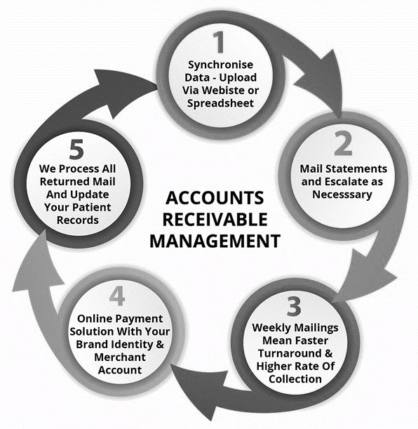
Figure 2: Accounts Receivable Management Cycle

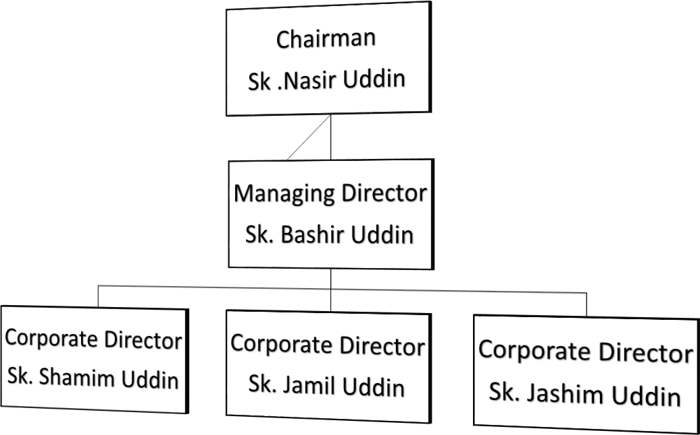

Figure 3: Organogram of Akij Group

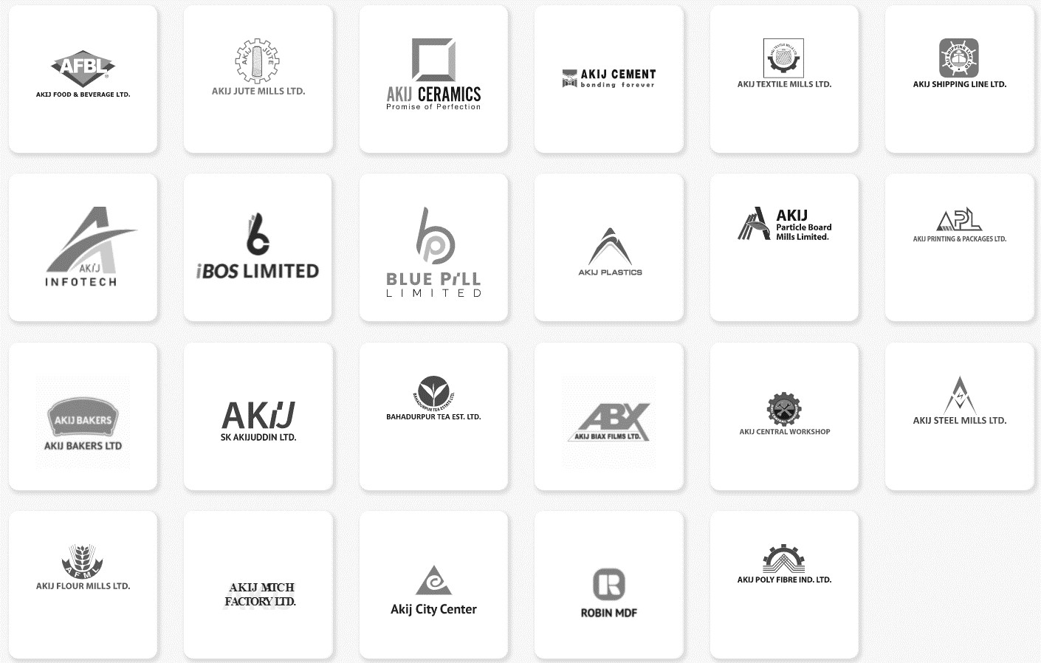
Figure 4: Companies under Akij Group

Account
and Finance Department
Audit
Department
Head
Office
Sales and
Marketing Department
Human
Resource Department
Supply
Chain Department
Figure 5: Akij Group Departments

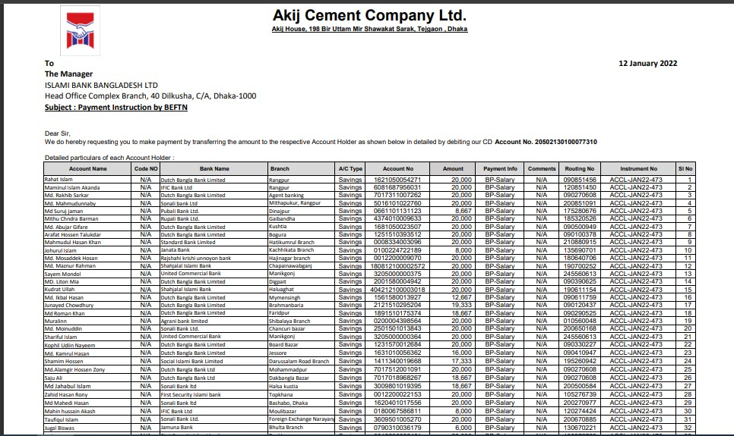
Figure 6: Akij Group Payment Management

Step 1:
Preparing an excel sheet
Step 2:
Checking statement from ERP software
Step 3:
Checking bank receivable page

Step 4:
Checking statement and making voucher
Step 5:
Permitting to distribute product
Step 6:
Doing bank reconcile
Step 7:
Doing creditor reconcile

Figure 7: Accounts Receivable Management process
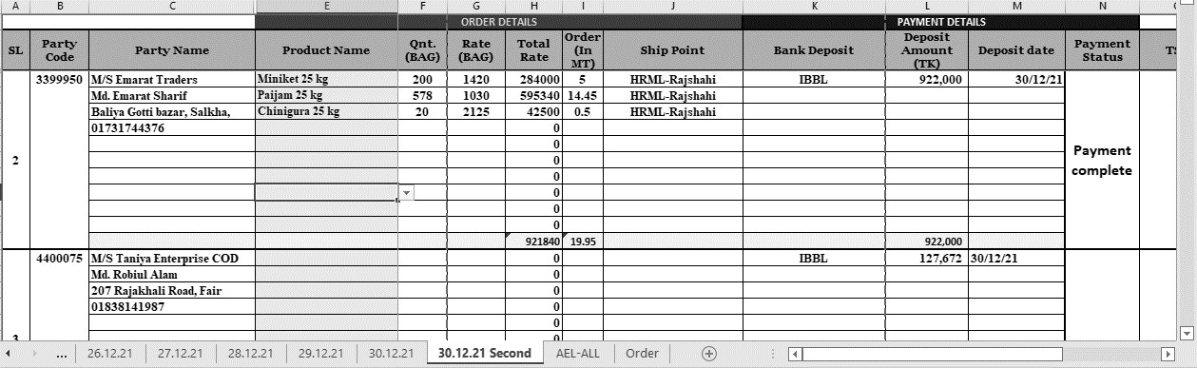
Figure 8: Excel Sheet of the Sales Team

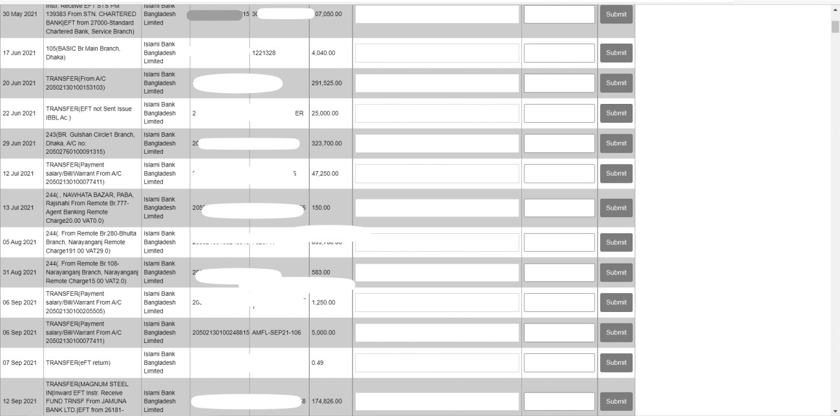
Figure 9: ERP Software Bank Receivable Page

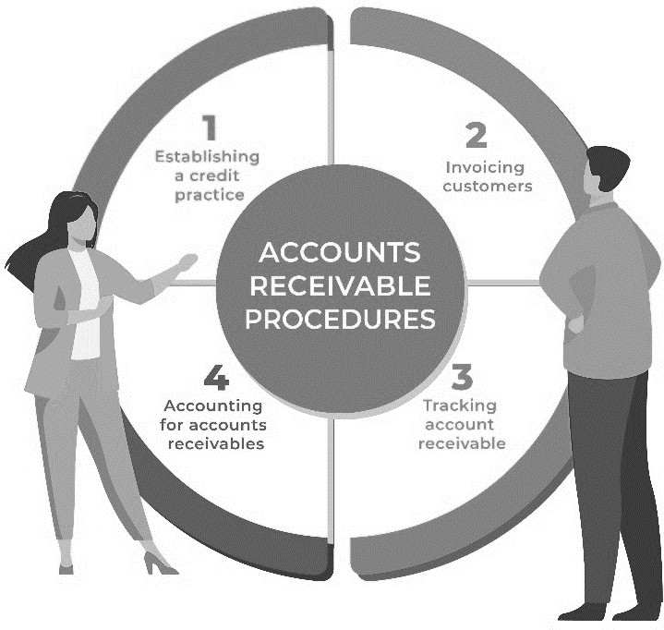
Figure 10: Accounts Receivable Procedures

Particulars |  | 2017 | 2018 | 2019 | 2020 | 2021
 | Jan | 7,432 | 8,567 | 7,992 | 8,205 | 7,221
 | Feb | 7,204 | 8,432 | 8,162 | 8,962 | 7,456

Accounts Receivables | Mar | 6,339 | 7,764 | 7,436 | 5,662 | 6,870
Accounts Receivables | Apr | 8,122 | 7,445 | 6,901 | 5,497 | 8,182
Accounts Receivables | May | 7,902 | 8,221 | 8,112 | 5,982 | 8,282
Accounts Receivables | June | 6,662 | 6,839 | 8,081 | 5,839 | 7,856
Accounts Receivables | July | 7,095 | 8,202 | 6,288 | 6,086 | 7,921
Accounts Receivables | Aug | 7,223 | 7,662 | 7,664 | 6,231 | 8,256
Accounts Receivables | Sep | 8,092 | 6,545 | 8,221 | 6,176 | 8,482
Accounts Receivables | Oct | 8,967 | 9,102 | 8,952 | 7,885 | 6,930
Accounts Receivables | Nov | 6,952 | 7,465 | 8,766 | 7,942 | 7,830
Accounts Receivables | Dec | 8,212 | 6,202 | 7,566 | 8,005 | 8,321
Total A/R |  | 90,202 | 92,446 | 94,141 | 82,472 | 93,607
A/R Growth |  |  | 2.49% | 1.83% | -12.4% | 13.5%
A/R Turnover |  | 10.2 | 14.3 | 15.8 | 12.8 | 10.8
Figure 11: Accounts Receivable for the last 5 years (2017-2021)

