
Internship Report
On
Evaluating the Impact of Marketing Mix Decision on Sales Performance:
A case study on ACI Coil

Submitted To
Muhammad Hasan Al-Mamun
Assistant Professor
School of Business & Economics
United International University
Submitted By
Mehanaz Sultana Aurni
ID: 111 131 211
BBA Program
School of Business & Economics, United International University
Date of Submission: September 3, 2018
Letter of Transmittal
September 3, 2018
Muhammad Hasan Al-Mamun
Assistant Professor
School of Business & Economics
United International University
Madani Avenue, Badda, Dhaka -1212
Subject: Submission of Internship Report
Sir,
It is a pleasure to take the opportunity to submit this report, which has been prepared as per the requirement of Internship. This report has been created in accordance to your requirements as well as the requirement of the host organization.
The internship program, which is of three months, helped me to learn a lot. It also enabled me to gain practical knowledge on dealing with customers and to perform different tasks using specialized software. This report is based on an overview of the organization and the experience I have gained during my internship program at ACI Limited.
Despite the difficulties I faced while preparing this report mainly due to time constraints, I have tried to be as critical and analytical and the information provided are accurate to the best of my knowledge.
Sincerely,
Mehanaz Sultana Aurni
ID: 111131211

Acknowledgment
First of all, I would like to thank Almighty Allah for giving me the strength to complete my internship with attachment to ACI Limited for three month period. I would like to thank Almighty for guiding me for the timely completion of this internship report. I would also like to thank my parents for their continuous support during the toughest three months of my undergraduate life without which I would be unable to successfully complete my internship.
Next, I would like to thank all the people who had significant contribution in helping me throughout my internship and in fulfilling the requirements for the internship program at united international University. Firstly, I would like to thank my faculty advisor Mr. Muhammad Hasan Al-Mamum for guiding me and helping me continuously for the past three months for the successful completion of my internship.
I would like to thank my Supervisor, Md.Zakir Hossain Sarker, Consumer Brands Manager for supervising me and providing various key information and giving me the path to write a fruitful report also Business Analyst Officer Abu Hana Khaledn Mostofa and Assistant Manager, Sales Administration Md. Samusr Rahman Rimon to give a great guidance to me to make a faithful report and it is really very pleasure to me that he makes a correction of my report and give the correct solution always. I also thank him it was a great opportunity to do internship in such an organization like ACI Limited. I always felt that I was under guidance of highly qualified and experienced personnel. The experiences I have gathered will be very beneficial in my career.

Table of Content:
Chapter 1
Sl. No. | Particulars |  |  | Pages
1 |  | Introductory Part |  | 1
 | 1.0 | Introduction to the Report |  | 1
 | 1.1 | Topic in hand |  | 1
 | 1.2 | Objectives of the study |  | 1-2
 | 1.3 | Methodology |  | 2
 | 1.4 | Scope of the report |  | 2-3
 | 1.5 | Limitations of the study |  | 3
 | 1.6 | Ethical Considerations |  | 3
 | 1.7 | Context of the study |  | 3-4
Chapter 2
2 |  | Organizational Background and Industry Perspectives |  | 5
 | 2.1 | Background of the Organization |  | 6
 | 2.1.2 | Historical Background |  | 7
 | 2.2 | Different Business Units |  | 8-14
 | 2.3 | 2.3.1 | Corporate information | 14
 |  | 2.3.2 | Corporate Information of the organization | 14
 | 2.4 | Corporate Governance |  | 15
 |  | 2.4.0 | The Management Committee and Board of Directors | 15
 |  | 2.4.1 | Organizational Organ Gram | 16
 | 2.5 | Mission & vision |  | 16-17
 | 2.6 | Company Values |  | 17
 | 2.7 | Company policy & Global compact endorsement |  | 18-20
 | 2.8 | Fundamental Departments |  | 20-22
 | 2.9 | Industry Perspectives |  | 22-23
Chapter 3
3 |  | The Main Part |  | 24
 | 3.1 | Findings of the study |  | 25
 | 3.1.1 | Definition of Marketing Mix |  | 25
 | 3.1.2 | Elements of Marketing Mix |  | 26
 | 3.1.3 | Importance of evaluating Marketing Mix |  | 27
 | 3.2 | Marketing Mix of ACI |  | 27-28
 |  | 1 | Product | 28-29
 |  | 2 | Price | 29-30
 |  | 3 | Placing | 30-31
 |  | 4 | Promotion | 31-34
 |  | 5 | Process | 34-35
 |  | 6 | Packaging or Physical Evidence | 35
 |  | 7 | People | 35-36
 | 3.3 |  | Sales Promotion | 36
 |  |  | Promotional Mix and Elements | 36
 |  | 3.3.1 | Advertising | 37
 |  | 3.3.2 | Direct Marketing | 37-38
 |  | 3.3.3 | Internet Marketing | 38
 |  | 3.3.4 | Sales Promotion | 38-39
 |  | 3.3.4 | Public Relation | 39-40
 |  | 3.3..5 | Personal selling | 40
 |  | Rsearch Part |  | 41
 | 3.4 | Problem Statement |  | 41
 | 3.4.1 | Background of the problem |  | 41
 | 3.4.2 | Research Methodology |  | 41-42
 | 3.5 | Research Design |  | 43
 | 3.6 | Develop Independent Variables & Dependent Variables |  | 44
 | 3.7 | Data Analysis |  | 44-45
 | 3.7.1 | Questionnaire Scale & Hypothesis Development |  | 45-46
 | 3.8 | Hypothesis Testing |  | 47-48
 | 3.8.1 | Graphical Representation |  | 47-54
 | 3.9 | Findings |  | 55
 | 3.10 | Recommendation |  | 56
Chapter 4
 | 4.1 | Actual Task Part |  | 58
 | 4.2 | Internship program |  | 58
 | 4.3 | Internship Activities |  | 58-59
 | 4.4 | Key job responsibility |  | 59-60
 | 4.5 | Internship Position |  | 60
 |  | 4.5.2 | Primary Learning | 60-61
 |  | 4.5.3 | Secondary Learning | 61-65
 | 4.6 | Learning Experience |  | 65
 |  | Conclusion |  | 66
Chapter 5
 | 5.1 | Bibliography |  | 68-69
 | 5.2 | Survey Questionnaire |  | 70
 | 5.3 | Abbreviation |  | 71

Executive Summary
This internship report is based on practical experience at ACI Limited. This report mainly deals with the evaluation of the impact of marketing mix and promotional mix on sales performance of ACI Coil. This report consists of 7ps and five major parts with different tasks and I my my best to make a standard report based on this topic. Before working or doing my Internship program, I was very interested to know about the sales, marketing and promotion activities of a FMCG company. ACI Limited is one of the largest conglomerates in the country with businesses in pharmaceuticals, agriculture, consumer products etc. ACI stands for Advance Chemical Industries. ACI Limited is one of the most popular corporate names in Bangladesh. It is the most trusted brand as well as ensured quality product supplier. This report is designed basis on my theoretical knowledge and Practical experiences at ACI.

The objective of this report titled as “Evaluating of the impact of marketing mix decisions on sales performance: A Case Study on ACI Coil” is focused on the overall Marketing mix, sales performance and improving promotional mix of ACI Coil. ACI’s Mosquito Coil products performances are weaker than their other products. The company needs to focus on developing the sales as well as they need to promote their product through the radio, television, newspaper, outdoor advertising and through other strategies that will help to increase their coil sales.

Lack of promotional efforts and lack of a well-designed marketing program were found to be key causes of poor performance of the brand. I have also mentioned some recommendations for ACI Coil about what activities they need to follow to increase their coil’s sales. I hope they will be benefited from those recommendations.

Key Words: Marketing Mix, Sales Performance



CHAPTER ONE
Introduction

1.0 Introduction
This report is an Internship Report ready as an obligation for the completion of my BBA program from United International University. The primary goal of the internship is to provide a corporate experience to the students and a chance for translation of theoretical learning in real life situation. An internship is a period of work experience offered by an employer to give students exposure to the working environment, often within a specific industry, which relates to their field of study. Students are placed in organizations, research institutions as well as development projects. The program concealments a period of 12 weeks of organizational accessory and 2 to 3 weeks of report finalization work. After the achievement of four-year academic BBA program, the period of my organizational part was, by policy 12 weeks, starting from February 01, 2018. I was placed in ACI Limited’s Consumer Brand Division (Sales), Dhaka for the internship program.

Topic in Hand:
In this report I have concentrated on my topic “Evaluating the Impact of Marketing Mix Decisions on Sales Performance: A Case Study on ACI Coil” Theoretically we can describe what is the actually meaning of evaluating marketing mix and how the sales performance will increase through improving promotion. Basically, the report is made based on primary data, secondary data and information about the company. The procedure and findings of the study are mainly exhibiting my volume for some creative and original approach to solving practical problems in today’s business.
  - Objectives of the Study
The research will be aimed at fulfilling the following objectives-
- To develop an understanding of Marketing Mix and an overview of ACI Coil.
- To determine the impact of brand image and attractive promotional activity on consumer buying patterns.
- To understand the pricing factors influencing on consumption of ACI Coil.
- To identify the reason for which ACI Coil current promotional activities are not providing desire result.
- To recommend some initiatives based on the findings to improve sales performance of ACI Coil.
- To describe the process of implementing the effective distribution networks and distribution channels of ACI Coil.
1.3 Methodology:
Methodology is the process, technique or method of observation, survey and analysis. For
Smooth and accurate study everyone has to follow some rules and regulation. The study assigns
Were collected from two sources:
1.3.1 Primary sources:
- I have collected the primary data by receiving interview different executives of ACI Ltd.
- Practical work.
- Face to Face conversation with sales representative, Distributors, Area Sales Manager and Zonal sales manager etc.
- Direct observations.
    - Secondary sources:
- Website of ACI Limited
- Other different WebPages
- In my report I tried to minimize the usage of secondary data as much as possible. I have used secondary data only in the cases where it was not possible for me to use primary data.

  - Scopes of the report:
The scope of the report covers the organizational overview and structure, background, objectives, basic functions, sales performance, products analysis, Sales promotion, competitor analysis, trade marketing through push and merchandising items for market research of international packaging with unique through the Sales and Marketing department of ACI Consumer Division. And for that reason, that information was very much restrictive within the organization as this brand are going a very much completive Brands. Hence, the main focus was on the major activities carried out by the CB (Consumer Brand) sales department. During my internship, I tried best to learn the strategy and techniques followed by the experts of ACI Limited. I am really thankful to the employees of all departments for keep supporting and inspiriting me during my Internship.
1.5 Limitation of the Report:
ACI Limited is really a great place to gain practical knowledge. Though I have given extreme effort to prepare this report, while the time of preparing report, I had to face some obstacles. Which are as follows–
- As we know that the internship’s duration is only 3 months which is very short time for collecting all type of data about the organization. For this reason, I am not able to find efficient information what are needed for this report. This was not enough. So, I could not go in-depth analysis.
- While doing an internship, in some parts of my inquiry, my performance was stuck by some lack of experience.

1.6 Ethical Considerations:
The whole report completed by my hard work. I got maximum information from my authorized supervisor, Staff and their website. I was very much regular during my internship period also kept regular communication with my supervisor.

1.7 Context of the Study:
ACI is one of the biggest FMCG Company in Bangladesh who has been serving in Bangladesh and outside of the country to develop the country’s economy. Currently more than 10K people working at ACI and their growth rate has been increasing in a remarkable rate.
“ACI is one of the largest Bangladeshi conglomerates. The company operates through three reportable segments: Pharmaceuticals, Consumer Brands and Agribusiness ACI established as the subsidiary of Imperial Chemical Industries (ICI) in 1968”.

“It has been incorporated as ICI Bangladesh Manufacturers Limited on 24 January 1973. The company was renamed as Advanced Chemical Industries Limited (ACI Limited) on 5 May 1992. The company sold its insect control, air care and toilet care brands to SC Johnson & Son in 2015”.

CHAPTER TOW
Organizational Background and
Industry Perspective

2.1 Background of the Organization:
“ACI was established as the additional of Imperial Chemical Industries (ICI) in the then East Pakistan in 1968. After independence the company has been incorporated in Bangladesh on the 24th of January 1973 as ICI Bangladesh Manufacturers Limited and also as Public Limited Company. This Company also obtained listing with Dhaka Stock Exchange on 28 December, 1976 and its first trading of shares took place on 9 March, 1994. Later on, 5 May, 1992, ICI plc divested 70% of its shareholding to local management. Consequently the company was registered in the name of Advanced Chemical Industries Limited. Listing with Chittagong Stock Exchange was made on 22 October 1995”.
Bangladesh is a country which is tiny in size but large in population. ACI Limited is one of the most popular corporate names in Bangladesh. It is the most trusted brand as well as ensured best type of quality product supplier. ACI Ltd plays an important role as a provider to national economic condition. Along with this, they have left their footsteps in international platform through foreign investments, joint ventures and brand affiliations. ACI has been acknowledged as a founding member of the community of Global Growth Companies by the World Economic Forum which is the most prestigious and demanding business networking organization.
ACI Limited stands for the name “Advanced Chemical Industries limited” which refers that they started their business with Pharmaceutical goods. After that they spread dissimilar brunches and sectors of product lines within their operation.
Logo:
The logo of ACI Ltd is very mesmerizing. It is green in color and there are waves in the logo.
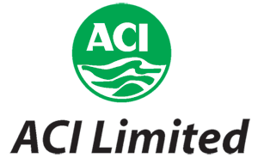
Figure 2.1: Logo of ACI Ltd.
2.1.2 Historical Background:
“ACI Limited is one of the leading companies in Bangladesh. It was recognized as a subsidiary of Imperial Chemical Industries (ICI) plc, U.K. in 1968. At that time, it was one of the oldest Industrial units in our country. After the liberation war, the enterprise was stated ‘abandoned’. Then it had been incorporated in Bangladesh on the 24 of January 1973 as ICI Bangladesh Manufacturers limited as a subsidiary of ICI. On 24 June 1973, the factory again started its operations under the name ICI Bangladesh Manufactures Limited. On the 5 of May 1992, ICI Plc divested 70% of its share to local (Bangladeshi) management and hence ACI Limited came into existence. At present ACI is a foremost corporate figure in Bangladesh. It is a Public Limited Company with a total number of 15,550 shareholders, among which there are six foreign as well as fourteen local institutional shareholders. The company is diversified in to six major’s businesses. Besides, the company has a large list of international associates and partners with trade and business agreement”.

2.2 Different Business Units of ACI:
The figure below illustrates the different Business units of ACI Ltd.
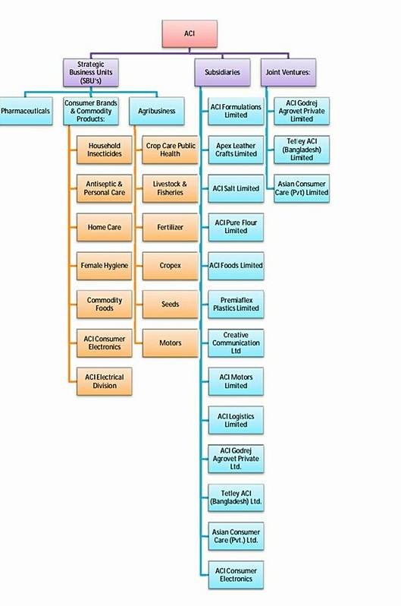
Figure 2.2: Business Unit of ACI Limited

- Strategic Business Units:
My particular department exists under the ACI Consumer Brands Department.
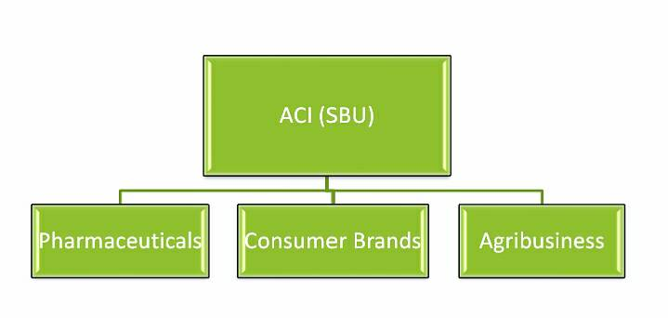
Figure2.3: SBUs of ACI Ltd.

- Pharmaceuticals:
“ACI carries their bright heritage of ICI- world renowned British Multinational in given that the people of Bangladesh live with healthcare products and superiority medicines. Its state-of-the talent pharmaceutical plant represents Bangladesh's mission of growth for a truly world class manufacturing facility. ACI's rich the legacy leads to modernization and higher value-added formulations”.
The inclusive range of product ACI pharmaceuticals includes products from all chief therapeutic as well healing classes and in a variety of measure forms like tablet, capsule, dry powder, liquid, cream, gel, ointment, ophthalmic and inject able. ACI Pharmacy also has nature of the art plant on Novel Drug Delivery System (NDDS). It produces world class Modified Release drug and medicine to supply the mandatory and essential of pharmaceutical manufacturer of household and international market. It exports high quality pharmaceuticals to the superior number of countries of Asia, Africa & South America.

Figure2.4: Pharmaceuticals of ACI Ltd.

- Consumer Brands:
“ACI Consumer Brands (CB) were founded in 1995 with two chief brands of the company – ACI Aerosol and Savlon. These are two most of the prestigious products which are enjoying the brand leadership position in the market. The separation started to take new businesses through off shore trading as well as local industrialization. In this progression ACI Consumer Brands launched many new products and also promises with Joint Venture business relationships with ‘Dabur India’ and ‘Tetley UK’ and participate international alliances with world renowned companies. The Consumer Brands Division has the power to having an unambiguous presence in consumers' heart and mind with the market leading brands like ACI Aerosol, Savlon, ACI Mosquito Coil & ACI Pure Spices and Flour. With close to 80% market split in own categories, ACI Aerosol and Savlon are the constant performers in keeping the household clean and free from germs and harmful insects”.
The ACI mosquito coil has also created as a alarming challenger to both the mosquito and the opposition, by provided the successful and reasonable declaration to the conscious people of Bangladesh. A sound mind build with a sound body-ACI believes in this age-old axiom and our young creation needs to develop the healthy physique and sound mind who will lead the next generation.
With this belief, ACI has steps up into their goods food business with “ACI Pure” Brand. The mission is to give the purest of the food items to Bangladeshi consumers at reasonable prices for which ACI has invested in very large scale in this condition of the art manufacturing services for daily kitchen nuts and bolts like space evaporated edible Salt, Spices and Flour. The products are attracting the consumers by providing 100% dirt free, pure and standard food ingredients which can struggle against any international products. ACI Consumer Brands are effectively providing the consumer demand for foreign products in household and personal care division with the world famous product range of Colgate, Nivea & Dabur. With the proper distributing and marketing of ACI consumer brands, the world's No. 1 tea brand "Tetley" is now available to the consumers of Bangladesh. As a successful business, The ACI Consumer Brands are paying attention on grab the reliable growth required to maintain the success and to make ACI an even powerful company.
The Consumer Brands has the believe that the best way to assist the consumers, people and the shareholder of ACI. “ACI Consumer Brands Strategic Business Unit is headed by the Executive Director, Mr. Syed Alamgir. Mr Alamgir is regarded as a challenging personality in the area of Sales and Marketing in Bangladesh market. His way record has many successful brands which reached to manage the position in different sectores in the FMCG market. He gives support by a skilled group of professionals working in the Marketing and Sales operations”.
Consumer Brand and Commodity Products:
I. Household Insecticides.
II. Antiseptic and Personal care.
III. Home Care
IV. Female Hygiene
V. Commodity Foods
VI. ACI Electronic Division



Figure2.5: Consumer Brand and Commodity Products of ACI Limited
- Agribusiness:
“ACI Agribusiness is the biggest provider in Bangladesh in Agriculture, Livestock and Fisheries and deals with Crop Protection, Seed, and Fertilizer, Agric machineries, and Animal Health products. These businesses have overestimated of presence in Bangladesh. CC & PH supply, crop protection chemicals, Seed supplies Hybrid Rice, vegetable and Maize seeds, Fertilizer Supplies Micronutrient and Foiler fertilizer, Agric machineries supplies Tractors, Power Tiller and Harvester and Animal Health supplies high quality Nutritional, Veterinary and Poultry medicines and vaccines. ACI provides clarification to the farmers through a large number of group scientists & skilled professionals”.

I. Crop Care Public Health.
II. Livestock and Fisheries
III. Fertilizer
IV. Cropex
V. Seeds
VI. Motors
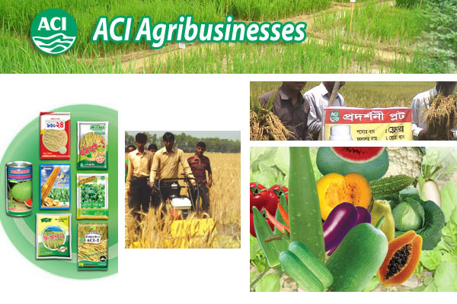
Figure 2.6: ACI Agribusinesses
- Subsidiaries:
- ACI Formulations Ltd.
- Apex Leather Crafts Ltd.
- ACI Pure Salt Ltd.
- ACI Pure Flour Ltd.
- ACI Foods Ltd.
- Creative Communication Ltd.
- ACI Motors Ltd.
- ACI Electronics Ltd.
- ACI Logistics Ltd.
- ACI Godrej Agrovet PVT Ltd.
- Tetley ACI Bangladesh Ltd.
- Asian Consumer Care Ltd.

- Joint Venture:

- ACI Godrej Agrovet PVT Ltd.

- Tetley ACI Bangladesh ltd.

- Asian Consumer Care Ltd.

2.3 Corporate Information:
“ACI Plc of UK had a pharmaceutical business in Bangladesh. In 1992 the business was hand over to the management and then the name of the Company changed to Advanced Chemical Industries (ACI) Limited. ACI inherited the rich ICI culture of product superiority, customer service and social liability and continues to nurture. ACI is also the first Company in Bangladesh to get certification of ISO 14001 Environmental Management System in 2000. ACI employees are pompous of their work background, business ethics and environmental consciousness”.

2.3.1 Corporate Information of the organization at a glance:
Name of Company | Advanced Chemical Industries Limited
Nature of business | Manufacturing, Processing, Retail, Service
Founded | 1968
Location
  ACI Center, 245 Tejgaon Industrial Area, Dhaka 1208
Headquarters | Dhaka
Fax | 880 2 8878619 & 8878626
E-mail | info@aci-bd.com
Logo | 

Table 2.1: Corporate Information of ACI Limited
2.4 The Management Committee and Board of Directors:

The Management Committee
Name | Designation
Dr. Arif Dowla | Managing Director
Dr. F H Ansarey | Executive Director, Agribusiness
Mr. Syed Alomgir | Executive Director, Consumer Brands
Mr. M. Mohibuz Zaman | Chief Operation Officer, Pharmaceuticals
Mr. Pradip Kar Chowdhury | Executive Director, Finance and Planning
Mr. Sabbir Hasan Nasir | Executive Director, Logistics
Mr. PriyatoshDatta | Director; Quality Assurance, Pharma
Mr. AbdusSadeque | Director, Marketing & sales, Pharma
Ms. Sheem Abed Rahman | Director, Corporate Affairs
Mr. Md. Monir Hossain Khan | Financial Controller
Mr. Imam Ahmed Istiak | Director, Operation, Pharma

Table 2.2: The Management Committee

2.4.1 Organizational Organ Gram:
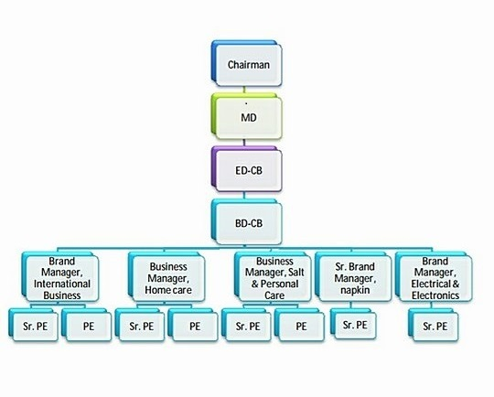
Figure 2.7: Organization Structure of ACI Consumer Brands
2.5 Mission and vision of ACI Limited:
2.5.1Company Mission:
ACI's Mission is to develop the quality of life of the people throughout affordable application of knowledge, technology and skills. ACI is dedicated to the pursuit of brilliance through world-class products, pioneering processes and empowered employees, to provide the highest level of satisfaction to our customers.
2.5.2 Company Vision
To achieve the mission ACI will,
➢ Present products and services of high and reliable quality, ensuring value for money to our consumers.
➢ Endeavour to achieve a position of leadership in each grouping of our businesses.
➢ Develop our employees by cheering empowerment and gratifying innovation.
➢ Promote an environment for getting the knowledge and personal growth.
➢ Attain a high level of efficiency in all our operations during effective utilization of resources and acceptance of appropriate technology.
➢ Promote comprehensive growth by encouraging and supporting our distributors and suppliers in improving efficiency.
➢ Ensure greater return on investment through sensible use of resources and professional operations, utilizing our core competencies.

2.6 Company Values:
The core values of ACI are:
➢ Quality
➢ Customer Focus
➢ Innovation
➢ Fairness
➢ Transparency
➢ Continuous Improvement

2.7 Company Policies
Quality Policy
“ACI is the first company in Bangladesh who obtained ISO 9001 certification for quality management system in all categories”.
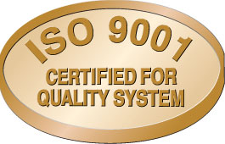
Figure 2.8: ISO 9001 Certified for Quality System
High rang of services and reliable quality, ensuring value for money to their customers is one of the significant visions are offering the products.
Environmental Policy
“ACI is the first company in Bangladesh to who obtained ISO 14001 Certification for Environmental Management System”.
ACI is dedicated to formulate and carry out all its operations in an environmentally friendly manner, prevention of pollution or degradation of the environment and ensuring repeated improvement in the exploitation of resources.

Figure 2.9: ISO 14001 Certified for Environmental Management

Global Compact Endorsement
“The ACI group has tried to consistently demonstrate it’s the environment over the years and commitment towards its employees also. It has been documented as the practitioner and promoter which are socially responsible business behavior for the organization. To take it as a commitment, ACI has authorized the philosophy of the Global Compact on August 18, 2003. The Global Compact endorsement is a outstanding initiative sponsored by the United Nations Secretary General Kofi Annan. It is depends on a very simple concept which is whether or not necessary by law, corporations should be implement basic human rights and the accepted environmental standards in all their business activities and labor low, try to balancing all possible negative effects of globalization. The compact calls on companies to embrace the ten universal principles in the key areas of labor standards, human rights and the environment”. These ten principals are:
Human Rights
- To appreciate and maintain the International Human Rights within the company's global influences.
- To make sure that their personal corporations are not making violence with Human Rights of the organization.
Labor
iii. To remove biasness from the workplace.
iv. Closing down the recruitment process among the child labor.
v. The right to collective bargaining power about the salary and give respect of freedom of association.
vi. To get rid of the uses of mandatory and enforced of the labor.
Environment
vii. To support a way of protect in advance to environmental challenges.
viii. To presume the initiative to encourage greater environmental capability and responsibility.
ix. To supply the environmental friendly technology motivate and about this.
Anti-Corruption
x. To work in opposition to all types of fraud, including theft and corruption.

2.8 Departments of ACI

- Administration department
Administration department specially work to maintain friendly surroundings through proper monitoring with the company policy.
- Finance and Planning
ACI Finance is the nerve middle of the conglomerate. The major areas of its activities include:
• Corporate Finance
• Treasury
• Insurance and risk management
• Costing
• Credit Management
• Accounts payable management
• General accounting
• Taxation
• New business management
- Commercial department
• Commercial department of ACI ensure all RM & PM to run smooth business.
• Also maintaining a good relationship with the customer both based on nationally and internationally.
- MIS department
• MIS department of ACI provide all over IT related work and deliver for the company.
• Manages hardware obstacles shooting and databases what are related to the business sales and inventory and also maintain a smooth transformation of software's too.
• MIS delivers customized all kind of data and also provide analytical term to the management the team.
- Distribution department
• The Company maintains strategically located sales centers in nineteen different locations across the country.
• Distribution system through it’s more than 300 skilled and trained manpower and a large fleet over eighty vehicles.
• Capable of maintaining a cold chain for vaccines and insulin.
- Training department
Training activity of ACI is to build up for all members of ACI family through the training, skill development, and workshop.
- HR department
• HR department keep working on their policies, manpower Planning and succession planning to procedures for Recruitment & Selection,.
• This department works on qualitative aspects and Balanced Score Card for measuring performance appraisal and use some other function also.
• ACI is a platform to learn, grow and contribute for improving and managing the quality of life of people.

2.9 Industry Perspectives

Considering FMCG Industry in Bangladesh, ACI is the pioneer company in Bangladesh in almost every sector. ACI currently has more than 125 products and many of the goods are marketed abroad. Export helps to increase the amount of foreign currency and ultimately it will boost the economy in Bangladesh. Though all other FMCG companies are contributing a lot, ACI has an edge as this company is one of the biggest groups of company in Bangladesh.
Some products of ACI have got the global reorganization that clearly reflect that ACI make world class products. Though these products are made from Bangladesh, the countries employment rate, usages technology, training, innovative, R&D etc has been gradually increasing.
ACI is the pioneer and superstar for the other company as well; they can learn a lot of things from ACI in both management practice and manufacturing sectors. There is no benchmark or ranking currently available in Bangladesh to compare the company’s performance but it could be easily recognize that ACI has been in the top for many years. After all a company like ACI is must for a developing country like Bangladesh.
Over the last 44 years, ACI has provided the people of Bangladesh countless necessary products every day. They promised best quality products in the cheapest price possible and so far, they have kept their words. This is why the people of Bangladesh love the ACI Group of Companies and all their products
Anyway lots more info on ACI’s UPP strategy and results will hit the market over the coming months. From an industry perspective it is always superb to see key companies in the market step up towards meeting new challenges and demands. The more momentum in payments companies the faster we all succeed. They are become renowned worldwide for some of their value able product and one of this is their ACI salt
Global Recognition
“ACI Pure Salt has received the global recognition for its excellent packaging design through the book, “Pack Your Life” volume 3. This book is published with all the top ranking packet design from all over the world”.
Best Brand Award
“ACI Pure Salt has been adjudged and awarded ‘Best Brand Award 2015’ in the Salt Category. This evaluation was done by Millward Brown, a world renowned research firm through extensive qualitative and quantitative research across all consumers countrywide.
In 2008, ACI Pure Salt received Best Brand Award across all food and beverage category. ACI Pure Salt continued to receive the award of Best Brand when Salt was made a separate category in 2011, 2013, 2014, and 2015”.

CHAPTER THREE
Findings of the Study (The main part of the study)

3.1 Findings of the Study
The main findings of the study are related to the evaluation of the marketing mix and increase the sales performance by improving promotional mix of ACI Coil. All the elements of the marketing mix influence each other and the market. The marketing mix needs a lot of understanding, market research and consultation with several people, from users to trade to manufacturing and several others.
Another finding of the study is to find out developing sales performance and sales promotion of ACI Coil and feedback of the market about their brand position.

3.1.1 Definition of Marketing Mix:

According to Philip Kotler - "Marketing Mix is the combination of four elements, called the 4P's (product, Price, Promotion, and Place), that every company has the option of adding, subtracting, or modifying in order to create a desired marketing strategy"

According to Principles of Marketing, 14e, Kotler and Armstrong, 2012 - "The Marketing Mix is the set of tactical marketing tools - Product, Price, Promotion, and Place - that the firm blends to produce the response it wants in the target market."

In the book of E. JeromeMcCharty. It says that "Marketing Mix is the controllable variable which the company puts together to satisfy this target group. The 7Ps has a focus on the customer and customer is not part of the marketing mix but rather the customer should be the target of all marketing efforts”.
The marketing mix refers to the set of actions, or tactics, that a company uses to promote its brand or product in the market. The 7Ps make up a typical marketing mix - Price, Product, Promotion , Place, People, Process, Physical evidence. However, nowadays, the marketing mix increasingly includes several other Ps like Packaging, Positioning, and even Politics as vital mix elements.
3.1.2 Description: What are the 7Ps of marketing?
Product refers to the item actually being sold. The product must deliver a minimum level of performance; otherwise even the best work on the other elements of the marketing mix.
Price refers to the value of the product. It depends on production cost of the product, targeted segmentation; distribution cost of the market and other direct and indirect cost are included here. The pricing strategy can be several types sometimes it’s totally depend on the overall business plan. Pricing can be also used to differentiate one product to another and can occupy the final image of the product.
Place refers to the point where product are placed for the sale. In every industry, wants to display their and try to catching the eye of the consumer and this will be possible by finding a good distribution place where customer can able the product easily, it’s also called ‘place’ strategy. Choosing a right location is a mantra of a retail business. In fact, retailers pay a premium amount only for suitable place.
Promotion refers to all the activities which is taken to make the product or service known to the customers and trade. This can include advertising, word of mouth, press reports, commissions and awards to the trade and other different promotional strategy. It can also include consumer schemes, direct marketing, contests and prizes what can help people to attract about the product.
People refer to the company’s employees, who deliver the service, It is very important in marketing. Hire and train the right people to deliver superior service to the business clients, weather they run a support desk, customer service, programmers etc .
Process refers to the system and processes of the organization affect the execution of the service. It could be the entire sales funnel. Pay system, distribution process, and other systematic procedures to ensure a business that is running efficiently.
Physical evidence refers any physical store or product..For the service industries there should be physical evidence that the service was delivered. However physical evidence pertains also to how a business and its products are perceived in the market place.

3.1.3The Importance of Evaluating Marketing Mix Decisions:
Marketing mix is a tool which can create the implementation of it through the effective process and make the best marketing strategy. The marketing mix can assess the overall process of the product, price, place, promotion and plays a vital role in the overall marketing approach.
Marketing mix helps to finding out all type of strategy related with the marketing and right for the organization. This step is very first step for making a marketing plan and also the business plan. Marketing mix is the mixture of the positioning, targeting, segmenting which is also another valuable part of the marketing mix.
It can make the decision which is regarding of based on the products while positioning plan also decided on the basis of the price targeting and segmentation. The marketing mix decisions also have an impact on the decision making regarding on the pricing strategy and promotion. Therefore, the marketing mix strategy goes hand in hand solution through the positioning, targeting, and segmentation.
All the elements, which are included in the marketing mix and the complete marketing mix, have the major bonding with one another.
3.2 Marketing Mix of ACI:
The marketing mix is the set of controllable, tactical marketing tools that a company uses to produce a desired response from its target market. It consists of everything that a company can do to influence demand for its product. It is also a tool to help marketing planning and execution.

Every successful company need to create a successful mix of the right product at right price at the right place through the right promotional tool. Thus, marketing mix is mixture of 7Ps: product, price, place, and promotion, process, physical evidence and people. ACI Consumer brands has also followed a good marketing mix to market into their product and most importantly they used all of the Ps and try to interrelated all the mix elements. Now I would like to discuss about the 7Ps of ACI Consumer brands.

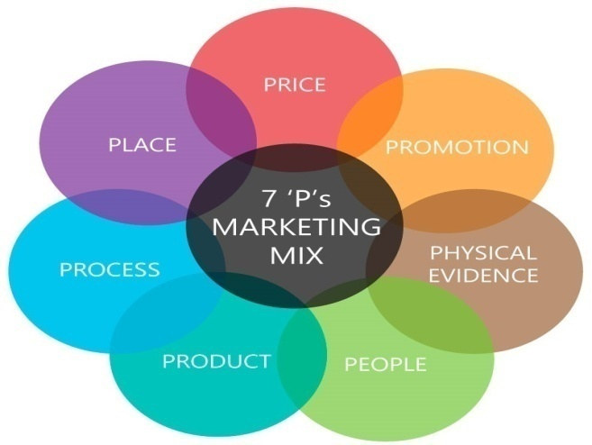
Picture 3.1: Marketing Mix
- Product:
Products are the key elements for the ACI Limited.ACI Limited is proud of the products that consist of the part of their Consumer Brands division. The Consumer Brands Division having the obvious and clear presence in consumers’ heart and capture their mind with the market leading Commodity Products. Household Insecticides, Antiseptic and Personal car, Home Care, Female Hygiene, Commodity Foods, ACI Electronic Division. But I am going to described only the part of household insecticides products.
Household Insecticides:
The home care products of the Consumer Brands division make proud of the ACI Limited. I choose only one products of ACI Mosquito Coil.
ACI Mosquito Coil:
ACI Mosquito Coil is another important product of the Home Care category of ACI Consumer Brands. ACI Mosquito Coil has different Brands based on different shape, color and fragrance and price. ACI Mosquito coil has the following brands:
- ACI Hi Power.
- ACI Super.
- ACI High Booster and
- ACI black fighter

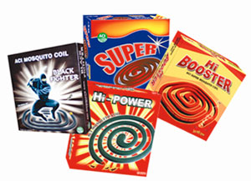
Picture 3.2: ACI Mosquito Coil
- Price:
Price has a major role in developing a product. It’s also an important element in marketing mix because it is directly related to the revenue generation and all other parts of marketing mix. Pricing decisions are influenced by many objectives like profit, costs, organizational and marketing objectives and so on. To set the price of the ACI Coil follow the product carton-based pricing strategy. Though ACI is providing better quality than anyone in Bangladesh, they impose the same price for the customers. So, it makes them able to grab the highest market share in the country. However, the trade price differs based on the market demand of the product in various locations of the country.
The new product will launch for the mass market and thus price competitiveness may vary from other brands as ACI Consumer Brands is planning to focus and build their pricing strategy based on the products SKU size which may create competitive advantage for the brand and the organization.

- CB Based Price List:
Given below the Household Insecticides Products Price List-
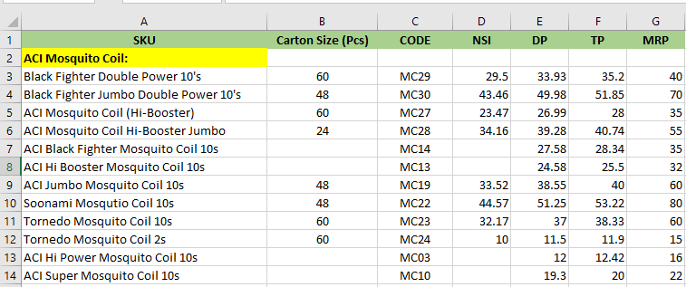
Picture 3.3: ACI Mosquito Coil

- Place:
The place is the crucial part which is making the available where the customers demand are high and the uses of the product also very high on that area. Thus, it is concerned with the stores or showrooms where goods will be displayed and directly sold their product. ACI Limited has a distribution channel throughout the country. ACI Limited has their distribution points in almost every district at Bangladesh. And every regional distribution point has their sub depots through which products are distributed through the retailers of the nearby areas.

Regional Distribution points are: “Dhaka, Savar, Dinajpur, Faridpur, Jossore, Rangpur, Bogra, Rajshahi, Maymensingh, Tangail, Gazipur, Chittagong,Comilla,Bandarban, Maijdi, Coax’s Bazar, Narayangang, Comilla, Kustia, Khulna, Sreemangal, Sylhet, Chandpur etc”.

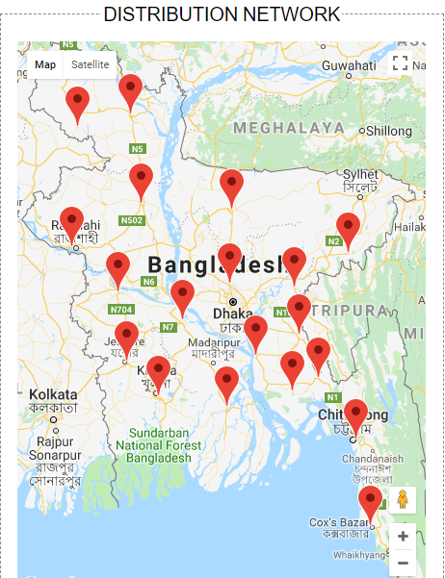

Picture 3.4: Distribution Network of ACI Limited

4. Promotion:

Promotion is the process which is relates to communicating with customers and provides all type of necessary information to attract them in making decision to buy the products. The cost of promotions is attached with represents a sizeable proportion of the overall cost of production item. However, a most successful promotional strategy helps to grow up the products femousity and also helps to build long term relationship with increasing the number of sale for this effective promotion. ACI Limited has TV Ads, Activation, and Event, Conference program, corporate publication, social media and corporate advertising they do for the promotions of their brands.. Again, very often the distributors and retailers are provided various trade offers, incentives and commissions to boost up the sales. Many people are not concern about the brand but only used that product which is available the market most and purchase it. So, if ACI provide offers and commissions the retailer or sellers to motivate them and increase the sales too.

- TV Ads:
Television Ads is a span of television programming produced and paid for by an organization which conveys a message, typically to a market a product or service Limited made TV based on their products. ACI Coil try to publish their product through the Advertising.
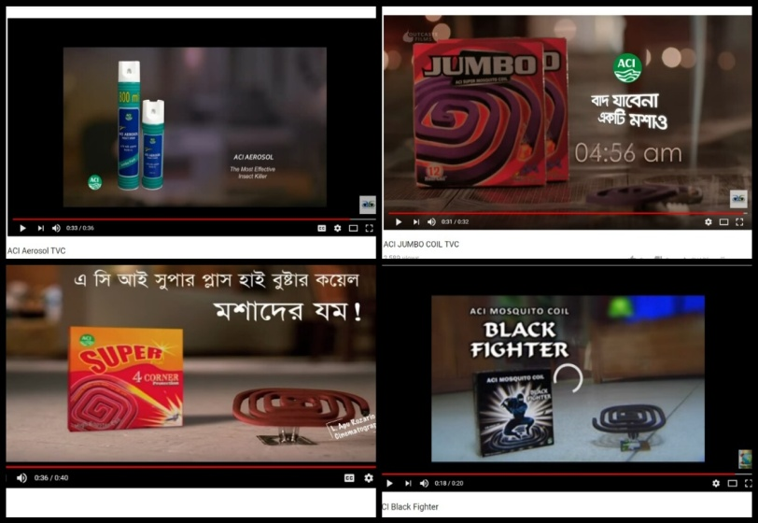
Picture 3.5: ACI Coil TV commercial Ads

- Activation: ACI Coil use their product promotion activation method to bring a brand message to life through a strategic, integrated campaign that leverage the full potential of a wide range of marketing communication tools in order to maximize results and provide the greatest return on their customer marketing investment. ACI Limited does different kinds of activation like- Market Activation, corporate activation etc.
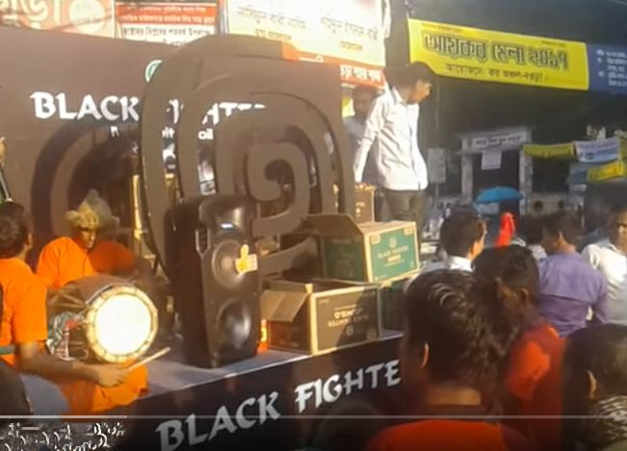
Picture 3.6: Black Fighter Coil Promotion Activation
- Conference Program: A typically meeting of people with a shared interest, typically one that takes place over several days. Actually, it’s an idea sharing forum and conservation that includes experts who advice how to species in captivity. On last 19th February ACI Consumer Brands arranged CB Sales and Marketing conference with their sales peoples and employee. They are also going to be held press conference. The news show on the GTV Channel.

- Events:
ACI Limited also arranged different types of Events based on occasion.
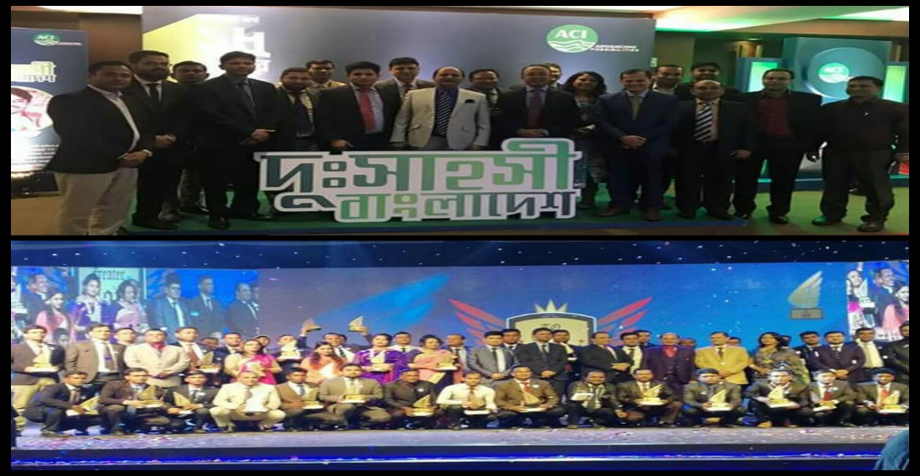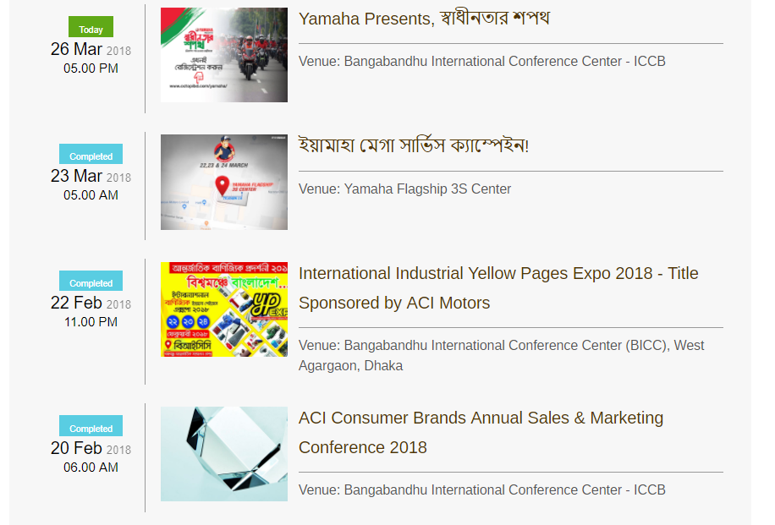

Picture 3.7: Some Events of ACI Limited

- Display promotion in Super shop:
ACI stresses a lot on different forms of trade promotion. ACI pushes the product to retail stores, Super shop and offers discounts and other forms of promotional offers. These have been quite successful as retailers readily display coil, Aerosol and other brands from ACI. During the market audits that I conducted, it was seen that the promotional offers work and stock availability of ACI products was quite high. ACI recently conducted a wet market activation program in different wet markets across Dhaka City. This encouraged the retailers to keep more of products in market.
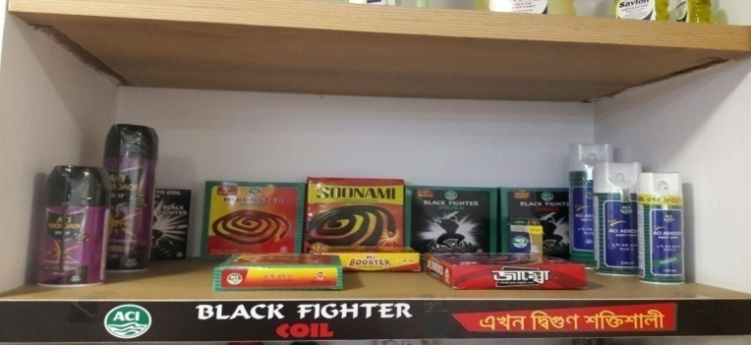
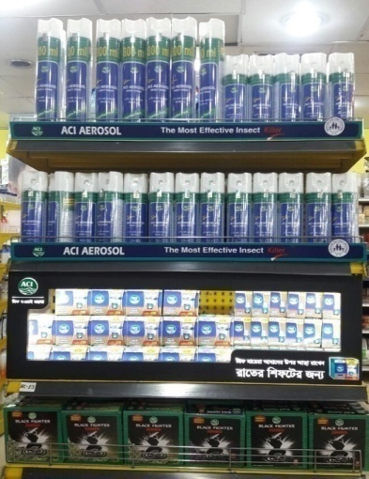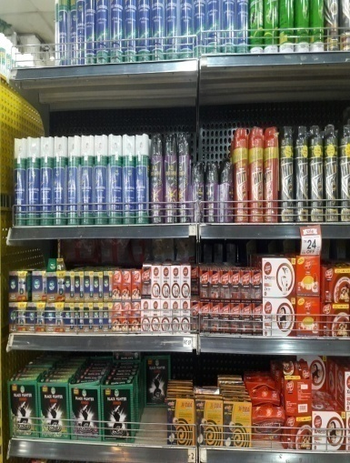

Picture 3.8: Display proportioning Super shop

5. Process:
This element of marketing mix looks at the systems used to deliver the service. It means all services need to be underpinned by early defined and efficient process. Because of that customer can identify the effectiveness of the company.
The products are first manufactured in the factory, from factory half of the products are sent directly to the distribution points to the retailers through some rented vehicles and half of the products are sent to the depots and then to the distribution points and then to the retailers. This process is done through some rented vehicles and some company owned vehicles.
The distribution process flow is shown by a flow chart below. And the distribution channel process is shown by a map bellow-
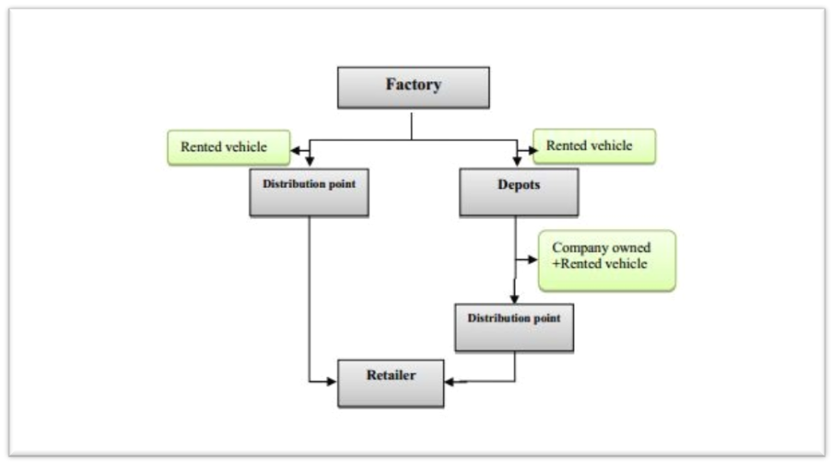
Flowchart 3.1: The distribution process flow of ACI Limited

6. Packaging or Physical Evidence:
Developing an eye-catching packaging for a product is one of the biggest challenges a marketer faces. As days passing by, marketers focus more on packaging thus consumers attract towards their products. There are varieties of coil packaging both traditional and creative available in the market.
As the physical evidence they maintain their factories and distribution centers which have lots of machinery cleanly and friendliness manner for employees. And they also provide t shirt and cap for their brand promoters.
7. People:
People are essential in the marketing of any product or service. From a marketing management perspective, it is important to ensure that employees represent the company in alignment with broader messaging strategies. In the Consumer Brand sales department of ACI Limited their have more than 100 people are working in different area of the Bangladesh to represent the company. When they are hired in the company then they are train by their supervisor to deliver superior service to the clients. The marketing people are always ready to give better services to the customer. CB Sales division tries to maintain good relationship with their valuable customer by providing high quality products along with a moderate price. Also handle to all the territories sales people and sales coordinators at together. They monitor the performance of all the sales peoples and sales coordinators and ensuing that processes are followed or not. They are also expected to supervise the shopkeepers as well as distributors.

3.3 Sales performance:

Sales performance uses raw data concerning the number of customers a sales associate speaks to compared with the number of actual sales. By reviewing the sales performance of an employee, a sales performance manager can determine his strengths and weaknesses.

Sales performance is the practice of monitoring and guiding personnel to improve their ability to sell products or services.

Promotional Mix:
The Promotional Mix refers to the blend of several promotional activities used by business to create, maintain and increase the demand for a product. (Business Dictionary)
The Promotion Mix is the bunch of some promotional activates like integration of Advertising, Personal Selling, Sales Promotion, Public Relations and Direct Marketing. The marketers need to view the following questions in order to have a balanced blend of these promotional tools.

Elements of Promotional Mix:
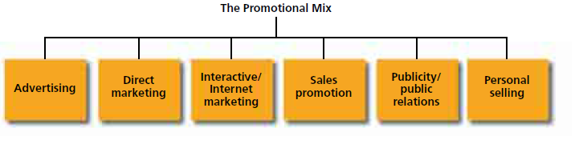
Figure 3.1: Elements of the promotional mix
3.3.1 Advertising:
The word advertising comes from the Latin word "advertere meaning” to turn the minds of towards”.
According to American Marketing Association "Advertising is any paid form of non- personal presentation and promotion of ideas, goods and services by an identified sponsor".
Advertising is used for connecting with the business information to the present and the future Customers and attract the customers about the product sometimes advertisement can raise the customers unwanted demand.
Advertisement normally supplies information about the advertising firm, quality of the product, available place of its products, etc. Advertisement is necessary element for both the buyer and the sellers. However, it is more important for increasing the sales performance. In the modern era the large-scale production, organization cannot even think to maintain the sale performance of their products without provide advertising. Advertisement supplements personal selling to a great extension. Advertising has gathered great importance in the recent world where tough competition in the market and fast changes are happening. It is Technology, where makers are find fashion and taste sense of the customer.
TV advertisements at the time of news and sponsoring TV programs that are watched by target markets. Also adds in radio, web sites, posters, labeled boxes, and also the product will promote itself with the attractive packing.
3.3.2 Direct Marketing:
With full blessing of science and technology, companies can reach to the customers directly without any intermediaries or any medium which are paid for. The e-mails, text messages, Fax, are some kind of tackle of direct marketing. The organization can send the mails and messages to the customers if they need to be conversant about the new offerings or the sales promotion strategy.

Now a day’s direct marketing as an additional factor of the Promotional Mix. Direct marketing is much more than sending direct mail and choose order catalogs scheme. It involves a diversity of activities, including database maintenance, direct selling, print medium and direct response through the ads or respond on direct mail, and different transmit and telemarketing.
One of the chief tools of direct marketing is straight reaction of the advertisement, whereby a product is showed through an ad that takes attention of the consumer to purchase directly from the manufacturer. Traditionally, direct mail has been the primary medium or less affordable medium for direct-response advertising, although television and magazines has become gradually more important media.
    - Internet Marketing:
As the new millennium has starts, we are discovering the most energetic and revolutionary changes of any period in the history of marketing, as the advertising and promotion are making. These changes are being determined by growing up the technology and improvements that have led to significantly growth of communication through interactive media mainly the medium of Internet. Interactive media permit for a back-and-forth stream of information whereby users can involve there self easily and recreate the form and content of the information they collect in real time. Dissimilar with traditional forms of marketing connections such as advertising, which are one-way in nature, the new media allow users to execute a diversity of functions such as obtain and modify any information and metaphors, make investigation, answer to questions, and of course, make purchases too. In accumulation to the Internet, other forms of interactive media include CD-ROMs, kiosk, and interactive television. However, the interactive medium which is having the largest impact on marketing is the Internet, particularly during the part known as the World Wide Web.

    - Sales promotion:
The next component of the promotional mix is sales promotion, which is commonly defined as those kinds of marketing actions that provide additional value or incentives to the sales persons, the distributors, or the final consumer and can encourage direct sales. Sales promotion is usually busted into two major categories: consumer-oriented and trade-oriented activities.
- Consumer-oriented sales promotion is targeted to the vital user of a product or service and includes couponing, sampling, premiums, contests, sweepstakes, and different kind of point-of-purchase equipment. These promotional tools persuade the consumers to formulate an immediate acquisition and thus can encourage short term sales.
- Trade-oriented sales promotion is targeted to the marketing mediators such as wholesalers, distributors, and retailers who are directly related with sales. Promotional and allowances, price deals, sales contests, and trade shows are some of the promotional tackle used to promote the trade to stock and develop a company’s products.

    - Publicity/Public Relations:
Another vital element of an organization’s promotional mix is publicity/public relations.
- Publicity
Publicity is the non-personal communications concerning an organization, product, service, or thoughts not directly paid for and run under recognized sponsorship. It typically comes in the shape of a news story, leader, or publication about an organization and its products and services. Like advertising, promotions are related non-personal communication to a mass audience, but unlike advertising, publicity is not directly paid for by the company for their product. The company or organization participates to find the media to cover up or run a positive story on a product, service, reason, or event to affect awareness, familiarity, opinions, and/or behavior. Techniques used to grow publicity comprise news releases, press conferences, aspect articles, photographs, films, and videotapes.
- Public Relations
It is essential to distinguish the difference between publicity and public relations. When an organization analytically plans and distributes information in an attempt to control and manage its figure and the nature of the publicity it receives, it is really engaging in a purpose known as public relations. Public relations are defined as “the management function which evaluates public attitudes, identifies the policies and procedures of an individual or organization with the public interest, and executes a program of action to earn public understanding and acceptance.”
Public relations use advertising and a multiplicity of other tackle—including special publications, participation in social activities, fund-raising, sponsorship of individual events, and various public relationships actions to enhance an organization’s image.

    - Personal Selling:
The final but another important element of an organization’s promotional mix is personal selling, “a form of person-to-person communication in which a seller attempts to assist and/or persuade prospective buyers to purchase the company’s product or service or to act on an idea. Advertising, personal selling involves direct contact between buyer and seller, either face-to-face or through some form of telecommunications such as telephone sales”. This interface gives the marketer communication elasticity; the seller can see or hear the prospective buyer’s reactions and modify the message consequently. The personal, individualized communication in private selling allows the seller to tailor and pamper the message to the customer’s specific needs or basis of condition.
Personal selling also involves more instant and specific feedback because the impact of the sales performance can generally be assessed from the customer’s reactions and purchase attempts. If the feedback is inauspicious, the salesperson can adjust the message. Personal selling efforts can also be targeted to exact markets and customer types that are the best prediction for the company’s product or service.

Research Part
3.4 Problem Statement:
During my internship period in ACI, I have witnessed their coil market is weaker than their any other products market. That’s why I choose to do my report on finding out what is hurting sales performance of ACI Coil.

3.4.1 Background of the Problem:
This report is based on “Increasing Sales Performance by improving promotional mix of ACI Coil”. The focus of the study is to analyzing the current market acceptance of ACI coil based on the increasing sales performance, sales promotional Mix and also developing the advertising for market position. During my internship program at ACI Limited I had observed a major issue which was more sensitive to give close attention. As ACI Limited is popular brand but there are few products which are not popular in market Like Coil. Because of poor sales promotional actives like less powerful and ineffective advertising. Lack of less promotional mix and advertising (Social media\Tvc, newspaper, digital marketing and outdoor advertising) fall their sales. But now ACI Coil team is trying to overcome their lacking.
My objective of the research is to find out developing sales performance and sales promotion of ACI Coil and feedback of the market about their brand positioning. So, I made a Hypothesis based on my research and find out some relative issues and tried to make some suggestions to make ACI Coil more popular.

3.4.2 Research Methodology:
While I was conducting the study, I have collected various types of primary and secondary data. Data has been collected through different sources like by taking interviews to the customers. The questionnaire contains only Liker scale. Secondary information has been collected through different journals, books, research publications and organizational website.

Research Approach:
- Survey
Type of research:
- Quantitative.
Research Instrument:
- Questionnaires with Structure question.

Data Sources:
I collected my whole data based on two sources. These sources are given below
Primary Data:
By three months Internship project time I observed and collected the primary data from Employees and Clients of ACI Limited through structured questionnairs. How I collect my informations from them is given below-

- by talking with my Spervisor
- discussing with the managers and staffs
- face to face conversation with the customers.
- personal discussion with Sales and office employees.

Secondary Data:
Secondary data had been collected from various report like-
- website of ACI Limited
- prospectus
- Published documents
- Some important files.

3.5 Research Design:
3.5.1 Sampling Plan:
After deciding my research approach I design a sample on two decisions including sampling Frame as follows-
3.5.2 Sample frame:
My sampling populations are those people, who are employees & customers of ACI Limited.
Here Sample size, n= 42
3.5.3 Sampling Procedure:
The respondents have been choosen from different sources and the procedure was Probability Sampling (Simple Random Sampling)

3.6 Develop Independent Variables & Dependent Variables:

Dependent Variables
Independent Variables

- Social Media
(e.g. Facebook& Company website)

2. Radio /TVc
Will increase the sales performance ACI Coil

- Newspaper

- Celebrity Ads
(e.g. Movie & Drama celebrity)

5. Outdoor Advertising
(e.g. Billboard)

Diagram 3.1: Independent Variables & Dependent Variables
3.7 Data Analysis:
- Hypotheses Test: Z test
The following formula has been followed:
We know that,
Z test = ($\overline{X}$–$μ$) / ($σ$/$√$n)
Where,
µ = Mean Value
n = Sample Size
σ = Standard Deviation
$\overline{ X}$= Average

3.7.1 Questionnaire Scale &Hypothesis Development:

A very crucial segment of a survey is hypothesis development and testing. The hypothesis is just a general statement with in-depth significance. It is presented before the respondents as a form of 5 Liker Scale. The hypothesis is very useful to figure out the thoughts of people regarding any particular issue.

Questionnaire Scale:
In order to analyze the responses a 5-point Liker Scale has been used.
Options to Respond | Weight
Strongly Disagree | 1
Disagree | 2
Neutral | 3
Agree | 4
Strongly Agree | 5
Table 3.1: Questionnaire Scale

Hypothesis Development:
H1: | Using social media Ads (e.g. Facebook& company Website) will increasethe sales of ACI Coil.
H2: | Using Radio/ TVc Ads will increase the sales of ACI Coil.
H3: | Using Newspaper (e.g. Bangle &English) Advertisement will increase the sales of ACI Coil.
H4: | Using popular face on TVc (e.g. Movie & Drama celebrity) will increase the sales of ACI Coil.
H5: | Using Outdoor advertising (e.g. Billboard ads) will increase the sales of ACI Coil.
Table 3.2: Hypothesis Development

H1) Hᴏ: Using social media Ads will not increase the sales of ACI Coil
Hᴀ: Using social media Ads will increase the sales of ACI Coil.
H2) Hᴏ: Using Radio/ TVc Ads will not increase the sales of ACI Coil.
Hᴀ: Using Radio/ TVc Ads will increase the sales of ACI Coil.
H3)Hᴏ: Using Newspaper Advertisement will not increase the sales of ACI Coil.
Hᴀ: Using Newspaper Advertisement will increase the sales of ACI Coil.
H4)Hᴏ: Using popular face or celebrity on TVc will not increase the sales of ACI Coil.
Hᴀ: Using popular face or celebrity on TVc will increase the sales of ACI Coil.
H5)Hᴏ: Using Outdoor advertising will not increase the sales of ACI Coil.
Hᴀ: Using Outdoor advertising will increase the sales of ACI Coil.

3.8 Hypothesis Testing:
Likert Scale |  | H 1 | H 2 | H 3 | H 4 | H 5
Strongly Disagree (1) |  | 6 | 7 | 5 | 8 | 8
Disagree (2) |  | 5 | 4 | 7 | 7 | 3
Neutral (3) |  | 2 | 3 | 10 | 4 | 9
Agree (4) |  | 7 | 8 | 9 | 14 | 12
Strongly Agree (5) |  | 22 | 20 | 11 | 9 | 10
Calculation | Total | 172 | 156 | 140 | 135 | 139
Calculation | Average | 4.09 | 3.72 | 3.33 | 3.21 | 3.30
Calculation | Standard Deviation | 1.57 | 1.53 | 1.35 | 1.44 | 1.40
Calculation | Z Test | 6.63 | 5.17 | 3.81 | 5.84 | 3.63

Table 3.3: Hypothesis Testing (Summary of the Survey Respondents)

3.8.1 Graphical Representation:

Hypothesis #1
Hᴏ: Using social media Ads will not increase the sales of ACI Coil.
Hᴀ:Using social media Ads will increase the sales of ACI Coil.
In other words,
H_{0:} µ = 2.5
H_{A:} µ >2.5
n= 42
Since the sample size n > 30 so, I may use z - test.

Here,
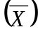=$\frac{172}{42}$= 4.09
$$Standard deviation =\sqrt{\frac{6{\left(1-4.09\right)}^{2}+5{\left(2-4.09\right)}^{2}+ 2{\left(3-4.09\right)}^{2}+7{\left(4-4.09 QUOTE \overline{x}\right)}^{2}+22{\left(5-4.09 QUOTE \overline{x}\right)}^{2}}{42}}$$
σ = 1.57

Z calculation:
In a 5point scale µ is 2.5
Z = $\frac{\overline{x}–μ}{\frac{s}{\sqrt{n}}}$ =$(4.09-2.5)/(1.57/√42)$=6.63
It has been observed that the tabulated value of Z_{0.05} = 1.645 and the calculated value of Z _{cal} = 6.63which is not within acceptable region so the Null hypothesis is rejected. And at 5% significance level, it can be said that using social media Ads will be increased the sales of ACI Coil.

Figure 3.2: H#1, Respondent’s percentage towards using social media Ads will increase the sales of ACI Coil.

Hypothesis # 2
Hᴏ: Using Radio/ TVc Ads will not increase the sales of ACI Coil.
Hᴀ: Using Radio/ TVc Ads will increase the sales of ACI Coil.
In other words,
H_{0:} µ = 2.5
H_{A:} µ >2.5
n= 42
Since the sample size n > 30 so, I may use z - test.

Here,
=$\frac{156}{42}$ = 3.72
$$Standard deviation =\sqrt{\frac{7{\left(1-3.72\right)}^{2}+4{\left(2-3.72\right)}^{2}+ 3{\left(3-3.72\right)}^{2}+8{\left(4-3.72 QUOTE \overline{x}\right)}^{2}+20{\left(5-3.72 QUOTE \overline{x}\right)}^{2}}{42}}$$
σ = 1.53

Z calculation:
In a 5 point scale µ is 2.5
Z = $\frac{\overline{x}–μ}{\frac{s}{\sqrt{n}}}$ =$(3.72-2.5)/(1.53/√42)$= 5.17

It has been observed that the tabulated value of Z_{0.05} = 1.645 and the calculated value of Z _{cal} = 5.17 which is not within the acceptable region so the Null hypothesis is rejected, and at 5% significance level, it can be said that using Radio/ TVc Ads will increase the sales of ACI Coil.

Figure 3.3: H#2, Respondent’s percentage towards using Radio/ TVc Ads will increase the sales of ACI Coil.

Hypothesis # 3
Hᴏ: Using Newspaper Advertisement will not increase the sales of ACI Coil.
Hᴀ: Using Newspaper Advertisement will increase the sales of ACI Coil.
In other words,
H_{0:} µ = 2.5
H_{A:} µ >2.5
n= 42
Since the sample size n > 30 so, I may use z - test.
Here,
=$\frac{140}{42}$= 3.33
$$Standard deviation =\sqrt{\frac{5{\left(1-3.33\right)}^{2}+7{\left(2-3.33\right)}^{2}+ 10{\left(3-3.33\right)}^{2}+9{\left(4-3.33 QUOTE \overline{x}\right)}^{2}+11{\left(5-3.33 QUOTE \overline{x}\right)}^{2}}{42}}$$
σ = 1.35

Z calculation:
In a 5 point scale µ is 2.5
Z = $\frac{\overline{x}–μ}{\frac{s}{\sqrt{n}}}$ =$(3.33-2.5)/(1.35/√42)$= 3.81
It has been observed that the tabulated value of Z_{0.05} = 1.645 and the calculated value of Z _{cal} = 3.81which is not within the acceptable region so the Null hypothesis is rejected, and at 5% significance level, it can be said that using Newspaper Advertisement will increase the sales of ACI Coil.

Figure 3.4: H#3, Respondent’s percentage towards using Newspaper Advertisement will increase the sales of ACI Coil.

Hypothesis # 4
Hᴏ: Using popular face or celebrity on TVc will not increase the sales of ACI Coil.
Hᴀ:Using popular face or celebrity on TVc will increase the sales of ACI Coil.
In other words,
H_{0:} µ = 2.5
H_{A:} µ >2.5
n= 42
Since the sample size n > 30 so, I may use z - test.
Here,
=$\frac{135}{42}$= 3.21

$$Standard deviation=\sqrt{\frac{{8\left(1-3.21\right)}^{2}+7{\left(2-3.21\right)}^{2}+ 4{\left(3-3.21\right)}^{2}+14{\left(4-3.21 QUOTE \overline{x}\right)}^{2}+9{\left(5-3.21 QUOTE \overline{x}\right)}^{2}}{42}}$$
σ = 1.44

Z calculation:
In a 5 point scale µ is 2.5
Z= $\frac{\overline{x}–μ}{\frac{s}{\sqrt{n}}}$ =$(3.21-2.5)/(1.43/√42)$ = 5.84
At 90% confidence level it has been observed that the tabulated value of Z_{0.05} = 1.645 and the calculated value of Z _{cal} = 5.84 which is not within the acceptable region so the Null hypothesis is rejected. And at 5% significance level, it can be said that popular face or celebrity on TVc will increase the sales of ACI Coil.

Figure 3.5: H#4 Respondent’s view towards using popular face or celebrity on TVc will increase the sales of ACI Coil.

Hypothesis # 5
Hᴏ: Using Outdoor advertising will not increase the sales of ACI Coil.
Hᴀ: Using Outdoor advertising will increase the sales of ACI Coil.
In other words,
H_{0:} µ = 2.5
H_{A:} µ >2.5
n= 42
Since the sample size n > 30 so, I may use z - test.

Here,
=$\frac{139}{42}$= 3.30
$$Standard deviation=\sqrt{\frac{8{\left(1-3.30\right)}^{2}+3{\left(2-3.30\right)}^{2}+ 9{\left(3-3.30\right)}^{2}+12{\left(4-3.30 QUOTE \overline{x}\right)}^{2}+10{\left(5-3.30 QUOTE \overline{x}\right)}^{2}}{42}}$$
σ = 1.40

Z calculation:

In a 5 point scale µ is 2.5
Z= $\frac{\overline{x}–μ}{\frac{s}{\sqrt{n}}}$ =$(3.30-2.5)/(1.40/√42)$ = 3.63
It has been observed that the tabulated value of Z_{0.05} = 1.645 and the calculated value of Z _{cal} = 3.63which is not within the acceptable region so the Null hypothesis is rejected. And at 5% significance level, it can be said that using Outdoor advertising will increase the sales of ACI Coil.

Figure 3.6: H#5 Respondent’s view towards using Outdoor advertising will increase the sales of ACI Coil

3.9 Findings:
- From hypothesis-1 it can be observed that 14% respondents are strongly disagreed, 12% respondents are disagreed, 5% respondents are neutral, 17% respondents are agreed and 52% respondents are strongly agreed which indicates that using social media Ads will increase the sales of ACI Coil.

- It’s notified from hypothesis-2, 17% respondents are strongly disagreed, 9% respondents are disagreed, 7% respondents are neutral, 19% respondents are agreed and 48% respondents are strongly agreed which indicates that using Radio/ TVc Ads will increase the sales of ACI Coil.

- From hypothesis-3 it is revealed that 12% respondents are strongly disagreed, 17% respondents are disagreed, 24% respondents are neutral, 21% respondents are agreed and 26% respondents are strongly agreed which indicates using Newspaper Advertisement will increase the sales of ACI Coil.

- It’s observed from hypothesis-4, 19% respondents are strongly disagreed, 17% respondents are disagreed, 10% respondents are neutral, 33% respondents are agreed and 21% respondents are strongly agreed which indicates that using popular face or celebrity on TVc will increase the sales of ACI Coil.

- From hypothesis-5 it can be seen that 19% respondents are strongly disagreed, 7% respondents are disagreed, 21% respondents are neutral, 29% respondents are agreed and 24% respondents are strongly agreed which indicates that using Outdoor advertising will increase the sales of ACI Coil.

3.10 Recommendation:
From my point of view, I have given some recommendations that may improve ACI Limited. They are given below:
- From hypothesis-1, it can be seen that 52% respondents were strongly agreed that using social media Ads will increase the sales of ACI Coil. But still 14% respondents were strongly disagreed. For this reason, ACI Limited should be using social media Ads (e.g. Facebook & company Website) that will increase their sales of coil.
- Radio/TVc ads also effective advertisement that can increase the sales which has been found from hypothesis-2, 9% of the respondents were disagreed on this statement. So, ACI Limited should that be using Radio/ TVc Ads will increase their sales of Coil.
- It has been noticed from hypothesis-3, Newspaper Advertisement will increase the sales but still there were 17% respondents who were disagreed on it. So, ACI Limited should keep working on newspaper advertising to improve their sales.
- It’s already seen from hypothesis-4, by popular face or celebrity on TVc will increase the sales of ACI Coilbut still 17 % of the respondents were disagreed on it. So, ACI should keep their eyes on this matter for their continuous improvement.
- Outdoor advertising will increase the sales of ACI Coil but it has also found from hypothesis-5 that 7% of the respondents were disagreed with it. So, ACI should get to find out the reason behind of this for improving their Billboard ads.

CHAPTER FOUR
Analysis of Internship Experience

4.1 Analysis of Internship Experience:
This report has been done as per the requirement for successful completion of the Internship program. Exposure to the business world and acquiring practical work experience was the primary objective of this report. According to the requirements, I joined in ACI Limited as an internee on the date of 1st February, 2018. I have worked for three months in Sales Admin Department. In the period of my three months’ internship program, I have learned so many things. Although it’s a Private organization all the stuffs of the organization were very friendly and helpful.

4.2 Internship Verification:
I did my Internship at ACI Limited which is situated at Novo Tower, 270, Tejgaon Industrial Area, Dhaka-1208, Bangladesh from ^{1st} February to 30th April 2018.My department was sales admin department under Consumer Brands division. In the time of internship period, I worked both in office and go to field work under the supervision of Md. Zakir Hossain Sarker, General Manager of ACI Sales. They have structure, space and opportunities for working of internship students. So my main object is to understand their system of working in the marketing division.

4.3 Internship Activities:
As I worked both in office and field during my internship period, they divided my duties in two parts: (1) Official activities and
(2) Field activities.
(1) Official Activities:
At office, my duties are maintain and observe about collecting Consumer brands sales activities data, Primary and secondary sales data entry in MS Excel sheet, making incentive sheet, create presentation based on ACI sales related topics. I always keep contact with area managers and territory managers to observe their requirements and stock. Attending ACI Sales and Marketing conference program 2018 held in Bashundhara Convention Center.
(2) Field Activities:
During my internship period, I went to distributer points to know more about ACIs sales and promotional activities. Within this period, I visited different distributer points like Gulshan, Uttara, and Gazipur under Dhaka area and collected information’s. I talked with ASMs (Area Sales Manager) and SRs (Sales Representative) face to face to know about total sales, product problem, the promotional activities, quality of the products, reasonable price, brand image, ECO percentage and product availabilities. And to find out what types of promotional activates ACI do, I also visited different markets to know about ACI products demand and customer expectation to warding ACI product.
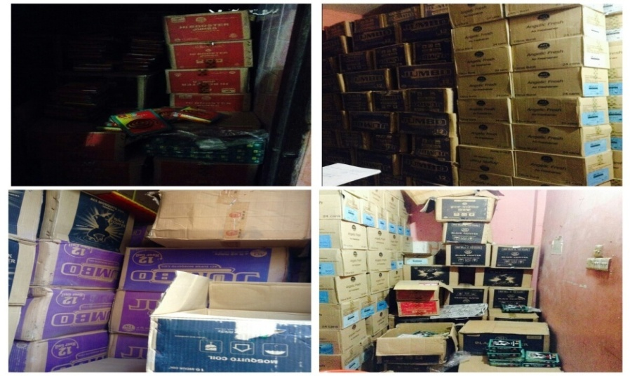
Picture 4.1: Product Coverage
4.4 Key Job Responsibilities:
I joined in ACI Consumer Brands Division of ACI Limited on February 1, 2018 as an intern. In this company I worked under the General Manager Sales (Consumer Brands), my role was to help him in his daily work, completing and checking the document, overseeing overall activities and performance of the workers and various marketing and promotional activities and performance of the company. In the company, my daily working time was from 8:30am to 6pm, 5daysaweek. During that time my duty was to observe the sales performance and keep contact with zonal sales manager, area managers and territory managers. In this short time, I also acquired the corporate culture of ACI Limited. Maintaining a good relationship with supervisors, line managers and the Director as well as others intern mates. We would like to help each other and establishing a perfect corporate environment. I got opportunity to work with very talented person at office which will leverage at impact in my future career.

  - Internship Position:
I have worked for three months with different sections. During my Internship period of ACI Limited I was gathered more knowledge which is related to my topic and I also knew the information which is not related to my topic. Actually, Internship project work is very important to the BBA students to grow knowledge and it helps to create more capabilities and Confidence of works in any situation or any business. Three months Internship is not enough time to learn everything of any business situation or anything; on the other hand, it is very effective course of a student to learn beyond their academics. So, in a sentence I can say that, it is nothing but everything if I can learn or want to learn. Now, I would like to divide my all those learning into two categories. These are given below-
1. Primary learning
2. Secondary Learning
Here, a short description about my learning:
4.5.1 Primary Learning:
In primary learning I just learn about some basic things like:
- Organizational culture.
- How to behave with Colleagues, Clients and others.
- How to make a good relationship with another.
- Time management.
- How to deal with clients in Business conference.
- Contact with company’s employees.
- Maintaining rules and regulations.
- How to deal with ZSM, ASM & SR.
- How to deal with Brand promoters.
- What are the sales department do.

4.5.2 Secondary learning:
ACI Limited is the private multinational organization, so there are huge activities and lots of work on various departments, that’s why they do all kinds of efficient task under the various departments. In this organization there are some departments to work like marketing department, Brand department, Finance department, HR department. My supervisor assigned me under the sales admin department. I worked different kind of section of ACI Limited. All activities are not possible to show here because my working activities are depending on different situation. So, some exact working activities are shown below which I was regularly do-
- Distributer point visit:
During my internship, I went to visit distributer points. Within this period, I visited different distributer point like Gulshan, Uttara, and Gazipur under Dhaka area and collecting information about total sales, analysis products problem, the promotional activities, quality of the products, reasonable price, brand image, product availabilities and automation system.
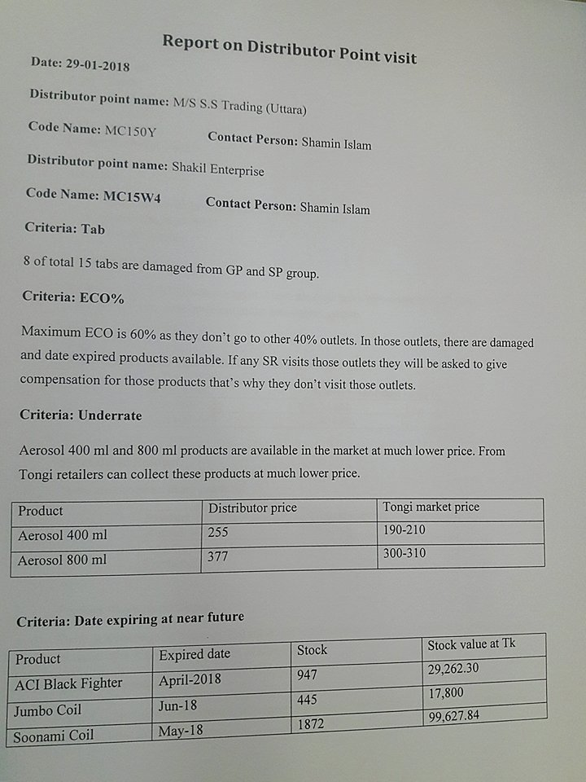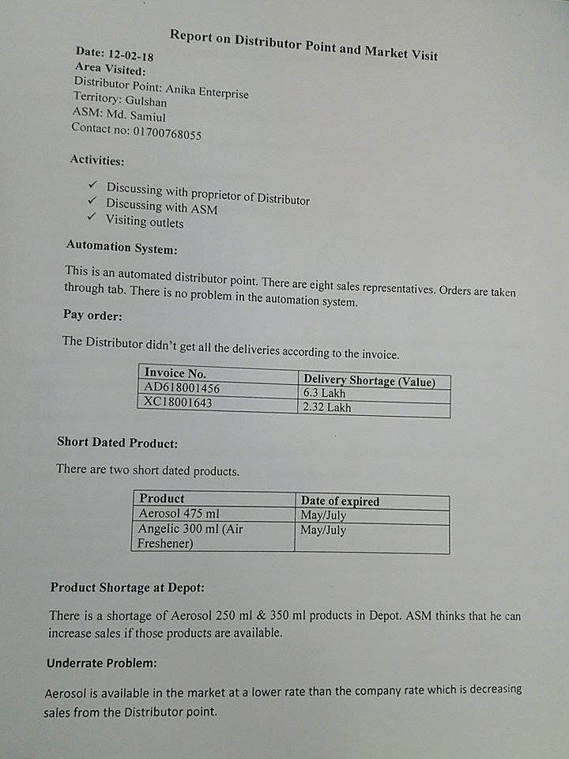

Picture 4.2: Collecting Document
After collecting the information from distributor point I made a report on it and submit it to my Supervisor. He carefully observed the report and discussed about it. Also, I gave him the necessary note beside the information.

- Market Visit:
I have visited the different departmental stores and super shop to see the market position of ACI Consumer Brands product and also other brands relative products. I tried to gather information as much as I could, I also tried to know about the competitors product and their future movement which can help ACI Limited and able to make their brand stronger than other.

- Sales Analysis:
During my internship I have analyzed the sales record of 2017- 2018 and tried to find out the present situation of sales and the possible way of develop the sales.
- Maintaining internal and external relationship:
I had to maintain some internal and external relationship with ASM, ZSM, SR, and SS. As, I had to contact them through the mobile before visiting the place under their territory.

- Preparing sales related presentation:
Sometimes I prepared sales related presentations based on Consumer brand products, comparison between 2016 and 2017 achievement and upcoming plan.

- Collecting necessary documents:
I have to collect all the necessary documents like, location name, beat name, ASM (Assistant Sales Manager) contact number, SR (Sales Representative) contact number, retailer shop list etc. I collected all the documents from ACI server that is confidential and I had the right to use it.

- Preparing Incentive Sheet:
Sales Incentive is a formal scheme that used to promote or encourage sales manager by getting incentive price. If sales manager or sales coordinators achieve their targets than company provide incentive to them. And I listed out the GP, SP& CP sales from all regions and territories to find out the incentive achiever.
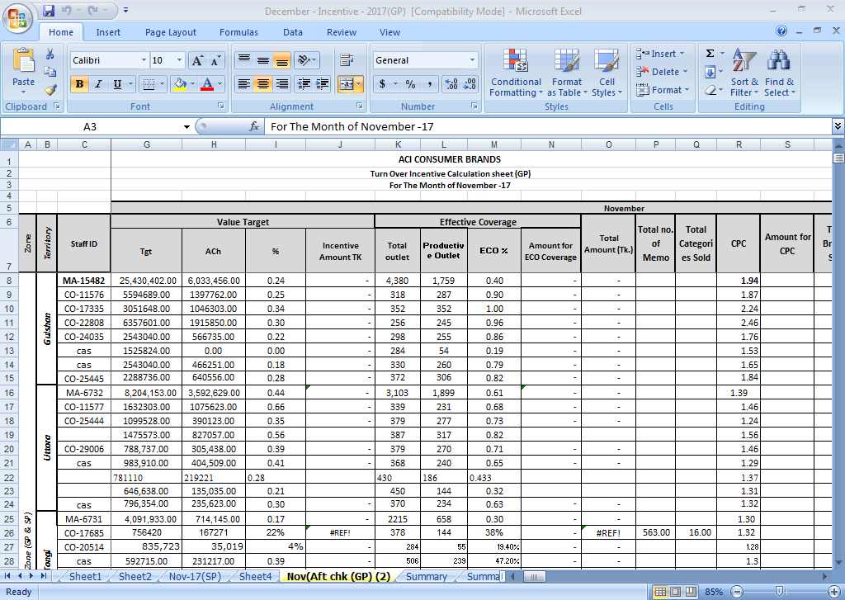
Picture 4.3: Incentive Sheet
- Attending Sales Conference:
ACI sales Consumer Brand arrange sales conference program 2018 held at Bashundhara Convention City. All the sales people and marketing team attend that program. In this conference sales people are motivated by their respective managers to develop their skills and it will help them to achieve their targets and goals. As I was here three months, for this I was get opportunity to attend that Conference.
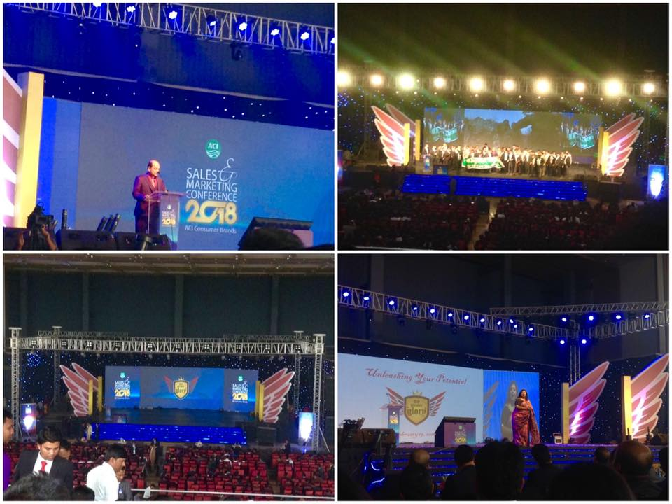

Picture 4.4: Attending sales Conference
4.6 Learning Experience:
As a BBA student I had to perform an internship in a business organization. I did my internship in ACI limited. That was my first experience of working in professional business environment. I was very much nervous as well as excited before joining in that company. But surprisingly I have find out that none of the task is that much harder. My company supervisor was very helpful to me at every task. He made my tasks so easy and comfortable through his advice experience and suggestions. Everything was done successfully. The most important thing was to adjust with the professional work environment.
While working that organization the most important thing I have found that interpersonal communication is the most important factor to working corporate environment. I need to communicate with different types of people from different social and cultural backgrounds. It is not easy to blend in a corporate environment quickly. Positive attitude toward the job and responsibilities are also important.

Conclusion:
ACI Limited Bangladesh is one of the renowned organization in our country. The product I choose ACI Mosquito Coil, the Marketing Mix elements have proper use of it but the reasons of Mosquito Coil performances are weak because of lake of promotion, competitors, quality etc. But now they are try to improve their products. The reason behind their success can be described through their efficient marketing strategy. This strategy is described separately in the order of product, pricing, placing, production and promotion in this report. ACI Coil should relentlessly strive elevate the brand to become the number 1 consumer brands company in Bangladesh. Their aim is also to offer the people convenience through establishment of a large and extensive dealer network throughout the country. ACI Coil is continuously increase distribution channels. Improving standard quality, through maintain high standards and commitment to creating outstanding opportunities for professional growth so that associates can achieve their highest potential. They are now focusing on developing their sales and promotional mix in the market. They are now following some marketing strategy. Ultimately they want to increase their sales by persuading marketing activities. They need to promote their products in various ways. In order to become the market leader, they must develop their strategy. However, ACI limited also faces many challenges in the near future. Specially need a big plan to promote their Coil products and grab the highest market share. Though they are doing some promotional activities for Coil but they should come up with even more ideas for their promotional mix. The company need to focus on develop the sales as well as they need to promote their product through the radio, television, newspaper, outdoor advertising and through other strategy. If ACI Coil is able to overcome all the difficulties mentioned above, there is no doubt that within a short period time, the company will have insurmountable advantages in the market. That’s the way ACI Coil achieve their Success day by day.

CHAPTER FIVE
Appendix Part

5.1 Bibliography:
APA Citation Technique:
1 | ACI background of Organization 2017, ACI Limited. (17 Feb 2018) Retrieved from http://www.aci-bd.com/about-us/company-profile.html
2 | ACI historical background 2018, ACI Limited. (21 Feb 2018)  Retrieved from http://www.aci-bd.com/about-us/company-profile.html
3 | ACI Strategic Business 2013, ACI Limited. (21 Feb 2018)  Retrieved from http://www.aci-bd.com/business-units2.php
4 | Corporate Governance 2016-2017, ACI Limited. (2 March 2018)  Retrieved from http://www.aci-bd.com/corporate-governance-compliance-status
5 | Chairman’s Profile 2000 – 2018, Advanced Chemical Industries Limited. (3 March 2018) Retrieved from http://www.aci-bd.com/chairman.php
6 | The board of director 2013, ACI Limited. ( 26 March 2018)  Retrieved from http://www.aci-bd.com/acifl/the-board-of-directors.html‎
7 | 2017, ACI Limited. (30 March 2018) Retrieved from http://  www.aci-bd.com
8 | Sales performance definition2017, Bizfluent (7 April 2018)  Retrieved from https://bizfluent.com/facts-6945389-sales-performance-definition.html‎
9 | Sales performance 2016, Aero Leads. (14 April 2018) Retrieved from https://aeroleads.com/blog
10 | www.businessdictionary.com/definition/promotion-mix.html
11 | Promotion mix 2018, Wikipedia .(17 April 2018)  Retrieved from https://en.wikipedia.org/wiki/Promotional mix‎
12 | William J. Stanton Monday (6 May 2018) Mass Communication. Retrieved from https:// www.yourarticlelibrary.com/essay/advertisement-definition...of-advertisement/27984
13 | The State of Queensland. (1995–2018) Queensland Government.  < Retrieved from  https://www.business.qld.gov.au/runningbusiness/marketingsales/.../advertising/types
14 | Promotion Mix 2018, Business Jargons (27 May 2018)  Retrieved from https://businessjargons.com/
15 | Home care products 2010, Advanced Chemical Industries Limited. ( 2 June 2018) Retrieved from https://www.aci-bd.com/home-care-products.php‎

5.2 Survey Questioner
Survey Research Questionnaire
Dear Respondent,
Good day. I am a student of Bachelor of Business Administration from International University of Business Agriculture & Technology. Please go through the following questionnaires and identify the appropriate response for each of them. Here I am doing my research on the following topic: “Increasing Sales Performance by Improving Promotional mix of ACI Coil”. Please complete the following questionnaires.
Name……………………………………………………………………………………………
Age……………………………………………………………………………………………...
Gender………………………………………………………………………………………….
Cell No………………………………………………………………………………………….
[Please put a tick mark for the following questions. Thanks a lot for your co-operation]
Question | Strongly  Disagree  (1) | Disagree  (2) | Neither  Disagree  nor Agree  (3) | Agree  (4) | Strongly  Agree  (5)
Do you agree that using social media Ads will increase the sales of ACI Coil?
Do you agree that using Radio/ TVc Ads will increase the sales of ACI Coil?
Do you agree that using Newspaper Advertisement will increase the sales of ACI Coil?
Do you agree that using popular face or celebrity on TVc will increase the sales of ACI Coil?
Do you agree that using Outdoor Advertising will increase their sales of ACI Coil?
5.3 Abbreviation:
ABBREVIATIONS | ELABORATION
BBA | Bachelor of Business Administration
Pvt. | Private
ACI Ltd | Advanced Chemical Industries Limited
SR | Sales Represented
ZSM | Zonal Sales Manager
ASM | Area Sales Manager
SS | Sales Supervisor
ISO | International Organization for Standardization
GP | General Product
SP | Special product
CP | Cleaning product
DP | Distributor Price
TP | Trade Price
MRP | Market Price
SKU | Stock keeping Unit
Μ | Mean value
N | Mean value
Σ | Standard deviation
$$\overline{X}$$ | Average

