Internship Report
On
Recruitment and Selection Process of First Security Islami Bank Limited



Submitted To:
Jerin Haque Chhanda
Lecturer
School of Business and Economics (SOBE)

Submitted By:
Fatema Tuz Zohra
ID: 111182072
School of Business and Economics (SOBE)

Recruitment and Selection Process of First Security Islami Bank Limited

Letter of Transmittal

April 1, 2023
Jerin Haque Chhanda
Lecturer
School of Business and Economics (SOBE)
United International University

Subject: Internship report on Recruitment and Selection Process of First Security Islami Bank Limited.

Respected Ma’am,
I am pleased to enclose herewith a copy of my 3 months internship work related to the HR Recruitment & Selection Process of First Security Islami Bank Limited from October 04, 2022 to January 04, 2022, which includes a precise analysis of what I have learnt about how the bank conducts their recruitment and all related activities for your record and measures.
I hope my report serves what it has been assigned for. Please feel free to review this report and if you have any questions feel free to contact me anytime at fzohra182072@bba.uiu.ac.bd
Sincerely,

...............................
Fatema Tuz Zohra
111182072
Human Resources Management
School of Business and Economics
United International University

Acknowledgement

First of all, I would like to express my gratitude to Almighty Allah for giving me the opportunity to successfully complete these 3 months internship period.

Secondly, I would like to thank Mr. Syed Waseque Md. Ali, Managing Director of First Security Islami Bank Limited, by whose reference I have got the opportunity for my internship.

Thirdly, I would like to thank the people of the HR Division. This report is the result of help and guidance of these people who have given me ideas, their valuable time and support to complete my report inch by inch. Without their cooperation this report would not be as informative as it is now.

And lastly, I would like to convey my sincere gratitude to my academic supervisor, Ms. Jerin Haque Chhanda, Lecturer, School of Business and Economics (SOBE). Without her proper guidelines and instructions, this report would not have been effective and efficient. Her valuable guidance has shaped my internship report to be a successful one.

I have worked wholeheartedly to deliver my best effort by meeting all the requirements of my respective faculty and gathering insights about the recruitment and selection process of an organization. This internship period was a lesson for me as I was able to gain new practical knowledge about how recruitment of an employee takes place in the real world.

Executive Summary

The report is focused on the recruitment and selection processes as they are practiced by First Security Islami Bank Ltd. (FSIBL). The introduction begins with my understanding of the recruitment and selection process and how the bank treats the overall recruitment and selection process. The field of HRM has changed over the decades. The role of modern managers also changes, requiring today’s organizational leaders to deal with increasingly dynamic and complex environments. Recruitment & Selection is considered as the initial stage of human resource management. It entails a routine step by step strategy to enhance the chances of selecting the right candidates.
The report attempted to clarify organizational background by including a brief history, vision, mission, and objectives of the bank. The departmentalization of the bank is constructed along with an organogram of the bank in details. First Security Islami Bank Ltd contributes towards developing a long-term strategic plan to maintain dynamic growth. To be the premier financial institution in the country, First Security Islami Bank makes a positive contribution to society and country.

The primary objective of the report is to examine the overall recruitment and selection process of the First Security Islami Bank. The report also intended to evaluate the differences between the recruitment process of probationary officers and experienced bankers.

The recruitment and selection processes in FSIBL are found to be very systematic. The recruitment process is considered to be one of the core functions of HR Division. The recruitment process in the bank involves identifying ways to attract the potential candidates, screening them, shortlisting and interviewing them, and finally hiring the candidates and coordinating them with the entire ecosystem of the bank. For potential bankers, job postings are posted at bank websites and print media. The applicants provide their CVs for the desired position. For probationary officers, a written test is required and job experience is not required but academic qualifications must be met.

FSIBL has a rich Human Resource Division, which is very well-organized and systematically maintained. As per the Employee Service Rule of the bank, HR practices are handled in a systematic and efficient way.

Key Words: Recruitment, Selection, Bank
Table of Contents
Chapter 1: Introduction…………………………………………………………………………..08
Chapter 2: Organizational Background……………………………………………………….…10
2.1 History of FSIBL………………………………………………………………....11
2.2 Vision of FSIBL……………………………………………………………….......11
2.3 Mission of FSIBL……………………………………………………..…….…….11
2.4 Core Values of FSIBL….…………………………………………………………12
2.5 Strategic Objectives of FSIBL…………………………………………………….12
2.6 Organogram of FSIBL…………………………………………………………….13
2.7 Departmentalization of FSIBL ………………………………………………..….14
Chapter 3: Objectives and Methodology ………………………………………………………..15
3.1 Objective of the study……………………………………………………………..16
3.2 Limitation of the study……………………………………………………………16
3.3 Methodology of the data collection…………………………………………...….17
Questionnaire on recruitment and selection………………...…………………….17
Chapter 4: Findings of the report ……………………………………………………………..…20
4.1 Recruitment process life cycle followed by FSIBL………………………………22
4.2 Recruitment policy of FSIBL…………………………………………………......23
4.3 Recruitment procedure of FSIBL…………………………………………….…..25
4.4 Selection………………………………………………………………………......26
4.5 Difference between the recruitment and selection process of experienced banker and probationary officer………………………………..………………………………………. 26
4.6 Drafting appointment letter………………………………………………….…...27
4.7 Joining Activities…………………………………………………………………..28
Questionnaire Responses……………………………………………….….. 31
Chapter 5: Recommendation and Conclusion …………………………..……………………... 42
5.1 Recommendation…………………………………………………………………43
5.2 Conclusion………………………………………………………………………..45
Photograph of HRD Division…………………………………………………………46
References………………………………………………………………………………….….…47

Chapter 1: Introduction

1.1 Introduction:

The combination of a few functional activities which are performed within the organization that facilitates the most effective use of people or employees to achieve organizational goals and individual goals is what shapes Human Resources Management. The field of HRM has changed over the decades. The role of modern managers also changes, requiring today’s organizational leaders to deal with increasingly dynamic and complex environments followed by a precise well defined human resource planning. Hence Human Resources Management is no longer just an administrative role rather than a strategic role.
The 7 core practices of human resources management that works universally:
- Human Resource Planning
- Recruitment and Selection
- Training and Development
- Performance Management
- Employee Relations
- Employment Law and Compliance
- Compensation and Benefits
- Administration, Payroll & HR Systems
Recruitment and Selection is considered as the initial stage of human resource management.
It entails a routine step by step strategy to spot job vacancies, analyze the desired role, reviewing applicants, screening, short listing and placing the right candidate for the right position. Effective recruitment enhances the chances of selective candidates. First Security Islami Bank Ltd. has a well-established human resource division. They have their own distinguished recruitment and selection policy. An individual is further recruited and selected in the following procedures.

The recruitment process of FSIBL usually involves the criteria: Advertisement for recruiting different grades of employees such as Probationary Officer, Trainee Assistant Officer, Trainee Assistant Cash Officer, First Assistant Vice President etc. as well as set up educational qualifications for such categories. The selection process of First Security Islami Bank involves the steps: Application, resume screening, screening call, assessment test, in person interviewing, background checks, Reference Checks, decision and job offer.

Chapter 2: Organizational Background

2.1 History of First Security Islami Bank Limited
First Security Islami Bank was incorporated in Bangladesh on 29 August, 1999 as a banking company under companies act 1994 to carry on banking activities. It obtained permission from Bangladesh Bank on 22 September 1999 in order to commence its business. On 25 October, 1999 it was inaugurated. It is a full-fledged third-generation progressive Sharia based Islami Bank with a corporate culture and a steady growth in its business expansion.

First Security Islami Bank Ltd contributes towards developing a long-term strategic plan to maintain dynamic growth. A wide range of services involves accepting deposits, making loans, discounting bills, conducting money transfer and foreign exchange transactions and performing other related services such as safekeeping, collections and issuing guarantees, acceptance and letter of credit. The company establishes a philosophy of “A Step Ahead in Time” with talented and brilliant personnel, equipment with modern technology. It was the year of January 1, 2009 when the bank changed its name and mode of business to be entitled as First Security Islami Bank Limited.

2.2 Vision of First Security Islami Bank
Becoming the leading financial institution in the nation based on Islamic Sharia through the delivery of excellent banking services, high-quality products, and services, all supported by cutting-edge technology.

2.3 Mission of First Security Islami Bank
- Contribute positively to society and the environment by ensuring that the services provided by devoted and motivated professionals are at the highest possible level of satisfaction.
- By maintaining business ethics and openness at all levels, provide solutions to the community's needs for Islamic banking services, which will help the industry, sustain its market share growth.
- By ensuring sustainable growth, establishing the full value of the honorable shareholders, and, most importantly, making a significant contribution to the national economy, you can give investors an optional investment value.
- Build the best rides as a symbol of worship and a source of pride for the employees' accomplishments and work.
- Provide comfortable access through various means anytime and anywhere by allowing individuals to improve the quality of life and bring peace of mind.

2.4 Core Values of First Security Islami Bank Limited
- They trust in the Almighty Allah.
- They adhere to the spirit of Islamic Shariah.
- They believe in integrity, transparency and accountability.
- They ensure our clients' expectations by anticipating their needs and responding with a sense of urgency
- They approach business decisions with an emphasis on long term growth and sustainable profit.
- They communicate with candor and transparency to provide the best services.

2.5 Strategic Objectives of First Security Islami Bank
- Employing, retaining local qualified personnel, and continually developing their skills and expertise to provide banking services and manage operational risks in line with industry best practices. Applying the equal opportunity employment principle to encourage personnel to grow within the bank.
- Establishing a set of managerial succession and adopting technological changes to ensure development of an Islamic Bank as a stable financial institution.
- Achieving financial strength and growth, including expanded market share, and generating income for its shareholders through strengthening trust and partnership with our customers and an ongoing focus on providing professional and quality customer service.
- Designing suitable products and services which are very responsive to meet the client's financial needs and aspirations as well as ensuring adequate risk-adjusted return for the bank through delivering services with the implementation of world class IT infrastructure.
- Introducing existing products into a new market and new products to new and existing markets with our innovative service approach and conforming to monetary laws and regulations.

2.6 Organogram of First Security Islami Bank Ltd

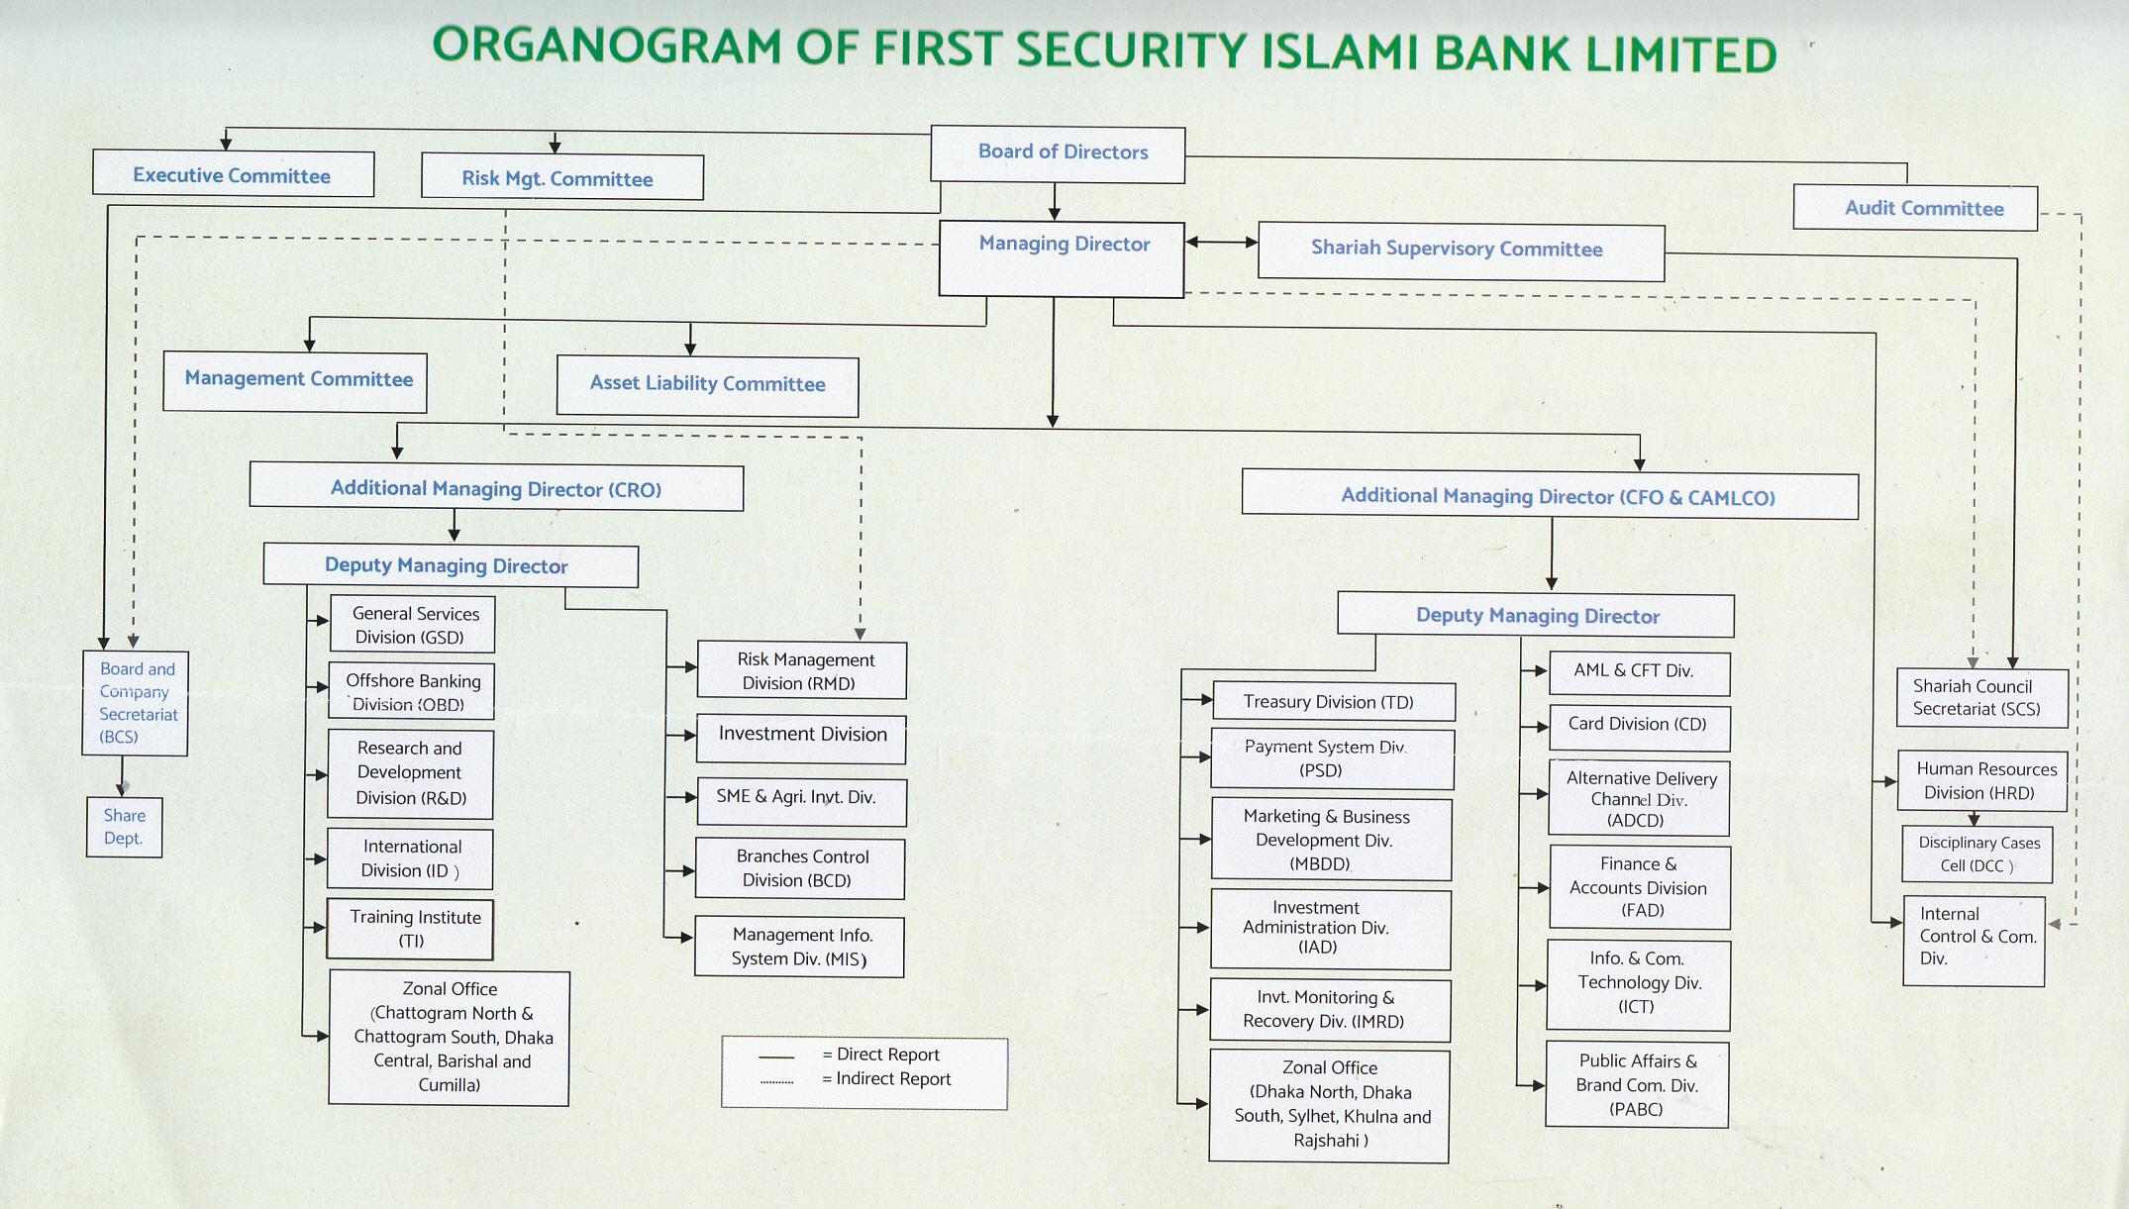
The above image is taken from the annual book 2021 of First Security Islami Bank Limited.

2.7 Departmentalization of First Security Islami Bank Ltd

Internal Control &
Compliance Division

Shariah Council Sectt
Treasury Division
Branches Control Division
International Division
General Services Division

Management Information
System Division

Payment System Division

Research & Development
Division

Risk Management Division

Alternative Delivery
Channel Division

Anti Money Laundering &
CFT Division

Card Division
Finance & Accounts
Division

Information &
Communication
Technology Division

Marketing & Business
Development Division

Public Affairs & Brand
Communication Division
Training Institute
Offshore Banking Division

Chapter-3: Objectives and Methodology

3.1 Objectives of the Study

Broad Objective: The general objective of this internship program is to examine the overall recruitment and selection process of the First Security Islami Bank Limited.

Specific Objectives:
- To increase the know-how of the practices of Human Resources Management works in corporate life.
- To evaluate the difference between the recruitment process of probationary officers and experienced bankers.
- To assess the recruitment and selection process practices by FSIBL.
- To understand the work principles of the corporate environment and management of professionalism at the Bank.
- To acknowledge how the HR Division of the bank analyzes the future requirements of the organization, cope with any unforeseen situations in day to day business operations that arise and regulate recruitment processes.
- To fulfill requirements of the BBA program of UIU.

3.2 Limitations of the Study
- Deadline of completing the internship period within 3 months is a restriction of time to learn more.
- Some information is kept confidential.
- Completing the report based on tasks performed at the headquarter but not branch.

3.3 Methodology of the Data Collection
Primary Data:
- Observation of the practical recruitment and selection process that takes place at the bank.
- Resigned and released files of ex- employees.
- Discussion with the supervisors through using questionnaire

Secondary Data:
- Academic Calendar 2020
- Annual Report of 2021 of First Security Islami Bank Limited
- General reports of FSIBL
- Code of conduct
- Internet

QUESTIONNAIRE ON RECRUITMENT AND SELECTION

Dear respondent,
I am performing the following survey for my internship and the results will be used for my report only. I would request you to provide constructive and valuable responses. Please answer each question by marking the level of agreement that best reflects your corresponding statement.

- What is the most important management function in your bank in your opinion?
- Planning
- Organizing
- Staffing
- Leading
- Controlling

- Identify the source from where you came to know about the job?
- Advertisement
- Consultant
- Personal reference
- E- recruitment

- Which is the most important quality the organization looks for in a candidate?
- Knowledge
- Past Experience
- Optimistic Nature
- Team work ability

- In your opinion, what type of selection procedures will help in selecting the right kind of candidate?
- Written test
- Interview
- Group discussion
- All
Questions | Agreed | Disagree | Neutral
Does the bank have clearly well-defined position objectives, requirements and candidate specification in the recruitment process?
Does the bank do a proper job analysis before the selection process begins?
Is the resume screening and shortlisting method used by the bank satisfactory?
Do you believe the selection process of the bank is a good one?
Do you think bank looks for experienced employees in selection
Process?
Do you think HR practices of the bank are efficient?
Does the bank follow different recruitment processes for different grades of employees?
Does the bank take any technological support for the recruitment process?
Are you satisfied with the present recruitment and selection process of the bank?

Chapter 4: Findings of the Study

Good recruitment is very important for every organization. This is because it is very challenging to place the right people for the right roles at the right time. Recruitment is not simply about filling up the number of vacancies that will be available in the organization. But it is about making efficient use of workforce planning to understand what skills are needed to enhance organizational performance, not just for the Hr Team but for the managers who are involved in the entire selection process.

Recruitment is one of the core functions of the Human Resource division. Recruitment involves identifying to attracting to screening to shortlisting to interviewing to selecting, hiring and onboarding employees.

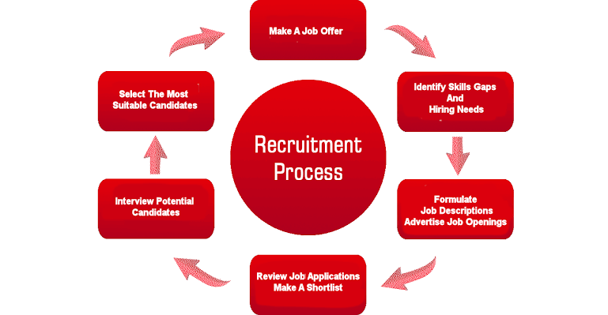

Figure: Recruitment process from start to finish

4.1 The Recruitment Process Lifecycle that consists of 7 steps followed by FSIBL are as follows:

- Identifying the Hiring Needs: The branch manager informs the respective Human Resources Division (HRD) at the conference or passes out an official letter about the hiring needs. If any kind of vacancy is available employees are granted promotion to fill up the gap. Zonal head or manager informs about the availability of the vacancy at respective branches. FSIBL tries to internally adjust such vacancies.

- Preparing the Job Description: Once the hiring needs are met, next is to prepare a job description. This job description provides the duties and responsibilities that the employees are expected to play.

- Talent Search: Categorized by internal sources of recruitment and external sources of recruitment. Internal sources of recruitment involve such as internships. But will be eligible on the basis of BBA and MBA ( performance during internship period). External recruitment involves advertisements such as newspaper, bank’s official websites online/ E-recruiting.

- Screening and Shortlisting: At first job positions are advertised.The responses to the advertisements are further sorted and screened. Hr officials shortlist candidates by their following CV and cover letters. They thoroughly study the CV and cover letter. Candidates who are shortlisted are called for the written tests which are conducted by the IBA. Once passed, viva examinations are held. Once the viva is passed a list of following top 200 candidates are provided to the HRD. Appointment letters for 100 probationary officers and 100 junior officers are provided.

- Interviewing: Preliminary interview sessions are conducted by panel and face to face interview. The interview sessions are also held by third party interviews (e.g. IBA/ Dhaka University), Deputy Managing Manager, Managing Director, Additional Managing Director, HR Head (concerned divisional head).

- Evaluation and Offer of Employment: The final stage of the recruitment process. This is where candidates are ready to accept the offer letters after terms and conditions are discussed over the interview session.

- Introduction and Induction of the New Employee. Once all sorts of screening are done candidates are introduced as the employee of the organization. The induction of the employee is then conducted by providing a welcome kit to the new employee as a means of establishing relationships with new employees. The freshers are provided with gifts and snacks as a means of acceptance at the organization.

4.2 Recruitment Policy of FSIBL
Sanction/ Creation of Posts:
- Unless otherwise decided by the Board the authority to sanction /create new posts shall lie with the Board of Directors.
- The management should examine the workload and analyze the same justifying additional requirements of officers under various categories. Proposals for additional posts shall thereafter be submitted to the Board for necessary sanction.
- No recruitment/ appointment in any capacity and category whatsoever shall be made without prior sanction of such posts. Subject to review from time to time, the appointment will be given by the competent authority abiding by the rules, regulations, and formalities as laid down hereinafter.

Classification of Service:
The services of the bank shall be classified as under
- Permanent/ Contractual
- Temporary

Classification of Posts:
The employees of the bank shall be classified and designed as shown below. Any modification, addition, or alteration to the classification and designation must first have board approval.
- Executives
- Officers
- Cash Officer

Recruitment of Officers at Entry Level
The bank will recruit following categories of officers at entry level:
- Probationary Officer
- Trainee Junior Officer
- Trainee Assistant Officer
- Trainee Assistant Cash Officer

Qualification for Recruitment:
Probationary Officer (PO)
- Candidates should not cross 30 (thirty) years of age as on the date application.
Minimum qualification a candidate could be eligible for is (MBA/MBM/ Master).
- 4 years Honors in Business Administration, Finance, Banking, Accounting. Management, Marketing, HRM, MIS, International Business, Tourism, and Hospitality Management, Economics, English, Public Administration, Law, Computer Science and Engineering, Mathematics , Statistics and Agricultural Economics from any public or private university approved by UGC required with an GPA of at least 4.00 out of 5.00

Trainee Junior Officer (TJO):
- Candidates should not cross 30 (thirty) years of age as on the date application.
- Minimum qualification a candidate could be eligible for is (MBA/MBM/ Master) from any public or private university approved by UGC with a 1st Class/ Division in all academic examinations.

Trainee Assistant Officer/ Trainee Assistant Cash Officer (TAO/ TACO):
Candidates must not be over 30 (thirty) years of age as on the date of application and requires only 4 years honors.

Trainee Assistant Officer (TAO):
- Minimum qualification is a Master Degree from any public or private university approved by UGC with no 3rd Class/Division or;
- Graduation in Engineering in any Discipline from any public or private university approved by UGC with no 3rd Class/Division.

Trainee Assistant Cash Officer (TACO)
Candidates must hold at least Bachelor Degree in any discipline from any public or private university approved by UGC.

4.3 Recruitment Procedure of FSIBL
Advertisement: For recruitment in different grades, advertisement shall be published at least in two national dailies inviting applications for the posts from eligible candidates giving at least15 days’ time.

Selection Process of Entry Level Candidates
Selection of candidates for the entry level officers- probationary officers, Trainee Junior Officers, Trainee Assistant Officers and Trainee Assistant Cash Officers shall be made on the basis of:
i) Educational qualification: 20 marks
Written test : 100 marks (70% in General Knowledge and 30% knowledge on Islamic Affairs)
ii) Vice Voce : 30 marks
Total : 150 marks

The following criteria must be used to calculate points for educational qualification:
i) For Probationary Officer:
1st Equivalent - Higher/ extra/ professional qualification = 5
2nd Equivalent - Higher/ extra/ professional qualification = 5

ii) For Trainee Assistant Officer/ Trainee Assistant Cash Officer
1st Equivalent - Masters = 5
2nd Equivalent - Masters= 4

4.4 Selection
Written (conducted by Institute of Business Administration (IBA), University of Dhaka for Probationary Officer) and Vice Voce tests shall be conducted on two subjects:
(i) General Knowledge (General and Professional aspects) and
(ii) Knowledge on Islamic Affairs.
In written tests, at least 50% marks shall be treated as qualifying marks in both General Knowledge and Knowledge on Islamic Affairs.

4.5 The difference between the Recruitment Process of Experienced Bankers and Probationary Officers:
For bankers, job postings are posted at bank websites and print media. The applicants provide their CVs for the desired position. Through the community the interview session is held. Once the employee is selected, he/ she is offered the appointment letter. No written test is provided for the experienced banker, only VIVA is provided. Minimum graduation is a must for experienced bankers along with the same job experiences and job knowledge. For a higher post such as Vice President (VP), Senior Vice President (SVP), Executive Vice President (EVP), or Deputy Managing Director (DMD), leadership qualities are required.

On the other hand, for probationary officers a written test is required. There is no need for experience but academic qualifications are a must. BBA and MBA both are needed. Without an MBA no applicant will be qualified for the position.

4.6 Drafting Appointment Letter

After a successful selection process candidates are provided with appointment letters under the following criteria:

- The selected employee will be required to serve in any unit of the bank in Bangladesh and abroad.
- The service in the bank shall be governed and regulated as per the term and conditions of the employees service rules and regulations of the bank as maybe framed or amended from time to time
- The employee will be required to sign a Surety Bond Cum Service Agreement (on taka 300 Non- Judicial Stamp) to the effect that employee will serve the bank for a period of 5 (five) years from the date of joining ( as per prescribed format to be provided by HRD, HO on which an acceptable witness with valid NID and recent photograph from your end will sign thereof in front of HR officials on the day of joining.
- At the time of the joining the service of the bank, employee will be required to sign the general code of conduct of the service Rules and Regulations of the bank, Declaration of the Fidelity and secrecy Bond, conflict of interest and Proprietary Information Agreement along with passport size photograph, fitness certificate from a registered medical practitioner, character certificates, attested photography of NID card, TIN certificate, etc.
- The employee further undertakes and binds himself to the bank to serve at least 5 (five) consecutive years ( applicable for the probationers) and the lateral Grade entranced
(Experienced Banker) will have to serve the bank at least 3 consecutive years.

Mode of Appointment:
The appointment shall be made from the panel so prepared by the Human Resources Division (HRD) after approval for the competent authority.

Engagement of Temporary/ Contractual Staff:
Temporary staff may be engaged on contractual basis by the bank directly or through outsourcing with approval of the board.

4.7 Joining Activities:
- Original and another two sets of photocopies of all academic, training, experience and other qualification certificates and mark sheets duly attested by first class Gazetted Officer.
- Six copies of recent passport size photographs (lab print) duly attested by first class Gazetted Officer.
- Character certificates from two respective persons
- Attested photocopy of Nationality Certificate/ Nationality ID Card
- Release Order from present employer ( for the experienced banker)
- Six NON-Judicial Stamps

- Commencement of Service:
The service under the bank shall commence from the working day on which an employee reports for duty at the place and time intimated to him/ her by the competent authority if he/ she reports before noon and the next working day if he/she reports in the afternoon.

- Assignment of Duty:
- A worker may be given the tasks that are occasionally decided upon.
- In any location within or outside of Bangladesh, an employee may be required to service the bank.

- Service Agreement:
An employee at the time of entering the service of the Bank shall sign and execute the following documents such as Discipline and General Conduct, Declaration of fidelity and Declaration of secrecy which should be maintained strictly as a means of rules and regulations.

Probationary Officer, Trainee Junior Officer, Trainee Assistant Officer and Trainee Assistant Cash Officer shall enter into an agreement with the Bank to serve the Bank for a minimum period of 05 years unless terminated/dismissed before the period .

Experienced Executives and Officers shall enter into an agreement with the Bank to serve the Bank for a minimum period of 03 years unless terminated /dismissed before the period .

Undertaking to the effect that the Bank will have the authority to file suit against him / her if any document submitted by him/her is found fake after verification by HRD from respective Board/ University or any information given by him/her is found wrong in future.

- Probation Period:
- A candidate selected for an appointment as a Probationary Officer shall be on probation for a period of 01 (one) year.
- A candidate selected for appointment as a Trainee Junior Officer shall be on probation for a period of 01 (one) year.
- A candidate selected for appointment as a Trainee Assistant Officer/ Trainee Assistant Cash Officer shall be on probation for a period of 01 (one) year.

In case any Probationary Officer/ Trainee Junior Officer/ Trainee Assistant Officer/ Trainee Assistant Cash Officer is unable to show satisfactory progress during the probation period, the authority may extend his/her period of probation or offer him/ her an appointment in a lower grade or dispense with his/her service.

- Confirmation:
On satisfactory completion of probation period, probationers shall be finally eligible for confirmation to a post to which he/she has been recruited.

- Activities of Audit Task related to Recruitment
There are 2 types of audits; Internal and External. The internal audit is the bank of FSIBL. The external audit is the Bangladesh Bank. The 2 auditors constantly keep checking on whether recruitment at the bank is taking place according to the Service Rules Book. Any further changes are suggested or recommended accordingly regarding the improvement of the recruitment process.

Responses from the Questionnaire
The objective of the internship report is to apply my learning in the field of Human Resources so that I could discover the functions of Recruitment and Selection of First Security Islami Bank Ltd.

To justify my learning I made a survey on existing employees of the organizations. Certain factors of the recruitment process are identified in the questionnaire. The respondents are expected to answer according to their opinion.

Survey

Sample Size | 17
Age limit | 28-63
Job Level | Officer-Executive Vice President

The respondents agree to the point that planning and leading is the most important function in First Security Islami Bank Limited in their opinion.

Through advertisement and personal reference, these employees have come to know about the job; while some have agreed that they have gone through E recruitment as well.

Half of the respondents have agreed to the point that knowledge and past experience is the most important quality the organization looks for in a candidate; while others are opposed to the fact that optimistic nature and team work ability are two most important considerations an organization looks for in candidates.

Almost everyone has agreed that a written test, interview and group discussion are the type of selection procedures that they think will help in selecting the right kind of candidate.

Questions | Agree | Disagree | Neutral
- Does the bank have clearly well-defined position objectives, requirements and candidate specification in the recruitment process? | 15 | 2 | -
- Does the bank do a proper job analysis before the selection process begins? | 12 | 1 | 4
- Is the resume screening and shortlisting method used by the bank satisfactory? | 11 | 1 | 5
- Do you believe the selection process of the bank is a good one? | 9 | 1 | 7
- Do you think the bank looks for experienced employees in the selection process? | 11 | 1 | 5
- Do you think HR practices of the bank are efficient? | 12 | 1 | 4
- Does the bank follow different recruitment processes for different grades of employees? | 17 | - | -
- Does the bank take any technological support for the recruitment process? | 16 | - | 1
- Are you satisfied with the present recruitment and selection process of the bank? | 9 | 2 | 6
Total | 112 | 9 | 32

Question 1: Does the bank have clearly well-defined position objectives, requirements and candidate specification in the recruitment process?

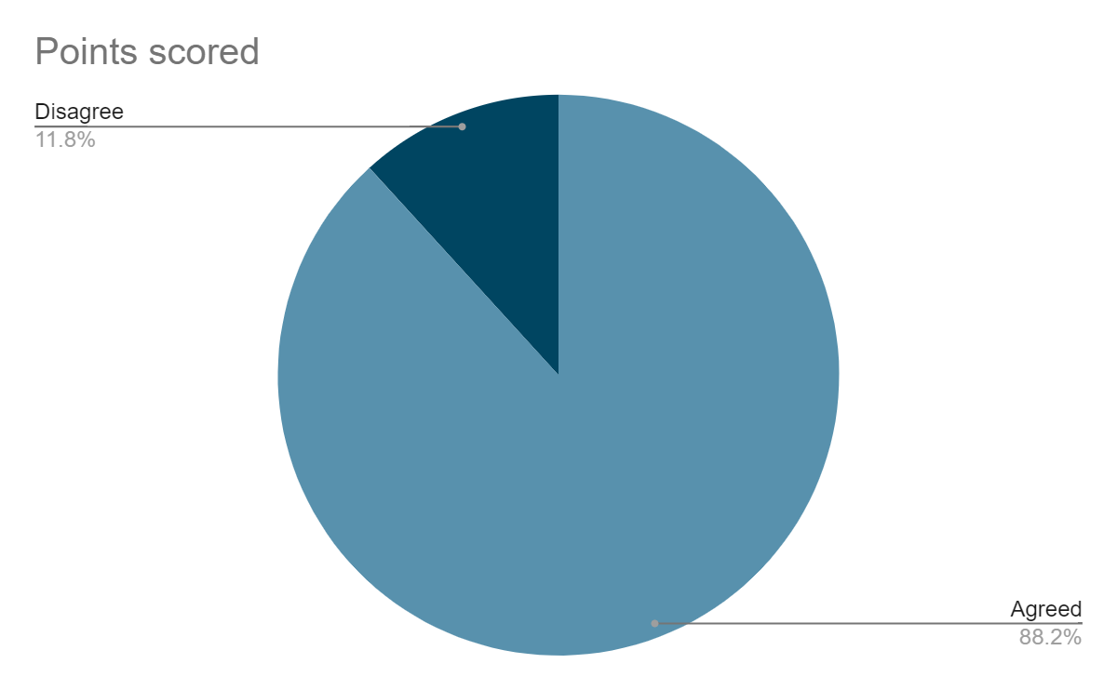

Response for Question 1: From the following survey we discovered that 88.2% respondents agreed that First Security Islami Bank clearly defines position objectives, requirements and candidate specification in the recruitment process, whereas 11.8% respondents disagrees with the statement and 0% are neutral. It is very important to define position objectives, candidate requirements and specifications for the organization because FSIBL believes that this will give the fresher an idea of what they are seeking for.

Question 2: Does the bank do a proper job analysis before the selection process begins?

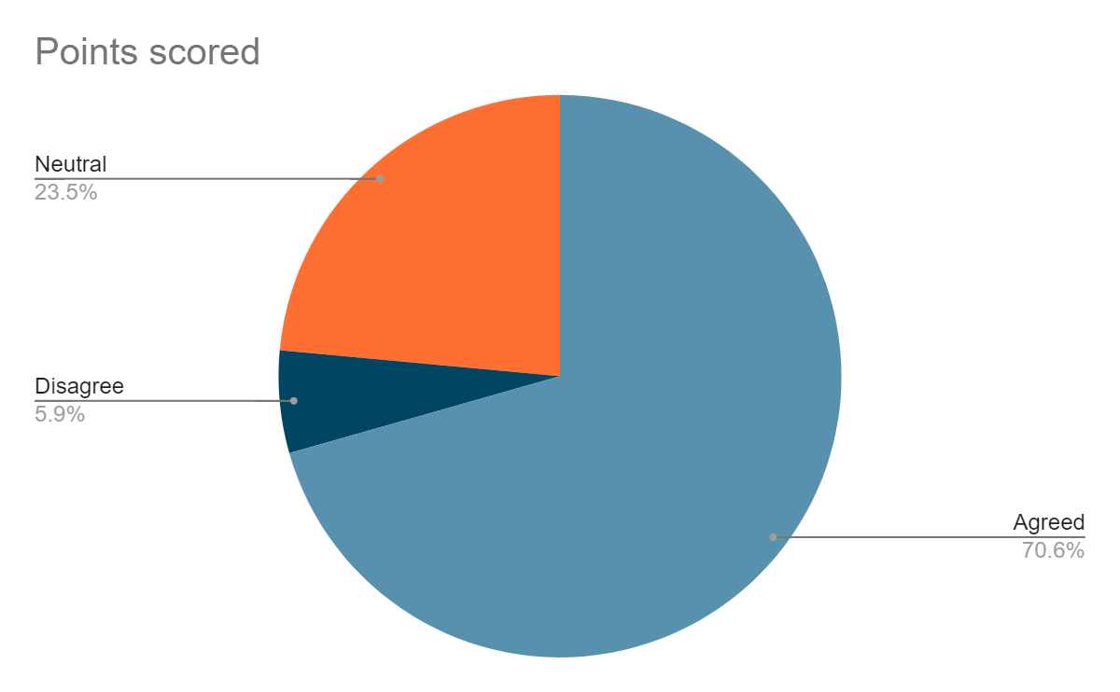
Response for Question 2: From the following survey it is acknowledged that 70.6% respondents agreed that First Security Islami Bank Limited conducts proper job analysis before the selection process begins. 5.9% respondents disagreed with the fact and 23.5% remained neutral. Through job analysis First Security Islami Bank Limited determines the duties of any positions and characteristics of fresher to recruit.

Question 3: Is the resume screening and shortlisting method used by the bank satisfactory?
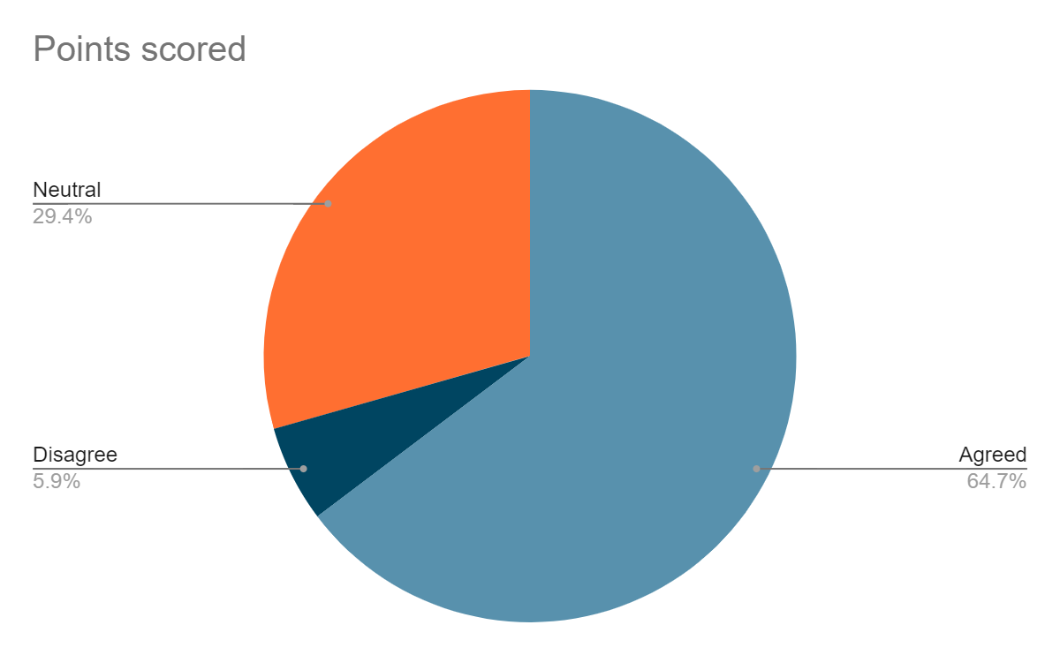

Response for Question 3: From the following survey we discovered that 64.7% agreed with the statement that the screening and shortlisting method used by the bank is satisfactory whereas 5.9% disagreed with the fact and 29.4% respondents remained neutral.

Question 4: Do you believe the selection process of the bank is a good one?
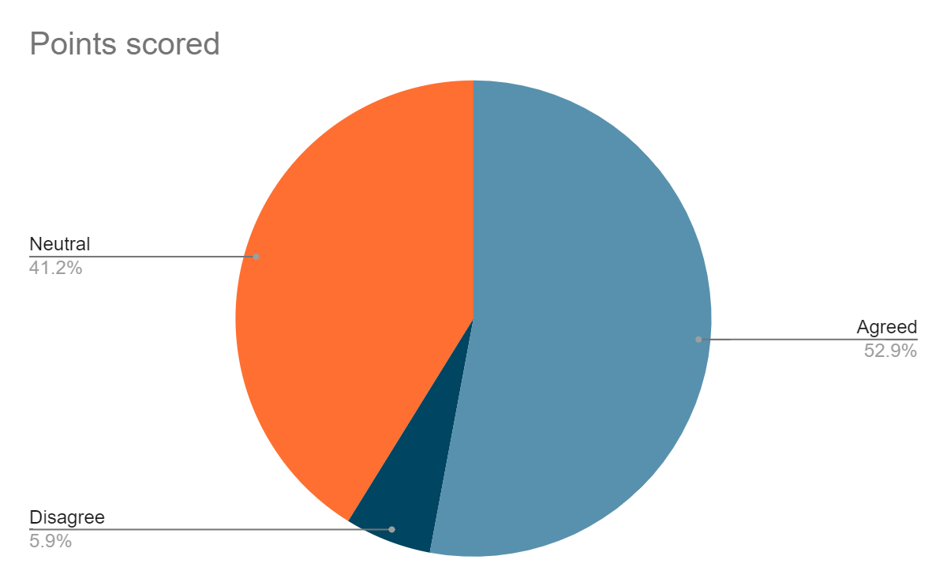

Response for Question 4: 9 out of 17 respondents have agreed to the statement that First Security Islami Bank follows a good selection process. This means 52.9% of the respondents, whereas only 5.9% disagreed with the fact and 41.2% of the respondents remained neutral to the statement.

Question 5: Do you think the bank looks for experienced employees in the selection Process?
Response for Question 5: 11 out of 17 have agreed to the statement that First Security Islami Bank Limited caters for experienced employees in the selection process, whereas 1 out of 17 has disagreed to the fact and 5 out of 17 has remained neutral.

Question 6: Do you think HR practices of the bank are efficient?

Response for Question 6: 70.6% has agreed to the point that HR practices of First Security Islami Bank is efficient, whereas 5.9% disagrees and 23.5% has remained neutral to the statement. Effective HR practices will support their valuable employees, understand what motivates and engages employees and ensure employees are satisfied. As a result, creating the best employee experiences accordingly.

Question 7: Does the bank follow different recruitment processes for different grades of employees?


Response to Question 7: 17 respondents agreed to the statement that FSIBL has different recruitment processes for different grades of employees.

Question 8: Does the bank take any technological support for the recruitment process?

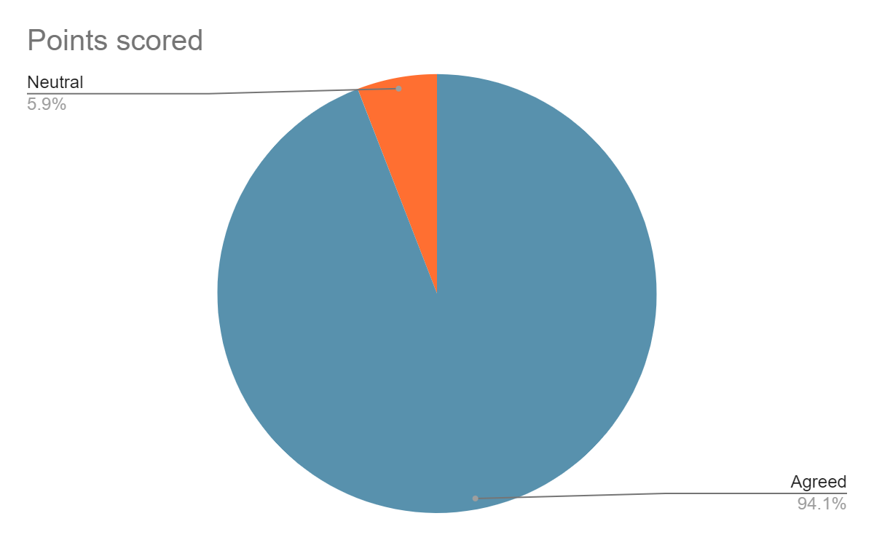
Response for Question 8: 16 out of 17 has agreed to the statement that the Bank has technological support for the recruitment process. This means 94.1% of the respondents. First Security Islami Bank has E-recruitment websites and HRM software known as Orbits. Through these well-established websites, banks hire applicants, collect CVs, provide admit cards etc. After joining, Bank updates all the information of the employees on their software, Orbits, besides the official hard copy.

Question 9: Are you satisfied with the present recruitment and selection process of the bank?

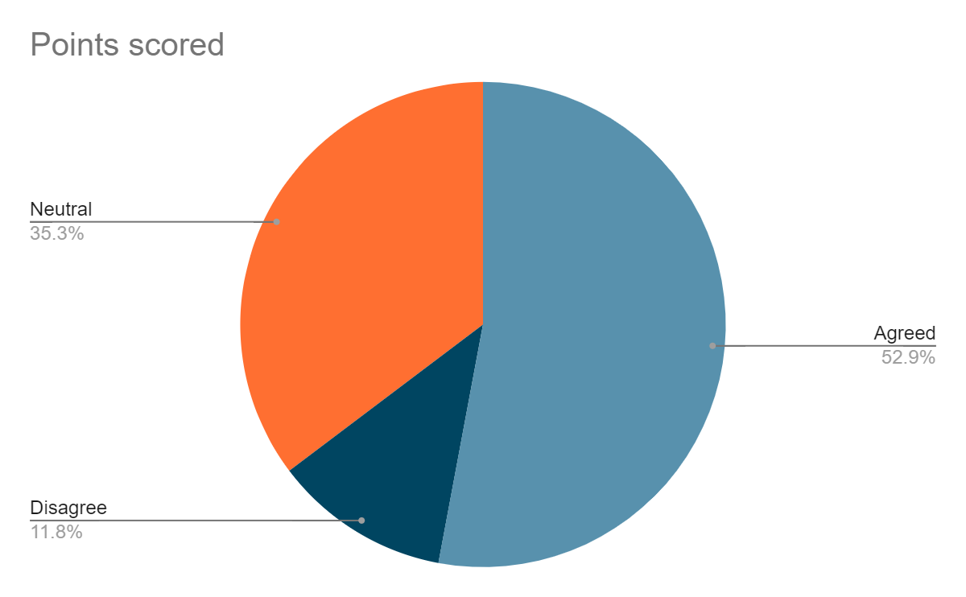
Response for Question 9: 52.9% of the respondents have agreed to the statement that they are satisfied with the present recruitment and selection process of the bank. 11.8% of the respondents have disagreed with the statement and 35.3% of the respondents remained neutral.

Chapter-5: Recommendation and Conclusion
5.1 Recommendations:
First Security Islami Bank Limited practices a standard Human Resources Management. During my internship period, I have noticed some issues which need to be addressed. Below I have certain recommendations that would improve the recruitment and selection process of FSIBL.

- Education Qualifications: Master of Business Administration is the minimum qualification required by the bank. Without the MBA employees will not be confirmed as an official employee. I would like to recommend that applicants who have their degree of Bachelor or Honors should get the opportunity to apply. Also those who are pursuing their ongoing MBA degree should equally have the opportunity to apply; except cash officials like Trainee Assistant Cash Officer (TACO).
- Age Limitation: Age limit is 21-30 years. Freshers above 30 years are not eligible to apply for any respective positions. I would like to recommend that the age limit should be at least 35 years.
- Update Compensation and Other Benefits: 6 out of 17 respondents seem to be neutral about their level of satisfaction with the present recruitment and selection process of the bank. I would recommend that banks should improve and update compensation and benefit policies in order to increase employee’s satisfaction level.
- Different Grading Systems: FSIBL has different grading systems during recruitment. Diverse grading systems with different names should be uniform among banks in Bangladesh. This will not create any discrimination as well.
- Viva and Written Test: As we already know there is no written test for experienced bankers, I would like to recommend that both viva voce and written test should be taken for experienced bankers.
- Multiple Examination Systems: Usually banks have only 1 layer of examination for the applicants. But I would like to recommend 2 or 3 examination systems while recruiting employees. (For example; 1st 50 applicants should be Probationary Officers, 2nd 50 applicants should be Trainee Junior Officer, and last 50 applicants should be Trainee Assistant Officer.)
- Training Facilitates: Increase of training facilities specialized on HR
- Zero Paper Based HR Work: I would recommend that banks should reduce their paperwork and switch to a full computerized system. This will reduce wastage of paper.
- Succession Planning of HR Officials: Bank should always be prepared with any sort of unforeseen events on leaving of top management. A succession plan should always be ready so that top positions can be filled up as soon as an official leaves.
- Medium of Communication Channel: In order to reach a wide pool of applicants, banks should use various and valid mediums of communication and advertisement channels. For example, the Bank doesn’t advertise official job postings at LinkedIn, Facebook and National Television channels. I would recommend advertising for job postings or job circular at LinkedIn, Facebook and national TV channels.

5.2 Conclusion:
The recruitment process of First Security Islami Bank Limited identifies the best methods in order to find the qualified applicants. As per Employee Service Rule of the bank, HR practices are handled in a systematic way as per Bangladesh Bank direction. The working environment of the bank makes employees happy at the end of the day. That's why they are here; resulting in lower turnover rates, higher productivity. This has led to greater efficiency and higher profits for the bank.

First Security Islami Bank Limited has a rich Human Resources Division. It has maintained a successful organizational responsibility by having a well-organized and cooperative HR team.
Stakeholders such as top management like CEO, CPO, CMO, and CFO Head to HR professionals like Subject Matter Expert and Professional Human Resource (PHR) to managers. Employees to consultants are responsible for managing human resources. First Security Islami Bank Limited employs local qualified personnel, continually developing their skills and expertise to provide banking services and manage operational risks in line with industry best practices.

After completing the internship report I have learnt that recruitment and selection process is one of the major activities of Human Resource Management. It is not only about identifying the “right candidate” for the “right position” but also exploring right potential in the employee who would yield a company’s core values.

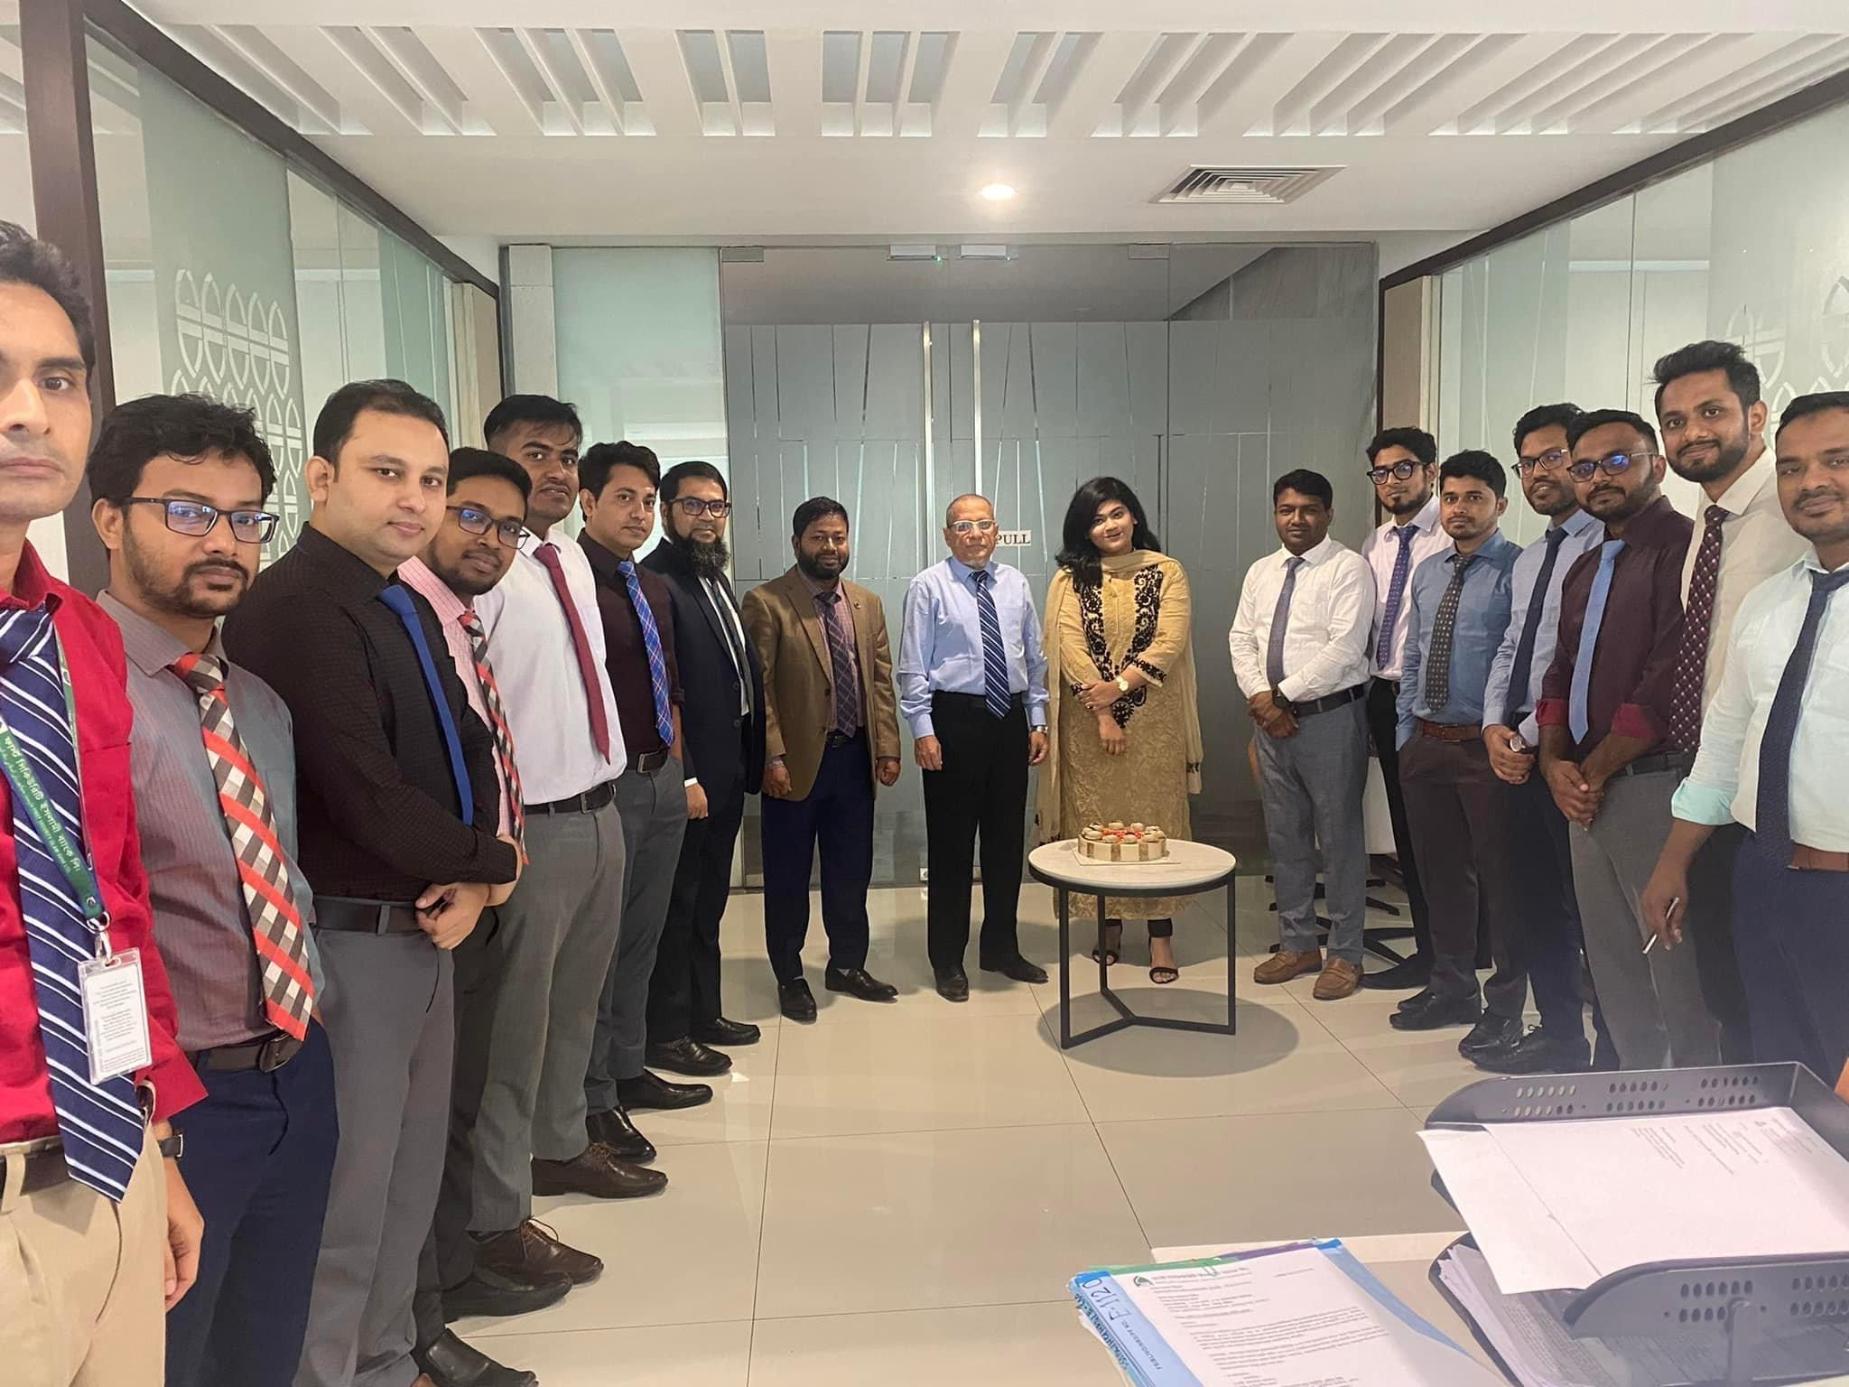
The Human Resource Division (HRD) of First Security Islami Bank Limited. This picture was taken on my birthday, 30 October, 2022

References:
- (n.d.). First Security Islami Bank Ltd. – First Security Islami Bank Ltd. Retrieved January 3, 2023, from https://fsiblbd.com/
First Security Islami Bank Limited. (n.d.). Wikipedia. Retrieved January 3, 2023, from https://en.m.wikipedia.org/wiki/First_Security_Islami_Bank_Limited
First Security Islami Bank Limited. (n.d.). Wikipedia. Retrieved January 3, 2023, from https://en.m.wikipedia.org/wiki/First_Security_Islami_Bank_Limited
HOQUE, T. (2021, June 7). Our Mission – First Security Islami Bank Ltd. - Dhaka. FSIBL. Retrieved January 3, 2023, from https://fsiblbd.com/our-mission/
Vision – First Security Islami Bank Ltd. - Dhaka. (2021, June 7). FSIBL. Retrieved January 3, 2023, from https://fsiblbd.com/vision-2/

- (n.d.). First Security Islami Bank Ltd. – First Security Islami Bank Ltd. Retrieved January 3, 2023, from https://fsiblbd.com/
First Security Islami Bank Limited. (n.d.). Wikipedia. Retrieved January 3, 2023, from https://en.m.wikipedia.org/wiki/First_Security_Islami_Bank_Limited

3. (n.d.). First Security Islami Bank Limited. (n.d.). Wikipedia. Retrieved January 3, 2023, from https://en.m.wikipedia.org/wiki/First_Security_Islami_Bank_Limited
HOQUE, T. (2021, June 7). Our Mission – First Security Islami Bank Ltd. - Dhaka. FSIBL. Retrieved January 3, 2023, from https://fsiblbd.com/our-mission/

4. First Security Islami Bank,Service Rule Book, 2023

5. First security Islami Bank, Human Resources Management Database, 2023

