
THESIS
Present and Future Trends in Use of Renewable Energy in Bangladesh.

Supervisor:
Mohammad A. Ashraf, PhD

Submitted by:
Zuairia Binte Noor
ID: 121171010
GUIDED RESEARCH
Course Code: ECO 4395 (A)

Table of Contents
Abstract: 4
CHAPTER 1 5
INTRODUCTION 5
1.1 Introduction 5
1.2 What is renewable energy? 5
1.3 Background of the study: 6
1.4 Problem Statement: 9
1.5 Aims and objectives: 10
1.6 Significance of the study: 11
1.7 Limitations of the study: 11
CHAPTER II 12
REVIEW OF RELATED LITERATURE 12
2.1 Introduction 12
2.2 Bangladesh's current solar energy situation: An Overview 12
2.3. Prospect of Bangladesh in solar cooking: 15
2.4 Global interest of renewable energy 16
2.5 Advantages of solar energy: 19
Review: 21
Theoretical framework: 26
CHAPTER-III 27
RESEARCH METHODOLOGY 27
3.1 Data source and collection methods: 27
All data and information used for the purpose of this research were found using secondary sources, given the pandemic situation. The opinions of the different respondents were also collected through an online survey on people who have SHSs installed in their house. Secondary data about solar energy systems was gathered from many websites and recently published articles from various sources, with the intention to keep our view of the industry as transparent and least complicated as possible. 27
3.2 Work location and descriptions 27
3.3 Sample and sampling 27
3.4 Statistical treatment 27
CHAPTER-IV 28
FINDINGS OF THE STUDY 28
4.1 Time period of using solar energy 28
4.2 Cost of buying solar panel 28
4.3 Level of satisfaction using the solar energy system 29
4.4 used electric line prior to employing Solar Panel 30
4.5 Purchasing of solar panel on bank loans 30
4.6 Service of company providing solar panels 30
4.7 Cost effectiveness of solar panels compared to non- renewable electricity supply: 31
4.8 Whether they faced any problem after installing solar home systems: 31
5.2 Policy Implementation: 33
Reference: 34

Present and Future Trends in Use of Renewable Energy in Bangladesh.

Abstract:
Renewable Energy is a significant objective of developing countries like Bangladesh. It is a reliable and efficient source of electric power. The government of Bangladesh has emphasized on its growth as the country shows promising potential in the market of renewable energy. Moreover, as one of the countries that is most prone to climate change effects, renewable energy establishes a clean and sustainable model for development, as opposed to the very expensive import of petroleum that the country is currently dependent on. The economy of Bangladesh has, hence, started to show a gradual shift towards renewable energy for its source of fuels such as biomass, solar, wind, etc. It has been reported that approximately 76% of Bangladesh’s population are out of on-grid connected electrical supply. The country have been using its finite supply of natural gas to keep up with the exponentially increasing demand for fuels. According to projections, the country will run out of its natural gas supply by the year 2028 and this has led to several government and non-government bodies to focus on the country’s prospects in renewable energy. This paper will focus on the future trends and prospects that have resulted from this scenario and how it is likely to affect the long term development goals of the country’s economy.
For this paper, data was collected using a systematic random basis via questionnaire. The results have shown potential for profitable business activity in the renewable energy sector which would help secure the country’s future for energy. This will, in turn, provide ample comfort to society as an abundant source of energy promises a convenient lifestyle. This paper also recommends spreading motivational awareness about the use of renewable energy to prepare the population for this shift. If implemented successfully, Bangladesh is likely to achieve its sustainable development goals.
Key words: Renewable energy, renewable energy in Bangladesh, solar panels, consumer attitude towards solar panels.

CHAPTER 1

INTRODUCTION

1.1 Introduction
Bangladesh is one of the world's fastest-emerging economies, but it is also one of the most vulnerable to climate change. Both of these critical elements compel the country's long-term growth plans to include sustainable and renewable energy sources. Renewable Energy is a significant objective of developing countries like Bangladesh. It is a reliable and efficient source of electric power. The government of Bangladesh has emphasized on its growth as the country shows promising potential in the market of renewable energy. Moreover, as one of the countries that is mostly prone to climate change effects, renewable energy establishes a clean and sustainable model for development, as opposed to the very expensive import of petroleum that the country is currently dependent on. The economy of Bangladesh has, hence, started to show a gradual shift towards renewable energy for its source of fuels such as biomass, solar, wind, etc. It has been reported that approximately 76% of Bangladesh’s population are out of on-grid connected electrical supply. The country has been using its finite supply of natural gas to keep up with the exponentially increasing demand for fuels. According to projections, the country will run out of its natural gas supply by the year 2028 and this has led to several government and non-government bodies to focus on the country’s prospects in renewable energy. This paper will focus on the future trends and prospects that have resulted from this scenario and how it is likely to affect the long term development goals of the country’s economy.

1.2 What is renewable energy?
Renewable energy is useful energy derived from renewable resources that are regenerated naturally on a human timescale, such as carbon-neutral sources such as sunshine, wind, rain, tides, waves, and geothermal heat. Although the majority of renewable energy is sustainable, some of it isn't; for example, some biomass is not sustainable. Production of electricity, air cooler and water heater, transportation, and rural energy services are all common uses of renewable energy. Bangladesh's renewable energy sector has a lot of space for expansion. According to the World Bank, Bangladesh is among the top six world economies in terms of yearly GDP growth as of 2019. The country now depends primarily on natural gas and biofuels to meet its energy consumption demands.

1.3 Background of the study:
Bangladesh is a rapidly progressing country with an area of 1015 km-2, and it is overpopulated. One of the problems that stem from this is that the country fails to supply electricity to a lot of distant areas. Despite the fact that Bangladesh gained independence in 1971, electricity was first used in the region on December 7, 1901, at Ahsan Manzil, the residence of the Nawab of Dhaka. Later, at Dhanmondi, a power house was established, and the voyage of commercial distribution began in 1930. The Water and Power Development Authority (WAPDA) was established in 1959 to take over the private sector's energy producing system. Following Bangladesh's independence in 1972, the government established the Bangladesh Power Development Board (BPDB), which was separated from WAPDA. The BPDB began its voyage with only 547 MW of installed capacity and 683 GWh of net energy generation (FY1971-1972). Following two decades of modest and steady improvement, the sector faced significant adjustments.
However, in recent times, Solar Photovoltaic (PV) Technology is used for electrification in such distant rural areas, and it has proved to be a reliable method and is increasing in popularity. Solar Home Systems are a decentralized system which is why it proved to be convenient for the distant and isolated areas of the country, hence it attracts support from both governmental and non-governmental organizations. The rural areas of Bangladesh are greatly benefiting from solar power systems, with this system running and changing the current scenario of energy needs. As of now, 30 organizations run businesses that supply solar energy in Bangladesh. The first company to introduce this system to rural areas was Grameen Shakti in 1996. In 1997, Bangladesh Rural Advancement Committee (BRAC) introduced a Solar Energy Program that aspired to sustainable development. Bangladesh falls back when it comes to electricity supply as compared to other countries, but the government aims to eliminate this problem and ensure electricity supply for the entire nation. Energy obtained from oil, gas, and coal continue to rise in demand. However, the issue of fossil fuels being used up persists and so, the world continues to invest interest and money in developing alternative resources. Both developed and developing countries have been dependent on renewable energy for the past two decades. Developing countries have been showing a greater interest and determination to the proper use of renewable energy that does not cause pollution such as wind, solar, hydro, geothermal, biomass, and tidal energy. Only 0.016% of the population had access to electricity in 1980. After 40 years, that percentage has risen to 85 percent. Besides Mongolia, only Bangladesh is the other country which has electrification below 90%.
Bangladesh has achieved minor but steady progress since the local Ministry of Power, Energy, and Mineral Resources established renewable energy policy guidelines in 2008. The sector's post-reform state altered rapidly, leaving an indelible mark on both installed capacity and total net generation. Natural gas currently elucidate almost 65 percent of entire power generation. Wind, hydropower, and solar PV, on the other hand, are all on the rise.
Figures 1.1 and 1.2 depict the historical trend of Bangladesh's power sector's cumulative total installed power and net generation (excluding captive power) till FY2019-2020. Since 2010, Bangladesh's power sector has grown at a rapid pace.
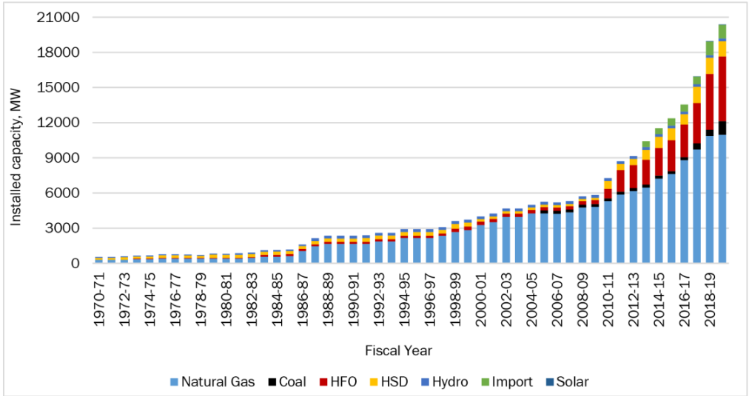
Fig 1.1. Bangladesh's Installed Power Generation Capacity till 2019-2020.
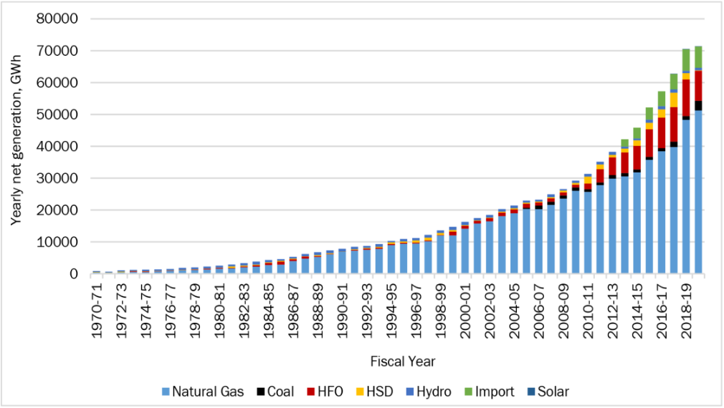
Figure 1.2: Bangladesh’s Net Energy Generation till 2019-2020
The Bangladeshi government has launched a variety of projects aimed at increasing the use of renewable energy. One such initiative is the development of a Renewable Energy Policy that needs minimum 10% of total generation to come from renewable resources. The target is not only that the greenhouse gas emissions be reduced, but the country's energy security will be ensured as well. The GOB implemented 500 MW Solar Programs in 2012 in order to promote renewable energy resources and reach the RE target in the total generation mix. The private sector has been selected as one of the program's most important partners.
Therefore, in the long run, extensive deployment of renewable energy technologies tightly integrated with smart grid and large-scale storage facilities would be one of the most effective solutions for Bangladesh to simultaneously address environmental, economic, and energy security challenges. The development of a “National Solar Energy Road Map, 2021–2041” is critical in this regard.

1.4 Problem Statement:
The demand for power has exponentially increased over decades. The supply of power is made available through grids in most economies. A nationwide interconnection of many sources that lead to a number of stations that generate power, is the primary supply of power for commercial, industrial, governmental, financial etc. purposes. The basic needs that power is required for in households are transportation, heating, cooling, cooking, etc. This supply is commercialized. To keep up with the frantic pace of power usage, commercialization is crucial. Technology has grown to be more dependable and sophisticated over the years, so much so that it has reached our household and commercial activities. With the rise of e-commerce, the interaction process has become easier. With increased demand for energy in a hugely populated country like Bangladesh, it is difficult and yet important to ensure power supply for remote and rural areas. One of the best ways for that is adoption of renewable energy to generate power supply to those areas.
Hence, it has become pivotal to adopt sustainable and cost effective sources of power. For this reason, this paper evaluates the trends this country has shown for its shift towards renewable energy.
Major worldwide challenges such as air pollution, fresh water pollution, coastal pollution, deforestation, biodiversity loss, and global climate deterioration are progressively dominating energy development. To avoid catastrophic global consequences, it will become increasingly difficult to engage in large-scale energy-related activities without ensuring their sustainability, even in developing countries where energy development and use, as well as electricity generation, are seen as a higher priority than their impact on the environment, society, and even the energy resources themselves. The long-term control of global climate change and the maintenance of climate safety levels necessitates a link between climate change policies and sustainable development strategies in all countries which includes the use of renewable energy for saving the planet from pollution.

1.5 Aims and objectives:
To learn about the prospects for solar energy usage in our country, as well as the commercial issues. Following a thorough examination, the following precise study objectives are developed.
• To determine the marketing strategies of various government and non-government organizations in our country that are involved in the solar energy business.
• To analyze the opportunities and benefits of this type of business.
• To find out why individuals choose solar energy systems in the first place.
• To learn regarding the cost of solar energy systems and the people who use it.
• Develop a firm understanding of the solar energy industry as a whole.
• The government of Bangladesh is considering and planning a solar energy grid.

1.6 Significance of the study:
Nowadays, with the vigorously increasing population and need for renewable energy. The want for solar home systems to satisfy the demand for electricity has also increased. We need more renewable resources to meet the need of the increasing demand. Through this we can know about the current condition of the market for solar home system and its future potential to meet the demands of the increasing population.

1.7 Limitations of the study:
- Time was limited so did not get enough time to research on this topic.
- Amidst corona situation the field survey and collecting data physically was not possible.
- I would have learned more about this topic if I had spoken to an electrical engineer.
- More governmental and non-governmental organizations are working to help us know more about this issue and improve the effective use of renewable resources for power production in the future.

CHAPTER II

REVIEW OF RELATED LITERATURE

2.1 Introduction
The generation of electricity in Bangladesh to a great extent is dependent on natural resources and 80% of electricity is produced from natural gases. Renewable sources of energy are budget friendly and can be recreated over time. These resources can help to stop the excess use of non-renewable resources and decrease the adverse effects of the resources on nature. Using solar energy as a mean of power generation can be very effective because it has no waste and no discharge. As a result no adverse effect on the nature. Solar energy can be a helpful solution to solve the power crisis problem in Bangladesh. Both governmental and non- governmental organizations are working to supply solar panels to the people and make it more reachable to people from every classes.

2.2 Bangladesh's current solar energy situation: An Overview
Bangladesh is a subtropical country with almost 70 percent of the year's sunlight falling on it. As a result, solar panels can be used to generate a significant amount of electricity. In Bangladesh, solar power varies with season. Bangladesh sustain a mean of 4–6.5 kW h m2 of daily solar radiation, with the maximum quantity in April and the lowest quantity in December. The Renewable Energy Research Centre (RERC), Dhaka University is the only place of source with all measured data for Dhaka. As a result, solar energy could be a great source for resolving Bangladesh's power shortage.
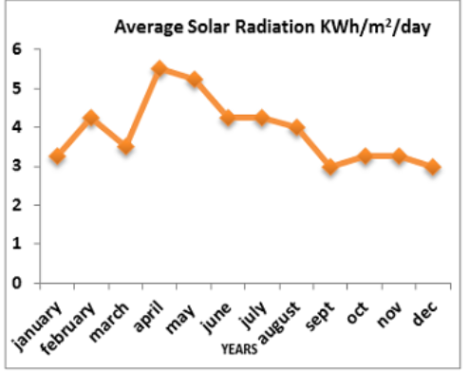
Figure 1.3: monthly mean solar radiation in Bangladesh
The government of Bangladesh has recently made a number of initiatives to inspire people to start using photovoltaic energy. Almost every other recently constructed apartments now has solar panels and a grid attached to help with power shortage. Even in rural areas, several non-governmental organizations have been striving to supply solar panels to villages at a low cost. Up to 2015, the total number of SHSs installed, as well as the number of SHSs installed every division, has greatly increased. The graph 1.4 below shows that the SHS distribution is the highest in Dhaka district and least in Sylhet district. The following equation can be used to compute solar power: Psolar=area per square foot watts per square foot.

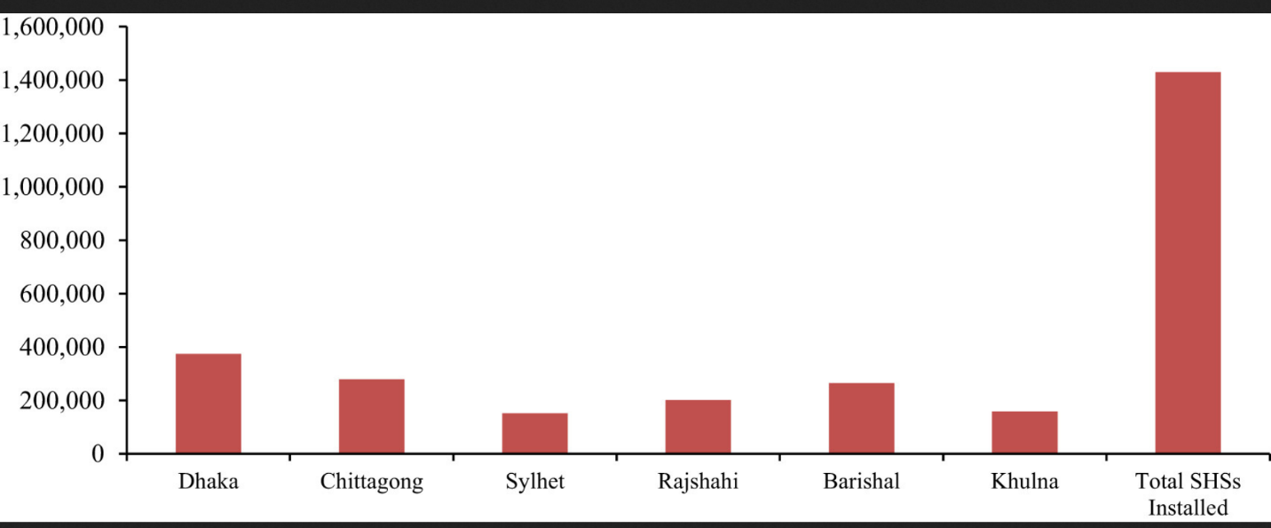
Figure 1.4: Division of solar home systems in all the six divisions of Bangladesh up to Jan 2015
Up until January 2019, roughly 4.13 million SHSs had been installed as part of the scheme in distant locations where gird extension is difficult and expensive. As a result of the program, solar electricity is now available to 18 million individuals, or 12% of the nation's entire population, who formerly relied on kerosene lamps for illuminating households and other places. IDCOL aims to fund 6 million SHS by 2021, which will have a 220 MW power producing capacity.
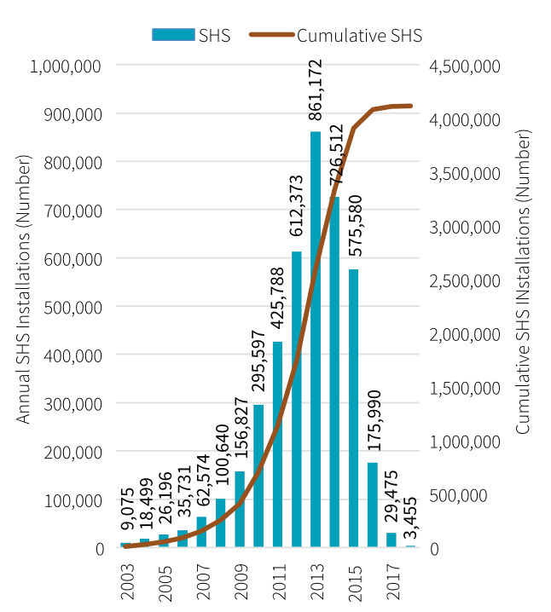
Figure 1.5: yearly and cumulative SHS installations

From the above figure we can see that after a slow start, the rate of installation picked up, reaching a high of 861,000 SHS installed in 2013. From 726,000 in 2014 to 576,000 in 2015, 176,000 in 2016, 29,000 in 2017, and nearly 3,500 in 2018, the rate of installation has been steadily decreasing. The SHS Program provided funding for approximately 4.115 million SHS.

2.3. Prospect of Bangladesh in solar cooking:
A solar cooker is a gadget that cooks food by generating heat from sunshine. Solar cooking is the healthiest and most environmentally friendly method of cooking. To cook food, it makes use of solar energy, which is abundant in nature. Solar cookers are divided into three categories. . Solar energy has resulted in economic benefits such as expanded labor hours and self-employment. Rural residents who now have access to electricity have discovered various opportunities to improve their lifestyle. Rural residents have undergone training in order to provide services such as maintenance to customers after they have purchased the SHSs, which has resulted in the creation of new jobs. It has been estimated that 500 women are involved in this field, and at least 20,000 jobs have been created in this field.

2.4 Global interest of renewable energy
Renewable energy is gaining popularity around the world. Because all renewable energy sources are more expensive to create power than traditional fossil-fuel and nuclear sources, each country has developed alternate policies to promote renewable energy technologies. The domination of renewable energy in the energy sector has always been suggested by economists and experts. However, investment in renewable energy is a costly project. Even then, this does not deter countries from investing in the research and development of its uses and sources, hoping to gain a competitive advantage in the future. These trends are further cemented by environmental risks, incremental price and demand for fossil fuels, and minimizing risks associated with nuclear technology. Bangladesh is a country with a lot of sunshine, therefore it may be a model for putting a lot of money into renewable energy like solar photovoltaic systems.
The majority of lighting is provided by energy-inefficient 60–100 W incandescent light bulbs. In Bangladesh and India, pilot projects using Light Emitting Diodes (LEDs) and Compact Fluorescent Lights (CFLs) have been implemented. The former has low power consumption and are better suitable for batteries, but they have a significantly greater initial cost. CFL bulbs are initially more expensive, but they last around ten times longer than incandescent bulbs and are less expensive in the long term. Over the course of its lifetime, a single 18 W CFL used in place of a 75 W incandescent will save around 570 kWh. CFLs are now used by the majority of individuals in our country. CFL manufacturing is becoming more popular. A table regarding the wattage and cost of the different types of light is given below:
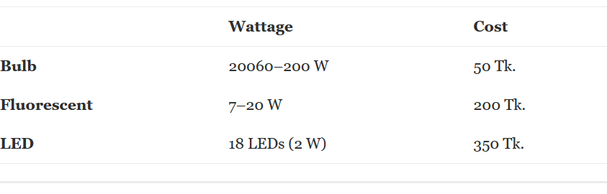
Over the last decade, the globe has seen a tremendous increase in current RE-based technologies. In fact, as a result of lower costs, more investments, and noteworthy breakthroughs in enabling technologies, the year 2017 saw the highest recorded rise in renewable power capacity. The world has seen a continuous rise in global primary energy consumption, particularly in power consumption, over the last few years. The yearly change in worldwide primary energy consumption in 2017 and 2018 was +2.2 percent and +2.9 percent, respectively, according to the BP Statistical Review of World Energy reports.
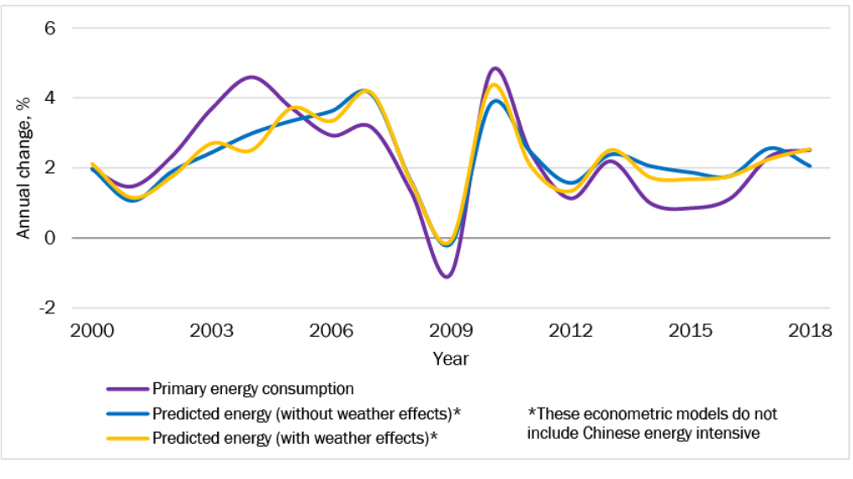
Figure 1.6: Global Energy Consumption Growth up to year 2018
However, in 2019, the rate of increase in energy consumption has slowed slightly. It was stated in an article of the BP Statistical Review of World Energy (2020), that the growth rate in 2019 was +1.3 percent, thanks in part to the widespread use of renewables and natural gas. When compared to prior years, these energy sources have significantly supplanted coal from the energy mix, resulting in a significant reduction in emissions. Despite the fact that oil has remained the dominating fuel, the trend of increasing portions of renewable energy in the combination of global energy has been particularly noticeable in the previous two decades (as shown in Figure 2.2). Renewable energy sources (including hydro) met about 11% of the world's main energy consumption in 2019. When only electricity is considered, renewables account for 10.4% of total electricity generation, exceeding nuclear power generation for the first time.
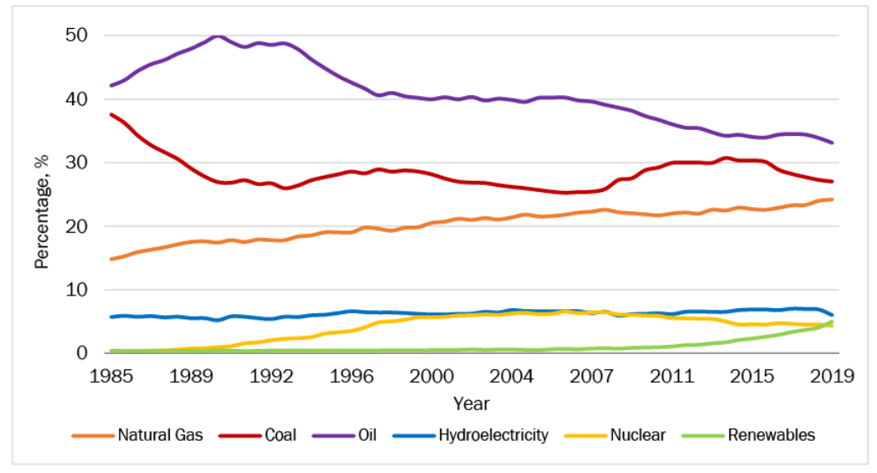
Figure 1.7: Increased proportion of renewable energy in primary energy consumption
In the electricity sector alone, RE power use increased by 17 percent in 2017, which was more than the previous 10-year average and the greatest growth to that point. Resources experienced a relatively stable global market in 2018, delivering over 26% of total global electricity generation. However, 2019 has been another record-breaking year for renewables, with over 200 GW of generating capacity deployed around the world.

2.5 Advantages of solar energy:
The move to renewable energy will speed economic development, ensure reliable and cheap energy access, and upgrade medical care and standard of life. The Institute of Fuel Research and Development (IFRD) of the Bangladesh Council of Scientific and Industrial Research (BCSIR) and the Centre for Mass Education in Science (CMES) collaborated to create a low-cost, lightweight (about 2–3 kg) cooker. However, it has one drawback: it must manually track the sun. Cooking for a family of 5–6 people takes roughly three hours on a bright sunny day.
Solar Dryer is being developed by the Institute of Food Science and Technology (IFST). They created a cabinet dryer to dry up vegetables, fruits and other objects. It has a covered flat plate that captivates solar energy, transforms it to heat, and then distributes the heat to circulating water. It was invented by IFRD. At temperatures below 90 °C, this sort of warmer is ideal for supplying poor quality thermal energy.
In Bangladesh, solar PV-based fertilization is not a new notion. It do not necessitate the use of any high-tech components. The key issue is the real price of inundation, which is mostly determined by the irrigation model on the basis of rural Bangladesh's socioeconomic situation. Because inundation requirements are only critical during the 3-4 dry months, the operating cost of major irrigation projects becomes prohibitively high. SHS has grown dramatically in rural Bangladesh during the last 5–6 years, reflecting the rural people's attitude toward an alternative source of income. Unfortunately, the energy production of a SHS is quite low, hardly enough to support basic household needs such as lights, due to the low output of SHS. Even for small-scale manufacturing, Solar panels are not meant to supply energy support. Micro-grid systems, in which freestanding mini networking grids are meant to provide energy to small rural areas from a central energy station, offer an alternative. All the power plants might be entirely solar PV or a combination of solar PV and diesel. When it comes to micro-grid designs, there are two possibilities. There are two types of micro grids: 1) Alternating current micro grid and 2) Direct current micro grid. Solar PV technology is required to be used to generate main power. Initial costs may be considerable, but they can last a long time.
In our country, nowadays there are two types of electric vehicle being used. One type is known as "easy bike" in the area. It resembles a standard CNG-powered auto rickshaw, however it runs on electricity. The second mode of transportation is a two-seater rickshaw. Both are energy efficient and environmentally beneficial, and they are well-known both throughout the world and also in Bangladesh. They normally use 50 Ahr, 80 Ahr, 100 Ahr, and 120 Ahr batteries, depending on the vehicle's proportions and momentum. There is presently no known recharging station for them because they absorb a lot of power from the grid. As a result, a solar-powered electric vehicle recharging station can be built. Because the solar panels are positioned on top of the CNG filling station or fuel pump, this operation can run alongside it. This technology may be used in almost any section of Bangladesh because the country has nearly the same level of solar insulation to generate the requisite electrical energy.

Review:
Renewable energy in Bangladesh is a sector with room to grow. As of 2019 Bangladesh is among the top 6 global economies by annual GDP growth according to World Bank. To satisfy its energy consumption needs the country mainly relies on natural gas and biofuel. The annual sales figure of Grameen Shakti proves that the number of clients are growing every year. There were just 228 solar systems installed at the end of the year 1997. But this number increased to 1,655,201 by the end of 2015. M. Masukujjaman et al. (2021) examined the intention behind the purchase of renewable energy and he found that the purchase was not linked with social hype or trend but rather people intended to purchase renewable energy because they believed in its usefulness.
The solar home systems is used to supply electricity at homes and shops or to charge cellular phones, run television, radio. The usage of solar electricity as an alternative source of energy is becoming increasingly widespread due to its high popularity and dependability. Solar energy is simple to install, has low maintenance costs, and requires no monthly payments. Grameen Shakti teaches local people about solar power technology so that they can create their own business using their abilities, so creating new jobs and reducing unemployment in Bangladesh.
Although the use of renewable energy is not new in Bangladesh, renewable electricity generation has remained in the demonstration stage. Solar (PV) as SHSs; solar cookers, dryers, water heaters, and tunnel dryers for crops; biogas; biomass machines; and improved cooking stoves are all examples of current renewable energy machineries. A 62 kW system was the first and largest solar PV (photovoltaic) installation.
Because of the global shortage of fossil fuels, as well as in Bangladesh, the necessity for a long-term shift to alternate energy sources is required. Solar energy necessitates a significant investment in costly silicon panels. Solar panels covering a home's rooftop would be insufficient to meet its needs (without air conditioning), necessitating the usage of large batteries at night. Due to the Himalayan Mountains in the north, wind speeds in Bangladesh are too low for economic viability. Recently, in the West, there has been a push to make biodiesel from grain, which is then blended with gasoline in modest amounts. However, the manufacture of biodiesel takes up space that could otherwise be used to grow food.
Wind energy could be a viable alternative energy source for Bangladesh. Because the power generated by wind energy is related to the wind's velocity. This means that the higher the wind velocity, the more power is generated. Bangladesh has a 724-kilometer coastline along the Bay of Bengal. It blows over Bangladesh with an average speed of 3 m s−1to 6 m s−1 from March to September. In Bangladesh, winds are accessible mostly during the monsoon and for one to two months before and after the monsoon, and from October to February, wind speeds are either quiet or too low. The Kaptai Hydro-electric Power Station, which is located near the seashore, generates the most electricity. As a result, the wind power plant can be used to assist the Kaptai power plant from March to September, when the load is crucial. There are numerous islands in the Bay of Bengal where the wind is very strong. Kuakata, Sandwip, and St. Martin are among the towns with suitable wind turbine locations. The majority of the individuals who live in this area are fishermen. They have a slim probability of getting electricity from the national grid because carrying the line through this location is difficult. Wind energy can be a medium to solve this problem.
Although not a new concept, tidal power offers an alternative to satisfy current energy demands. Tidal energy is generated when the sea level rises and falls. Bangladesh is a flood plain delta with a 710-kilometer coast along the Bay of Bengal. Bangladesh has 19 coastal districts, 12 of which are located right beside the sea. Along the seashore, tidal power installations can be developed. They can meet energy demands when they are all functioning at the same time, and they are also employed to protect coastal areas from storms. Several devastating cyclones (e.g., Sidr, Aila) have struck the coastal region of Bangladesh in recent years. Infrastructure has been built to combat these disasters. These embankments and barrages could also be utilized to generate electricity from the Bay of Bengal's 2–8 m tidal head. Three things are required: a water-propelled paddlewheel, a generator connected to the wheel to create energy, and some electric controllers to manage the power output with varied water flow. When required, tidal power can be promptly shut down and restored with minimal losses. As a result, tidal power has the potential to be a valuable source of renewable energy for Bangladesh.
N.K. Das and J. Chakrabarty (2020) suggested that renewable energy would play a huge role in meeting the power demands in the rural and distant areas of Bangladesh, particularly biomass. Biomass is the world's fourth largest source of energy, and it meets the fundamental energy needs of rural communities in developing countries for cooking and heating. The research of Md. Abdullah Hil Baky (2017) found that biomass fuel and other renewable energy used in households, is a clean access to energy for households. It refers to all types of organic matter, including everything from fuel wood to marine plants. Biomass energy production is a fantastic way to help the environment by minimizing the production of common greenhouse gases. There are a variety of technologies for converting biomass into energy, including heat and electricity. It is a mixture of greenhouse gases created by animal dung, poultry droppings, and other biomass wastes, including CH4 (40–70%), CO2 (30–60%), and other gases (1–5%). This gas is flammable and can be used in generation of electricity. Biogas can be used to cook and generate electricity. Biogas, derived primarily from animal and municipal waste, may be one of Bangladesh's most promising renewable energy sources.
In a paper, which analyzes the energy transition for Bangladesh, Ashish Gulagi et. Al. (2020) mentioned that the current situation has led to higher greenhouse gas emissions and overall higher costs of energy consumption. KM Nazmul Islam et. Al. (2021) examines the emission of greenhouse gas emissions from livestock, and found that a combination of all renewable energy use reduces emission of carbon dioxide and other emissions by 37.5%. His paper further finds that existing financial programs should focus on a commercial scale consumption rather than taking household scale consumptions into account.
A digester, a biogas collection tank, a generator, as well as the necessary piping and controls, make up a biogas-based energy generation system. Anaerobic fermentation takes place in the anaerobic digester, which produces biogas. Grameen Shakti is a well-known NGO working in the subject of biogas. They've built 13,500 biogas plants so far. In Rajshahi, the Seed Bangla Foundation recently suggested a 25 kW biogas-based power plant. Under its National Domestic Biogas and Manure Programmers, IDCOL, a government-owned investment company, has set a goal of establishing 60,000 biogas plants in Bangladesh by 2018[12]. (NDBMP) Wahidul K. Biswas (2001) suggested that the most efficient mix of energy for Bangladesh would consist of 25% coal, 25% natural gas, and 35% renewable energies.
When there is a shortage of electricity, such as during high demand, it is common practice to disconnect certain zones, a procedure known to all as load-shedding. This process reduces commercial and industrial productivity significantly. Through disruptions in illumination, air coolers, and means of entertainment, such as television, it lowers quality of life. Load shedding has been at its worst in recent years during the hottest days of summer and, at the very least, throughout the middle of winter. During the winter months in Dhaka, there is hardly no power outage. In the summer, load shedding in urban areas can last up to 3–4 hours a day. The heat and the hours of power shortage are inextricably linked. This is compelling proof that air conditioners are the leading cause of power outages.
Load-shedding is addressed by home and commercial customers that have made significant investments in generators and IPS (Instant Power Supply), UPS (Uninterruptible Power Supply). Each of the many new mobile phone BTS stations is rated at around 12 kW. Back-up generators are typically in the 30 KVA range. Due to significant load-shedding, IPS is commonly employed in urban areas. IPS also consumes a significant amount of electricity. All of these backup generators are inefficient in comparison to huge power plants. UPS only returns around half of the energy it consumes. As a result, the expense of these backup powers rises. Md. Mustafizur Rahman et Al. (2021) focused his research on households’ pattern of consuming energy based on their income. The results indicated that rich households tend to spend more on non-renewable energy which is suitable for their lifestyle, whereas houses with limited income spend more on renewable energy and it proves to be sufficient for their lifestyles
Solar PV is growing in popularity since it does not require any additional resources (such as water or combustible) or machinery. Solar PV systems are increasingly being deployed in agricultural regions. In the past two decades for increasing the installed capacity by two times, the cost of constructing and inserting solar PV systems has decreased by almost 20%. Because of Solar energy, power generating capacity increased by 70% globally in 2008 and 47% globally in 2009, leaving worldwide solar capacity more than twice as high at the end of 2009 as it was at the end of 2007. Over the previous ten years, the solar business has risen at a 35 percent annual rate. . Shamsuddin Ahmed et. Al (2014), in their paper, stated the many advantages of Bangladesh, due to its geographical location, of the extensive use of grid connected solar electricity and stand-alone solar PV system
In the Chittagong hill tracts region, the Bangladesh Power Development Board has set up an exceptional SolarPV for the purpose of electrification. SolarPV electrification has come out as the most suitable technology choice for these areas' power supply. In each of the three sub-districts of the Rangamati district, a 10 kW central AC solarPV system is constructed. The shops in that market have been electrified with regular AC electricity thanks to these systems. Infrastructure Development Company Limited has aided non-governmental organizations in the insertion of solar home systems, with a total of 1,320,965 SHSs with a generating power of more than 36.5 MW installed as of February 2015, indicating that solar PV electrification is the preferable technology choice for rural electrification. Moreover, Wahidul K. Biswas (2001) created a model for generating income for the rural population through use of renewable energy. The model would be an extension of the well-known credit approach offered by NGOs like Brac. Marginal farmers would earn through RETs (Renewable Energy Technologies) activities, which would help them repay loans. A.K. Hossain stated in his article that accelerated deployment of RETs reduces the burden of imported fuel. . Furthermore, M.F Hossain and M.J, Uddin (2017) mentions policy recommendations to the government to promote usage of renewable energy for remote and rural areas of Bangladesh.

Theoretical framework:
The main aim of this research is to show the present situation of renewable energy resources mainly solar energy in Bangladesh and also its acceptability, advantages and downsides. More and more people are working to improve the solar energy sector by every passing day. However, there are very small amount of studies on the consumers who install solar home systems and their satisfaction level and whether they would recommend this source of energy to others. The major part of the study focuses firstly on evidence that can be observed or theoretical interpretation of the statistical data.
The price and availability of solar radiation on a daily basis, whether the cost of installing the solar panel is higher than the non-renewable source of electricity, social norms all these influence the purchase intention against solar panels. So, attitude, subjective norms and the cost of installing the solar panels are the three dependent variables. The benefits of using solar energy may include less emission of GHG. As a result, may attract more consumers. The present opinions of the respondents will help to predict the future of the renewable energy markets.

CHAPTER-III

RESEARCH METHODOLOGY

3.1 Data source and collection methods:

All data and information used for the purpose of this research were found using secondary sources, given the pandemic situation. The opinions of the different respondents were also collected through an online survey on people who have SHSs installed in their house. Secondary data about solar energy systems was gathered from many websites and recently published articles from various sources, with the intention to keep our view of the industry as transparent and least complicated as possible.

3.2 Work location and descriptions
To conduct the research an online survey was done on some real users from different areas of the Dhaka city. The primary aim of this research is to focus on the solar energy business in larger Dhaka. There are numerous NGOs that provide solar system facilities to rural people throughout the country, and about 4,000,000 individuals in our country currently use solar energy systems.

3.3 Sample and sampling
10 respondents were chosen at random from houses in different areas who utilize a solar energy system, and those who were eligible completed the questions. People throughout the country, especially in isolated areas, rely on solar panels for power. In Dhaka City, a list of those who use solar household systems was compiled. Respondents were chosen from various income groups. An online questionnaire is created to assess the perceptions of potential customers on numerous areas such as pricing and after-sales support.

3.4 Statistical treatment
After the collection of data, standardized editing procedures were used to evaluate and verify the data. Finally, both descriptive and inferential statistics were analyzed using Microsoft Excel.

CHAPTER-IV

FINDINGS OF THE STUDY

4.1 Time period of using solar energy

The figure below shows that 40% of respondents use solar energy for one to three years, whereas 20% use it for less than one year and between three and five years. Only 10% of respondents have been using solar energy systems for more than 5 years. And 30% of the respondent used solar energy between three and five years. .
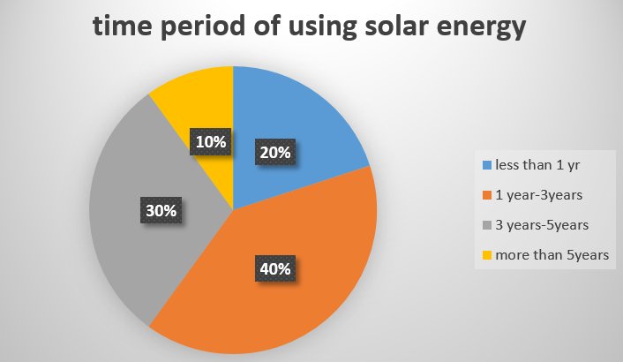

4.2 Cost of buying solar panel
The figure below reveals that 50% of customers bought solar panels for $125 to $250 USD, while 30% paid in between $300 to $450 USD. Also, 20% of them use solar panels that cost between $750 and $800 USD. Other commercial solar panels cost in between $1200-$2000 USD and more. Solar energy has a hefty cost, according to this study. To attract more customers, businesses could lower their solar energy panel costs and prices.
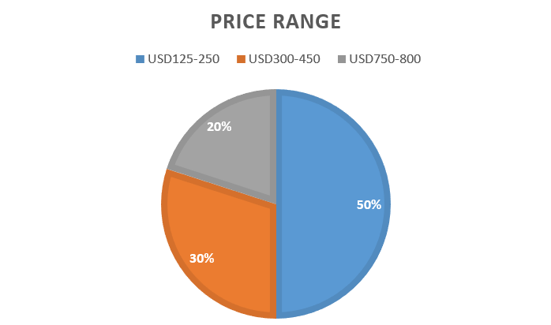

4.3 Level of satisfaction using the solar energy system
60% of consumers are content, with 10% being extremely satisfied and 30% being dissatisfied (according to the chart below), indicating that the majority of solar panel users are content with the services.
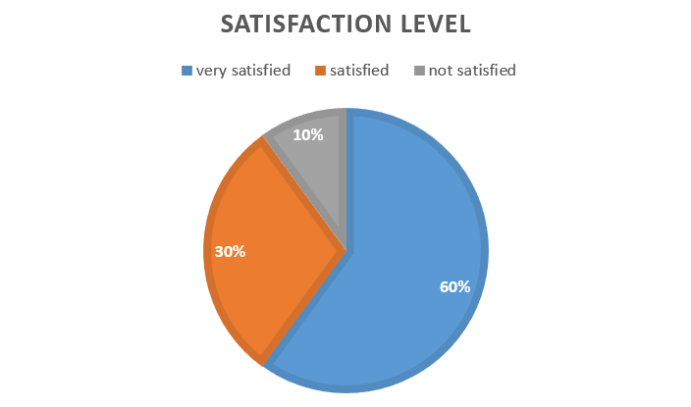

4.4 used electric line prior to employing Solar Panel

Regarding the use of any electrical line prior to employing a solar panel, 90 percent voted "Yes," while just 10% stated "No." According to the data, the majority of respondents already utilize electricity. As a result, they use solar panel systems as an alternate energy source.

4.5 Purchasing of solar panel on bank loans

60% said “yes” while 40% said “no” when asked if they would buy a solar panel with a bank loan or any of the various NGOs' loans. The cost of a solar panel is expensive, according to this data, hence people buy them on credit. To attract more customers, businesses could lower their solar energy panel costs and prices.

4.6 Service of company providing solar panels

In terms of solar energy system servicing, 20% of those who responded said great, while 20%, 50%, and 10% expressed good, moderate, and dissatisfied, respectively. The majority consumers were pleased with the service of the solar panels. However, in order to increase their consumer base, they should improve their service. All of the respondents stated that the companies offer warranties on solar energy systems. All of the respondents are pleased with the expanded warranty period for solar panels.
70 percent replied "no," 20 percent said "yes," and just 10% said "no" when asked whether their solar energy needs are fulfilled. The majority of people believe that solar energy panels are insufficient to meet their needs. This suggests that the demand for solar energy is increasing.

4.7 Cost effectiveness of solar panels compared to non- renewable electricity supply:

In regards to the economical effectiveness of solar energy systems, 80% of respondents said “No,” while 20% said “Yes.” Because of the initial set-up expense, the majority of consumers felt it's still expensive. To attract more customers, businesses could lower their solar energy panel costs and prices.

4.8 Whether they faced any problem after installing solar home systems:
When asked if they had any troubles after acquiring a solar panel, 90 percent of customers said "No," while only 10% said "Yes." This data study shows that solar energy systems work substantially better because they require very little maintenance.

Chapter V
Conclusion

Based on the comments, it appears that a solar energy panel trading exists in Bangladesh and the consumers have increasing urge to use it. In terms of consumer perceptions of this commodity (calculated in terms of comfort and ease, country-specific perceptions, and so on), migration to renewable energy sources can help the economy of the country if effective deals and facility is provided to consumers. The price of these energy systems should be reduced so that people from various classes can benefit from them and have the money to purchase them.
Some of the points that can be considered to deduce the findings is the initial expense of inserting a solar energy system. It is the most significant disadvantage of installation of solar panels due to the excess price of the semi-conducting elements needed in its construction. Solar energy has a high cost when compared to non-renewable utility-provided electricity. Because of energy shortages in the present time the solar energy sector has become more price competitive. One of the disadvantages of installing solar panels is to attain a high level of efficiency, it must be installed across a vast area. The system's effectiveness is also influenced by the sun's position, though this issue can be mitigated by installing particular components. Moreover because of clouds and air pollution the solar energy generation is impacted. Even though a backup of battery solution will fix this problem, there is no availability of solar energy at night. In the rainy season, there will be less solar energy produced.
However, in Bangladesh, producing electricity with solar panels, and other renewable energy resources, has become a quiet revolt. Solar PV energy is now being victoriously employed as a long lasting source of energy for residential lights. Though it began in Bangladesh in the off-grid area for rural lighting, city uses are growing with each passing day, whether through hybrid or grid systems. In Bangladesh, there is a lot of prospect for the solar energy business sector. The government of Bangladesh should take the required efforts to stimulate both business magnets and consumers.

5.2 Policy Implementation:
• The government could lower VAT/taxes on accessories of solar panels and materials used to construct it, particularly the taxes on battery and solar cells, to decrease the supply-demand imbalance.
• The governing body could offer loans with low interest rates to rural residents who want to purchase solar panels.
• Because of the absence of solar energy at night, on rainy days, or during the cold season, energy storage should be prioritized.
• Initial installation costs must be subsidized by the government.
• The government should issue more solar energy business licenses.
• To maintain a high level of service, the organization should upgrade its proper monitoring of the solar system.
• To prevent load shedding, the government should install solar energy systems in government buildings.
• The organization should provide enough training for users of this technology.

Reference:
Hossain, M. F., Hossain, S., & Uddin, M. J. (2017). Renewable energy: Prospects and trends in Bangladesh. Renewable and Sustainable Energy Reviews, 70, 44-49.
Chowdhury, S. A. (2020). National Solar Energy Roadmap, 2021-2041.
Baky, M. A. H., Rahman, M. M., & Islam, A. S. (2017). Development of renewable energy sector in Bangladesh: Current status and future potentials. Renewable and Sustainable Energy Reviews, 73, 1184-1197.
Biswas, W. K., Bryce, P., & Diesendorf, M. (2001). Model for empowering rural poor through renewable energy technologies in Bangladesh. Environmental Science & Policy, 4(6), 333-344.
Baky, M. A. H., Rahman, M. M., & Islam, A. S. (2017). Development of renewable energy sector in Bangladesh: Current status and future potentials. Renewable and Sustainable Energy Reviews, 73, 1184-1197
Biswas, W. K., Bryce, P., & Diesendorf, M. (2001). Model for empowering rural poor through renewable energy technologies in Bangladesh. Environmental Science & Policy, 4(6), 333-344
Masukujjaman, M., Alam, S. S., Siwar, C., & Halim, S. A. (2021). Purchase intention of renewable energy technology in rural areas in Bangladesh: Empirical evidence. Renewable Energy, 170, 639-651.
Islam, K. N., Sarker, T., Taghizadeh-Hesary, F., Atri, A. C., & Alam, M. S. (2021). Renewable energy generation from livestock waste for a sustainable circular economy in Bangladesh. Renewable and Sustainable Energy Reviews, 139, 110695
Gulagi, A., Ram, M., Solomon, A. A., Khan, M., & Breyer, C. (2020). Current energy policies and possible transition scenarios adopting renewable energy: A case study for Bangladesh. Renewable Energy, 155, 899-920.
Ahmed, S., Islam, M. T., Karim, M. A., & Karim, N. M. (2014). Exploitation of renewable energy for sustainable development and overcoming power crisis in Bangladesh. Renewable Energy, 72, 223-235.
Hossain, M. F., Hossain, S., & Uddin, M. J. (2017). Renewable energy: Prospects and trends in Bangladesh. Renewable and Sustainable Energy Reviews, 70, 44-49.

