“An Analysis of Human Resource Management Practices of National Credit and Commerce Bank”

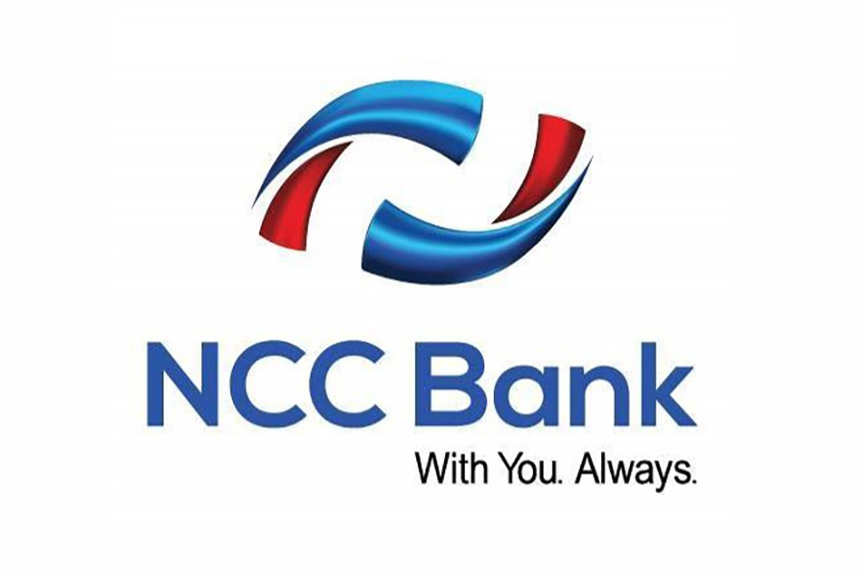

Project Report on
An Analysis of Human Resource Management Practices of National Credit And Commerce Bank

Submitted To
Piana Monsur Mindia
Assistant Professor
Faculty of Business and Economics
United international university
Dhaka, Bangladesh

Submitted By
Ramisa Jahan
ID: 111 161 258
BBA Department
School of Business & Economics
United International University

Submission date:
17th December 2020

Letter of Transmittal
17th December 2020
Piana Monsur Mindia
Assistant Professor
Faculty of Business and Economics
Subject: Submission of project report titled “An Analysis of Human Resource Management Practices of National Credit and Commerce Bank Limited”.
Dear Madam,
This is my immense pleasure to submit my project report on the topic of “An Analysis of Human Resource Management Practices of National Credit and Commerce Bank Limited" which was entrusted to me as a partial requirement for the fulfillment of the BBA Program.
This report allowed me to know about the HRM practices of the NCC bank. I trust this report can give a state of operations of the Human Resource Management practice of National Credit and Commerce Bank Limited. I did my best to present a genuine and relevant detail as possible and tired of maintaining the instructions that you have advised.
I would like to express my sincere gratitude and appreciations to you for allowing me to work on this project. I truly hope that you will simply appreciate my work and kind enough to accept my report with your utmost delight.
Thank you.
Sincerely yours,
……………………………
Ramisa Jahan
ID: 111 161 258
Major: Human Resource Management
Department: BBA

Letter of Declaration

I, Ramisa Jahan hereby declare that this project report entitled “An Analysis of Human Resource Management Practices of National Credit and Commerce Bank Limited” is an authentic work done under the supervision of Ms. Piana Monsur Mindia, which is for the partial fulfillment of the award of the degree of Bachelor of Business Administration (BBA) degree from United International University.
I also confirm that the report is completely prepared for my academic requirement, not for any other purposes. It might not be used with the interest of the other party of the organization.

Yours sincerely,
……………………………….
Ramisa Jahan
ID: 111 161 258
BBA Program, of Business and Economics.
United International University.

Letter of Acceptance

It is to certify that Ramisa Jahan bearing ID: 111 161 258, Department: BBA, a student of United International University. Her project report entitled “An Analysis of Human Resource Management Practices of National Credit and Commerce Bank Limited” is prepared with thoughtful and relevant documents and ideas.

I am glad to be a supervisor in setting your carrier courses. I believe that this is a worthy report that satisfies the requirements of the United International University bachelor of business administration degree.

I wish you continuous progress in life.

____________________________________
Piana Monsur Mindia
Assisstant Professor
School of Business and Economics
United International University.

Acknowledgement

First, all thanks to Almighty Allah, the most praiseworthy and merciful who has given me the strength to complete this report within the planned time.

I would like to express my genuine and valued gratitude to my academic supervisor Piana Monsur Mindia. Throughout the report writing period, I am whole-hearted deeply indebted to her for the encouragement and guidance and has made me confident and self-dependent. Her constant involvement and appreciation have greatly contributed to my report. Furthermore, her valuable feedback and encouragement helped me a great deal to assemble the report in an extremely well organized way.

And, I am immensely thankful to the HR manager of NCC bank for his great cooperation and for providing me with the requisite details on the preparation of this project and also by giving the suggestions, assistance & supply of information, which were beneficial to me that helps me to complete my assigned project report.

Finally, I am also very thankful to my family & friends, who have been so cooperative, boost me, and a strong supporter of my success.

Executive Summary

This project report presents an analysis of the Human Resource Management practices of National Credit and Commerce Bank Limited. The National Credit and Commerce Bank Ltd has a remarkable banking background. With its dynamic market provision of 104 branches across Bangladesh, it has operated as a leading private commercial bank and provided its customers with earnest and personalized banking service in a responsive and technology-based environment. The objective of the bank was to put in action resources from within and utilize the resources in such a way, that help to make development for the country's Industrial and Trade Sector and operating a catalyst formation in the form of the capital market as well.

This article provides the background details of the company and mostly the NCCBL HR practices, which includes recruiting and selecting process, training and development plan, performance appraisal, and compensation and benefits plan. Moreover, the last chapters discuss the recommendations regarding the HRM practice of NCC bank also did summarization the report to conclude. I have tried my best to present all the valuable pieces of information about the HRM practices of NCC bank.
The first part of this report commences with an organizational insight of NCC Bank Limited giving its organizational history, organization objective, mission, vision, goal, corporate culture, and product and services Following that the next section has described the detailed information of NCCBL Human Resources Management practices. This is the largest part which comprehends the definition of HR, then have described the NCCBL recruitment and selection procedure, guiding principles, their recruitment sources. Employers today must make sure that their today’s training programs are confirmed to the organizational strategic goal. NCCBL is very conscious about providing training to its employees to enrich their knowledge and develop personal growth. It also discusses the NCCBL training need assessment, the NCCBL training institute and its function, training techniques followed, training materials, evaluation of training, and the NCCBL training program. Then have discussed the NCCBL performance appraisal, which consists of performance appraisal of NCCBL, types of performance to measure, measurement technique, and performance evaluation.
It has discussed the compensation and benefits of NCCBL. Direct and indirect compensation, employee benefit and leave, discretionary benefit, service rule of NCBL, career development in NCCBL.

Besides, in the next part of the report, I have discussed the SWOT analysis of NCC bank. Here I have discussed the strength, weaknesses, opportunities, and threats of the NCC bank and figure out some findings of the bank. The last part of the report has proposed some recommendations that can enhance the NCCBL human resource division and end the report with the conclusion.

Table of Content

Letter of Transmittal i
Letter of Declaration ii
Letter of Acceptance iii
Acknowledgement iv
Executive Summary v
CHAPTER – 1 1
INTRODUCTION 1
Origin of the Report 2
1.2 Objectives of the Study 2
1.3 Scope of the study 3
1.4 Methodology of the Study 3
Limitations of the Report 4
CHAPTER – 2 5
LITERATURE REVIEW 5
Human Resource Management 6
Recruitment & Selection 8
Training & Development 8
Performance Management 8
Compensation & Benefits 9
CHAPTER – 3 10
ORGANIZTIONAL BACKGROUND 10
3.1 Introduction of National Credit and Commerce Bank Limited 11
3.2 Objectives of National Credit and Commerce Bank Limited 13
Mission 14
Vision 14
3.5 The Goal of the Bank 15
3.6 Core Value 15
3.7 Features of National Credit and Commerce Bank Limited 16
NCCBL Management Hierarchy 17
3.8 Corporate Culture of NCC Bank Ltd 20
CHAPTER - 4 21
HRM Practices of NCC Bank Limited 21
Human Resource Management 22
4.1 The Human Resource practice in NCC Bank Ltd 23
4.2 Human Resource Division: 24
4.3 Definition of Recruitment and Selection 26
4.4 Recruitment and Selection Process of NCCBL 27
4.4.1 Recruitment and selection procedure for Entry level Position 27
4.5 NCC Bank Recruitment Sources 35
4.6 Training and Development 37
4.7Training Design Process 38
4.8 Training Need Assessment 40
4.9 NCC Bank Major Training Providers 41
4.10Training Institute at NCCBL 41
4.11Function of NCCBTI 42
Training Plan 2020 43
Training Techniques Followed By NCC Bank: 46
4.14.1 on the job training: 46
4.14.2 off the job training: 47
4.15 Evaluation of Training 48
4.16 Top Management Support in Deterring the Importance of Training 49
4.17 NCCBL Training Design Program 50
4.18Performance Management 50
4.19 Performance Appraisal in NCC Bank Ltd 51
4.20 Types of Performance to Measure 52
4.21 Measurement Technique of Performance 52
4.22 Performance Evaluation 53
4.23 NCCBL Compensation and Benefit 55
4.24 Service Rule of National Credit and Commerce Bank Limited 56
4.24.1 Transfer, Termination, Retirement and Resignation 56
4.24.2 General Conditions of Service 57
4.24.3 Employee Benefits and Facility 58
4.24.4 Leave Rule 59
4.25 Career Development in NCC Bank Limited 63
CHAPTER – 5 65
SWOT ANALYSIS AND FINDINGS 65
5.1 SWOT ANALYSIS OF NCC BANK LIMITED 66
5.2 Findings 69
CHAPTER – 6 70
RECOMMENDATION AND CONCLUSION 70
6.1 Recommendation 71
6.2 Conclusion 72
CHAPTER – 7 73
QUESTIONNAIRE 73
7.1 Interview Questionnaire 74
CHAPTER – 8 75
REFERENCE 75
8.1 Reference 76
Bibliography 76

Figure 1: NCCBL Management Hierarchy 17
Figure: 2 Recruitment Process 38
Figure 3 Training Design Process 45
Figure: 4 Performance Appraisal of Management Trainee 60
Figure: 5 A Career Development Opportunity In NCC Bank Limited 71

CHAPTER – 1

INTRODUCTION

Origin of the Report
This project report is prepared to fulfill the requirement of the internship/ project program of the BBA degree in the Department of Business Administration, United International University. My honorable supervisor Piana Monsur Mindia ma’am has assigned me the report titles ‘An Analysis of Human Resource Management Practice of National Credit & Commerce Bank Limited’. This report has discussed the HRM practices of NCC Bank Ltd and for their bank development, how they can utilize Human resources.

1.2 Objectives of the Study

The purpose of the report is to know the implementation of HR practices of a bank. Here, I have selected National Credit and Commercial Bank Limited (NCCBL) as my topic subject. I have analyzed the National Credit and Commercial Bank Limited HR practices. The specific objectives of this report are mention below:

To know Human Resources Management practices of the NCC bank.
To know about the recruiting and selecting procedure of the bank.
To know about training and development methods applied in the bank.
To know performance management practices in the bank.
To know about the compensation and benefit provided to the employees.
To know about the training institute of NCC Bank Limited.
To identify their SWOT analysis.
To identify the findings of the bank.
To recommend suggestions for further development.
To get a clear idea about the employee career development in the bank

1.3 Scope of the study

The report mainly focuses on the HRM practices of NCC bank. National Credit and Commercial Bank limited is one of the renowned banks in Bangladesh. I have prepared this report by detailed discussion with the HRM manager of NCC Bank. I had tremendous insight into all the activities of HRM practiced by the NCC Bank in preparation for this report.

1.4 Methodology of the Study
In preparing such a report, some research methods need to follow. It is a descriptive report. This report is prepared based on the existing HRM practice of NCCBL.
I could not visit the organization and collect the data directly during the Covid-19 pandemic, but still, I have tried to collect the data both from primary and secondary sources. For preparing this report, I have looked into various books, blogs, journals, websites, and company websites that have supported me a lot. After getting data from the manager, then carefully examined the data and lastly summarized it.

Primary Data
I did my utmost to collect the information during this pandemic situation. I have acquired the data through a questionnaire that contains only close-ended questions. The Primary data was collected by telephone interviewing the respective HR manager of NCC Bank.

Secondary Data
- Annual report of NCC bank
- Bank website
- HR books
- Internet sources

Limitations of the Report

I have observed certain limitations during the preparation of this project report. The limitations are as follows:

- Firstly, I could not visit the organization due to covid pandemic. Therefore, I tried my level best to collect information over the phone.
- Time was another major limitation for this most of the aspects could not present in the report.
- Some information could not be collect due to organization confidentiality.
- Some information was not available on the net also.

CHAPTER – 2

LITERATURE REVIEW

\

Human Resource Management

HRM is the part of the business that deals with the people factor. HRM works with an organization's human affairs, ranging from recruiting to the labor relationship.HRM focuses on the human side of management. It is a mechanism for the acquisition, growth, encouragement, and management of an organization's human capital.

Human resource management is also a systematic and comprehensive approach to handling persons and the community and atmosphere of the workforce. Well achieved, it also encourages employees to contribute efficiently and productively to the general direction of the business and the achievement of the goals of the organization.

The main objective of Human Resources (HR) is to ensure that an organization can attain success by employees. Hr departments manage an organization's intellectual resources and work on developing policies and procedures. As well as managing employee relations or compensation, they may specialize in identifying, hiring, training, and improving employees. Professionals in training and development ensure that workers are trained and have continuous improvement. This is performed through training programs, performance assessments, and opportunities for promotions.

Employee relations deal with employees' issues when procedures are violated, such as situations of abuse or discrimination. The management of employee benefits includes the development of pay structures, family leave plans, promotions, and other opportunities for workers. The existence of an HR department is an indispensable component of every business regardless of the size of the organization. An HR department is responsible for boosting employee productivity and shielding the organization from any challenges within the workforce that could emerge. HR functions include compensation and incentives, hiring, replacing, and staying updated on any regulations that can influence the organization and its employees.

Organizations have been more people-centered than ever before in this modern age, especially when this strategy yields great dividends in terms of increased worker productivity and lower turnover rates. Management of human resources or HRM plays a critical role in supporting employers and organizations to achieve their targets.

HRM's functions play a significant part in the organization's growth and progress ultimately. When employees develop and enhance their performance. Overall, the company will automatically undergo growth and expansion. Job planning and job analysis, recruitment/hiring and placement, training and development, compensation and incentives, performance management, administrative relations, and labor relations are some of HRM's primary roles.

The objective of Human Resource Management

- Manage human resources productively.
- Enhance individual development
- Build attractive working relations among all members of the organization.

Recruitment & Selection
In HRM, recruiting and selection is a significant operation structured to enhance workforce power to achieve the strategic objectives and priorities of the company. It is a method of recruiting, screening, short listing, and choosing the best applicants for the vacant positions needed. The recruitment and selection process, the selection aspect of the system involves screening the candidates, conducting interviews, shortlisted the most suitable candidate, and eventually choosing the first-class person for the position.
One of the primary goals of management is to follow this process. Indeed the success of a corporation primarily depends on the efficiency of its employees. Recruiting employees with the right qualifications can bring significant benefits to an organization. It can minimize expenses by recruiting workers at a wage or salary that the company can afford. Employees, like any other assets, should then be carefully chosen, handled, and maintained.

Training & Development
Training and development consists of improving the effectiveness of businesses and the people and teams within them.[1] Training may be regarded as associated with on the spot adjustments in organizational effectiveness via organized education, on the same time as improvement is related to the development of longer-time period organizational and worker goals. While schooling and improvement technically have differing definitions, the two are generally used interchangeably and/or collectively. Training and development has traditionally been a subject inside implemented psychology but has in the final decades grow to be closely associated with human sources management, skills control, human sources improvement, educational design, human factors, and information management.

Performance Management
Performance control is the procedure of reviewing an worker’s performance during the preceding year or cycle and finding out where he or she stands as a long way as their peers inside the same band are concerned. The method of reviewing outcomes, arriving at a rating and then finding out upon the bonus or earnings hike is what performance control is all about. Before we have a look at the subject sentence, it is far vital to recognize what is going into the decision-making process and who is worried within the identical.

Compensation & Benefits

The procedures for compensation and benefits introduce transparency of human resources and reward employees for the success achieved. The compensation and benefits provide management with the compensation packages to create a difference between employees as the company can develop a high-performance organizational culture.

Moreover, the compensation and benefits department is responsible for the accountability of the organization's compensation policies and ensuring the internal consistency of the overall cash. Companies recruit individuals to accomplish their organizational objectives and individuals enter firms to raise cash and develop their careers. Apart from the reputation and job profile of the organization, the money given as a salary is vital to recruiting individuals to work with the organization.

CHAPTER – 3

ORGANIZTIONAL BACKGROUND

3.1 Introduction of National Credit and Commerce Bank Limited

National Credit and Commerce Bank Limited began its glorious journey of excellence around a decade to improve the financial sector of Bangladesh. That is to improving Bangladesh's economic situation by supplying the finance sector with successful and creative banking and financial goods.

After the independence, the war in Bangladesh National Credit and Commerce Bank Limited is one of Bangladesh's second-generation home non-public banks. It is a private sector schedule formed under the custody of the Bank Company Act, 1991 and incorporated on 17 May 1993 as the Public Limited Company Act 1994.

National Credit and Commerce Bank Limited has a unique background. Back in 1985, the corporation began its journey into the country's financial market, as an investment firm. The company's mission was to mobilize and invest resources from within in such a way as to expand the trade and industrial sector of the country and play a catalyst role in the formation of the stock market. Its presence in the stock exchange has benefited the company to a significant degree in this regard. NCCBL has now emerged as a big player in all financial market, as its journey in 1993, emerging from several key challenges. The bank was able to achieve a commendable CAMEL ranking and its performance during the year ended 2000 was remarkable in terms of profitability.

The bank operated up to 1992 with 16 branches and subsequently transformed with the approval of the central bank, subsequently transformed into a complete scheduled private commercial bank in May 1993 with paid-up capital Tk. 39 core from a broad network to represent the country.

National Credit and Commerce Bank Limited has developed over the years as one of the centers to form of the financial sector in Bangladesh.NCC has grown over the years as one of the foundations of the financial sector in Bangladesh and play an important role in developing the economic involvement of the private sector.
NCC Bank Ltd has gained a commendable reputation and plays an important role in the overall private sector in the economy. It provides its customers with genuine personalized service in a technology-based environment.

3.2 Objectives of National Credit and Commerce Bank Limited

National Credit and Commerce Bank Limited's main objective is to maximize profit through client satisfaction, which reflects the idea of any form of a service-oriented organization. National Credit and Commerce Bank determined benefit by offering the best and revered service along with other corporate goals.

The objectives of NCC Bank are mentioned below:

- Ensure high investment returns and several service offerings.
- Play a major part in the sustainable growth and development of this nation's economic condition.
- Make sustainable investments, develop a balanced growth plan, and maximize annual profitability.
- Residing as the industry leader through expanding the business and automating banking activities.
- Adopt appropriate management technology.
- To create an absolute integrated financial service system.
- To generate employment opportunities for contribution to the commodity.
- Building a strong, dynamic, and sustainable organization, that engages in good business behavior and provides the highest quality service

Mission

- To provide our customers with outstanding financial service focused on a good customer relationship.

- Providing our clients and stakeholders with a long-lasting approach that blends our cutting-edge technologies, expertise, and financial strength.

- Creating a productive and supportive group where customers and our individuals can succeed.
.

.

Vision

In serving the country as a progressive and socially responsible financial institution, to become one of the most influential commercial banks by putting credit and trade together for the greater benefit for shareholders and sustainable economic growth.
.

3.5 The Goal of the Bank

To share a large segment of the banking sector is to utilize the available workforce and state-of-the-art technologies to increase the prosperity of shareholders.
- Long-term objective: To maximize the shareholders' capital value.

- Short-term objective: To attain a satisfactory rate of return on investment by providing a wide variety of outstanding banking services.

3.6 Core Value
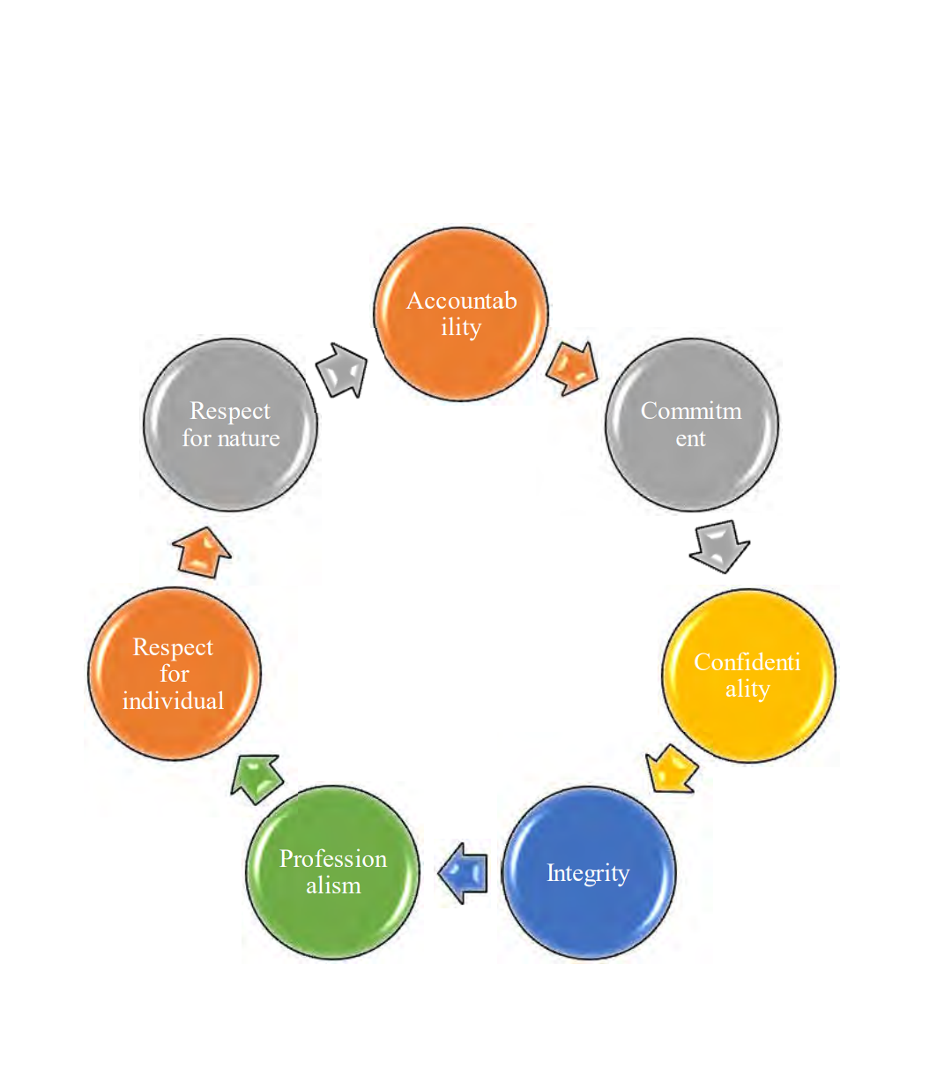

3.7 Features of National Credit and Commerce Bank Limited

There are such a lot of motives in the back of the higher performance of National Credit and Commerce Bank Limited than another newly hooked up banks:
• Highly certified and efficient experts are in the management of the bank.
• A Research & Planning Division with productive people has developed by National Credit and Commerce Bank Limited.
• The automated operation device has offered the standard and set of customer service for all branches of NCCBL.
• All qualified staff were encouraged to achieve the ultimate goal of NCCBL by the organizational factors and teamwork.
• As a member of the SWIFT machine for accelerating overseas exchange transfers, National Credit and Commerce Bank Limited emerged.
• For the saving of low-earnings individuals who are not accessible in various such as "Ajebon Pension Scheme," National Credit and Commerce Bank Limited has added a few other schemes.
• The Bank provides a better saving rate than various financial institutions.
• In comparison with the other banks, National Credit and Trade Bank Limited collects a smaller fee from their customer.
• National Credit and Commerce Bank Limited also holds social duties along with technology benefits.
• The Bank consistently directed its client's capacity by providing helpful advice.

NCCBL Management Hierarchy

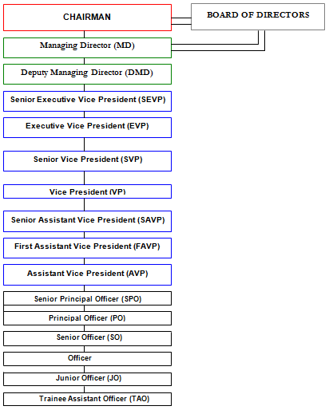

Figure 1: NCCBL Management Hierarchy

Branches of NCC Bank Limited
Number Of Branches | Branches Of NCCBL | Number Of Branches | Branches Of NCCBL
1 | Motijheel Main Branch | 21 | Chaumuhani Branch
2 | Agrabad Branch. | 22 | Shymoli Branch(next opening)
3 | Khatungonj Branch | 23 | Bangshal Branch.
4 | Khulna Branch. | 24 | Moulvibazar Branch
5 | Babubazar Branch | 25 | Jessore Branch
6 | Jublee Road Branch. | 26 | Rangpur Branch
7 | O.R Nizam Road | 27 | Kawranbazar Branch
8 | Chowhatta Branch. | 28 | Dilkusha Branch.
9 | Dhanmondi Branch | 29 | Islampur Branch
10 | Elephant Road Branch. | 30 | Halishahor Branch.
11 | Mogbazar Branch. | 31 | Foreign Exchange Branch.
12 | Gulshan Branch | 32 | Modunaghat Branch
13 | Malibag Branch. | 33 | Uttara Branch
14 | Cox's Bazar Branch | 34 | Baralekha Branch
15 | Laldighirpar Branch | 35 | Syedpur Branch.
16 | Jatrabari Branch | 36 | Patgram Branch
17 | Mirpur Branch. | 37 | Baraiyarhat Branch
18 | Feni Branch. | 38 | Majhirghat Branch
19 | Kadamtali Branch | 39 | Bogra Branch
20 | Laximpur Branch. | 40 | Nababgonj Branch
41 | Midford Branch. | 51 | Andorkila Branch.
42 | Hajigonj Branch
43 | Madaripur Branch
44 | Rajshahi Branch.
45 | Nawabpur Road Branch
46 | Banani Branch
47 | Commilla Branch
48 | Chakaria Branch
49 | Jaggannathpur Branch
50 | Madhabdi Branch

3.8 Corporate Culture of NCC Bank Ltd

Corporate culture aims to express its norms, mindsets, attributes, and confidence that represent and demonstrate its nature to individuals from an organization. It helps to establish the priorities, procedures, structure, and entry of an organization to operate, consumers, speculators, and the most influential network. Therefore, their deep and diverse business culture establishes a strong bond with their partners. It also provides loyalty for members and customers. With its absolute and incomparable business culture, NCC Bank is one of the finest examples of corporate banks.
The Bank's members see themselves as a community and a family that leads to collaboration for change. Positive and brilliant organizational cultures create up an upper hand over the long term and step in as an impartial platform that is meaningful and remarkable. Over the long haul, positive and brilliant corporate societies build up an upper hand and fill in as an important and noteworthy authoritative resource.

CHAPTER - 4

HRM Practices of NCC Bank Limited

Human Resource Management

Human Resource Management includes all administration choices and plan that straightforwardly concern or impact the individual or HR who work for the association. As of late forward consideration has been devoted to how associations oversee HR. This expanded consideration originates from the conviction that an association's representatives empower the association to accomplish its objective and the executives of this human asset are basic to an association's prosperity.

The rise of an individual is no new development except for determining them as an asset in a more conventional manner has been made in the current days. The organization considers human assets as an incorporated piece of corporate administration for otherworldly profitability. The organization follows a dedicated approach for enlistment, preparing and advancement, persuading, arranging, holding, and keeping up the current HR based on quality instruction, preparing, and working encounters.

The concept of HRM is that it is the process of interacting with groups of humans in a concentrated and detailed manner. This includes the areas of recruiting (hiring human beings), retaining of human beings, selection and administration of pay and benefits, regulation of results, control of trade, and taking care of corporate exits to round off sports. This is the standard concept of HRM, which allows some analysts to illustrate it as a cutting-edge variant of the Staff Management attribute that was used in advance.

Collaboration is not something more than a human asset. The human resource division is tied to the board's measurement of "individuals". Since individuals are embodied by each organization, acquiring their administrations, improving their skills, enabling them to perform substantial amounts of performance, are vital to achieving hierarchical objectives and ensuring that they continue with the association's duty.

4.1 The Human Resource practice in NCC Bank Ltd

NCC Bank Limited has the best Human Resources, which are that, the utmost strength for them that has the flexibility to reach outside and continuously bring in improvements to the Bank's aim for improvement and success. The primary responsibility of the Human Resource Department of NCC Bank is to expand, maintain and intrigue skills and ensure the "Best Person in the Right Place" which helps to accomplish the long-term organizational success through the participation of its active workers. Their HR department is responsible for the management and monitoring of all HR-related tasks such as recruiting and hiring process, incentives, and benefits, preparation and development, performance assessments, HR preparation. The divisions of NCC Bank HR are also strongly adapted with the new Technological assistance helps develop their comprehension and expertise.
NCC Bank has a main managed HR system, so the financial institution uses a Flora-designed HRD computer called Core banking program, which allows all types of HR wishes to be adequately supported by both its employees and HR officers. For some form of question involving leave request, transfer order, discharge order, training, compensation, and others with the head office, all branch office staff will randomly contact inside the HRD system. NCC Bank Ltd also has its educational establishment called the Training Institute of the NCC Bank (NCBI). This institution aims to train its workers to improve their productivity and efficiency for any form of banking preparation and compulsory skill development.

Also, the HR arranges various training programs for its staff from various regional offices and organizes training courses for them at the NCC Bank Training Institute (NCBI). Organize instruction at various training institutes, such as BIBM, BBTA, etc. The NCC Bank has a department of planning and administration (under the HRD) and the primary responsibility of this department is to oversee the overall planning process.
.
.

4.2 Human Resource Division: The NCCBL Human Resource Division's vision is to improve business performance and competitive advantage by attracting, engaging, and rewarding individuals with organizational strength in a winning community to accomplish competitive goals. Human Resource Management in every organization – plays a significant role. It is also an important part of NCCBL. There is a specific HR division in NCCBL. Thus, Human Resource Management plays a big role in every organization.

HRM objectives of NCCBL Bank:

The objective of HRM in the NCCBL bank described as follows.

- It is to hire the best employee at the right time in the right job.
- Lessen the turnover of employees.
- Motive employees to work at high levels with great enthusiasm.
- Not to waste time on pointless interviews.
- Remove unequal discrimination in employment
- Establish strong moral and good interpersonal ties within the organization
- Maintain peace in the organization.
- Attract qualified employees and retain them in the bank.
- Recognize human desires and meet them.

Top areas of interest of organizational change
--------------------------------------------------------
1. Performance management
2. Leadership development
3. Career and succession planning
4. Change management
5. Talent retention
6. Assessment and measurement
7. Analytics and metrics
8. Culture assessment
9. Talent management system
10. Recognition, rewards, incentive
11. Compensation and benefits
12. Employee selection/staffing
13. HRIS
14. Organization planning and development
15. Training and development

4.3 Definition of Recruitment and Selection
In HRM, recruiting and selection is an important function designed to optimize the strength of employees to achieve the strategic priorities and objectives of the organization. It also requires understanding that a role is to be filled, analyzing the needs of the process, writing the activity list, advertising the process list to the proper candidate pool after which amassing programs. If you cross on to outline the recruitment and choice manner in HRM, the choice part of the method consists of screening the applicants, appearing interviews, short list the most certified candidate and sooner or later, choosing the fine man or woman for the activity.

Recruitment and Selection is the method of determining the need for a job, specifying the criteria of the position and the jobholder, advertising the work, and selecting the most suitable candidate for the job.

One of the principal goals of management is to follow this recruitment and selection process. The success of every organization, indeed, depends on a large degree on the efficiency of its employees. Recruiting employees with the right qualifications will bring benefits to an organization and, it can minimize expenses by recruiting staff at a wage or salary that the organization can afford. Employees, much as any other resource should choose carefully, supervised, and retained.

4.4 Recruitment and Selection Process of NCCBL
The Human Resource Division plays a significant role in deciding the total workforce requirement of the bank. NCC Bank Ltd, which offers fair job opportunities for all citizens of Bangladesh. The NCC Bank has a strategy of recruiting, retaining, and empowering professional and trained workers within the company. The board of directors usually decides the Bank's recruitment policy from time to time. The basic entry-level requirement for any official job is a Master's degree. In any discipline, however, NCC Bank mainly prefers a minimum Masters Degree or MBA for the designated junior officer, called management trainee officer rank. The recruitment begins with a structured written examination at NCC Bank for the entry-level role, conducted and supervised by the Institute of Business Administration (IBA), University of Dhaka Bangladesh Institute of Bank Management (BIBM). After completing the written exam, a three-phase interview is administered by a panel of experts consisting of the country's esteemed and influential bankers for the successful applicants.

4.4.1 Recruitment and selection procedure for Entry level Position

- Job Analysis
A job analysis is an in-depth assessment of the duties, obligations, and skills that are necessary to perform an employment role efficiently. In other words, work analysis is a system by which the main components of a given job are determined, including the tasks and skill specifications of a job and the type of person to be employed for it. Job review defines the work description and role definition data for writing. NCCBL has a comprehensive job analysis, including job descriptions, job definition, and job appraisal. Ideally, the recruitment process starts with a review of the job description and job specifications for the work.

NCC Bank does the job analysis before initial recruitment. They try to inform the real employment practices about the work in the job analysis. Once every year, NCC Bank performs its job analysis. It is a very time-consuming process. It will take a few days to interview five to six workers and the managers are involved in explaining the procedure and purpose for the analysis.

- Job Description

The job description is the method of a given job's general and written statement, based on the outcomes of a job review. The primary objective of the work description is to gather job-related details to advertise a specific job. It is performed to decide in a specific job what needs to be delivered. It indicates what workers are expected to do with the unique work vacancy. Job description tells about the job title, job duties, job summary, job location, working condition NCC Bank design its job description including the activities performs within the work information about the job duties and responsibilities; reporting to and of employees, job summary, a requirement-working condition under job is performed.

- Job Specification
Another component of the job analysis is job specifications. It defines the type of employee needed (in terms of talent, expertise, and special attitude, and different types of test scores) and details of the workplace conditions that are to encounter on the job.

- Conduct recruit survey

NCC Bank at first identifies in which department they need to recruit. Therefore, the HR department assigned the officer his first duty is to conduct an internal survey to identify where the recruit needed and how much needed. From every department, if there is any shortage of employees then they give a requisition to the HR that they needed this many candidates. Therefore, NCC Bank at first identifies the need for a recruit.

- Management Trainee Position

NCC bank sets a level of skill for the entry-level through which they can select the candidates. They prefer applicants with minimum MBA/MBM/Master with a four-year Honors holder from any public university or NSU, BRAC, AIUB, EWU, IUB, ULAB, IIUT. NCC bank gives much preference to the MBA candidates. Aspiring candidates must have a minimum GPA of 4.00 out of a GPA of 5.00 scale and a CGPA of 3.00 out of a scale of 4.00. SSC and HSC candidates must have 1st class division and no 3rd division is allowed. Candidates who have passed the O and A level should have a minimum GPA-3.00 within the scale of 4.00.

- Recruitment sources

When NCC Bank receives the application form from the offices, HR then advertises the work to the individuals. NCCBL uses various types of sources for its job advertisement. Such as newspapers, online portal, job portal, web search, etc. Every bank has an agreement with a different job portal. NCC Bank also has a contract with a job portal is BDjobs.com. NCC bank asks about the information of recruiting but they do not disclose how many they will select candidates.

- Submission of CV

After setting the job requirement and then published it and mentioned the address, mail ID to send the CV or to drop the CV in NCC bank respective website or can send the hard copy to the HR department. Also, a time is fixed for sending the CV. Therefore, the applicant has to send the CV within this time.

- Sorting of CV
When the CV is submitted, NCC Bank goes for CV sorting. It is to see whether it has met the requirement of the job. The sorting continues until it meets up the requirement.

- Conduct a written test

Selected applicants will sit for the written exam after the initial screening. IBA or BIBM conducts this competitive written exam. For the sorted CV a database is created and sends it to IBA or BIBM. Then IBA or BIBM set a questionnaire. For the written test, the question comes from the subject like English, Bengali, Analytical Ability, Computer, Math, and general.NCC Bank notifies about the written exam to the selected candidates in their mail ID, address.NCC Bank sends the admit card to the candidates and acknowledges the exam timetable.

- Marking criteria
After conducting the exam then IBA prepares a question-answer sheet, they do the markings. According to the requirement, they see the marking of all the candidates. From this, it lists down the highest mark to the least mark. The candidate which got the maximum mark will be considered as 1st, like this way it will do the sorting up to number 100.

- Selection of eligible candidates for the Interview
NCC Bank has a recruitment board or recruitment team. This recruitment team consists of an HR head, top management, and MD. Then the selected candidate's list is presented to them. After that, the members all together take a decision. Therefore, the qualified applicants are called for attaining an interview.
- Employment Interview
The interview is taken by the recruitment team, which consists of the HR head, top management, and MD. The interview is taken in 3 phases. In the 1stphase of the interview the different sort of questions being asked. As the candidates are freshly graduate so it is considered that they are informed with new information, new knowledge, so based on that questions are being asked. The most common questions being asked on the interview board like saying something about yourself, how smartly candidates answer this question is the main thing to see. Besides that, it also focused on how good communication skill a candidate has, presentation skill, how much informative, etc.

- Presentation
After the interview, the candidate has to give a presentation. They mostly focused on how uniquely the candidate gives the presentation, to see if they add some additional information in the presentation related topic.

- Conduct a Banking training exam
After all this NCC Bank takes a training exam for the candidates who have been passed the interview. The candidate has to give a banking training exam. After the exam, the NCC Bank will ultimately select the candidates. Besides, the remaining candidate will be on the waiting list.

- IT Test
Candidates after completing an interview have to give a short IT test after completing the interview. That will justify their computer skill or IT skill.

- Appointment Letter

NCC Bank after doing the final selection then provides the appointment letter to the candidates. When the appointed candidates join the bank, Head Office assigned the candidates to the selected branch for a probationary period.

- Joining Process and placement

As NCC Bank, provide the appointment letter to the selected candidates. In that, appointment letter time duration is mentioned that within this date the candidate has to join in the organization. Normally the duration is not more than 1 month. If the candidate is a fresh graduate then the management committee decision date is given and asked to join on that date immediately. However, if the candidate is an experienced person then NCC Bank provides a one-month notice to the candidate that within this one month the candidate has to join. In case if the candidate couldn’t join with this one month due to unavailable of the release letter then before the end of one month the candidate has to apply to HR by mentioning the reason. After the joining on that day, an orientation will be held. The new candidate got introduced to all the departmental head and then the placement is made of the new employees In NCC Bank the employee will join at first in the HR department. Later the HR will place them in a different department.
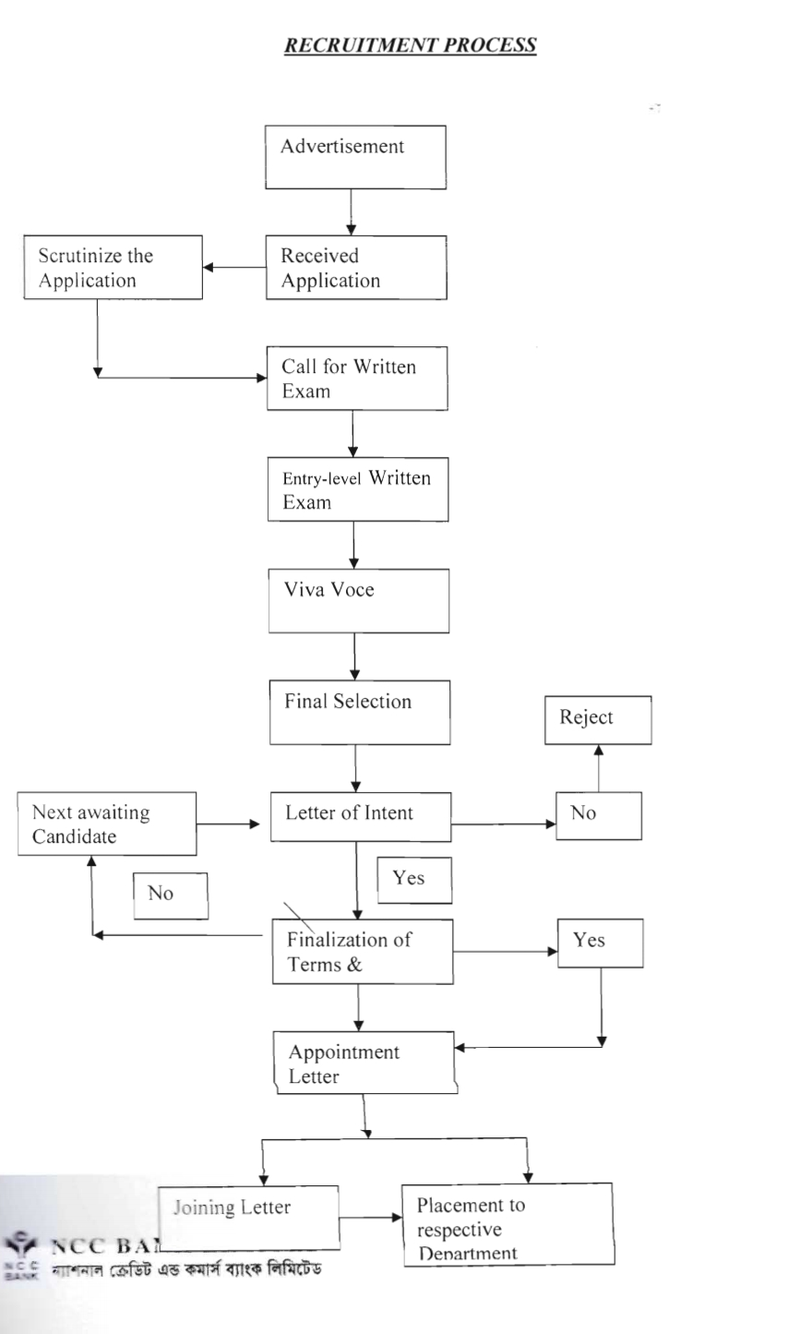
Figure : 4.1 Recruitment Process
Figure: 2 Recruitment Process

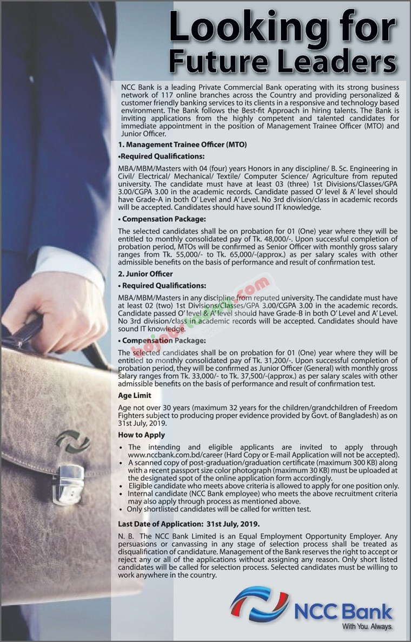
Job Circular

4.5 NCC Bank Recruitment Sources
NCC Bank at first identifies the recruit needed in different departments. A requisition form is given to the HR head, after that HR then advertises the job circular into different job portals or sites. For their job advertisement, NCCBL uses several types of sources. Such as:

Newspaper Advertisement
The announcement of vacancy is spread by the distribution of ads in national newspapers. For publishing ads, the common and renowned newspapers are selected. The commercial to be distributed in national newspapers is appealing. It includes specifics of the role, the purpose of the appointment, venue, key responsibilities, terms and conditions, age limit, the minimum level of education, work experience, qualifications for employment, special requirements. The department involved sends a job listing to HR in a specified format with employee requisition. HR decides the advertisement based on the position's work description and sends an alternative for his or her inputs to the line manager if any advertising confirmation. Before submitting any advertisement to newspapers, the public relations department is responsible for design and illustrations.
Online Job Portal
NCC Bank also goes for the online job portal. As every bank has an agreement with the different job site. NCC Bank also has an agreement with BDjobs.com. Therefore, BDjobs.com, asked for the resources but they do not disclose the actual requirements. NCC Bank mentioned all the detailed information about the job position, education qualification, job responsibility, minimum requirement, age limit, compensation package, work experience, location, age limit, and special requirement.

Career Fairs
A career fair is nowadays has become a very common source for headhunting. NCC bank takes parts into different career fairs that are organized by different popular universities.

Internal recruiting
NCCBL would like to appoint internal applicants who are suitable and skilled for the current or new position and who meet the criteria of the current and future posts.NCC Bank could make the appointments by the promotion, up-gradation, or transfer with the approval of the authority. In internal recruiting, it mostly preferred experienced persons. During the probationary period, nobody is allowed to apply for an appointment. Promoting internal personnel on the concept of succession planning should concern.

External recruiting
For a successful external recruiting effort, it requires proper planning and coordination.NCC Bank does this external recruiting in a very confidential way and technically. It is conducted one to one. Recruiters will typically identify, assess, and recommend the most qualified to the head of the different departments in which the vacancy has taken place. It also prefers the experienced person for external recruiting. NCC Bank tries to get the best employee in their organization.

4.6 Training and Development
Training and Development is an organizational function that focuses on improving the performance of individuals and groups. Training is an instructional method that includes sharpening skills, ideas, improving behavior, and learning more information to increase employee results. Effective & productive workforce preparation helps to develop their expertise & skills, which ultimately enables an organization to progress.

The development has a long-term vision. It is all about employee training for both current and future work, empowering them with learning opportunities to upgrade their skills, and undertaking further challenging and productive activities.

4.7Training Design Process
Training is all that can be organized and planned. For the current staff, training design is designing innovative training and learning programs and lectures. These points out the training differences and fills them with new material for improved performance. It also helps the staff to improve their talents instead of being static in their jobs.
Training Process

Step 1: The first step of the training design process is a need assessment, which is too important to identify whether there is any training need.
Step 2: It is to ensure that employees have the drive and fundamental abilities required to learn the material of the training.

Step 3: A learning environment has to be created which has necessary for learning to happen.

Step 4: It is to assure that trainees adapt the quality of the training to their jobs. This stage includes making the trainee learn how to handle the development of expertise, as well as seeking help from co-workers and supervisors.

Step 5: It is to assure that trainees adapt the quality of the training to their jobs. This stage includes making the trainee learn how to handle the development of expertise, as well as seeking help from co-workers and supervisors.

Step 6: It is to select the form of training depending on the goals of learning and the environment of learning. A conventional training approach of face-to-face engagement with trainers or e-learning using CD ROM or web-based training can be part of the process.

Step 7: It is to review and make changes to the curriculum or revisit some of the earlier stores in the process to strengthen the system to accomplish learning, activity, improvement, and other learning goals.

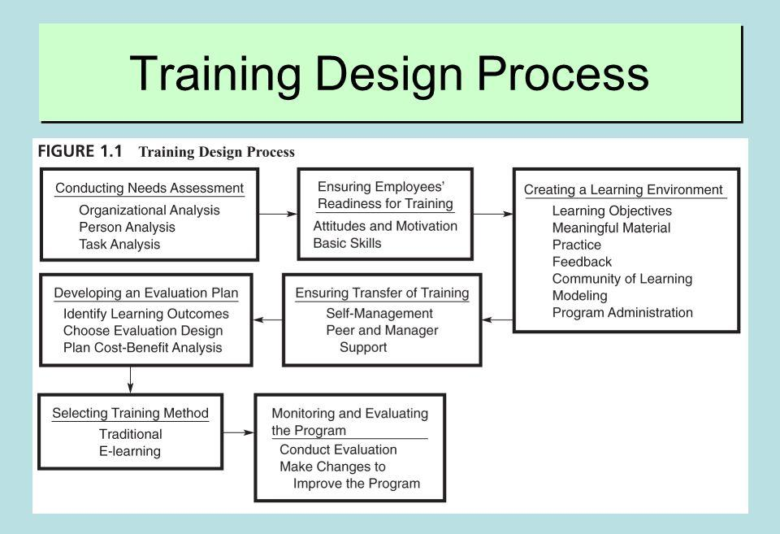

Figure: 3 Training Design Process

4.8 Training Need Assessment
A good training program begins with a representation of the training needs of employees. The term of training is to identify the gap between the anticipated levels of performance with the current performance levels. NCC Bank also conducts the training need assessment. The three ways to identify training needs are:

1. Organizational Analysis: NCC Bank determines out whether training supports the strategic decision of the organization, supports managers, colleagues, training operation personnel, and identifies what training tools are available. It determines the organization's best asset on the basis from which a resource is examined.
2. Person Analysis: Person analysis state the person characteristic. NCC Bank also focuses on the employee’s level of skill. It helps to determine the employee’s readiness for training. It determines whether the output of employees implies the need for training. It is to see their interpersonal relationship in a team, communication, learning capability, and way of attitude. The need for training may result in changes in the job nature, new technology usage, performance problem, cannot adapt to the latest technology changes.

3. Task Analysis: NCC Bank identifies the employee’s competency. It is to measure their work activity, knowledge, skill, ability, responsibility. It is to see whether the employees are performing the given task properly, under which conditions tasks are performed. It is mostly suitable for newly recruited employees.

4.9 NCC Bank Major Training Providers
In Bangladesh, almost every bank has an in-house training center. NCC Bank also has its in-house training and development center called the Credit And Commerce Bank Training Institute). It is in the HR department. There is a training principle for this training center. Also, this training center arranges various training programs for its employees. Besides, that NCC Bank also had some other training providers including, BIBM (Bangladesh Institute of Bank Management), BBTA (Bangladesh Bank Training Academy), and SCB (Standard Chartered Bank), BBTA (Bangladesh Bank Training Academy), SCB (Standard Chartered Bank). NCC Bank also arranged training by the renowned institution for its employees.

4.10Training Institute at NCCBL

NCCBL Training Institute was originally known as the NCL Training & Research Institute (NCLTR).In 1993, NCL appeared in the NCC Bank Limited and was renamed NCC Bank Training & Research Institute following NCL TRI. In 1994, CCBTRI conducted their training at Green Road to train their internal human resources. After the launch of the Head Office Human Resource Division, NCCBTRI stayed with the NCC Bank Training Institute again and began its journey on the fourth floor of the Head Office in January 2002. Due to space constraints, NCCBTI was shifted to NCC Bank Bhaban 13/ 1-2, Toynbee Circular Road from Head Office. NCCBTI is now on the l0th floor of Peoples Insurance Company Ltd Bhaban, 36 Dilkusha C/A Dhaka.

4.11Function of NCCBTI

Training is a continuous process based on requirements. NCC Bank arranged various training program based on the need of the training. NCC Bank conduct a training called “Foundation Training”. It is a compulsory training that every experience employee and newly recruited employee have to do it. Even for banking sector, this foundation training is necessary to do. The foundation training takes 1 month. In this, training employees learn about organization norms, rules, regulations, policy, terms and conditions. This training is arranged in different segment and takes 1 month to complete. Every newly recruited employee and experienced employee has to do this training. As per the employee skill, knowledge based training are provided.NCC Bank apart from this arranged training program like training on credit, foreign trade training etc. Even if Bangladesh Bank introduce any new credit policy, NCC Bank conduct a research of this their training center. They also developed a training model for it and offer a group of employees these training .The NCCBL Training Institute also holds many seminars on relevant issues to improve personnel skills.
The training procedures of NCC Bank are divided into three:
❖ General Banking Training: General banking training it is about the details works in the bank, from opening client account, deposit money, selling different product, to make understand about different scheme, how remittance come, how to deposit and withdraw money about all this details general banking training is given.
❖ Credit Department Training: This credit department deals with loan giving and taking.
It provides training on how a customer can apply for loan, what documents to be submitted, how a loan can be taken, and loan disbursement. The Credit Administration Department is associated with this credit department.
❖ Foreign Trade Training: It is about the export and import financing, financing in RMG sector.

Training Plan 2020

- NCC Bank always tries to develop its training center with the latest technology. In their training center, they will introduce the database. For being informative with the latest changes it will introduce the E-learning session.
- In NCC Bank, every employee’s mobile there is set an app. When they click on that app it will show various options for the new training option, new ideas, information about a new subject, from their training center. All this information is given in that app.
- After completing, any training or any new subject then an employee can do self-evaluation. There is a questionnaire where the employee gives their answer. Then the answer goes to the database.
- Training center will do a SWOT analysis of those collected data.NCC Bank emphasizes mostly on the training because as the world is changing and for this changes the employee have to be part of this training session. So how fast can one adapt himself to the changing situation that is the most important thing to see?
- To adapt to the changes in the training, the training center will arrange further different training models, training design.
- In the bank if a problem arises then it is to identify why that problem occurs, what can be done so that this problem might not arise. As a problem arises, a new training model will be developed for this.
- NCC Bank has a research center when any problem arises they have been asked to identify the problem, identify the losses, how to overcome such problem in future, how to prepare the employees for such problem, taking some measure steps to overcome the problem.
- From regulatory compliance with new banking laws of the Bangladesh Bank guidance circular, the training course will be organized.

Training and Workshop Arranged By NCCBL Training Center

Serial Number | Name of NCCBL Training Courses | Duration
1 | Foundation training for Bankers Course | 1 month 15 days
2 | Credit Management | 6 days
3 | International Trade Finance And Foreign Exchange | 6 days
4 | Human Resource Management And Marketing Services | 5 days
5 | Industrial Finance And Project Appraisal | 3 days
6 | Advanced Credit Management | 5 days
7 | Advanced International Trade Payment And Finance | 5 days
8 | Merchant Banking And Capital Market Services | 3 days
9 | Consumer Banking | 3 days
10 | IT Audit System | 1day
11 | Some Financing Banking | 1 day
 | Workshop Program
12 | Anti Money Laundering Workshop | 1 day
13 | ICT Security And Safety Workshop | 1day
14 | Prevention Of Money Laundering And Combating The Financing Of Terrorism | 2 days
15 | Foreign Remittance Disbursement Workshop | 1 day
16 | Credit Risk Management Workshop | 1 day
17 | Import Analysis And Documentation Workshop | 1 day
18 | Export Analysis And Documentation Workshop | 1 day
19 | International Foreign Trade Policy And Bangladesh Bank Guideline Analysis Workshop | 2 days
20 | Banking Administration Analysis Workshop | 1 day
21 | General Banking Workshop | 1 day
22 | Core Banking Software Analysis Workshop | 1 day
23 | Banking Rules And Regulations Compliance Workshop | 1 day
24 | Liquidity Risk Management | 2 days
25. | Lending Strategies And Loan Portfolio Management in Banks | 2 days
26. | Legal Aspects Of Securities And Documentation | 2 day
27. | Small And Medium Enterprise (SME) Financing | 1 day
28. | Managing Risk In Agro Sector Financing | 1 day
29. | Retail Banking And Consumer Finance | 1 day
30 | Spreadsheet Analysis In Bank Sector | 2 days

Training Techniques Followed By NCC Bank:

Therefore, after analyzing the training needs assessment NCCBTI then arrange a training program for their newly recruited and for their current employees too. There are two ways of training and development programs mostly practiced by every organization.
✓ On the job training
✓ Off the job training

4.14.1 on the job training:

In this stage, the NCC financial institution head workplace has allocated the newly appointed employee to the training method in the actual job situation and improves their productivity.NCC Bank provides training at the workplace during the performance of the actual work. As the employees are learning at the workplace, so this training aims to make the employee familiar with the normal working conditions. As the employee is learning by performing. In NCC Bank, they used to make employees learn something new along with their actual work. The employee in the HR department is also given training of credit department. The supervisor or experienced personnel will demonstrate to the trainee how to execute a specific task. The trainee follows the instructions and performs the task. The experienced employees carry it out. On the job training program apprenticeship, job rotation, and special assignment are included.

- Job Rotation

Job rotation with the different departments of the company is simply a horizontal method of rotating job responsibilities. To acquire expertise, experience, and an over-understanding of the workings of various divisions. NCC Bank conducts job rotation among employees that includes moving employees from one job to another.

- Coaching

Supervisors and senior officers who instruct them about the work often mentor workers at NCC Bank. It not only means that the employees understand the work by training, but it also has access to direct input on pressure points to perform the job.

- Job Enlargement

NCC Bank also goes for job enlargement, which is a horizontal restructuring method there is an increase in the number of task associated with a certain job. It increases the workforce flexibility. Employee along their actual work they are also working on additionally so that they enlarge their job.

4.14.2 off the job training:

The training institution of NCC Bank offers off job training to both newly employed and current workers. NCC Bank brings specialists from various establishments and holds various kinds of seminars and workshops for the employees. In NCC bank Lecture, the method is commonly used. In a lecture wherein employees are given a lecture about the job requirements and the necessary skill required for implementing the job. This lecture method concentrates on understanding instead of emitting information and skills through reading assignments and experience. NCC Bank also offers an orientation course and foundation course for its new employee. NCC Bank Ltd Training Institute uses many other alternatives to this system, such as workshops, seminars, presentations, case studies, structured training, and computer-based training, along with class sessions.

4.15 Evaluation of Training
Training is a continuous phase and it can be assessed at various points during the process. Employees are assessed by comparing their recently learned expertise with those identified in the objectives of the training program. Any difference is noticed and changes are made to the training curriculum to allow it to fulfill the particular objectives. Timely review opposes the divergence of training from its objectives. Training evaluations contribute to the process of obtaining the data required to assess not whether training is successful.
Training assessments can provide both quantitative and qualitative methods of social research. Evaluating the success of on-the-job training includes analyzing the following areas: the outcomes of training in terms of measurable productivity or performance, whether or not those qualified have improved their actions as a result of training, the abilities that trainees have learned from training, and the reaction of trainees to the program.
To evaluate the effectiveness of the training program NCC bank uses the Kirk Patrick Model. Four stages of the Kirk Patrick Models are discussed below.
✓ Reaction
✓ Learning
✓ Behavior
✓ Results
Level 1: Reaction
Reaction results refer to the trainee's interpretation of the program, including the equipment, the trainer, and the content of the training. NCC Bank Ltd typically refers to a questionnaire completed by trainees or may take it as a verbal interview. They then judge on the employee's comments; if workers have less than positive responses about the training, it is unlikely that the other person will be interested in the training, or that the employees undertaking the course will receive some kind benefit from it. Since the team of trainees is inevitably big at NCC Bank, the questionnaire process is typically used to receive input.
Level 2: Learning
Learning results are used to assess the degree to which trainees are aware of the concept, details, strategies, and procedures presented in the training program. It analyses what skills trainers have gained in the program. The NCC Bank decides whether the trainee knows how to make a decision. If workers have experienced little but of course, we should foresee no improvement in their conduct. At times, the administration also arranges success assessments where the trainees perform specific assignments or show the skills that they have gained from the training program.
Level 3: Behavior
Behavior outcomes are used to determine the extent of technical competence or behavior. The NCC Bank commonly measured this by observation. NCC Bank may verify whether workers do something better or handle problems in a particular manner or not. NCC Bank may test their results in job experiences. The trainees will be asked to provide feedback about their actions or abilities. Besides colleagues, supervisors and subordinates can also be a guide to evaluate trainee performance based on their experience.
Level 4: Results
Evaluation of outcomes looks at the cumulative results of the training and the effect of the training on effectiveness, production, consistency, customer care, or some other way. As the last step, management determines if the training curriculum and the expertise or experience learned by the workers in those programs have strengthened the workforce and the company as a whole. his can be measured by assessing the unemployment rate of workers, the efficiency of the staff, the competitiveness of employees, the level of income, customer complaints, the efficiency of employees, and the various departments of the organization.

4.16 Top Management Support in Deterring the Importance of Training

NCC Bank's senior management also plays an important role in considering the significance of training. When any training session is conducted in NCCBTC at that time the MD, CEO being present at the beginning or end of the training program. They show an involvement approach in the training. NCC Bank Top managers are also active in training and development in many ways, including giving feedback into the advancement of the learning curriculum, serving as trainers, attending courses as speakers, or working as advisors. Also, in the training session, they share their experience, different learning technique, and the way of problem-solving, adding new ideas, and always trying to motivate them. Therefore, in every training program, there is a great involvement of the top management. Based on the training topics the top management shares their information with the trainees. They want that the resource pool will be multi-tasking, they become quick learners, motivated and they will learn the best of this training so that they develop themselves and give the best to achieve the goal.

4.17 NCCBL Training Design Program

NCC Bank designs their training design program based on the present requirement. Now a day’s there are many modifications to training programs. Therefore, when the training program is designed it focuses on whom the training is to conduct. They at first identify the level like junior level, mid-level, senior level. Therefore, when the training is provided to the junior level employee then for that a different model is made, it is designed with visualized information, database information, different video. When the training is provided to a mature level for them the information has to be classic information. Therefore, the structure of the training program depends on whom the training is to be offered. It is based on a root level, a senior root level, a middle level, a senior middle level, a senior level, and a management level.

4.18Performance Management

Performance management is the non-stop process of evaluating, standardizing, and flourishing the collective success
of individual staff and teams and connecting overall performance with the organization's overall objectives. In other words, to accomplish the strategic objective of the company, performance management is a continual process of contact between a manager and an employee that exists during the year. Defining objectives, setting targets, assessing goals, providing feedback, and evaluating outcomes are involved in the contact strategy.

Performance Appraisal
Performance appraisal is a formal and systematic system via which is connected with the strengths and weaknesses of the personnel are identified, measured, recorded, and advanced. Performance appraisal is a comprehensive evaluation of job performance and an understanding of a person's abilities for further growth and development.
Performance measurement is such a process by which teams evaluate the results of work performance. When it is done successfully, employees, their superiors, the HR department, and the organization benefit by deciding the individual activity that leads to the company's strategic focus. Overall success value determinations however are affected by the usage of multiple approaches within the organization, which in turn influence the accomplishment of organizations.

4.19 Performance Appraisal in NCC Bank Ltd

To assess the performance of executives, managers, and employees NCC bank conduct a Performance Appraisal program. Regular employees, their performance is evaluated annually. Moreover, NCC bank named this term as "Annual Confidential Report" (ACR). Here the supervisors observe employee's performance and later provide feedback concerning their performance in the range between good or bad. It is a formal process. Banks have done ACR annually. This is a structured performance review process, where supervisors evaluate the performance of each employee using some standard appraisal method.

In NCC Bank, the performance appraisal is done two times a year. They have individual software called “Performance Appraisal Software”. This software is accredited with HRIS (Human Resource Information System).
That is the resource pool it has, for every resource pool, it has an ID. In every ID, regard there is the employee’s designation, job description. This job description is measured. The job description is then numbering, sorting is done based on this the measure is done. Other criteria are done is the soft skill where it identifies if the employee is a quick learner, job orientated, compliance-oriented. It also sees the behavior, knowledge, and attitudes. In this, criteria NCC Bank conducts the performance appraisal.

4.20 Types of Performance to Measure
In NCCBL, performance is assessed based on the result. The resulting approach emphasizes the outcome and activities of the employees. It indicates that success is measured based on the result. This method addresses bottom-line concerns such as to what degree an individual can meet the objective, whether or not they can accomplish their targeted goal, how much benefit the employee has brought into the organization over a year.NCC Bank to measure the performance they mainly focus on every individual employee target. They emphasize performance.

4.21 Measurement Technique of Performance
To measure the performance, NCC bank uses a Graphic rating scale that is the most popular used tool. It has a curve with a bend. Like NCCBL, conduct the output assessment twice. For one of the output dimensions, the rater measures an employee using a range consisting of specifically defined scale points. The ranking criteria are based on behavior, accountability, and a detailed job review.
A rater describes an employee's performance in the graphic rating scale system as falling on the scale at 5 points, such as bad, decent, nice, very good, and outstanding. A score ranging from 5 points for outstanding to one for bad is applied to the scale point. The cumulative score can be determined for an employee by summing the ranking overall metrics rate. As the performance appraisal is done twice, so if it is seen that after six months an employee performance picks to 100% then, that employee performance is emphasized most. For that employee, they are very easily oriented expose many benefits.

4.22 Performance Evaluation
EVP HRD begins the performance evaluation of the employees of the company only at the end of every year. The forms of Employee performance evaluation are submitted to the heads of the agency. Moreover, the areas of development and the associated preparation criteria for next year also listed. The appraisal forms were filled out correctly and then submitted back to the HR department.

The training requirements listed in the appraisal forms are decided by the Principal Officer/AVP HRD to prepare an agreement for the NCC Bank training institute, where the head prepares the preliminary annual schedule. The training plan is carefully review by the head of administration involved and approved by the President / Managing Director.
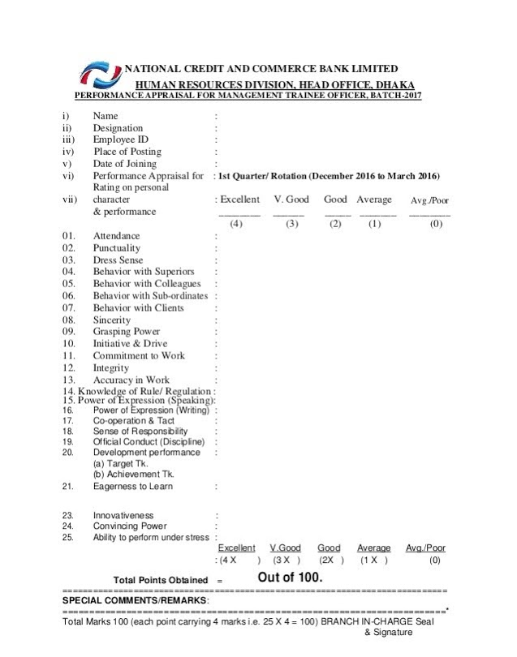
Figure: 4 Performance Appraisal of Management Trainee

4.23 NCCBL Compensation and Benefit

NCC Bank Ltd gives its employees a lucrative pay package. NCC Bank ensures equal and equitable compensation plans focused on market demands and market standards. The NCC Bank compensation plan includes fair pay and comprehensive benefits packages are all structured to impact and encourage professional achievement. The compensation packages are divided into two parts:
1. Direct Compensation
Salaries: NCC Bank Compensation provided a basic monthly salary. Moreover, the amount of salary is mentioned in the appointment letter. Besides, employee's salaries are reviewed on the annual basis according to their performance, and based on their performance the salary can adjust at the discretion of the bank.
Incentives: NCC Bank is focusing on the incentive they offer cash incentives that rely on bank revenues.
2. Indirect Compensation
Benefits: NCC Bank shall provide its employees with indirect financial compensation benefits in nature, such as the Pension Scheme, the Discretionary Fund, the Bonus, etc.
Services: NCC Bank offers additional facilities and services to its employees, including house loans, transportation facilities, personal loans, car loan facilities, etc.
NCC Bank rewards its employee for their performance, it provides a certificate. It has some financial benefits and additional benefits also. For the compensation NCC Bank, every year has an increment for every employee according to performance. As the employee is categorized based on that the increment is given. The outstanding employee is getting the most increment and the employee whose performance is medium that employee is getting some sort of increment. In this way, all the employees are getting more or less increment. The employee who is doing poor performance they are not getting any benefit rather more emphasis is given in training, motivation. The employee who is performing poorly if they are motivated and guided then they will also do a better performance. So the compensation is based on result-oriented performance. By depending on this NCC Bank compensate its employees.

4.24 Service Rule of National Credit and Commerce Bank Limited
Service Rule is one of the basic factors of any organization. The Service Rule of the National Credit and Commerce Bank Limited was introduced in 1998. The regulations of service must be followed to take decisions on various issues relating to personnel, administrative or operational matters. Every employee of the organization shall abide by the rules and regulations of the service rule in respect of any matter such as pay scale, leave, retirement, etc.
On the service rule of NCCBL, the three aspects are given much importance. These are:
- Transfer, Termination, Retirement, and Resignation
- General conditions of service( Pay Scale)
- Leave Rule

4.24.1 Transfer, Termination, Retirement and Resignation

Transfer: According to Bangladesh Bank, the transfer rule is that employees will be transferred upon the completion of 3 years of service in the organization. No employee will be transferred within 3 years. Therefore, in NCCBL the transfer rule is that the employee will be transferred to another Branch/Office after completion of 3 years of service in any branch or department. Probation is there in NCCBL, if the management wants, they may transfer any employee at any time. However, no employee can stay in one branch or office for more than a minimum of 3 years.

Termination: In NCCBL, the probationer or temporary staff member shall be liable for termination by the competent authority without assigning any justification after granting him one month's notice in writing or payment of one month's minimum salary, including dearness allowances (if any instead of such notice,) the probationer/temporary staff member shall not be entitled to any form of termination of service compensation.

Retirement: In NCCBL, every employee shall retire from service. The retirement conditions are that on completion of 60(sixty) years of age. Besides an employee may retire voluntarily after completion of 25 years of banking service including in NCCBL. In NCCBL, the management may also give retirement to any employee if he or she has completed 25 years banking service. In retirement scheme of NCCBL provide benefits like gratuity, provident fund, health service benefit, earned leave benefit. Also, provide designation wise car for the transport purpose. In every month, a portion of installment is given from the salary. Later after 5month, that car becomes permanent to the employee and he / she can take it after his retirement.

Resignation: In NCCBL for the resignation, employee can apply for it any time. However, they are not made immediately release from the job. When a employee give a resignation letter after that an audit is done. In this employee have to collect a release order from the Department which is related to his work and to get a clearance certificate from the previous job place. Normally before one month, an employee has to notify that, he /she wants to resign. If the employee wants to resign by today then the employee has to collect the release order from cost finance department. The employee may, however, pay the Bank an amount equivalent to his one months' substantive pay in lieu of notice period.

4.24.2 General Conditions of Service
Nature of Pay Scale
The term Pay scale means the scale of pay, which is drawn by way of an employee every following month. The pay scale is structured according to the designation. From every designation, the pay structure is divided into 3 parts. Like as the assistant officer has 3 pay structure category, some AO will get 28000, another pay scale is 32000 and another is 36000. From every designation, there is a 3-category pay structure. As the AO gets 28000 in a year, after one year they will get an increment. After getting this increment they will go to the second scale and the salary will be 32000 and after 3-year automatic promotion to be given. For every designation, there is a promotion, for the promotion they have to give the exam. NCCBL revised their pay scale from time to time and the Board of Directors permitted the pay scale.

4.24.3 Employee Benefits and Facility

NCC Bank Limited believes in imparting knowledgeable customer service as well as enough benefits to the employees to their satisfaction. The benefits and facilities provided by the bank to the employee are given below:

Bonus: In addition to basic wages for occasions such as Eid UL Fitr and Eid UL Azha, NCC Bank Limited awards bonuses as Festival bonuses, and employees of different religions get the bonus at their respective religious festivals. NCC Bank additionally offers another festival bonus in Pohela Baishakh. The number is based mainly on the employee's basic wage which includes two bonuses per year. As for basic wages, the benefits are the same. The bank also gives employees incentives consistent with their performance. This bonus is called a performance bonus, which is given to the employee based on their performance. This is as per the rules of Bangladesh Bank. NCC Bank allocates this bonus as per the performance appraisal that has been done. Through the performance appraisal, the outstanding employee will get the most percentage, the excellent employee will get some percentages like this way the employee will get a performance bonus. Therefore, NCC Bank based on performance appraisal will allocate the performance bonus to the employee. Also, the boards of NCC Bank at its decision can grant employee incentive incentives from the net profit received by the bank.

Gratuity: The NCC Bank entitled the employee to a gratuity benefit scheme for their protection after leaving the company, withdrawal. The Board is allowed to change the Laws of Gratuity. Bank has provided it to normal and permanent employees who without withdrawal have completed a minimum period of 5 years of service. For each completed year of service, they are entitled to a one-month minimum payment to be determined on the last pay earned from the bank. Therefore, the workers can get five more basics in all. Employees on lateral entry shall also be entitled to gratuity payments because of the year in which their services are provided to the Bank in the case of normal retirement or cessation of service after a minimum of 5 years.
.

Provident Fund: Provident fund is a voluntary contribution scheme. The advantage of the service that it helps daily workers of the bank to save 10% of their simple salaries per month. When a fresher employee joins the organization until the probation period, he or she will not be entitled to the provident fund. Upon completion of the probation term, a permanent employee would be entitled to the provident fund. The permanent employee will pay 10% o his base wage to the Provident Fund.

4.24.4 Leave Rule

Earned leave –Employees NCC Bank Limited are entitled to receive maximum basic pay leave for each calendar year at a pace of 30 days. The earned leave will be added to the worker's leave account on the first day of each English calendar year. The staff will take one month of total earned leave at a time. If any employee has taken 20 days earned leave then the remaining 10 days balance shall be accumulated to the account and when employees leave the organization, they will get the amount.
Casual leave – Casual leave is a leave of absence granted to an individual who will not be able to attend duty over such a period due to unexpected sickness or urgent private matters for a short time. An employee is allowed to enjoy casual leave in the NCCBL for a limited period of 10 (ten days in a calendar year with a full minimum salary. NCCBL approved a limit of 03 days of casual leave to its employees. If extended further, the entire leave period shall be treated and converted into earned leave, and the officer's accounts shall be debited.
Sick leave – In NCC Bank Limited, sick leave given to an employee for a maximum of 3 days. The employee is eligible for exercising the sick go away benefit from the date of his/her joining. If the employee needs more sick leaves, then the employee has to show a hospital document as proof that he/she was very sick.

Maternity leave– NCC Bank Limited offers six months of maternity leave to all female employees who have completed two years of service in the Bank. This leave shall not be adjusted along with other leaves. Maximum twice may be availed during the employment period of the employee.

Special kinds of leave
Hajj leave – In NCC Bank Limited employees after working for a minimum of 10 years of service in the bank may allow Hajj to leave for 30 days along with pay to perform the Hajj. Also, as the employee is getting the earned leave of 30 days so if any employee wants they can go for two months that is for 60 days. As the employee is already getting the 30 days Hajj leaves besides that they can also take the earned leave 30 days which in total is 60 days leave can take. However, if they want more days then those are adjusted without the pay and casual leave, sick leave.

Study leave – NCC Bank Limited allowed study leave to an employee without pay at the consideration of the management to enable him/her to undertake a study on Banking/Business related subject(s) or training courses, etc. for a maximum period of 2 years provided the concerned employee who has rendered minimum 5 years service of Bank. The management will decide if the employee can go on study leave. It depends on management decisions. The employee availing such leave must agree to serve the bank for a minimum period of 5 years on completion of the same.

Leave | Time Duration
Earned leave | 30 days in a calendar year
Casual leave | 10 days in a year
Sick leave | 3 days
Maternity leave | 6 months
Hajj leave | 30 days
Study leave | Maximum 2 years

Discretionary Benefits
Paid time Off – NCC Bank Limited also offers the paid time off benefit. If the bank thinks that the employee needs foreign training then they get an invitation from the respective organization. It mentioned the employee's names who will be allowed to go for foreign training. For those employees, NCCBL will bear all their costs. From there staying, eating, traveling all there expense will be paid by the Bank. Besides that, those employees will also get an international allowance.

Health Insurance – For every employee, NCC Bank Limited has health insurance. The bank also has a full-time appointed doctor. The employee can take a doctor's appointment and can visit the doctor. When an accident occurs while doing on the job then there is health insurance coverage.

Maternity Benefit – For the maternity benefit, NCC Bank Limited has set a bar. That is for two children the female employee will be given 25000+ 25000 =50000 amount. For the first child after submitting the bill the bank will give 25000 at first and then later remaining 25000 will be given for the two children.

NCCBL Human Resource Development
NCCBL Human Resource Development has focused on the following aspects:
1. NCC Bank conducts Training Need Assessment.
2. It prepares Training Calendar for the Company.
3. NCC Bank, from time to time, revises and conducts New Employee Orientation programs.
4. NCC Bank mostly put priority to organize and conduct In-house training programs.
5. NCC Bank also emphasizes organization tailored made programs; arrange training in the local and foreign institutions.
6. NCC Bank maintains and updates the Training Database.
7. NCC Bank timely prepares reports, training agreement, and record keeping of all training and employee development initiatives.
8. NCC Bank mostly emphasizes to evaluate the effectiveness of orientation/training programs.

4.25 Career Development in NCC Bank Limited

Career development is the associate level and specific skills tool and the opportunity for improvement and career development. In this system, it is a deliberate cycle of managing an organization's HR development through different progressive roles.NCC Bank Ltd gives its employees a career development advantage. NCC Bank Ltd's most important objective is to improve the workforce, proper system of training, and reforming the work. In a supportive environment of consideration and transparency in which people of diverse backgrounds can reach their maximum potential and give their overall performance standard, the NCC financial institution offers each worker integrity and appreciation.
The financial institution’s human resources policy emphasize supplying task delight, increase opportunities, and due popularity of superior overall performance of the worker. NCC Bank Limited for every designation two years later the employee got a promotion. Even if an employee performs better or fulfills the target more than the actual one or has added more value to performance then in that case, the employee may get a promotion within one year also which is called the “Accelerator Program.” It is completely career-oriented.

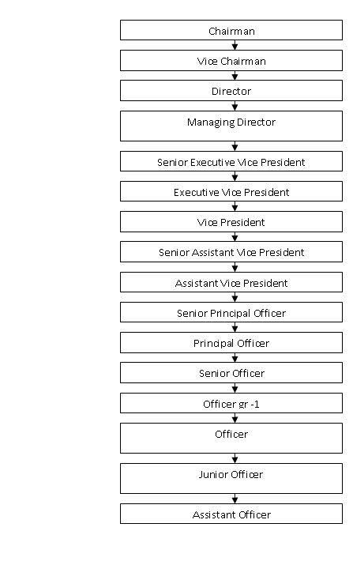
Figure: 5 A Career Development Opportunity in NCC Bank Limited

CHAPTER – 5

SWOT ANALYSIS AND FINDINGS

5.1 SWOT ANALYSIS OF NCC BANK LIMITED
Strength:
- NCC Bank Limited's infrastructure is incredibly sturdy.
- Compared to its other banks, NCC Bank offers reliable service to its clients.

- Experienced bankers and organizational stakeholders have formed management.

- NCC Bank practices a diverse strategy of recruiting and selection. By careful screening procedures, they employ qualified applicants from the industry.
- NCC Bank has launched real Time Online Banking Service as part of Consumer Enhancement Programs, covering all of its branches throughout the country.
- NCC Bank has introduced MICR checks to conform to the Bangladesh Electronic Clearing House introduction (BACH). They also implemented switching tools to build the ATM interface to have their own ATM network.
- NCC Bank's mid-level resource is coming up with the career, planning, and training session part is excellent.
- In NCC Bank employee does not tend to switch the job as it benefits the employees. It is a performance-based bank. The employee career path is excellent.
- The software used here is HR software, banking software, marketing software all this software is internationally up to the mark.
- They have recently launched an online banking service that will allow all of their transactions to automate.
- NCC Bank strongly emphasizes workforce preparation and growth, which aims at enhancing the professional development of employees and accelerate corporate efficiency.
- Goodwill has also been accomplished by NCC Bank, as it is one of the top banks that manage to attract valuable customers.

Weaknesses:
- There are just a few ATM booths of the NCC bank and not in the best areas. Therefore, the scope of ATM card usage is limited.
- A very limited quarter of the organization takes into account the vast number of employees in the NCC Bank HR division.
- Software and Internet services are not accessible to all authorities. In comparison, some may not have sufficient knowledge of computers.
- The bank does not have any department for research and development.

Opportunities:
- The foreign revenue is high in NCC Bank as most foreigners do the transaction through the NCC Bank.
- As this is a full compliance bank, so there is an opportunity to being a great banking leader in the future.
- In NCC Bank, there is an establishment of a proper Human Resource Information System (HRIS).
- As this bank has a performance-based career path so an employee from entry-level can reach the top level even if it performs better than they hold the position of MD also.
- The bank can provide its clients with more creative and modern services.
- NCC bank can also introduce Micro credit business for individuals and small businesses.
- By retaining a new market, NCC Bank can diversify its portfolio.
- To provide banking services in remote areas. NCC bank can open several new branches.
- NCC Bank should hire more efficient and skilled employees to provide quick and proficient service to its customers.

Threats:
- Now in today’s time, the banking sector has mostly become online-based, so there is a scope of international fraud. Therefore, these become a severe threat. Every time the bank has to update its patch, to keep backup every time, to antivirus the software, regularly to develop the Anti Hacking System so that the bank is not internationally hacked.

- The banking sector in Bangladesh is extremely competitive because there are so many private banks, foreign multinational banks. NCC Bank also needs to analyze its HR strategy and guidance annually so that they can hire a satisfactory and prospective applicant.

- Both multinationals and fast-growing local banks with new products and services have captured vast markets within a brief time and have moved between existing banking customers.

- Often Bangladesh Bank orders private commercial banks to comply with rules and regulations, which are sometimes not suitable for any commercial bank.

5.2 Findings

- NCC Bank has a structured and much-systematized HR department.

- They offer attractive compensation benefits and other facilities to their employees.

- In NCC bank, employees and management level shares an outstanding and excellent relation.

- After finishing ten to fifteen years in the bank, they provide each employee with their service benefit.

- They provide staff with attractive festival promotions, incentives, and other services within a year.

- NCC Bank offers an initial training program that is mandatory for each employee.

- IT management deals with IT policy documentation, internal IT audit, training, and insurance program.

- IT operation management relates to the dynamics of technology operations management, including change management, asset management, and management of operating environment procedures. The goal is to reach the highest standards of quality of technology service by diminishing operational uncertainty.

CHAPTER – 6

RECOMMENDATION AND CONCLUSION

6.1 Recommendation

NCC Bank Ltd, however, is a very well established financial institution in Bangladesh and operates effectively in the domestic sector. Although the NCC bank HRM practice is quite suitable, they do not maintain standardized human resource policies. I would suggest that the bank should upgrade some of its policy procedures in the areas of general banking, recruitment, training and development program.
So here, I have made some recommendations regarding the HRM practices, which might help NCC bank HR division to leverage its human resource for the sustainability of the bank.
- The bank should arrange adequate training and development measures to achieve productive and efficient employees.
- NCC bank should implement an effective Human Resource Information System (HRIS), from which it is easy to seek out all the details of any workers.
- NCC bank should arrange proper training orientation for newly recruited employees.
- The bank should follow proper HRM guidelines to encourage employees.
- The outspokenness and sincerity of all employees to the manager should practice more.
- Periodical overall performance appraisal needs to finish and giving recognition and rewards to the qualified personnel to keep motivating them.
- They ought to concentrate on proper strategic planning that helps to sort out the employee's forecasting demand and aim to avoid employee shortages or overstaffing.
- NCC bank must open up about recruiting effort through external sources like a job fair. Besides, they should also look into the virtual recruitment process.
- NCC Bank uses Flora banking software, as this is not advanced software for banking. Therefore, they need comprehensive and specialized banking tools.
- NCC bank should include a 360-degree performance appraisal method for its employee's performance evaluation process. It can benefit the branch manager, supervisor, and subordinate to evaluate each other's overall performance. Moreover, this is very vital for the development of the HR Division.

6.2 Conclusion

NCC Bank Limited is thriving to be the initiator of 4th generation banking. Throughout the report, I have analyzed all the essential information about the Human Resource department of NCCBL from different points of view.
The department of human resources plays a vital role in the organization's overall efficiency. NCC Bank Limited their Human Resource Department is doing well in recruiting, selection, providing outstanding training opportunities that help to develop employee's personal growth as well as improving their performance, it also provides attractive compensation benefits, conduct a great performance appraisal. NCC Bank also motivates its employees to work up to their full potential and keep the bank standards elevated in terms of banking service and delivering prominent customer service. After completion of the report, I have made some suggestions like Performance Appraisal Method of NCCBL maybe 360 Degree, through which both supervisor and subordinate can compare different performance, which is need for the betterment of HR Division. Training Institute should proper evaluate. NCC bank should set up a proper HRIS, which allows them to know the details about any employees. For sustainability, the right skills or competencies should enhance. A proper annual training schedule should draw up. Human Resource Management is an important department for any organization. Therefore, NCC bank should give much emphasis to the development of the organization and simultaneously for the betterment of employees.

CHAPTER – 7

QUESTIONNAIRE

7.1 Interview Questionnaire

- What is the recruitment and selection procedure for entry-level position in NCCBL?
- What are the qualifications required for the position of management trainee?
- What are the guiding principles for the employee when recruited and selected?
- What are the recruitment sources of NCCBL?
- How NCCBL did their training need assessment?
- How NCCBL design their training process?
- Who are the major training providers in NCCBL?
- Say something about the training institute at NCCBL?
- What is the function of NCCBTI?
- What is the training plan for 2020?
- What are the training materials used in NCCBL?
- What are the trainings and workshop arranged by NCCBL for their employees?
- What are the training techniques followed by NCCBL?
- How NCCBL evaluate the training?
- How the top management support in determining the importance of training and learning?
- What is the performance management in NCCBL?
- What is the type to measure performance in NCCBL?
- What is the measurement technique of performance appraisal follow?
- How NCCBL evaluate the performance?
- What is the compensation policy of NCCBL?
- What is the service rule of NCCBL?
- Discuss about the transfer, resignation, termination policy of NCCBL?
- What are the employee benefit and facility are given in NCCBL?
- What leave benefit is given to employee in NCCBL?
- .What is the special leave of NCCBL.
- What are the discretionary benefits given in NCCBL?
- What is the possible career path in NCCBL?
- What about the SWOT analysis of NCCBL?

CHAPTER – 8

REFERENCE

8.1 Reference

Bibliography

Aguinis, H. (2018- 2019). Performance Management. Boston: Pearson Education.
Aguinis, H. (2018- 2019). Performance Mangement (3rd ed.). Boston: Pearson Education.
Aguinis, H. (208-209). Performance Mangement (3rd ed.). Boston: Pearson Education.
Annual Report 2018. (n.d.). Retrieved from NCC Bank Limited Website: https://www.nccbank.com.bd/files/annual_report_2018.pdf
Chand, s. (n.d.). Recruitment: Meaning, Definition, Process and Factors influencing Recruitment. Retrieved from Your Article Libarary website: https://www.yourarticlelibrary.com/recruitment/recruitment-meaning-definition-process-and-factors-influencing-recruitment/25950
Compensation and Benefits. (n.d.). Retrieved from HRM HanbBook Website: https://hrmhandbook.com/hrp/compben/
Harness, J. (2019, june 09). Definition Of Recruitment And Selection. Retrieved from bizfluent website: https://bizfluent.com/info-8212981-recruitment-process-hr.html
HRM - Compensation Management. (n.d.). Retrieved from Tutorials point: https://www.tutorialspoint.com/human_resource_management/human_resource_management_compensation.htm
Human Resource Management. (n.d.). Retrieved from whatishumanresource.com website: http://www.whatishumanresource.com/human-resource-management
Human Resource Mnagement. (n.d.). Retrieved from Wikipedia website: https://en.wikipedia.org/wiki/Human_resource_management
Juneja, P. (n.d.). Performance Management as a HR Management Concept. (M. S. Team, Editor) Retrieved from Management Study Guide Website: https://www.managementstudyguide.com/hr-performance-management.htm
National Credit and Commerce Bank Limited. (n.d.). Retrieved from Banglapedia Website: http://en.banglapedia.org/index.php?title=National_Credit_and_Commerce_Bank_Limited
NCC Bank. (n.d.). Retrieved from Wikipedia website: https://en.wikipedia.org/wiki/NCC_Bank
NCC Bank Limited. (n.d.). Retrieved from NCC Bank Limiyed Website: https://www.nccbank.com.bd/
NCC Bank Limited About Us. (n.d.). Retrieved from NCC Bank Limited Website: https://www.nccbank.com.bd/index.php/nccbprofile
NCC Bank. (n.d.). NCC Bank. Retrieved from https://www.nccbank.com.bd/: https://www.nccbank.com.bd/
Noe, R. A. (2017-2018). Employee Training And Development (6th ed.). McGraw-Hill.
Training And Development. (n.d.). Retrieved from Wikipedia website: https://en.wikipedia.org/wiki/Training_and_development
Travor C.Brown, P. O. (2018, September). Performance Management: A Scoping Review of the Literature and an Agenda for Future Research. Human Resource Development Review .

