Internship Report
On
Financial Performances of Le Méridien Hotel: A Comparative Study with other Five Star Hotels in Bangladesh


Prepared For
Muhammad Enamul Haque Assistant Professor, Finance
School of Business & Economics
United International University

Prepared By
Areli Das Chowa
ID: 111141381
BBA Program Major: Finance
ID# 111 141 381

Date of submission: 14th July, 2018

Letter of Transmittal
Muhammad Enamul Haque
Assistant professor
School of business and economics
United International University

Subject: Submission of internship report.

Dear Sir,

I have completed internship program. The report has been complied as per your requirements. It gives me immense pleasure to tell you that working on this report with you has given me a wide range of experience.
The report is based on a research on Financial Performance Analysis of Le Méridien Dhaka as well as the knowledge, experiences and the skills that I have acquired during my period of internship in that organization.

I am thus submitting this report with the hope that lives up to your satisfaction. However, I will be glad if you enlighten me with yours thoughts and views regarding he report. In addition, if you want to enquiry about any aspect of the report, I would be glad to answer your queries.

Sincerely,
Areli Das Chowa
ID- 111 141 381

Acknowledgement

First of all, I want to thank Almighty for giving me the strength, skill, patience and opportunity required to successfully complete my internship.
After that, I would like to thank my internship Supervisor Muhammad Enamul Haque for his continuous guidance and assistance in preparing the report about Financial Performances of Le Méridien Hotel: A Comparative Study with other Five Star Hotels in Bangladesh. His valuable advice has helped me a lot in writing this report. I am immensely thankful to him for the supports he has provided during my Internship period.
I would like to thank my intern supervisor Mehedi Hasan for giving me the opportunity to work with him during my internship period. His constant guidance and support has help me shape my internship in a perfect way. I have tried my best to implement his suggestions on making this report.
I would also like to take the opportunity to thank some of the employees I have work with during my internship period. My sincere gratitude to goes to the director of finance and the whole team of finance for giving me time from their busy schedule.
Finally, I want to thank everyone involved in my internship providing their time, advice, suggestions and support in each stage of my internship.

Executive summary

This paper is made for the accomplishment of internship program as required by the business School of United International University. The report is consisted of three major parts- company overview, Internship outcome and research work.

The name of the company on which the report has been prepared, is Le Méridien Dhaka. It is luxurious five star hotel which officially started its journey in November, 2015. Le Méridien is one of the leading international brands operating in many countries all over the world. Le Méridien is a joint venture with Marriot International and Best Holdings Ltd. in Bangladesh.

Internship in such organization helped work in international atmosphere. This is the time when students gather practical experience and confront reality in workplace. During this period students learn get the opportunities to develop their communication skill and most importantly to become professional. Some learnings during my internship at Le Méridien Dhaka have been shared in the report.

The main part of the report contains the descriptive analysis of financial variables of Le Méridien Dhaka along with the comparison with three other five star hotels completing in the same market. Secondary data has been used in the purpose of making this report.

Contents
Executive summary 3
Chapter 1: Introduction 5
1.1 Introduction 6
1.2 Objective of the Study 6
1.3Scope of the Study 6
1.5 Secondary Source 7
1.6 Limitations of the Study 7
Chapter 2: Company Overview 8
2.1Company profile 9
2.2 Owner’s overview 9
2.3 Service Offerings 9
2.4 Foods and Beverage Venues: 12
2.5 Different Style Cuisine 13
2.6 Official Organogram 14
2.7 Business Departments 14
2.8 Finance Department Overview 15
Chapter 3: Internship Outcome 16
3.1 Position in the organization 17
3.2 Assigned job Responsibilities 17
3.3 Competencies and skills acquired on the job 17
Chapter 4: Performance Analysis: Quantitative Part 18
4.1 Introduction 19
4.2 Results and Discussion 19
4.3 Liquidity Ratios 19
4.4 Activity or Efficiency Ratios 21
4.5 Debt Ratios: 25
4.6 Profitability Ratios 27
Chapter 5: Findings and Conclusion 30
5.1 Findings 31
5.2 Recommendation 31
5.3 Conclusion 32
Bibliography: 33

Chapter 1: Introduction

1.1 Introduction
This report is based on the financial performances of hotel Le Méridien. This report will cover the financial performances of Le Méridien in comparison with three other banks. The purposes of this report are to analyze the performance and growth of the hotels in hotel business in Bangladesh. Financial analysis is one of the most important process proceeding financial planning and budgeting. In order to gain the better understandings of hotel’s performances, it is necessary to perform the business assessment and comparison.

1.2 Objective of the Study
The primary objective of this report is to analyze the financial performances of hotel Le Méridien. The other specific objective can be categorized as follows:
- To achieve the information regarding the hotel environment and its financial performance related information.
- To find out the performance of the leading hotels in the same business.
- To know the market position of hotel Le Méridien.
- To estimate the future position of this hotel in the hotel industry.

  - Scope of the Study
The field of my study is the operation of Le Méridien in Dhaka. For conducting this study an overall knowledge of the financial ratios is necessary. The scope of the organizational part covers the organizational background, objective, function, departmentalization and product and services of hotel Le Méridien as a whole. The main part covers financial analysis and comparison with other three five star hotels

1.4 Methodology of the Study
Methodology is a system of methods used in a particular area of study. For analyzing in a particular area of study, there are two source of information.
1. Primary source
2. Secondary source
As there is no convenient and available primary source for making for making this report, I have use secondary sources of information for preparing this. This report is basically prepared on the basis of secondary sources of information. They are as follows:-

1.5 Secondary Source
- Annual Report of Le Méridien
- File Balance Sheet and Various Documents.
- Different textbooks and materials.
- Website of Le Méridien
- Investopedia & Wikipedia about different Categorized ratios

1.6 Limitations of the Study

This report has been conducted from the intention to make this realistic and properly accepted. Though I have given utmost effort to prepare the report but there are some limitations. All the given information was not fully complete and some information was secret. However the limitations are:
- Lack of in depth knowledge and analytical ability for writing such report.
- International hotel policy of not disclosing some data and information for obvious reason.
- In case of secondary data collection, there were very few secondary information was available.
- As the duration was three months for my internship so I didn’t get enough time to know about all departments.
.

Chapter 2: Company Overview

2.1 Company profile
The brand Le Méridien Dhaka was first introduced by Air France in eighties with the vision to be in the top position by providing the most amazing service in the hotel industry. Later it was acquired by the Starwood Hotels and Resorts and became one of the prestigious brands of that time. The company has been very tactical in extending their business which earned it a sophisticated brand image world-wide. The success of the hotel caused many other hotels all over the world. Le Méridien started its business in Bangladesh in November, 2015.

2.2 Owner’s overview
Best Holdings Ltd. is a part of metro group founded by Mr. Amin Ahmed in 1973. The group has interest in civil construction work, real estate developments, manufacturing pharmaceutical products, trading consumer’s goods sector. Best holding signed a 35 year long contact with Starwood hotels and the development cost is around USD 65.50 million. With the land cost the total cost is around 140 million US dollars. Best Holdings is capable of coping with any financial adversity or uncertainty comes its way.

2.3 Service Offerings
Le Méridien Dhaka offers service with the largest number of rooms which 304, in the country. It also has 7 different restaurants serving 4 different cuisine including infinity rooftop. Furnished with a fitness center and a spa, SPG members enjoy excellent offers during their visit in here. It also own 7 meeting rooms where there’s all the desired facilities to make anyone’s event memorable.

The following table shows the rooms and meeting halls Le Méridien owns:

Room Category | No of Rooms | Room size  (SQM)
Deluxe Room | 220 | 29-45
Club Rooms | 52 | 29-45
Club Premium | 21 | 50-69
Junior Suites | 11 | 54-70
Executive Suites | 11 | 70-84
Le Méridien Suites | 2 | 120
Presidential Suite | 1 | 396

FUNCTION ROOMS | AREA (SQM) | ROUND | THEATRE | U-SHAPE | CLASSROOM
Grand ballroom | 515 | 300 | 550 | 250 | 500
Pre-function Area Grand ballroom | 225 | N/A | N/A | N/A | N/A
Sky ballroom  (North + South) | 423 | 220 | 440 | N/A | 400
North Sky | 178 | 100 | 200 | N/A | N/A
South sky | 245 | 120 | 240 | N/A | 200
Pre-function area  Sky Ballroom | 405 | N/A | N/A | N/A | N/A
Panowa | 76 | 60 | 120 | N/A | 100
Jaflong | 72 | 60 | 120 | N/A | 100
Rangamati | 76 | 60 | 120 | N/A | 100
Kuakata | 85 | 70 | 140 | N/A | 120
Somapura | 100 | 80 | 160 | N/A | 120
Bhulua | 65 | 50 | 100 | N/A | 80
Sundarban | 70 | 60 | 120 | N/A | 100
Pre-function area  Meeting Rooms | 218 | N/A | N/A | N/A | N/A

2.4 Foods and Beverage Venues:
Favola: Favola is the Italian restaurant at Le Méridien Dhaka. It offers authentic Italian dishes to meet up customers desires. Two Italian chefs along with other chefs make the perfect Italian foods.
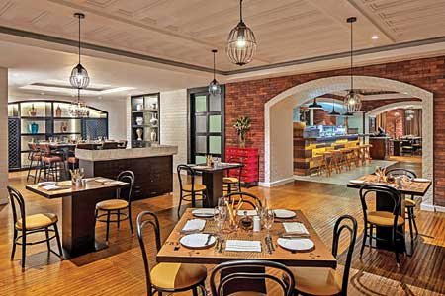
The ingredients used vary in different regions.
Olea: Olea is the Arabic restaurant that serves Arabian foods. It has a very eye-catching interior designing. This restaurant gets very crowd during holy month Ramadan.
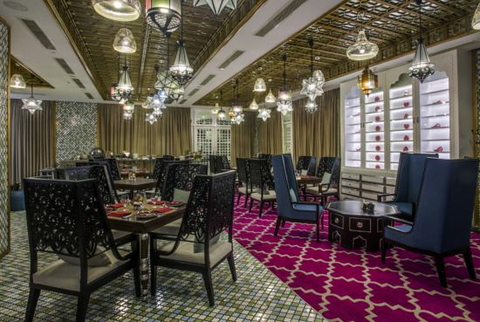
15 Above: 15 above is mainly the Bar where alcoholic and non-alcoholic drinks are served along with live music. There is usually small snacks menu. This Bar is situated on 15th floor.
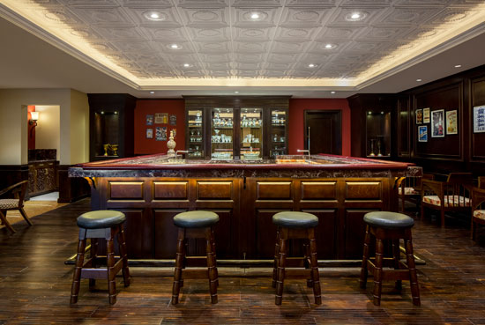
Latest Recipe: Latest Recipe is the most popular restaurant of LM Dhaka. International mainly British cuisine is served here.
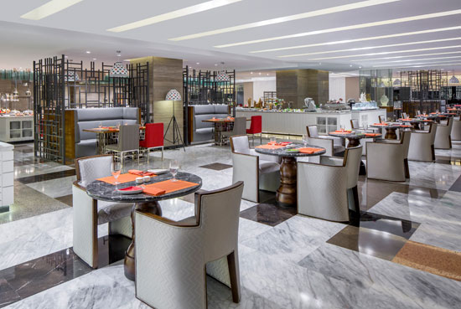
People can have buffet breakfast and dinner at this restaurant. This place offers a great opportunity to hang out with friends and family while enjoying its delicious dishes.
Latitude 23: Latitude 23 is a signature Le Méridien restaurant which is situated in the lobby area. It offers snacks and fresh coffee. People visiting the hotel can have a great time in the lobby with a Latitude 23 drink.
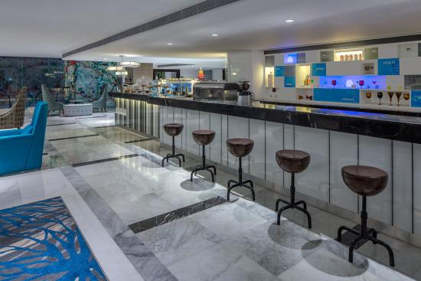

2.5 Different Style Cuisine
A modern interpretation of traditional hotel lobby, Le Méridien Dhaka hub offers an array opportunities for the guests to gather, connect and enjoy.

Infused with local flavor, eye-openers offer a destination focused discovery in each sip. Local flavor with a creative twist elevates the classic morning meal.
A sophisticated array of spirited liberations, it’s the classic European aperitif with a modern twist. 

2.6 Official Organogram

2.7 Business Departments
Le Méridien runs its business under following departments:
- Finance
- Sales and Marketing
- Front Office
- Security
- Food and Beverage
- Housekeeping
- IT
- Engineering
- Revenue

2.8 Finance Department Overview
The finance department of Le Méridien is interlinked with the accounts department. Finance department is mainly responsible for collecting, keeping and reviewing fiscal records and process the documents which involves fiscal transaction to the company. All financial records and journals entries of Le Méridien are prepared by this department. This department also ensures the maintenance of accounts of the company. Director of Finance leads the Finance department. The yearly budget is prepared by this department with the help of other departments. In case of financial complications Finance department takes care of it to find solutions. All the restaurant bills made by the associates on official purpose are also approved by director of finance. There’s a meeting that holds every week where associates presents the current reports and discussion takes place if there’s any issue. Director of finance reports to the general manager of the hotel.

Chapter 3: Internship Outcome

During my internship period from March 2018 to June 2018, I have basically worked with the finance and sales and marketing department. I was assigned to my supervisor who directed me throughout my internship period. My main job was to collect the information and assist other employees to prepare the records.

3.1 Position in the organization
My position in the organization was trainee. The main task of a trainee is to assist the other employees of the department.

3.2 Assigned job Responsibilities
Although a significant amount of learning happened just observing the senior employees work, I however had a number job responsibilities which I had to perform during the period:
- Updating database on daily basis
- Matching soft copy data with the hard copy to check errors.
- Make financial performance report for general manager.
- Create daily, weekly and monthly sales call report.
- Do bookings on ISAC
- Check availability of the rooms and banquet halls on requirements.
- Send EDMs for offers
- Attend walk-in guest and give the site visit
- Attend all the queries on phone and email.
- Create meeting schedule

3.3 Competencies and skills acquired on the job
- Professionalism: One of the most important skills I gain through the experience is professionalism. It made no sense to me waiting for the office hour to end but I eventually learned that any important task can come at the end period.
- Working under pressure: Working under pressure is something I have learned in this journey. I was assigned to four/five task at the same time and there was deadline for each task. I had work after office hour. I remember making mistake and correcting the whole thing again.
- Communication Skill: I have developed my communication skill. I had to deal with local and international guests visiting Le Méridien Dhaka. I am more comfortable communicating with people than I was before my internship. I also think I can study people now
- Confidence and patience: I am more confident and patient than before. The sense of accomplishment after completing a job with success made me feel confident. Being an introvert person, I still managed to be open to people.

Chapter 4: Performance Analysis: Quantitative Part

4.1 Introduction
In the market of economy, corporate finance is one of the key resources that are limited. The fact that resources are limited influences the limitation of financial operations since there is no department that has no contact with financial department. One of the most common and most used methods of financial analysis is the financial statements analysis and ratio analysis. By brining certain items from financial statements in mutual connection, via simple mathematical formula, it is possible to determine an overall performance of the company, measured through finance. The decision of whether a company should invest into franchising arrangement with large international connection is a big dilemma for the investors in hotel business. Justification of this investment may be subject to the financial analysis. This research paper demonstrates the financial results of four city hotels that are parts of international corporate hotel chain. Moreover, this market is noticeably growing with new internationals hotels operating under franchise management.
This paper is the result of the comparative analysis of financial performances of the four wee-known hotels in Dhaka city which are- Le Meriden Dhaka, The Westin, Pan Pacific Sonargaon, and Radisson. All of them operate using the brand of internationally renowned hotel chains.

4.2 Results and Discussion
Financial analysis were performed based on the information year 2016. According to the current regulations of organizations all the hotels are five star rated. 199 SITCON 2018 - COMPETITIVENESS FACTORS OF TOURISM ENTERPRISES hotels, which served as a starting point for making the comparative analysis.
Financial ratios: Financial analysis is can be done through analyzing the financial statements or by financial ratios. The data or information are collected through simple mathematical formula. In this paper we go through following ratios to compare the financial performances among the selected hotels:
- Liquidity ratio
- Activity ratio
- Debt ratio
- Profitability ratio

4.3 Liquidity Ratios
Liquidity ratios are often called as the indicator of firm’s short-term solvency due to the fact that they are calculated by using working capital and short-term liabilities. Thus, short- term creditors are those who are mostly interested here.
Following liquidity ratios are explained below to have a better understanding of the comparison:
Current ratio:
Ratio | Le Méridien Dhaka | The Westin | Pan Pacific Sonargaon | Radisson
Current Ratio | 24.90 | 0.30 | 4.16 | 3.12

Current ratio measures company’s ability to pay its long-term and short-term obligations. Based on the above given data, we can see Le Méridien is more capable of paying its obligations in comparison with other three hotels. Hotel The Westin lacks in here, it has very minimum amount of resources to meet its liabilities.
Net working capital:
Ratio | Le Méridien Dhaka | The Westin | Pan Pacific | Radisson
Net working Capital | 712.143 | -817.327 | 100.118 | 451.045

Net working capital refers to the net amount of all the elements of working capitals of the firm. It is used to determine if company’s current assets are enough to cover current liabilities. The table shows, Le Méridien has greater amount of current assets. On the other hand, The Westin is seen having big issue with its NWC.
Quick ratio:
Ratio | Le Méridien Dhaka | The Westin | Pan Pacific | Radisson
Quick Ratio | 3.33 | 0.26 | 3.72 | 2.99

Quick ratio measures the dollar amount of liquid asset available for each dollar liabilities. As we know, quick ratio should be higher than 1 which indicates the company has enough quick fund in hand to meet its current obligations. All the three hotels have quite a good quick ratio except The Westin.
Based on the above-given tables, quite different results could be observed. The most liquid hotel is hotel Le Méridien Dhaka, while hotel The Westin demonstrated some serious liquidity problems as well as the result of net working capital. It should improve its NWC as it represents the indicators that commercial bank often use in the decision making process of loan approvals

4.4 Activity or Efficiency Ratios
Activity ratios gives us the opportunity to have an insight into how some activities were conducted in previous periods. For instance, collection of accounts receivables, the success of managing inventory etc. In this way, we can have an overview of company’s financial performances.
Accounts receivable turnovers:
Ratio | Le Méridien Dhaka | The Westin | Pan Pacific Sonargaon | Radisson
Accounts Receivable Turnover | 21.14 | 13.13 | 4.21 | 24.5

Accounts receivable turnover is an activity ratio measuring how effectively a firm uses its assets. It measures firm’s effectiveness in extending credits and collecting debts on credit. In the table, it is clear that Radisson has highest number of accounts receivable turnover which means 24.5 times a year it collects accounts receivables. It also indicates that Radisson is more efficient to issue credit to its customers comparatively.
Days in sales receivables:
Ratio | Le Méridien Dhaka | The Westin | Pan Pacific Sonargaon | Radisson
Days in Sales Receivables | 17.56 | 27.77 | 84.56 | 15.01

By dividing the outstanding receivables by average daily sales value, estimation of days in sales receivables can be done. It should be range from 30-60 days. Any upward trend means that an increasing amount of cash is needed to finance the business. Pan Pacific Sonargaon shows greater days in sales receivables.
Inventory turnover ratio:
Ratio | Le Méridien Dhaka | The Westin | Pan Pacific Sonargaon | Radisson
Inventory Turnover Ratio | 41.77 | 7.41 | 41.06 | 78.78

Inventory turnover ratio is an efficiency ratio that indicates how effectively inventory is managed comparing the cost of goods sold with average inventory. According to the data in the table, Radisson has higher inventory turnover ratio which is a good sign for the hotel. It shows hotels efficiency to convert inventories into cash.
Day’s sales in inventory:
Ratio | Le Méridien Dhaka | The Westin | Pan Pacific Sonargaon | Radisson
Days’ Sales in Inventory | 8.75 | 49.25 | 8.87 | 4.63

This ratio is a measure of firm’s financial performances which indicates how long it takes to turn its inventory into sales. A lower DSI is preferred generally. Radisson has a better DSI according to the theory.
Cash Conversion Cycle:
Ratio | Le Méridien Dhaka | The Westin | Pan Pacific Sonargaon | Radisson
Cash Conversion Cycle | 26.03 | 91.56 | 95.52 | 19.65

The ratio measures the number of days for which cash is tied up in inventories and accounts receivable. It aims at assessing how well a company is managing their working capital. The shorter the circle the more liquid the company’s working capital position. In the table above, Pan Pacific has the highest CCC and Radisson has shortest CCC.
Total asset turnover:
Ratio | Le Méridien Dhaka | The Westin | Pan Pacific Sonargaon | Radisson
Total Asset turnover | 6.44 | 3.06 | 21.78 | 0.46

The asset turnover ratio is an efficiency ratio that measures a company's ability to generate sales from it asset by comparing net sales with average total asset, so higher turnover ratio is always preferable. After analyzing the table, we found that Pan pacific has the highest total asset turnover. It means that this hotel is using its assets more effectively than the others. Radisson is most likely to have management or production problems.
Ratio | Le Méridien Dhaka | The Westin | Pan Pacific Sonargaon | Radisson
Accounts Payable turnover | 5.07 | 0.67 | 3.34 | 3.31

Accounts payable turnover: It is calculated by taking the total purchases made from suppliers or cost of sales and dividing it by average accounts payable during the same period. Generally, the higher amount is preferable than lower. A higher ratio shows that the company pays its bills more frequently. Le Méridien stands it the front row when measuring the accounts payable ratio.
Turnover in day:
Ratio | Le Méridien Dhaka | The Westin | Pan Pacific Sonargaon | Radisson
Turnover in Day | 71.34 | 267.55 | 106.56 | 108.56

This ratio again measures how efficiently a firms uses its assets
4.5 Debt Ratios:
The ratio suggests how the companies finance their debts. Few debt ratios are calculated to have a better assessment of financial position of the company.

Ratio | Le Méridien Dhaka | The Westin | Pan Pacific Sonargaon | Radisson
Debt Ratio | 0.97 | 0.99 | 0.37 | 0.51

Debt ratio measure the extent of company’s leverage. To provide a financial structure of the company, this ratios very important. The lower the ratio, the better it is for the company. We could conclude that Pan Pacific Hotel has better performance here by analyzing the table. Debt-equity ratio:
Ratio | Le Méridien Dhaka | The Westin | Pan Pacific Sonargaon | Radisson
Debt-Equity ratio | 24.44 | 26.08 | 0.26 | 0.83

This ratio is calculated by dividing it total liabilities by its shareholders equity. It is used to measure company’s financial leverage. A less than 1 ratio indicates that the portion of assets provided by the shareholder is greater than the portion of asset provided by the creditors and a greater than 1 ratio indicates that the portion of assets provided by creditors is greater than the portion of assets provides by the stockholders.
Interest coverage ratio:
Ratio | Le Méridien Dhaka | The Westin | Pan Pacific Sonargaon | Radisson
Interest coverage ratio | 39.14 | -1.02 | 67.41 | 4.53

Interest coverage ratio determines how easily a company can pay their interest expenses on outstanding debt. Ratio analysis depends on how much risk the company will take. If the ratio is less than 1 then the company is not making enough money to pay its debt. Here hotel The Westin falls into that category. On the other hand, other three hotels ratio is more than 1 means they have enough capabilities to pay their interest.

4.6 Profitability Ratios
The goal of business is not solely about revenue grow or business growth but also healthy returns which we call profitability. Four profit margins are selected for the study.
Ratio | Le Méridien Dhaka | The Westin | Pan Pacific Sonargaon | Radisson
Gross profit margin | 3.59 | 0 | 0.27 | 0.28

Gross profit margin: Gross profit margin is calculated by dividing gross profit by revenues. It determines how much money is left from revenue after cost of goods sold. Le Méridien has higher gross profit margin in comparison. It means investors will more interest to invest in their business.
Net profit margin:
Ratio | Le Méridien Dhaka | The Westin | Pan Pacific Sonargaon | Radisson
Net profit margin | 3.25 | 0 | .21 | .24

Net profit margin determines how much net income Company has with its total sales achieved. A higher net profit margin means a company is more efficient at converting sales into actual profit.
Return on investment:
Ratio | Le Méridien Dhaka | The Westin | Pan Pacific Sonargaon | Radisson
Return on investment | 0.84 | 0 | 0.46 | 0.07

Return on investment evaluates the performance or potential return from a business. The higher the ROI the more efficiently the company uses their asset base. Le Méridien has the higher ROI than three other three which means they own more potential to business.
Return on equity:
Ratio | Le Méridien Dhaka | The Westin | Pan Pacific Sonargaon | Radisson
Return on equity | 20.50 | 0 | 0.65 | 0.15

Return on equity measures how well a company can use the money from shareholders to generate profit and grow the company. It is a profitable ratio from shareholder’s point of view. Investors want to see high return on equity. Like the previous two ratios, Le Méridien seem to do best in return on equity as well.

Chapter 5: Findings and Conclusion

5.1 Findings
A finding is necessary for going a better conclusion for any successful report. For this reason here I have tried to accumulate all the matters through I have described in this report.
- A finding is necessary for going a better conclusion for any successful report. For this reason here I have tried to accumulate all the matters through I have described in this report.
- .Le Méridien has higher gross profit margin in comparison. It means investors will more interest to invest in their business.
- The Westin needs to work on their performances more than the three other hotels as their liquidity has some serious problems.
2

5.2 Recommendation
Le Méridien is a very reputed hotel in the hotel industry and they are trying their level best to serve everyone equally. Still, as it is mandatory for my report, I would like to recommend something for the betterment of their future-
- Financial manager must ensure that all the risks are detected and managed. It must be noted that the financial analysis of only one hotel requires a serious approach while their mutual comparison and the analysis of the effects to business decision making.
- The hotels should have a balanced level of borrowed fund and debt ratio against equity.
- The main key to any improvement in service industry, is to satisfy the customers. However, hotels should focus on that first.
- Le Méridien should hire more member in their finance department, as according to my observation work load is very high.

5.3 Conclusion

The work experience at Sanofi Le Méridien Dhaka has been a great learning ground for me. It will help me shape the foundation I will build my future career on. Investing in the hotel require adoption of series of complex business decision. It requires high amount of investment in fixed assets, well-structured so that they result in high return. There are certain and uncertain risks. Financial manager must ensure that all the risks are detected and managed. It must be noted that the financial analysis of only one hotel requires a serious approach while their mutual comparison and the analysis of the effects to business decision making, such as whether to invest into franchise agreements or not requires more serious analysis. What could be concluded based on the above-given information is that although those are the four hotels classified under the same category, oriented under the same market segments, and given these are the hotels with decent amount of rooms, we must underline that they have a completely different financial structure and business efficiency.

Bibliography:

- http://www.starwoodhotels.com/lemeridien
- http://whatis.techtarget.com/definition/social-media
- https://www.facebook.com/LMDhaka/
- Internal Sources
- Official Website of Le Méridien
- Wikipedia

