Role of Education in Women Empowerment in Bangladesh

By Tasfia Sultan
ID: 121151022

Supervisor: Musharrat Shabnam Shuchi
Assistant Professor
Department of Economics
United International University

Date: January 31, 2022

Contents
Abstract 5
Introduction 6
1.1 Background of Study 6
1.2 Statement of Problem 6
1.3 The Objective of the Study: 7
Literature Review 8
2.1 Definition of Empowerment 8
2.2 Definition of Empowerment of Women 8
2.3 Dimensions of Women Empowerment 9
2.4 Justice Theory and Women Empowerment 11
Theoretical Backgrounds 12
DATA ANALYSIS AND RESULTS 14
4.1 Study1: Use of Secondary Data 14
4.1.1 Hypotheses Development: 14
4.1.2. The Effects Ownership of Land and Total Wage in Women Empowerment 14
4.1.3 Methodology: 16
4.1.4 Data Analysis and Results: 17
4.2 Study 2: Use of Primary Data 19
4.2.1 Hypotheses Development: 19
4.2.2 Economic Empowerment 19
4.2.3 Socio-cultural Empowerment 19
4.2.4 Familial Empowerment 19
4.2.5 Legal Empowerment 19
4.2.6 Political Empowerment 20
4.2.7 Psychological Empowerment 20
4.2.8 Methodology 21
4.2.9 Data Analysis and Discussion 21
Conclusion 25
6.1 Findings 25
6.3 Policy Implications 26
6.4 Limitations of the Study 27
References 28

List of Abbreviations
FLF | Fellow of the Leadership Foundation
SDGs | Sustainable Development Goals
GOB | The Government of Bangladesh
BBS | Bangladesh Bureau of Statistics
UN | United Nations
BANBEIS | Bangladesh Bureau of Educational Information and Statistics

Abstract

This study aims to examine how education affects women's empowerment in Bangladesh. In Study 1 of this research, the impact of education on FLF membership is investigated using secondary data. Binary logistic regression was used in this study, and the results revealed a strong correlation between FLF participation and education levels (i.e., no education, elementary education, secondary education, higher secondary education, and university education). The findings of Study 1 revealed a strong relationship between women's FLF involvement and their overall pay as well as their land ownership. Study 2 made use of primary data, which was gathered through an online survey platform. Additionally, logistic regression was utilized in this study to examine the connection between the six traits of women and women's employment. The results of research 2 demonstrated a strong link between economic empowerment and women's employment. However, there was no discernible relationship between the other five aspects of women's empowerment and employment in this study.

Introduction

1.1 Background of Study
For underdeveloped nations where there are still gender disparities, empowering women is a difficult subject are restricted to the home, in charge of all domestic duties, and they are not allowed to participate in national economic activities. To achieve the SDGs and advance the nation, the economy is absolutely necessary. The Vision 2021 plan, which aims to make Bangladesh a middle-income country, was unveiled by the GOB. By 2041, the nation must achieve all 17 of the Sustainable Development Goals (SDGs) of the UN. Bangladesh had 169.4 million residents as of July 2021, with 50% of them being women (Bangladesh Bureau of Statistics [BBS], 2021). The Labor Force Survey (2020–2021) reports that the overall labor force participation rate is 58.2%, with a male participation rate of 80.5% (BBS, 2020) and a female participation rate of only 36.3%. However, the majority of women are unable to participate in the growth of their country because of social stereotypes and gender discrimination that still exist. The nation needs to put more emphasis on empowering women and girls by ensuring that all children receive a complete and equal education (SDGs 4 and 5). Rural women in Bangladesh are the most disadvantaged segment in the nation. As a result, the GOB must adopt important measures to guarantee high-quality education and provide rural women in the nation more power in order to integrate them into society and the development process of the nation.

1.2 Statement of Problem
Girls' net enrollment in basic school increased from 97.6 percent in 2020 to 98.8 percent in 2015, while boys' net enrollment increased from 92.2 percent in 2020 to 97.1 percent in 2021. 2020 (BANBEIS). The country, however, is unable to reduce the proportion of female students who drop out of school. At the secondary level in 2021, 42.19% of female pupils dropped out of school. In Bangladesh, rural areas have a greater rate of girl students dropping out of school than metropolitan ones do (Islam Sarker et al., 2021). Women's empowerment spurs the nation's economic progress, and education for women ensures improved health care, slower population growth, increased food production, financial stability, and assistance in reducing poverty (Kuenning, M. & Amin, 2001; Coleman, 2010). (Duflo, 2012). In Bangladesh, a large percentage of women (41.7%) experience physical, emotional, and physiological harm as a result of the extreme physical or sexual activity of their life partners. In comparison to urban areas, where the lifetime partner intensity (in any form) rate was lowest (54.4%), rural areas had the greatest levels (74.8% of ever-married women). Bangladesh was also rated 50th (with an overall score of 72.6%), down two positions from the previous year despite an increase in score of 0.4 points. Some experts claim that reducing the gender gap and empowering women are substantially positively correlated. Women need education in order to participate in the workforce, identify, and overcome hurdles in their way (Stromquist, 2015).

1.3 The Objective of the Study:
Bangladesh is ranked 141 out of 153 nations by the World Economic Forum's measure of women's economic empowerment and opportunity (World Economic Forum, 2019). The role of education in empowering women has been the subject of numerous studies. These studies, however, only cover a small number of topics and do not examine how different degrees of education affect women's empowerment. This study aims to close the knowledge gap and explore how education affects women's empowerment it is Bangladesh. This study suggests the following line of inquiry:
1. Is there any evidence that education has a material impact on FLF participation or women's economic empowerment?
2. Is there a connection between economic empowerment and women's employment?
3. Is there a connection between socio-cultural empowerment and female employment?
4. Is there a connection between women working and familial/interpersonal empowerment?
5. Is there any link between women's employment and legal empowerment?
6. Is there a link between political empowerment and women's employment?
7. Is there a connection between psychological empowerment and women's employment?

Literature Review

2.1 Definition of Empowerment
The definition of empowerment is provided by a number of earlier studies. It is the means that enable someone who is unable of doing so to develop the capacity to make crucial decisions regarding their course of action (Kabeer, 1999). The phrase "empowerment" refers to the improvement of disadvantaged people's resources and capacities to interact with, bargain with, direct, and hold accountable institutions that have an impact on their life (Narayan 2002, 14). However, some researchers describe women's empowerment as their ability to be financially independent, to rule over judgments that affect their life choices, and to be independent against violence (Rao & Kelleher, 1995). However, the concept of empowerment places a strong emphasis on the control of sources like material possessions, reliable supply, and ideas (Batliwala, 1994). It is a method that aids in taking charge of the variables that have an impact on people's or communities' lives (Gibson, 1991). Increasing one's capacity for making decisions, learning about relationships, life formation, and controlling factors that affect how one lives, among other empowering dimensions (Walters & Manicom, 1996). It is a method that aids individuals in acquiring the strength to break free from the social, economic, and political injustices that are currently present (Wallerstein, 1992). Empowerment, in accordance with Wallerstein (2001) and Whitmore (1988), is a social practice that encourages collaboration between people, groups, and societies in order to advance the objectives of increasing social status, bettering economical situations, and establishing cultural validity.

2.2 Definition of Empowerment of Women
Enabling is a technique for supporting women's empowerment (Kabeer, 2005). To achieve internationally recognized goals for improvement, sustainability, and social benefits; enhance the quality of people's lives, households, and societies; and promote businesses' progress and objectives, economies must grant women full access to financial opportunities at all levels of the economic structure (The United Nations, 2010).

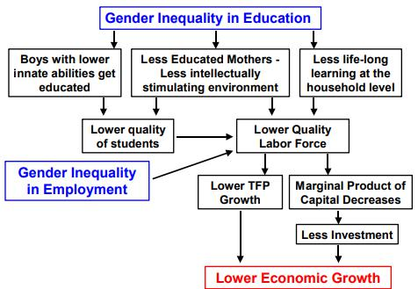

Source: (Klasen, 1999)
Figure 2.1: The Effects of Gender Inequality in Economic Growth.

2.3 Dimensions of Women Empowerment
- I it is believed that empowerment has many different goals, and in a given culture, the forces of the environment will define how successful it is. A primary-level safe environment is required for this, which will empower women. To secure the inclusion of women in groups, lessons from local, national, and international experiences and case studies must be drawn (Sing, 2009). Empowerment is a multifaceted strategy that gives women lifetime access to an understanding of their full potential (Sushama, 1998).
- Rowlands' (1997) study divided empowerment into the following three categories:
Rowland (1997) went on to say that this would possibly necessitate team activities that are centered on cooperation rather than competitiveness (Rowlands, 1997). Women can work, though, and make money, enabling them to support their families and giving the rest of the family a positive perception of their financial independence (Kabeer, 2005). Therefore, having a job signals having money (Elliott, 2008), and having enough money is a tremendous deterrent against having insufficient money (Biswas 2010). The position of working women is also acknowledged as a key aspect in the advancement of women's financial independence and as a sign of their general level of wellbeing in the country (Mammen & Paxson, 2000).
Additionally, it is acknowledged that the situation of working women is a key aspect in the advancement of women's financial independence and a sign of their general state of wellbeing in the country (Mammen & Paxson, 2000).

Table 2.1. Commonly Used Dimensions of the Empowerment of Women
Dimension | Household | Community | Broader Arenas
Economic | Women's income control, relative support of the family, and access to and management of family resources | Women's access to employment, ownership of property and assets, credit availability, participation in or representation in local trade associations, and market access | Women's participation in well-paying jobs Women's economic interests are represented by CEOs in macroeconomic policies, state budgets, and federal budgets.
Socio-Cultural | Women's rights to freedom of movement and the absence of prejudice towards daughters who are committed to attending college | Women's participation in extra-familial groups and social networks; access to modern transportation; visibility in and access to social spaces; and changes to patriarchal standards (such as son preference); The feminine as a recurring symbol in myth and ritual | good media portrayals of women, their responsibilities, and contributions; women's literacy and access to a wide range of educational opportunities
Familial/Interpersonal | Participation in household decision-making, sexual relationship control, and the capacity to decide whether to have children. | Changes in the marital and kinship systems that show a higher importance and level of independence for women. | Regional and national trends in the timing of marriage, divorce alternatives, political, legal, and religious support for (or lack of overt resistance to) such changes, as well as systems that make contraception and safe abortion easily accessible.
Legal | Legal rights awareness and domestic support for exercising rights | Community advocacy for rights; public awareness initiatives; and efficient local enforcement of legal rights | laws promoting women's rights, access to resources, and choices; legislative advocacy recourse to legal systems to address infringement of human rights
Psychological | Self-worth, effectiveness, and psychological health | A general understanding of injustice and the potential for mobilization | Women's sense of belonging and entitlement; institutional recognition of women's belonging and entitlement
Source: (Malhotra, Schuler, and Boender, 2002)

2.4 Justice Theory and Women Empowerment
According to the social exchange theory, which highlights how crucial equality is to bringing about change, is the source of the first component of justice, known as distributive justice (Adams, 1965). Issues with distributive justice are prevalent across the community and affect interactions between people or groups in any situation (Deutsch, 1985).

2.5 Women's Power and Empowerment
The concept of power poses a hurdle to women's empowerment. Four types of power have been discovered by prior study, and each category offers recommendations for empowering women and their capacity to enhance fundamental and personal transformation (Rowlands, 1997).

Table 2.2. Types of Empowerment and Implications for the Empowerment of Women.
Types of Empowerment | Implications for women’s empowerment
Power over | The power to command others. Resistance to changes in the balance of power, such as when women overtake males, is typically encountered, and this can lead to new forms of oppression and injustice..
Power to | The capacity to make decisions and alter environmental factors. In order for women to challenge and transform power structures (i.e. change others' power over them), they must develop their own personal capacities.
Power with | The ability to decide how to change the surroundings. Women must develop their own innate abilities if they are to confront and alter existing power structures (and hence alter others' ability to control them).
Power within | Significantly higher levels of awareness and regard for oneself. Women's desire for both personal and institutional change is based on their knowledge of socially constructed identities and hierarchies as well as their acceptance of others and themselves as equals.

Theoretical Backgrounds

A person who understands the concept of empowerment might have a deeper grasp of the specific systems used for its implementation since, as researchers have stated in earlier studies, it is the core and primary philosophy and perspective of the world (Sadan, 1997, p.13). The three elements of power show how judgments are controlled by values and institutional procedures, and how this control intensifies when knowledge shifts as a result of cultural allegories, figures, and language.

Table 3.1. Lukes (1974) Three-Dimensional View of Power

One-dimensional view of power | Two-dimensional view of power | Three- dimensional view of power
Focus on: | (Qualified) critiques of behaviroal focus. Focus on: | Critiques of behaviroal focus. Focus on:
a) behavior;  b) decisions making;  c) (key) issues;  d) observable (overt) conflict;  e) subject interests, seen as policy preference revealed by political participations. | a) Decision-making and control over the political agenda (not necessarily through decisions)  b) Issues and potential issues;  c) Observable (overt and covert) conflict;  d) (Subjective) interests; seen as policy preferences or grievances | a) decision-making and control over the political agenda (not necessarily through decisions); b) issues and potential issues  c) observable (overt or covert) and latent conflict;  d) Subjective and real interest.

In order to explain the structure of women's empowerment, Longwe (1995) discusses various levels of empowerment, such as the welfare of women, admission to sources, conscience regarding gender equality, equal participation in making judgments, and equal control of women over various factors without subordination.

Table 3.2. The Women’s Empowerment Framework
Level of Empowerment | Description
Control | Women and men have equal control over factors of production and distribution of benefit, without dominance or subordination
Participation | Women have equal participation in decision-making in all programs and policies
Conscuentization | Women belive that gender roles can be changed and gender equality is possible
Access | Women gain access to resources such as land, labour, credit, training, marketing facilities, public services and benefits on an equal basis with me. Reforms of law and practice may be prerequisites for such access
Welfare | Women’s material needs, such as food, income, and medical care, are met.
Source: Longwe (1995)
A measurement strategy for women's empowerment through five dimensions mobility, self-esteem, resource control, and decision-making was proposed by Mahmud, Shah, and Becker in 2012. They used media exposure (TV and/or radio) as a criterion in addition to demographic status, economic standing, social status, and media exposure to gauge the level of women's empowerment in rural Bangladesh.

DATA ANALYSIS AND RESULTS

4.1 Study1: Use of Secondary Data

4.1.1 Hypotheses Development:
4.1.1. Effects of Education on Empowerment of Women
According to some academics, education has increased over time and a better degree of knowledge promotes happiness (Stevenson & Wolfers, 2009). Women's personalities, decision-making abilities, and adaptability are linked to education, which also directly enhances the socioeconomic conditions of families, groups, and countries (Haq, Jali, & Islam, 2017). According to numerous research, work and education levels have a big impact on how empowered women feel. Nowak, Dahal, and Hossain (2016) After accounting for participants' social and economic situations, Nikkhah et al. (2010) found that respondents with higher education were more empowered than respondents without higher education (Nikkhah et al., 2010).

H1: Lack of education has an impact on women's emancipation.
H2: Women's empowerment is impacted by primary education completion.
H3: Secondary education completion has an impact on women's empowerment.
H4: Higher secondary education completion has an impact on women's empowerment.
H5: A tertiary education's completion has an impact on women's empowerment.

4.1.2. The Effects Ownership of Land and Total Wage in Women Empowerment Owning property titles plays a significant role in empowering women.
Female property ownership's implications and involvement in household decision-making also vary by region (Valera et al., 2018). Having land titles, however considerably enhances women's empowerment (Mishra & Sam, 2016). The study's hypothesis was that having land ownership would empower women.
H6: Land ownership has an impact on the empowerment of women. Depending on how much money women in the family share in salaries, the family can affect her level of power and authority, establish her status in the home, and enhance her quality of life. circumstances by lessening dependence on the male family members (Kato & Kratzer, 2013). Women are given a greater role and the ability to voice their ideas in the family when they contribute to or make up the entirety of the family's income (Meisenbach, 2009). In addition, although if their earnings are lower than those of their male counterparts, women who manage their finances are more willing than males should send boys and girls to school (Svensson, 2012). Because of this, this study proposed:
H7: Total wage affects women's empowerment.

Figure 4.1: Effects of Determinants of FLF Participation

4.1.3 Methodology:
Study 1 looked at how women's empowerment is impacted by their education levels, overall wages, and land ownership. 33,451 female respondents from all throughout Bangladesh participated in this study, which employed data from the Bangladesh Labor Force Survey 2012–2021 and their observations. Between July 2020 and June 2021, the Labour Force Survey 2020–21 gathered information from a sample of 1,23,000 families in the country's rural, urban, and city corporation sectors. The survey's goal is to evaluate Bangladesh's labor market's major indicators and labor market data in their current state. Female labor force participation, a binary variable, is the dependent variable. Total wage is a continuous variable among the independent variables, whereas ownership of property, lack of education, primary education, and secondary education, higher secondary education, and tertiary education each take the values o and 1.
Table 4.1 Description of the Variables
Variables | Description of the variables
Dependent variables
Female labour forces | Female labour forces  participation | =1 if the female is participating in the labour force  =0 otherwise
Independent variables
No education | No education | =1 if the female labor force has no education  =0 otherwise
Primary | Primary level of education | =1 if the female labour force has completed primary education  =0 otherwise
Secondary | Secondary level of education | =1 if the female labour force has completed secondary education  =0 other wise
Higher Secondary | Higher secondary level of education | =1 if the female labour force has completed higher secondary education  =0 otherwise
Tertiary | Tertiary level of education | =1 if the female labour force has completed tertiary education  =0 otherwise
Own land | Ownership of land | =1 if the female labour force owned land  =0 otherwise
Total wage | Monthly total wage | Numeric

4.1.4 Data Analysis and Results:
The table lists some descriptive data regarding the sample of FLF participation from Bangladesh. In contrast to the 82% of FLF who are not in the labor market, statistics show that only 18% of FLF are currently employed. 28% of FLF participants are uneducated, 22% are in the primary grades, 40% are in the secondary grades, 7.6% are in the 2.6% of students are in tertiary grades, which are upper secondary grades. The average total monthly salary of the sample's FLF members is 272 Bangladeshi Taka (BDT).
Table 4.2. Summary Descriptive Statistics
Variables | Observations | Men | Std. Dev. | Min | Max
Dependent variables
Female labour force | 33451 | .1767062 | .3814256 | 0 | 1
Independent variables
No education | 33451 | .2789752 | .448502 | 0 | 1
Primary education | 33451 | .2153 | .4110364 | 0 | 1
Secondary education | 33451 | .4019013 | 4902895 | 0 | 1
Higher Secondary Education | 33451 | .0760515 | .2650845 | 0 | 1
Tertiary education | 33451 | .0261278 | .1595176 | 0 | 1
Own land | 33451 | .8746824 | .3310837 | 0 | 1
Total wage (monthly) | 33451 | 272.217 | 3171.127 | 0 | 1
The Hosmer-Lemeshow goodness-of-fit test demonstrates that the model adequately accounts for the data (Prob > chi2 = 0.6261).
Table 4.3. Logistic Model for FLF Participation, Goodness-of-fit test
Number of observations=33451
Number of groups=5
Hosmer-Lemeshows chi2(3)=1.75
Prob>chi2=0.6261
According to the results (Table 4.3), there is a positive and substantial correlation between involvement in FLF and various degrees of schooling. Higher education levels are associated with increased FLF involvement. Additionally, a positive association between FLF membership and total wage and coefficient estimation of the variable's land ownership is shown.

Table 4.4. Logistic Regression Finding of FLF Participation
Female labor force | Coef. | St.Err. | t-value | p-value | [95% conf | Interval]
No education | 1.978* | 1.01 | 1.96 | .05 | -.002 | 3.957
Primary | 2.408** | 1.01 | 2.38 | .017 | .429 | 4.387
Secondary | 2.367** | 1.01 | 2.34 | .019 | .388 | 4.346
Higher Secondary | 2.718*** | 1.01 | 2.69 | .007 | .737 | 4.698
Tertiary | 2.912*** | 1.013 | 2.88 | .004 | .928 | 4.897
Own land | .422*** | .053 | 8.01 | 0 | .319 | .525
Total wage | .003*** | 0 | 7.90 | 0 | .002 | .004
Pseudo r-spuared | 0.102 |  | Number of observations |  | 33451.000
Chi-square | 3172.519 |  | Prob>chi2 |  | 0.000
Significant level *** p<.01, ** p<.05, * p<.1

Table 8 of the results of the hypotheses testing summarizes the effects of no education, primary, secondary, upper secondary, and university education, own land, and total wage on the FLF engagement of women.

Table 4.5 Summary of Hypothesis Testing Results

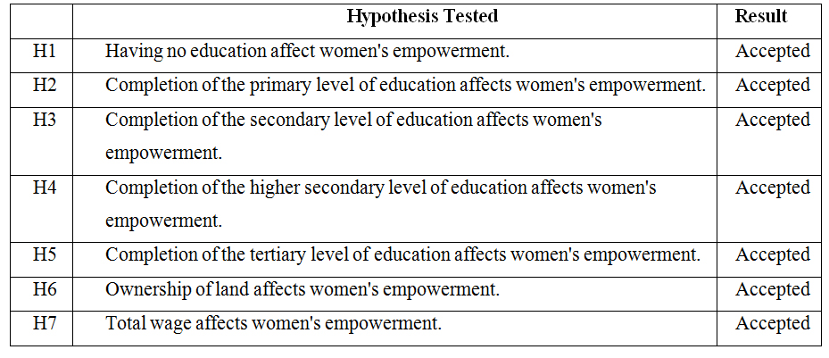

4.2 Study 2: Use of Primary Data

4.2.1 Hypotheses Development:

4.2.2 Economic Empowerment
Employment is the key driver of economic empowerment for women, particularly in jobs involving money because it gives them the opportunity to make decisions and dissipate power (Noureen, 2015). Women's employment status directly influences their economic empowerment since it increases FLF membership. Working women therefore have greater economic empowerment than non-working women. (2015) Meraj, Sadaqatt, and Sheikh. Enhancing control over household finances can contribute to reducing gender inequality, which will ultimately increase women's economic power. Therefore, increasing women's financial independence makes a substantial contribution to eliminating gender inequality and encourages empowerment (Peinado & Serrano, 2018). As a result, the following was the study's hypothesis: H₁: Economic empowerment and women's employment are significantly correlated.

4.2.3 Socio-cultural Empowerment
Women can protest against societal practices by having a voice thanks to equal educational opportunities. Higher levels of consciousness, information, and original notions are made possible for women by their education (Maslak and Singhal, 2008). Therefore, the empowerment of women to participate in social activities that increase capacity through learning, doing, and improving is a sign of growth in the human component (Inglehart & Wezel, 2005). Consequently, it is assumed:
H2: The employment of women and socio-cultural empowerment are strongly correlated.

4.2.4 Familial Empowerment
Some researchers claim that women who work for pay have more influence over decisions than women who exclusively work for free (Becker, Fonseca-Becker & Schenck-Yglesias, 2006).

4.2.5 Legal Empowerment
According to Bilal's (2014) research, employed women who are working are more aware of and actively use their legal rights than unemployed women (Bilal, 2014). Consequently, it is assumed:
H4: Legal empowerment and women's employment are significantly correlated.

4.2.6 Political Empowerment
According to Haq, Akram, Ashiq, and Raza (2019), the dominant power structure that currently exists and prohibits women from assisting and mediating in society can only be challenged by work status. Haq, Akram, Ashiq, & Raza in 2019 Women typically choose to work and earn money to get by, which has nothing to do with the gender binary. The lack of empowerment is mostly caused by this form of work (Singh & Raghuvanshi, 2012). Though, when a woman's salary is minimal, she is either prohibited from participating in politics or her profession does not alter her home responsibilities and further their quest for equal property rights (Cinar & Kose, 2018). Consequently, it is assumed:
H5: Political empowerment and female employment are significantly correlated.

4.2.7 Psychological Empowerment
Employee motivation and self-awareness are increased through psychological empowerment, which benefits managerial and organizational outcomes (Quinn & Spreitzer, 1997). Employees who feel psychologically empowered can manage their job responsibilities, feel competent when doing tasks connected to their jobs, and have an impact on how decisions are made at work (Yukl & Becker, 2006).

H6: The employment of women and psychological empowerment are significantly correlated.
Figure 4.2: Effects of Determinants of Employment

4.2.8 Methodology
125 women from the Bangladeshi capital city of Dhaka were given questionnaires as part of this study using the online survey tool Qualtrics. The data collection window in 2020 ran from July to August. However, SPSS (Statistical Package for Social Sciences) was used in this inquiry to examine the data.

Table 4.6. The Definition of the Variables
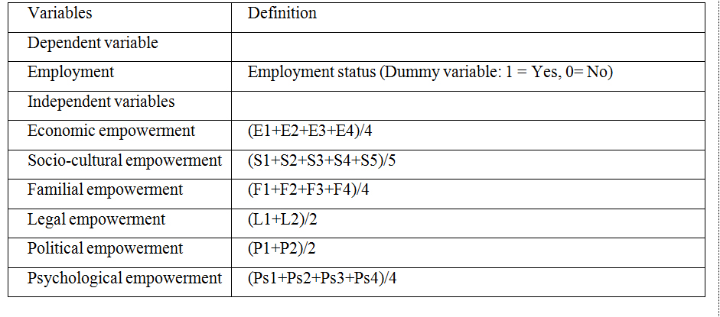

4.2.9 Data Analysis and Discussion
According to the respondents' descriptive statistics from Table 10, the majority of them are between the ages of 18 and 25 (28%), 26 and 29 (30.4%), and 30-39 (28.8%). The majority of the 125 respondents—62.4%—are married, while 36% are unmarried. In total, 70.4% of respondents are employed, compared to 29.6% who are unemployed. According to the table, 28.8% of participants get a monthly salary between BDT 36000 and 50000, while 8.8% of employed respondents earn BDT 51000 or more. Additionally, only 2.4% of respondents' monthly salaries are lower than the BDT 10,000 category, whereas 21.6% of respondents have monthly incomes between BDT 26000 and 35000, 8.8% have monthly incomes between BDT 10000 and 25000, and 8.7% have monthly incomes between BDT 10000 and 26000. According to the table, just 11.2% of respondents come from households where women are the head of household, whereas 74.4% are.

Table 4.7. The Demographic Profile of the Respondents (N=125)
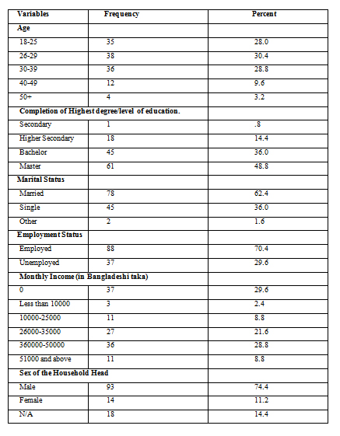Cronbach Alpha's reliability statistic reveals that 21 of the survey's questionnaire's items scored 89.0%, indicating that the data is reliable. A figure greater than 50% is regarded as adequate, and in this study, that figure is 89.0%.

Table 4.8. Reliability Test of the Factors of Employment Status
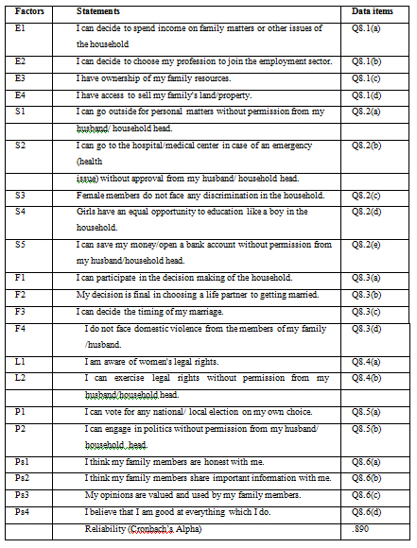
The model's Hosmer and Lemeshow test is nonsignificant, with a value of 2 (7) = 8.901, =.260, indicating a well-fitting model.
Those who scored higher on economic empowerment were more likely to have women in employment, according to Table 12's regression slope, which is both favorable and statistically significant (p=.000, b=4.083) (adjusting for the additional predictor). According to the odds ratio for this predictor, here is a factor of 59.306 difference in the probability of women finding employment for every increase in the raw score for economic empowerment (indicating increasing odds). However, it is not discovered that other predictors (five attributes of empowerment) of women's employment are significant.

Table 4.9. Binary Logistic Regression Results
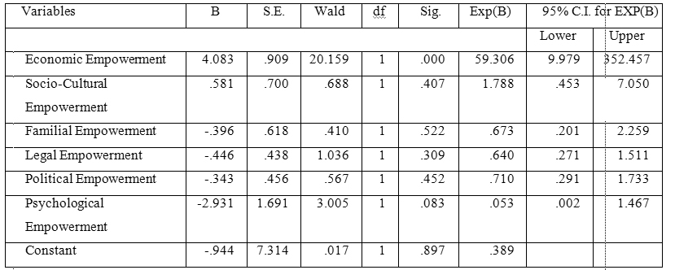
Table 13 summarizes the findings of the hypothesis testing and shows how economic, sociocultural, familial, legal, political, and psychological empowerment relate to women's employment.

Table 4.10. Summary of Hypothesis Testing Results
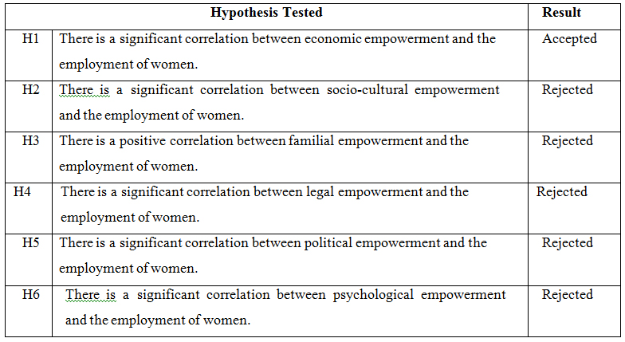

Conclusion

6.1 Findings
Women's empowerment is one of the top development concerns in the world. Empowering women is essential for decreasing poverty and the accomplishment of the Sustainable Development Goals (SDGs). In this regard, Study 1 looks at whether education fosters women's emancipation. This study looked into how measures of women's empowerment and education related to women's engagement in the labor force. The findings of study 1 show that women with higher levels of education are more likely to enter the workforce and develop the ability to secure their own financial resources. The research findings also imply that owning land increases the likelihood that women will work. Women who work in agriculture and own their own land can make more money than women who do not. The rise in monthly income has an effect on the expansion of female labor force participation. Study 1 concludes as a result that education is essential for women's empowerment.

6.2 Managerial Implications
- I The essay's aim was to investigate the importance of education as one of the key elements in empowering women. Sen (2000) made a point of the significance of women's empowerment as a prerequisite for poor countries becoming developed countries (Sen, 2000). Therefore, empowering women economically has the ability to profoundly modify and speed up the country's development. The first study's findings supported the hypotheses H1, H2, H3, H4, and H5, which posited that FLF engagement is influenced by education levels—whether primary, secondary, upper secondary, or university—land ownership, total wage, and other factors. The initial investigation's findings point to the following conclusions:
- Make sure that women can easily access high-quality education, especially in rural areas of the nation. ii) Ensure that women have access to well-paying, respectable jobs. iii) Make sure to in order to encourage more women to join the workforce sufficient safety and foster a welcoming workplace. iv) Ensure that women can exercise their property rights.
Study 2 aims to examine the relationship between women's employment and the six elements of empowerment. The second study's findings support hypothesis 1: that working women benefit from women's economic empowerment. The second study, however, rejects: H2: Women's employment and socio-cultural empowerment are significantly related. H3: There is a sizable connection between women's employment and familial empowerment. H4: Employment of women and legal empowerment are significantly correlated. H5: Women's employment is significantly correlated with political empowerment. H6: The employment of women is significantly correlated with psychological empowerment. As a result, the second study's findings suggest the following conclusions: I Ensure women's economic empowerment by giving them access to family resources and land, giving them control over home decisions, allowing them to choose a profession. ii) Protecting women's freedom of movement, equal access to education, safety from all types of discrimination, and other fundamental rights will ensure their socio-cultural empowerment. Affirming women's full participation in household decision-making, their right to choose a life partner, and their safety from domestic abuse will ensure women's family empowerment. iv) Ensure that women have access to their legal rights in order to promote their empowerment on the legal front. v) Encourage women to use their political rights without hindrance in order to ensure their political empowerment. vi) Encourage women to increase their sense of self-worth and confidence in their ability to carry out any worthwhile task in order to ensure their psychological empowerment.

6.3 Policy Implications
Since many nations around the world understand how important women's empowerment is to a nation's economic growth. For developing nations like Bangladesh to flourish sustainably, women must be given more influence overall. For women to be empowered, it is essential to guarantee their access to higher education and other fundamental rights. Based on this research, it is suggested that the government create new laws or review existing ones to ensure that women receive better education and suitable employment. Given the intrinsic importance it plays in ensuring women's welfare and ability to advance in areas like earning money and acquiring property, decent labor is essential to economic empowerment. In this regard, the government should enact laws to support women's participation in higher education and the workforce. The implementation of anti-violence policies is crucial to protecting women from all forms of prejudice, whether they occur inside or outside the home. Participating in programs for skill development might also help women feel more confident. In order to help women build their self-esteem and their capacity to participate in the country's economic sector, the local government should step up and organize various skill development training programs in collaboration with the private sector and NGOs.

6.4 Limitations of the Study
The second study's limited sample size posed a constraint on this investigation. Due to the tiny size of the sample, the survey results could not be produced. The questionnaire was answered by 125 female participants. Whereas during the time of data collection, 37 respondents were unemployed and 88 respondents were working women. Additionally, the study only included participants from Dhaka, the nation's capital. In order to acquire comprehensive results, it was advised in this study that future research should collect Both quantitative and qualitative approaches are used to analyze data from urban, rural, and city corporations around the country.

References
Ackah, C., Ahiadeke, C., & Fenny, A.P. (2009). Determinants of Female Labour Force Participation in Ghana, Institute of Statistical, Social and Economic Research, University of Ghana, Legon, Accra.
Adams, J. S. (1965). Inequity in Social Exchange. Advances in Experimental Social Psychology, 267-299. doi:10.1016/s0065-2601(08)60108-2
Ahmad, M. & Ahmed, M. (2002). Bangladesh Education Sector Overview, Japan Bank for International Cooperation (JBIC).
Ashraf, D., & Farah, I. (2007). Education and Women’s Empowerment: Re-examining the Relationship. Education, Gender and Empowerment: Perspectives from South Asia, 15-31.
BANBEIS. (2016). Bangladesh Education Statistics 2015.
Bangladesh Bureau of Statistics [BBS]. (2019). Gender Statistics of Bangladesh 2018. Batliwala, S. (1994). The Meanings of Women’s Empowerment: New Concepts for Action.
G. Sen et al. (Eds.) Population Policies Reconsidered: Health Empowerment and Rights, 130-131, Harvard University Press, Cambridge, UK.
BBS. (2018). Labour Force Survey (LFS) 2016-2017.
BBS. (2017). Education Scenario in Bangladesh: Gender Perspective.
Becker S., Fonseca-Becker F., Schenck-Yglesias C. (2006) Husbands' and Wives' Reports of Women's Decision-Making Power in Western Guatemala and Their Effects on Preventive Health Behaviors. Social Science & Medicine, 62(9),2313-2326. DOI: 10.1016/j.socscimed.2005.10.006.
Bies, R. J. & Shapiro, D. L. (1987). Interactional Fairness Judgements: The Influence of Causal Accounts, Social Justice Research,1,199-218.
Biswas, S.K. (2010). New Tribal Panchayat in Nicobar Islands. Kurukshetra, 59(1), 20-23, Ministry of Rural Development, New Delhi.
Black, C. F. (2016). Global Gender Gap Report. In Encyclopedia of Family Studies. https://doi.org/10.1002/9781119085621.wbefs350
Carless, S. A. (2004). Does Psychological Empowerment Mediate the Relationship Between Psychological Climate and Job Satisfaction? Journal of Business and Psychology, 18(4), 405-425. doi:10.1023/b:jobu.0000028444.77080.c5
Coleman, I. (2010). The Global Glass Ceiling: Why Empowering Women is Good for Business. Current, 89(524), 3–6.
Collins, M. S. (2007). Understanding the relationship between leader-member exchange (LMX), psychological empowerment, job satisfaction and turnover intention in a limited-service restaurant environment (UMI No: 3260704). Ohio State University.
Cornwall, A. & Rivas, A. M. (2015). From Gender Equality and Women’s Empowerment to Global Justice: Reclaiming a Transformative Agenda for Gender and Development. Third World Quarterly, 36(2), 396–415.

Deutsch, M. (1985). Distributive Justice: A Social-Psychological Perspective, New Haven:Yale University Press.

Duflo, E. (2012). Women Empowerment and Economic Development. Journal of Economic Literature, 50(4), 1051-1079. doi:10.1257/jel.50.4.1051
Elliott, C. M. (Ed.) (2008). Global Empowerment of Women: Responses to Globalization and Politicized Religions. Routledge, New York.
Fuller, J. B., Morrison, R., Jones, L., Bridger, D., & Brown, V. (1999). The Effects of Psychological Empowerment on Transformational Leadership and Job Satisfaction. The Journal of Social Psychology, 139(3), 389-391. doi:10.1080/00224549909598396
Eyben, R., Kabeer, N., & Cornwall, A. (2008). Conceptualising Empowerment and the Implications for Pro Poor Growth: A Paper for the DAC Poverty Network, Institute of Development Studies.
Haq, M. A., Akram, F., Ashiq, U., & Raza, S. (2019). The employment paradox to improve women’s empowerment in Pakistan. Cogent Social Sciences, 5(1). doi:10.1080/23311886.2019.1707005
Haq, M. A., Jali, M. R., & Islam, G. M. (2017). Decision-Making Ability as a Source of Empowerment Among Rural Women of Pakistan. Global Social Welfare, 4(3), 117-125. doi:10.1007/s40609-017-0091-7
Hur, M. H. (2006). Empowerment in Terms of Theoretical Perspectives: Exploring a Typology of the Process and Components Across Disciplines. Journal of Community Psychology, 34(5), 523–540.
Inglehart, R., & Welzel, C. (2005). Modernization, Cultural Change, and Democracy: The Human Development Sequence. Cambridge: Cambridge University Press. doi:10.1017/CBO9780511790881
Islam Sarker, M. N., Wu, M., & Hossin, M. A. (2019). Economic Effect of School Dropout in Bangladesh. International Journal of Information and Education Technology, 9(2), 136–142.
Joo, B. (., & Shim, J. H. (2010). Psychological Empowerment and Organizational Commitment: The Moderating Effect of Organizational Learning Culture. Human Resource Development International, 13(4), 425-441. doi:10.1080/13678868.2010.501963
Kabeer, N. (2005). Gender Equality and Women's Empowerment: A Critical Analysis of the Third Millennium Development Goal 1. Gender & Development 13(1), 13-24.
Kabeer, N. (1999). Resources, Agency, Achievements: Reflections on the Measurement of Women's Empowerment. Development and Change, 30, 435-464.
Kato, M. P., & Kratzer, J. (2013). Empowering Women through Microfinance: Evidence from Tanzania. ACRN Journal of Entrepreneurship Perspectives, 2(1), 31–59.
Kessey, C. (2005). Empowering Muslim Women through Microcredit Scheme: The Case of the Suyani Gonja Muslim Women's Group WOPAG, Working Papers, Ghana: Historical and Contemporary Studies.
Klasen, S. (1999). Does Gender Inequality Reduce Growth and Development? Evidence from Cross-Country Regressions. Policy Research Report on Gender and Development Working Paper Series, 7, the World Bank, November.
Kuenning, M. & Amin, S. (2001). III . Government Transfers and Human Security Women’s Capabilities and the Right to Education. International Journal Of Politics, Culture and Society, 15(1), 125–142.
Leventhal, G. S., Karuza, J., Fry, W. R., & Mikula, G. (1980). Justice and Social Interaction. In Beyond Fairness: a Theory of Allocation Preferences,3,167-218. Springer New York.
Luttrell, C., Quiroz, S., Scrutton, C. & Bird, K. (2009). Understanding and Operationalising Empowerment. ODI Working Paper 308. Overseas Development Institute, London.
Mahmud, S., Shah, N. M., & Becker, S. (2012). Measurement of Women’s Empowerment in Rural Bangladesh. World Development, 40(3), 610–619.
Malhotra, A., Schuler, S. R., & Boender, C. (2002). Women’s Empowerment as a Variable in International Development. The World Bank, Washington DC.
Mammen, K. & Paxson, C. (2000). Women’s Work and Economic Development, The Journal of Economic Perspectives, 14 (4): 141–164

Meisenbach, R. J. (2009). The Female Breadwinner: Phenomenological Experience and Gendered Identity in Work/Family Spaces. Sex Roles, 62(1-2), 2-19. doi:10.1007/s11199009-9714-5

Mishra, K., & Sam, A. G. (2016). Does Women’s Land Ownership Promote Their Empowerment? Empirical Evidence from Nepal. World Development, 78, 360–371. https://doi.org/10.1016/j.worlddev.2015.10.003

Murphy‐Graham, E. (2008). Opening the Black Box: Women’s Empowerment and Innovative Secondary Education in Honduras. Gender and Education, 20(1), 31-50. doi:10.1080/09540250701650623

Nashid, K., & Haider, S. (2007). Role of Education in Enabling Empowerment of Women in Bangladesh.

Neil, T. O., Domingo, P., & Valters, C. (2014). Progress on Women’s Empowerment From Technical Fixes to Political Action. ODI Working Paper 06, November, 1–16.
Nikkhah, H.A., Redzuan, M., & Abusamah, A. (2010). The Effect of Women's Socio-Demographic Variables on Their Empowerment, Journal of American Science, 6(11), 426-434.
Nowak, H. A. Z., Dahal, G., & Hossain, I. (2016). Women Education and Empowerment : Its Impacts on Socioeconomic Development in Bangladesh and Nepal. In Fourth 21st CAF Conference in Harvard, 9(1), 135–154. Bostan, Massachusetts, USA.

Peinado, P., & Serrano, F. (2018). Gender Inequality in the Labour Market and the Great Recession. Inequality, 233-274. doi:10.1007/978-3-319-91298-1_6
Quinn, R. E., & Spreitzer, G. M. (1997). The road to empowerment: Seven questions every leader should consider. Organizational Dynamics, 26(2), 37-49. doi:10.1016/s0090-2616(97)90004-8
Rao, A. & Kelleher, D. (1995). Engendering Organizational Change: The BRAC Case in Getting Institution Right for Women in Development, IDS Bulletin, 26(3).
Rappaport, J. (1987). Terms of Empowerment/Exemplars of Prevention: Toward a Theory for Community Psychology. American Journal of Psychology, 15(2), 121-148.
Rowlands, J. (1997). Questioning Empowerment: Working with Women in Honduras.
Sadan, E. (1997). Empowerment and Community Planning Translated from Hebrew by Richard Flantz. http://www.mpow.org/elisheva_sadan_empowerment_intro.pdf
Seguino, S., & Floro, M. (2003). Does Gender Have Any Effect on Aggregate Saving: An Empirical Analysis, International Review of Applied Economics, 17(2), 147–166.
Sen, P. (1999). Enhancing Women's Choices in Responding to Domestic Violence in Calcutta: A Comparison of Employment and Education. The European Journal of Development Research, 11, 65-86.
Sing, P. A. (2009). Women’s Participation at Grassroot Level: An Analysis, Mainstream Weekly. 47(12). https://mainstreamweekly.net/article1207.html
Sharma, A., & Saha, S. (2015). Female Employment Trends in India: A Disaggregated Analysis, The NEHU Journal, 13(2), July-December, 17- 30.
Stevenson, B., & Wolfers, J. (2009). The Paradox of Declining Female Happiness. American Economic Journal: Economic Policy, 1(2), 190-225. doi:10.1257/pol.1.2.190
Stotsky, J. G. (2006). Gender and its Relevance to Macroeconomic Policy: A Survey. IMF Working Paper 06/233, International Monetary Fund, Washington.
Stromquist, N. P. (2015). Women’s Empowerment and Education: Linking Knowledge to Transformative Action. European Journal of Education, 50(3), 307–324. https://doi.org/10.1111/ejed.12137
Sundaram, M. S., Sekar, M. & Subburaj, A. (2014). Women Empowerment: Role of Education. International Journal in Management & Social Science, 2(12), 76–85.
Sushama, S. (1998). Women and Empowerment Approach and Strategies, Discovery Publishing House, Delhi.

Svensson, N. (2012). The Role of Women in Promoting Peace and Development: Proceedings of the 10th Annual Conference on the Horn of Africa, Lund, Sweden, September 23-24 2011. Somalia International Rehabilitation Centre (SIRC).

Valera, H. G., Yamano, T., Puskur, R., Veettil, P. C., Gupta, I., Ricarte, P., & Mohan, R. R. (2018). Women's Land Title Ownership and Empowerment. ADB Economics Working Paper Series. doi:10.22617/wps189556-2
Wallace, T & March, C. (Eds.) (1991), Changing Perception: Writings on Gender and Development. Oxfam, Oxford.
Wallerstein, N. (2001). Powerlessness, Empowerment and Health: Implications for Health Promotion Programs. American Journal of Health Promotion, 6(3), 197-205.

World Economic Forum. (2019). Insight Report Global Gender Gap Report 2020. Retrieved from www.weforum.org
Yukl, G. A., & Becker, W. S. (2006). Effective Empowerment in Organizations. Organization Management Journal, 3(3), 210-231. doi:10.1057/omj.2006.20
Zafar, Z. (2016). Women Empowerment in South Asia : The Role of Education in Empowering Women in India, Journal of Indian Studies. 2(2), 103–115.

