INTERNSHIP REPORT

Internal Audit Practice of Multinational NGO: A Case Study on RMMRU

Submitted to
Dr. Mohammad Tariq Hasan
Associate Professor
School of Business & Economics
United International University, Dhaka

Submitted by
Md. Shamiur Rahman
Id: 111 191 128
Major: Accounting
School of Business & Economics

Date of Submission: 2nd December, 2023



LETTER OF TRANSMITTAL
2nd December, 2023

Dr. Mohammad Tariq Hasan
Associate Professor,
School of Business & Economics
United International University

Subject: Submission of internship report on “Internal Audit practice of Multinational NGO: A Case study on Refugee & Migratory Movement Research Unit (RMMRU), Bangladesh”.

Dear Sir,
It’s a great pleasure to prepare this internship report & and submit it to you on “Internal Audit Practice of Multinational NGO: A Case Study on Refugee & Migratory Movement Research Unit, (RMMRU), Bangladesh”. It was a great opportunity to complete the internship in the Refugee & Migratory Movement research unit. It’s a great pleasure to carry out the internship report under your supervision.

This internship report, will focus on the Internal audit of RMMRU. In this report, will do try level best to present how they internal audit & and other necessary things. Hope that this internship report will be of great value to you.

Sincerely
Md. Shamiur Rahman
ID: 111 191 128
United International University

DECLARATION OF THE STUDENT

Md. Shamiur Rahman declared that the Internship report titled “Internal Audit Practice of Multinational NGO: A Case Study on Refugee & Migratory Movement Research Unit, Bangladesh.” is uniquely prepared by after the completion of three months’ work experience at RMMRU.

Also confirming that the report is prepared only for his academic requirements. It might not be used with the interest of the opposite party of the corporation by which they can collect any information about the organization.

Name: Md. Shamiur Rahman
ID: 111 191 128

ACKNOWLEDGEMENT

First, I, Md. Shamiur Rahman wants to thank my creator Almighty Allah. I would like to express his sincere gratitude and cordial thanks to the academic supervisor “Dr. Mohammad Tariq Hasan, Associate Professor, School of Business & Economics, United International University. Through his constant supervision, Moral Support, Valuable Instruction & helpful advice, able to complete this internship report properly.

I am also thankful to all the personnel of the Refugee & Migratory Movement research unit, Head office, Dhaka. for their kind support. It was a great chance for me to work with them. Especially, express gratitude towards Md. Kaisar Hossain (Finance & Accounts Coordinator, RMMRU). Also, give thanks to Md. Qazi Sham Sun Newaz (Accounts Officer, RMMRU), Mohammed Sherajul Islam (Accounts Officer, RMMRU). Who gave all the support that was needed to prepare this internship report.

Finally, I would also be grateful to all staff and officers of the Refugee & Migratory Movement Research Unit, Dhaka, for their hearty cooperation in this internship and reports.

TABLE OF CONTENTS
LETTER OF TRANSMITTAL ii
DECLARATION OF THE STUDENT iii
ACKNOWLEDGEMENT iv
TABLE OF CONTENTS v
EXECUTIVE SUMMARY vi
CHAPTER ONE: INTRODUCTION 1
1.1 Background 1
1.2 Origin of the study 1
1.3 Objective of the study 1
1.4 Scope of the study 2
1.5 Limitations of the study 2
CHAPTER TWO: COMPANY AND INDUSTRY PREVIEW 4
2.1 Company Overview 4
2.2.1 Mission Vision of RMMRU 4
2.2.2 SWOT Analysis of RMMRU 5
2.2.3 RMMRU FOUNDING MEMBERS 6
2.2.4 RMMRU Economic Source 6
2.2.5 RMMRU Financial Report 7
2.2 Industry Analysis 8
2.2.1 Specification of the Industry 8
2.2.2 Size, Trend, and Maturity of the Industry 9
CHAPTER THREE: METHODOLOGY 10
CHAPTER IV: INTERNSHIP EXPERIENCE 11
4.1 Introduction to NGO 11
4.2 NGO Audit 11
4.3 Benefits of Audit for NGOs 11
4.4 Types of Audits for the NGO 12
4.5 RMMRU Internal Audit Practice 12
4.6 Audit Committee Structure 13
4.7 Duties & Responsibilities: 14
4.7.1 As an Intern 14
CHAPTER FIVE: CONCLUSIONS & RECOMMENDATIONS 17
5.1 Conclusion 17
5.2 Recommendation 17
REFERENCE 18

EXECUTIVE SUMMARY
This report is prepared as a requirement of the internship of the BBA program at United International University. This report focuses on 3 months of working experience in the Refugee & Migratory Movement Research Unit (RMMRU), Dhaka. The report will give a clear explanation about the NGO’s internal audit practice of RMMRU. It was established in 1995 with a vision of work for refugee and Migratory people. Those people are refugees from one to another country. Also, those people who went work for another nation and came back. RMMRU works for their problem and try to solved them. RMMRU trains them on how they survive in their future life. This report is all about NGOs audit, NGO different types of audits, and mainly RMMRUs internal audit practice. In this report, we talk about how RMMRU doing its internal audit, its internal audit body, its financing source. They do their internal audit for every project. Before any external audit comes, they also do their internal audit. They check their all-specific project accounts related to all papers, transactions, how the project money was used, how much was used etc.

Keywords: Internal audit, audit procedure, types of audits, Multinational NGO, Bangladesh

CHAPTER ONE: INTRODUCTION

Background
One of the best places to acquire theoretical knowledge is a university. However, in practice, having merely theoretical knowledge is insufficient because employers generally look for other traits in addition to theoretical knowledge. Therefore, students also need real field experience. For such a search, the students use their academic knowledge to investigate several career fields and to gain practical field experience. Our university strongly recommends that we participate in an internship program to help strike a balance between this practical and theoretical understanding. A student might test the path he or she chose for a future career by participating in an internship. Due to this internship was completed at RMMRU, a well-known NGO in our nation, and the report's subject was “Internal Audit Practice of Multinational NGO: A Case Study on RMMRU”. Internal Audit is very important for any organization because without internal audit no organization can sustain itself. In an internal audit, we can identify the organization’s internal scenario.

Origin of the study
A student’s internship report is a crucial component of the BBA curriculum. A student must work a specific amount of time at a company to complete the internship report. Through this internship, a student will have the possibility to get real-world work experience and the ability to communicate practical and theatrical expertise. In conclusion, he likes to claim that this report is a demonstration of his ability to apply what he has learned in the course to actual professional situations. This internship report subject helps him to understand Bangladesh’s NGO sector’s internal auditing system. Under the supervision and direction of Dr. Mohammad Tariq Hasan, Associate Professor, School of Business and Economics, United International University, completed a report titled “Internal audit procedure of Multinational NGO: A case study on RMMRU” based on his practical work experience.

Objective of the study
In general, we learn theoretical information about several elements over our academic careers. However, in today’s job market, work experience is still a need. The importance of gaining relevant job experience in one key area of the study cannot be overstated. It all comes down to using the theoretical knowledge you acquired in school in real-world circumstances. It is crucial to develop a connection between theory and practice in practical settings. Practically the present accounting and Auditing standards, the functions of regulatory agencies, the activities of various domestic and international financial and non-financial institutions, and the government itself all play a significant role in the process of NGO auditing (Cazenave & Morales, 2021; Hasan & Chakraborty, 2011; Hasan, Rahman, Sumi, Chowdhury, & Miraz, 2020; Mohabbat Khan, 2003).

The objectives of this report are:
- The specific goal is to have a basic understanding of internal auditing procedures for NGOs and other financial services.
- Mix up the theoretical information from the lecture room with real-world experience.
- Identify the problem of the NGO financial transactions and Calculation.
- Understand in depth how internal audit planning is created and carried out.
- Gather specific and relevant information that can aid in understanding how to gather data and handle evidence to produce an audit report.

Scope of the study
Because it was an intern, his options were constrained and limited. For the data collection for this report, adhered to a certain level of formality. You will have a thorough understanding of RMMRU’s internal audit process after reading this study. An essential component of an audit program is internal audit. If the audit program is changed in any way, the audit plan must also be updated.

Limitations of the study
The report’s specific goal was to provide an in-depth analysis of the internal audit process. It’s not unusual to face certain challenges throughout this internship period. Even though, during this internship experience, freshers may have a lot of support from coworkers and the management side of the firm.

Limitations are another word for these barriers, which are mentioned below:
- Since the internship was his first real-world experience, he was unable to fully understand the internal audit procedure.
- The length of the internship period is insufficient to cover all of the necessary information.
- Some of the conclusions were reached solely based on his observation and knowledge of the situation. Therefore, there is a chance for numerous errors to occur.

CHAPTER TWO: COMPANY AND INDUSTRY PREVIEW

Company Overview
RMMRU is a hub for community-based research and activism. RMMRU registered with NGO affairs BUREAU under the foreign donation’s regulations ordinance (1978). Since its founding in 1995, RMMRU has made a concerted effort to shed light on how migration may kick-start pro-poor growth and poverty reduction in South Asia. RMMRU continues to support collaborative research that successfully ties together and integrates global migration discourse with regional grassroots programs to identify and address the main problems affecting Bangladeshi migrants. RMMRU continues to bridge the gap between academics and grassroots trailblazers thanks to its close ties to regional migration programs and leadership in the academic field of migration discourse. RMMRU then contributes significantly to the creation of useful and pertinent training courses and workshops for prospective migrants and Bangladeshi grassroots NGOs with a focus on migration. RMMRU is a research-based organization. So, they see their research began contributing to policy change.

The organization soon realized if the fruits of policy changes are to be enjoyed by the target beneficiaries, then they need to access information and the capacity of the service providers needs to be enhanced. By 1998, the unit incorporated capacity-building training of different service providers and awareness raising of the migrants as two other areas of its core functions. Over the years RMMRU has specialized in five areas. These are: (a) Evidence–based research. (b) Setting policy reform agenda and contribution in policy formulation. (c) Institutional capacity building of service providers. (d) National and community-based awareness campaigns and (e) Networking and referral. RMMRU also partners with leading research consortia and national and international networks to collectively generate new knowledge on migration and uphold the rights of migrants globally, regionally, and locally. RMMRU is the secretariat of Bangladesh's civil society for migrants.

Mission Vision of RMMRU
Mission:
To be the premier resource center on migration, refugee, statelessness, trafficking, and displacement issues in South Asia, upholding the international standards of rights.

Vision:
- Promote evidence-based research on the contribution of migration in achieving sustainable development.
- Prepare future leaders for ensuring good governance in migration by imparting right-based training.
- Ensure access to accountability of private and public service providers and access to justice for the target population.
- Empowerment of migrant workers and the left behind members of their families, climate-induced migrants, refugees, stateless and displaced people and help them develop their organization at the grassroots.

SWOT Analysis of RMMRU
SWOT analysis identifies an organization’s strengths, weaknesses, opportunities, and threats. Understanding an NGO’s strengths, weaknesses, opportunities and threats is crucial.

Strength
- Different types of research.
- Very much organized.
- Providing goods and services effectively and efficiently.
Weakness
- Indicators are either too few or too many to accurately assess research results.
- Measurements don’t exist in many collaborations.
Opportunity
- Able to absorb many people.
- Refugees can bring employment, investment, opportunities, and larger markets.
Threats
- Collecting the research resources.
- Priority, Issues with deploying expensive, complex, and maintenance-intensive systems.

RMMRU FOUNDING MEMBERS
In the year 1995 Refugee & Migratory Movement Research Unit was Established in Dhaka, Bangladesh.

Founding Chair:
- Dr. Tasneem Siddiqui. (Professor of Political Science University of Dhaka).
Founding Member:
- Dr. Chowdhury Rafiqul Abrar (Executive Director of RMMRU).
- Dr. Shahdeen Malik (Founding member of RMMRU & Advocate, Bangladesh Supreme Court).
- Dr. Yasmin Ali Haque (UN Resident Coordinator a.i. and UNICEF Representative).
- Dr. Sumaiya Khair (Professor of Law, University of Dhaka & Advisor Executive Management, TIB).

RMMRU Economic Source
Based on the study RMMRU is a well-known research & project-based NGO in Bangladesh for refugee & migratory people. They help them in different ways. Because it’s a research & project-based NGO many foreign countries work with them & they send some research work & project work. This foreign country also funds this organization for research & project work. Foreign funding is the main economic source of this organization. Some project's name is given below:
- HELVETAS – SIMS.
- FAIR SQUARE PROJECT – United Kingdom.
- SALAM (SOUTH ASIA CENTER FOR LABOR MOBILITY & MIGRANTS).
- SIMS (STRENGTHENED & INFORMATIVE MIGRATION SYSTEM).
- VITAL SIGNS: QUANTIFYING AND RESEARCHING ASIAN WORKER DEATHS IN THE GULF, BUILDING A COALITION FOR GREATER PROTECTION.
- RMMRU – SRM (ILO).

RMMRU Financial Report
- Statement of Income & Expenditure:
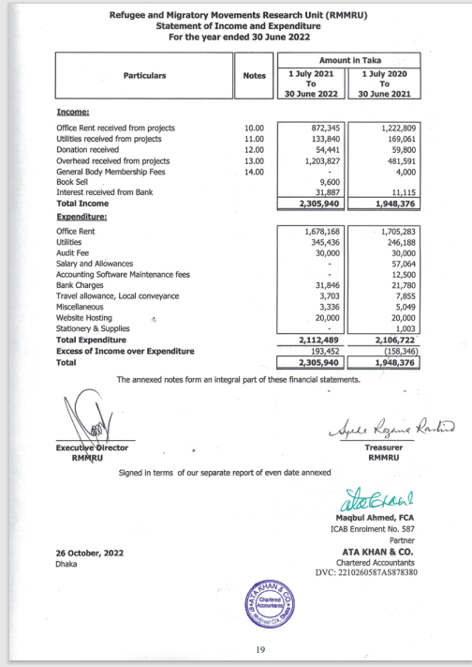

- Statement of Receipts & Payments:
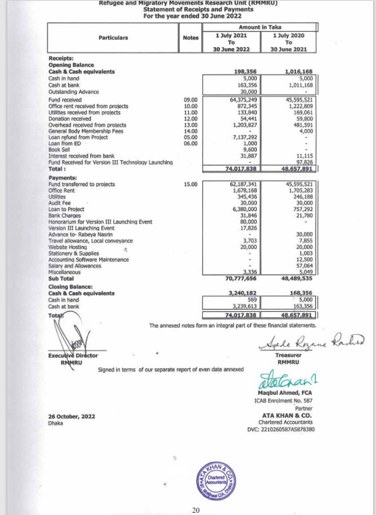

- Statement of Financial Positions:

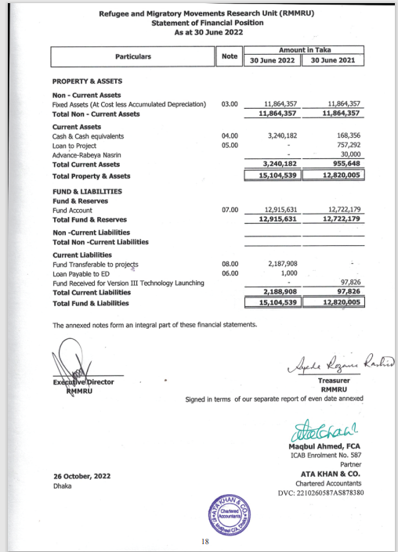
Industry Analysis

Specification of the Industry
In Bangladesh, there are many different types of NGOs. And, their work is different from one another. Some, well-known NGOs in Bangladesh: RMMRU, BRAC, CARITES, CARE Bangladesh, ASA Bangladesh, OXFAM Bangladesh, BURO Bangladesh, DRC Bangladesh etc. These NGOs work in different sectors. Like: BRAC work for social empowerment, education & health, etc. Like that, every NGO works in its field. In this report, The NGO is RMMRU. RMMRU mainly work on research and Project. This research and project are based on refugee & migratory movements. RMMRU also works for refugee & migratory rights (Siddiqui, Sultana, Sultana, & Akhter).

Size, Trend, and Maturity of the Industry
RMMRU is a well-known NGO in Bangladesh. It was established in 1995. They are working for refugees & migrant people. In Bangladesh, RMMRU works in different districts and rural areas. Their sub-offices are Cumilla, kisorganj, Tangail, and many other cities. In the future, they will open more new offices in other districts. In the Refugee and migration sector, RMMRU has worked very well from the beginning. On the other hand, The Danish Refugee Council (DRC) also works for refugee people. They started their operation in Bangladesh in 2014. They mainly work for the Rohingya population in Cox’s Bazar Bangladesh. RMMRU & DRC both work for refugees but RMMRU is well established because RMMRU work Bangladesh since 1995. RMMRU also has some competitors: Danis Refugee Council Dhaka, Norwegian Refugee Council Dhaka, IOM Bangladesh, Care Bangladesh etc (Sikder, 2008).

CHAPTER THREE: METHODOLOGY
This report has been organized based on experience gained during the period of internship. Information has been collected from primary as well as secondary sources.

Primary Data:
Data has mostly been gathered through correspondence with staff members who operate at various desks.

Secondary Data:
Numerous reading materials, including circulars, brochures, and annual reports are considered secondary sources.
The following sources were used to compile the data & information needed to complete the report:
- Annual reports.
- Web sites.
- Files & documents of RMMRU.

CHAPTER IV: INTERNSHIP EXPERIENCE

Introduction to NGO
An NGO is a group of people providing services without concern for profit, but only to help those in need in society. Raised funds for the non-profit organization by members, contributors, or foreign donations. Donations and achieving social goals including providing education, financial aid to the needy access to health care, and addressing other social issues are other ways that NGOs collect money.(Karns, February 21, 2023). An NGO is created for the benefit of the people and the country. Donations come from the govt. and contributors who want to support society are the main source of funding for an NGO. The NGOs keep records of all incoming and outgoing financial transactions. To ensure that the Donors can rely on the reports, the NGO can also have the book inspected for their benefit by an impartial auditor. NGOs are required to file income tax fillings tax filings as well.

NGO Audit
An organization that runs its charitable efforts on donations from the public is known as a non-profit organization (NGO). Therefore, the NGO must prepare financial statements and accounts to demonstrate its performance to the broader public. NGOs may be incorporated as a corporation under the 2013 Companies Act, a public trust under the Trust Laws or Societies Registration Act, or both. For the Chartered Accountants (CA) to audit the NGO's books of accounts, a foreign donation is required. Depending on the type of registration used, an NGO has its financial records audited by the incorporation law. The Trust Act, Societies Act, Companies Act, or Income Tax Act are followed when conducting the audit (Haryani & Pranoto, 2012; Hasan & Chakraborty, 2011; Hasan et al., 2020).

Benefits of Audit for NGOs
- The audit assists the NGO in demonstrating the accuracy and integrity of its financial statements and operating procedures.
- An auditor is also used by the NGO to look into certain issues.
- The NGO receives insightful guidance from auditors on financial issues and controls.
- An audit gives the NGO the chance to use the auditor’s knowledge.

Types of Audits for the NGO
There are 4 types of NGO’s Aduit.
- External Audit
- Internal Audit
- Donor Audit
- Investigative Audit

External Audit:
The external audit is carried out by a neutral external auditor. By reviewing samples of the records, such an auditor provides a qualified opinion on the fairness and reliability of the financial accounts. The auditor’s view is crucial in establishing a body of evidence attesting to the veracity and accuracy of financial reports.

Internal Audit:
The NGO’s officers, other employees, or any professional specifically hired for the audit carry out the internal audit. An internal audit is used to verify the policies and practices of the NGO.

Donor Audit:
The donor audit is carried out by either the donor themselves or any NGO external auditors. This assures contributors that their contributions are properly used.

Investigative Aduit:
When an NGO suspects a problem, an investigative audit is conducted, and the auditor is expected to find and look into all the basic and secondary facts.

RMMRU Internal Audit Practice
RMMRU is a well-known research-based & project-based NGO in our country. They work for refugees & migrant people. Because it’s a project & research-based that’s why they get many foreign funds from different countries. So, when the research & project end the foreign country who gave the fund, wants the details about where their fund was used. The donor sends some auditors to audit the whole fund thing. They do the external auditing. Before an external audit, the accounts office needs internal auditing. RMMRU doesn’t hire any internal audit team. They create their internal audit team from the account’s office. The audit committee head is “Accounts & Finance Coordinator”.

Audit Committee Structure

Executive Director

Accounts & Finance head

Audit officer 1 Audit officer 2 audit officer 3

RMMRU follows this structure. They create their internal audit team & when the organization head approves the team, they start their internal audit. But The committee needs to follow some rules (Hasan, Molla, & Khan, 2019; Hasan & Rahman, 2019).

Rules need to follow the committee:
- The Board is responsible for appointing the audit committee.
- There is at least one member who is qualified to assess the accuracy of the budget & financial statements due to their knowledge & experience.
- Along with the members of the organization’s governing body, the audit committee consists of at least three to five members.
- Members of the committee have a variety of professional backgrounds and areas of expertise.

During this Internship period at the Refugee & Migratory Movements research unit, in Dhaka. Work as an Accounts intern.

Duties & Responsibilities:
- Assists in banking transactions (writing deposit slips, preparing the letter for collecting bank statements, etc.)
- Assists in VAT & TAX challan preparation.
- Attach revenue stamp & pain seal where applicable.
- Bill check of purchase.
- Scan & photocopy of bills & other documents of the respective project.
- Check different types of Vouchers (Journal, Payment, Receipt, Contra, Payroll voucher)
- Check the acknowledgment receipt.
- Check Debit and credit vouchers.
- Reconciliation Statement.
- Work on Tally Prime gold.

As an Intern
Internship at RMMRU on August 1 and finished on October 31. Selected for the accounting department. Supervisor has been teaching him what will be the main job and how to do the work since the first day. He introduced him to each department and gave a brief overview of each one’s responsibilities. Which department is in charge of which kind of task? How a transaction initiates a process and how it is completed? One of his main duties was to review each project accounts file and the real procedure. Return the paperwork to the accounts department if it doesn’t carry out all the steps correctly. Supervisor gave training that which things needed to be follow for which project because each project has different rules.

Finally, as part of the goal of the internship, they gave him some more duties. We have always believed that no one can learn high-quality values without working hard. It might be able to bring some more value and benefits as build our skills for their given work. For the internship, Internship's main responsibility was:
- Assists in Banking transactions (writing deposit slips, preparing the letter for collecting bank statements, etc.)
- Assists in VAT & TAX challan preparation.
- Attach revenue stamp & pain seal where applicable.
- Bill check of purchase.
- Scan & photocopy of bills & other documents of the respective project.
- Check different types of Vouchers (Journal, Payment, Receipt, Contra, Payroll voucher)
- Check acknowledgement receipt.
- Check Debit & Credit voucher.
- Reconciliation Statement.
- Work on Tally Prime gold.

Check Voucher:
The supervisor presented with a different Voucher bill on the first day of work. He told that only just check the vouchers and see how it made & whose signature was there. The First Two/ Three days just review the different types of Vouchers, like Journal Vouchers, Payment Vouchers, Receipt Vouchers, etc. Then, He gave some new files & asked to check all of the signatures that were required to approve the voucher. If there is any signature missing, then he told him to inform him. First, it was a bit hard for him to understand the whole procedure but after a while, it was easy for him & checked many vouchers within a very short time.

Attach revenue stamp & paid seal where applicable:
During the internship period, the Supervisor told when to check the bills of the organizations. If there any bill’s amount was above 500 takas. Then the bill will need a revenue stamp. And, seal a paid seal. So, when checking the organization's different purchase bills give them a paid seal and also see if the amount is above 500 takas, then attach a revenue stamp.

Scan & Photocopy:
Sometimes few papers need to be scanned & Photocopy. So, it was scanning and photocopying the papers & other documents.

Work on Tally Prime Gold:
In tally prime gold software used in the account’s office. During the internship period, worked on that software to enter the data. In the University AIS course, he learned Tally ERP 9. During the Internship One day work on Tally Prime Gold to help the supervisor enter the data. It was quite similar to Tally ERP9.

VAT & TAX:
Internship period, check proper calculation of VAT and tax challan. Sometimes, prepared Cahalan. During the internship period, worked with the HELVETAS – SIMS, SIMS, VITAL SIGNS, TIM project. Checking their all-accounts-related documents. And if any documents are missing then inform the supervisor.

DEBIT VOUCHER:
During internship period, made debit voucher. In NGO enclose with Debit vou8cher: Top sheet, log book, check copy, conveyance sheet, purchase requisition, bill copy, VDS challan (311), TDS challan (111).

PAYMENT VOUCHER:
During internship time when creating a payment voucher here need some supporting for evidence base. So, when something was bought by NGO, we enclose with payment voucher: purchase requisition, cash memo/bill, and goods received note.

CHAPTER FIVE: CONCLUSIONS & RECOMMENDATIONS

Conclusion
RMMRU is one of the growing NGOs in Bangladesh. They work for Refugee and Migratory people’s rights. In this report he talks about the RMMRU internal audit system, and how they do their internal audit. They said in NGOs there are different types of audits. Like: Donor Aduit, Internal Audot, External Audit etc. They also said they do not have hired any people for internal audit. They do their internal audit by their own accounts people. They create an internal audit committee and do their internal audit when they need. They also said, that when a donor audit needs the donor send someone and they do the Donor Audit. During the internship, He work for internal audit. This internship period he done two projects internal audit and help one doner audit. Lastly, he said as an emerging NGO RMMRU is doing a great and he feel proud to get a chance and worked with this NGO and its personnel. He wished that RMMRU will be one of the leading NGO within a few years.

Recommendation
- Note down the internal audit findings.
- Identify the root level problem.
- Time to Time ready the audit file.

REFERENCE
Haryani, E., & Pranoto, T. (2012). A PROPOSED-INTERNAL AUDIT MODEL FOR NGO IN INDONESIA:(STUDY ON CHILDREN DEVELOPMENT CENTER-SALATIGA CLUSTER). Researchers World, 3(3), 60.

Kamat, S. (2017). The privatization of public interest: theorizing NGO discourse in a neoliberal era. In Social Movements (pp. 263-288). Routledge India.

Refugee and Migratory Movement Research Unit, Dhaka. [ Online] Available at: https://www.rmmru.org

RMMRU. (2022) Annual report January to June. RMMRU. https://www.rmmru.org

RMMRU. (2021) Annual report. RMMRU. https://www.rmmru.org
https://www.britannica.com/topic/nongovernmental-organization/additional-info#history

Cazenave, B., & Morales, J. (2021). NGO responses to financial evaluation: auditability, purification and performance. Accounting, Auditing & Accountability Journal, 34(4), 731-756.

Haryani, E., & Pranoto, T. (2012). APA. Indonesia: Researchers World.

Hasan, M. T., & Chakraborty, M. (2011). Evaluation of Auditors' Compliance with ISAs: Evidence of Bangladesh. hypothesis, 21.

Hasan, M. T., Molla, M. S., & Khan, F. (2019). Effect of board and audit committee characteristics on profitability: Evidence from pharmaceutical and chemical industries in Bangladesh. Finance & Economics Review, 1(1), 64-76.

Hasan, M. T., & Rahman, A. A. (2019). Conceptual framework for IFRS adoption, audit quality and earnings management: The case of Bangladesh. International Business and Accounting Research Journal, 3(1), 58-66.

Hasan, M. T., Rahman, A. A., Sumi, F. R., Chowdhury, A., & Miraz, M. (2020). The moderating role of audit quality on the relationship between IFRS adoption and earnings management: Evidence from Bangladesh. International Journal of Mechanical and Production Engineering Research and Development (IJMPERD), 10(03), 9141-9154.

Karns, M. P. (February 21, 2023). Britannica.

Mohabbat Khan, M. (2003). Accountability of NGOs in Bangladesh A critical overview. Public Management Review, 5(2), 267-278.

Siddiqui, T., Sultana, M., Sultana, R., & Akhter, S. RMMRU.
Sikder, M. J. U. (2008). Bangladesh. Asian and Pacific Migration Journal, 17(3-4), 257-275.

