Social Media Marketing and Employee Branding: An Internship Experience at iSmartu Technology Bangladesh Ltd.

Farjana Tanzim
111 221 016

This report is submitted to the school of Business and Economics, United International University as a partial requirement for the degree fulfillment of Bachelor of Business Administration

Social Media Marketing and Employee Branding: An Internship Experience at iSmartu Technology Bangladesh Ltd.

School of Business and Economics
United International University

SUBMITTED TO
Dr. Seyama Sultana
Professor
School of Business & Economics (SoBE)
United International University (UIU)

SUBMITTED BY
Farjana Tanzim
111 221 016
Course Code: INT 4399
Registration Trimester: Fall 2025
Major: Marketing

Date of submission:

Letter of transmittal

28 February 2025
Dr. Seyama Sultana
Professor
School of Business and Economics (SoBE)
United International University

Subject: Submission of the Internship Report
Dear Ma’am,
It is hereby submitted to you with the kind perusal of your report, which is entitled the Social Media Marketing and Employee Branding. Your instruction has been the greatest advantage to me, of which I am grateful. I used the advice of my company supervisor as I worked on this report.
It has been an amazing experience working at Ismartu Technology Bangladesh Ltd. I believe that my new skills and knowledge gained during the internship will be incredibly useful in my further career activities. I do hope that you will peruse this report and make your comments with wisdom. I would be very pleased if my report provided you with a better understanding of the problem and related information.

Sincerely,
Farzana Tanzim
ID- 111 221 016
Program: BBA
Major: Marketing

Certification of Similarity Index

Declaration of the student

As the author of this internship report, Social Media Marketing and Employee Branding: An Internship Experience at iSmartu Technology Bangladesh Ltd., I, Farjana Tanzim, accept the responsibility for myself for the work presented herein.
All the data and information included in this report were gathered and analyzed through my direct involvement and participant observation over the course of my internship period, which lasted three months. I do hereby declare all facts and findings presented in this study are true and relevant and reflect the practical experiences obtained as a member of the HR Culture Team at the iSmartu HR Center of Excellence (COE).
Every bit of info has been included with the rightful consent and authorization of the organization. Additionally, I verify that no content from any other source or website has been directly copied or shared without giving proper citations for the original author.

Corporate Evidence

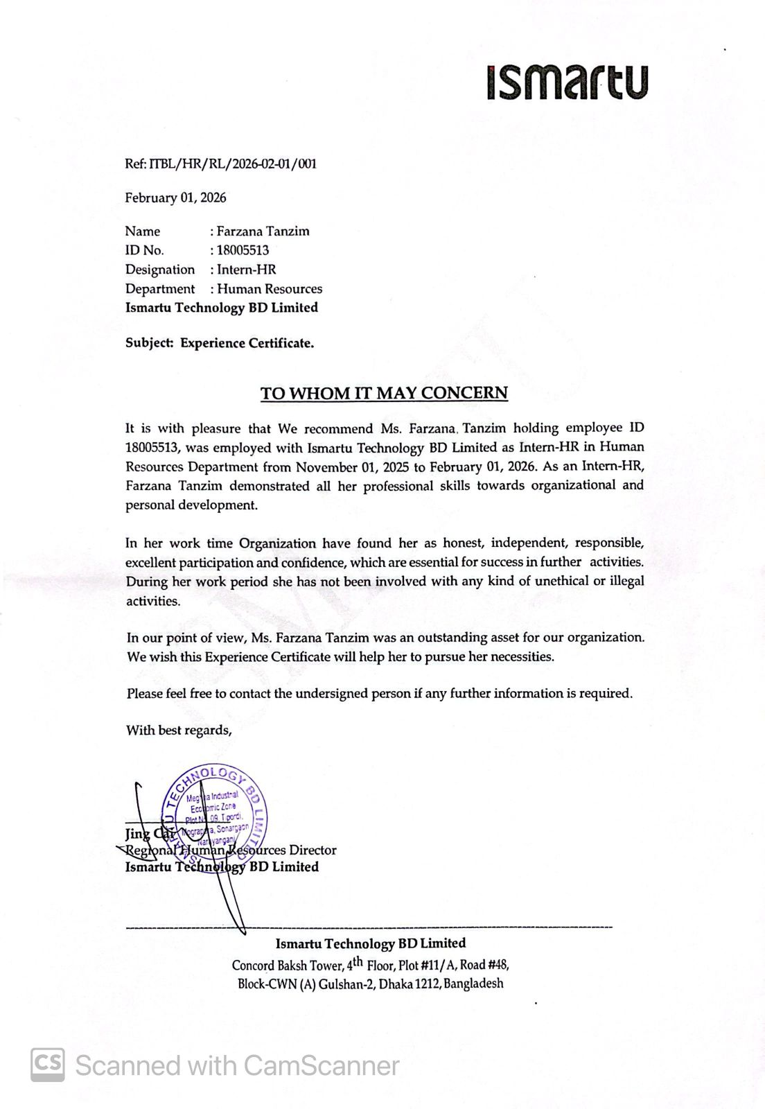

Acknowledgement
To begin with, I would like to state that I am so grateful to Almighty Allah who gave me the drive, patience and capacity to complete my BBA program and come up with this internship report within the time frame given.
This report is the result of my constant working, studying, and the help of numerous people who advised and motivated me on my way. The report would not have been done in its current shape without their cooperation and useful advice.
I would also like to express my most heartfelt gratitude to my academic supervisor, Dr. Seyama Sultana, Professor, School of Business and Economics (SoBE), United International University (UIU) and his continual guidance, valuable feedback, and constructive advice. The way he supported me even at the initial stages of my internship report made me remain on the right track and enhance the overall quality of my work.
I equally thank my highly esteemed peers and bosses at iSmartu Technology Bangladesh Limited who provided me with a chance to work with them as well as shared their practical knowledge and experiences. Their support and motivation to collaborate, as well as professional assistance, enabled me to appreciate the practical corporate world and add to my learning process.
Lastly, I would like to express my appreciation to all those who in one way or another helped to complete this report with success.

Table of Contents

Letter of transmittal iii
Certification of Similarity Index iv
Declaration of the student v
Corporate Evidence vi
Acknowledgement vii
List of Abbreviation x
Executive Summary xi
Chapter 1: Introduction 1
1.1 Background of the report 1
1.2 Objectives of the Report 2
1.3 Rationale of the Report 3
1.4 Scope and Limitations of the Report 3
1.5 Data Collection Method 4
1.6 Definition of Key Terms 6
Chapter 2: Company & Industry Profile 8
2.1 Company Analysis 9
2.1.1 Overview and History 9
2.1.2 Trend and Growth 10
2.1.3 Product / Service / Customer Mix. 11
2.1.4 Company Operations / Activity 13
2.1.5 SWOT Analysis 14
2.2 Industry Analysis 15
2.2.1 Specification of the Industry 16
2.2.2 Industry size, Trend and Maturity 17
2.2.3 Industry SWOT Analysis 19
Chapter 3: Internship Experience 22
3.1 Position, Duties, and Responsibilities 23
3.2 Training and Development 27
3.3 Contribution to Organization/Operations 29
3.4 Evaluation 30
3.5 Skills Applied 30
Chapter 4: Conclusions and Key Facts 31
4.1 Recommendations 32
4.2 Key Understanding 32
4.3 Conclusion 33
References 34
Appendix-A: 35
Appendix-B: 37

List of Abbreviation

HR COE | HR Center of Excellence
SMM | Social Media Marketing
ODM | Original Design Manufacturer
LLD | Learning, Leadership, and Development
ICT | Information and Communication Technology
R&D | Research and Development
EVP | Employer Value Proposition

Executive Summary

The internship report is a detailed report about my field experience with the iSmartu Technology Bangladesh Limited, and I got a chance to work in a vibrant and technology-oriented business organization. The main aim of this report is to narrow down the conceptual gap between theoretical understanding acquired in the BBA program and practical aspects in an organization.
In the process of my internship, I was introduced to different operational and coordination processes that provided me with an improved knowledge of the workflow in companies, cooperation within teams, and professional communication. I monitored the way iSmartu Technology Bangladesh Limited provides technology-based solutions and handles their relationships with customers within a competitive market. The experience enabled me to acquire key professional attributes, including time management, problem-solving, flexibility, and detailing.
The report will also contain the company profile, industry analysis as well as SWOT analysis to determine the present state and the prospects of the organization. Based on the analysis, it is seen that iSmartu Technology Bangladesh Limited has high growth potential because of rising digitalization rate in Bangladesh. Nonetheless, the threats that the company also must deal with are high competition rates and the fast pace of technological development.
Generally, it was a good learning experience that has enhanced my theoretical and applied competencies. Experience has equipped me better in my future job in the corporate world, especially in those jobs that need analytical skills, coordination and communication

Chapter 1: Introduction

1.1 Background of the report
In the contemporary corporate world of Bangladesh, the convergence of digital communication and corporate culture has emerged as an important strategic asset. As the Smartphone market is entering a phase of early maturity having moved out of the growth stage, companies such as iSmartu Technology Bangladesh Ltd must differentiate not only by product but by their reputation as employers. This report, called "Social Media Marketing and Employee Branding," examines how these two pillars work in support of the company's manufacturing and operational excellence.
The digital transformation in Bangladesh has resulted in a boom in the use of the internet and social media platforms, which have become the main platform for the interaction of consumers as well as attracting talent. For iSmartu, which produces devices for some major brands such as TECNO, Infinix and itel, social media marketing is a dual-purpose tool. While this drives sales in a market where prices are critical, it is also the basis for the process of Employer Branding - the process of positioning the company as a "vibrant and technology-oriented business organization" to attract and maintain high-quality talent.
This report is based on a three-month internship in the HR Culture Team at iSmartu's HR Center of Excellence (COE). During this time, emphasis was laid on the use of internal and external communication to close the gap between corporate goals and employee experience. By applying marketing principles to the HR functions, for example, by designing social media content for the SmartGen internship campaign and cultural events like Winter Fest, the organization builds a narrative of innovation and inclusivity. Therefore, this background sets up the fact that employee branding via social media is no longer an administrative luxury but a necessity in maintaining a competitive edge in the high growth electronics industry.

1.2 Objectives of the Report
The main goal of this report is to analyze the real-life application of social media marketing and employer branding in HR Culture department of iSmartu Technology Bangladesh Ltd. The specific objectives are described as follows:
To understand the role of Social Media Marketing in Employer Branding: To explore how the process of digital content creation and social media campaigns such as SmartGen internship advertisements have helped to develop a positive image of the organization.
To assess the Employee Engagement in the form of Cultural Activities: To record and analyze the planning and implementation of important corporate events, such as the New Year Celebration and Winter Fest, as means of improving workplace motivation.
To bridge the gap between Theory and Practice: To apply theoretical knowledge acquired during BBA program to the operational and coordination processes of technology-oriented business organizations.
To evaluate HR Operations and Talent Pipelines: To learn about the role of the recruitment support functions such as CV shortlisting for the SmartGen program and how they fit into shaping long-term recruitment objectives.
To analyze the Industry and Company Positioning: To perform an in-depth SWOT analysis of iSmartu and the industry of smartphones in Bangladesh to understand the external factors that are affecting corporate strategy.
To identify Professional Development and Skills: To reflect on the technical and soft skills learned during the internship, such as proficiency in corporate communication, event management and data tracking skills.

1.3 Rationale of the Report
The reason for this report is the need to capture the change from academic theory to the professional realities of the corporate world. As the smartphone business in Bangladesh becomes more competitive and price conscious, companies like iSmartu Technology Bangladesh Ltd must rely on more than just manufacturing efficiency - they must develop a sustainable employer's brand to attract and retain the best talent.
The following are the key reasons for conducting this study:
Strategic Importance of Branding: In a market where fast technological development and competition is high, knowledge relating to how social media marketing is branding employees is important to the growth of organizations.
Operational Insight: It is a detailed analysis of the contribution of HR functions like HR COE in building their culture in the organization through event management and internal communication.
Professional Validation: The report provides the development of some of the skills required in the corporate world such as data management in Excel software, professional presentation designing and stakeholder coordination, which are indispensable to have a future career in the corporate world.
Industry Analysis: With an analysis of the role of iSmartu as an affiliate of Transsion Holdings, the report gives a pragmatic insight into the way local manufacturing entities are dealing with global supply chains and government policies in Bangladesh.

1.4 Scope and Limitations of the Report
Scope of the Report: The scope of this report is focused on the internship experience for three months at iSmartu Technology Bangladesh Ltd. between November and January. It focuses specifically on the activities of the HR Culture Team in the HR COE. The report focuses on the following areas:
Employer Branding & Communication: Study of social media content creation for social media such as Facebook and internal communications strategies used to promote company culture.
Event Management: Comprehensive written documentation of planning and execution of the engagement programs for employees New Year Celebration and a Winter Fest.
HR Operations: Introduction to support the SmartGen Internship Program, CV shortlisting and candidate database management.
Organizational Analysis: A study of the manufacturing operation of iSmartu, product mix (TECNO, itel, Infinix) and their position in Bangladeshi smartphone industry.
Limitations of the Report: Despite attempts to give a thorough analysis, some limitations were faced during the preparation of this report:
Time Constrain: The time constraint of the internship was limited to three months, which may not be enough to see the long-term impact of employee branding initiatives.
Confidentiality: Because of corporate policy and the sensitive nature of information contained in HR related data, some strategic financial information or specific employee personal information could not be disclosed in the report.
Limited Access to Strategic Analytics: As an intern, exposure was mainly at the level of operational execution as opposed to high level strategic HR analytics.
Narrow Departmental Focus: The report is very limited to the departmental functions of the HR and marketing-related branding areas and does not include much in-depth information on the technical processes of manufacturing or the operations of the factory floor at Narayanganj.
Reliance on Secondary Data: Due to the availability of company records and secondary observations, some of the knowledge of industry analysis and market trends is based on secondary data, which is not conducted in an exhaustive way.

1.5 Data Collection Method
To ensure the accuracy and reliability of the report, a combination of both primary and secondary data collection methods was utilized. This approach enabled to get a complete analysis of the relationship between social media marketing and employee branding at iSmartu Technology Bangladesh Ltd.
- Primary Data Collection
Participant Observation: Being actively involved in the day-to-day activities of the HR Culture Team and the HR COE gave me insight into corporate workflows and employee engagement strategies.
Practical Involvement: Hands-on experience of designing social media content for the SmartGen internship campaign and internal communications enabled a practical understanding of branding techniques.
Event Coordination: Managing and executing cultural events e.g. the New Year Celebration and Winter Fest - qualitative data was provided on employee motivation and organizational culture.
Internal Documentation: Maintaining and updating HR tools, such as the Annual Cultural Calendar and training trackers in Excel, provided operational data used throughout the report.
- Secondary Data Collection
Company Records: Internal manuals, official email communications, and previous HR activity reports were reviewed with the goal of understanding established policies and branding standards.
Official websites - the company's social media pages Information on parent company Transsion Holdings and brands, such as TECNO, Infinix, and itel was gathered from official websites and social media pages.

1.6 Definition of Key Terms
To get better clarity of various concepts discussed in this report, the following important terms are defined in the context of iSmartu Technology Bangladesh Ltd and Mobile manufacturing industry:
Employee Branding (Employer Branding): The process of positioning an organization as an "employer of choice" by promoting its unique culture, values and work environment to current employees as well as potential / future candidates.
Social Media Marketing (SMM): The process of using social media platforms, such as Facebook, to design and publish compelling content designed to engage an audience and promote company events and create brand awareness.
HR Center of Excellence (HR COE): A special group within the Human Resources department that specializes in high-level strategy and best practices in certain areas such as organizational culture and talent development.
HR Culture Team: A sub-unit of the HR department, a team responsible for managing engagement, internal communication, and organizational traditions to create a positive atmosphere in the workplace.
SmartGen Internship Program: A talent pipeline program taken up by the company to attract and shortlist and train young professionals bridging the divide between the learning on the formal curriculum and the actual practice in the corporate world.
Original Design Manufacturer (ODM): Business model where a company (like iSmartu) designs and manufactures products which are eventually rebranded by another firm to sell the products; recently used in the exportation of iSmartu's tablet projects.
Transsion Holdings: Parent company of iSmartu and a global technology company behind brands such as TECNO, itel, and Infinix that are active in the emerging market.
Employee Engagement: The extent to which an employee is committed and involved with their company, which is often increased by cultural events such as Winter Fest or New Year celebrations.
Learning, Leadership, and Development (LLD): An area of functionality within the HR department focused on building technical and professional skills of the workforce through organized training and tracking.



Chapter 2: COMPANY & INDUSTRY PROFILE

2.1 Company Analysis
iSmartu Technology BD Ltd. serves as a prominent manufacturing and assembling entity within the Bangladeshi technology sector. As an affiliate of the China-based international firm Transsion Holdings, the company leverages global expertise to provide high-quality, affordable smart products to the local market.

2.1.1 Overview and History
Established in 1979, iSmartu has evolved into a major manufacturing base in Bangladesh, specifically designed to capture the rapidly expanding domestic smartphone market. The company operates a contemporary production plant in the Meghna Industrial Economic Zone, Narayanganj, representing a significant investment of approximately USD 22 million. This facility spans over 22,000 square meters and adheres to international production and safety standards. While initially focusing on local assembly, the company is strategically shifting toward a global export model, evidenced by its 2025 regulatory permit to produce tablets for the US-based brand DrKumo.
Strategic Purpose:
Bangladesh has been chosen as the strategic market due to:
- Large population (170+ million)
- Increasing smartphone penetration.
- Increasing need for low-cost smart devices.
- Digital transformation in government.
The company leadership on several occasions has emphasized on the south Asian region of Bangladesh as a key growth centre.
Recent Development:
In 2025, the tablets were received by iSmartu with a regulatory permit to produce tablets under an ODM model based on the DrKumo brand of the US with the sole purpose of exportation. This represents the trend of the company towards the global export assembly rather than the local assembly.

To put it in simple terms, iSmartu began as a local production branch of Transsion brands, but it is slowly transforming into a manufacturer of smart devices that are intended to be exported.

2.1.2 Trend and Growth
The expansion of iSmartu Technology BD Ltd. is directly attached to the expansion of the markets of smartphones and digital devices in Bangladesh in general. In the last ten years, there has been a high rate of digital transformation in Bangladesh. The use of the internet has gone up, online learning has risen, mobile banking has risen and the use of social media has become commonplace. All these developments resulted in more demand for smartphones and smart devices.
Bangladesh had extensively been relying on imported smartphones when iSmartu entered the market. Many of the devices were costly due to importations fees. Policies that promoted local production of electronics were later introduced by the government. This change in the policy provided a chance to local production by such companies as iSmartu.
To begin with, the firm specializes in assembling smartphones with imported components. In the initial phase, the capacity of production was average. Nonetheless, with the rise in demand and popularity of the brand, the company had to put into place more production lines and employees. The factory is currently able to manufacture about one million mobile phones a month. This capacity is huge, meaning that there will be a high expansion of operations soon.
Diversification is also another key strength in the growth of the company. iSmartu initially focused on manufacturing low-end smartphones. It later ventured into devices of the middle range and intelligent accessories. The company has recently ventured into the tablet production industry, especially to the export markets. This shift of single-product focus to diversified production is a sign of strategic maturity.

Creation of jobs is also a major growth indicator. The factory has been able to generate thousands of direct and indirect jobs. Advanced manufacturing machinery has been trained by local technicians, engineers and production workers. This does not only favor the growth of a company but also leads to the development of industrial growth at the national level.
Strategically, iSmartu is slowly changing its operational strategy whereby it is doing simple assembly but a notch higher in value. The shift towards ODM export production implies that the company seeks to become more integrated in the global supply of electronic products.

2.1.3 Product / Service / Customer Mix.

Product Mix
iSmartu Technology BD Ltd. manufactures and assembles various electronic products that are smart. It has a diversified product mix with a variety of brand names belonging to its parent company.
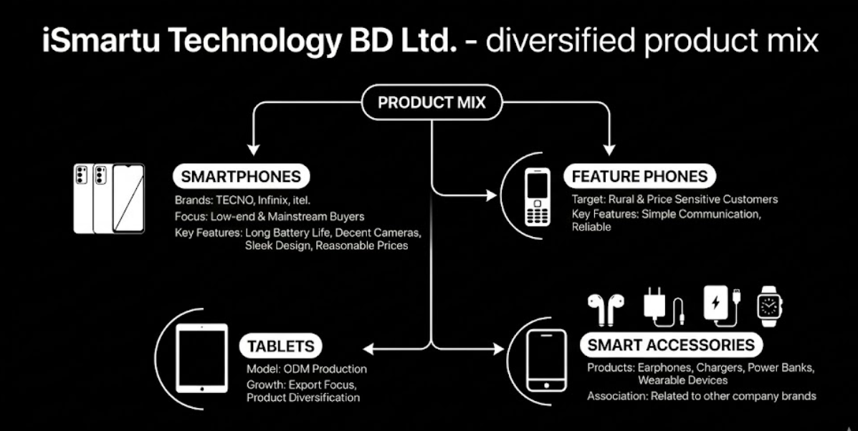
The key product segments are:
Smartphones: The top part of the production comprises smartphones in the name of TECNO, Infinix, and itel. These gadgets focus primarily on low-end and mainstream buyers. The phones will be built with convenient capabilities like long battery life, decent cameras, and sleek designs with reasonable prices.
Feature Phones: The company produces feature phones, in addition to smartphones. These phones have found their way into the hands of rural and price sensitive customers who like simple communication devices.
Tablets: The company has recently started production of tablets on an ODM model. This points to the shift towards export production and product diversification.
Smart Accessories: The company is involved in the manufacture and sale of smart accessories like earphones, chargers, power banks, and wearable devices, which are related to its other brands.
Service Mix
Even though iSmartu is primarily a manufacturing firm, there are various service activities indirectly supported by it including:
- Testing and certification of quality.
- Technical maintenance services.
- Distribution and logistics coordination.
- Partner network based after sales services.
The company also has its manufactured devices that are sold on the market after passing on international standards of quality.
Customer Mix
The iSmartu customer base can be categorized in a few segments.
Local Distributors: Authorized distributors of TECNO, Infinix and itel in Bangladesh are the main direct customers.
Retail Consumers: The primary end users consist of budget-conscious consumers, students, young professionals, and first-time smart phone customers.
International Clients: ODM manufacture has already seen the entry of international customers and overseas brands as a new customer base.
Most of the customers are price-sensitive market segments. Thus, affordability and cost-efficiency are still in the focus of the company strategy.

2.1.4 Company Operations / Activity
The iSmartu Technology BD Ltd. operations are aligned according to the efficiency of manufacturing, quality management, and supply chain management.
Manufacturing Process: There are various production lines at the factory. The process usually involves the following steps in manufacturing:
- Import of components
- PCB assembly
- Installation of screens and battery.
- Software installation
- Quality testing
- Packaging and labeling
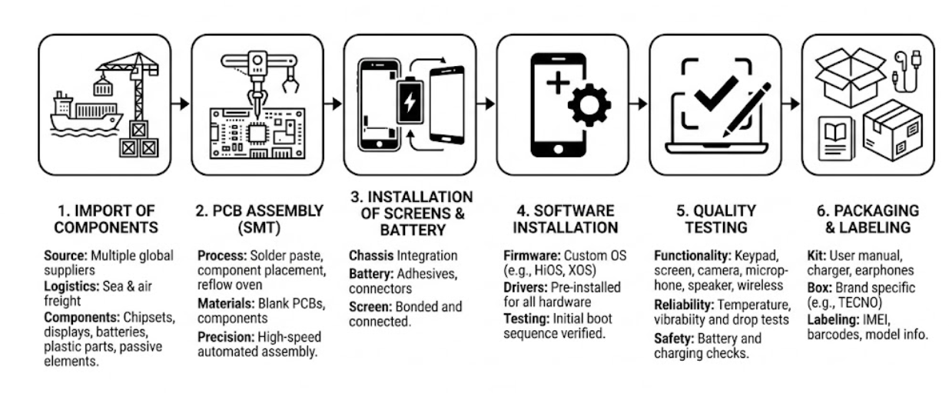
Every phase is subject to standardized procedures, which are aimed at consistency and safety.
Supply Chain Operations: The company runs the international supply chain network. A high number of components are brought in by foreign suppliers. These are further assembled in the region. Finished products are further extended to retailers and warehouses once they are produced.
Logistical management has been complexing with the change in the introduction of export operations. The company now must deal with domestic distribution as well as international shipment.

Quality Control: Quality control is a significant operations feature. Each device goes through several tests prior to being packed. Such tests can be battery performance testing, software stability testing and hardware inspection.
Human Resource and Training: The company has local engineers, technicians and workers. Consistent training sessions are held to enhance technical expertise and performance. The workplace standards and safety measures are upheld to have a productive working environment.
Compliance and Regulation: The company adheres to government rules regarding telecommunication, importation fees and electronic safety laws. Compliance facilitates smooth operations and also shields the company against the legal risks.

2.1.5 SWOT Analysis
Strengths
It has large support from Transsion Holdings, which is one of the strong points of iSmartu. This offers financial stability, technological knowledge and brand name. Another advantage of the company is the fact that the modern manufacturing infrastructure and large production capacity are present.
The other major strength is that it specializes in affordable devices. This is a good strategy to fit in with consumer demand since Bangladesh is a price-sensitive market.
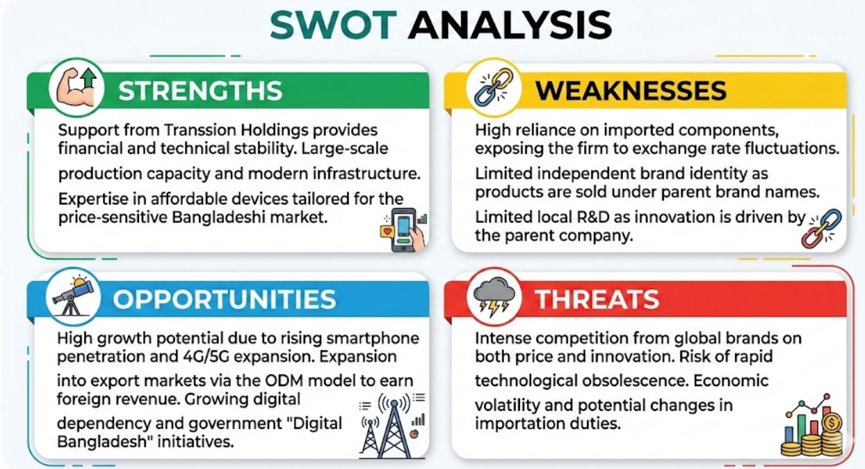

Weaknesses
One of the weaknesses is the reliance of imported parts. This exposes it to exchange rates fluctuations and disruption of global supplies. The company possesses minimal independent brand familiarity as well since most of the devices are distributed under different brand names.
On top of that, there is limited local research and development work since the parent company makes the key decisions related to innovation.
Opportunities
Digital transformation in Bangladesh has high growth potential. The rising smartphone penetration, growth of 4G/5G networks, and the growing population of the young population are long-term demand drivers.
Export production is also a good opportunity. After expansion of the ODMs, the company will be able to earn more foreign revenue and spread internationally.
Threats
The smart phone market is very competitive. Global brands are very competitive in terms of price and innovation. The danger of rapid technological change also exists since one can easily become outdated. Economic volatility, exchange rate fluctuations and changes in the regulations can also influence operations.

2.2 Industry Analysis
The future and performance of iSmartu Technology BD Ltd. are hugely determined by the state of the smartphone and smart devices market in Bangladesh. This industry has experienced a revolution in the last ten years because of a fast-paced digitalization, more people are now more online, and most people now rely on mobile technology to carry out their daily tasks like communication, education, banking, entertainment and even freelancing.

Bangladesh is today thought to be one of the brightest upcoming markets of Smartphones in South Asia. Massive population, the growing middle-income population, and the initiatives of the government towards developing a Digital Bangladesh have provided a good basis to continue the growth of the industry. The industry is also very competitive and is sensitive to economic and technological changes. Hence, an in-depth industry analysis is important to know the external environment that iSmartu is operating in.

2.2.1 Specification of the Industry
iSmartu Technology BD Ltd. is a company that is in the mobile handsets and smart devices manufacturing and distribution business, which is subsector to the overall Information and Communication Technology (ICT) and consumer electronics sector of Bangladesh.
High volume sales, high price competition, and product turnover are the major characteristics of the smartphone industry in Bangladesh. The budget and mid-range segment of the market is largely dominated by the budget segment compared to many other developed markets where a premium device prevails. Affordability, battery life, camera quality and sleek design are some of the key factors that most consumers attach their importance to as opposed to high branding.
The industry structure is characterized by several tiers of players. International brands like Samsung Electronics, Xiaomi, and Vivo are ranked first and offer competition to Transsion group products like TECNO, Infinix, and itel. There are also local brands like Walton and Symphony Mobile, which remain in the market, especially in the low-cost segment.
In this ecosystem, iSmartu will be a local manufacturer and assembler and allow Transsion brands to save on importation expenses, act quicker to market pressure and adhere to local government incentives to add domestically.
The other aspect that has served to characterize the industry is the dominance of offline retail channels. Despite increased e-commerce in Bangladesh, most smartphone purchases are done at the retail outlets. Before consumers buy their products, they tend to physically examine the device and hence the relationships with dealers and distribution networks become very crucial.
The industry may be said to be high-volume, price-sensitive, technology based and very competitive with efficiency of operations and market responsiveness as key success factors.

2.2.2 Industry size, Trend and Maturity

Industry Size
The market of smartphone in Bangladesh has grown very fast within the last 10 years. The country has a huge consumer base of smart devices as it has a population of over 170 million people and most of them have access to the internet using over 100 million internet users. The shipments of smartphones are in the millions every year, which means that the demand is high and stable.
The need for smartphones has also been enhanced by the growth of mobile financial services, online learning systems, use of social media, and freelancing. To many consumers, smart phones are no longer luxuries but necessities.
To businesses such as iSmartu Technology BD Ltd, the market is huge and the company is growing making it very promising to the company and therefore most in the competitive low-cost segment of smart phones, the demand is the highest.
Industry Trends
There are some critical trends that are defining the Bangladesh smartphone industry.
To begin with, the market is becoming more oriented towards value-for-money devices. Customers are getting educated and conscious of prices. Buyers are no longer interested in the brand prestige alone but specifications including RAM, battery capacity, quality of the camera, and the speed of the processor. The trend is highly biased towards those brands that can provide competitive attributes at reasonable rates.

Second, the market is dominated by the budget and mid-range segments. Most of the consumers in Bangladesh belong to the middle and lower-income segments, which instinctively leads to the demand targeted at the affordable smartphones. There are still premium devices that take up a rather small portion of the overall market.
Third, there is an increased local production and assembly. The government of Bangladesh has been promoting production locally by promoting it via tax incentives as well as policy encouragement. This has led to the establishment of several foreign brands, which have their assembly plants in the country. The movement decreases importation and assists in lowering retail prices. In the case of iSmartu, this trend is very applicable since the company has been able to make local manufacturing its main advantage.
Fourth, there is rapid technological development. The rapid charging tools, artificial intelligence cameras, gaming processors, and bigger batteries are also turning out to be the norm even in entry-level phones. In the meantime, 5G phones are slowly coming into the market, but it will not gain popularity until the development of the network infrastructure.
Fifth, it is observed that offline retail prevails over purchasing behavior. Even with the increase in online shopping, majority of consumers actually visit actual mobile shops. Purchase decisions are influenced by factors such as trust, product demonstration and installment facilities.
Industry Maturity
The smart phone market data of Bangladesh is at the late growth phase and shift to early maturity.
On the one hand, it is still growing as most of the users are moving away with feature phones into smartphones. Rural penetration is also on the increase. These reasons point to a potential continuous growth.
Conversely, the level of competition has been very stiff, and the metropolitan markets are slowly saturating. The budget segment also is making product differentiation more of a challenge. These pointers indicate that the industry is gradually transitioning to the maturity phase.
In the case of iSmartu Technology BD Ltd., it implies that the growth opportunities are open, but in the long-term, additional efficiency, differentiation, and technological adjustment are to be considered as the keys to success.

2.2.3 Industry SWOT Analysis

External Economic Factors
The economic climate of Bangladesh tends to favour the development of smartphone industries. An increase in per capita income, the middle-class growth, and the growth of digital financial services are all positive factors that promote the device demand. The measures that are taken by government to encourage digital connectivity also provide good conditions.
Nevertheless, macroeconomic pressures are still sensitive in the industry. Inflation has the potential of decreasing the purchasing power of the consumers particularly in the low-end markets. The fluctuations in exchange rates cause the price of the imported components to be high and this directly impacts the manufacturers such as iSmartu. Moreover, an increase or decrease in the importation duties or taxation policies may affect pricing policies within the industry.
In general, the economic situation is favorable but at the same time unpredictable, and the companies need to be cost-effective and flexible in their prices.
Technological Factors
The most dynamic force in smartphone industry is technology. This is due to the short life spans of products as innovation is very fast. Things that can be regarded as advanced features today might become standard one year later.
The major technological forces are the advancements in mobile processors, artificial intelligence technology cameras, battery optimization, quick charging protocols, and the slow deployment of the 5G network. Bangladesh consumers are being more tech-sensitive, particularly the young consumers who are more active in comparing specifications prior to buying.
In the case of iSmartu, it is imperative to keep up with the trends of technology. As the firm is cooperating with Transsion brands, its competitiveness is limited by the speed of integration of new technologies into the devices produced locally.
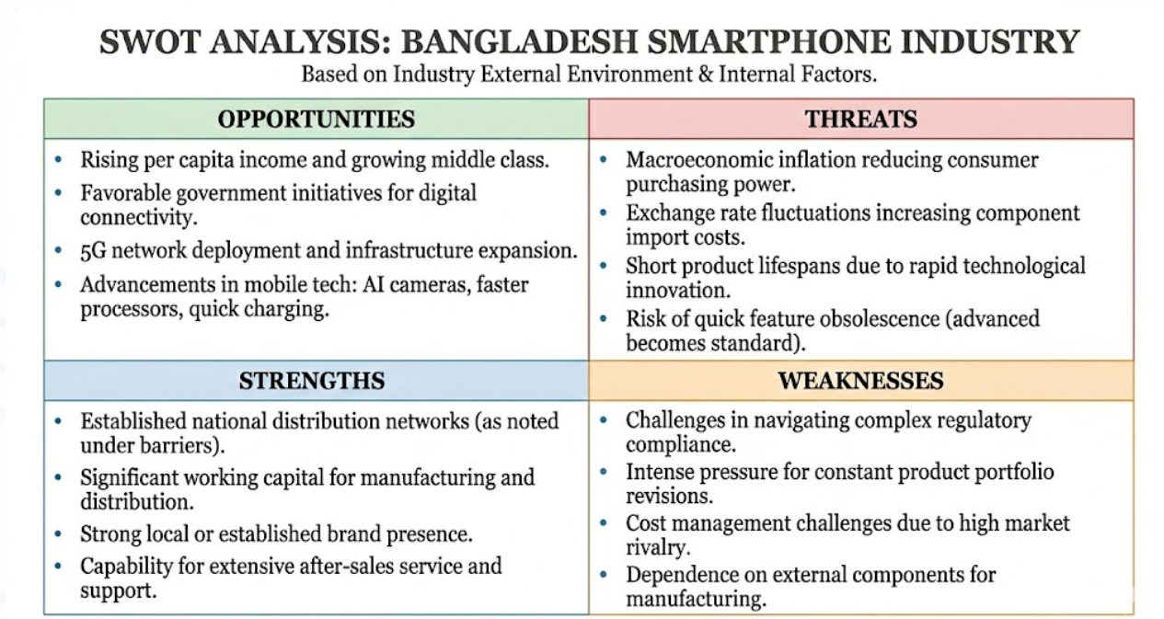
Barriers to Entry
The industry of smartphones in Bangladesh has medium entry barriers.
On the one hand, it is not difficult to become a small importer or distributor and enter the market. It is far more challenging to create a strong and sustainable position, however.
Major barriers include:
- Strong brand competition
- Large working capital requirements.
- Demand for national distribution channel.
- The expectations of after-sales services.
- Regulatory compliance
- Dealer relationship management.
Capital requirement and technology competency is another entry barrier to manufacturing players such as iSmartu. Thus, new entrants may emerge, but it is difficult to scale and get long-term profitability.

Threat of Substitutes
The smartphone industry has a moderate to low degree of the threat of substitutes. Smart phones are multifunctional gadgets that are applied in communication, education, entertainment, banking, and business. These functions can hardly be substituted by other devices.
The potential substitutes are feature phones, tablets and refurbished smartphones. Yet both possible solutions are limited. The feature phones do not have smart capability; tablets are not that portable and refurbished phones also have a problem with trust among the consumers.
With the growing levels of digital dependency in Bangladesh, smartphones are becoming a necessity product and no longer a needs gadget. This decreases the industry substitution risk.
Industry Rivalry
The smart phone market competition in Bangladesh is very high. There are many foreign and home-based brands that are competing fiercely in terms of price, promotions, product releases and incentives by dealers.
Brands Transsion, meaning TECNO, Infinix, itel, occupy good positions in the budget market, and such brands as Samsung, Xiaomi, Vivo, and Realme can compete at various price ranges. The other local brands like Walton and Symphony also pose a challenge especially in the entry level equipment.
The market is highly dynamic, which is caused by frequent model launches and low-price differences. The companies should always revise the portfolio of their products and have a good distribution network to stay competitive.
In the case of iSmartu Technology BD Ltd., such intense competition implies that operational effectiveness, cost management, and healthy channel relations are fundamental to maintenance in the market.

Chapter 3: Internship Experience

3.1 Position, Duties, and Responsibilities
It is a managerial role and will include planning and implementation of different projects that are critical to the organization.
In my undergraduate degree, an internship of three months offered through iSmartu Technology BD Ltd. in the Human Resources Department was assigned to me. I was working with the HR Culture Team in HR COE. My internship lasted between November and January where I was able to be exposed to a broad spectrum of practical HR and employee engagement practices.
This internship enabled me to appreciate the fact that contemporary HR functions go beyond the administrative role and contribute to employee experience, employer branding, and organizational culture. My job involves creative activity, coordination activities, and analytical support.
During the internship, my tasks may be divided into the following large areas:
Creation of Content in social media and Internal Communication: I have started my internship by working with the HR Culture department on the design and publication of internal and external communication materials. Among my main tasks was to develop compelling Facebook and internal communication posts that would be consistent with the events and observances of the company.
I made and arranged posts on several occasions, which included:
- International Men's Day
- Victory Day (16 December)
- Christmas celebration
- New Year celebration
- SmartGen internship campaign advertisements.
- Other internal awareness writing.
When writing these posts, I was required to be consistent with the brand, use the right tone, and make sure that the visual aspect met the company requirements. The given task allowed me to build a solid knowledge of employer branding communication and content design with audience in mind.
Cultural Event Management and Co-ordination: Other important activities that I was engaged in during my internship included employee engagement events such as the New Year Celebration and Winter Fest. Through these experiences, I was provided with practical exposure to actual corporate event management.
New Year Celebration: In the case of the New Year program, I participated actively in the planning, all the way to the end. My tasks involved coming up with various event material including:
- Gift stickers
- Planning of event cake designs.
- Food token design
- Customized notebook design
- Greeting cards
- Desk calendars
- Event backdrop
- Creatives of Facebook announcements.
In addition to the design work, I had to communicate with several internal and external parties. This involved negotiating with suppliers of gifts, negotiating printing prices, and on-time supply of supplies.
I kept tracking sheets regarding:
- Vendor follow-ups
- Printing status
- Material inventory
- Checklist of event preparation.
On the event day, I was able to assist the team in setting up the venue and checking the flow of the participants as well as hosting. I also assisted in dealing with last-minute changes and this experience taught me how flexibility is vital in event management.
Scenario of imaginary coordination: As an example, at the last week before the New Year event, there existed a risk of delay of the calendar delivery by a vendor. I took the initiative to make follow-ups, inform the others about the new schedule and organize a different printing process to make sure that the event does not get affected. This experience enhanced my ability to solve problems and manage stakeholders.
Winter Fest: In the case of Winter Fest program, my work was more of operation support and coordination. I assisted in:
- Event planning support
- Participant tracking
- Material organization
- On-site event monitoring
- Post-event documentation
These events taught me that the activities of employee engagement play a direct role as pertains to motivation of the workplace and organizational culture.
SmartGen Internship Program Support: The other significant task during my internship was to assist the SmartGen Internship Program which is a talent pipeline program of the company.
My contributions included:
- Shortlisting of CVs on predetermined conditions.
- Preliminary background checks on candidates.
- Helping to take the interns on campus tours.
- Enabling candidate database management.
During the process of screening CVs, I was taught how HR professionals assess the profiles of a candidate depending on their academic history, extracurricular activities, and cultural fit. This was an eye opener as I have learned quite a few basics of recruitment.
Support of Learning, Leadership, and Development (LLD): Within the LLD functionality, I helped the team with the execution and documentation training.
I was responsible for:
- Developing training materials drafts.
- Creating PowerPoint presentation training.
- Favoring logistics training.
- Keeping annual training tracking records.
- Helping with attendance and feedback compilation.
This excursion aided me in the realization of how planned and monitored learning interventions in corporate HR are organized.
Reporting and Administrative Support: During my internship, I used to prepare and maintain different HR reports and communication documents on a regular basis. My tasks included:
- Production of HR activity reports.
- Preparation and sending official email messages.
- Internal articles publication.
- Designing internal sensitization posters.
I also assisted internal security communication through the designing of awareness posters like:
- Earthquake safety community awareness.
- Red Line policy communication.
These assignments enhanced my writing skills and focus in professional writing.
Preparation of Cultural Calendar on a yearly basis: One of the most outstanding duties that I did was to help prepare and maintain the Annual Cultural Calendar. This calendar describes scheduled employee engagement activities of the year.
My work involved:
- Gathering event inputs among the stakeholders.
- Organizing the annual schedule.
- Creating visual layout
- Checking and monitoring event status.
- Maintaining the master file
Through this assignment, I have acquired strategic exposure to long-term HR planning as opposed to short-term execution work.
Industrial Attachment: Factory Visit: As part of my professional development and to better understand the scale of iSmartu's operations, I had an industrial attachment that consisted of a visit to the manufacture facility. This experience offered a pragmatic view of the core business of the company:
- Facility Overview: went to the modern plant situated in Meghna Industrial Economic Zone, Narayanganj, which is a USD 22 million investment.
- Operational Scale: Seeing the factory floor enabled me to appreciate the huge production capacity and it can produce about 1 million mobile phones per month.
- Manufacturing Process: I got an inside look into the manufacturing process with a first-hand view of stages such as the PCB assembly, installation of software, and stringent quality testing.
- The following are some of the topics highlighted during the visit: - Workforce Integration: The key role of Employee Branding was emphasized in a high-stake manufacturing context where thousands of local technicians and engineers receive training to international standards.

3.2 Training and Development
In my internship at the iSmartu Technology BD Ltd., I was given two formal training courses in technical training which enriched my professional skills greatly.
Training 1: Mastering of Microsoft PowerPoint:
This was training on high level presentation designing and corporate story telling. My PowerPoint skills were low prior to the training. By the end of the program, I was sure of the ability to develop professional corporate presentations.
- Mastered Emerging Technology.
- Morphic change to facilitate visual narration.
- Slide master customization
- Complex picture formatting.
- SmartArt transformation
- Individual sequencing of animation.
- Interactive slide Zoomable.
- Gradients and transparency.
- Integration and visual hierarchy of icons.
- Infographic slide design
- Section zoom navigation
- Optimization of presenter views.
Application: I used these methods when I was making training material and internal presentations to the HR team.
Training 2: Learning how to use Microsoft Excel: This training was aimed at data processing, reporting effectiveness and analysis capabilities.
- Complex Excel Functions mastered.
- High-end Excel Functions Mastered.
- Data Functions
- SUM
- AVERAGE
- COUNT / COUNTA
- MAX / MIN
- Lookup & Reference
- VLOOKUP
- HLOOKUP
- XLOOKUP
- INDEX-MATCH
- Logical Functions
- IF
- Nested IF
- IFERROR
- Data Analysis Tools
- Pivot Table
- Pivot Chart
- Sorting and Filtering
- Conditional Formatting
- Data Validation
- Productivity Tools
- Freeze Panes
- Remove Duplicates
- Text to Columns
- Flash Fill
Application: I applied these competences when keeping training trackers, CV databases, and event monitoring sheets.
Development of Content and Article Writing: In addition to technical equipment, my internship enhanced my:
  - Corporate content writing
  - Internal article writing
  - Essay letter writing in email.
  - Employer branding communication.

3.3 Contribution to Organization/Operations
My three months as an intern contributed to HR Culture and LLD functions in several significant ways.
My innovative designs contributed to the aesthetic appeal of interior messages and branding of events. The resources that I had prepared to the New Year Celebration were directly applied to the official program, and this gave me a real-life exposure to the impact of business.
My role in the SmartGen Internship Program facilitated the process of shortlisting by ensuring that the first screening process was done in a streamlined way by maintaining clean databases of CVs and shortlisting records. My Excel tracking files enhanced transparency on training participation and preparation of events status.
Moreover, my internal awareness posters helped the company work towards enhancing communication among employees in respect to safety and adherence to the policies.
Though I was working as an intern, I always made efforts to own the tasks given, meet the deadline, and deliver quality work in a professional manner.

3.4 Evaluation
All in all, my internship experience at the iSmartu Technology BD Ltd. was a valuable and professionally enriching experience.
My performance was noted to have the following strengths:
  - Good imaginative ability in design work.
  - Good adaptability within a corporate setting.
  - Good communicator between the stakeholders.
  - Reporting attention to detail.
  - Positive learning attitude
Potential areas of improvement:
  - Should acquire better exposure to strategic HR analytics.
  - Should develop more advanced excel automation.
  - We should have more experience in end-to-end recruitment handling.
The internship was able to bring academic knowledge and practical corporate HR activities together.

3.5 Skills Applied
I proactively used several technical and soft skills during the internship.
- Design & Creative Tools
- Canva
- Adobe Illustrator
- Microsoft Office
- Microsoft PowerPoint
- Microsoft Excel
- Microsoft Word
- Professional Skills
- Stakeholder coordination
- Event management
- Content writing
- Time management
- Organizational skills
- Communication skills
All these competencies have assisted me in executing my duties in a proper manner and serving in HR Culture team.

Chapter 4: Conclusions and Key Facts

4.1 Recommendations
To retain its competitive advantage in the Bangladeshi smartphone business, it is recommended that the following strategies are implemented by the HR Culture function and the Marketing function:
Integrate Data Analytics into Branding: Move away from being purely creative in content and use social media analytics to determine the engagement levels of the "SmartGen" campaigns and internal communications.
Expand "Behind-the-Scenes" Storytelling: Leverage platforms such as Facebook to share the lives of engineers and technicians at the Narayanganj factory to humanize the brand and reinforce industrial employee brand.
Automate HR Tracking: Graduate from Excel tracking of training participation (LLD) to automated dashboards to keep track of event materials inventory and eliminate operational errors.
Strengthen Local R&D Identity: To counter the threat of fast-changing technology, use social media to demonstrate local technical expertise and manufacturing quality standards.
Consistent Employer Value Proposition (EVP): Make sure that there is consistency between the "vibrant and technology-oriented" image promoted online and the experience in the physical workplace through sustained investment in events such as Winter Fest.
Diversify Social Media Content: Apart from event-based content, the company should also generate 'behind the scenes' content about the engineers and technicians at the Narayanganj factory to make the brand more human and industrial employer image strong.

4.2 Key Understanding
The internship offered several important insights into the strategic need to digitally brand in a manufacturing context:
Dual-Purpose Communication: Social media marketing is not exclusively for customers, but rather for iSmartu, it is top communication tool for positioning the company as an "employer of choice" to attract young talents.
Cultural Engagement as Retention: Large scale events such as the New Year Celebration and Winter Fest are crucial to keeping workforce motivated in a high-pressure manufacturing environment.
Bridging the Theoretical Gap: Practical application of BBA principles showed that HR must operate with a marketing mindset to be effective.
Operational Excellence: Witnessing the factory's ability to manufacture one million units per month reinforced that great branding must be supported by strict quality control and technical training (LLD).

4.3 Conclusion
The internship at iSmartu Technology Bangladesh Ltd taught me that in the emerging field of electronics, Social Media Marketing and Employee Branding are not the secondary roles of the business but are now the core business necessities. By collaborating with the HR Culture Team, I saw first-hand how digital content and corporate events help to build a narrative of innovation that serves the company's manufacturing objectives.
While the industry is challenged by high competition and economic volatility, iSmartu's move towards ODM export production and a focus on low-cost smart technology make it poised for long-term growth. This experience has filled the gap between what I have learned in school and what I need to know in the real world, giving me the analytical, design, and coordination skills needed to have a successful career in corporate marketing and human resources.

References
Kotler, Philip. (2009). Marketing Management, 11 ^{th} edition, Prentice Hall of India,India.
Malhotra Naresh K. (2007). Marketing Research and Applied Orientation, 4th edition, Prentice Hall of India, India.
Kotler, P. & Keller, K. (2010). Marketing Management, 14 ^{th} Edition, Upper Saddle River, NJ, PrenticeHall.
Clow, Kenneth E.; Baack, Donald E.
iSmartu Technology BD Ltd. (2025). Annual cultural calendar: 2024-2025 strategy for employee branding.
Sultana, S. (2026). Instructional guidance on social media marketing and employee branding practices.
Transsion Holdings. (2025). Brand portfolio and global manufacturing standards: TECNO, Infinix, and itel.
Bangladesh Telecommunication Regulatory Commission. (2025). Annual report on mobile handset manufacturing and internet penetration in Bangladesh.
https://drive.google.com/drive/folders/1JFPLhyBeiFOjZl_8l-m7mMO7cnlBOANM?usp=sharing

Appendix-A:
Offer Letter
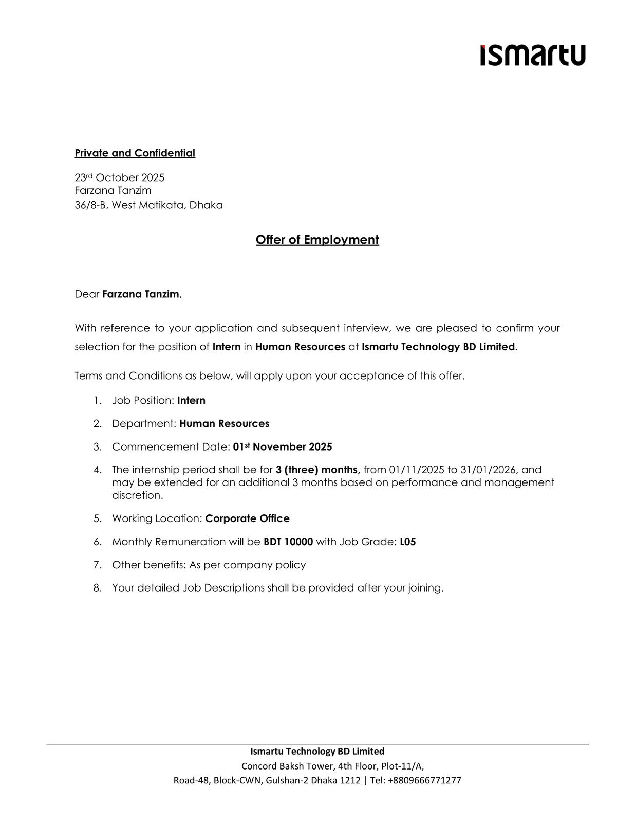

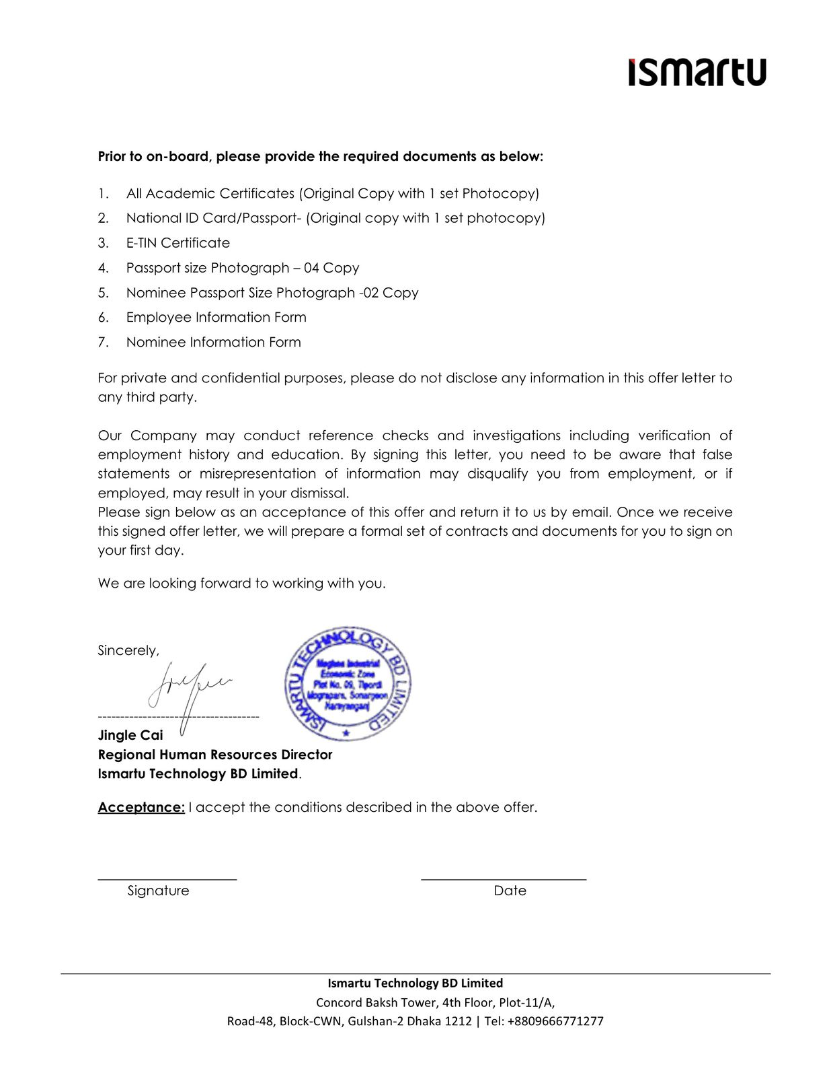

Appendix-B:

