Internship Report On

“Retirement Provident Fund (RPF): A Study on Data Path Limited.”
Prepared For
Dr. James Bakul Sarkar
Associate Professor,
School of Business and Economics (SOBE)

Prepared By
MD. Fahim Hassan
ID: 111 183 085
Major: Accounting
INT-4399_Internship
Trimester: Fall 2023

United International University (UIU)
Date of Submission: 15/12/2024

PREFATORY PART

Letter of Transmittal

Date: 15/12/2024 To,
James Bokul Sarkar
Associate Professor
School of Business and Economics (SoBE)
United International University (UIU)
United City, Madani Avenue, Dhaka 1212.

Subject: Submission of Internship Report.
Dear Sir,
I would like to express my gratitude and thanks for the completion of the internship report “Retirement Provident Fund (RPF): A Study on Data Path Limited”. In accordance with your instruction to complete the INT-4399 coursework. In constructing this report, I have done my outmost to ensure that all important details are included alongside any explanations and learning from the company that were gained during my placement in order to give a broad and informative version. This project provided me with theoretical, as well as hands-on experiences. Working at Data Path Ltd. has been a wonderful experience and I have learned so much. It was also a good experience to make this report and I hope that it will be of help as well and I am always open for any questions or clarifications.
Kindly accept this report and give your valuable verdict I will be highly thankful to you. I would be greatly honored if you consider this report informative and helpful to better understand the whole issue.
Sincerely Yours,

Md. Fahim Hassan
ID: 111 183 085
Program: BBA
Department: School of Business and Economics (SoBE) Major: Accounting

Letter of Authorization


Student Declaration
I am MD. Fahim Hassan, ID # 111 182 085 a student of Bachelor of Business Administration (Accounting) under the School of Business And Economics (SoBE), United International University (UIU), declaring that this internship report entitles “Retirement Provident Fund (RPF): A Study on Data Path Limited.” has been prepared as partial fulfillment of the requirements for my internship program.
I hereby declare that the report has been prepared ethically and individually as a part of the internship program based on my working experience at Data Path Ltd. Corporate Office, Level # 10, Rupayan Shopping Square, Sayem Sobhan Anvir Rd, Dhaka-1229. All the information is collected from valid sources and guidelines are followed according to the requirement of the authority. I do hereby declare that this internship report is an original work and has not been submitted anywhere earlier. I also state that no part of this report has been or is being submitted elsewhere for the award of any degree, diploma, or recognition.

Md. Fahim Hassan ID: 111 183 085
Program: BBA
Department: School Of Business and Economics (SoBE) Major: Accounting
United International University - UIU

SUPERVISOR’S DECLARATION
It is hereby declared that Md. Fahim Hassan ID # 111 183 085 of BBA has completed his Internship Report and Research on "Retirement Provident Fund (RPF): A Study on Data path Limited". under my supervision.
I wish Md. Fahim Hassan all the best in his future life and may he prosper forever.

……………………….

Dr. James Bakul Sarkar
Professor And Coordinator of BBA in AIS Program
School of Business and Economics
United International Universities (UIU)

Acknowledgement

In the first place, I thank The Almighty God for making it possible for me to prepare this report with all necessary research. I would like to acknowledge the authority of Data Path Ltd. for helping me with this and providing preferred information from an internal document.
I may have to leave my profound sense of gratitude to the understanding and cooperation that is bestowed upon me in order to accomplish my project work assigned report on “Retirement Provident Fund (RPF) – a data path limited study”. Acknowledgement First of all I would like to acknowledge my academic supervisor, James Bakul Sarkar, Associate Professor, UIU on cooperating such with flexible advisor who always guided me well and given the proper direction in doing my Internship Report which is essential requirement of Bachelor of Business Administration Program as a part.
It gives us great pleasure to express our thanks and regards to Mr. Tanvir Hasan Shakil (Manager, Plan Admin) for giving valuable input, suggestion and the process of working on topic in my internship period. I owe him greatly because without his help I would never accomplish the goals of my research. I also express my gratefulness to Mr. Md. Asiful Alam, Business Analyst (Operations) & Senior Team Leader (Plan Admin); Mr. Tanvir Mahtab Shejan, and Mr. Mohammad Kazy Reza, Assistant Team Leader- who were very supportive throughout my journey of working with the teams under the Plan Admin Department Securing Emotional Well-being within our Organization I also want to thank Mr. Azizul Huq Banna, Manager of Plan Admin Department; for generously sharing knowledge and guidelines with me. So I owe to the Plan Admin Department of Data Path Ltd. that made me work by creating a friendly corporate and giving essence how to feel work is fun in corporate life. Please also convey my immense thanks to everyone in the Data Path Ltd. family and friends, colleagues who directly or even indirectly encouraged me for this publication. I had a lot of fun from my intern period till preparing final report.
I am hoping that this will assist me in my future professional work. Also, I thank for all the people that make me able to do this report. Last but not the least i want to humbly thank all my family members and myself who helped me physically, psychologically as well economical supports to complete my graduation.

vTable of Contents

Table of Contents
Letter of Transmittal iii
Letter of Authorization iv
Student Declaration v
SUPERVISOR’S DECLARATION vi
Acknowledgement vii
Executive Summary xi
Chapter 1 Introduction Part 1
1.1 Introduction to the Report: 2
1.2 How research can be part of the internship report? : 3
1.2.1 Broad Objective: 4
1.3 Scope of the Report: 5
CHAPTER 2 6
2.1 Background of the Organization: 7
2.2 Corporate profile of Datapath Ltd: 8
2.3 Vision & Mission Statement: 8
2.4 Corporate Governance: 9
2.5 Top Management: 10
2.6 Organizational Hierarchy: 10
2.7 Product & Services: 11
2.7.1 BPO in Bangladesh: 21
2.8 Serving a Wide of Range of Industries: 23
Formula: 27
2.10 Macro-environment (External Environment Analysis): 29
2.11 Micro-environment (Internal Environment Analysis): 31
Department & Work Assignment Part 33
3.1 Assigned Department: 34
3.2 Departments Goal: 34
3.3 Structure and Manpower: 35
3.3.1 Manpower of the Organization: 36
3.3.2 Structure and Manpower of the department: 37
3.4 Departmental Activities: 38
3.5 Departmental Achievement: 39
3.6 Task and Duties performed: 39
3.7 Working Environment: 46
3.8 Facilities and Constraints Faced: 47
Facilities Faced: 47
Constraints Faced: 47
3.9 Lesson Learned from the Internship: 48
4.1 Background of the study: 50
4.2 Problem Statement: 52
4.3 Objectives of the Study: 52
4.4 Literature Review: 52
4.4.1 Conceptual Framework: 53
4.5 Methodology: 54
4.5.1 Research Design: 54
4.5.3 Population Size: 55
4.5.4 Sample Size: 55
4.5.6 Method of Data Collection: 55
4.5.7 Research Limitation: 56
4.6 Recommendations: 56
Chapter 5 Conclusion part 57
5.1 Conclusion: 58
5.2 References: 59
Abbreviation: 60
Appendix : 61

List of Figures and Tables
Figure 2.1 Top Management of Datapath 10
Figure 2.2 Investments of 401(k) Plan Assets .21
Figure 2.3 Bangladesh Software and ITES Industry 22
Figure 2.4 BPO Specialists and BASIS Companies 23
Figure 2.5 Company’s Client Count 32
Figure 3.1 Manpower of the Organization 36
Figure 3.2 Manpower of the Organization 37
Figure 3.3 Department Achievement 39
Figure 3.4 Census 43
Figure 3.5 Non-discrimination Test 44
Figure 3.6 Contribution Calculation 45
Figure 3.7 Relius Software 45
Figure 3.8 Unify Software 46
Figure 4.1 Conceptual Framework of the Study 53
Table 1 Datapath Corporate Profile 8
Table 2.1 Organization Hierarchy 11
Table 4.1 Research Design 54

Executive Summary

The Bachelor of Business Administration will be awarded on completion of the required course work for the BBA degree and an internship program. This report was generated as a part of my internship with Data Path Ltd, a BPO (Business Process Outsourcing) organization Based in Dhaka, Bangladesh, Data Path Ltd. is a Third-Party Administrator (TPA) for US retirement / 401(k) plans. A US-based company, Advance Steel Tube Mills (ASTM), owns the majority share of BD) Bangladesh office of Data Path Ltd (an Offshore branch of July Business Services Ltd). This post is related to TPA BPO company work which involves some 401(k) plans, so have this case and for the same do some BPO research of 401(k) client satisfaction and offshore office effectiveness. Descriptive research design Data were analyzed and data were presented to offer an understanding of the concept. There were 3 hypotheses developed for the survey and a total of 66 samples had been collected based on the principle of convenience sampling. The data was analyzed using mean, standard deviation and Z-test statistics Hypothesis testing was successfully employed as both of the findings of alternative for each hypothesis should be accepted. The analysis outcome point the goal of the research at a glance, as clients are happy with the TPA´s global legal and financial decision-making assistance; A local office for 401 (k) handling and advice launched by another TPA offshore complying to its applied rules; this service can be referred from existing assignees to their companies. In the market, business process outsourcing is needed to drive job creation. Outsourcing is easy with today’s information technology. The IRS and the Employee Retirement Income Security Act of 1974 (ERISA) regulate 401(k) plans in the United States. Finally it may be tough to outsource this business from any other country but with superior man power nothing is impossible.

Chapter 1 Introduction Part

Introduction to the Report:
Internship Program (mandatory for BBA, and partial changes for Business Administration curriculum) Internship Program. After obtaining all the mandatory courses of this BBA course, students may undertake an internship program to get their Bachelor of Business Administration (BBA) degree. Internship is the professional learning experience that offers meaningful, work related to a students' field of interest or major. You need time for someone with no financial experience to learn on the job, and you cannot replace that with theoretical knowledge only. Here's how a Internship Program can comes in rescue to save student from the wilderness of business world that classroom knowledge could be used. Intern programs help students learn and work in a practical environment. Briefly, the students are provided to the company within the world. An Internship Report has to be written by every student at the end of the internship. Initial Internship Goal This report captures initial internship goals and how they were achieved during the internship period. My department was accounting administrations; it was very helpful for me as I am a student of Accounting.
The RPF in the United States is different from Bangladesh. Laws, regulations, systems, and even the methods of financial transactions all differ from here. Retirement Fund is another terminology for the 401(k) Plan, initiated by the United States Congress aimed at compelling Americans to save for retirement. Employers who select this plan for their business get a tax exemption. Employer and Employee Contributions: The retirement fund plan accepts employer and employee monetary contributions. A USA-based company wants to get its retirement plan executed, but it can't do it with internal employees and they are legally required to be run by a "Third Party Administrator (TPA)". One of the company's Bangladeshi TPAs is Data Path Ltd., which processes Business Process Outsourcing (BPO) for the United States and is a parent corporation of July Services Ltd. in the U.S.
I wanted to do my internship as a student of business administration in an environment where I could learn something new and apply the concepts I had learned during my academic studies. Due to this, I got the chance there for an internship at Data Path Ltd. Data Path Ltd — this one was a bit of a petnapping test, general knowledge, software / IT, and communication… but they sent me a door interview…. I started interning for this company on October 15, 2023. I am in the “Plan Admin” department here.
My supervisor in there was Experience Manager, Plan Admin; He consistently mentored me (To Venture around like stuff I have not learned). My manager was cool and helpful, no really he could come up with new projects on the fly to ensure I am not just wasting time of my internship adding value to looking already bleak life ahead. My supervisor and the entire BPO department was my classroom. It was an amazing organization and department!

How research can be part of the internship report? :
I wanted to explore the professional area and learn skills that will help me improve my resume and expand my career options. I wanted to observe and participate in the daily tasks and responsibilities performed by professionals and learn about workplace culture, politics, and etiquette. As I am doing my major in Accounting. I aim to learn the different policies, designs and steps of the retirement policy so that I could develop the ideas of implementing them into the companies of Bangladesh. This internship allowed me to grow individually to be more professional and skilled. During my internship period in Data Path Ltd, I have been appointed in the Plan Admin Department which works for July Business Service’s Clients only. As this is completely a new industry in Bangladesh, there are lots of topics to research about the industry which will help me to complete my intern report. After four months of interning at Data path Ltd., I learned how to conduct our work and communicate professionally with one another. During these four months, I had to interact and work with Managers, Team Leaders, and Executives, so I had to dress and act professionally. During my internship, I was exposed to retirement benefit planning software that I had never seen before, such as Relius, Unify (Web based application). These programs are used on a daily basis by Data Path to process retirement benefit plans and play an important role in providing services to its customers. Census maintenance, automatic contribution calculations, and report generation are the most common applications for this software. Prior to starting my internship, I knew very little about the business world. This four-month journey has taught me a great deal. There is no such thing as a problem-free environment or situation, I have realized. At the same time, I recognize that the business world is vastly different from student life, and that moving from one stage to the next is not easy. Throughout my internship, I encountered a variety of difficulties. Nonetheless, I did my best to adapt to the changes during my internship. The accounting principles or procedures of Retirement Provident Fund (RPF) followed by the USA is complex on root level as opposed to what we learn here in Bangladesh. People in the USA industry follow a set of rules and regulations while carrying out the 401k operations and it is due to those rules that the RPF accounting procedures have grown to be so complicated in the first place.
The RPF industry without any doubt may have an impact on the outsourcing world here in Bangladesh. This sector happens to be lucrative as more people are investing in 401k plans at an exponential rate and simultaneously showing growth in both stock market and individual financial security. Bangladesh can learn a lot from this industry. This applies to how one must abide by rules and how the US government is concerned for its elderly and retired citizens.

Broad Objective:
The broad objectives of this report are:

- To gather information about United States Retirement plan industry 401(k).
- The organization and complexity of their retirement plan
- An idea on Business Process Outsourcing (BPO) industry in Bangladesh and to share some knowledge regarding the retirement benefit plan of US.

    - Specific Objectives:

To The specific objectives of this report are:
- Outsourcing in Bangladesh under USA 401(k).
- Read More: How the USA Retirement Plan Regulatory Mechanism Works.
- Learn how the management and allocation of finances goes for USA Retirement Provident Fund.

Scope of the Report:

The report is based on U.S. 401(k) RPF under USA Letter. Findings the Bangladesh Business Process Outsourcing (BPO) sector has one of the biggest USA 401(k):-RPF industry .Data Grid View Cell Style. A 401(k) is a kind of employee-supported pension plan. When an employee contributes to a 401(k) plan, it provides them with tax benefit on the contribution. Employee contributions are deducted from their payroll and invested in funds the employee chooses (from a list of available offerings). It is an offshore center of July Business Services Ltd in the USA, providing BPO services for US retirement fund plans. It explains the origins of US-based RPF and how a Bangladeshi offshore office does almost all the work with experienced staff. Of course, there are laws, the work flow, BPOs, investments, distribution of funds and everything else that comes with working on a retirement plan. This report was produced after examining each step in the process, reviewing RPF books, into the report is based on the U.S. 401(k) RPF under the USA Letter. The findings show that the Bangladesh Business Process Outsourcing (BPO) sector has one of the biggest 401(k) RPF industries. A 401(k) is a type of employee-supported pension plan that provides tax benefits on the contributions made by employees. Employee contributions are deducted from their payroll and invested in funds of their choice from a list of available offerings. This report details the offshore center of July Business Services Ltd in the USA, which provides BPO services for US retirement fund plans. It explains the origins of the US-based RPF and how a Bangladeshi offshore office manages nearly all the work with experienced staff. The report covers laws, workflow, BPOs, investments, distribution of funds, and other aspects related to working on a retirement plan. It was produced after examining each step in the process, reviewing RPF books, and conducting interviews with Qualified 401(k) Administrator (QKA) managers and hands-on retirement planning administration work reviewing Qualified 401(k) Administrator (QKA) managers and hands-on retirement planning administration work.

CHAPTER 2
Organization Part (Datapath Ltd.)

Background of the Organization:
Data Path is a professional services firm specializing in USA retirement plan and other related administrative service business clients. I suggest only that I work with employers and financial partners to create products. This firm will also implement retirement plans and provides ongoing plan management, giving you a little more of the full-service experience. The firm offers a mixture of both solo retirement plans and large corporation/follow-on retirements managed on behalf of closely held businesses/small cap global corporations as well large intangible asset types competing globally.
Jim Hudson entered the pension plan field in the early 1980's as a Certified Public Accountant. It was during these years that Jim developed his niche in the complex world of the 401(k) industry. He was previously around retirement plan administration prior to starting July Business Services in 1994. John Humphrey got his start in retirement BPO after working as a Certified Public Accountant at one of the big four accounting firms where he worked in this firm's tax consulting services. John founded July Business Services in 1994.
The company started in 1995, literally with no clients and a small professional office suite. The emphasis for the management was to establish key business partnerships, recruit top notch employees, and design business processes during the initial years. The firm's marketing effort yielded important referral relationships with investment advisors, mutual fund companies, banks and brokerage firms. In the first few years, these relationships resulted in some incremental growth. As 1996 wound down, Data-Path had more than 250 retirement plan clients and about 5 employees.
Data Path Ltd is already operating in the two countries as a joint business since 2008. Today, Data Path has over 500 employees. Working as a true partner Data Path helps businesses to high performance having the accurate blend of experience, industry know-how and insights. It is currently used at a couple American companies. It is highly likely that Data Path Ltd. is the only organization able to provide all these solutions in an end to end format starting from capture (data and document), transform, process, mine and workflow using bleeding edge technologies for a long time. This is achieved by means of a ground-breaking series products and services. Data Path takes a structured approach to solutions that can impact businesses in an impactful way.

Corporate profile of Datapath Ltd:

Corporate Profile
Name of the organization | Datapath Ltd.
Logo | 
CEO and Managing Director | Mr. Ashfaqur Rahman
Type of Company | Private limited Outsourcing company
Date of Incorporation | 2008
Corporate Head Office | Rupayan Shopping Square, Level 6 & 10, Plot #02, Sayem Sobhan Anvir Rd, Bashundhara R/A, Dhaka-1229 Bangladesh
Contact No | 880-2-9863216  +880-175844459
E-mail | info@data-path.net
Table 1: Datapath Corporate Profile

Vision & Mission Statement:

Vision Statement:
To obtain the leading position in the outsourcing marketplace, we aim to transition from traditional BPO to the next generation.

Vision Statement:

To effectively serve clients using the latest technologies, transformation and innovation are at the core of Data Path Ltd.

Corporate Governance:

The American Society of Pension Professionals and Actuaries (ASPPA) is the premier national organization for career retirement plan professionals. The members of the Academy come up with fields that help in retirement income management, benefits policy and work within a complex, technical, and highly regulated environment. ASPPA serves as a unifying body for the professionals who have made their careers in retirement plans and pension policy. ASPPA (American Society of Pension Professionals & Actuaries) is a nonprofit professional organization based in Washington, D.C., that represents retirement plan professionals working within the field and advocates for favorable retirement income policies on behalf of 16,000 plus members.
The ASPPA Government Affairs Department actively follows legislative and regulatory developments affecting retirement benefits and pension policy. Originally established in 1966 as an actuarial organization, ASPPA has broadened its constituency and is now comprised of pension professionals from various disciplines including actuaries, consultants, administrators, insurance experts, financial planners, accountants, attorneys and human resource managers. While ASPPA members themselves come from diverse backgrounds, they are united in their commitment to retain a private pension system.
Big time laws with an enormous effect on what bosses do and hence affecting employee benefits are regulations like the Employee Retirement Income Security Act of 1974 (or ERISA), so named when it was instituted into law on Sept. 2, 1974. ERISA set the stage for all employee benefit plans to follow and created a broad legal structure of which other laws governing employee benefits are now a part. Retirement Plans Today, they are subject to complex reporting and disclosure requirements, including filing IRS and Department of Labor (DOL) forms and providing notices to plan participants. This depends on the type of plan and its manner of operation.

Top Management:
Data-Path Management structure
Ashfaqur Rahman
(CEO & MD)
Shakhawat Hossain Chowdhury
(Assistant Director)
Mahfuzur Rahman
Software Development Director
Asifur Rafique
Operations Director

nt of Data Path Ltd.
Figure 2.1 Top Manage
Khandaker Fazle Rabbi
HR Director
Source: Data Path Ltd. Management

Organizational Hierarchy:
When we talk about the way a company is run, it is understood in terms of its hierarchy which goes from top level management (or C-Level) all the way to a bottom employed staff. In layman's terms, this structure is adopted by those organizations that have one central head and then a set of subordinates.
Organizational Hierarchy at Data Path Ltd.

Chairman
Director
CEO & Managing Director
Directors
Senior Managers
Department Managers
Assistant Managers
Senior Team Leaders
Team Leaders
Assistant Team Leaders
Quality Assurance
Executives
Senior Executives
Executives
Trainee Executives
Intern Trainees

Table 2.1 Hierarchy of Data Path Ltd. Source: Data Path Ltd. Management

Product & Services:
Through its experienced team, Data Path readily develops tailored solutions to streamline key Third-Party Administrator (TPA) functions. The services are provided by Data Path Ltd, which are listed under the Retirement Provident Plan. Typically they ensures the laws and regulations of Employee Retirement Income Security Act of 1974 and process the employee funding named as Deferral and Roth Deferral, also there is employer contributions such as Profit Sharing, Match, Safe-Harbor etc. Data Path has a software development wing and Business Process Outsourcing.

Trend and growth
Data-Path Limited. a great way to get a positive end answer of their customer so by that way they are a evolving industry with lots of opportunities to grab as a back-end office of Business Process Outsourcing in Bangladesh. The strict mechanism of data accumulating and reporting, eventually when such information is accumulated or announced just then they approach, pull back, and structure a report making aid for the way towards preparing structure to be submitted to IRS. Data Path Limited. continuously trying to offer a good solution that may help clients for easy understanding.

Customer mix
Data-Path is a well-known local private Limited outsourcing enterprise that is associated with July Business Services located in Bangladesh. That means, our biggest cooperating associate is July Business Services. July Business Services have many different kind of clients starting from solo plans like lawyers, doctors, musicians who run their own retirement benefiting plan, other than that there is sole-traders, partnership, 403(b) non-profit organization, S-Corporation, C-Corporation etc. who run their retirement benefiting plan through TPA like us.

Services mix
For the July Business Services and for their profit Data Path Limited is offering the following services to its US clients.

Plan Design
Retirement plans are typically structured to satisfy any business type of goal and also technique. Whether it is employee enrollment and maintenance or improving the performance. Blessing for major task authorities of the key professions and constant check planned via client management administrator.

Plan Setup

To efficiently set up retirement plans or amendment over the present association from the present provider. Data Path limited devoted setup institution group hands-on offerings to arrange all elements of plan setup. Our services include:
Setup paperwork (Scrub, Census Checking)
Volume Submitter Doc Loan policy
Submission contribution
Transfer asset through account Document from previous TPA
Takeover plan needs unique care
Required Minimum Distribution
Distribution Summary
Top Heavy Report
General Non-Discrimination Report
Maximum Deductible Contribution
415 Batch report
Highly Compensated Employees, KEY Employees, Officers

BPO

The experts at July have over 25 years of BPO experience and specialize in this somewhat niche area. A team of professionals acting as an account consultant will implement the client's plan.
Data-Path specialists have 5 plus years BPO experience, specializing in this highly focused field. The client's plan will be serviced by a team of delights experienced superficially as an account representative

Plan Operation Support

It gives everything the client needs to help the estimation of plan, including telephone and email access to its counselors. Its arrangement activity bolster administration incorporates the accompanying:
Eligibility Calculation Vesting Calculation
Contribution Allocation
Loan and Distribution Processing

Compliance Testing
Its account representative gives total consistency testing service to keep up the fidelity of client’s plan. Its compliance testing services include the following:
Top Heavy Testing ACP & ADP Testing
Minimum Coverage Testing
General Non-discrimination Testing Workbook enrolls
Education Invested.
Sheets contribute reasons

Tax Compliance

Data Path advisors deliver signature-prepared tax return forms to satisfy all tax filing requirements. Tax compliance services include the following:
Form 5500
Form 5330
Form 1099-R & Form 945
Form 5310 (For plan termination)

Plan Recordkeeping

July and Data Path gives automated recordkeeping administrations through their group partners and through July's day by day valuation recordkeeping stage:
24 Hour Internet Access
Day by day Valuation of Accounts Plan Sponsor Account Access
Quarterly Participant Statements

Participant services
July offers high-quality tools to help Client’s Retirement Benefit plan and secure a sound financial future through its affiliations with financial providers.

Payroll service
The better alternative may be the single provider handling both retirement and finance administrations to reduce work stress without compromising on accuracy and efficiency. Our July service guarantees are some of the strongest in the industry, but our goal is to get your payroll error free every time

Fringe Benefit

July services provide the following benefits:

Medicinal repayment plans
Adaptable spending records and Section 125 Fringe Benefit Plans Health Reimbursement Arrangements (HRAs)
VEBA and other specialized funding designs Premium-only plans
Different types of repayment or cases handling programs

Enrollment Materials

July gives an insightful choice to clients to fund utilizing under July recordkeeping service they are guaranteeing and security for their financial data.
Worksheet risk measure Form enrolled
Workbook enrolls Education Invested.
Sheets contribute reasons

Plan Selection and Management | Data Path offers comprehensive packaged recordkeeping and administrative services, designed to ease the complexity of managing retirement plans. Their services include plan documentation, form creation, compliance testing, and more. By taking care of all these intricate details, Data Path allows employers to focus on their core business.
Service at Every Step | From the signing up phase to the ongoing support stages, Data Path's exceptionally qualified retirement experts steer clients throughout the process. Whether a petite company or a larger corporation, personalized and professional help is given to guarantee successful execution and management
Plan Design & Documentation Service | Choosing, customizing, and implementing a strategy is a time- consuming procedure. The expert staff will walk clients through each stage of the procedure, including:  -Initially, the employer's controlled group or any associated service entities are comprehensively evaluated. This nuanced examination facilitates strategic design aligned with structural requirements  -Subsequently, a personalized strategy is collaboratively developed, pragmatically balancing interests of ownership, labor, and operations. The optimized solution is singularly tailored for all involved  -Preexisting arrangements, if assumed, undergo exhaustive review. All provisions are scrutinized to identify necessary alterations ensuring full alignment with goals and statutory compliance.  -Mandatory documents specified by IRS and DOL are fastidiously prepared, guaranteeing scrupulous adherence to legal regulations and standards.  -Prepare the IRS and DOL-required plan paperwork.  -Prepare the Summary Plan Description that will be distributed to participants in the plan.
Administration and Recordkeeping Service | To ensure seamless and efficient plan operations, Data Path offers a wide range of services, including:  - Tracking Participant Vested Percentages: This involves calculating the number of hours an employee must work to become eligible and determining the percentage of ownership over their funds.

Plan Entry Requirement and Eligibility | -Determine eligibility They assess whether employees meet the criteria to qualify for employer contributions and forfeiture allocations.  -Apportioning Contributions: Payments from both the employer and worker are properly designated to person accounts judiciously.  -Distributing Returns: Ensures returns initiated by the plan are rightfully shared among members judiciously.  -Reallocating Forfeitures: When befitting, relinquishments are reassigned to other members following plan rules.  -Handling Distributions: This involves calculating the amount for distribution, readying necessary distribution notices, release forms, and IRS Form 1099-R for tax reporting judiciously.  -Handling Loans: Establishing loan accounts for members, readying promissory notes, amortization schedules, and tracking loan repayments judiciously.  -Managing Hardship Withdrawals: If a member needs to withdraw funds due to fiscal hardship, they decide the eligible amount and ready necessary forms judiciously.  -Reconciling Trust Account Balances: Makes sure the plan’s trust account balances are accurately maintained and reconciled judiciously.  -Preparing Member Statements: Statements are created regularly to notify members of their plan balances, contributions, and returns judiciously.  -Supervising Age 73 Distributions: For members needed to receive least distributions after age 73, observation is conducted to guarantee timely disbursal judiciously.
Annual Compliance Testing and Government Reporting | -Data Path provides a full array of services to facilitate seamless and efficient plan administration:  -Setting Up Participant Vested Percentages: Include calculating the hourly units an employee needs to work for qualification and note how much equity they own in their funds.  -Eligibility testing: They determine how many employees may be included in a plan for purposes of employer contributions and forfeiture allocations.  -Contribution Allocation: Contributions are correctly allocated to participant accounts, regardless of the source of funds (employer or employee contributions).  -Payments of Plan Earnings — To ensure earnings that the plan generates are properly paid out to participants.  -Reallocation of Forfeitures — forfeitures are sometimes used to provide additional benefits to participants in accordance with plan rules.  -Distribution calculations Releasing necessary notification, release form Distribution processing IRS Form 1099-R  -Loans: Creating Loan Accounts per participant, Generating Promissory notes, Amortization schedules and Monitoring loan repayments.  -Processing Hardship Withdrawals: A participant needs a withdrawal for financial reasons, so the eligible amount is calculated and the appropriate forms filled out.  -Reconciliation of Trust Account Balances§ Making sure plan trust accounts are maintained accurately and reconciled on a timely basis.  -Generating Participant Statements: Participants receive quarterly or other routine statements of their balances, contributions, and returns.  -Age 70½ Distributions Monitoring: For participants who must receive minimum distributions, monitoring makes sure they are distributed in time.  -Compliance Tag Testing and Reporting  -DPC’s team of subject matter experts ensure plans remain compliant with U.S. federal regulations and deliver remediation solutions for any problems that may arise. Their services include:  -Deductions in Investment and Production (§404).  -Annual additions testing (§415)  -Top-Heavy Testing (§416).  -Coverage Testing (§410(b)).  -ADP/ACP Testing (applicable only for different types of benefit plans).  -IRS Form 5500 Preparation (includes All Related Schedules for Government Reporting)  -Summary Annual Report: A report delivered to a participant that summarizes the plan's financial activities.
Consulting Services | - Data Path offers a full spectrum of professional service consulting in any facet of the administration or management of health- care benefits including:  -Changes to the Plan: Helping with plan modifications, discontinuations, or consolidations  -Assistance with IRS and DOL Audits: Advising companies that are undergoing an audit by the IRS or Department of Labor.  -Support for changes in Plan Design: The tool offers guidance for structural modifications to the plan.  -Needs Studies and Projections: where a study or projections of participant needs is necessary, which may taper off as the economy improves;
Software Development Services | -Full-stack development services from Data Path Ltd covering a broad spectrum of modern tech tools This team is composed of very committed specialists with vast experience in technology, including software developers and engineers working on UI/UX development and testing. Here you can find the business applications that we create with new technologies —  -Programming Languages:. NET/Core, C#, ASP. NET Version : 4.5, Web API JavaScript Type Script Angular JS/4  -Databases: SQL Server, MySQL, NOSQL databases.  -Technologies: Web Technologies, Assisted and CSS3 with Less/Sass.  -Mobility Platform: Android / iOS.  Content Management PHP, Word Press  -Testing Tools – Testing tools to automate quality checks

Data Path Ltd., July Services Ltd. USA Retirement Plan – 401(k) industry Retirement Market — As of June 30, 2022, employer-sponsored retirement plans (those limited to employees and the self-employed) are estimated at $37.2 trillion in savings from US workers for their future retirement needs; this total includes private sector DC plans ($7.5 trillion), government DC plans ($4.3 trillion), annuities as well as benefit plans funded by insurance products ($3.7 trillion), federal pension assets from defined benefit and DC plans covering current retirees and workers ($6.3 trillion), state & local pension assets (($5.0)); all of which include other Individual Retirement Accounts (IRAs) ($13.9). 401(k) assets totaled $3.1 trillion in 2021, representing 17% of the US retirement market. Graph: Type of investments from 401(k plan asset to different investment markets.

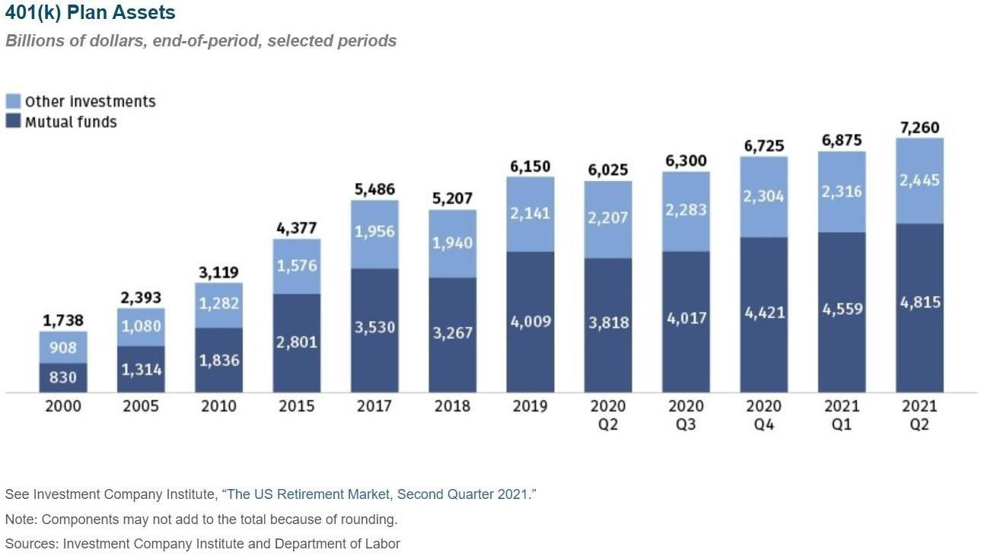
Figure 2.2 Investments of 401(k Plan Assets in Markets

BPO in Bangladesh:

There are large numbers of BPO companies working with many sectors daily in Bangladesh. And In Bangladesh BPO Industry grows fast. Possible reasons for this expansion; have been the underused human resource, available labor, government support, inferring infrastructure, skilled manpower lower cost and high reliability of products. According to a survey by the software, there are about 800 registered software and ITES (IT Enabled Service) companies in Bangladesh. It is estimated that several hundreds more are small home-based software and IT businesses operating both domestically and in foreign markets unregistered
There is a Figure below, which presents about of Bangladeshi Software and ITES in terms of number of enterprises, revenue, and total human resource engaged in the industry and industry revenue proportion.

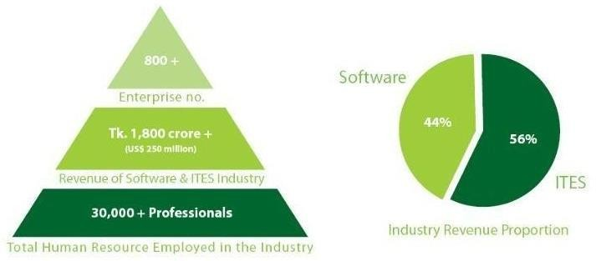
Figure 2.3 Bangladesh Software and ITES Industry in BPO Source: BASIS

The entire industry is worth Tk. 1800 crore (1.8 billion). Additionally, this industry supports around 30,000 HR, IT, and other graduates. The software and IT service industry is undoubtedly one of the top sectors for graduate employment in the country, with an average monthly compensation of over Tk. 15,000.
In a further study, BASIS surveyed 300 member companies on the nature of their business and the size. Figure: More than 70% of companies deliver software to their customers many also provide different types of IT enable services to their clients alongside Nearly half of the companies (47%) offer an array of IT-enabled services like data/form processing, graphic/web design (etc.), another 18% have either built software products or productized “bulletproof” products that were evolved in layers overtime through use cases and tests from hundreds to thousands of client installs.

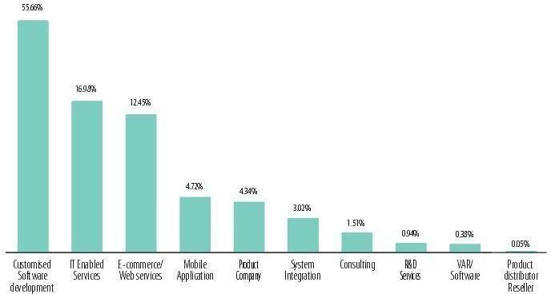
Figure 2.4 BPO Specializations of BASIS Member Companies

Serving a Wide of Range of Industries:

Work Related Activities | Organization Related Activities | Other Activities
Termination/Retirement | Accounting Department | E-communication
In service (59.5)  Withdrawal | Workflow department | Single Project creation
Loan | Human Resource Department | Pre determine target
Hardship withdrawal | Allocation department | Daily work activities
RMD (70.5) | ERISA or Plan document  department | Day to day work
Force-out | IT Department | Filling up the forms  everyday
Plan termination | New business or Installation  department | Sending email
Hardship Withdrawal | Outsourcing department | Outdoor activities
Corrective | Recordkeeping department | Reporting supervisor
Plan termination | Software development department | Check participant address

  - Financial performances:

Return on Assets (ROA):
Return on assets (ROA) indicates a percentage of a company's return on assets in generate income.
ROA measures how effectively a company can manage its assets. Above rate more favorable for investors. The ROA ratio shows an upward trend in earning

Formula:

Return on Assets (ROA)= (Net Income After Tax /Total Assets) × 100

Year | 2018 | 2019 | 2020 | 2021 | 2022
ROA (%) | 1.4 | 0.7 | 0.7 | 1.1 | 1.2
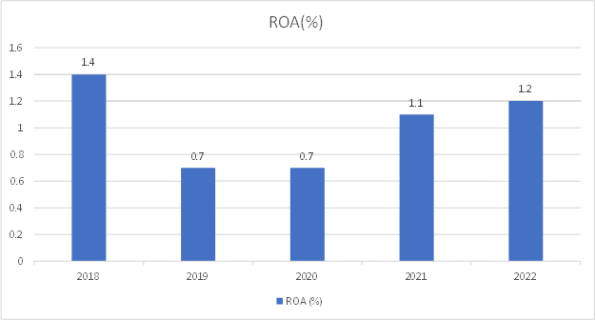

I can visually see their performance from 2019 (0.7%) per above ratio and also in the year 2020 (0.7%) had relatively poor form compared to the other three years. Probably the decrease in Net which has occurred here as well could be a probable reason for this change. Their net income is decreased
and even 100% of total assets have declined if we compare with last year, but in 2018 they had performance that was good, compare with 2019 and 2020 Here should the manager use their efficient for which to take profit by raising thanks return on asset.

Return on Equity (ROE):
Return on equity is the ratio through which we are able to know about how much we are generating income from our shareholders' equity.

Formula:
Return on Equity (ROE) = (Net Income After Tax /Total Share Holder Equity) × 100

Year | 2018 | 2019 | 2020 | 2021 | 2022
ROE (%) | 15.9 | 8.2 | 9.9 | 14.8 | 15.8

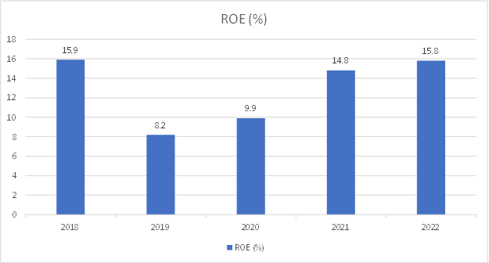

Above the diagram shown I can see 8.2% in 2019 and not good enough. But this improved in 2020 to 9.9%, which worked out a good job of generating substantial returns on equity capital. This level was then slowly increased to above the 14.8% in 2021, and more than tripled by mid-2022 (15.8%). The performance hit an all-time high of 15.9% last year.

Net Interest Margin:
Net Interest margin ratio is the ratio that represents the management efficiency in earning better Spread from their total assets.
The formula is given bellow:

Formula:

Net Interest Margin = (Investment Income–Interest Expenses)/Average Earning Assets

Year | 2018 | 2019 | 2020 | 2021 | 2022
Net Interest Margin (%) | 4.30% | 4.10% | 5.00% | 3.80% | 4.60%

3.80%
6.00%
5.00%
5.00%
4.60%
4.30%
4.10%
4.00%
3.00%

2.00%

1.00%

0.00%
2018
2019
2020
2021
2022
Net Interest Margin (%)
Net Interest Margin (%)

Here the net interest margin ratio was high in 2020 which was 5.00 % and lowest in 2021 which was 3.80 %. In 2018, 2019 and 2022 it was respectively 4.30 %, 4.10 %, 4.60 %

Debt Equity Ratio:
Debt Equity ratio is another financial performance indicator through which we are able to know to which degree the company is financing its operations through debt than equity.

Formula:
Debt Equity Ratio= Total Liability /Total Equity

Year | 2018 | 2019 | 2020 | 2021 | 2022
Debt  Equity Ratio (%) | 1.00 | 1.22 | 1.31 | 1.22 | 1.23

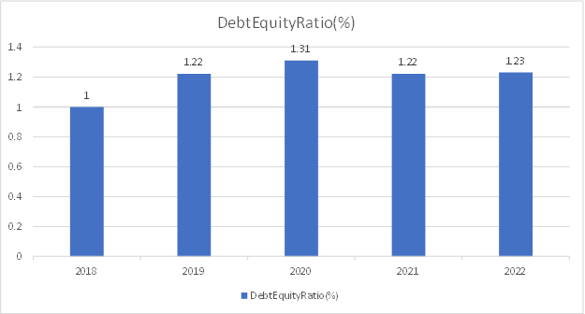

Here, Debt to Equity Ratio was highest in 2020 which was 1.31%andlowestin2018thatwas1%.
And in 2019,2021 and 2022 were respectively 1.22%,1.22%, 1.23%

Earnings Per Share:

Formula:
Earnings per Share= (Net Income−Dividends Payments)/Average outstanding ordinary Shares.

Year | 2018 | 2019 | 2020 | 2021 | 2022
EPS (BDT) | 4.1 | 2.1 | 2.4 | 3.9 | 4.4
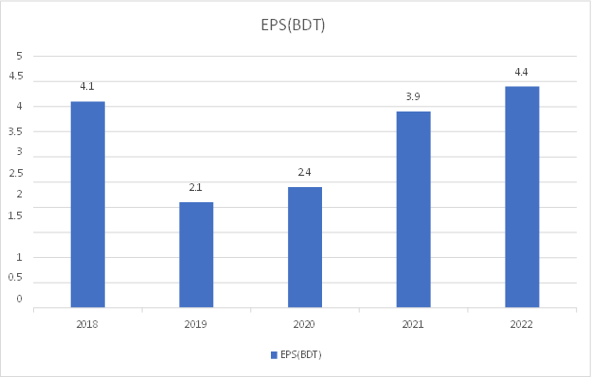

Here, earnings per share were higher in 2022 which was 4.4 BD Tend lower in 2019 which was 2.1 BDT. And in 2018, 2020 and 2021, it was respectively 4.1 BDT, 2.4 BDT, 3.9 BDT

Macro-environment (External Environment Analysis):
Microenvironment analysis affords organizations insight into prospects and dangers posed by external forces, empowering strategic decisions. Evaluating political, economic, sociocultural, technological, legal, and ecological dimensions—the PESTLE framework—One Bangladesh outsourcer appraised these macro conditions.

Data Path Ltd. assessed how its homeland's leadership, markets, communities, innovations, regulations, and surroundings facilitated or fettered operations. From this vista, managers charted strategies attentive to non-financial realities molding demand. Analyses like PESTLE give firms foresight into shifts remodeling their industries, aiding competition. Though analyzing tools alone cannot predict the future, they help orient executives toward context shaping viability. With sensitivity to forces beyond bottom lines, assessments like these support choices with vision to weather disruption and seize what change bears.
As a BPO company in Bangladesh, Data Path Ltd.'s PESTLE framework looks like this:

Political Factors:
- The laws of Bangladesh for a joint-venture company such as Data Path Ltd. guarantee non- discriminatory treatment of foreign and local investment, as well as repatriation of proceeds from share sales and profit.
- Because this company is incorporated with July Services Ltd. in the United States by BPO, it has a Bangladeshi Tax Identification Number (TIN), a VAT certificate from the National Board of Revenue, and a trade license from the relevant city corporation.

Economic Factors:

- Outsourcing work to Bangladesh provides substantial cost savings for overseas clients like those in the United States, given differences in wage levels between the two nations. Lower costs underpin the BPO model.
- As an exporter of services, Data Path brings valuable foreign currency into Bangladesh through deals with international customers. Offshoring spurs revenue growth.
- Even as other industries idled during the pandemic's worst, Data Path managed to avoid layoffs or pay cuts, demonstrating the resilience of their business amid turmoil. Retained staff now fuel recovery.
- Collaborating with American retirement funds expands Data Path's key client base and drives increasing revenue from that prosperous sector. Mutually gainful partnerships foster enduring economic ties.

Sociocultural Factors:

- More and more companies in America are instituting retirement plans for workers as the government aims to support citizens in their golden years. Consequently, Data Path is taking on additional projects to establish these funds.

- Retirement plans have grown popular owing to tax breaks and other social incentives, fueling the company's continuing expansion.

- Americans aspire to save for the future while maintaining current spending habits. Retirement plans function as a reliable repository for accumulating wealth over the long haul.

- Business process outsourcing is a thriving Bangladeshi industry because of the lucrative income potential it presents.

Technological Factors:

- Data Path Ltd., a BPO firm, works with a variety of clients and employs a variety of software to keep track of and record the work.
- The marketing team in the United States advertises and brings clients who are eager to begin RPF for their company. Following that, all data and information are transferred to Bangladesh via various technological media. All retirement plan work is done in Bangladesh and then transferred to the United States, and it is possible for the tech- facility.
- Data Path Ltd. demonstrates the most responsive characteristics to their clients through technology.
- This company also offers software development and technical consulting.

Environmental Factors:

- Data Path prioritizes environmental awareness among employees and participates in various conservation campaigns.
- Strict protocols govern waste disposal and food service to safeguard the surrounding ecosystem.

Legal Factors:
- Data Path functions as a separate legal body in Bangladesh through a joint venture agreement.
- It pays appropriate taxes to the Bangladeshi government dependent on revenues.
- The company enforces disciplinary procedures and adheres to all relevant US retirement legislation when serving American clients, including ERISA, IRS, and Department of Labor regulations
It works for clients in the United States because it is a BPO company. As a result, when working and creating a retirement plan, all instructions and legislations, as well as auditing laws and overviews, are followed in accordance with the ERISA Act, IRS and DOL laws of the United States of America.

Micro-environment (Internal Environment Analysis):
The micro environment refers to an organization's immediate surroundings and has a direct impact on it on a daily basis. As a result, it's often referred to as the environment in which it operates which means, internal environment analysis for a company. It is critical for a company to keep track of and assess all aspects of its micro environment, such as customers, competitors, and so on. However, here is Data Path Ltd.'s microenvironment analysis:
Competitors: Breaking into this industry is not easy, but it is really difficult. First and foremost, a large number of technically skilled people are required, as only a small number of people in this country are familiar with the RPF of the United States. As a result, further training is required.
In light of this, Data Path Ltd.'s only and largest competition is "Fin Source Limited," Bangladeshi RPF outsourcing firm. In 2011, a group of top Data-Path Ltd. workers resigned to form Fin Source Limited, an RPF outsourcing firm. In the existing market, there is no other competition.
Suppliers: The term "suppliers" refers to those who bring and transfer a retirement 401(k) plan to Data Path Ltd. July Business Services is Data Path Ltd.’s parent company, and its Marketing team is in charge of bringing new plans and new clients to Data Path Ltd.
Employees: The wheel of Data Path Ltd keeps turning courtesy to its highly skilled employees. Employees are trained from the ground up and become proficient and competitive. As a result, it has a work accuracy of 99.99%. Employees here are capable of meeting tight deadlines while adhering to US labor standards.
Customers: Data Path Ltd.’s customers are employers who have implemented a retirement plan for their company. As the Bangladeshi off-shore office of July Services Ltd., USA, Data Path Ltd. provides services to customers as a Third-Party Administration (TPA). In December 2022,

the company had 5349 clients using RPF TPA services, according to business records. In 2022, there were 1097 new customers/ clients.

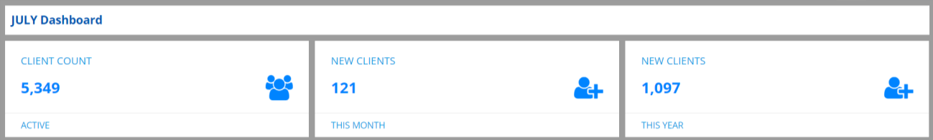
Figure 2.5 Company’s Client Count Source: Unify (Software)

Data Path has a strong ability to maintain client happiness, which is why the number of customers continues to grow.

CHAPTER 03:

Department & Work Assignment Part

Assigned Department:
I obtained my industrial training in Plan Admin Department of Data Path Ltd. Data Path Ltd. has 14 departments. Since this organization has been making retirement plans for US firms; Plan Admin functions with financial regulation, legislative audits as well as modeling data, calculating both employee contributions and employer contribution ensuring non-discrimination test. Plan administrators are there to make sure that the retirement plan is in compliance and allows everyone save for their future, getting approval from the client helps us finalize the retirement plan. This is where the legal documentation has to be, studies and tests get done, monitoring of what activities are going on aspect. 401(k) plans can charge administration fees, which are usually paid by either an employee or a combination of both the employer and participant.

Departments Goal:
Participating in a 401(k) plan is simple for many employees. But, despite how simple things appear to be, there's a lot going on behind the scenes, from day-to-day administration to compliance obligations. The goal of Plan Admin (PA) department is:
- To carry out the plan in accordance with the legislation.
- To ensure that all types of employees data such as Birth Date, Hire date, Re-Hire Date, Termination Dates and last but not the least have to calculate manually whether the participant has fulfilled the eligibility requirement to enter the Plan Entry Date receive the same financial distributions without discrimination.
- To ensure that plan guidelines and federal regulations are followed.
- Providing enough audit support and filing of compliance documents.
- Create an error-free report and transmit it to the customer while maintaining adequate communication.
- Assuring that all plans are provided to the client (employer) before the tax deadline.

Structure and Manpower:
A company structure is a framework that organizes and allocates activities to meet some business objective. These actions will most likely affect the policies of the company and responsibilities.
Manpower is the total number of people who are engaged in a company, or available for a specific project or task. Various techniques by which organizations do the estimation and planning of (temporary) personnel requirements for both. Human Capital is the most valuable asset of any organization and you need trained professionals to do your work.

Manpower of the Organization:
Manpower is distributed across Data Path Ltd.'s 14 departments, as shown below:
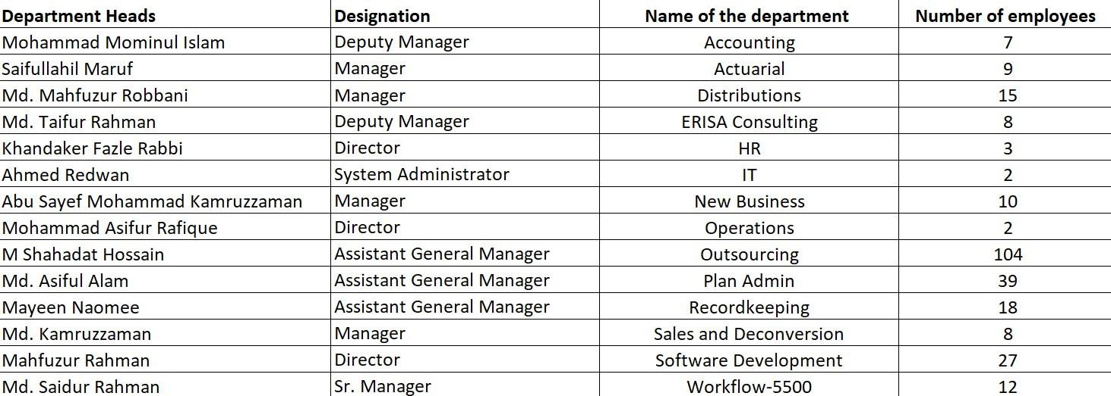

Figure 3.1 Manpower of the Organization Source: Data Path Ltd. Management

Structure and Manpower of the department:
With regards to manpower, this is how the BPO department is structured:







Counts
Hierarchy
- Assistant General Manager, Business Analyst
2
- Manager
3
- Deputy Manager
4
- Assistant Manager
5
- Team Leader
6
- Assistant Team Leader
7
- Senior Executive
8
- Executive
9
- Trainee

Figure 3.2 Manpower of the Organization Source: Data Path Ltd. Management

Departmental Activities:
The Plan Admin department performs a variety of tasks to ensure that the plan is error-free, that financial accounting is correctly computed and notified, and that assets are allocated lawfully. The Plan Admin department's activities include:
Consultation on the design of the original plan

Creating Summary Plan Description for participants and beneficiaries

Transaction approval (loans, distributions, etc.)

Compliance with plan guidelines and federal requirements is monitored

Support for discrimination tests and audits

Filing of a compliance report

The annual participant census creation

Employee communication on a day-to-day basis

Plan Admin (PA), Data Path Ltd.'s Core department, it is always concerned with the company's general well-being and suggests actions as necessary. This department is involved in office tours, office administration, and other side-corporate activities in addition to organizational tasks.
Making excel report based on Billing Worksheet.

Generating twenty three Retirement Provident Reports.

Preparing Budgets, Voucher, Petty Cash Book

Result that leads to make decision to my immediate subordinate

Report to my immediate senior officer and updating daily production log.

Accomplishing the given data into presentation and in a time bound.

Departmental Achievement:
The PA department is responsible for retirement plans administration at every level, dealing strictly with ERISA, IRS and DOL-provided legislation in U.S. territory only. 99.95% accuracy rate (administration, consultation during design, financial allocation of plans within stringent guidelines– this phase is extremely important as we must get it right) stating the correct distribution amount without error and completing the final compliance report prior to client tax filing deadline This division observes a maximum seasonality between 15th of March, 15th of April, 31st of July and 15th of October each year they have these deadlines and within these deadlines Plan Admin has to complete their Compliance Reports . Compliance — Plan Admin Department has to finish all compliance reports and handover on time.
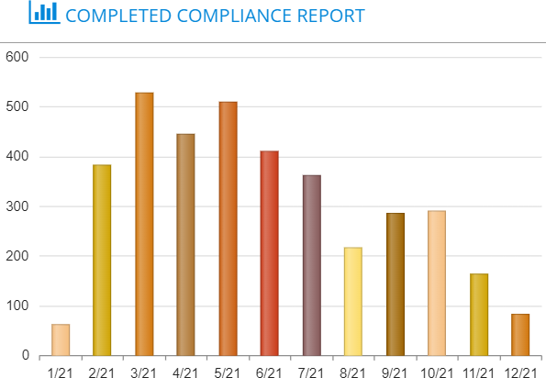
Figure 3.3: Department Achievement

Task and Duties performed:
During my internship, I gained valuable experience in the Plan Administration sector and learned extensively about the United States Retirement Provident Fund. I began with no prior experience in this field but ended up working in financial administration for retirement plans. The following are the duties that I completed throughout my internship:

Understanding the 401(k) industry: The United States had just suffered its first modern social security crisis in the early 1980s. Domestically, the United States was suffering from high unemployment and inflation in the late 1970s leading to a shortfall of revenue. Retirement was becoming an economic burden on nations, corporations and households worldwide… with greater apprehension regarding state pension provision for early retirement in the developed world, workers continued to aim at retiring only a few years before 65. Consequently, the concept of saving up for your older years was born. When an employer sets up a retirement plan for his or her company, they get the United States tax payer to chip in. Employees have been allowed to contribute on a pre-tax basis through payroll deductions since the IRS changed its rules in 1981, boosting the popularity of both employers and employees for these accounts. As many as half of large employers were offering 401(k) plans or planning to offer one within two years, according to the Employee Benefits Research Institute.

Recognizing contributions in a plan: There are two main types of retirement plans: "Defined Contribution Plan" and "Defined Benefit Plan". In this context, the focus is on the "Defined Contribution Plan". A 401(k) plan allows for two types of contributions: "Employer Contributions" and "Employee Contributions". While employees have the choice to contribute to a retirement fund, it is not mandatory. However, employer contributions are mandatory.

Administrating a plan for specific Plan Year: The plan year is the year for which the retirement plan is established. It can align with the calendar year, running from January 1, 2024, to December 31, 2024. Alternatively, the plan year may follow an odd schedule, such as from May 1, 2024, through April 30, 2025.

Determining HCE & NHCE; Key Employee and Non-Key Employee; Family Attribution: A highly compensated employee is defined by the IRS as someone who fits one of the following two criteria:
- In the previous year (here, year 2022), he or she received $135,000 (this amount is subject to change) or more in pay from the employer that sponsors his or her 401(k) plan will be determined as Highly Compensated Employee (HCE) for the plan year 31st December 2023.

2. At any point over the previous year, regardless of pay, owned more than 5% of the shares in a company sponsoring the plan. According to "Family Attribution," every owner who owns more than 5% of the company is an HCE, and his grandfather, father, son, and spouse are all HCEs if they participate in the plan. Employees that do not meet the HCE criteria are referred to as Non- Highly Compensated Employees (NHCEs).
Often, an HCE is also a key employee, but there are some essential differences to be made. Anyone who passes any of the following criteria at any point throughout the plan year is considered a key employee:
1. If a person owns more than 5% of the firm sponsoring the plan, he or she is considered a key employee; If an individual owns more than 1% of the organization sponsoring the plan and earns actual compensation of more than $150,000 for the year, he or she is considered a key employee. This currency limit is fixed, and unlike other restrictions, it does not grow with inflation.
2. If an individual is an officer of the organization sponsoring the plan and gets actual compensation of $185,000 or more for the year, he or she is considered a key employee (2023). Employees that do not meet the Key criteria are referred to as non-Key. Family Attributions applicable here, too.

Working with “Plan Document” and “Compliance Questionnaires”: A 401(k) plan document controls what a retirement arrangement contains and how it is regulated. Details How the Plan Works: This is generally contained in a plan document that details, the specific type of plan, how it operates and any unique features to accomplish client company needs & goals. The client's 401(k) advisor may help the client draft and amend a plan document, but as employer of 401(k), what is there in that refer to employer. What is in the plan document for your client to choose & also allows your clients to state it is retirement type and contribution have assets As expected, there is a limitation and guidelines followed which are controlled by IRS.

A compliance questionnaire requests information from the client for the specific plan year. It includes details about the client's desired contributions for the following year, as well as information about late deferrals, severance pay, required bond amount demographics, plan participation, employer and employee contributions, various testing rules, distributions, plan loans, other plan operations, IRS voluntary compliance and correction programs.
I read, understood, and analyzed the plan document and compliance questionnaire before moving on to Plan Admin process for contribution Calculation, fully understanding what the client wants for the following year
.
Calculating Eligibility, Entry Date: Employees who work for a company that are in a plan must be “eligible” and have to have a plan “entry date” to receive contributions. If an employee gets an “entry date” he/she can make employee contribution accordingly, but there are some other employer contribution for which an employee must fulfill the requirements such as the employee must complete 1000 hours or/and must be employed on the last day of the year. Employer-specific “eligibility requirements” exist which is stated in plan document. Assume Mr. Stacy has decided to create a retirement plan for his business. He employs a total of 56 people. He stated that an employee who has attained the age of 21, has worked for one year, and has completed 1000 hours of service would be eligible for a contribution from the plan and frequency of the entry date has to be monthly. Now, very few of the 56 workers will be funded by the plan, and others will be disqualified due to the eligibility requirements.

Calculating Vesting: "Vesting" in a retirement plan means taking ownership of the employeer contribution such as match and profit sharing only. This means that each employee will own a certain percentage of their plan account each year. An employee who is fully vested in his or her account balance owns it entirely, and the employer cannot forfeit or reclaim it for any reason. Employees may forfeit non-vested amounts if they are paid their account balance (for example, when they leave their job) or if they do not work more than 500 hours in a year for five years. To have a vesting year calculated there is also some requirements such as 1000 working hours or just have to complete one consecutive year.

Working with Census: The census is a 401(k)-administration document that includes details on the employees. A plan administrator uses the information for annual non-discrimination testing. These tests check the extent to which 401(k) benefits are spread amongst company employees. Since filing deadlines apply, the census should already be completed in the first half of any plan year.

Here's an example of a census:
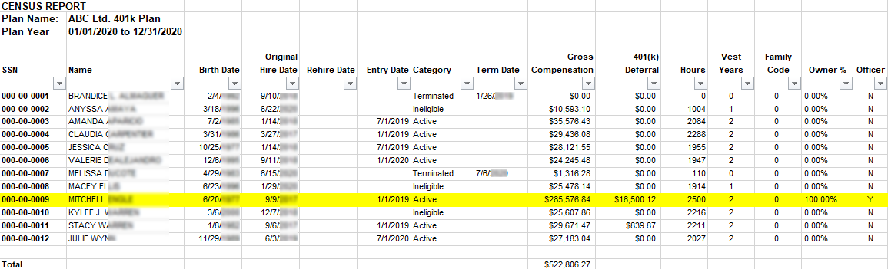
Figure 3.4 Census Source: MS Excel working file
Non-discrimination Tests: NDTs are tests that make sure 401(k) retirement plans benefit all employees (and not just owners or highly paid staff). If a plan does not stay in compliance with the IRS's standards, it can face fines and penalties as well as administrative headaches. The U.S. government provides substantial tax breaks for 401(k) retirement plans. Because these tax breaks are so great, the government wants to prevent 401(k) plans from essentially becoming a benefit that only benefits business owners and highly compensated employees (HCEs). Providing an advantage to HCEs over non-HCE is deemed "discriminatory" and, therefore, a series of annual tests are required to demonstrate that the plan does not in fact discriminate. Employers who sponsor 401(k) retirement plans must pass non-discrimination tests or make corrections if they fail. Those without a schedule for addressing failures in manual NDT testing jeopardize their certified status.
Here's Non-discrimination test’s example in census:
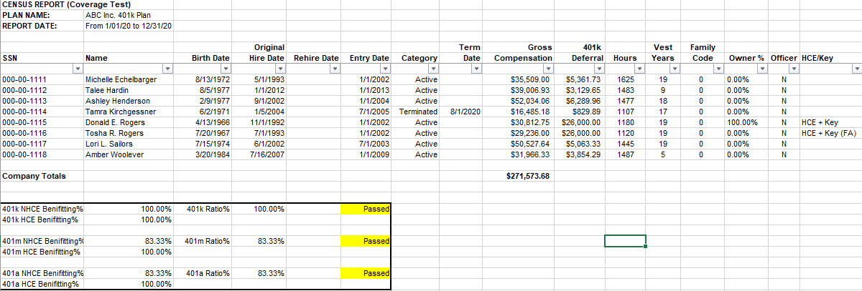
Figure 3.5 Non-discrimination Test Source: MS Excel working file
Contribution Calculation: The part where the employees themselves contribute, which is commonly known as Deferral means they are deferring certain % of their salary to the retirement provident fund. The company matches the deferred dollars, based on how much money in a “Match” and with respect to that amount of repayment for his/her salary each employee defers. For example: Mr. Smith deferred $1000 (Deferral), and he is an employee, his employer has signed up to a 2% match this year. Therefore our boy Mr. Smith will get ($1000*2%) = $20 employer match another case: Profit Sharing. Employers can share their profit with employees on the same. That certain amount can be a range of say between $40 and $60 or it could simply be just some percentage. Example: Ms. Parker is an employer and she's just going to distribute $10,000 equally between 10 employees. So, now all the employees will be getting ($10,000/10) = $1000 – The so-called employer contribution again with profit sharing. On the other hand, Ms. Parker wishes to distribute 5% of her earnings with the workers This means the company profit is $10,000. Means $500 of employer contribution and profit sharing will be allotted to each employee
There are more breakdowns about employer contribution and there are laws, limits. Everything comes to concern when retirement plan for an organization comes in.
Example of contribution calculation in census is given below:
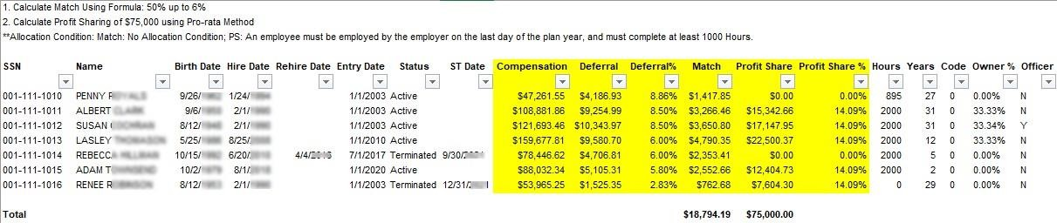

Figure 3.6 Contribution Calculation Source: MS Excel working File
Working with official software’s: Data Path Ltd. uses a variety of software. Data Path communicates with clients using software, submits reports, and asks questions via software as an offshore office of July Services Ltd., USA. I relied heavily on "Microsoft Excel" and Microsoft Words for financial calculations; "Relius" is used to generating reports and printing calculations which is then have to re-check human touch, for plan formulation, information, and report; and "Unify" to communicate with clients and submit reports to clients.
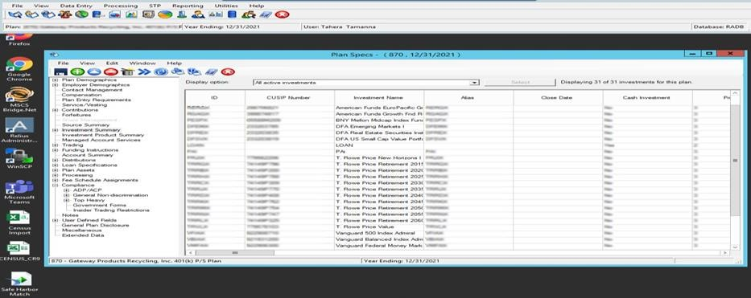

Figure 3.7 Relius Software Source: Official Server

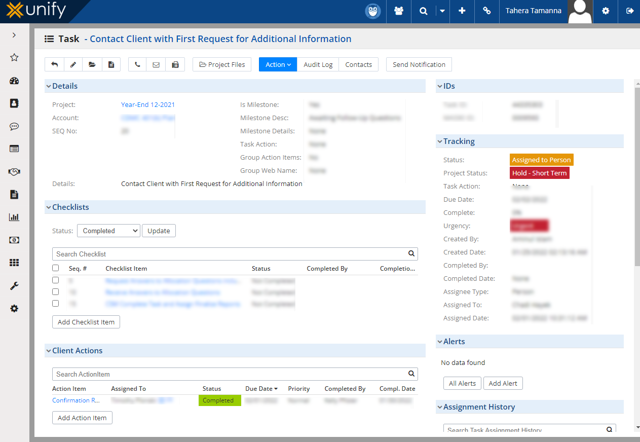

Figure 3.8 Unify Software

Working Environment:
Source: Official Server

Data Path Ltd ia a very positive environment. Seniors helping them with their work or academics! I had to take time off for academic reasons, as I was merely a “normal” university student during my internship. That company has always been useful for this purpose. The sick days they will be lenient over I had no idea about the industry when I first entered, but every single person in Plan Admin was more than equipped to train me with starting from scratch.
Discipline issues are closely monitored in this company. If anyone notices a violation of corporate rules, they should promptly notify management without hesitation, and appropriate action will be taken. At Data Path Ltd., punctuality and gender equity are valued. Employees are encouraged to complete tasks within office hours and are not encouraged to arrive early or leave late. Both male and female prayer rooms are available.
Every last working day of the week, employees go to a sporting complex and play football and badminton together for employee refreshment.

Facilities and Constraints Faced:
In Data Path Ltd, facilities were more than constraints. However, there are certain constraints.

Facilities Faced:
- Available academic and sick leave

- Available office transport

- Full-time training and handsome remuneration for interns

- Fully subsidiary lunch, snacks, coffee

- Full desktop computer setup with strong, stable internet connection

- Available IT support

- Knowledge sharing without any boundary

- More leaders than bosses

- Strong IT and software training
- No communication gaps

- Sports day celebration

- Annual tour
- Prayer and lunch break
- Motivation for work

Constraints Faced:
- Limitation to get financial data for confidentiality

- Not a very popular industry in Bangladesh

- Managing time for academic purposes while working full-time

- Not a Career focusing job in a long run as the industry 401(k) itself is USA based.

Lesson Learned from the Internship:
During my internship, I was well-trained and had a rewarding experience. The real-world experience helped me prepare for potential employment following graduation. However, I did run into some issues, which I eventually worked out. Whatever occurs, maintaining an optimistic attitude increases the productivity.
My learnings from the practicum are:

Primary Learnings | - Knowledge about BPO  - Knowledge about 401(k) industry of USA  - Applying financial administrative rules and calculation technique’  - Preparing financial reports  - Knowledge about trust accounting and summary of accounting  - Lost earning calculation  - Get familiar with tax and audit rules
Secondary Learnings | - Organizational behavior  - Time management  - Following strict deadline  - Practical observing and gaining knowledge from it  - Communication at workplace  - Co-operation and appreciation practice

Chapter 4 Research Part

Background of the study:
In today's technology-driven world, Outsourcing, also known as Business Process Outsourcing (BPO), has become a widely discussed term. It involves engaging another individual or company, either domestically or globally, to handle specific business operations and responsibilities. According to industry experts, the BPO sector experienced a 20% year-over-year growth, reaching around $300 million last year, largely due to increased government services. Data Path Ltd. is a Bangladeshi TPA that provides Business Process Outsourcing services for the 401(k) industry in the United States. This company is a joint venture with July Services Ltd. in the United States, and the clients of July Services Ltd. are also clients of Data Path Ltd.
Data Path engages with Clients via multiple pieces of communication software, collects client data then assembles 401(k) (retirement) plans for large and small businesses across the US including Plan Design & Administration, Compliance Services from daily compliance testing to annual reporting services, Record Keeping and Documentation [house most important documents related your Retirement plan), Fiscal Consulting + ability to handle many difficult financial situations same day or next] and Software Development [high-coding language like Java is plus]. The 401(k (RPF) industry has been highly organized in the United States since it emerged following a severe recession. The recession of the early 2000s was a period when economic activity fell severely in most countries that had experienced occasional or persistent sluggishness for several years. The US saw an unusually high unemployment level of 7.8 percent in mid-1992, nearly one and a half years after the end of its mild recession at the start that January (the spring issue). Job growth was first slowed by many big layoffs in defense-related industries. Then all of a sudden, people were out of jobs and entering retirement (the stock market had also plummeted) Meanwhile the US government was finding it difficult to convince retired seniors to pay in their Senior Citizen Allowance.
This is when the US government made a move to make 401(k) industry robust so employees can at least count an assumed financial responsibility in case there lost their jobs or retired. This selling point attracted many buyers and enrollments after the government reported about tax savings for an employer offering 401(k)plans to its employees, which could make employers join retirement provident fund sector more aggressively than ever. You contribute to a plan, and your contributions are then invested into specific funds or options within the retirement account in which you have chosen to save. This is how the United States bounced again from its downturn and also the retirement provident fund saved both federal govt plus old to our life. A corporate entity (in the United States) is not allowed to set up its 401(k) plan on their own, per IRS law. That's where a Third-Party Administrator (TPA) comes in to assist them in carrying out their 401(k) plan while adhering to all applicable laws.

Problem Statement:
Strong legal and financial expertise, effective 401(k) consultation, and robust client referral networks will propel Third Party Administrators (TPAs) to superior growth and market dominance in the competitive benefits administration landscape.

Objectives of the Study:
The following are the study's objectives:

- To assess the company’s Legal and Financial Administration of TPA.
- To analyze the effectiveness of an offshore financial consultation service in 401(k).
- To examine the possibility of getting referral from existing clients to potential client.

Literature Review:
The study focuses on BPO based on the Retirement Provident Fund 401(k) industry in the United States, a few papers and academic publications were studied to explain the study. Here are a few illustrations of literary reviews:
According to (Sharif, 2018) outsourcing is a cost-saving mechanism that can be implemented because of the robust social security systems in USA. In India as well, the retirement fund benefit is being highly respected both by government and citizens. It is having great mastery of the government that they are falling in making it compulsory by law on employer giving this retirement fund benefit to their employee during his/her retire time. The Retirement Plan as known in the retirement industry is essentially a platform for employers to establish what the Internal Revenue Service (IRS) and Department of Labor (DOL) instruct them to install which results in providing their employees with some form or benefit relating to a pension plan.
According to a magazine article from 2018, outsourcing is the practice of having certain job functions done outside of a company instead of having a department or employee handle them. A function can be outsourced to either a company or an individual.
The purpose of outsourcing is to help companies reduce costs and increase revenue. As outsourcing becomes more common, companies are looking to outsource processes to revitalize their business, reduce costs, and transform their organizations (Barbara, 2007).
When discussing the US Retirement Provident Fund and Third-Party Administration, (Khan) stated that the government, as well as the citizens, are highly concerned about the retirement benefits in the United States. The government mandates that employers provide retirement fund benefits to their employees when they retire. The Internal Revenue Service (IRS) and the Department of Labor (DOL) both require employers to set up a retirement benefit plan for their employees, which is referred to as a "Retirement Plan" in the retirement sector. Every company in the United States with a retirement benefit plan is required to prepare a report by IRS laws and regulations. The job of TPA (Third Party Administrator) is to compile the report and the allocation letter on behalf of the client. The plan specification report, census report, summary of accounts report, plan totals report, trust accounting report, ADP/ACP testing report, trust accounting report, and top-heavy testing report are all included in the allocation report. Compliance Testing Reports, such as required minimum distribution reports, maximum deductible contribution reports, and coverage testing reports, must be prepared by a TPA firm.

Conceptual Framework:
Independent Variable
Getting Referral from The Existing Clients
Independent Variable
Effectiveness of financial consultation service in 401 (k)
Independent Variable
TPA Legal and Financial Administration

Dependent Variable Third Party Administrator
(TPA)

Figure 4.1: Conceptual Framework of the study

Methodology:
Therefore, research methodology is only the practical "how" of any type of real and systematic search. It is particularly focused on how a research study has been systematically designed to produce accurate, reliable findings that answer the questions for which it was intended. It is so because a battery of hypotheses have been formed for dissertation that need to be substantiated or rejected in the process. The study is examined deductively by creating hypotheses, accordingly hypothesizing in the research.

Research Design:
In this case using "Quantitative Research" method in which the data was analyzed with Quantitative Data Analysis principles. Quantitative Data Analysis is a scientific method to research and analyses in which quantitative data are collect or quantifies what has been collected. Something which is being elucidated many a time or again, answering to the what and how much questions of anything. The coding process was conducted based on each of the research questions to ensure that there will be proper analysis while doing it. This data was coded (assigned a category), cleaned, and organized.
Responses have been collected through Likert Scale:

Opinion | Weight
Strongly Agree | 5
Agree | 4
Neutral | 3
Disagree | 2
Strongly Disagree | 1
Table 4.1: Research Design

Type of Research:

This research topic in one way proposed for “Descriptive Research” as it is by tradition worried with presenting a problem and the answers of this problem. Descriptive statistics are typically broken down into measures of central tendency (i.e. the general average or mean) and measure of variation. This study used descriptive data as the analyzed variables were explained in terms of percentages, means and standard deviations.

Population Size:
Total population size is 7000. The population was comprised from the regular clients of Data-Path Ltd.

Sample Size:
Sample size is 66. The sample size was chosen from July/Data-Path's long-term existing clients who have used all the company's services for a long time. I have distributed my questionnaire to 100 clints through e-mail and got 66 responded.

Sampling Method:

In this study, the "Convenience Sampling" method was applied. A convenience sampling method is a Non-probability Sampling approach in which the sample size is drawn from a group of people who are convenient to contact.

Method of Data Collection:
To fully complete the research, two types of data were gathered – Primary Data and Secondary Data.
Primary Data: A questionnaire survey was used to collect primary data from the regular clients of Data Path Ltd. or July Services Ltd.
Secondary Data: Secondary data was gathered by-

- Reading related articles/research papers from journals

- Data Path Ltd.'s official website

- Organizational internal documents and international survey

- Internet website that is related.

Before analyzing the collected data for this study, it was prepared. The dataset was examined for missing information and outliers. Outliers were defined as values that fell outside of the calculated range.

Research Limitation:
Because July Services Ltd. in the United States and Data Path Ltd. in Bangladesh are both private limited companies, all of their client data and information is kept totally confidential. It was difficult to collect data and contact people for research purposes. There was also a time constraint and a lack of experience conducting such research.

Recommendations:

The following recommendations are based on the research:

Business satisfaction, they can impact the brand and also have an effect when using a TPA in the 401(k) sector like Data-Path Ltd., or otherwise throughout other sectors. Highly skilled professionals can be trained to run the other TPA companies in different fields. If they have access to suitable technology then geography is no obstacle when it comes to building their skills.
While there are those who hold this perception, not all of the financial administrative duties typical to a 401(k) seem possible in an offshore office (and especially from a global legal standpoint). One would be to build a training session comprising industry professionals, get people there by promising work in the field strictly if they were fans of financial data and force them into back-office support.
The way how Data-Path got new clients was that existing clients gave them referral to their friends/colleagues, like July Services. Data-Path still performs great, so the clients are fine with sharing it. More An Emporium of Ideas Data-Follow should pay more attention to the quality of human resources and other developing opportunities. The companies should also have to stay in touch with their clients and amplified promotion would be beneficial as well.

Chapter 5 Conclusion part

Conclusion:

There might be a large number of BPO companies in Bangladesh but only some can qualify the standards. As a case in point, the Data-Path Limited is managed by two people of American origin Jim Hudson and John Humphrey (U.S.). They recruited hard workers, people who wanted to grow and learn things all the time until they reached approximately 170 employees — up from just six having come a decade ago. This only happened because the two Americans selected highly motivated, supportive and well led top management. Countries can save costs and accelerate revenue by deploying Business Process Outsourcing (BPO). There isn't a geographic limitation in the business world nowadays. This led experts to make a presumptuous prediction where they said that people can move wherever they would get the job done at lesser price(with experienced labour). Therefore, Business Process Outsourcing (BPO) is an alternative to these countries like Bangladesh or else others in the context of earning remittance along with providing more job scope for those skilled unemployed populations. USA Detail oriented is a requirement in the 401(k) space. The laws and Regulations greatly vary from here, as well the mechanism is more made and managed. The outsourcing sector is one where the laws and scrutiny provided on regular basis. If the business of 401(k) industry can be outsourced for TPA company in Bangladesh, then any other side on earth where there is some good internet penetration and English speaking is possible to work as service providers. What is needed here are a little comprehensive study of Business Process Outsourcing (BPO), transmutation of common human to an economic resource with due skill set and moral value education, the approval for BPO.

References:

Ahmed, M. S. (2019, April 17). Retrieved from Comparative Study on Retirement Plan between Bangladesh and the United States of America (USA): http://dspace.uiu.ac.bd/handle/52243/1008
Barbara, J. K. (2007). business processes and Methodologies. business processes and Methodologies.
Calbasa, M. C. (2023, March 13). Retrieved from A Comparative Study of the Retirement Benefits of Private and Government Employees Towards An Information Awareness Campaign: https://papers.ssrn.com/sol3/papers.cfm?abstract_id=4382122
Islam, M. A. (2022, February 27). Retrieved from BUSINESS PROCESS OUTSOURCING: A CASE STUDY ON DATA-PATH LIMITED: http://dspace.uiu.ac.bd/handle/52243/2361
Islam, R. (2021, April 12). Internship Affiliation Report on Activities at ERISA Department of Datapath Limited. Retrieved from Internship Affiliation Report on Activities at ERISA Department of Datapath Limited: http://dspace.uiu.ac.bd/handle/52243/2089
Ltd., D. (n.d.). DataPath Ltd. Retrieved from DataPath Ltd.: https://www.data-path.net/career/ Rahman, f. R. (2022, April 5). Retrieved from Retirement Plan for USA Citizens: A Case Study
on Data Path Ltd.: http://103.109.52.4:8080/handle/52243/2406
Reluao, A. J. (2023, March 13). Retrieved from A Comparative Study of the Retirement Benefits of Private and Government Employees Towards An Information Awareness Campaign: https://papers.ssrn.com/sol3/papers.cfm?abstract_id=4382122
Sharif, M. J. (2018). Outsourcing of Retirement Provident fund (RPF). Dhaka: UIU. Shimu, T. J. (2022, March 16). Retrieved from A Case Study on Accounting Procedure
Recordkeeping for Retirement Plan at Data-Path Ltd.:
http://103.109.52.4/handle/52243/2392

Abbreviation:
BPO- Business Process Outsourcing RPF- Retirement Provident Fund DOL- Department of Labor
ERISA- Employee Retirement Income Security Act of 1974 IRS- Internal Revenue Service
TPA- Third Party Administration

BASIS- Bangladesh Association of Software and Information System

Appendix

Appendix : Financial performances:

Particulars | 2022 | 2021 | 2020 | 2019 | 2018
Balance Sheet
Authorized Capital | 15,000 | 15,000 | 15,000 | 15,000 | 15,000
Paid-up Capital | 10,672 | 10,164 | 10,164 | 9,680 | 9,219
Reserve Fund &Surplus | 20,552 | 18,654 | 15,252 | 14,750 | 15,650
Total Shareholders' Equity | 31,224 | 28,818 | 25,416 | 24,430 | 24,869
Bond | 11,690 | 11,600 | 9,200 | 8,800 | 7,250
Deposits | 282,064 | 254,781 | 246,704 | 205,170 | 183,493
Borrowings | 54,895 | 58,769 | 44,168 | 60,453 | 37,906
Loans and Advances | 286,380 | 268,202 | 246,944 | 231,391 | 196,596
Credit to Deposit Ratio | 81.3% | 74.7% | 79.1% | 82.5% | 84.9%
Credit to Deposit Ratio | 85.3% | 82.7% | 79.4% | 77.7% | 84.7%
Investment to Deposit Ratio (IDR) | 64.7% | 30.9% | 67.5% | 29.6% | 35.1%
Debt-Equity Ratio (times) | 12.4 | 12.3 | 13.0 | 12.3 | 10.1
Investments | 54,920 | 46,251 | 39,452 | 27,882 | 25,508
Fixed Assets | 6,465 | 5,920 | 5,675 | 3,519 | 3,277
Earning assets | 345,361 | 325,011 | 290,209 | 273,006 | 220,875
Total Assets | 416,902 | 382,926 | 354,689 | 324,780 | 275,531
Off-Balance Sheet Exposures | 228,065 | 136,338 | 118,329 | 135,748 | 98,845
Income Statement
Net Interest Income (excluding investment income) | 12,048 | 8,363 | 10,832 | 9,201 | 7,495
Investment Income | 2,579 | 3,438 | 2,086 | 1,842 | 2,791
Non-interest Income | 6,776 | 4,936 | 5,367 | 4,859 | 4,630
Operating Income | 21,403 | 16,737 | 18,285 | 15,902 | 14,916
Operating Expenses | 10,403 | 9,697 | 9,998 | 9,223 | 8,047
Operating Profit (profit before  provision and tax) | 11,001 | 7,040 | 8,287 | 6,679 | 6,869
Provision for Loans, Investment and Other assets | 2,546 | 644 | 2,556 | 2,324 | 1,718
Profit Before Tax | 8,455 | 6,395 | 5,731 | 4,355 | 5,152
Profit After Tax | 4,743 | 4,012 | 2,472 | 2,018 | 3,628
BIS Capital Measures*
Risk Weighted Assets (RWA) | 305,194 | 269,322 | 244,925 | 259,413 | 202,210
Tier Capital | 32,445 | 29,017 | 23,664 | 21,507 | 20,522
Tier Capital | 10,769 | 12,800 | 13,471 | 13,304 | 9,232
Total Regulatory Capital (Tier-I  and II) | 43,213 | 41,817 | 37,136 | 34,811 | 29,755
Tier Capital Ratio | 10.6% | 10.8% | 9.7% | 8.3% | 10.1%
Tier II Capital Ratio | 3.5% | 4.8% | 5.5% | 5.1% | 4.6%
Total Capital Adequacy Ratio | 14.2% | 1 5.5% | 15.2% | 13.4% | 14.7%

Ratio Total Assets | 73.2% | 70.3% | 69.1% | 79.9% | 73.4%

Credit Quality
Non-Performing/classified Loans (NPLs) | 13,906 | 10,850 | 14,244 | 12,326 | 10,678
Percentage of NPL over Total Loans and Advances | 4.9% | 4.0% | 5.8% | 5.3% | 5.4%
Provision for Unclassified Loans | 4,973 | 5,159 | 4,240 | 3,486 | 2,310
Provision for Classified Loans | 5,602 | 3,933 | 5,830 | 4,488 | 3,737
Export | 186,029 | 119,987 | 130,241 | 117,520 | 98,593
Import | 326,480 | 180,817 | 197,590 | 172,937 | 164,588
Remittance | 39,411 | 34,291 | 37,286 | 28,631 | 30,464
Efficiency/Productivity Ratio
Return on Average Equity (ROE) | 15.8% | 14.8% | 9.9% | 8.2% | 15.9%
Return on Average Assets (ROA) | 1.2% | 1.1% | 0.7% | 0.7% | 1.4%
Cost to Income Ratio | 48.6% | 57.9% | 54.7% | 58.0% | 53.9%
Yield on Advance based on average EOD balance | 7.1% | 8.4% | 10.3% | 9.7% | 8.7%
Cost of Deposit based on average EOD balance | 2.5% | 4.6% | 5.4% | 5.6% | 4.4%
Net Interest Margin Ratio | 4.6% | 3.8% | 5.0% | 4.1% | 4.3%
Statutory Liquidity Ratio (SLR)-at  the close of the year | 21.2% | 17.2% | 17.5% | 14.6% | 15.8%
Cash Reserve Ratio (CRR)-at the  close of the year | 6.2% | 4.9% | 6.7% | 6.9% | 7.4%
Current Ratio (Times) | 0.9 | 0.9 | 0.8 | 0.9 | 1.1
Operating Profit per Employee | 2.4 | 1.6 | 1.8 | 1.7 | 2.1
Operating Profit per Branch | 76.9 | 53.3 | 62.8 | 51.0 | 52.8
Share Information
No of Shares Outstanding (in million) | 1,067.2 | 1,016.4 | 1,016.4 | 968.0 | 921.9
Operating Profit per Share (BDT) | 10.3 | 6.9 | 8.2 | 6.9 | 7.5
Earnings Per Share (BDT) | 4.4 | 3.9 | 2.4 | 2.1 | 4.1
Market price per share (BDT)as on  close of the year (DSE) | 27.3 | 24.8 | 21.1 | 30.2 | 53.2
Price Earnings Ratio (Times) | 6.1 | 6.3 | 8.7 | 14.5 | 13.0
Net Assets Value Per Share (BDT) | 29.3 | 28.4 | 25.0 | 25.2 | 27.0
Dividend Cover Ratio (EPS/DPS) | 177.8% | 175.4% | 162.1% | 189.5% | 170.4%
Total Dividend** | 25.0% | 22.5% | 15.0% | 11.0% | 24.0%
Cash Dividend | 12.5% | 17.5% | 15.0% | 6.0% | 19%
Stock Dividend | 12.5% | 5.0% | 0.0% | 5.0% | 0
Distribution Network
Number of Branches | 121 | 121 | 121 | 119 | 118
Number of Sub-Branches | 12 | - | - | - | -

Appendix A: Hypothesis Calculation in SPSS.
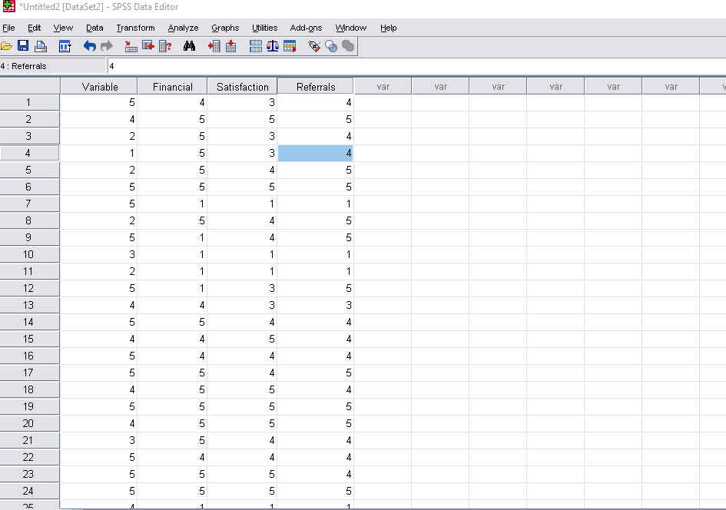
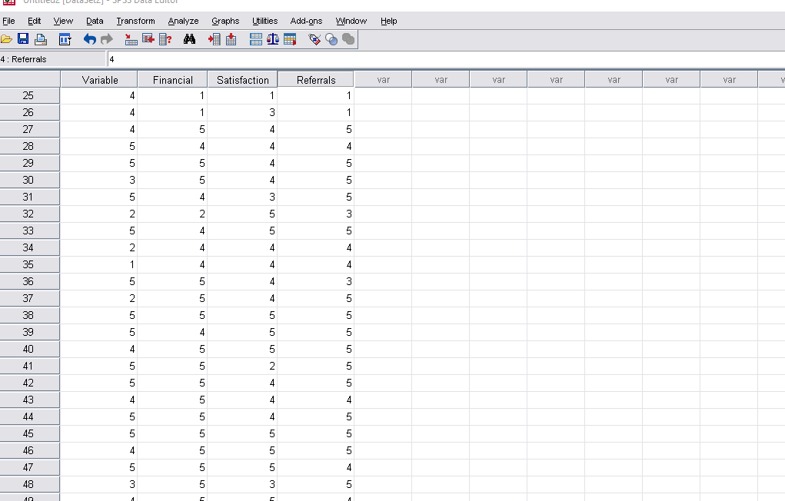

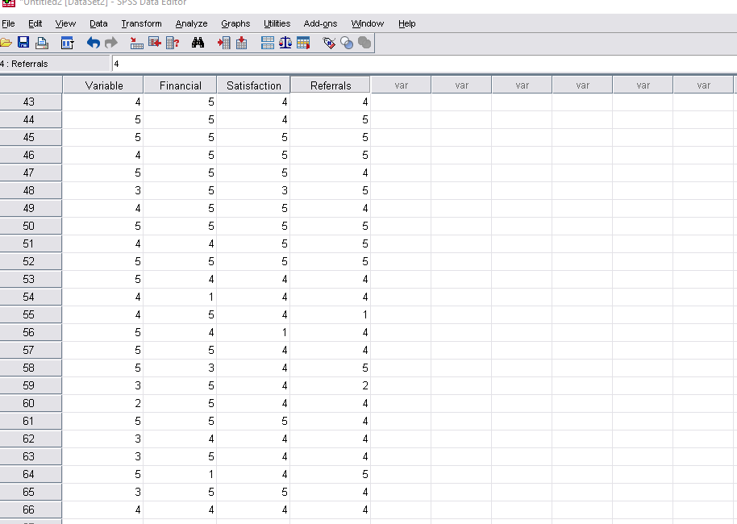
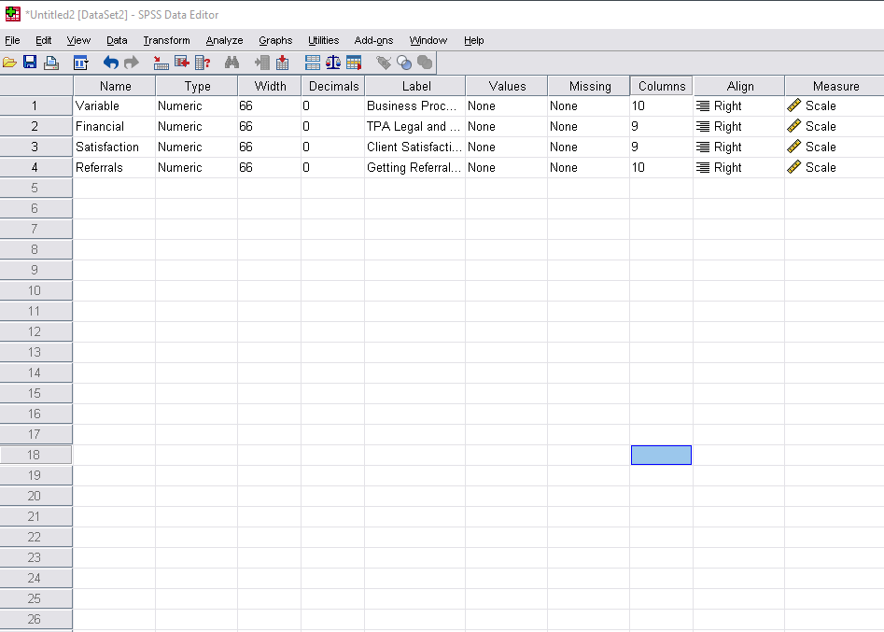

Appendix B: Survey Question
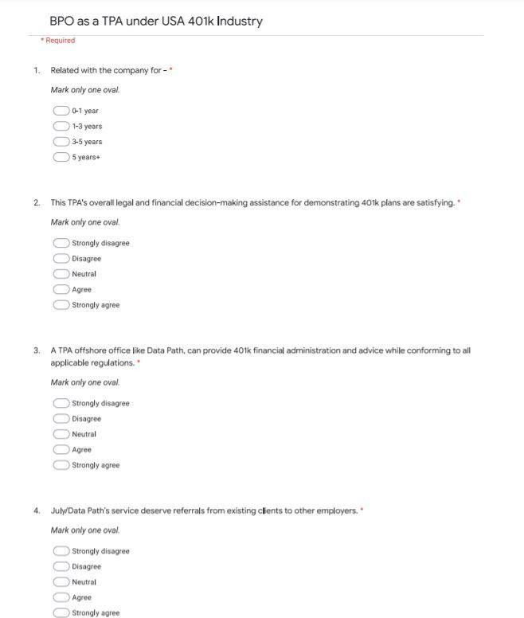

Appendix C: Response to Survey Questionnaire

Time |  |  | This TPA's overall legal and financial decision-making assistance for demonstrating 401(k) plans are satisfying. | A TPA offshore office like Data Path, can provide 401(k) financial administration and advice while conforming to all applicable regulations. | July/Data-Path’s service deserve referrals from existing clients to other employers.
12/3/2023 0:00 | 9:47:19 | AM | Agree | Neutral | Agree
12/3/2023 0:00 | 9:49:51 | AM | Strongly agree | Strongly agree | Strongly agree
12/3/2023 0:00 | 9:50:11 | AM | Strongly agree | Neutral | Agree
12/3/2023 0:00 | 9:53:03 | AM | Strongly agree | Neutral | Agree
12/3/2023 0:00 | 9:53:19 | AM | Strongly agree | Agree | Strongly agree
12/3/2023 0:00 | 9:53:36 | AM | Strongly agree | Strongly agree | Strongly agree
12/3/2023 0:00 | 9:53:52 | AM | Strongly disagree | Strongly disagree | Strongly disagree
12/3/2023 0:00 | 9:54:15 | AM | Strongly agree | Agree | Strongly agree
12/3/2023 0:00 | 9:54:29 | AM | Strongly disagree | Agree | Strongly agree
12/3/2023 0:00 | 9:54:37 | AM | Strongly disagree | Strongly disagree | Strongly disagree
12/3/2023 0:00 | 9:54:48 | AM | Strongly disagree | Strongly disagree | Strongly disagree
12/3/2023 0:00 | 9:55:55 | AM | Strongly disagree | Neutral | Strongly agree
12/3/2023 0:00 | 9:59:11 | AM | Agree | Neutral | Neutral
12/3/2023 0:00 | 10:00:08 | AM | Strongly agree | Agree | Agree
12/3/2023 0:00 | 10:00:21 | AM | Agree | Strongly agree | Agree
12/3/2023 0:00 | 10:02:58 | AM | Agree | Agree | Agree
12/3/2023 0:00 | 10:05:19 | AM | Strongly agree | Agree | Strongly agree
12/3/2023 0:00 | 10:06:41 | AM | Strongly agree | Strongly agree | Agree
12/3/2023 0:00 | 10:11:40 | AM | Strongly agree | Strongly agree | Strongly agree
12/3/2023 0:00 | 10:12:29 | AM | Strongly agree | Strongly agree | Strongly agree
12/3/2023 0:00 | 10:18:03 | AM | Strongly agree | Agree | Agree
12/3/2023 0:00 | 10:19:19 | AM | Agree | Agree | Agree
12/3/2023 0:00 | 10:19:49 | AM | Strongly agree | Strongly agree | Agree
12/3/2023 0:00 | 10:20:58 | AM | Strongly agree | Strongly agree | Strongly agree
12/3/2023 0:00 | 10:21:22 | AM | Strongly disagree | Strongly disagree | Strongly disagree
12/3/2023 0:00 | 10:22:58 | AM | Strongly disagree | Neutral | Strongly disagree
12/3/2023 0:00 | 10:25:04 | AM | Strongly agree | Agree | Strongly agree
12/3/2023 0:00 | 10:25:05 | AM | Agree | Agree | Agree
12/3/2023 0:00 | 10:25:05 | AM | Strongly agree | Agree | Strongly agree
12/3/2023 0:00 | 10:25:06 | AM | Strongly agree | Agree | Strongly agree
12/3/2023 0:00 | 10:31:24 | AM | Strongly agree | Neutral | Strongly agree
12/3/2023 0:00 | 10:36:17 | AM | Agree | Strongly agree | Neutral
12/3/2023 0:00 | 10:37:32 | AM | Disagree | Strongly agree | Strongly agree
12/3/2023 0:00 | 10:40:24 | AM | Agree | Agree | Agree
12/3/2023 0:00 | 10:41:21 | AM | Agree | Agree | Agree
12/3/2023 0:00 | 10:45:18 | AM | Agree | Agree | Neutral
12/3/2023 0:00 | 10:49:19 | AM | Strongly agree | Strongly agree | Strongly agree
12/3/2023 0:00 | 10:49:41 | AM | Strongly agree | Strongly agree | Strongly agree
12/3/2023 0:00 | 10:49:51 | AM | Strongly agree | Strongly agree | Strongly agree
12/3/2023 0:00 | 10:50:52 | AM | Agree | Disagree | Strongly agree
12/3/2023 0:00 | 10:51:05 | AM | Strongly agree | Agree | Strongly agree
12/3/2023 0:00 | 10:51:27 | AM | Strongly agree | Agree | Strongly agree
12/3/2023 0:00 | 10:51:35 | AM | Strongly agree | Agree | Agree
12/3/2023 0:00 | 10:53:36 | AM | Strongly agree | Strongly agree | Strongly agree
12/3/2023 0:00 | 10:54:07 | AM | Strongly agree | Strongly agree | Strongly agree
12/3/2023 0:00 | 10:59:28 | AM | Strongly agree | Strongly agree | Strongly agree
12/3/2023 0:00 | 11:02:12 | AM | Strongly agree | Neutral | Agree
12/3/2023 0:00 | 11:03:06 | AM | Strongly agree | Strongly agree | Strongly agree
12/3/2023 0:00 | 11:09:01 | AM | Strongly agree | Strongly agree | Agree
12/3/2023 0:00 | 11:24:18 | AM | Strongly agree | Strongly agree | Strongly agree
12/3/2023 0:00 | 11:34:10 | AM | Strongly agree | Strongly agree | Strongly agree
12/3/2023 0:00 | 11:42:04 | AM | Agree | Agree | Strongly agree
12/3/2023 0:00 | 11:56:32 | AM | Strongly agree | Agree | Agree
12/3/2023 0:00 | 11:57:11 | AM | Agree | Agree | Agree
12/3/2023 0:00 | 11:58:52 | AM | Strongly disagree | Strongly disagree | Strongly disagree
12/3/2023 0:00 | 12:19:32 | PM | Strongly agree | Agree | Agree
12/3/2023 0:00 | 12:23:29 | PM | Agree | Agree | Agree
12/3/2023 0:00 | 12:36:40 | PM | Strongly agree | Agree | Strongly agree
12/3/2023 0:00 | 1:12:13 | PM | Neutral | Agree | Disagree
12/3/2023 0:00 | 1:15:08 | PM | Strongly agree | Strongly agree | Agree
12/3/2023 0:00 | 4:49:53 | PM | Strongly agree | Agree | Agree
12/3/2023 0:00 | 5:10:06 | PM | Strongly agree | Agree | Agree
12/3/2023 0:00 | 6:54:20 | PM | Agree | Agree | Agree
12/3/2023 0:00 | 7:41:19 | PM | Strongly agree | Strongly agree | Strongly agree
12/3/2023 0:00 | 8:50:56 | PM | Strongly disagree | Agree | Agree
12/3/2023 0:00 | 10:44:37 | AM | Strongly agree | Agree | Agree

