INTERNSHIP REPORT
ON

Marketing and Promotional Activities of Kazi Food Industries Limited (KFIL)



Internship Report
BBA Program
Spring-2019

Supervisor
Dr. Md. Shariful Alam
Associate Professor

Submitted By
Mohammad Nazmul Hasan
ID: 111151327

Date of Submission: 23 October, 2019

Letter of Transmittal

23 October, 2019
Dr. Md. Shariful Alam
Associate Professor
United International University

Subject: Submission of Internship Report on “Marketing and Promotional activities of Kazi Food Industries Limited”.

Dear Sir
I would like to inform you that this report is made on the topic given by you. Though this Internship Report I have tried my level best to present the real picture of the “Marketing and Promotional activities of Kazi Food Industries Limited” I have given enough efforts to prepare the report as per your instructions.
I hope you will consider those mistakes and this report.

Sincerely yours

………………………

Mohammad Nazmul Hasan
Id- 111 151 327
Programme- BBA
Session: 2015-2019
Major: Marketing

Contents
Letter of Transmittal ii
Executive Summery 1
STUDENT’S DECLARATION 2
SUPERVISOR’S DECLARATION 3
Acknowledgement 4
Chapter One – Introduction 5
Introduction 5
Origin of the report: 5
Objective of the report: 5
Scope of the study: 6
Significance of the study: 6
Chapter Two – Methodology 7
Primary sources: 7
Secondary Sources: 7
Limitations 8
Chapter Three- Organizational Background and Industry Perspective 8
The Food Industry in general in Bangladesh: 8
Kazi Food Industries: 9
Mission- 10
Vision 10
Other Information: 10
Information on slaughterhouse: 10
Compliance Certifications: 10
Corporate Information of Kazi Farms Group: 11
Operational activities of the Organization: 11
Products: 11
Ice cream 11
Kazi Farms Kitchen: 13
Health Promises: 14
Franchise Operation: 15
Social Responsibility 15
16
Competitors of Bellissimo Ice-cream: 18
SOWT analysis of Kazi Farms Group 19
Chapter Four- Findings and Analysis of the Study 21
Chapter Five- Conclusion and Recommendations 30
Chapter Six- Appendix 31

Executive Summery

KFIL is a well-known company in Bangladesh. KFIL is very famous for its frozen food and ready to eat foods. They are holding around 40% share of the frozen food industry. KFIL also is known for its premium quality ice-cream. They directly import some vital raw material of ice-cream from New-Zealand for giving the consumer best possible premium taste. Besides this, they also market Za’n Zee ice-cream for middle-range group of consumers. Throughout this report, I tried to explain how KFIL promote their brands among the customer group, what is their strength, weakness, opportunity and threat. This report also contains some of their decision-making process regarding the situation. In the introductory part, I discussed about the industry background and also the company background. In the company background part here I tried to show their covering market area and also their market share and customer base. I also discussed the competitor of KFIL brands. As we know, KFIL has different brands so its normal that the competitor will be different. In the main part, I discussed how KFIL promote their brands in physical, digital, and also social media. The analysis also includes some sort of promoting strategy and procedure of KFIL. And finally, after analyzing their strategy for promoting the brands, I tried to give some recommendations to the company to make the strategy more effective and efficient.

STUDENT’S DECLARATION

I do declare that the work presented in this Internship Report entitled “Marketing and Promotional activities of Kazi Food Industries Limited” has been prepared by me. I have not submitted this report to any other University or any organisation.
The report I have submitted does not break any subsist law or copyright. I will take charge of every loss and damages if it break any foreign obligation.

___________________________
Mohammad Nazmul Hasan
Id- 111 151 327
Programme- BBA
Session: 2015-2019
Major: Marketing

SUPERVISOR’S DECLARATION

This is to certify that Mohammad Nazmul Hasan, student of BBA Program, Id- 111 151 327, Session: 2015-2019, Major: Marketing, United International University, have completed his Internship Report Titled “Marketing and Promotional activities of Kazi Food Industries Limited.”

I wish his success in life.

______________________________

Dr. Md. Shariful Alam
Associate Professor
United International University

Acknowledgement

It is essential to have knowledge about the relationship among theory and practical knowledge. Only then a student can claim himself as a sincere student. Many people helped me a lot to prepare this report on time by giving necessary information. It’s time to thank all those people.
First and foremost, I would like to acknowledge my heartiest gratitude and indebtedness to Dr. Md. Shariful Alam, Associate Professor of United International University for his guidance, supervision and help in all stages of carrying out my work. Without his critical analysis and suggestion at every step of the report, this report could not have reached its present form.

Secondly, I would like to convey my thanks to Rajib Saha Manager of Kazi Food Industries Ltd. and other employees of KFIL for providing me with valuable information that was very much needed for the completion of this report.
Finally, although I have given my utmost effort to prepare the report, this report may include some lacking. I apologies for any unintentional mistakes.

___________________________

Mohammad Nazmul Hasan
Id- 111 151 327
Programme- BBA
Session: 2015-2019
Major: Marketing

Chapter One – Introduction

Introduction
In this era of business everyone has to be very careful while choosing strategy for business. Every organisation has its own policy and strategy to make its business successful and profitable. In this dynamic world almost every company are using different type of marketing and promotional activities to make the business profitable. Here in this report the marketing and promotional activities of Kazi Food Industries Limited is being presented. To make this report I have focused on the marketing and promotional system that KFIL (Kazi Food Industries Limited) is currently following for promoting and for getting the best sale and concern of their customers.

Origin of the report:
For the fulfilment of BBA internship program is required. The contrivance of internship program is to prepare the students for the job world. Through this internship I get opportunity to apply my theoretical knowledge which I gained throughout the BBA programme into the real work life experience. An internship is a semblance of the real job world.
Reason for internship report-
- Knowing the actual job responsibility.
- Preparing for corporate world.
- To parallel the factual situation with the theoretical knowledge that is learned in the Academy.
- Fulfilling the partial requirement of both internship and BBA program.

Objective of the report:
Overall Objective:
- Presenting the information regarding marketing and promotional activities of Kazi Food Industries Limited.

Particular objective:
- Understanding the promotional activities of KFIL.
- Gather marketing related information of KFIL.
- Learn the systematic procedure that is followed by KFIL.
- Compare the theoretical knowledge and experience throughout the internship to understand the difference of real work life and learned lesson from university.
- Conduct a survey to know customer satisfaction.
- Find out the lacking of their existing policy.
- Suggest to remove those lacking.

Scope of the study:

I desire to understand the topic of my report “Marketing and Promotional activities of Kazi Food Industries Limited” throughout the 3 months’ time period of my internship in KFIL (Kazi Food industries Limited) where I have joined as internee.

Significance of the study:

This report has some important for KFIL as well as myself. I got to learn about corporate world by the means of this report. The Marketing department of Kazi Food Industries Limited will be benefited from this study. They will get to know about the lacking and problems of their existing marketing and promotional policies. They will know how to improve their promotional policies. Organisation can find out their flaws from inside and the recommendation which is given to the report will help them to improve their promotional procedure.

Chapter Two – Methodology

This report is prepared in a systematic way. Starting from collecting data to interpret, analyse and giving recommendation I have used some method. Most of the information is being gather here through the counselling with the team member of the Marketing and Branding team of KFIL.
For collecting required data Survey researched strategy is used. Survey is done with some Quantitative questions. Method called self-administrative questionnaire is followed where survey questions provided to the respondents and they have fill up those questions by themselves.

Sources:
Data collection process:
In this report here I collected data through some survey and also through counselling with my office supervisor and colleague.
Analytical tools: MS Excel

Primary sources:
- Observations
- Interview with the assistant Marketing manager of KFIL.
- Survey

Secondary Sources:
- KFIL website
- Internet
- Google scholar
- ERIC( Education Resources Information Centre)
- Mendeley for reference
- ERP Software
- SPSS

Limitations
There are some limitations exists in this report -
- Sample size is small for conducting data analysis part.
- Respondents may not feel comfortable to providing answers that present themselves in an uncomfortable manner.
- Due to confidentiality of some information, accurate response may not revealed.
- As some assumption is made on the basis of the collected data, so here can remain some error in this report.
- Time constraint
- Lack of support of some member

Chapter Three- Organizational Background and Industry Perspective

The Food Industry in general in Bangladesh:

The industry of food in Bangladesh is a rapidly high growing sector, employing an important part of our country's labor force and also on economy. The food processing industry in Bangladesh grew at an average annual rate of 7.7 percent between 2004 and 2010. In its 25006 Economic Census, the Bangladesh Bureau of Statistics indicated that there were approximately 246 medium-sized food processing industries exercising 19% of Bangladesh's industrial manufacturing workforce or 8% of the total manufacturing workforce. The food industry employs 2.45 % of the total workforce in the country and in 2010, it accounted for 2.01 % of GDP. Throughout the nation, there are also various small-scale factories and national units engaged in food processing. The food processing division in Bangladesh is a USD 4.5 billion industry, as per some industry interpreters. Bangladesh exported concocted food and drinks worth more than $700 million, of which over 60 percent were shrimp and fish items in 2010.
Food processing has been a mild scale in Bangladesh, with domestic or family businesses using easy processing expertise to store and handle raw agricultural products to produce them as food and feed. Though the industrial scale of food processing using contemporary technology especially for wheat and rice milling, mustard seed grinding and very shortbread and cookie manufacturing came in the 1960s, this development did not gain momentum in terms of operating scale and grade till the 1980s.

Present Circumstance of Food Industry in Bangladesh:
The food processing industry in Bangladesh defines one of the significant possible fields within the industrial segments. The industry accounts for about 20%of the labor force for more than 22 percent of all manufacturing production and operation. This industry includes processing of pulses & oilseeds, dairy, bakery and confectionery, cereals, vegetables and fruits, carbonated beverages and non-carbonated fruit juices, drinks, other beverages and numerous other food products. 370 members of BAPA (The Bangladesh Agro processors Association) involved in the processing, production, and exporting of products.

GDP impact:
The food processing industry has great impact in the GDP of Bangladesh:
- Bangladeshi food processing company export high amount of product in Middle East and also some European country and collect huge amount of foreign currency with the product.
- Export to Iran, Indonesia and Turkey of fresh horticultural foodstuffs.
In the domestic and export sectors, there is tremendous potential for food manufacturing sub-sectors along with vacuum fried fruit chips, potato chips, bakery items, soft drinks, confectionary items, frozen vegetables and meat, processed fish, grain products, poultry and milk processing, spices powder, tomato and different types of spices’ paste, canned jackfruit and pineapple, fast food, ready to eat breakfast cereals, food additives, aromas and so many.

Kazi Food Industries:

Kazi Food Industries Limited is a recent venture of the Kazi Farms Group. Located in Beron, Ashulia. KFIL started operations with the introduction of premium quality ice cream brand 'Bellissimo' in 2013. To cater to the demand of a mass market ice cream, KFIL launched another ice cream brand 'Za 'n Zee' in 2014. Kazi Farms Kitchen (KFK), a frozen food brand launched by KFIL in the late 2013, has become one of the leading brands in this category in Bangladesh.

A wide range of product sale under the brand name Kazi Farms Kitchen. These are all guaranteed to not contain any antibiotic residues, as chickens are not fed any antibiotics within 7 days of slaughter, as per international practice and the chicken is totally grown up with natural procedure . The meat is also guaranteed to be produced from chickens raised on feed not containing MBM (meat and bone meal) as per European standards. The meat product are totally anti biotic free in nature and the healthy.

Mission-
To provide consumers with food products that are totally safe, free of any harmful chemicals, innovative with the highest quality at an affordable price.

Vision
To be the most trusted consumer Food Company in Bangladesh.

Other Information:

- Number of depots: 12 (capacity : 2,10,000 Liter)

- Number of Delivery vehicles: 55 in different capacities

- Number of Permanent Employees: 900 plus

- Number of freezers: 14,000 plus

- Number of distributors: 300 plus across the country

Information on slaughterhouse:

- Slaughterhouse process area: 16,000 sft

- Per day capacity: 15,000 to 18,000 pcs birds

- Per hour capacity 1,000 pcs birds

Compliance Certifications:

They produce safe food by maintaining following compliance in their processing plant:

- HALAL

- ISO 22000:2005

Corporate Information of Kazi Farms Group:

Name of the Company: Kazi Farms Group

Type: Private

Industry: Poultry

Founded: 1996
Founders: Kazi Zahedul Hasan
Kazi Shahidul Haque

Owners: Kazi Zahedul Hasan

Employees: 7000

Corporate Office: Ahmed Kazi Tower, House-35, Road-02, Dhanmondi, Dhaka-1205
Telephone: +880-2-9612290-93, 9612184
Fax number: +880-2-9612185
IP No: +09613606060
Email address: info@kazifarms.com

Operational activities of the Organization:

Products:

Ice cream

Bellissimo:

- This is the first premium ice cream brand in Bangladesh.

- This is the only local ice cream brand to which use 10% milk fat – rich, creamy ice cream.

- Ingredient are totally natural.

- Market leader in premium ice cream category in retail.

- Nationwide distribution channel to get the urban and non-urban customer base also.



Za ‘n Zee:
- Positioned as a new and exciting ice cream brand that compete with other mass level brands.

- Available across the country both urban and rural areas.
- Diverse range of product portfolio to attend different customer segments.

- Maintaining regular growth in the market share every year.

- Take world number-1 Cricketer Shakib-Al-Hasan is the Brand Ambassador.

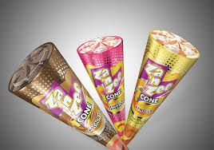

Kazi Farms Kitchen:

- Launch: November, 2013 with huge range of frozen food.

- Franchised outlet launch: October, 2014.

- They are the market leader in the frozen food category.

- Sustaining robust growth from the beginning in the market.

Products:
- Meat based
- Flour and Fish based frozen food
- Egg
- Solar-oven dried fish
- Orange jelly and strawberry jam.

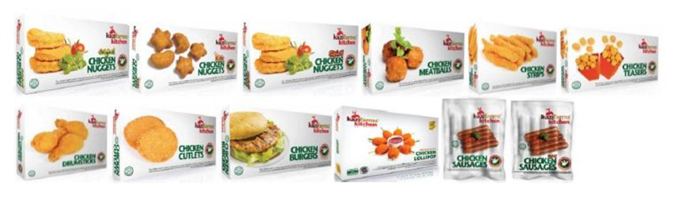

Health Promises:

Kazi Farms Kitchen has four health promises that have been followed strictly for its frozen products. These health promises are unique in Bangladesh and has already given Kazi Farms Kitchen a competitive advantage among its competitors.

MBM (meat and bone meal) free feed:

KFK feed chickens that do not contains any MBM. That is why our chickens do not run the risk of containing any harmful bacteria.

No antibiotic residue:

Chickens are sometimes given antibiotic treatment. When people eat farmed chickens or products made from those chickens, they may unknowingly consume "residual" antibiotics, which may still have been in the chicken's body at the time of slaughter. This may end up building resistance to antibiotics in the human body. We guarantee that there are no residual antibiotics in Kazi Farms Kitchen products.

No harmful preservatives:

Preservatives used in food products can be harmful for human health. Kazi Farms Kitchen products do not contain any harmful preservatives.

No tasting salt:
Tasting food can cause headache and high blood pressure. Kazi farms don’t use tasting salt.

Franchise Operation:

- Kazi Farms Kitchen started its franchised operation in October 2014 and within a very short time it has expanded nationwide with the promise of ‘Eat Better’.

- Presently Kazi Farms Kitchen has more than 130 franchised outlets across the country and the number is increasing in every month.

- This franchised outlets sell chicken based fried items, frozen packs (flour, meat and fish based) as well as Bellissimo premium ice cream.

Social Responsibility

- Kazi farms Group is the main financial donor of Central women’s university, the private university established in Bangladesh for women only.
- Kazi Farms Group also contributes to the operation of Kazi Zahural Huq College. This is a free privately-managed HSC college with one of the highest pass rates of the district.

Competitors of Kazi Food Industries: There are many competitor of KFIL in the Bangladeshi market some are competing in the ice-cream industry and some are competing in the frozen food industry. The name and operation of those company are given bellow:

- CP
- Golden Harvest
- Brac Chicken
- Paragon
- AG Foods
- Jhotpot
- Lamisa
- Ready Cheaf
- Bengal Meat
- Rich

C.P. Bangladesh Co. Ltd:
C.P. Bangladesh Co., Ltd. is C.P. Group Thailand's sister concern. Founded in 1999, C.P. Bangladesh Co., Ltd. They are doing business in the poultry and agricultural industry in Bangladesh. The firm is delivering verity of frozen and ready to eat product in Bangladesh and they are mainly competing with Kazi firm in the frozen food sector.s

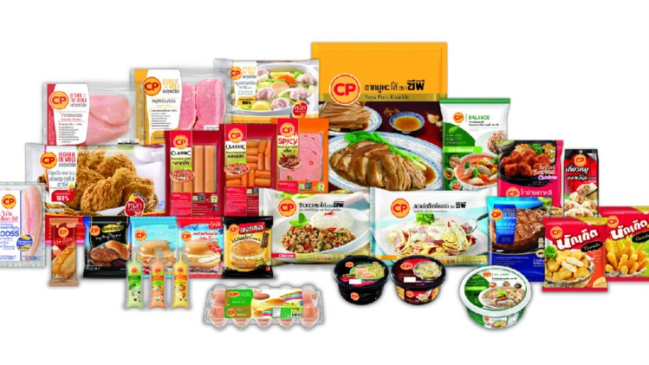

Golden Harvest Agro Industries Ltd.
Golden Harvest is the pioneer in the frozen food industry. They are offering a huge range of frozen food in the market. The Golden Harvest is the main and big competitor for the frozen food industry. Their product are very famous among the consumer group that’s why they can initiate any plan to make the aggressive marketing process.
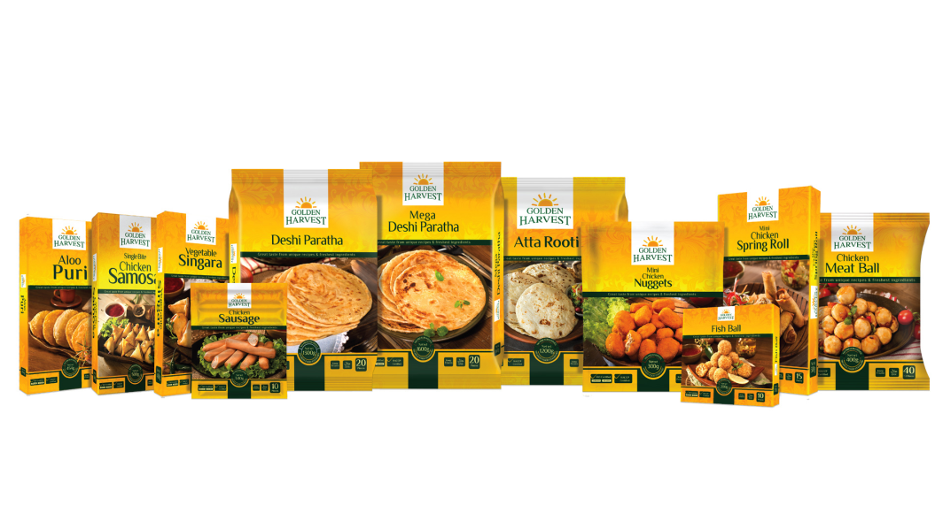


Paragon Agro Ltd.
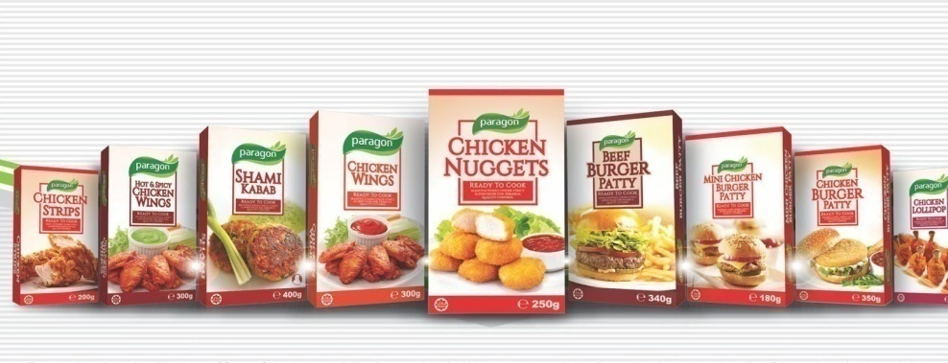
Paragon Agro Ltd. is one of Bangladesh's preeminent broiler chicken processors, frozen foods manufacturing, its own garden-packed tea and branded egg manufacturers.


BRAC Chicken
BRAC Chicken, a BRAC social company, unveiled its recent variety of frozen foods, including masala nuggets, children's nuggets, standard nuggets, drumsticks, wings, burger patties, sausage, kebab, cutlet and chicken tandoori.
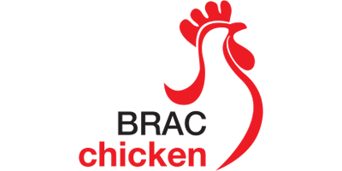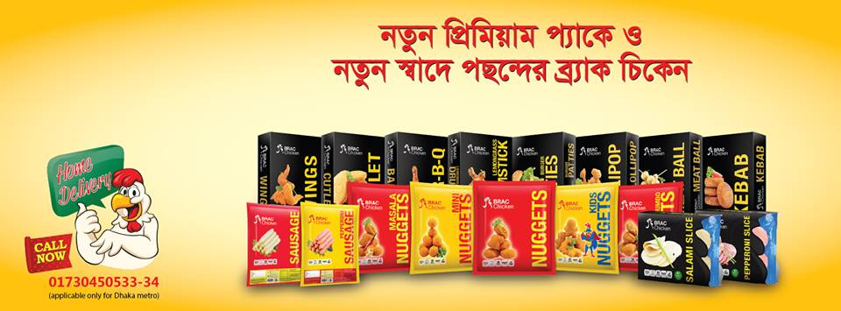

Competitors of Bellissimo Ice-cream:


Igloo is very famous ice-cream company in Bangladeshi market. They have huge range of product line and verity flavour ice-cream. They are the giant in the ice-cream industry.
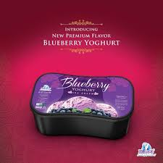

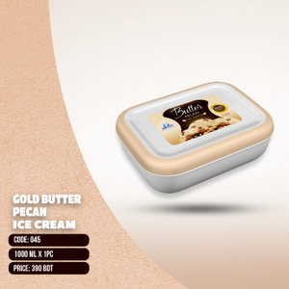
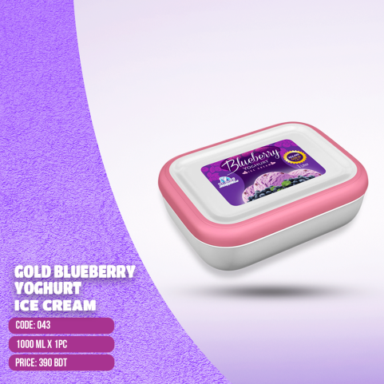


Polar Ice-cream:

In 1987 Polar brand arrived, Dhaka Ice Cream Industries Ltd. developed the hygienically manufactured and marketed ice cream in Bangladesh for the first time, mostly from renowned Australian, Europe manufacturers. Polar ice-cream's core issue is food safety for its valuable consumers. Its variety expands to a broad variety of wrapped ice creams, ice cream stickers, cup ice creams, and lollies in a variety of delightful flavours plus textures.

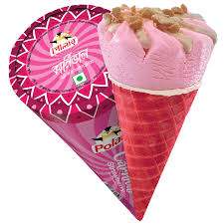

SOWT analysis of Kazi Farms Group

My topic is -“Marketing and Promotional activities of Kazi Food Industries Limited.”
Through SOWT I am going to show different types of strengths, challenges and barriers of the Kazi Farms marketing and promotional activities.
Here is the SWOT analysis of Kazi Farms Group:
Strength:
- KFIL is the leading brand in the product category.
- They have huge number of distributors among their competitor and right now they have 130 franchise outlet within the country and the number is increasing day by day.
- They have huge range of product in the frozen food and also in the ice-cream factory which give them a great position in the market.
- They have a TV channel call Dipto TV which give them advantages of promoting their product among the customer group.
- The economic strength of the company is very strong.
- They are promoting their product widely within the country because they got huge number of distributor.
- They also promote their brand through some event because they got huge support from there funds.
- They can also promote their product with their product criteria like no harmful preservatives for health issues.

Weakness:
- The frozen foods industry is subjected to criticism by various doctors and dieticians who consider frequent consumption of frozen food is bad for health as it affects the blood pressure which are affecting their promotional activities.
- Low total purchase by per customer.
- The size of chicken also a great barriers for the quality management.
- Communication with the vendor and the distribution is a great weakness of the KFIL.

Opportunity:

- There is very growing market in Bangladesh.
- Their TV channel is creating a great opportunity for promoting their product among the customer group and get the top market reach.
- The developing lifestyles and fast urbanization create a great opportunity for the fast and the ready to eat product in Bangladesh.
- The online and the event promotional activities is a great source of marketing and promotional activities.

Threat:

- The health awareness is growing across the country which may decline the use frozen and fast food product in Bangladesh.
- Continuously rising prices of raw material such as flour, oil and raw vegetables is a great pressure to the company.
- Their competitions are the great threat for the company because already they have promoted themselves as the king of the market.
- When promoting frozen foods and vegetables are not in great demand right now

Chapter Four- Findings and Analysis of the Study

Marketing and Promotional activities of Kazi Food Industries Limited:
Promotion
Kazi Farms Kitchen always play a very vital rule to get most effective reach to their customer mind by promoting their product and services. They promote in a physical environment, traditional and digital media. They are coordinating their promotion to different third party who assist them in designing POSM and other Promotional tools.
In a Physical Environment
In physical environments at special events such as concerts, festivals, trade shows, and in the field, such as in grocery or department stores KFIL promotes their product and services. They also try to interact with the customers in different field to get most close reach through different event activates. The purchase of a product can be faster with discounts free items, or a contest.
Sponsorship: Kazi firms kitchen take advantages of sponsorship facility to promote their product. They sponsor different kinds of program in different School, College, and University.

Brand Promoters: Kazi Farms Kitchen promotes their brand and product with the help of brand promoter in different kinds of event and activations. Brand promoter try to share different kinds of information about a brand and product, answer to customers query, promote the differentiation (USP) of the brand and encourage customers to purchase companies products. Kazi Farms Kitchen appoint brand promoters in Dhaka International Trade Fare stall and special occasion like Eid UL Fitr, Eid UL Azha, Puja, and Christmas.

Activation: Activation in superstore is done when companies launch new product and offers .It is like giving customer, a company’s product as free sample and chance to get close with the offerings which encourage them to buy their product and offerings.

Traditional Media
Traditional media are the most common source of promotion which includes print media such as newspapers and magazines, electronic media such as radio and television, and outdoor media such as banner or billboard advertisements and so on. Each of this source of media play very vital role for a brand or companies promotional activities.
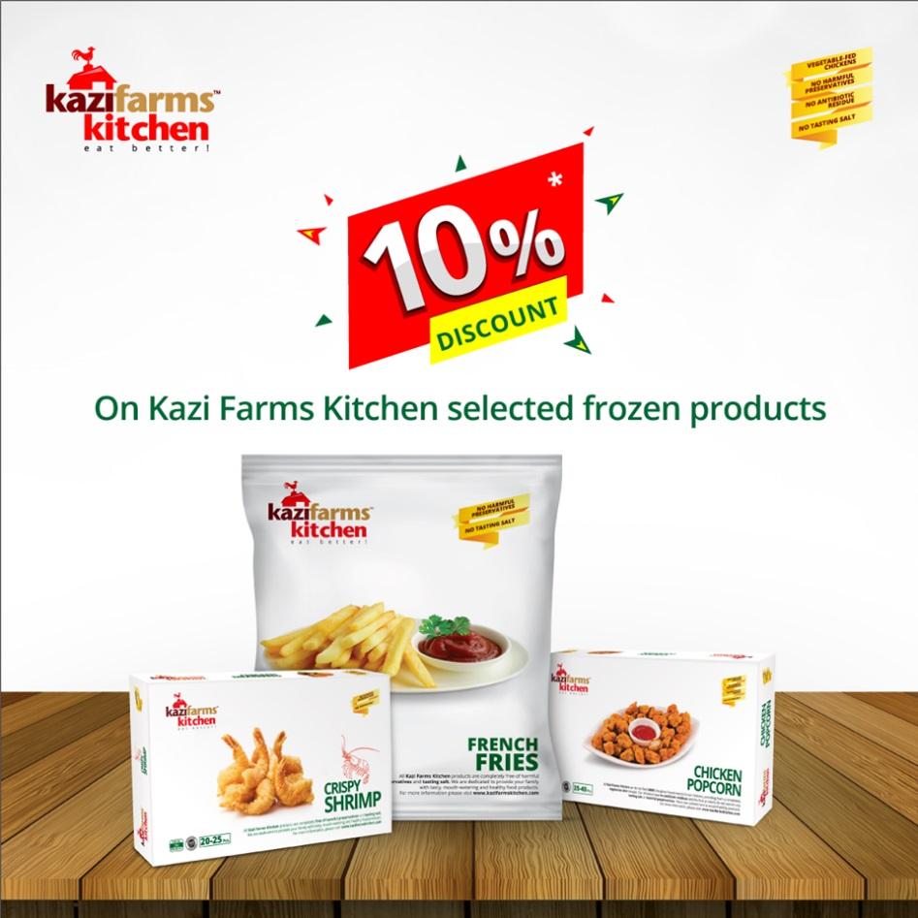

Advertisement: At first Kazi Farms Kitchen focused less importance on advertisement as a promotional media to keep balance in demand and supply of their product as it can create huge demand for a company’s product. When their demand and supply of products has increased a lot than the past, they are focusing more on advertising in all source of media. Now KIFL are most focused company on broadcasting in those advertising media. Also KFIL own a TV Channel called “Deepto TV” which play very important role in the promotional process of the company product and services.

Radio commercial: Kazi Farms Kitchen promotes their product greatly through Radio Commercial. Commercial radio stations make most of their revenue selling "airtime" to advertisers. Radio advertisements or "spots" are available when a business or service provides valuable consideration.

Radio commercial Endorsement: KFIL promotes their product through Radio Commercial endorsement. In radio commercial endorsement, RJ (Radio Jockey) of different radio program speaks about any of the particular product/brand the company of which endorses that radio program.

Point of Sales: POS (Point of sale) materials advertisements are the way of attracting interest of the consumers and promoting brands goods, services exactly at points of sale. The main goal of POS-materials is in motivating the customer to make a purchase. KFIL use different point of sales materials like Billboard, light box, poster, festoon, cut out, dangler, X banner, press ad, leaflet and so on to get the customer interest.

Digital Media

Digital media, which includes Internet, social networking and social media sites, is a modern way for brands to promote the brands product and services and get close with consumers as it releases news, information and advertising from the technological limits of print and broadcast infrastructures.

Digital Marketing: Kazi Farms Kitchen gives top most importance in digital marketing for the most conveniences of the customer as they become busier with the life so they can only search and get the information from the website.

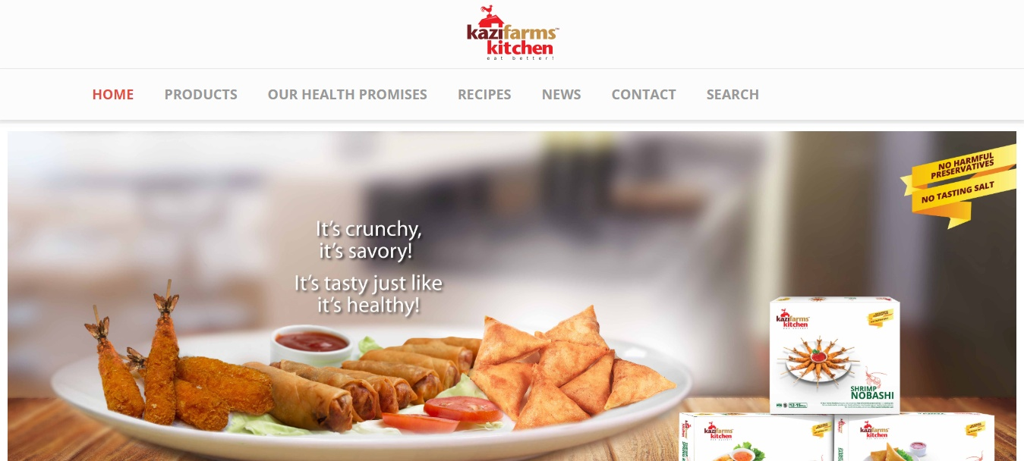

KIFL has a website the address is www.kazifarmskitchen.com the consumer can get any sort of product and offer related information from the website.

People

All companies are depend on the people who run them from the bottom line Sales staff to the MD. Placing the right people in the right is very vital for a company to successfully provide the products/services to the consumers or the customers. KFIL ensure its business activity with highly motivated workforce under the close supervision of strong management. Employees perform their specific activities under the umbrella which can be called teams like Key Account team, Franchise team, R&D, sales, marketing and Branding, Finance and so on.

Production Team: The production team are the factory employees who are responsible for producing the products and offering according to sales demand of KFIL.

Accounts Team: Accounting team are responsible for maintaining the balance of the fund and the return are coming from the investment and also keeping the accounts.

Purchase Team: Purchase team is responsible for sourcing, negotiating the raw material with possible supplier to get product at a suitable price and also minimize the cost of purchasing raw materials.

Key Accounts Team: Team Key Accounts is responsible for corporate sales and also managing frozen food items in different super shops, department stores, retail stores. Finding new opportunity of investment for the company.

Franchise Team: Franchise team is responsible for analysing opportunities to establish franchise store in different area based on potentiality of that area. This team are also responsible for analysing the consumer buying power, demand/ interest in company’s products, population, and capability of possible franchisee for selecting best possible location.

R&D: Research and development team is responsible for regular developing new product opportunities, improving existing products, observing market condition, competitors, and consumers changing behaviour and needs and demands.

Sales: Sales team is responsible for keeping close eyes on the sales to ensure sale of products to the dealer and retailer who eventually sell the products to the final consumers. This team give target to each dealer for the sales and end of the month they try to comply with this target and also give the best target gainer best return from the company.

Marketing and Branding: Marketing and Branding team is responsible for performing marketing activities like advertising, promotion, communication and positioning their products in the mind of consumer through their performance. This team maintain very critical point to get the customer closer through their promotion on different media.
Kazi Farms Kitchen also initiate different kinds of promotional activities in different way like they sometime arrange some sort of competition and select the best possible candidate and give them special Prize for the win. This sort of competition engage huge number of people interest.There is one example of Bellissimo’s competition.



There are three Facebook page of KIFL’s three brand which are given bellow:

Bellissimo Facebook page:

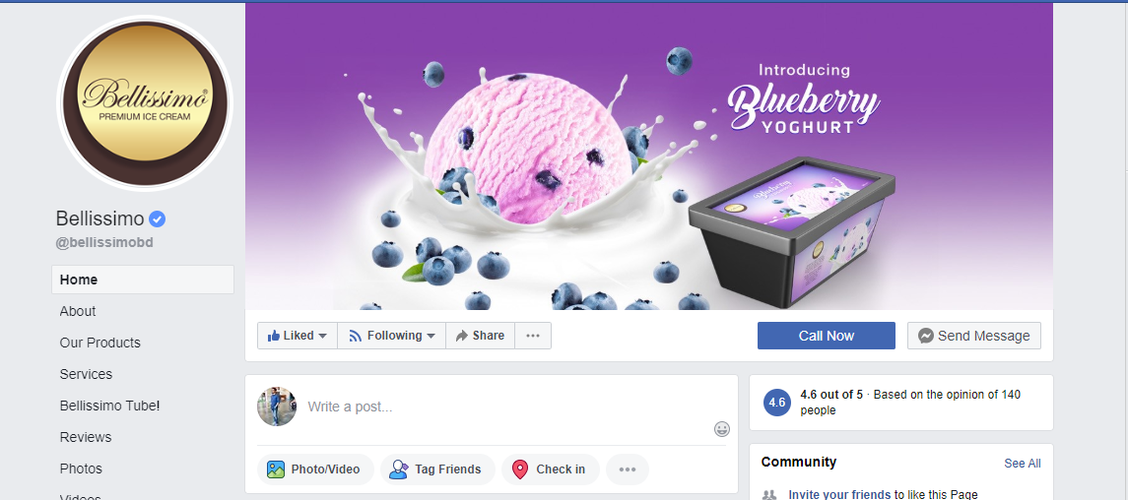

Kazi Farms Kitchen Facebook page: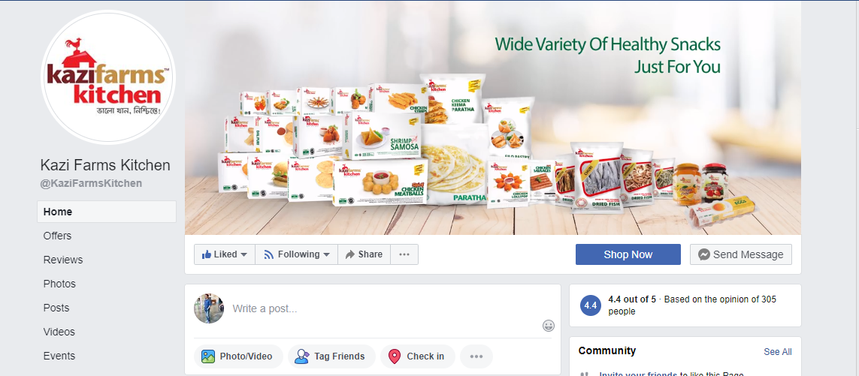Za’n Zee Facebook page: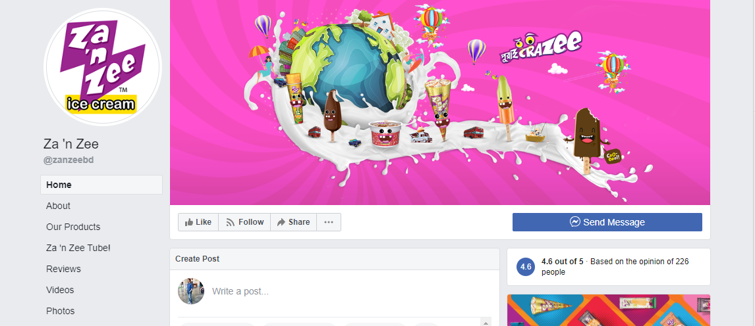

Now a days we all know social media has a great influences in the market. People all over the world spend a huge amount of time in social network. Facebook is the most famous platform of the social gathering. On an average people spend at least 4 hours of their everyday time in social network Facebook. So, KFIL don’t miss the opportunity to get close with their potential customer and inform about their offerings in social platform. Through this pages KFIL promote their brands and also promote new offers and items. People can easily go to their pages and can get any sort of information from there.

Findings
From the very first part of analysis here I show the mostly used form of promotional process of KFTL. Here I show how KFIL promote their brand in physical environment, non-physical which is virtual environment. In the physical here KFIL use sponsorship in different program and also they promote in their different activation through their brand promoter. Brand promoter play a very vital role in promoting the brand through word of mouth marketing process. Also I try to show how KFIL promote their brand in non-physical which is virtual environment through the traditional media like TVC, Radio program and also radio commercial endorsement process. KFIL also promote their dealer around the country as we know they almost own 130 franchise outlet within the country. The franchise outlet play very important role of promotional advantages. Here also in the company background part I also show SWOT analysis of KFIL here I discussed about the strength, weakness, opportunity and also the threat of the company.

Overview of the Competitor:
As we know that KFIL has three well-known brand in the market. Which are ready to eat and frozen brand Kazi Farms Kitchen, Premium ice-cream brand Bellissimo, and another ice-cream brand Za’n Zee. So, it’s very normal they will got different sort of competitor in different field. For frozen and ready to eat product Kazi Farms Kitchen has CP, Golden Harvest, and Paragon, as their competitor. And for Premium ice-cream Bellissimo the have Igloo premium as their competitor, and for the Za’n Zee ice cream they has polar, kuality and so on as their competitor.

Chapter Five- Conclusion and Recommendations

Conclusion:

Kazi Food Industries Limited always try to provide consumer 100% chemicals free, anti-biotic free and totally organic, highest quality product with a very affordable price. KFIL wants to position themselves as the market leader of frozen product and also the most trusted company in their business area.
Throughout my 3 months internship period in branding and marketing department I got to know how they promote themselves in the market. KFIL want to get the market leader position in the Bangladeshi market, it’s not that much easy because for being market leader they must acquire the most customer of frozen food with them but there are some giant in the market like Golden Harvest and CP.
For being market leader there must be something which can differentiate KFIL from others. So, KFIL here use a very highly strategic technique they started to promote themselves with their most important product criteria like anti-biotic free, organic food development which bring them huge customer attention.
Beside those I have some sort of recommendation for KFIL which I observe throughout my internship period that should be corrected.

Recommendations:

- There are some sort of gap in demand and supply of KFIL product. KFIL must focused on this gap where the dealer are requirement must be fulfilled.
- For being favourite in the bottom line consumer group KFIL must enlist themselves in the big and famous super-shop around the country and ensure their product availability.
- KFIL must design and advertise their product by giving priority to the personal and family using criteria as their most of the consumer are family person.
- They must give higher priority on social media and digital media advertisement as we know the majority of their potential consumer are engage social and digital media greatly.
- As maximum consumer prefer self-service, KFIL should give more importance to this fact of ensuring their products presence in attractive condition& position in the freezers within customers reach.
- They should invest more in R&D to create new product and flavour by identifying the demand and desire of actual and potential customer of frozen food.
- They should find out some way by which they will be able to increase the taste of product by maintaining the quality of their products.
- They should regularly inspect their product quality to ensure their standard.

Chapter Six- Appendix
  - :: Kazi Farms Group :: | Kazi Food Industries. (n.d.). Retrieved April 22, 2019, from https://www.kazifarms.com/Kazi Food Industries
  - :: Kazi Farms Group :: | Social Responsibility. (n.d.). Retrieved April 22, 2019, from https://www.kazifarms.com/Social Responsibility
  - Bouzari, A., Holstege, D., & Barrett, D. M. (2015). Vitamin Retention in Eight Fruits and Vegetables: A Comparison of Refrigerated and Frozen Storage. Journal of Agricultural and Food Chemistry, 63(3), 957–962. https://doi.org/10.1021/jf5058793
  - Consumer Resources - NSF International. (n.d.). Www.Nsf.Org. Retrieved from http://www.nsf.org/consumer-resources/cooking-cleaning-food-safety/cooking/defrosting
  - Golden Harvest Agro Industries Ltd. – Golden Harvest. (n.d.). Retrieved July 26, 2019, from http://www.goldenharvestbd.com/agro/
  - Harris, J. M. and R. S. (n.d.). Consumer Demand for Convenience Foods: Demographics and Expenditures. Retrieved from http://ageconsearch.umn.edu/bitstream/46585/2/38030026.pdf
  - History of frozen food - Fresh from the Freezer. (n.d.). Retrieved July 26, 2019, from https://freshfromthefreezer.co.uk/about-frozen-food/history-of-frozen-food/
  - Kazi Farms Kitchen | Eat Better. (n.d.). Retrieved July 26, 2019, from http://www.kazifarmskitchen.com/products/all
Baldwin, R. (2007, October 4). Importance and Impact of Product Availability. Retrieved December 29, 2016, from http://synchronoussolutions.blogspot.com/: http://synchronoussolutions.blogspot.com/2007/10/importance-and-impact-of-product.html
Mowles, C. (2009). Consultancy as temporary leadership: Negotiating power in everyday practice. International Journal of Learning and Change, 3, 281-293. http://dx.doi.org/10.1504/IJLC.2009.024693
Whitmore, M. (2011, June 11). The Advantages of Frozen Foods. Retrieved December 28, 2017, from livestrong.com: http://www.livestrong.com/article/468741-the-advantages-of-frozen-foods

