Social Media Marketing: A study at the Texort Digital Marketing



Social Media Marketing: A study at the Texort Digital Marketing

Submitted by:
MD. Majidul Islam
ID: 111 143 075
School of Business and Economics
United International University

Supervised by
Dr. Kawsar Ahmmed
Associate Professor
School of Business and Economics
United International University

Date of Submission: 20th May 2019

Letter of Submission

May 20, 2019

Dr. Kawsar Ahmmed
Associate professor
School of Business and Economics,
United International University

Subject: Submission of report on “Social Media Marketing: A study at the Texort Digital Marketing”

Dear Sir,
This is my pleasure to submit the internship report. I have been working three months long internship program at Texort. The title of the report is “Social Media Marketing: A study at the Texort Digital Marketing” I have prepared this report to fulfill my internship requirement.
I have given my best effort to combine all my internship work together in this report. While doing my three months internship in this organization I have learnt lots of things about business. I was working here as a digital marketing intern. Moreover I have tried to develop my knowledge in different aspects. In general my internship in this organization was an eye opener for me. It has enabled me to bridge the gap between theoretical knowledge and practical aspects of corporate world. Even though I have tried my best to maintain the quality and consistency of the report, still there may have some inadvertent mistakes, omissions or errors for which I apologize in advance.
This report is based on my workings, experience and observations during my internship in Texort. Despite facing some problems, difficulties and obstacles I have tried to be as much detail oriented as possible. Working on this report has been a delightful experience for me. I really appreciate the opportunity to work on this project. If you need any further elaboration on any issue, I shall be very glad to oblige. Thanks and best regards,
Sincerely yours,
_______________
Md. Majidul Islam

Acknowledgement
I would like to take this opportunity to give thanks everybody who has helped me complete this report. My special regards go to my honorable supervisor Dr. Kawsar Ahmmed, Associate Professor of school of Business and Economics, United International University; for guiding me throughout completion of this report. His continuous support and observation throughout the project has helped me tremendously to accomplish this task. His optimism and faith in me and my skills gave me huge confidence in myself and my work. Even during times when my work appeared difficult to me, I perpetually received correct direction after a meeting with him. My internship report itself has been analyzed and cleft scrupulously under his management. I'm very humbled to have received the chance to work on this subject and it has helped me gain a practical knowledge of the company workplace and has helped me in achieving sensible knowledge as well as corporate culture.
I owe a way of gratitude to CEO, of Texort for choosing me as an intern out of an extremely competitive environment. He is undoubtedly professional in this field and allowed me to work on my internship report during office hours. Without his constant guidance, endless efforts and joyful encouragement, this study wouldn't have been successful. Finally, I would prefer to give thanks all of my coworkers for their support. Along with that I would also like to express my heartfelt gratitude to all the members of marketing, Creative team, Digital marketing department, Media department and R&D department to stay supportive and inspirationally for successfully finishing this report.

Abstract
Social media marketing is a powerful weapon for the business of all categories to reach prospective customers. It is a form of internet marketing to create and share a particular brand message on social media networks. Prime activities include posting text message and image updates, video clips and other contents that drive audience engagement who are connected.

This study is done on social media marketing in connection with the Texort Digital Marketing Agency. In this study, six areas are examined whether they are practiced properly at the Texort so that success in social media marketing is achieved. A survey questionnaire was administered and data were collected from 120 respondents. Results show that for the success in social media marketing, consistency and frequency, brand value, personal touches, follower engagement, and analytics are very important.

Based on the findings several important insights are instituted including-
- Without social media marketing, increasing brand value and the business horizon is totally a tough job.
- Audience engagement is not always preferred.
- Other media communication is equally important in addition to social media marketing.
- Dynamic analytical ability is required to enjoy the full benefits from social media marketing.

Keywords: Social media, consistency and frequency, brand value, personal touches, follower engagement, analytics

Table of Contents
Letter of Submission 3
Acknowledgement 4
Abstract 5
CHAPTER 1 1
1.1 Introduction 1
1.2 Background 2
1.3 Motivation 2
1.4 Objectives 3
1.5 Scope 3
1.6 Significance of the research: 3
CHAPTER 2 5
An Overview of Texort Digital Marketing and Literature Review 5
2.1 About the Texort 6
2.2 Mission & Vision of Texort 6
2.3 Focus of Texort 6
2.4 History of Texort 7
2.5 Location of Texort 7
2.6 Services of Texort 8
2.6.1 Search Engine Optimization 8
2.6.2 Pay per Click 8
2.6.3 Social Media Marketing 9
2.6.4 Marketing Strategy & Research 10
2.6.5 Content Writing & Marketing 10
2.6.6 Email Marketing 10
2.6.7 Conversion Rate Optimization 11
2.6.8 Graphic Design 12
2.6.9 Web Design & Development 12
2.7 Clients of Texort 13
2.8 Project of Texort 14
2.9 Organ-Gram of Texort 15
2.10 What does social media mean 16
2.11 Types of Social Media 17
2.12 Importance of Social Media for Marketing and Communication 22
2.13 What factor impact on Social Media Marketing for communication 23
2.14 How factor impact on Social Media Marketing and communication success 26
CHAPTER 3 27
Methodology, Analysis and Findings 27
3.1 Introduction 28
3.2 Sample for the present study 28
3.3 Measurement 28
3.4 Data collection procedures 31
3.5 Data Analysis 31
3.6 Findings 45
3.7 Discussion 46
3.8 Recommendation 46
3.9 Conclusion 46
Reference 48
Appendix 1 49
Appendix 2 52

CHAPTER 1

Introduction

In this advanced world practical experiuence is fundamental thing to survive. So we must have to have some practical learning and expertness to go for any work. According to the academic rule the students of BBA (Bachelor of Business Administration) must have to complete internship at the end of their BBA program. The major objective of this this program is to ensure that students gains working skill of their major and minor areas. As a student of Bachelor of Business Administration I have got internship to work in Texort. I am working here from January 15, 2019 to April 15, 2019. In my 12 weeks of work period I have learned many important new things that introduced me with the representativeness of the work and daily life. This also helps me to gain practical and theoretical knowledge. It looks like in the reality there is some relation with the theoretical experience and in the work we must have to follow some structure that we have learned from the educational life. It also seems like we must have to get in death knowledge of any learning of any information or skill. But sometimes our theoretical learning is not enough. In that situation we have to think and plan according to our practical knowledge. Sometimes it might happen that we do not need any theoretical knowledge (some special case). We must have to have the enough knowledge of any practical work and which is more important than theoretical knowledge. With the inadequate knowledge we can’t be successful in any work. So getting proper practical skill is much more important.
Nowadays online Business or E-commerce is getting essential part of our modern life. Around the world there are 15 to 25 million online stores who are selling the products on the internet today. Almost all the businesses are going for the website based works and marketing and selling. Banking, hospitality, delivery, even the grocery shops are also in online. When all the segments are going for online or website based work. For this digital marketing, social media marketing and communications increase tremendously.
I have chosen my topic on “Social media marketing and communication”.

Background

For the long time I’ve doing research on how the market works for various types of products, seeing the software market too. Developers are developing a system/software but they couldn’t make money out of it because they are failing to reach to the potential clients who may need that system or the products. So many developers may drop developing as their system isn’t being bought at all. So, I found an opportunity to solve this problem. There are so many marketers of digital marketers existing but they are not smart enough to focus the deeper technology that is used to develop the system which may attract the client to buy it. It can be great if a tech savvy who already know the internal developments technology & special features he can surely make a greater and smarter advertisement strategy than the other marketers. As I’ve utilized that coding section don’t give me that much pleasure but uses of technology & business area do so, i want to fulfill that requirement of a digital marketer in the software industry by doing smart digital marketing.

Motivation

As we can see, in the era of technological revolution, the AI (Artificial Intelligence) is becoming smarter day by day. In the past day even to design a web front page we needed to hire someone who is web designer, we needed another one to develop the backend maybe one more to maintain the system. But now a day, system upgraded so much that even a Non-IT guy create website & maintain this by just few clicks. So, after 5-10 years from now there’ll come easier technology that the lower level developers or designers will lost their jobs. On the other hand, the marketing will exist till one product exists. So, the more the marketing strategy can be diversed through customer psychology the more sales can be generated as the sales will increase the profit. That’s motivates me to take Digital Marketing as my career. Besides in this platform as i have to work with branding so it’ll be easier to get self-branding side by side.

Objectives

There are some objectives for the Internship Program those are:-
- Getting familiar with DM strategy
- To become smart in the relevant sector (E-Marketing)
- To examine the impact of consistency and frequency on social media marketing
- To examine the impact of brand value on social media marketing
- To examine the impact of personal touches on social media marketing
- To examine the impact of follower engagement on social media marketing
- To examine the impact of analytics on social media marketing

1.5 Scope
The report’s scopes are followed below-
- Information for the analysis was collected from the internal websites, database, research papers, study materials, Internal Crowd base network- Social network and knowledge sharing platform of Texort.

- Geographic scope of the report is limited at intervals Bangladesh market.

- Due to confidentiality conditions within the company, it was not reasonable to gather more information that could present the report more informative from all aspects.

1.6 Significance of the research:

There are so many importance of this research; it’s mainly help those people who are going to do research on digital marketing, social media and communication sector, online based social service sector or digital marketing. The students, the digital marketing companies and the investors who have interest this kind of marketing project. This is also helpful for people like
- Learners
- Interns
- Researchers
- Digital marketing people
- Buyers
- Shareholders
- Reporters
- Content writers
- Entrepreneur
- People who don’t trust the digital marketing
- People who don’t trust social media
- People who are going to be the member of different marketing forum

CHAPTER 2

An Overview of Texort Digital Marketing and Literature Review

2.1 About the Texort

Texort is a full-service digital marketing agency that provides Graphic Design, Web design and development, digital advertising, strategy, and 360º marketing services & solutions to all over the world.
Company Name: TEXORT
Website: www.texort.com
Company Type: Digital Marketing Agency

2.2 Mission & Vision of Texort

- We are a digital marketing agency that helps brands link, converse, analytics and co-create with its target customers and clients. We mainly do effective use of digital marketing, content building, social, search and mobile platforms.

- We are a full digital service company that delivers across the worth chain service right from launching a complete via digital to assembling a brands prominence via digital to driving business leads and sales for a brand.

- Our company focus is to bell the CAT that stands for intelligent idea, analyze and technology and that we leverage this to deliver across digital and online campaigns be it media driven or artistic led campaigns.

2.3 Focus of Texort

- Creativity
Creativity is at the main of our strategy to online, social media and mobile events. We have a tendency to don’t simply engrain creative thinking in style and technology thought and implementation however furthermore insert it within the manner we have a tendency to act planning a complete event. To us creative thinking isn't associate degree possibility for digital promotion however the manner of maintaining online communication is absolutely vital because the output is counting on the standard of the content, strategy furthermore.
- Analytics
Analytics helps to measure. Nothing might be as philosophical as this statement. We have a tendency to have faith in that whereas digital offers memorability in each side its possible to deliver insights still remains unexploited. This is often as a result of the general public explore for information and not analytics to drive insights. We have a tendency to influence analytics to drive and deliver and improvement results.
- Technology
Technology is often associate degree enabler however technology will in it be associate degree innovation furthermore. Technology are often cool however once it involves digital advertising world it’s similarly essential on however technology is applied. We’ve leveraged the capacity of improved reality, Social API, RFID and plenty of such tools for many of our campaigns.

2.4 History of Texort

We started our journey to the world of advertising in 2010. Since then we tend to intermeshed ourselves up for endurance in flying the road to success. Texort was named after Tech9 then; in 2018 it’s rebranded by the name TEXORT & gathered, collected or accumulated. Relating with this nature, we've got taken honeybee as our company symbol that happens to collect or accumulate the purest of food found in the nature, the honey.
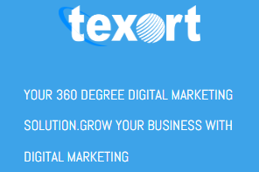

2.5 Location of Texort

TEXORT Ltd.
Website: texort.com
251/C Khilgaon, Dhaka-1219,
Bangladesh.

2.6 Services of Texort

Texort provides 360º digital marketing solutions including:-

2.6.1 Search Engine Optimization

Our Engagements Typically Begin With A Total Site Audit, A Competitive Analysis And Implementation. A Typical SEO Engagement Involves the Following:-
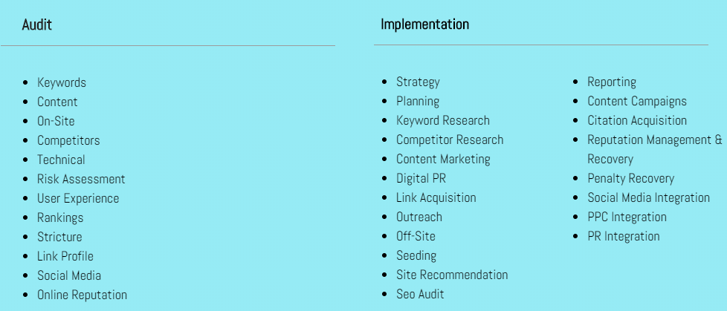

2.6.2 Pay per Click

64.6% of individuals click on Google Ads after they are searching for a service or product online. Five hundredth of individuals arriving at a retailer’s website from paid ads are additional possible to shop for than people who came from associate degree organic link. PPC (‘Pay Per Click’), conjointly referred to as paid search selling, could be a sort of on-line advertising wherever you simply procure every time a user visits on an ad that takes you thru to your website.
Whether you have dynamic PPC events or are entirely new the world of paid search. Our group of Google certified PPC specialists are committed to gaining your goals efficiently. Our ROI targeted method allows us to make a customized tactic that is ideal for your business, and that we also can manage your campaigns.
PPC will work for an organization of any dimension. It doesn’t have any headed whether or not you're a start-up or a multi-million pound company, PPC levels the enjoying arena. A well-structured and optimized PPC event can exceed simply an outsized billfold. At TEXORT, our advisors are skilled to fulfill and exceed your aims. Whether or not or not its ROI targeted, minimizing your price per attainment, or just growing your market share, it’s simply what we have a tendency to do.
While search engine optimization could be a nice approach for long-term growth, typically you really need an immediate boost. TEXORT internet marketing offers Pay per Click campaign management, guaranteeing that the money you spend is place to the perfect possible use.

2.6.3 Social Media Marketing

Social Media marketing may be one of the quickest ways that To Propel Your Business To the highest. Whether or not you’re A Dog Bowtie E-Commerce website (Please Tell us that’s a true Thing) Or a multinational B2B tech Company, Social Media marketing will assist you herald Purchases, Leads, and Boost brand awareness. Our approaches are:-
- Consolidation and measurement of target market.
- Design of effective marketing plan and application.
- Continuously scheduled updates in adding as news and articles as they happen.
- Continuous social media communication, along with acknowledgement and reaction.
- Sustainable analysis, following and adaptation to online trends and funds.
- Inspiring awareness and support among blogging groups and environments.
- Targeting exact main point, title, phrases and topics important to your brand.
- Advantage of analytics and data-tracking tools for policy improvement.

2.6.4 Marketing Strategy & Research

We use several varieties of analysis like knowledge analyzation and focus cluster tests to uncover insights for your whole. We tend to produce experiences that reinforce your brand, flip customers into brand evangelists and position your company for long-run growth. Nice design starts with a comprehensive strategy; however it won’t change state while not artistic intuition. We tend to mix logic with ability to make a decision however your brand ought to look, feel, and sound.

2.6.5 Content Writing & Marketing

While we all know the way to target search engines and therefore the internet community, you recognize your customers best, thus we would like you to be concerned the maximum amount as you would like as we tend to write your content.
You would have access to a fervent content expert, and might be in spontaneous contact, giving those directions, checking on their progress, asking any queries, and requesting any revisions you’d wish to see.
Fill us in on your ideal client, and the way you wish them to feel when they visit your web site and begin reading the content. Texort will even develop personas of your targeted clients.
You can select the tone and phrasings of the content visitors are reading. Whether or not you wish it to be light-hearted or formal, business-like or casual, we will work our writing style to your desires.
You can review the content the maximum amount, or as very little, as you would like. We’re assured in our writing skills and recognize we’ll offer you with content that's appealing to both search engines and other people. Of course, the ultimate approval is yours to create, and if there's something you don’t like or wish to feature, simply allow us to grasp and it'll be done.

2.6.6 Email Marketing

Permission-based email marketing provides the proper chance to grow your revenue by frequently interacting together with your current and potential customers. Despite however massive your contact information is, email selling permits you to speak with all of them with efficiency and in a very personal method. We’ll assist you leverage the ability of email marketing to:



We facilitate our clients build their current email newsletter method run additional smoothly:
• Initial email theme development
• Ongoing story that includes approved content
• Monthly split-testing and coverage

2.6.7 Conversion Rate Optimization

Conversion Rate optimization (CRO) offers various important chances for any business to extend income by creating enhancements to the planning and feel (usability) of your pages. There’s no necromancy or sorcery – simply a scientific method supported wisdom. A lot of and a lot of online businesses communicate conversion rate optimization techniques because:

- One-Time Investment, Long-Term Benefits

After a company finance in CRO, you get long-lasting positive effects that end in a lot of sales and leads for longer time period.

- Easy Assessment

A company can simply track the potency of their new pages in Google Analytics, its gives you easy access to measure the achievement of their efforts.

- Rapid Results

In our expertise, company will be able to entirely give back your investment with CRO among 3 to 5 months. Anyways this trusts on the initial state of company web site and also the probability of your project.

- Multiple Effects

Within very short time company may notice a great change in your overall sales and improved dealings values once they developed the usability of their web site. In near future they also may notice that higher repeat of sale again and again.

- Unmatched Flexibility

With the appropriate CRO strategy, there ought not to re-develop company’s whole web site from scratch. In some cases, even minor UI/UX changes are enough to significantly develop their ROI.

2.6.8 Graphic Design

What we tend to design could be a direct reflection of your brand: we tend to aim for every expertise to be advisedly built and engaging. From logo development, packaging, environmental style, annual reports to national campaigns – our focus are to make sure the audience is listening. By shaping a brand’s graphic vision, we tend to craft innovative visual stories that attract the target market audiance and build long run success.


2.6.9 Web Design & Development

Web Development We Provide:
- Blogs
- corporate websites
- Business websites
- Presentation websites
- Dating projects
- Marketplaces
- E-learning
- Online classifieds
- Real estate websites
- E-commerce sites
- Landing pages
- Community sites
- Responsive sites

2.7 Clients of Texort

- Gearlaunch – POD Platform (Print On Demand)

Gearlaunch may be a POD platform that refers to Print on demand is once you sell your own custom designs on products like mugs, t-shirts, and phone cases. Ali-Express drop shipping permits you to decide on from countless product to sell. In each cases, the supplier ships product on to your customers on your behalf.



- Nurseist – Blog
Nurseist.com is journal website that blogs nursing tips and helps nursing students to achieve success in school of nursing.
Also this website covers a couple of type of nursing topics. Topics includes nursing lifestyle, humor, life hacks, gift ideas, quotes, mnemonics, nursing scholarship data and far a lot of things. We provide informative, relevant, and diverting articles for your reading pleasure. It would be like your favorite nursing lifestyle magazine–only on steroids. Therefore sit back, relax, and let entertain you with innumerable of knowledge sure to keep you occupied and inform us all that Nursing is often here to remain. After all, Nursing is all concerning sharing.
Keeps the fervor burning nurses!



2.8 Project of Texort

- Nurseia – POD Project

Nurseia is a POD store. Here customers can order any design they wish to buy & then after placing order the design goes to production. After production the customer gets the delivery.

This is the project where i’m working with. Basically our approach is to rank the site in the search engine such as Google & Bing. To do SEM (Search Engine Marketing), We have to develop every Social Media channels, run those accordingly. Also used Web 2.0 blogs & Forums which help nurseia store to rank up in the search engine.

Website: www.nurseia.com



2.9 Organ-Gram of Texort

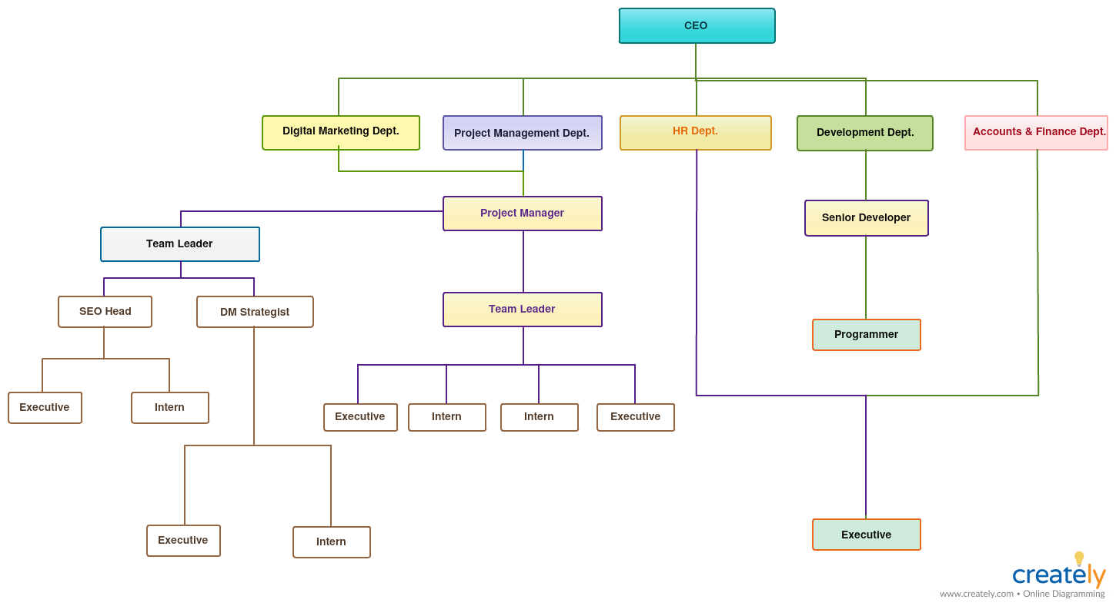

2.10 What does social media mean

Social media is that the alignment of online communications channels dedicated to community-based input, interaction, content-sharing, video sharing and collaboration. Websites and applications dedicated to forums, microblogging, social networking, social bookmarking, social curation, and wikis unit of measurement at intervals the assorted types of social media.
Social media refers to websites and platform that area unit designed to help individuals to share content fast, easily, expeditiously, and in period of time. Many folks destine social media as application on their mobile, however the truth is, and this communication tool started with computers and other devices. This thought stems from the actual fact that the majority social media users’ access their tools through apps.
The capacity to share photos, videos, opinions, events, etc. in period of time has remodeled the manner we have a tendency to live and, also, the way we have a tendency to do business. Retailers World Health Organization exercise social media as associate degree essential a portion of their promoting policy sometimes see measurable results, however the importance of successful social media is to not treat it as an excessive accessory however to treat it with an equivalent care, respect, and gives a center attention on you are doing all of your promoting efforts.

2.11 Types of Social Media

Looking the recognition and influence of Social Media, Channels, company businesses and marketers rummage around for differing sorts of online Media online network that they'll use to focus on and turn into their viewers.
Common people are active on Facebook, Twitter, Snapchat, and Instagram types of social channels.
But for a vendor or any complete, several alternative forms of Social Media channels square measure there to discover, as they play a big role in targeting and changing prospects. Here we tend to have access into all the several forms of online Media branding strong networks that may enhance your reach and complete responsiveness on the net.

- Social Network: Facebook, Twitter, LinkedIn
Such forms of Social Media area unit accustomed escort people or brans on the online. They assist a business via stigmatization, customer or target segment consciousness, communication building, customer service, lead increase, and higher conversion rate. You’ll be able to channelize various types of Social Media campaigns on these networks which will support you widen your reach. A number of the advantages of those Social Networks are:
- They inspire people and businesses to move online and share knowledge and opinions for making certain reciprocally dynamic relationships.
- In this a business sorting out the simplest ways that to improve up-to-date promoting events then they find a spread of organic and paid ways that to try and do this on Facebook, Twitter, and LinkedIn forms of social medias.

- Media Sharing networks: Instagram, Snapchat YouTube
Media sharing forms of Social Media area unit won’t to notice and share images, live video, video clip and other forms of media on the net. They’re additionally reaching to assist you in complete a frame work, lead increasing, focusing then on. They furnish people & type an area to find and media share therefore the target customers are often targeted and reborn into a considerable and result driven means potential. Social networks these days additionally come with these options, however, for sharing media, sharing of media are their main role.
Now it’s become very popular to share image and video on Instagram, YouTube and snapchat also very helpful now days.
To think whether or not you must use these networks for your online business or not, you must take into account your capitals and target customers. These channels can assist you run very effective campaigns or events to come up with mains and broaden your target audience.

- Discussion Forums: Reddit, Quora, Digg:
Such varieties of Social Media platforms area unit used for tracing, sharing and discussing totally various varieties of info, thoughts, and news. They assist businesses by being prime notch source for doing perfect research. These forums are unit the oldest ways in which of running Social Media selling events. Before the entry of standard Social Media players like Facebook, these forums were the places wherever experts, specialists and enthusiasts won’t to do totally various varieties of discussions regarding a range of fields.
These discussion forums have an enormous range of users and it ensures new reach for your business. These area unit the places that give the answers to totally different queries of any domain
In case your business desires deep client analysis then these places would the foremost appropriate one for your business
Along with allocation info and knowing answers, these places area unit terribly impact in advertising in addition
- Bookmarking and Content Curation Networks: Pinterest, Flipboard:
Opting for such styles of Social Media can assist you decide, share, discuss and save a range of up-to-date content and media that are trending moreover. They’re terribly useful in channelizing complete consciousness for your business, plus, selecting this one to run differing sorts of Social Media selling campaigns can assist you create web site traffic and client commitment. Just in case you wish to run some out of the box extremely artistic campaigns which will not only update your audience and however additionally involve them then this one is best work.
To run Social Media campaign on Pinterest, you would like to possess a website that's bookmark-friendly. You must improve headlines and pictures for the feeds that Bookmarking and Content Curation Networks use for accessing and sharing your content.
Flipboard helps you to produce your own Flipboard magazine by exploitation most partaking content and therefore you'll showcase that to your viewers.
- Consumer Review Networks: Yelp, Zomato, TripAdvisor:
Using client Review networks can assist you determine, share and review totally different data a few kind of merchandise, services or brands. Once a business gets positive feedback on these networks, their claims flip a lot of credible as a result of reviews on these networks act as Social Proof. For running a made Social Media promoting Campaigns, it's significant for today’s businesses to possess progressive feedback on these sites. Additionally, resolution all the problems that your customers are posting on these Review platforms is another issue that's planning to be vital for the positive and creative outcomes for your business.
These networks provide an area to users for revising totally various sorts of merchandise and facilities that they need used
Review content adds nice worth to any brand as a result of it'll influence a lot of and range of latest patrons to aim your services
Yelp and Zomato kinds of platforms provide location-based review services which will assist you run location-based social campaigns.
- Blogging and Publishing Networks: WordPress, Tumblr, Medium:
You should select these styles of Social Media networks for publishing, discovering and commenting on articles, social media blogs and different content on the online. Content marketing is one among the foremost effective ways in which to focus on, draw attention, have interaction and turn into a target market. It’s aiming to be the bottom of undefeated online selling campaigns that play the foremost necessary role in change funnels of Digital marketing campaigns. WordPress and Blogger are the normal blogging platforms whereas Tumblr (micro-blogging service) and Medium (Social publishing Platform) is that the latest blogging and publishing networks.
These networks are must for the companies that need to successfully use content selling, plus, you'll share this content on a range of Social Networks like Facebook, Twitter, LinkedIn, etc.
Content that you just use on these networks can will assist you produce a distinct segment for your business and viewers United Nations agency are in search of data regarding that niche will obviously visit your diary or website.
- Social Shopping Networks: Polyvore, Etsy, Fancy:
Want to search out all the newest trends within the promoting or crave to understand the searching tips then such sorts of Social Media channels are for you. Additionally, they assist you follow totally various brands, share fascinating things and build a sale on these Social searching networks. Businesses will use such sorts of Social Media Platforms for making whole consciousness, increasing involvement and commerce merchandise on some new and effective platforms. These channels convert e-commerce by creating them additional participating via some fascinating social parts.
To use these networks effectively you ought to create a website that participates searching experience with social experience
These networks are terribly result driven for small businesses and startups as they will sell their products with none land based mostly workplace or store.
- Interest-based Networks: Goodreads, Houzz, Last.fm:
You can use such varieties of Social Media networks for linking with other people who have same varieties of hobbies or interests. You’ll be able to simply notice the audiences who have an interest in knowing a lot of and a lot of regarding the types of product and services that you simply offer. This makes it one of the most effective networks for participating together with your viewers and generating exclusive brand conciseness online. Compared to huge social networks, using Interest-based networks would assist you run a lot of targeted campaign.
Choosing these networks can assist you focus solely on one product or service associated with any specific subject, for example, home décor, Digital marketing training, Music, Books, etc.
These networks are appropriate places to interact with the viewers of a selected niche.

2.12 Importance of Social Media for Marketing and Communication

As an old marketing concept to customers like promotion and fewer effective, businesses are come to social media to attach in positive ways in which with customers and therefore the people that influence them. We’d like aware simply however social media has changed the actual meaning we tend to are linking, act, communicating with customer and cooperating as people, and so society as a whole. Now a day’s social media plays a vital role in marketing and communication. Today’s most of the people are engaged on social media so marketing through social media now become more important and essential.
The key to social media achievement is not to get hung up on the tools and technology, but to focus on how a company can utilize them more successfully to:
- Social media helps to highlight the visibility of a private brand and that of a business.
- It helps to build and increase personal and professional networks and also helps create a communication network.
- Social media helps to develop and grow relationships with customers and influencers
- Social media helps to involve in real-time and communication with people, including solving queries.
- Social media broadcast and distribute pure content that demonstrates capability.
- Social media helps to share back links to appropriate information that adds value to the customers as well as business.
- It an effective source Connect with company community of followers, customers and supporters
- Its eventually create new leads and boost sales for a business.
Social media marketing now days become a key element of success of a business. A company use social media in many ways. If a company utilize social media effectively for marketing and communication it give them advantages like increased brand awareness, high inbound traffic, improved search engine rankings, higher conversion rates, best customer satisfaction, improved brand loyalty, increase brand equity, cost-Effective, gain marketplace insights, thought leadership etc. Social media for marketing and communication is very important. It helps a company to reach its goal.

2.13 What factor impact on Social Media Marketing for communication

- Reasonable expenditure:
Some individuals begin a social media campaign as a result of they see it as a “free” approach. It doesn’t value something to make a page for a company, nor will it value something to create a post (unless you choose to spice up or sponsor it). however if you would like to visualize important results, you can’t treat it sort of a free strategy; you would like to be ready to take a position in it, whether or not that’s within the kind of paid ads, talent to hitch your group, or raw time to take a position in your hard work.
- Strategy:
Without knowing if your follower like your post or not you cannot post blindly on your social media.. Before you start, you must have a officially documented strategy that dictates your aims, your target market, and the way you propose to flourish over time. This document can guide your selections, assist you hire new individuals to your team, and provides you a templet you'll progress over time.
- Consistency and frequency:
Profitable social media ways area very unit consistent and frequency must need regularity. If you treat social media as a novelty, you would possibly post with serious volume one week, however post nothing following week, and your daily activity may change drastically from day to day. Followers wish to understand what they'll want from you, therefore if you undergo these rapid changes in volume, you’ll alienate the terribly individuals you’re making an attempt to draw in.
Some social media accounts will get by with posting once every week to stay their followers happy, however if you would like to strike a profit, you would like to be additional active than that. Betting on the stage you’re exploitation, you must be posting a minimum of multiple times daily and interesting together with your followers on a virtually constant basis.

- Brand Value:
Social media may be a platform for replacing brand value; if you wish your customers to shop for from you, or maybe offer you a “like” or a comment; you wish to grant them some worth in exchange. That worth will are available in many various forms; as an example, you'll take “value” virtually and provides them discounts or special deals, otherwise you may give them with worth within the form of sensible or entertaining content.
- Personal touches:
Social media is additionally an area for individuals to attach with people. If you approach your social media plan as an organization, instead of a personal, you’re reaching to separate individuals. If you’re posting on behalf of the corporate complete, you clearly ought to build some changes to the voice and tone you use but you must still have lots of individual touches in your campaign?
- Follower engagement:
Speaking of private touches, simply providing content to the lots and wanting for additional followers isn’t sufficient if you wish to grow a thriving, communicating audience. Passive followers, who technically follow you however don’t interact together with your brand, are essentially worthless. If you wish your followers to be occupied in your whole expertise, you would like to interact with them on an everyday basis, through queries, conversations, and content shares.
- Profitable calls to action:
It took me seven points to induce to what's arguably the foremost significant piece of the profitability puzzle. Why? As a result of your call-to-action (CTA) is merely reaching to build money if you have a strong, invested viewers to require advantage of it. Here, your aims are to often call your audience to action, by sending them to your web site or giving them the chance to shop for one thing. Whatever the endpoint or meant action, it ought to either produce revenue or get your brand one step nearer to generating revenue.

- Analytics:
Chances are, your first wave of ways isn’t planning to be sufficient to strike an inexpensive profit—but however are you able to tell obviously, and what are you able to do concerning it? Analytics is that the answer to each. You would like to own a resource and a concept to live specifically however effective your campaign has been, and note points that may be developed within the future. In progress optimization is that the only thanks to secure a long-term revenue.
- A plan to scale:
Finally, you’ll have to be compelled to have an idea in place to scale your campaign. The greater your social empire is, the additional cost-effective it’s aiming to become, since each action you're taking are magnified in significance with a bigger viewers. Which means posting additional usually, leveraging additional platforms, and perhaps even recruiting new people to handle the accrued employment.

If you'll add these ten all-significant elements to your social media campaign, you should have any bother earning a come on investment (ROI) for your hard work. If implemented properly, with a solid initial strategy, social media will be one amongst the highest-ROI marketing ways out there; however while not these qualities, your hard work may well be vain.

2.14 How factor impact on Social Media Marketing and communication success
Reasonable expenditure
Social Media Marketing and Communication Success
A plane to scale

Analytics
Profitable calls to action
Follower Engagement
Personal Touches
Brand Value
Strategy
Consistency and Frequency

Social media marketing means marketing through social media. For this types of marketing highly engage with communication. Without communication social media marketing is not possible to success. Here this social media marketing and communication success influence by some factors this are reasonable expenditure, strategy, consistency and frequency, brand value, personal touches, follower engagement, profitable calls to action, analytics and finally a plan to scale. This entire factor interrelated to each other. If a company or individual marketers wants to success social media marketing and communication they must need to focus on this entire factor. This factor is very important for social media marketing and communication success.

CHAPTER 3

Methodology, Analysis and Findings

3.1 Introduction

Social media is a very important for marketing and communication. Here we try to find out what factor affecting social media marketing success. Now a day’s social media use every marketers but everyone would not be successful in this sector. We try to know what actual factor associated with this social media success. For this I collect primary data and doing a primary research. At first I collect some important factor based on previous research. The factors are Here this social media marketing and communication success influence by some factors this are reasonable expenditure, strategy, consistency and frequency, brand value, personal touches, follower engagement, profitable calls to action, analytics and finally a plan to scale. Based on these factor I select five important factors those are expenditure, strategy consistency and frequency, personal touches and finally follower engagement. After selecting this I develop a questionnaire for quick survey. The main purpose of the survey is to find out what factor affecting social media marketing success.

3.2 Sample for the present study

Sample is the part of population. For this survey I select 120 samples. I was doing this survey on 120 people from different age and different occupation.

3.3 Measurement

Measurement is a very important thing for a study. For this survey I use primary scale of measurement. I use five point Likert scale of measurement.
To measure the expenditure variable four items were used on five point Likert scale. Following table shows the item used for this variable.

Table: Measurement for Expenditure variable
- Social media marketing is a less costly method to promote a brand
- Social media marketing creates less pressure on advertising budget
- Social media marketing is a cost effective promotional tool
- Compared to the cost social media marketing generates greater impact

To measure the consistency and frequency variable four items were used on five point Likert scale. Following table shows the item used for this variable
Table: Measurement for Consistency and Frequency variable
- Consistent delivery of brad related information is vital in Social media marketing success
- Immediate sharing of brand information in Social media acts as an effective weapon for branding
- Consistent brand information sometimes make customer bombard with information
- More frequent and consistent posting of information is inevitable in social media

To measure the Brand Value variable four items were used on five point Likert scale. Following table shows the item used for this variable
Table: Measurement for Brand Value variable
- Social media marketing impact positively on the creation of brand value
- An organization can depend solely on social media marketing for its brand value
- Other media promotion has less impact on brand value creation than Social media marketing
- Companies active in social media have more brand value that those are not active in social media

To measure the Personal Touches variable four items were used on five point Likert scale. Following table shows the item used for this variable

Table: Measurement for Personal Touches variable
- Customized approach is essential in Social media marketing
- It is easy to treat each customer individually in Social media marketing
- Customization is facilitated with the social media
- Customized contents in Social media attract more customer attention

To measure the Follower Engagement variable four items were used on five point Likert scale. Following table shows the item used for this variable
Table: Measurement for Follower Engagement variable
- Social media marketing success is measured by follower engagement
- Follower engagement is always good in social media marketing
- Compared to other medias, follower engagement is more easy and effective in social media
- Follower engagement always create positive word-of-mouth

To measure the Analytics variable four items were used on five point Likert scale. Following table shows the item used for this variable
Table: Measurement for Analytics variable
- Availability of analytics in social media made the marketer job easy to approach customer properly
- Social media analytics can generate any type of stakeholders intelligence
- Analytics facility made the social media a less trusted source of information for a brand
- Privacy issue is hampered through analytics in social media

3.4 Data collection procedures

Without data a research is nothing. Here I want to know what factor affecting social media marketing success. I develop a questionnaire on google form and collect data online. It’s a primary research so we collect primary data through online by using a questionnaire. I also use some secondary data also. For preparing this research I some secondary data also.

3.5 Data Analysis

I use google form for collecting data. Here I got 120 responses. So I analyze data based on this 120 responses. This survey I collect data from different people, different occupation and different ages people give their opinion on this survey. Based on all things I analyze these responses.
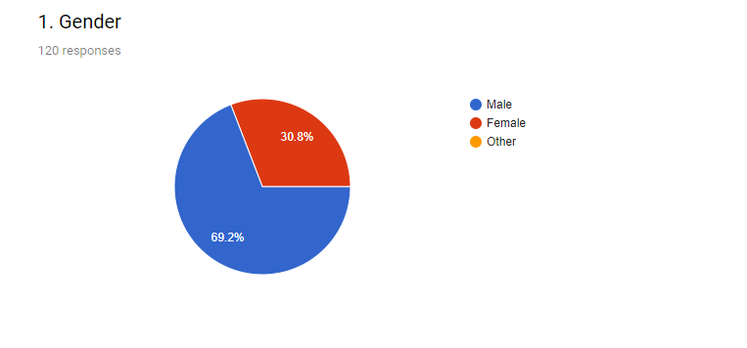This survey 69.2% male and 30.8% female give their valuable response.
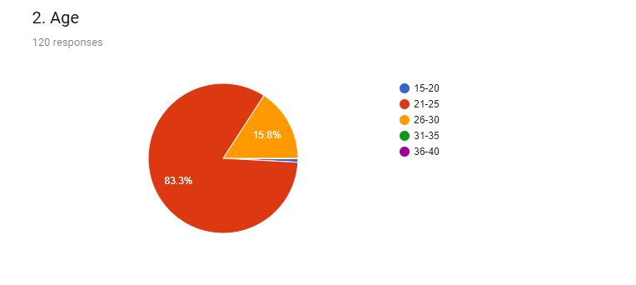
Majority of participant are 21-25 ages’ people. They are 83.3%. 26-30 ages people are 15.6% and finally 15-20 ages people are 0.8%.
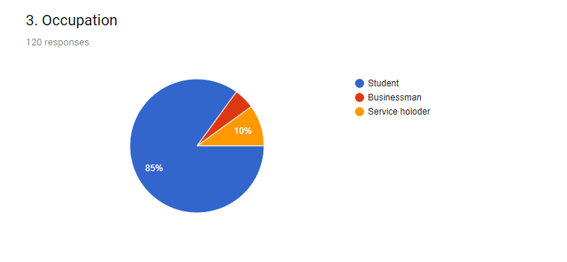
This research majority of the participants are student. They are 85%. Here also have 10% service holder and 5% student.

Expenditure
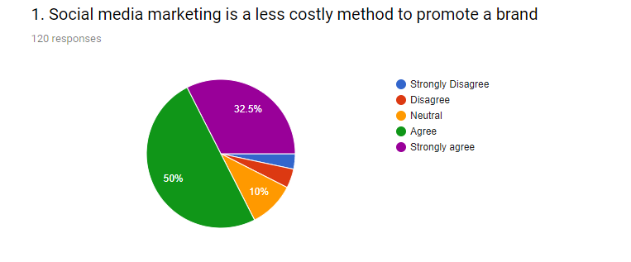
“Social media marketing is a less costly method to promote a brand” this statement I got 50% agree, 32.5% strongly agree, neutral 10%, disagree 4.2% and 3.3 strongly disagree. In this statement majority of the respondent support it and they think social media marketing is a less costly method to promote a brand.
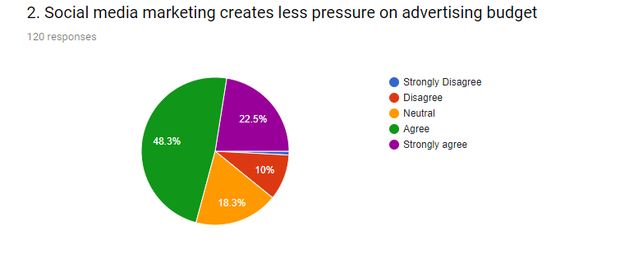
“Social media marketing creates less pressure on advertising budget” in this statement I got 48.3% agree, 22.5% strongly agree, neutral 18.3%, and disagree 10%. So majority support this statement.
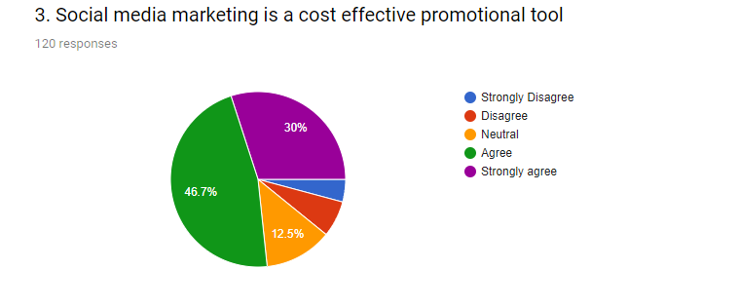
“Social media marketing is a cost effective promotional tool” in this statement I got 46.7% agree, 30% strongly agree, neutral 12.5%, disagree 6.7% and 4.2% strongly disagree. So here majority of the respondent support this abatement. They support social media marketing is a cost effective promotional tool.
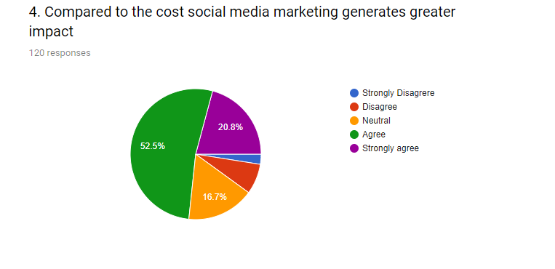”Compared to the cost social media marketing generates greater impact” in this statement I got 52.5% agree, 20.8% strongly agree, neutral 16.7%, disagree7.5% and 2.5% strongly disagree. So here majority of the respondent support this statement. They support compared to the cost social media marketing generates greater impact. Social media compared to the cost now a day’s one of the best platform to generate high impact.
Consistency and Frequency
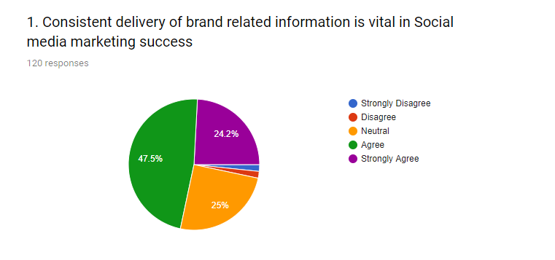
“Consistent delivery of brand related information is vital in Social media marketing success” in this statement I got 47.5% agree, 24.2% strongly agree, 25% neutral, disagree1.7% and strongly disagree 1.7%. In this statement most of the people support this statement.
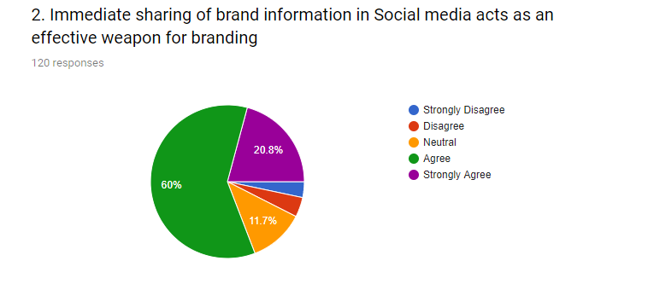
“Immediate sharing of brand information in Social media acts as an effective weapon for branding” in this statement I got 60% agree, 20.8% strongly agree, 11.7% neutral, disagree 4.2% and strongly disagree 3.3%. In this statement most of the people support this statement.
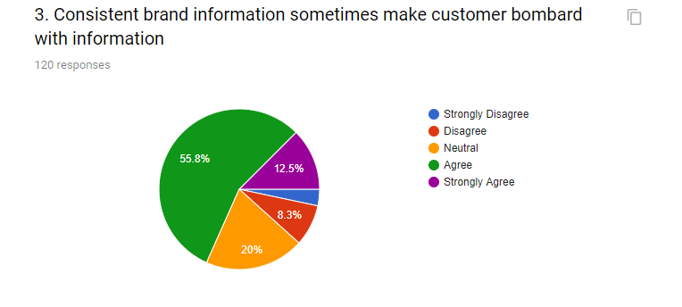
“Consistent brand information sometimes make customer bombard with information” in this statement I got 55.8% agree, 12.5% strongly agree, 20% neutral, disagree 8.3% and strongly disagree 3.3%. In this statement most of the people support this statement.
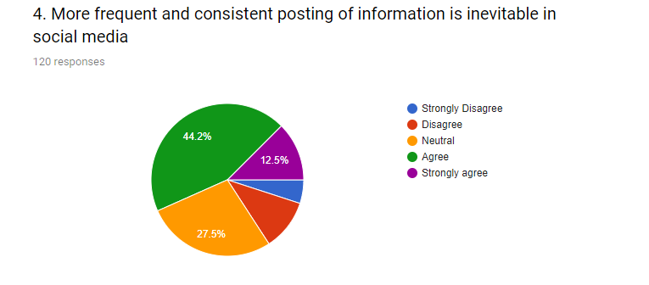
“More frequent and consistent posting of information is inevitable in social media” in this statement I got 44.2% agree, 12.5% strongly agree, 27.5% neutral, disagree 10.8% and strongly disagree 5%. In this statement most of the people support this statement.

Brand Value
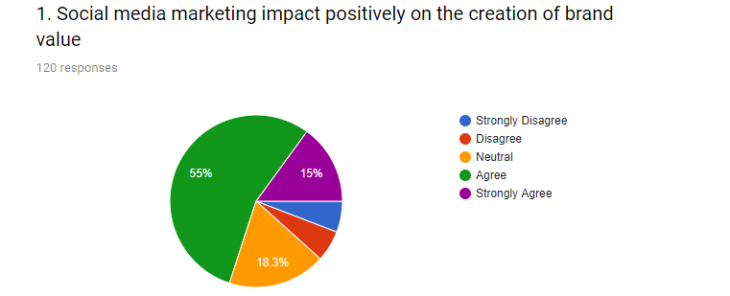
“Social media marketing impact positively on the creation of brand value” in this statement I got 55% agrees, 15% strongly agree, 18.3% neutral, disagree 5.8% and strongly disagree 5.8%. In this statement most of the people support this statement.
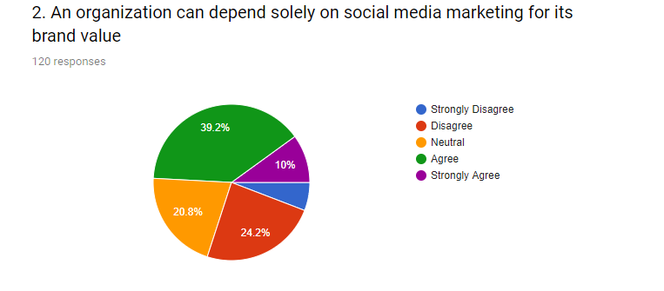
“An organization can depend solely on social media marketing for its brand value” in this statement I got 39.2% agrees, 10% strongly agree, 20.8% neutral, disagree 24.2% and strongly disagree 5.8%. In this statement most of the people support this statement.

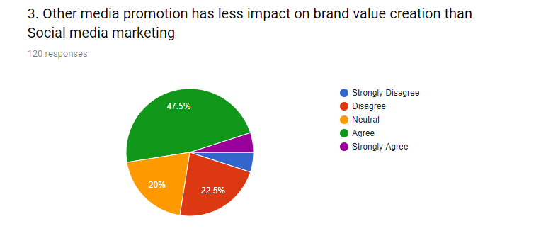
“Other media promotion has less impact on brand value creation than Social media marketing” in this statement I got 47.5% agrees, 5% strongly agree, 20% neutral, disagree 22.5% and strongly disagree 5%. In this statement most of the people support this statement.
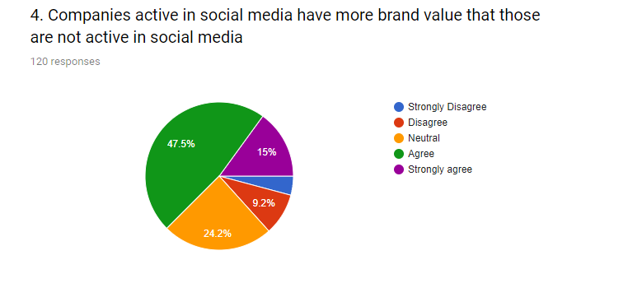
“Companies active in social media have more brand value that those are not active in social media” in this statement I got 47.5% agrees, 15% strongly agree, 24.2% neutral, disagree 9.2% and strongly disagree 4.2%. In this statement most of the people support this statement.

Personal Touches
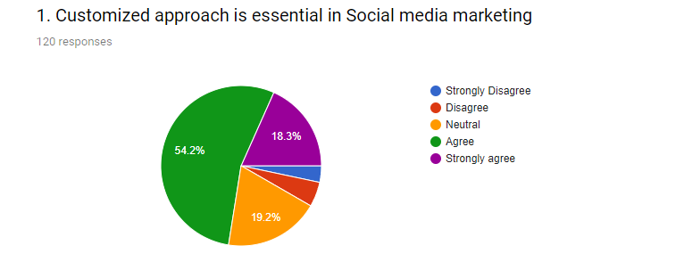
“Customized approach is essential in Social media marketing” in this statement I got 54.2% agrees, 18.3% strongly agree, 19.2% neutral, disagree 5% and strongly disagree 3.3%. In this statement most of the people support this statement.
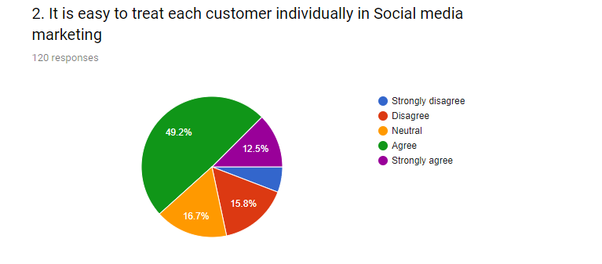
“It is easy to treat each customer individually in Social media marketing” in this statement I got 49.2% agrees, 12.5% strongly agree, 16.7% neutral, disagree 15.8% and strongly disagree 5.8%. In this statement most of the people support this statement.
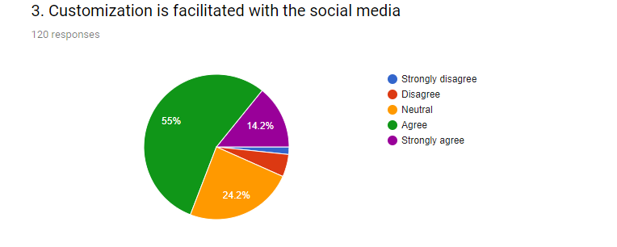
“Customization is facilitated with the social media” in this statement I got 55% agrees, 14.2% strongly agree, 24.2% neutral, disagree 5% and strongly disagree 1.7%. In this statement most of the people support this statement.
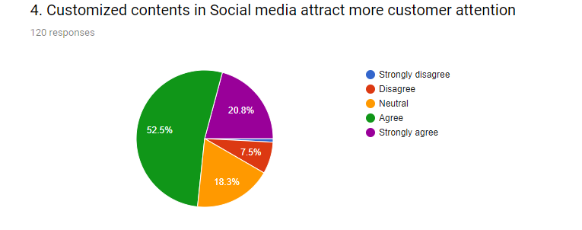
“Customized contents in Social media attract more customer attention” in this statement I got 52.5% agrees, 20.8% strongly agree, 18.3% neutral, disagree 7.5% and strongly disagree 0.8%. In this statement most of the people support this statement.

Follower Engagement
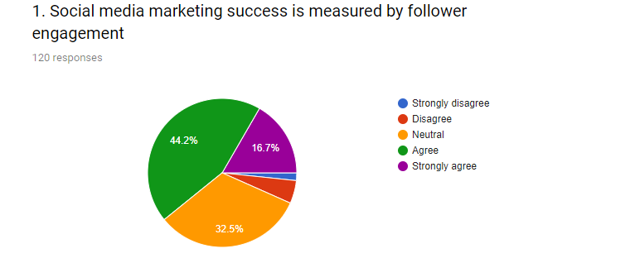
“Social media marketing success is measured by follower engagement” in this statement I got 44.2% agrees, 16.7% strongly agree, 32.5% neutral, disagree 5% and strongly disagree 1.7%. In this statement most of the people support this statement.
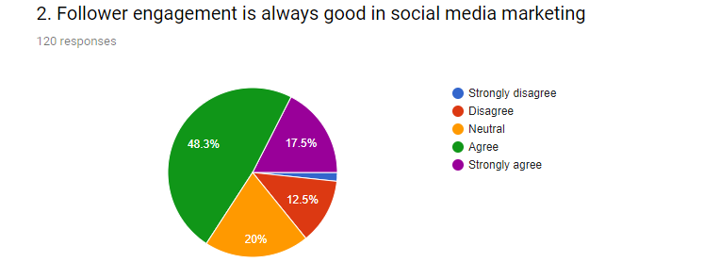
“Follower engagement is always good in social media marketing” in this statement I got 48.3% agrees, 17.5% strongly agree, 20% neutral, disagree 12.5% and strongly disagree 1.7%. In this statement most of the people support this statement.

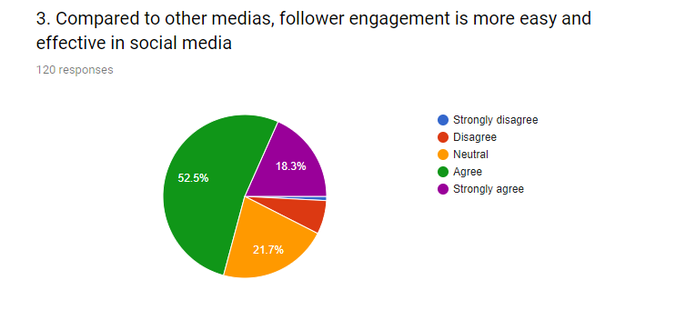
“Compared to other Medias, follower engagement is more easy and effective in social media” in this statement I got 52.5% agrees, 18.3% strongly agree, 21.7% neutral, disagree 6.7% and strongly disagree 0.8%. In this statement most of the people support this statement.
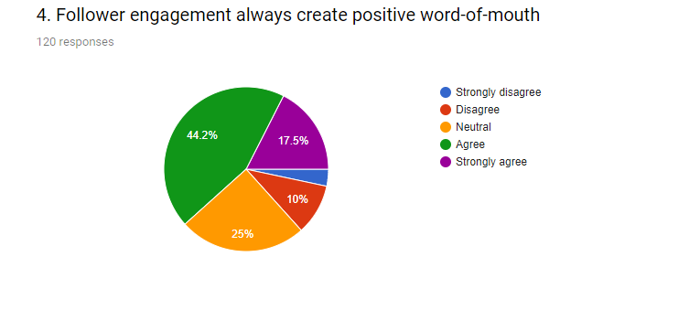
“Follower engagements always create positive word-of-mouth” in this statement I got 44.2% agrees, 17.5% strongly agree, 25% neutral, disagree 10% and strongly disagree 3.3%. In this statement most of the people support this statement.

Analytics
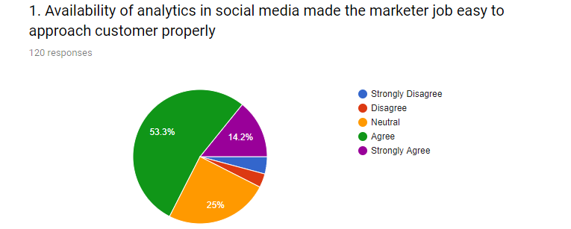
“Availability of analytics in social media made the marketer job easy to approach customer properly” in this statement I got 53.3% agrees, 14.2% strongly agree, 25% neutral, disagree 3.3% and strongly disagree 4.2%. In this statement most of the people support this statement.
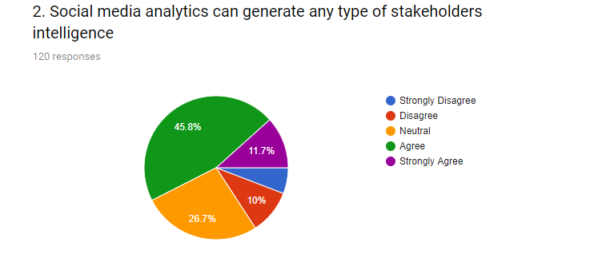
“Social media analytics can generate any type of stakeholder’s intelligence” in this statement I got 45.8% agrees, 11.7% strongly agree, 26.7% neutral, disagree 10% and strongly disagree 5.8%. In this statement most of the people support this statement.

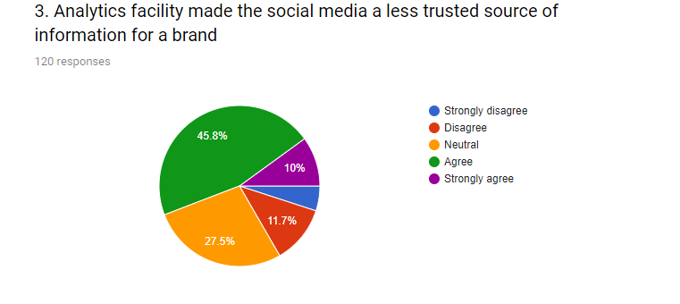
“Analytics facility made the social media a less trusted source of information for a brand” in this statement I got 45.8% agrees, 10% strongly agree, 27.5% neutral, disagree 11.7% and strongly disagree 5%. In this statement most of the people support this statement.
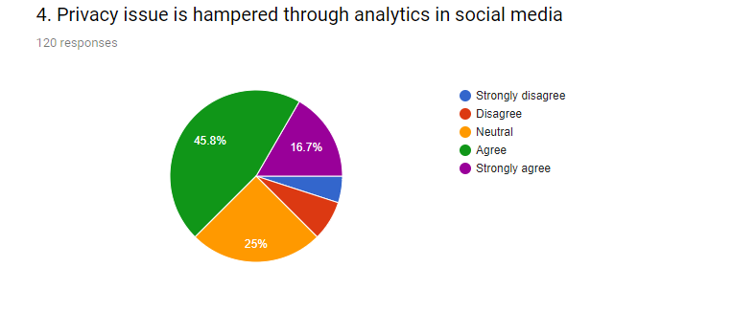
“Privacy issue is hampered through analytics in social media” in this statement I got 45.8% agrees, 16.7% strongly agree, 25% neutral, disagree 7.5% and strongly disagree 5%. In this statement most of the people support this statement.

3.6 Findings

In today’s modern time marketing and communication through social media become so popular. In this study I try to find out factors that affecting social media marketing success. After analyze all data I find out some important findings that’s given below:
- In this study I find out that Social media marketing is a less costly method to promote a brand
- Social media marketing creates less pressure on budget. Social media marketing helps to minimize budget cost.
- Social media marketing is a cost effective promotional tools. Social media marketing is cheaper than any other promotional tools.
- Social media marketing generate higher impact than others.
- Social media marketing success depends on consistency and frequency. In every part of social media like information sharing, regular posting on social site and communication with customer all things must need consistency and frequency.
- Social media marketing impact positively on the creation of brand value. It was a great source of positive brand value.
- Social media marketing creates high brand value. Other media promotion has less impact on brand value creation than Social media marketing.
- Customized approach is essential in Social media marketing. Customize approach helps to become success on social media marketing success.
- It is easy to treat each customer individually in Social media marketing. In offline or physical ways it’s very tough.
- Customized contents in Social media attract more customer attention.
- Social media marketing success is measured by follower engagement and follower engagement is always good in social media marketing.
- Compared to other medias, follower engagement is more easy and effective in social media. Follower engagement always creates positive word-of-mouth.
- Social media analytics also a important part of social media marketing success. Its helps to generate any type of stakeholder’s intelligence.

3.7 Discussion

In this survey I find out that people have now a day take social media marketing and communication positively. Now days people are highly engage in social media. Most of the people are now use social media. So social media marketing is most effective than traditional ways of marketing. Social media marketing have some benefits its less costly, high reach, positive word of mouth, budget friendly, easy to create positive brand value. This survey majority of the people support social media marketing. If a company wants to build their positive image and expand business they must need to follow social media marketing.

3.8 Recommendation

After completed this survey here I found few things that’s may represent as recommendation. Here my survey topics are factors affecting social media marketing success. Recommended all the factors affect social media marketing and communication success. For this social media marketing and communication I have some recommendation.
- For social media marketing a marketer need a very good knowledge about social media and how its work. Without knowledge social media marketing success may not possible.
- A digital marketing agency needs sufficient resource for social media marketing and communication success.
- Frequently and consistently communication is very important for social media marketing. Without communication social media marketing just nothing.
- Follow up, lead to follow up, follower engagement must need to do regularly.
Social media marketing is a platform where a marketer needs to do all things regularly and continuously. Without this a social media marketing and communication may not possible.

3.9 Conclusion

Today’s world people are engaging with social media highly, More 70% people are now active user on different social site. They share their life event, activity and so on. So for social media marketing and communication become a very import part for business. If marketers perfectly use this they must face success on social media.
In today’s world, I think that social networks are a important of reality that has become a locality of the business world. Moreover, over ninety percent report that they use social networks for business. Whereas, more than 60% have admitted that they have gained new potential customers over various social platforms. Social media marketing now days become a popular platform. Day by day it’s improved dramatically. In future everything associated with social media marketing.

Reference

  - www.texort.com
  - www.nurseia.com
  - www.nurseist.com
  - https://www.digitalvidya.com/blog/types-of-social-media/
  - https://www.wordstream.com/social-media-marketing
  - https://blog.hootsuite.com/social-media-for-business/
  - https://www.quora.com/What-is-the-role-of-social-media-in-marketing
  - https://www.forbes.com/sites/jaysondemers/2017/10/05/the-10-factors-that-will-make-your-social-media-marketing-campaign-profitable/#216fdd366697

Appendix 1



QUESTIONNAIRE
Factors Affecting the Social Media Marketing Success

Dear Respondent:
I am a student of BBA program at the United International University doing internship on “Social Media Marketing: A study at the Texort Digital Marketing” as a partial requirement for the fulfillment of BBA degree. For preparing my internship report on social media marketing success, I am collecting data from the respected respondents.

Please put your valuable opinion and answer the following questions. I assure you that your information will be used only for academic purpose.

- Gender
- Male | - Female | - Other
- Age
- 15-20 | - 21-25 | - 26-30 | - 31-35 | - 36-40
- Occupation
- Student | - Businessman | - Service holder

Expenditure | Strongly Disagree (1) | Disagree (2) | Neutral (3) | Agree (4) | Strongly Agree (5)
Social media marketing is a less costly method to promote a brand | 1 | 2 | 3 | 4 | 5
Social media marketing creates less pressure on advertising budget | 1 | 2 | 3 | 4 | 5
Social media marketing is a cost effective promotional tool | 1 | 2 | 3 | 4 | 5
Compared to the cost social media marketing generates greater impact | 1 | 2 | 3 | 4 | 5
Consistency and Frequency
Consistent delivery of brad related information is vital in Social media marketing success | 1 | 2 | 3 | 4 | 5
Immediate sharing of brand information in Social media acts as an effective weapon for branding | 1 | 2 | 3 | 4 | 5
Consistent brand information sometimes make customer bombard with information | 1 | 2 | 3 | 4 | 5
More frequent and consistent posting of information is inevitable in social media | 1 | 2 | 3 | 4 | 5
Brand Value
Social media marketing impact positively on the creation of brand value | 1 | 2 | 3 | 4 | 5
An organization can depend solely on social media marketing for its brand value | 1 | 2 | 3 | 4 | 5
Other media promotion has less impact on brand value creation than Social media marketing | 1 | 2 | 3 | 4 | 5
Companies active in social media have more brand value that those are not active in social media | 1 | 2 | 3 | 4 | 5
Personal touches
Customized approach is essential in Social media marketing | 1 | 2 | 3 | 4 | 5
It is easy to treat each customer individually in Social media marketing | 1 | 2 | 3 | 4 | 5
Customization is facilitated with the social media | 1 | 2 | 3 | 4 | 5
Customized contents in Social media attract more customer attention | 1 | 2 | 3 | 4 | 5

Follower engagement | Strongly Disagree (1) | Disagree (2) | Neutral (3) | Agree (4) | Strongly Agree (5)
Social media marketing success is measured by follower engagement | 1 | 2 | 3 | 4 | 5
Follower engagement is always good in social media marketing | 1 | 2 | 3 | 4 | 5
Compared to other medias, follower engagement is more easy and effective in social media | 1 | 2 | 3 | 4 | 5
Follower engagement always create positive word-of-mouth | 1 | 2 | 3 | 4 | 5
Analytics
Availability of analytics in social media made the marketer job easy to approach customer properly | 1 | 2 | 3 | 4 | 5
Social media analytics can generate any type of stakeholders intelligence | 1 | 2 | 3 | 4 | 5
Analytics facility made the social media a less trusted source of information for a brand | 1 | 2 | 3 | 4 | 5
Privacy issue is hampered through analytics in social media | 1 | 2 | 3 | 4 | 5

Thank you for the cooperation!!!

Appendix 2

