INTERNSHIP REPORT

A case study
on
“Retail banking (personal banking) of CITY BANK”
Prepared by: Afreen Hossain
ID: 114163011
Department of BBA in AIS

Prepared for: Mohammad Tariq Hasan
Assistant Professor
School of Business & Economics
United International University
Date of submission: 31st August, 2019


LETTER OF TRANSMISSAL
31st August, 2019
Mohammad Tariq Hasan
Assistant Professor
School of Business & Economics
United International University
Subject: Submission of internship report
Dear Sir,
It is an honor to handover my internship report to you which is made upon personal banking of City Bank for Dhanmondi Branch where I got nominated as the only intern to participate in City Alo Credit Card launching ceremony.
It is an opportunity for me to work for City Bank and gain practical experience on retail banking especially in knowing personal banking and also getting to see the real picture of the corporate world has simultaneously helped to boost up my career path enriching my knowledge and experience to the next level. Even though it is part of the banking sector I have got to gather more technological knowledge which is making banking work much easier and simpler than ever before. I would like to thank you for the cooperation, supervision and support that have enabled me to pursue this report on due time. It would not have been possible without your help to substantiate for this report. Please feel free to make any kind of queries regarding this report to me.
Sincerely,
----------------------------------
Afreen Hossain
ID: 114163011
BBA in AIS
United International University

ACKNOWLEDGEMENT

Firstly, I would like to express my appreciation to my honorable supervisor Mohammad Tariq Hasan. His persistent supervision and assistance played the vital role in making the accomplishment of the report. He always gave me his suggestions that were crucial in making this report as flawless as possible.
I am indebted to Mohammad Ibrahim Khalil, Dhanmondi Branch Vice Principal & Manager of Banking Division who is not just supportive but also very understanding and knowledgeable and dedicated towards his job who taught me how to face challenges despite having rush time and tough banking hours. He made me feel more confident and more responsible in these three months. Another person whom I must mention of is Mohammad Shafiqul Islam who is Dhanmondi Branch Operational Manager. He is very hardworking and responsible person who handles all the odds of our branch and safeguards all from any unavoidable circumstances. I am really blessed that because of my Internship I got the opportunity to work for these people.
I also met Shahriar Jamil Khan (Head of Coporate Affairs), Pratik Arora (Network Partner of South Asia) and Kurush Dastoor (Network Partner of South Asia) who took part in City Alo credit card launching event and in just a few hours I learned many new things what I might not gained it from elsewhere if I was not nominated for it.
It does resemble to the fact that learning has got no end. We learn everyday but it depends on us how we can implement them in making a better future of tomorrow.

EXECUTIVE SUMMARY

City Bank Ltd compacts with four diverse and substantial banking divisions which composes Retail Banking, Corporate and Investment Banking, SME Banking and Treasury Banking. This report will provide a comprehensive elaboration of retail banking activities performs by the bank. Moreover it also includes general information, monetary information, learning, findings, and sanctions of CBL. Retail banking denotes to banking where banking organizations accomplish transactions which is directly related to consumers, rather than businesses or other banks. Services offered consist of: savings and checking accounts, mortgages as well as personal loans, debit cards, credit cards, and so forth. Under retail banking City bank provides three altered types of loan for better accessibility of the customers such as City Drive, City Express and another one is City Solution. There are some certain benefits and positive effects of the loan; again it has some negatives too, which are listed in findings part of the report. This report will be helpful to gain knowledge in retail banking and some other banking institutes in order to launch retail banking besides it may help the management of City Bank ltd. I have made it upon retail banking in correlation with General Banking, Foreign Exchange, Business Department and so on; I have worked on retail banking activities and saw financial trades of the bank. This report contains retail banking activities of City Bank of Dhanmondi Branch. Under retail banking, general banking department contain all deposits and withdrawals(both inwards and outwards), its activity, interest rates, cash, foreign remittance/ bills, money laundering, prevention of money laundering, dispatch, and all public services provided to its clients (& also to the bearers).

Keywords: Retail banking, customer, City Bank, Retail Operation

DECLARATION

I myself Afreen Hossain bearing ID number 114163011 declare the fact that all these information provided here are composed, inscribed and amended by me and that they have not been published till now.

----------------------------------
Afreen Hossain
ID: 114163011
BBA in AIS
United International University

TABLE OF CONTENT:

Introduction 10
1.1 Origin of the study 11
1.2 Purpose 11
1.3 Objectives 12
1.3.1 Primary Objectives 12
1.3.2 Secondary Objectives 12
1.4 Policy of the Data Collection 14
1.4.1 Primary Sources 12
1.4.2 Secondary Sources 13
1.5 Limitations 13
Overview of City Bank Limited 14
2.1 Background of the Company 15
2.2 Organizational Structure 16
2.3 Objectives of the City Bank 17
2.4 Mission, Vision and Core Values Vision 17
2.5 Core values are stated below 17
2.6 Strategies 18
2.7 Business Philosophy 18
2.8 Organogram 19
2.9 Organizational Hierarchy 20
2.10 Services and Products 20
2.11 Departmental Activities 21
2.11.1 Account Opening Section 22
2.11.2 Bills and Clearing Department 22
2.11.3 Remittance 25
2.11.4 Cash Section 26
2.12 Other Services 27
2.13 Strengths, Weaknesses, Opportunities and Threats 27
2.13.1 Strengths 27
2.13.2 Weaknesses 28
2.13.3 Opportunities 29
2.13.4 Threats 30
Analysis & Findings 32
3.1 Deposits 33
3.2 Export Business 34
3.3Total Income 35
3.4 Essential Financial Findings of City Bank, Dhanmondi Branch 36
3.4.1 Profit 37
3.4.2 Deposit 38
3.4.3 Employee Turnover Rate 38
3.5 Findings 42
Conclusion And Recommendations 42
4.1 Conclusion 43
4.1 Recommendations 43
Appendix 46
References 47

LIST OF ACRONYMS

- CIB –City Bank Limited
- CS –Customerservice
- CASA-Current account savings account
- SMS-Short Message Service
- CDM-Cash Deposit Machine
- CSM-Customrer Service Manager
- BOM-Branch Operation Manager
- AMEX-American Express Company
- TP-Transection Profile
- NFB-None Funded Business
- SWOT-Strength Weakness Opportunities & Threads
- NID-National Identity Card
- DD-Demand Draft
- DPS-Dividend Per Share
- FDR-Fixed Deposit

CHAPTER- ONE INTRODUCTION\

Introduction
The prominence of private bank is more imperative than the state-owned banks in the third world countries like Bangladesh. This refers to 21st era of globalization and cooperation amid both multinational and foreign dealings. Surviving in an open market is one of the foremost challenges in this world. Bank plays vital financial institution that has got a vivacious role in the county’s business & central of the disbursement system. The more challenges we have the more competitive world it is becoming with the expansion of commercial institutions. The intern report has been organized based on practical evidence and abstract indulgent. The City Bank limited (CBL) follows unified management strategies, and the head office strongly controls all the branch offices.

1.1 Origin of the Study
This internship report has been designed to offer the students with a prospect to find in job training period and it purpose is to convey the two actualities of learning the theoretical and practical knowledge together. In fact, this report is part of Bachelor of Business Administration in Accounting Information System. The title of the report is “Retail Banking (Personal Banking) of the City Bank Limited on Dhanmondi Branch” and assigned by the respected supervisor, Md. Tariq Hassan, Assistant professor, School of Business and Economics, United International University.

1.2 Purpose
The purpose to go for this name is to gain knowledge about banking services which are retail based in accordance to my country perspective. This study certificates me to gather knowledge on general banking enactment of the CBL. Predominantly, there are three tasks that banks do almost every day especially personal banking. In effect, the main purpose of this internship is to make a conduit ideas gained in academic life and apply in real-world.
1.3 Objectives
Report making was part of my academic curriculum which is why it is compulsory. It reveals the substances what is going to be measured by the end of this study. The name has been assigned by my honorable faculty Md. Tariq Hasan and it is on “Retail Banking Personal Banking of City Bank Limited of Dhanmondi Branch”. The main moto of my internship is to get a practical direction from the bank and to know how it runs and what it performs.
1.3.1 Primary Objective
- To comprehend retail banking enactment of the City Bank Limited.
1.3.2 Secondary Objectives
- To recognize the numerical performance of the City Bank limited.
- To deliberate tasks and processes of every level of the organization of the Bank.
- To classify the problem facing the Bank.
- To relate speculative knowledge with practical experience in several functions of the City Bank limited.
- Estimate customer service of the City Bank limited.
1.4 Policy of the Data Collection

There are two types of data collection sources; they are given as follows:

- Primary Data
- Secondary Data

1.4.1 Primary Sources
The primary data are obtained for the first time and this ensures originality. Primary data sources are mentioned below:
• it can be directly obtained from customers taking any sort of bank services
• it can be found from visiting different desks of employees providing services to customers at bank
• it can come out from bankers thoughts and words
1.4.2 Secondary Sources
• Website of the City Bank Ltd
• financial statements of the bank
• past bank records of the bank
• banking documents, books, brochures and journals related to the bank.

1.5 Limitations
Information couldn’t be gathered because of privacy of the bank. Therefore, it is very tough to carry out a detailed analysis of the bank's problems and the service provided by the City Bank Ltd (Dhanmondi Branch). At the same time, I tried to adjust to those problems. The main limitations faced in producing this report are as follows:
- It does not allow obtaining all type of data and information due to confidential matter of fact.
- Sometimes it is because of its software and their technical issue things become hard and time consuming where manual work would have solved this matter.
- Lack of proficiencies created constraints in the way of careful assessment of this topic.

CHAPTER- TWO
OVERVIEW OF CITY BANK LIMITED

2.1 Background of the Company

CBL is a private bank of Bangladesh. It started off its journey in 1983 with Tk. 1.75 Billion by twelve entrepreneurs of the country. It has its very first and foremost branch at B.B. Avenue Branch inside the capital. The vertical aim to initiate it was to bring difference in numbers in the scope of Banking Sector. Today it provides its customers not just in Bangladesh but also abroad. CBL at present has more than just one hundred online branches with SME service centers across the country include Islamic Banking branch known as Manara Account, woman branch in Gulshan commonly called City Alo. In addition to these it has got several ATMs of its own; and ATM allocation arrangement with a partner bank CBL started its Customer Call Center operation. They even introduced CDM before any other banks. It stands for cash deposit machine. It can be used to pay any sum of money to both account and credit card payments. Though it states that only beyond 50,000 BDT should be placed and sealed for using this machine with few basic instructions to properly make any transection. There are some special deposit envelops for it too where each can place 1lac to do any deposit and most interestingly this deposits are transferred within the same day.

2.2 Organizational Structure
The City Bank Ltd. is among a very few local banks who do not track traditional, decentralized, geographically coped, branch-based business/profit model. In its place, the head office located in Gulshan and also in Motijhil regulates its business and operation sharply via five separate units specifically:
1. Business Unit
2. Branch Banking
3. Risk Unit
4. Operations Unit
5. Service Management Unit
The City Bank Ltd. is accountable for all its activities related with the supplying of the fresh credit cards, billing and accounting, customer service, credit supervision & charge approvals along with marketing the cards. City Bank also provides its customers and its card members with plethora of privileges and underwent several programs in Bangladesh. The CBL likewise deals outstanding benefits all over the world with more than 13,000 offers at over 10,000 merchants in 75 countries. CBL has given its users up-todate distribution networks. For noteworthy performance, the bank has been awarded for its outstanding performance too. In 2000, The City Bank received “Top Ten Company Award” from the honorable Prime Minister of Bangladesh. City Touch has given a new shape to banking where clients can do many things without even visiting the bank physically.

2.3 Objectives of the City Bank
The major objective of the CBL is to build huge profit out of its investment and generate more dividends for its shareholders, to attain the objective; the bank is improving the performance quality to an extended level. And persuade the clients through their expertized work as well as is to keep up the reputation high through their customer services oriented facilities. It always keep its software updated. Recently Finacle is the software used by CS which is on a mission to get updated even all the staffs are being sent to attend trainings on it at the head office. Its motto is to deliver every single customer services available in today’s banking process for their clients.

2.4 Mission, Vision and Core Values Vision
In order to become one of the prominent banks in the country providing its customers with the best services and fulfilling its commitments is its mission for the followings:
- To contribute in its total quality service management
- To maximize the use of expertized skills
- To maintain continuous growth of market share ensuring Quality
- To maximize bank’s profits by ensuring its steady growth
- To nurture an enabling environment where innovativeness and performance is rewarded.
2.5 Core values are stated below
- Result Driven
- Accountable & Transparent
- Courageous & Respectful
- Engaged & Inspired
- Focused on Customer Delight
2.6 Strategies
CBL trusts in the practice of market-oriented strategic planning, developing & maintaining a workable fit between the organization's objectives, skills, and resources. The goal of such approach is to shape and reshape the banks business and services so that they produce target profits and growth. The strategic planning of CBL comprises of two organizational levels, which are given below:
- Location Based strategy
- Business Level Strategy
2.7 Business Philosophy
Despite rigid struggle among banks maneuver in the country Bangladesh, both home and abroad, CBL has made a surprising dynamic growth in every territory of its processes. The activities of CBL are very implicit & massive in compared to that of another bank in the country today. CBL has a very good slogan- “For Relationship Banking” which is the foremost of CBL

2.8 Organogram
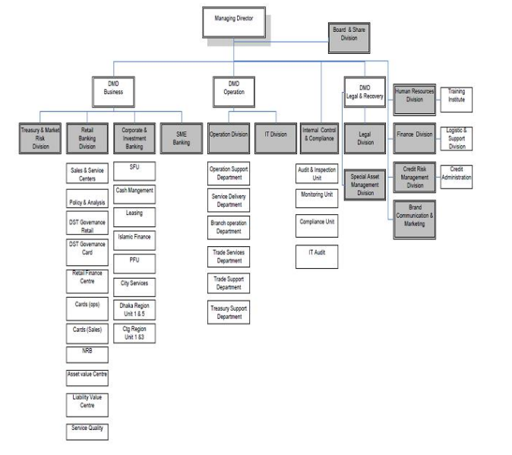

Figure: 2.1

2.9 Organizational Hierarchy

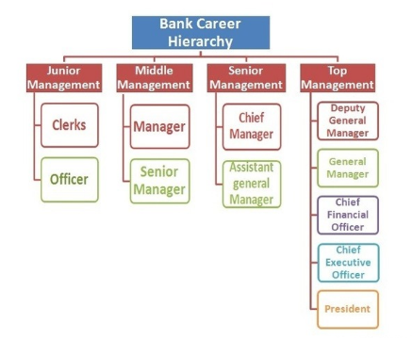
Figure: 2.2

2.10 Services and Products
This bank introduced several financial products and services since its inauguration which includes:
- Corporate and Investment Banking
- Retail Banking
- SME Banking
- Treasury and Market Risks
- Islamic Banking
- Internet Banking
- Woman Banking

2.11 Departmental Activities
Personal Banking Section is a form of service authorized by a government to accept deposits, pay interest, clear checks, make loans, act as a transitional in financial transactions, and provide other financial services to its customers. General banking department performs the central functions of a branch. General banking department is generally opened to supreme customers. A bank does not produce any sellable product but does offer a wide range of economic services to its customers. Personal banking of this branch contains: account opening section, checkbook issue, transfer of account, closing of account, remittance section, online banking, clearing and bills section, cash section, data entry section and many other services too.

The general banking or personal banking involves the following sectors:
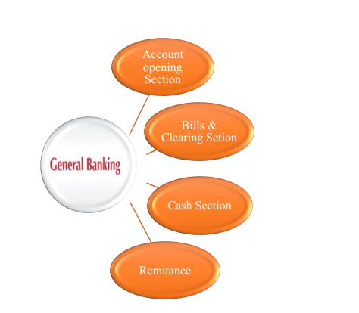
Figure: 2.3

2.11.2 Account Opening Section:
The relationship between a banker and a customer would only arise by the contact between them. And it could be done by means of opening an account. So this section pays a great matter of concern for the bankers to handle the clients with more dedications. City bank limited opens the following accounts for its customers.
Types of account of CBL:
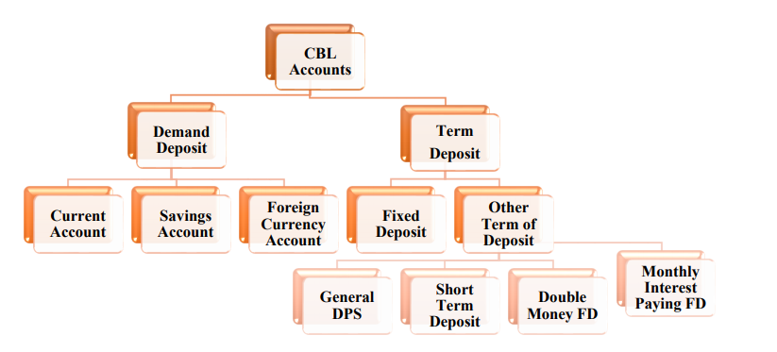
Figure: 2.4
Current Account: it is applicable for any businessperson or organization. Customer can request and drawing their full cash without giving any notice to the Bank. Account holder will provide with cheque book of 50 or 100 pages. The distinct features of this account are as below:
- The main objective is to help high profile customers as big business person, joint stock companies, public limited companies and private limited companies
- CBL current account does not pay any interest on current deposit.
- Minimum deposit of Tk 10000/= is required for opening a current account.

Types of Current account:
- Individual account
- Proprietorship account
- Partnership account
- Limited account
Savings Account: A savings account is planned for individuals who belong to both lower & middle class who have contributes a proportion of their earnings to meet their forthcoming desires and demands from their savings. Same as current account there are also reqires Tk 10000/= to open a savings account. Account holders are provided with cheque books. Savings account can be opened either individually or jointly, and account holder get interest on it.
Types of Savings account:
- Savings delight account
- High value savings account
- Basic savings Account
- Student savings account
Foreign Currency Account:
Foreign currency account is one of many other services like that of any other financially attractive products like FCY Account, RFCD Account and NFCD Account for individuals which are offered in the form of bundle offers. RFCD Account and NFCD Account is the most popular form of deposit products to high net worth of any non-resident living in Bangladesh and a large number resident Bangladeshi who frequently visit abroad for holidays and other business resolutions. They can open RFCD account in foreign currency brought in their native country from travelling overseas for different purposes. Types of Foreign Currency account:
- RFCD Account
- NFCD Account

Terms and conditions of Deposit account:
Fixed Deposit Receipt (FDR): It is a type of deposit, a huge amount of money is deposited in the bank for comparatively higher rate of interest that are being offered to the depositor for a period of 3 months, 6 month, 1year to 10 years under one condition that they can be withdrawn before maturity also can take away only the profit proportion on a monthly basis.
Other Term of deposit:
- General DPS Account: It is an owing DPS product which is different and more attractive than the predominant DPS products available in the market. It is a perfect way to keep finances secured for future ahead. The monthly deposit ranges from BDT 500 to BDT 50,000.
- Short Notice Deposit (SND): It is the discrete type of account which is just in between CD and SD offering income at the rate of 6% (simple rate of profit designed yearly on daily balance) but needs 7 days-30 days preceding notice for the withdrawal of money.
- Double money FD account: It entities to double the initial amount of the customers in a shortest possible time. It is one time deposit only.
- Monthly payment interest account: In this type of FD amount which starts from BDT 50000. Customers can avail loan by having this type of deposit. It also facilitates the customer with encashment facility before the maturity period.
2.11.2 Bills and Clearing Department

Clearing standpoints the joint payment claims made among member banks at a fixed period of time and place in regard to those instruments drawn from each other. Clearing House provides room to make arrangement under which member banks confirms to meet, via their representatives, at an appointed time and convenient place to deliver required instruments drawn on the other and in return to obtain instruments drawn of them.

Types of Clearing:
- Inward Clearing: Clearing returns (inward) comprises of instruments which were offered by us to other banks in order to make payments but having been compensated and due by them for specified cause through the clearing house.
- Outward Clearing: When a specific branch accepts instruments drawn from other bank within one clearing area and sends those instruments for collection through the clearing arrangement it would be considered as an Outward Clearing for that particular branch.

2.11.3 Remittance
Customers of a bank need to transfer their fund to elsewhere within the country and they can do it through the remittance section of the bank of general banking which deals with only local remittances. During my internship period I have observed it in my branch. It has got three types of local remittances.
These are:
- Demand draft: This is in order to make a payment which is drawn by one particular branch of a bank upon another branch of the same bank for a sum of money in any place. It is outside of the clearing house area of delivering branch. It is a negotiable instrument. It can be go across or not, for payment of DD bank checks the assessment encryption which was first mentioned on the draft. If the assessment encryption agrees then the bank makes payment .This issuing bank sends advice letter for the DD to acknowledge the branch to make the payment and give further confirmation. Demand draft is an instrument that covers an order by the issuing branch upon another branch known as Drawee branch to pay certain amount to the payee or to his/her order on demand.
- Pay order: It is like cash but not just cash. It is an instrument which issues from a particular branch of a bank and encashment must be made from the same branch. Unlike cheque there is no possibility of dishonoring pay order because before issuing bank pay order bank takes out money of the pay order in advance .It is not a negotiable instrument as it will not facilitate to get either endorsed or crossed.
- Mail transfer: It is where there is no telex machine or telephone line then this system can be used. It is the least used technique for transferring fund as it is time consuming and risky and that the mail might get a junk mail. When the handover of fund from one branch to another takes place by mail but most of the time over telephone it is called MT. procedures for making the issue which is time saving and less risky too.

2.11.4 Cash Section
Cash is the most liquid property for a bank and it should be dealt very carefully. So this department is truly handed with rigorous care. This department starts the day with cash in vault. All cash receipts and payments are completed through this department. I was not authorized to deal with this section. Operation of this section begins at the start of the banking hour. Cash officers start making transactions by taking away money from the vault, known as the opening cash balance. Vault is kept in a much secured room. Keys of the room are kept under the control of cash officer and Branch Operation Manager. The amount of opening cash balance is recorded into a register. After whole days of doing transactions extra of the money remains in the cash counter would be put back in the vault and known as the closing balance. Money is received and paid in this section.
- Cash Receipt: Depositors deposit money in their account in this section by means of writing all the necessary information in a deposit slip or by using CDM machine then the necessary information need to be put in a separate CDM envelop. This section also receives cash from customer for any pay orders made by the customers, bank draft telex transfer etc. this bank receives all cash receipts are deposited in this department.
- Cash Payment: This section accepts the cheques from the depositors for payment in cash. After receiving cheque it will be scrutinized to see whether it is a valid one or not, does the account have sufficient fund or not. Cash officer verifies the amount both in figure and word date of the cheque and signature etc. then finally authorized officer compares the sign on the cheque with the specimen sign, and approve whether the balance in the account is sufficient. If these are satisfactory, then payment will be made against the cheque.

2.12 Other Services
Other Services provided by the CSM in Dhanmondi Branch. In the transaction profile (TP) form they updates information regarding any account holder monthly transaction (limit of cash deposit and cash withdraw) in case it becomes higher then the bank will call the customer to update their TP.
2. Signature change procedure: If any customer wants to changes his/ her account signature then he/she must bring one copy passport size photo along with his signature if it is a current account. There are two forms available to change the signature. One is the changing signature form and another is a signature card.
3. Contact information change procedure: If any customer changes their communication address /mobile/email address then they also can update information in order to update the information into the account. In case if the communication address has been altered then the customer must provide a verified copy of their changing address like that of their utility bill of the address/copy of the passport or NID if this same address is stated there.

2.13 Strengths, weaknesses, opportunities & threats (SWOT) Analysis
Every financial institutions and organizations have got some internal strengths and weaknesses and has some external opportunities and threats. The next will present the City Bank’s SWOT:
2.13.1 Strengths
1. American Express Credit Card: The CBL has launched together local and dual currency (BDT and Dollar) Amex Credit Cards on 7th November, 2009. According to the contract, CBL is going to become the high-class supplier and dealer of Amex cards in Bangladesh. Brand image of Amex is surely going to be the brand standing of City Bank ltd.
2. New Management: The CB’s management squad has been meaningfully changed since 2007. New departments like NFB (None funded business), Policy and analysis are always left open for further improvement.
3. Experience: City Bank ltd. has been in the industry for about 25 years. During this long period of existence in the industry has helped CBL to develop an in-depth knowledge about the industry trends as well as helped to build up strategic corporation with many corporations which most other banks have failed to achieve in such short time.
4. Availability: Currently CBL has got a software named Finacle in 82 Finacle (Online) branches, also one renowned Islamic Banking Branch and five SME centers all over the country and one Woman Branch. This mass number of branches has made it easier for their customers making best use of the advantages of CBL.
5. Good Relationship with Customers: One of the foremost strength of CBL is they can maintain good relationships and do more networking with their customers. They treat their customers very friendly and helpfully supporting them in any financial difficulties they face. That enables the customers to leave the bank with a happy face.
2.13.2 Weaknesses
1. Low remuneration package: Compared to other banks, CBL’s payment package is not up to the mark. And with this lower payment policy, CBL won’t be able to employ well-known and efficient employees of the country and might even lose their current talented employees.
2. Lower service quality: CBL’s service standard is lower compared to other banks. Except few selected branches (Dhanmondi & Gulshan branch), most other branch don’t even have high-class and well-organized inner design. Customers are not treated according to their confidence and service is very slow in some branches for the poor network system. There is a need to provide training for them to make further improvement and give better quality of service to its potential clients and enhance CBL’s reputation to the next level.
3. Existing elderly employees: A large part of CBL employees are employed in this bank over 35 years. The new management is finding it difficult to assign these employees, it is only because of those employees who are reluctant to accept new policies and bring new changes within the Bank. So there is a need for change in the policies and procedures too.
4. Fragile Brand Image: Prior to the launching of Amex Cards, CBL had harsh brand identity within its customers which continued for more than 20 years. Now it would be hard for the new managements to get adapted with change in this brand identity suddenly.
5. Lack of own ATM services: Many customers complain that ATM booths are not existing in some areas or one booth is very far from each other.

2.13.3 Opportunities
Credit Card Business: The card business of Bangladesh is booming if we analyze the data from last few years. ATM’s, Debit cards and Credit cards are becoming a vibrant product both for the customers and bank itself. A major proportion of the Bank’s revenue comes from this. CBL had launched AMEX Credit Cards on 7th November, 2009. This is surely going to boost their card business and brand image. In addition, CBL is looking onward to include Master Card in their card business. Both of these plays vibrant role for CBL to nurture as the leader in the card business in Bangladesh.
Online Banking: With the innovation and user-friendliness of technology, the need for online banking is receiving more importance. Both local and foreign banks are moving towards online banking to ease the business practice for their customers. The CBL too, has taken some marvelous efforts. They have already transformed eighty three (83) of their branches into online through internet services.
Automation: Since 2007, one of the major projects was to automate its process by using the newest technology and software. At present all branches are linked via intranet. This network based banking is developing the overall, making the departmental jobs much easier and faster, ensuring better and much faster customer service. CBL employees are also using software called ‘Finacle’ which helps them to track information & data about their customers within a fraction of minutes. This has made a great move in automation with definite reason to provide CBL huge gain over other banks in the industry.
High growth of sales and trade finance: City Bank earns an enormous sum from their sales team and trade finance now. They need to train their sales team properly because it’s a great chance for them
2.13.4 Threats
- VISA Credit discounts: As I have already stated that CBL has started a spellbound project of American Express in the card segment of the banking industry. But, the card segment of Bangladesh is already led by Visa credit cards. Moreover, right after the launch of Amex Cards, several banks (i.e. standard chartered bank) has undertaken noteworthy deductions in their visa card offerings. Under these conditions, more promotional efforts in Visa by other banks can have a shocking result in CBL’s Amex Project.
- Failure to establish AMEX brand image: Compared to the existing foreign banks, CBL’s brand image is supposed somewhat poor. Particularly in case of service quality. With the existing brand identity of its own, CBL might fail to formed AMEX brand identity suitably.
- Maintaining a broad target market: CBL’s target market consist of consumers from lower class to consumers with high net worth. Lately started ‘Celtic Project’ is designed for solely the elite class of Bangladesh. However, with least training, the existing employees might not to provide sufficient service to these different classes of people, mainly since the expected service quality of the upper class is much different than the lower classes.
- Management Collision: In 2006, a major change occurred in the history of CBL’s management because of the sudden recruitment of certain fresh personalities. The novel management squad renewed the overall structure of the bank and centralized its operations. They tried to confirm that the new management consists of young and highly talented people of the industry. Several of existing employees think that under this new management their future prospect of job is zero and in contrast, the new management is not even ready to agree that there exists some sort of confusion and is trying to convince that only people with high skills have been chosen for newly undertaken projects. This obscure shade of confusion between these two groups of employees can reason major costs in the future projects of the CBL.

CHAPTER- THREE ANALYSIS & FINDINGS

3.1 Deposits
Deposits are the major sources of funds for every money-making institute, they all want that to have sufficient deposits escalating their business in a continuous increasing inclination. So now are days, deposit mobilizations have become a perplexing mission for the commercial banks to face. In point of fact a deposit is the utmost source of fund for any bank and especially for the City Bank limited Dhanmondi Branch. Among all other branch of City Bank, Dhanmondi Branch gathers a massive amount of money from deposits. Here last five year deposits:
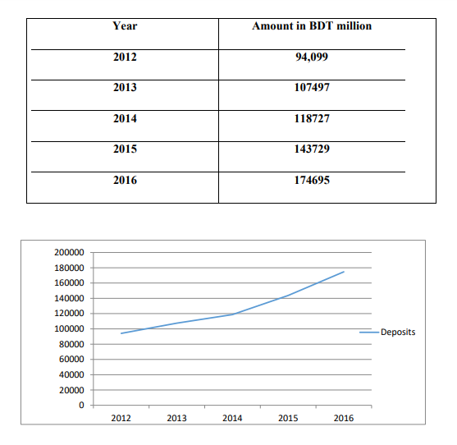
Figure: 1
DEPOSITS (in million)
3.2 Export business:
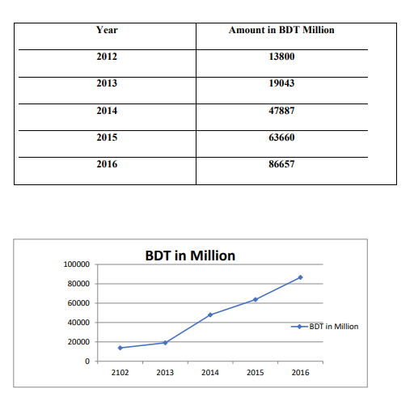

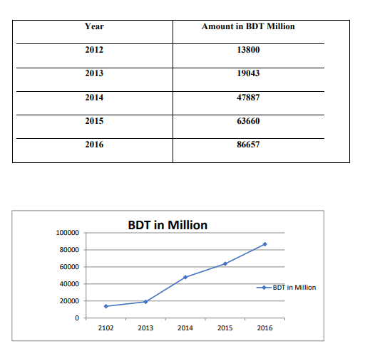
Figure: 2
EXPORT BUSINESS (in Million)

3.3 Total Income
From 2012 to 2016 onward the total income has dramatically inclined from 4770 million to 6477 million.

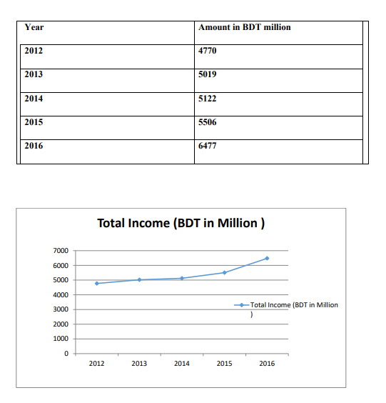

Figure: 3
TOTAL INCOME (in Million)
3.4 Essential financial findings of City Bank, Dhanmondi Branch
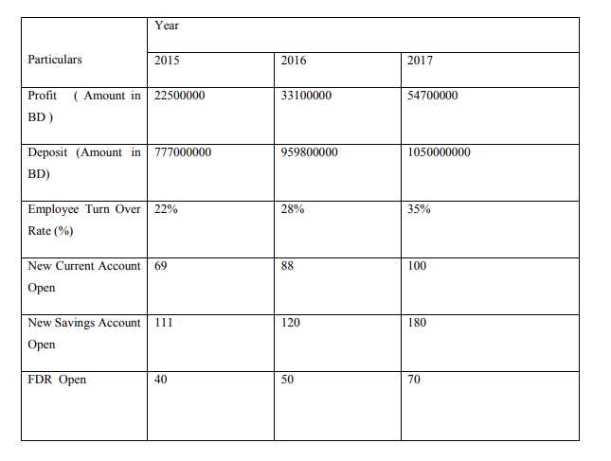
Figure: 4
3.4.1Profit
If we breakdown the profit then we find it that Dhanmondi Branch accomplishes enormous profit in compare to 2015 to 2016. Every year the profit of the branch will be increased because of dependability, credibility, incomparable customer services, and employee’s commitment to their assigned work. Officers of the Dhanmondi Branch always try to provide its customers with the best service that helps them to gain a huge profit. As they are very efficient profit increases in a remarkable way from 2015 to 2017, in 2015 the profit was 2,25,00,000 BDT and in 2017 the profit was 5,47,00,000 BDT. So the profit figures depict the contemporary situation of the branch and also how they performed.
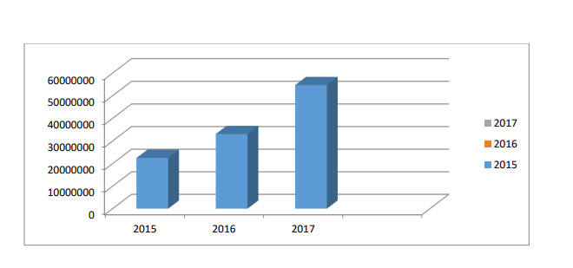
Figure: 5
PROFIT (in BDT)

3.4.2 Deposit
As I have already stated that deposit is the main income source of the City bank limited compare to any other fragment. In 2017 the branch achieves 1,05,00,00,000 BDT. No doubt it is an enormous sum for any branch. In contrast with 2015 the amount has increased day by day. Customers are fascinated to open deposit account at City Bank limited because of some following reason:
1) various options are there for the customers to decide any amount according to their need. The amount starts from 10,000 to 1,00,000
2) excise duty is very negligible in compared with other private banks
3) Customers can avail any product related services from any branches of CBL in any location

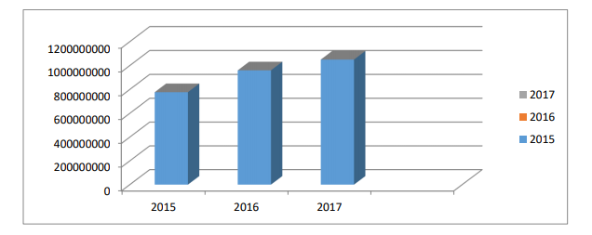

Figure: 6
DEPOSIT (in BDT)

3.4.3 Employee Turnover Rate
The turnover rate of the City bank is very low; in 2015 turnover rate was at 20% is and in 2017 turnover rate was 35%. The rate is not only in Dhanmondi branch but among a whole of 97 branches of the City bank limited. Employees are not fascinated to switch to another bank because of some reason.
1. This is one of the reputed private local banks of Bangladesh
2. The atmosphere of the bank is really very pleasant
3. Employees work with great coordination and maintain amazing corporate bonding among them
4. Attractive remuneration packages are also provided here.

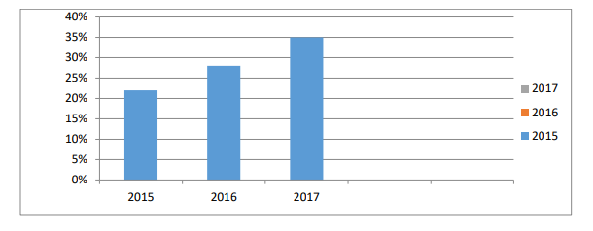
Figure: 7
EMPLOYEE RATE TURNOVER (in %)

Employee Turnover Rate (%) 3.4.4 of CBL for current Account is an only ultimate deposit account. Dramatically, this demand of current account is increasing because of some reasons:
• Lots of options, current account can open individual, sole proprietor, joint account, partnership accounts
• Zero interest rate is charged
• The initial lowest deposit for this account is 10,000tk.
• No incidental charge (IC) is taken. In this chart we can easily see the demand of current account is growing; in 2015 the amount of new current account was 69 and in 2017 the amount of new current account was 100.
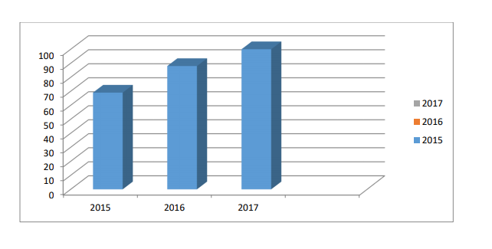
Figure: 8
NEW CURRENT ACCOUNT OPEN
A Savings Account is intended for those belonging to both lower classes and middle classes who have to save a proportion of their earnings to fulfill their future need and forestall an income from their savings. It is intended to stimulate savings from non-profit making institution, society, clubs, and charities and so on. It this types of account, customers can deposit their money having an interest from the bank at a minimum rate of interest for every monthly transaction like from 6% to 8.5%. That is the reason why majority of the clients want to save rather than withdrawing from the savings account. Last year the amount of new savings account has amplified from last two years, in 2017 the amount is 180.
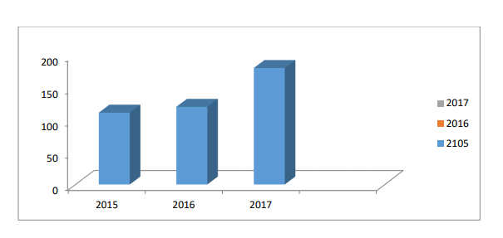
Figure: 9
NEW SAVINGS ACCOUNT OPEN

New Savings Account Open 3.4.6 Fixed Deposit Receipt (FDR) Fixed Deposit Receipt (FDR) account offers its customers the opportunity to finance with a fixed amount for a fixed period at a fixed rate of interest. The customers have the preference to re-invest their funds with both of their principal amount and interest amount they receive upon the maturity or principal amount and the interest amount being provided into their SB accounts. Customers are very much concerned in FDR. Here the rate is increasing because of the increase in FDR among the people, with the interest rate is increasing now are days
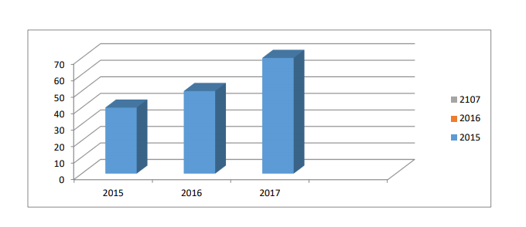
Figure: 10
NEW FDR OPEN
3.5 Findings
This financial institution is markedly centralized. For every kind of finalization of any work, every branch office must go for approval from its Head Office (Gulshan & Motijhil). The Head Office tightly controls every branch office. This sort of reliance on Head Office slows down the actions of every branch office. From my internship perspective, I have found out that Dhanmondi Branch takes long time for providing quality services. This raises the question whether quality should be more prioritized or quantity. Consequently, many customers are move to other banks to save their time.
Understanding customers’ savings inclinations and market call, the bank has successfully launched four new deposit products which are: City Onayash, City Ichchapurun, City Projonmo and City Shomridhdhi.
- “CITY TOUCH” is very much popular and convenient internet banking application tool for the customer ( only debit card users)
- Monitoring unit of every branch leaves some loopholes
- Sporadically the process of transferring information to the management is quite a long process
- The counter service is infrequently not efficient as of not having enough employees for the counter sector.
- The branch is making a profit every year at a stable rate. The rate of deposit collection in every year is growing at a positive rate.
- Customers who run out of time and have to wait in the bank in busy rush days find nowhere to sit
- From deposit sector & export business of City bank meets a remarkable in last five years
- HR policies need to be upgraded in order to speed up the processes
- Current accounts, savings account, FDRs these are growing day by day.
- IT need more supportive; sometimes branch run out of network which is a real hassle for the productivity to be enhance

CHAPTER-FOUR
CONCLUSION AND RECOMMENDATIONS

4.1 CONCLUSION
A bank must have a goal to attain. To attain that goal bank must fix its vision and mission. Customers are the focus of that mission and vision for any organization. Because most of the banks are providing same services and their features and characteristics are also same. So it becomes very hard for a financial institution to create competitive advantage and to provide superior and quality to customers. Service is the only tool that can distinguish one bank from other. Customers will select that bank which is providing first, error-free & quality services. Otherwise, it will be very tough for a bank to attract more customers and even they can lose their present customers if service quality is not good enough. The City Bank ltd. is a famous commercial bank in the country. City Bank limited is committed to keeping up its promise to provide responsive services in banking to its valued customers. CBL management has always put individual effort to uphold the interest and trust of their customers. Time to time, City bank offers different attractive packages of the program for customer and offers which remain on changing. According to my perception, they require a much prompt guideline to operate their activities. Of course, the level of customer satisfaction varies from bank to bank and even from branch to branch within a bank. Lastly, it can be said throughout the results attained so far are moderately acceptable, service of City Bank Ltd. Still, keeps excellent potentiality. They have excellent chances in the market to apply, and they can definitely last in the industry with fall profitability by approving some current appropriate strategies. To continue the expectations of the customers, the CBL has to take all the necessary actions to satisfy their customers because if the customers once recognize that they are not receiving appropriate treatment, they may change to another bank.

4.2 RECOMMENDATIONS
It has become a very crucial thing for every business to construct a strong presence in the market by optimizing the profit margin by means of cultivating their customers as much as possible. To sustain in a much competitive industry, bank has to categorize its schemes that funding, suitable or counterpart the bank's resources & skills to the demand of the environment to cash its opportunities and stand threat & to correct company weakness building on the strengths. After completing my internship program with City Bank, Dhanmondi branch, I consider the following recommendations may help them to increase the level of performance and to achieve more customer gratification:
1. A bank is a financial institution whose main task to provide services to its customers. Its profit comes from the level of customers’ gratifications. So, the authority always should put concern about their customers and the quality of service they are providing to them in the correct time.
2. City Bank should have better branch sitting arrangement for their clients with more help desks.
3. The loan application process time is very lengthy; to make it faster the CBL may provide online loan application submission & personal credit processing.
4. Debit card services are made instantly in my branch however it is yet to come at some other branches where customers find it a hassle to poke for its delay and not being delivered in due time.
5. Sales team should be trained to increase their efficiency. Many of them are seen to be informal with their dress-up and also informal with their seniors too. They intend to have more like complaining against the branch they visit but ignore their inefficiencies and avoid learning from their mistakes.
6. ATM Booths are not available in many locations. It should be increased and also the network issue is too much to waste the clients’ valuable time and also it hampers the productivity of the bank too.
7. After joining this branch I never found dollars available and yet to discover the reason behind.
8. An independent market survey performance can be made every year or two so access to the booming trend of CBL in the country.
9. The City Bank should have the accumulated opportunities skill of both old employees with that of the innovative minded fresher.
10. Every employee must be shuffled every week or two so that they can become expertise in every kind of tasks and not just sit and become master in only in doing one particular task.
11. There is a separate segment right beside my branch commonly known as City Gem where the prioritized customers are only served with priority. I think there should be not be any priority of customer rather priority should be given to time and in the importance of all.

References
Strategic Management, Charles W. L. Hill and Gareth R. Jones, 7th Edition
Principle of Marketing, Philip Kotler and Gary Armstrong, 11th Edition Annual Reports
Annual Report of City Bank Limited 2016
Websites Web side of the City Bank www.thecitybankltd.bd Others
Daily statement of The City Bank limited of Dhanmondi Branch, Dhaka.
Monthly Report of The City Bank limited of the year 2017.
Statement of affairs of CBL, Dhanmondi Branch
Different document of The City Bank Limited,Dhanmondi Branch

