

Internship Report on
Learning and Development Practices at Daraz Bangladesh


Submitted to:
Ms. Shayla Khanam
Assistant Professor
School of Business & Economics
United International University

Submitted by:
Most Afia Mukarrama Mohona
ID: 111 183 048
School of Business & Economics
United International University

Submission date: February 10, 2023

Letter of Transmittal
February 10th, 2023
Ms. Shayla Khanam
Assistant Professor
School of Business and Economics
United International University
Subject: Submission of the internship report titled “Learning and Development Practices at Daraz Bangladesh”

Honorable Ma’am,
I would like to state with the utmost respect that I have completed my internship report on Learning and Development Practices at Daraz Bangladesh successfully by the grace of Almighty Allah, which is a requirement of the BBA program of United International University (UIU).
The information of the entire internship report demonstrates the learning outcome of my experiences working as an intern at Daraz Bangladesh Ltd in the Ops Learning and Development department, theoretical studies from the book, website of the organization, online research and the findings of the interview sessions.
I have put in my best effort to bring out a well-organized informative internship report by providing supportive and sufficient data needed which will fulfill the desired requirements.
Therefore, I would be very grateful, if you kindly give your precious judgement on my effort.

Sincerely,
Most Afia Mukarrama Mohona
ID: 1111830483
Table of Contents
Letter of Transmittal ii
List of Figures v
List of Tables v
Executive Summary vi
Chapter 01: Introduction 7
Chapter 02: Objective of the Study 9
2.1 Primary Objective 9
2.2 Secondary Objective 9
Chapter 03: Methodology of the Study 10
3.1 Type of Data: 10
3.2 Sample Size: 11
3.3 Sampling Technique or procedure: 11
3.4 Data Collection Process: 11
3.5 Data Analysis Technique: 12
3.6 Limitations: 12
Chapter 04: Organizational Background and Industry Perspective 13
4.1 Historical Background of the organization 13
4.1.1 Mission and Vision of Daraz Bangladesh 14
4.1.2 Values of Daraz 15
4.1.3 Organogram of Daraz Bangladesh 16
4.1.4 Important Departments of Daraz Bangladesh 17
4.1.5 SWOT Analysis of Daraz Bangladesh Ltd. 18
4.2 Current Industry Scenario 19
4.2.1 Daraz Bangladesh Limited’s Porter Five Forces Analysis 21
Chapter 5: Findings of the Study 23
5.1 Human Resources Functions at Daraz Bangladesh: 23
5.2 Learning and Development (L&D) activities at Daraz Bangladesh: 25
5.2.1 Trainings conducted by (L&D) department 26
5.2.2 6S Implementation: 29
5.2.3 Daraz Seller Associate Training (DSAT): 33
5.2.4 Compliance: 35
5.2.5 Newsletter & Highlights: 36
5.2.6 Workshops 36
5.2.7 11.11 Campaign: 37
Chapter 6: Recommendation and Conclusion 40
6.1 Recommendation: 40
6.2 Conclusion: 41
Chapter 7: Appendix 42
7.1 Reference 42
7.2 Questionnaire: 43

List of Figures
Figure 1 Vision and Values of Daraz 14
Figure 2: Organogram of Daraz Bangladesh 16
Figure 3: E-commerce Business Model of Bangladesh 19
Figure 4: E-commerce companies and their market share 20
Figure 5: SWOT Analysis 21
Figure 6: Visualization of the L&D Workflow 25
Figure 7: Figure: Process Flow to provide Trainings by Daraz Bangladesh 27
Figure 8: 6S Lean Workplace 29
Figure 9 : 6S Process Flow 31
Figure 10: Figure: Daraz 11.11 Campaign 2022 Performance Dashboard 38

List of Tables
Table 1: Important Departments of Daraz Bangladesh 17
Table 2: Name of the Training courses provided at Daraz 26
Table 3: 11.11 Campaign highlights 39

Executive Summary
The study explores employee learning and development activities in the context of Daraz Bangladesh, a leading e-commerce company. The primary objective of this academic internship report is to complete a requirement for the BBA program and gain a deeper understanding of HRM theories and their applications in the job field. The secondary objectives include gaining an understanding of the operation and functions of the learning and development department at Daraz Bangladesh, exploring the challenges and opportunities faced, understanding the impact of technology, and the role of the department in the Daraz 11.11 Campaign.
The methodology demonstrates that this study is based on primary data (practical experience, face-to-face conversation, personal observations, field visits) and secondary data (websites, prior research studies, relevant articles, and other publications) collected through a qualitative interview with 3 key personnel of the Learning and Development (L&D) department of Daraz Bangladesh. The data was collected through a prepared questionnaire and analyzed using reading materials, on-ground knowledge, and past trends. The study had limitations such as data confidentiality, time constraints, lack of sufficient data.
Findings and Analysis mention that Daraz Bangladesh has a separate (L&D) department that provides regular trainings to riders and operators through technology and practical work. The L&D team also implements 6S in all hubs, which refers to Sort, Set in Order, Shine, Standardize, Sustain, and Safety. It also conducts a review analysis of customer feedback, identifies operational issues, investigates, analyzes and provides training based on the results to improve customer satisfaction. The team is also responsible for maintaining compliance, releasing newsletters and highlights, and conducting workshops for Daraz employees.
The recommendations show improvements for Daraz Bangladesh Ltd.'s Learning and Development team to bring more effective and efficient results. These include taking feedback from employees after training, organizing monthly sessions with employees, increasing workshops, collaborating with industry organizations for specialized training, and turning L&D team members into certified trainers. Following these recommendations for the L&D department can support employee growth and contribute to the company's success.

Chapter 01: Introduction

Training is one of the most vital parts of the Human Resource Department. There is a saying “Train people well enough so they can leave. Treat them well enough so they don’t have to.” – Sir Richard Branson. Training is something that enhances our job knowledge, skills, grooming, and competencies. It helps our employees, managers as well as employers. It helps the organization from different aspects to grow further. Employee training is a program that assists employees with explicit knowledge and skills to improve their present work performance thus helping in the total productivity of the organization. This Learning and employee development is interrelated with each other inseparably and has a direct relationship between them. Employee development, motivation, commitment toward work, and overall productivity increase with learning. Organizations, therefore, offer a wide range of training for specific employees from time to time for their development in themselves and in the organization.
Training and development was first initiated back in the very beginning of the 400s and are still evolving towards a better outcome for both employees and organization. From then till now training and development remained one of the most important sectors in human resources management. The evolution of training and development was necessary as it needs to line up with the overall pattern of future work environment abilities, support the organization's business targets, and be conveyed in an innovative way that reflects the advanced move in business. Organizations in this intricate, diversified working world should comprehend that human resources are the most significant asset. (Employee Training and Development: The Benefits and Why it’s Important, 2019)
The training evaluation of the participants contribute series of development of the stakeholder value. At present, the modern approaches of human resource training are applied to various organization both Local Company and Multinational Companies in Bangladesh. To ensure organization with full of knowledge and skilled workforce. Both short term and long-term training helps the stakeholders to grow with their abilities. Specific training needs can be measured by employer and managers thus implemented. To get the maximum leverage, training must incorporate the need and want of the management of the organization.
Employee usually learn new things from on the job and off the job training as changes take place continuously. It aids them to enrich their knowledge base. They acquire more job centric knowledge and skills through different types of training. Training itself is a process to nurture and build the fundamental of each organization. These training enhance the skillset results the salary and other benefits also increase of each individual at workplace. They can deliver their work with full motivation very effectively and efficiently due to proper training. Due to all these training the overall supervision cost of the organization dramatically decrease. They need less guidance from their superior and they become more accountable and responsible towards work fulfillment.
The entire study will assist us through the process of learning and Development (L&D) on the leading E-commerce company, Daraz Bangladesh. We will be knowing about the benefits of learning and employee development along with its significant impact on the productivity of the organization. We will be gathering knowledge about the relationship between employee motivation and commitment with the training. The study will also demonstrate the different types of training for different target segments of employees and how the entire (L&D) department works to increase the success rate of the operations of Daraz Bangladesh.

Chapter 02: Objective of the Study

Primary Objective

Conducting the academic internship report is the primary objective which is the partial requirement for completion of the BBA program. It is to understand the academic implications of the learnings, there are 3 credits allocated for this internship. Based on the learnings from the overall BBA program especially the Human Resources courses, I tried to identify the different uses of HRM theories and learnings in the job field.

Secondary Objective

As secondary objectives, I have focused on understanding the below-mentioned followings:
- Understand how a learning and development department operates in the largest e-commerce organization, Daraz Bangladesh.
- Articulate the challenges and opportunities that the department faces in daily activities.
- Understand the significance of the L&D department being separated from the human resources department in its operation.
- How technology plays a role in the learning and development of Daraz Bangladesh.
- How the L&D department achieve its compliance
- Role of the L&D department in the Daraz 11.11 Campaign, the biggest campaign of Daraz Bangladesh.
Overall obtaining a 360-degree knowledge of the department, the e-commerce industry along with its problems and prospects in the future world was the secondary objective behind the completion of this internship.

Chapter 03: Methodology of the Study

The entire internship report is a demonstration of the learning outcome from the job experience of my internship conducted at Daraz Bangladesh. According to the analysis of the data and information from the job experience and research, this report has been prepared. The methodology of data collection, sampling, and analysis are broken down below:

Type of Data:
Since the internship report is prepared mostly from the collective information from the job experience and academic knowledge, primary data was mostly used. Yet to understand the historical background of the organization along with the industry scenario, secondary data were used.
- Primary sources:
- Practical experiences on the job.
- Face-to-face conversation with the Head of the Department, senior executive and executives of the department. Here I followed my prepared questionnaire to ask questions from time to time on the work breaks to understand more about their work, work culture, procedures of how the department works, limitations as well as recommendations. Through the discussions, qualitative data was collected to be reshaped and utilized in this study.
- Personal observations and learnings on the job helped to acknowledge various aspects of the study.
- Field visits during the job helped to witness and understand the real implication and outcomes of the L&D department on the field.

- Secondary sources:
- Websites carrying information regarding the historical background of Daraz Bangladesh. It also gave an overview of how Daraz evolved with time.
- Prior Research studies regarding the E-commerce sector, Daraz Bangladesh, and the L&D department.
- Relevant articles regarding the topic gave a clear understanding of what different writers all over the world thinks researched and found about the topic in hand.
- Other relevant publications helped in the identification of the study.

Sample Size:
A qualitative interview was conducted with 3 most important personnel of the Learning and Development (L&D) department of Daraz Bangladesh. Those three personnel were, the Head of the Department (HOD) of the L&D department, the senior executive and the executive of the mentioned department.

Sampling Technique or procedure:
The entire Learning and Development (L&D) department runs with a team of 8 members where there are 3 interns, 3 executives, 1 senior executive, and 1 Head of the department. I tried to choose the sample in such a way so that I can gather a maximum of data. Therefore, I took 1 executive, 1 senior executive, and the head of the department for the sample.
The executive of the department is the most senior of the team in terms of working in that team, therefore he could share more information about the previous working procedures versus the present condition. The senior executive of the department works as the team leader, who knows the team better and how the day-to-day activities run. Lastly, the HOD gave an overall view of the opportunities and threats of the department along with valuable insights.

Data Collection Process:
I have prepared a questionnaire consisting of some open-ended and close-ended questions which would be enough to collect data from different perspectives. Since it is difficult to manage dedicated hours for the interview, I have utilized three months of my internship period at Daraz Bangladesh. I have asked different questions at different times according to the scenario to obtain their view on the question and the scenario. Thus, I have got more time to conduct the study, and more reaction time to understand and learn through the internship period. Huge data along with opportunities, threats, previous situations’ solutions, and future possibilities and scope of work could be easily identified and monitored.

Data Analysis Technique:
Since the collected data is qualitative data, therefore I got a few different perspectives on the same question asked. I analyzed the answers by studying different reading materials provided, on-ground knowledge, and past trends. Thus, I have presented their views with supporting data from my study.

Limitations:
Throughout my entire internship, my peer colleagues were so supportive to help me learn through the job. Yet there were a few limitations I faced to prepare the entire report. They are as follows:
- Data Confidentiality and copyright issues created barriers to freely conducting the study.
- Due to the 11.11 campaign rush, the team was extremely busy to share much information which would contribute to the report.
- The L&D department is comparatively new to other departments at Daraz Bangladesh, so I faced a lack of sufficient data availability.
- Conducting such a study within only 90 days is relatively difficult. A little more time would add more useful insights to my study.
However, I tried to utilize the maximum resources I could avail to complete this study successfully and outline the L&D activities at Daraz Bangladesh.

Chapter 04: Organizational Background and Industry Perspective

Historical Background of the organization
The word "Daraz," which is an Urdu word, is used to refer to the entire e-commerce sector as "Drawer." In Bangladesh, Daraz Confidently launched its company as daraz.com.bd. A fourth internet service provider's website first debuted in the middle of 2013. 4 million people follow Daraz on Facebook, where it is active. Despite this, Daraz is well-known in the online world and keeps an eye on search engine optimization. This implies that Daraz frequently appears at the top of search results for "Google's most comprehensive online website." The biggest is this South Asian e-commerce behemoth called Daraz. (IDLC Monthly Business Review, n.d.)
German Venture Capital founded Daraz in 2012 and served as its founder. Daraz's South Asian endeavors also include Bangladesh and Myanmar. The other three important South Asian markets for Daraz are Pakistan, Nepal, and Srilanka. Thus, Daraz has its 5 ventures running in 5 South Asian countries. In 2018, Daraz was acquired by Alibaba Group, one of the world's largest e-commerce companies. Since then, the company has continued to grow and become one of the leading e-commerce platforms in Bangladesh, offering a convenient and secure shopping experience for consumers in the country. The current CEO of Daraz is Bujarki Mikkelsen. (Daraz Bangladesh Company Profile | Management and Employees List, n.d.)
Daraz Bangladesh has been instrumental in revolutionizing the e-commerce market in Bangladesh by providing customers with a wider range of products at competitive prices, and a seamless and convenient shopping experience. The platform offers a wide range of payment options, including cash on delivery, credit/debit card payment, and mobile banking, making it easy for customers to purchase items online.
In addition to its core e-commerce business, Daraz Bangladesh also runs various campaigns and sales throughout the year, such as the popular "Daraz 11.11 Sale" and "Daraz 12.12 Sale". These sales events have become major shopping festivals in Bangladesh, attracting millions of customers and providing a boost to the country's economy.
Daraz Bangladesh has also made significant efforts to support local businesses and entrepreneurs. Through its "Daraz Mall" platform, the company provides small and medium-sized businesses with a platform to sell their products to a wider audience, helping them reach more customers and grow their businesses.
Overall, Daraz Bangladesh has had a positive impact on the country's economy, providing a platform for local businesses to reach customers, and making shopping easier and more convenient for consumers. Currently Daraz Bangladesh is serving Bangladeshi citizens with its 89 hubs all over the country. (We Trust Each Other, and Our Customers Trust Us: Daraz CEO | Bangladesh E-Commerce Industry, n.d.)

Mission and Vision of Daraz Bangladesh

Mission: Acquiring all buyers in the marketplace is the mission of Daraz Bangladesh.
To achieve this, the company regularly provides a variety of discounts to assist customers in cutting costs on their purchases. Daraz also endeavors to maintain the lowest prices possible for its customers, and as a result, the company's motto is "Happy Shopping."
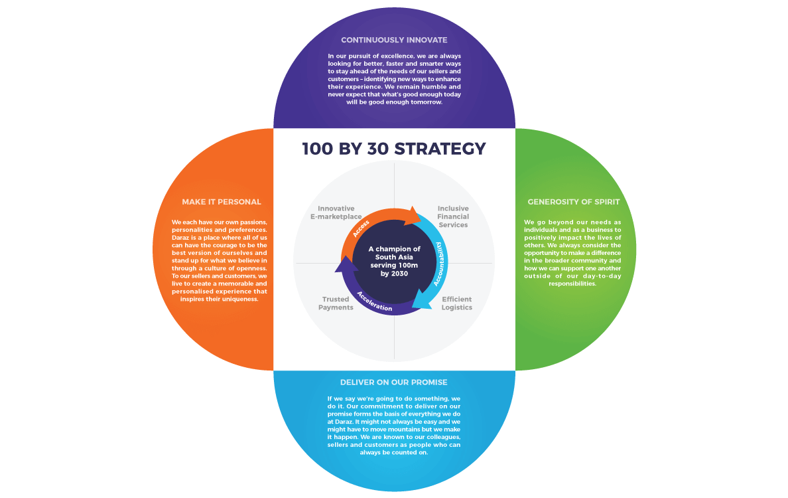
Vision: A Champion of South Asia serving 100m by 2030.

Figure 1 Vision and Values of Daraz

4.1.2 Values of Daraz

Daraz operates with four main values as described below:
- Make it Personal
Daraz recognizes that every individual has his or her own passion, personality, and preference. Daraz provides an environment where everyone can confidently express their individuality and uphold their beliefs through an inclusive culture. Daraz empowers its sellers and customers to design a customized and noteworthy experience that displays their distinctiveness.
- Continuously Innovate
In pursuit of excellence, Daraz constantly strives to stay ahead of the demands of its sellers and customers by seeking out new and improved ways to enhance their experience. The company is always looking for ways to be better, faster, and more efficient. Despite their progress, Daraz remains humble and recognizes that what works today may not be sufficient in the future.
- Generosity of Spirit
Daraz goes above and beyond both their personal and corporate needs to have a positive impact on the lives of others. The company continuously considers ways to make a positive impact in the wider community and ways to support each other beyond their regular responsibilities.
- Deliver on our promise
Daraz always follows through on their promises. Their dedication to fulfilling their commitments is the foundation of everything they do at Daraz. It may not always be simple, but they will do what it takes to make it happen. Daraz has a reputation for being reliable and dependable among its employees, sellers, and customers. (About Us | Daraz.Com.Bd, n.d.)

Organogram of Daraz Bangladesh

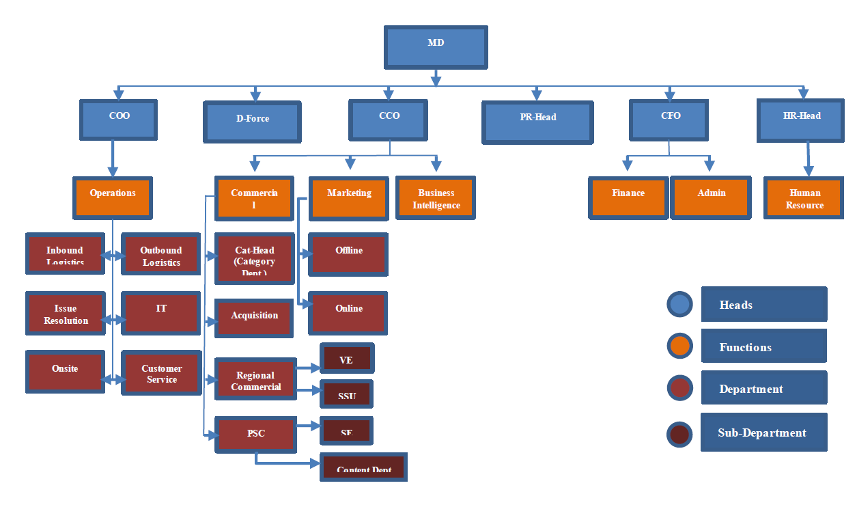
Since the start of the adventure, Daraz Bangladesh has expanded significantly. The business has spent a lot during the past two years. 19 hubs have recently been created outside of Dhaka city, and there are now more offices inside the city as well which totals to 89 hubs all over the country. Daraz has also received a large number of sellers since they arrived in Bangladesh. The organogram is getting more complicated as the operations expand. The diagram below shows a straightforward hierarchy description:
Figure 2: Organogram of Daraz Bangladesh
Managing Director (MD) of Daraz Bangladesh is at the top most centre of the Organogram. There are Chief Operational officer (COO), D-Force, Chief Communication Officer (CCO), Public Relation Head (PR), Chief Financial Officer (CFO), and Chief Human Resource Officer (CHRO) right under the command of the MD.
The COO leads the Operations which has the Inbound Logistics, Outbound Logistics, Issue Resolutions, IT, Learning and Development and customer services department under it. The CCO leads the commercial, marketing, and business intelligence departments. The CFO leads the Finance and Admin department and the CHRO leads the Human Resources department. All the Departments have their Head of the Department (HOD), Team leads/ Senior Executives, Executives ,and Junior Officers to run the departments smoothly. (Our Team — Daraz, n.d.)

Important Departments of Daraz Bangladesh

Each division within a company is essential, depending on the scope and complexity of the mission. The divisions strive to be effective from their viewpoint in their strategy. To better accomplish the corporate aim, departments are staffed with a diversity of qualified people. Daraz is a global e-commerce company, so each department's operations are planned and carried out in accordance with the guidelines established by the Alibaba Hq. The main departments of Daraz are:
Table 1: Important Departments of Daraz Bangladesh
Commercial | Graphics Design
Finance | Issue and Resolution
Marketing | Content Management
Accounting | Public Relation
Human Resource | Information Technology
Sales Management | Category Management
Business Development | Operations
Administration | Customer Services

SWOT Analysis of Daraz Bangladesh Ltd.

A SWOT analysis looks at a organization's strengths, weaknesses, opportunities, and threats by analyzing its marketing strategies and goods as a whole or by particular departments (SWOT). Overall, it helps a corporation make wiser decisions and succeed more often in all of its undertakings. The following Daraz Bangladesh Ltd. SWOT analysis has been finished.
- Strength
Better website and app than rivals: The DARAZ Bangladesh website and mobile application perform better than those of rivals like pickaboo.com, clickbd.com, and bagdoom.com, all of which offer comparable services.
Deals with recognizable brands: At DARAZ Bangladesh, there is a sale on popular brands like Samsung, Bata, and Apex.
Customer dependability: Because many businesses offer consumers who purchase through DARAZ Bangladesh verified warranties, purchasers seem to be more likely to receive genuine products and have a period of time to return them.
- Weakness
High rate of turnover: DARAZ In Bangladesh, since there are little opportunities for growth and low earnings, there is a high turnover rate.
No refunds on specific goods: Books and apparel are two examples of items that cannot be returned or refunded.
- Opportunity
Online business pioneer: Bangladesh's internet market, which is still developing, has a lot of potential to accept orders from other countries. Daraz currently only accepts orders from China, but it intends to eventually accept orders from other countries as well. A gift delivery service could be offered by DARAZ Bangladesh in additional to cakes, cards, and flowers.
Emergency delivery: In the future, if there is a need, they might start providing urgent deliveries, such as same-day delivery.
- Threat
If DARAZ Bangladesh is unable to establish a stronghold in the market, global powerhouses like Amazon or eBay might take over.
The majority of DARAZ Bangladesh's prospective clients are unable to reach it because Bangladesh is still a developing nation with subpar internet infrastructure.
Emerging local competitors could pose a severe threat. As a result, there are other competitors on the market.

Current Industry Scenario
In Bangladesh's e-commerce industry, there are two main types of inventory management-based business models. The first is the "Retail or Inventory-Led" model where e-commerce companies purchase goods in large quantities and sell them to customers. The second is the "Marketplace or Zero Inventory" model where online retailers act as intermediaries between suppliers and buyers. There is also a "Mercantile Model" in which online retailers offer delivery services and earn commissions without holding any stock, with "Ajkerdeal" being a prime example.(Historical Development of ECommerce in Bangladesh - Business Inspection BD, n.d.)
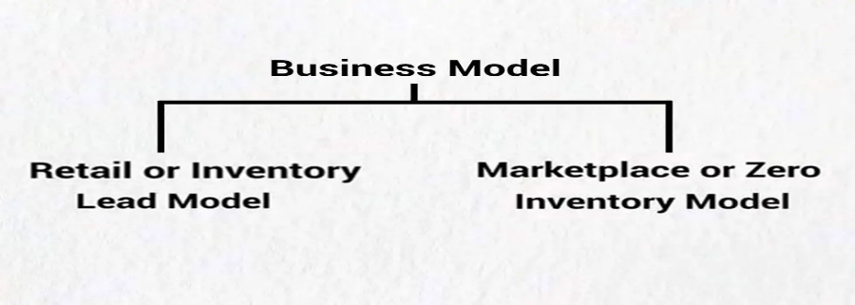

Figure 3: E-commerce Business Model of Bangladesh

According to an e-Cab analysis from 2021, Bangladeshi e-commerce platforms started promoting heavily in 2019 and started to develop into full-fledged enterprises in 2020. In Bangladesh, there are about 2500 e-commerce platforms, of which 1% are large companies, 4% are medium companies, and 95% are tiny companies. There are 1,600 ecommerce business owners that are currently members of e-Cab; 27% of them are female business owners, and 73% are male business owners.
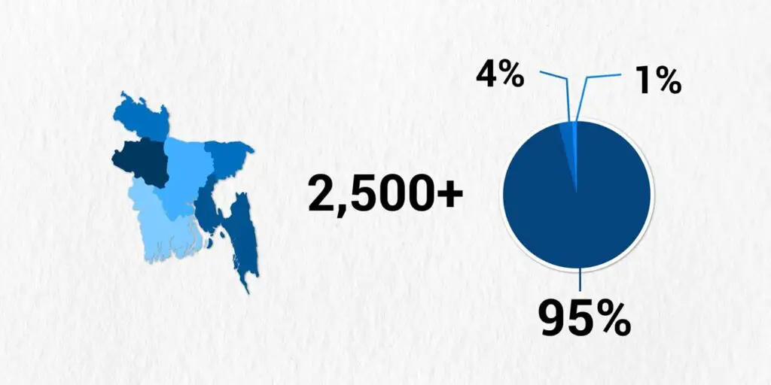
Figure 4: E-commerce companies and their market share

In Bangladesh, F-commerce, which refers to businesses based on Facebook, has grown rapidly alongside e-commerce. The launch of Facebook's "Live" feature has further fueled the growth of f-commerce, with over 5 lakh Facebook company pages in the country, with 2 lakh of them actively engaged in commercial activities. Despite the annual growth rate of 25% for e-commerce platforms in Bangladesh, there is a high dropout rate of 35% among new entrants. According to a report by e-Cab, the average basket value in the e-commerce market in Bangladesh is around BDT 2,200. In 2020, the average daily transaction volume of e-commerce was BDT 44 crore, which increased to Tk 16,000 crore by the end of the year. A financial express reported that the value of Bangladesh's e-commerce market was USD 2 billion in November 2020, but with an annual growth rate of 50%, the market is expected to reach 3 billion by 2023.(E-Commerce in Bangladesh: Prospects and Challenges, n.d.)

Daraz Bangladesh Limited’s Porter Five Forces Analysis
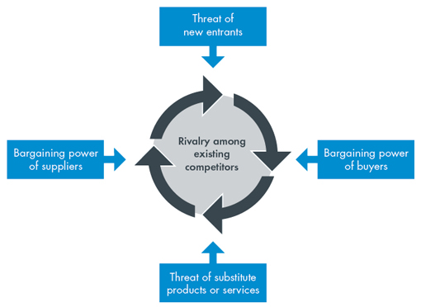
Porter's Five Forces study is a useful place to start when examining the competitiveness of any business climate and calculating a company's profitability. Below I am going to share my analysis of these forces and their effect on Daraz Bangladesh Ltd.

Figure 5: SWOT Analysis
- Bargaining Power of Buyers
Customers that shop online have little to no negotiating leverage because local businesses set the prices. For the exact same item in several goods, the majority of sellers charge about the same price. Rivalry limits the amount of exchange choices available to buyers. Customers can choose to buy from a range of merchants and remaining on the same platform as a consequence.
- Bargaining Power of Suppliers
Daraz has no affiliation with the vendors on the Daraz system because merchants only conduct business there in exchange for a commission for using the Daraz platform. Due to seller ties, vendors' negotiating power may harm sellers, though Daraz and other e-commerce sites that operate similarly are exempt from this. Due to the overwhelming quantity of suppliers, they also have little negotiating strength.

- Threat of Substitute
Products that can be replaced present a problem because they can be bought in person or via numerous e-commerce websites. As a result, you have several alternatives when it comes to purchasing items at this business. The primary and alternative products are both available on the Daraz website, a direct rival. There are no hazards due to the extensive assortment of goods offered by Daraz Bangladesh. Daraz Bangladesh presented a number of ideas and fundamental values-based solution alternatives. They went to tremendous measures to prove to their customers that they were unbeatable.

- Competitive Rivalry
There is intense competition in Bangladesh's e-commerce business because of the vast number of competitors. Additionally, this conclusion is supported by the stance of all other forces. Hence, it is possible to say that market rivalry is fairly fierce, which attracts consumers to the sector. DARAZ, a well-known actor, was able to effectively convey these worries.

- Threat of New Entrant
New rivals present a sizable challenge as Bangladesh's e-commerce industry develops and thrives. Instead, this company is simple because, even though it will take a while to expand, anyone who can design an app and website for a tablet or a smartphone is now in business. Although this industry is immensely wealthy, new competitors offer a serious threat. Newcomers struggle to enter the market because of the large governmental infrastructure. New rivals consequently have a decreased chance of success.

Chapter 5: Findings of the Study

This section of the report is derived from my personal experience while working at Daraz Bangladesh, the answers obtained from the questionnaire responses, learnings from the reading materials provided by Daraz, and personal observations from field visits.

Human Resources Functions at Daraz Bangladesh:
The HR department plays a crucial role in every business as it oversees the well-being of employees. Daraz Bangladesh's HR department is no exception, and it is responsible for handling various HR-related tasks such as payroll management, policy regulation, and more. The general manager stays in communication with the HR department and deals with any matters that require higher-level intervention. The deputy manager works closely with the general manager to assist with HR-related issues and also collaborates with executives on various tasks such as the hiring process, payroll administration, and other HR matters including rules and policies and a performance appraisal system.
The HR department is responsible for managing the hiring process for new employees. When other departments within the organization have a need for new hires, the department heads submit a requisition. The HR department then works with the department heads to perform a job analysis and create the job posting. This is important to ensure that the HR department understands the specific responsibilities and duties of each position. The job posting is then posted on various employment websites and social media platforms and the HR department also makes an effort to promote the job opening internally to see if they can find a suitable candidate. At times, department heads may refer qualified candidates they know through their own networks. The HR department collects resumes and the executives review resumes that meet the requirements outlined by the department head. After reviewing resumes, the HR department schedules interviews with the appropriate department head and notifies the selected candidates of the interview date and time.
The first round of interviews is conducted by department heads to assess which candidates have the most potential. If they pass this stage, the candidates will be interviewed by the deputy manager, who will verify their work history, credentials, and other introductory information. The deputy manager also conducts background checks on all applicants, including reaching out to references and previous employers if necessary. If all goes well, the candidates may then be interviewed by the group managing director and general manager of the HR department, which is only done when hiring for higher level positions.
Once the candidates meet the requirements, they receive an offer letter, with a deadline of one or two weeks to sign it, to meet the company's need for new employees. For more senior positions, the deadline to sign the contract is limited to one month to allow the candidates to fulfill their prior employment obligations. Based on their performance after being selected, applicants may be put on a probationary period of up to one or two months, during which they are introduced to their responsibilities and tasks, and may also receive training on specific aspects of their job. Daraz Bangladesh places a strong emphasis on on-the-job training. Once the probationary period is successfully completed, employees start working under the terms of their regular employment contract.
Daraz Bangladesh follows a strict schedule for its employees' work hours, either from 9:30 am to 6:30 pm or from 10:00 am to 7:00 pm. Employees who arrive late face fines. The HR department allows for up to 14 sick days and a maximum of three days off for other reasons, as well as 20 vacation days per year and other paid time off. Paychecks are issued to employees on time, usually during the first week of the next month, which is a busy time for the HR department as payroll must be processed and the accuracy of information must be verified. The HR department also creates employee benefits and incentives, ensuring they are relevant and supportive of employee motivation. The department has a zero-tolerance policy towards harassment or discrimination, and those caught violating it face consequences.
Performance Appraisal is also a popular practice for employees conducted by the HR department. At Daraz Bangladesh, they do not employ the 360-degree evaluation method, instead, they prefer a self-assessment approach where employees assess their own performance and behavior for growth and learning purposes. To complement self-evaluation, Daraz also implements a 10-point system where line managers in each department conduct assessments. These evaluations occur on a quarterly basis, however, the frequency may vary based on performance and evaluation outcomes.
Daraz Bangladesh provides an annual salary increase to employees who meet their KPIs. Those who have been with the company for more than a year are eligible for two additional bonus payments during the year, along with the option to take paid time off for vacations and the possibility of paid leave encashment. In addition to monetary compensation, Daraz Bangladesh also covers the cost of the phone sim card provided to employees. The company also holds an annual event called Re-Treat, which serves as a recreational outing for all employees and is a non-monetary benefit.

Learning and Development (L&D) activities at Daraz Bangladesh:
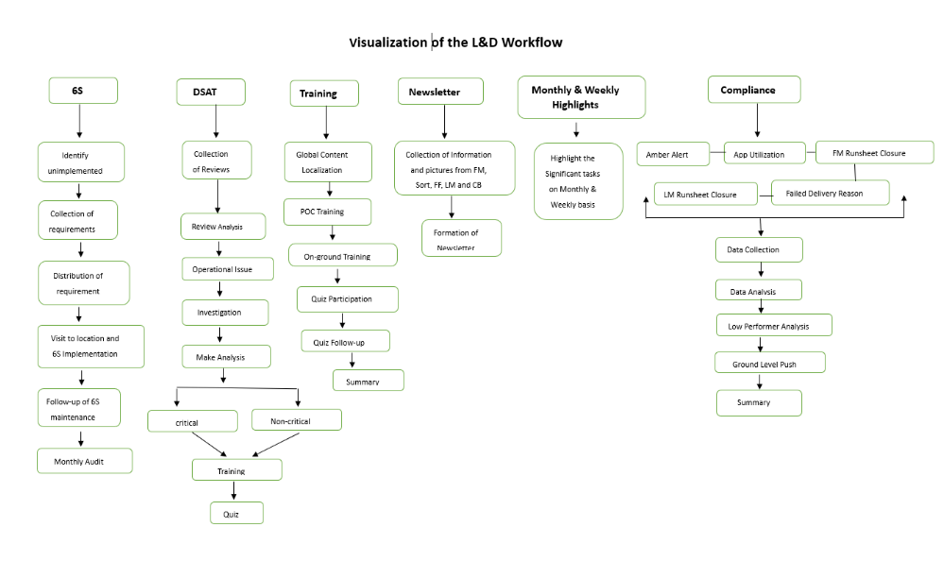
In most companies, we see Learning and Development (L&D) as a part of the HR department. Yet in Daraz Bangladesh, Learning and Development is another separate department with a wide range of activities. HR department as well as L&D works hand-in-hand as separate but cooperative two departments to run the operations of Daraz Bangladesh Venture. The study shows the activities of the L&D department at Daraz Bangladesh.

Figure 6: Visualization of the L&D Workflow
The above diagram shows the elaborated look of different segments of work that L&D department does. In the following discussion, we will demonstrate each of the segments thoroughly.

5.2.1 Trainings conducted by (L&D) department

One of the major tasks of the Learning and Development (L&D) department is to provide training. There are regular trainings from Daraz Global which are provided to the riders and operators. These trainings reach to the riders through a proper channel. Daraz Ops Academy is where all riders and operators are enrolled after joining Daraz. All the training materials are provided there for their better understanding and learning. After completing each trainings, they have to seat for a quiz to pass the training and implement the learnings in real service.
The list of the major trainings provided to the riders and operators are as follows:
Table 2: Name of the Training courses provided at Daraz
 | Name of Trainings
1. | DEX Skill Matrix Training
2. | Employee Onboarding Training
3. | FF Skill Matrix Training
4. | CB Skill Matrix Training
5. | Customer Experience Training (DSAT) + Communication Skills for Collection Point Staff
6. | Fulfilment Training for 6S Lean Implementation
7. | Communication Skills & Handling Uncertain Situations for Last Mile Heroes
8. | Health and Safety Training for Riders
9. | Good Behaviors at the Workplace
10. | Cross Border 11.11 Training

Likewise, the above-mentioned listed trainings, the L&D department conducts around 50 trainings to all the riders and operators of Daraz Bangladesh.
The main training contents come from Daraz Global. After conducting the training needs assessment, the global L&D department creates the training content as per the needs and understanding of the audience. The training contents are provided in a video format along with the text contents of the video. Later the global contents are prepared as per the understanding of the local rider and operators by the Daraz L&D BD venture.
The following process flow shows how the training is conducted by the L&D team.
Figure 7: Process Flow to provide Trainings by Daraz Bangladesh

- Global Content Localization:
After the Global Content comes from Daraz Global, the L&D BD venture team localizes and vocalizes it as per the understanding of the local riders and operators. The video is again being prepared in the Bengali language to assist in better understanding. Later the localized and vocalized video is prepared and uploaded in the Daraz Ops academy so that the certain audience can access it and learn it efficiently.
- POC training:
When the localized video is uploaded, the POC (Point of Contact) to those riders and operators are informed through an online or offline meeting. The meeting is conducted by the executives of the L&D department who has keen knowledge of the training content and its importance. In the following meeting, the POC of 83 hubs all over Bangladesh should be present to understand the effectiveness and importance of the newly uploaded training. Not only that, the training contents are also well discussed so that the POC can easily convey the training contents to the riders and operators of his specific hub.
- On-ground Training:
On-ground training is also conducted by the L&D team. The L&D team visits different ISD (Inside Dhaka) hubs to conduct the on-ground trainings towards the riders and operators. The team gets divided and visits each of the 11 hubs and takes the trainings accordingly. The riders and operators gather around to listen to the trainer and watch the training video content. The localized video is then again discussed among the audience for better understanding. Many of the curious audience ask questions and share their real service experience so that they get clear knowledge of what is ideal to do in order to solve any situation. At the end of the session, the L&D team ensures all the riders and operators are clear about the subject topic and are well-motivated to implement the learnings in the field while dealing with the customers.
- Quiz Participation:
In order to make sure that the riders and operators actually learned the content, there is a system of attending quizzes through the Ops Academy as a mark of completion for the given training. It is a condition from Daraz Global that each and every enrolled rider/operator of the training should attend the quiz and obtain a minimum of 90% mark in order to pass the training course.
- Quiz Follow-up:
The L&D team should continuously take follow up on whether all the enrolled students from all the 83 hubs attended the quiz and obtain 90%marks to pass the course. There are hub supervisors of each hub to contact if the riders/operators from that hub have participated in the quiz obtaining the pass marks. The L&D team members contact these supervisors to take follow up on this quiz participation.
- Summary:
All these overall activities as well as responses from all the hubs, the quiz participation rate, and results should be summarized by the L&D team and then submitted to Daraz Global. Since the same training is being attended by the rider and operators from all the ventures of Daraz, the quiz participation rate along with the quiz results are compared. From history till now, Daraz BD venture always ranks top among all other Daraz ventures in the world.

6S Implementation:
Implementation of 6S is another role of the Learning and Development (L&D) department of Daraz Bangladesh. It is very necessary that every hub of Daraz Bangladesh has the 6S maintained very effectively. The elaboration of 6S as per Daraz is demonstrated below:
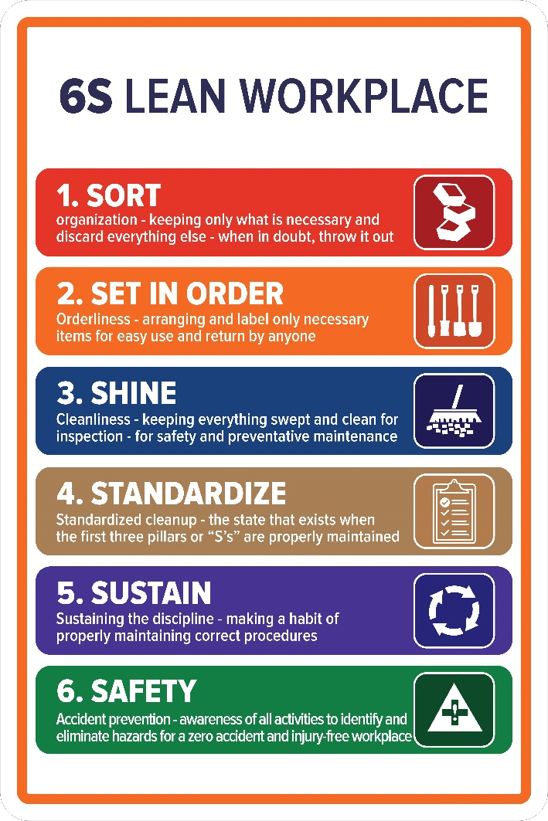

Figure 8: 6S Lean Workplace

- Sort: Everything in the hub should stay well-organized with whatever is necessary for the hub. Every necessary element should stay and all other unnecessary things should be thrown out at the end of each working day. It is often said that when there is any doubt, throw it out. The hubs often get jammed with numerous fewer necessary things. In this way, hubs can get rid of much and stay organized.

- Set In Order: It refers to the orderliness of the hub. In order to keep everything in order, it is very necessary to label the necessary items and arrange them in order. Thus, items can be handy, easy to use and if needed can be returned easily too.

- Shine: It refers to the cleanliness of the hub. There is a huge bulk of parcels that land and get out to be delivered each day from each hub. Thus, every day the hub gets dirty, dusty, and full to waste that needs to be removed. Therefore, everything needs to be swept and cleaned for inspection each day. Thus, safety and preventative maintenance is ensured.

- Standardize: This refers to standardize clean up. It will be ensured when the above 3S will be well maintained.
- Sustain: When the discipline of the hub is well-maintain each day, it refers to sustaining the discipline. From receiving the bulk of parcels to delivering them to the right customer efficiently, the operators and riders need to maintain the procedures. When the procedures are maintained every time, we can refer to it as sustaining the discipline.

- Safety: While working with a bulk of parcels, it is necessary to maintain accident prevention measures. Every worker should be aware of all the activities so that they can identify and eliminate any hazards that can cause any harm. Thus, a zero-accident and injury-free workplace can be ensured.

Daraz Believes that every hub should have these 6S well-maintained to run properly. Learning and Development (L&D) department takes regular follow-up from the hub supervisors about the 6S maintenance. The Process Flow on how the L&D department conducts it is as follows:

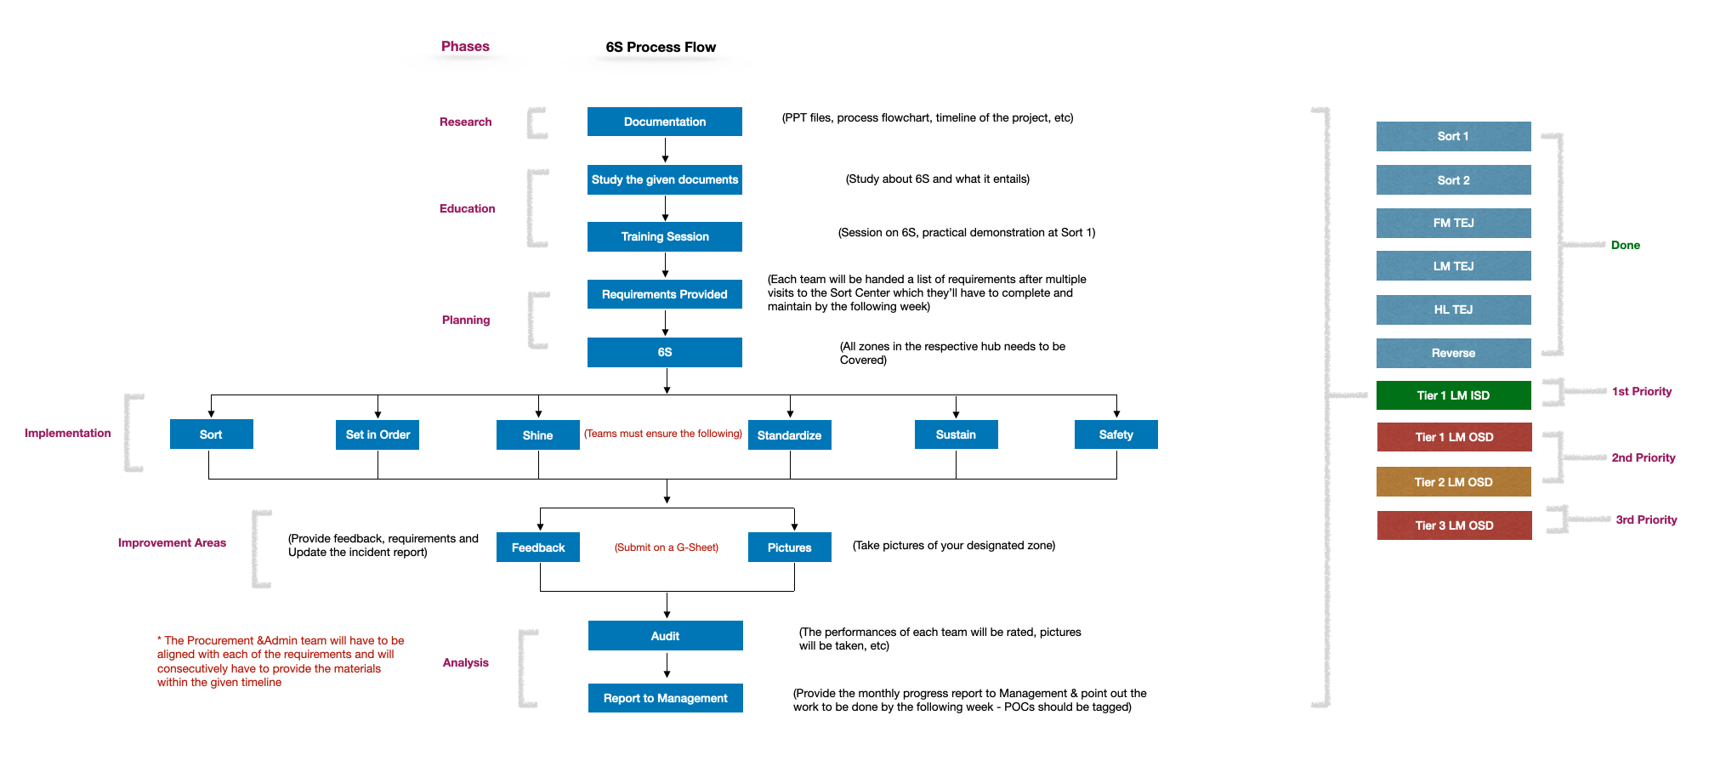
Figure 9 : 6S Process Flow
- Research: In the research part, the L&D team collects the ppt files, process flowchart, the timeline of the project, etc to know details of the 6S. Learning about the documentation gives a clear idea of conducting the 6S and implementing it effectively in an efficient manner. Thus, collecting all the necessary documents is essential.

- Education: The L&D department learns from the collected documentations thoroughly about what it entails and how to implement it accordingly. Later the team takes training sessions on 6S at selected ISD (Inside Dhaka) and OSD (Outside Dhaka) hubs all over the country. At the training sessions, the team teaches about all the elements in the 6S and ensures that the hub knows about it and its implementation. Apart from the hub visits, the 6S implementation is also demonstrated at the Tejgaon Sort centre where various hub supervisors gather to learn about it.

- Planning & Implementation: The L&D team provides a form of a list of requirements to each of the hub supervisors after multiple visits to the sorting centre. Each of the hub supervisors will then have to complete the form and submit it so that the L&D team can provide the necessary requirements. Here, the L&D team aligns with the procurement and Admin to provide the necessary requirements within the given timeline. Each hub will need to implement all the elements of 6S at their hub within a week after receiving the requirement from the L&D team. Sort, Set in order, Shine, Standardize, Sustain and safety all should be ensure and well visible at the hub.

- Improvement Areas: After successfully implementing 6S, the L&D team should take feedback from the hub supervisors about the problems and prospects on implementation. If any further requirements are needed should be informed as well. The team also collects pictures from all the hubs to measure whether the 6S is perfectly maintained and well visible.

- Analysis: Lastly, the L&D team conducts audit and report to the management about the overall 6S performance by the entire Daraz Bd venture. In the audit, the performance of 6S is rated among all the hubs according to the pictures. Later, the monthly progress report is sent to the management and next month’s work is pointed out.

Daraz Seller Associate Training (DSAT):

DSAT stands for Daraz Seller Associate Training, it's a program designed by Daraz to provide training and support to their seller partners on how to effectively manage their online store and grow their business on the platform. The Daraz Seller Associate Training program is a comprehensive initiative aimed at empowering Daraz's seller partners with the knowledge and skills they need to succeed on the platform. The program covers various aspects of e-commerce such as:
- Product Listing: Teaching sellers how to optimize their product listings for better visibility, accurate information, and appealing presentation.
- Pricing: Advising sellers on how to price their products competitively, taking into account the platform's fees and the target market.
- Marketing & Promotions: Educating sellers on how to use Daraz's marketing tools and promotions to increase sales and brand awareness.
- Customer Service: Providing guidance on how to handle customer inquiries, complaints and returns effectively.
- Operations & Logistics: Offering support in managing their online store's operations and logistics, such as order fulfillment and shipping.
The learning and Development (L&D) team conducts this DSAT very effectively and sincerely. The following steps are maintained in order to reach the DSAT following the evaluation:
- Step 1: Collection of Reviews: The L&D team collects reviews and feedback from the customers who have given their feedback of product and services through the Daraz website or app.

- Step 2: Review Analysis: The collected reviews are analyzed to identify common themes and patterns, and to categorize them by topic or type. Positive feedback are appreciated yet the negative feedbacks are the one that is analyzed. Generally, the feedbacks claims mistakes of either the seller or the rider. Executives from the L&D team note every negative response and categorize them as the seller’s or rider’s fault.

- Step 3: Operational Issue: Any operational issues are also checked before it is given for further investigation.

- Step 4: Investigation: Later investigation is conducted to determine the root cause of the issue claimed by the customer and to gather additional information as needed.

- Step 5: Make Analysis: An analysis is made to evaluate the information gathered on the issue. The fault of the seller or the rider is clearly identified. The issue is then classified as critical or non-critical based on the impact of the analysis. Critical issues require immediate attention and action; thus it can result in blacklisting the seller if it is a seller’s mistake or sacking the rider if it is a rider’s mistake. While non-critical issues are addressed in such a way that it never happens again in the future.

- Step 6: Training: Based on the results of the investigation and analysis, the seller or the rider is enrolled in specific training based on the type of mistakes that occurred. The seller has to go through DSAT in order to learn what mistakes s/he caused and what could be the ideal behavior in such a case. In case of rider, he is enrolled in a CXP (customer experience) training to learn and rectify the mistakes.

- Step 7: Quiz: A quiz is given to sellers who have completed the DSAT program to assess their understanding and retention of the training material. Again, in order to pass the quiz, one has to obtain a minimum of 90% of marks.

This process flow helps ensure that customer feedback is collected, analyzed, and acted upon in an efficient and effective manner. Thus, the L&D team also helps to improve customer satisfaction and business performance.

Compliance:

Maintaining the compliance rate is necessary for every department. The compliance rate for Learning and Development department depends on maintaining the following factors:
- Amber Alert: Amber Alert is an alert that is notified by the rider when he is close to the customer’s home. A rider is trained such that he will call the customer to know if he is available at the location given and available to receive the parcel. When the customer is available, then the rider notifies the customer using this amber alert. The alert needs to be given by the rider at least 1 hour before the delivery. If it is not maintained properly, it refers that the rider is not well-trained or well-motivated to work in such a manner. The L&D team needs to maintain this in order to keep the compliance rate high.

- App Utilization: "App Utilization" in Daraz refers to the usage of the Daraz app by customers or the customers' engagement with the app. It measures how often customers open the Daraz app, how long they spend using it, and what actions they take within the app, such as browsing products, adding items to their cart, and making purchases.
App utilization is an important metric for Daraz because it helps the company understand the effectiveness of its app and make improvements as needed. A higher App Utilization rate plays a role in a higher compliance rate.

- Failed Delivery Reason: "Failed Delivery Reason" in Daraz refers to the reasons why delivery of an order could not be completed successfully. It could include reasons such as incorrect address provided, recipient not available at the time of delivery, lack of proper identification, package refused by the recipient, or any other reason that prevents the delivery from being completed as planned. The "Failed Delivery Reason" helps Daraz to understand why delivery has failed and take steps to prevent similar failures in the future. Riders should be able to provide the exact reason behind failed delivery. The increase in the number of failed delivery can result in a low compliance rate.
There are other couples of confidential elements which have roles in the compliance rate of L&D and are prohibited to be shared in academic reports.
Data Collection is carried on for the above-mentioned factors to be analyzed so that the compliance level can be maintained. The result of the data analysis is then used to find out any possible gaps or places where improvement can be made. Later ground check is conducted to check on the gaps. Possible solutions and improvements are made and lastly a summary of the overall situation is submitted to the management for further evaluations at Global.

5.2.5 Newsletter & Highlights:

The Learning and Development (L&D) department needs to release Newsletter and Highlights to all the departments of Daraz Bd venture along with Daraz Global to inform about the activities done by the department.
In order to release Newsletter, the (L&D) team collects information from the First Mile team (FM), Fulfillment team (FF), Sort team, Last Mile team (LM), and Cross Border team (CB) about their activities on a particular month. Since the newsletter is released on a monthly basis, this information is then processed and then released in a form of a presentable newsletter to the audience.
Highlights are released on a bi-weekly and monthly basis by the L&D team. The Highlights mentioned any notable activity done by the team within that particular time period. The highlights may mention the hub visits by the team, the training overview for the 11.11 campaign, batch-wise training timeline of DEX (Daraz Express) and FF (Fulfillment) along with DOPs (Daraz Operations) Tracker Performance Rate. It also visualizes the POC training moments, the global content vocalization, on-ground rider training for ISD LM hubs, in-house employee training for sort, LM, FF & FM and lastly the certification memories.

Workshops

Recently Learning and Development (L&D) department has taken initiatives to train not only the Rider or Operators but also the employees of the entire Daraz Ops. This initiative has moved Daraz Global and the ideation turned into reality on the 31st of January, 2023. The 1st ever workshop conducted by Daraz Bd L&D team was on Effective Communication.
Initially there were a list of workshop ideas presented to the Head of the department and the Daraz Global L&D team, later the “Effective Communication” got selected to be the first ever workshop conducted by the L&D BD team. The idea from the content till its execution entirely was initiated and created by the L&D team on its own. The day long workshop contained learning elements along with different games to engage employees and enhance their communication skills. It has also boosted up their confidence and bonding among each other. The feedback of this workshop is so positive that employees want more of these workshops in future.
The team has plans on further workshops and is now working on its next workshop to bring betterment for the Daraz Ops employees.

11.11 Campaign:
Daraz's 11.11 campaign is a major online shopping event held annually on November 11th. It's an opportunity for Daraz, one of the largest online marketplaces in Bangladesh, to offer its customers a wide range of discounts and promotions on various products, including electronics, fashion, beauty, and home goods. During the event, customers can find special deals such as flash sales, limited-time offers, and free shipping. The 11.11 campaign is a way for Daraz to attract new customers, drive sales, and boost revenue during the holiday shopping season. In recent years, the 11.11 campaign has become increasingly popular in Bangladesh, with more and more customers taking advantage of the discounts and promotions offered by Daraz. These promotions add to the excitement of the 11.11 campaign and create a sense of urgency for customers to take advantage of the deals before they expire. The 11.11 campaign is a key event for Daraz, as it provides a platform for the company to showcase its products and services, while also increasing its customer base and revenue.
Since Daraz provides a huge number of promotional flash sales and various numerous offers, the delivery pressure rises to its maximum compared to the delivery of the entire year. Thus, they need to recruit a huge number of new riders and operators to tackle this huge number to deliveries all over the country. In this year Daraz has to recruit over 6000 new riders and operators to support the 11.11 campaign orders. The Learning and Development team had to undergo massive pressure to train these new recruits efficiently and ensure their participation on quizzes with a high passing rate. With the joint dedication of all the team members and the cooperation of all the hubs around the country, the Learning and Development team has achieved a record-breaking training compliance rate of 98% in the 11.11 campaign. This compliance rate is not only higher than other Daraz ventures but also higher than any previous records achieved by any Daraz L&D team. It was an absolute achievement from the Daraz Bd venture.
To celebrate this achievement and to reward the hard-working people behind this, the L&D team organized a certificate distribution ceremony. “Best Performer in 11.11 trainings” was rewarded to different POC and hub supervisors for their outstanding performance throughout the entire campaign.
The overall performance of Daraz was magnificent in this 11.11 campaign of the year 2022. The overall performance summary of Daraz 11.11 campaign 2022 is demonstrated below:
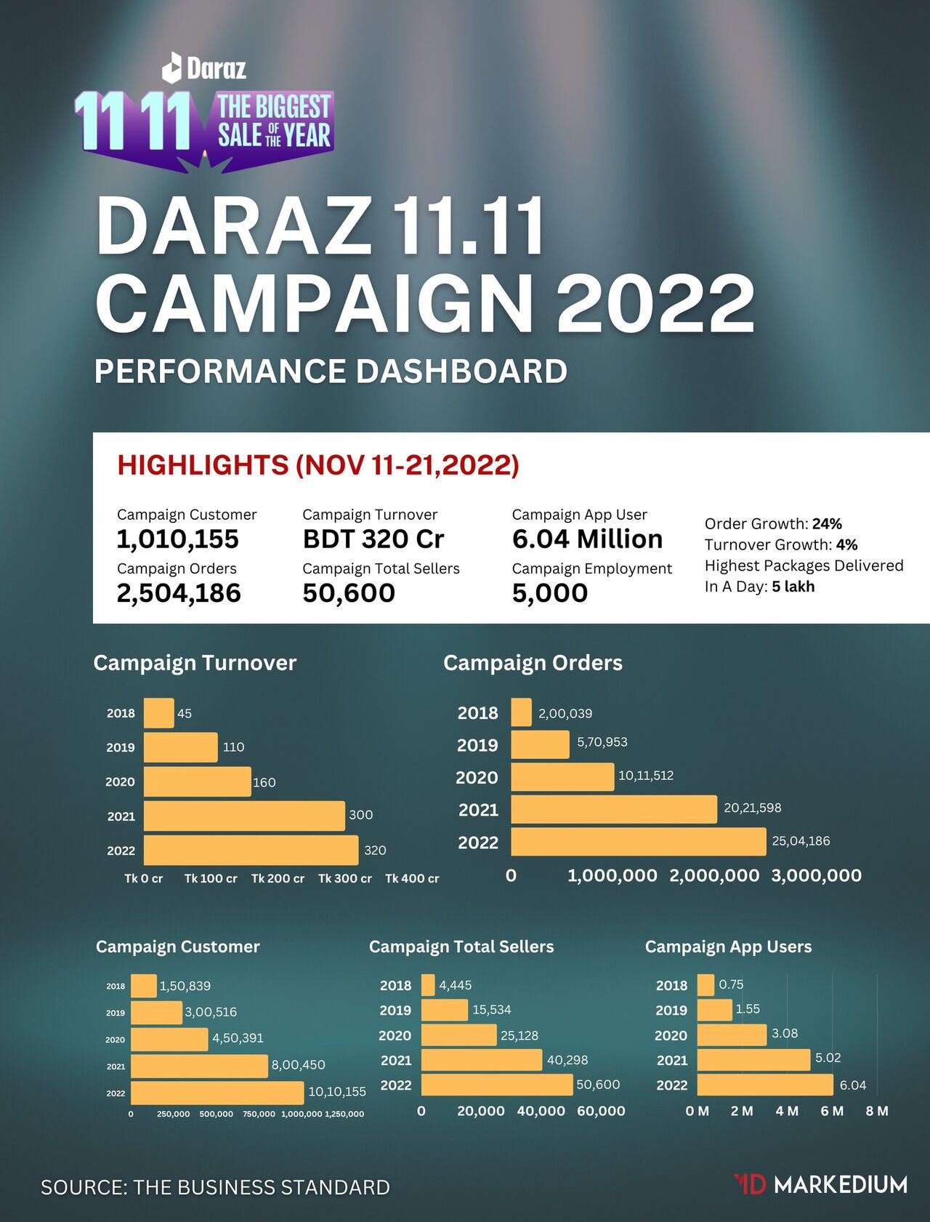

Figure 10: Daraz 11.11 Campaign 2022 Performance Dashboard
As per The Business Standard, the highlights from Nov 11 to 21 of 2022 show the following results:
Table 3: 11.11 Campaign highlights
Campaign Customer | 1,010,155
Campaign Orders | 2,504,186
Campaign Turnover | 320 Cr BDT
Campaign Total Sellers | 50,600
Campaign App Users | 6.04 Million
Campaign Employment | 5000
Order Growth | 24%
Turnover Growth | 4%
Highest Packages Delivered In a day | 5 lakh

The numbers show quite a huge business achieved by Daraz Bangladesh within just 10 days. The L&D team believes that it has played a major role in the success that has been visible to the entire country. It is also notably seen that Daraz decreased the level of failed deliveries and complaints from the customers’ end. This clearly implies that the training for the sellers, riders, and operators had a significant positive impact on the 11.11 campaign run by Daraz.

Chapter 6: Recommendation and Conclusion

Recommendation:
Employment at major multinational companies can be challenging. There are always opportunities to acquire new abilities and confront new challenges. During my time at Daraz Bangladesh Ltd., I gained extensive experience and knowledge. I was able to make insightful observations and will therefore be able to suggest some recommendations.
Learning and Development is comparatively a new team formed by Daraz and ever since it has been evolving with time. The Head of the department is open to any positive changes and is trying to make better outcomes. The following recommendations can be made for the department to bring more effective and efficient results:
- The L&D team can take feedback from the rider/operators after they have gone through certain training and evaluation. It will allow the team to understand its effectiveness and know the gaps in its training procedures.
- The L&D team can organize monthly sessions with the riders/operators to know about any training topic to add to the course list which can help them to provide better service to the customers or can make their work easier.
- The team can increase the workshops with the Ops employees based on their career goals, skills, and job requirements to ensure they receive targeted and relevant training.
- Daraz can collaborate with industry organizations and training providers to offer specialized training and development opportunities to employees.
- Daraz can also take initiative to turn all the L&D team members into certified trainers which would increase their efficiency and credibility.
Implementing these recommendations can help Daraz create a dynamic and effective learning and development program that will support employee growth and contribute to the overall success of the company.

Conclusion:
Daraz is a leading e-commerce platform in Bangladesh that has been running successfully by offering a wide range of products and convenient online shopping experiences to its customers. It has established itself as a trustworthy brand by providing quality products at competitive prices, fast delivery services, and a user-friendly website. Additionally, Daraz's partnerships with local and international brands, secure payment options, and excellent customer service have helped the platform attract and retain a large customer base. As a result, Daraz has become one of the most popular online shopping destinations in Bangladesh and has been instrumental in driving the growth of the country's e-commerce sector.

The learning and development department of Daraz Bangladesh is responsible for providing training and professional development opportunities to employees. This department plays a crucial role in enhancing the skills and knowledge of the workforce and promoting a culture of continuous learning. The learning and development department offers a variety of programs, including workshops, online courses, and on-the-job training, to help employees grow professionally and advance in their careers. This department also assesses the effectiveness of its programs and makes necessary changes to ensure that the training provided is relevant, up-to-date, and aligned with the needs of the business. Overall, the learning and development department of Daraz Bangladesh has been an important contributor to the company's success and is helping to foster a supportive and empowering work environment.

Chapter 7: Appendix

Reference
About Us | Daraz.com.bd. (n.d.). Retrieved February 10, 2023, from https://www.daraz.com.bd/about-us/
Daraz Bangladesh Company Profile | Management and Employees List. (n.d.). Retrieved February 10, 2023, from https://www.datanyze.com/companies/daraz-bangladesh/372835094
E-commerce in Bangladesh: prospects and challenges. (n.d.). Retrieved February 9, 2023, from https://www.newagebd.net/article/147734/e-commerce-in-bangladesh-prospects-and-challenges
Historical Development of eCommerce in Bangladesh - Business Inspection BD. (n.d.). Retrieved February 9, 2023, from https://businessinspection.com.bd/historical-development-of-ecommerce-in-bd/
IDLC Monthly Business Review. (n.d.). Retrieved February 10, 2023, from https://idlc.com/mbr/article.php?id=379
Our Team — Daraz. (n.d.). Retrieved February 10, 2023, from https://daraz.com/our-team/
We trust each other, and our customers trust us: Daraz CEO | Bangladesh E-commerce Industry. (n.d.). Retrieved February 10, 2023, from https://www.tbsnews.net/features/panorama/we-trust-each-other-and-our-customers-trust-us-daraz-ceo-331240

Questionnaire:
- Can you tell us about your role and responsibilities within the Learning and Development Department of the company?
- How has the e-commerce industry evolved in recent years, and how has the Learning and Development department adapted to these changes?
- Can you share some of the initiatives and programs the department has implemented to enhance employee skills and knowledge in the industry?
- How does the department measure the effectiveness of the learning and development programs offered?
- How does technology play a role in the learning and development process at the company?
- Can you discuss the process for selecting and implementing new learning technologies or tools within the department?
- How does the department ensure that the learning and development programs align with the company's overall business strategy and goals?
- Can you give an example of a successful learning and development project or program that was implemented at the company?
- Can you mention the major activities conducted by the learning and Development department?
- What is the major workload during 11.11 Campaign that the Learning and Development department faces?
- Can you mention the number of new recruits during 11.11 Campaign?
- What is the passing mark for the trainees who attend the training evaluation quiz?
- What are the activities needed to achieve due to maintain a high compliance rate?
- What is the highest percentage of compliance rate the L&D department obtain?
- What are the future projects to make the department more efficient in Daraz Bangladesh?

