Internship Report on:
Identifying the factors that create Employee Job Satisfaction on Human Resource Department in Aarong

UNITED INTERNATIONAL UNIVERSITY


INTERNSHIP REPORT on
Identifying the factors that create Employee Job Satisfaction on Human Resource Department in Aarong

Submitted to:
Yeasmin Islam
Assistant Professor
School of Business & Economics
United International University

Submitted by:
Jannatul Ferdous Laboni
ID No: 111 151 491
BBA, School of Business & Economics
United International University

Date of Submission: 08.06.2020
Letter of Transmittal
Date:
To,
Yeasmin Islam
Assistant Professor
School of Business & Economics
United International University

Subject: Submission of internship report on identifyingthe factors that create Employee Job Satisfaction on Human Resource Department in Aarong.

Dear Madam,
Here is my internship report on “Identifying the factors that createEmployee Job Satisfaction on Human Resource Department in Aarong”, which is compulsory for finishing of my graduation program. I have given my utmost effort to collect all the necessary information to complete the report. I am very glad that I have the opportunity to submit my internship report on the experience I gained during my 3 months of internship periods at Aarong. I have prepared this report in accordance with the instructions provided by you.
I therefore hope that the analysis that I have completed is on perhaps to your expectation. It has been a great experience for me doing the report and I have tried my best to put everything which are related to the report. I believe the practical learning and experience in Aarong will help me a great deal later on. I am thankful for your constant guidance and support during the preparation of my internship report.

Sincerely yours,
Jannatul Ferdous Laboni
ID: 111 151 491
BBA, School of Business & Economics
United International University

Acknowledgment

Firstly I would like to thank the Almighty Allah for all the gratitude, who made every movement viable and rescued me in any kind of crisis. At that point I should express profound gratitude to Aarong Human Resource division for choosing me as an apprentice. I see myself as blessed because I had the ability to work with such committed people who gave me handy learning and made the beginning of my corporate life very battled. It is sure that completing of this report would not be conceivable without their mindful help.

I am very grateful to my supervisor S.M. Zahidul Islam (Manager, HRD) for helping me to understand the corporate benchmarks and societies in Aarong. I likewise need to thank my senior associates Sanjida Sultana (Sr. Official, HRD), Rutaba Fairuz (Sr. Official, HRD), Shefa Binte Zakir (Officer, HRD), Mohammad Tanjil Hossain (Officer, HRD) for helping me in each and every progression during my entry level position program. For my future career, the guidance from entire Human Resource Department of Aarong is very much helpful indeed.

At that point I would like to thank Yeasmin Islam, Assistant Professor of School of Business & Economics,for helping and giving me right direction during the apprenticeship time frame. I am highly indebted to her for constant supervision, guidance as well as utmost support in completing the report. I additionally need to express profound gratitude to Career Counseling Center (CCC) of United International University for their assistance.

Executive Summary

This report is an analysis of factors that create Employee Job satisfaction on Human Resource Department of Aarong. Aarong is an immense affiliation working with numerous delegates where Aarong HR office fills in as a strong capacity to manage those countless HR with their extraordinary pound. Beginning fragment of this report consolidates little introduction about the report, objective, framework, degree and limitation of the report.
The second part of the report contains the literature review which includes definitions, theories, factors and measurement of employee job satisfaction.Basically literature review represents author’s logical discussion regarding theoretical issues. In this report, some authors who have been enriched the human resource sector, their study such as theoretical description and quotation related with employee job satisfaction have been included.So it will help to understand the concept of employee job satisfaction precisely.
The third part portrays about the company affiliation, their history, and mission and vision verbalization. It likewise gives brief portrayal of Ayesha Abed Foundation, Aarong's thing offering, endowments constrained by Aarong, Aarong's logo, and so forth. This bit of the report gives a view about Aarong's culture, their contributions and colossal qualities to set up themselves as Bangladesh's major way of life retail chain.
The fourth part incorporates investigation and translation of the overview poll of Aarong representatives. The main objective of the report was to understand the factors creating employee job satisfaction on the HR department. So, the quick survey contains with appropriate questions was arranged to achieve it. In this part, the opinion of employees regarding their job satisfaction towards the HR department is included along with graphical presentation.
The fifth part is the last part where the completion of the report is given. Here some recommendations are suggested which are developed from the findings of the survey. From the findings it is clear that Aarong has a positive image towards it employees but for betterment they can give focus on the recommendations. By then the references of the considerable number of information and record are also given.

Table of Content
Contents
Chapter-01
Introduction 1
1.1: Background of the Report: 2
1.2: Rational of the Report: 2
1.3: Scope of the Report: 2
1.4.1: General Objective: 3
1.4.2: Specific Objective: 3
1.5: Methodology of the report: 3
1.5.1: Sources of information: 3
1.5.1.1: Primary Sources: 3
1.5.1.2: Secondary Sources: 3
1.6: Limitations of the Study: 4

Chapter-02
Literature Review 5
2.1: Employee Job Satisfaction: 6
2.2: Theories of job satisfaction: 6
2.3: Effects of employee Job Satisfaction: 7
2.4: Factors of employee Job Satisfaction: 9
2.5: Measuring employee Job Satisfaction: 11

Chapter-03
Company Profile 13
3.0. Overview of the company: 14
3.1. History of the company: 15
3.2. Logo: 17
3.3: Mission Statement: 18
3.4: Vision Statement: 18
3.5: Key Values: 18
3.6: Operational Network: 20
3.7: Organogram: 21
3.8: Products of Aarong: 22
3.9: Awards: 24

Chapter-04
Analysis and Findings 25
4.1:Descriptive Analysis: 26
4.2: Findings: 38

Chapter-05
Recommendations and Conclusion 39
5.0: Recommendations: 40
5.1: Conclusion: 41
5.2: Appendix: 42
5.3: References: 45

Chapter-01

Introduction

1.1: Background of the Report:
Job Satisfaction has an important role in the professional world now a days. It is believed that the success of an organization depends on the job satisfaction of the employees. Job satisfaction is defined as the extent to which an employee feels self-motivated, content & satisfied with his or her job. An employee is satisfied when he or she finds his or her job is interesting, rewarding and reliable. Job satisfaction has some more factors such as job stability, career growth and a comfortable work life balance. A great deal of components take part to achieve work fulfillment and simultaneously absence of them is responsible for job dissatisfaction. Internship is a short period of work experience in which an employer offer students the chance to get the experience in the actual working environment, often within a specific industry; which they can relate to their field of study. This report has been prepared under the guidance of honorable faculty Yeasmin Islam, Assistant professor of United International University. Now a days a major change is present in the organizational behavior over the world. Organizations must design their policies and practices toward the maximum benefits. Beside this, to ensure the constant growth of the company, they must be concern about employee job satisfaction.
During the internship period in Aarong, the blend of the theoretical and practical knowledge has been gained. All necessary information from some primary & secondary sources are collected as accurate as possible. As Aarong has some privacy policies and restricted access to information so some limitations in the information remain.

1.2: Rational of the Report:
This report is a part of the academic BBA Program. The principle purpose behind this report is to represent the understanding of the set of work done and experiences gathered in the midst of the entire session of the internship program. Being an HR intern it is manageable to study about the employee behavior in the organization. So this report is helpful to understand the employee job satisfaction on HR department in Aarong.

1.3: Scope of the Report:
From this study the factors of job satisfaction are described. Factors such as work place, safety, knowledge sharing, compensation and benefits, promotion opportunity and many more are included in employee satisfaction. As job satisfaction is a dependent variable, it depends on those factors. By working practically in Aarong, the knowledge of job satisfaction components has been gained as relevant as possible. The analyses and findings are based on a quick survey of 25 respondents and practices applied at Aarong.

1.4: Objectives of the Report:
The objectives of this internship report are given below:

1.4.1: General Objective:
To explore the factors that create job satisfaction of Aarong employees on the human resource departmentand to provide an acceptable picture of it.

1.4.2: Specific Objective:
- To know about the employee perception in Aarong.
- To discover the blend betweenemployee expectations and the facilities they receive towards the expectation.
- To recognize the components dependingemployees motivation toward work.

1.5: Methodology of the report:
The information sources of data that are being used in this report, those are given below. Those sources are: primary and secondary sources.

1.5.1: Sources of information:
Primary data are collected through the employees of Aarong. They have taken part in answering some relevant questions which were needed for the quick survey. Secondary data are taken from: Aarong Website, Human resource articles and previous internship reports.

1.5.1.1: Primary Sources:
- To collect necessary information, conversation with associates were done.
- To get the data of quick survey, questions were answered by the responsible employees.
- Most of the basic sources were accumulated fromobservations and experiences from the obligations and duties during internship program.

1.5.1.2: Secondary Sources:
- Secondary data were collected from Aarong Website.
- Some other data has been collected from the previous internship reports who have the experience of internship in Aarong.

1.6: Limitations of the Study:
This report has some limitations which are given below:
- As sharing any internal issues most importantly HR related information are completely prohibited by the conditions of Aarong, the internal information are fully ignored in this report.
- Most of the organization would not prefer to describe their inside policies so the responsible employees may not be given proper information about their pay packages and compensation benefits.
- Aarong HR department deals with a lot of responsibility. Only three months’ time period is not enough to see each and every practices of the HR department. The research is not so much wider and the HR practices are examined according to personal conception. It was quite tough to get in touch with all of the issues of Aarong. So all information are not collected and some information are quickly reviewed.

Chapter-02

Literature Review

2.1: Employee Job Satisfaction:
Employee job satisfaction is the extent to which an employee feels self-motivated, content & satisfied with his or her job. Employee feels job satisfaction when there is stability of job, secure career growth and a comfortable work life balance. This indicates the employee is having fulfillment at work as the work meets the desires for the person.
Job satisfaction is a complex and multidimensional concept which can mean different things to different people. Job satisfaction is basically linked with motivation, but the nature of this relationship is not clear. Satisfaction is not the same as motivation. Job satisfaction is too of an attitude, an internal state. It could, for example, be incorporated with a personal feeling of achievement, either quantitative or qualitative (Mullins, 2005).
Job satisfaction is the amount of joy or contentment incorporated with a job. If an employee like his job earnestly, he will experience high job satisfaction. If the employee dislike his job earnestly, hewill experience job dissatisfaction(Brin, 1991).

2.2: Theories of job satisfaction:
There are some theory concepts of job satisfaction which are given below:
- According to Maslow’s needHierarchy theory, some researchers have approached on job satisfaction from the perspective of need fulfillment (Regis & Porto, 2006; Worf, 1970)(Porto, 2006). Maslow described individuals will not acquire satisfaction of one need level until the lower level needs are met (Villa et al, 1992). When a person has satisfied their needs of the bottom four tiers, they have reached self-actualization (Jarvis, 2005). Which means that, if the company can not satisfy lower level needs such as employee’s physiological needs by Compensation and healthcare or cannot provide a sound and healthy work environment to fulfill employee’s safety need then there can happen employee job dissatisfaction.

- Herzberg's Motivation Hygiene Theory (1968) effectively delineates the reasons job satisfaction. According to his two factor theory, there are motivator and hygiene factors present in one individual's job. Rewards and benefits are hygiene factors, if this factor is not present, they will cause job dissatisfaction, but their presence will not necessarily bring job satisfaction. What makes Hygiene different from motivators is the fact that they are not related to the content of the work but to the context of the job itself(Herzberg, 1974). Besides, Pritchard, Dunnette, and Jorgenson (Pritchard, 1972) indicate that feelings of underpayment lead to decreased performance and low productivity.

- From J. Stacy Adams’s Equity theory (Adams, n.d.), motivation of an employee depends on the relationship between the employee’s perceptions of how fairly is he being treated and how hard he is motivated to work. Job satisfaction as a blend between what individuals perceive they need and what rewards they perceive they receive from their jobs (Huber, 2006).

- Edwin A. Locke suggests in Discrepancy theory that an employee’s job satisfaction originates from what he feel is significant than whether his needs are fulfilled or not. A person rates a variable to “how much” of that variable is wanted. According to Locke, Satisfaction occurs when the job fulfill what one values. With expectations, values may vary from group to group and between individuals within any one group. One might well be satisfied by an unexpected promotion, an unexpected rise in salary, and one might be dissatisfied with an unexpected dismissal (Locke, 1969).

2.3: Effects of employee Job Satisfaction:
(Vroom, 1964) has said that there is relationship between job satisfaction and various aspects of job behavior and job behaviors are correlated with job satisfaction. Specifically, he classifies them into studies of turnover, absenteeism, accidents and job performance. So, some effects of employee job satisfaction include:
- Efficiency & high productivity: Job performance mainly depends on employee’s job satisfaction. Schermerhorn, Hund and Osborn (1998)(Schermerhorn, 1998) Robbins (1994)(Stephen P. Robbins, 2002) said that a person with high level of job satisfaction holds positive attitude towards his job, a person who is dissatisfied with his job that holds negative attitude towards the job. So, employee’s job performance can be higher along with this, productivity can be massive because of positive attitude and thus there can found greater efficiency in his task.

- Profit rate: Richmond, Mccroskey and Davis (1982), stated that “moderately satisfied employees may be more productive than dissatisfied employee. Extremely satisfied employees may create the type of work group known as the “happiness for lunch bunch” (McCroskey, Larson & Knapp, 1971) and be more of a social group than a work group, hence lowering productivity. So, if there is job satisfaction in employees companies can have enormous beneficial outcomes.

- Employee loyalty: There is a significant and strong relationship between organizational commitment and employee job satisfaction. (Shahnawaz, 2006)Investigated the effect of job involvement and job satisfaction on organizational commitment. If the organization wants higher levels of employee commitment towards the job, they must work to increase employee job satisfaction in order.
- Employee retention: All organizations, regardless of whether big or little, realize that worker turnover is costly. When representatives are satisfied, they are commonly considerably less liable to leave. If they are happy with their job and feel secure so they may not want to leave that constant job security. Sowmya and Panchanatham (India, 2011) noted that, even small job dissatisfaction among the employees can cause visible negative impact in the area of negligence and high staff turnover.

- Greater Creativity and Collaboration: According to Kahn (1990), engaged employees work with passion and feel a profound connection to their company. They propel innovation and move the organization forward (CRABTREE, 2004). That means when positive feelings are available in an individual, it makes his mind work much better, along these the individual be progressively inventive and better at problem solving.

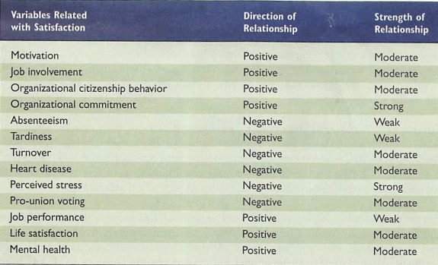
This table summarizes the relationship between employee job satisfaction and some other variables is either positive or negative. Strong relationships reflect that managers can significantly influence the variable of interest by increasing job satisfaction.

2.4: Factors of employee Job Satisfaction:
Employee job satisfaction is influenced by various factors. According to House & Wigdor (1971), the factors related to job satisfaction or dissatisfaction varies from person to person. It may be dependent onthe nature of work, work conditions & culture, occupation level, Remuneration, work social affairs and management etc. Some of this factors are discussed below:
Work environment:(Pearson, 1991 and Inamizu, 2016)pointed out that organizational values and physical conditions are significant factors related to the work environment. The physical working conditions refer to as the quantity of work and availability of resources such as tools and machines, lighting, ventilation, air conditioning and workspace (Oosthuizen, 2001). Lam's research figured that work environment is an influential factor in predicting overall employee job satisfaction for the Chinese restaurant managers.
Supervisor: A supervisor is a frontline manager who is responsible for the supervision of employees(Boshoff and Mels, 1995).According to Boshoff and Mels,a positive relationship exists between job satisfaction and supervision. A supervisor plays a significant role in providing support, technical guidance and passion for work related issues. Alessandri (2017)supported this viewbyadding that supervisory behavior has a great influence on the development of trust in relationships with employees.
Payment:Arnolds and (Boshoff, 2001)found that monetary rewards have a significant satisfaction for upper level managers. According to McLean (1996), payment (also referred to as salary or wage or remuneration) always appears as a strong dissatisfier and many people think they are underpaid. Wan et al. (2014) agreed with this finding and revealed that educators feel that they do not receive fair payments for the work they do. Similarly, Taba (2018) founded that senior managers in the public sector were concerned with their remuneration, stated that they need a lot of motivation to commit to the job.
Promotion:Promotion known as advancement, is a motivator(Lemons and Jones, 2001). This research indicated that this factor contributesto the job dissatisfaction of employees. Roodt (2002)stated that promotions make opportunities for personal growth, increase responsibility and social status. Kosteas (2011) proved that job satisfaction might help to bring promotion opportunities, especially in the case of top managers. Promotion creates significantpositive effect on employee performance.

Work itself:Oosthuizen (2001) stated that “Work itself refers to the doing of the work and the type of work. The job can be changing or repetitive, monotonous or creative, easy or difficult”. An employeefeels motivated and satisfied if jobs include skill variety, task identity, task significance, autonomy and feedback (Pearson, 1991). The job nature is a significant source of satisfaction for senior managers, especially forthose whose jobs provide challenges and direct feedback (Knoop, 1995; Yalabik, 2017). Oosthuizen (2001) indicated that the variety of work individuals has contribution to their satisfaction.
Work Group:Williams and Anderson (1991) discussed that employee job satisfaction increases when having friendly and supportive colleagues. Yeoh (2007) surveyed on some women and pointed outthat those who werelacking supportfrom their colleagues tended to have job dissatisfaction. Many evidence suggested that relationships with co-workers haveconsiderable effects on employee job satisfaction of federal government workers in the United States (Clark, 2009). Necessary characteristic of the relationship between co-workers is cohesiveness as it relates to the group’s productivity (Roodt, 2002).
Benefits:Employee’s benefits are referred to asrewards such as pension, life insurance, medical insurance, working accident insurance etc. thatthey receive for being an employee ofthe company or their positions in the company. Artz (2010)agreed that one of the significant and positive determinants of job satisfaction is fringe benefit. According to Lam (2001), rewards (including benefits) have a positive relationship with the job satisfaction and employee job satisfaction is an important factor to predict.

2.5: Measuring employee Job Satisfaction:
Many organizations face challenges in accurately measuring job satisfaction because job satisfaction can differ among various people within an organization. Many studies have shown that high performing employees do not feel satisfied with their job simply as a result of high level titles or increased pay.
Jobs require interaction with colleagues and bosses, following company rules regulations and policies, meeting performance standards, living with working conditions that are often less than ideal, and the like.
This means that an employee’s assessment of how satisfied or dissatisfied he or she is with his or her job is a complex summation of several job elements.
There are two popular approaches of measuring job satisfaction which are given below:
- Single Global Rating: In the single global rating method individuals are asked to respond to one question such as, "all things considered, how satisfied are you with your job?"
The top marking consist number 5 which indicates high satisfaction and the lowest marking consist number 1 that indicates highly dissatisfaction. Participants circle their opinion in this scale.
- Summation Score:This approach identifies key components in a job and asks for the employee’s feelings about each component. Typical components that might be included are the nature of the work, present salary, promotion opportunities, supervision and relation with co-workers.
Researchers used some ways of measuring job satisfaction in this summation score approach. Those ways are given below:
- Job Descriptive Index (JDI): JDI was developed by Smith, Kendall, and Hulin in 1969. It is a particularly subjective employee job satisfaction measure. 72 items in this index assess five factors of job satisfaction which include: work, pay, promotions, supervision, and coworkers. Through the combination of ratings of satisfaction, company can measure employee job satisfaction. The scale is straightforward, members answer either yes, no, or cannot choose in case of if given options precisely portray individual's activity.
- Global Job Satisfaction Scale: Warr, Cook, and Wall developed this measurement approach in 1979. It includes 15 items to determine overall employee job satisfaction. Two subscales are used for extrinsic and intrinsic aspects of the job. The extrinsic section consists eight items and the intrinsic consists seven items.

- Job Satisfaction Relative to Expectations: This measurement approach was developed by Bacharach, Bamberger, and Conley. It determines the degree of agreement between the perceived quality of broad aspects of a job and employee expectations. This approach is most effective to reflect how job stresses role conflicts, or role ambiguities can hamper an employee from meeting job expectations.
- Minnesota Satisfaction Questionnaire (MSQ): The long form of this survey is made up of 100 questions which is based on 20 subscales. Minnesota Satisfaction Questionnaire measures employee job satisfaction with ability, achievement, utilization, activity, authority, advancement, compensation, company policies and practices, co-workers, creativity, moral values, recognition, independence, responsibility, social service, security, supervision human relations, social status, supervision technical variety and working conditions.
- Job Satisfaction Survey (JSS): In 1997, this measurement approach was developed by Spector. This survey contains 36 items based on nine job features. The job features include supervision, pay, benefits, promotion, contingent rewards operating procedures, nature of work, co-workers and communication. The JSS uses a six point Likert scale with 1 describing ‘disagree very much’ and 6 describing ‘agree very much’. Participants are asked to circle 1 of 6 numbers that represents to their agreement or disagreement about each item.
Compared to the other measurement approaches, the JSS is fairly typical in that the items reflects statements about an individual's job or job situation. The JSS is more alike to the JDI than to the MSQ because it is more descriptive in nature (Jex, 2002).
Before measuring employee job satisfaction, managers should know about the daily contacts and existing data related to the employee. They should have get in touch with their employees through constant interaction and communication.

Chapter-03

Company Profile

3.0. Overview of the company:
Aarong is a chain of retail outlet located in major cities in Bangladesh an enterprise of BRAC (Building Resources across Communities). Aarong means Bengali for ‘village fair’. It has started its journey in 1978. This moral brand started as a modest way to engage provincial artisans to rise above poverty.Aarong bolsters 65,000 craftsman with reasonable terms of exchange. Reforming the retail business with exclusive expectations for quality and creativity, this notable brand mixes the customary with the contemporary in manners that never stop to win buyer request both at home and abroad.
Its goal is to give a steady and profitable wellspring of work for the poor provincial individuals. Another point was to affirm the ladies right and to set up them as an important resource in the general public. In the process Aarong contributes extraordinarily to BRAC's objective of destitution mitigation and strengthening of poor people.
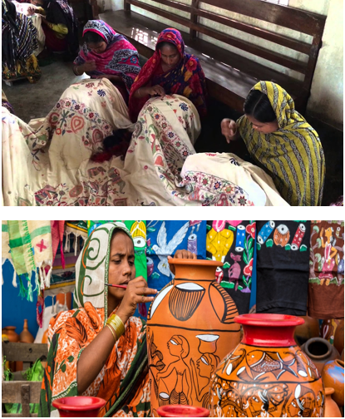

3.1. History of the company:

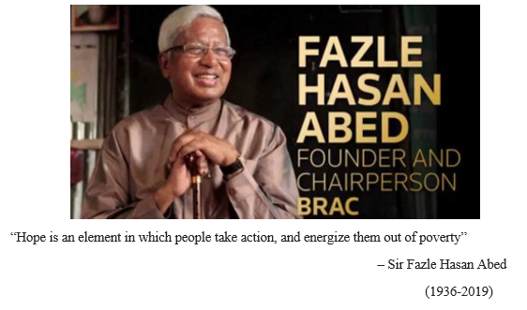

In 1976, Ayesha Abed, the existence accomplice of Sir Fazle Hasan Abed, originator of BRAC (NGO) BRAC, started the basic exercises of Aarong by perceiving and endeavoring assorted things with different show-stoppers that ladies could pass on at home, for example, nakshikantha, weaved stock, cases, mats and things made of stick, bamboo and jute.
In 1978, BRAC went into a joint endeavor with the Mennonite Central Committee, the general progress arm of the Mennonite Church, to open a shop in Dhaka called Aarong – implying 'town sensible.
In the midst of the late 1970s and mid-1980s, BRAC started to study and rundown the plans and subjects of standard showstoppers by visiting evident centers, old workmanship administrators and private specialists. They contracted master craftsperson to help train town ladies and made a material structure and association workshop in Manikganj to endeavor assorted things with materials and advances in sewing, weaving and concealing.
AAF's first undertaking, the Manikganj focus, was opened on 3 September 1983. In spite of beginning the AAF, Aarong opened four retail outlets and started passing on to some degree measurement of stock to reasonable exchange relationship the middle of the 1980s.
By the mid to late 1980s Aarong started to rise as a structure brand to the style business. By the mid-1990s, Aarong changed into the essential arrangement house in Bangladesh and had made a one-stop objective for center to high society urban customers.
Regardless, by the late 1990s and mid-2000s, Aarong faced a cash related occurrence considering sensible association and a nonappearance of headway. Some spot in the extent of 2001 and 2004, the affiliation was revamped to improve everything from costing, regarding, structure and publicizing to new thing presentations and brand movements. In 2004, its game plans totaled about US$14 million. Aarong earned a preferred position of US$1.96 million for BRAC which was scattered among its development, direction, and thriving projects, with the greater part taking off to an excellent program for the ultra-poor. In 2013, Aarong had crossed US$50 million in game plans.

Ayesha Abed Foundation (AAF):
In 1982, the Ayesha Abed Foundation (AAF) was set up by family and amigos to regard the memory and work of the late Ayesha Abed who kicked the bucket double-crossing her infant kid adolescent, Shameran, and vigorous youngster, Tamara. The establishment was made to build up ladies' abilities in different strong points through a fitting workplace, money related and thought help and preparing. From the outset it was enlisted with the association to get outside generous enrichments and raise holds, at any rate currently works similarly as a touch of Aarong.
The AAF board fuses the eight family and pals of the late Ayesha Abed. Its cash related game plan is a touch of the Aarong activity under BRAC.
The AAF experts are for the most part individuals from BRAC's town alliance social gatherings or the get-together of the individuals. The establishment purchases cautious work made by the town ladies, assorted NGOs and workmanship makers.
Aarong was the significant brand to begin managing photograph shoots near to style shows up, appears and changed sorts of media-centered occasions.In the midst of the 1990s, Aarong kept on structure brand an impetus through arrangement shows and media thought occasions.Aarong also kept growing its age limit with the advancement of three new AAF focuses.

3.2. Logo:
An image of a peacock is represented in the logo of Aarong. Mainly the sparkling gorgeous design of a peacock’s tail make it more eye catching which is the concern of the logo. Aarong deliversattractive and unique products as a peacock that is the indication of the logo. There are two colors in the logo. One is black and another is orange. Black represents professionalism and the orange represents energy.


Figure: Logo of Aarong

The logo of Ayesha Abed Foundation is straightforward and simple to clarify. The logo is made with the 3 letters AAF (Ayesha Abed Foundation) in calligraphy. Indeed, even in the logo the name of the establishment is written in Bengali language too that makes the town individuals more solace with the organization.”


Figure: Logo of Ayesha Abed Foundation

3.3: Mission Statement:
“To make Aarong the best in the world in providing a unique Bangladeshi lifestyle experience which promotes Bangladeshi pride while empowering people and protecting the environment.”

3.4: Vision Statement:
Aarong's vision is to remain market pioneer all through its business. Aarong grow its business in universal field. Aarong has a fantasy to grow more craftsman of Bangladesh and make them subordinate and draw in an ever increasing number of worldwide clients toward Bangladeshi Culture.

3.5: Key Values:
Aarong’s values are same as BRAC. The key values are:

- Innovation: Aarong values the innovation that creates opportunities for the poor to lift themselves out of poverty. They strive to display global leadership in ground-breaking development initiatives.
- Integrity: Aarong values the integrity, because transparency and accountability are the most essential elements of our work ethic. With clear policies and procedures, they continue to display the utmost level of honesty in our financial dealings.
- Inclusiveness: Aarong is focused on inclusiveness to guarantee that they connect with, support and perceive the value of all citizenry, paying little mind to race, religion, gender, nationality, ethnicity, age, physical or mental capacity, financial status and geology.
- Effectiveness: Aarong values effectiveness in the entirety of their work, which continually challenge themselves to perform better and to improve and develop the effect of their interventions.

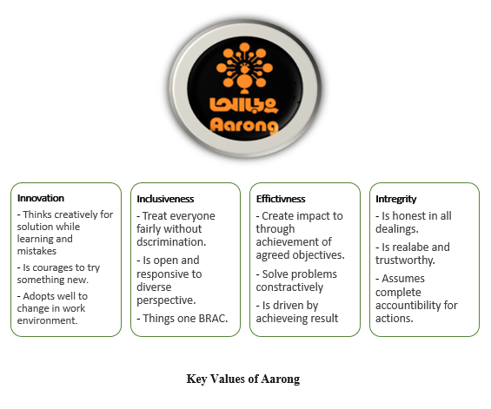

3.6: Operational Network:
Aarong task sort out starts from the production of the unmistakable things which are sold in the retail outlets. The things are conveyed under foundation for creation and get-together named Ayesha Abed Foundation. Ayesha Abed Foundation is organized in Baniachong,ManikganjJessore, Gorpara, Jamalpur, Sherpur, Kushtia,Pabna, Rajbari, Pallobi, Nilphamari, Jhenaidah,and Kurigramhaving 653 sub concentrates transversely over Bangladesh. More than forty thousand of the total ladies of Aarong creators work direct for Aarong in these 13 age centers in and Twenty-5,000 free supportive social events and regular family-based experts also, exhibit their craftsmanships through Aarong.
After the collection of the things and section in the outlet customers can buy the things from the retailer outlets. The assignments in the outlets are generally passed on by the executives of the outlets. They essentially are careful to manage the outlet inventories, thing moves, customer organizations, portion gatherings, and workforce the administrators. They supervise the outlet's execution and areexplicitly careful to report the Cooperative Officer of Retail and Infrastructure for any kind of movement occurs.

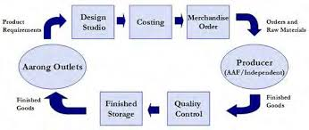

3.7: Organogram:
This part, the hierarchical outline of Brac-Aarong is given below:

Organogram of Aarong

3.8: Products of Aarong:
Aarong began with the subject of making unadulterated silk and top notch nakshi kantha. As time goes on, it transformed into the most noteworthy retail chain of Bangladesh together with structure, lifestyle and nuclear family things. The product can be disengaged into tinier characterizations. Aarong offers different types of assistance to the generation laborers of Ayesha Abed Foundation. They are given below:
- Clothes and Accessories:
- For Men: Traditional (Panjabi), formal wears (Executive shirts), fotua, short kurta, T-shirts, stoles/shawls, sandals etc.
- For Women: Traditional (sari), Western, nightwear, shawls/scarfs, shoes, bags, fabrics etc.
- For Children: Clothes, toys, books, shoes etc.


- Leather: Shoe, bag, belt, box, photo frame etc.
- Jewelry: Gold, silver, pearl, antique and others.
- Nakshi Katha: Decorative, wall hanging etc.



- Home Accessories: Curtain, bed cover & cushion, table lamps, napkin rings, candles, mats, cutlery, gift box, ornament box, mirror, bowls & platters, plant accessories etc.



- Foods: Milk, butter, honey, juice etc.



3.9: Awards:
Aarong was conceded the Best Brand Award in the Fashion Boutique class at Bangladesh Brand Forum's yearly regard work. The Bangladesh Brand Forum's Best Brand Awards 2015 limit was held at the Radisson Blu Hotel in the capital on Saturday, November 21, 2015.
Bangladesh Brand Forum joined with Milward Brown and perceived best brands of Bangladesh for 2015 to see those brands that have achieved amazingly fundamental statures in both business respect and buyer inclination. Mohammad Abdur Rouf, Chief Operating Officer, BRAC-Aarong, went to the regard organization to get this respected regard.
Aarong has gotten the Bangladesh Supply Chain Excellence Award 2018 in the classification of "Greatness in production network fund" as a nearby association at an occasion held at ICCB on 21st July, 2018. The occasion was together sorted out by IPDC Finance Ltd and Bangladesh Supply Chain Management Society.

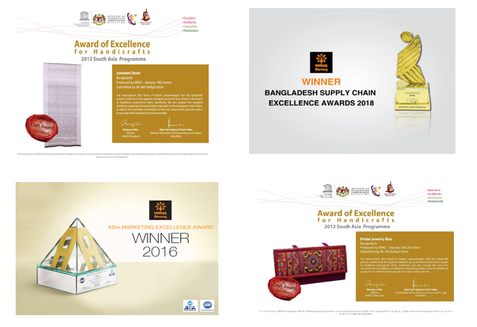

Chapter-04

Analysis and Findings

4.1:Descriptive Analysis:
The research attempts to identify the “Factors that create Employee Job Satisfaction on Human Resource Department in Aarong”. To conduct this research primary and secondary sources of data is used. Primary data are collected from the Aarong employees using questionnaire. 18 Question were prepared and 25 responsible officials were selected from HR & Marketing department as respondents. Out of 25 respondents 15 respondents were male and 10 respondents were female.
A structured questionnaire in a 5 point scale was developed for the factors creatingemployee job satisfaction on Human Resource Department in Aarong. A five point scale ranging from 1 to 5 with 5 indicating strongly agree and 1 indicating strongly disagree was used in this regard.
As the table is not very informative so to come up with the conclusion some pie chart has been created.
Result:
SL | Statement | Strongly Agree |  | Agree |  | Neutral |  | Disagree |  | Strongly Disagree
SL | Statement |  | % |  | % |  | % |  | % |  | %
1 | The organization provides a safe & healthy work environment. | 9 | 36 | 12 | 48 | 4 | 16 | 0 | 0 | 0 | 0
2 | HR department is concern about employee’s physical & mental health both so that conduct some routine checkup for employees. | 10 | 40 | 14 | 56 | 1 | 4 | 0 | 0 | 0 | 0
3 | The recruitment process is unbiased. | 11 | 44 | 12 | 48 | 2 | 8 | 0 | 0 | 0 | 0
4 | The selection process is enabling to choose the most appropriate candidate (from the view point as an employee) | 7 | 28 | 13 | 52 | 5 | 20 | 0 | 0 | 0 | 0
5 | The organization provides varieties of task (scope of job rotation) | 8 | 32 | 15 | 60 | 2 | 8 | 0 | 0 | 0 | 0
6 | The organization promotes team work. | 10 | 40 | 13 | 52 | 2 | 8 | 0 | 0 | 0 | 0
7 | There is enough space & scope to show the creativity of individual employee | 10 | 40 | 12 | 48 | 3 | 12 | 0 | 0 | 0 | 0
8 | There is opportunity to share knowledge & ideas when any decisions are made. | 10 | 40 | 12 | 48 | 3 | 12 | 0 | 0 | 0 | 0
9 | The organization clearly explains its instructions to its new employees & continuously guide them. | 6 | 24 | 14 | 56 | 5 | 20 | 0 | 0 | 0 | 0
10 | There are routine training programs which are useful for furnishing employees skill & Ability. | 12 | 48 | 11 | 44 | 2 | 8 | 0 | 0 | 0 | 0
11 | Supervisor provide adequate feedback & also sufficient support from the seniors. | 7 | 28 | 14 | 56 | 4 | 16 | 0 | 0 | 0 | 0
12 | The management has adequate help during peak workload. | 9 | 36 | 13 | 52 | 3 | 12 | 0 | 0 | 0 | 0
13 | The organization is up to date with new technologies such as different HR Software. | 10 | 40 | 11 | 44 | 4 | 16 | 0 | 0 | 0 | 0
14 | Updated software are easy to operate. | 11 | 44 | 12 | 48 | 2 | 8 | 0 | 0 | 0 | 0
15 | There is fair evaluation system on individual performance. | 13 | 52 | 11 | 54 | 1 | 4 | 0 | 0 | 0 | 0
16 | HR department ensures 360 degree performance management feedback system. | 7 | 28 | 14 | 56 | 4 | 16 | 0 | 0 | 0 | 0
17 | The pay structure is fair and HR department offers a comprehensive benefit packages. | 10 | 40 | 15 | 60 | 0 | 0 | 0 | 0 | 0 | 0
18 | By Performance measurement system HR department highlight the insight performer as well as ensure reward system for employees. | 7 | 28 | 15 | 60 | 3 | 12 | 0 | 0 | 0 | 0

The Graphical presentation and the interpretation of this research is given below:
Working Condition:
- The organization provides a safe & healthy work environment.

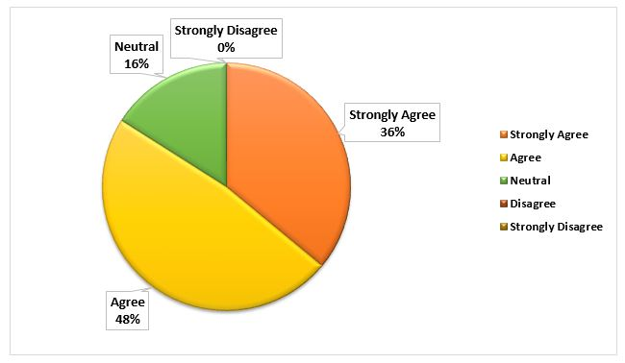

INTERPRETATION:From this graph, here 12 employees give support on agree and 9 employees give support strongly agree. That means 84% almost everyone supports that Aarong provides outstanding working environment.

- HR department is concern about employee’s physical & mental health both so that conduct some routine checkup for employees.
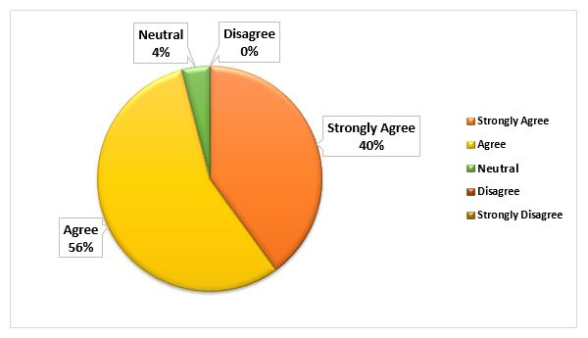

INTERPRETATION: The above graph shows that most of the respondents are agreed (14 respondents) and strongly agreed (10 respondents) with Aarong offers adequate opportunities for physical and mental checkup to keep them fit. On the other hand, 1 respondent is neutral with this.
Recruitment & Selection Process:
- The recruitment process is unbiased.

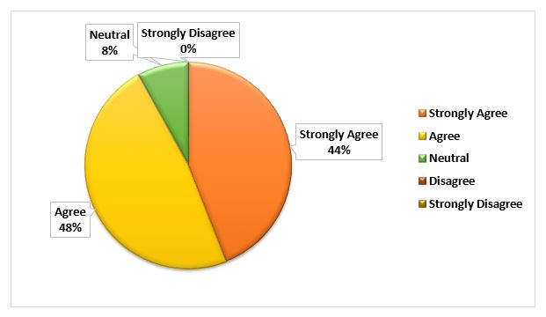

INTERPRETATION:All of the staff such as 92% staffs think that the recruitment process followed by Aarong is free from biasness. This is a positive indication for an organization.

- The selection process is enabling to choose the most appropriate candidate (from the view point as an employee)
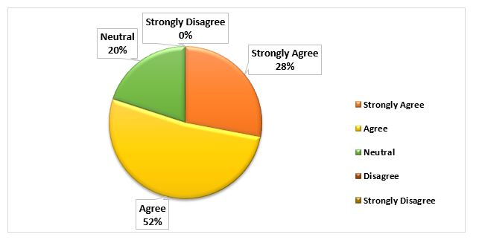

INTERPRETATION:From this graph, here 5 employees are neutral, 13 employees give support on agree and 7 employees give support strongly agree. That means 80% employees believe the selection process helps to catch up the most appropriate candidate.

Job Nature:
- The organization provides varieties of task (scope of job rotation)
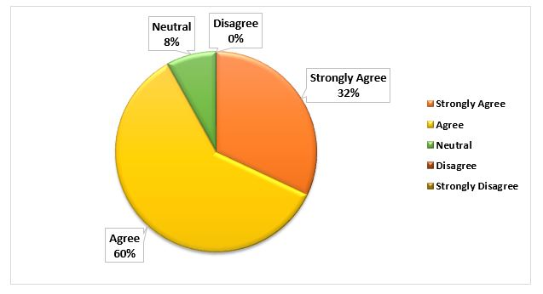

INTERPRETATION: Aarong is an organization where there is a scope of job rotation. 92% employees are supported with this statement that Aarong provides them varieties of task.

- The organization promotes team work.

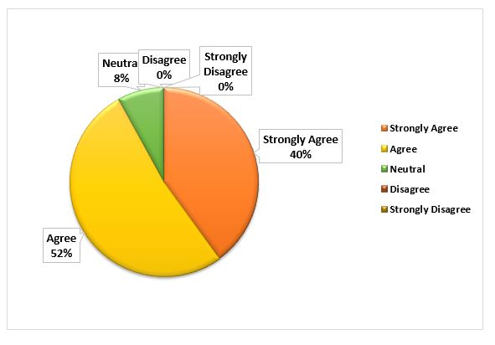

INTERPRETATION: Various tasks are hold on where team work is necessary. Aarong also emphasizes on team work. Almost all of the employees such as 92% employees are strongly supported with this statement.

Employee engagement:
- There is enough space & scope to show the creativity of individual employee.
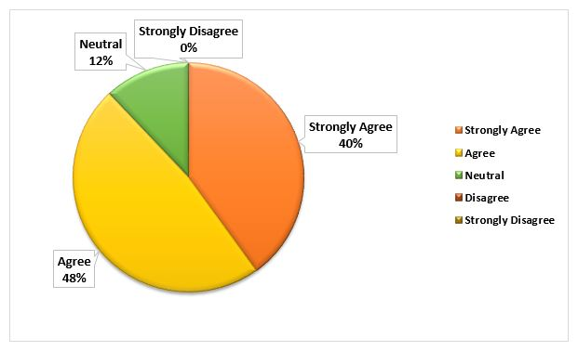

INTERPRETATION:From theabove graph shows that most of the respondents are agreed (12 respondents) with there is enough space & scope to show the creativity of individual employee. 10 respondents are strongly agreed. On the other hand, 3 respondents are neutral to this.The HRM department of this organization ensures this requirement. 88% employees are strongly supported this organization.

- There is opportunity to share knowledge & ideas when any decisions are made.

INTERPRETATION:From the above graph shows that most of the respondents areagreed (12 respondents) and 10 respondents are strongly agreed to this statement that they get the opportunity to share knowledge & ideas when any decisions are made.
Training & Skill development:
- The organization clearly explains its instructions to its new employees & continuously guide them.

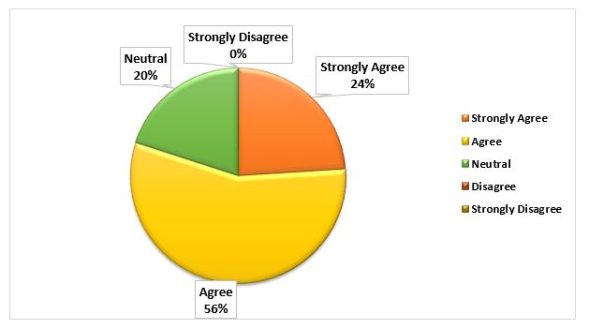
INTERPRETATION:Here 5 employees give opinion on neutral, 14 employees agree and 6 employees give strongly support that the organization clearly explains its instructions to its new employees & continuously guide them. The average result 80% employees support the statement.

- There are routine training programs which are useful for furnishing employees skill & Ability.

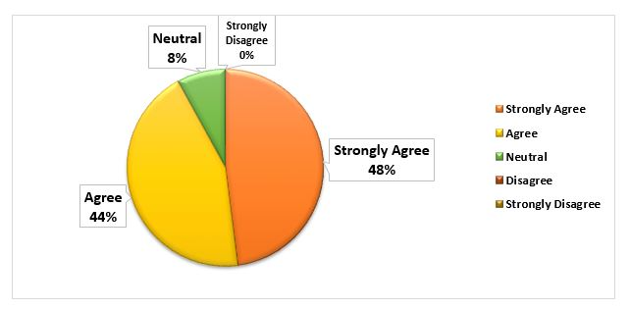
INTERPRETATION: Aarong provides useful training which enrich their basic knowledge. The response rate is seen positive regarding this statement. 92% employees believe that, training programs are given preciselywhich are useful for furnishing their skill & Ability.

Management Support:
- Supervisor provide adequate feedback & also sufficient support from the seniors.

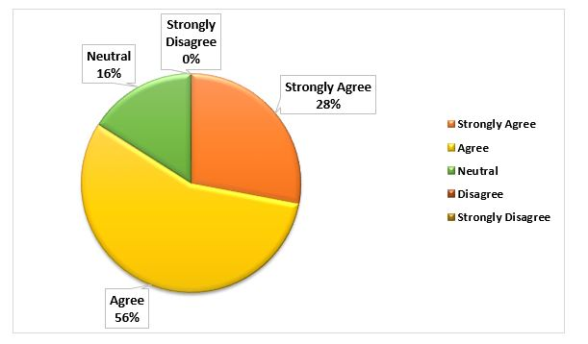
INTERPRETATION:This graph shows that most of the respondents are agreed (14 respondents) 7 respondents are stronglyagreed and 4 respondents are neutral. That means 84% employees are satisfied with the feedback and support provided by their seniors.

- The management has adequate help during peak workload.
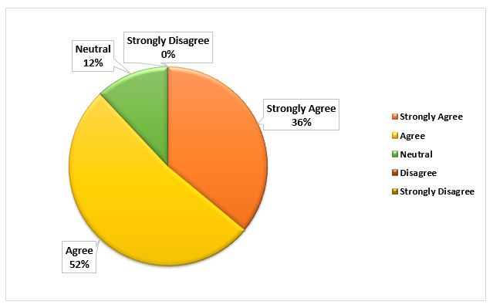

INTERPRETATION: During heavy workload the management helps a lot to reduce the pressure. From this graph, it is seen 13 vote on agree, 9 vote on strongly agree, this means 88% employees agreed that, there is an opportunity to get help from the management during peak workload pressure.
Updated Technology:
- The organization is up to date with new technologies such as different HR Software.

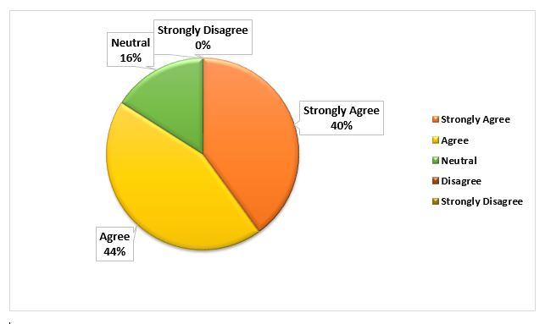
INTERPRETATION:Technology is the booster factor to increase productivity. Every organization must ensure up-to-date technology. Aarong provides new technology. In this graph, 84% employees think that the organization is up to date with new technologies such as different HR Software.

- Updated software are easy to operate.
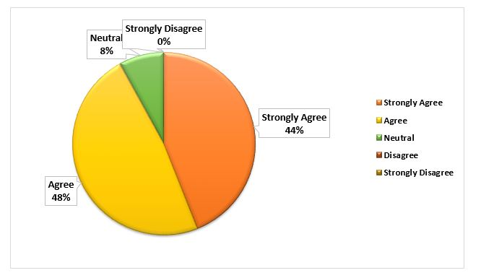

INTERPRETATION:All of the staff such as 92% staffs think that the software used by Aarong is comfortable to operate. This indicates good approach for an organization.
Performance Appraisal:
- There is fair evaluation system on individual performance.
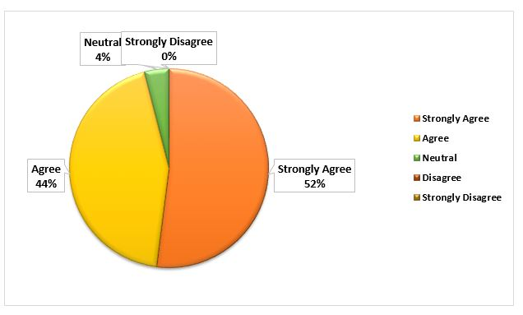

INTERPRETATION:The above graph shows that 13 respondents are strongly agreed, 11 respondents agreed and 1 respondent is neutral to this. Almost all the staff (96%) think the individual performance evaluation system at Aarong is fair and unbiased.

- HR department ensures 360 degree performance management feedback system.

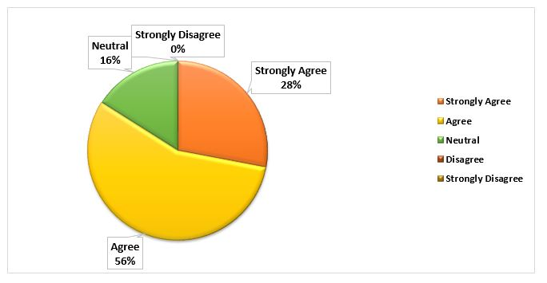
INTERPRETATION:This graph shows that most of the respondents are agreed (14 respondents) with 360 degree performance management feedback system. 7 respondents are stronglyagreed to this. On the other hand, 4 respondents are neutral to this. That means 84% employees are satisfied with that their feedbacks are also taken by the seniors.
Compensation & Benefits:
- The pay structure is fair and HR department offers a comprehensive benefit packages.
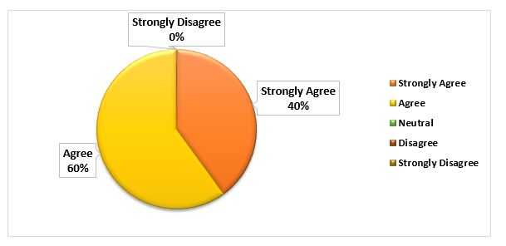

INTERPRETATION:From the above graph shows that most of the respondents are agreed (15 respondents) and stronglyagreed (10 respondents), which mean that the pay structure is fair in this organization and the HR department offers comprehensive benefit packages. All of the employees support this statement.

- By Performance measurement system HR department highlight the insight performer as well as ensure reward system for employees.
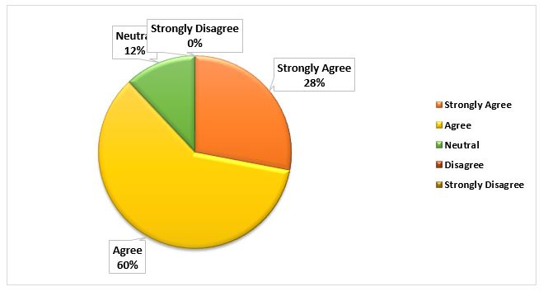

INTERPRETATION:From the above graph, most of the respondents are agreed (15 respondents) and strongly agreed (7 respondents) with that the HR department highlight the insight performer as well as ensure reward system for employees. On the other hand, 3 respondents were neutral to this.

4.2: Findings:

The main purpose of this quick survey was identifying the factors that create employee satisfaction on the HR department regarding their job. Some important points have found during the survey that are given below:
- From the analysis and interpretation, most of the employees think they are the part of the organization.
- The work environment is well furnished and polished for the employees.
- It is concluded that here employees get good opportunities to use their abilities and skills which are relevant with their job duties.
- The culture is suitable for their working environment.
- Management helps a lot when work stress is higher and there is also stress free work environment for the mother employees.
- The co-workers are so much helpful as well as the supervisor guides them friendly.
- They got opportunity to do varieties of task not only some routine work. So there is less boredom feeling among the employees.
- Rules and regulations are equal for all. As well as the management is free from biasness.
- Good training facilities are there for developing the employee’s knowledge and skill. It is also helpful for increasing the productivity and keep up-to-date the employees.
- The organization is free from harmfulness. The working environment is safe and sound. So the employees feel refresh and secured in their organization.

Chapter-05

Recommendations and Conclusion

5.0: Recommendations:

This report moreover has a few recommendations for Aarong which are referenced below:

- Aarong should care about employee well-being more. Though they are already concerned about it, but they should care regularly. This regular concern will reduce the employee turnover rate.
- Communication is a major part of developing good network system among the employees. Communication process between senior and junior should be regular and constant as now it is.
- The software programs must be more prominent refreshed with the goal that the individual can perform easily.
- Aarong can empower their employees and show them a clear career path. This will make the employees more motivated and besides reduce boredom in their work.
- The training programs should be held more often so that employees will be more confident about their work. Offering this learning opportunity can make the employees feel that they are important to the organization so the employee retention rate can be higher.
- Aarong can measure the employee engagement in the work and on the basis of that measurement, Aarong can give extra reward. When an employee will perform out of his regular work and that performance is outstanding, then he or she will be rewarded.
- When an employee feels the organization is his or her very own and its welfare is very much depended on his or her performance then the employee work by his heart and soul. So recognizing this to the employee should be done by Aarong. They can expose the expectations of the organization to the employee so that the employees can feel their importance in the organization.

5.1: Conclusion:

Aarong has a reputation and brand image all over the world. They gain it through numerous procedures and hard works. They have kept up standards of their all departments and also their item quality from the earliest starting point. Aarong focuses on employee job satisfaction so earnestlyand for this, the activity they follow is extremely suitable as far as Bangladesh's culture and they are exceptionally severe and legitimate to their exhibition the board framework.
During the internship period it’s seen that most of the employees are satisfied with their work environment. They get better opportunity to use skills. Aarong provides an equal rules and regulations and provides right instruction to all. Basically, the employees are overall satisfied on the Human resource department so it is certain that employeejob satisfaction rate is standard in Aarong. They can keep their actions toward employee update day by day for further betterment in competitive workplace.

5.2: Appendix:
Survey questionnaire regarding employee job satisfaction in Aarong:

Employee perception regarding Job Satisfactionon HR department
Name:
Designation:
Service duration at Aarong:

You Have to Rank each of your statement from 1 to 5. In this process 1 indicates "Strongly Disagree", 2 "Disagree", 3 "Neutral", 4 "Agree" and 5 "Strongly Agree".

 |  |  | Strongly Disagree | Disagree | Neutral | Agree | Strongly Agree
Criteria | SL | Statement | 1 | 2 | 3 | 4 | 5
Working Condition | 1 | The organization provides a safe & healthy work environment.
Working Condition | 2 | HR department is concern about employee’s physical & mental health both so that conduct some routine checkup for employees.
Recruitment & Selection Process | 3 | The recruitment process is unbiased.
Recruitment & Selection Process | 4 | The selection process is enabling to choose the most appropriate candidate (from the view point as an employee)
Job Nature | 5 | The organization provides varieties of task (scope of job rotation)
Job Nature | 6 | The organization promotes team work.
Employee engagement | 7 | There is enough space & scope to show the creativity of individual employee
Employee engagement | 8 | There is opportunity to share knowledge & ideas when any decisions are made.
Training & Skill development | 9 | The organization clearly explains its instructions to its new employees & continuously guide them.
Training & Skill development | 10 | There are routine training programs which are useful for furnishing employees skill & Ability.
Management Support | 11 | Supervisor provide adequate feedback & also sufficient support from the seniors.
Management Support | 12 | The management has adequate help during peak workload.
Updated Technology | 13 | The organization is up to date with new technologies such as different HR Software.
Updated Technology | 14 | Updated software are easy to operate.
Performance Appraisal | 15 | There is fair evaluation system on individual performance.
Performance Appraisal | 16 | HR department ensures 360 degree performance management feedback system.
Compensation & Benefits | 17 | The pay structure is fair and HR department offers a comprehensive benefit packages.
Compensation & Benefits | 18 | By Performance measurement system HR department highlight the insight performer as well as ensure reward system for employees.

5.3: References:

Aarong. (2020, March 10). Retrieved from wikipedia: https://en.wikipedia.org/wiki/Aarong
About Aarong. (2020, April 3). Retrieved from aarong: https://www.aarong.com/about-aarong/
Adams, J. S. (n.d.). Stacey Adams equity theory. Retrieved from yourcoach: https://www.yourcoach.be/en/employee-motivation-theories/stacey-adams-equity-theory.php#:~:text=John%20Stacey%20Adams'%20equity%20theory,alone%20do%20not%20determine%20motivation.&text=The%20belief%20in%20equity%20theory,co%2Dworkers%20and%20the%20organiz
Boshoff, A. &. (2001). The challenge of motivating top management: A need satisfaction perspective. SA Journal of Industrial Psychology, 27(1), 39-42.
Brin, A. D. (1991). Essentials of Management.
CRABTREE, S. (2004). Getting Personal in the Workplace. Business Journal.
Equity Theory of Motivation. (2020, January 13). Retrieved from iedunote: https://www.iedunote.com/equity-theory-of-motivation
Factors Influencing Job Satisfaction (With Diagram). (2020, February 2). Retrieved from yourarticlelibrary: https://www.yourarticlelibrary.com/hrm/jobs/factors-influencing-job-satisfaction-with-diagram/53312
Huber, M. T. (2006). Disciplines, pedagogy, and inquiry‐based learning .
Jarvis, M. (2005). The Psychology of Effective Learning and Teaching. Nelson Thornes.
Job Satisfaction. (2020, January 17). Retrieved from mbaskool: https://www.mbaskool.com/business-concepts/human-resources-hr-terms/4394-job-satisfaction.html
Locke, E. A. (1969). Goal Setting and Task Performance.
Mullins, L. J. (2005). Management & Organisational Behavoiur. London: FT Pitman.
Porto, R. &. (2006). Model-Driven Architecture - Foundations and Applications. Bilbao, Spain: Springer.
Pritchard, R. D. (1972). Effects of perceptions of equity and inequity on worker performance and satisfaction. Effects of perceptions of equity and inequity on worker performance and satisfaction. Journal of Applied Psychology., 56(1), 75–94.
Schermerhorn, H. a. (1998). Organizational Behavior.
Shahnawaz, M. G. (2006). Human Resource Management Practices and Organizational Commitment in Different Organizations.
Stephen P. Robbins, M. K. (2002). Management. Prentice Hall.
Theories of Job Satisfaction. (2020, January 13). Retrieved from iedunote: https://www.iedunote.com/job-satisfaction-theories
Vroom, V. (1964). Work and motivation. Wiley.

