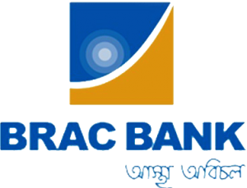


SME Banking of BRAC Bank Limited

Internship report
on
"SME Banking of BRAC Bank Limited"

Submitted to
Mofijul Hoq Masum
Asst. Professor
School of Business & Economics (SOBE)
United International University

Submitted by
Ahmedul Hasan Avash
ID # 111 151 565
Bachelor of Business Administration (BBA)
School of Business & Economics (SOBE)
United International University

Date of Submission: 20/10/2019

Letter of Acknowledgement

At first, I would like to express my appreciation to ALLAH for giving me the strength to complete my internship and finished my report in the specified moment. Then I would like to thanks my Faculty Advisor Mofijul Hoq Masum (Assistant Professor, School of Business and Economy, United International University) for his support. His supervision was help me a lot for completing my report.
I am also thankful to my organizational supervisor Md. Toukir Ahmed (Associate Manager, Payment & Asset Management) who helps me a lot to understand the organizational work. Then I like to thank Prashanta Shaha (In charge, Payment and asset Management).
Moreover I am also thankful to my BRAC Bank Limited Senior and colleagues for their support, suggestion, guide and advice.

Letter of Transmittal
20th October, 2019
Mofijul Hoq Masum
Assistant Professor
School of Business and Economy
United International University
Subject: Internship Report on “SME Banking of BRAC Bank Limited”
Dear Sir,
I am glad to inform you that I am submitting my internship report on “SME Banking of BRAC Bank Limited” as a core requirement of my BBA program. I have shared my learning, experience and knowledge about this topic during my internship period.
Now I am very thankful to you for giving me this opportunity and for all of your support, supervision and advice.

Sincerely Yours,

…………………………………..
Ahmedul Hasan Avash
ID: 111 151 565
United International University

Declaration
I, Ahmedul Hasan Avash declare that the internship report entitled “SME Banking of BRAC Bank Limited” is prepared by me to United International University. As the Internship report is a prerequisite of BBA program, I have made this report after working at the Head office of BRAC Bank Limited for three months.
I also confirm that the report is prepared only for educational purpose, not for any other purpose or not submitted to any other educational institute for reward or degree. The report is totally presented by me.


Signature: …………………….
Date: 20/10/2019
Ahmedul Hasan Avash
ID: 111 151 565
Bachelor of Business Administration (BBA)
United International University
Table of Content
Table of Contents
Letter of Acknowledgement i
Letter of Transmittal ii
Declaration iii
Executive Summary vi
List of Acronyms vii
1.1: Introduction 1
Chapter: 1 Introduction 1
1.2: A Brief introduction of BRAC Bank 3
1.3: Objectives of the Study 3
1.4: Rational of the Study 4
1.5 Scope of the Study 4
1.6 Limitations of the Study 4
Chapter: 2 Methodology 5
2.1: Methodology 6
Chapter: 3 Organizational Background and Industry Perspective 7
3.1 Background of Banking History 8
3.2: Background of BRAC Bank Limited 9
3.3: Mission, Vision & Values of City Bank 9
3.4: Management and focus of the Organizations 11
3.5: Operational Activities of the Organization 13
3.6: Product or Service Line of BRAC Bank Limited 14
3.7: Departments of BRAC Bank Limited 16
3.8: Organogram 17
3.9: SWOT Analysis 18
Chapter: 4 Findings and Analysis of the Study 20
4.1: SME Banking Of BRAC Bank Ltd 21
4.1.1: Overview of SME Financing 21
4.1.2: Importance of SMEs in Bangladesh 21
4.1.3: Performance of SME Banking Sector in BRAC Bank 23
4.1.4: BRAC Bank SME Banking Procedure 23
4.1.5: BRAC Bank Compared to its Competitors 25
4.1.5: BBL SME Banking Products, Structure & Process: 26
4.1.6: Terms & Conditions of BRAC Bank SME loan 27
4.2: Findings 28
Chapter: 5 Experiences during Internship tenure 29
5.1: Internship Job Responsibilities 30
5.2: Critical Observations 31
Chapter: 6 Conclusion and Recommendations 32
6.1: Recommendations: 33
6.2: Conclusions 34
Chapter: 7 Appendix 35
7.1: References 36

Executive Summary
BRAC Bank is one of the top Privet commercial bank in Bangladesh. It has established in July 4, 2001. BRAC Bank is dominating in the Small & Medium Enterprises (SME) banking sector of Bangladesh. BRAC Bank is the world 4th largest SME Bank. BRAC Bank has been performing quite well in the SME Banking Sector. Small and medium Enterprises (SMEs) are excellent concern as a significant poverty reduction in Bangladesh. BRAC Bank is the Bank in Bangladesh focusing SME Financing from beginning of its inception. It focuses on People, Planet and profit. BRAC Bank offered Loan and Deposit product for their SME service. The Division of SME Banking maintains the largest amount of assets in the Bank's company divisions. BRAC Bank strongly focused on their SWOT analysis. BRAC Bank is gradually improving on technological advancement and building relationship with customer. For countries economic development BRAC Bank finance to the SME Entrepreneur. GDP growth, Women empowerment and reduction of urban migration are the importance of SME Banking. Furthermore, I have completed internship at Payment and Asset Management department under Finance division. During my internship period I have fulfilled various types of responsibilities. Here I have share my work experience.
Keyword: SME Banking, Missing Middle, Vendor, Corporate Banking, Retail Banking.
List of Acronyms
- BBL - BRAC Bank Ltd
- SME - Small and Medium Enterprise
- ATM - Automated Teller Machine
- GABV - Global Allowance for Banking on Value
- CEO - Chief Executive Officer
- DMD - Deputy Managing Director
- CRO - Chief Risk Officer
- COO - Chief Operating Officer
- GSS - General Security Service
- HOICC - Head of Internal Control and Compliance
- CTO - Chief Technology Officer
- TT - Telephone Transfer


1.1: Introduction

Chapter: 1
Introduction

Small and medium-sized Enterprises (SMEs) are of excellent concern as a significant poverty reduction plank in Bangladesh. For supportable & balanced industrial growth in the nation, special emphasis on developing Small & Medium Enterprise should be placed, the government has developed a comprehensive industrial policy for 2005 to assist address the problems of free market economy and globalization. I have done my report on SME Banking of BRAC Bank. BRAC Bank Limited is the country's biggest SME Bank and the fourth biggest SME Bank in the globe for excellent loan amounts. The SME Banking Division maintains the highest amount of assets in the Bank's company divisions (SME Banking, Retail Banking, Corporate Banking and Probashi Banking).As the name signifies, it provides lending and deposit solutions as well as value adding services to small and medium size businesses within the country.

1.2: A Brief introduction of BRAC Bank
BRAC Bank Limited is one of the leading privet commercial bank in Bangladesh. It has established on 4th July 2001. At the very beginning BRAC Bank came with one of their core objective to provide the Small and Medium Enterprise (SME) Banking to the people of Bangladesh. At a time it was almost impossible to get finance for SME Entrepreneur. In that time BRAC Bank stepped forward to finance those unbanked SME Entrepreneur. SME sector provide the height amount of profit in their profit portfolio. It has total 186 Branches, 456 SME unit offices, 448 ATM Booth, 7000 number of employee and 1.2 million customers all over the Bangladesh. BRAC Bank is the only member of Global Alliance for banking on Values from Bangladesh. BRAC Bank is the leading market leader in mobile banking. BRAC Bank mobile banking service is known as Bkash. In terms of earning profit, BRAC Bank is in the top position. Last year they were the third privet bank who were earn height amount of profit.

1.3: Objectives of the Study
Broad Objectives
The broad objective of this report is to analyses the SME Banking activities of BRAC Bank Limited. This report is based on BRAC Bank's overall SME function. Necessary data and information were gathered primarily from the SME Department and from the website of BRAC Bank Limited. Drive holistic and inclusive growth of Bangladesh, Drive growth for the benefit of clients and positions over selves’ sustainability for future are the Broad objective of this report.
Specific Objectives
- To analyze SME loan process at BRAC Bank.
- To provide collateral on security for financing
- To analyze return on asset and return on equity of BRAC Bank
- To measure about the segregation of missing middle.
- To identify low customer satisfaction.

1.4: Rational of the Study
The report is prepared as a part of my internship program. The main rationale of the study is to enhance my knowledge on an origination in person by working there with a time specifications. Find the importance of SME Banking in Bangladesh is another reason of this report. Unless it is relevant in practical ways, theoretical understanding will be little importance.

1.5 Scope of the Study
- I have got the real life working Experience
- Collect Data direct from Organization Stuff and Employee
- Easily got many Data because of supervisor help and cooperation
- Source of Data Collection was more reliable
- Collect data from different Branch

1.6 Limitations of the Study
On the manner to preparing this report, I found problems that could be called the study limitation.
- The bank's internal and economic data is confidential and critical.
- The findings are not validated by statistically.
- I didn’t cover the all area of BRAC Bank
- Time period was short
- Lack of comprehension of the respondents
- Lack of experience before in banking industry
- Unable to cover all the sectors of BRAC bank

Chapter: 2
Methodology

2.1: Methodology
Data are collected from both primary & secondary sources. To collecting relevant data for this report are chosen from primary and secondary sources.
Primary sources of Data
- Face to Face conversation with the bank officers and stuffs.
- Informal conversation with the clients.
- Official records and observing practical works.
Secondary source of Data
- Annual report of BRAC Bank Limited
- prospectus of BRAC Bank Limited
- SME circulars
- Product or Service Lists
- Visit website of BRAC Bank Limited
- Many Circulars published by Bangladesh Bank
- Several Booklets of BRAC Bank Limited
- Training materials of learning and Development division.
- Different manuals and circulars of BRAC Bank Limited.

Chapter: 3
Organizational Background and Industry Perspective

3.1 Background of Banking History
The history of Banking is attractive as the history of civilization. It is very difficult to answer that when did the banking start. But record suggest that Banking has come from Babylon when people having faith on God and they keep their valuable things in temples. In that time this was called “Temple Banking”. The first public bank was established in 1157. Bank of Venice is the first public bank. Bank of England was first introduced printed cheques during the time of 1749 to 1759. Bank of Hindustan was the first modern bank in Bengal which was established in 1770 in Culcutta.
After liberation the former Bank State bank of Pakistan is knows as Bangladesh bank. From that time Bangladesh Bank is the central bank of Bangladesh. In that time Bangladesh bank conduct all kind of banking activities for Bangladesh government. After that, when they became the central bank, they formulate and implement monitory policy. Make intervention policy in the forign exchange market, manage the foreign reserve of Bangladesh, issue bank note and control all commercial bank of Bangladesh.
There are 59 schedule bank and 5 Non-schedule bank in Bangladesh. Now 06 stated owned commercial bank, 03 specialized bank, forty one privet commercial bank, 08 Islami sariah based bank and 09 foreign banks operate in Bangladesh. Banking sector has a big impact on a country economy. When we need credit, we got finance from bank. Now a day’s people cannot think their business activities without bank. By providing finance bank help different sector for develop. And it helps to develop our country economy.

3.2: Background of BRAC Bank Limited
BRAC bank is one of the most significant banks in Bangladesh. BRAC Bank has started its journey since 2001. At the beginning the journey was not smooth for BRAC Bank. They have faced some legal obligation from the High court. That’s why they were failing to start their operation till 3rd June 2001. After dismissed by Supreme Court on June 4 they have started their operation. At beginning their main concept was Small & Enterprises (SME). Sir Fazle Hasan Abed was the founder of BRAC Bank. And Mr. Muhammad A. (Rumee) Ali was the founder chairmen. The largest NGO BRAC is the parent organization of BRAC Bank. The Bank takes inspiration from its parent organization and enters into the SME Banking market. BRAC Bank SME banking is 4th largest organization in the world and 1st largest organization in Bangladesh. Now BRAC Bank is one of the dominant players in Bangladesh banking sector. Now they are focusing in other sector. They have entered in Retail Banking and corporate banking sector. It has 186 Branch all over the Bangladesh. Their head office is at Tejgaon Gulsahan. BRAC Bank unique mobile banking system is known as bKash, which is a subsidiary of BRAC Bank. bKash is the market leader in Mobile banking in Bangladesh. BRAC also introduce ELDORADO a web based remittance system. BRAC offer its share for public in 2006. And they got enlisted with Chittagong Stock Exchange in 24th January 2007. They also got enlisted with Dhaka Stock Exchange in 28th on that month. Now BRAC Bank Profit after tax is BDT 5,547 Million, Earning per share is BDT 5.17, Net asset value per share BDT 29.50, Loans and Advance BDT 238,008 Million, Deposit BDT 228,622 Million. They think they are on the track to become the best bank in Bangladesh.


3.3: Mission, Vision & Values of City Bank
Vision
Building a profitable and socially responsible financial institution focused on market and business with growth potential, thereby assisting BRAC and its stakeholders to create a just, enlightened, healthy democracy and poverty free Bangladesh.
Mission
- Sustainable growth in Small & Medium Enterprise sector;
- Continuous low-cost deposit growth in retail property with regulated development;
- Corporate Assets to be funded through self-liability mobilization;
- Growth in Assets through syndications and investment in quicker growing sectors;
- Continuous endeavor to increase non-funded income;
- Keep our debt fees at 2% to keep a steady profitable increase
- Achieve environment friendly synergies between the bank’s branches, SME unit offices and BRAC field workplaces for delivery of remittance and the bank’s different products and services;
- Keep a diversified, far-flung team fully motivated and driven to realize the vision of the bank.
Core Values
- Forming an authentic, open and enabling environment
- Value and respect individuals and make merit based decision.
- pursuit of business innovation and improvement
- Recognition and reward on performance
- Serve the best interest of our owners
- Profit and Sound growth
- Responsible, trustworthy

3.4: Management and focus of the Organizations
The management committee of BRAC bank consists of Managing director and CEO, Deputy Managing Director (DMD) and Chief Risk Officer (CRO), Chief Operating Officer (COO), Head Of General Security Service (GSS) & Procurement, Bank Secretary, & CAMLCO, Head of Corporate, Retail and SME Banking, Head of Treasury & Financial Institutions, Head of Operations and Human Resources, Head of Communications.

BRAC Bank focus on 3ps. These are People, Planet and Profit. Sustaining growth in the SME sector is a special vision of BRAC Bank.

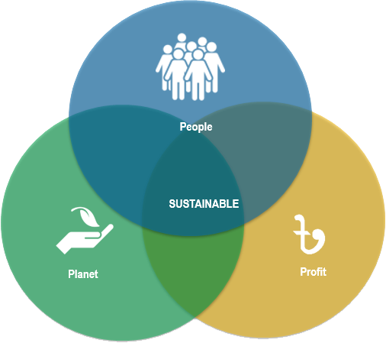
BRAC Bank focused on the framework of Social, Economic & Environment.
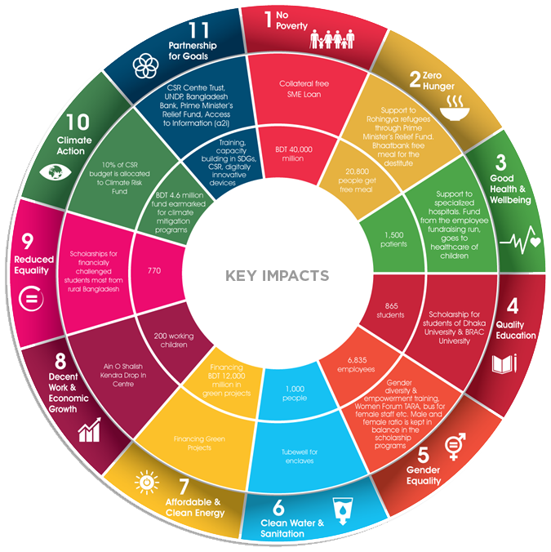

BRAC Bank creates its value for the society. The value created for employees are skill development, building capacity and supporting job creation. The economic value creates for its shareholders are driving economic growth, implementing and developing efficient business and supporting economic growth. The environmental value of BRAC Bank creates natural environment. By helping customers to diminish the impact of climate change.

3.5: Operational Activities of the Organization
BRAC Bank conducts their operation in 04 fields:
- Small & Medium Enterprises (SME) Banking
- Retail Banking
- Corporate Banking
- Foreign Trade & Treasury
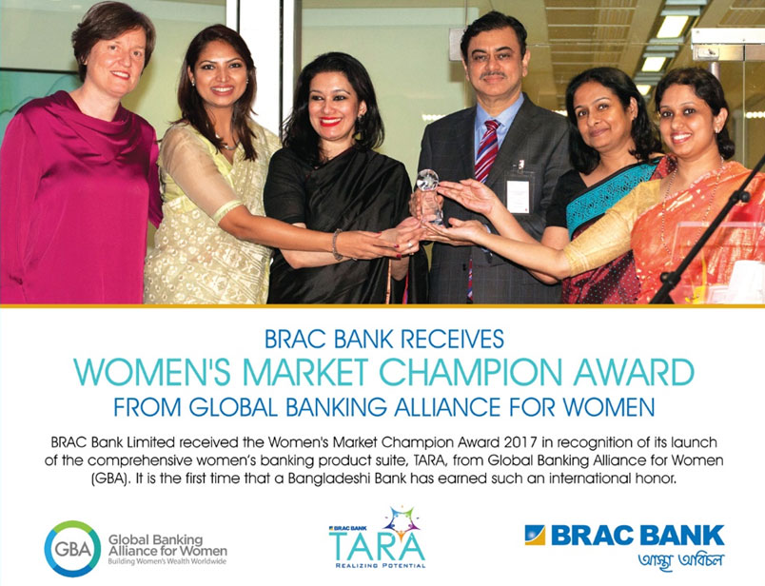
BRAC Bank operates in all kind of customer banking service. BRAC bank main focus is on Small and Medium Enterprises (SME) Banking of Bangladesh. In their total profit portfolio SME Banking provide height number of profit. But now BRAC Bank has shifted their focus on other sector. BRAC Bank is operating in Retail Banking, Corporate Banking, and Foreign Trade & Treasury Division. In Retail division they provide home loan, car loan and in some cases they provide personal loan. In their corporate banking division they conduct all kind of commercial banking activities. They conduct business with multinationals, countries local companies, NGOs and etc. Treasury division is one of the rising divisions of BRAC Bank. This division deals with the money market of Bangladesh. This division processes all kind of treasury related product. They also conduct business with foreign companies.

3.6: Product or Service Line of BRAC Bank Limited
1. Small And Medium Enterprises (SME): BRAC Bank SME products are divided in two categories. A. Loan product B. Deposit Product
A. Loan Product:
- ANONNO (Unsecured loan)
- APURBO SME Loan (Secured loan)
- TARA SME Loan (Women entrepreneur loan)
- SME Loan (Commercial Housing loan)
- BAHON SME Loan (Commercial Vehicle loan)
- SOHOJ SME Loan (Secured convenience loan)
B. Deposit Loan:
- PRAPTI Current account
- PRACHURJO Fixed deposit
- SONCHOY SME deposit
2. Retail Banking: Retail Product is divided in two categories. A. Loan Products B. Deposit Product.
A. Loan Product:
- BRAC Bank Home Loan
- BRAC Bank Personal Loan
- BRAC Bank Auto Loan
- BRAC Bank Holiday Loan
B. Deposit Product:
- BRAC Bank triple benefit saving account
- BRAC Bank current plus account
- BRAC Bank deposit premium scheme
3. Corporate Banking: BRAC Bank corporate products are:
- Working Capital Finance
- Capital Machinery Finance
- Project Finance
- Lease Finance
4. Foreign trade and Treasury: BRAC Bank covers the following trade:
- Letter of Credit
- Back to back letter of credit
- Handling import document
- Imports loans
- Shipping guarantee
- Delivery order
- Export LC
- Export bill negotiation
- Export financing
- Letter of guarantee
- Local Mutual find
- IPO fund Management
5. Women Banking: BRAC Bank women banking is known as TARA"
6. Internet Banking
7. Agent Banking

3.7: Departments of BRAC Bank Limited
To run an organization in an effective and efficient way, every organization should have particular department or division. For specific work every department should be well equipped. If it is not present in an organization, the scenario may be hampered. BRAC Bank has divided particular department & Division that’s why this works very well with BRAC Bank Limited. The Departments & Divisions are:

- Human Resources Division
- Finance Division
- Operations Division
- Risk Management Division
- Credit Division
- Banking Service Department
- SME Banking Division
- Retail Banking Division
- Corporate Banking Division
- Treasury Division
- Internal Control & Compliance Department
- Marketing & Product Development
- Remittance Operation Department
- Legal Department
- Monitoring Department
- GSS & Procurement Division
- Information Technology Division
- Business Relationship Department
- Trade & Remittance Department
- And Many More

3.8: Organogram
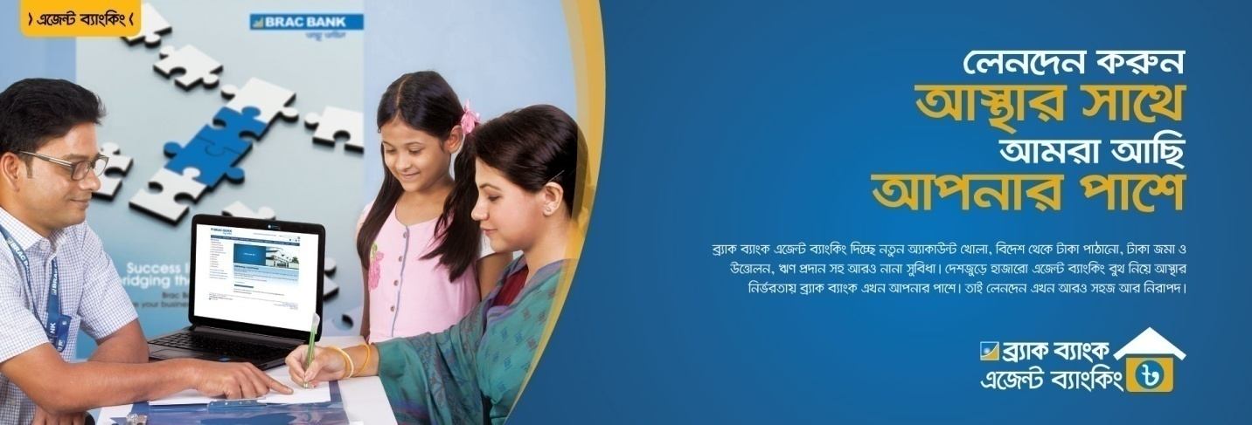
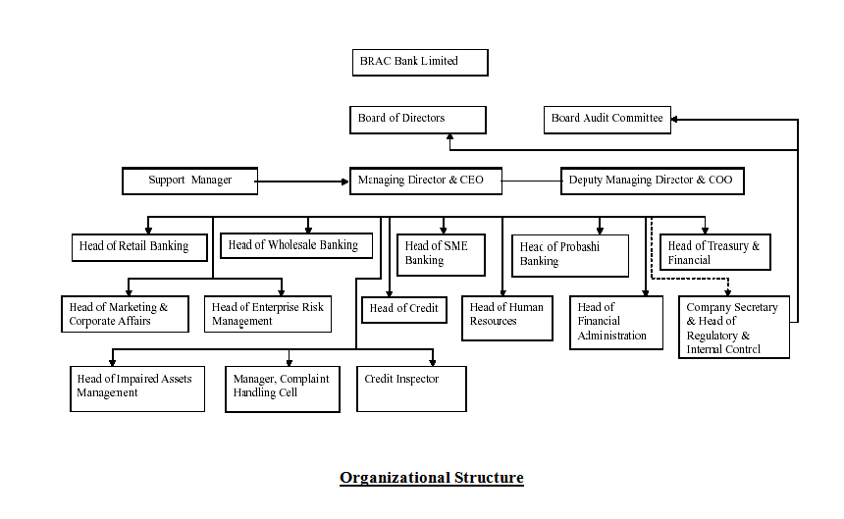
Selim R.F. Hussain sits at the top of the management hierarchy. He is the Managing Director & CEO of BRAC Bank; He is immediately followed by two deputy managing directors; Chowdhury Akhtar Asif and Md. Sabbir Hossain. Below them are several heads of divisions such as CFO, CRO, etc.

3.9: SWOT Analysis
SWOT Analysis consists of Strength, Weakness, Opportunities and Threats. Every organization focused on their SWOT Analysis to find out there internal and external assessment. BRAC Bank give emphasize on their SWOT analysis to operate more effectively and efficiently.
Strength
- Focus on Technological Advancements: The most important feature that I have noticed during my tenure at BRAC Bank is that they are constantly focused on improving their technological features. This includes upgrading Wi-Fi solution, purchasing the latest banking software, establishing high speed connectivity links, etc.
- Building customer relationship outside branches: I got to know and interesting detail from Muhammad Fazlul Haque, CRO of Mohakhali SME office. Whenever he gets free time he tries to socialize with his clients outside the office. He regularly has a chat with them over tea or coffee. This creates a long term bonding and future references for potential candidates.
- Preference for Interns: BRAC Bank prefers to offer their own interns full time positions unlike other organizations. This is a very positive motivation for interns to work hard and secure a good position in the company.
- Extra Benefits for Employees: BRAC bank employees enjoy certain discounts from other BRAC subsidiaries. E.g. BBL employees get 10% discount from Aarong. Also, when they join the company, they get free Debit cards and bKash accounts.
Weaknesses
- Remuneration Packages are Low: Compared to other banks, the salaries of entry level employees are less. Few employees have expressed their dissatisfaction over this issue.
- Lack of Promotion of SME Banking: It seems that the SME products are not getting enough promotion which is a big concern. Most information regarding SME Banking is transmitted through word of mouth. BRAC Bank is mainly an SME Bank and must brand itself as such.
- Working hours are not enforced: like many other banks, the working hours are not strictly maintained. The official closing time is 6pm but often personnel must work for 2-3 hours extra due to work load. This is unhealthy as people have the least energy to work with at night.
Opportunities
- Expand to more areas: BRAC Bank could open branches in places such as Dinajpur, Bagerhat, Pirojpur, etc.
- International Expansion: Since BRAC is one of the most renowned NGOs in the world, BRAC Bank could attempt to go overseas with their operations.
- Engaging in CSR activities: BRAC Bank could organize some events to benefit the society which will also help them boost their brand image.
Threats
- Upcoming banks: The upcoming private local banks can also pose a threat to the existing private commercial banks like BRAC Bank Limited. More local private banks are anticipated to emerge in the next few years. If that occurs, competition intensity will continue to increase, and banks will need to create strategies to compete against a foreign bank slaughter.
- Multinational banks: The emergence of multinational banks and their rapid expansion poses a potential threat to the new emerging private banks. More foreign banks are anticipated to arrive in Bangladesh due to the booming energy industry. Furthermore. the already existing foreign banks such as Standard Chartered, Citi Bank N.A, etc. are now pursuing an aggressive branch expansion strategy. These banks are establishing more branches countrywide and are already involved in SME operation.
- Contemporary banks and financial institutions: The contemporary banks and financial institutions of BRAC Bank Limited such as Dhaka Bank, Prime Bank, and Dutch Bangla Bank Limited and IDLC are its major rivals.

Chapter: 4
Findings and Analysis of the Study

4.1: SME Banking Of BRAC Bank Ltd

4.1.1: Overview of SME Financing
There is an incredible interest in small and medium enterprises (SME) as a crucial plank of financial condition reduction in Bangladesh. The authorities have formulated a complete industrial policy 2005 by means of placing different way for SME improvement for sustainable industrial development in the country.
BRAC Bank Limited is the country's biggest SME bank and the world's fourth biggest SME bank for excellent loans. The Division of SME Banking maintains the largest amount of assets in the Bank's company divisions.
SMEs in Bangladesh generate a variety of labor intensive items including, purchaser items, toys small tools and paper merchandise for the home market. These industries further growth provides different investment possibilities. In recent years, export-oriented manufacturing in small and medium-sized enterprises has acquired momentum. Entrepreneurs from Hong Kong, Japan and Korea have taken advantage of Bangladesh's inexpensive and readily trainable labor and infrastructure facilities to produce export products.

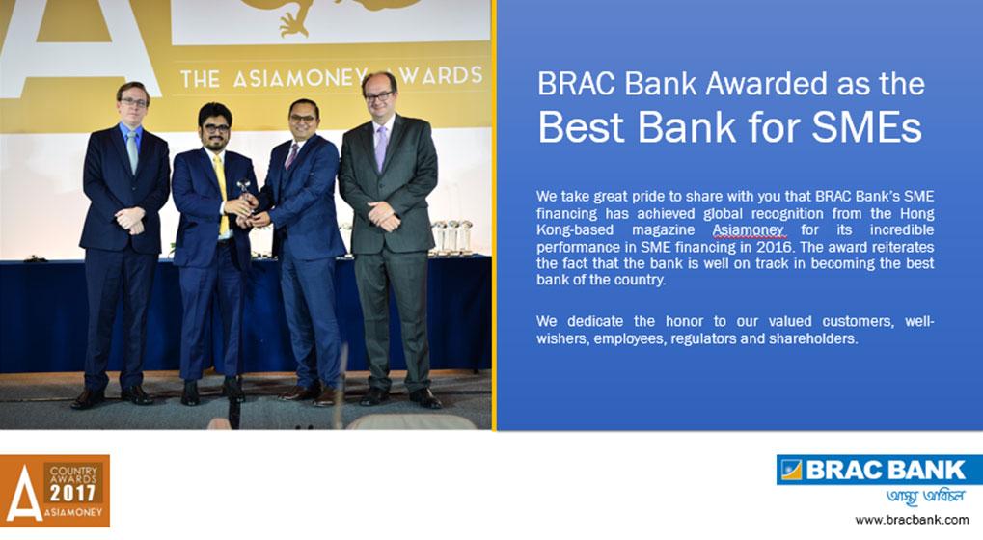
4.1.2: Importance of SMEs in Bangladesh

- Employment Generation
SMEs engage the middle and lower classes of the economy more effectively. It is estimated that SMEs generate around 60-70% employment. This is found from a report of the International Monetary Fund (IMF).
- GDP Growth
If more people are engaged in business it ultimately contributes positively to the GDP of the country. SMEs in Bangladesh contribute around 30% to the GDP.
- Enhanced Living Standard
Since the lower class of the economy is being engaged in forms of businesses, it helps them to improve their living standards to a much better position.
- Women Empowerment
A considerable amount of SMEs are run by women. This is crucial for women empowerment in our country. Women run various types of businesses such as cultivation, raising livestock, weaving, etc.
- Creation of Entrepreneurial Class
SMEs are empowering people to make money for themselves. Hence, they are their own bosses and it is helping in developing an entrepreneur culture. People are being inspired to break free from poverty.
- Reduction in Urban Migration
Rural people are now involved in different types of work in their own villages. Thus, this decreases the need to shift to the city which saves costs and ensures that villagers are able to stay with their family members at home.

4.1.3: Performance of SME Banking Sector in BRAC Bank
BRAC Bank has been performing quite well in the SME Banking Sector. The competition is quite tough as more rivals have emerged such as Standard Chartered Bank, Jamuna Bank, IFIC Bank, etc. But, BRAC Bank has maintained its position at the top of the pyramid.
As we can see below, private banks constitute around 60% of loans in the SME industry. BRAC Bank SME division holds 7.90% SME portfolio of private banks. This means they hold 3.51% SME portfolio of the entire industry.

- Total Outstanding of SME Loans in the industry: BDT 121,762 Crore
- Total Outstanding of SME Loans position of Private Banks: 73,057 Crore
- Total Outstanding of SME Loans position of BRAC Bank in the private banking sector: 5,771 Crore
- Total Outstanding of SME Loans position of BRAC Bank in the industry: 4,274 Crore

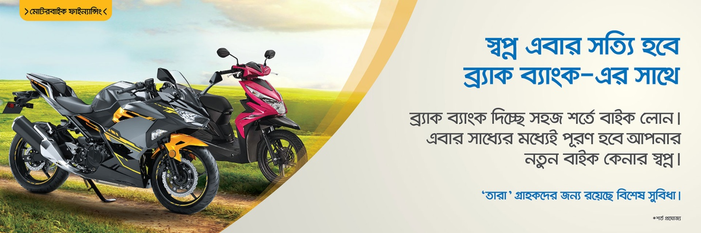
4.1.4: BRAC Bank SME Banking Procedure
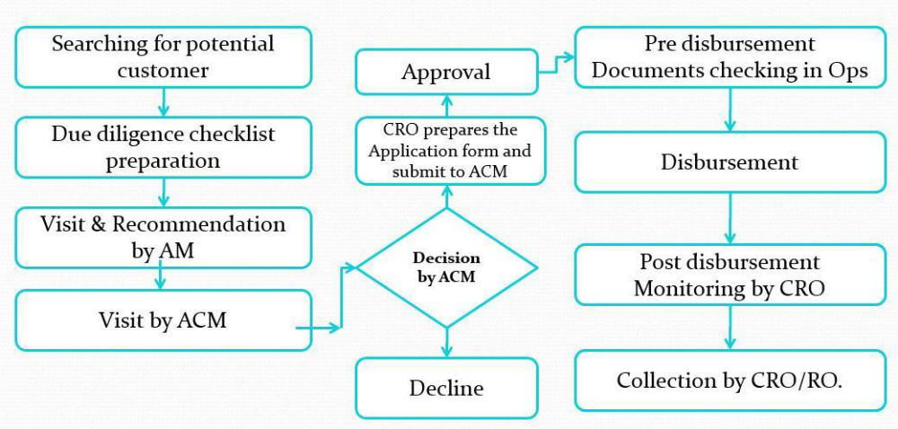
The bank follows certain steps before it sanctions a loan to a particular SME. The steps have been described below in detail:

- CROs constantly search for potential customers among their known contacts or surroundings
- Once they find a candidate, the CROs make an early assessment and try to determine what amount of loan would be ideal for them
- The Area Manager then visits the candidate and if is satisfied with the early assessment then recommends it to the Area Credit Manager
- The Area Credit Manager then decides whether or not to sanction a loan to the potential candidate
- If it is approved then the CRO prepares the application forms
- The form along with other necessary documents of the candidate is sent to Operations for checking
- The loan is then disbursed and regular monitoring is done post disbursement
- The CROs then collect the installments against the loans accordingly.

4.1.5: BRAC Bank Compared to its Competitors
According to Business Innovation Facility (2012), Islami Bank Bangladesh Limited is the largest lender SME in Bangladesh. 83000 SME customers and 11000 women entrepreneur customers In IBBL. 590bn Taka is the national SME target for 2012 calendar year and IBBL has committed to Taka 125bn.
BRAC Bank is the 2nd largest SME Bank lender in Bangladesh. The MD and CEO of BRAC Bank said in The Daily Star in an interview- “Set up in 2001, BRAC Bank is the largest SME bank in the country. Of its Tk 9,000 crore loan portfolio, SMEs account for 50 percent. Of the SME loans, 92% are without collateral with an average loan size of Taka 6-7 lakh. In the last 10 years, the bank has lent over Taka 15,000 crore to over 3.5 lakh SMEs.”
There are some SME lender Bank in Bangladesh, these are:
- Sonali Bank Limited, with over 1,000 customers and total SME of Taka 59bn
- Eastern Bank, with 9,000 SME customers and OLB of Tk10.9bn
- Mutual Trust Bank, with 3,300 SME clients and an OLB of just Taka 2.8bn but around 20% of its portfolio in SME lending

4.1.5: BBL SME Banking Products, Structure & Process:

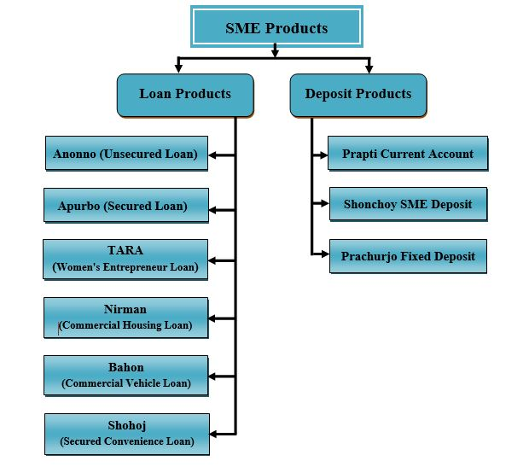
BRAC Bank has divided their product in two categories, these are Loan Product and Deposit product. Loan Product and Deposit product are also divided by another categories with a beautiful name. Such as: Anonno, TARA, Apurbo etc.

4.1.6: Terms & Conditions of BRAC Bank SME loan
For providing small and medium loans, BRAC Bank SME department following some terms & conditions.
  - Selection criteria must be met by prospective borrowers and companies
  - The loan amount is between Tk. 1 lac to 5 crore
Loan can be repaid in two ways:
- With monthly interest payment in equal monthly credit installment.
- One payment can be mature, after the ending of quarter residual payable of interest.
There are various dates for Loans, such as, quarterly, half yearly, Yearly, 2 years, 30 months and 36 months. Cash (BBL) or TT (Telephonic Transfer) are the way of Loan Disbursement for client A/C. The borrower will install a signboard in the Manufacturing unit's visible location of company listed as being funded by BRAC Bank Limited. The borrower must provide the required and appropriate collateral and other securities in accordance with the requirements and processes of the bank.

4.2: Findings
- BRAC Bank focusing SME Financing from beginning of its inception and its SME loan process is easier for customers.
- Only bank provides Collateral or security fee financing.
- The Return on Asset & Return on Equity is quite better than other Banks.
- Focus on SME Financing to Missing Middle.
- Low customer satisfaction.
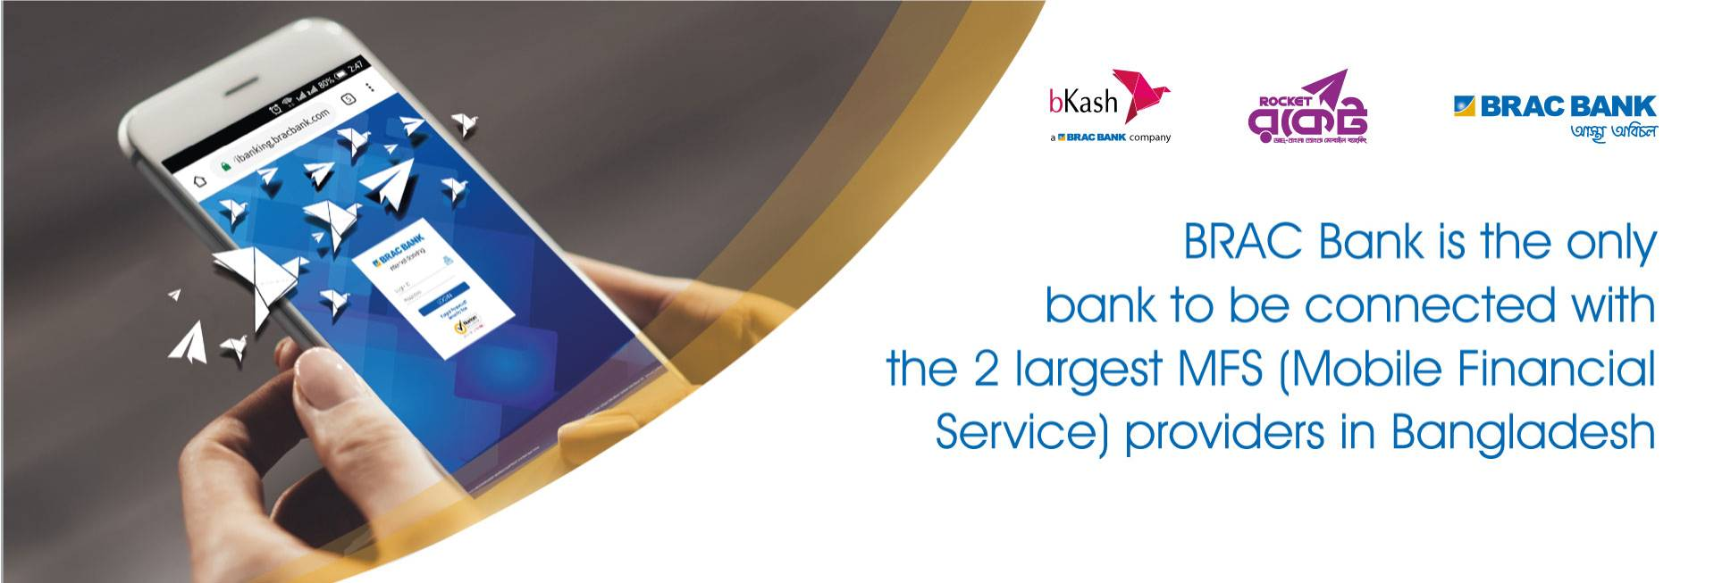
Experiences during Internship tenure

Chapter: 5
Experiences during Internship tenure

5.1: Internship Job Responsibilities
During my tenure at Payment & Asset Management department, I have fulfilled various types of responsibilities. These included typical desk work, computer related tasks and interacting with Vendors. The details have been described below:
- Preparing work orders
A work order is basically a letter which places an order for an item to a specific supplier. It includes the name of the product, price, supplier name, terms and conditions. Once there is a requisition for an item, I would proceed to make a work order. After printing, it has to be signed by the head of procurement for final approval. The soft copy of the work order is mailed to the vendor and the hard copy is retained for office records.
- Making comparison statements
Comparison statements are made to compare and contrast the specifications and prices of a particular product. This is done when various vendors submit quotations for the same product.
- Payment approval note
When a product is delivered, the vendor submits the bill to Payment department. Then, a payment approval note is made which is attached to the bill and forwarded to payments. This note has to be signed by the head of payment and asset management before it is forwarded.
- Purchase approval form
When procurement department is planning to buy a high value item which costs a few lacs or even crores,they have to inform to Payment and asset management depertment.and they must seek approval from all heads. The purchase approval form states the terms and conditions of the purchase and must be signed by the authorities.

5.2: Critical Observations
Over the course of my internship, I have come across numerous observations some of which have been discussed below.
- Respect for interns
One thing that was very clear from day one is that interns are treated as part of the workforce and humbly welcomed in BRAC Bank. Everyone from the head of the department to colleagues show ample respect to interns. Other organization should adopt such similar culture I believe.
- Punctuality is maintained
All employees are required to be present by 10am and sign in their computers to record attendance. Late attendances are actively monitored by HR hence everyone tries to show up before 10am. Even interns are subject to strong supervision.
- Day care facilities
A very unique feature of the BRAC Bank head office is the day care facility. This is something which is absent in many reputed organizations so it’s a big plus point for parents working here.
- Working environment
BRAC bank probably has the biggest head office in the Gulshan area. It is very exciting to work in such a massive infrastructure with respectful colleagues.

Chapter: 6
Conclusion and Recommendations

6.1: Recommendations:



- Reduce of interest rate on SME financing.
- Promotion campaign on rural area to reach the Missing Middle.
- Searching new products which will better suits with targeted low customers.
.

6.2: Conclusions
All the banks play an important role in the economic development in the country. Business activities cannot be conducted without the banks. As such BRAC Bank helps SME entrepreneur by providing SME loans to starts or renovate the business. Although the small & medium entrepreneur’s intention is to doing the business but due to lowest capital are not able to do their business. BRAC Bank dominate SME sector in Bangladesh. BRAC Bank Limited is well known as Small & Medium Enterprise banking. By overcoming the limitations such as: high interest rate, low customer satisfaction etc. its wide network and vast activities including BKASH, Bits, BRACSaajan has established itself as a comprehensive financial solution in the country.

7.1: References

Chapter: 7
Appendix

- Bracbank.com. (2019). Brac Bank. Available at: https://www.bracbank.com [Accessed 13 Sep. 2019].
- Bracbank.com. (2019). Brac Bank. Available at: https://www.bracbank.com/en/sme/ [Accessed 16 Sep. 2019].
- Express, T. (2019). Prospect of SME banking in Bangladesh. The Financial Express. Available at: https://thefinancialexpress.com.bd/views/prospect-of-sme-banking-in-bangladesh-1550240624 [Accessed 17 Sep. 2019].
- Lam, R., & Burton, S. (2006). SME banking loyalty (and disloyalty): a qualitative study in Bangladesh. International Journal of Bank Marketing, 24(1), 37-52.
- Alam, M. S., &Ullah, M. A. (2006). SMEs in Bangladesh and SME financing: An analysis and some recommendations. The Cost and Management, 34(3), 57-72.

