



Internship Report

On

LankaBangla Securities Ltd.

Submitted To:
Mr. Mosabbir Uddin Ahmad
Assistant Professor BBA Department
United International University

Submitted By:
Sourav Basak 111 181 097

Date of submission: 12 February 2023

Letter of Transmittal
February 12, 2023

Mr. Mosabbir Uddin Ahmad Assistant Professor
School of Business and Economics
United International University
Subject: Submission of Internship Report on LankaBangla Securities Limited.
Dear Sir,
Respectfully, I am pleased to inform you that, with the help of Almighty God and your precious guidance, I have completed the report required for the INT 4399 course.
Thank you for giving me the opportunity to learn about the organization and formal academic reporting. Both have helped me a lot. The goal of my work was to make it easy to understand.
I have the utmost confidence that this report will not only meet your expectation but also exceed the expectations that you have. I would like to request you, if you give the report your thoughtful evaluation and acceptance, I would be very grateful to you.

Yours obediently,

Sourav Basak ID – 111181097
BBA Program, Finance

School of Business and Economics United International University

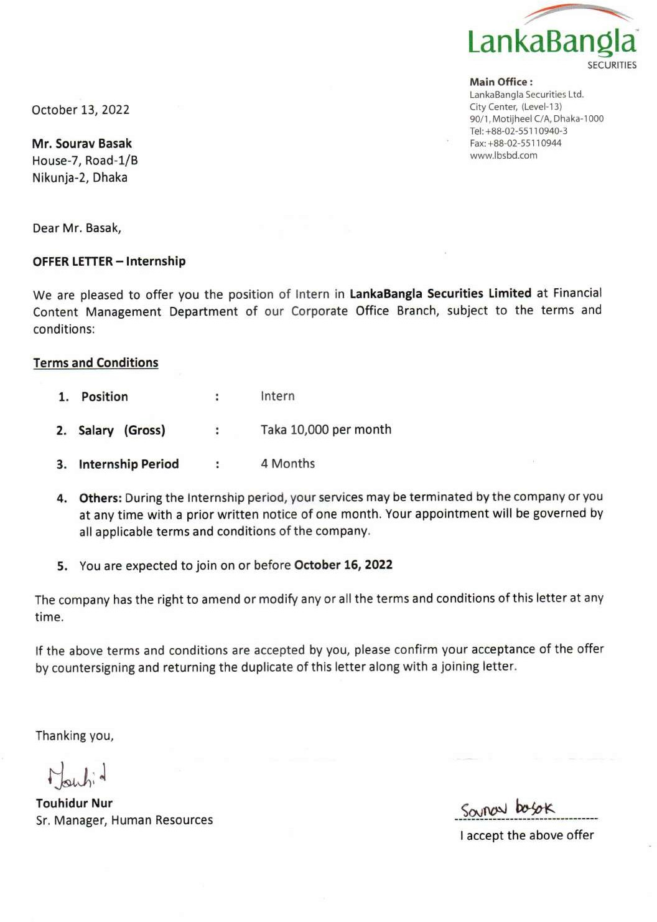Acknowledgment

First of all, I would like to offer my gratitude the Most Merciful God for giving me the opportunity to complete this report.
I would also like to thank my esteemed internship supervisor, Assistant Professor Mosabbir Uddin Ahmad, for his valuable guidance and advice that helped me to complete the report effectively. Thanks to everyone who give the time to write the internship report. Special thanks to A S M Moniruzzaman (Department In-charge), Sohely Naznin (Senior Executive), Md. Rafiul Islam (Senior Executive), and Sakura Abida (Executive) of Financial Content Management Department at LankaBangla Securities Limited, for his assistance in completing the report.
I would also like to thank all respondents for their contribution, participation and commitment to this research.

Table of Contents

Executive Summary 5
Introduction 6
Report Objective: 7
Methodology 7
Chapter One 8
Overview of LankaBangla Securities Limited 8
Short History of LBSL 9
Products: 10
Services: 10
Platforms: 11
Corporate Information 12
Subsidiaries of lankabangla: 13
Principle Business Activities: 16
List of Directors Of the subsidiaries: 17
Corporate Financial Service: 19
Retail Financial Services: 19
Credit Rating 20
Equity Capital 21
Reserves: 21
Financial Highlight of LankaBangla Group 21
Operational Performance: 22
Equity Parameters: 23
Credit Rating 23
The Chairman’s responsibilities: 24
The Managing Director’s responsibilities: 24
Chapter Two 25
SWOT Analysis between LBSL & IDLC 25
SWOT Analysis: 25
Strength 26
Weakness: 33
Opportunities 38
Threat 40
Chapter 3 41
Experience in LBSL 41
My experience in LankaBangla 42
Activities: 42
Name of General companies: 44
Banking and Non-bank Financial Institutes: 46
Life insurance companies: 47
Format of Financial Statement for General Industry: 48
Learnings: 53
Challenges: 53
Contribution 54
Conclusion 55
Reference 56

Executive Summary

In this report I broadly explained overview of the LankaBangla Securities Limited, SWOT analysis between LBSL and IDLC and my experience, learning, and contributions. In the first chapter, overview of the company, I tried to give a clear idea about LankaBangla. In the second chapter I have conducted a SWOT analysis between LBSL and IDLC, where I have discussed about their services, their financial conditions like ROE, ROA, EPS, net profit after tax, operating revenue, debt, their technology, their strategy. Analyzing these two leading companies about the relevant areas, I tried to draw a comparison between these two and thus where LBSL has scope to furter improve. In the last chapter, I have discussed about my experience, what I learnt in my internship period and my contributions to the company. The most important part of the third chapter, how we handled an entire project is broadly explained. In addition, I gave the format of the general company instructed by foreign client. It will make the reader clearer about the project. However, the experience I get over there and how I learn things while completing the project everything is very clearly explained in the third chapter.

Introduction

As per the requirement of the BBA program at United International University, every student needs to pass through an internship program under any organization to achieve knowledge of the practical job market. To fulfill this requirement, I have completed my internship under a financial service provider organization LankaBangla Securities Limited. Here, I worked in the “Financial Content Management” Department, and my job responsibility was related to the well-known “LankaBangla Financial Portal” (https://lankabd.com/). However, LankaBangla Securities Limited was the most relevant to my department (Finance) and most effective for me to increase my practical knowledge. At the end of the internship, the internship report is an essential part of the process.
This internship report has been done under the guidance and supervision of my respected faculty Mr. Mosabbir Uddin Ahmad Assistant Professor of United international University. This report consists of the various functions of LankaBangla Securities Limited., and mostly the operating side of the “Financial Content Management” department where I worked during my internship. It also contains my day-to-day activities, challenges, and learnings. In addition, my point of view about the practical job market, responsibilities, duties, and effectiveness of an internship for a fresh graduate. It will show the difference between my thought and reality. Finally, this report is a complete view of my internship journey at LankaBangla Securities Limited.

Report Objective:
- Fulfillment of the requirements under the School of Business and Economics to complete my internship course INT 4399 - Internship” to complete the BBA degree at United International University.
- Earning experience and becoming habituated to the working environment. Also, checking the theoretical knowledge from the view of reality.
- Achieving in-depth knowledge of different industries in Bangladesh based on financial statements.
- Learning about the capital market and proper idea about Dhaka Stock Exchange.

Methodology:
This report has been compiled using data from a variety of sources. Nevertheless, I have concentrated more on the experience acquired. Most of the report is mainly composed of my actual observations. To generate this report more specifically, a particular strategy was used. Here, I have used both primary and Secondary source to prepare this report more informative.
Primary Sources:
- My department head, instructors, and other employees of LankaBangla Securities Limited.
- My duties, responsibilities, activities, and personal experiences.

Secondary Sources:
- Official website of LankaBangla Securities Limited.
- LankaBangla Financial Portal.
- Dhaka Stock Exchange Website.
- Financial Statement of LankaBangla Finance Limited.

Chapter One Overview of
LankaBangla Securities
Limited

Short History of LBSL
In Bangladesh, LBSL is a non-banking financial organization. By obtaining a license from Bangladesh Bank pursuant to the Financial Institution Act of 1993, it began its journey back in 1997 as a joint venture FI in transnational collaboration. It assists in the purchase and sale of securities and deals with consumers. It is a division of Lanka Bangla Finance, one of the largest financial institutions in the world, which offers a wide range of financial services and goods. According to DSE, it is the top brokerage house for 2021. As the industry leader in capital market services, LankaBangla has been working tirelessly to create an effective, thriving, and transparent capital market in Bangladesh. Its subsidiary LankaBangla Securities Limited is the market leader and offers top-notch brokerage services. Additionally, LankaBangla recently debuted trade express, the only brokerage firm offering an app-based trade service that enables buyers and sellers to transact.

VISION:
to create, nurture, and maximize value for stakeholders, thereby Growing Together, to be the most chosen financial service provider.

MISSION:
- Assist in our customers' growth by providing financing and top-notch service.
- Maintain the company's inherent meritocratic culture.
- Be sustainable and make sure our cherished shareholders receive high-quality profits.
- Support initiatives to grow our community.
- Improvement of the process continuously.
- Modern technology and one-stop service.
- Research and analysis

CORE VALUES:

Strong ideals that are deeply ingrained in our society define us. To assist us in executing our plan, the following goals were created by our values.
- Cherish a sense of ownership.
- Be customer centric.
- Grow as a team.
- Act with integrity and professionalism.
- Deal with respect.

Products:
- Equity
- Bond
- Closed End Mutual Funds
- Open End Mutual Funds

Services:
- Brokerage Service (International Brokerage Service).
- Margin Loan Facilities.
- Investor Relation Services.
- DP Services.
- Custodial Services.

DP Services:
- BO account opening and maintenance.
- Dematerialization of securities.
- Re-materialization of securities.
- Change of Ownership.
- Pledging and Unpledging services.
- Transfer of securities.
- Transmission of securities.

Platforms: There are four individual and essential platforms of LBSL.

TradeXpress:
Customers can perform trades using the smartphone service offered by LankaBangla Securities from any location in the world. This is the web trading platform that allows for simultaneous trading on multiple exchanges. By using this app service, investors can trade on both markets. During trading hours, it provides them with real-time data, so they may place their buy/sell orders at the proper time and at the proper price. Customers or investors can access flexible trading using mobile devices like Android and iOS as well as laptops and desktops from any location.
iBroker:
Investors can now open a BO account, or Beneficiary Owners Account, from their home or any other convenient location. Other choices include applying for an IPO and receiving impending IPO-related news.
Financial Portal:
LankaBangla financial portal is one of the most renowned and well-known to those groups of people who are interested in the capital market sector and connected with this sector. It shows all information about Dhaka Stock Exchange (DSE) and Chittagong Stock Exchange (CSE). Anyone can collect the financial information of any DSE or CSE-listed company using this portal, and all data is open and free to everyone. It provides the financial ratios of all companies, market research information, financial news, market situation, live graph, AGM news, board meeting news, IPO news, market announcement, different analysis tools, market parameters, money market news, economic indicators, commodity, currency, etc. essential things to people by which people can take their investment decision. This portal follows the Dhaka Stock Exchange and Chittagong stock exchange for the most accurate information.
Market Pulse:
Market Pulse is a full-fledged financial monthly magazine published by LankaBangla securities limited. It contains financial data and news about the market and shows an overview of the market in that month. It’s a complete package of financial market data.

Corporate Information:
Company Name: LankaBangla Securities Limited.

Legal Form: With a license from Bangladesh Bank under the Financial Institution

Act of 1993, LankaBangla Securities Limited began its operations as a jointventure financial institution in 1997.Date of Commencement: July 05, 1995
Corporate Office: City Centre (Level-13) 90/1, Motijheel C/A, Dhaka-1000 Phone: +880-2-55110940-3
Fax: +880-2-55110944

Email: info@lbsbd.com

Website: https://www.lbsbd.com/

Managing Director: Mr. Mohammed Nasir Uddin Chowdhury Chief Executive Officer & Director: Mr. Khandoker Saffat Reza
Chief Technology Officer & Director: Mr. S.A.R. MD. Muinul Islam Head of Operations: Mr. Mohammad Shaidus Zaman

LankaBangla Financial Portal (Motijheel Extension):
Address: A.A. Bhaban Level-5, 23 Motijheel C/A, Dhaka-1000 Phone: +880-2-9563901-5, +8801730038558
Fax: +880-2-9563902

Email: masud.hossain@lbsbd.com

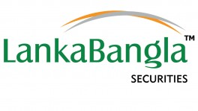

Subsidiaries of lankabangla:
- LankaBangla Securities Limited

- LankaBangla Investment Limited

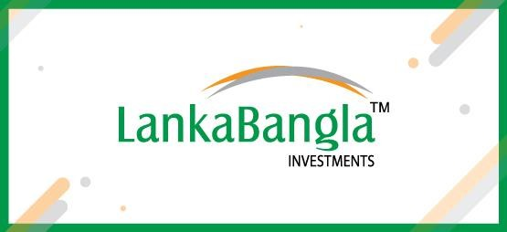

- 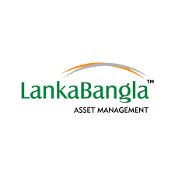LankaBangla Asset Management Company Limited

- LankaBangla Information System Limited

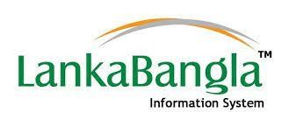

- BizBangla Media Limited

Principle Business Activities:
Organization | Principal Business Activities
LankaBangla Securities Limited | The principal business of Lankabangla Securities Limited is to act as a member of Dhaka Stock Exchange Limited and Chittagong Stock Exchange Limited and to issue shares, shares and securities, commercial papers, bonds, debentures, debentures, Treasury bills and/or other financial instruments.
LankaBangla Investments Limited | The main activities of these companies are mainly service- based, such as interest income, and fee-based services, such as: underwriting of securities, issue management, register to issue, portfolio management, corporate advisory services etc.
LankaBangla Asset Management Company Limited | - Manage the assets of any trusts or fund of any type and/or character and hold, acquire, sell or deal with such assets of any trust.  - manage any mutual fund, growth fund or any other allotted scheme approved by the Government for the time being.  - Manage and manage mutual funds, provident funds and pension funds, in accordance with relevant rules and regulations, for the purpose of conducting investments and business, or underwriting and conducting trusts, and as executor, trustee, custodian and/or otherwise; to manage.
LankaBangla Information System Limited | Consultancy & Training, Market Data Service to International Fund Manager and Exchanges, develop

 | specialized simulation tools for trading, outsourcing, Private Cloud Computing, ITES, Project Management, Process Management, Cloud Services, Business Process Outsourcing (BPO), Registered Educational Provider (REP) affiliating with world recognized companies, System Integrator (SI), E-Commerce, M-Commerce, IT Audit, Trading of PC, Servers, Network, Security and Accessories and many more with changes of technology and business diversities
BizBangla Media Limited | Printing and publishing of newspaper, Journals, magazines, periodicals, books any other literary and non- literary works.

List of Directors Of the subsidiaries:
Particulars | Name of Directors | Position
LankaBangla Securities Limited | Mr. Mohammad A. Moyeen | Director
LankaBangla Securities Limited | Mr.I.W. Senanayake | Director
LankaBangla Securities Limited | Mr. B. W. Kundanmal | Director
LankaBangla Securities Limited | Mr. Al-Mamoon Md. Sanaul Huq | Independent Director
LankaBangla Securities Limited | Mr. Mohammed Nasir Uddin Chowdhury | Director
LankaBangla Securities Limited | Mr. Khwaja Shahria | Director

 | Mr. S. A. R. Md. Muinul Islam | Director
 | Mr. Khandoker Saffat Reza | Director
LankaBangla Investments Limited | Mr. Mohammad A. Moyeen | Director
LankaBangla Investments Limited | Mr. B. W. Kundanmal | Director
LankaBangla Investments Limited | Mr. Al-Mamoon Md. Sanaul Huq | Independent Director
LankaBangla Investments Limited | Mr. Abdullah Al Karim | Director
LankaBangla Investments Limited | Mr. Mohammed Nasir Uddin Chowdhury | Director
LankaBangla Investments Limited | Mr. Khwaja Shahriar | Director
LankaBangla Asset Management Company Limited | Mr. Al-Mamoon Md. Sanaul Huq | Independent Director
LankaBangla Asset Management Company Limited | Mr. Khwaja Shahriar | Director
LankaBangla Asset Management Company Limited | Mr. Abul Kalam Mohammad Kamruzzaman | Director
LankaBangla Asset Management Company Limited | Mr. Quamrul Islam | Director
LankaBangla Asset Management Company Limited | Mr. Shamim Al Mamun | Director

LankaBangla Information System Limited | Mr. Mohammad A. Moyeen | Chairman
LankaBangla Information System Limited | Mr. Mahbubul Anam | Director
LankaBangla Information System Limited | Mr. S. A. R. Md. Muinul Islam | Director
BizBangla Media Limited | Mr. Mohammad A. Moyeen | Chairman
BizBangla Media Limited | Mr. Mahbubul Anam | Director
BizBangla Media Limited | Mr. Dewan Hanif Mahmud | Director

Corporate Financial Service:
Lankabangla is working to expand its corporate portfolio towards 2021. In 2021, a total of BDT
13.447 billion in corporate loans was disbursed compared to his BDT 9.034 billion in 2020, a significant year-on-year growth of 48.9%. Similarly, the asset portfolio increased by Tk 2.7 billion from 23,483 BDT in 2020 to 26,183 BDT in 2021. This represents a year-on-year growth of 11.5%.

Retail Financial Services:
In 2021, the company continued to focus more on retail finance activities. In 2021, a total of 14,938 million BDT was disbursed to retail financial services in the form of auto loans, home loans, personal loans, credit cards and personal loans.
Home Loan:
In 2021 total home loan disbursement was BDT 888 million and in percentage it has increased by 40% compared to the year of 2020.

Auto Loan:
In 2021, BDT 1,478 million has been disbursed as auto loan compared to 262 million in 2020 resulting in 464.8% increase in disbursement.
Personal Loan:
Personal Loan disbursement has increased by 75.7% in 2021 with a total figure of BDT 1,495 million.
Credit Card:
During 2021, a total of 22,306 new credit cards were issued by LankaBangla. The card portfolio has increased by 12.4% in 2021 to BDT 4,488 million from BDT 3,995 million in 2020.
Liability Management:
Total Term Deposit portfolio in 2021 was BDT 48,005.90 million from BDT 47,427.81 million in 2020, resulting in 1.22% increase compared to the portfolio of 2020.

Retail Liability Management:
in 2021 Retail liability management has been increased to BDT 25,523 million which is 5.4% higher than the year 2020.
SME Liability Management:
At the end of year 2021 SME liability Management has been increased at BDT 3918 million which shows growth increased by 4.5 % from the year 2020.
Corporate Liability Management:
Corporate Liability portfolio consists of a diverse deposit portfolio of corporate clients. The value of the portfolio stands at BDT 12,105 million at the end of 2021 decreasing by 5.4% from 2020.

Credit Rating:
Credit Rating Agency of Bangladesh Limited (CRAB) has rated LankaBangla Finance Limited on July 19, 2021, with ‘AA3’ rating in the long term and ‘ST-2’ rating in the short term based on

audited financial statements as of December 31, 2020. It means financial capability is very well. The default rate of repaying the loan is very low. So, they can take loan very easily and it is very attractive to the customer which will create trust among the stakeholder of the company.

Equity Capital:
Paid-up Capital of LankaBangla Finance Limited as at 31 December 2021 amounted to BDT 5,388.39 million consisting of 538,838,623 ordinary shares.

Reserves:
Particulars | 2021 | 2020
Share Premium | 1,090.89 | 1,090.89
Statutory Reserve | 2,049.58 | 1,927.78
General Reserve | 50.84 | 45.41
Capital Reserve | 13.96 | 14.50
Revaluation Reserve | 1,681.85 | 1,018.07
Retained earnings | 2,085.15 | 1,641.73

Financial Highlight of LankaBangla Group:
All figures in BDT million except (%)

Financial Position | 2020 | 2021 | Growth of 2021  over 2020
Total Assets | 81,835 | 88,927 | 8.67%
Total Liability | 71,612 | 78,053 | 8.99%
Business Disbursement | 22,007 | 34,269 | 55.72%

Property Plant and Equipment | 2,777 | 2,595 | -6.57%
Current Asset | 61,658 | 63,451 | 2.91%
Current Liability | 54,511 | 52,734 | -3.26%
Net Current Asset | 7,147 | 10,717 | 49.96%
Non-Current Asset | 20,178 | 25,476 | 26.26%
Long Term Liabilities | 17,101 | 25,318 | 48.06%
Loans and Advances | 58,472 | 62,888 | 7.55%
Term Deposits | 46,947 | 47,501 | 1.18%
Total Investment Portfolio | 76,249 | 82,982 | 8.83%

Operational Performance:
All figures in BDT million except (%)

Financial Position | 2020 | 2021 | Growth of 2021  over 2020
Operating Revenue | 9,690 | 10,294 | 6.24%
Operating Expenses | 2,388 | 2,874 | 20.35%
Financial Expenses | 5,972 | 4,873 | -18.41%
Non-Interest Revenue | 1,543 | 3,402 | 120.44%
Net Profit Before Tax | 1,178 | 1,705 | 44.74%
Net Profit After Tax | 979 | 1,306 | 33.46%

EBITDA | 7,484 | 6,861 | -8.33%

Equity Parameters:
All figures in BDT million except (%)

Financial Position | 2020 | 2021 | Growth of 2021  over 2020
Authorized Capital | 10,000 | 10,000 | 0.00%
Paid-up Capital | 5,388 | 5,388 | 0.00%
Shareholders' Equity | 10,046 | 10,679 | 6.29%
No. of Share Outstanding | 539 | 539 | 0.00%
Net Asset Value (NAV) Per Share | 18.64 | 19.82 | 6.29%
Earnings Per Share (EPS) | 1.81 | 2.38 | 31.46%
Market Price Per Share (Closing) | 31.40 | 37.30 | 18.79%
Price Earnings Ratio (Times) | 17.37 | 15.70 | -9.64%
Profit per Employee | 1.10 | 1.70 | 54.13%

Credit Rating:
Financial Position | 2020 | 2021 | Growth of 2021  over 2020
Long term | AA3 | AA3 | AA3
Short Term | ST-2 | ST-2 | ST-2

The Chairman’s responsibilities:
- Lead the Board and ensure its effective functioning.
- Sets the ethical tone of the board and company.
- The agenda of the Board of Directors is set in consultation with the managing directors and secretaries of the group companies.
- Ensure that the Board maintains the highest standards of integrity and responsible corporate governance.
- Balanced and accurate feedback communication between the board and the CEO.

The Managing Director’s responsibilities:
- Appoint a leadership team and ensure proper succession planning and performance reviews.
- Development of corporate strategy for review and approval by the board.
- Develop and recommend to the Board a budget that supports the Group's long-term strategy.
- Monitor the Group's performance and report to the Board of Directors.

- Setting the tone for ethical leadership and creating an ethical environment. General and legal obligations and responsibilities of directors.
- Extensive discussions with company officers and directors.

Chapter Two
SWOT Analysis between LBSL & IDLC

SWOT Analysis:
S= Strength W= Weakness O= Opportunity
T= Threat

However, SWOT Defines the companies market scenario such as how the company is running, what to improve, where to invest, as well as how they have to retain the current position where they are good at. Companies’ strength and weakness is internal which company can control but opportunity and threat are external which company cannot control. Opportunity will be created by the market and company has to grab the opportunity and same goes for the threat company cannot totally minimize the threat but they can avoid threat. Mow I am going to show the SWOT of LankaBangla compared its Competitors Like IDLC.

Strength:
Brand Value
LankaBangla: LankaBangla is the highly popular brand with a unique brand identity all over the Bangladesh. First of all, it has its own app where customer can directly buy and sell securities which is why it the most customer friendly and well recognized. In addition, LankaBangla is placed the top brokerage house in 2021 approved by Dhaka Stock Exchange and became the most popular brand as well as market leader in the country.
IDLC: IDLC is also the well-recognized brokerage house is Bangladesh but not the market leader. You cannot directly buy and sell securities through their app. Here you have to use DSE app to trade among customer. But they are customer friendly and always prefer their customer. So, it is gradually upgrading themselves.
Decision: Based on the discussion we can say that Lankabangla is already established and serving high range of customer base. on the other hand, IDLC recently Started creating its brand value. so, Brand Value of LankaBangla is higher than the IDLC.

Better Technology
LankaBangla: It is technologically rich than ever Because Recently LankaBangla has launched Trade express first time ever in Bangladesh any brokerage firm launched this app. However, Lankabangla has its own portal where you will find every kind of information you need about any
listed company’s past data as well as present data. Now introducing some app that has recently been introduced.
Trade express: Customers can trade from anywhere in the world using the smartphone service provided by LankaBangla Securities. A web trading platform that allows you to trade simultaneously on multiple exchanges. By using this app service, investors can trade on both markets. Real-time data is provided during trading hours so you can place buy and sell orders at the right time and price. Clients and investors can access flexible trading from anywhere using their mobile devices such as Android and iOS, as well as laptops and desktops.
iBroker: Investors can now open BO or beneficial owner accounts from their home or other convenient location. Other ways include applying for an IPO and receiving news about his upcoming IPOs.
LankaBangla portal: Lankabangla Financial Portal is one of the most reputable and well-known groups interested in and associated with the capital markets sector. All information about Dhaka Stock Exchange (DSE) and Chittagong Stock Exchange (CSE) is displayed. Through this portal, anyone can collect the financial information of his DSE or CSE listed company and all data is free and open to everyone.
ILDC: Technologically IDLC is in backward Position than LankaBangla. It doesn’t have any personal app by which customer can trade. But it has the app where customer can get information about company and account related information but doesn’t have any portal like LankaBangla.

Net profit after tax

 | LBSL (in million)
 | 2021 |  | 2020
 | 1303
 |  | 979


Net Profit After Tax
Net Profit After Tax
1303
979
2020
2021

IDLC (in million)
2021 | 2020
2116 | 2540

Decision: If, you look at the graph both LBSL and IDLC you will see net profit after tax is higher in IDLC but growth rate is negative on the other hand the growth rate of net profit after tax is increasing so, this is the good sign. It indicates LBSL profit is growing and expenses is decreasing and the company is capable to retain the old customer as well as attracting the new customer.
Net Profit After Tax
Net Profit After Tax
2540
2116
2020
2021

Operating Revenue

LBSL (in million)
2021 | 2020
10294 | 9690


Operating Revenue
Operating Revenue
10294
9690
2020
2021

IDLC (in million)
2021 | 2020
10944 | 12941

Decision: Looking at both the LBSL and IDLC charts, we can see that the IDLC has a higher operating revenue, but the growth rate is negative. On the other hand, net after-tax profit growth is trending upwards, which is a good sign. This indicates that LBSL's operating revenue is increasing and operating costs are decreasing, allowing the company to retain old customers and attract new ones.
Operating Revenue
Operating Revenue
12941
10944
2020
2021

Return on Asset

LBSL (in %)
2021 | 2020
1.18 | 1.53


ROA
ROA
1.53%
1.18%
2020
2021

IDLC (in %)
2021 | 2020
1.50 | 1.41

Decision: ROA is higher is LBSL Than IDLC. It means LBSL is using their asset very effectively and efficiently which is why they are getting more return on asset than IDLC. So, we can say LBSL is perfectly using their asset that’s why growth rate is also higher. However, it is the strength of LBSL regarding using their short-term asset and long-term asset.
ROA
ROA
1.50%
1.41%
2020
2021

Weakness:
Earnings per share

LBSL (in TK)
2021 | 2020
2.38 | 1.81


EPS
EPS
2.38
1.81
2020
2021

IDLC (in TK)
2021 | 2020
5.34 | 6.42

Decision: LBSL gave EPS 2.38 in 2021 however, IDLC gave EPS 5.34 in 2021 which is higher than LBSL. So, shareholder of IDLC is getting more than LBSL which is a weakness of LBSL.
EPS
EPS
6.42
5.34
2020
2021

Return on Equity

LBSL (in %)
2021 | 2020
12.60% | 10.02%


ROE
ROE
12.60%
10.02%
2020
2021

IDLC (in %)
2021 | 2020
13.21 | 17.27

Decision: Shareholder of IDCL is getting more return than the shareholder of LBSL which is weakness of LBSL but growth rate of ROE is positively increasing for LBSL.
ROE
ROE
2020
2021
13.21%
17.27%

Dividend payout Ratio

Company Name | Cash Dividend | Stock Dividend
LBSL | 10% | 5%
IDLC | 15% | 5%

Decision: IDLC is giving the higher dividend payout ratio than LBSL. Their stock dividend payout ratio is similar but cash dividend payout ratio is different. So, shareholder of LBSL will not be satisfied here if, they compare themselves with IDLC dividend payout ratio. So, it is the weakness of LBSL.

Opportunities
Capital market is expanding
All over the world capital market is expanding. New companies are interested to include in the capital market because of some advantage. In Bangladesh there are some new Banks and NBFIs recently been listed in DSE and CSE market. so, market growth is now visible in the DSE website. Common people are interested to invest in the capital market instead to invest in the money market. however, new customer base is creating. So, there is a chance to attract the new customer and give them the best experience in the capital market.
LankaBangla

LBSL (Operating Income)
2021 | 2020 | Difference  2021-2020
5,421,370,887 | 3,717,519,947 | 1,703,850,940

LankaBangla is taking the market expand opportunity so perfectly. Because if, we look at their operating income it is positively increasing from 2020 to 2021. It means they are obtaining new customer which is why their operating income is increasing.
IDLC

IDLC (Operating Income)
2021 | 2020 | Difference  2021-2020
7,600,420,037 | 6,667,523,644 | 932,896,393

Decision: if we look at the difference from 2021 to 2020, we can see LBSL operating income is much higher than IDLC. It indicates LBSL is attracting and serving more customer than IDLC.

Technological Development
LankaBangla: LankaBangla is technologically well develop. It has its own financial portal where potential customer will get updated news 24 by7. It has the Trade express by which customer can directly trade securities. Moreover, LankaBangla has iBroker and market pulse. In addition, it has very strong server and excellent IT team. So, in the digital era of technology LankaBangla is one step ahead from their competitors.
IDLC: IDLC is also changing their technology with the change of the world. They have their own server, IT department, online portal and they are still trying to update their own app and portal to compete with the competitors.

Foreign Investment is increasing

LankaBangla:

On 25 May 2021, LankaBangla received USD 15,000,000, which is equivalent to BDT 1,271,700,000, as a foreign Investment.
On 21 September 2021, LankaBangla Finance Limited received USD 5,000,000, which is equivalent to BDT 426,500,000, as a foreign investment.
On 24 November 2021, LankaBangla Finance Limited received USD 16,000,000, which is equivalent to BDT 1,393,600,000 as a foreign Investment.
From the total share of outstanding 9.09% are the foreign investor invest in LBSL which is good sign for the LBSL as well as capital market.

IDLC:


Shareholders Matrix
5%
14%
24%
57%
Institutions Directors Individuals
Foreign

Decision: if we look into both the scenario of LBSL & IDLC we will see LBSL is grabbing the opportunity most than IDLC. Because Foreign investment percentage is higher in LBSL.

Threat
Inflation Rate is increasing
Inflation Rate is external which company cannot control. But it can cause huge loss for the capital market. so, if the capital market is in danger, then all the brokerage firm will be in danger including LankaBangla and IDLC.
Foreign Exchange Rate is increasing
As we know foreign investment is increasing day by day. And it is good sign for the economy but if, exchange rate increases then company has to face huge loss to repay the foreigners. Because of the war between Russia & Ukraine dollar rate is rising badly which is bad for the capital market as well as brokerage firm like LankaBangla and IDLC.

Chapter 3
Experience in LBSL

My experience in LankaBangla
I started my internship on October 16, 2022. I've made many different types of activity. Every time I faced challenges, I tried to solve those challenges and sometimes I solved them. I learned from every challenge. I have always strived to apply my insights and carry out activities. The journey from beginning to today is full of challenges, activities and lessons. My goal was to do my best to improve my daily activities. As an intern, I was always focused on my goals and the tasks assigned to me.

Activities:
My first task was to research my current project and ask the project manager to outline my overall responsibilities. Working with financial statement history documents of companies listed on Dhaka Stock Exchange (DSE) and Chittagong Stock Exchange (CSE) was the central task of this project. The aim of this project was to provide a standard format of financial statements for the last five years for the Bangladesh market, where the structure of financial statements can appear different for each company. The Project Manager provided the BATBC and MJLBD annual accounts in the first week for analysis and comparison with the project format. I used it for training purposes. I do my task, talk to him about it, and clarify my issues.
My project manager then scheduled some DSE and CSE enlisted companies with confirming the data. I checked at each of these company’s balance sheets, income statements, cash flow statements, and changes in equity part. I finished the statement of changes in equity and calculated the financial statements using our new format given by the foreign client.
After couple of days my department in charge assigned a senior executive to train me that how to operate the portal (http://Lankabd.com). My instructor explained everything about the LankaBD portal. Also explained the data uploading process and data collection source. Then asked me to upload a piece of news to the portal by myself, and I did that. But suddenly, we got a mail from our foreign client, and they need some edits of data related to the line item “Revaluation surplus” and “Revaluation Reserve”. Then we started checking all data again and followed the instructions. They asked us to keep the revaluation reserve item under the general reserve and the Revaluation Surplus item under the Revaluation surplus. But we listed both of the list items under the revaluation reserve. Our team completed checking all data and editing. Thursday (10th November 2022), we resend the data set.

After this, we started the task of 2nd batch. The task was the same as the previous one. But this time but most of the company was from the IT sector and service-based. In addition, it was a task with several industries.
First of all, I didn't deal with any insurance company's financial statements during my time at university, however, this is the first time I have undertaken a journey with the financial statements of the insurance industry. It was my responsibility to gather information from the financial statements and enter it in an Excel file as well as upload data for the fiscal year 2021 to the insurance industry's LankaBangla financial portal. But initially, I looked at the insurance industry's unique financial statement structure for the. I, therefore, began my workday and input data for about 12 different insurance companies. My instructor asked me about my understanding of the financial statements for the banking business as well as insurance company.
My department in charge assigned me a project as individual responsibility for the first time after few weeks. In this project, a format was developed for all life insurance companies listed in the Dhaka Stock Exchange. It was my responsibility to compile all the financial data and line items from the financial statements for the 14 life insurance companies. At first, I prepared a base file with the formula in the excel for this project. then, I input data into each of the insurance company’s balance sheet, income statement, cash flow and equity statement. As the format was new to me so, I found some difficulty in the beginning however, I was able to complete the project perfectly and my instructor was satisfied with my work.
Now I am giving the list of the companies that we analyzed and made format for the foreign clint.

Name of General companies:
Serial | Company Name | Industry Name
1 | Zaheen Spinning Limited | Textile
2 | Apex Footwear Limited | Tannery Industries
3 | Apex Tannery Limited | Tannery Industries
4 | Bata Shoe Limited | Tannery Industries
5 | Fortune Shoes Limited | Tannery Industries
6 | Basundhara Paper Mills Limited | Paper & Printing
7 | Khulna Printing & Packaging Limited | Paper & Printing
8 | Bangladesh Monospool Paper Manufacturing  Co. Limited | Paper & Printing
9 | Paper Processing and Packaging Limited | Paper & Printing
10 | Sonali Paper & Board Mills Limited | Paper & Printing
11 | Far East Knitting & Dyeing Industries Limited | Textile
12 | Bangladesh Submarine Cable Company  Limited | Telecommunication
13 | Grameenphone Limited | Telecommunication
14 | Robi Axiata Limited | Telecommunication
15 | ACI Limited | Pharmaceuticals & Chemicals
16 | ACI Formulations Limited | Pharmaceuticals & Chemicals
17 | The ACME Laboratories Limited | Pharmaceuticals & Chemicals
18 | AMAN Cotton Fibrous Limited | Textile
19 | Summit Alliance Port Limited | Service & Real Estate

20 | Alif Industries Limited | Textile
21 | Al-Haj Textile Mills Limited | Textile
22 | Alif Manufacturing Company Ltd | Textile
23 | Alltex Industries Limited | Textile
24 | Anlima Yarn Dyeing Limited | Textile
25 | Northern Jute Manufacturing Company  Limited | Jute
26 | Eastern Housing Limited | Service & Real Estate
27 | Paramount Textile Limited | Textile
28 | Northern Jute Manufacturing Company  Limited | Jute
29 | Apollo Ispat Complex Limited | Engineering
30 | Aamra Technologies Limited | IT Sector
31 | ADN Telecom Limited | IT Sector
32 | Agni Systems Limited | IT Sector
33 | BDCOM Online Limited | IT Sector
34 | Aamra Networks Limited | IT Sector
35 | Daffodil Computers Limited | IT Sector
36 | Genex 14 Infosys Limited | IT Sector
37 | Intech Limited | IT Sector
38 | Information Services Network Limited | IT Sector
39 | Information Technology Consultants Limited | IT Sector
40 | Aftab Automobiles Limited | Engineering

41 | Anwar Galvanizing Limited | Engineering
42 | Atlas Bangladesh Limited | Engineering
43 | Bangladesh Autocars Limited | Engineering
44 | Heidelberg Cement Bangladesh Limited | Cement
45 | Monno Ceramic Industries Limited | Ceramics Sector

Banking and Non-bank Financial Institutes:
Serial | Company Name | Industry Name
1 | Dhaka Bank Limited | Banking Industry
2 | Dutch-Bangla Bank Limited | Banking Industry
3 | Export Import (Exim) Bank of Bangladesh | Banking Industry
4 | The City Bank Limited | Banking Industry
5 | ICB | Banking Industry
6 | Islamic Bank Limited | Banking Industry
7 | IFIC Bank Limited | Banking Industry
8 | First Security Islamic Bank Limited | Banking Industry
9 | Eastern Bank Limited, | Banking Industry
10 | Delta Brac Housing Finance Corp. Limited | NBFI
11 | United Finance Limited, | NBFI
12 | FAS Finance & Investment Limited, | NBFI
13 | MIDAS Financing Limited | NBFI
14 | IPDC | NBFI

15 | IDLC | NBFI
16 | LankaBangla finance | NBFI

Life insurance companies:
Serial | Company Name | Industry Name
1 | Chartered Life Insurance Company Limited | Banking & Insurance industry
2 | Delta Life Insurance Limited | Banking & Insurance industry
3 | Fareast Islami Life Insurance Company Limited | Banking & Insurance industry
4 | Meghna Life Insurance Company Limited | Banking & Insurance industry
5 | National Life Insurance Company Limited | Banking & Insurance industry
6 | Padma Islami Life Insurance Limited | Banking & Insurance industry
7 | Popular Life Insurance Co. Limited | Banking & Insurance industry
8 | Pragati Life Insurance Limited | Banking & Insurance industry
9 | Prime Islami Life Insurance Limited | Banking & Insurance industry
10 | Progressive Life Insurance Co. | Banking & Insurance industry
11 | Rupali Life Insurance Company Limited, | Banking & Insurance industry
12 | Sandhani Life Insurance | Banking & Insurance industry
13 | Sunlife Insurance Company Limited | Banking & Insurance industry

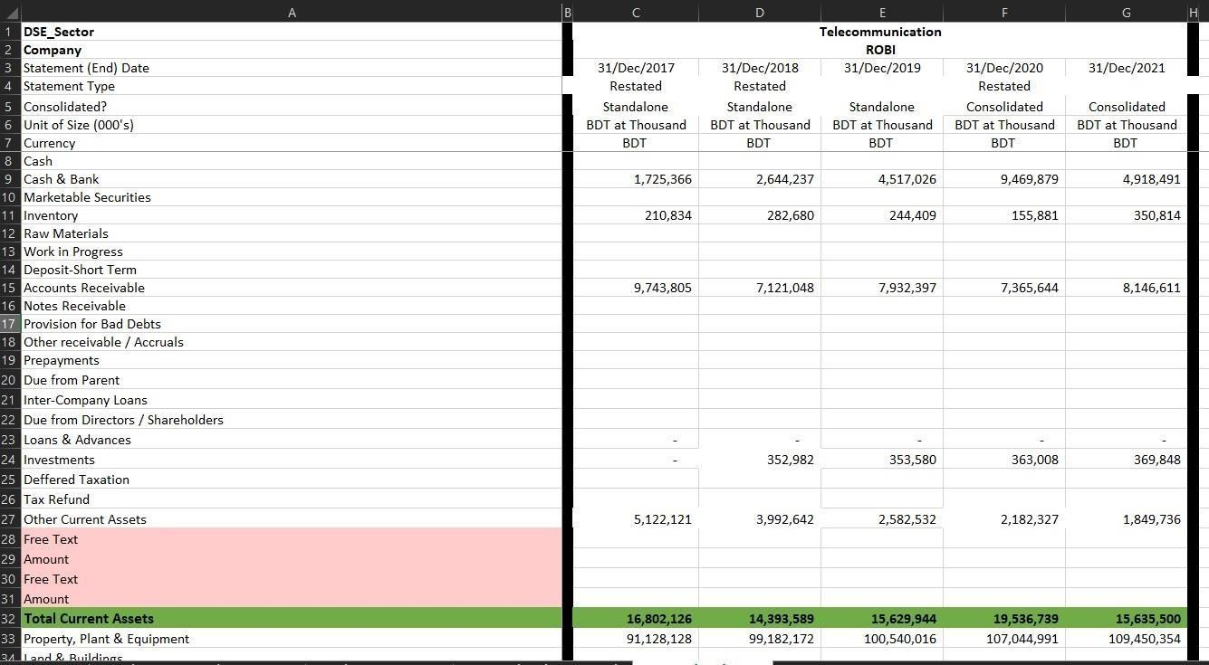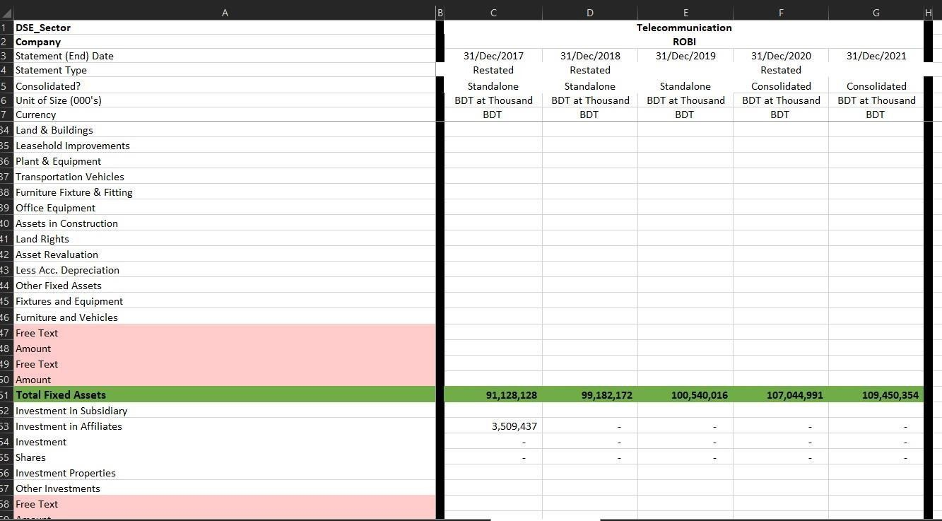

Format of Financial Statement for General Industry:

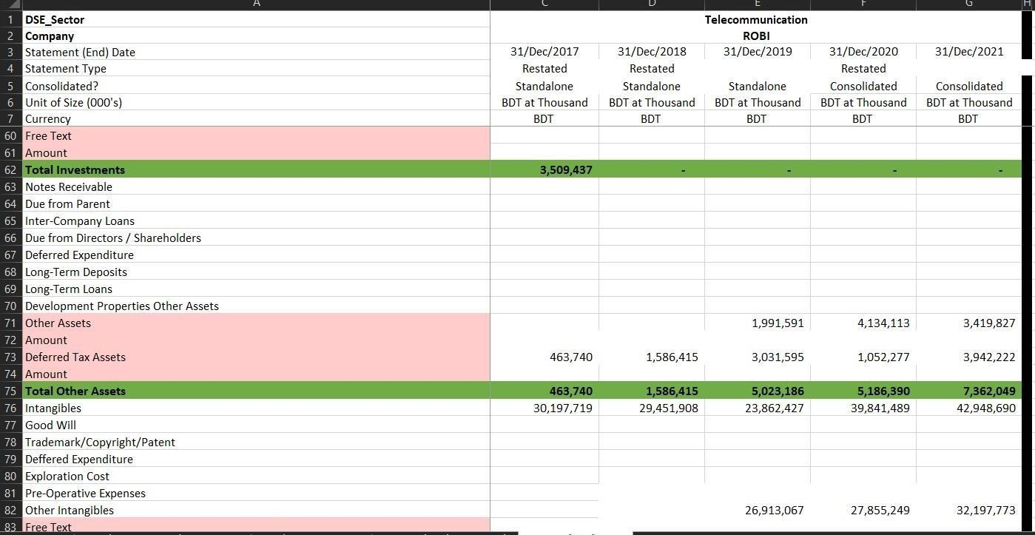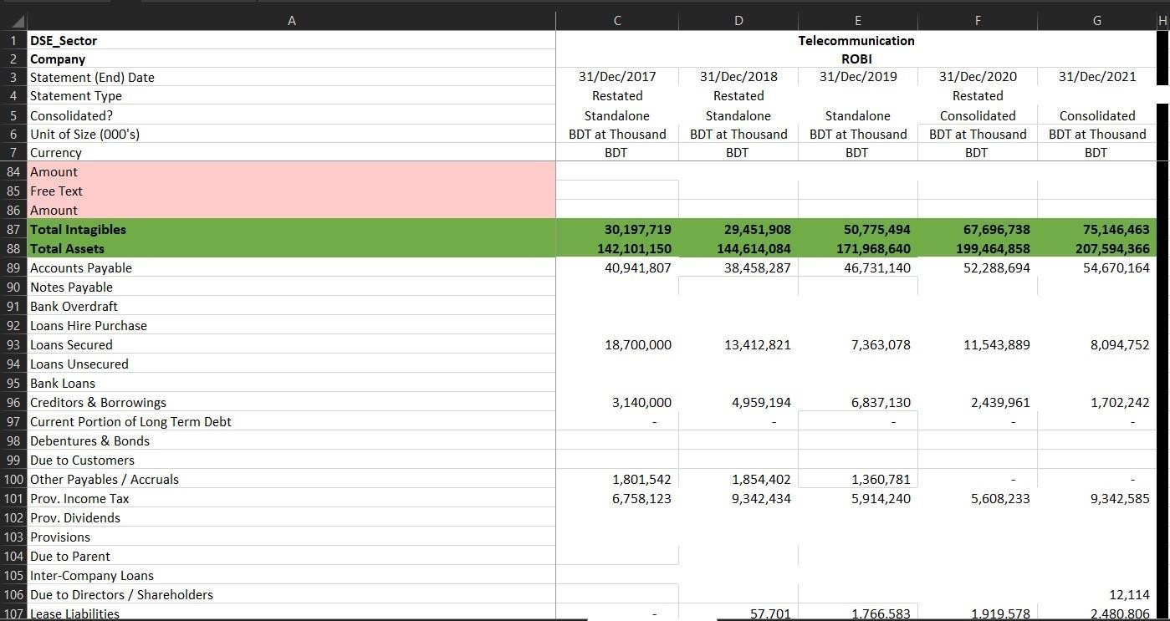

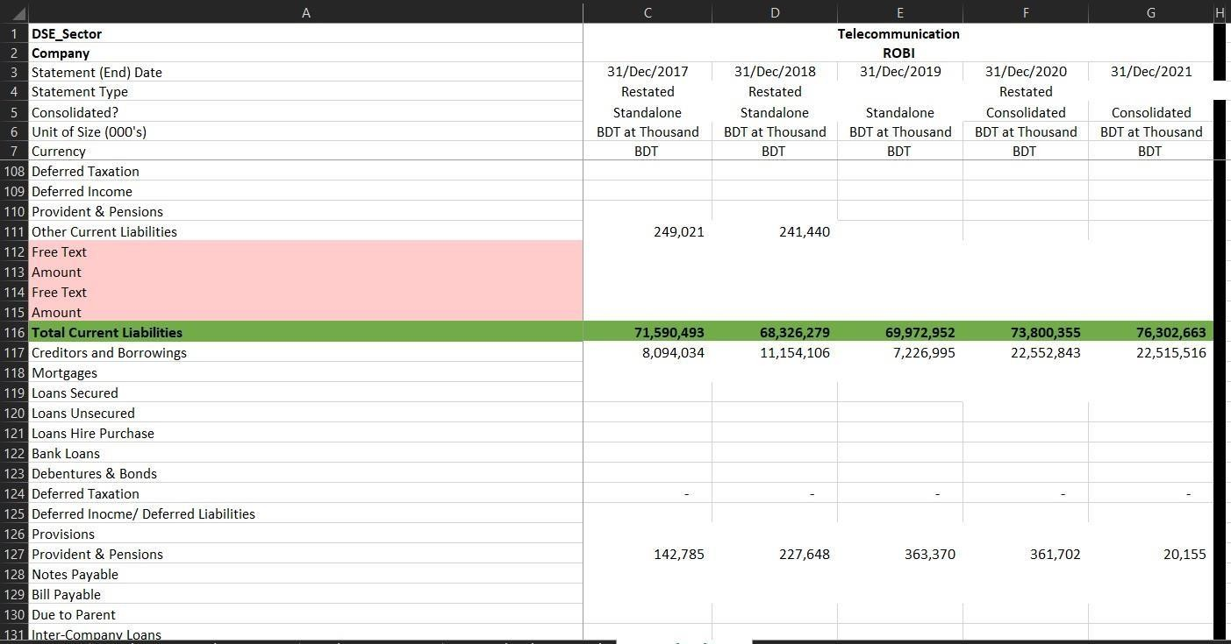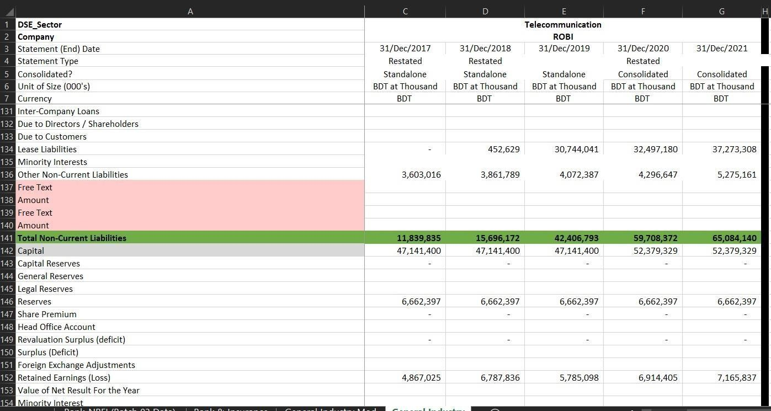

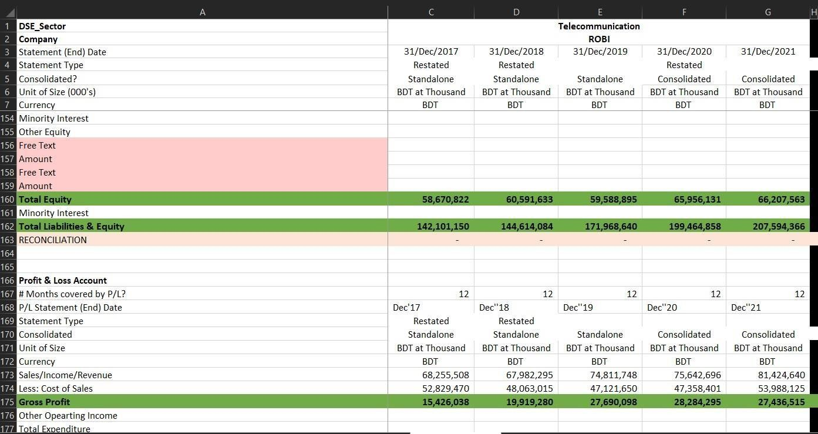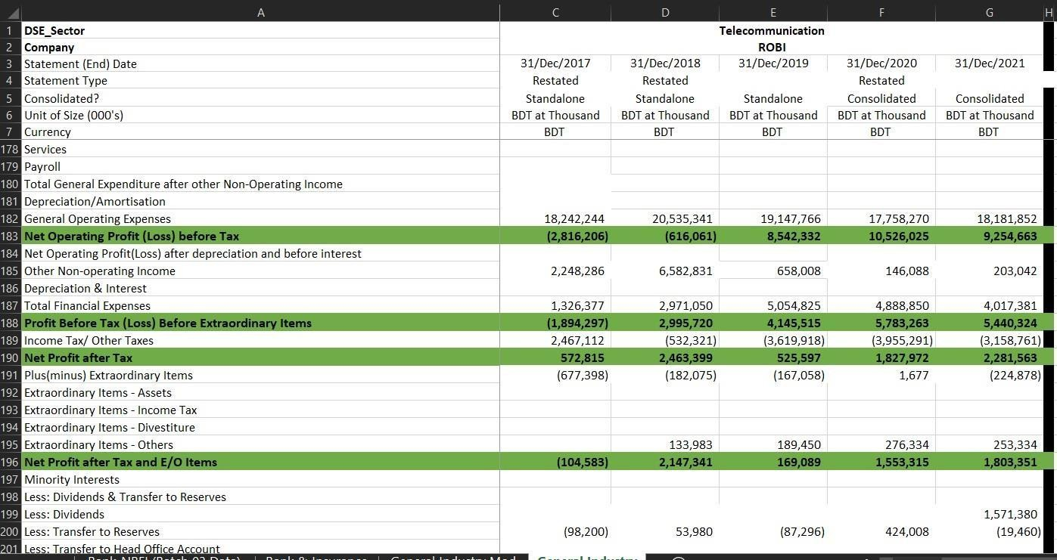

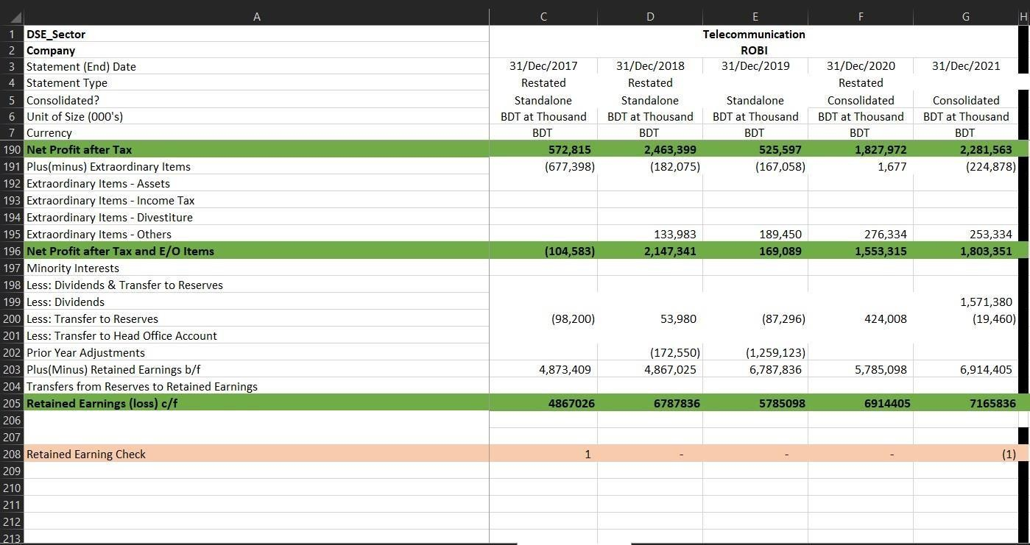

Learnings:
In this internship, most of the time, I worked in MS Excel and Google Spreadsheets. That’swhy I achieved great working skills in excel. You also learned how to navigate the LankaBD financial portal and how to upload data to the portal. Also, I now know all the options on this site. Through, this internship, I got to know the capital market intensively. You can now understand graphs of indices, prices, bid prices, ask prices, industry conditions, news, winners, losers, IPO updates, daily market reports and more. Also, through my project, I was able to know the annual accounts of various industries in Bangladesh. During this internship, I worked with over 100 DSE and CSE listed companies in various industries. Annual financial statement templates vary by industry. So, throughout this project, I have observed different kinds of degrees. Banking, NBFI and insurance industry in particular were the best parts of my learning.
However, through this internship, my communication skills improved. In my office, most of the time I was in touch with different employees from different departments. This has taught me how to communicate with senior management, supervisors and colleagues. I also learned to gain experience, work under pressure, and complete the required tasks on time.

Challenges:
Starting from an academic institution and working in a formal work environment for the first time is always difficult. During this full-time internship, I faced many challenges, tried to solve them and learned from these challenges. The first and biggest challenge was adapting to the new environment and culture. Strictly observe business hours from 8:00 a.m. to 3:30 p.m.
Second, working individually was difficult. My responsibility was based on the final project. Different industries have different bank statement templates and fields. We shared one Google Sheet with all the organization's data. It was tricky and the process was risky enough. One mistake can affect all the data in this table. In addition to sharing a single table that impacts internet connectivity. Also figuring out the correct names for the list items was difficult enough. First of all, it was very difficult to calculate the statement of changes in equity and get the correct value.
However, I overcome from all the challenges and dealing the corporate office effectively so far.

Contribution:
I have been working in LankaBangla for 3 month and I am hired for 4 months as an intern. However, I was hired for a special project in the department of financial content management. The project was about to develop a financial statement for the listed companies instructed by the foreign client. They gave us a format and according to the format we had to complete Balance Sheet, Profit & Loss account, and Equity Statement for the DSE and CSE listed companies.
At first, when I joined there, I was given to complete the file for the general companies which I have given those companies list above. We had a very short time to finish all the general companies which is why we had to work in the off days. But finally, we finished within the time boundaries and was able to submit files to them.
Secondly, came the second slot data, where we had to finish all the listed Banks and NBFIs statements. And the time was only 5 days but fortunately we completed all the statements and submit files again.
Then finally came listed general insurance files and life insurance files. We again completed all the files within the time. The most important thing is I was part of the project and helped them to complete the project perfectly.
Then I did some basic things for the financial portal of LankaBangla. Financial portal needs to be Updated all the time. And to keep the portal updated we need to always upload the very recent data to the financial portal. And this is the financial content departments responsibility to keep the portal updated. So, I was one of the members did upload the news to the portal.
So, these all are my contributions to the LankaBangla.

Conclusion:
As an intern I have had the great experience with LankaBangla. I enjoyed the environment, learning process and corporate behavior in LankaBangla. I learnt how to work under pressure, professionalism as well as productive communication with other colleagues. My supervisor as well as my department in charge was very supportive. Whenever I got stuck in work, they made me clear all the things very softly. I am very pleased to be a part of LankaBangla Securities as well as I am delighted to be a part of Financial Content Management department at LankaBangla Securities. Throughout my internship period I got to know many new things from them which will help me to tackle the unpleasant situation in the corporate world in the upcoming future. I will be grateful to my team as well as LankaBangla securities Limited for choosing me as an intern and also for giving me such a great learning experience in the short period of time.

Reference
- Lankabangla Financial Portal- Live stock data of Dhaka Stock Exchange (DSE), financial statements, research, chart and level 2 data. (n.d.). https://lankabd.com/
- 403 Forbidden. (n.d.). https://www.dsebd.org/

- i-Broker. (n.d.). https://ibroker.lbsbd.com/

- Otto, M. J. T. (n.d.). IDLC Securities Limited. https://securities.idlc.com/

- UIU DSpace Home. (n.d.). http://dspace.uiu.ac.bd/

- Google Scholar. (n.d.). https://scholar.google.com/

