Project Report
On
Management of Foreign Exchange of Al-Arafah Islami Bank Limited

Project Report
On
Management of Foreign Exchange of
Al-Arafah Islami Bank Limited

SUBMITTED TO:
Mohammad A.Ashraf
Associate Professor
School of Business & Economics
United International University

SUBMITTED BY:
Md. Zahid Ul Islam
ID- 111 122 036
School of Business and Economics
United International University (UIU)
Letter of Transmittal
Feb 4th, 2018
To,
Mohammad A. Ashraf
Associate Professor
United International University, Dhaka

Subject: Submission of Project Report on “Management of Foreign Exchange of
Al-Arafah Islami Bank Limited” .

Dear Sir,

It is my pleasure to submit the Project report entitled “Management of Foreign Exchange of Al-Arafah Islami Bank Limited” for the fulfillment of BBA degree. With available data, information and related knowledge what I have learnt from Finance courses, I have tried to make my paper as much comprehensive as possible.

I am grateful to you for giving me such an opportunity, and I appreciate this Project program. I hope that you will cordially receive my Project paper.

Sincerely yours,

Md. Zahid Ul Islam
ID- 111 122 036
School of Business and Economics
United International University (UIU)

Acknowledgement

At the very beginning, I might want to pass on my sincere appreciation to Allah for giving me the quality and the self-restraint to finish the Thesis report. Words really will never be sufficient to express how thankful I am, yet never the less I might attempt my level best to express my thankfulness toward a few people.
This Project report may never have been finished without the important learning of Finance, help of numerous books, articles, sites, and essential information. It improved my insight on Financial Statements, general exercises and in addition saving money business. Because of each one of those people, who have helped me, giving me collaboration, books and articles in setting up the proposal give an account of the allocated theme "Management of Foreign Exchange of Al-Arafah Islami Bank Limited"
I also would like to provide my sincere gratitude to Our United International University, School of Business and Economics, for providing me an opportunity to complete the internship program successfully. I would like to thank and I am very grateful to my project adviser Muhammad A. Ashraf (Associate Professor). I would like to convey my sincere gratitude to K. M. Shameem A Satter (Principal Officer) and other employees of Al-Arafah Islamic Bank Limited international Trade Services, Sub-Center, Banani and mirpur Branch, they helped me a lot to collect information for preparing my report.
I thank them all from the core of my heart.

Declaration

It is here by guaranteed that the Project report has been completely and precisely has done without anyone else's input. There is no copyright infringement in this report. To prepare the report, I have taken assistance from K. M. Shameem A Satter (Principal Officer) of Al-Arafah Islamic Bank Limited and furthermore utilize the annual report and other steady exercises for making the report.

I likewise affirm that, the report is set up for my scholarly prerequisite not for other reason and this report isn't submitted in some other place previously. I also guarantee that, this report was not submitted to some other colleges.

Sincerely yours,
Md. Zahid Ul Islam
ID- 111 122 036
School of Business and Economics
United International University (UIU)

Origin of the Report
Project Program of United International University is an Under-Graduation requirement for the BBA students. This study is a substitute of Internship program of BBA curriculum at the United International University where I have to work and assemble necessary information from Al-Arafa Islami Bank Limited with the guidelines of my respected thesis supervisor Mohammad A. Ashraf.

The report has been prepared as an academic requirement of achieving BBA degree by Md. Zahid Ul Islam, BBA student major in Finance from United International University, requested our honorable course teacher Mohammad A. Ashraf to supervise me during my Project program. He thoughtfully accepted my request and asked me to prepare a report on “Management of Foreign Exchange of Al-Arafa Islami Bank Limited” after my 4 months of course period there on. I gather all the essential info’s by 1 months long, after getting knowledge, I managed to prepare my report on “Management of Foreign Exchange of Al-Arafa Islami Bank Limited” and submitted to my honorable supervisor.

1.2 Scope of the Study
My respected supervisor granted me to prepare a thesis paper on “Management of Foreign Exchange of Al-Arafa Islami Bank Limited” and in this report I covered the whole foreign exchange activities of AIBL like Export, Import and Remittance.

Rationale of the Study
With the developing competitors among nationalized, Foreign and commercial banks is attempting in the matter of how the banks function its dealing with a record movement and how customer organization can be made engaging. Business or private banks are trying to survey their standard dealing with a record organization to an unrivaled standard, to meet the testing needs. So they center around better execution and nearness. Under the above conditions, it has ended up being fundamental for Al-Arafah Islami Bank Ltd, one of the principle business banks, to think towards the change, who are truly executing the methodologies grasped by the best organization will have a chance to pass on their slants and will have the feedback about their dealings from the customer.

Objectives of the Study
Broad objective:
• The wide target of this report is to think about the "Foreign exchange activities of AIBL".
Specific objectives:
• To comprehend controls in regards to “Foreign exchange” of AIBL.
• To break down the export import procedure of AIBL.
• To distinguish remittance management process of AIBL.

Methodology
To make the report more significant and presentable, two sources of data and information have been used extensively. These are Primary Data and Secondary Data and both of these primary and secondary data sources were used to construct the report. Please note that most of the information collected in secondary sources.
Primary Sources of Data:
- Personal surveillance.
- Face to face discussion with the officers and Clients.

Secondary Sources of Data:
- Annual report of Al-Arafah Islami Bank Ltd.
- Bangladesh Bank Periodical.
- Progress report of the Bank.
- Several kinds of Academic text-book and training sheet.
- Different publications regarding banking functions and foreign exchange operations.

Profile of the Al Arafah Islami Bank

Profile of the company

2.1 History of the Bank
Al-Arafah Islami Bank Ltd (AIBL) is a Banking company enlisted under the Company act, 1994 with its Head Office at Peoples Insurance building, 36 dilkusha commercial area, Motijheel, Dhaka-1000. The Bank began its activity from 27 September 1995.
With the goal of making progress here in this world and here after by seeking after the route coordinated by Allah and the way appeared by His Rasul (SM), Al-Arafah Islami Bank Ltd. was set up as a private limited company.
Al-Arafah Islami Bank is a interest free shariah bank and its method of activity is considerably not quite the same as those of other commercial banks. The bank be that as it may, renders a wide range of business keeping money benefits under the direction of the Bank company Act 1991. It directs its business on the standards of musharaka, bai-murabaha, bai-muajjal and hire purchase transactions.

2.2 Objective of AIBL
Objectives define the outcomes anticipated from seeking after specific techniques. Objectives ought to be quantitative, quantifiable, sensible, justifiable, testing, various leveled, reachable and consistent among hierarchical units. AIBL has built up their goals to accomplish their key and monetary focuses to have solid upper hand in the saving money division. The destinations for which AIBL is built up are:
• To set up relationship saving money.
• To stay a standout among other bank in Bangladesh.
• To present completely computerized saving money framework.
• To keep hazard position at a worthy rate.
• To keep up satisfactory liquidity.
• To keep up sound development of business with wanted picture.
• To control the framework and guarantee the straightforwardness.
• Proper use of assets.

2.3 Vision of AIBL
To be a pioneer in Islamic Bank in Bangladesh, contribute altogether towards the national economy and furthermore to build up premium free exchange in the economy.
2.4 Mission of AIBL
At first to fulfill the Almighty Allah both in this world an even the hereafter and furthermore to expand the volume of shariah based Managing an account.
2.5 Corporate culture
Employees of AIBL share certain common values, which helps to create a AIBL culture.
• The customer comes first.
• Search for proficient magnificence.
• Openness to new thoughts and new techniques to energize imagination.
• Quick basic leadership.
• Flexibility and incite reaction.
• A feeling of expert morals.
2.6 Strategies of AIBL
• To manage and operate the Bank in the most efficient manner to enhance financial performance and to control cost of fund.
• To take a stab at consumer satisfaction through quality control and delivery of quality services.
• To distinguish clients credit and other saving money needs and screen their observation towards our execution in meeting those prerequisite.
• To survey and refresh strategies, systems and practices to improve the capacity to stretch out better administrations to clients.
• To prepare and build up all representatives and give sufficient assets with the goal that client needs can meet, be mindfully tended to.

2.7 Management
AIBL is managed by highly professional people. The present Managing Director of the bank is a forward-looking senior banker having decades of experience and multi discipline knowledge to his credit both at home and abroad. He is supported by an educated and skilled professional team with diversified experience in finance and banking. The management of the bank constantly focuses on the understanding and anticipating customer’s needs and offers solutions thereof. Al-Arafah Islami Bank Ltd has already achieved tremendous progress within a short period of its operation. The bank is already ranked as one of the quality service providers & known for its reputation. Management of Al-Arafah Islami Bank Ltd is headed & leaded by the renowned banking personality Alhajj Abdus Samad.

2.8 Hierarchy of AIBL
Chairman
Managing Director (MD)
Deputy Managing Director (DMD)
Executive Vice President (EVP)
Senior Vice President (SVP)
Vice President (VP)
Assistant Vice President (AVP)
First Assistant Vice President (FAVP)
Senior Principal Officer (SPO)
Principal Officer (PO)
Senior Executive Officer (SEO)
Management Trainee Officer (MTO)
Executive Officer (EO)
Officer

2.9 Branches of AIBL
Al-Arafah Islami Bank Ltd is the Private bank in Bangladesh. There are 110 branches all over the country.
Total Branches of Al-Arafah Islami Bank Ltd:

Zone | Branches
Dhaka | 56
Chittagong | 26
Rajshahi | 07
Sylhet | 07
Barisal | 05
Khulna | 09
Total | 110

2.10 Sponsors
The sponsors of AIBL are very effective driving business people of the nation having stakes in various fragments of the national economy. They are famous industrialists and specialists having wide business notoriety both at home and abroad.

The Management of Foreign Exchange of Al-Arafah islami Bank

3.1 Export
The merchandise and services sold by Bangladesh to foreign families, agents and Government are called export. The export exchange of the nation is directed by the Imports and Exports (control) Act, 1950. There are various conventions, which an exporter needs to satisfy when shipment of products. The exports from Bangladesh are liable to export exchange control practiced by the Service Of Trade through Boss Controller of Imports and Exports (CC and E). The conventions and technique are listed as takes after:
1. Getting exports LC: To get export LC frame exporter issued by the shipper.
2. Accommodation of export report: Exporter needs to present every single important record to the gathering bank in the wake of transportation of merchandise
3. Checking of export report: In the wake of getting the archives broker used to check the records according to LC terms
4. Transaction of export report: If the bank acknowledges the archive and pays the esteem draft to the exporter and forward the record to issuing bank that is known as an arranging bank. In the event that the bank buys the LC then the bank regularly goes about as gathering bank.
5. Acknowledgment of continues: This is the period when the issuing bank has understood the installment.
6. Answering to the Bangladesh Bank: according to direction by Bangladesh bank the bank needs to answer to separate bureau of Bangladesh bank by specifying most recent installment.
7. Issue to Continues acknowledgment endorsement (PRC): Bank needs to issue go before acknowledgment testament of export LC to the provider/exporter for getting money help.
  - 3.1.1 Export task:
Bangladesh exports a substantial amount of products and ventures to foreign family units. Readymade material articles of clothing (both weaved and woven), Jute, Jute-made items, solidified shrimps, tea are the fundamental products that Bangladeshi exporters exports to foreign nations. Articles of clothing area is the biggest part that exports the lion offer of the nation's export; Bangladesh exports the vast majority of its readymade pieces of clothing items to U.S.A and European People group (EC) nations, Bangladesh exports around 40% of its readymade articles of clothing items.
  - 3.1.2 Advantages of export activities:
Proprietorship focal points are the association's particular resources, universal experience, and the capacity to grow either ease or separated items inside the contacts of its esteem chain. The locational points of interest of a specific market are a blend of market potential and speculation chance. Internationalization focal points are the advantages of holding a center capability inside the organization and threading it however the esteem fasten as opposed to acquire to permit, outsource, or offer it.
  - 3.1.3. Disadvantages of export tasks:
For Small and medium endeavors (SME) with under 250 workers, pitching products and ventures to foreign markets is by all accounts more troublesome than serving the local market. The absence of learning for exchange controls, social contrasts, distinctive dialects and foreign-trade circumstances and in addition the strain of assets and staff collaborate like a square to export, the accompanying suspicions demonstrates the fundamental points of interest.
• Financial administration exertion.
• Customer request.
• Management botches.
  - 3.1.4. Ways of exporting:
The organization can choose to export straightforwardly or in a roundabout way to a foreign nation.
• Direct offering in export procedure.
• Direct offering through wholesalers.
• Evaluating wholesalers.
• Direct offering through foreign retailers and end clients.
• Direct offering through web.
Circuitous offering implies offering through middle person.

3.2 Import
To import, a man ought to be skillful to be and merchant. As per Import and Export Control Act, 1950, the Workplace of Boss Controller of Import and Export gives the enrollment (IRC) to the shipper. In a universal business condition, purchasers and dealers are for the most part obscure to each other. So dealer of products dependably looks for security for the installment of his exported merchandise. Bank gives export ensure that it will pay for the products for the benefit of the purchaser if the purchaser does not pay. This assurance is called Letter of Credit. In this way the agreement amongst shipper and exporter is given a legitimate shape by the broker by 'Letter of Credit'.

  - 3.2.1 Kinds of import:
1) Industrial and shopper merchandise.
2) Intermediate merchandise and enterprises.

Organizations import merchandise and enterprises to supply to the household showcase at a modest cost and preferable quality over contending products made in the local market. Organizations import items that are not accessible in the neighborhood advertise.

  - 3.2.2 Two expansive kinds of merchants:
1. Looking for any item around the globe to import and offer.
2. Looking for foreign sourcing to get their items at the least expensive cost.
3.3 Remittance
A remittance is an exchange of cash by a foreign laborer to a person in his or her nation of origin. Cash sent home by transients rivals global guide as one of the biggest budgetary inflows to creating nations. Specialists remittances are a huge piece of global capital streams, particularly concerning work exporting nations.

3.1.1 History of Remittance:
Remittances are not another marvel on the planet, being a typical attendant to relocation which has dependably been a piece of mankind's history. A few European nations, for instance Spain, Italy and Ireland were vigorously reliant on remittances, even Bangladesh is generally subject to remittance, In Asia the vast majority of the nations are reliant on foreign remittance on the grounds that the greater part of the nations are no so rich.

  - 3.4 Confinements on import and export of certain money:
1) The Government may, by notice in the official Periodical, arrange that, subject to such exclusions, assuming any, as might be contained in the warning, no individual should, aside from with the general or extraordinary authorization of the National Bank and on installment of the charge, assuming any, recommended bring or send into the nation any gold or silver or any money notes or monetary certificates or coin whether nation or another nation.

2) No man should, aside from with the general or exceptional authorization of the National Bank or the composed consent of a man approved for this sake by the National Bank, remove or send from nation any gold, gems or valuable stones, or cash notes, certified receipts or coin or foreign trade.

  - 3.5 Foreign Trade Division:
The Foreign Trade Division is partitioned into two segments:
I. Foreign Exchange (L/C Task): It incorporates Import and Export.
ii. Foreign Remittance.

3.6 Import
Import implies buy of merchandise and enterprises from the foreign nations. Typically purchasers, firms, businesses and Legislature of Bangladesh import products to meet their different necessities. In this way, in short we can state that import is the stream of products and ventures bought by monetary specialist remaining in the nation from financial operator remaining abroad.

  - 3.7 Import Regulations:
According to Import and Export control Act 1950 no individual can indent, import or export any products in Bangladesh aside from if there should be an occurrence of exclusion issued by the administration of the people groups of Bangladesh. As indicated by Import and Export Control Act, 1950, to be a merchant the individual ought to get the Import Enlistment Authentication (IRC) from the Workplace of Boss Controller of Import and Export. Merchandise from South Africa and Israel or products began from these nations are not importable. Import of merchandise into Bangladesh isn't passable on the banner vessel of Taiwan, South Africa and Israel.
  - 3.8 Methodology of Import Enrollment Authentication (IRC):
To bear on the matter of import the main thing one needs is enrollment with the authorizing specialist of the zone. To get this enlistment the intrigued individual/foundations presents the application alongside the accompanying papers/reports straightforwardly to the main controller of imports and Exports or particular zonal workplaces of CCI&E. Following papers/reports are typically required to acquire IRC,

1. Salary impose enlistment testament.
2. Nationality testament.
3. Testament from Council of Business and Industry or Enlisted Exchange Affiliation.
4. Bank dissolvability testament.
5. Duplicate of exchange permit.
6. A sending letter to the CCI&E.

On accepting application the individual CCI&E workplaces will examine the reports and lead physical confirmation (if essential) and issue request notice to the forthcoming Shippers to outfit the accompanying papers/records through their selected Bank:

1. Unique duplicate of Treasury Chillan stored as IRC expenses.
2. Resources declaration.
3. Two duplicates of international ID measure photos of the Shipper.
4. In the event of organization enlisted association deed.

The assigned bank of the candidate will investigate the papers/archives and check the mark of the candidate. In the wake of examining and check the designated bank will forward the same to the separate CCI&E office with sending plan for copy through bank's illustrative. The CCI&E office will recognize on copy duplicate of the sending calendar and return back the same to the bank delegate on being fulfilled in the wake of examining of the records the individual zonal workplaces of CCI&E will issue Import Enlistment Authentication (IRC) to the candidates.
  - 3.9 Strategies for Import:
There exist various systems of bringing in merchandise from the foreign nation. Merchandise might be specifically transported in from the foreign fabricates or they might be foreign through the offering operators of the foreign makers. Whoever does the capacity there are a few phases of bringing in, which are as per the following:
Trade Enquiry
Procurement of Import Licence and Quota
Obtaining Foreign Exchange
Placing the Indent or Order
Dispatching a Letter of Credit
Obtaining Necessary Documents
Customs Formalities and Clearing of Goods
Making the Payment
Closing the Transactions

  - The means taken in import methodology are talked about as takes after:
(1) Trade Enquiry:
The primary stage in an import exchange, similar to some other exchange of procurement and deal identifies with making exchange enquiries. An enquiry is a composed demand from the meaning purchaser or his operator for data in regards to the cost and the terms on which the exporter will have the capacity to supply products.
The shipper should specify in the enquiry every one of the points of interest, for example, the products required, their depiction, list number or review, size, weight and the amount required. So also, the time and technique for conveyance, strategy for pressing, terms and conditions concerning installment ought to likewise be demonstrated.
In answer to this enquiry, the merchant will get a citation from the exporter. The citation contains the points of interest with regards to the products accessible, their quality and so on., the cost at which the merchandise will be provided and the terms and states of the deal.
(2) Acquisition of Import Permit and Standard:
The import exchange BD is controlled under the Imports and Exports (Control) Act, 1950. A man or a firm can't import products into BD without a legitimate import permit. An import permit might be either broad permit or particular permit. Under a general permit merchandise can be foreign from any nation, though a particular or individual permit approves to import just from particular nations.
The Legislature of BD announces its import approach in the Import Exchange Control Strategy Book called the Red Book. Each merchant should first see if he can import the merchandise he needs or not, and the amount of a specific class of products he can import amid the period secured by the pertinent Red Book.
For the reason for issuing permit, the merchants are partitioned into three classes:
(a) Set up merchant.
(b) Genuine clients.
(c) Enrolled exporters, i.e., those import under any of the export advancement plans.
With a specific end goal to get an import permit, the proposing merchant needs to make an application in the endorsed shape to the authorizing expert. In the event that the individual imported merchandise of the class in which he is intrigued now amid the essential time frame recommended for such class, he is dealt with as a built up shipper.
A built up shipper can influence an application to secure a Quantity To testament. The testament determines the amount and estimation of products which the merchant can import. For this, he outfits points of interest of the products imported in any one year in essential period endorsed for the merchandise together with narrative proof for the same, including a declaration from a sanctioned bookkeeper in the recommended frame ensuring the c.i.f. estimation of the products imported in the chose year.
The c.i.f. esteem incorporates the receipt cost of the products and the cargo and protection paid for the merchandise in travel. The share testament qualifies the built up merchant for import up to the esteem showed in that (called Standard) which is ascertained based on past imports. On the off chance that the shipper is a genuine client, that is, he needs to import merchandise for his own particular use in modern assembling process he needs to get permit through the recommended supporting specialist.
The supporting specialist guarantees his necessities and suggests the allow of permit. If there should be an occurrence of little businesses having a capital of not as much as Tk. 5 lakhs, they need to apply for licenses through the Executive of Businesses of the state where the business is found or some other expert explicitly endorsed by the Administration.
(3) Submitting the Indent or Request:
After the underlying customs are finished and the merchant has acquired the permit quantity and the essential measure of foreign trade, the subsequent stage in the import of merchandise is that of putting in the request. This request is known as Indent. An indent is a request set by a shipper with an exporter for the supply of specific products.
It contains the directions from the shipper with regards to the amount and nature of merchandise required, strategy for sending them, nature of pressing, method of settling installment and the cost and so forth. An indent is generally arranged in copy or triplicate. The indent might be of a few sorts like open indent, shut indent and Corroborative indent.
In open indent, all the essential particulars of products, cost, and so forth are not specified in the indent, the exporter has the circumspection to finish the conventions, at his own end. Then again, if full particulars of merchandise, the value, the brand, pressing, shipping, protection and so on are said obviously, it is known as a shut indent. A corroborative indent is one where a request is put subject to the affirmation by the merchant's operator.
(4) Dispatching a Letter of Credit:
For the most part, foreign dealers are not familiar to each other thus the exporter before transportation the products needs to make sure about the reliability of the merchant. The exporter needs to make sure that there is no danger of non-installment. For the most part, for this reason he requests that the merchants send a letter of credit to him.
A letter of acknowledge, famously known as 'L/C or 'L.C is an endeavor by its guarantor (more often than not merchant's bank) that the bills of trade drawn by the foreign merchant, on the shipper will be respected on introduction up to a predefined sum.
(5) Acquiring Fundamental Records:
Subsequent to dispatching a letter of credit, the shipper has not to do much. On receipt of the letter of credit, the exporter orchestrates the shipment of products and sends Exhortation Note to the shipper instantly after the shipment of merchandise. An Exhortation Note is an archive sent to a buyer of merchandise to illuminate him that products have been dispatched. It might likewise show the plausible date on which the ship is relied upon to achieve the port of goal.
The exporter at that point draws a bill of trade on the merchant for the receipt estimation of merchandise. The transportation reports, for example, the bill of filling, receipt, protection strategy, declaration of inception, customer receipt and so on., are additionally joined to the bill of trade. Such bill of trade with all these appended reports is called Narrative Bill. Narrative bill of trade is sent to the shipper through a foreign trade bank which has a branch or a specialist in the merchant's nation for gathering the installment of the bill.
There are two kinds of narrative bills:
(a) D/P, D.P. (or then again Records against installment) bills.
(b) D/A, D.A. (or then again Record against acknowledgment) bills.
On the off chance that the bill of trade is a D/P charge, at that point the records of title of products are conveyed to the cabinet (i.e., shipper) just on the installment of the bill in full. D/P bill might be locate charge. If there should be an occurrence of sight charge, the installment must be made instantly on the introduction of the bill. Be that as it may, as a rule a beauty time of 24 hours is allowed.
Since charge is to be paid inside a specific period after sight. In the event that the bill is a D/A bill, at that point the archives of title of merchandise are discharged to the cabinet on his acknowledgment of the bill and it is held by the financier till the date of development. Normally 30 to 90 days are accommodated the installment of the bill.
(6) Traditions Customs and Clearing of Merchandise:
Subsequent to accepting the reports of title of the merchandise, the shipper's just concern is to take conveyance of the products, when the ship lands at the port and to convey them to his own particular place of business. The shipper needs to conform to numerous customs for taking conveyance of products. Unless the accompanying specified conventions are consented to, the products lie in the authority of the Custom House.
(a) To get support for conveyance or conveyance arrange:
At the point when the ship conveying the merchandise lands at the port, the shipper, as a matter of first importance, needs to acquire the support on the back of the bill of filling by the delivery organization. Some of the time the transportation organization, rather than embracing the bill to support him, issues a conveyance request to him. This underwriting of conveyance request will qualifies the shipper for take the conveyance of the products.
The transportation organization makes this underwriting or issues the conveyance arrange simply after the installment of cargo. On the off chance that the exporter has not paid the cargo, i.e., when the bill, of filling is stamped cargo forward, the shipper needs to pay the cargo so as to get green flag for the conveyance of merchandise.
(b) To pay Dock levy and acquire Port Trust Duty Receipts:
The shipper needs to submit two duplicates of a frame known as 'Application to import' appropriately filled in to the 'Replenishing and Transporting Levy Office'. This office collects a charge on every single imported useful for administrations rendered by the dock experts regarding filling of products. Subsequent to paying the essential charges, the merchant get back one duplicate of the application to import as a receipt 'Port Trust Contribution Receipt'.
(c) Bill of Passage :
The merchant will then fill in frame called Bill of Passage. This is a shape provided by the custom office and is to be filled in triplicate. The bill of section contains the particulars with respect to the name and address of the shipper, the name of the ship, bundles number, marks, amount, esteem, depiction of merchandise, the name of the nation wherefrom products have been foreign made and custom obligation payable.
The bill of section shapes are of three sorts and are imprinted in three hues Dark, Blue and Violet. A dark frame is utilized for non-dutiable or free products, the blue shape is utilized for merchandise to be sold inside the nation and the violet shape is utilized for re-exportable merchandise, i.e., merchandise implied for re-export. The shipper needs to submit three types of bill of section alongside Port Trust Duty Receipt to the traditions office.
(d) Bill of Sight :
On the off chance that the merchant isn't is a position to supply the nitty gritty particulars of merchandise on account of deficiency of data provided to him by the exporter, he needs to set up an announcement called a bill of sight. The bill of sight contains just the data controlled by the shipper alongside a comment that he isn't in a position to give finish data about the products. The bill of sight empowers him to open the bundle and analyze the products within the sight of custom officer in order to finish the bill of section.

(e) To pay Traditions or Import Obligation :
There are three kinds of imported merchandise:
(I) Non dutiable or free products,
(ii) Products which are to be sold inside the nation or which are for home utilization.
(iii) Re-exportable products i.e. products implied for re-export. In the event that the merchandise are without obligation, no import obligation is to be paid at the custom office.
Custom experts will allow the conveyance of such products after common examination of the merchandise. Be that as it may, if the merchandise are at risk for obligation, the shipper needs to pay custom or import obligation which might be founded on weight or estimation of products, called Particular Obligation or on the estimation of imported products Promotion valorem Tune.
There are three kinds of import obligations. On a few products very low obligations are exacted and they are called income obligations. On some others, very high obligations are charged to offer insurance to home ventures against foreign rivalry. While merchandise imported from specific countries are given particular treatment for the require of import obligations and for their situation full defensive obligations are not charged.
(f) Reinforced and Obligation paid Distribution centers :
The port trust and custom specialists keep up two kinds of distribution centers Fortified and Obligation paid. These distribution centers are arranged close to the dock and are exceptionally helpful to shippers who don't have stockroom of their own to store the foreign made merchandise or who, for business reasons, don't wish to convey them to their own particular distribution center.
The merchandise on which the obligation has just been paid by the shipper can be kept in the obligation paid distribution centers for which a receipt called 'stockroom receipt' is issued to him. This receipt is an archive of title and is transferable. The fortified distribution centers are implied for merchandise on which obligation has been paid by the shipper. On the off chance that the shipper can't pay the obligation, he may keep the merchandise in Fortified distribution centers for which he is issued a receipt, called 'Dock Warrant'. Dock Warrant, likewise like distribution centers receipt, is an archive of title and is transferable.
The fortified stockrooms are utilized by the shipper when:
(I) He has no storage facility of his own.
(ii) He can't pay the obligation quickly.
(iii) He needs to re-export the merchandise and in this manner does not have any desire to pay the obligation.
(iv) He needs to pay the obligation in portions.

An ostensible lease is charged for the utilization of these stockrooms. One extraordinary preferred standpoint of these distribution centers is that the shipper can offer the merchandise and exchange the title of products only by supporting stockroom receipt or dock-warrant. This will spare the shipper from the inconvenience and costs of conveying the products from the distribution centers to his go down.
(g) Arrangement of clearing Operators :
At this point we comprehend that the merchant needs to satisfy numerous legitimate conventions previously he can take conveyance of merchandise. The shipper may take the conveyance of the merchandise himself at the port. In any case, it includes a lot of time, costs and trouble. Subsequently, to spare himself from the botheration of consenting to all the confounded conventions, the merchant may select clearing specialists for taking the conveyance of the merchandise for him. Clearing operators are the specific people occupied with crafted by performing different conventions required for taking the conveyance of products for others. They charge some compensation on playing out these important administrations.

(7) Making the Installment
The mode and time of making installment is resolved by the terms and conditions as consented to before between the merchant and the exporter. If there should arise an occurrence of a D/P charge the archives of title are discharged to the shipper just on the installment of the bill in full. On the off chance that the bill is a D/A bill, the records of title of the products are discharged to the merchant on his acknowledgment of the bill. The bill is held by the investor till the date of development. More often than not, 30 to 90 days are permitted to the merchant for making the installment of such bills.
(8) Shutting the Exchanges
The last advance in the import exchange technique is shutting the exchange. On the off chance that the merchandise are as per the general inclination of the shipper, the exchange is shut. However, in the event that he isn't happy with the nature of merchandise or if there is any deficiency, he will keep in touch with the exporter and settle the issue. On the off chance that the products have been harmed in travel, he will assert pay from the insurance agency. The insurance agency will pay him the remuneration under a guidance to the exporter.
3.10 Export
Export intends to exchange merchandise starting with one place then onto the next. The exporter must pay obligation on products exported. The exporter ought to get enrollment from the workplace the main controller of import and export, exchange permit ERC, LCA to open export L/C.

  - 3.11 Methods of Export:
Having an Export Order
Assessment and Confirmation of Order
Developed or Procuring Goods
Clearance from middle Excise
Pre-Shipment Inspection
Appointment of Clearing and Forwarding Agents
commodities to Port of Shipment
Port Formalities and Customs authorization
Dispatch of Documents by Forwarding Agent to the Exporter
Certificate of Origin
Dispatch of Shipment Advice to the Importer
Submission of papers to Bank
Asking Export incentives
  - 4.12 The steps of Export:
As a general rule, an export practice is closed effectively simply after the exporter has possessed the capacity to convey the relegation as per the export contract and get installment for the merchandise.

This includes routine with regards to recommended methodology to be performed. The truth of the matter is that one needn't bother with just to be extremely very much educated about his/her export organization, his/her items, his/her providers, his/her export chain, his/her market, the world market, yet one likewise has to know the export principles and terms, the distinctive societies that one targets and the last clients' needs.

At that point comes satisfying these necessities by the most focused path and by enhancing one's administrations. This is so since all offer similar items with minor changes, however what has the effect is the strategy and the esteem added administrations one gives to a definitive buyers. Basically, that influencing an export to organization is a simple procedure, yet influencing effective and dependable export to organization is an exceptionally troublesome errand

Consequently, it appears to be germane now to influence you to take in the different advances' engaged with the handling of an export arrange.
These are recorded as takes after:

1. Having an Export Request:
Preparing of an export arrange begins with the receipt of an export arrange. An export arrange, basically expressed, implies that there ought to be an assention as a record, between the exporter and shipper before the exporter really begins creating or acquiring products for shipment. By and large an export request may appear as pre-format receipt or buy request or letter of credit. You have as of now learnt these equitable in the previous segment.

2. Examination and Affirmation of Request:
Having gotten an export arrange, the exporter ought to inspect it with reference to the terms and states of the agreement. Truth be told, this is the most critical stage as every single consequent activity and responses rely upon the terms and states of the export
arrange.

The examination of an export arrange, hence, incorporates things like item depiction, terms of installment, terms of shipment, review and protection necessity, archives acknowledging installment and the last date of transaction of reports with the bank. Having being happy with these, the export arrange is affirmed by the exporter.

3. Assembling or Getting Merchandise:
The National Bank of Bangladesh, under the export credit (premium sponsorship) plot, stretches out pre-shipment credit to exporter to fund working capital requirements for buy of crude materials, preparing them and changing over them into completed merchandise with the end goal of exports. The exporter approaches the depend based on set down methodology for the pre-shipment credit. Having gotten credit, the exporter begins to make/get and pack the merchandise for shipment abroad.

4. Leeway from Focal Extract:
When products have been made/acquired, the procedure for getting leeway from focal extract obligation begins. The Focal Extract and Deal Demonstration of BD and the related guidelines give the discount of extract obligation paid. There are two elective plans whereby 100 for each penny refund on obligation is given to export items on the accommodation of the confirmation of shipment.

The main plan is to make installment of the extract obligation at the season of expelling the export committal from the production line and record a claim for refund of obligation after exportation of merchandise. The second plan is to expel products from industrial facility/distribution center without installment yet under a suitable bond with the extract specialists.

5. Pre-Shipment Examination:
There are number of-merchandise whose export requires quality confirmation according to the Legislature of BD notice. Thusly, the BD custom experts will require the accommodation of an examination declaration issued by the capable and assigned specialist before allowing the shipment of merchandise happens.
Investigation of export merchandise might be led under:
(i) Consignment-wise Examination.
(ii) (ii) In-process Quality Control.
(iii) (iii) Self-Affirmation.

The Examination Testament is issued in triplicate. The first duplicate is for the traditions check. The second duplicate of the authentication is sent to the merchant and the third duplicate stays with the exporter for his reference reason.

6. Arrangement of Clearing and Sending Agents:
On culmination of the way toward acquiring the Review Endorsement from the custom organizations, the exporter names clearing and sending operators who play out various capacities in the interest of the exporter.
The fundamental capacities performed by these operators incorporate pressing, checking and naming of relegation, plan for transport to the port course of action for shipment abroad, traditions leeway of freight, obtainment of transport and different reports.

Keeping in mind the end goal to encourage the exporter in releasing his obligations, the accompanying reports are submitted to the operator:
(I) Business receipt in 8-10 duplicates
(ii) Traditions Revelation Shape in triplicate
(iii) Pressing rundown
(iv) Letter of Credit (unique)
(v) Assessment Testament (unique)
(vi) G.R. Frame (in unique and copy)
(vii) AR4/AR4A (in unique and copy)
(viii) GP-l/GP-2 (unique)
7. Merchandise to Port of Shipment:
After the extract freedom and pre-shipment examination conventions are finished, the merchandise to be exported are pressed, stamped and marked. Appropriate stamping, marking and pressing help snappy and safe transportation of products. The export office finds a way to save space on the ship through which products are to be sent to the merchant.
The delivery space can be held either through the clearing and sending specialist or cargo dealer who takes a shot at sake of the transportation organization or specifically from the delivery organization. Once the space is saved, the transportation organization issues a record known as Delivery Request. This request fills in as a proof of room reservation.
In the event that merchandise are sent through a street transporter to the port, no particular custom is included. On the off chance that, the merchandise are sent by rail to the port of shipment, assignment of wagon should be acquired from the Railroad Board.
The accompanying records are submitted to the booking railroad yard/station:
(I) Sending Note (A Railroad Report)
(ii) Transportation Request
(iii) Wagon Enlistment Expense Receipt

When wagons have been allocated, products are stacked, for which railroads will issue Rail route Receipt (RR). At that point, this receipt and different records are sent to the clearing and sending operator at the port town. In the meantime, the generation/export division takes protection approach in copy for hazard scope (inside and also abroad) for the products to be exported.

8. Port Conventions and Traditions Leeway:
Having gotten the reports from the export division, the clearing and sending operator takes conveyance of the payload from the railroad station or the street transport organization and stores it in the distribution center. He likewise acquires traditions freedom and authorization from the port experts to carry the payload into the shipment shed. The custom division awards consent for export at the workplace of the traditions and physical check of merchandise in the shipment shed. The leeway for export is given on the Transportation Bill.
The clearing and sending operator is required to present the accompanying records with the Traditions House for getting traditions freedom and authorization:
(I) Delivery Bill
(ii) Contract Shape
(iii) Letter of Credit, if appropriate
(iv) Business Receipt
(v) GR Frame
(vi) Investigation Authentication
(vii) AR4/AR4A Shape
(viii) Pressing Rundown, if necessary

In the wake of accepting records from the export office, the clearing and sending specialist exhibits the Port Put stock in Archive to the Shed Administrator of the port. He gets trucking request conveying the load to the travel shed for physical examination by the Dock Appraiser.

The Dock Appraiser is introduced the accompanying reports to encourage him in physical examination of export products:
(I) Transportation Bill
(ii) Business Receipt
(iii) Pressing Rundown
(iv) AR4/AR4A Frame and Door Pass
(v) GR Frame (copy)
(vi) Review Endorsement (unique)

The Dock Appraiser, subsequent to making examination, makes 'Let Export' underwriting on the copy duplicate of the Delivery Bill and hands over it to the Sending Operator. Every one of these reports are introduced to the Preventive Officer who puts a support 'Let Ship' on the copy duplicate of the Delivery Bill. The preventive officer directs the stacking of freight on board the vessel.
After the merchandise are stacked on board the vessel, the skipper of the ship issues a receipt known as 'Mate's Receipt' to the Shed Director of the port concern. The sending, specialist in the wake of paying port charges, takes the conveyance of the 'Mate Receipt'. He submits to Delivery Organization and solicitations it to issue the Bill of Replenishing.

9. Dispatch of Reports by Sending Specialist to the Exporter:
Subsequent to getting the Bill of Replenishing from the Transportation Organization, the clearing and sending operator dispatches every one of the archives to his/her exporter.

These reports include:
(i) Commercial Receipt (authenticated by the traditions).
(ii) (ii) Export Advancement Duplicate.
(iii) (iii) Disadvantage Duplicate.
(iv) (iv) Clean on Board Bill of Filling.
(v) (v) Letter of Credit.
(vi) (vi) AR4/AR4A and Door Pass.
(vii) (vii) GR Shape (in copy).

10. Certificate of Origin:
On receipt of above archives from the sending specialist, the exporter now applies to the Assembly of Business for an Endorsement of Cause and acquires it. On the off chance that the merchandise are exported to nations offering GSP concessions, the exporter needs to secure the GSP Testament of Starting point from the concerned expert like Export Investigation Office.

11. Dispatch of Shipment Counsel to the Shipper:

Finally, the exporter sends 'Shipment Guidance' to the shipper hinting the date of shipment of the relegation by a named vessel and its normal time of landing in the goal port of the merchant.

The accompanying records are additionally sent to the merchant to encourage him for taking conveyance of the' dispatch:
(I) Bill of Replenishing (non-debatable duplicate).
(ii) Business Receipt.
(iii) Pressing Rundown.
(iv) Traditions Receipt.

12. Accommodation of Reports to Bank:
Toward the finish of the procedure, the exporter shows the accompanying archives to his bank for acknowledgment of his sum because of the merchant:

(I) Business Receipt.
(ii) Endorsement of Beginning.
(iii) Pressing Rundown.
(iv) Letter of Credit.
(v) Marine Protection Strategy.
(vi) GR Shape.
(vii) Bill of Filling.
(viii) Bill of Trade.
(ix) Bank Confirmation.
(x) Business Receipt.

13. Asserting Export Motivating forces:

On completion of the preparing of an export arrange at the three levels of shipment i.e., pre-shipment, shipment and post-shipment, the exporter claims for export motivating forces acceptable to him/her.
3.13 Foreign Remittance
Foreign Remittance alludes to the exchange of reserve starting with one nation then onto the next either through the workplace channel i.e. managing an account channel, post office or the casual channel. In Bangladesh still casual market is assuming a huge part. Notwithstanding, we might constrain our discourse inside the official channel. Foriegn Exchange profit are imperative for the nation as important foriegn trade is engaged with the exchange system. From the year 1990, money related advancement has been begun which is as yet going on. Because of advancement, confinements on outside settlement progress toward becoming simplicity Bangladeshi Taka, is convertible for current sum exchanges on March 24, 1994 with the view to accomplish better conversion scale administration framework. What's more, from April 1994 Bangladesh Government has acknowledged the status of Article VIII of International Monetary Fund.
  - 3.14 Functions Performed by Foreign Remittance:
• Issuance of TC, Cash Dollar/Pound.
• Issuance of FDD, FTT and buying, installment of the same
• Passport support.
• Encashment Certificate.
• F/C Account opening and documenting.
• Maintenance of record of Cash Dollar, FC Deposit A/C and TC.
• Preparation of all related articulation, Voucher and posting
• Preparation of Weekly, Monthly, Yearly Statement for Bangladesh Bank return convenient.
• Attending all related correspondence to other Bank or Institution.
3.15 Kinds of Foreign Remittance
Their managing in outside trade includes purchasing and offering of remote trade covering internal settlements got from abroad and outward settlements sent to another country. Remote Remittance has two wings i.e. Internal and Outward Remittance.
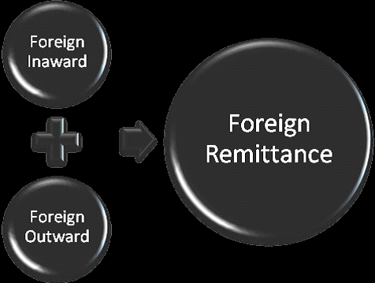

3.15.1 Inward Foreign Remittance
Internal remittance covers buy of foreign money as foreign T.T., DD, and bills and so forth sent from to another country supporting a recipient in Bangladesh. Buy of foreign trade is to be accounted for to Trade control Division of Bangladesh Rely upon Form– C.

Followings are the Internal foreign Settlement:
I. Foreign Transmitted Exchange Payable.
II. Foreign Request Draft Payable.
III. Voyagers Check Payable.
IV. Encashment of foreign monetary forms supported in the visa.
V. Buy of Foreign Monetary forms.

3.15.2 Outward Foreign Settlement
Outward settlement covers offers of foreign money through issuing foreign T.T. Drafts and so on and in addition offer of foreign trade. Offer of foreign trade is accounted for to Exceed expectations control Branch of Bangladesh flank on shape T/M. Settlements issued to foreign relates to satisfy its client's need are the Outward Foreign Settlement.

It includes the accompanying:
I. Foreign Request Draft Issued.
II. Explorers Check Issued.
III. Foreign Transmitted Exchange.
IV. Underwriting of Foreign Monetary standards in visa.
V. Offer of Foreign Monetary standards.

  - 3.16 Foreign Exchange Operation of a Competitor: Al Arafah Islami Bank Limited
Import
• Opening of letter of credit
• Advanced Bill
• Bills for accumulation
• Import credits and certifications
Export
• Pre-shipment counsel
• Purchase of foreign bills
• Negotiating of foreign bills
• Export ensures
• Advanced for conceded sum installment
• Confirming letter-letter of credit
• Advanced against bill of gathering
Remittance
• Issue of DD, TT, MT and so on.
• Payment of DD, TT, MT and so forth.
• Issue and upgrade of voyagers check
• Issue and upgrade foreign money note

3.16.1 Import Section

Imports of merchandise into Bangladesh is managed by the service of industry and trade as far as the Export and Import Act, 1950, with import approach orders issued by yearly, and Public Notices and Import Registration Certificate (IRC) issued every now and then by the workplace of the Chief Controller of Export and import (CCE and I). Through the procedure of import some vital yet which are deficient in our nation items are transported in to meet the neighborhood needs of the general population. Shared Trust bank restricted likewise assumes an essential part of bringing in products.

To get Import Registration Certificate (IRC) the accompanying declarations are required for doing import exercises with Al Arafah Islami bank Limited:

• Trade License

• National declaration

• Income assess freedom declaration

• Asset testament

• Banks dissolvability testament

• Memorandum and article of affiliation

• Certificate of fuse (assuming any)

• Registration association deed (assuming any)

• Rent of the business premises.

3.16.2 Import Procedures

An importer is important to have the accompanying to import through Al Arafah Islami Bank.

• Applicant needs to apply for opening letter of credit by a formal frame.

• Applicant needs to present the Letter of Pro-forma Invoice or letter of indent.

Letter of Indent: Many dealers have their operator in merchant's nation. On the off chance that the agreement of purchasing is made between the specialist of the venders and the purchaser at that point Letter of indent is required. Letter of Pro-forma Invoice: If the agreement is made specifically between the dealers and the purchaser at that point Letter of Pro-forma Invoice is required.

• Applicant needs to submit Letter of Credit Authorization Form (LCAF).

• Applicant needs to submit protection report.

• Applicant needs to plan FORM-IMP.

• Applicant needs to submit Indenters Registration Certificate (IRC). This endorsement being restored each year. This testament is important if the agreement is made between the specialists of the venders and the purchaser.

• Then after exact investigation bank will open a Letter of Credit.

• They have been made an arrangement to give an endorsement named Tax Payers Identification Number (TIN). Tax collection division issues this declaration.

• While opening letter of credit, shipper must keep certain level of the record an incentive in the bank as edge.

3.16.3 Import Policy

Toward the start of each money related year, the Chief Controller of Exports and Imports declares the Import approach covering diverse parts of imports in the up and coming year. The fundamental focuses secured by the Import Policy are the accompanying:

• Items importable against – Cash outside Exchange, Foreign guide and trade, Wages Earners Scheme.

• The Procedure for enlistment of new comers into the import exchange.

• The strategy for accommodation of use for Repeat License.

• Items qualified for imports amid the delivery time frame.

• The method for imports by mechanical merchants and business shippers and for import under Wages Earners conspire.

• Procedure for development of gatherings.

• The dates for opening Letter of Credit, and shipment and the standards for revalidation of the License or Letter of Credit Authorization (LCA).

3.16.4 Export Section
Nature of wealth in each nation relies upon the expansion of generation and expanding cooperation in universal exchange. Bangladesh sends out an expansive amount of products and services to outside. By expanding creation in the fare segment we can raise the business level of such a very populated nation like Bangladesh. Readymade textile garments, tea, Jute, Jute-made items,frozen shrimps are the principle merchandise that Bangladeshi exporters export to outside nations.
Garments sector is the biggest sector that exports the maximum share of the country's export. Bangladesh sends out the vast majority of its readymade garments products to European Community (EC) nations and USA. Bangladesh trades around 40% of its readymade pieces of clothing items to U.S.A. The greater part of the exporters who trade through AIBL, are readymade pieces of clothing exporters. They open export letter of credit here to send out their products, which they open against the import letter of credits opened by their outside merchants.
Export letter of credit task is simply turn around of the import letter of credit activity. For sending out products by the neighborhood exporter, bank may go about as prompting banks and gathering bank for the exporter.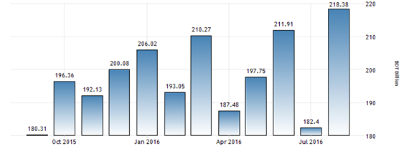
Figure 5.1: Export Income of Bangladesh
(Source: Bangladesh bank (2016), Export income)

3.16.5 Export Policy

Export policies defined by the Ministry of Commerce, Government of Bangladesh (GOB) give the general motivators and rule for development of exports in Bangladesh. export arrangements additionally set out stock shrewd yearly target. It has been chosen to define these policies to cover a five-year time span to make them synchronous with the five-year designs and to give the approach run the show.

The export arranged private area, through their delegate chambers and bodies are counsel in the detailing of fare approaches and are likewise passing on in the different fare advancement bodies set up by the administration.

3.16.6 Export Procedures
The Export and Import exchange our nation are directed by the Import and Export Control Act, 1950. Under the export arrangement of Bangladesh the exporter needs to get Export registration Certificate (ERC) from Chief Controller of Import and Export (CCI&E). The ERC is required to renew each year. The ERC number is to join on EXP forms and different papers associated with sends out.

3.16.7 Foreign remittance section

Foreign Currency (FC) Accounts

Foriegn Currency Account (FCA) is a value-based record named in a money other than the home cash and can be kept up by a bank in the nation of origin or a bank in another nation. Presently the activity of Foriegn Currency Account has been more changed. Assets from these Accounts are openly remittable to any nation as per the requirements of Accounts holders. Common Trust Bank Ltd gives the administration of outside settlement through remote money records to the customers. Sorts of Account: Foriegn Currency Account (FCA) is a value-based record named in a money other than the home cash and can be kept up by a bank in the nation of origin or a bank in another nation. Presently the activity of Foriegn Currency Account has been more changed. Assets from these Accounts are openly remittable to any nation as per the requirements of Accounts holders. Common Trust Bank Ltd gives the administration of outside settlement through remote money records to the customers. Sorts of Account:

FC Account

Citizen or resident Foreign Currency Deposit Account

Non-Citizen or Non-resident Foreign Currency Deposit Account.

Currency in which FC A/Cs can be opened
Foreign Currency Accounts can be opened either in
- US dollar
- Pound
- Euro
- Japanese Yen
Papers and Documents required for opening Foreign Currency Account

3.16.8 Foreign Exchange Income
Throughout the year, treasury kept up banks net open position and FC liquidity in a reasonable way to oversee swapping scale chance engaged with commercial transactions of both on-shore and seaward keeping money units. The year began with USD 22.30 billion reserve and at the year-end it was USD 27.06 billion.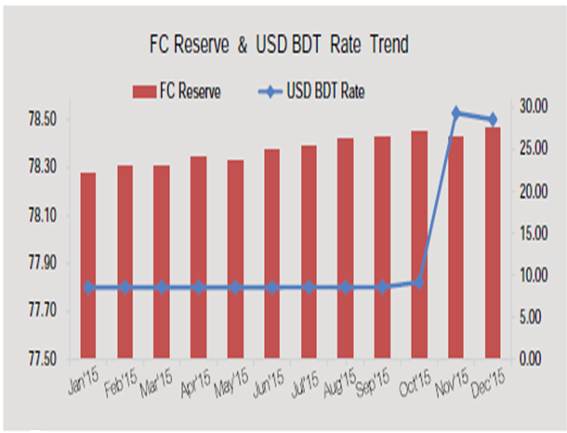
Figure 5.2: Foreign Exchange Income
(Source: Bangladesh customs (2016) from http://bangladeshcustoms.gov.bd/beta/relevant/foreign_currency_declaration_form.)
(Bangladesh Bank (2016) Remittances)

Foreign Exchange Analysis on AIBL

Foreign Exchange Analysis on AIBL
  - 4.1 Import Procedures followed by AIBL
As per import and export control act 1950, the office of chief controller of import and export gives the enlistment (IRC) to the shipper. In the wake of getting this individual needs to secure a letter of credit approval from Bangladesh Bank.

4.1.1 Presentation of the documents:
- Invoice.
- Bill of lading.
- Certificate of deposit.
- Packing list.
- Weight list.
- Shipping Advice.
- Non-negotiable copy of bill of lading.
- Bill of exchange.
- Pre shipment inspection report.
- Shipment certificate.

Import financing of AIBL:
(a) Letter of Credit Facility
(b) borrowings against importer merchandise
(c) Borrowings against trust receipt

  - 4.2 Export Procedure of AIBL
The export form Bangladesh is liable to export exchange control practice by the Ministry of commerce through chief controller of export and imports. No exporter is permitted to export any item passable for export from Bangladesh if the items are illegal to law.

Export department of AIBL:
. At the point when any association needs to export any item to other nation than that specific association as a rule opens an export letter of credit (L/C) from this area of the bank.

4.2.2 Export financing of AIBL:
Exporter exporting merchandise from Bangladesh to some other nation on the planet. After
Shipment the exporter needs to demonstrate the reports to the Bank inside the foreordained Period for the transaction of the archives.
  - 4.3 Procedure for opening letter of credit sequentially in AIBL:
- Lien of exports.
- Opening of BTB (L/C under that).
- ABP (accepted bills for).
- Under production.
- Export made.
- Collection/purchase of export bills.
- Collection from export L/C issuing.
- Non-stop A/C.
- update to head office.
- Credit counsel to branch.
- Head office ETDA (A/C debit).
- BTB payment.
- Respective party A/C.
- If PC Facility then.
  - 4.4 Foreign remittance of AIBL:
AIBL places an essential part to exchange cash from different nations to Bangladesh and Bangladesh to different nations internal and outward T.T, M.T and draft are the fundamental component of foreign exchange remittance.

  - 4.5 Foreign Trade Business of AIBL (2012 to 2016):
Type | Foreign Exchange Business
Type | 2012 | 2013 | 2014 | 2015 | 2016
Import | 59909.80 | 52751.30 | 57705.20 | 55907.00 | 61034.50
Export | 64988.60 | 64250.50 | 68844.10 | 57929.40 | 41860.40
Total | 124898.40 | 117001.80 | 126549.30 | 113836.40 | 102894.90

  - 4.6 Earnings through Import of AIBL (2012 to 2016):
Figure in Million Taka
Year | Whole Bank Import | Branch Import
2012 | 50909.80 | 4094.08
2013 | 52751.30 | 4743.72
2014 | 57705.20 | 5809.43
2015 | 55907.00 | 6510.23
2016 | 61034.50 | 6705.25

  - 4.7 AIBL Import (Graph)
Figure in Million Taka
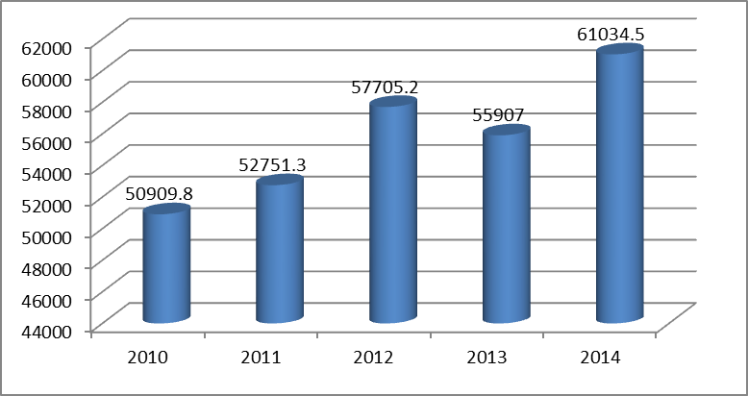
2012 2013 2014 2015 2016

The aggregate import took care of by AIBL expanded step by step to some degree. In year 2012 it was Tk 50909.80 Million, and it expanded to Tk. 52751.3 Million in year 2013. Assist we see the development proceeds as the import dealt with expanded to Tk. 57705.2 Million in year 2014. We can see in the chart which demonstrates the upward pattern of the import took care of by AIBL. In 2015 it was diminished to Tk. 55907 Million all of a sudden its expanded patterns 2014. A year ago import was Tk. 61034.50 Million of every 2016. Progressively step by step the sum will increment. It is guarantee that the branch will raise benefit step by step.
  - 4.8 AIBL Branch Import (Graph):
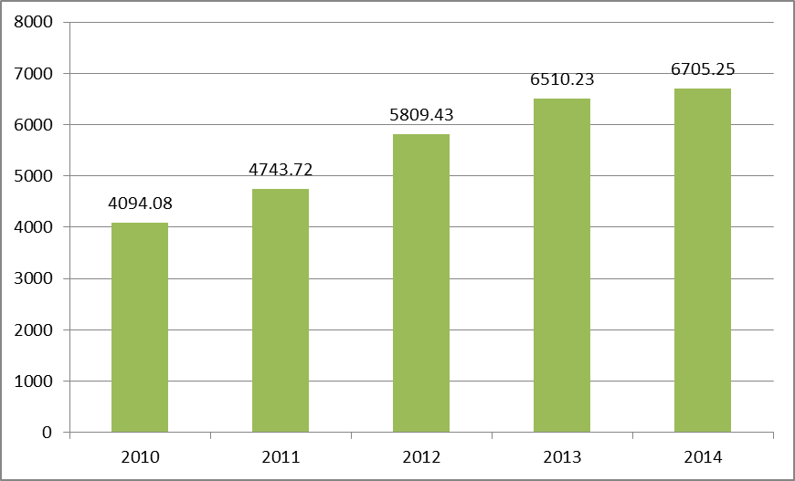
2012 2013 2014 2015 2016
  - 4.9 AIBL Earning through Export:
Figure in Million Taka
Year | Whole Bank Export | Branch Export
2012 | 64988.60 | 2479.82
2013 | 64250.50 | 3270.69
2014 | 68844.10 | 3178.59
2015 | 57929.40 | 4425.05
2016 | 41860.40 | 4500.25

  - 4.10 AIBL Export (Graph):
Figure in Million Taka
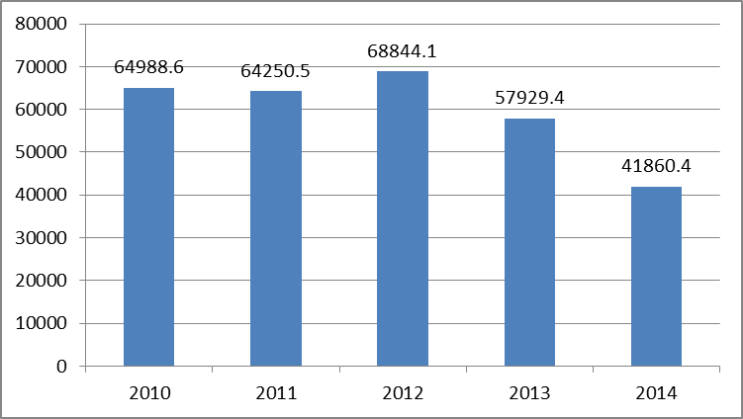
2012 2013 2014 2015 2016

Here we can see from the graph above that, first two year (2012-2013) export it approximately same amount is tk 64988.6 millions & tk. 65250.50 millions. In 2014 it was tk. 68844.10 millions. But last two year (2015-2016) unexpectedly it is decreased by tk. 57929.4 & tk. 41860.4 millions. This specify bad position for Al-Arafah Islami Bank Ltd.
  - 4.11 AIBL Branch Export (Graph):
Figure in Million Taka
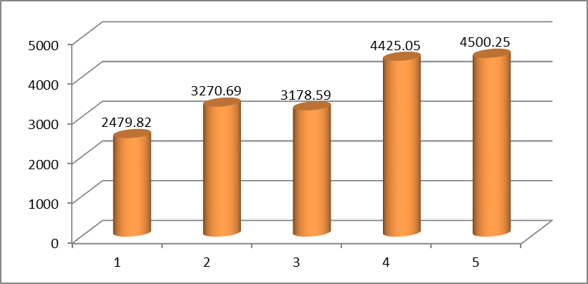
2012 2013 2014 2015 2016

  - 4.12 Foreign Remittance of AIBL:
Year | 2012 | 2013 | 2014 | 2015 | 2016
Remittance | 8200.00 | 6859.00 | 4029.00 | 3360.03 | 1594.11
  - 4.13 Foreign remittance of AIBL (Graph):
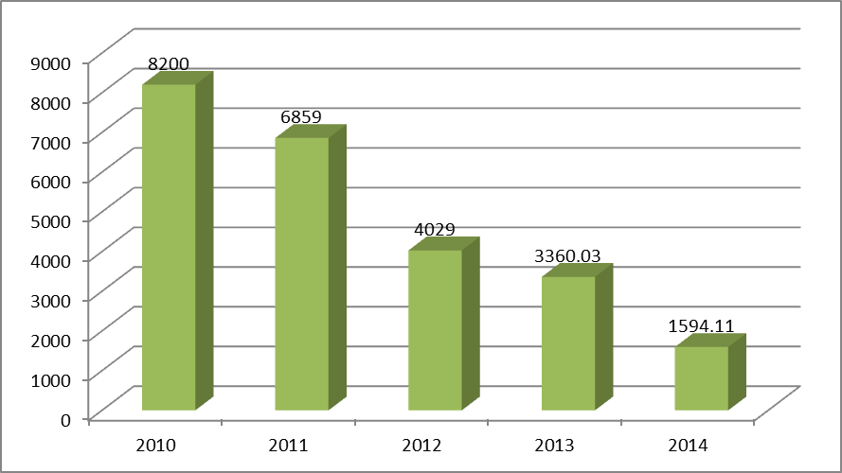
2012 2013 2014 2015 2016

Remittance is a big issue to develop a country’s economy. This table contains the total foreign remittance through the AIBL. We can observe that the remittance decreased every year from 2012 to 2016 overtime. This leads the poor performance by AIBL in this sector.

  - 4.14 Guarantee of AIBL:
Year | 2012 | 2013 | 2014 | 2015 | 2016
Guarantee | 4471.00 | 5578.10 | 4515.30 | 5687.20 | 6620.00

  - 4.15 Guarantee of AIBL (Graph) :

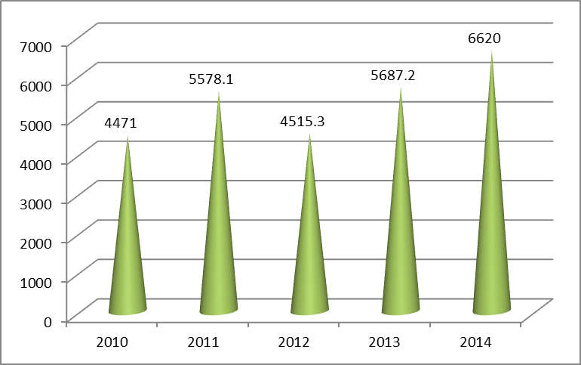
2012 2013 2014 2015 2016

From above mentioned graph which shows that, increasing trends of AIBL assurance over the last 5 years (2012-2016)

Findings, Limitations & Recommendations

Findings, Limitations & Recommendations

Findings:

These significant discoveries of AIBL (Al-Arafah Islami Bank Ltd.) from the examination are as per the following:

    - Although their everything branches (110) are in web based managing an account which is exceptionally restricted to achieve remote region clients.
    - Remittance administration framework isn't that much solid. Poor execution was following last going before years.
    - AIBL database framework isn't up to the stamp for outside trade.
    - Lengthy process for remote trade tasks.
    - They don't have that much publicizing effort for huge business. Clients even still don't think about its task of that territory.
    - AIBL is a much dependable Bank.
    - They are strict with the religious guidelines of managing an account.
    - Day by day the fame of AIBL is expanding.

Limitations
Although I have tried to find out in and gather for my project’s as much as data I can, I found some difference between what I learn in the theory and what are practical. The report was completed under certain constraints which were:

- Difficulty in gaining accesses to accounts of the bank.
- Difficulty in obtaining relevant data even with the help of the bank employees.
- Only 90 days were not sufficient to visit all the desks of the branch.
- Unavailability of necessary documents.
- In collecting information, there is some problem because of the excessive nature of confidentiality maintained by the officials.

Recommendations

After noticing all the ins and out related to the foreign exchange management of Al-Arafah Islami bank, I have some recommendations for better banking service to its customers & hold its market for wealth maximization. These are stated below:
- Al-Arafah Islami Bank Ltd (AIBL) should expand their branches to remote area of Bangladesh.
- AIBL should give more focuses on foreign remittance because huge portion of our national income comes from remittance.
- The Bank should develop an effective database needed for analyzing Foreign Exchange Business.
- AIBL should train especially on foreign exchange operations to those department employees to be more efficient.
- AIBL should take immediate step regarding advertising or any other step for big business.

Conclusion

&

References

Conclusion:

Bank is a very important and vital for economic development in mobilizing capital and other resources. AIBL is also contributing to the advancement of the socioeconomic condition of the country. To keep peace with the current market and demand, AIBL is following several strategies and taking new initiatives, offering new products and services to the customers according to shariah. The bank should maintain well-structured communication from upper level to lower level. AIBL have a strong position in the competitive market. It is among one of the fastest growing Bank. As the economy of Bangladesh is increasing so is the foreign trade and AIBL Bank like always have played its role in making sure that things go smoothly. The bank is doing its best to provide better Import, Export and comparatively little bit poor Remittance services (last 5 years statistics) to the customers. Export, Import is all showing positive trends even after the global challenges that we are facing today. Other hand AIBL can manage best remittance service as they want only proper focuses is needed. But the foreign trade handled by bank decreased in recent year, this may be because of opening of new branches in different business centers and the instability in the economy of the world.

References

References:
Annual Reports:
- Al-Arafah Islami Bank Ltd (2011-2016)

Published Document & Banking manual:

- Foreign Exchange Division Manual of AIBL.

- Several Booklets from AIBL.

- Other internship reports of AIBL.
- AIBL Yearly Report (2015)

Websites:
www.Bangladesh bank.org.bd
Bangladesh Bank

www.dsebd.org
Dhaka Stock exchange

www.bibm.org.bd
Bangladesh Institute of Bank Management

www.al-arafahbank.com

Al-Arafah Islami Bank Limited

