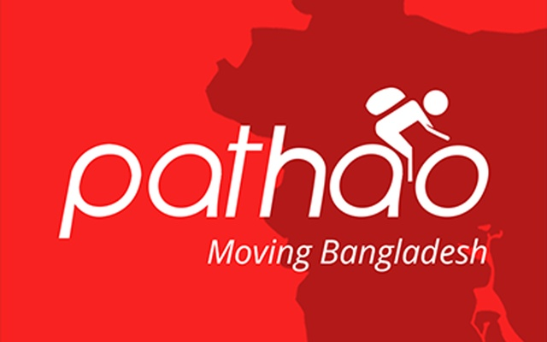
Consumer Satisfaction of Pathao: A Study through University Level Students of Bangladesh
Supervised by
Muhammad. Rehan Masum
Assistant Professor,
School of Business and Economics
United International University (UIU)

Prepared by
Joynob Akter
ID: 111 132 207
School of Business and Economics
United International University

Submission Date: 15th January, 2019

Letter of Transmittal

To,
Muhammad Rehan Masoom
Assistant Professor,
United International University,
Dhaka, Bangladesh

Subject: Submission of project report on “Consumer Satisfaction of Pathao.

Dear Sir,
You will be glad to know that I have recently finished my project report on the topic “Consumer Satisfaction of Pathao: A Study through University Level Students of Bangladesh”. It was a great time for me to gather all the information from the students of UIU about their satisfaction level of Pathao rides and delivery service. As we know, the location of UIU is in remote place from Dhaka city, most of the students, I have found, have used Pathao and some other ride sharing services. All the time of gathering information for my project report was very informative and interesting for me.
From the beginning of my project program, I have got a lot of useful resources and guidelines through written and orally, that were proved very essential to complete my report. I have followed all the steps that were necessary to make my report a valuable one. I, therefore, pray and hope that your honor would be kind enough to grant my project report and oblige thereby.
Sincerely yours,
Joynob Akter
ID: 111 132 207
BBA Program
United International University



Acknowledgment

At the beginning of this report, I want to thank my Almighty Allah for making me able to complete all the courses successfully and come to at this last stage of my BBA program.

I want to thank my project supervisor and my respected faculty, Muhammad Rehan Masoom, Assistant Professor, United International University, for allowing me to work on my desired project topic. All the supports that were either written or oral proved essential for me. I think it would not be possible for me to complete the report without the guidelines and support that I received from him.

I want to share my sincere gratitude to Mr. Md. Muhtasim Jawad, Content and Communication Specialist of Pathao Ltd. for all the help and websites link to find my necessary articles related to my report. I also want to thank Mrs. Anulekha Chowdhury, MTO, Pathao Ltd. for helping me when I had faced any difficulties.

Finally, I want to share my gratitude to all the respondents who respond quickly and took my survey questionnaire seriously during their busy schedule. All their valuable responses helped me to sum up and finish my project report.

Abstract

Pathao Ltd. is the fastest growing technology startup in Bangladesh. It offers services in the areas of ride sharing, delivery of foods from the restaurants to consumer’s home, parcels and mail. The company was founded in 2015 by a group of young entrepreneurs who quickly became a brand and a cult nationwide. The company was recently funded by ‘Gojek’, an Indonesian ride-sharing company. Initially, the company started operations as a parcel delivery company with an Android application for the service delivery process. The company has quickly used the sectors mentioned above and is now the leading player in the vehicle-sharing market and is rapidly moving beyond the Uber in South Asian car sharing market, recently acquired by the Singapore-based company Grab. The competition will be fierce in the coming months. Pathao was able to stop the game at the end of 2016 since technology has reached millions of people and is now part of everyone's life, if someone goes to work or simply orders food at home.

Consumer Satisfaction is a unique idea and includes factors, for example, the quality of the product, the quality of the service gave, the environment of where the product or service was obtained and the cost of the product or service. Organizations regularly use consumer loyalty surveys to quantify the satisfaction level.

In this project report, I tried to gather information about Pathao and measures its consumer experience and satisfaction level. In the first chapter, some basic details of this report are going to be shared along with the general brief of Pathao, the rationale of the report, the background of the report and few limitations that I have faced while creating the report. In chapter 2 & 3, I will discuss the objectives and Methodologies that are used to measure the consumer satisfaction of Pathao. In chapter 4, some basic definition is shared to clear the basic knowledge of this report to any reader. The main part of the report is in chapter 5, where the findings of consumer satisfaction of Pathao is measured based on a Questionnaire. This Questionnaire is added to the appendix part of the report.

Finally, I have provided some suggestions in the recommendation and Conclusion chapter on how Pathao, as a brand capable of communicating more efficiently to its consumers, improve its service to its consumer. Hopefully, the suggestions will help for the betterment of Pathao.
Table of Content
Chapter 1: Introduction
1.1 Introduction to the topic in hand 2
1.2 A brief introduction of the Ride-Sharing sector 2
1.3 Rational of the study 3
1.4 Background of the study 3
1.5 Limitations of the study 4

Chapter 2: Objectives and Methodology of the report
2.1 Objectives of the Study 6
2.2 Methodology of the Study 6
2.2.1 CATs Data collection: 7
2.2.1 Sample design: 7
2.2.3 Analytical tools: 7

Chapter 3: Literature Review
3. Literature Review 9
3.1 Consumer expectations 9
3.2 Consumer Satisfaction 9
3.3 Brand Loyalty 10
3.4 Importance of consumer satisfaction 10

Chapter 4: Organizational Overview of Pathao
4.1 Organizational Profile 13
4.2 Mission 13
4.3 Vision 13
4.4 Values 14
4.5 Types of Services 14
4.6 Major Competitors 14
4.7 SWOT Analysis 15

Chapter 5: Findins and Analysis of the report
5. Findings and Analysis of the report: 17
General Questions on Pathao 18
Specific Questions on Consumer Satisfaction of Pathao 19

Chapter 6: Recommendations and Conclusion
6.1 Recommendations 26
6.2 Conclusion 27
References 28
Appendix- 29

Chapter One
Introduction

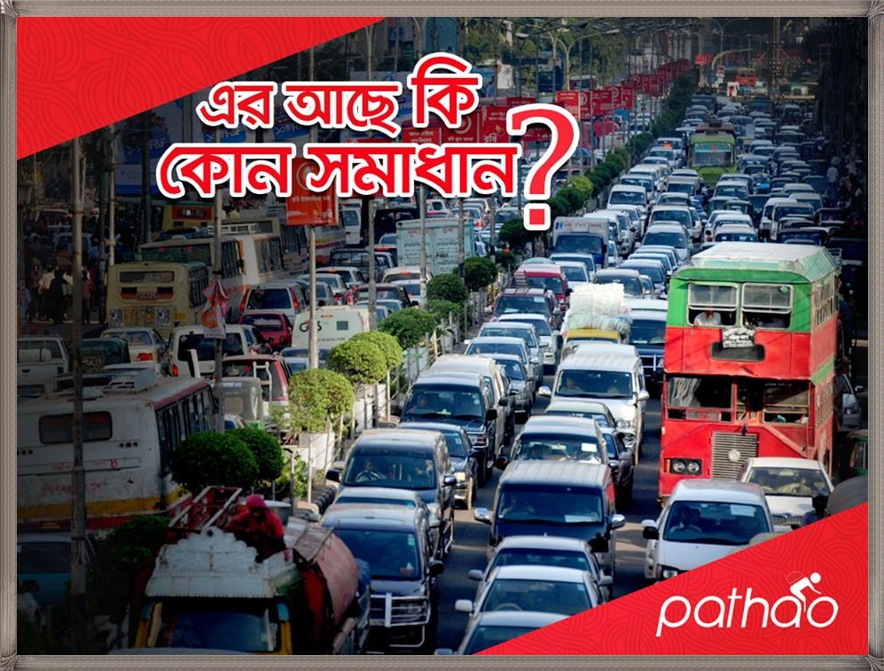

1.1 Introduction to the topic in hand
Pathao, a company of a variety of international investors, is the fastest growing technology startup in Bangladesh. The Pathao mobile application is mainly based on its tangible solutions to tackle Bangladeshis crucial infrastructural problems. While starting itself as the most important e-commerce delivery company in Bangladesh, it expanded into passenger transport and food distribution services. Employs a dynamic fleet of motorbikes and cars, provides solutions with the help of technology to change the transportation problems of the country.

Customer satisfaction is the proportion of how the necessities and reactions are served and conveyed to exceed the expectations of the customer. It must be achieved if the customer has a general decent connection with the service provider. In the present competitive business marketplace, customer satisfaction is an essential performance type and fundamental differentiator of business strategies. Consequently, the more is customer satisfaction, the more is the business and the relationship with the customer.

CSATs is abbreviated as Customer Satisfaction Survey is utilized to measure the levels of consumer satisfaction with the products, services or experiences of an organization. This is a kind of customer experience survey and can be used to assess customer needs, recognize problems with their products and services, or target customers according to their answers. The answers are got from them often showed by assessment scales to quantity fluctuations over time and get a deeper understanding of whether or not the company or organization encounter consumer expectations.

1.2 A brief introduction of the Ride-Sharing sector
Ride-sharing is no exception, as the world's highest trend flows into this end of the world. Bangladesh Pathao is the most popular local ride-sharing company which has closed ground in 2016 and late 2016. At this juncture at Uber's entrance to the Bangladesh market, apart from the advent of Pathao and witnessing a leap in the space of sharing the journey, some ride-sharing companies move to emerge to meet public demand is also known as e-commensurable names - up to 500,000 passengers by the opt-in app, by November 2017, get plenty of praise for cars and bikes through Apps. This number was only 10,000 in January.

Technical companies started the Bangladeshi market with the introduction of Uber, Pathao and Amar Ride in Dhaka in 2016. These enterprises have created the tendency to order a taxi or a motorbike to order single or shared travel using mobile apps. There is considerable encouragement, Pathao 2015. As part of an e-delivery back, using its fleet of motorbikes, the company has succeeded, but when it was not until October 2016, Uber introduced the Pathao motorcycle ride service launched in Dhaka in November 2016. Decide to pay. Despite their popularity, it is not a pioneer of motorcycle-based ride-sharing in Bangladesh. That honor is the share-in-motorcycle, which is May 7, 2016. However, it seems that Pathao's higher business model is one of the more successful and popularly launched journeys. The reason that Uber noticed Pathao was successful, the last 2017 quarter, UberMoto launched - the motorcycle model provided taxi service to the following Pathao. Actually, Uber originally established the manner for the company: such as Chalo, Muv, Dhaka Moto, Bahon, Love Bike, Love Ride, Taxiwala, Dako, Ezzyr, Speed ​​and Hellow Ride, all of which are eager to create e-commerce in many markets.

1.3 Rational of the study
We mostly follow in the memorizing theories and write them in our exam in our traditional education system. Anyways. United International University provides us the opportunities to feel the real-life knowledge outside of the traditional learnings. At the end of the BBA semester, UIU provides their students to observe any particular sector, industry or organization to apply their educational learnings into real-life situations under the supervision of a well-trained faculty member who provides us idea and guidelines to prepare writings that named as a project report. In my project report, I have tried my best to share what I have observed during the last three months of my project program. I had chosen to work on Pathao Limited. Pathao is highly growing company and becoming a trend in Bangladesh of traveling fast from one place to another place. It had started its journey in 2016 and already has provided its service to millions of customers in Bangladesh. In my project report, I have concentrated on the consumer satisfaction of Pathao and collected survey out comes from several students of my United International University students. This report can help Pathao to utilize the analysis and recommendations in the future. University students and faculties can compare their bookish knowledge to my real life observations which may also help them to improve their learnings.

1.4 Background of the study
At the last semester in United International University students of BBA and MBA program, have to go through either an internship or a project program. The internship program is the working experience that a student has to earn by working in a particular institution, what students have to submit with an internship report. And in a project report, students have to observe any institution without working in that organization. Students have to observe a particular side related to his major areas and prepare a project report. During this time of three months project period, the student is under the supervision of one of our supervisor as well as course faculty who guides him or her during the project period. So, after a lot of effort, a projects paper is being prepared.
I had chosen to work on Pathao Limited. Pathao is highly growing company and becoming a trend in Bangladesh of traveling fast from one place to another place. It had started its journey in 2016 and already has provided its service to millions of customers in Bangladesh. In my project report, I have concentrated on the consumer satisfaction of Pathao and collect information through a survey questionnaire from several students of my United International University students. The findings and analysis are going to be shared in the later chapter of this report.

1.5 Limitations of the study
The limitations of the report are those qualities of structure or strategy that affected or impacted on the explanations of the findings from this report on Consumer Satisfaction of Pathao. But during last three months of the project period, I have seen and found various limitations that created some confusions and problems.
- Limited period: It is hard to difficult for me to create such an extensive report in this few months of projects. Most of the offices had taken a long time to provide me a meeting schedules.
- Survey limitations: Student who use their own car or bike, didn’t provide me with information on Ride-sharing or delivery services of Pathao. Some students were providing biased information according to their choice, so I had to be careful to provide my questionnaire among a lot of students.
- Secrecy: A lot of information was very confidential for Pathao that they requested to its user to share in the public (Hint: Accidents per year). This information are not included in this report what can have a high impact on my report of customer satisfaction of Pathao.

Chapter Two
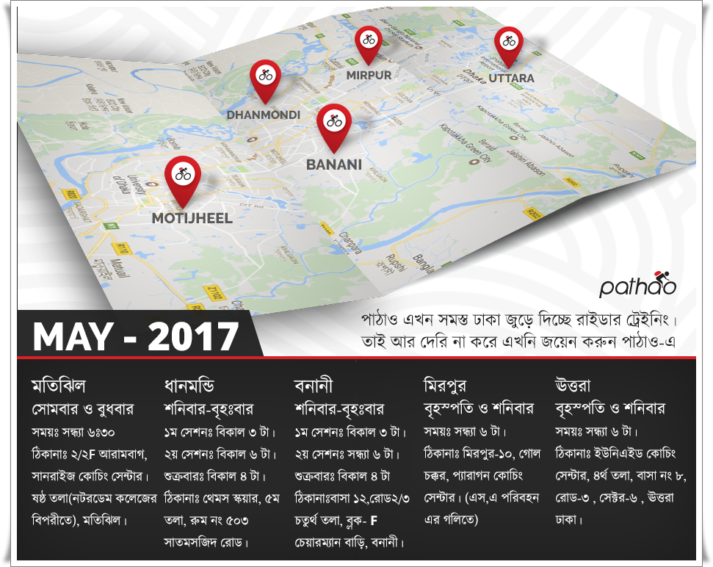
Objectives and Methodologies of the Report

2.1 Objectives of the Study
The objectives of the report is an explicit outcome that an individual or framework intends to accomplish inside a period. Objectives are more specific and less demanding to quantify than objectives. Objectives are fundamental instruments that underlie all arranging and vital functions of the report.
    - Broad Objectives
This project report is the pre-requirement to complete the BBA degree From United International University. So, gaining the BBA degree is the general objectives of preparing this report.

    - Specific objectives
These objectives are way more important than the general objectives. The objectives are highly related to this report. And provides a better understanding of why this report is prepared.
- To share a general understanding of Pathao Limited.
- To survey a questionnaire to the university students to find out their CATs of Pathao.
- To analyze the customer satisfaction level of Pathao.
- To share the interpretations and some recommendations of the report.

The methodology of the Study
2.2.1 Data collection process: I have created the report using several primary and secondary sources. These sources are describing below:
- Primary Sources:
- Through formal and informal communication with various riders and trainers of Pathao.
- Online communication with the respondents.
- Personal experience using Pathao services.
- Secondary Sources:
- Annual Report of Pathao.
- Online articles, blogs, and website to find current information about Pathao.
- Several published books and articles used in the literature review chapter.

    - CATs Data collection: To make my survey easier to the respondents, I had created a Questionnaire in Google Docs and shared the link to the respondents so that they can answer the questions in their free time.

    - Sample design: I have randomly chosen few UIU groups on Facebook and shared my Survey links so that respondents can answer my survey questionnaire randomly. Finally, I have collected authentic 58 respondents who are doing BBA or MBA program at United International University.

    - Analytical tools: I have used MS Excel, Google Docs & Excel, Facebook groups to prepare, collect, and interpret my survey findings of the report. Various bar chart and pie charts are also used in this report using Microsoft Excel.

Chapter Three
Literature Review
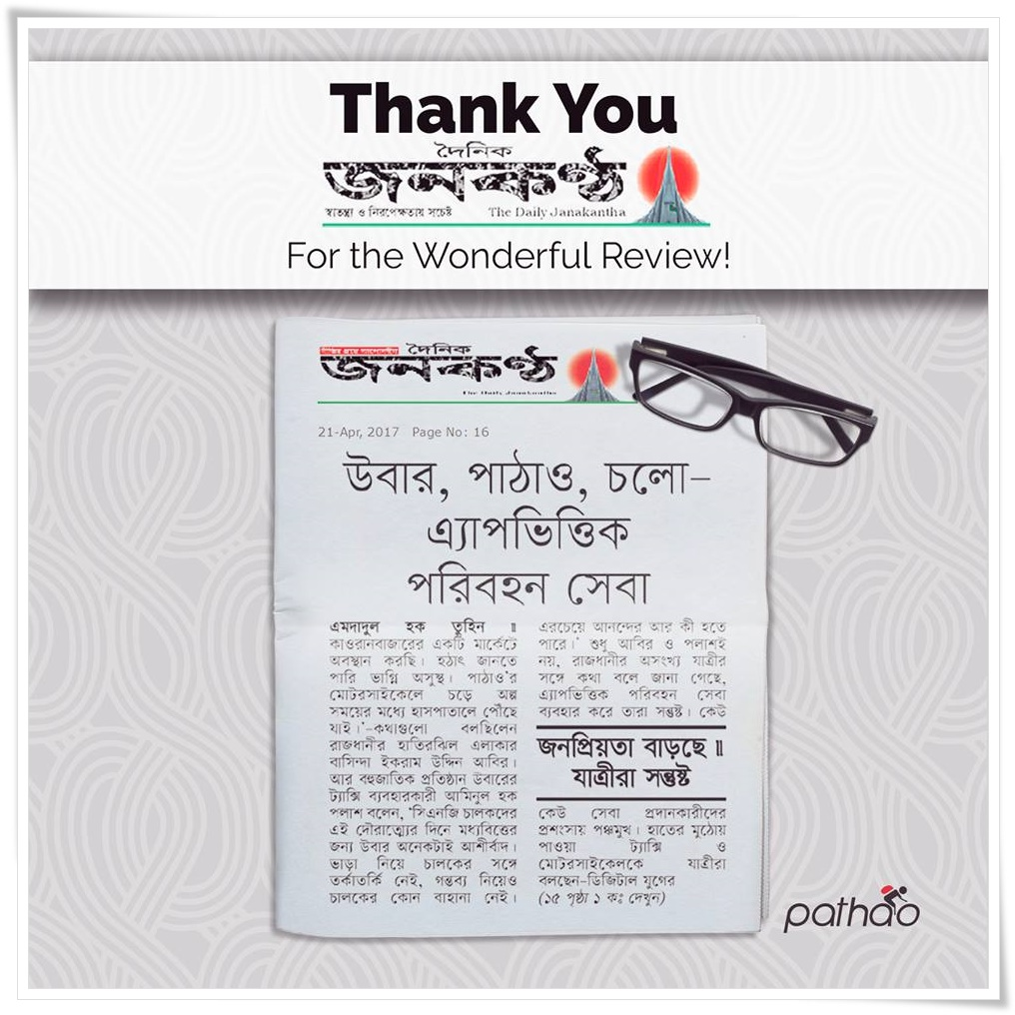

3. Literature Review
The review of the literature is an analysis and research of the literature available in my topic or preferred subject area. Literature review lists state of the art about the subject or topic I’m writing about. This section will clear basic ideas of some technical terms to the reader of the report such as:

3.1 Consumer expectations
According to Meuter (2012), the "Consumer's Expectation" refers to the total perceived benefits that a consumer anticipates from the service and products of an organization. If genuine consumers have a product that exceeds expectations, they are usually satisfied. But if the real execution falls under the expectation, they are usually discouraged.

Organizations use the market survey to assess consumer expectations for certain services or products. The service improvement is the company's procedure used to gather a response that meets the consumer's expectations. Advertising and different types of promotion add details to consumer expectations. The explicit needs or needs that consumers need to have in a certain area affect their expectations.

(Source: Matthew L. Meuter, Amy L. Ostrom, Robert I. Roundtree, Mary Jo Bitner (2012) Self-Service Technologies: Understanding consumer Satisfaction with Technology-Based Service Encounters. Journal of Marketing: July 2000, Vol. 64, No. 3, pp. 50-64.)

3.2 Consumer Satisfaction
According to Lawrence & McDaniel (2005), Customer Satisfaction (regularly shortened as CSAT, or more accurately CSat) is a term every now and again utilized in marketing. It is a proportion of how services and administrations provided by an organization meet or outperform customer expectation. Customer satisfaction is characterized as "the quantity of customers, or level of total customers, whose revealed involvement with a firm, its services, or its administrations (appraisals) surpasses indicated satisfaction objectives."

The Marketing Accountability Standards Board (MASB) underwrites the definitions, purposes, and develops of classes of measures that show up in Marketing Measurements as a major aspect of its progressing Regular Dialect in Marketing Venture. In a study of about 200 senior marketing administrators, 71 percent reacted that they found a customer satisfaction metric exceptionally valuable in overseeing and checking their organizations.
It is viewed as a key execution pointer inside the business and is regularly part of a Reasonable Scorecard. In a focused marketplace where organizations go after customers, customer satisfaction is viewed as a key differentiator and progressively has turned into a key component of the business procedure.
(Source: Gitman, Lawrence J.; Carl D. McDaniel (2005). The Future of Business: The Essentials. Mason, Ohio: South-Western)

3.3 Brand Loyalty
According to Smith & Hanover (2016), Brand loyalty is a design of buyer behavior in which buyers focus on a specific brand and make acquisitions after a while. Organizations use imaginative marketing procedures, such as programs or loyalty rewards, forecasts, brand ministers, and motivating forces as free examples of brand loyalty.

In a deeply aggressive market, overwhelmed by new and established brands, organizations use different strategies to develop brand loyalty. Stronger customers will buy their most beloved brand, paying little for accommodation or cost. Organizations pursue customer purchases and purchase trends, build partnerships with their customers through dynamic benefits for customers and attract brand spokespersons.

Brand loyalty is best when it comes to the qualities that are most important to your customers. Customer loyalty requires that customers re-enter and profits expand. Marketing professionals will look at the buying and buying trends of the buyer to allow them to create brand loyalty.

(Source: Kerry Smith, Dan Hanover, 2016, Experiential Marketing: Secrets, Strategies, and Success Stories from the World's Greatest Brands)

3.4 Importance of consumer satisfaction
According to Samouel and M.J. Page (2015), Customer satisfaction ought to be measured as an essential part of a business as it helps business owners an indicator to measure and improve business performance from customer's point of view. Specifically, this objective and training is not an essence of loyalty to buyers, but it is not an incredible method to understand new opportunities that may be long-term clients or buyers. Also, it may provide intrinsic warning signs that may harm a client and may leave the danger. Given this, consumer satisfaction can provide businesses with the right angle to understand which angles should be functioning and where to update. Consumers' satisfaction is often perceived as the main difference, in what companies have always been in a particular business center. Companies benefited from these discriminatory conditions generally apply to customer satisfaction by applying their business processes. By observing regular assessments and consumer satisfaction, the informed choice can be applied to establish new projects. Therefore, it is one of the main steps used to measure the customer's retention and measurement of customer satisfaction.

(Source: Joseph F. Hair, Jr, Mary Wolfinbarger, Arthur H Money, Phillip Samuel, Michael J Page, 4 March 2015, Book name: Essentials of Business Research Methods, Available in https://www.taylorfrancis.com/books/9781317471233)

Chapter Four
Organizational Overview

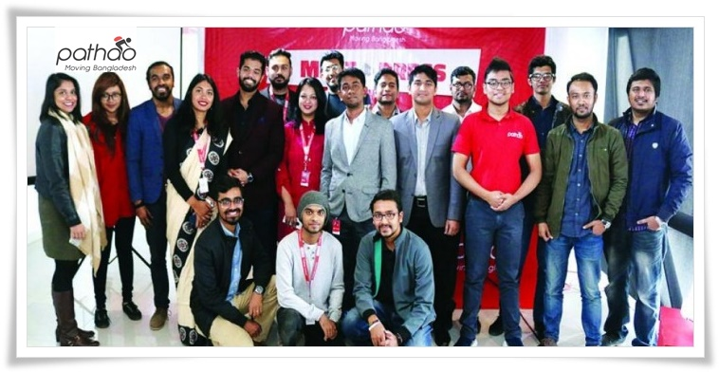

4.1 Organizational Profile
Pathao was established by business people like Hussain M. Elius, Fahim Saleh and Adnan Shifat in 2015, with the objective of handling a standout amongst the most problems that are begging to be addressed tormenting businesses and suburbanites in Dhaka City, Transportation. There are two essential verticals of activities of the organization: giving delivery and collection of money from businesses through their Pathao Fulfillment service; and, transportation service, much like Uber yet with motorbikes, through Pathao Rides. Utilizing a similar base framework, Pathao serves diverse markets and plans on growing tasks to other delivery services, for example, food delivery (2017). The trio had worked independently in their own activities, yet they had recognized a key issue and found an astute answer for a standout amongst the most basic issues looked by private companies and suburbanites in the city. They found a clever method to handle the issue without contributing enormous capital. Its armada of motorcycle drivers and bicycle errand people acquire the parcel to customers Dhaka and past. The service blossoms with the back of developing an interest for dependable internet business conveyances in Bangladesh. Then again, in spite of the absence of priority of motorcycle taxis in the nation, Pathao's Ride services got on. First and foremost, it was an armada of 100 drivers utilized by the startup, however, now they have a system of 500 independent drivers notwithstanding the utilized staff, serving a normal three to four rides per day. After some time, Pathao would like to grow tasks to different areas of the nation.

4.2 Mission
The mission of Pathao is 'Moving Bangladesh.' For the most reliable and community-driven media transit, parcel delivery, carpooling and food supplies in Bangladesh, the company is making fast and cheap daily travel through home delivery. The organization is taking a big step to change the system about how logistics services are adopted in Bangladesh.

4.3 Vision
‘One app, all solutions’ is the recent vision of Pathao. The company is generating realistic solutions to tackle the major infrastructural issues in Bangladesh. After providing delivery solutions of Bangladesh, Pathao gives another solution of ride sharing, which is a great problem in the capital city, Dhaka, using a highly dedicated fleet of motorcycles and cars. But they have just established their services in Dhaka and Chattogram city and sharing a vision to spread their services all of the districts of Bangladesh.

4.4 Values
In Pathao, it all starts with the riders and consumers. The company values all its partners with respect and importance. This pioneering attitude has returned to its entrepreneurial roots, inspiring collaboration, innovation, and transparency on all its platforms. Pathao's Spirit can be neutral on the following points:

- The whole unit is not created
- Everyone builds
- Pathao will never stop learning
- Continues the conversation
- Compassion and kindness
- Conservation and continuity

4.5 Types of Services
Pathao provides in total five types of services in Bangladesh. These services are provided in the chart below:

Chart 1: Services of Pathao

4.6 Major Competitors

Chart 2: Major Competitors of Pathao in Bangladesh

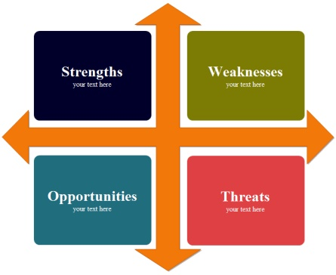
4.7 SWOT Analysis

- Strength

- Weakness

- Opportunities

- Threats

Chapter Five
Findings and Analysis

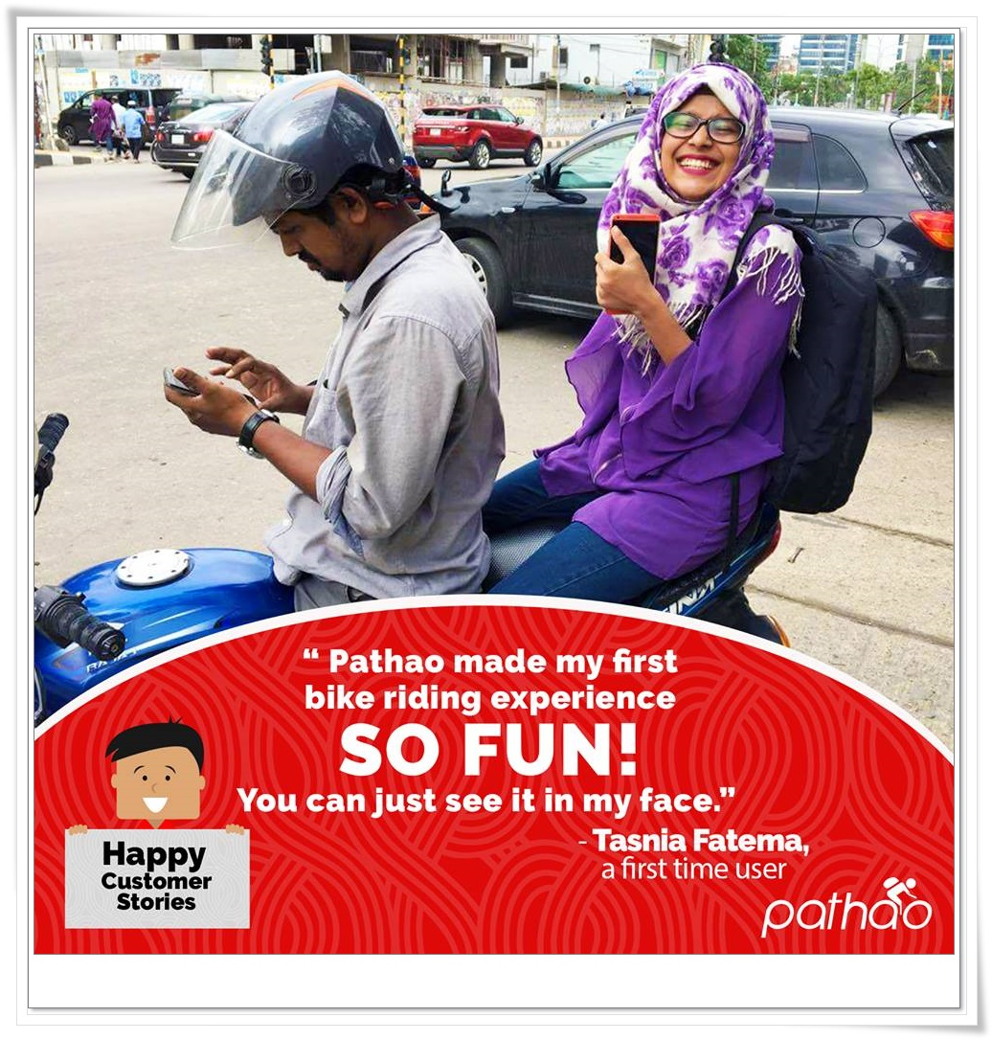
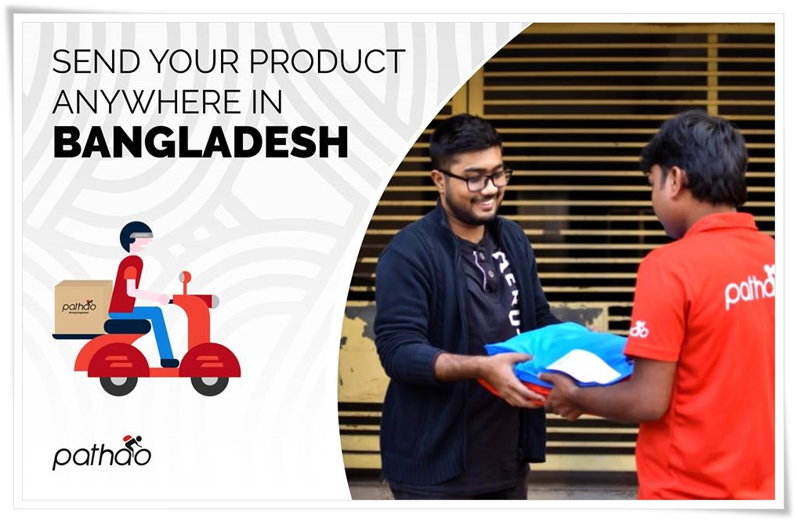

5. Findings and Analysis of the report:

The analysis of the consumer satisfaction of Pathao is found through a survey questionnaire made by with the help of Google form and invited several university students through social media sites. A total of 58 respondents participated in the survey and shared their opinion on a few specific questions that are necessary to analyze the consumer satisfaction of Pathao. This chapter is going to interpret the survey analysis to find out the consumer satisfaction of Pathao.
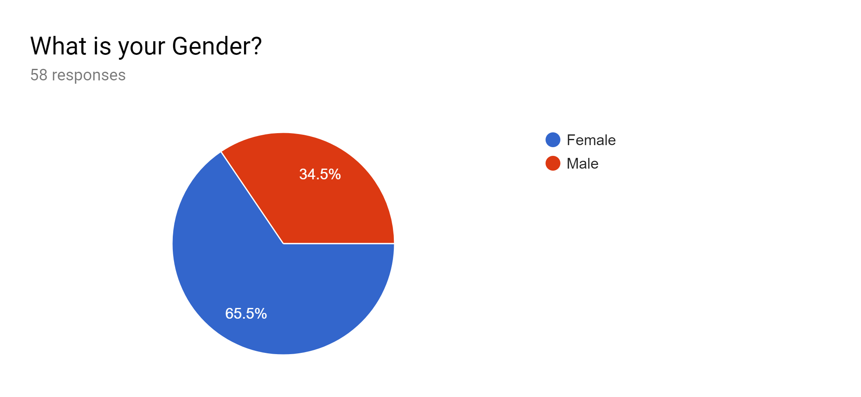
Interpretation: Total 58 respondents take part in the survey. According to gender, 65.5% of the students were female, and 34.5% of the students were male.
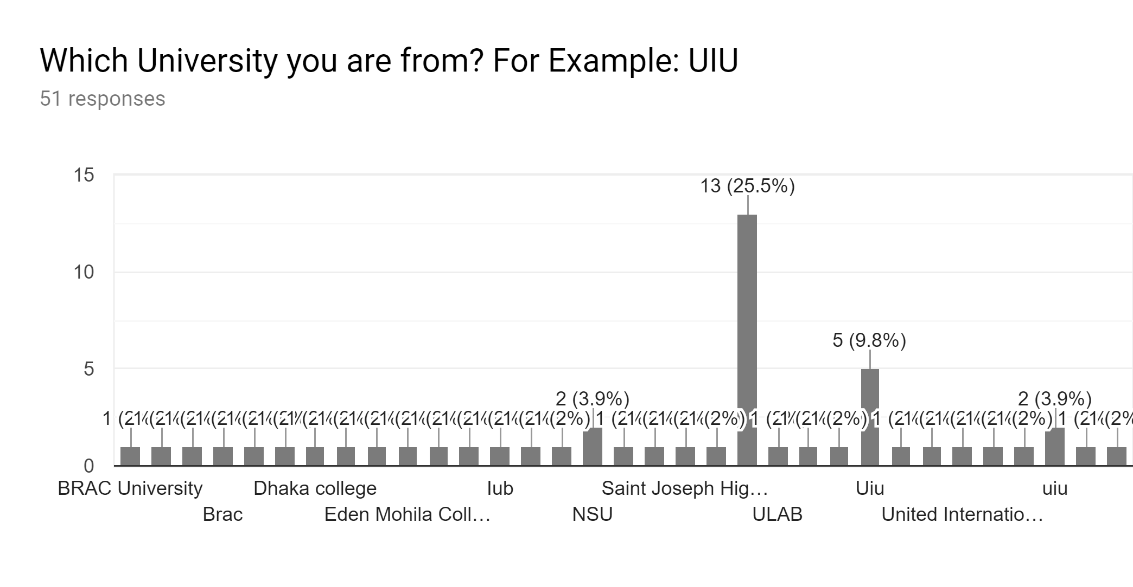
Interpretation: From total 51 students out of 58, who replied the upper question, maximum students were from United International University (UIU). Few students of the various reputed university of Bangladesh also participated in the survey.

General Questions on Pathao

In this section, I tried to get an idea of how much students are aware of Pathao:
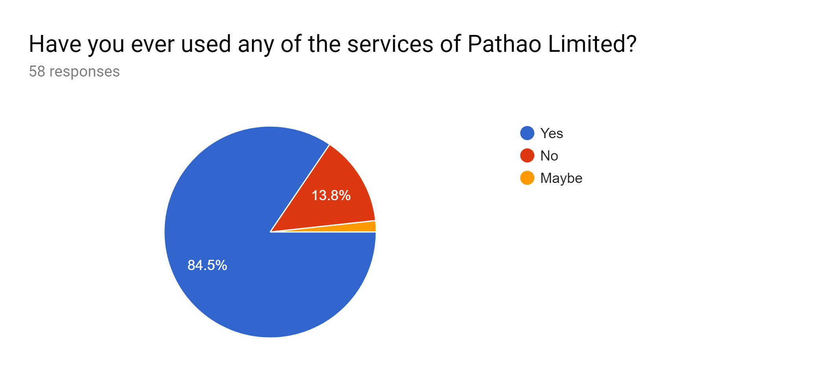
Interpretation: 84.5% or 49 students have already used Pathao services. 13.8% or 8 students are there who never used Pathao before. So, it can be said that the awareness of Pathao services from the respondents are high enough.
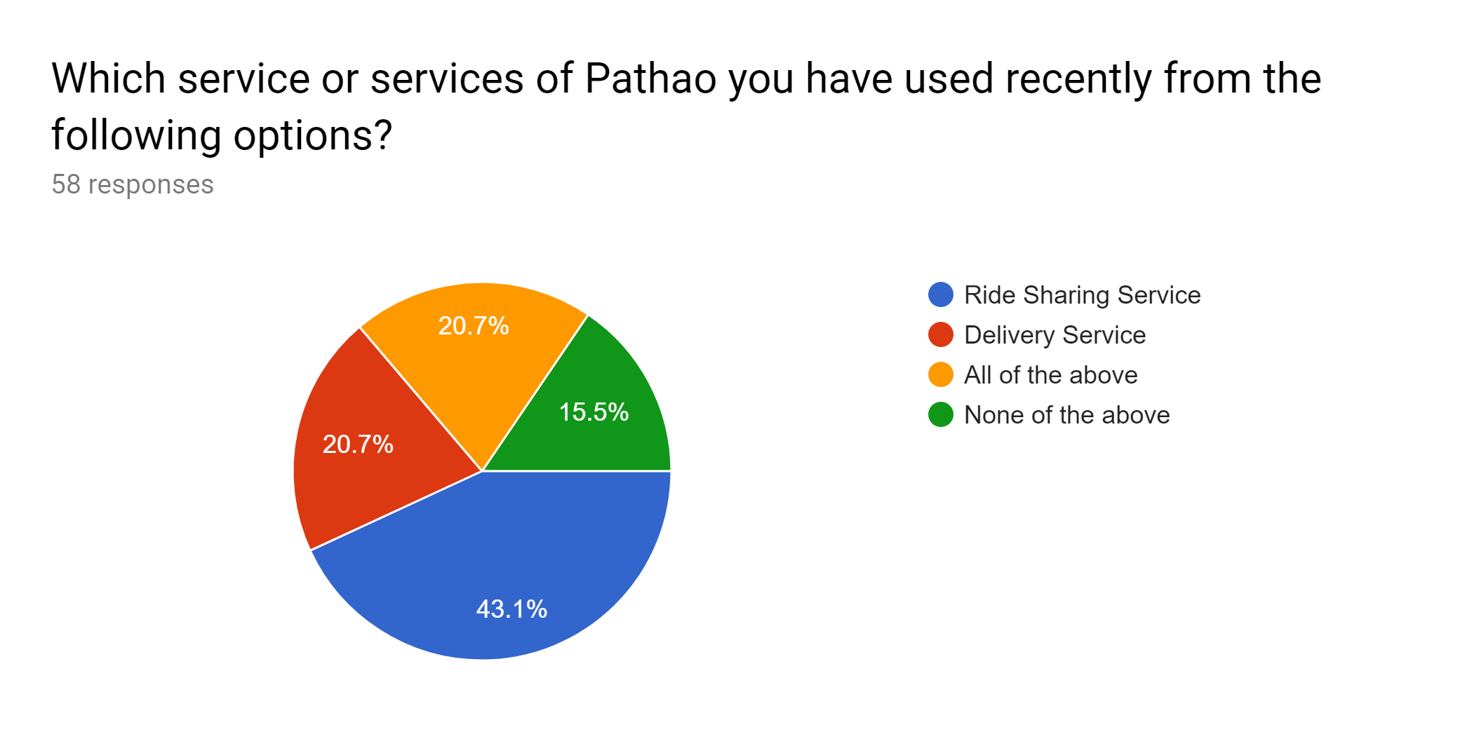
Interpretation: Total 58 students responded the question, and Most of them have used the Ride-sharing services (43.1%), 20.7% of the students have only used the delivery services, and both of the services are taken by 20.7% students. There is 15.5% student who never used any services of Pathao before.
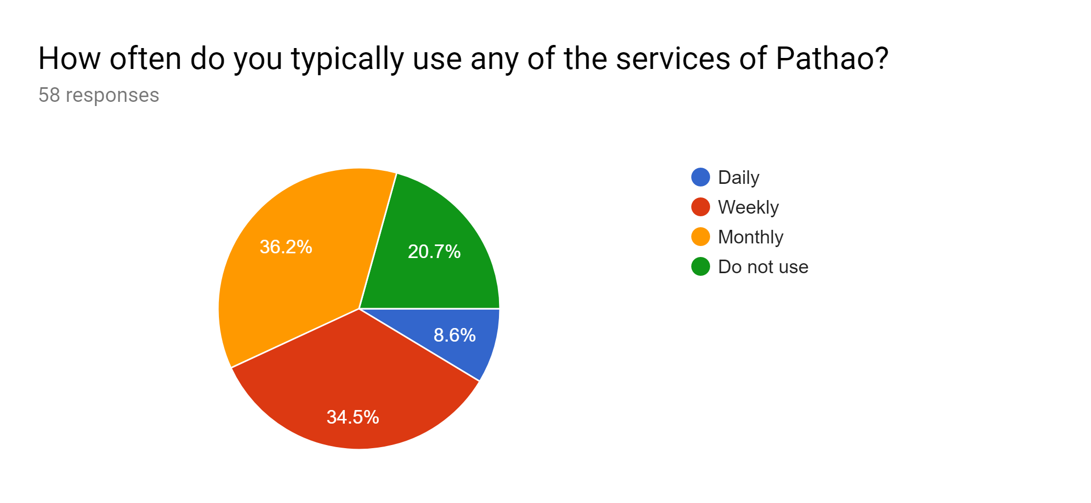
Interpretation: Total 58 students are shared their opinion on the upper question, among them the majority of the students use Pathao services monthly (36.2%). 34.5% of the students use a weekly basis, and 8.6% of them use daily basis. However, there are 12 students out of 58 who never use Pathao at all.
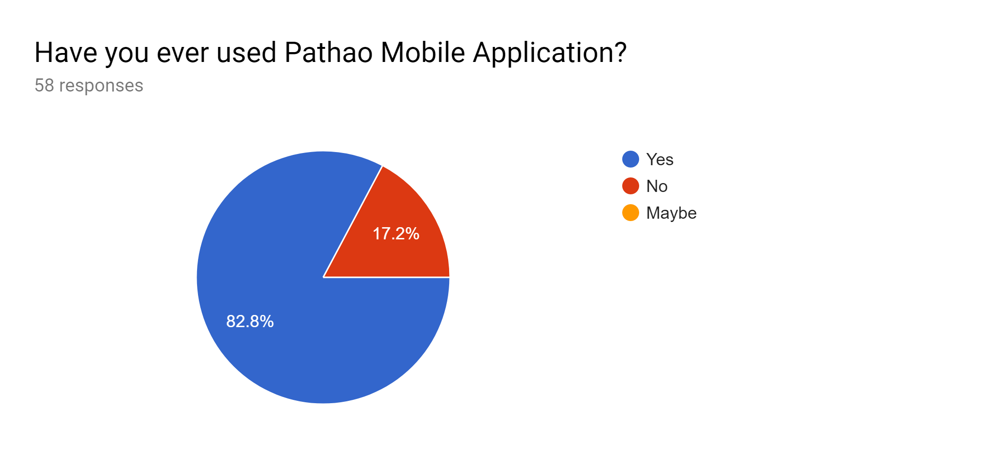
Interpretation: 48 out of 58 students (82.8%) replied on the question that they have used and 17.2% of students never used the mobile application of Pathao.

Specific Questions on Consumer Satisfaction of Pathao

This section was created to analyze the specific information on consumer satisfaction from the university level students. The answer required from each question were asked by five scale options so that consumers can easily share their state of mind on Pathao.
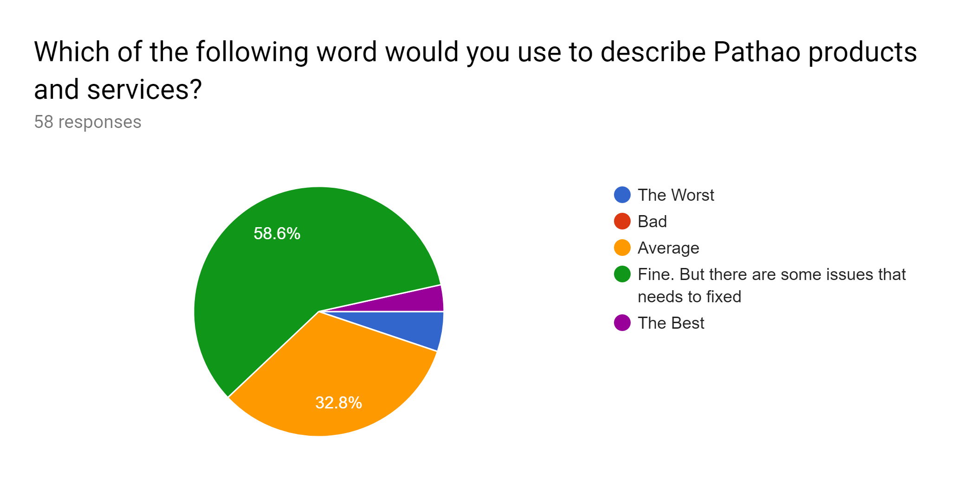
Interpretation: The pie chart shows that among 58 students, 58.6% of them give fine to the products and services of Pathao, but they agreed on that Pathao has some issues that are needed to be fixed. 32.8% of the students marked average also. A few numbers of student (4) shared that the products and services of Pathao are the worst.

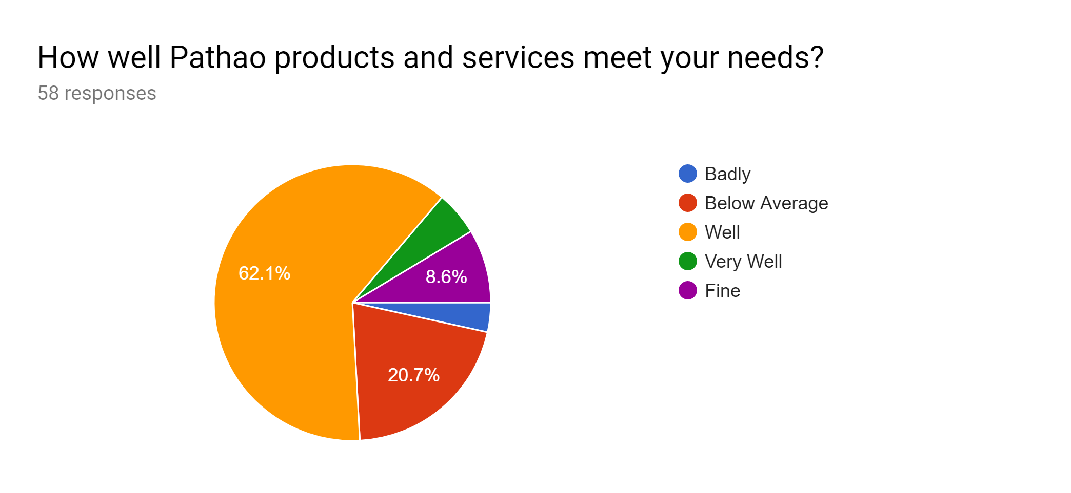
Interpretation: The question answered by 58 students and 62.1% or 36 of them said that the products and services meet their need well and 8.6% students marked fine. On the other hand, 12 students (20.7%) marked that the service provided by Pathao are below average.

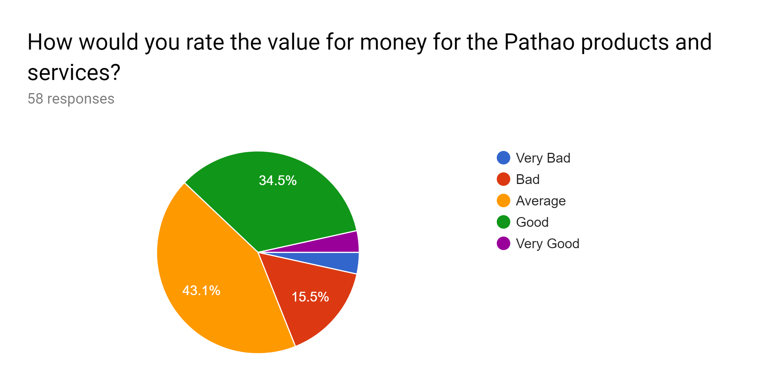
Interpretation: Mixed answers come from the upper question that measures the rate of the value for money for the Pathao Products and services. The majority of students marked the option average, and 34.5% of the students shared that the value for money of the Pathao products and services is good.

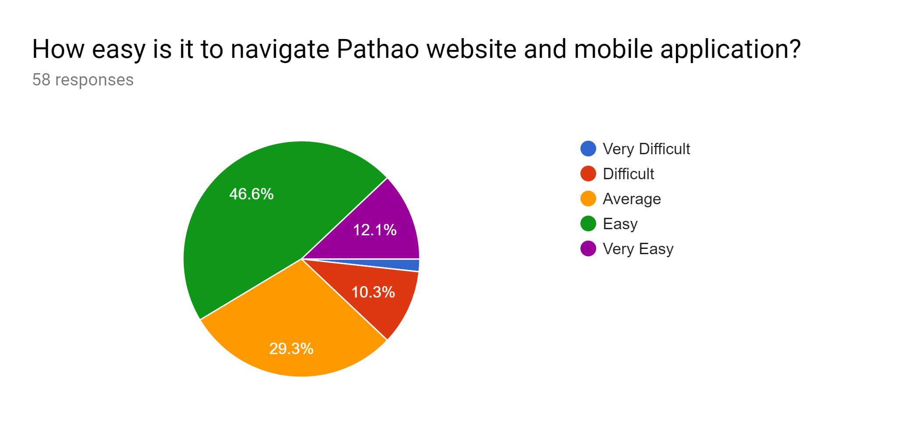
Interpretation: The question above measures the satisfaction level of students of the Pathao websites and mobile application. 46.6% found it easy and 12.1% found it very easy to use. On the other hand, 10.3% of the students said that they found it difficult when they use Pathao websites and mobile application.

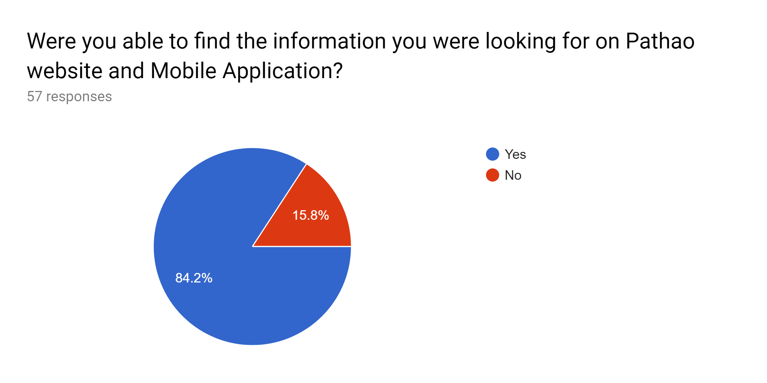
Interpretation: 84.2% of the students shared that they found the information from the website and Pathao mobile application they were looking for. On the other hand, 15.8% shared that they have found it difficult when the use Pathao website and mobile application for their necessary information.
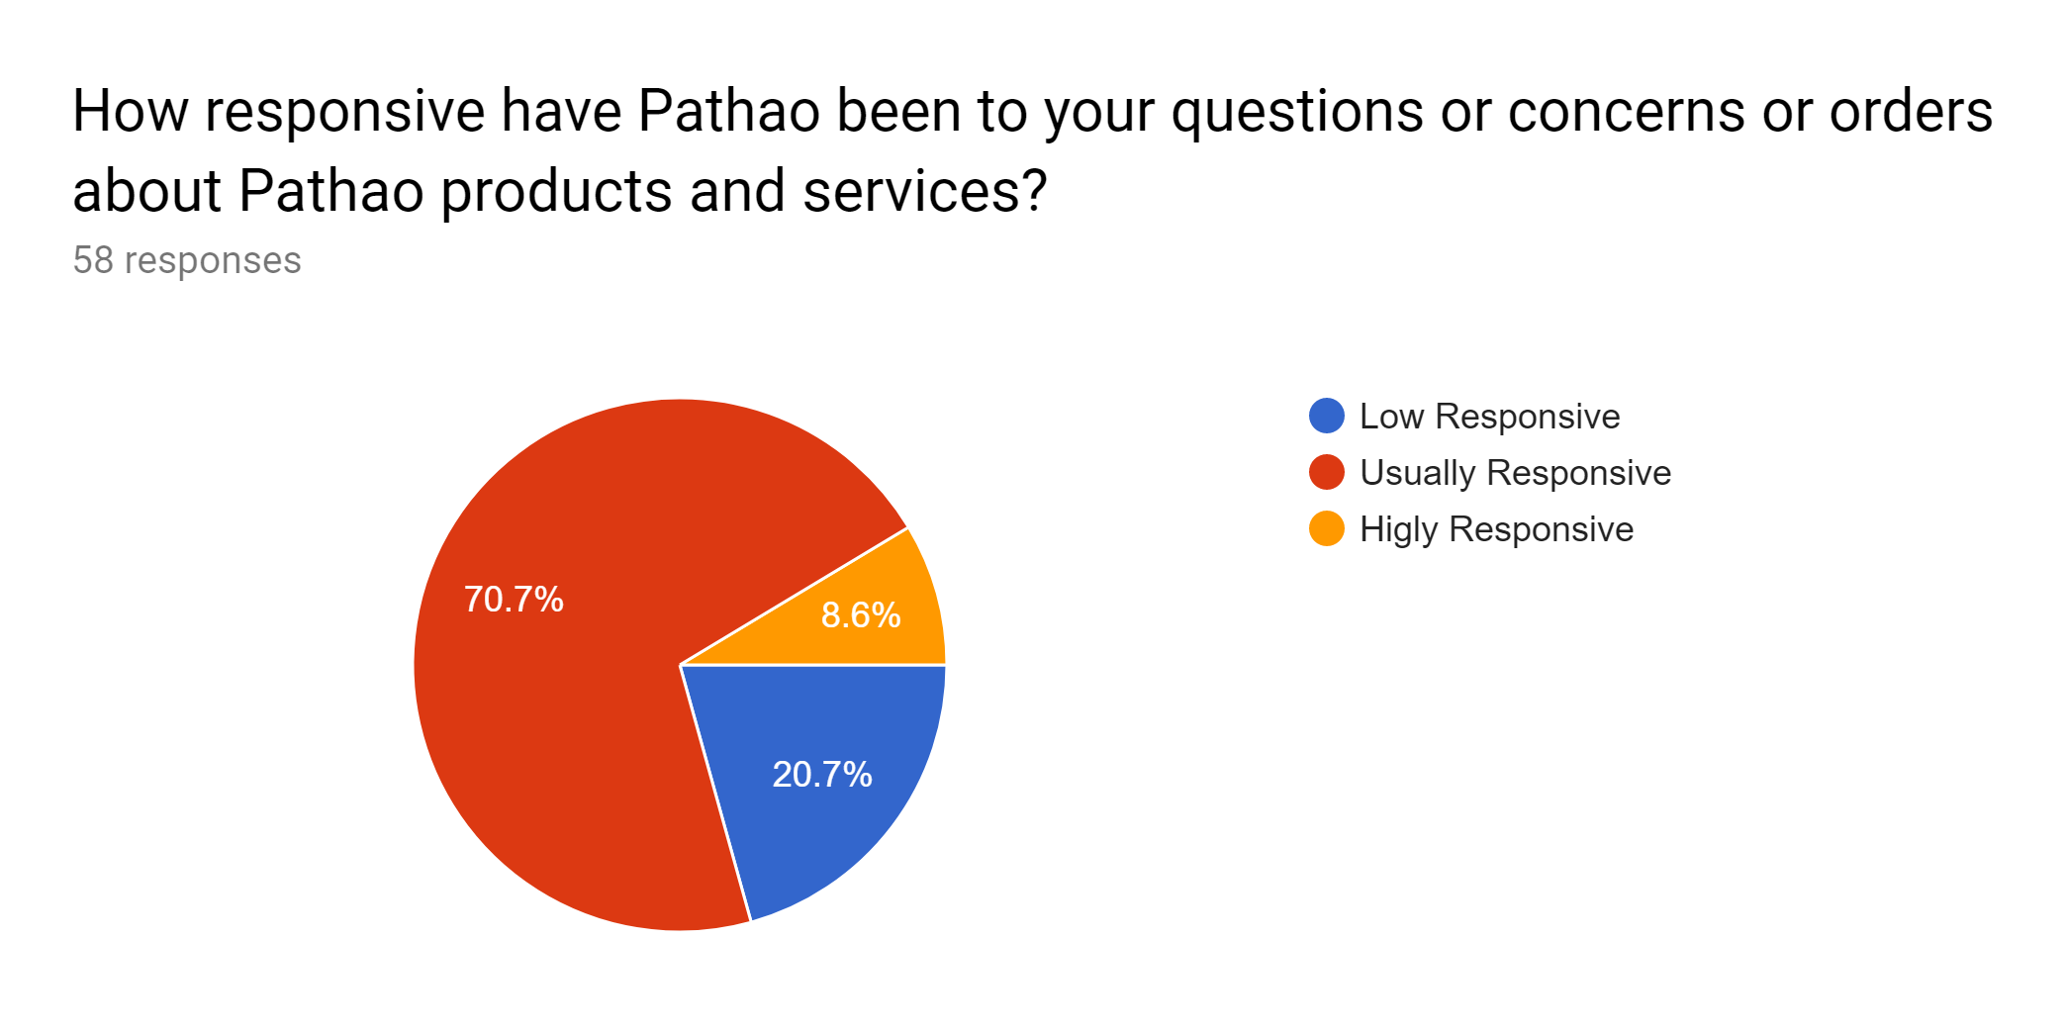
Interpretation: The upper question measures the satisfaction level of students on the term of responsiveness of Pathao, when they place an order to Pathao. Fifty-eight students answered the question, among them 70.7% means 41 students marked that Pathao is usually responsive and 8.6% of them marked that Pathao is highly responsive.

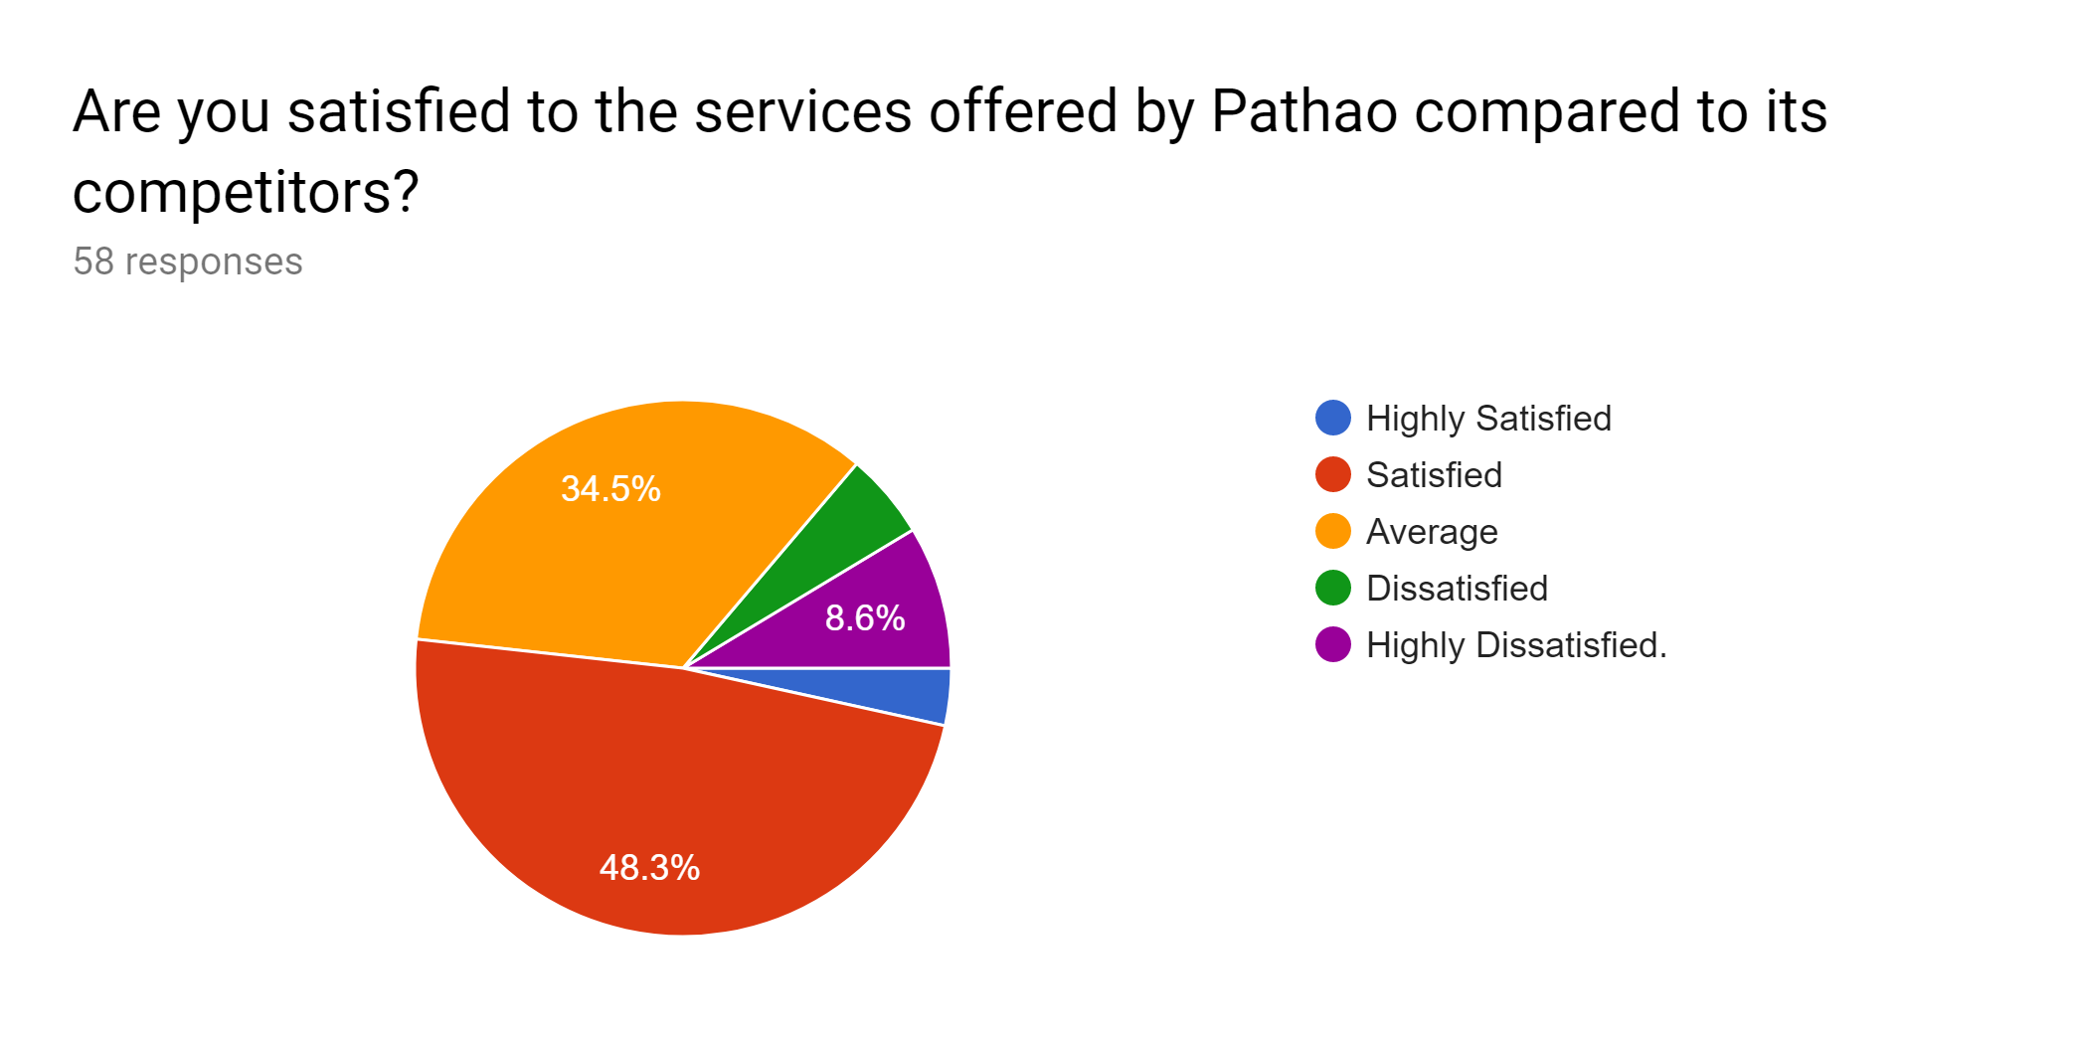
Interpretation: This was a direct question to students to know their satisfaction level using Pathao services compared to its competitors. Among 58 students, 48.3% or 28 students marked that they are satisfied and 34.5% have marked that they found Pathao services average, compared to its competitors.

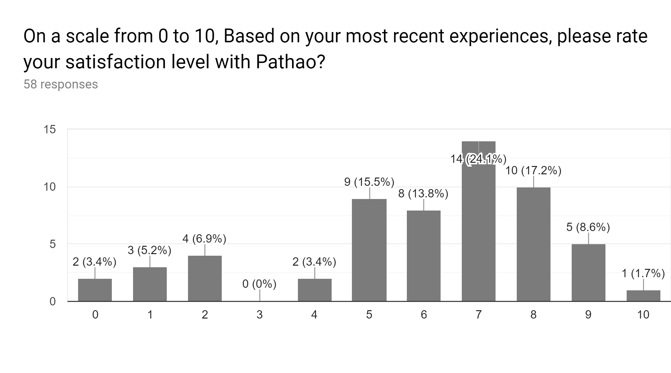
Interpretation: From the Bar chart above, 47 out of the 58 students marked the rating 5-10 that describes that they are satisfied with the services of Pathao. Only 11 students marked that they are not satisfied with the services of Pathao and here most of them never used Pathao service at all.

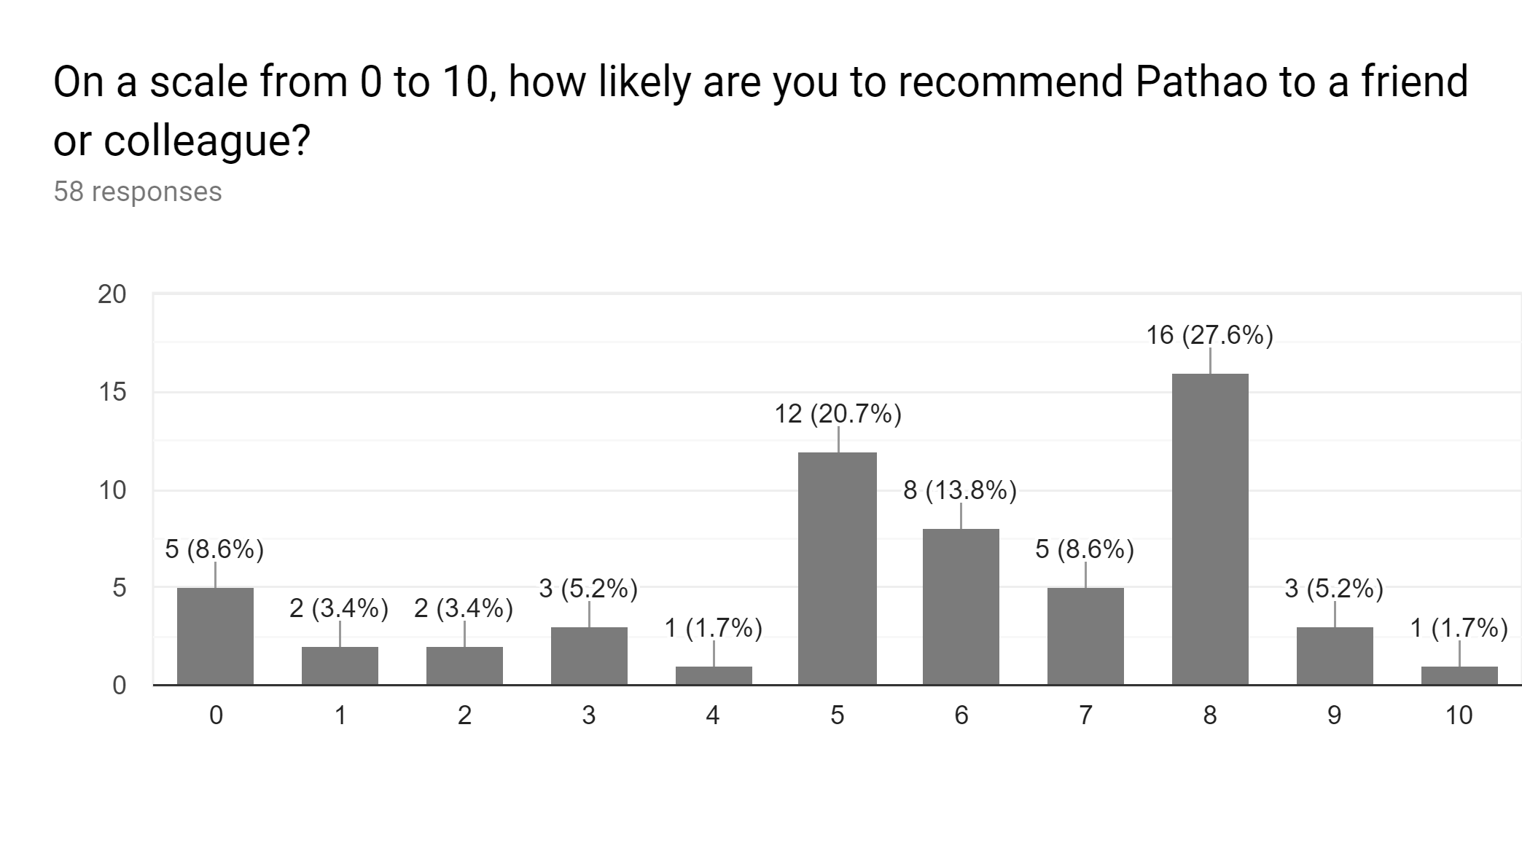
Interpretation: When consumers are satisfied with the services they will recommend the company to their friends and family. From the bar chart above, it can be seen that 45 out of 58 of the students rated 5-10. It displays that they will recommend the Pathao services to their friend, families, and colleagues. On the other hand, very few students (13) marked that they will not recommend.

Chapter six
Recommendations and Conclusion

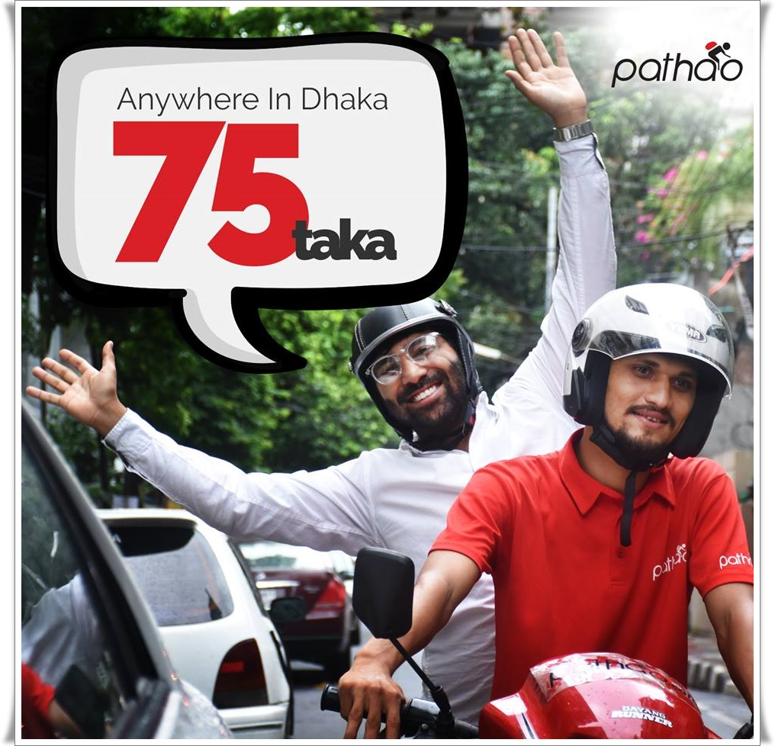

6.1 Recommendations
The analysis and findings chapter displays that the majority of students among my randomly selected 58 students are satisfied with the products and services of Pathao. Still, Pathao could not improve it all of its ways to provide the satisfaction to all of its consumers. Additionally, a lot of students don’t have used Pathao till now. In this chapter, some suggestions are going to provide for the betterment of Pathao consumer satisfaction. The suggestions are giving below:

- Several University students use personal cars and bikes, Pathao ought to enhance its services to meet all the meet and demand for all people in the country.
- Pathao needs to improve its mobile app to all kinds of consumers as few are facing difficulty to understand the app.
- Pathao ought to publish its annual report publicly as it is hard to find theoretical information about this company and its diversified services.
- Trainers and riders should be well trained as well as well-educated so that their manner satisfies the consumers to hire Pathao again.
- The pricing strategy of Pathao should be minimized compared to the other competitors of Pathao.
- Safe Rides and Product delivery must be ensured. Pathao needs to focus highly on the safety and security issues and reduce the accident rate because this any bad news can highly impact on the overall consumer satisfaction.
- The website and mobile app of Pathao seem very complicated for the uneducated people. These sites and apps should be made for all types of people of our society.

6.2 Conclusion
The analysis and findings of the project report show that Pathao is currently the most favorable and acceptable ride-sharing brand for the consumers of Bangladesh regarding their satisfaction level. Pathao should work more on inventing new services so that they can capture deliver and fulfill all levels of consumer demand.
This study will benefit the ride-sharing services of Pathao as well as other competitors and, thanks to the results of this report; every ride-sharing company can improve customer satisfaction in increasing the competitive advantage over vehicle sharing, branding, and competition. The authors advised that travel provider service providers focus on the promotion of coupons and pricing and pricing, which will have less effect on customer satisfaction. Therefore, to implement their marketing strategy, they must work, especially due to price and promotion, they support the performance of their companies in the transportation sector. On the other hand, customer satisfaction is the most influential factor. As a result, service providers can improve or maintain these three reasons to satisfy their customers.
However, Pathao ought to be more responsive to the infrastructural issues of Bangladesh. It should reduce traffic jam and importantly road accidents by training its riders and trainers on a monthly basis. Its services need to available in all the areas of Bangladesh. All these will help Pathao to be a number one ride-sharing company and serve their consumers well.

References
(1) Maisha, 2018, Trip Issues and Reporting, Article Available at: https://pathao.zendesk .com/hc/en-us/articles/115004903113-Trip-Issues-and-Reporting
(2) Abdullah Wasif, 2018, Article name: Share a ride! Article available at: https://pathao. zendesk.com/hc/en-us/articles/115003511373-Share-a-ride-.
(3) Dhaka Tribune, 2017, Meet the minds behind the success of Pathao, Available at https://www.dhakatribune.com/business/2017/09/24/meet-minds-behind-success-pathao
(4) Matthew L. Meuter, Amy L. Ostrom, Robert I. Roundtree, Mary Jo Bitner (2012) Self-Service Technologies: Understanding consumer Satisfaction with Technology-Based Service Encounters. Journal of Marketing: July 2000, Vol. 64, No. 3, pp. 50-64.
(5) Gitman, Lawrence J.; Carl D. McDaniel (2005). The Future of Business: The Essentials. Mason, Ohio: South-Western
(6) Kerry Smith, Dan Hanover, 2016, Experiential Marketing: Secrets, Strategies, and Success Stories from the World's Greatest Brands
(7) Joseph F. Hair, Jr, Mary Wolfinbarger, Arthur H Money, Phillip Samuel, Michael J Page, 4 March 2015, Book name: Essentials of Business Research Methods, Available in https://www.taylorfrancis.com/books/9781317471233

Appendix-
Survey Questionnaire
