

Performance Management System in Banking Industry of Bangladesh: A Study on JAMUNA Bank Limited (JBL)
Name of the student
Sadia Afrin

This report is submitted to the school of Business and Economics, United International University as a partial requirement for the degree fulfillment of Bachelor of Business Administration.

Internship Report
On
Performance Management System in Banking Industry of Bangladesh: A Study on JAMUNA Bank Limited (JBL)
Course code: INT 4399
Submitted To
Md. Kazimul Hoque
Assistant Professor
School of Business and Economics
United International University
Submitted By
Sadia Afrin
ID: 111 161 010
Bachelor of Business Administration
Enrollment: Spring 2021
Major in Human Resource Management
United International University
Date of Submission: February 28, 2022

Letter of Transmittal
February 28, 2022
Md. Kazimul Hoque
Assistant Professor,
School of Business and Economics,
United International University
Subject: Submission of Internship Report.
Dear Sir,
With due respect, I am submitting my internship report on “Performance Management System in Banking Industry of Bangladesh: A Study on JAMUNA Bank Limited” which is the part of fulfillment of Bachelor of Business Administration degree and the INT course 4399.
As a consequence, I am delighted to submit my report, which serves as both a learning experience and an illustration of the distinctions between theoretical and practical action.
Therefore, I would like to express my gratitude to you for all of the support and guidance you have provided me. I hope this report will meet your expectations. I would be grateful if you would accept my internship report with the utmost appreciation.
Sincerely

Sadia Afrin
ID – 111 161 010
BBA Program, Major in Human Resource Management
School of Business and Economics
United International University

Declaration of the Student
I am Sadia Afrin, student of Bachelor of Business Administration, major in Human Resource Management, United International University; I do hereby declare that:
- The internship report on “Performance Management System in Banking Industry of Bangladesh: A Study on JAMUNA Bank Limited” consisted of presentation of my original work.
- This study brings together the efforts of a number of individuals who have been involved in providing appropriate references for the literature review, conducting interviews for the purpose of analyzing the topic and discussions, and analyzes the information obtained as a whole.
- And this report has been prepared under the supervision of Md. Kazimul Hoque, Assistant Professor, Business and Economics, United International University.
In addition, I certify that the report was prepared solely for academic research purposes and that I did not participate in any unethical practices while compiling it.
Sadia Afrin
ID – 111 161 010
BBA Program, Major in Human Resource Management
School of Business and Economics
United International University

Acknowledgement
To begin, I would like to express my deepest gratitude to Allah for giving me with the strength necessary to fulfill my internship report accountabilities, as well as to complete the report on time.
After that, I would like to convey my heartfelt appreciation to my course supervisor, Md. Kazimul Hoque, Assistant Professor, Business and Economics, United International University for his valuable support and constructive guidance. To be honest, if it hadn't been for his invaluable assistance, guidance, and cooperation throughout the approach, I would not have been able to complete the report on time with accuracy. I am delighted to have the opportunity to complete my internship report under his supervision.
I would like to express my recognition to the employees of JAMUNA Bank Limited (Simrail Branch, Narayanganj) for their participation and contribution of their precious time to the completion of the formal and informal interview sessions.

Executive Summary
The internship report was prepared as a requirement for the completion of Bachelor of Business Administration (BBA) degree. I acquired great hands-on experience while working as an intern at JAMUNA Bank Limited, which I have outlined in my report.
The study of the report has been conducted on performance management system of JAMUNA Bank Limited (JBL)." The major objective of this report is to illustrate how the human resources department of JBL plans, operates and implements the performance management system in their banking and financial service sector. HR activities, following performance driven culture and strategy, planning for performance management and implementation system are included in this report.
The first chapter includes an introduction part such as background of the study, objectives, scope, limitations, and methodology of the report.
The review of the literature is included in the second chapter. This chapter's purpose is to provide data that has been obtained from appropriate academic sources in relation to the study's topic.
The third Chapter deals with the overview of JAMUNA Bank Limited, its strategic plan for banking services, facilities & accommodations, HR policies and philosophy.
In fourth chapter, the whole performance management system of JAMUNA Bank Limited has been analyzed. For analyzing the topic and information, qualitative technique and verbal analysis has been used.
In chapter five, on the basis of analysis part some challenges faced by JBL's Human Resources Department (HRD) are discussed, along with some solutions. In this chapter, I've put my report to a conclusion.

Table of Content

Executive Summary iv
Chapter 01: Introduction
1.1 Introduction of the Report 2
1.2 Origin of the Report 2
1.3 Objectives of the Report 2
1.3.1 Primary Objective 2
1.3.2 Secondary Objectives 2
1.4 Rationality of the Study 3
1.5 Methodology of the Report 3
1.5.1 Primary Sources 3
1.5.2 Secondary Sources 3
1.5.3 Data Collection and Analysis Plan 3
1.6 Scope of the Report 4
1.7 Limitations of the Report 4
Chapter 02: Literature Review
2.1 Performance Management System 6
2.2 Importance of Performance Management System in an Organization 7
2.3 Performance Assessment/ Appraisal/ Evaluation 9
2.4 Link between Performance Appraisal and Performance Management 9
Chapter 03: Orgnization Preview
3.1 Take a look at JAMUNA Bank Limited 12
3.1.1 Response to the COVID 19 Pandemic 13
3.2 Mission 14
3.3 Vision 14
3.4 Strategic Approach and Objectives 14
3.5 Core Values 15
3.6 Products and Services 16
3.7 Management Structure of JBL 20
3.8 Board of Directors 20
3.9 Human Capital at JBL 21
3.10 Philosophy of Managing Human Capital at JBL 22
3.10.1 HR Service Excellence 23
3.10.2 Digital HR 23
3.10.3 JBL Standardized Policies 24
Chapter 04: Analysis of PMS at JBL
4.1 Data Analysis Method 26
4.2 Performance Driven Culture at JAMUNA Bank Limited 26
4.3 Performance Management System of JBL 27
4.4 Step 01: Performance Planning and Target Set 28
4.4.1 Goal Setting Approach 29
4.4.2 Development Planning 30
4.4.3 Career Development Planning 33
4.5 Step 02: Performance Execution 33
4.6 Step 03: Performance Assessments 34
4.6.1 Types of Performance Assessments 35
4.6.1.1 Managers’ Assessments 35
4.6.1.2 Self Assessments 36
4.6.1.3 Multiple Assessments 36
4.7 Step 04: Performance Review 37
4.7.1 Coaching and Feedback 37
4.7.2 Models for Coaching 38
4.7.3 Steps for Coaching 38
4.7.4 Employee Motivation at JBL 39
4.8 Reward and Recognition 39
Chapter 05: Findings, Recommendations and Conclusion
5.1 Findings 42
5.2 Recommendations 42
5.3 Conclusion 43
References 44

List of Tables
Table 1.1: The Members of Board of Directors in JBL 21
Table 1.2: Five Components of Measuring Performance 35
Table 2.2: Extrinsic and Intrinsic Motivating Tools at JBL 39
List of Figures
Figure 1.1: Core Values of JAMUNA Bank Limited 15
Figure 2.2: Management Structure of JAMUNA Bank Limited 20
Figure 3.3: Five Factors of HR Business Partner Approach of JBL 21
Figure 4.4: Standardized Polices of JBL 23
Figure 5.5: Performance Management System of JBL 26
Figure 6.6: The Cycle of Performance Management System at JBL 27
Figure 7.7: Goal Setting Approach of JBL 28
Figure 8.8: Career Development Planning (Individual) 30
Figure 9.9: Graphical Representation of Training Status for the Year 2020 31
Figure 10.10: Generating Development Planning in Three Stages at JBL 31
Figure 11.11: Development of Career Plan at JBL 32
Figure 12.12: Timelines for Review Process at JBL 36
Figure 13.13: Employees’ Benefits and Rewards on the Basis of Performance at JBL 39

CHAPTER 01
INTRODUCTION

Introduction of the Report
In the twenty-first century, organizations’ success and long-term viability are highly dependent on the quality of their human capital. As a consequence, the performance of the organization is boosted of the core competences of employees and teams. Identifying the best performers, paying them well enough to make them feel comfortable, and developing their abilities so that the organization can remain competitive are all posing huge challenges to corporations. An efficient performance management system has thus evolved. It is essential that an organization's performance management system be used effectively in order to gain a competitive advantage in the global marketplace. Firms are moving more quickly to improve the efficiency of their performance management systems as the relevance of PMS grows in many industries. The banking industry is no exception, as companies are working more quickly to improve the effectiveness of their PMS. The process of performance management begins with the enrollment of a new incumbent in a system and concludes with the termination of an employee's employment with the company. The purpose of the report is to study on performance management system of JAMUNA Bank Limited.

Origin of the Report
This internship report is prepared for a partial requirement for the degree fulfillment of Bachelor of Business Administration. I have gained hands on experiences about the HR activities and following practices in banking industry in Bangladesh. And these issues are a significant source in the main study of this report which has been done under the supervision of Md. Kazimul Hoque, Assistant Professor, Business and Economics, United International University.

Objectives of the Report

Primary Objective
- The primary objective of this study is to provide a general overview of JAMUNA Bank Limited’s performance management system and to identify any shortcomings.

Secondary Objectives
- To get an overview of JAMUNA Bank Limited.
- To analyze the current performance management system in JAMUNA Bank Limited.
- To find out the shortcomings in PMS of JBL.
- To provide some recommendations that can help to develop effective performance management system for JBL.

Rationality of the Study
The purpose of this study was to get an understanding of the performance management system used by JAMUNA Bank Limited. In all, there are 149 branches with a total of 3, 096 employees. Consequently, I am attempting to determine how the human resource department of JAMUNA Bank Limited analyses its employees' performance and how they motivate them to achieve higher levels of performance. I'm also attempting to learn about various different PMS that the bank uses to analyze the performance of their employees.

Methodology of the Report
The data used for the study of the report have been acquired from two different sources. The specifications are as follows:

Primary Sources

The material for this report has been acquired from a variety of primary sources, as well as primary data from respondents to formal and informal interview sessions for the purpose of studying the subject matter. Another method is used to obtain primary data:
- Face to face interaction and discussions with employees of JAMUNA Bank Limited (Simrail Branch, Narayanganj).
- An observation from internship experiences and HR related tasks and job responsibilities.

Secondary Sources
The secondary data was gathered from the following sources:
- Newspapers, Articles, books, Journals, which are related to the concept of performance management system and performance evaluation process.
- Official Website of JAMUNA Bank Limited.
- Annual reports (2020, 0219) of JAMUNA Bank Limited.

Data Collection and Analysis Plan
For the purpose of analyzing the topic, formal and informal interview sessions have been conducted with the employees and the HRD of JAMUNA Bank Limited which was based on prior study on performance management system of JAMUNA Bank Limited and includes a wide range of valuable information.
For presenting the data and information, I have not included any quantitative techniques in this internship report. More specifically, the paper is concerned with a practical hand on experience. I mostly utilized verbal analysis to explain performance management system of JAMUNA Bank Limited, as well as to identify the types of practices they have explored using those activities.
Some tables and figures have been used in the analysis and presentation of the data.

Scope of the Report

The primary goal of this study is to get an understanding of the JAMUNA Bank Limited's performance management system and how it is being implemented and maintained. Bank performance management systems, on the other hand, are private and thus cannot be discussed in detail. When it comes to performance management, I've had direct experience with how the HR department handles it. I am thankful for the opportunity to learn about a bank's actual performance management system.

Limitations of the Report
Some of the limitations for completing the report are listed below:
- Some information cannot be made available due to confidentiality and other bank obligations.
- Working in a single branch makes it very difficult for me to obtain all of the necessary information.
- Some of the employees of HRD of JAMUNA Bank Limited had not given so much time on my interview sessions.

CHAPTER 02
LITERATURE REVIEW

Literature Review Part
This main purpose of this chapter is to provide theoretical concept obtained from the study's subject matter's relevant literature.

Performance Management System
A company's human resources department uses a performance management system to engage employees in furthering the company's efficiency by attaining its stated vision, mission, and goals (Techfunnel, 2021). A global economy necessitates a need to generate (and maintain) highly-trained workers (Travor C. Brown, 2018 ). Employee growth and development are generally seen as the primary goals of performance management (Aguinis, 2013). In a nutshell, "identifying, monitoring, and developing the performance of people and teams and aligning performance with the strategic objectives of the business" is a broad definition of (PM) Performance Management (Cascio, 2014). Human resource development and performance management may be linked by using this fundamental idea (HRD). To support this, (Bob Hamlin, 2011) conducted a review of the literature in which they proposed four core purposes of HRD: "enhancing individual or group effectiveness and performance"; "enhancing organizational effectiveness and performance"; and, "developing knowledge, skills, or competencies."
For a variety of reasons, PM is essential to HRD. To begin, the four primary goals of HRD and the above concept of PM have a great deal in common. Secondly, (Werner, 2017) believes that PM research might serve as a bridge between HRM and HRD, as HRM's fundamental role is to evaluate people, while HRD's core function is to improve both individual and organizational performance. Coaching is a third HRD intervention advocated by HRD experts in the context of performance management (RF Poell, 2014). Managers must be trained to be successful coaches, and they must possess the necessary interpersonal skills. Human resource professionals also have a duty to establish an environment that encourages coaching (Werner, 2017). There is a strong correlation between the inclusion of these coaching components and expanding PM's scope beyond the traditional yearly performance review.

Importance of Performance Management System in an Organization
According to (White, 2021), a few of the reasons why continuous performance management is so important for every firm are listed below.
- It Predicts the Future
If you're constantly assessing and regulating your workplace's performance, you can anticipate potential problems. When it comes to any problem, early identification is crucial. The more quickly issues are addressed; the less likely they are to have an impact.
You may shift an employee to another job that does not involve collaboration, you can teach the employee on how to function in a team, or you can fire the individual if the firm detects they are not team players. Taking action before a problem arises may save the firm both time and money.
- Helps Design and Implement Training and Development Programs
The sooner a problem is detected, the better. Personnel may not be adhering to necessary processes in this instance. A lack of control might cause the organization to crumble if this trend continues. It is likely that this would be identified, though, if it were subject to performance evaluations. The organization may then establish training programs to transform the issue into a growth opportunity.
- Provides Clarity in the Organization
A big cause of stress for many employees does not understand what they are supposed to do or who they are supposed to report to. To make all of this evident, the business has a tool: performance management. Productivity may suffer if understanding is impaired. By providing the knowledge they need, employees will have a better chance of being more productive and confident.

Provides the Opportunity for Exchanging Feedback
Open communication may swiftly derail personal or professional relationships that lack it. Employees seldom get the opportunity to communicate their issues or disappointments when management discusses their performance with them. Employees and employers may share feedback when performance management is done correctly. Encouraging employees to voice their thoughts not only improves morale, but it also often results in a more positive work environment.

Increases Employee Retention
Rewarding and recognizing workers is another goal of performance management. One of the most common reasons for leaving a job is the inability to get enough acknowledgment for one's efforts. There is a desire to be rewarded for their efforts. Aside from that, prizes and recognition may help keep workers around by offering clarity, the capacity to give criticism, and the chance for more training as needed.

Boosts Employees Productivity and Engagement
Employees will be more engaged if performance management is done in a way that includes them. In situations when management and staff aren't on the same page, it's as if everyone is merely going through the motions. As a result, their role becomes more like a job than a fulfilling one. On the other side, performance management has the ability to completely engage employees and make them feel like they are a part of the company. As a consequence, output increases since employees are more content and committed to their jobs.
It is essential that the leaders of your company understand the importance of performance management. If you try to avoid it, you'll end yourself in trouble. With the help of HR and other executives, devise a plan for performance management. Consider asking your employees what they believe needs to be done to improve things. It may take some time to develop an effective performance management system, but the work will be well worth it.
- Helps to enforce goal setting and achievement
It is important for workers to understand the company's goals and the role they play in accomplishing them via an efficient performance management system. This suggests that they are aware of how their work contributes to the company's success.
Thus, performance management aids in creating corporate and leadership goals. Employees will have a greater sense of ownership and commitment to the company if their efforts are focused on achieving the organization's strategic objectives.
- It offers mentoring for increasing performance
The goal of performance management is to make employees more productive. It will help managers enhance their performance while providing an opportunity for managers to explore their future career plans. Executive managers and HR managers might use it to provide additional mentoring and training as part of developing promotion criteria.

Performance Assessment/ Appraisal/ Evaluation
Performance evaluation is described as a procedure that systematically assesses a workers personality and performance generally by managers or direct supervisors against the predetermined criteria like skill set, understanding about the function, technical know-how, attitude, timeliness and so on (Frank J. Landy, 1983).
According to (Kumari, 2020) Performance assessment, performance review, merit rating, yearly reviews, etc. are all different terms for the same thing: assessing an employee's ability to perform. This procedure is used to determine an employee's innate traits and talents, as well as their degree of competence, for the benefit of both the individual and the business they work for. Identifying an employee's worth to a business is the goal of this assessment. Managers and supervisors use performance assessment to find the appropriate individual for the right role based on the skills they bring to the table. Every company requires a solid performance evaluation system without a doubt.
Managers and supervisors utilize a variety of approaches to assess workers based on objective and subjective criteria; nevertheless, the process may be complicated, and both aspects are necessary in order to accurately assess an employee (Kumari, 2020).

Link between Performance Appraisal and Performance Management
According to (Larmore, 2022), the most popular instrument for performance management is the performance assessment; therefore there is a relationship between the two. Measuring and monitoring employee performance demands precise tools in performance management. Managers may assess employee performance in depth through performance evaluations, and they can also set goals and objectives for the employee to work toward in the future. For the purpose of performance management, this evaluation is sent to HR personnel.
To ensure that workers are working toward a same objective, they must have a clear grasp of their job requirements, and they must get frequent performance evaluation. While offering suggestions for improvement, it's also a fantastic way to praise outstanding work. Performance appraisals are the most often used tool for performance management since they enable HR to accomplish most of their goals in performance management. As a result, the majority of firms have a performance evaluation and performance management programs that work hand-in-hand (Larmore, 2022).
To the benefit of a company, performance assessments are designed by HR specialists. They are usually given to front-line managers, who use them to assess their own staffs. In order to effectively manage performance, managers rely on appraisals since they compel them to talk openly with their staff about their work, progress, and goals. Performance evaluations done by colleagues or by employees themselves are becoming increasingly commonplace in certain workplaces. Organizations utilize a variety of methods to evaluate their employees, but performance evaluations by management are the most popular (Larmore, 2022).
Quarterly, semi-annual, or yearly are all acceptable intervals for conducting effective performance evaluations. In order to reduce managerial bias, questions in the evaluation should need the replies to be supported statistically. In this way, managers may give their employees a specific set of goals and objectives to strive toward before their next performance review. The evaluation should also take into account the employee's capacity to accomplish the goals and objectives that were established at the prior appraisal meeting. Employees should know in advance what awards they may anticipate at various levels of success, so there are no surprises (Larmore, 2022).
Businesses can better support their performance management goals when assessments are fair, objective and goal-oriented. Another tool may also be necessary to monitor and enhance performance evaluations: the balanced scorecard. However a performance evaluation is implemented, it must be examined and updated over time to ensure its accuracy as a tool for assessing employee performance. An effective link between performance evaluation and management can only be made if the evaluation is well conceived and implemented (Larmore, 2022).

CHAPTER 03
ORGANIZATION PREVIEW

Take a look at JAMUNA Bank Limited
In Bangladesh, JAMUNA Bank Limited (JBL) is one of the leading private banks in Bangladesh with a network of 149 branches, 28 sub-branches, 15 banking booths, and 314 ATMs. On April 2, 2001, JAMUNA Bank was incorporated as a public limited company under the Companies Act, 1994, and it began operating as a bank on June 3, 2001.
The Bank offers a wide range of products and services, including Corporate, Retail, SME, Agri-finance & Islamic financing solutions, Merchant Banking, and Securities Brokerage, to assist trade, commerce, industry, and the general business of the nation. Providing export-import, manufacturing, service, infrastructure, and other business solutions are all areas in which JBL plays a critical role in the development of the economy. It has been JAMUNA Bank Limited's ongoing attempt in order to satisfy client demand that it has been developing its banking operations with the following goals in mind:

JAMUNA Bank Limited (JBL)
Private Commercial Bank, Headquartered in Dhaka
Form of Business | Banking Service
Key Business Segments | NRB, SME, Retail, Wholesale and Offshore
Corporate Head Office | Hadi Mansion, 2 Dilkusha Commercial Area, Dhaka 1000, Bangladesh
Website | https://jamunabankbd.com/front/index
Number of Branch | 149
ATMs | 214
Islamic Banking Branches | 02
Offshore Banking Units | 01
Employees | 3, 096
Source: (Annual Report of JBL, 2020)

Response to the COVID 19 Pandemic
Each and every part of our life is being affected by the pandemic - from the way JAMUNA Bank Limited, they communicate and engage with their families to the way they work and interact with their customers, colleagues and communities of the bank.
- Customers:
- Helped their clients feel secure at a period of uncertainty by allowing access to government declared COVID-19 stimulus programs to support business concerns severely impacted by this pandemic.
- Their services are digitized, thus they see a digital change in banking. Due of the Covid-19 outbreak, people, particularly the younger age, wish to avoid physically visiting bank locations. To react to the changes, they added new functionality to our Just Pay digital banking application to better serve our consumers. Now JAMUNA Bank Cardholders may pay their credit card bills, electricity bills, and online shopping bills using their applications ‘Just Pay'.
- Colleagues:
- At JAMUNA Bank, their employees are their most valuable asset, and they have continued to make investments that put their well-being first throughout the pandemic and its consequences.
- Priority was given to preventing the bank's human resources against the spread of COVID 19, and the bank provided the highest levels of health and safety at work, including a sterile work environment and the use of proper equipment.
- In order to prevent any potential health hazard or mental illness, personnel were provided complete opportunity and scope for working from home and full remuneration and benefits for doing so. The company has established a rapid reaction team made up of senior executives to keep an eye on suspicious activities and speed up banking services throughout its network.
- When the bank went into lock down mode, it gave additional incentives to those workers who worked tirelessly to eliminate all dangers, panic, and fear of death. Not only that, but the Bank provided jobs for the relatives of the victims of the COVID 19 incident.

- Communities:
- A number of JAMUNA Bank's community development initiatives are supported by the bank. Towards the goal of alleviating the present labor shortage brought on by the COVID-19 epidemic, JAMUNA Bank Foundation and Al-Haj Nur Mohammed Trust provided 30 Sewing Machines and 30 Auto Rickshaws to the poor, defenseless, and jobless.

Mission
- The Bank's primary objective is to provide a wide range of products and services at a competitive price while utilizing appropriate technology and providing timely service so that sustainable growth, reasonable returns, and a positive impact on the country's development can be achieved with a motivated and professional workforce.

Vision
- To establish itself as a major financial institution and to play a key role in the growth of the country.

Strategic Approach and Objectives
- The goal is to achieve and maintain the highest possible CAMEL rating.
- Through the establishment of Strategic Marketing Plans, it is possible to build relationship banking and increase service quality.
- To maintain its position as one of Bangladesh's most profitable and asset-quality-focused financial institutions.
- The integration of information technology will allow for the introduction of completely automated systems.
- In order to secure a sufficient rate of return on investment.
- To maintain a manageable level of risk (including any off balance sheet risk).
- In order to satisfy maturing obligations and commitments while also maintaining appropriate cash.
- The goal is to keep the firm expanding and projecting the desired image.
- To keep processes open and transparent while also ensuring proper control measures are in place.
- Workforce development and retention is the goal of an effective HR management system.
- To ensure that all available resources are used to their full potential.
- In order to have an efficient management system, it is necessary to make sure that ethical standards, openness, and accountability are observed at all levels.
- Pursuing CSR initiatives in order to ensure their continuous support for future generations, distressed people, and the progress of underprivileged people around the nation.
- Developing a reputation as a bank that is growth-friendly and customer-focused.
- Ensuring a culture of compliance through strengthening risk management approaches.
- Encouraging environmental awareness and support for "green" spaces.

Core Values
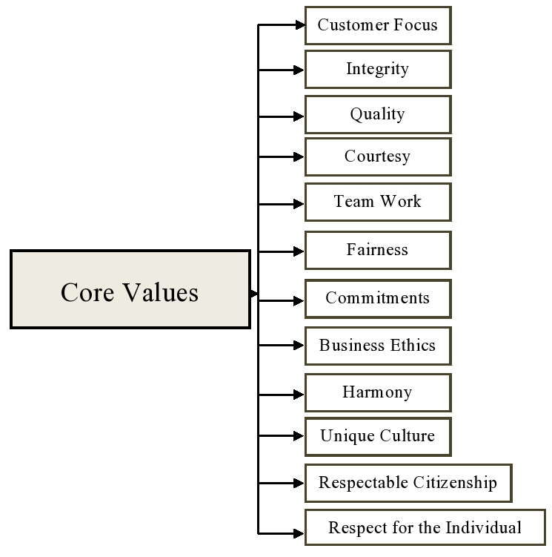
Figure 1.1: Core Values of JAMUNA Bank Limited
Source: (Annual Report of JBL, 2020)

Products and Services
In order to meet the specific needs of its customers, they provide a broad variety of goods and services. Banking products and services are JAMUNA Bank's range of specialization. We're working closely with their valued customers to find the best combination of goods and services to help them succeed.
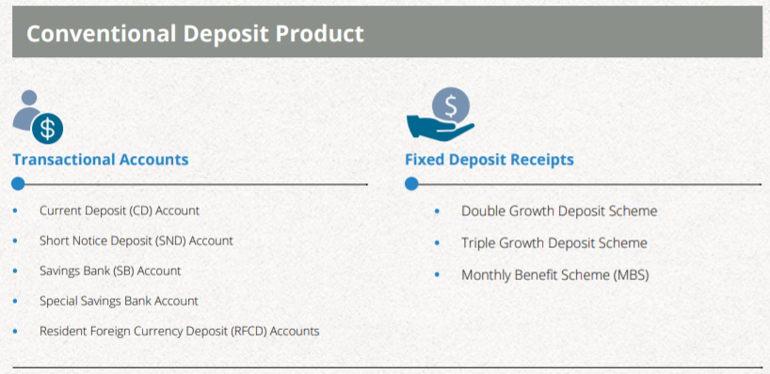
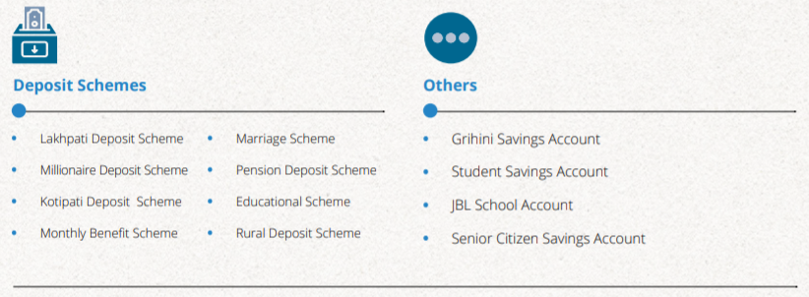

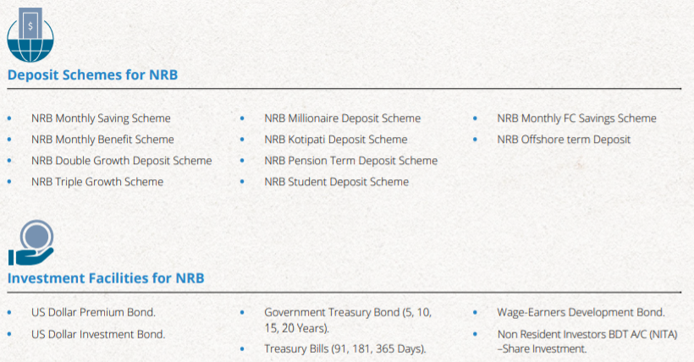
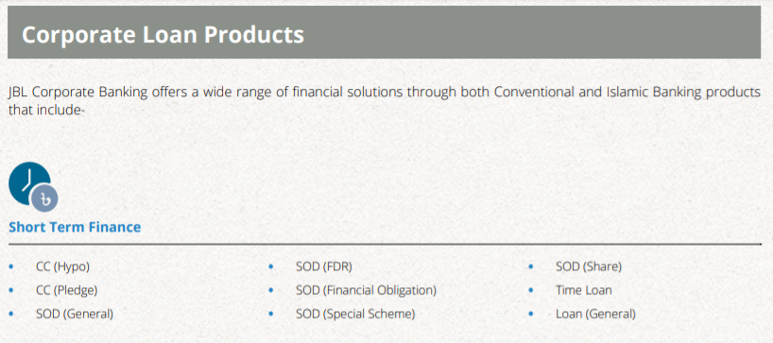
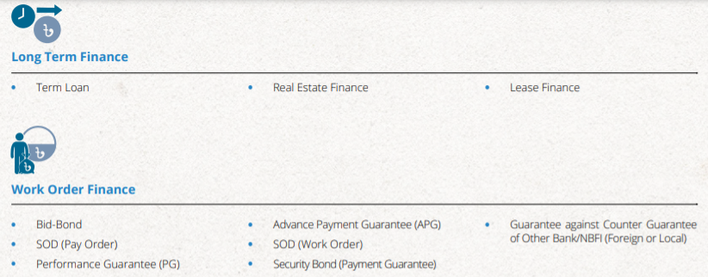

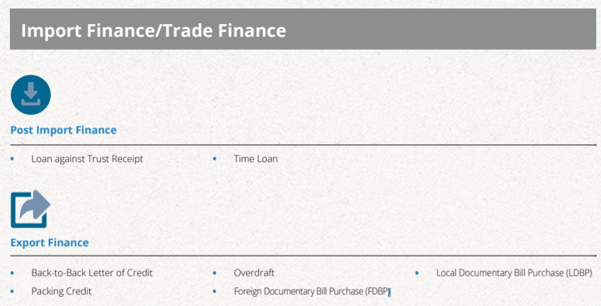
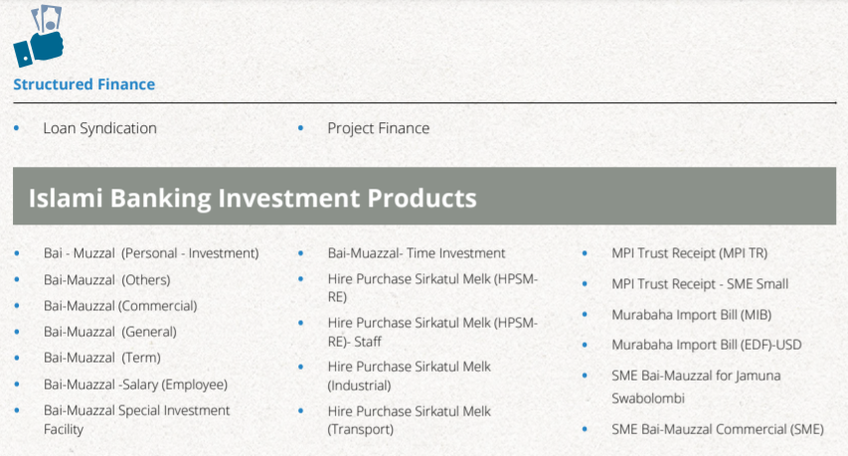



Management Structure of JBL
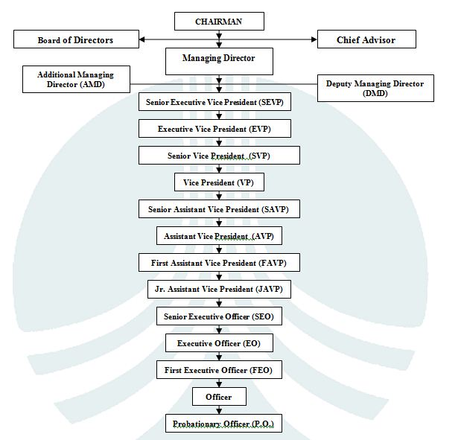
Figure 2.2: Management Structure of JAMUNA Bank Limited

Board of Directors
Management at the highest level is overseen by the Board of Directors, which was established by the Bangladesh Bank's Nationalization Order in 1972. The Bank's Board of Directors consists of 20 members. The Board is under the direction of the Chairman. The chairman of the board is often a well-respected and well-liked professional or ex-professional. The central government appoints the Directors, who come from a variety of backgrounds, including the public and commercial sectors and the chairman and the board of director appoint the Managing Director for JAMUNA Bank Limited. The Bank has fourteen directors and three independent directors; each of them has been selected by the central government to serve. The board of directors of JBL is showed in a table:

Table 1.1: The Members of Board of Directors in JBL

Human Capital at JBL
In JAMUNA Bank Limited, Human capital includes their employees, people, their health and wellbeing, their experience, their inventive potential, and their motivation to work hard. "Human Resources" is JAMUNA Bank Limited's (JBL) biggest asset. The primary source of funding is their employees, who are referred to as Human Capital by JBL. "Discipline, Individual Efficiency, Customer Service, Quality, and Team Work" have been the driving forces behind the Bank's exceptional success. JBL's Human Resources Management Philosophy is:
- Generating extra value via the use of personnel,
- The Human Resources Value Proposition.
With the deep established attitude of leading and winning, the team of Human Resources Division at JAMUNA Bank is persistently prospering in order to offer value to the major stakeholders of the bank, which include customers, line managers, workers, and investors of the bank.
JBL's Human Resources Department has been following a philosophy that focuses on hygiene-motivation aspects to remove employee unhappiness and boost employee job satisfaction, which immediately contributes to the bank's bottom line and has already begun to establish a pool of brilliant people.

Philosophy of Managing Human Capital at JBL
When it comes to JBL, they are completely reliant on Human Resources, which are therefore referred to as Human Capital in the bank. They think that these five (05) criteria allow us to produce the most effective and efficient Human Capital, which assures the Bank's success in achieving its corporate objective via the following approach:
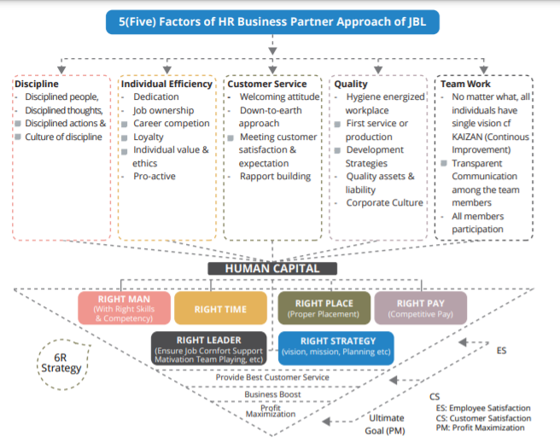
Figure 3.3: Five Factors of HR Business Partner Approach of JBL
Source: (Annual Report of JBL, 2020)
The five elements listed above were effectively implemented by their competent management team via their unwavering efforts. "Right Person in Right Place at Right Time with Right Pay under the Right Leadership with the Right Strategy" is the goal of Human Capital Management, and it is their responsibility to attract, retain, and develop talent in order to engage "Right Person in Right Place at Right Time with Right Pay under the Right Leadership with Right Strategy." This 6R approach provides the highest level of employee happiness, which has a positive influence on our ability to provide the greatest customer service, which in turn helps us to grow our company and increase our wealth as a result.
Besides JBL's greatest asset is a collection of highly driven, multi-talented workers. Employees at the company are treated with respect and given the opportunity to develop their full potential via a performance-based, rewarding work environment. Additionally, this assists the organization since it demonstrates actions that provide value. To ensure long-term viability, JBL places a high priority on recruiting and selecting employees based on their skills and merit, providing competitive compensation packages, providing ample training and development opportunities, fostering a high-performance culture, and allowing employees to raise concerns and receive counseling.
Human Capital is a critical component of the company's long-term viability and success. The bank places a high priority on maximizing the value of its human resources. Workplace safety and development are top priorities for the company, which results in higher levels of dedication and productivity from its workers.

HR Service Excellence
Human Resources (HR) service excellence is a goal at the bank as they embrace the changes and deliver integrated, innovative people-centered services that support the Bank's long-term strategic strategy. Individuals are encouraged to develop and build their professions as a result of their efforts to assist them in accomplishing their objectives. In order to offer their clients with a valuable range of HR services, they stay up to date on the latest HR developments. In order to ensure that their customers, i.e. the employees, get great service, they encourage them to give them their thoughts and ideas through frequent contact channels.

Digital HR
In order to measure, analyze, and improve the HR services provided to its employees, they are translating HR procedures into data. Internal software skills helped them create industry-standard HR software at a lower cost to the stakeholder community. They're putting together a competence inventory so that they can put the appropriate person in the right position. In addition, since there are no other options for training, they are developing a digital learning system. In order to recruit the greatest people, they also use digital services provided by third parties.

JBL Standardized Policies
For the sake of fostering a healthy corporate environment, JBL has adapted and established rules into standard work policies. Employee retention, retirement benefits, and workplace safety are all important considerations in the development of JBL's policies.
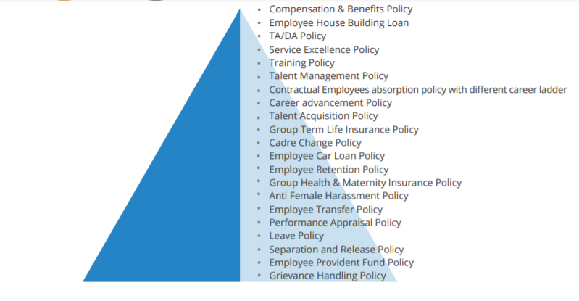
Figure 4.4: Standardized Polices of JBL
Source: (Annual Report of JBL, 2020)

CHAPTER 04: ANALYSIS
PERFORMANCE MANGEMENT SYSTEM AT JBL

Data Analysis Method
For the purpose of analyzing the topic, a standard level questionnaire has been designed. This questionnaire is based on prior study on performance management system of JAMUNA Bank Limited and includes a wide range of valuable information. The information and data has been collected from the employees, HR manager of JAMUNA Bank Limited through conducting formal and informal interview sessions.
For presenting the data and information, I have not included any quantitative techniques in this internship report. More specifically, the paper is concerned with a practical hand on experience. I mostly utilized verbal analysis to explain performance management system of JAMUNA Bank Limited, as well as to identify the types of practices they have explored using those activities.
Some tables and figures have been used in the analysis and presentation of the data.

Performance Driven Culture at JAMUNA Bank Limited
In order to reward and keep the abilities of the Bank's personnel, the HRD of JAMUNA Bank Limited, they appraise/evaluate them honestly and unbiased, and they make concrete decisions based on their performance, key performance indicator- KPI (SMART) has been implemented in the bank, as well as the use of "The Balance Score Card." All of JBL's success is dependent on the efforts of its existing staff. SMART KPIs were utilized as performance management tools to analyze the contribution of all employees in a transparent way to measure quantitative and/or qualitative performance in relation to the stated objective for a particular year in 2017. The measuring variables are considered in conjunction with the objectives and organizational and personnel behavior.
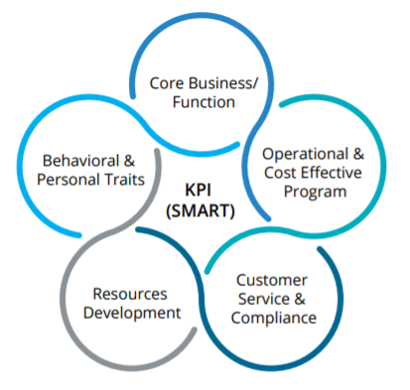
At the start of each year, the overall aim of the organization is tumbled down to the individual level, and every employee of the bank is kept informed of the target, tasks, and responsibilities that have been assigned to them. A self-rating is completed by the employee, and then the managers meet with the individual to review the accomplishment and objective.

Performance Management System of JBL
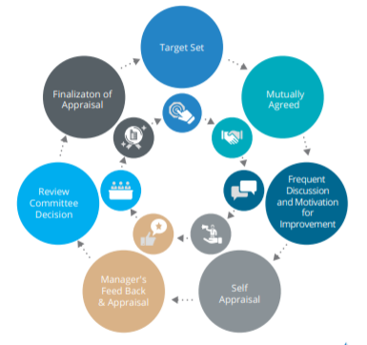
Figure 5.5: Performance Management System of JBL
Source: (Annual Report of JBL, 2020)
A performance management system is a technique of continuously monitoring and analyzing an employee's performance in relation to key performance indicators. It is a method through which human resources encourages employees to perform better in their jobs. A vital part in this process is played by both the workers and their immediate supervisor.
- The Role of Supervisor: The procedure must be completed efficiently and completely, and the supervisor must ensure that this is done. Employees must be motivated by their supervisors in order to achieve objectives and goals. The process of performance management should be carried out under the constant supervision of a supervisor.
- The Role of Employees: Employees play an essential role in any organization. The success of an organization is closely related to the performance of its employees. The whole performance management system has a direct impact on an employee's career advancement. When it comes to JAMUNA Bank Limited, one can depend on them to always have a high-performing culture.

Figure 6.6: The Cycle of Performance Management System at JBL
SMART goals are part of JBL's performance management system. From the top of the organization, SMART goals are set. An important part of JBL's performance management system focuses on the continuing training and development of each employee.

Step 01: Performance Planning and Target Set
The initial phase in JAMUNA Bank Limited's PMS system is performance planning. They create a goal at the beginning of each year to give staff a sense of direction for the year. Planned activities are the result of a team effort. Every cycle of performance management begins with a meeting between the manager and the employees when they discuss what needs to be done and how it should be done. The whole organization benefits from planning. To begin, in JBL, goals are identified and set. There are three different sorts of goals they establish for the organization. These are discussed below:
- Personal Goals for Employees: JAMUNA Bank Limited has placed a limit on the total of employees who may establish personal goals. Every year, each employee is allowed to establish up to five personal objectives. Employees might set their own objectives or follow the example of their management. Managers may have to set the aim themselves. Employees may also adopt last year's targets.

- Managers have stated their Objectives & Goals: In order to encourage their employees to follow in their footsteps, managers share their entire goals on the JBL website. It is up to managers whether they want to communicate their aims to all of their staff or just a few. The announced aims of the five managers are understood in terms of their own personal aspirations. Employees' five-goal restrictions aren't affected if they copy these objectives.

- Assigned Goals: The management of JBL sets these kinds of goals. These objectives have no bearing on the manager's original five objectives. This objective may be modified by employees who are assigned to it.

Goal Setting Approach
When it comes to setting targets objectives and goals of the organization, JAMUNA Bank Limited takes this method.

Figure 7.7: Goal Setting Approach of JBL
- Assess Business Needs: The fundamental goals of JBL serve as the foundation for the organization's overall mission and objectives. Following their goals is the first order of business for those at the top of the organizational structure. Individual and team objectives are assigned to each department by the department heads.
- Formation of SMART Goals: The formation of SMART goals is the next step in the JBL goal-setting process.
- Specific: This time, the motivation was clearly stated.
- Measurable: A clear framework for evaluating and compensating performance.
- Achievable: It is important that goals be reachable given the resources and skills available.
- Relevant: Organizational objectives must be aligned with those of the organization.
- Time Bound: Set a reasonable timeframe for completing the assignment.
- Adding Goals to the PMS: The method is used by JBL to keep track of their objectives. Employees of JBL may re-create their objectives by taking into consideration performance, production, and budget.
- Explore Goals: In order to accomplish all of JBL's objectives, they divided them down into manageable, more achievable goals.

Development Planning
The strategic measurable goal that an organization intends to attain within a certain time period is what is meant by "development planning." JAMUNA Bank Limited is a strong believer in the need of constant improvement in order to achieve one's objectives. As a result, they design their training programs to include strategies for enhancing workers' short- and long-term job performance. Employees may track their progress by reviewing the development plan on a regular basis. Employees are able to recognize their own personal growth opportunities and difficulties. The long- and short-term goals of a person's professional growth may be identified in a development plan.

Long Term
Development Program of JBL
Short Term Development Program of JBL
Attain Career Objectives
Increase Job Performance

Figure 8.8: Career Development Planning (Individual)
Using the JBL's website, employees may create their own growth plans for themselves. JBL goes through a series of steps in order to establish a development plan. They are as follows:
- Identify Strengths: Current performance evaluations, feedback from peers and supervisors may help build strength (SWOT analysis & 360 degree feedback).

- Make Plan to improve Skills: In the viewpoint of JBL, 60 percent of development takes place on the job (through work and assignments), 30 percent takes place through experience gained from peers (mentoring and coaching), and 10 percent takes place through training programs (functional skill training, self-study project).

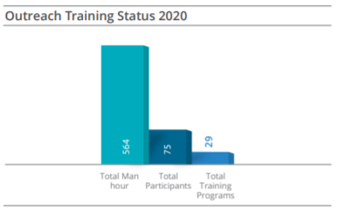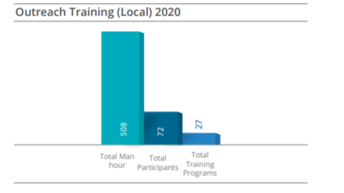
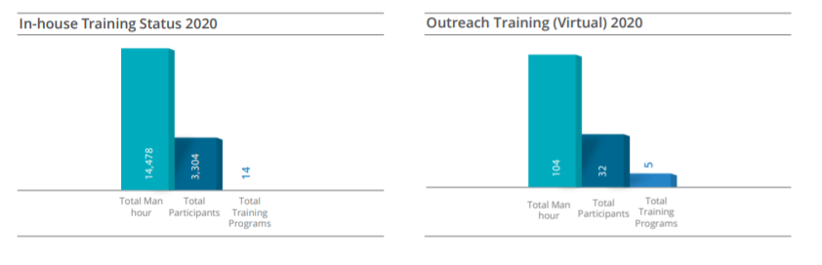
Figure 9.9: Graphical Representation of Training Status for the Year 2020
- Recognize Next Progressive Work: The last stage is to determine progressive employment that is both of interest to the individual and consistent with his or her career goals (s). After this, the employee's next task ought to be upward. They meet with their supervisors after completing the three-step procedure of JBL.

Figure 10.10: Generating Development Planning in Three Stages at JBL

Career Development Planning
The JAMUNA Bank Limited and its employees, as well as the management, are all involved in the development of a career plan.

Figure 11.11: Development of Career Plan at JBL

Step 02: Performance Execution
Performance execution follows on from the previous phase of performance planning. It's time to get down to business and complete what they started. The first step in achieving their objectives is to put them into action. Those who work for JAMUNA Bank Limited are in charge of putting the bank's strategy into action. Employee involvement, on the other hand, does not begin at this point. Employees play an essential role in the planning process. JBL adheres to a number of factors throughout this stage of the performance execution process. These are discussed below:
- Goal-setting dedication: Employees and their supervisors decide on objectives during the performance planning phase. As a result, employees must strive to achieve those objectives. Employees' active engagement guarantees that they are dedicated to the objectives that they have chosen for themselves.
- Continues Coaching and Feedback: Employees at JBL don't have to wait until the end of the review cycle to get a review. Every step of the way, they take a proactive approach and seek for feedback and guidance from their supervisor.
- Communication with Supervisors: An open conversation between employees and supervisors may help improve productivity. As a result, JBL’s employees keep in touch with their managers on a frequent basis.

- Sharing Data: Employees at JBL are required to provide their supervisor with a regular performance update.
In the performance execution stage, the supervisor is also accountable for a number of things:
- Observation and Documentations: The manager must keep an eye on the performance of his or her personnel on a frequent basis. They have to keep track of how much work is completed each day. It is the duty of the manager to maintain records of the work done by his or her staff. On a regular basis, they must maintain documents for both high and low-performance scenarios.
- Updates of Goal and Objectives: It is possible to alter or reimaging an organization's aims at times. As a result, it is the obligation of the supervisor to offer an update on progress toward targets.
- Feedback: In order to offer frequent feedback on an employee's performance, it is the obligation of the supervisor.
- Providing Resources: Employees should be provided with materials to aid in the growth of their jobs by their supervisors.
When it comes to performance execution, both the supervisor and the employees are responsibility for it.

Step 03: Performance Assessments
The following step after the performance execution stage is the performance evaluation step. Performance evaluation is a method of determining how well a piece of work performs. It is a vital step in the implementation of a performance management system. It is the responsibility of both the supervisor and the workers to determine the degree to which the desired behavior has been shown during this phase. It is essential that both the supervisor and the employees take possession of the assessment process, as this will result in more effective information being utilized in the review stage of the process.

Types of Performance Assessments
In the JAMUNA Bank Limited, three forms of evaluation are carried out. These are as follows:

Managers’ Assessments
These sorts of evaluations are carried out by the bank's manager. The manager completes an assessment form and assesses the performance of the employee. The form is split up into two sections. They are as follows:
Core Job Responsibility and Key Performance Indicator (KPI)
This section is rated 60 points since it covers the essential job tasks and key performance indicators. Employees are evaluated in this section based on their performance in five components.
Rating Types | Input Numeric Numbers (Value)
Excellent | 05
Very Good | 04
Good | 03
Average | 02
Below Average | 01
Table 1.2: Five Components of Measuring Performance
Competence Assessment
This section is scored 40 points. It consists of the following elements:
- Business Knowledge,
- A working knowledge of banking regulations and laws,
- Activity Planning & Execution,
- Team Work,
- Developing and Managing Self Performance,
- Personal Conduct and Integrity,
- Communication Skills,
- Behavior and Attitude.
A manager's evaluation is important because they want to know:
- Regardless of whether or not the intended behavior is shown.
- Whether or whether the expected outcome was attained.

Self Assessments
Sometimes, the evaluations are conducted by the employees themselves. Employees evaluate themselves. The form is filled out by employees who rate their own work performance. They perform self-assessment for the following reasons:
- It improves employee satisfaction with the performance management system.
- In addition, it fosters a sense of fairness among employees.

Multiple Assessments
In JAMUNA Bank Limited, Multiple sources of data are gathered in a multiple evaluation. Like:
- Peers: Peers are persons with whom one shares a workplace or a position of authority. There is no better source of reliable information than a colleague or a coworker.
- Customers: The customers are those who use the employees' services. Customers may be asked for information by supervisors on sometimes.
- Both Manager and Employees: They may gather information from both managers and employees at times.
They carry out multiple evaluations for the following reasons:
- It increases the level of dedication.
- Provide the necessary information.
- Ensure that the management and the employee have a shared knowledge of the situation.

Step 04: Performance Review
The following phase is a review of the results of the performance evaluation. Employees and supervisors gather for a performance evaluation. They go through their findings in this meeting. Employee-supervisor discussions are often referred to as meetings. Employees must attend this meeting since their supervisors will give them feedback. Meetings are held to reflect on the events of the past, and they are conducted in the same manner as they have in the past. Employees that are subjected to a thorough evaluation get dreadful comments.
JAMUNA Bank Limited adheres to a timeline for the whole review process, which is as follows:

Figure 12.12: Timelines for Review Process at JBL

Coaching and Feedback
Continuous feedback and mentoring is essential. Employee motivation is boosted by regular feedback and coaching, according to studies. It also improves the overall quality of work. JBL provides its employees with training facilities. Training in the areas of coaching and feedback is available both virtually and in person.

Models for Coaching
GROW Approach

Will

Options

Reality

Goal

Self-awareness and responsibility were two of JBL's primary goals in implementing the GROW approach.
SBI Approach

Impact

Situation

Behavior

In order to facilitate a two-way coaching conversation, JBL utilized this concept. In order to provide feedback that is suitable and motivating, they turned to this paradigm. Using this approach, urgent problems may be addressed right away.

Steps for Coaching
- Analyze: Employee performance data must be collected and explained in terms of the individuals' and employees' overall performance. Generate a checklist of the employees who will be coacher’s performance gaps. Then, JBL selects a coaching method.
- Develop: JBL develop an objective for each session of coaching. They concentrate on one or two behaviors in every meeting. They link objection and preparation to overcome them.
- Conduct: Two-way communication between the management and the employee is essential to a successful coaching session. JBL is a place where people ask questions, share insights, and make decisions based on those insights.
- Documentation: The employees and management of JBL work together to set a goal and agree on the next step. The manager keeps track of the employee's progress and compiles a list.
- Follow up: Coaching is not a one-time review, but rather a strategy for motivating employees to work hard.

Employee Motivation at JBL
Individuals' motivations are a component of their mind's structure, not something that can be seen with the human eye. Motivation has a direct impact on behavior.
The goal of JBL is to get everyone on board with working hard and going the additional mile in order to meet their set goals. Employees are more likely to accomplish their particular goals if they are motivated, which is why the bank's HR professionals have implemented the following intrinsic and extrinsic motivating tools:
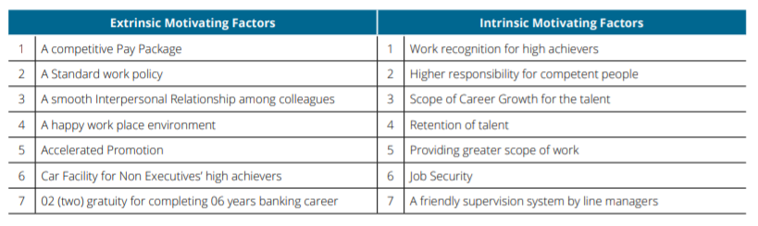
Table 2.2: Extrinsic and Intrinsic Motivating Tools at JBL

Reward and Recognition
The term "compensation" refers to the monetary and non-monetary rewards that employees get. Employees, on the other hand, get non-cash benefits like respect and position.
To motivate and retain its employees, JBL offers both tangible and intangible benefits. The employees’ benefits are discussed below:
- Base Pay Increase: Employees are paid a basic salary for the job they do. Depending on their position and duties, JBL determines a basic salary for each of its employees. Management may decide to raise an employee's basic salary at year-end if they determine that the person has met his or her objectives for the year.
- Short Term Incentive: The allocation of short-term incentives is dependent on the success of previous years. However, JBL does not include these short-term incentives in the employees' basic salary. A one-time payment is required. Employees get a one-time salary raise after their year-end performance evaluation. Employees are more motivated to do their best job when given short-term rewards.

- Long Term Incentives: Future performance is influenced by incentives that are in place for the long run. If an employee's performance is outstanding, JBL will make every effort to preserve a long-term connection with them by providing them with long-term incentives.
- Employee of the Year Award: Employees at JBL are recognized each year with the title of "employee of the month" for their outstanding work. This is done in front of the all of the each branches’ employees of JBL to motivate the rest of the employees.
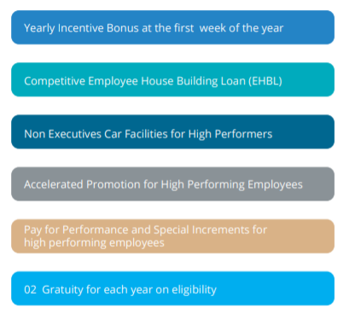
Figure 13.13: Employees’ Benefits and Rewards on the Basis of Performance at JBL

CHAPTER 05
FINDINGS, RECOMMENDATIONS AND CONCLUSION

Findings
JAMUNA Bank Limited has an effective performance management system as consequence employees are motivated and it will boost their performance. According to the analysis and internship experience in HR department at JAMUNA Bank Limited, some of the findings are listed below which are based on their current performance management system of JAMUNA Bank Limited:
- JAMUNA Bank Limited reviews its employees using a range of approaches that vary based on their position within the organization. Istiaq Rahman, Senior Officer of the Human Resources Department of JBL said that, employees who work in the cash collection department can be evaluated using numerical ratings, whereas employees who work in the human resources department, whose job description cannot be expressed in numerical terms, are evaluated using a different method than employees who work in the cash collection department.
- According to JBL's Head of Accounts, Jakariya Hossain, evaluating personnel on the basis of financial components is simple and clear, but doing so on the basis of nonfinancial components is more challenging. The present PA system at JBL has a number of limitations, including this one.
- JBL employs a 360-degree feedback system, which encourages employees to be self-aware of their own performance and to improve it. This approach assists JBL in being aware of the diverse skills that each employee has. According to one of my results, the carrier growth possibility at JBL is rather low when compared to other banks. It has the potential to produce workplace dissatisfaction since promotion opportunities in JBL are unknown, and pay rises are also highly debatable.

Recommendations
Performance management systems are essential to increasing employee productivity and organizational growth. An effective performance management system is connected with a successful performance evaluation process. The following is a list of some of the recommendations about the performance management system of JAMUNA Bank Limited:
- All departments and divisions must develop a system of peer evaluation in which one colleague reviews the performance of another colleague. In general, manager-only assessments are less successful than peer reviews since they are carried out from a single point of view, while peer reviews are carried out from several points of views. In addition, since they often work with and in front of their coworkers, they have a stronger grasp on their coworkers' positive and negative traits. This will have a significant impact on the productivity and cooperation of employees.
- Employees should be provided with weekly feedback so that they may keep track of their own performance and so that they may be given the opportunity to make improvements as soon as feasible. The efficacy of performance assessment will be substantially increased if the supervisor offers feedback whenever it is required, and if it is crucial to provide feedback promptly, the supervisor should not wait for a set period.
- When it comes to carrier development, JAMUNA Bank Limited should do more to support on career growth opportunities of employees. The promotion and compensation increases should also be increased. They should have frequent performance evaluation meetings. When employees get frequent feedback on their performance, they are more likely to perform at their best. Managers should devote more effort to identifying and attracting the most skilled members of their teams. To keep them, managers must do everything they can to keep them in the organization. Managers should put a lot of effort into coaching their employees to help them become stronger players on the team.

Conclusion
In banking industry, JAMUNA Bank Limited is one of the country's most well-known banking or financial institutions, recognized as a client-focused organization that delivers a wide range of high-quality, high-value goods and services as well as financial supports to the people of the country. In this report, the study is based on the analysis of performance management system of JBL. In JBL, they make an effort to maintain a fair Performance Management System. The human resources department plays a significant role in this system. They are the most productive and efficient teams in JBL.
In conclusion of the report, a performance management system is a critical component of every organization, and it is also a useful tool for monitoring productivity. Everyone in an organization has a role to play in achieving the organization's goals and objectives. The self-esteem and productivity of the employees will also be boosted by executing a performance management.

References

Aguinis, C. a. (2013). Performance Management, 3rd ed. Boston : Pearson.
(2020). Annual Report of JBL. Dhaka, Bangladesh: Jamuna Bank Limited. Retrieved from https://jamunabankbd.com/front/information/1/82
Bob Hamlin, J. S. (2011). What is HRD? A definitional review and synthesis of the HRD domain. Journal of European Industrial Training, 35, 199-220.
Cascio, W. F. (2014). Leveraging employer branding, performance management and human resource development to enhance employee retention. Human Resource Development International, 17, 121-128.
Frank J. Landy, J. L. (1983). The measurement of work performance : methods, theory and applications. New York: Academic Press.
Kumari, S. (2020). Performance Appraisal: Meaning, Concept and Obstacles. Retrieved from https://www.yourarticlelibrary.com/hrm/performance-appraisal-hrm/performance-appraisal-meaning-concept-and-obstacles/86889
Larmore, C. (2022, February 18). What Is the Connection between Performance Appraisal and Performance Management? Retrieved from Wisegeek: https://www.wise-geek.com/what-is-the-connection-between-performance-appraisal-and-performance-management.htm
RF Poell, T. R. (2014). The Routledge companion to human resource development (pp. 258-271). New York: Routledge.
Techfunnel. (2021, January 19). Performance Management System – A Complete Guide. Retrieved from Tech Funnel: https://www.techfunnel.com/hr-tech/performance-management-system/
Travor C. Brown, P. O. (2018 ). Opportunity, fair process and relationship value: Career development as a driver of proactive work behaviour. Human Resource Management Journal, 22, 4-20.
Werner, J. (2017). Human resource development/talent management. Boston: Cengage Learning.
White, D. (2021, June 21). Importance of Performance Management in an Organization. Retrieved from Tech Funnel: https://www.techfunnel.com/hr-tech/importance-of-performance-management-in-an-organization/?read_more

