Internship
Report On
Training and development process of Ad din Foundation and It's effectiveness



Report On
Training and development process of Ad din Foundation and It's effectiveness
Submitted To
Ms. Ishrat Sultana
Assistant Professor
School of Business and Economics
United International University

Submitted By
Mahjabin Mustafa Esha
ID# 111 181 033

Submission Date:
13th May, 2023

United International University
Letter of Transmittal
May 13, 2023
Ms. Ishrat Sultana
Assistant Professor
School of Business and Economics
United International University

Subject: Submission of Internship Report

Dear Mam,
I am writing to inform you that, I am Mahjabin Mustafa Esha a student at United International University, have successfully completed a four-month internship at Ad Din Foundation under your supervision.
I am pleased to submit the report you requested regarding the Training and development process of ad din Foundation and Its effectiveness. I conducted thorough research and analysis to compile this report for my reporting purposes. Although I made every effort to prepare a report free of errors, I apologize in advance for any mistakes that may have occurred. I hope that you will kindly take into consideration any errors.
It would be an honor for me to receive your acceptance and gratitude. Please feel free to ask any questions, and I reserve the right to answer them.

Thank you,
Sincerely Yours,

Mahjabin Mustafa Esha
111181033

Student Declaration
I am Mahjabin Mustafa Esha and my ID number is 111181033. I am a student of BBA Department at United International University, with a major in Human Resources Management. I hereby confirm that I have authored the Internship titled " Training and development process of ad din Foundation and It's effectiveness." This report is entirely my own work, and I have not submitted it before to fulfil any degree requirement.

Acknowledgement
My utmost gratitude is what I wish to convey to everyone who assisted me in completing my report. Firstly, I express gratitude to the Almighty Allah for providing me with the fortitude and perseverance to finish this work successfully.
I would also like to extend my heartfelt thanks to all the employees who helped me collect data and shared their experiences in my questionnaire of Ad Din Foundation. Their contributions were invaluable to the completion of this report.

Finally, I want to give special recognition to my supervisor Ishrat Sultana, Assistant Professor at United International University. She provided guidance and support from the beginning to the end of this project, and I could not have completed it without her immense help and valuable suggestions.

Table of Contents
Executive Summary v
Chapter 01: Introduction 1
1.1Background of Report: 2
1.2 Scope of the Report: 2
1.3 Objective of the Report: 2
1.4 Methodology: 2
1.5 Limitation: 3
Chapter 2: Literature Review 4
2.1 Human Resource Management 5
2.2 Managerial Functions of HRM 5
2.3 Operational Functions of HRM 6
2.4 Practice in training and development: 7
2.5 Employee Training and Development Techniques: 7
2.6 Model of Training Procedure 9
2.7 Recruitment & Selection functions in HRM: 10
Chapter 03: Company overview 12
3.1 Company Profile: 13
3.2Mission: 13
3.3 Vision: 13
3.4 Institute of Ad din Foundation 14
3.4.1 Hospitals of Ad Din Foundation: 14
3.4.2 Medical College of Ad din Foundation 14
3.4.3Nursing Institute of Ad din Foundation 14
3.4.4 School Under Ad Din Foundation 15
3.4 Ad Din Pharmaceuticals: 15
Chapter 04: Finding and analysis 16
4.1 Data analysis: 17
4.1.1 Management (trainer) interview: 17
4.1.2 Survey of Employees: 19
Chapter 05: Findings and Recommendation 31
5.1 Findings: 32
5.2 Recommendations: 33
Conclusion 34

Executive Summary

Ad-din Foundation is a reputed organization in Bangladesh. Ad-din Foundation was established in 1980. At present, Ad-din has numerous ongoing projects, including hospitals in Dhaka, Keranigonj, Jessore, Kushtia, Khulna, and Postogola, as well as medical colleges in Dhaka, Jessore, Keranigonj, and Khulna, nursing colleges in Dhaka, and nursing institutes in Dhaka, Jessore, and Kushtia.
This report focuses on training and development process of Ad Din Foundation and its effectiveness. This report covers all the relevant information regarding the training and development process throughout my internship program.
The report is divided into Five chapters, with the first chapter dealing with the introduction, Scope, Background and objectives of the study along with this here also discuss methodology of the report in this report is conducted through primary and secondary data for primary data collection use a formal questionnaire. In The second chapter provide literature review on HR function and on training and development. In The third chapter provide details information of Ad Din Foundation. The fourth chapter contains data analysis and of survey of employees, and management interviews. The fifth chapter presents the findings and recommendations based on the entire report.
The main findings of the study indicate that Ad Din Foundation regularly arranges training programs and Ad Din Foundation's training sessions help their employee to understanding their job more clearly, personal Development and Adapting with new technology. Furthermore, the Training and development program have great impact on job performance and it improve job Commitment of Employee.

Chapter 01: Introduction

1.1Background of Report:

This report, which is based on the information gathered during an internship program, is being submitted to the School of Business and Economics at United International University as a mandatory component for the completion of a Bachelor of Business Administration degree

1.2 Scope of the Report:

The project will focus on the Training and development process of ad din Foundation and Its effectiveness.

1.3 Objective of the Report:

Main Objective: The main objectives of this report is to know Training and development process of ad din Foundation and Its effectiveness.

Secondary Objective:
- To find out relationship and effectiveness of training and development.
- To gather knowledge about training and Development
- To complete Degree Requirement.

1.4 Methodology:

- Topic Selection: Topic is selected by me and its has been approved by my honourable supervisor.
- Data Collection Process: Using a basic random sampling technique, I gathered data by surveying 11 individuals from Ad Din foundations management and staff. To investigate the entirety of Ad Din foundations training and development practices, I utilized a questionnaire with 20 questions, with 10 questions designed for management and 10 for personnel.
- Sample Size: total sample size is 11 (10 employee and 01 management level employee)
- Data Collection Method: To carry out this project, I utilized both primary and secondary data, which are the two types of data collection method.
Primary Data: Formal questionnaires and direct interviews were utilized to gather primary data. The questionnaires were distributed in hard copy format directly to the respondents.
Secondary Data:
- Organizations Website
- Internet
- From Different report
- Relevant journal and book

1.5 Limitation:

while preparing this project the following are the primary limitations that had the greatest impact:

- Not everyone was helpful in providing information.
- Secondary data source was inadequate.
- Limitation of research experience

Chapter 2: Literature Review

2.1 Human Resource Management
Byars and Rue define HRM as a system of actions and methods necessary to Achieving organizational goals by skillfully managing people across all levels of a company. Leon C. Megginson explains that the talents and aptitudes of employees represent the sum of their innate abilities, acquired knowledge, and skills. However, these attributes are also acquired by the wider population. Dunn and Stephens state that the HRM process is responsible for attracting, retaining, and motivating all managers, both in the line and staff roles (&amp & Rue, 2018).

2.2 Managerial Functions of HRM
Planning: Careful planning is necessary when setting goals and targets for an organization. To achieve these objectives, HR employs various strategies and guidelines. The primary aim of this planning is to anticipate potential job vacancies, identify the necessary tasks, and determine the best sources for recruitment. In order to align with the company's strategic objectives and meet the needs of various job markets, the HR supervisor must forecast both the demand and supply for each job group.
Organizing: Careful planning is necessary when setting goals and targets for an organization. To achieve these objectives, HR employs various strategies and guidelines. The primary aim of this planning is to anticipate potential job vacancies, identify the necessary tasks, and determine the best sources for recruitment. In order to align with the company's strategic objectives and meet the needs of various job markets, the HR supervisor must forecast both the demand and supply for each job group.
Direction: Through guidance and support, the workforce is empowered to achieve organizational objectives. To this end, supervisors utilize diverse motivational strategies and foster amicable relationships with their employees. However, for the HR manager of a company, this phase can pose significant challenges. They must be adept at recognizing staffing requirements and devising appropriate solutions. Additionally, since human motivation is a continuous process, even after fulfilling previous aspirations, new ones may emerge, making motivation an ongoing effort.
Controlling: Controlling is the ultimate managerial function in the cycle, which involves examining the results against the standards set during the strategy development stage to identify any deviations. After regaining control of HR, the HR Manager reviews the results to detect any variances and takes corrective measures in the subsequent cycle to rectify them. It is advisable to revisit the planning phase after regaining control of HR to ensure that the corrective actions taken align with the organization's objectives and standards.

2.3 Operational Functions of HRM
Employment: Employment is the primary functional aspect of HRM with the HR manager responsible for its implementation in every section of the organization. The HR department collaborates with all other departments to ensure the development of effective manpower policies, rules, and guidelines. Employment encompasses the identification and recruitment of skilled professionals essential to achieving the organization's goals and objectives.
Training and Development: Training is an organized collaborative effort, often supported by an employer, aimed at helping employees acquire job-related competencies. It is a crucial element in human resources development, involving the refinement of specific skills through both instruction and practical application. By providing workers with the tools necessary to perform their jobs correctly, efficiently, and with a high degree of conscientiousness, training is an invaluable asset to any organization. Its ultimate goal is to enhance the knowledge and abilities of the workforce in a given task. Development is designed to create opportunities for supporting the growth of human resources within an organization.
Remuneration and Benefits: In order to measure up against its competitors in the market, a corporation has developed its own compensation and benefits package. The company strives to create a consistent salary and benefits framework. The offered compensation and benefits include flexible work hours, educational expenses for employees' children, dental and medical insurance, additional paid time off, as well as maternity and paternity leave. Maintenance: In order to retain skilled and efficient workers, it is imperative for the HR manager to ensure job security and create a positive work atmosphere. To achieve maximum productivity, the HR department must provide a comfortable work environment.
Additionally, the HR manager can consider introducing recreational activities within the workplace, as long as they do not hinder productivity. It is also the responsibility of the HR manager to provide transportation options and a canteen for the employees' convenience. Performance Appraisal: The HR department has the ability to evaluate employees' performance based on their work output. By utilizing this feature, the HR manager can determine a worker's efficacy within the organization and identify any potential areas for improvement. With the help of this tool, the HR team is able to develop tailored development plans for workers who fail to meet the minimum job requirements. Ensuring Legal Compliance: Ensuring compliance with laws and regulations related to working conditions, job status, minimum wage, tax benefits, and other factors affecting employees is crucial for protecting the business. It is imperative that the human resources department of every workplace strictly adheres to these laws. The survival and longevity of any corporation hinge greatly on its ability to comply with such regulations.

2.4 Practice in training and development:
Training: Training is a deliberate initiative taken by a corporation to facilitate the learning of job-related competencies by employees. In the field of human resource development, training is a simple yet significant concept that aims to enhance a particular ability to a desired level through practical experience and education. With the aid of training, a worker can be positioned to carry out their job with accuracy, efficiency, and a sense of responsibility, making it an invaluable tool in the workplace. The primary objectives of training are to assist participants in developing their knowledge, skills, and abilities, and applying them to their day-to-day activities.
Development: The process of acquiring knowledge, skills, and abilities (KSA) through training activities is commonly known as development. The ultimate goal of such activities is to help employees progress in their careers. Development encompasses various opportunities that are designed to facilitate professional growth. In today's work environment, motivation cannot be solely attributed to financial incentives. Individuals working for organizations seek more than just a job; they aspire for a fulfilling and meaningful career (Chand, n.d.).

2.5 Employee Training and Development Techniques:
On the Job Training (OJT): This approach involves new or inexperienced employees observing and replicating the actions of their peers or supervisors while performing their duties. OJT comes in various forms, which include:
Job Rotation: Job rotation is classified into two types: vertical and horizontal. Vertical rotation allows every employee access to different work positions, with varying duties and responsibilities. Horizontal rotation, on the other hand, is reserved for exceptional performers and provides opportunities to develop multiple skills, such as branch manager roles.
Assistantship: In this form of OJT, the employee receives daily tasks from an assistant, who serves as a trainer. Companies such as GP and Banglalink offer this type of training in Bangladesh.
Committee Assignments: A group of trainees works together to solve an organizational challenge through discussions. This type of training promotes teamwork and collaboration, such as multi-task/project teams or cross-functional teams.
Internship Training: Internships are a popular type of OJT. Students in fields like business, engineering, or medicine are typically required to complete internships. Students receive training for a specified period, such as 3 or 6 months.
Off-site training: is conducted in a designated location for the purpose of instruction, which may be nearby or far from the workplace. Various types of off-site training include:
Case study method: Trainees work with HR managers to solve business-related issues by coming up with all possible workable options, enhancing their analytical and critical thinking skills.
Simulation exercises: HR managers present hypothetical scenarios for trainees to respond to. Role play: Trainees replicate the role of a certain character in a challenging scenario presented by HR, which is recorded for self-evaluation.
Games-Based Training: Decision-making exercises allow trainees to explore various tactics and their effects on different participants, commonly used by companies dealing with rules, laws, or technology.
Experiential learning: Employees participate in activities that help them approach issues and develop long-lasting solutions, while enhancing knowledge sharing. Outdoor training: Modern approach to training outside of the office.
Theoretical: Training abroad that is theoretical, provided by companies such as Google, IBM, and Intel. Vestibule training: Technology- or machine-based training provided by HR supervisors away from the actual work area.

2.6 Model of Training Procedure
ADDIE Model: The Center for Educational Technology at Florida State University originally developed the ADDIE Model U.S. Army and then quickly adopted by all branches of the U.S. Armed Forces ((Branson, 1975). The ADDIE Model is composed of five stages, with the
Step 1: being the Analysis phase. This phase involves identifying the organizational gap, which can manifest as low client satisfaction, poor profitability, high turnover rates, and other similar issues. The Analysis phase, also known as Training Needs Analysis (TNA), gathers data on employee performance deficiencies to determine the root causes of the performance gap.
Step 2: which is the drafting stage, creating training objectives is a crucial aspect of the design process as it provides guidance on what and how to train. The design process results in determining the necessary components for the training program to facilitate learning and its practical application in the workplace.
Step 3: which is the development phase, HR utilizes the guidelines from the design phase to create an instructional plan that aligns with the training objectives. The instructional strategy outlines the specific tactics and elements required in the training program to achieve its goals, including the order, timing, and overall synthesis. The output of this phase comprises everything necessary to execute the training program.
Step 4: During the implementation phase, all the preceding phases of the training process converge. It is advisable to conduct a pilot program before the actual training to test the program and make necessary adjustments before the live training.
Step 5: the evaluation phase, two types of evaluations are conducted. Firstly, the process evaluation determines how effectively the training process achieved its objectives and whether the trainer followed the recommended methodology. Secondly, the outcome evaluation is conducted at the end of the training and is based on the training objectives. A positive outcome indicates success, while a negative outcome requires repeating the process and returning to the analysis phase (Imed Bouchrika, 2022).

2.7 Recruitment & Selection functions in HRM:
Recruitment involves actively seeking out, identifying, and hiring qualified candidates for a specific job or role. The recruitment process encompasses all stages of hiring, from the initial search to the successful integration of the new employee into the organization.
Selecting an employee entails identifying and hiring candidates who have the necessary qualifications to occupy a vacant position in an organization. It is a process of choosing suitable applicants for job vacancies.
Recruitment Functions:
The HR department is usually tasked with recruitment, aiming to locate and entice suitable candidates. To accomplish this goal, the department utilizes job descriptions and specifications as a framework for the recruitment process. It is important to recognize that the HR manager overseeing candidate selection and screening may not be the same person who ultimately supervises the successful candidate's job performance.
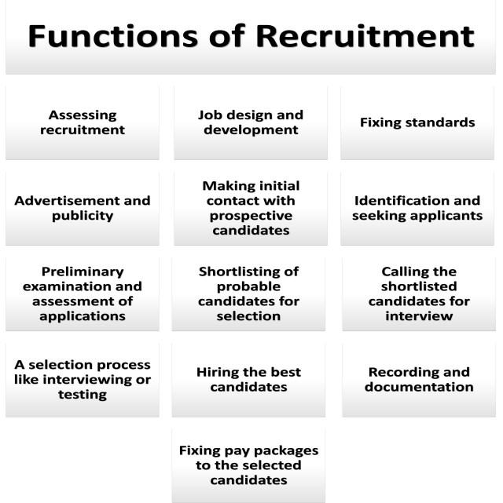

Sources of Recruitment:

There are two main categories of recruitment sources which are as follows:
Internal sources which include current employees, employee referrals, former employees, and previous applicants.
External sources which consist of trade associations, advertisements, employment exchanges, campus recruitment, walk-ins and write-ins, consultants, radio and television, competitors, and E-recruiting.
Selection Process:
The process of selecting candidates for a job through HRM (Human Resource Management) involves multiple stages aimed at identifying and choosing the most suitable candidates. Initially, a job description and person specification are developed, and potential candidates are sourced through various means such as job postings, referrals, or recruitment agencies. The next phase involves screening and shortlisting candidates based on their qualifications, skills, and experience. Shortlisted candidates are then invited for interviews, tests, and assessments to determine their suitability for the job. Throughout the process, HR professionals must uphold legal and ethical requirements, ensure fairness and objectivity, and maintain effective communication with candidates. Finally, based on the outcome of these evaluations, a final selection decision is made, and the preferred candidate is offered the job.

Chapter 03: Company overview

3.1 Company Profile:
In 1980, the Ad-din Foundation was founded with the purpose of assisting the less fortunate population of Bangladesh, and its initial undertaking centered on constructing an orphanage in Jessore. Since then, over the span of 37 years, Ad-din has broadened its reach by executing a range of initiatives throughout different regions of the country.
Ad-din is currently engaged in several projects, such as the construction of hospitals in Dhaka, Keranigonj, Jessore, Kushtia, Khulna, and Postogola, as well as medical and nursing colleges in Dhaka, Jessore, Keranigonj, and Khulna. Nursing institutes are also being established in Dhaka, Jessore, and Kushtia. In addition, Ad-din has established a medical technology institute in Jessore, and implemented mobile eye clinics, a maternal and child health project, and a project aimed at preventing and repairing obstetric fistulae. Moreover, Ad-din has an integrated health and microfinance program that offers health insurance
The Ad-din hospitals were established to provide affordable, high-quality care and have since become recognized as centers of excellence. They are celebrated for their quality, affordability, and patient friendliness.
Ad-din's objective is to offer superior teaching facilities and a committed faculty team, including some field experts. With these resources at their disposal, Ad-din has successfully produced exceptional medical graduates, who not only excel in their clinical practice but also demonstrate social responsibility (Foundation, n.d.).

3.2Mission:
The College's mission is to produce high-quality physicians who possess the necessary knowledge, skills, and professionalism as prescribed by the Bangladesh Medical and Dental Council (BM&DC). These physicians must be capable of providing excellent medical care while also exhibiting a lifelong learning mindset. They must also be equipped to work in various environments and emerge as leaders in the national healthcare system, as well as contribute to meeting the healthcare and research requirements of the country.

3.3 Vision:
The College envisions gaining national and international acclaim for its excellent education and ability to produce graduate physicians equipped with essential knowledge, skills, and professionalism. These physicians must be capable of continuing their service and pursuing careers that contribute to enhancing the health promotion, disease prevention, treatment, and medical research of the nation.

3.4 Institute of Ad din Foundation
Ad din Foundation have several institutes they have 8 hospital 4 medical college 4 nursing college 3 school along with this they have ad din Pharmaceuticals & Ad din welfare

3.4.1 Hospitals of Ad Din Foundation:

- Ad-Din Hospital Dhaka, Maghbazar, Dhaka
- Ad-Din Sakina Medical College Hospital, 15 Rail Road, Jessore
- Ad-Din Hospital, Kushtia,
- Ad-Din Eye Hospital Chanchra, Dalmil Jessore
- Ad-Din Barrister Rafiq-Ul-Huq Hospital, Postogola
- Ad-Din Akij Hospital, Khulna
- Basundhara Addin Medical Hospital, Bashundhara.
- Addin Children Hospital, Jessore.

3.4.2 Medical College of Ad din Foundation

- Ad-Din Women’s Medical College,Dhaka
- Basundhara Ad-din Medical College,Dhaka
- Ad-Din Akij Medical College Boyra, Khulna
- Ad-Din Sakina Medical College (ASMC) Pulerhat, Jessor

3.4.3Nursing Institute of Ad din Foundation
- Fatema Nursing Institute 2 Bara Maghbazar, Dhaka
- Ad-din Nursing Institute Pulerhat, Jessore
- Safina Nursing Institute, Kushtia
- B.Sc. Nursing Institute, Dhaka

3.4.4 School Under Ad Din Foundation

- AD-DIN SHISHU KISHOR NIKETON Jhikor Gasa, Navaron, Jessore.
- Akij Collegiate School Navaron, Jessore
- Sakhina Girls School Brandipara, Jessore

Ad Din Pharmaceuticals:
Ad-din Pharmaceuticals Ltd. was founded in 1996 under the name Jess Chemical and Pharmaceutical Works Private Limited, with the aim of enhancing the quality of healthcare service. In 2007, it changed its name to Ad-din Pharmaceuticals Limited and established its manufacturing facility at the BSCIC Industrial Estate in Jessore. Ad-din aspires to become a prominent research-based pharmaceutical company with a global presence in the shortest time possible. The company has already taken steps to expand its business in overseas markets and has finalized agreements with renowned pharmaceutical companies. Additionally, Ad-din is set to embark on fundamental research soon. The company's core objective is to provide high-quality medicine at affordable prices for everyone.

Chapter 04: Finding and analysis

Data analysis:

The data collection process was carried out through a basic random sampling technique, wherein 11 individuals from the management and staff of Ad Din foundations were surveyed. The investigation of training and development practices of Ad Din foundation was conducted through a questionnaire consisting of 20 questions, with 10 questions each for management and personnel. The sample size consisted of 11 individuals, including 10 employees and 1 management level employee. To gather data, use both primary and secondary data collection methods. Formal questionnaires and direct interviews were used to obtain primary data, while secondary data was obtained from various sources such as the organization's website, internet, reports, and relevant journals and books.

4.1.1 Management (trainer) interview:

- Which Training Method do you implement in your Organization?
Ad Din Foundation employs a diverse range of training methods that are tailored to the individual needs, demands, and stylistic preferences of employees.
- How are training needs analyses conducted in your organization?
Ad Din Foundation conducts TNA through annual evaluations and online surveys, wherein the supervisor selects the necessary training for their subordinates, while allowing the subordinates to choose their own training. Additionally, individuals vying for leadership roles have the authority to identify their own training needs.
- What relationship is there between the KPI and workshops/training that the Ad Din foundation offers?
There is a correlation between Training and KPI. In accordance with the KPI, Ad Din Foundation provides functional training for underperformers, which includes effective communication and professionalism. On the other hand, for high performers, Ad Din Foundation provide leadership training as a part of their succession planning.
- How do pay scales for employees, revenue generated by the company, and employee turnover rate all connect to training?
At Ad Din Foundation, employees undergo training programs that cover both functional and soft skills. Soft skills training acts as a catalyst, while functional skills training enhances workforce productivity. The training workshops serve as indirect compensation since they boost employee motivation. This motivation, in turn, improves employee performance, which ultimately results in increased productivity and profitability for Ad Din Foundation. Additionally, employee training fosters greater commitment and support for the company, thereby reducing employee turnover rates.
- Which individual or group in your organization undergoes training sessions most frequently??
Ans: Based on Ad Din Foundation 's requirements, it depends.
- How often your organization hold training sessions?
Ans: It is dependent on Ad Din Foundation requirements, but typically training workshops are not offered on the 1st, last, and 8th days of each month.
- How training feedback Collected?
Through Offline communication and Meeting in person Ad Din foundation gathered feedback
- What are the barriers to provide training and advancement in your organization?
Ans: Ad Din Foundation training and development department strives to consistently provide employees with the requisite training, despite facing certain challenges, including:
- Time constraints
- Negative attitudes of some workers
- Dependence on external training resources.

4.1.2 Survey of Employees:
Question 1 - Are training sessions frequently conducted by your company?
Degrees | yes | no
Opinions counts: | 10

Interpretation: Based in data it appears that the of respondents answered "Yes" to the question of whether their company often holds training sessions. This suggests that training sessions are a common practice within the companies that were surveyed. Based on the poll, it can state that 100% of workers claimed that Ad Din Foundation frequently arrange training program.

Question 2- How much time is allocated for training periods in your organization?
Degrees | Adequate | To be extended | To be shortened | Easy to handle /manageable
Opinions counts | 4 | 2 | - | 4

Interpretation: Based on Data it can be interpreted that there are three possible options for the training period:
Adequate: 40% of respondents feel that the amount of time allotted for the training period is enough or adequate.
To be extended: 20% of respondents feel that the training period needs to be extended.
Manageable: Another 40% of respondents feel that the current training period is manageable, although it may not necessarily be sufficient or optimal.
Overall, it seems that a majority of respondents (80%) have some concerns or reservations about the current training period, either feeling that it needs to be extended or that it is only manageable. This suggests that there may be room for improvement in the training program to better meet the needs and expectations of those participating in it.

Question 3- Participating in a training program will improve your job performance. Do you agree with this claim?
 | Strongly Disagree | Disagree | Neutral | Agree | Strongly Agree
Respondents | - | 1 | 2 | 6 | 1

Interpretation: Based on the data, the majority of respondents agree that participation in training programs improves their level of job performance. Specifically, 60% of the respondents agree, while only 10% disagree with the statement. Additionally, 10% of respondents strongly agree with the statement, and 20% are neutral.
Therefore, it can be concluded that the majority of respondents believe that training programs have a positive impact on their job performance.

Question 4 - Would you agree that the individual providing the resources has exceptional proficiency in the relevant subject matter?
 | Strongly Disagree | Disagree | Neutral | Agree | Strongly Agree
Respondents | - | - | 4 | 4 | 2

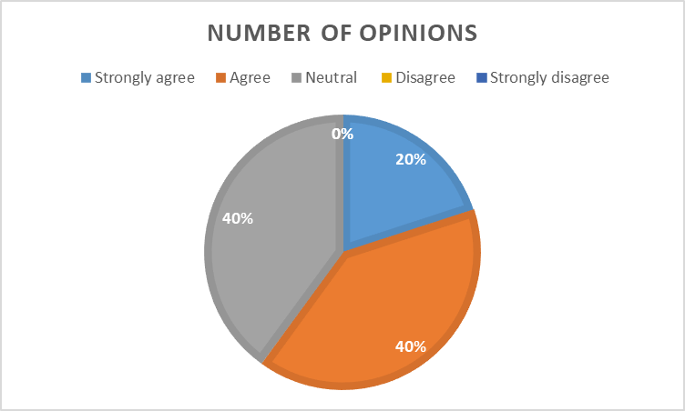
Interpretation: Based on the data, it appears that a maximum of the respondents either agree or strongly agree with the statement that, in terms of subject matter the resource person are excellent, with 60% of the respondents falling under these two categories. Another 40% of the respondents were neutral, indicating that they are not agree or not disagree neither agreed with the statement. None of the respondents disagreed or strongly disagreed . Therefore, overall, it seems that the respondents have a positive view of the resource person's subject matter expertise.

Question 5 - Training program facilities the maximal quality, do you agree with this claim?
 | Strongly Disagree | Disagree | Neutral | Agree | Strongly Agree
Respondents | - | - | 2 | 6 | 2

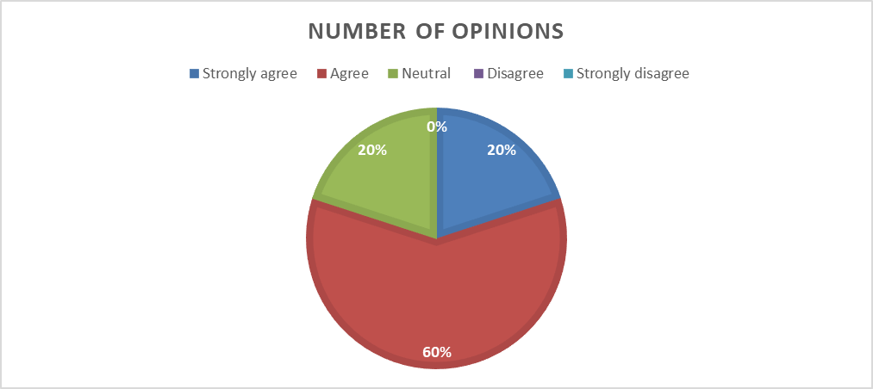

Interpretation: it seems that the majority of people (80%) either agree or strongly agree with the Claim that training program facilities were excellent . Additionally, 20% of people remain neutral on the topic, while no one disagrees or strongly disagrees with the statement. And none strongly disagreed. Therefore, it can be concluded that the majority of respondents had a positive perception of the facilities for the training program.

Question 6 - how would you evaluate the quality of the training courses you participated in?
 | excellent | poor | Very poor | good | Very good
Respondents | 1 | 1 | 3 | 5 | -

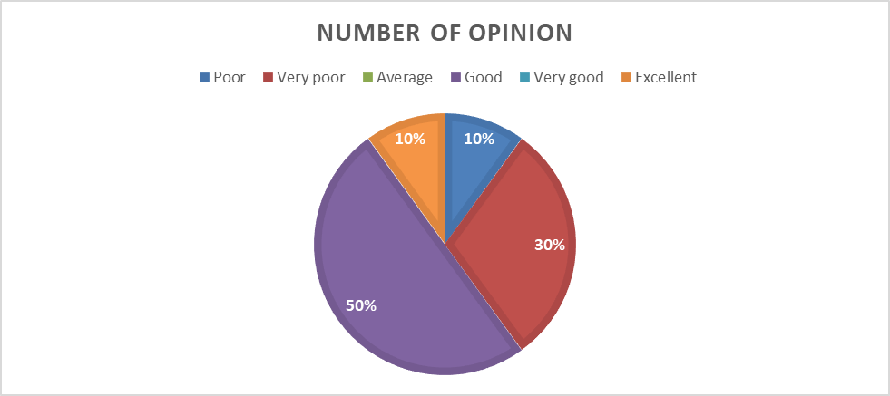

Interpretation: Based on the data provided, I would rate the quality of the training courses as subpar, with 40% of respondents indicating poor or very poor quality. Only half of the respondents rated the courses as good or better, with 10% rating them as excellent. Notably, there were no respondents who rated the courses as average. Overall, the data suggests that there is significant room for improvement in the quality of the training courses.

Question 7 - What is the most common appraisal of training?
 | No Complaints | Unplanned Session | Gap Between Employees | Take much times of Employees
Respondents | 6 | 3 | 1 | -

Interpretation: Based on the data, the most common criticism of the training session is that it is unplanned, with 30% of respondents indicating so. However, it is worth noting that the majority of respondents (60% did not have any complaints about the training sessions. Only 10% of respondents felt that there were grater gaps between employees during the training sessions, and none of the respondents felt that the training sessions took too much time of employees.

Question 8 - Does training help enhance interaction between workers and employers?
Degrees | Yes | No
Opinion Counts | 10 | -

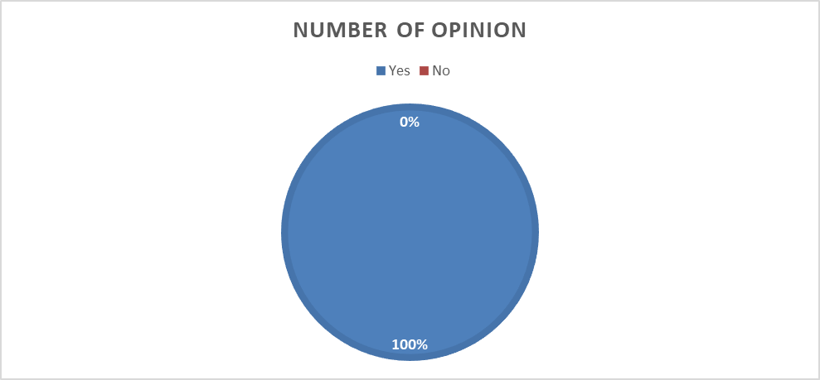
Interpretation: From the available information, it can be concluded that all 10 participants agreed regarding the positive impact of training on the interaction between workers and employers. There were no dissenting opinions among the respondents. This indicates that the participants hold the view that offering training to employees can enhance communication and cooperation between workers and their employers, resulting in increased productivity, job fulfillment, and overall success of the company.

Question 9- Was the training helpful in your personal growth and development?
Degrees | Yes | No
Opinion Counts | 9 | 1

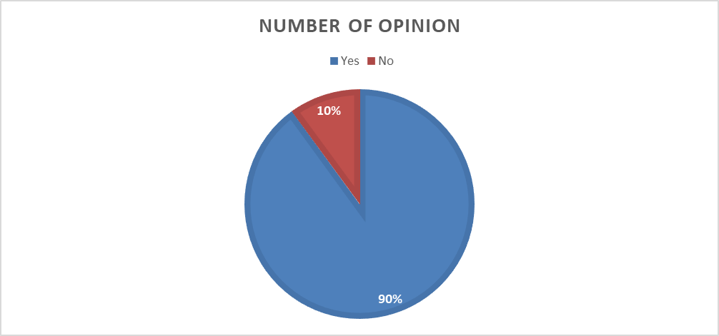
Interpretation: it can be interpreted that the majority of the respondents (90%) found the training course to be beneficial to their personal development, while a small proportion of respondents (10%) did not find it beneficial.
This indicates that the training course was generally effective in helping individuals improve their skills and knowledge, and potentially contributed to their overall growth and development. However, it is worth noting that a small percentage of individuals did not find the training course to be helpful, which could be due to a variety of factors such as differences in learning styles or individual preferences.

Question 10: Being trained can assist you in adapting to the ever-evolving technology and carrying out your job effectively?
 | Strongly Disagree | Disagree | Neutral | Agree | Strongly Agree
Respondents | - | 2 | 2 | 5 | 1

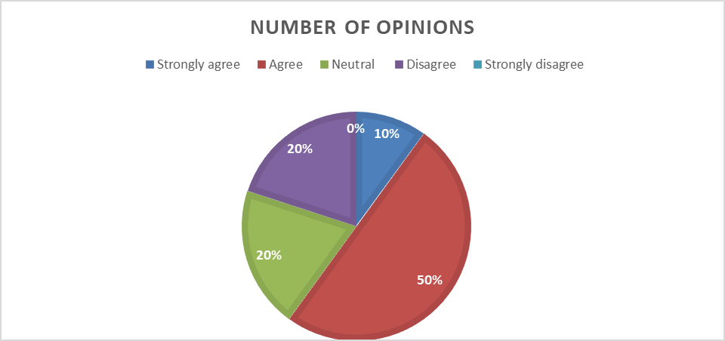
Interpretation: Based on the data, it can be interpreted that a majority of respondents (50%) agree that being trained can assist in adapting to ever-evolving technology and carrying out their job effectively. A significant percentage of respondents (20%) have a neutral stance on this statement, while the same percentage (20%) disagree with it. No respondents strongly disagree with the statement. Overall, the data suggests that there is a general consensus that training can be beneficial in adapting to changing technology and performing job duties effectively, although a notable minority disagrees with this idea.

Question 11- Would you concur that receiving training contributes to performing a job with greater dedication?
 | Strongly Disagree | Disagree | Neutral | Agree | Strongly Agree
Respondents | - | 1 | 2 | 5 | 2

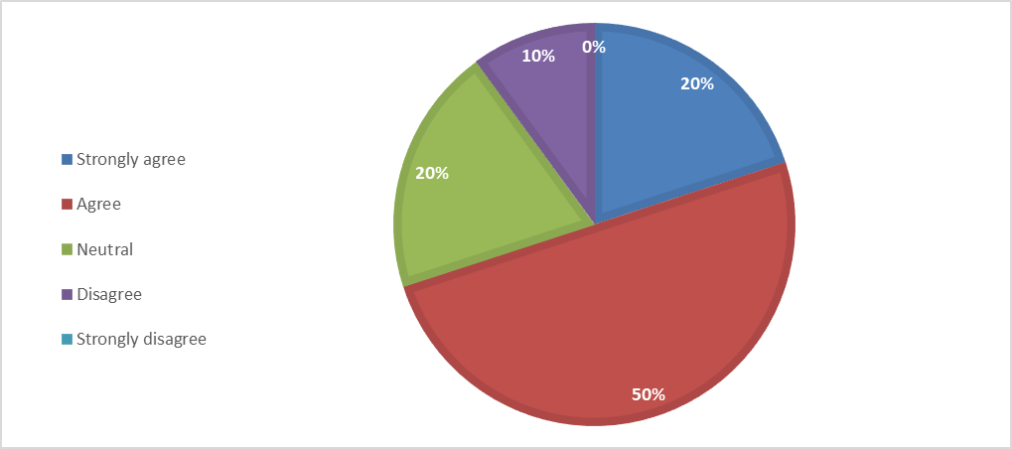
Interpretation: Based on the data, it can be interpreted that a majority of people (70%) agree or strongly agree that training helps to do the job with Much more dedication. Another 20% are neutral on the issue, while only 10% disagree. It suggests that there is a general consensus among the respondents that training can improve job commitment.

Question 12- Would you concur that training aids in gaining a clear understanding of the job?
 | Strongly Disagree | Disagree | Neutral | Agree | Strongly Agree
Respondents | - | 2 | - | 5 | 3

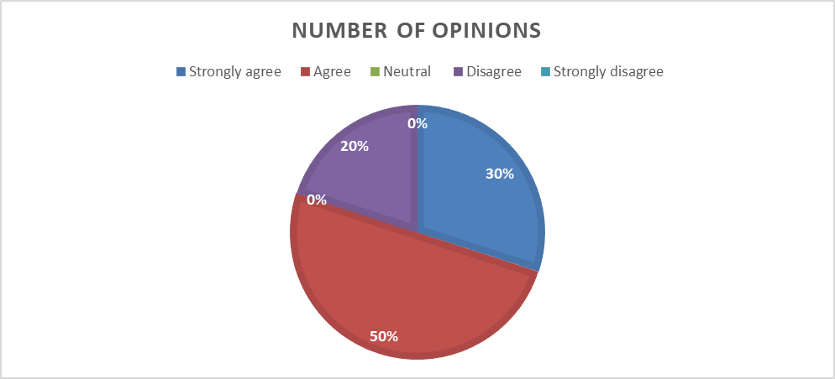

Interpretation: Based on the data, 80% of are agree and strongly agree that training helps to understand the job clearly, while 20% disagree. It's important to note that none of the respondents chose "neutral" or "strongly disagree" options.
This suggests that the majority of the respondents find training to be beneficial in understanding their job more clearly, while a significant minority may not feel the same way. It's also possible that the 20% who disagree with the statement might have had negative experiences with training programs in the past or may have felt that they did not benefit from them.

Chapter 05: Findings and Recommendation

5.1 Findings:

Effective employee training is an essential element of any thriving organization as it equips employees with the required knowledge and skills to carry out their duties competently and proficiently. Ad Din Foundation is an eminent establishment that has acknowledged the significance of employee training and development. The Foundation provides a wide array of training techniques that are customized to meet the specific needs of each employee. Additionally, it offers leadership and team-building training. Overall, Ad Din Foundation's initiatives in training and development have instilled a culture of constant learning and enhancement, leading to a workforce that is highly skilled and dedicated. There is some finding below;
- Ad Din Foundation employs a diverse range of training methods that are tailored to the individual needs
- Ad Din Foundation offers leadership and team-building training as part of their succession planning.
- Ad Din Foundation regularly arranges training programs.
- Training programs have a positive impact on employee job performance.
- Training program have great impact on Employee personal development.
- Training program helps employee in adapting to changing technology and performing job duties effectively.
- Training improve ad dins employees job commitment.
- Though employees are satisfied regarding quality of training but There is some option for improvement
- The provided training programs are able to meet gap between employee and job task
- Ad din foundations employee are happily joined at their training program and they are more concern about their job difficulties for overcome.

5.2 Recommendations:
Assessing the effectiveness of employee training and development programs is crucial for an organization's growth and success. This helps ensure that employees acquire the necessary knowledge and skills to perform their job responsibilities effectively. To achieve its objectives and enhance employee performance, Ad Din Foundation should evaluate its training and development program. To enhance its training and development program, Ad Din Foundation should take multiple steps. Conducting periodic assessments and evaluations of the program can assist in pinpointing the areas that need enhancement: Here some recommendation:
- After each training session, the trainer should assess the learners' knowledge level and evaluate the program's effectiveness.
- Ad Din Foundation must investigate any lower KPIs and annual turnover rates among its employees.
- Ad Din Foundation can introduce a reward system for the top performers in its T&D program.
- Ad Din Foundation should increase incentives for staff attendance at training sessions to encourage participation.
- Ad Din Foundation should need to focus more on the quality of its training program by hiring more qualified external trainers.

Conclusion

The findings of the report clearly indicate that Training and development is important part of the organization its play a vital role of employee job performance and organizational turn over. Employee become more committed to their organization after getting training. Traning and development is a major part of human resource management every organization should provide more concern on it.

Since joining Ad din foundation as an intern, my knowledge of T&D issues has expanded significantly. However, my report preparation was hindered by data limitations. As the HR Division's data is highly confidential, I was not granted access to all T&D related information. To compensate for this, I drew upon my academic expertise, AD Din job experience, and online resources to create this report. Consequently, I only used a limited amount of data to support my findings. Despite this challenge, my internship experience has been a valuable learning opportunity for me, and I am eager to leverage the knowledge gained to advance my career.

Bibliography
&amp, B., & Rue. (2018, 6 12). Human Resource . Retrieved from StudiousGuy: https://studiousguy.com/human-resource-management/
(Branson, R. C. (1975). ADDIE Model timeline. https://www.kroobannok.com/.
Chand, S. (n.d.). Retrieved from yourarticlelibrary: https://www.yourarticlelibrary.com/human-resource-development/methods-of-training-on-the-job-training-method-and-off-the-job-methods/32369
Foundation, A. D. (n.d.). Retrieved from https://ad-din.org/
Imed Bouchrika, P. (2022, 09 26). Education . Retrieved from research.com: https://research.com/education/the-addie-model

Appendix
Questioners:
Managerial Questions:
- Which Training Method do you implement in your Organization?
- How are training needs analyses conducted in your organization?
- What relationship is there between the KPI and workshops/training that the Ad Din foundation offers?
- How do pay scales for employees, revenue generated by the company, and employee turnover rate all connect to training?
- Which individual or group in your organization undergoes training sessions most frequently??
- How often your organization hold training sessions?
- How training feedback Collected?
- What are the barriers to provide training and advancement in your organization?
Employee Survey:
- Are training sessions frequently conducted by your company??
- How much time is allocated for training periods in your organization?
- Participating in a training program will improve your job performance. Do you agree with this claim?
- Would you agree that the individual providing the resources has exceptional proficiency in the relevant subject matter?
- Training program facilities the maximal quality, do you agree with this claim?
- how would you evaluate the quality of the training courses you participated in?
- What is the most common appraisal of training?
- Does training help enhance interaction between workers and employers?
- Was the training helpful in your personal growth and development?
- Being trained can assist you in adapting to the ever-evolving technology and carrying out your job effectively?
- Would you concur that receiving training contributes to performing a job with greater dedication?
- Would you concur that training aids in gaining a clear understanding of the job?

Picture of all medical college hospital, nursing institute
