Corporate Social Responsibility Practices of
Bank Asia Limited
This report is submitted to the school of Business and Economics, United International University (UIU), as a partial requirement for the degree fulfillment of Bachelor of Business Administration.

Submitted To
Md. Kaium Hossain
Assistant Professor
School of Business and Economics

Submitted By
Marzia Akter Mahi
111 152 276
Major in Marketing


School of Business and Economics
United International University (UIU)

Date of Submission: February 1, 2022

Corporate Social Responsibility Practices of Bank Asia Limited


Letter of Transmittal
February 01, 2022
Md. Kaium Hossain
Assistant Professor
School of Business and Economics
United International University (UIU)
Subject: Submission of Internship Report on Bank Asia Limited.
Dear Sir,
This is my admirable pleasure to conduct my internship report for your kind approval. My internship report is on “Corporate Social Responsibilities Practices of Bank Asia Limited”. The entire observations and results of the overall study are detailed written in this report. This was basically assigned to me as a partial requirement for the completion of my Bachelor degree. This report was all about an in depth analysis of the real time situations in organization.my three-month internship was tremendous and it was a wonderful great opportunity for me to enrich my learning and thinking about the corporate world and also social practice of Bank Asia Limited. It seems to me that, I really have been gotten knowledge and I also get chance to learn a lot from this opportunity and I’m also very determined to go forward with all my learning.
I always would be available for replying and be ready for giving answer of any query and also will be glad to clarify any discrepancy that may arise in regard to this report. I am requesting you to excuse, for the mistakes that might be take place in this report instead of my best effort.
Thanking You.
Sincerely,
Marzia Akter Mahi
ID: 111 152 276
BBA Program
United International University
Declaration of Student
I hereby declare that the intern report is based on my original work except for quotations and citations that have been duly acknowledged. I also declare it has not been previously or concurrently submitted for any other degree at UIU or other institutions.

Marzia Akter Mahi
ID: 111 152 276
BBA Program
United International University

Acknowledgement
In this current running world project or report is like a bridge between theoretical and practical workings. I have involved me to complete this and also it was a partial requirement of my Bachelor degree. From the very beginning I would like to thank the supreme power the Almighty God, who is always guided me to everything in my life track. Without his grace this paper may not become reality. Next to him are my parents and family, whom I greatly indebted for me brought up with love and encouragement to this stage. Without their support this also may not come real.
I would like to express my deep sense of gratitude to my supervisor Mr Md. Kaium Hossain. His kind support and guidance took me to the next level to complete this. I have also learned a lot about different stage at the eve of my degree completion. I am really thankful to almighty to have the support and guidance from a person like my supervisor sir.
There is also another person whom I need to show my gratitude also. I am highly obliged in taking the opportunity to sincerely thanks to Mr. Mahbub Rahman, his support has increased my confidence level and motivated me to work with more energy.
Finally, I am cordially thankful to all my teachers, my friends, my staffs those who helped me at once. Still, I have no valuable words but my heart and also this report is completed with full of favors. I pray to Almighty for everyone’s bright future.

Executive summary
Corporate Social Responsibility (CSR) is a self-regulatory business model that enables a company to be socially responsible to its stakeholders and the general public. This intern report has been made on the CSR practices of Bank Asia Limited. The report detailed how Bank Asia carries out its CSR responsibilities. CSR is really a great way to raise morale in the workplace. The report has been prepared for the fulfillment of the internship program, which is also a requirement of the BBA program. The primary purpose of this intern report is to find out the Corporate Social Responsibility (CSR) practices of Bank Asia Limited. This report consists of six chapters titled introduction, company and industry preview, methodology, analysis and findings, internship experience, and recommendations and conclusion. Both primary and secondary data were used in this descriptive type of research. Bank Asia spend from 2017 to 2020 a significant amount in Health and disaster management. And also spend a large part in Education. They spend less amounts on sports and arts and culture. But to compete with other banks in the industry, Bank Asia should also extend its contribution to other areas like economic well-being, sports, financial funding, and arts- cultures. By participating in more CSR projects, Bank Asia can strengthen its public image and become Bangladesh's most famous bank for CSR operations.

Table of contents
Chapter 1 9
Introduction 9
1.1 Background of the Report 10
1.2 Origin of the Report 10
1.3 Objectives of the Report 11
Specific Objectives- 11
1.4 Scope of the Report 12
1.5 Limitations of the Report 12
Chapter 2 13
Company and Industry Preview 13
2.1 Company Analysis 14
2.1.1 Overview and History 14
2.1.2 Vision and Mission 15
2.1.3 Organizational Structure 17
2.1.4 Departmental Activities 18
2.1.5 SWOT Analysis 23
2.2 Industry Analysis 24
2.2.1 Specification of the Industry 24
2.2.2 Size, Trend and Maturity of the Industry 25
2.2.3 Barriers to Entry 27
2.2.4 Threats of Substitutes 28
2.2.5 Industry rivalry 30
Chapter 3 31
Methodology 31
3.1 Introduction 32
3.2 Research Design 32
3.3 Data Collection 32
Chapter 4 33
Analysis and Findings 33
4.1 Analysis of Corporate Social Responsibility (CSR) 34
Analysis of the donation yearly 36
4.2 Findings of the Report 39
Analysis of the total Four years 2017 to 2020 CSR donations 46
Chapter 5 48
Internship Experience 48
5.1 Job Responsibilities 49
5.2 Training 49
5.3 Contribution to Departmental Functions 50
Chapter 6 51
Recommendations and Conclusion 51
6.1 Recommendations 52
6.2 Conclusion 53

Chapter 1

Introduction

1.1 Background of the Report
Corporate social responsibility helps to increase both society and the brand recognition also value of every company. Now a day’s companies are not just only focusing with their business. They are also well concerned about how people think about them and also well concerned about doing something to the society as they are existing in the society first. Corporate responsibility programs are a great way to raise morale and ethical in the workplace.
As we know, banks are a monetary association that puts away cash kept by clients, pay it out when required, make advances in revenue, and trades money. Now days not only other corporate sites banks are also playing a wonderful and extraordinary part in CSR activities. As every person in the society are directly or indirectly related or connected with any bank that exists in the society. So, banking sectors are also considering this and trying to take active part to the corporate responsibility to the society. Banks give an incredible assortment of monetary administrations. As all the private banks is under controlled by the Bangladesh Bank. Then BAL Limited has been well- renowned Bank in Bangladesh for a long time. Bank Asia Limited performs their banking activities so smoothly and also well concerned to the development of the society where they exist. Bank Asia Limited is very sound with their CSR activities from many years. Bank Asia has been conscious of corporate social responsibility from the very beginning of its operation in 1999. They always focus of doing the betterment of society first and then it will come back.
This report is also a detail file of the corporate social activities of Bank Asia Limited and their regular corporate responsibility programs are listed and described details in the report.

1.2 Origin of the Report
As we know everyone get benefit from internship plan and it is always beneficial for the person who does it practically and every time it is a beneficial plan and a prerequisite to complete the BBA program. It helps people to develop personal character also. Generally, the basic requirement of the internship was to provide an ‘on the job’ experience to the student and also an opportunity to relate with real life situation. Internship report is always a bridge between theoretical and practical lessons. So, to fulfill this purpose I started my internship at Bank Asia Limited, under the supervision of two supervisors. One is internal from the institute from where I am going to complete my degree and another is Bank Asia Limited for three months. This report titled “Corporate Social Responsibility Practices of Bank Asia Limited”. With this working experience and it is a great opportunity to made and prepared my internship report with great and wonderful observation and supervision also the guidance of my honorable and very respective sir MR Md. Kaium Hossain, Assistant Professor School of Business and Economics, United International University (UIU)

1.3 Objectives of the Report
Every report is prepared based on several facts or aims. As this internship report is a partial requirement of the completion of my Bachelor degree. So, there are several objectives behind this report and among them some of our broad objectives and some of them are the specific objectives. In every report there are some objectives and here I mentioned two types of objectives: broad and specific, as mentioned below.
Broad Objective- The broad objective of this report is to find out Social responsibility practices of the Bank Asia ltd.

Specific Objectives-

- To understand how Bank Asia Limited engages in CSR activities and responds to the social and economic needs of the country.
- To gain a better understanding of the general banking works of Bank Asia Limited.
- To make some recommendations regarding current CSR practices of Bank Asia Limited to find out better and full quality service further and change the services into the best level.

1.4 Scope of the Report
There are so many scopes that is helpful for people those are interested in the CSR, basically it is a report what is based on “Corporate Social Responsibility Practices of Bank Asia Limited”. Basically, this report will be very helpful for the people those who have the intention to make and willing to do this kind of researches in the CSR and this platform of banks in Bangladesh. Here also with the help of this document or through this kind of document person could get enough info and using this document helps to improve knowledge, the willing person can make the document and collect the information and accumulate it to make a better documentary about the services what banks provided and what are the products they provided and all the products will be represented by CBL in their corporate social works and all the better activities and performances what they been provide in fulfilling their customers those are real targets, also societal betterment and gives the satisfaction and development in the nation. The basic scope of the report will supportive and also beneficial for everyone those are willing to gather or learn about all CSR process and activities of Bank Asia Limited and others also.

1.5 Limitations of the Report
While completing the report, there were a few limitations mentioned below.
- The Bank's website does not provide enough information about their Corporate Social activities and operations.
- There was a lack of relevant financial data on CSR operations with physical or online support during this investigation.
- Due to Bank’s confidentiality, it was impossible to collect detailed financial information on CSR activities.

Chapter 2

company and industry preview

2.1 Company Analysis

2.1.1 Overview and History
For any country’s development banking sector can play a vital role for every time. For any developing country like Bangladesh this sector is very important one for the overall country’s economy. Bank Asia Limited is a moving forward and fast developing bank in the banking sectors in Bangladesh. Bank Asia Limited has their all kinds of features of customers segment like retail, SME and corporate clients.
Bank Asia Limited generally started their service with a strong vision that is serving people innovative banking products and services that can be easily affordable for the customers. The bank's commitment is very loyal to all its customers and they are strongly determined to provide an innovative banking service to their all customers and also to the society. They also strictly determined to maintain the standard with the race of this globalized world, with all kinds of technological support at every moment. Bank Asia Limited always think for the tomorrow and how they can be convenient and affordable to their customers day by day. Now a days Bank Asia Limited stands with the top-rated banks of Bangladesh by their extraordinary and customer-oriented services and expanding outlets.
Bank Asia Limited has been started their journey initially at November 27, 1999 with the help and guidance of a successful entrepreneur's group of Bangladesh. At that their basic objective was to bring quality services in the banking sector. They were also determined to perform actively in increasing the growth of national economy. Bank Asia Limited the single bank in Bangladesh that acquires the Bangladesh operation of two foreign banks namely Muslim Commercial Bank of Pakistan and Bank of Nova Scotia of Canada. Initially it was floated with bright and successful entrepreneurs those was formed a group and they were known and establish recognized person that are outstanding for the society. These people have been set up enormous milestone through business activities and they did it by conducting operations and gathering the business by acquires them. The Bank what is called Nova Scotia that was the first bank in the history of Bangladesh and that is a great change for the country. Bank Asia limited is known and makeable and it was remarkable over the years for the growth of its assets and liabilities in the beginning of history in the banking industry. Bank Asia has been participating very well in the local money market. As well as their foreign currency market they are participating well. In the Banking sector, Bank Asia Limited is the most facilitator’s that is really significant and it is for the inclusion of finance in Bangladesh. And it is giving their best and excellent banking services to all the main points of the country and also develops mobile banking with developing their app. And it was created through “Agent Banking” services in Bangladesh during 2014. That was a very much adoptable remarkable and exceptional step for the banking sectors in Bangladesh. They have been given around three thousands five hundred plus outlet and Thirty lakhs plus clients those are important among the village people of the rural areas of Bangladesh which has been changing their behavior and attitudes to the rural customers. And also they help rural people who want to know the banking services which are very common in their employees.
Bank Asia Limited has a really long term and strong goals also vision and mission and it will be the build a Bangladesh that will be free from destitution and healthy Bangladesh. Bank Asia Limited wants to make new bank accounts as per the ability and desire for each and every ability full person and who has desires to open account of the country by expanding the Agent Banking Network in every rural areas of the country. They actually desires and they are setting goals and working to the open and they are announcing for the first time that is technologically advance and it is digitalized banking system in Bangladesh. And for the upcoming generations by transforming traditional banking with the help of modern technology and they also recruit technician for everywhere in the places of Agent banking.

2.1.2 Vision and Mission
The Slogan of Bank (BAL) is “For a Better Tomorrow”. Bank Asia Limited indicates their determination for the future days. Bank Asia Limited is structured with a strong vision and mission.

Vision
A poverty free Bangladesh is the vision of Bank Asia Limited. They considers human dignity and human rights first. They dream , where human dignity and human rights will take the first place at any consideration and that can reduce poverty from Bangladesh. Because their first and very important thinking is only about their customers and customers always gets the most priority from them.
Mission
- Bring the best and high-quality service to the customer’s first and participates in the growth expansion and development of national economy.
- To set maximum integrity standards that can easily bring the total satisfaction to their clients, shareholders and employees
- To become the top most sought after bank in banking sector in Bangladesh the, with the help of innovative and easy works with their cooperative team.
Considering the services of BAL has some strong core values that they always follow before providing any services to their customers.
Core Values
- Always consider customers interest and satisfaction as their first priority and provide easy getting customized products and services
- Add values for stakeholders by performing the best in banking operations.
- Always they are maintaining maximum moral standards and all the dealings are transparent.
- Contribute significantly and remarkably for society’s betterment.
- They ensure highest level of motivational and balanced environment for the employee and always respect them in optimal work-life balance.
- They are also committed to protection of atmosphere at every stage and go green.

2.1.3 Organizational Structure
Chairperson of Bank Asia Limited

MD
DMD-Deputy Managing Director
SEVP-Senior Executive Vice President
EVP- Executive Vice President
SVP
VP
FVP-First Vice President
AVP-Assistant Vice President
FAVP-First Assistant Vice Preside
SEO-Senior Executive Officer
EO- Executive Officer
SO-Senior Officer
JO-Junior Officer
BO- Banking Officer
TO- Trainee Officer

Figure1: Organizational Structure

2.1.4 Departmental Activities
Major departments of Bank Asia limited (BAL)
Major Sections | Department Name
Branches | Customer Service Department
Branches | Cash Management
Branches | Accounts Department
Branches | Dispatch Department
Branches | Clearing Department
Branches | Credit Department
Branches | Foreign Trade Department
Corporate Office | Human Resources Department
Corporate Office | International Division
Corporate Office | Treasury Department
Corporate Office | IT (Information Technology)
Corporate Office | Card Division
Figure 2: Basic Departments

Human Resource Department
Human resource department of any organization is one of the most important departments for the organization. Every organization tries to recruit the best humans for their organization. Recruiting humans is also transparent for the organization. Human Resource Department is a responsible for transparently recruit best talents successfully. The human resource department conducts training and developmental programs for the development of the Human capital of the bank continuously. There are also in-house training programs available that is also conducted by internal and external trainers. All these developmental programs are updated for the highest development of organization and also to the customers. At the beginning of the banking sectors Bank Asia Limited has been chosen the best employees for them those who are expert in this area and still they are strict with their thinking and still being one of the leading companies in banking sector they are always focusing for the best and expert humans for them.
Marketing Department
The marketing department of any organization plays important role for the organization because organizations every good or bad steps explore to the customers by this marketing. The marketing department of BAL is always active for consumer focused because basically maintain all the marketing activities of the Bank, as examples ensuring all the marketing and digital marketing works and activities, developing and maintaining various different kinds of marketing concepts, topics, such as their objectives, activities, materials, advertisements, programs, press and releases, also other special events as well as programs that approved and finalized by their senior management and Directors and Md. CEO take also the decisions and gives direction to the juniors how will they manage and organize the events of this Bank. The marketing department one more work what they do, what is providing guidance and coordinates implementation of what is new or existing products and services. This Marketing Department of Bank Asia Limited is also responsible for being the primary contact stage of any public relations and media contacts, advertising, and certain business development activities that promote the spirit, philosophy, dedication, and general direction of the Bank. Their all kinds of activities are exploring with the help of marketing department.
International Division
International Division that evolves and develops also repair all their important comprehensive financial international relationship and personal financial relationships within international target market group through knowledgeable sales executive officers and they give efforts as well as works very hard, and identifies the qualified International clients those are potential and committed clients. While the Bank Asia Limited is one of the largest and popular and well known also leading companies in the history of banking sector in Bangladesh, they have a largest number of international customers and they are also very much cooperative and transparent with their services to these international customers. They think that international customers are the important representative of their organization to other countries. The department take many initiate contacts assess those are important and also need; it presents an array of products and services, also close and push to sales. International division or department is responsible and liable for the management of the clients out of the country and total service of the international client relationship, and for the expansion and larger the business also profitability, complex and profitable relationships in the units and company gets profit from it.
Credit Card Department
Bank Asia Limited has four types of credit division with providing the different available and reliable services to the clients. Credit Division is responsible and also liable for gathering and collecting keeping and analyzing the credit information on the current status and the potential borrowers; they determines and found out the advisability of granting credit for borrowers and for diversified types of loans duties, that also include all assisting loan officers in writing loan requests; by promoting business for the Bank by maintaining a good customers relationships and referring them to appropriate and accurate staff for brand spanking new services.

Audit Department
Audit department is basically of Bank Asia Limited is responsible and also work for developing, maintaining, controlling, implementing also communicating and finally observing the whole Treasury Bank and Audit’s the vision, mission, goals and methods and rules regulations. Generally, the audit department always has to play an important and vital role for the organization and this department is the most important department for the organization. Basically the Organizational growth and betterment always depended highly in this audit department of every Bank. All critical and tough business process and method this audit department of Bank Asia Limited develops, evolves also maintains an effective and strong relationship with business partners that helps the business partners to understand and balance banks business types strategy, method, rules, goals, mission, vision with appropriate risks management that controls and encourages business unit management to self-assessing its business surroundings and environment and develop what will be the action plans around the gaps that would impact sound risk management or getting success in meeting business plans. This division also ensuring that staff understands and is appropriately aligned to the company’s objectives, and stay abreast to tactics employed by Audit and the business units they review. Apart from this audit department of Bank Asia Limited including assuring that adequate resources and training are provided to staff, sufficient to ensure full compliance with all regulatory requirements.
Information & Communication Department
Basically Information & Communication Department is responsible and always take liable for the entire Bank’s electronic services and cash management services, including all the development, implement, deployment and maintenance of the Bank’s website, Internet services web site create; assists the accounts of balances in the business development officers within the sales of related products and services. These kinds of information department of Bank Asia Limited always take responsibility to direct supervisory duties to the staffs of department and staffs always takes helps from this info department; the coordinates staffs is also help for converging altogether related and linked areas of the department in this bank; and ensures and give 100% make surety to various kinds of department activities and projects that helps to run smoothly and increase potentiality and efficiently that is always beneficial and profitable for the BAL.
Overall Activities of Bank Asia Limited
Around 20 years before the banking services were not same and critical as today’s services where every banks needs to maintain a lot of things. It has been changed a lot and every bank what is giving financial services those company now wants to fix and focus of their customers those are important for their company and also reliable and trustable to them. Nowadays functions of commercial Banks are now very wide and varied. Generally, the activities of Bank Asia Limited can be classified under two categories. One of them is primary and another one is secondary.
Primary Functions:
The major and primary functions of Bank Asia Limited are same as like other financial and Commercial Banks. Basically, these functions and activities always same for every financial organization in the banking sector. These includes
- Accepting all the deposits.
- Lending money to customers.
- Creating credits for clients.
- Creating medium of exchanges.
Secondary Functions:
Now a Days every bank working with agent banking and this is helping people to open accounts, also today’s the banking sector has been changes all their banks services, commercial Banks like Bank Asia that all financial activities has been performing with a new trend, besides performing the functions Bank Asia, cover a wide range of financial and non-financial services to meet the growing needs of customers at the same time. Some of the services are helping people to easily getting money from their home and these services are also very nearest available only to the purchasers while others are available and avail to the general public. The service that is called subsidiary services provided by a contemporary banker that could be classified and described into following three groups which are as follows:
- Agency Services that is called Agent banking
- The Generally Utility Services
- The Trade Service Business
Besides all of this services and departments Bank Asia Limited also provides SME Small loan departments for providing SME services, Agent Banking services, Agri/Rural departments, Islamic banking services, and all Digital banking services. All these services have been increased their image to the clients, customers and Bank Asia Limited has also become the top ranked commercial bank in the country under sustainability growth.

2.1.5 SWOT Analysis
Strengths
- Strong sustainable banking services with expert talented management team
- Modern technology focused services
- Available ATM services with modern ATM machines at every places
- Wide branch network
Weaknesses
- The bank have a limited workforce employees are burdened
- The banks management is centralization and decentralization
- Lack of people awareness about their sustainability
- The credit procedures system sometimes become too lengthy
Opportunities
- International image with ranked sustainability
- Easy digital services for rural areas
- Increasing departments and services for the customers betterment
- Increasing branches and ATM booth at everywhere
Threats
- Multinational banks are growing with variety of services
- Bangladesh Bank’s intervene
- High number of competitors among Contemporary Banks
- Fluctuating customers mind set

2.2 Industry Analysis

2.2.1 Specification of the Industry
Basically, after the independence of Bangladesh, the banking industry has begun its journey in the Bangladesh. As we know that the Bangladesh Bank what is known as the only one central bank of the country and it has the main and prime chief authority and it has the administrative authority in the banking industry since 16th December 1971. Basically According to the rules of Bangladesh Bank Order, in the year 1972 the Government revamped the Dhaka branch and make the name of central bank the Bangladesh bank of and the previous name is the State Bank of Pakistan as the central bank of the country and when the central bank named it Bangladesh Bank it gives a retroactive effects the day what is 16 December 1971.
Initially, The Bangladesh bank has been started its journey in Bangladesh with six different types of nationalized bank what is commercial; among them the three of them are the bank what are our state- owned bank what is specialized and the other nine banks what are the foreign Banks. Basically, the central bank is fundamentally categorized into two types. One is Scheduled Banks where the bank follows and maintains the order of Bangladesh Bank, like 1972 are known as scheduled banks. On the other hand, another one is Non- Scheduled Banks, where banks had been established for specific objective and operate under scheduled banks’ act.
In the year 1985 country’s administration have announced the tight and monetary rules and strategy that is also a logical monetary system and it was established in that year. And it was also a food print pointed toward doing the restriction for the development of domestic private credit as well as the government had been getting the financial structure and also a financial framework. That kind of method or way was basically fulfillment in the dividing and diminish the evolvement or maybe it was the development of our cash supply system and it also completes all the domestically credit system. In 1986 FY the net credit to the general public authority really declined. The issue of credit was recuperation stayed in a danger to financial solidness, liable for genuine asset misallocation and unforgiving imbalances. The government had been started to compelling all measures to recover and repair and also improve the monetary system control and the draconian compression of credit accessibility contained the danger of coincidentally debilitating new economic growth of Bangladesh. It was commercial banking structure or it’s called framework that always overwhelms the area of Bangladesh's monetary.
As Bank Asia Limited could be a schedule Bank, and it is under the private sector what was established and made it named to the people of the country with the ambit and goals of Bank Company Act, 1991 and it was incorporated as a Public Ltd. under the Company Act, 1994 on September 28, 1999.So The Bank Asia had been started its commercial banking operations from November 27, 1999 with the inauguration of the Bank’s Corporate Office at the Rangs Bhaban that is situated at Dhanmondi 27.. And get a vast and huge amount of public response that enabled the Bank to stay up the plan of expanding its network in the city also out of the city.

2.2.2 Size, Trend and Maturity of the Industry
As a developing economic country, Bangladesh has been wishes and wants to develop the country’s financial industry and make the monetary system advanced and it is really important change for a developing country. And for the last 30 years the nation has been watching a large fabulous extension in the financial or banking sector in Bangladesh. And this banking industry as working for the developing of Bangladesh monetary system and it has been reached the limits of system and want its above or up and also going to the beyond by make it advance the technology and also monetary incorporation of the poor in provincial zones in country where the microfinance works and microcredit are the arrangement of the instruments to completing that objective and goals.. This is helping and assisting through extending and expanding all kind of adaptation of the country’s next provincial economy, and in the end and as a good result it gets support, that is the more economical support and it is becoming smore market-arranged.
The Bank has been going in the main of time and a time of primes. In the time of the decade and the most recent time of decade, banks are appearing colossal development and evolvement in the accounting of report sizes, benefits and productivity. The general characteristics of resources and arrangement goes against those resources have improved essentially. It is completing the monetary record of sizes as far as resources of the private business banks have improved from 1194911.41 million dollar to 3560533 million dollar in every five years. Actually the absolute advance portfolio always remains at 2587394 million dollar and here as far as it was 846579.9 million dollar out of 2006. This Banks had been created and expanded their working pay from four key sources-net interest pay, investments, commission, trade financier, and other working payment system. In the year 2007 this banks has been got intensely associated with the capital market. They also expanded their openness in the capital market by getting different kind of vendor what gives the permission to the banking industry and also gives financier permits. Bank Asia also broadly and vastly expands through the restricted speculation with the immediate openness. They vigorously did profit by getting from the capital market gold mine till 2011. And they also charge based on the wages those were moreover beyond the expanding with the extension measure of their settlement inflow and exchange the finance development and progress.
In the current market place Banks saw an additional bountiful liquidity stream in the currency market. They have seen a most minimal rate in interbank repo in 2010 and it was the option for bank. And the Bank had the way and option to keep an extending spread in spite of bringing down the normal loaning rate. The development rate of M2 in 2010 to 2011 was 21.34% and in 2009 to 2010 it was 22.43 percent. That was high cash supply evolvement and it was the development what’s made overabundance into the books of banks, which was discover an approach to the capital market. This gives an immense cash supply development also made the capital market blast and bold finally added a large value level for climbing in the economy.
According to Bangladesh Bank, in 2018 seven states-had and three private region banks were running capital inadequacies, that necessary state-upheld recapitalization or bailouts of these banks to keep up open trust in the financial framework. The Capital of Risk-weighted Assets Ratio (CRAR) that, remained at 11.6% toward the finish of December 2019, which was 10.5% in 2018. Out of 58 booked banks, 48 banks kept a CRAR of 10% or higher as of December 2019. All out capital deficit remained at almost BDT 236 be in December 2019 in the banking industry.
The finance department has been seen the area of BDT 18.2 ban that had been fall down in the case of default credits and a 9% NPL in March 2020 as the Bangladesh Bank had been suspended announcing of default advances from January for helping organizations tide over the Covid 19 pandemic. The monetary emergency in covid 19 that was the midst of Corona virus, Banks started to make capital deficiency that will increment later and because of rising NPL it will get further provision. The banks BB’s has get convenient choice to refine and make confine banks profit installment until September 2020 and it is inviting the advance to fortify the monetary soundness of banks.

2.2.3 Barriers to Entry
There are so many barriers, but here are some barriers that are getting entry in banking industry which might be considered as the most prime and noticeable barriers that are enlisted in the following:
- The Foundation measures: In every country, when a bank start or set up setting up the banks are dependent on the vast numerous models for example: least capital, permitting necessities, and so forth.
- Any Fixed speculations: Every bank must have an IT department or the framework, also branch organization department, as well as ATMs, web banking, and so on, and these must will have cost a great deal of cash. so that as it will may get or, the bank will need to choose and get ready for this from before the starting, as it is the framework this will be the premise of your system.
- Establishment criteria: The worlds every country, when establishing a new bank they have to show a minimum capital that is a main matter for establishing a new bank, and it is important requirement to have a bank must have to get a license.
- Banks Fixed investments: Every bank what is replacement bank that have to get to logical an IT infrastructure that is really important, and a branch network setting, both of ATM, and also the services of internet banking, etc. These services will take a lot of money that is barriers to entry.
- Staff: As another bank, it will require experienced staff, to begin with. The bank should have the way to open or any option to poach this workforce from their current positions with the right measure of motivators. Or they may have more money in hand.
- Competition or the saturated market: The market is already developed repeatedly over by the prevailing banks. You will need to be able to make a difference. This can be through your product offering, marketing, services, pricing or something else. But you've got to make a decision and plan for this from before the start, as this may be the idea of your strategy.

2.2.4 Threats of Substitutes
Some threats are also considered for the banking sector and these are in the following:
- Threat of New Entrants: The regulatory and capital requirements when starting a replacement bank, between 1977 and 2002 a mean of 215 new banks opened annually and consistent with the FDIC1. The numerous banks what is newly made that banks are entering now in the market annually and it is the main threat of latest entrants should be extremely high. However, because many of them are doing mergers and banks those are failures the standards number of total banks decreases by roughly 253 in a year. A core and first reason is trust which is the biggest barrier of entry for the banking industry is trust.
The industry now taking many deals what is with the other people's money and financial information but new banks now find it so difficult and tough to start and build up. Because and many dues to the character of the banking industry people are more willing and keeping trust in the film star and also they are putting their trust in superstar, documented, major banks who they concede to be a trustworthy. Now the banking industry has been undergone a consolidation during which is the major banks that is seeking to serve all of the customers who has financial needs under their roof. This consolidation furthers the role of trust as a barrier to entry for brand spanking new banks looking to compete with major banks, as consumer are more likely to give permit one bank to carry all their accounts and repairing their all financial needs. The barriers to entry are relatively low for the banking system. While it's nearly impossible for brand spanking new banks to enter the industry that offering the trust and full range of services as a serious bank, it's easy to open up a smaller bank operating on the regional level.
- Power of Suppliers: Capital is the primary resource for a bank and there are four major suppliers within the industry.
- Customers deposit.
- Customers banks Mortgages and loans.
- The Banks Mortgage-backed securities.
- Loans from other financial institutions
By utilizing these four major suppliers, the bank often ensure the required resources required to service their customers' borrowing needs while maintaining enough capital to satisfy withdrawal expectations. The power of the suppliers is supporting the market, power is usually considered to fluctuate between the medium to high.
- Power of Buyers: The individual is not posing; threat to the banking system, but here is one major factor that affecting the facility of buyers is comparatively high switching costs. If an individual has one bank that services their banking needs, mortgage, savings, checking, etc., it is often an enormous hassle for that person to modify to a different bank.
Make and trying to give customers belief and convince them and ensure customers to modify and changes to their bank they're going to often times lower the worth of switching, though most of the people still would love to changes and get better to persist with their current bank. Now a day the internet has been greatly increased the facility of the buyer within the banking system and getting easier app for them. The internet has greatly increased the convenience and reducing the value for consumers to match and also the costs of opening the accounts and holding the accounts also because the rates offered at various banks. ING Direct introduced high yield savings accounts to catch the buyers' attention, and then they went a step further and made it very easy for patrons to transfer their money from their current bank to ING. ING was successful in their attempt because they managed to form switching costs very low in terms of your time and capital.
Availability of Substitutes: Todays many and more of the banking industry's biggest and largest threats of substitution is non-financial banks but aren't from rival banks and the non-financial competitors is a bid threat for them. The industry doesn't suffer any kind of real and positive real threat of substitutes as far as deposits or withdrawals; however, insurances, mutual funds, and glued income securities are a number of the various banking services that also are offered by non-banking companies. There is always the threat of various substitutes and the threat of payment method substitutes and loans are giving relatively high for the industry. For an example, now superstar electronics, jewelers, car dealers, and more tend is going to supply and reaching preferred financing on “the big ticket" items. It is often times these non-banking companies offer a lower interest rate on payments then the buyer would otherwise get from a standard loan
Competitive Rivalry: In the bank system of our country the banking industry always is considered highly competitive in the market of this industry. As the financial services of the industry has been around and surrounded for several and many years and almost every important and normal people who need it and everyone who needs banking services already has them for years. Because of this, banks must plan to lure clients faraway from competitor banks. They always do this through offering lower financing, higher rates, investment services, and greater conveniences than their rivals of competitors. The banking competition is a race what usually counts a war race to work out which bank offers both the simplest and fastest services, but it has caused banks to experience a lower return that is called ROA or Return on Assets. As giving the character of the industry it's more likely to ascertain further consolidation within the banking system what is more important. Major Banks tends to be best and like better to acquire or merge with other banks than to spend money in the marketing department and advertising department.

2.2.5 Industry rivalry
In the banking industry the banks are assuming an important key part in the economy of finance. In the country banking industry has a rival competition and it is applying an effect on the monetary system that is turning the events. There are always having shown negative impacts on the banking rivalry system that is going on the danger that has been taken by banks. That may be doing hamper on the monetary system steadiness. A large significant level of rivalry in the banking sector or in the financial business, the government’s assistance is necessary to gain through decreasing the costs of monetary works and administration and subsequently quickening venture and development. The truth comes from two channels of transmission and it increases the truth that comes from channels and it ought to be told. A more significant level comes from one viewpoint, that banking rivalry should bring about lower restraining infrastructure force of banks. Otherwise, it will keep reduction in financial costs. After that it wills again, the decreased rivalry must will increase and willing banks to lessen their expenses. And that will be their expense what will be shortcomings. This last direct is especially encouraging as far as government assistance gains. Finally that is the significant level of degree of the expenses failures in the financial areas.
Banking rivalry is the issues in the basis of competition and it regards to banking rivalry and it has belongings those are compelling according to specifically experiencing significant major change nations. When the bank is in credit; there is by a wide margin that will be the biggest wellspring of outside money for organizations. When speculation is especially giving touch to abatement in credit rates. And it is decreasing of restraining infrastructure leases and cost failures would subsequently do affect venture and financial development.

Chapter 3

Methodology

3.1 Introduction
The methodology is the study of research methods, or, more formally, "a contextual framework for research, a coherent and logical scheme based on views, beliefs, and values, that guides the choices researchers make"(Kara, 2015). It comprises the theoretical analysis of the body of methods and principles associated with a branch of knowledge. The data collection methodology involves gathering data from all the applicable sources to discover answers to the examination issue.

3.2 Research Design
Research can be of three types, depending on the kind of problems. Types are exploratory, descriptive, and causal. This research is descriptive. In the form of every study, the descriptive type of research utilizes all the data characteristics. It also works to depict the features of a population, situation, or phenomenon that has to study.

3.3 Data Collection
Here, I have used secondary data and data collected from different sources. The data sources are as follow:
Secondary Sources:
- The annual reports of Bank Asia Limited.
- The versatile kinds of archives that was given through the officers, those are concerned and those are from the association.
- The Bank Asia Limited’s website.
- Relevant Institutional books.

Chapter 4

Analysis and Findings

4.1 Analysis of Corporate Social Responsibility (CSR)
The social activities that every company now a days gives priority most. And it is called CSR or Corporate social responsibility shortly known as- “CSR” is an administration idea whereby organization planning social and common worries in their exchange activities and natural with their accomplices. This is also a form of international private business. This is also described to all as the private business self-regulation. This is a management concept where company integrates social and environmental concern in the business. As every business exist in the society. So, for every organization they need to have a fair concern for the society because this is their ultimate existence place.
Corporate Social Responsibility is basically a strategic part of any business that includes brand reputation. Any organization can be socially sound if they are active in their CSR part. Any business or any organization can take part in the CSR activity for their strategic purpose or for their ethical purpose. If their purpose is strategic then they can earn profit, good will and brand reputation also. Again, if the purpose is for ethical practice, then that is also good for them. They will surely be socially and ethically sound organization. This will also can create a better impact for the organization.
Corporate social responsibility (CSR) is an organization's obligation to direct the social, common and monetary effects of its activities proficiently and in accordance with open longings. It is portion of a company’s approach to corporate administration and regularly touches each portion of the business—operations, human assets, fabricating, supply chain, health and security, and more. Almost each open or private company needs great notoriety. To attain this reputation CSR plays imperative useful parts. Companies set up great reputations, draw in positive consideration, save cash through operational proficiency, minimize environmental impacts, draw in beat ability and inspire advancement.
Any organization can take part with the CSR activities for the feel of these four responsibilities. Like
Economic Responsibility- In least level of this pyramid represents a business to begin with obligation and must be profitable. To survive in the long-term and to get advantages of society the only way for a company is to be profitable. Economic responsibility is an interconnected field that focuses to find some kind of harmony between the exchange, natural environment, and altruistic practices.
Legal Responsibility- This is the most imperative duty out of these four levels as it will show up how organizations lead its exchange inside the business place. Business laws, rivalry with different organizations, charge guidelines and prosperity and security of laborers are few instances of the legitimate commitments that an organization should follow to.
Ethical Responsibility- It is caring for government assistance of the delegates by guaranteeing sensible work rehearses for the laborers moreover the laborers of their providers. Guaranteeing reasonable work rehearses for representative infers that there will be no sexual orientation, race, or dedicated segregation among the laborers and every specialist will be offered reprieve even with pay for ascend to work and unrivaled living compensation remittance.
Philanthropic Responsibility- Philanthropic duty suggests serving mankind. This model pays thought to the prosperity of the unprivileged or helpless people who seriously need our help to keep up on this planet. Companies fulfill their magnanimous responsibility by giving their time, cash, or assets to charities and organizations at national or universal levels.
Corporate Social Responsibility (CSR) of Bank Asia Limited
The Corporate Social work what is also called CSR, that is referring to a self-management mechanism or way where every bank is ensuring tractability with the strong activity and with the strong character of regulation, moral set and standard also in country or out of country’s ethical and standard form of norms. In the Bangladesh the CSR law or regulation’s that will be made of guideline or law in coming up with our CSR road frame. Bank Asia also gives importance on long years plans and that plan is set by the planners and it is more than short term, instead of the short-run and this is the things that have property for years as well as that last and tenure the ultimate effects on the individuals and community of this nation. Bank Asia’s company has the responsibility to do Social work what is called CSR activities in Bangladesh that is running through the same kind of thinking and logical way that area unit covered by the Board of directors and administrative people of the Bank. In Bank Asia, all of the workers work with a bigger mission and vision and. they're intended to give contribution to the bank’s social work and first steps those are as seems heat cloth garments providing to the winter hit rural persons around everywhere in Bangladesh, and gives money and books to merit able students and it is a part of “spreading knowledge” finally they are distributing free newspaper daily to totally various and each kind of well establish university in Bangladesh. They have a tendency to conjointly give informatics camcorder around the several locations in the country for secureness and to be keeping safe. Bank Asia conjointly gives money in sports and tournaments that is called Banga bondhu International Volleyball Championship 2018 and In-house tournament. Employes’ perfervid involvement in CSR adds new dimensions to the bank’s CSR portfolio. Throughout 2018, Bank Asia has contributed a quantity of Tk.126.91 million for the general wellbeing and giving best of the state.
YEARS | EDUCATION | HEALTH | SPORTS | ARTS AND CULTURE | DISASTAR MANAGEMANT
2020 | 17.80$ millions | 139.76$ | _ | 0.53$ | 23.23$
2019 | 13.18$ | 29.12$ | 0.02$ | 0.62$ | 40.71$
2018 | 39.23$ | 1.28$ | 1.27$ | 7.23$ | 27.13$
2017 | 45.70$ | 13.18$ | 0.20$ | 0.50$ | 82.60$
Total | 115.91$ | 183.34$ | 1.49$ | 8.88$ | 173.67$

Analysis of the donation yearly
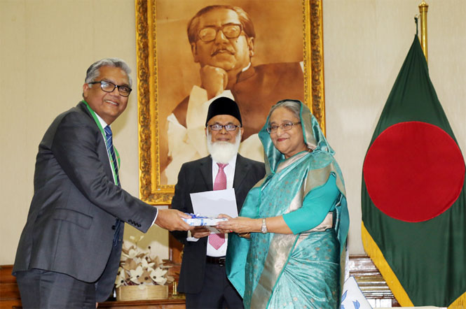
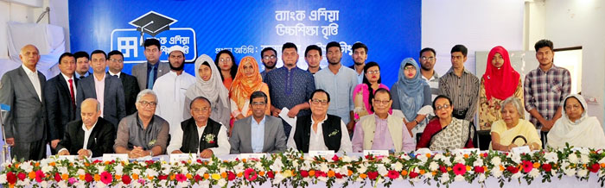
Figure 3: CSR investment of Bank Asia Limited
Bank Asia Foundation
As we started for reading basic rules what is implementing in the bank and the rules and way of Bank Asia for leading and conducting all larger company community (CSR) Activities by the organizations and the company. Banks Asia companies founder has been started its works and activities from Gregorian calendar month 2017. Now days, all of muse has doing effects on the works and tasks of CSR during a lot of proper way, constructed and property manners.
The Foundation has been emplaned with a concept what actually start to build a two hundred and fifty bed hospital that has been made bodily fluid medical faculty at Malkhanagar, Munshigonj. Mr. A Rouf Chowdhury, Chairman of the Bank Asia Limited and Bank Asia Foundation and of their members of the family has given more than seven hundred decimal and a three stored building for to making the entire Hospital. The Hospital has been made for establishing a hospital and it has been renovation and interworked with the work of what is current.
Not only there is one thing also, the muse had been establish a large elaborated exercise and that was select as a final list of two hundred and thirty around a number, for the students for Bank Asia that is for Higher degree studies Scholarship for the year 2018 and also they have been distributed higher scholarship for the merit students by cash that has been started already:
The activities of the muse, amongst others, are going to be the following:
- They have been provided the total treatment facilities. And the facilities has been given throughout the hospital, clinics, medical & also in eye camps
- They are also provided the merit scholarships to the rural poor and worthy students
- They are distributing blankets and winter cloths among the poor & distressed individuals
- They have been distributing and contributing financial support also different help and assisting tools for the distributing of individuals stricken by natural and different disasters like flood, fire attack, famine, cyclone, earth quack, storm, accident, pestilence, drought, epidemic etc.
- They are also marketing instructional, scientifically activities, spiritual and social works and tasks in the organizations
- And finally they are providing other kind of things as like charitable activities.
Green Banking
Bank Asia continues to believe that whenever the volume develops responsibly and always maintains a green and green environment, playing a serious and important role in mitigating environmental risk to support people's lives is really crucial in the world. From the beginning, Bank Asia has been committed to and will continue to pursue environmentally, economically and socially responsible real estate development. As a banking or financial entity, they often play an intermediary role between economic development and environmental protection in relation to care. Our inexperienced banking activities are found in multidimensional areas or places, each of which embodies internal inexperienced activities in support of the inexperienced economy.
Each bank uses all kinds of environments, always motivates and inspires them to use email, looks forward to online instructions for communications and connections, uses natural light, and makes heavy use of energy-saving lamps. These steps also show the bank's internal and external efforts to satisfy the internal management environment in supporting inexperienced banks. Their banking policy tips and job guides for inexperienced people are distributed to all or all of our employees to educate and inform them about banking inexperienced and there are instructions on how to save energy, water, save paper, etc. Bank Asia has also developed its own environmental policy, demonstrating its commitment to the environment for a real estate future. We have grouped our real estate businesses under the Green Banking Unit, which has permanent employees. Also, in early 2017, Bank Asia introduced a new replacement department which, in coordination with Bangladesh Bank and its real estate think tank, appointed the same real estate finance department to oversee real estate banking and real estate finance.

4.2 Findings of the Report
The Bank Asia Limited offers reliable assistance to the public external confined businesses. After analyzing the different stage of performances of Bank Asia Limited several facts can be highlighted which are really appreciable for them. These points are bellow described.
- Bank Asia Limited’s CSR activities are basically based on social welfare, educational support, economics betterment, health support and disaster reliefs.
- Bank Asia Limited is always maintain their responsibilities to the martyrs’ families those past generation were the heroic person for the country.
- Bank Asia Limited always helps and supports governments as government assistance with their direct and indirect sustainable contribution to the country.
- Bank Asia Limited contributes more on educational activities and environmental sectors at any place in Bangladesh by performing their best in CSR activities.
- Compare to other banks and organizations Bank Asia Limited’s corporate social responsibilities are huge in number which is being highlighted day by day
- Bank Asia Limited performs tremendous at the social activity level like distributing warm cloths, supporting disaster affected peoples and their support is very sustainable.
- Bank Asia Limited has become the top ranked company under sustainability.

Through social work and business activities, they have tried to create a healthy environment. Bank Asia always seeks to achieve and promote a healthy society and these communities will increase their better access and this will improve the welfare and efficiency of the country, which will provide better access and access to the education sector, which will provide opportunities to provide those who need to improve their employability and guarantee a comprehensive and composed society as a whole, the closest thing to Bank Asia. Bank Asia also provides educational support to deserving company students. To achieve a good, healthy and harmless, irrepressible and sustainable rural environment in times of adversity and disaster, so that they can rebuild them exists and livings, Bank Asia always provides tremendous support to society.

CSR Donation 2020
Education in year 2020: Bank Asia donated around 248 students and provided the direct scholarship to help them further their studies in educational institutions. Bank Asia donated or assisted the students of Motijheel Model School & College and Bank Asia contributed the large sum of money for the establishment of the school. Bank Asia also made a contribution, helping with the purchase of books, the refurbishment of the Sirajdhikhan Public Library's study room and book cafe. And works with a CSR joint venture initiative called "Spreading Knowledge for All" and Bank Asia provides one thousand (1000) copies of The Daily Star newspaper to Jahangirnagar University students every day.
● Disaster management: More than 52,400 or 54,000 blankets were sponsored and donated to those affected by the cold in different parts of the country, and Bank Asia distributed warm clothes to those affected by the cold in different parts of the country during the harsh winter waves . of cold to carry out their humanitarian activities.
● Art and Culture: In order to continue the cultural and artistic activities, Bank Asia has donated and sponsored various types and various events in educational institutions to promote the culture of Bangladesh to the new younger generation.
● Health: Bank Asia has received a donation for COVID-19 prevention treatments and in case of crisis for the treatment of patients to alleviate their PM and ensure their well-being and well-being and has been PPE from the Bangladesh Police Welfare Fund Tk. 10 million Bank Asia donated COVID-19 protective PPE to Bangladeshi police forces who are actively involved in commercials and to protect the nation. For the establishment of hospital they donated 27.36 million of a huge amount of land along with a three-story building in Malkhanagar, Sirajdikhan, Munshigonj for the construction of renovations and interiors of the MA Amiran Hospital whose works are in progress Contribution to the course for the Covid-19 patient tk. 2.4 million Aware of the health impact of COVID-19, Bank Asia has contributed to various COVID patients across the country.
They spent most of the amount in Health sector. Less in sports, and they spent almost nearly same amounts in education and disaster management.
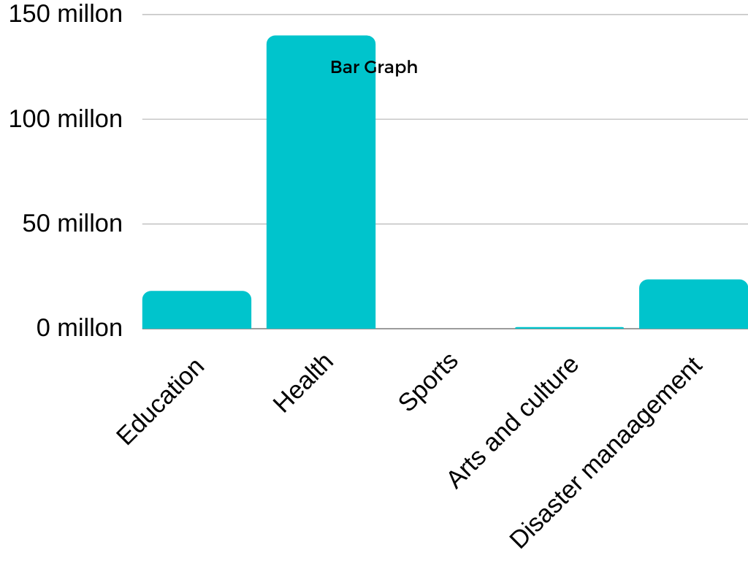

CSR Donation in 2019
Bank Asia spent a huge amount of Tk 116.15 million on the welfare and general improvement of the nation.
● Education: Our next generation has a crucial role to play in shaping and building the digital Bangladesh that we all believe in. Bank Asia believes that a solid education will help instill a sense of patriotism and morality in children. In 2019, Bank Asia donated approximately DKK 29.51 million for direct scholarships and educational infrastructure development.
● Health: curative treatment of 12 individual patients 12 patients received financial support for treatment from Bank Asia. Therefore, Bank Asia provided a total of Tk 1.19 million for the treatment of these 12 patients, which includes Bank Asia staff. Bank Asia donated 2.36 million Swiss kroner for the construction of houses, interiors and civil works of the Faculty of Medicine and the Holy Family Hospital to build better health facilities open to the public.
- Disaster management: Bank Asia is always giving commitment for the welfare of the society at the crucial moment and the community at large. The Bank always responds promptly to support the affected humanity. In 2019, the bank donated large sums of money to distribute warm clothes to cold-stricken people in different regions and poor areas of the country during the harsh and cold winter period for the operation of their businesses. For this they spent a lot of money and for this the bank donated about Tk. 40.71 million in 2019.

- Sports: In 2019, Bank Asia Tk donated 0.02 million to Uttar Baghopara Jubo Somaj Football as the main sponsor and organized various kinds of internal tournaments to encourage Bank employees.
- Bank Asia has always supported the promotion of arts and culture where Bank has distributed Tk. 0.62 million in 2019. Other social projects in 2019, Bank Asia donated/sponsored/spent 12.50 million tk on social projects, including Fatema Khanam Zame-Masjid, Bhola, the Prime Minister's release fund for sufferers of Chalkbazar - Tragedy and also Children's Day care center to support the government in carrying out its humanitarian activities.
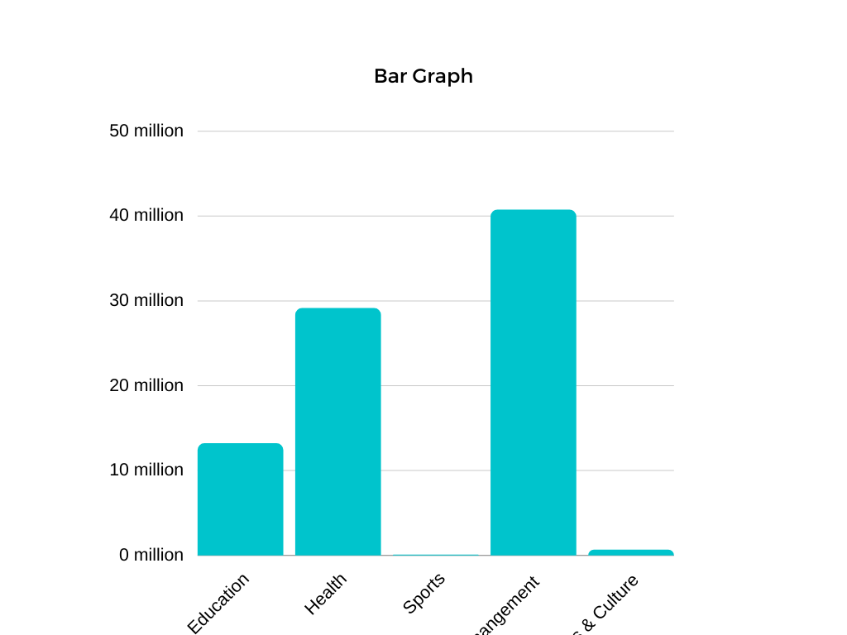
Bank Asia spends for corporate social work in 2019 at Disaster management much more and they less spend for sports. After disaster management they mostly spends

CSR Donation in 2018
Education: The most prominent and one of the largest CSR activities of Bank Asia Ltd. offers an undergraduate scholarship program for poor and deserving rural students who wish to continue their studies in public universities. The bank launched the program in 2005 for students who have real merit and dream of serving the country's society but lack the ability and resources to pursue higher education from poor backgrounds. The scholarship is awarded by the rural branches of the bank and is based on the performance of the SSC and HSC results. Bank Asia received the scholarship for 1,750 students. Each of the students receives 51,000 Tk per year as a scholarship. In 2018, Bank Asia donated approximately DKK 39.23 million for direct scholarships and educational infrastructure development.
Health: The bank is committed to improving the lives of students in HFRCMCH dormitories, Bank Asia has provided financial support to Holy Family Red Crescent Hospital and Medical College and in 2018 the amount was 3.30 million Swiss kroner for construction with the aim of generating awareness and bringing about tangible changes in society The Daily Star, the most widely distributed and respected national newspaper in England, and have planned to distribute copies of the newspaper to deserving students in various respected public bodies. Bank Asia supplies 1,000 newspapers per day as a CSR initiative under a joint venture initiative called "Spread Knowledge" and in 2018 Bank Asia Tk. 2.98 million provided for this purpose.
Children have the right to advance from their own point of view. With this in mind, since 2005 Bank Asia has provided therapeutic assistance to privileged children who are blind at birth in our country. Bangladesh Eye Hospital is the only partner of this great social work through sophisticated treatment and care. So far, 1,164 blind babies from across the country have donated to Bank Asia Tk. 0.81 million for the treatment of 11 individual patients. The Bank also strengthened its support to individuals and institutions in the context of its CSR activities. gained sight thanks to the support of Bank Asia.
Sports: In 2018, the bank donated and contributed TK 1.15 million for Bangabandhu International Volleyball Championship-2018 and Dhaka City Club as sponsorship and also organized several internal tournaments to encourage and motivate employees.
Arts and Culture: During 2018, by distributing tk7.23 million, Bank Asia has always supported the promotion of arts and culture.
Disaster management: Bank Asia is committed to the welfare of the entire society in the country. The bank is responding quickly to support affected humanity. In 2018, during the harsh winter cold, the bank distributed warm clothes to people affected by the cold in different parts of the country to carry out its humanitarian activities and also to support those affected by the floods. To this end, in 2018, the bank donated tk 27.13 million.
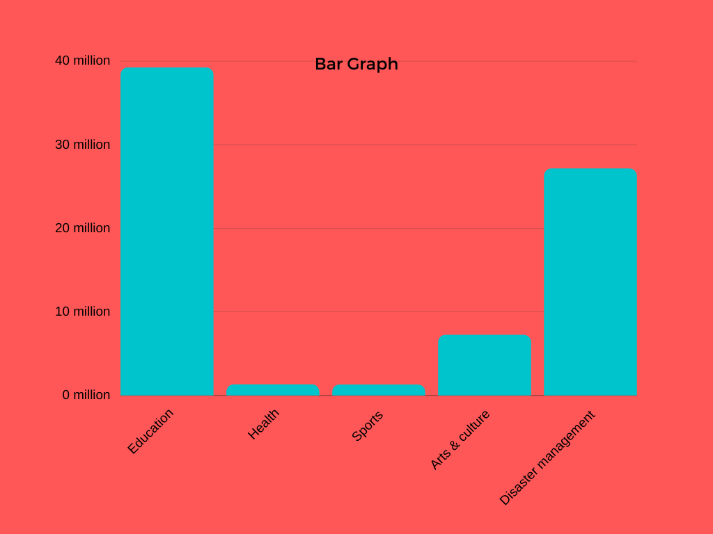
In 2018 they spend most of the amounts on education, And less in health and sports. And they also spend lot of money on disaster management but less than education. And the partially a good amount spend on arts and culture.

CSR Donation in 2017
- Education: Bank Asia Ltd. has received a scholarship program for poor rural students who are talented and deserving students willing to study in public schools of higher education. The bank started and organized the program in 2005 for deserving students who have real merit and dream of serving the country and society, but cannot afford higher education. This scholarship was awarded by the Bank's rural branches based on secondary results or SSC and HSC. Bank Asia awarded the scholarship to 1,545 students. Each of the students annually receives Tk.51,000/- as salary. In 2017, Bank Asia also donated and spent around 45.70 million on direct scholarships and the development of educational infrastructure.
- Health Bank Asia, through its members, formed the Bank Asia Donor Group. The intention of the group is to donate blood when and where it is needed, to give after effects to the eyes, to empower and encourage people at all levels to achieve this priceless gift. About 100 members have already officially joined the donor pool platform and started donating blood. This group organizes a blood donation program every year and collects blood donations for the Bangladesh Red Crescent Society.
- Sports: 2017 Bank Asia donated and contributed 0.20 million Swiss Kroner to the Bangladesh Bridge Federation as a sponsor of the 2017 Bridge World Cup, organized various sports and supported and encouraged internal tournaments to help employees of the Bank to encourage Asia.
- Arts and culture: Bank always supports arts and culture and Bank Asia always supports people related to arts and culture and also supports arts and culture promotion activities. This bank distributed around DKK 0.50 million to Aranyak Natyadal for sponsorship and Shorrong Dinajpur Gallery for organizing the 4th Shishu Kishor Art Exhibition (sponsorship), Shibgonj General Library for book purchase and mosque construction Sahaba James.

- Disaster management: Within Bank Asia, all presidents are committed to the well-being of community members and society as a whole. The bank is always sensitive to those affected and also responds quickly to support and help the affected humanity. In 2017, during the harsh winter cold, the busy Bank Asia distributed warm clothes to cold-stricken people in different parts and regions of the country to carry out its humanitarian activities and also to support the people affected by the floods. For this and for the purpose in question, the bank donated 82.6 million in 2017.

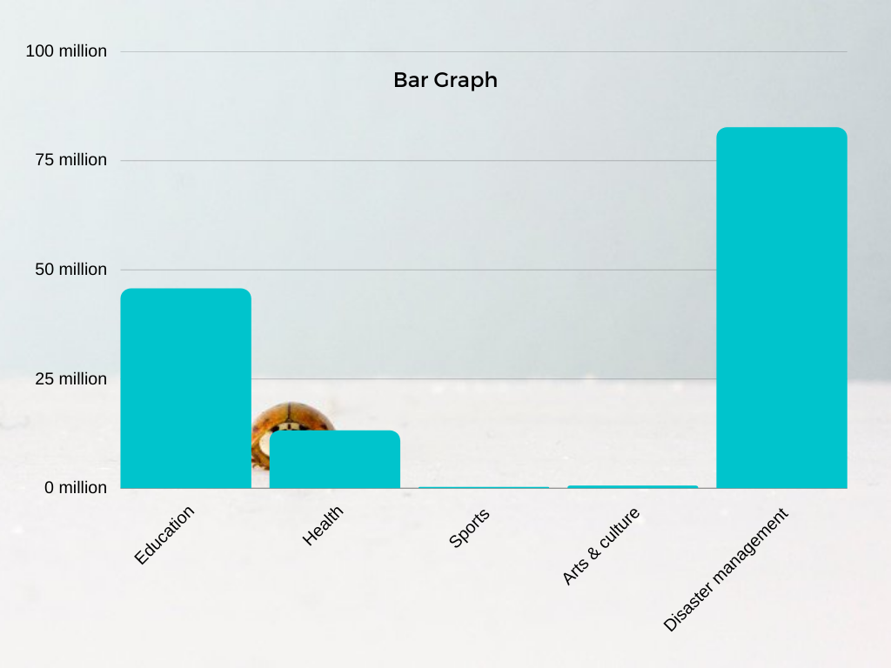
In 2017 Bank Asia spends most of the money on disaster management. They spend also in education sector for CSR purpose. And spend 13.17 million for Health which is less than education donations. And few spend on sports and culture.

Analysis of the total Four years 2017 to 2020 CSR donations
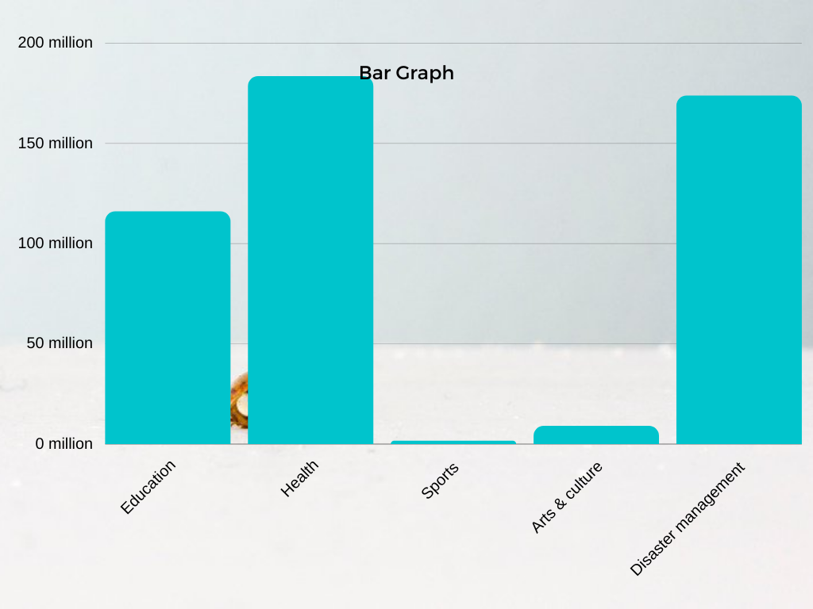
Bank Asia spend from 2017 to 2020 a large amount in Health and disaster management. And spend also a large part in Education. They spend fewer amounts in sports and arts and culture.
- In 2018 they spend most of the amounts on education, And less in health and sports. And they also spend lot of money on disaster management but less than education. And the partially a good amount spend on arts and culture.
- Bank Asia spends for corporate social work in 2019 at Disaster management much more and them less spends for sports. After disaster management they mostly spend in disaster management.
- In 2020, they spent most of the amount in Health sector. Less in sports and they spent almost nearly same amounts in education and disaster management.

Chapter 5

Internship

Experience

5.1 Job Responsibilities
In the bank I worked in customer service and collection. I have stored and retrieved customer information and received feedback from them. I also observed and monitored the entire work process, monitored new clients. Along with all this work, I also have to deal with general banking. The general banking operations I did there are the following:
- I was there to open accounts,
- I counted the money
- I received the delivery note,
- I also in times of customer pressure, I have worked there in customer service with various departments,
- I have also attended important meetings.
BAL provided me with an excel survey file to collect weekly customer information and feedback, so I had to send this data to BAL HQ.

5.2 Training
Asian Bank Limited. (BAL) train their permanent staff more than the interns they hire. They called interns at headquarters and called interns before they arrived for internship hours. And then they sent them to customer service. The head of the department discusses with the trainees how they will work and what the activities will be and gives them the rules and guidelines. After the first week of the internship in the bank, the trainees are instructed by the branch manager and the supervisor, each of the trainees tries to learn, and the employees of their departments support them in banking training. In addition to these activities, the bank always monitors the activities of the trainees and also gives instructions by email. The service office and the human resources office are in contact with all the interns of the BAL-based branch. Human resources and services managers open a chat group, What Sapp, and provide daily guidelines and collect information from each of the interns in the branch.

5.3 Contribution to Departmental Functions
In any bank, the duty of every intern is to serve customers and provide account information as well as communicate with customers. And then after the bank hours were over, it was my duty to oversee and monitor every department in the bank. I work with clients and they have been very difficult at times. BAL believes that interns are the third eye of this bank. And they can bring more satisfaction to customers and the bank. What was the contribution to the departments, these are given below:
- The service department, my job was to communicate with valued customers. And I know that there were always your problems and what I can do, also I always offer you the best services according to your needs. At the bank I really try to help the customers and I try to help them as much as possible and I have worked with the service people and the customer service representative. I worked as an assistant.
- When there are many customers in the bank and I am in a hurry, I start counting money and checks. And I also worked on counting the grand totals and putting them into the data. I also keep the money and bribe that I kept with the sticker.
- I was there as a service employee. So it was about introducing customers to new services, making them understand how it works, and also encouraging them to open accounts, FDRs and time deposits. Customers have been very satisfied with customers with the new services.
- I was the eye of the bank, working under the direction of an official. In the bank I work every day with weekly data and provide a database. I didn't just work based on customer responses or feedback. That is why I also worked for the bank branch and as a clerk and did my best in the bank office.

Chapter 6

Recommendations and Conclusion

6.1 Recommendations
Based on the analysis of CSR practices of Bank Asia Limited, below are some recommendations for improving Bank's CSR services.
- One of the priorities of Bank Asia is to focus on doing well for society. Accordingly, Bank is always doing its best in CSR practices, despite the growing competition.
- Workforce planning is insufficient and does not work correctly, so Bank Asia Limited needs to work on it and improve it. As Bank Asia Limited is awarded and ranked as the most sustainable bank, they should focus more on their workforce and CSR planning to hold their positions.
- Bank Asia Limited should increase its CSR contribution in every sector like other banks such as AB Bank, IFIC Bank, and National Bank contribute social and economic well-being and sports, financial funding, and arts- cultures.
- Becoming the top-ranked sustainable company, they should participate in CSR activities more than other organizations.
- Bank can open a hospital as a part of its CSR. It could be an eye hospital where any severe and complex operations, for poor they may open a free visit and discount for them.
- Bank may open a school for poor children or an ashram for elders.

6.2 Conclusion

After the journey of more than 20 years in the history of the banking sector, nowadays, Bank Asia Limited has become one of the largest and top-ranked banks in sustainability rating 2020 by the central bank of Bangladesh. Besides the deposit segment of Bank Asia Limited's impacts, the bank's advancement in different helpful endeavors will incredibly influence our economy. So everyday normal banking activities and the Corporate Social Responsibility of the Bank Asia Limited are turning out to be more standard classification based. In cities and rural areas, Bank Asia Limited is becoming more and more popular day by day. Bank provides various services to the cities, rural, and international peoples. Bank Asia Limited is also actively participating in the different stages of improvement and betterment for society, making them sound to the Corporate Social Activities practices. Their CSR-based performance also makes them the best day by day.

References
Kara, H. (2015). Creative research methods in the social sciences: A practical guide. Policy Press.P. 4. Isbn 978-1-4473-1627-5. Oclc 908273802.
Website Links
https://www.assignmentpoint.com/business/banking/general-banking-division-bank-asia-limited.html
https://core.ac.uk/download/pdf/74352132.pdf
https://www.bankasia-bd.com/
References of Books and Policies
The Annual Report- 2020 & 2019 of Bank Asia Limited
Policies- General Banking Guidelines
Bangladesh Banks: Banking Regulation and Policy Department (BRDP)

