Internship Report
On
HRM Practices in Babylon Group Limited

Submitted to:

Farhana Rashid
Assistant Professor
School of Business & Economics
United International University

Submitted By:
ZarinTasnimMoutushi
ID: 111-141-190
Program: BBA (Major in HRM )
School of Business and Economics

Date of Submission: 16th May, 2018

.
Letter of Transmittal
May 15th, 2018

To
Farhana Rashid
Assistant Professor
School of Business and Economics
United International University

Sub: Submission of Internship Report on HR Practices in Babylon Group Ltd

Dear Madam,
Here is my internship report on “Babylon Group Ltd”. I am submitting this
report as the part of my internship in Babylon Group Ltd.While preparing this report, I tried my level best to follow your guidelines and also took help and suggestions from my organizational supervisor Mr. Atiqul Islam Apu Deputy Manager (HR Training & Development).The entire report is based on my practical experience in the Babylon Garments Babylon Group Corporate Head Office in the HR department. I have tried my level best to include almost everything what I have learned during the internship program at Babylon Group Ltd. I shall be highly encouraged and obliged if you would be kind enough to receive this report. If you have any further query concerning any additional information I would be very pleased to let you know.

Thanking you.
Sincerely yours,
_____________
ZarinTasnimMoutushi
ID-111-141-190
BBA Program, School of Business and Economics
United International University

ACKNOWLEDGEMENT
At the very beginning, I would like to express my gratitude to Almighty Allah for making me able to complete my internship and my graduation. Then I must express my deep gratitude to my University supervisor Farhana Rashid, Assistant Professor, UIU for his guidance and suggestions in finishing the internship program successfully. I would like to place my gratitude to the HR of Babylon Group for giving me the chance to finish my internship position in their regarded association.

I would also like to thank my host organization supervisor Mr. Atiqul Islam Apu Deputy Manager, HR who has helped me to learn many new things during my internship program. I would also like to thank Mr. A.B.M Shajahan, Mr. Mainul Hosen, Ms. Fahmida, Ms. Hazera Khatun, Mr. Arif, Mr. Kazi Tushar Alam, Ms.Dalia, Ms. MaksudaEti, Ms Shutopa Islam for all their support and instructions. I would also thank, Head of HR for letting me work with him at times.

During the preparation of the project work I got huge support from my co-workers, friends, my supervisor, who gave their ideas and time in the process of completing the report to be true to myself I must say that without their help it would be very hard for me to go through the entire process. I am thankful to all of them.

Table of Contents:

Content | Page Number
CHAPTER-1  INTRODUCTION | 1
1.1Introduction | 2
1.2 Origin of the Report | 2
1.3 Statement of the Problem | 2
1.4 Objectives of the Report | 3
1.5 Scope of the Study | 3
1.6 Limitations of the study | 3
1.7 Methodology | 4-6
1.8 Literature Review | 7-12
CHAPTER-2  COMPANY OVERVIEW | 13
2.1 Company Profile | 14-15
2.2 General Information | 16-17
2.3 Board of Directors, Short profile Babylon Group | 18-23
2.4 WRAP certified factory | 23
2.5 Marker Section | 23-27
2.6 Quality Policy | 28-30
2.7 Major Customers | 32
2.8 Export Growth | 33
2.9 Ethical Trading Practices | 34-36
2.10 Mission | 36
2.11 Vision | 36
2.12 Organizational Structure | 39-40
CHAPTER-3  EXISTING HR POLICY OF BABYLON GROUP | 41
3.1 Job Responsibilities | 42
3.2 Employee Recruitment Policy | 43-44
3.3 Worker Recruitment Policy | 45-49
3.4 Training & Development | 50-51
3.5 Compliance Management | 51-54
3.6 Wage & Benefit | 54-55
3.7 Grievance Handling | 56
3.8 SWOT Analysis | 56-57
CHAPTER-4  INTERNSHIP EXPERINCS | 58
4.1 My Contribution to the Organization | 59

Content | Page Number
4.2 Skills I have Gained | 60
4.3 Interaction with Supervisors | 61
4.4 Difference between my expectation & experience | 61-62
4.5 Influences on my Future Career plan | 62
4.6 People at Babylon | 62-63
4.7 Working Environment | 63
4.8 The Human capital & HR at a glance | 64
CHAPTER-5 :  FINDINGS & ANALYSIS | 65
5.1 Findings | 66
Positive sides | 66
Negative sides | 66-67
5.2 Recommendation | 67
Positive | 67
Negative | 68
5.3 Conclusion | 69
CHAPTER  -6 APPENDIX | 70
6.1 Questionnaires | 71-73
6.2 References | 74

EXECUTIVE SUMMARY
As I have mentioned earlier that this is an Internship report, which is a partial requirement of graduation program. Preparing report on Recruitment and selection of employee/worker is very common and for some extent trouble-free. Babylon garments began excursion in 1986 by its five boards of directors. It is one of the significant pieces of clothing producing association in Bangladesh. This association increasingly reducing its rejection and rework rate in-process and final garments in order to ensure product quality and delivery time as per buyer requirement and increase profitability. Babylon will guarantee sufficient training and suitable work to increase productivity and skills of the employee. In this study, I have tried to investigate the challenging career opportunities for young professionals over the last 35 years that Babylon provided. How their goal is to attract, retain and motivate the most competent people. This study emphasis on how Babylon maintains high recruitment standards and its providing local and overseas training to its employees. Human Resource department are the core part of each and every company to get a competitive man power and advantage from the competitors. There are many functions are followed globally to manage their employees. This report is about a little brief about Human Resource management functions are followed by Babylon and how their functional process is improve their efficiency in the market and what are the procedure follow to recruit the right talent. This complete analysis is based on my journey as an intern of Human Resource Department in Babylon Group.

Chapter 1: Introduction

1.1 Introduction:
Internship is an integral part of the BBA degree to have a practical working experience. It is an effective component to apply the academic knowledge and soft knowledge in a real working environment. It also gives the fresh graduates a little experience so that they do not run errands when they work in an office permanently. I, as an about to be graduate, was fortunate to work at Babylon Group Ltd. in the HR department which is my area of concentration. This internship gave me an immense opening to get an in-depth idea about the garments industry. My organizational supervisor was Mr. Atiqul Islam Apu Deputy Manager of HR.I was mainly integrated to Recruitment Division of the company where I got to know how to arrange a interview session. I would be keeping the records of the interview, co-ordinate interview programs and analyze the feedback reports.
I also got a chance to work with the salary and payroll and training divisions as well. This type of cross functional works has only developed my skills and made me more efficient. This internship has also taught me how to manage multiple works and influenced my career goals.

1.2Origin of the report:
The first objective of the report is to fulfil the partial requirement of the BBA program. Secondly, to give an overview of Babylon Group Limited in general based on my work experience. The origins of the report are:
- To analyze Human resource planning of Babylon Group Limited.
- To understand the various Human resource planning process, Recruitment, Training and Development of Babylon Group Limited.
- To make recommendation to eliminate the problems faced by Babylon Group Limited on it’s over all activities

1.3Statement of the problem:
HR practice is backbone for a organization, Without a good HR practice a organization could become a good company in the market. A good HR practice could bring a healthy environment in a company, and the employee of the company would positively express their affection towards the company. So a good HR policy could be one of strategy for becoming top in the market.

1.4Objectives of the report:
The main objective of the report is comparative analysis and to examine some data and trend son recruiting and training method that are using Babylon Group Limited. This report will reveal how Babylon Group limited focusing on recruiting & selecting fresh employee and job training. This objective comprises three main goals:
- To highlight organization recruiting, Selecting and training process.
- Provide Company overview
- To provide market overview and analysis that is why I tried to find out the turnover situation and actual growth in this organization. I also tried to know the organization’s HR code of conduct, their future plan and the rules and regulations of this organization. Knowing about this organization HR management motivation techniques were also an objective in this report.

1.5Scope of the study:
The scope of this report is confined to Human resource practices in Babylon Group Limited. It should only cover how the company manages human resource management.

1.6Limitations of the study:
There were some obstacles, which were hard to meet up with. The limitations are:
- Lack of adequate information due to confidentiality.
- Lack of documented and concrete secondary materials.
- Busy working environment.

1.7 Methodology:
Research is a systematic method of finding solutions to problems. It is essentiallyan investigation,arecordingandananalysisofevidenceforgaining knowledge. According to Clifford woody, ―research comprises of defining and redefining problem, formulating hypothesis or suggested solutions, collecting, organizing and evaluating data, reaching conclusions, testing conclusions to determine whether they fit the formulatedhypothesis.Thefollowingstudyillustrates the comparisonsofHuman Resource ManagementpracticesinBabylon Group.
1.7.1Types ofresearch
Thisreportwaspreparedbasedon Human Resourcemanagementpracticesof Babylon Group. I have followed two kinds of methodology for the arrangement of the report. The two ways in which I have collected information. Thereby, this studyis dealt with qualitative data while analyzing the sampled questionnaire. Interpretation of qualitative data andit is relevantin this report’s aspect.
1.7.2 Data collection
Data will be collected throughfacetofaceinterviewwiththekeypersonnelof HumanResourcedepartmentfromthiscompany. Interviewshelpedtoobtainin-depthinformationand helpedtheintervieweetosharetheirthoughtsandviewsindetail.Aslight drawbackwas facedwhencertainexecutiveswere reluctanttodisclosespecific informationdue totheir confidentiality,forwhichsomeimportant details weremissed out.

Primary Sources:
Direct interview though a questionnaire. The questionnaire comprises of close ended as well as open ended questions. In close ended questions dichotomous, some dimensions, checklist questions and multiple choice questions are used. I have collected this data with the help of a company supervisor; talk directly with the overall employees of Babylon Garments Ltd, Aboni Fashions Ltd and AboniKnitware Ltd and Babylon Medical Services Ltd, and other reachable branches.
Secondary Sources:
Secondary data is the data that is copied or exported from another source which can be either primary or secondary. They are secondary in nature and are in shape of finished product. Secondary data was collected so as to have accurate results. Required data was collected from various books, magazines, journals and internet. I visited the institution’s website to know about organization. I have collected some basic information from the website and analyzed the information.
1.7.3 Sources ofdata
To satisfy the first specific objective of this study – identifying the Human Resource managementpracticesofBabylonGroup,Coronaexisting Human Resource managementpracticesofthiscompanyhavebeenanalyzed.Facetofaceinterviewswiththekey personnelofHumanResource department fromthiscompanyhavebeenconducted.

1.7.4 Population:
An element is the object about which or from which the information is desired. The element of target population of the research study will be all the employee of Babylon Group.

1.7.5Sample
Ajudgmentsampling wasusedinordertocollectin- depthinformationtoachieve theobjectiveofthe study.Aquestionnaire,consistingof differentdimensionsofHuman Resource Management practiceswasdeveloped to collectthe data fromthecompany.Facetofacesemi-structuredinterviewswereconducted with thekeypersonnel ofHuman Resourcedepartment from this company. InterviewsareconductedwithManagerofHR,Adminand CSR Department, Head of HR, HR executive. Thereforethetotalsamplesizeconsistsof fourtoplevelpersonnelofHRDepartmentandtwoentry levelemployeesofHR Department ofBabylonGroup,
1.7.6 Data Analysis andpresentation
The study used face to face in depth interview research to Human Resource ManagementpracticesofBabylon Group Ltd.Face tofaceindepthinterview research designisthemostappropriate for tworeason.Thefirstisthatitisacross-sectionalresearchstudy wherethe datawas collected ata particular pointintime. In addition, thesecondreasonisthatit is purposedtomeasuretheperceptionoftheexistingHuman ResourceManagementwhich arepracticed at theworkplace.
Theintervieweeswouldbeaskedtosharetheexisting human resourcemanagementpracticesthat havebeen practiced byBabylon Group.

    - Data Editing
After conductingtheinterviewsofkey personnelofHumanResourcedepartmentfrom thiscompany, those data were checked for any incompleteness and for inconsistencies.They werealsoeditedinordertoeliminateerrorswhichisimportantin ensuring thatminimum data quality standards are met.Before analysis,thoseinformationneedstoeditwithanaimofmakingitmoremeaningful. This includes an initial screening to determine the legibility, and completenessoftheresponses. Wheretheresponsesareillegible,theresearchneeds to approach the respondent again to clarify the areas that were not clear or alternatively eliminate the whole response altogether. In this case, the questionnaireswere subjectedtotheprocessesandthefewincompleteresponseswere rectified and edited.

Extent
Extent refers to the geographical boundaries within which the research is conducted. Due to the time and resource constraints the extent of the target population of this research is limited only to the Dhaka city.
- Sample Size: I have tried to maintain the standard of the study, as there are more than 2200 employee in the group. So I have taken 5% means 110+ employee respondents as my sample
- Research Questions: It has been attached in the appendix.

Abbreviations

- HRIS(Human Recourse Information system)
- KPI (Key Performances Indicator)
- CM (Change Management)
- TNA (Training Need Assessment)
- RS (Reward System)

  - Literature Review:
Human Resource Management:
(HRM) is the term used to describe formal systems devised for the management of people within an organization. The responsibilities of a human resource manager fall into three major areas: staffing, employee compensation and benefits, and defining/designing work. Essentially, the purpose of HRM is to maximize the productivity of an organization by optimizing the effectiveness of its employees. (Armstrong, Michael. A Handbook of Human Resource Management Practice. Kogan Page Limited, 1999.)
Standards OF HUMAN RESOURCE MANAGEMENT
Business experts take note of that cutting edge human asset administration is guided by a few abrogating standards. Maybe the foremost rule is a basic acknowledgment that HR are the most vital resources of an association; a business can't be fruitful without adequately dealing with this asset. Another essential guideline, verbalized by Michael Armstrong in his book A Handbook of Human Resource Management, is that business achievement "is well on the way to be accomplished if the work force strategies and methods of the undertaking are firmly connected with, and make a noteworthy commitment to, the accomplishment of corporate destinations and key designs. (Mathis, Robert L., and John H. Jackson. Human Resource Management. Thomson South-Western, 2005.)

POSITION AND STRUCTURE OF HUMAN RESOURCE MANAGEMENT:
Human asset office duties can be subdivided into three zones: individual, authoritative, and profession. Singular administration involves helping workers distinguish their qualities and shortcomings; remedy their inadequacies; and make their best commitment to the venture. These obligations are brought out through an assortment of exercises, for example, execution audits, preparing, and testing.( Johnston, John. "Time to Rebuild Human Resources." Business Quarterly. Winter 1996.)

HUMAN RESOURCE MANAGEMENT-KEY RESPONSIBILITIES
Human asset administration is worried about the improvement of the two people and the association in which they work. HRM, at that point, is locked in not just in securing and building up the abilities of people laborer, yet in addition in actualizing programs that improve correspondence and collaboration between those individual specialists with a specific end goal to support hierarchical advancement.
The essential obligations related with human asset administration include: work investigation and staffing, association and use of work power, estimation and examination of work compel execution, usage of reward frameworks for representatives, proficient advancement of laborers, and upkeep of work drive. (Gubman, Edward L. "The Gauntlet is Down." Journal of Business Strategy. November-December 1996)
Job Analysis:
Comprises of deciding regularly with the assistance of other organization zones the nature and obligations of different business positions. This can include assurance of the aptitudes and encounters important to satisfactorily perform in a position, recognizable proof of occupation and industry patterns, and expectation of future work levels and ability prerequisites. "Occupation investigation is the foundation of HRM hone since it gives legitimate data about employments that is utilized to enlist and advance individuals, build up compensation, decide preparing requirements, and settle on other critical HRM choices," expressed Thomas S. Bateman and Carl P. Zeithaml in Management: Function and Strategy. Staffing, in the interim, is the genuine procedure of dealing with the stream of faculty into, inside (through exchanges and advancements), and out of an association. Once the enlisting some portion of the staffing procedure has been finished, choice is expert through employment postings, interviews, reference checks, testing, and different apparatuses. The procedure of employment investigation includes the investigator portraying the obligations of the occupant, at that point the nature and states of work, lastly some essential capabilities. After this, the activity investigator has finished a frame called a vocation psychograph, which shows the psychological prerequisites of the activity. The measure of a sound occupation examination is a substantial undertaking list. This rundown contains the useful or obligation zones of a position, the related errands, and the essential preparing suggestions. Topic specialists (occupants) and chiefs for the position being broke down need to approve this last rundown with a specific end goal to approve the activity examination.

Occupation investigation is urgent for to begin with, helping people build up their vocations, and furthermore to help associations build up their workers keeping in mind the end goal to augment ability. The results of employment investigation are enter impacts in planning getting the hang of, creating execution intercessions, and enhancing forms. The use of employment investigation methods makes the verifiable presumption that data about an occupation as it by and by exists might be utilized to create projects to enlist, select, prepare, and evaluate individuals for the activity as it will exist later on. ( Wilson, M. (2007). A background marked by work investigation. In L. Koppes, Historical points of view in mechanical and authoritative brain research. Mahwah, NJ: Lawrence Erlbaum Associates)

Organaizatin, Utilization &Maintanance:
An organization's work compel is another key capacity of HRM. This includes planning a hierarchical structure that makes most extreme utilization of an endeavor's HR and setting up frameworks of correspondence that assistance the association work in a brought together way. Different duties around there incorporate wellbeing and wellbeing and laborer administration relations. Human asset upkeep exercises identified with wellbeing and wellbeing as a rule involve consistence with government laws that shield representatives from dangers in the working environment. These directions are passed on from a few government offices, including the Occupational Safety and Health Administration (OSHA) and the Environmental Protection Agency (EPA), and different state offices, which actualize laws in the domains of specialist's remuneration, representative insurance, and different zones. Support undertakings identified with laborer administration relations principally involve: working with worker's parties; dealing with grievances identified with offense, for example, burglary or inappropriate behavior; and conceiving correspondence frameworks to cultivate collaboration and a common feeling of mission among representatives.
Recruitment and Selection
Recruitment is a centre capacity of human asset administration. It is the initial step of arrangement. Enlistment alludes to the general procedure of drawing in, short posting, choosing and selecting reasonable possibility for occupations (either perpetual or brief) inside an association. Enlistment can likewise allude to forms associated with picking people for unpaid positions, for example, wilful parts or unpaid student parts. Chiefs, human asset generalists and enrollment masters might be entrusted with completing enlistment, however now and again open segment work offices, business enrollment offices, or authority seek consultancies are utilized to attempt parts of the procedure. Web based innovations to help all parts of enlistment have progressed toward becoming widespread.According to (Syamala Devi Bhoganadam, Dr.DasarajuSrinivasa Rao, October 2014) among all other HR capacities enrollment is the prime capacity where representatives are passage into the associations.It’s a difficult task to find the right people for right task. Many other researchers say recruitment should be ethical to the organization in order to sustain in the competitive market. There are many other sources for traditional recruitment is by employee referrals, transfers and promotions, walk-in and by the advertisements. (https://en.wikipedia.org/wiki/Recruitment)
Performance appraisal
Is the practice of assessing employee job performance and providing feedback to those employees about both positive and negative aspects of their performance? Performance measurements are very important both for the organization and the individual, for they are the primary data used in determining salary increases, promotions, and, in the case of workers who perform unsatisfactorily, dismissal. A performance appraisal (PA), also referred to as a performance review, performance evaluation, (career) development discussion, or employee appraisal is a method by which the job performance of an employee is documented and evaluated. (Aguinis, 2011) said “Performance management is a continuous process of identifying, measuring and developing performance in organizations by linking each individual’s performance and objectives to the organization’s overall mission and goals”. Managers ensure that employee’s activities and outputs are compatible with the organization’s goals and consequently, help the organization improvement a competitive business advantage. Performance management therefore creates a direct link between employee performance and organizational goals and makes the employees‟ involvement to the organization explicit. (https://en.wikipedia.org/wiki/Performance_appraisal)
Reward systems
Reward framework is ordinarily overseen by HR territories also. This part of human asset administration is critical, for it is the system by which associations furnish their laborers with rewards for past accomplishments and motivators for elite later on. It is likewise the instrument by which associations address issues inside their work compel, through foundation of disciplinary measures.Aligning the work force with company goals, stated Gubman, "requires offering workers an employment relationship that motivates them to take ownership of the business plan." (Ulrich, Dave. Delivering Results: A New Mandate for HR Professionals. Harvard Business School Press, 1998.)
Compensation management
Compensation Management is the demonstration of disseminating some sort of financial incentive to a representative for their work by methods for the organization's strategy or strategies. In essential terms, it is paying a representative in view of the chose pay and arrangement for assistance for the position. The objective of remuneration administration is to discover quality individuals who perform quality work and after that repay them so as to hold them and diminish turnover rates. Some extraordinary sorts of pay incorporate compensation, additional time pay, commission, rewards, and support agreement that may incorporate wellbeing and dental protection, get-away time, and retirement savings.Human Resource Management has assumes noteworthy part in every single association.Today employees are considered companies assets so that they need to more efficient and effectively managed. To motivate employee’s salary and benefits is considered as one of the important factor. According to (Nazir, 2010) employees are not willing to work only for cash, they expect extra. This extra is known as employee benefits. It’s also a part of a salary, people are easily get become monotonous to their work so they need to motivate and it an important task to HR officials to take care of them. So, salary will not only thing they want for their motivation so anything which is equal to cash is more workable for the employees as their motivation.
Change management
(At times condensed as CM) is an aggregate term for all ways to deal with getting ready and supporting people, groups, and associations in rolling out hierarchical improvement. It incorporates techniques that divert or reclassify the utilization of assets, business process, spending portions, or different methods of activity that altogether change an organization or association. Authoritative change administration (OCM) considers the full association and what necessities to change, while change administration might be utilized exclusively to allude to how individuals and groups are influenced by such hierarchical progress. It manages a wide range of orders, from behavioral and sociologies to data innovation and business arrangements.

In a venture administration setting, the expression "change administration" might be utilized as an other option to change control forms wherein changes to the extent of a task are formally presented and affirmed.
Employee development and training
Training and developmentis another indispensable obligation of HR faculty. HR is in charge of looking into an association's preparation needs, and for starting and assessing worker advancement programs intended to address those necessities. These preparation projects can run from introduction programs, which are intended to adjust new contracts to the organization, to goal-oriented training programs expected to acquaint laborers with another product framework.
"After getting the right talent into the organization," wrote Gubman, "the second traditional challenge to human resources is to align the workforce with the business-;to constantly build the capacity of the workforce to execute the business plan." This is done through execution evaluations, preparing, and different exercises. In the domain of execution examination, HRM experts must devise uniform evaluation norms, create survey strategies, prepare directors to regulate the examinations, and after that assess and follow up on the adequacy of execution audits. They should likewise tie the evaluation procedure into remuneration and motivator systems, and work to guarantee that government controls are watched.
Duties related with preparing and advancement exercises, in the mean time, incorporate the assurance, outline, execution, and investigation of instructive projects. The HRM expert ought to know about the essentials of learning and inspiration, and should painstakingly outline and screen preparing and improvement programs that advantage the general association and the person.
The importance of this aspect of a business's operation can hardly be overstated. As Roberts, Seldon, and Roberts indicated in Human Resources Management, "the quality of employees and their development through training and education are major factors in determining long-term profitability of a small business'¦. Research has shown specific benefits that a small business receives from training and developing its workers, including: increased productivity; reduced employee turnover; increased efficiency resulting in financial gains; and decreased need for supervision."(U.S. Small Business Administration. Roberts, Gary, Gary Seldon, and Carlotta Roberts. "Human Resources Management." N.d.)

Chapter 2:
Company Overview



2.1COMPANY PROFILE
Babylon Group started its journey in 1986 with Babylon Garments Limited with a humble setup. Relentless efforts and a constant persuasion of quality resulted in the group’s expansion to 14 different concerns. All the units function independently but operate under the direct supervision of the group head quarter.
Babylon has strong footing in both knit and woven products. Several units of the group are dedicated to produce finest quality products for buyers around the globe. The group is self reliant and is involved in woven wear manufacturing, knit wear manufacturing, washing plant, printing house, knitting unit, dyeing and finishing of knitted fabrics, embroidery, trims manufacturing, paper converting and packaging, apparel trading etc. It also has fashion wear retailing outlets to satisfy the growing local demand.
The company currently employs over 10,000 skilled employees and had a turnover of about $90 million in the year 2009. In all the different production with the workers have to go through a process of continuous and rigorous training to maintain a high standard of production set by the management. The group also caters this driving force by ensuring facilities that exceed the minimum set by international regulators. It maintains a fair price shop, medical and day care services, scholarship programs and other benevolent initiatives for the employees and their family members. As part of their commitment towards the society, the group has established a medical service station open for all. Babylon distributes relief materials including cash to the victims in any part of the country during natural adversities.
BABYLON GARMENTS LTD. (Babylon Group) Corporate office situated at 2-B/1, Darussalam Road, Mirpur-01
Dhaka, Bangladesh 1216.
Number of employees work in this factory total- 2200.

2.2 General Information:
Babylon Group of concerns saw her development in the skyline of Readymade Garments Manufacturers in Bangladesh in the year 1986 through formation of a little sewing unit called Babylon Garments Ltd.
Through hard work and tirelessness Babylon figured out how to survive the troublesome circumstances in the early years. In the midst of the steady fight for presence Babylon in any case stayed with her initially received standards of genuineness, honesty, moral qualms and business morals. What's more, that most likely had helped Babylon ease delicately through the hazardous way toward progress and dependability in the resulting years.
Never absent to understand the future difficulties that lay ahead, Babylon dependably had put every one of her endeavours and intend to ace the prescribed procedures in all her assembling units with a specific end goal to accomplish proficient fitness and dependability.
It has been the arrangement since beginning that Babylon would constantly offer more to her clients than could be anticipated from her. To satisfy this dedication Babylon has been acting not just as a trusted provider of readymade pieces of clothing yet in addition as a generous accomplice toward every one of her purchasers and clients.
Thus meeting the exceptional necessities of her clients has turned into a custom around here house and a matter of pride for the Group.
Speedy reception of a portion of the other essential strategies like getting accreditation of ISO Quality Standard works on, guaranteeing all out consistence of different Code of Conduct prerequisites of esteemed purchasers over the world, organizing the requirement for making of perfect work conditions for the labourers and guaranteeing appropriate human services and security for them and so forth has granted Babylon a respectable position in the best echelons of the RMG makers in Bangladesh.
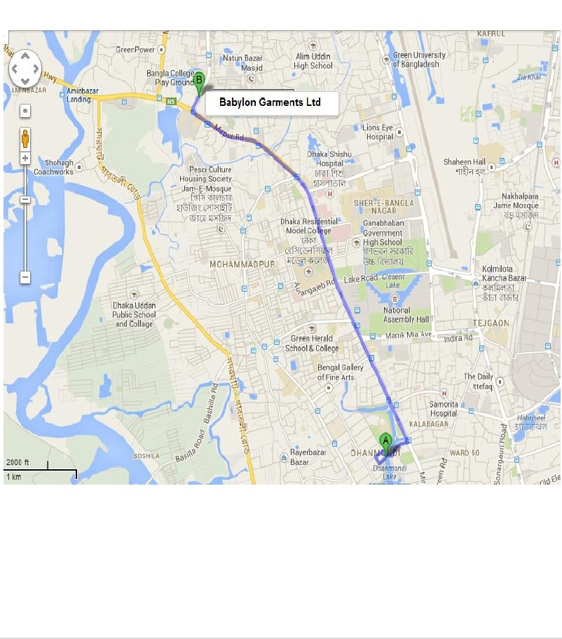

2.3 BOARD OF DIRECTORS:
Consists of the following members –
01. Mr. Neesar Ahmed – In charge of IMPORTS & ADMINISTRATION
02. Mr. Emdadul Islam – In charge of MARKETING & QUALITY CONTROL
03. Mr. Moinul Ahsan – In charge of FINANCE
04. Mr. Abidur Rahman - In charge of EXPORT & EMBROIDERY DIVISION
05. Mr. Abdus Salam – In charge of BABYLON TRIMS LTD.
A short profile of them Babylon Group:
- Babylon Garments Ltd.
- Aboni Fashions Ltd.
- Babylon Casual Wear Ltd.
- Aboni Knitwear Ltd.
- Aboni Textiles Ltd.
- Juniper Embroideries Ltd.
- Babylon Trims Ltd.
- Babylon Washing Ltd.
- Babylon Printers Ltd.
- TRENDZ (Local Retailing)
- Babylon Buying Services Ltd.
- Babylon Medical Services
- Babylon Logistics Ltd.
- Babylon Products (softy)
- Babylon Agriscience Ltd.
- SealandAgroIndustris Ltd.
- Newgen Tecnology Ltd.
- Babylon Resources Ltd.

Babylon Garments Ltd. (Established – Year 1986)
- Located at Company’s own premises at 2-B/1, Darussalam Road, Mirpur, Dhaka-1216.
- Total floor area about 90,000 sq ft.
- Capacity: 200,000 ~ 240,000 pcs. Of Men’s/ Children’s formal shirts per month (woven).
- Number of Production Lines : 10
Aboni Fashions Ltd. (Established – Year 2000)
- Located at Company’s own premises at Plot – 242-243, Union – Tetulzora, Hemayetpur, Savar, Dhaka.
- Total floor area about 25,000 sq ft.
- Capacity: 100,000 ~ 120,000 pcs of Men’s/Ladie’s formal & casual shirts per month (woven).
- Number of Production Lines : 05

Babylon Casual Wear Ltd. (Established – Year2006)

- Located at Company’s own premises at Plot – 23-24, Union – Tetulzora, Hemayetpur, Savar, Dhaka.
- This is a 3-stored building having a total floor area of about 90,000 sq-ft.
- Capacity: 300,000-350,000 pcs (per month- by considering 5 pocket denim) of Mens and ladies casual wear including Tops and Bottoms in Denim and other medium to heavy materials.
- Number of Production Lines : 10-11

Aboni Knitwear Ltd.(Established – Year2002)
- Knitted garment manufactory, is located at Hemayetpur, Savar (own premises).
- This is a 7-storey building having a total floor area of about 93,000 sq-ft.
- Has 31 production lines with a capacity of producing about 6, 25,000 pcs. Of Polo Shirts and 16,50,.000 pcs. of T-Shirts/Tank Tops etc. per month.
- Product range – Polo Shirts, T-shirts, Shorts, and Pyjamas etc. for Men’s, Ladies, and Children.
- Principal customers – BHS, Tesco, New Look, Sainsbury (UK); Zara (Spain); Jules, Kiabi (France), H&M (Sweden).
Aboni Textiles Ltd. (Set up – Year 2001)
- Aboni is a cutting edge and proficient Composite Textile Project for the generation of sewed textures.
- Located at Hemayetpur, Savar close Dhaka, being organization's own particular premises.
- Total developed territory 115,000 sq ft for Aboni Textiles Ltd.
- The weave material venture has been planned with all European best Machinery and Technical know-how. The present limit of the undertaking is 8.0 tons for every day for Knitting, 8.5 tons for every day for Dyeing and 10 tons for each day for Finishing. This task is having both tubular and with open-width office.
A cutting edge and proficient composite weave material industry outfitted with greetings tech European Knitting, Dyeing, and Finishing Machinery. Aboni offers different kinds of excellent tubular textures including interlock, single pullover, arouse polo, lacoste, rib, lycra rib, level sew neckline/sleeve and numerous different assortments of organized textures and elegant pieces of clothing.
Aboni now additionally offers stuttering, compacting, and calendaring of open width textures and is outfitted with 100% Cotton, T/C, CVC, and Polyester and Spandex blended texture completing offices.
Babylon Printers Ltd. (Built up – Year2004)
- Located at Company's own premises at Plot – 23-24, Union – Tetulzora, Hemayetpur, Savar, Dhaka.
- This is a 3-put away building having an aggregate floor region of around 25,000 sq-ft.
- Printing office for prints on sewed articles of clothing (Rubber, Plastisol and so forth.)
- Equipped with infra-red dryer and imported Curing Machine. Capacity – 50,000 pcs/day @ standard outline.

Babylon Printers Ltd. (Set up – Year2004)
- Located at Company’s own premises at Plot – 23-24, Union – Tetulzora, Hemayetpur, Savar, Dhaka.
- This is a 3-stored building having a total floor area of about 25,000 sq-ft.
- Printing facility for prints on knitted garments (Rubber, Plastisol etc.)
- Equipped with infra-red dryer & imported Curing Machine.
- Capacity – 50,000 pcs / day @ standard design.
TRENDZ (Established – Year 2004 )
- Babylon’s own brand
- TRENDZ has currently 7 (Seven) outlets in Dhaka City retailing western-oriental fusion outfit for Men, Women and Children.
- TRENDZ products are all designed by in-house designers and fabrics are sourced meticulously from home and abroad.
- TRENDZ is to go for more shops in Dhaka and neighbouring cities of the country soon.
Babylon Buying Services Ltd. (Set up – Year 2003)
Babylon Buying Services Ltd. (BBSL) is a one stop solution of apparel needs!
- Located at Company’s own premises at 2-B/1, Darussalam Road, Mirpur, Dhaka-1216. Bangladesh
- BBSL has been developed by gathering complaint / committed factories (Fair-trade, Organic, Oekotex etc.) of Woven, Knit, under garments, Sweater and Home textiles to meet the diversified needs of the customers around the world in terms of price, quality, lead time and value addition besides their own factories of Woven, tops & bottom & knit tops and bottom.
Product:
- Woven Tops & Bottom
- Knit tops & Bottom
- Sweat Shirt & Fleece Jackets
- Sweater
- Under Garments & Home Textiles.
With all kinds of value addition like Print, Embroidery, Appliqué, Garments Washing, Garments Dyeing (Pigment Dyed), Tie & Dye, Dip Dyed, Chemical Spray, Aromatic fabric, Cool max, Moisture Management so on.

Babylon Medical Services (Established – Year 2007)
- Location – Company’s own premises at Plot – 242-243, Union – Tetulzora, Hemayetpur, Savar, Dhaka.
- Floor Area – 2,500 sq-ft.
- Services –
  - Experienced Doctor
  - Pathological Test
  - Fair price Pharmacy
  - Operation Theatre
  - Sick Bed
  - Special services for factories.
All these factories are owned by the same owners and being managed from corporate office at 2-B/1, Darussalam Road, Mirpur, Dhaka – 1216. But each of the manufacturing units has its own factory management setup to perform from sample making, cutting etc. up to packing of the finished products.
Total number of employees in the Factories : About 9,529
Total Turnover in the year 2009 : About US$ 90.00 million
The Group of Companies owns 8-storied building at 2/B-1, Darussalam Road, Mirpur, Dhaka as the factory premises for three of the woven units and the corporate office. Keeping the environmental and decent labour practice issues in mind, the building has been designed in a manner that satisfies both local and international legal requirements that are necessary for responsible manufacturing.
- Each of the assembling units is furnished with free QC cell.
- Every unit has its own particular example making and test influencing set-to up.
- All the units utilize Japan/Korea root current piece of clothing hardware and gear.
- Group possesses unique machines to utilize taping and circuit arm-openings and side creases of wrinkle free shirts.
- Uses Light Box (Light sources D65, TL84, TUNGSTEN and UV) for checking shade variety in the textures and isolating shade parts.
- Group has Computer Aided Design (CAD – Investronica, Spain and Echosoft, China) framework for expedient and precise checking and Pattern making
Some special features of all apparel manufacturing units of the Group. Each of the factories of the Group has been specializing in specific apparel making only since inception. This endeavor has enabled the Group to earn a lot of fame in a very short time and put it on a leading position of the trade in the field of garment making.
The Group has now become extremely outstanding to the clients' group for its fantastic workmanship in its item. The Group believes that harder task is ahead to keep it up. And “to keep it up” now is the motto and motivation behind all efforts of the Group.

2.4 Babylon Garments Ltd. is WRAP ensured manufacturing plant.
Every real unit have isolate preparing places for laborers and staff. All specialists and staff experience instructional course in a normal premise. Preparing program is planned by the need evaluated for the objective gathering.
Group has a focal innovative work (R&D) cell where a five part group of architects and different authorities add to :
- Designing the most fitting machine format for the specific style.
- Suggesting enhanced work-strategy.
- Recommending utilization of unique work-helps.
- Reducing revamp and re-process.
- Raising profitability, enhancing effectiveness and at last adding to generation cost decrease.

2.5Marker Section:
In BGL & BDL marker is made both manual system & automatic system. In computer aided marker BGL & BDL use INVESTRONICAsoftware.
In manual marker making process, marker man use pattern paper to draw different garments parts in marker paper.


Babylon factories follow compliance requirements based on Code of Conducts of –
USA – Mothers Work, JONES, CHARMING SHOP, KOHL’S,
J.C.Penney, Walmart, Sears, May Co., Inditex,
WARANCO, HAGGAR, K-MART, PVH etc.
UK – Next, Arcadia Group PLC, Dimensions, Tesco, Primark, New Look etc.
FRANCE – CELIO, JULES, KIABI, MONOPRIX
SWEDEN – H & M (Hennes & Mauritz)
SPAIN – ZARA
Babylon Garments Ltd. – WRAP certified.
Aboni Textiles Ltd. – Oeko-Tex® certified.

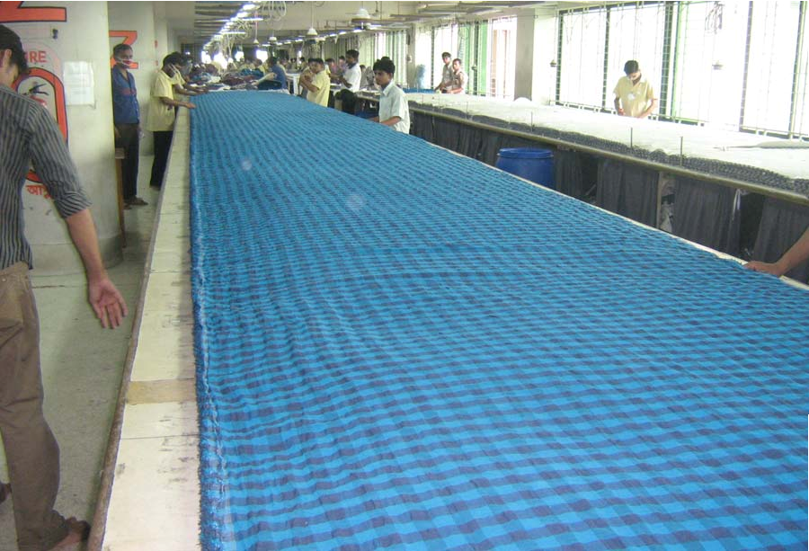
Picture: Cutting Section

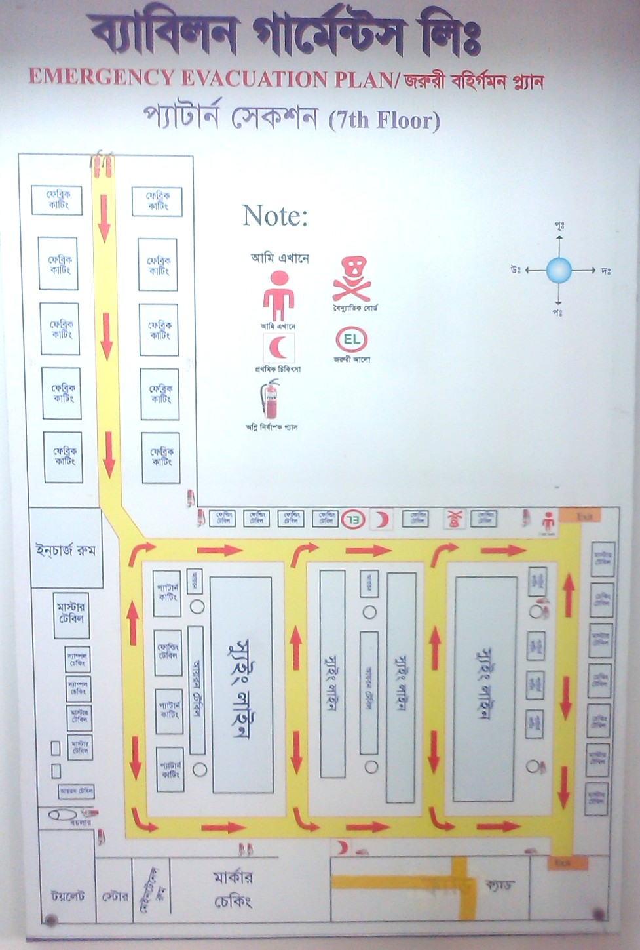
Layout of Sample Section

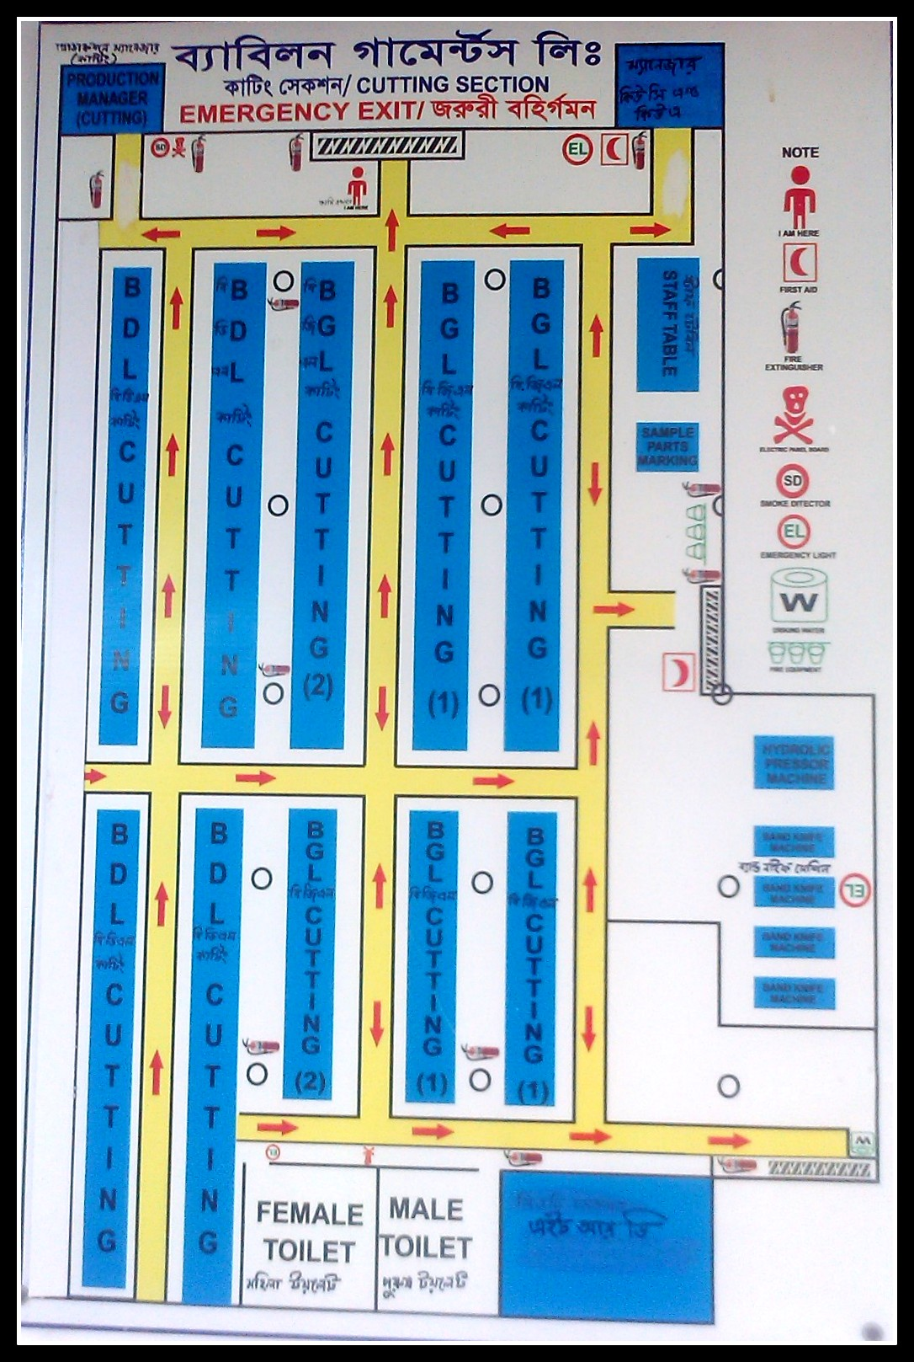

Layout of Cutting Section

2.5 Quality policy of Babylon group
Babylon gather devoted to meet and satisfy client necessity in articles of clothing making and furthermore endeavour to fulfil their workers. This gathering progressively decreasing its dismissal and modify rate in-process and last pieces of clothing to guarantee item quality and conveyance time according to purchaser necessity and increment gainfulness.
Babylon will guarantee adequate preparing and reasonable work to expand profitability and aptitudes of the worker.
This gathering dependably measures its execution in all territories now and again and takes measure to persistently enhance quality, workplace and worker fulfilment.
Corporate office controls every one of the units of the gathering which is situated in the Dhaka city.
To perform well every unit has its industrial facility administration setup from inspecting to completing of the item.
Both condition and word related wellbeing and security were considered amid planning the structures. Restorative offices are accessible in the generation offices. The two units of Babylon amass are credited on ISO 9001-2000. These are Babylon articles of clothing and Aboni materials. Babylon pieces of clothing are likewise WRAP affirmed. Aboni materials constrained of Babylon amass is ascribed on ecological administration framework ISO 14001-1990.
Babylon Group applies moral standards to all offices that deliver readymade pieces of clothing for sending out to outside nations. Its factory operates in a legal and cultural environment. These ethical principals express the basic requirement of Babylon factories in order todo business with its foreign customers.
Babylon makes constant efforts to promote bestpracticesandcontinuousimprovementof ethical issues in all its manufacturing units. For easy understanding of the issues the Babylon management has posted its contents on both Bangla and English to their notice board.
Woven units have turned out to be agreeable of code of behaviors of Capital Mercury Apparel Ltd., Mothers Work, Wal Mart, Kohl's of USA, Arcadia Group Plc, Dimension of UK, H and M of Sweden and the Knit unit by Reebok of Spain and BHS of UK.
Notwithstanding all ordinary machines and hardware, woven division utilizes the accompanying machines and gear to give different uncommon necessities of clients:-
- ArmHole and Side SeamFusing Machine
- Eyelet Sewing Machine
- Pintack Machine
- Blind Stitch Machine
- Saddle Stitching Machine
- CAD (Investronica)
- Cintex Needle Search Machine
The woven division has the limit of creating around 350,000 pcs of shirts/dresses (Men's and Ladies) every month.
The sew division in its composite structure has Knitting, Dyeing, Finishing and Sewing office situated close Dhaka City.
The division is still in its first stage, running with a limit of:
- tons for every day for Knitting, 7 tons for every day for Dyeing and 10 tons for each day for Finishing
- About 300,000 pcs of 'T' shirts/Tank tops every month
- About 200,000 pcs of Polo shirts every month
Sewing, Dyeing, Finishing units are outfitted with European best brand machines like Sclavos for Dyeing, Mayer and CIE for Knitting and Santex for Finishing.
Sew division weaves colors and completes 100% Cotton, CVC, T/C, 100% Polyester, lycra textures. Weaving unit sews all the essential structures including the accompanying:-
- Feeder Stripes
- Lycra Single Jersy
- Lycra Rib
- Waffel
- Herring Bone and so forth.
- The gathering has their own weaving units.

The group turns out to be more focused by including printing and bundling unit in the year 2003. This foundation causes cost lessening and smooth execution of the requests.
Babylon washing was set up in September 2003and has begun demonstrating its positive effect on Group's general business. RMG units of the Group are not any more subject to out sourcing of washing of Garments.
Product Category

WOVEN

Gents Ladies Children

KNIT


Gents

Ladies Children

2.6 Major Customers (Country wise)
WOVEN CUSTOMERS

Country |  | Company
UK | - | TESCO, DIMENSIONS, SAVILE ROW,  BHS, ROCHES, GRAHAM HUNTER, PRIMARK, NEXT
FRANCE | - | CELIO, VETIR, FABRISTYL, CAMAIEU
FRANCE | - | (JULES), RIPCURL, GO SPORTS
SWEDEN | - | KAPPAHL
DENMARK | - | BEST SELLER
HOLLAND | - | DOMO
SPAIN | - | CORTEFIL(SPRINGFIELD)
GERMANY | - | BROADWAY
USA | - | MOTHERS WORK, MAY DEPT., SAKS,  NYNE, MEIJER, BOSCOV, JC PENNEY,
USA | - | LEE, WALMART, SEARS, CARHARTT, CATO, K-MART, AMERICAN EAGLE etc.

Knit Customers:

Country |  | Company
USA | - | WALMART, TARGET, SARA LEE
UK | - | TESCO,BHS,GREENWOODS,NEW
UK | - | LOOK, ARCADIA, Jerzees
SWEDEN | - | H & M
GERMANY | - | TOM TAILOR, KARSTADT, QUELLE,
GERMANY | - | NECKERMAAN, WESTERN STORE
SPAIN | - | REEBOK,NIKE
DENMARK | - | EKSPERTO, MARCUS GRUPPEN,
DENMARK | - | FOTEX,BILKA
HOLLAND | - | Vroom&Dreesmann (V&D), O’NIEL
FRANCE | - | RIPCURL, JULES, MONOPRIX
FINLAND | - | INTRADE
ITALY | - | UPIM, TRR, METRO
BELGIUM | - | E5-Mode

2.7Export growth by graph:

Product mix:
Woven shirt (Short & Long sleeve) for Men’s, Women’s & Baby Wear
Numbers of worker:
Employee Quantity : 2108
Male Employee : 843
Female Employee : 1265
Area:

NAME: Babylon Garments limited (BGL-01 & BGL-02).
AREA: Total floor area 90000 square feet.
NAME: Babylon Dresses limited.
AREA: Total floor area 45000 square feet.

2.8 Ethical Trading Practice
Moral standards apply to all offices of Babylon Group that deliver readymade articles of clothing for sending out to outside nations. Babylon Group perceives that there are legitimate and social situations in which production lines work. These moral standards put forward the essential prerequisites of Babylon industrial facilities so as to work with its clients abroad.
Babylon tries to advance prescribed procedures and ceaseless change of moral issues in all its assembling units. For simple access to the issues, Babylon posted substance in the Notice Boards of industrial facilities in both Bangla and English.
The issues are:
Standard 1 – Laws and Regulation:
Babylon offices work in full consistence with the laws and controls of the locales in which they produce.
Standard 2 – Employment Age:
Laborers may not be more youthful than 18 years old.
Standard 3 – Forced Labor :
Babylon offices don't utilize automatic or constrained work – contracted, reinforced or something else.
Guideline 4 – Wage and Benefits:
Babylon offices remunerate their representatives decently by giving pay bundles involving wages and advantages that, in any event, agree to lawfully commanded least benchmarks. Every representative is given an unmistakable, composed representing each payroll interval. Representatives are made up for extra minutes as indicated by neighbourhood law.
Standard 5 – Hours of Work:
Babylon offices guarantee representatives' hours worked should not, on a consistently booked premise, surpass the legitimate constraints on customary and extra minutes hours in the locale in which they make or 60 hours for every week including additional time. But in uncommon business conditions, all workers are qualified for one three day weekend in each seven-day time frame.
Standard 6 – Health and Safety:
Babylon offices furnish their representatives with a spotless, protected and sound workplace, intended to avert mischance’s and damage to wellbeing emerging out of or happening over the span of work. All Babylon offices conform to all appropriate, lawfully commanded measuresfor work environment wellbeing and security. Every one of the specialists and staff appreciate free restorative treatment. Organization specialists are accessible full time.
Standard 7 – Discrimination:
Babylon regards social contrasts, business – including employing, compensation, benefits, headway, end and retirement in light of capacity and not on conviction or some other individual attributes. Babylon offices don't separate based on race, age, shading, national beginning, sex, religion, sexual introduction, incapacity or comparative elements.
Guideline 8 – Harassment:
Babylon offices approach all workers with deference and poise. Babylon offices don't subject workers to whipping, physical, sexual, mental or verbal provocation or manhandle.
Standard 9 – Woman's Rights:
Babylon offices guarantee ladies laborers get equivalent treatment in all parts of their business. Pregnancy test isn't a state of business, and pregnancy testing – to the degree gave by Babylon offices – will be at the choice of the specialist. Workers are not presented to dangers that may jeopardize their regenerative wellbeing, and representatives are not compelled to utilize contraception. Completely prepared CRECHES are accessible for the female specialists having babies.
Rule 10 – Monitoring and Compliance:
Babylon offices keep up nearby all documentation important to exhibit consistence with Global Compliance Principles. Babylon and its backups attempt confirmed measures, for example, declared and unannounced on location investigations of creation offices, to screen consistence with Global Compliance Principles. Babylon offices permit client's delegates full access to creation offices, worker records and representatives for private meetings regarding checking visits. Likewise Babylon offices react expeditiously to sensible request by client agents concerning the subjects tended to in a review.

2.9 Products
Woven, Composite Knit, Garments Accessories.

2.10 Mission
At Babylon, we strive to provide world class service and the best value to our customers. We
Thrive for excellence and work for ensuring a pleasant, clean and professional working condition for our employees and the people we do business with.
2.11 Vision:
- Gain market leadership in high value added apparel in USA and Europe.
- Use ‘Innovation’ and ‘Speed’ as prime drivers rather than cotton and cheap labor.
- Dominate this market in high quality:
- Men’s shirt (formal and casual)
- Women’s shirt
- Children wear

Human Resource Goal of Babylon Group:
Babylon Group Limited recognizes the interdependence between the employer and the employees and believes both parties need to be treated in a fair manner. To this end, Babylon specifically aims to do the following:
• To establish and administer the policies that enable Babylon to develop and implement opportunities, related to recruitment, employment, promotion, remuneration benefits, transfers and training opportunities without any regard to age, sex, race, nationality, ethnicity, political belief and religion.
• To create an environment of trust and support within the organization that will encourage employees to work well together as a team and at the same time, to encourage them to be dynamic, innovative and creative.
• To ensure there will be enough people with the right skills and talents to meet the company’s current and future needs.
• To ensure there are high quality processes in place for selection, appraisal and performance management.
• To manage succession plans for all senior management positions in the company.
• To ensure that government and company rules on safety, health, and hygiene at workplace are strictly observed.
• To eliminate all forms of forced labour in violation of basic human rights.

Strengths of Babylon:
Babylon is focused on recruiting the best resources and implementing programs to develop and retain high quality human resources. Babylon continues to implement human resource management policies and practices that are aimed at growing and developing employees and ensuring their active contribution towards the achievement of corporate goals. Effective resources have also been linked to superior Company performance. Babylon believes that its human resources are critical in building and running the Company. Each and every employee is considered, developed and motivated to contribute optimally towards the achievement of corporate goals.

Clients

Certificates

2.12 Organizational Chart:
BABYLON GARMENTS LTD. ORGANOGRAM
Designation | MP Required | Existing MP
Deputy Manager |  | 0
Jr.Manager |  | 2
Supervisor |  | 7
Inspector(QA) |  | 17
Total |  | 26
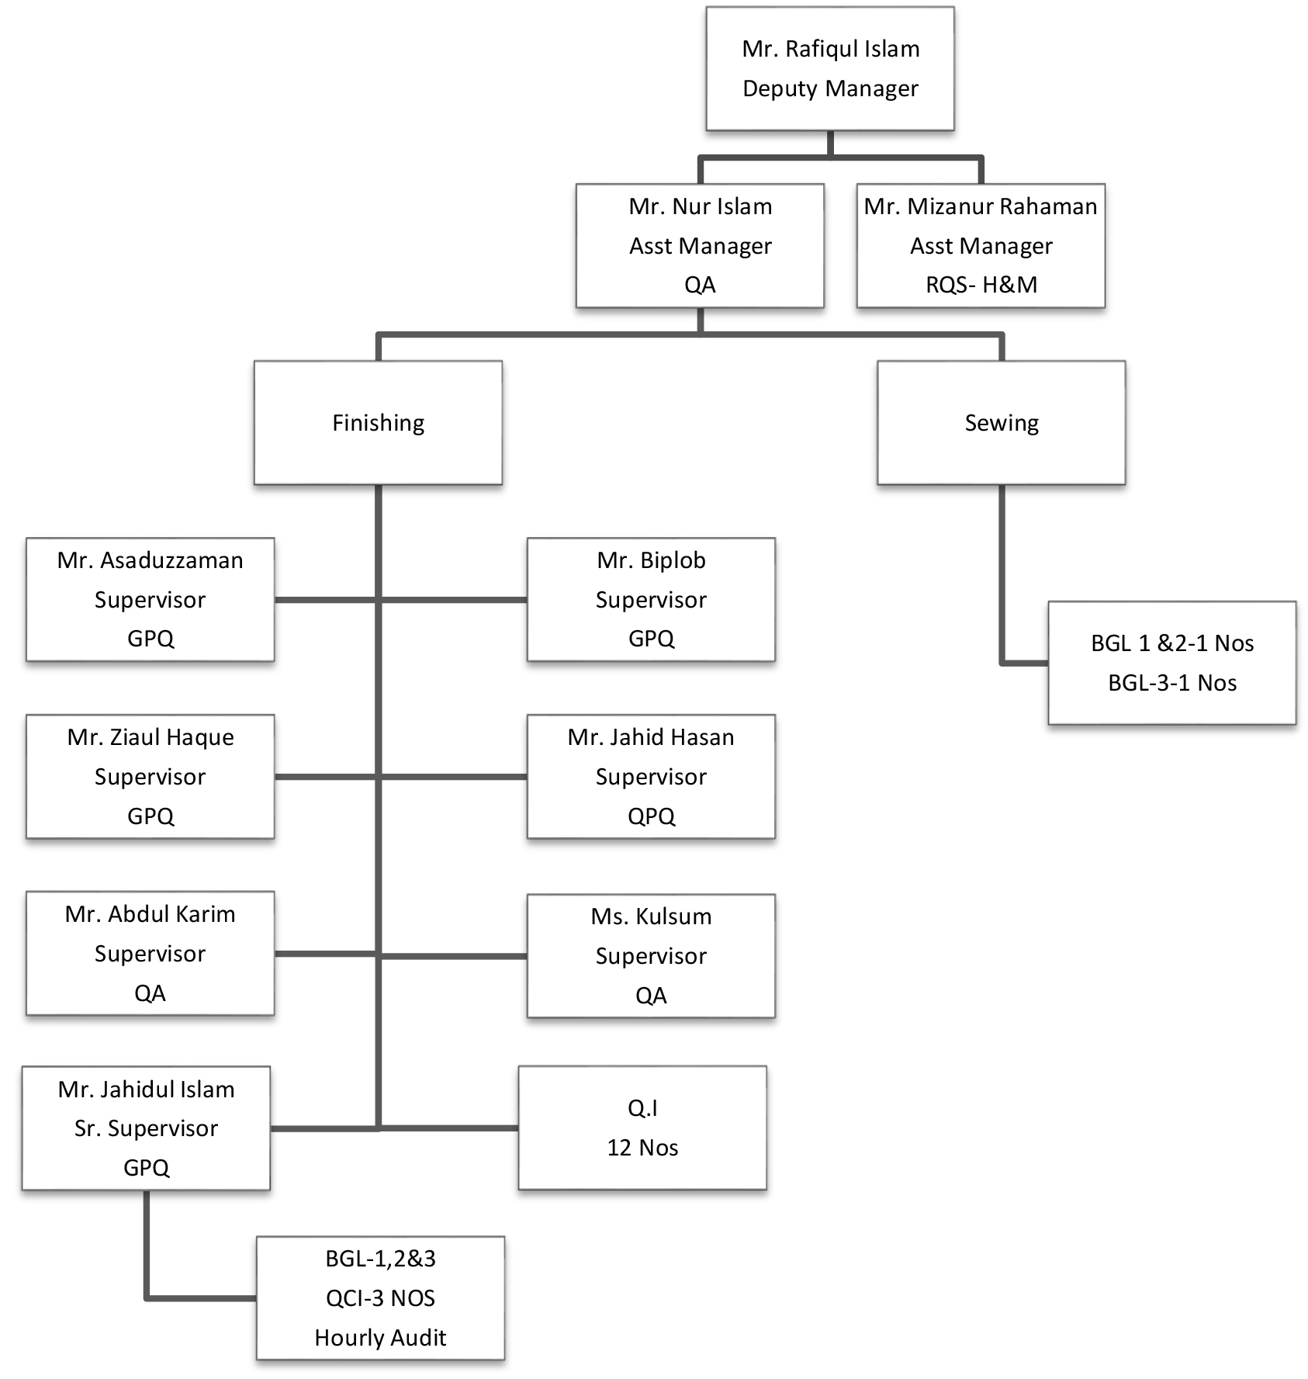
Major Job Responsibilities
Finishing Q.A
Line wise critical process check
Reduce kill garments
DHU & Audit check

Babylon Garments Organ gram:

GM

DGM

FACTORY MANAGER

ADMINISTRATION MANAGER

PRODUCTION MANAGER

CUTTING MANAGER

QUALITY MANAGER

SHIFT IN-CHARGE

FLOOR IN-CHARGE

SUPERVISOR

CHAPTER 3
HR Related Activities of BABYLON Group

3.1 JOBRESPONSIBILITIES
Duringmy internshipthoughIwantedtogatherknowledgeabouteachandevery activity ofthecompanybutatthesametimetheyassignedmesomeduties sothatIcanhave somepracticalknowledge,whichIfoundvery interestingandchallenging.Someofthe job responsibilities are described below:
WorkerAssessment:Asworkerturnoverisoneofthemainproblems ofeverycompany that’swhy companyneedstohigherworkerdaily.Thosewhoarechosenforassessment aregiventokentocomeinthe HR department.Thentheir information aboutprevious experience,educationqualification,addressetcisbeing writtenintheassessmentbook and sends forthephysical interview.
Posting Information: Those who passed in the physical interview their detail informationneedtopostinthe officialEMS(employee managementsoftware)software whereall theinformationoftheworkeris stored.
Againthisinformationneedstowriteinthe ServiceBookwhichispreparedtomaintain workers personal file.
Workersandemployeesleaveformalsoneedtopostinthecompany softwaresothatin case ofemergencythis can bechecked.
Preparingabsenteeismlist:Thisisalistfromwherethenumericalinformationabout the workerlike percentage and numberof maleand femaleworker, absent worker, department wisenumberofworker etc abouteachandeveryparticular dayis stored.

3.2 EMPLOYEERECRUITMENT POLICY

Motto:
- Equal opportunityofemployment.
- No discrimination in gender, sexreligion&color.
- Right man for right job.
- Fairjudgment forall employees.
- Respect forindividuals.

Recruitment Policies:
- FirstofallwedeterminetheManPowerrequirementasperprocess&machines.
- Afterpreparingmanpowerrequirementtheygoforadvertisementindaily newspaper, and throughLeaflet, Posters,Banners, Personal Contact.
Recruitment Process:
- Do not recruit anyemployeewho is less than 18years old.
- Do not employee anyforcelabor&prison labor.
- Procure applications from thesuitable candidates.
- Segregatetheapplication’s as perCriteria.
- Finalizethesuitabilityofthe candidate
InterviewProcess:
- Candidatehavetofaceanoralinterviewtotheresponsibledepartment head
- Sitforwrittentestwherecandidatehavetofacequestionaboutrelevant background.
- Thosewhopassinthewrittentestareaskedforemploymentinterview wherecandidatenegotiate aboutcompensation/salary.
- After final selection we issue appointment letter to select candidates mentioningall terms &condition ofhis/her employment.

PreliminaryInterviews

WrittenTests

Employment
Interviews
Appointment
Letter

3.3 WORKER RECRUITMENTPOLICY
Motto:
- Assuringsecurity.
- In-time delivery.
- First timequalityassurance.
- Fulfillingthepromises.
- Utilizingthe assets properly.
- Transparentactivities.
- Honesty, disciplineandregularityassurance.
Recruitment Policies:
Factory maintainsapolicyregardingrecruiting theworkers.Factory mainly followsthe regulationsthatUGCprovidedbutsometimesbuyer setsfewregulationandcompany followsthoseand thoserulesarenotagainsttoanylocalregulations UGCand govt. law. Theworkers recruitment policyprovided in below:
- Everyworkeris recruitedthrough followingrecruitment policy.
- Nation, religion,colororgenderarenot concern duringrecruitment.
- Recruitmentcommitteerecruits theworkers.
- Forrecruitingtheworkersadvertisementisgiventothenewspaper,posters, banners oranyothermeans.
- Applicantsmustprovidepassportsizephoto with C.V. and othernecessary documents.
- Under18years is not allowed as aworker.
- Birthcertificatemust beprovided beforejoiningto the company.

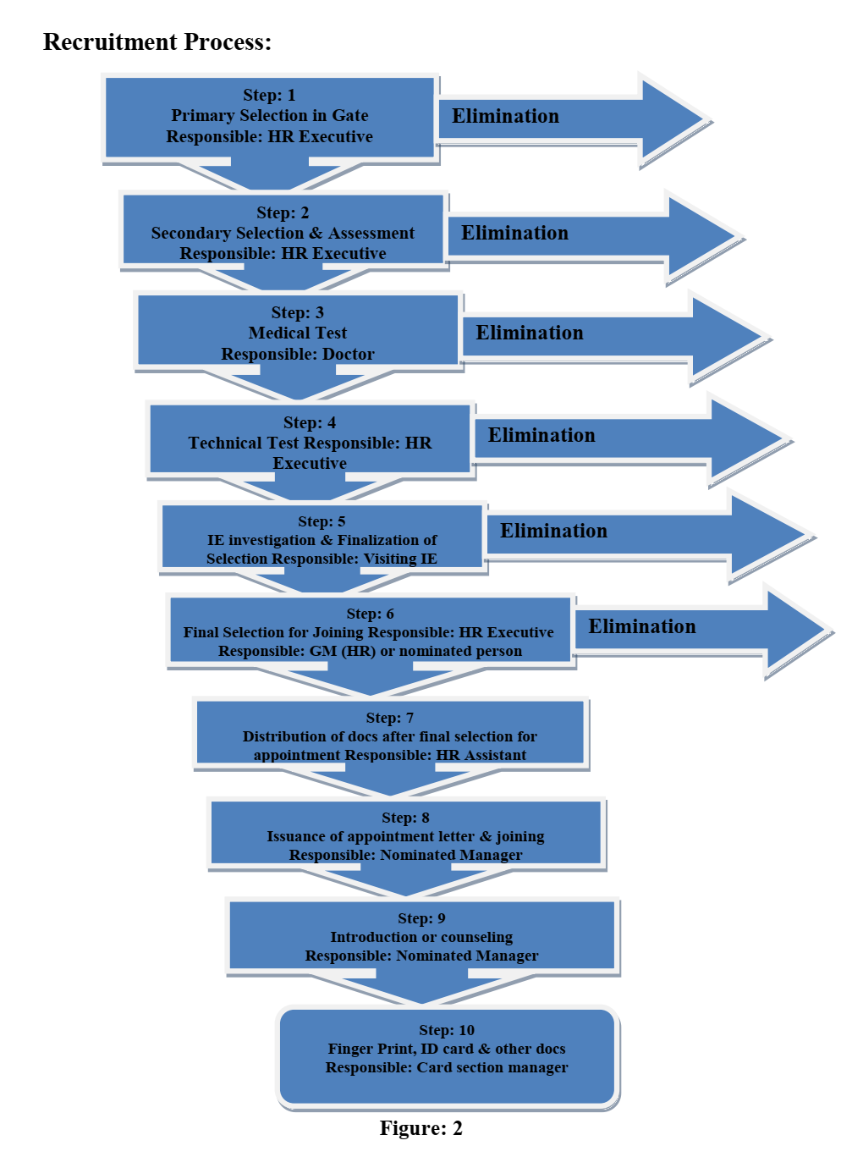
Functions at Step: 1 (PrimaryselectionIn Gate)
- General Selection.
- Physical Appearancechecking forage andfitness.
- Selectedcandidates shallbe given token and sendforthestep 2.
Functions at Step: 2 (SecondarySelection and Assessment)
- General Selection
- Assessment form fills up
- Helpers will besent to step 3
- Operatorswill send to step 4
Functions at Step: 3 (Medical Test forHelper, Operators and non management staff)
- Age detection
- Other healthcheck
- Aftertest operators will send to step 5 and helperto step 4
Functionsat step4(Technical test)
- Machine or process test
- Salaryfixing
- Operatorswillbacktostep3formedicaltestandhelperwillbeforwardedto step5
Functions at step 5 (IE investigation andfinalization ofselection)
- Checkingduel job in samegroup orfactory
- Checkingfake name andidentity
- Forwarded to step 6

Functions at step 6 (FinalSelection forJoining)
- Overseethe recruitmentprocess
- Oversee physical fitness
- Overseeageand send tostep 7
Functions at step 7 (Distribution ofdocuments after final selection for appointment)
- Receivingfinallysuitable candidates
- Providingdocuments relatingto appointment
- Forwarded to next step
Functions at step 8 (issuanceofAppointment letter and joining)
- Issuingappointment letter
- Joining
- Placement
- Sent to next step
Functions at step 9 (Introduction orCounselling)
- Counsellingand introduction
- Distribution ofhand book
- Takingasignatureadvisingforonlinephotograph
- Forwardedtolast step ofselection
Functions at last step 10 (Finger print or photo ID card and collections of other documents)
- Takingonlinefingerprint and photo.
- Giving IDcardandotherdocuments
Eventually itistruethatnowaday incompetitivebusinessworldmarketisvery much inevitableforasuccessfulOrganization.Ourgarmentssectorshavetofacecompetitions innationalandInternationalMarket.So,theyarevery muchneededofsufficientskilled andknowledgelaborandmarketing tocopewithmicro,macroenvironmentinnational andinternationalaspecteffectively.LotsofcompetitionexistsinInternationalMarketin garmentsIndustry.So, foreffectiveskill and knowledgelabourhas to preparefrom now on.
This companyis successfully implementing the HR policy. They followa fairRecruitmentandselection process.

3.4 Training & Development:
On the job training of BABYLON Group: On-the-job techniques include orientations, job instruction training, apprenticeships, Assistant to position, committee assignment job rotation and coaching. In the perspective, Babylon has adopted diversified training programs home and abroad including ICT (Information and Communication Technology) to produce quality service providers. Babylon also conducts the committee assignment. They apply the cross functional training.
Training period of Babylon Group: In the annual training program of Babylon Group for 2017 the training period duration maximum 15days minimum 7days to trained up their employee on the job training basis. They trained up their employee lower level to senior manager.

How to conduct the training: To enhance knowledge and develop technical skill. To improve efficiency and effectiveness of officers of managerial capabilities. To disseminate knowledge to the trainees about modern Administration. Providing necessary knowledge, tools & techniques to implement a Project efficiently. To provide knowledge about Service Rule, Accounts management, labor law policy, health & safety etc.

Number of employees of Babylon Group: Training of about 12500 skilled employees. We hope that this training program will help the trainees to learn how to do quality works efficiently.

Coaching:
Coaching is a one-to-one training process. Babylon Group must conduct the coaching for one to one training. Babylon helps in quickly identifying the weak areas and tries to focus on them. They also offer the benefit of transferring theory learning to practice. The biggest problem is that it perpetrates the existing practices and styles.

Committee assignment:
Babylon Group must be conduct project based training program. They trained up their employee to cross functional training system. Interdependent way they have to work together.

Mentoring:
Babylon Group focuses on their training is on the development of attitude. They used for managerial employees. Mentoring is always done by a senior inside person, so Babylon must be applying the mentoring training. It is also one-to- one interaction, like coaching.

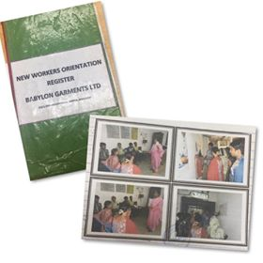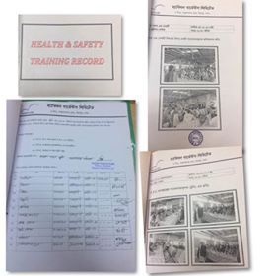

Various Training Programme

3.5 COMPLIANCE MANAGEMENT
Complianceisapackageofeventsrelatedtoconformity &assurance ofHumanRights, LegalRights,Health&Hygiene,Safety andWelfare&Freedomofassociationofan employeewithin the organization or the business.
People are working in the association. They are having numerous requests throughout their life. They ought to have their rights and benefits in their working spot inside the specific era, Occasion and in the different interims of their work.
Consistence affirms every one of these issues to get great creation for the undertaking, keeping up great and solid bury individual relations inside administration and representatives and superb workplace.
Consistence is such an occasions extravagantly recommended in our nation work Law. Like as – Factories Act-1965, where all conceivable wellbeing issues, Health, Welfare are recommended.
Work of Labor (S.O.) act 1965, where recommended all managerial working like - Disciplinary activity, Stoppage of work, Termination, Discharge, Lay off and so on.
Maternity Benefit Act - 1939
Installment of wages - 1936
Laborers' remuneration Act - 1923
IRO-69, where arrangements of opportunity of affiliation has characterized and recommended the legitimate arrangements.
A consistence division has performed to adjusting the occupations of Human Resource offices and human privileges of national and International angles. A consistence office work for to limit debate amongst laborers and proprietors
Therearethreetypes ofcompliance
- Social Compliance
- CTPAT Compliance
- Information Technology(IT) Compliance

Socialcompliance:
Socialcomplianceismoreimportantamongthe three.Socialcompliancemeansthe practice oflocallaborlawaccording tobuyerrequirement.Insocialcompliancefour stickers aremoreimportant. These are:
• No child labor
• Weekly&otherholidays
• Maternityleaves&benefits
• On timepayment ofwages

CTPAT Compliance:
CTPATmeansCustomTradePartnershipAgainstTerrorism.CTPATis ajointinitiative betweencustomandborderprotectionand business.Evolutions in businessoffers consultingservicestohelpcustomersenhancetheircargosecurity proceduresfortheir personnel,facilitiesandsupplychainpartnersinordertobecomecertified.Moreand more companiesaremakingcargo securitytheirtop prioritybyapplyingCTPAT.

IT Compliance Management:
Companiesaregivingmoreemphasisinmonitoringandreportingcontinuously on complianceenterprise wide.ITCMsolutionhelpsorganizationsaligntheirITcompliance effortswithregulatory requirements,theirownexisting compliance frameworkand industryIT ComplianceManagement (ITCM)solution offers standards.

IT Compliance ManagementsolutionhelpscompaniesassessITrisksand theirpotentialimpactsandmanagethemappropriatelyITCMsolution helpscompaniesto verify ITrisksand their potentialimpactsareassessed andmanaged appropriately.WhileinternalITauditsofsystemscanidentify controlsandprocesses, Babylon GroupLtd’spassionateandexperiencedprofessionalshelporganizationsextend their compliance activitiestocorporategovernance andimprovedriskmanagement, helpingclientsresolve identifieddeficienciesintheirIToperationsandmeetapplicable requirements.

Inshort,Babylon GroupLtd’sITCMsolutionincreasesintegrity andconfidentiality in financialandotherkeysystems.Itprovidesanearreal-timedashboardviewofcritical systemsandalertskey stakeholderswhenvariouscompliancethresholdsarebreached.It alsosupportsITdepartmentsinmonitoringtheirownability tomeetinternalcontrols. ITCM collaborativeandflexiblesolutioncombinesthesetechnologieswithmatureprocesses forsecurity, performance,and change andconfigurationmanagement.
3.6 WAGE&BENEFIT

Wages&salarybreakdownis

60%Basic and

40% allowances.
Any work after 8 hour will be treated as overtime. Mentionable herethat maximumtotal working hours adayare10 hourand perweek 60 hours.
Aworkerwillgetdoublepaymentthebasicforworkingovertimemorethan8 hours.
Overtime calculation: Basic ÷ 208 × 2 ×actual O.T. hours. 208 means total workinghours in amonth = (26 ×8=208).
No employeeis allowed to work morethan 10 hours aday&60 hours aweek.
Ineveryseven days ofweek onedayis off as weeklyholiday.

Incentives:
- Companypayattendancebonus100tk.forfullattendanceinthemonth&deduct
- Payingfoodallowancetk10.
- Provident subsidized
- Transportation facility.
Facilities:
- Twofestivalbonusespaidtoevery employeeinayear.Equivalenttotwobasicof wages/salaryduringtwoEid festive.
- Providedfree Medicalfacilities.Tofaceany emergencycompany providesfree ambulance services,treatmentprovidedat nocostincertaincircumstances from Babylon Medical centre.
- Leaveencashment:aftercompletionofyearifany employee whodoesnotenjoy portionof earnedleave or leave notgrantedasper rules,the amountof thatleave paid in cash.
Leaves&Holidays:
Thereare5types of leaves areprovidedtothe employeeinayear.
- Festival holiday-12 dayswith full pay.
- Casual leave-10 days with full pay.
- Earnedleave-14 days with full pay.
- Sickleave-14 dayswith full pay.
- Maternityleave-112 days (8weeks+8weeks)with payfortwicein wholelife.

3.7 GRIEVANCEHANDLING
Legalrightsof the employee &workers:
- Minimum wages/salary.
- Maximum 10 hourwork aday&60 hours in aweek.
- No femaleworker/employeeis allowed to workafter10 pm.
- Law full Overtimeallowances.
- No employment ofchild labor.
- Lunch&rest time as perlaw duringworkingtime.
ProvidePPE(PersonalProtectiveEquipment)andothersafetyrequirementstoconcern employees andworkers.

3.8 SWOT Analysis:
Strengths:
- •Very experienced administration authorities
- •Usage of present day gear
- •Sufficient creation limit
- •No outsourcing for printing, weaving and washing plant
Weakness:
- Delayed delivery of sample
- Lack of mechanized and present day gear
- They are not getting ready example plans
Opportunities:
- Now some remote nations are extremely intrigued about Babylon Garments
- Competitors are not that much solid like Babylon pieces of clothing
- As this a consistence production line and quality administration framework so there is colossal potential for business development.
Threats:
- .Emerging business sector of china and India
- Increased rivalry with nearby pieces of clothing
- Lack of power can make issue for the business

Chapter 4:
Internship Experience

4.1My Contribution to the Organization:
As an HR intern, I was working with the HR team. The team had only 12 people. So, as the team was small, the bonding was great. I was mainly taken as an intern for the Recruitment Division. But I had also worked with the Salary and payroll division, Training and Development division, Industrial Relation, Compliance.

Since the beginning, I was engaged into updating Exit interview analysis for the first part of the year Assigned by Mrs. Sumi, Welfare Officer of HR Division. Then I started to work with the recruitment team, CV Sorting, Interview Phone Call, Co-ordinate interview session. I also engaged into updating the training calendar with necessary information like number of trainings, number of participants, total man hour spent and total cost. I also had to do the filing of the all necessary documents chronologically. The responsibility of database management and file management of these training related documents were entirely upon me. With Mr. Atiqul Islam APU and Mr. Sajahan’s guidance, I successfully did that. I have done two project that given me Mr. Mainul Hosen. One is worker children’s scholarship and another One is Medical facility. I also was given the task of updating the training data in the HRIS with all attention and care so that the data on the database and HRIS would match. I also was given the task to the entry for Tax and Vat Deduction forms for the trainings.

I also got a chance to do another thing in the HRIS and that was employee profile update. The profiles were only in paper and needed to be updated on the system. I also helped Mr. Masum with some employee engagement activities.

I helped Mrs. Eti by typing letters of promotion for employees and learnt the entire process of spreading it. I also helped her with some filings. The most important task that I did with her was to finish the medical benefits documentation and the insurance documentation. It is a long and tiring task to do. I had problems at some points as not all the information was available. But I finished it with the help of her.

I had also worked with Mr. Arif in the payroll division by filing the performance appraisal forms and taking over some of her tasks like writing NOC of visa, wedding gift and new born baby gift memos for the employees etc. One of my biggest achievements at Babylon was to be able to co-ordinate an entire day-long training program.

4.2 Skills I have gained:
Internship, for most of the students is the first corporate exposure. So, the first thing that an intern learns is to get accustomed with the corporate culture. This teaches how to be in formal attire for 1/3 part of the day and manage works under extreme pressure. It was my first working experience at office, I was bound to know some new things and hone some skills.
The first and most important thing that I became skilful at while working at Babylon was getting accustomed with MS Excel and be fast in working on that. It is one of the most essential skills needed in the current workplace in Bangladesh. Previously, I did not have enough exposure to Excel as I did not have to do much works on that. I learnt the other functions of sorting the data in different ways to make different combinations.

My PowerPoint skills also got improved. In the academic environment, we used more colors in slides and prepared lengthy slides. Here, the management wants to see only the summary of any analysis. I had to plot a 7 slide data into one slide and also look at the colour combination.
I got exposure to the HRIS for two different purposes. I used it for employee profile updating and giving inputs for training data to keep the system updated.

I learnt how to write the memos and letters of concern for different employees and divisions. I worked with Mr. Mainul and Mrs. Eti to get to know some of their employee engagement activities.

I also worked with Mrs. Sumi and Mr. Mainul in the recruitment division where I learnt how they shortlist the candidates, call some of the candidates, take appointments from the management to make the panel of interviewers and to give support in the interview process.
I learnt how the new employees go through a process while joining and the things that they needed to submit and file them properly.

On a lighter note, I became very skilled in photocopying and scanning documents which even some of the employees could not do. I knew how to scan document separately and in one file.

4.3 Interaction with Supervisors & Co-workers:
As I have stated previously, the working environment of Babylon is absolutely fantastic. People are very workaholic and at the same time very funny to be around. I had to call everyone Apu/Bhaia regardless of their ages. There was no Sir/Madam allowed at office. This tells how friendly the office environment is. People in my department were the same. They were very helpful. I have worked very closely with Mr.Mainul and Mrs. Sumi & Mrs. Eti in the recruitment division. They would constantly ask me about my work and gave me instructions where needed. Also, they taught me a lot of things that would save time and make the work more presentable.

The other people of the department were very helpful and polite s well. As it was a small team, the bonding is very strong. Whoever assigned me any task; they would first brief me clearly about it and keep track of my work. They needed the work to be done perfectly and gave me time to do it. They also had no problem if I did it in my way. They were also very appreciative and would recognize my work.

Our Head of HR was the coolest person at office. He was the main reason that the team was so fresh and it was very nice to be around with him. He would be a friend and a leader and not a boss. He would also come to me sometimes and ask about my progress. He would also ask me for any suggestion and would try to initiate it if it made sense.

In a few words, people at the company were very serious when it came to work but was like a friend and colleague when it was about having fun or a conversation. I would hope to stay in touch with them.

4.4 Difference between my Expectations & Internship Experience:
Honestly speaking, I did not have very high expectations about my internship, that too in one of the leading RMG sector in the country. I have heard from some of them about their bad experiences during the internship. Most of them had to do the tasks which even the office assistant can do like filing, stapling etc. I have also heard that companies do not take the interns seriously and do not consider that as a potential resource.

I also thought that the culture in the office would be very rigid as it operates in the garments industry. I thought it would be like ‘all work and no play’ and the supervisors and other employees will not take me seriously.

I never expected my co-workers, supervisors and seniors to be so much kind and co-operative while assigning tasks. Neither did I expect them to give me do some important tasks that they would do. These people also helped me to develop my skills even more. Speaking of my fellow intern and others, the experience would be really dull had they not been there.

For a start, it was not bad at all and was far beyond my expectations. I had some wonderful co-workers, supervisors a beautiful office and a wonderful experience unlike some of my friends.

4.5 Influences on My Future Career Plan:
As I am a HR graduate, it felt really good to get an opportunity to do my internship in my area of concentration. During the first few weeks, I was mostly integrated in the recruitment division. Then, I started working with other divisions too.

Within the first few weeks, I quickly realized that being stuck in only one function of the work will not do any good for me and also, it would seem really dull; and it was. I always wanted to explore and after those weeks I was working with other divisions as well. Besides, my supervisor always believed that doing cross-functional works is really helpful to perfect the skills and makes a more effective employee. So, I felt encouraged when I was asked to do other works for my department.
As said before, I have always wanted to explore different opportunities. This organization created a feeling of likeness for this industry. But have always wanted to get exposure to different industries to enhance my skills and on-the-job knowledge. So, even though I have started to like this industry, I may not be working here any time soon. Especially, I have always wanted to work in the production related industries where there is a chance to work with many people, control may people and play with the labor laws. So, I am following my heart.I also look forward to know what the future has planned for me.

4.6 People at Babylon:
I worked in the HR department in the recruitment division of the company. So, my work was to work with people. My supervisor was one of the Deputy managers of the department. Almost all of them are former students of different public and private Universities. So, there was diversity there.. The people in my department were very friendly and co-operative. They made sure that I was feeling comfortable from the very first day. I never got any sort of unfair treatment from them. Even though the department is really small, the people in the department make it livelier than the other ones. Managing over 2200 employees of the company with a team of only 12 members is a very tough task. But this team has been doing it wonderfully.

4.7 Working Environment:
Extraordinary compared to other highlights of Babylon Group Ltd is its workplace. The workplace of HR branch of Babylon Group Ltd is basically brilliant. Every one of the representatives of the division are extremely proficient with regards to carry out their occupations. Then again when anybody required help, they were dependably there to assist each other. From the primary day, at whatever point I had any inconvenience in understanding anything, which I should concede that it happened a great deal on my underlying days of temporary position, every one of the division had helped me inside and out they could. I worked specifically under the supervision of Mr. Atiqul Islam Apu, Deputy Manager of HR, preparing and advancement division. The majority of the things I may have learnt in my temporary position involvement, the credit for that goes straightforwardly to this individual. Additionally, there were a great deal of commitments from individuals at different divisions as I have worked intimately with them also. They have helped me hugely in my temporary position days.

Over that, every one of the workers of Babylon are well disposed in nature. At first I was minimal stressed that how I would function with such a significant number of individuals who are more seasoned than me and on account of that reason I was somewhat hardened in my beginning days of entry level position. Be that as it may, inside the main week my associates facilitated me up. Furthermore, inside no time I felt some portion of the colossal Babylon family. We frequently used to eat together and furthermore hanged out after the available time. The treatment I got from them was particularly valued.

The general population inside the division used to make the office vivacious. Beginning from the supervisor to the help official, everybody used to make jokes and offer occurrences which used to make the place significantly more alive than alternate divisions. The physical condition too was magnificent. Every division had various work spaces with PC for their representatives. With adequate lighting and completely aerated and cooled division makes the workplace significantly more lovely. Subsequent to judging every one of the elements I needed to concede, the workplace is amazing at Babylon Group Limited.

4.8 The Human Capital & HR at a glance:
As I worked in the HR department of the company, my main concern was with the human capital of the company. The company puts huge emphasis on the career development, productivity, compensation management and health and safety of the employees to ensure a close to perfect work-life balance for all. The company has over 2200 employees now in their branches all over the country.

4.9 Recruitment Process:
In my time at Babylon, I worked with the recruitment division mostly and have seen continuous efforts from Mr. Mainul Hosen, Mrs Hazera Khatun Sumi and Mrs. Maksuda Khanam Eti to come up with the best possible recruitment architecture for talent development. CV Sorting, Interview Phone Calls, Exit interview response analysis, Co-ordinate interview session.

CHAPTER 5:
Findings & Analysis

Sample Questionnaire
Survey

Name (optional):

Phone Number (optional):

Gender: Male Female

Education: SSC or below HSC Bachelor Masters or above

Profession: House wife Service Holder Business Others

Avg. Monthly Family Income: 30k or below 30k-60k 60k-90k 90k – 120k above 120k

Please indicate your level of satisfaction with the following statements. Where 1 = Not Very Satisfied, 2 = Not Satisfied, 3 = Neutral, 4 = Satisfied, and 5 = Very Satisfied.

SN | Statements | 1 | 2 | 3 | 4 | 5
01 | Organization’s HR team are fully aware of the business needs and strategies
02 | The organization’s human resource requirements are systematically ascertained and an appropriate plan is formulated for satisfying the requirements
03 | The organization has a wide network of computerized human resource information system with the latest software
04 | The organization has been managing change by integrating the HR issues with the business strategies and the strategic change process
05 | Your organization has up-to-date job descriptions to enable you to establish job requirements.
06 | Are the roles and expectations for hiring clear between the hiring manager and human resources
07 | Your organization utilize a pre-screening process such as telephone interviews or a pre-screen questionnaire
08 | Your performance is an assessment for training needs at least on an annual basis.
09 | Have you reviewed your benefits strategy to determine if it fits your organizational strategy
10 | The organization has a control in place for updating employee information in the HRIS or other tracking mechanism such as a spreadsheet or database (e.g. human resources, hiring manager, etc.)
11 | The organizations verify educational statements/credentials on final candidates.
12 | The organization follows a formal procedure of potential appraisal
13 | The organization carries out succession planning in order to ensure that executives are available to fill gaps in key managerial positions
14 | Employees have access to profit sharing/gain sharing/employee share ownership plan.
15 | Is your human resources function adequately staffed to meet business needs (e.g. are problems resolved in a timely fashion.

Table with table source

Criteria | Score
Strongly agree | 50%
Agree | 30%
Neither agree nor disagree | 10%
Disagree | 10%
Strongly Disagree | 5%

Graph and Chart:

Interpretations and Findings
On the basis of the survey, it should be in relation to HR best practices. Strongly agree around 50% of HR employees, not too bad! Babylon is in fairly good shape from an HR best practices perspective. To rectify current issues, focus on the areas that have the lowest coring characteristics. Some of employees strongly disagree the score around 5% employees Babylon may have some problems in relation to human resources practices. Some of these problems may be quite serious. To rectify the issues, the company will need to focus on improving the lowest-scoring characteristics, particularly in areas that require legislative compliance. Babylon does not have many HR best practices currently in place and the company will need to refocus their energies on building the basic human resource programs. If many of these characteristics are left at its current state, there may be a breach of current legislation from a provincial and potentially federal perspective.
5.1 Findings:
Positive Sides:
- Babylon regards social contrasts, work – including enlisting, compensation, benefits, progression, end and retirement in light of capacity and not on conviction or some other individual attributes.
- Usage of current gear.
- Sufficient generation limit.
- No outsourcing for printing, weaving and washing plant.
- Now some remote nations are extremely intrigued about Babylon pieces of clothing.
- Babylon offices guarantee ladies laborers get equivalent treatment in all parts of their business. Completely prepared CRECHES are accessible for the female laborers having babies
- Babylon regards social contrasts, business – including enlisting, compensation, benefits, progression, end and retirement in view of capacity and not on conviction or some other individual qualities.
- Some laborers don't work in the floor wearing ID card.
- Factory encompassing is perfect.
- Very experienced administration authorities.
- Competitors are not that much solid like Babylon pieces of clothing.
- As this a consistence processing plant and quality administration framework so there is enormous potential for business development.

Negative Sides:
- Delayed conveyance of test.
- Lack of mechanized and current gear.
- They are not getting ready example plans.
- Emerging business sector of china and India.
- Increased rivalry with nearby pieces of clothing.
- Lack of power can make issue for the business.
- The laborers don't get any sort of acknowledgment or additional motivating force against their exceptional execution in the creation procedure.

- To keep the industrial facility plants, equipment's, machine devices in an ideal working condition.
- To guarantee determined exactness to client time plan isn't given.
- Fire quencher was not composed in Bangla to comprehend for laborers.
- To keep the generation cycle inside the stipulated run.
- Maintenance cost was not appropriately settled.
- They abstain from sinking of extra capital and specialists had not the age check authentication and kept in their own record.
- Canteen offices were not there in each floor.

5.2 Recommendation:
Babylon group now have a decent brand name in the business. So we don't have much to suggest. A few suggestions are-
Positive:
- Babylon offices guarantee ladies laborers get equivalent treatment in all perspectives.So; Child care room should be equipped with all the required facilities.
- Babylon respects cultural differences, Worker training and motivation programs should be arranged and update to remind them these things.
- Worker should not work in the floor without ID card.
- Factory surrounding should be more clean and hygienic.

- The social values and lifestyle of the exporting countries seem to be encouraging for this company.
- They ought to be watchful about convenient conveyance of the example.
- They can import some essential current and mechanized gear.
- They can require a few architects to make test outlines without anyone else's input.
- Training offices ought to be presented exceptionally for the new representatives.
- The directors dependably endeavor to expand their benefit at any cost without thinking about the advantages of the representative.

Negative:
- The buyers' preferences are mainly to low price, quality of the fibber content, laundry instructions, country of origin, brand name, and environmental friendliness.
- Technological change is mainly in the communication side of the industry. But in the production side change is not playing the vital role.
- Machine tools should me more improved.All electric panel board must ensure the danger sign should be posted.
- The production time should be maintained. Workers should get a proper time otherwise they’ll fall sick.
- Fire Fighting Equipment
- Fire Extinguisher must have the following:
- Inspection card should be in place.
- Picture of FFT should be posted.
- Refill date should be update.
- The maintenance cost should be a fixed amount because it’s very important for keep safe machineries.
- All workers should have the age verification certificate and kept in their personal file.
- Canteen facilities should be providing.
- Due to various hazard factors the business people basically outsource their requests as opposed to expanding limit.
- The pioneers of the laborers some of the time misinform the specialists for their own particular advantage. The pioneers need honesty, skill, consistency amongst word and activities, and faithfulness, i.e. all the merited characteristics of administration.

CONCLUSION:
All in all, it was a great learning experience for me and an absolute privilege to work at Babylon Group Ltd. This experience made me aware of my strengths and weaknesses and what I need to do to make myself ready for the job market. Most importantly, it gave me my first lesson on how to carry myself in a corporateenvironment. It gave me my first corporate experience and gave me hands-on lessons on what goes on in the real working environment. I hope to use these knowledge and experiences as I further growprofessionally. As of late, Human Resources issues have turned out to be vital to business thoughts in this consistently changing business condition. The present best association perceives all that really matters effect of the rising HR rehearses. Powerful Human Resources Departments are overhauling themselves from time to time to pull in, create and hold gifts. It is clear that viable HR hones convey investor return considerably higher than those of organizations without such practices. It is imperative for HR experts to familiarize with HR best practices to manufacture authoritative abilities in conveying manageable outcomes. Babylon Garments officially settled a brand name in Garments industry. Presently they have bunches of remote clients and interest for their Garments is expanding step by step. Babylon bunch is giving washing, printing, weaving offices and once in a while adornments for Babylon articles of clothing which make creation considerably simpler. So on the off chance that it can keep up its quality and standard it can have an immense business potential. The administrative, management, chain of command all are the well organized. They are well equipped with all of the modern machineries and the working environment is excellent. The relation between top management to bottom level is so nice & devoted to satisfy the customer demand by their activities. The factory runs by a number of efficient textile engineers, skilled technical & Non-technical persons. They are very sincere, co-operative and helpful.

CHAPTER 6:
APPENDIX

6.1 Sample Questionnaire:
Name (optional):

Phone Number (optional):

Gender: Male Female

Education: SSC or below HSC Bachelor Masters or above

1. How recruitment need is determined?

2. What isyour recruitment process?Is itsameforall level of employees?

3. Howdo use technologies indifferentHRpracticeslikerecruiting,training etc

4. Howyourcompanydetermines the duties and responsibilities ofajob?

5. Howdoesyour companydeterminethe skill required bythe job/position?

7. How your company recruits employees? Do you prefer internal or external recruitment?
What types of questions are asked in interview (job related, behavioural or situational)?
8. How theinterviews administered/ evaluated?(panel, mass)

9. Howyou inform theselected candidate (Telephone. E-mail, SMS)?

10. Is thereanyscopeof salarynegotiation?

11. Doyouconduct anymedical examination ofthe employees beforeselectingthem?

12. Doyouconduct anyexitinterview?

13. Doesyour companyhaveanyorientation program fornewemployees?

14. Doyouprefer organizational orientation or departmental orientation or both?

15. What type ofcurriculumyourorganization has for orientation program?

16. Whattype ofemployees iscapableof training?

17. Do youhave anyin housetrainingdepartment?

18. Whereyourcompanyorganizes trainingprogramsforemployees?Isitininsideor outsidethe organization?(on the job oroffthe jobtraining)

19. Fortrainingwhat approach doyoufollow themost?

a. Job Rotation b. Coaching. Seminar doters

20. Does yourcompanygiveany benefit toexistingemployeesforattendingtraining programs?Ifyes, pleasemention thetypes of benefits?

21. Whattype of personal skill development is thereforthe employees?

22. Doyouevaluatethetrainingprogram?Ifyes, pleasespecify.

23. Is thereanyretrainingopportunity?

24. Who appraises employeeperformancein theorganization?

25. In motivatingemployeesdoyou prefer financial ornon financial incentives?

26. What arethe necessarystepsyour companytakento improve employeeperformance?

27. What stepsyour companytakewhen theyget poor employeeperformance?

28. Doesyourcompanyhaveany extra-ordinaryemployeeperformanceexample?Ifyes, please sharethe thing.

29. What kind of benefits you provide forgeneralemployees? (Transportation, unemployment insurance, vacation, retirement benefits etc.)

30. Howyourcompanymatchesthebenefit/incentiveplanstoemployees‟needsand demands?

31.Whatmedicalbenefitsyouprovidetotheemployees(Maternityleave, sick leave, medical insurance, etc.)

32. Howyour companycompensatesyouremployees?
a. ThroughBank, b. Cash, c. Others

6.2 REFERENCES:
Armstrong, Michael. A Handbook of Human Resource Management Practice. Kogan Page Limited, 1999.
Burstiner, Irving. The Small Business Handbook. Prentice Hall, 1988.
Green, Paul C. Building Robust Competencies: Linking Human Resource Systems to Organizational Strategies. Jossey-Bass, 1999.
Gubman, Edward L. "The Gauntlet is Down." Journal of Business Strategy. November-December 1996.
Phillip, Harris. Managing the Knowledge Culture. Human Resource Development Press, March 2005.
Johnston, John. "Time to Rebuild Human Resources." Business Quarterly. Winter 1996.
Human Resource Management Practices in Bangladesh:http//www.hrmpb.com Retrieveddate June 20, 2007.Human Resource Management Practices in the 21st
Century: http//www.hrmp21.com/Retrieved date May10, 2007
Dessler, G. &Varkkey, B. (2011), Human Resource Management, 12th edition, Pearson, New Delhi. 4.
www.babylongroup.com
www.onlineclothingstudy.com
https://www.linkedin.com/company/babylon-group

