Internship Report
On
HR Practice and HRIS

Of





United International University
Internship Report
On
HR Practice and HRIS of ‘Renata Limited’

Course Code: INT4399

Submitted To
Md. Kazimul Hoque
Assistant Professor
School of Business & Economics

Submitted By
Md. Motaher Hossain
ID – 111 142 057

Submission Date: 21-9-19

Letter of Transmittal

21-09-19
Mr. Md. Kazimul Hoque
Assistant Professor
School of Business and Economics (SoBE)
United International University
United City, Madani Avenue, Badda, Dhaka - 1212
Subject: Submission of the internship report on “RENATA LIMITED.”

Dear Sir,
With due respect, this to inform you that I am Md. Motaher Hossain, ID – 111 142 057. I am very grateful to get the opportunity to submit my internship report on the topic “HR Practices and HRIS of Renata Limited”. This internship report is required to complete my BBA. I have followed the valuable instruction and guidelines of yours and organizational supervisor of mine as well during my internship period.
This report demonstrated my experiences that I have acquired during internship period at Renata Limited. It will be very helpful to enlighten my knowledge and corporate career as well.
I am hoping this report will be comprehensive and informative as well.
I am expressing special gratitude to you for giving your valuable time, guidance and support. I have tried my best to complete the report appropriately as possible. In this regard, I would like to thank you for giving me the opportunity to write and present my report on this topic and guiding me in every step while writing this informative report

Sincerely Yours,
Md. Mothaer Hossain
ID – 111 142 057
School of Business and Economics
United International University
Declaration of Authorship
I, Md. Motaher Hossain, ID – 111 142 057, a student at United International University, hereby declare that apart from the specific references that are made to the work of others, the contents of this internship report are original and have not been submitted in whole or in part for consideration for any other degree or qualification this, or any other University. The internship report is my own work and that includes nothing which is the outcome of work done in collaboration, except where specifically indicated in the text.

___________________
Student’s Signature
Md. Motaher Hossain
ID – 111 142 057
School of Business and Economics (SoBE)
United International University
Acknowledgment

First of all, I would like to thank Almighty Allah. Then I would like to thank my parents, faculties, classmates, colleagues. I would like to thank my supervisor Md. Kazimul Hoque, Assistant Professor, School of Business and Economics, United International University, for his valuable time, guidance, instructions, suggestions, and supports for preparing this report.
I would like to express my gratefulness to Ms. Nisbat Anwar (Head of HR), My internship supervisor Mr. Fuad Hasan Lotus (Additional Manager), Mr. Anupom Chowdhury (Senior Assistant Manager), Mr. Shahariar Islam (Assistant Manager), Mr. Omar Faruk Bhuiyan (HR Officer) and Ms. Rasia Islam (HR Officer) for their constant guidance and support. It would have been difficult to complete my report without their guidance and support.

Executive Summary

The last stage of completing my graduation of four years is the internship I have done this trimester. Renata Limited has given me the opportunity for an internship in HR. In this internship period, I have perfectly carried out and accomplished several assignments and projects- i.e. managing HRIS; preparing reports on employee engagement; and various reports and documents of Renata Limited. Renata Limited has helped me gain several maneuvers related to the Human Resource department of Renata Limited which includes aid ex-employees to receive their original certificates and related documents, informing present applicants about their interviews and appointment letters, assisting with the HR associated executions and data entries of the information of the employees and so on.
This report consists of my gained analytical and technical skills which helped me enhance my theoretical learning and development. It also includes my reasoning for distinguishing among academic and empirical knowledge. Evaluation of the organization and my experience is mentioned in the report as well.
Being the first time in the corporate world, I have come across several challenges which I tried my best to overwhelm and gain knowledge from the experiences regarding my expectations from the internship. This internship has encouraged me to work in HR in the future and I have also learned the tactics to imply to my internship if I was given another chance. It has helped me learn my strengths and shortcomings through various experiences. I was taught to overcome my shortcomings and utilize my potentials in Renata Limited propitiously.

Table of Contents
Chapter - 1 1
1.0 Introduction 2
1.1 Objectives of the Report 2
1.2 Scope of the Study 3
1.3 Methodology 3
1.4 Limitations 4
Chapter - 2 5
2.0 Literature Review 6
Chapter - 3 9
3.0 Overview of the Company 10
3.1 Company Profile 10
3.2 Corporate Vision of Renata Limited 11
3.3 Corporate Mission of Renata Limited 11
3.4 Values of Renata Limited 11
3.5 Subsidiaries of Renata Limited 12
Renata Agro Industries Limited 12
Purnava Limited 12
Renata Oncology Limited 12
3.6 Product Portfolio 13
Pharmaceuticals Products 13
Animal Health Products 13
Nutrition Products 14
3.7 Corporate Social Responsibility (CSR) 14
Chapter - 4 16
4.0 Responsibilities and Contribution towards Organization 17
Chapter - 5 18
5.0 HR practices in Renata Limited 19
5.1 HR Philosophy, Code of Conduct, The Laws, HR Functions, Organizational Hierarchy structure, Hierarchy Structure of HR Department in Renata Limited 19
5.2 Employee recruitment and selection 23
5.2.1 Strategy 26
5.2.2 Recruitment sources 26
5.2.3 Selection 30
5.2.4 Process of the Selection 31
5.2.5 Compensation and benefits 33
5.2.6 Training and Development 37
5.2.7 Performance Appraisal at Renata Limited 43
Chapter - 6 48
6.0 Human Resource Information System (HRIS) of Renata Limited 49
6.1 Impact of HRIS on HR activities of Renata Limited 66
Chapter - 7 68
Analysis: 69
Findings 70
Recommendation 71
Conclusion 72

Chapter - 1

Introduction

1.0 Introduction

Renata Limited (former Pfizer laboratories) is one of the leading pharmaceutical companies in our country. This company is producing and manufacturing human pharmaceutical products along with herbal products and animal health products.
I had a chance to do an internship under the Human Resource Division in Renata Limited. To get an internship opportunity at Renata Limited was wonderful. I have learned many things regarding my sector. I am really lucky that the three months during my internship period were so great with supportive people and the environment which gave positive energy to gather knowledge. The excellent knowledge and wonderful memories have shaped me as an optimistic and confident person which will boost me to follow my goals to become an HR driver of a company by overcoming any barrier.

Objectives of the Report

General Objective
The general objective of this report was to analyze the HR practice and Human Resource Management System (HRIS) in Renata Limited and to complete my total credits for graduation
Specific Objectives
- To determine how recruitment and selection processes can be done.
- To know how much benefits employee of Renata limited are getting
- To know the process of appraisal
- To examine the training and development process in Renata Limited
- To get a brief idea on HRIS, how it helps to Human Resources Division’s operation
- To identify some pitfalls on existing functions and on the system and provide some recommendation to increase the efficiency

Scope of the Study

At present, one of the leading business sectors is the pharmaceutical industry. In terms of business profit, growth, and efficiency, it has seen colossal growth in the last two decades in our country. This report gave an in-depth idea about the HR practices and how the company is maintaining its HRIS during my internship period. This internship report is the total experience with the HR Division and the organization as well. It was a privilege of working with the HR team and learning about their activities.

Methodology

I have used primary and secondary data to complete my report.
Primary Data
I have collected primary data from –
- Direct interview
- Observation
- Practical experience
Secondary Data
I have collected secondary data from the following sources. Those are -
Internal Sources
- Annual reports of Renata Limited
- Publish documents of Renta Limited
- Business Reviews of Renata Limited
- Website of Renata Limited
External Sources
- Manual and policy publications of Renata Limited
- Browsers and websites
- Journals
- Research papers
- Newspapers

Limitations

Confidentiality
As there was much information regarding the organization and product were secret and confidential. So there an information gap which let in the report at some places.
Time Constraints
It was a major drawback which is time constraint while I doing my report. I needed more time to observe the HR practice and HRIS. I had to be busy with my assigned tasks. So I think I did not get enough time for in-depth observation, data, and knowledge before working on this report.
Lacking knowledge of Corporate Sector
I had no in-depth knowledge regarding the corporate sector which is my limitation. It took some time to get adjusted to the working schedule.

Chapter - 2

Literature Review

2.0 Literature Review

HRM is the part of the organization that is concerned with the people dimension. HRM deals with human relations of an organization starting from recruitment to Labor relations. HRM is concerned with the people dimension of management. It is a process of acquisition, development, motivation, and maintenance of the human resources of an organization. (M. J. Jucious) Said, The field of HRM involves planning, organization, directing and controlling functions of procuring, developing, maintaining and utilizing a labor force. (Milkovich & Boudreau) Said, Human Resource Management is a series of decision that affects the relationship between employee and employer: it affects many constituencies and is intended to influences the effectiveness of employee and employer.
(Schuler, 1984) said about the six key practices of HRM. They are Training and Development; Compensation; Human Resources Planning, Staffing, including recruitment, selections, and socialization; Union – management relationships. According to (whatishumanresource.com), Training and Development is a structured program with different methods designed by professionals in a particular job. It has become the most common and continuous task in any organization for updating the skills and knowledge of employees in accordance with the changing environment. Optimization of cost with available resources has become a pressing need for every organization which will be possible only by way of improving efficiency and productivity of employees, possible only by way of providing proper employee training and development conditioned to that it should be provided by professionals.
(Armstrong , 2005) postulated that compensation management is an integral part of HRM approach to managing people and as such it supports the achievement of business objectives and it is strategic in the sense that it addresses longer-term issues relating to how people should be valued for what they want to achieve; It is therefore integrated with other HRM functions, especially those concerned with human resources development.
(Alan Price , 2007), in his work Human Resource Management in a Business Context, formally defines recruitment and selection as the process of retrieving and attracting able applications for the purpose of employment. He states that the process of recruitment is not a simple selection process, while it needs management decision making and broad planning in order to appoint the most appropriate manpower.
(Herman Aguinis, 2013) Said, Performance Management is a continuous process of identifying, measuring, and developing the performance of individuals and teams and aligning performance with strategic goals of the organization. The term Performance Appraisal refers to the methods and processes used by organizations to access the level of performance of their employees. This process includes measuring employees’ performance and providing them with feedback regarding the level and quality of their performance.
According to (Hedrickson, 2003), HRIS can be briefly defined as integrated systems used to gather, store and analyze information regarding an organization’s human resources. According to (Tannenbaum , 1990), HRIS, One which is used to acquire, store, manipulate, analyze, retrieve and distribute information about an organization’s human resources. (Kovach, 2002) said that, HRIS HRIS's of as business tools that help to standardize the gathering of information about the employees of the company. According to (Parry, 2010), HRIS can serve as a vital strategic tool as it shares crucial data with the management related to recruitment and retention strategies which can be aligned with the overall corporate strategy for realizing the organizational objectives of growth. Additionally, by using HR applications, a company can calculate the overall costs incurred per employee and its effects on the business as a whole. According to (Barkha Gupta, 2013), HRIS help a firm maximize the use of human resource and maintain competitiveness in its market the large organizations, human resource information systems (HRISs) provide the technology backbone supporting the complete body of human resource (HR) functions. In this role, HRISs play a critical part in the operation of each component of HR. Additionally, by integrating across business processes HRISs provide organizations with control, forecasting, and planning tools that supersede simple computerization of HR functions. For these reasons, effective use of HRISs in organizations contributes to overall organizational effectiveness. Human Resource Information System is a set of people, forms, procedures and data utilized to store, analyze, distribute and use the information of human resources. HRIS's goal is to provide accurate information for the use of persons making human resource-related decisions. The organization can use HRIS for human resource planning. New recruitments can be posted via HRIS as well as applications can be scanned and stored. HRIS also stores information about the employees’ participated in training and learning sessions. Performance appraisal, compensation, benefits, competences, and development plans are easily maintained in HRIS. Employees can search for a new career within the organization and be aware of future training. HRIS allows managers to follow employee’s ́job performance and planned versus used hours for a certain assignment. HRIS offers various reports available. Typical HR program involve things such as record-keeping, recruiting, selection, training, employee retention and compensation.

Chapter - 3

Overview of the Company

3.0 Overview of the Company

3.1 Company Profile

Bangladesh’s one of the top and rapidly developing pharmaceutical and veterinary commodity firms is Renata Limited which was previously known as Pfizer Limited. It has started its operation in Bangladesh as Pfizer Limited in 1972. Pfizer handed over possession of its activities in Bangladesh to regional investors in 1993 and it has been renamed as Renata Limited at that time.
The Chairperson and founding member of Renata Limited are Syed Humayun Kabir who died at the age of 83 on 7 July 2015. He was closely connected with major multinationals and known as one of the most renowned company specialists in the nation. The first vice-chairman of Pfizer Limited was Syed Humayun Kabir and after that, he became the chairperson of Renata Limited for 21 years till his passing.
Human pharmaceutical and veterinary services are the major objectives of Renata Limited. It is known as the fourth biggest pharmaceutical company in the nation and became the industry leader for their veterinary services. Moreover, Renata goods are also being marketed to Afghanistan, Cambodia, Ethiopia, Honduras, Guyana, Belize, Kenya, Malaysia, Hong Kong, Myanmar, Nepal, Philippines, Sri Lanka, Thailand, UK, and Vietnam and it is supposed to expand the business in many more countries of the world. In addition, it has been registered with a share value of roughly TK 87 billion on the Dhaka Stock Exchange Limited.
Besides, Renata does have eight factories located across three production locations. There are also two production plants at Renata Oncology Limited. It has delivered and distributed its products through 19 refineries throughout the nation. In addition, Renata has 4334 employees in total.
Source: Website of Renata Limited

Corporate Vision of Renata Limited

The corporate vision of Renata Limited is to continuously create Renata as one of the finest revolutionary generic branded Businesses.
Source: Annual Report of Renata Limited 2017-18

Corporate Mission of Renata Limited

The corporate mission of Renata Limited is to offer its clients and society the highest benefits in which they are residing and operating.
Source: Annual Report of Renata Limited 2017-18

Values of Renata Limited

- Emphasis on Customer: The primary reason for all their operation is customer satisfaction, loyalty, and retention.
- Credibility: Renata is in comply with the strongest moral principles.
- Economic involvement: They have been offering significant initiatives to enhance society’s safety and security. Also, they promote wellbeing awareness via innovation and collaboration among partners.
- Leadership Building: Without leadership, Renata may not fully develop throughout all areas of its operations. The creation of leaders thus is the main concern.
- Sustainable Development: Renata also concentrates solely on sustainable development and focuses on systematic advancement for the expansion of the company.
- The Corporate Family: Renata appreciates that individuals are the backbone of the achievement. It is the combination of a large family in which each employee receives equal and dignified treatment.

Source: Annual Report of Renata Limited 2017-18

Subsidiaries of Renata Limited

Renata Agro Industries Limited, Purnava Limited and Renata Oncology Limited are the three subsidiaries of Renata Limited.

Renata Agro Industries Limited
Renata Agro Industries Limited has become a private limited company that is established in Bangladesh on September 07, 1997 under the corporation’s act 1994. The company’s shares are controlled by the company’s directors. The main objectives of the company are the manufacturing and distribution of multiple agro-based goods and the reproduction and incubating of poultry products and the distribution of them. The company has commercially started operating in October 1998.

Purnava Limited
Another subsidiary of Renata Limited is Purnava Limited which is a private limited company established in Bangladesh 0 17th August 2004 under the companies act 1994. The main objectives of the company are to perform on the sales and distribution of all types of commodities, home appliances, grocery items, dairy products, vegetable oils, beverages. They have been engaged with various exports, imports, commission agents. In addition, non-medical healthcare services are also provided by Purnava Limited. To present the brands effectively, Purnava took a significant attempt to develop perceptions and impact of consumer preferences.

Renata Oncology Limited
It is a private limited company established on 12th August 2012 under the companies act of 1994. The company’s main operations are the production, advertising and sales of different goods centered on oncology. Currently, the market size of this product is low and thus wide operational costs may not be completely absorbed by small quantities. This subsidiary, even so, retains a key element of the company’s growth policy. There are several substitutes in the pathway, so Renata Oncology Limited’s potential will remain stable.

Product Portfolio

Renata Limited offers three categories of products. Those are pharmaceutical products for the welfare of the human being, animal health products, and nutrition products.

Pharmaceuticals Products
In this criterion, they offer different types of medicine based on the nature of diseases, the formulation, strength and pack size of the medicine. In the criteria of Antimicrobials, they have more than 100 medicines depending on the trade name, generic name, formulation, strength and pack size of the medicines. For Anti-Hypertensive, they offer more than 25 medicines based on various requirements. Moreover, they have four drugs for Lipid-Lowering Agent and provide eight drugs to control Diabetic. In addition, they have two formulae for hair regrowth solutions. Thus, based on the nature of diseases and the preparation, strength and package size of medicine, Renata Limited offers more than 500 medicines. The other different criteria are Eye, Ear and Topical Preparation, ANTIGOUT, NSAIDS, ANTIULCER Agents, Anti-Parasitic and Anti- Protozoal Agents, Anti-Fungal Agents, Anti-Tuberculosis Agents, Anti- Spasmodic Agents, Steroid, Anti- Acne Agent, Anti-Osteoporotic, Vitamins and Minerals, Anti-Oxidant, Anti-Allergic, CNS products, Hormone, Anti-Cancer, OXYTOCIC, Anti-Asthma, Anti-Fibrinolytic, Expectorant, Gastroprokinetic Agents, Oral Rehydration Saline, Narcotic Analgesic, Antipyretic, Amino Acid Supplement, Antiemetic, Anesthetic, Antiviral and others.
Source: Annual report of Renata Limited 2017-18.

Animal Health Products
Renata also provides different veterinary health products. Like human beings, animals are also suffered from various diseases. To prevent this, pharmaceuticals companies offer various medicine based on the nature of diseases. Renata offer near around 100 medicines which are made in a different formulation, packaging policy, and the power of the medicine. They offer Antibiotic, Cephalosporin, Sulphonamides, Anthelmintic, Antiprotozoal, Anti-Histaminic, NSAID, Glucocorticoid, Appetizer and Rumenotoric, Metabolic, Hormone products, Vitamin-Mineral Injections, Poultry products, Anthelmintic, Anti-Cocci dial, Electrolyte and so on.
Source: Annual report of Renata Limited 2017-18.

Nutrition Products
Renata also concerns about nutrition and they provide various nutrition products such as Rena WS, Rena C, Rena K, Rena Sel-E, etc. They also offer nutritional premix such as Rena Breeder, Rena Broiler, Rena Layer, Rena Fish, Rena Grower and so on which are also depend on the processing, power, and packaging of the medicine.
Renata Limited has different kinds of vaccines such as live vaccines and killed vaccines and also offer aqua products. Thus, it can be said that, as a renowned company, Renata has a wide range of product lines for the welfare of humanity as we as animals.
Source: Annual report of Renata Limited 2017-18.

Corporate Social Responsibility (CSR)

Corporate Social Responsibility (CSR) at Renata implies providing care for their staff and workers, helping the nation’s poor individuals and creating a safe climate for the future generation. Following are some initiatives that are taken by Renata:
- Medical care for employees and families: All permanent staff members, their family members, and kids are covered by the Renata health insurance program. Surgery, hospitalization, and regular visits to doctors all are involved in this extensive program.
- Support for nonprofit organizations: Renata provides support to a different charitable organization such as BRAC, PFF, HOPES, CCPR and etc. by funding them the smart amount. The total expenditure on these criteria is 3550000 Taka.
- Financial aid to children and former staffs: Renata Limited also offered former staff and their kids with economic help. In 2016-17, they have a total cost of taka 2,051,849 in these criteria.
- Surgery of life-threatening diseases for doctors: Doctors who are suffered from cancer or other life-threatening diseases, previously Renata had donated funds for them for the recovery. They have a total cost of 3,330,000 TK in this sector.
Therefore, it can be stated that Renata contributes a lot for the welfare of their staff and society as well and their total spending is TK 63,828,157 which is 2.43% of their total net income.

Chapter - 4

Responsibilities and Contribution towards Organization

Responsibilities and Contribution towards Organization

During my internship period in Renata Limited, my core responsibility was with File Mangement. I checked regular, contractual, casual files of employees. During the checking period, I noted missing information and after that, I called those employees to submit necessary documents to the head office HR. Within some days I got necessary documents from them after the phone call. Then I updated that information in Empress software (HRIS). The documents were NID, Educational Certificates, Beneficiary form, Employee Information form, etc. During my internship period, I assisted in the half-yearly increment process of casual and contractual employees. I checked appointment letters for new joiners. I assisted in the in-house recruitment process. I cross-checked the candidate’s CV and communicated with them during interview sessions. I also assisted in the biometric process for depots. I communicated with separated employees through text messages for the settlement process. I updated information in Empress Software (HRIS) regarding the settlement process. During my internship period, I got the opportunity to assist the HR team in various job fairs organized by universities and organizations. Apart from that, I did many tasks which are assigned by my supervisor

Chapter - 5

HR Practices in Renata Limited

HR practices in Renata Limited

5.1 HR Philosophy, Code of Conduct, The Laws, HR Functions, Organizational Hierarchy structure, Hierarchy Structure of HR Department in Renata Limited

HR philosophy of Renata Limited
- Providing the best HR service to employees inside the organization.
- Having a philosophy of HR which is very proactive.
- Recruiting quality employees.
- Motivating, encouraging and recognizing for a successful event.
- Providing equal opportunities.
- Maintaining discrimination free environment.
Code of Conduct
- Obedience to the company
- Support, respect and obey the Human Rights which are declared by internationally
- Dedication and good business practice
- Support the fair labor standard
- Ensure the safety of the health of the worker
- Keeping secret the business information which is confidential
The laws followed by Renata Limited
- Bangladesh Labor Law code 2006
- Law of EHS
- Law of IRO
- Other laws
HR Functions
- Recruitment and Selection
- Compensation and Benefits
- Training and Development
- Performance Appraisal

Employee Hierarchy of Renata Limited

In-House Grade

Director

General Manager
Senior Manager

Manager

Additional Manager
Deputy Manager

Assistant Manager

Senior Officer
Officer

Field Force Grade

Sales Manager

Assistant Sales Manager
Regional Sales Manager

District Sales Manager

Professional Services Manager
Professional Services Officer

Sales Representative

Hierarchical Structure of Human Resource Department

Ms. Nisbat Anwar
(Head of HR)

Mr. Moin Uddin Ahmed
(Deputy Manager)
Mr. Md. Mahmudul Haque
(Additional Manager)
Mr. Fuad Hasan Lotus
(Additional Manager)
Mr. Jansher Al Sabah Khan
(Senior Assistant Manager)

Mr. Syed Saheeb Ahmed
(Assistant Manager)

Mr. Anupom Chowdhury
(Senior Assistant Manager)

Mr. Samrat Hossain
(Front Desk Officer)
Mr. Md. Shumsuddin Bappy
(HR Officer)

Mr. Md. Shahariar Islam (Assistant Manager)
Ms. Sirazum Monira
(Front Desk Officer)
Mr. Md. Omar Faruk Bhuiyan
(HR Officer)

Ms. Raisa Islam
(HR Officer)

Mr. Mr. Md. Shaheen Alam
(Assistant HR Analyst)

Md. Motaher Hossain
(Intern)

Employee recruitment and selection

Recruitment

The parameter of managing people in an institution is indeed known as Human Resource Management or in simple term HRM or HR. The department is accountable for promoting the institution’s general objectives thru efficient human capital management by concentrating on personnel as being the most significant resource of the institution.
The very first stage towards designing the human capital of an organization is Recruitment. The objectives are to identify and employ the best applicants on schedule and on budget. In other words, it is the method of trying to identify and facilitate the prospective candidates to register for current and expected work opportunities.
Major Factors
The preceding points must be contemplated until continuing for any discussion with recruitment.
- What is the job’s goal and objectives? Where it fits in through the remaining of the unit?
- What kind of individual is needed to do the work efficiently?
- Will the work tasks or duties be completely re-allocated or revised or discarded?
Who is supposed to recruit?

Recruitment responsibilities are differing from institution to institution. The most feasible approach in an institution will be for the managers to boost demand for recruiting and hiring their own personnel. Thus, within an organization, the general manager is accountable for all executive staff recruitment. In addition, the secretary of the institution or director or CFO is responsible for recruiting planning and administrative personnel. Besides, the plant manager is charged for the recruitment of plant labors. However, based on the organization, the hiring manager could be anybody at a certain time.

The typical process of strategic recruitment of Renata Limited

To succeed, recruiting strategies are vital. A recruiting strategy is a comprehensive initiative comprising efforts by an institution to effectively find, select and employ skillful applicants to meet their vacancies. It provides the applicants with the skills and postures needed to achieve a company’s goal. However, it is the major phase in establishing a strong production base. It is a continuous approach that starts from sourcing resources to organizing and directing interviews and lastly choosing the best applicants.
Here are a few proposals for recruiting method to be optimized:
- Coordinate with the hiring manager
In the beginning, one should cooperate with the hiring manager to define personnel demands, specify vacant positions and outline criteria for each category. What are the fundamental abilities needed for being qualified for the job? They must directly contribute to the position’s specified duties and obligations.

- Writing Job Posting
The best way is being transparent about what qualities you are searching for, and describe what the task actually involves, mentioning both overall objectives and daily duties. One
may talk about how the work affects the ongoing excellence of your institution and enables you to achieve its goals and objectives. One can talk about the brand or culture of the employer of the company so that it can draw the attention of job seekers who feel positive about the company’s culture or brand value. Make the title more insightful then obscure. Subsequently, lengthy posting can switch off most skilled applicants, thus try to be descriptive.

- Source and reach out to applicants
Searching is the recruitment process where resources are obtained in accordance with the work requirement. This is a two-step method-
- Activation of source When the supervisor checks the vacancy and allows it to continue, the search for applicants begins. The sources are widely split into two classifications: internal and external.
- Selling The company chooses social media via which vacancies communications reach potential applicants.

- Screening Applicants
First of all, analyze the curriculum vitae and eliminate the applicants who do not fulfill the fundamental requirements. One may conduct in-person or mobile screener interviews, conduct a job evaluation exam or choose other assessment techniques for those who qualify. To begin the interview, set the list of best applicants.

- Start the interview
The second step of accessing applicants is to perform telephone or video interviews. The hiring manager will contact the applicants after reviewing the applications via mobile or video. This method has two effective results:
- It allows confirming whether applicants are engaged and accessible?
- It enables to provide fast idea into the approach of the applicant, the capacity to respond to the questions from the test and interpersonal skills.

- Evaluate the best selection
It is time to drive the decision for each applicant after fulfilling all the requirements. Variables such as expertise, ambition, social adding, and skilled engagement (professionalism, fitness, and esteem) can be evaluated. In addition, one may sit to share the result with the recruiting manager and try to identify the list of key selections.

- Talk about the details
It is likely worth understanding both sides what the demands must be if an applicant has reached this point. Thus, one can openly speak about wages demands, compensation packages, etc.
Obtaining the top candidates for a position might be an institution’s strategic advantage. Thus, the incomplete scheme of recruitment and selection may lead to huge disturbance, decrease efficiency, creates organizational problems and operational disruptions, dissatisfy customers and increase expenses.

Strategy

If an organization has an effective recruitment strategy, the achievement of that organization will be essential. However, if the recruitment and selection feature is not pursued in a deliberate and pragmatic way, it might become an expensive and complicated method. Therefore, the recruitment and selection strategy involves some criteria:
- To ensure that the institution has the abilities, expertise excellence which is needed to satisfy the long and short term organizational and functional needs.
- Verifying the supply and demand specifications
- Boosts the prospective candidate’s database.
- Optimize the selection method by identifying those candidates who reach the specifications of the role.
- May affect the probability of accepting a work proposition by an appropriate applicant.

Recruitment sources

There are several hiring methods that are more efficient to meet certain kinds of employment than others. The applicants may be accessible within the organization or outside it. There are two wide recruitments methods- both internal and external.

Internal sources

Workers who are already on a company’s payroll is the internal source of recruitment method. The former staff of the company who have already moved from the job is also involved here. Recruitment from inner source is performed by promoting, re-hiring and shifting staff inside the business to fill the vacant position. These tactics are used by organizations such as UPS, McDonald's.
Benefits of Internal Recruitment:
- It is an easier method to select and transfer current staff.
- Supervisors are conscious of current employees’ skills and experiences.
- It acts as an instrument to increase employee morale since internal recruitment generates work possibilities for current staff as well as promotion possibilities.
- Internal recruitment fosters a sense of employee allegiance.
- As existing staff already know the operating techniques of the institutions they would not take a long time to adapt to the new roles.
Nevertheless, the internal recruitment process may have disadvantages. It may lead the company workforce to failure. At the same time, there might be no new employee introduction or fresh thoughts. Sometimes staff who are not suited to a greater position receive promotions simply because they are working in the company for a lengthy period, not because of their abilities and talents.
Features of Internal Recruitment:

- It is a simple and fastest method.
- Easier than the external method of recruitment.
- Operates as an employee motivational instrument.
- The selection of the organization is restricted to current business staff.
- It is a waste of potential to hire new staff.
Employee Recommendations and referrals
Employee referral is the referral-based recruiting method where a candidate is nominated by the current employee of the organization. Identifying the best match for the job is indeed an obsolete method although the system may look like a fresh idea. The proposal from the existing worker is one of the best methods for people who will most probably work efficiently in the job. Whereas staff usually advise anybody unless they think they can work properly. Genuine data regarding the current work to the candidate is provided by the recommender.
All has its own strengths and weaknesses and a referral system for an employee is not unique in this case. In some institutions, an employee referral program is no so common. Moreover, in some cases, recruitment depends entirely on referrals from the staff. It provides workers a chance to join the business with their mates and renowned talents, aiding both their individuals and the company. The method is also beneficial for the company as it can prevent the additional burden of applicants for the publicity and evaluation process. As a result, it enables them to reduce the strain of the entire method of recruitment.
Importance of Employee Referrals
- The performance of the applicant would be superior.
- A larger variety of applicants.
- Pace of recruiting
- Enhances ideology and optimizes expenses
- An appropriate applicant for the best fit
- The stronger pace of sustainability and so on.

External Sources

External recruitment methods imply recruiting individuals from outside the institution. In certain terms, pursuing candidates from outside the institution. There are many external recruitment techniques available. The company has to evaluate the vacancies cautiously by using the techniques that perfectly meets the necessity. The method involves advertising, internet board promotions, recruitment agencies, and unsolicited candidates.

- Media Advertisement
The advertisement is perhaps the most frequent and favored external recruitment method. The advertisement in newspapers, professional publications, provides extensive details about the organization, type, and importance of the managerial position, necessary abilities, anticipated qualifications, and experience, etc. It enables a person to assess themselves towards the work demands and compete for the employment that fits him properly.

Recruitment agencies
To assist businesses and individuals, there are three distinct kinds of recruitment agencies. For example, national and govt. agencies, local employment agencies, and strategic consulting companies. All of them deliver precious support that matches jobs.

- Jobs fairs
Despite not being as common as they once were, job fairs proceed to assist hire executives to obtain access to big amount of applicants, particularly graduate candidates. The most wonderful thing about them is that they enable you to reach the applicant and speak to them in individual instead of viewing their curriculum vitae. Moreover, it could be a fantastic way to have a powerful impression of someone who provided the significance of mannerisms. In fact, it is a very excellent chance to create a brand of a company.
Virtual job fairs are a unique addition to the idea. They have the same objective as regular job conferences but instead, are conducted digitally.

- Online Recruitment
Since hiring managers start converting into the digital space, online recruitment has rapidly been the favored form of skill searching. For this reason, many intuitions are now paying more attention to their policies for online recruitment, confirming an efficient way to obtain fresh staff through social media. Nevertheless, online networking sites like LinkedIn have already developed a focused, readily available pool of applicants, enabling hiring managers to screen prospective recruits depending on their profile data. Companies give vacancy ads on their own websites. Because of the blessing of technology, applicants now get to know about job vacancy easily via Facebook, Twitter, Pinterest, and other professional sites. Besides, it has some drawbacks also.
- Job Boards
The most common and efficient technique of external recruitment method is job boards because they enable recruiters to catch a broader audience. It may also assist accelerate the recruiting method since job boards simplify things to genuinely apply for the vacancy. One important thing you should keep in mind to attract fresh talent that many companies tend to perform talent surveys on job boards. However, most of the job boards have resume records as well that help the organization to screen on the basis of the organization’s selected standards via the applicant’s database.

Features of External Sources:
- It is a lengthy and time-consuming method.
- It is a costly method.
- As vacancies are offered to external individuals, current employees may lose their morality.
- Recruiting fresh staff may contribute to the beginning of fresher, therefore a fresh set of talents and concepts being introduced.

Selection

The method of interviewing and assessing applicants for a particular profession and choosing an employee depending on certain standards such as competences, expertise, and knowledge is known as employee selection in HRM. Based on the recruiting company and the role of the job, employee selection can vary from quite an easy method to a very complex method. The aim is to grab the most appropriate applicant that best meets the work criteria in a company, to figure out whether the potential employee will succeed if recruited. A company is in a weaker situation to compete without skilled staff. Thus, it is the process of choosing a suitable set of expertise, aptitudes, skills which are embedded in an individual and it is the effort to have a blend between what the candidates can and intends to do and what are the requirements of the organization.

Process of the Selection

The process of selecting and vetting the appropriate applicant with the required talents and expertise to complete the open positions in an institution can be described as the selection process. This method differs from sector to sector, business to business as well as among the company’s department. Based on the requirements of each organization, they all have their own selection process. The core phases, however, stay the same. Let’s comprehend briefly how the process of selection works.
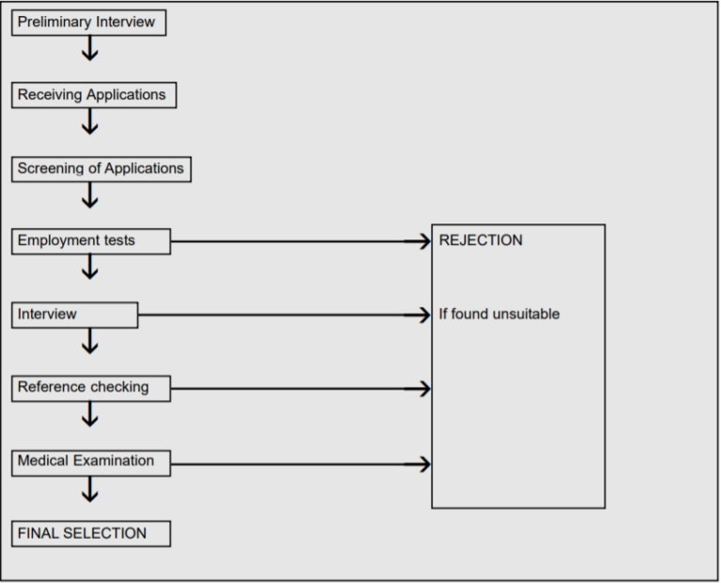
Figure 1: The Selection Process
Source: https://www.toppr.com/guides/business-management-and-entrepreneurship/human-resource-management/selection-process/
- Preliminary Interview:
It is a very common and fundamental interview to eradicate applicants who are totally unsuitable for the organizational job. This provides the company with a cluster of personnel possibly fit to complete their positions.
- Receiving Applications
Prospective personnel submits requests to the organization to register for the required position. The proposal provides data about applicants such as their bio-data, professional experience, extra curriculum activities, passions and interests to the panel members.
- Screening Applications
After obtaining the applications, they are tasted by a unique screening panel that selects applicants to consider them for an interview. Candidates can be chosen on specific requirements such as skills, professional experience, etc.
- Employment tests
Companies have to evaluate the applicant’s expertise and abilities before they choose an appropriate person for the position. It could be accomplished by multiple job tests such as basic intelligence testing, mental ability testing, skill testing, temperament testing, etc.
- Employment interview:
The following stage in the selection method is the interview with the applicants. This is conducted to define the skill and capacity of an applicant to operate in-depth in a company. The objective of a job interview is to determine the applicant’s competency and to show him a concept of the job structure as well as what the prospective applicant is supposed to do. For selecting the correct individuals for the correct position, an employment interview is crucial.
- References Check
Another very significant method of data is the individual who provides a prospective employee’s reference. Information about the capacities of the applicants, prior company experience, supervisory and management capabilities can be given by the referee. Data that are provided by the referee are intended to keep secret by the HR Department.

- Medical Examination
Another significant stage in the selection process is medical checkup and examination. It assists employers to understand whether prospective applicants are physically and mentally qualified to do their job responsibilities. An excellent medical checkup scheme guarantees greater health conditions of employees and decreases delinquency rate, collisions and turnover rate of employees.

- Final Assessment and Letter of Confirmation
This is the ultimate stage in the process of selection. After all written exams, interviews, and the medical test has been effectively conducted by the applicant, an approval letter has been sent or emailed to the applicant to confirm the job for him. All the work information such as workdays, payroll, compensation for leaves, festival bonuses, etc. are included in the approval letter. Employees are sometimes employed on a temporary basis in which they are continuously employed after their output satisfies the staff.

Compensation and benefits

Renata limited is always committed to maintaining compensation and benefits packages for the employee which is followed by the ‘Bangladesh Labor Law Act 2006’. The compensations and benefits which are provided by Renata Limited, are competitive in the local market and fair to all employees. To attract, recruit and retain highly skilled and qualified staff, the management monitors the salary market and changes in the current economy according to the financial efficiency of the company.
In – House
- Monthly: Basic salary, Allowance
- Yearly: Leave fare assistance, Yearly festival bonuses, Performance bonuses, yearly workers profit participation
- Long Term: Insurance, Gratuity, Provident fund
Field Force
- Monthly: Basic Salary, Travel Allowance, Mobile phone bill
- Yearly/ Quarterly: Leave fare assistance, Yearly bonuses, and Sales incentives quarterly and yearly.
- Long Term: Insurance, gratuity, provident fund.

Regular Salary system

- Practice of Payment
Renata Limited pays salaries to the employees in Bangladeshi Taka (BDT). In terms of salary, Head office Finance Department and Human Resources Department works jointly. There is a nominated bank account for every regular employee. After payroll-related calculations, documents send to the Finance department. Then the salary transfers to the nominated bank accounts From Finance Department. In terms of the contractual employee, employees collect their salary from the account section of head office, depots, and sites.
- Pro-Rated Payment system
Renata Limited follows the pro-rated payment system in terms of those employees who are hired in the middle of the month.

Allowance

Employees of Renata Limited many types of allowance. For example, Mobile allowance, Travel Allowance, Transportation Allowance, etc. Only regular employees are eligible to get these compensations from the company. Contractual employees do not get these facilities. But sometimes contractual employees get an allowance but in some situations. For example, for official purposes, if some officers’ requisites a car then the driver will get food allowance for their duty time.
Increment
All regular and contractual employees are eligible to get an increment on the basis of the evaluation of their performance. Usually, contractual employees are entitled to get increment in the middle of the year and the regular employees get increment in the last of the year.
Annual increment is paid on the basis of performance which categorized in 3 steps. Those are
- One step is for the employees who are rated fair.
- Two steps for the employees who are rated good and
- Three steps for the employees who are rated very good and outstanding
In some cases, an employee can get special increments as a reward from the Divisional head for his or her extraordinary performance. In those cases, the Divisional head has to mention the reason for giving such a special increment.
Leave fair assistance
All permanent employees of Renata Limited are eligible to get leave fair assistance to enjoy their annual leave. For every grade, the amount of annual payment is fixed. An employee, who worked for less than one year, will be paid on a pro-rate basis calculated from the date of joining.
Sales Increment
Sales increment is applicable to Field – Force employees. This sales increment is paid on a yearly basis. The Immediate supervisor fixes the target in every month. If a team member achieves or achieves more than target, he or she will get a sales increment at the end of the year. This sales increment is paid a yearly basis
Festival Bonus:
All employees of Renata Limited are entitled to get festival bonus. But to get a festival bonus, an employee has to complete 1 year. Otherwise, no employee will get a festival bonus. Usually, employees get the festival bonus before Eid ul Fitr and Eid ul Adha. Other festival bonuses are paid by other religion people before their festival.
Annual Bonus
Regular employees of Renata limited are eligible to get an annual bonus. To get the annual bonus, one-year completion is mandatory. Prorated payment is eligible for those employees who are serving their first year of employment.
Workers Participation Fund (WPPF):
According to Labor Law Code 2006, Renata Limited provides Workers Participations Fund to the employees but the condition is some specific eligible employees are eligible for this fund.
Provident Fund
Every employee is entitled to the provident fund. But an employee must have to complete 1 year. The contribution of the company will be paid after a continuous service of 3 years. There is a trustee on the provident fund which trusts consists of two Union members and three management members.
Gratuity:
The permanent employees who are confirmed will earn gratuity or service award after completing some specific years at the company. The employees, who will retire or resign, will entitle to gratuity. Apart from that, the employees who will be retrenched, dismissed, discharged, terminated by the company will be entitled to gratuity. But in terms of termination, the payment of gratuity will be inclusive and not in addition to what is stipulated in the relevant law.
Group Insurance
Renata Limited has a group insurance scheme for the employees but that is applicable for permanent employees only.
Long Service Award
Renata Limited presents the Long Service Award to the employees. The employees will be entitled to Long Service Award who have completed at least five years and showed their commitment for a long period to the company. As a token of appreciation, the employee will get a certificate and gift hamper.
Medical Facilities
Renata Limited has its own Medical Affairs Department where some skilled and professional medical practitioners are appointed to provide medical service to the employees. On the type or nature of the illness, hospitalization is allowed if the medical officer's advice or suggestions. An ambulance is always ready for emergency situations. The company bears full medical bills in some cases. Apart from that, there are some nominated diagnostic centers where employees get a discount if they show their ID card.

Facilities

Food:
Renata Limited provides lunch to all employees. There is a central cafeteria in Mirpur, Rajendrapur and Valuka and Depots. All employees do have their lunch in that cafeteria. The company compensates if the cafeteria fails to provide lunch.
The employees who are in dieting or do not participate in having lunch, the cafeteria will get compensated for the meal plan per day. Apart from that, the company provides breakfast and snacks to all employees.
Iftar Allowance
Renata Limited provides an Iftar allowance to all employees during the month of Ramadan and it is paid on the basis of per day attendance.
Car facility
Renata limited provides car Facilities to the Managers and the company bears all expenses regarding the car.
Van Pool Service
Renata provides Van Pool Service to the employees to all permanent employees.
Renata Park
Renata Limited has a park in headquarter. There are some benches, two conference rooms, a walkway, a lake, a table tennis ground, gymnasium. If any worker became stressed with the pressure he or she goes to the park and gets relief from the stress. There also some pets in the park ground.

Training and Development

Training means new information learning and emphasizes existing skills and knowledge. Any employee of any organization can develop themselves by taking the training. Training helps to improve the skills, concepts, changing attitude, efficiency and gaining more ideas and knowledge. Training helps to increase organizational productivity as well. To develop the employee’s efficiency, skills and company’s productivity, Renata Limited offers various training programs.
Training and development programs help to identify an employee’s –
- Performance Gap
- Growth Gap
- Opportunity Gap
Renata limited always concerns about the training and development of its employees. That is why the Human Resources Department and Training Department of the company arranges and conducts various types of training programs.
In Housing Training
Human Resources Department arranges training programs for in house employees such as Leadership training, MS Office training, IT Training, HRIS training, Training for Depot employees, etc.
Leadership Training
HR Department organizes various types of training where employees get direction to explore their leadership capability. Sometimes the HR dept. invites renowned leadership specialist. Sometimes the training session might be 2 or 3 days long. After getting knowledge and skills from the training, employees implement these to their corporate service.
MS Office Training
An employee has to give an exam on MS Office before selection. HR department conducts Advanced MS Office Training for every department employee. Usually, the HR department focuses on Advance Excel Training. HR department invites a nationally renowned Excel Specialist for the training.
IT Training
The HR department also gives IT training to the employees. As every department’s activities are based on software so during the induction period, the HR Department gives basic training regarding fingerprint issues, attendance, leave, vehicle requisition, etc. Apart from that employees get training if something new things are added in the system.
HRIS training
HR department conducts HRIS training only for HR employees of the company. This training is mandatory. Even it is mandatory for interns though they have some restrictions on some functions. Usually, during the induction period, the supervisor provides the training.
Training for Depot employee:
HR department arranges training sessions for Depot employees. After introducing, adding new functionality in the system, Team HR visits the depots and provides the required training.
Field Force Training
‘Sales’ is the lifeblood of an organization. Sales play an important role to increase the revenue of the company. To make a Professional Service Officer more knowledgeable and skilled, Renata Limited provides the best training to them. Before selecting as a Professional Service Officer, Training Department under the Sales Pharma Division provides 1 month to 1.15 months of training to prepare them for the competitive market. HR department provides and conducts training for Field Force. HR Department conducts training for Professional Service Officer, Professional Service Manager, District Sales Manager, and Regional Sales Manager.
If any department from In House or Field Force or Union, wants to train their employees the Department Head sends a requisition to the HR Department. HR Department arranges and conducts a training session according to their requirements.
Materials used by Renata Limited for Training
Renata Limited uses some materials to provide effective training. Those tools are
- Meeting, Lectures, Conferences, Courses
- Case studies
- Video, Audio, Graphs, Charts
- Hand Book, Manual
- Posters, Bulletin Boards and etc.

Training Methods

Renata Limited follows 2 types of training methods. Those methods are

On The Job (OTJ) Method
One of the most used training methods is OTJ. An employee started to get OTJ training from his or her induction or probationary period. Apart from that situation, wise employees from all departments from all designations might have to take OTJ. Some are methods under OTJ are:

Job Rotation
Job rotation is a common method in which is used by Renata Limited. As an intern working with file management I had experiences in admin and organizing function. Not only the HR Department but also other departments under In House follow this method. So employees gain knowledge regarding other functions.

Training by Supervisor
Training by the supervisor is the most popular method in Renata Limited. For example, as an intern, I learned File Management, MS Office, and Communication. Generally, supervisors provide training during the job hour to the employees practically.

Team Training
Here the team training means to achieve a common goal, coordinating the performance of an individual in a team. Renata Limited conducts these kinds of training as per the department’s needs.

Internship Training
Renata Limited has an internship program where an intern is able to learn theoretical and practical knowledge for their upcoming corporate life.

Behavioral Model
The behavior model focuses to increase some interpersonal skills like communication, negotiation, etc. It is one of the effective techniques to increase interpersonal skills. In this model, employees learn these skills besides their regular assign tasks. On the job training is not costly like off the job training and it is informal. It helps employees to be highly knowledgeable and productive.

Off The Job Training

Vestibule Training
It is one kind of classroom training. This training provides with the help of materials, machines which are identical with those in use in the place of work and helps to enable the trainee to give concentrate on learning new skills rather than on performing an actual job. To provide this training, management sends employees to Mirpur, Rajendrapur and Bhaluka Plants.

Lectures
Field Force Department follows this lecture method. During their training period, the Training Department provides lectures on its products, communications, etc. It is one of the suitable training systems and it is effective as well. This method is very helpful to understand the concepts.

Conferences
Renata Limited follows the conference method in terms of off the job training. The company arranges National Sales Conference for the Field Force Department. Employees are able to acquire knowledge from various sessions form the conference. Apart from that every year some sales team visits a foreign country to attend the conference. Product managers also visit foreign countries to attend conferences for their production purposes.

Foreign Training
Renata Limited sends its employees to the outside of the country to earn training. Engineers, Product managers visit many countries to receive the training.
Though Off the job is expensive, formal rather than on the job Training but Renata Limited arranges and conducts off the job training as they are highly concerned about quality.

Process of Training

Renata Limited is always concerned about training to establish an employee more efficient. That is why Renata Limited arranges different types of training programs. A few months ago a day-long training session was held titled “Managers Skill Development Program (MSDP)” where first-level managers (Senior District Sales Manager, District Manager) of Sales Pharma, Animal Health Division and Purnava of Rajshahi and Bagura Region participated. The whole training session was conducted by the respected Head of HR, Renata Limited.
Here, the process of training will be discussed on the basis of MSDP training.

Needs Assessment
Before conducting any training session, it is the core responsibility of the management to identify why the training is needed. The need for training means the difference between standard performance and actual performance. Basically, training tries to build a bridge between standard performances and actual performance where a gap or lacking will be solved. If any company wants to conduct a training program from the beginning, the training need assessment is needed.
So before the MSDP training, the management identified the reasons for training. To enhance communication skills, leadership skills the management took the decision to provide training to the senior managers of the field force. To increase sales, it is mandatory for sharp communication and leadership skills.
Design
After identifying the needs, management has to shape the design of the training program. As the HR departments were appointed to conduct the training program, the department focused on some functions to shape the design. Those are:
- Define the objects
At the design process, it is needed to identify the objects. The object can be single or it can be more than one. So in term of MSDP training, the objective was to enhance an employee’s communication and leadership skills that they can use it in their sales force to sustain in the competitive market by increasing the sales volume.
- Select the trainer
A trainer has to be selected after defining the objects. A trainer must have to be professional and experienced. A trainer must have deep knowledge of the company’s business and training area, ability to measure and identify the staff training needs, strong communication and interpersonal skills, innovative thinking and embrace efficiency. The Head of HR full fills each and every criterion so the management appointed her to conduct the training program.
- Develop the lesson plan
A developed lesson plan is required after selecting the trainer. The training session can be conducted in various methods like video presentations, orally, notes slide presentations, etc. For MSDP, the trainer followed the oral discussion and slides presentation. Apart from that how many days the training will go on that will be included in the lesson plan.
- Select method
There are two types of methods. Which are On the job method and Off the job method. Here, the trainer selected off the job training as that training is a day-long program. So the weekend is the perfect day for the training.
- Schedule program
After selecting the method it is important to fix the date and time. Renata Limited chosen a weekend and that was a day-long program.

Implementation
After designing the process implementation phase comes. In this step, a training plan has to be implemented according to the design which developed in earlier steps. The trainer provided videos, slides, notes to the trainees that they can relate easily. Trainees had many queries and faced difficulties to understand some topics. The trainer solved all queries and provided an example in her way to resolve the difficulties. The implementation phase went to quit smoothly as the design was well developed.
Evaluation
Evaluation is mandatory after the training period. The trainers were evaluated by the trainer in two ways. Those are
- Questionnaires
Some questions were provided by the trainer to the trainees for assessment. They got questions from the training materials which were covered during the training period.
- Viva
A short informal viva was conducted.
- Performance Review
After conducting the training period, the trainer gets review forms for every employee. The trainer gives marks according to the performance of trainees. Signatures of the trainer, department head and HR head are mandatory. If any trainee fails to prove him or herself then management takes a decision on him or her.
Still, now the trainees are in the evaluation process. And if –
Expected Performance = Actual Performance, then the training will be successful
Expected Performance > Actual Performance, the training will be not successful
Expected Performance < Actual Performance, the training will be highly successful
If any process fails then the process has to be started again from the first step.
Design
Implementation
Evaluation
Needs Assessment

Define the objectives

Select the trainer

Developing the lesson plan

Select method

Schedule Program

Figure: Training Process

Performance Appraisal at Renata Limited

If the performance and personality of an employee are assessed by the supervisor in a systematic process against some pre-stated standards, that is called performance appraisal. Pre stated or pre-defined standards are quality, leadership ability, communication skills, attendance, etc. For future growth and development, performance appraisal carries to identify an employee’s competencies and abilities. Performance appraisal helps the supervisor to place the employee’s position depending on their skills.
Renata Limited does a performance appraisal every year. The performance appraisal of regular employees has to be done in the last month of the year. And the performance appraisal of contractual and casual employees has to be done in the middle of the year. During my internship period, my activities were involved with Field Force’s files. So here I will try to discuss how the performance appraisal of Field Force has to be done.
The objectives of Performance Appraisal in Renata Limited
The objectives of performance appraisal in Renata Limited for both In house and Field Force are given below:
- To take a decision regarding an employee’s salary, incentives, and bonus
- To make a bridge between supervisor and subordinates
- To promote the employees on the basis of their performances
- To provide confirmation of those employees who have joined as a probationary officer after 6 months.
- To find out the requirements of training for the employees
- To identify the strength and weakness of an employee
The criteria of the Performance Appraisal System for Field Force
The criteria of the performance appraisal for field force are –
Sales Target
The core focus of the supervisor for performance appraisal is monitoring whether an employee is able to achieve his sales target or not. The supervisor fixes a sales target every month. At the ending of the month, the supervisor receives their sales report. Then the supervisor gives the marks according to their sales for employee’s performance appraisal.
Attendance
Attendance is one of the basic criteria for performance appraisal. Field Force employees have to give attendance in software which is monitored by his supervisor. Highest attendance has a positive impact on performance appraisal.

Communication Skill
Communication skill is another important criterion for performance appraisal. The core responsibilities of the sales force are generating prescriptions selling the product. So communication with colleagues, doctors, representatives of pharmacies, chamber attendants and other group related product play as important indicators to appraise the performance. Because if a salesperson is well communicated with others then he will be able to increase the sales volume. Usually, the immediate supervisor prepares a report on the basis of the performance of PSO, PSM, DSM and provides the report to the GM of the Sales Pharma Division and the Head of HR Division.
Leadership Skill
Usually, the tasks of a team leader are making steady progress, preparing sales targets for the team, identifying significant issues to the supervisor. A team leader holds a position of authority and respect from peers. He or she has to establish a good leadership in his team that the targets can achieve. A leader has to overcome many critical situations by implementing good leadership skills.

Productivity or Deadlines
Whether an employee is able to finish the assigned tasks within deadlines or without or not is an important indicator of performance appraisal. The positive and negative appraisal can be done by the supervisor by monitoring the productivity of employees.

Stress Management
The market situation can change at any time because of the economic factor, political factor, etc. So the bad impact can be put on sales. If an employee can control his or her stress and try to overcome that situation successfully by implementing strategies or plans, then the supervisor will count it as positive for performance appraisal.
Attitude and Cooperation
It is important to show a positive attitude towards colleagues, supervisors, customers and the company. To achieve the goal cooperation among the employees is important. The supervisor marks a positive attitude and cooperation for the appraisal.
Initiative
The employee has to be an initiative. He or she has to take challenges. He or she has to try to improve himself or herself than previous. Supervisor considered how an employee tries to take imitative to improve himself or herself, how they develop a strategy to sell the product for performance appraisal.

The process of Performance Appraisal in Renata Limited

The process of performance appraisal is followed by Renata Limited for Field Force is given below:

Establishing Performance Standard
In the first step, the supervisor has to set a standard that will be followed as a base to compare the actual performance. At this stage, it is needed to set the standard to count the performance of the field force employees as successful or failure and the degrees of their contribution to the goal and objective of the company. The supervisor has to clarify the standards properly to the employee that they can easily understand.
For example, A District Sales Manager has fixed a standard for every PSO, PSM that they have to sale 12,000 boxes single brand Rolac 10 mg in three hospitals. This standard has fixed for one month.

Communicating Standards and Expectations
After establishing the standard, the responsibility of the supervisor is to let all PSOs and PSMs know the standard. The standard should be clear to employees who will help them to understand their duties and to know what is expected from them. At the first of the month, Supervisor meets with PSO, PSM and clears them about the monthly targets.
Measuring the Actual Performance
This is an important and tough part of the process because in this step the actual performance of the employees is measured which have done by themselves in a given time period. This is a continuous process that involves monitoring the performance though out the total month. A careful selection is required is this stage. Appropriate techniques of measurement have to be applied in there by the supervisor. No business will affect the outcome and assistance will be provided rather than interfering in an employee’s task.
Comparing the Actual Performance with Desired Performance
The actual performance lesson with the desired performance. The comparison states the gap or deviation in the performance of the employees from the standard sets. The outcome shows that -
The actual performance > The desired performance or,
The actual performance < The desired performance The result can get by evaluating and analysis of data that are related to the performance of employees. For example, as per standard which was fixed during the first step, a PSO or PSM has to sell at least 12,000 boxes single brand Rolac 10 mg in three hospitals within one month. So if any employee is able to achieve the target, it is perfect and if any employee is able to achieve sell 12,000+ boxes of Rolac 10mg in three hospitals in one month then it will be considered as positive for appraisal.
There are many techniques in the evaluation. Usually, the supervisor uses The Graphical Scale Method which is known as the Traditional Method to evaluate.
Discussing the Result
After comparing the actual performance with the desired performance, the supervisor prepares the result. After that supervisor communicates with employees and conducts the personal discussion. The supervisor discusses with them the outcome, problems, and possible solutions. The supervisor has to discuss with employees with the aim of problems solving. The supervisor has to give the result by showing a positive attitude that employees do not get frustrated or do not put a bad impact on their regular tasks. The main focus of the supervisor in this step is to motivate the employees. The feedback should be controlled in a very cautious way as it can lead to an emotional outburst if is not controlled properly.
Usually, the supervisor fixes a meeting regarding performance appraisal at the end of the month. Then he talks with his team members personally. He discusses with them the outcome, what should do or what should not, how to overcome the lacking etc.

Decision Making – Taking Corrective Action
At the last stage, the supervisor has to take a decision on his subordinates. As this is a monthly appraisal, so if any employee’s actual performance is more than the desired performance then he requests higher authority to provide sales incentive. If any employee is continuously showing good performance, he or she can get the opportunity to visit foreign countries. If any employee keeps this performance throughout the whole year, he or she might get the promotion. So those decisions have to be made by the supervisor. Apart from that, if any employee’s performance is poor then supervisor provide them counseling or send them to various training program related to his job.
Establishing Performance Standard
Communicating Standards and Expectations

Measuring the Actual Performance

Comparing Actual Performance with Desired Perfromance

Discussing the Results

Decision Making

Figure: Performance Appraisal Process

Chapter - 6

HRIS in Renata Limited

Human Resource Information System (HRIS) of Renata Limited

The timeline of software in Renata Limited for the HR Department

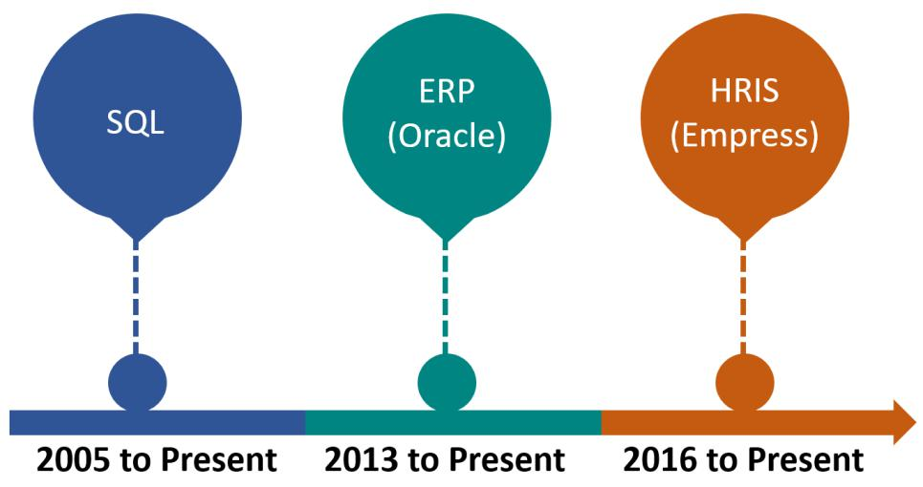

The here and now the HR department of the Renata Limited is giving more concentration on their HR software is called “Empress”. A brief discussion regarding “Empress” is given below:
EMPRESS – HRIS Software
Overview of the EMPRESS:
‘’Employee Productivity Escalation System (EMPRESS)” is known as a web-based multi-company or location supported HRIS to manage employees and their regular activities which is developed by “Azolution Software & Engineers Ltd”. EMPRESS v5.0 is very innovative to improve the Human Resources Management System (HRIS) and to save time. EMPRESS facilitates the HRIS to manage employee records, Roster, Attendance Management, Movement, Leave Management, Conveyance, Payroll, Recruitment, Training, Performance, Canteen, Vehicle Management, fund, etc very efficiently. The utilization of resources can be improved more 50% which will help to save the time of the management more than half by executing EMPRESS. Empress the No. 1 (One) HR solution in Bangladesh is empowering the corporate for better Human Resource Management (HRM).

An illustration of EMPRESS software is given below:

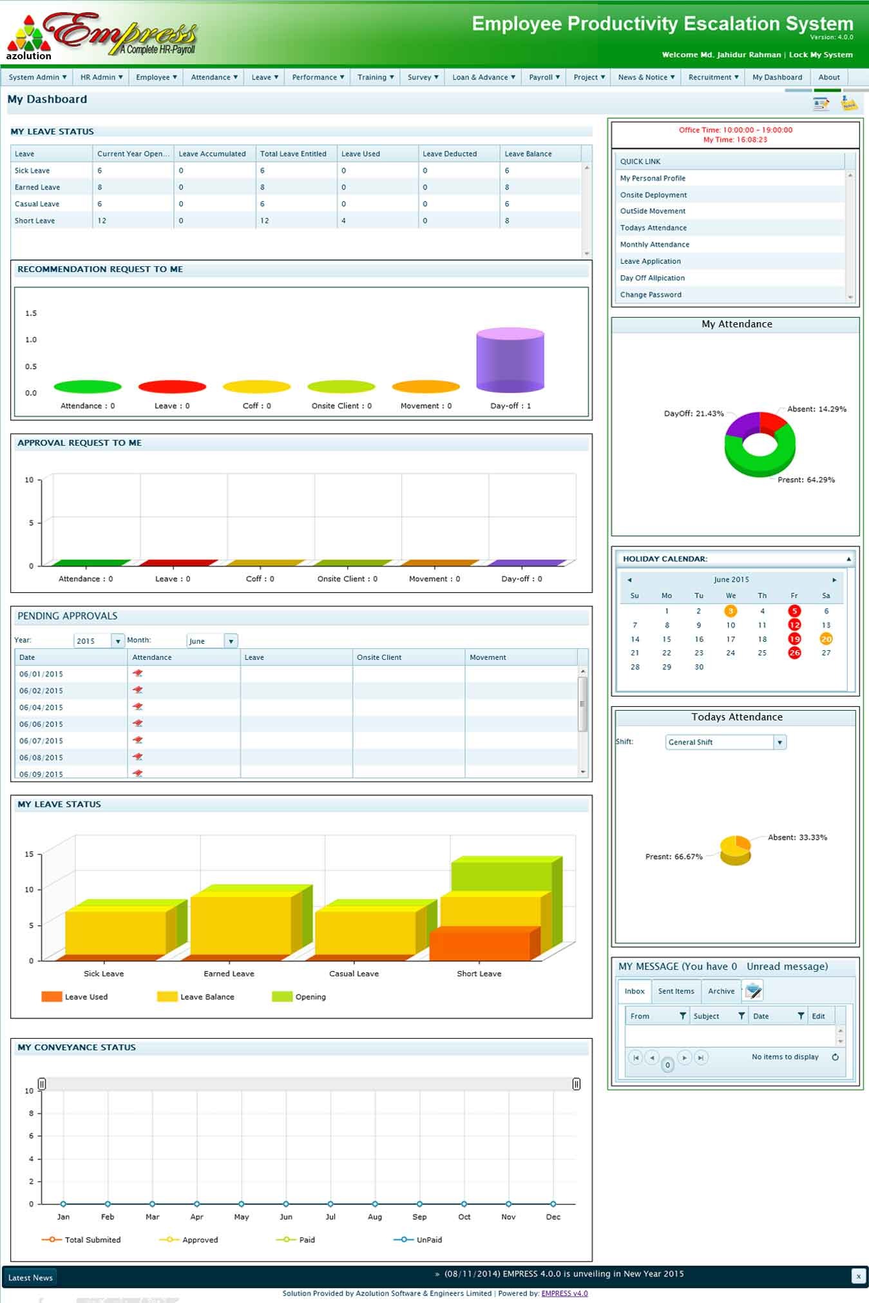
(Source: Website - http://www.empresshr.com/Features.aspx#hideme1)

Benefits of Users
- This web-based system has access from anywhere
- It is centrally installed with a browser-based client
- It captures attendance automatically and gives notification
- The payroll process of Empress helps to reduce 75% of manual time
- The productivity of an employee is escalated by self-assessment
- It reduces time more than half of its total management

Values Added by Empress
- It escalates the productivity of employee self-service (ESS)
- There is a Management Analytical Dashboard to get snapshot
- It makes easier the recruitment by process flow
- It provides the facility of Streamline Attendance Discipline by punch capturing
- It gives the protection of overtime abuse by punch calculation
- It reduces the processing time of Payroll more than half

EMPRESS in Renata Limited
Renata Limited introduced EMPRESS software in the Human Resources Department in 2016. Every regular employee of the HR department has an account in EMPRESS along with interns though they are contractual. But all employees do not have access to all functions. They can see their information on attendance, leave, vehicle, medical facilities and some other functions but they do not have access to editing. I had access to 3 (Three) functions. But I tried to know about other functions. I got permission from my supervisor to discuss on some functions in very short. So I will discuss those three functions along with other functions with some features:
Interface

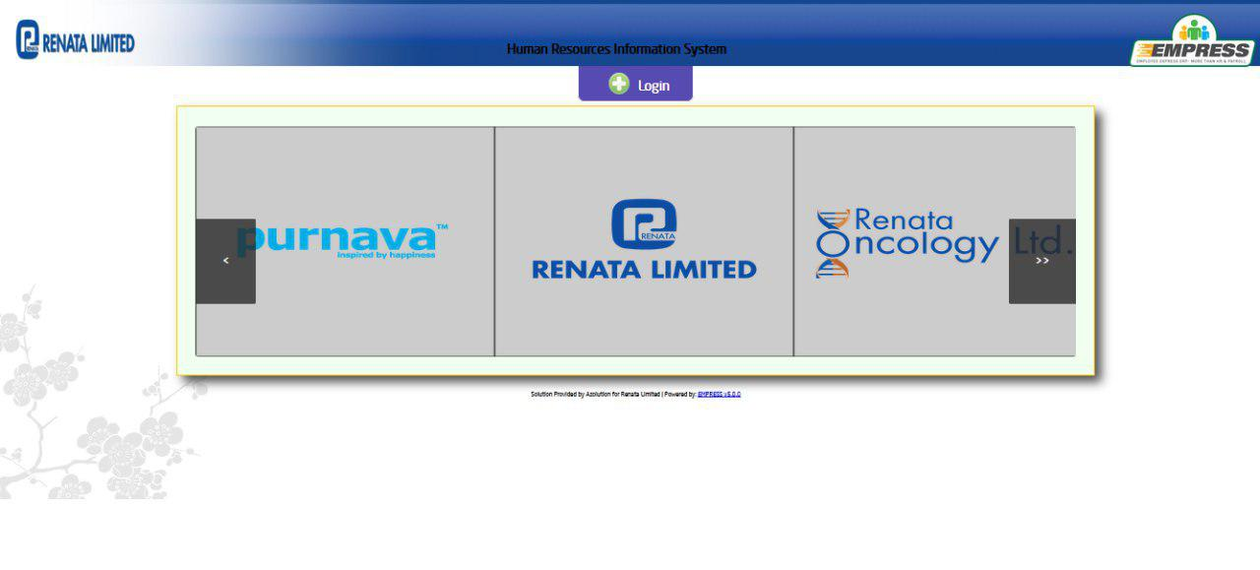

This is the interface of Empress which is used in Renata Limited. There are some logos. There is a logo of Renata Limited on the top of the left and there is another logo at the top of right which is Empress’s logo. The logos of Purnava, Renata Limited and Renata Oncology are being seen in the middle. And there is a Login box in the upper middle. To get access to the software, press on the Login box is needed.

Software System Login
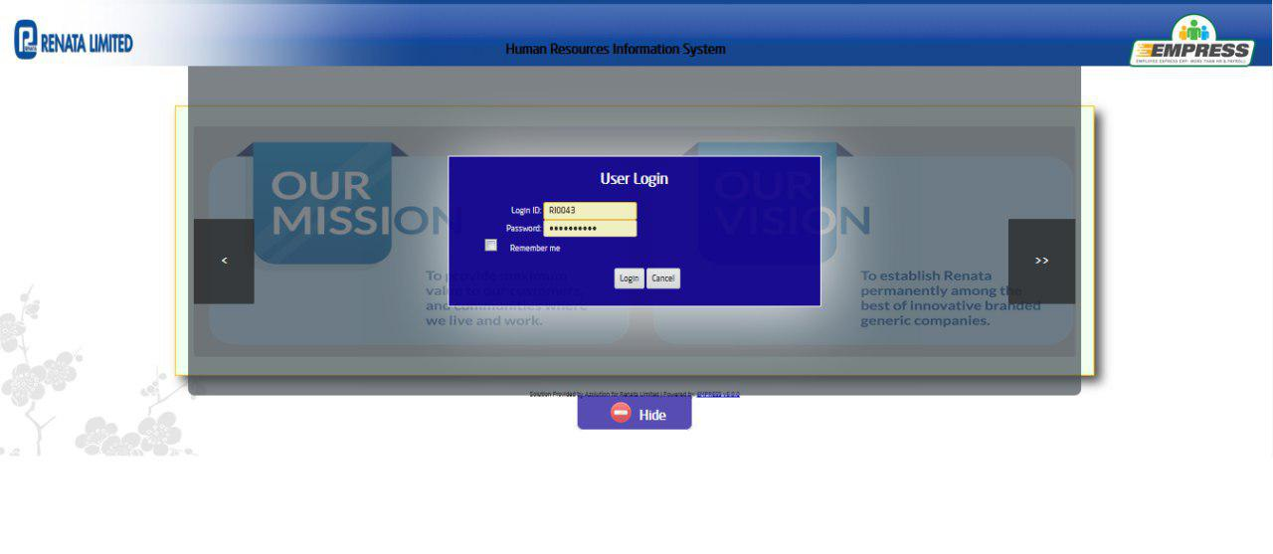

This is the software system login box where there are two boxes, Login ID and Password. After putting the correct login ID and password, Users can get access. If someone forgets the pass then he or she has to ask a password from the Senior Assistant Manager who is assigned from the management to main this system. Sometimes password can be forgotten. That is there another option to remember me. By putting the press on the box, It will be saved so the user can get access by putting the press on Login only.

Dashboard:
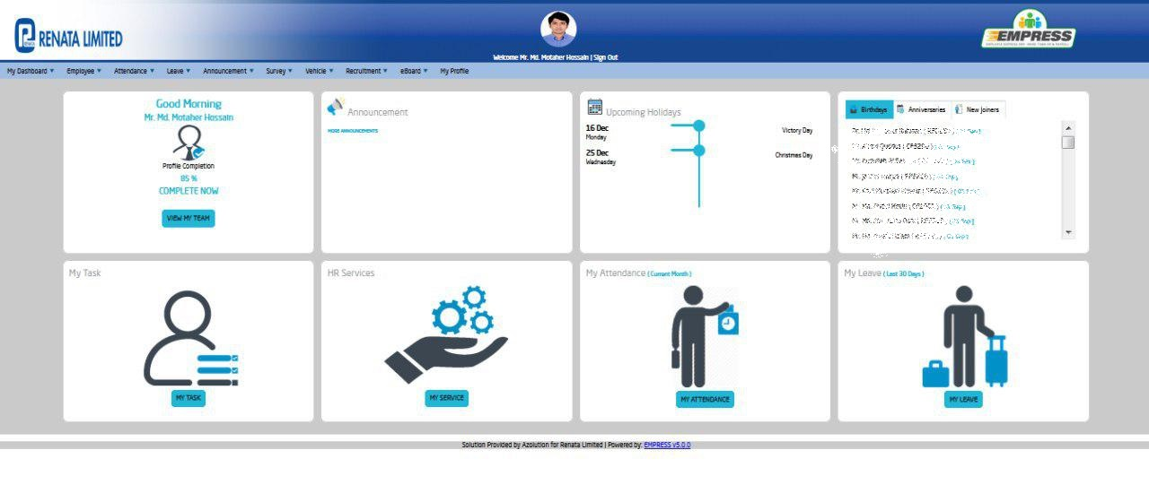

Here we can see the photograph of the user, user’s name and sign out option. Under the user’s name and sign out option, there is a row with some functions. Those are:
- My Dashboard
- Employee
- Attendance
- Leave
- Announcement
- Survey
- Vehicle
- Recruitment
- E-board
- About
Apart from that, there are 6 (six) functions below that row. Those are:
- My profile
- Announcement (Linked with upper row’s Announcement function)
- Upcoming Holidays
- Birthday work, Anniversary and New Joiners
- HR service
- My Attendance (Link with upper row’s Attendance function
- My leave (Link with upper row’s Leave function)

Employee Performance Management

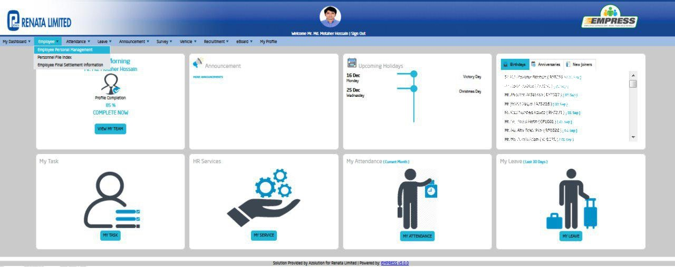

In Employee Personal Management, all data of an employee are being saved. To get the information of an employee, it is needed to press on Employee function then another three functions will be shown. After pressing on the Employee Personal Management, A new window will be opened. The new window is like –

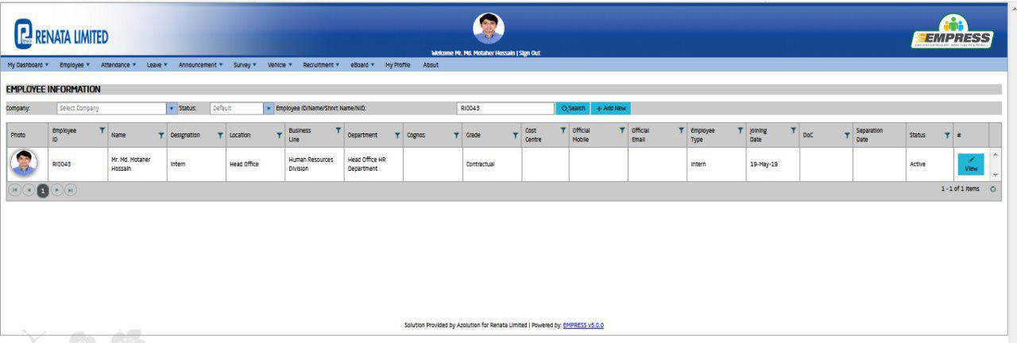

To know employee information first it is needed to put the employee ID on the search box. After pressing the search button a row will be shown. So some information about an employee will be shown. Those are
- Photo
- Name
- Designation
- Division and Department
- Location
- Grade
- Official Mail, Official Phone Mobile Number
- Employment Type (Regular/Contractual/Casual)
- Joining Date, Date of Confirmation, Separation, and Status

After pressing the view box, A now open will be opened like following this -
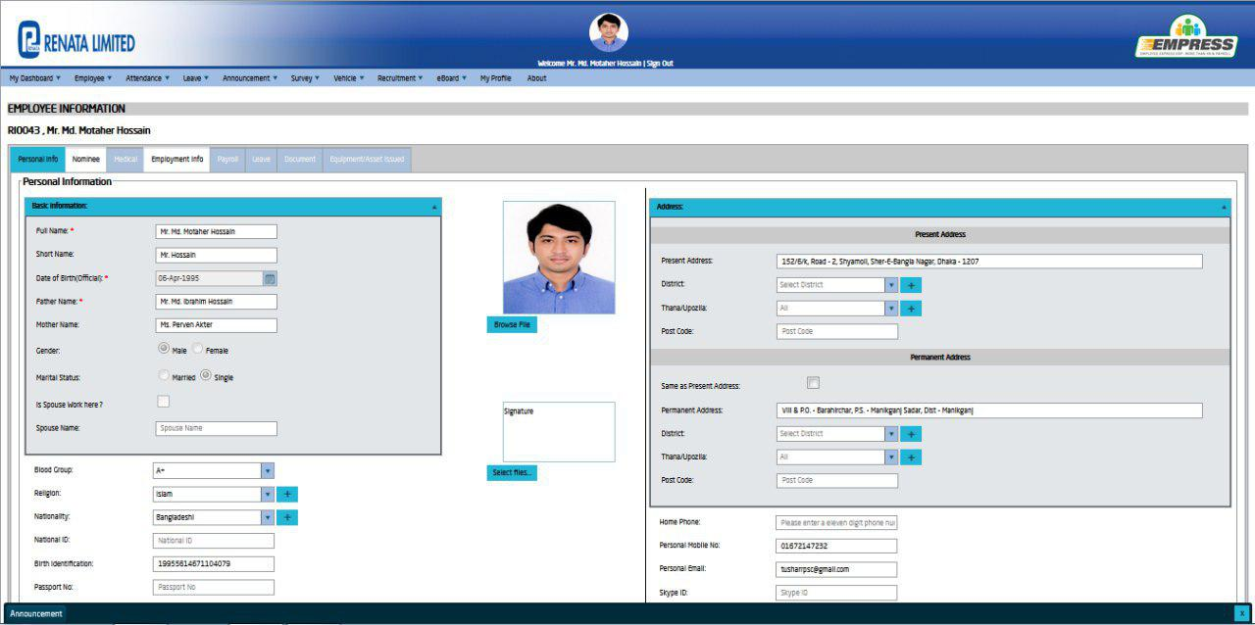
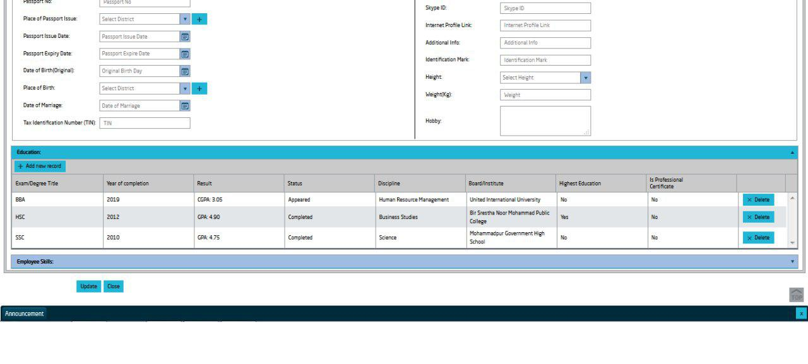
This function contains the personal info of an employee. When an employee joins the company, an account has to be created where all personal info will be saved. Filling up all information is not mandatory but some information is mandatory to fill up. Those are -
- Name
- Father’s and Mother’s name
- Gender
- Marital Status
- Gender
- TIN Number
- Date of Birth, Date of Marriage (if married)
- NID, Passport No. or Birth Certificate No.
- Present Address and Permanent Address
- Educational Information

Nominee, Hospitalization, Group Insurance, Provident Fund, and Gratuity

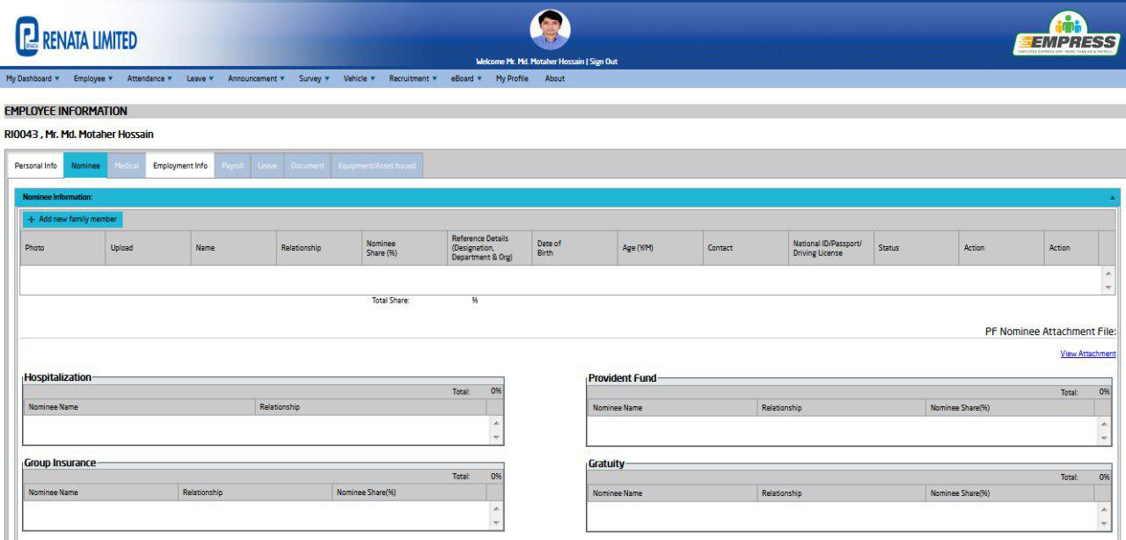

After joining an employee, the HR department provides a Beneficiary Form to the employee. If an employee dies then the amount of gratuity, the amount of provident fund will get his or her nominee. But the condition is the nominee below the age of 18 (eighteen) no one can be the nominee of an employee. The nominee has to provide some attested supporting documents with beneficiary form. There is some mandatory important information that has to be filled up. Those are
- Name
- Relationship
- Nominee Share
- Date of Birth
- Age
- NID Number, Passport Number or Birth Certificate Number

Apart from that, all information regarding medical facilities, group insurance, provident fund, and gratuity have to be updated in this section. As I was an intern so I did have access to these functions.

Employee Information

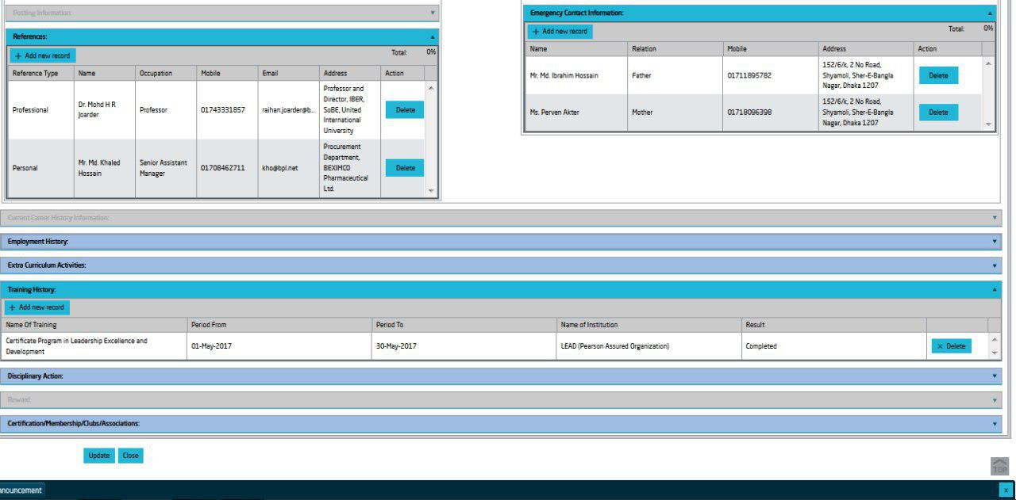

After joining an employee, the HR department provides Employee Information form to his or her. There is some information which has to fill up in this section
- Professional and Personal References
- Emergency Information
- Emplacement History (If clearance certificate issue is ok )
- Extra Curriculum Activities
- Training History
- Disciplinary Action
- Certification or Membership

Attendance

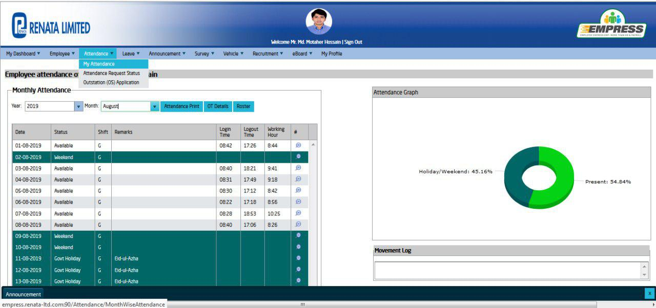
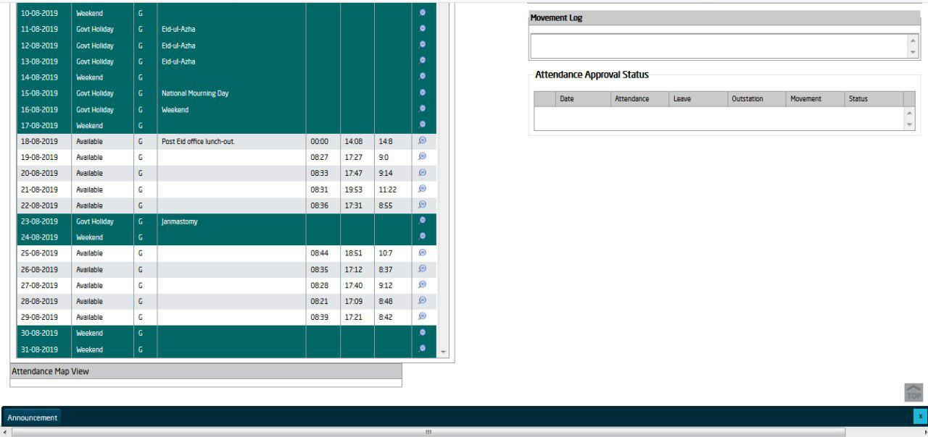

From this function, Employees are able to know details of their attendance like -
- Date
- Status
- Shift
- Remarks
- Login Time
- Logout Time
- Working Hours
All the employees of Renata Limited can see their attendance status from this function. Before entering the office and before leaving the office all employees have to put their figure print on the machine. The machine transfers their entering time and leaving time to the Empress. There is an option where employees are able to see their attendance time from their joining date to the present time. Is someone is absent then the row will show red color? The green color shows the holidays and weekends. Anyone can print his attendance status and can see also the OT (Overtime) status. Employees can get overall ideas regarding attendance status from the pie chart.

Leave Management

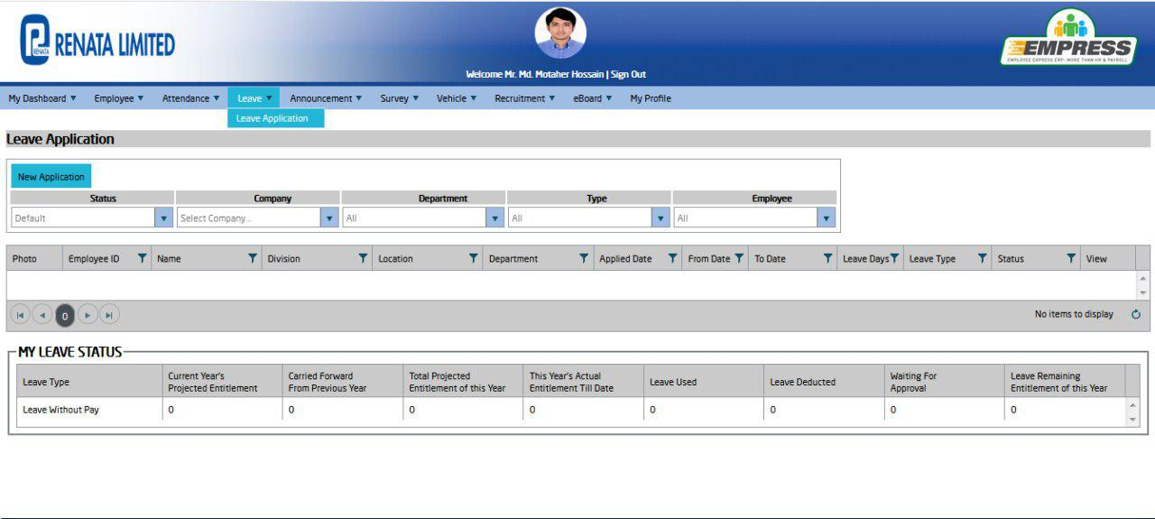
Employees can apply for the leave and they can also view their Leave status. For leave application, employees have to fill-up the form on Empress. Information is given below
- Status
- Company (Renata Limited, Purnava)
- Department
- Type
- Employee

Leave application has to be accepted from the Departmental Head.

Vehicle

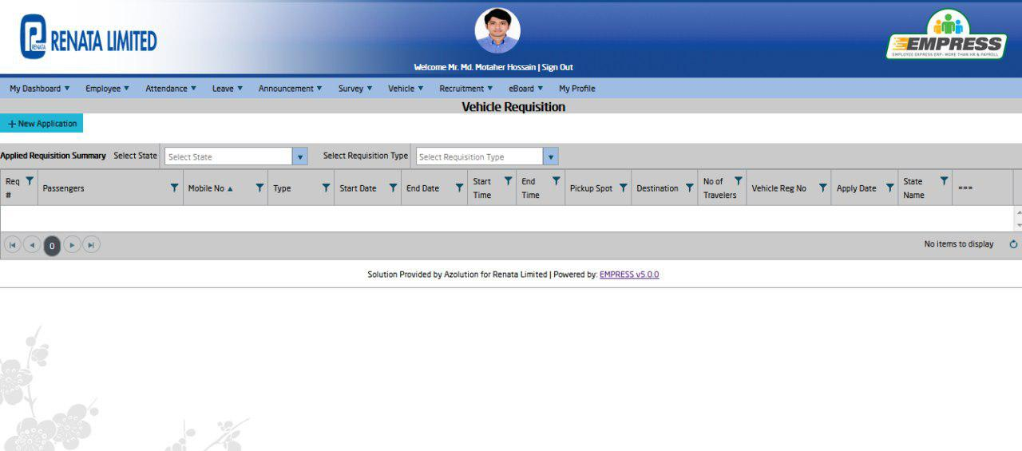
An employee (from officer grade) can get vehicle support for official purposes after getting the approval from Departmental Head. Sometimes employees can use a vehicle for their personal uses but approval from the Head of HR is needed at that time. To give a requisition for a vehicle, the employee has to fill up the information. Those are –
- Passenger
- Mobile No.
- Type
- Start Date and End Date
- Start Time and End Time
- Pick up Spot and Destination
- Vehicle Registration No.
- State Name
An HR officer is appointed to allocate these requisitions. After allocating, those requisitions have to approve by Senior Assistant Manager who is Vehicle In charge.

E- Board
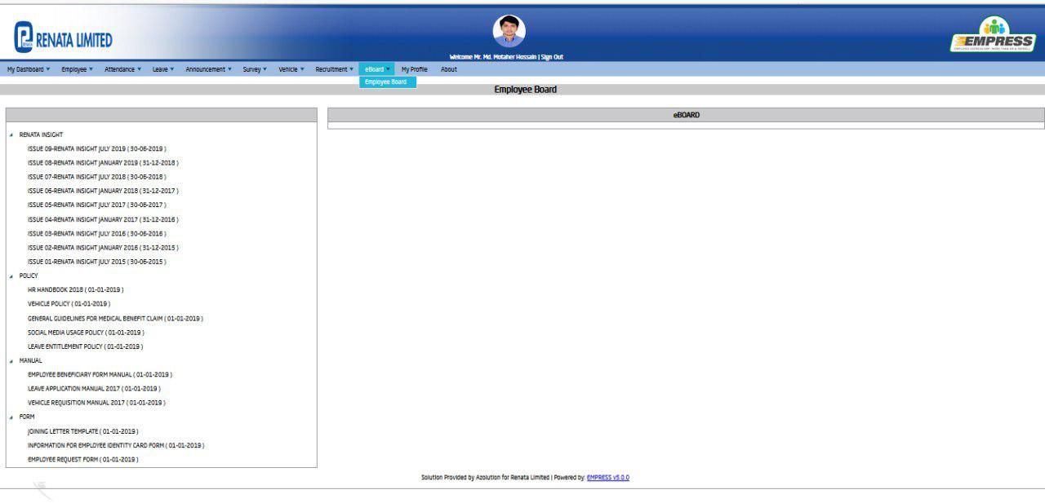
From the E- Board, employees will be able to get information about Renata Limited. Those are -
- Renata Insight
- HR Handbook
- Vehicle Policy
- General Guidelines for Medical Facilities Claim]
- Social Media Usage Policy
- Leave Entitlement Policy
- Employee Beneficiary and Employee Information form manual
- Vehicle Manual
- Joining Letter Template
- Information for Employee Identity Card Form
- Employee Request Form

Impact of HRIS on HR activities of Renata Limited

After introducing HRIS software Empress, HR activities become easier. It saves time and money as well. Once at a time, some process regarding HR took a long time but now it takes the time just of the mouse click. For the HRIS system, Renata Limited is running its HR activities of 4,334 people. It has good on some functions of the HR department. Those are –
Employee Information
It becomes easier than before to find out any information on an employee. The info can be needed in emergencies at any time. For example, an employee needs a clearance certificate or employment certificate. Medical papers, Gratuity papers, Provident fund papers are related to these. Information files kept in a cabinet. So it took a long time. Now for HRIS, it is very easy to use. It reduces the time to get a clearance certificate, employment certificate, etc.
Payroll
Before introducing the Empress, the payroll activities were so much complex. At that time, payroll-related tasks were done by Oracle. Basically, the Department of Finance used that software. As it was not proper HR software, sometimes critical problems arose. Sometimes it took a long time. More employees were needed at that time to complete the payroll process of a month. Now HRIS is saving time and reducing the cost.
Attendance
Before introducing HR, Employees had to the signature on Attendance Log Book during entering and leaving the office. It was tough to adjust the attendance of each employee of the company. Now a machine is set up in the office. When employees enter or leave the office, they just put their figure on the machine and the machine sends the data to empress software. Now employees can be able to know their attendance management.
Leave Management
Employees had to write an application to the Department Head for the leave once a time. There were uses of more papers. Now employees can apply for the leave by the Empress. The employees can check easily their leave status. Uses of more papers have reduced.
Performance Appraisal
The performance appraisal process is very easy now. The appraiser can get easily information on the attendance status and the leave status from Empress. So it reduces the time of the appraiser to complete the appraisal process.
Vehicle Management
The vehicle management becomes more efficient because of HRIS. Once a time employees had to submit handwritten requisition. More papers were used. It took a long time to process. The chance of mistakes was high. But now employees can give requisition on Empress. The process is paper-free now. It saves time and reduces hassle.
E-board
After joining, employees get information regarding policies, manuals, and rules from the HR department. So any employee forgets about those policies, manuals, and rules then he or she can know those from Empress.
Announcement
Employees can get an update of the announcements from the Empress. Once a time, all kinds of the announcement were posted on the notice board. But now employees can get notification of announcements from Empress.

Chapter - 7

Analysis, Findings, Recommendations, and Conclusion

Analysis:
- To ensure the development of the employee the HR department of Reneta organizes regular training session which is very essential for the employee as well as the organization
- The salesforce department and the guests from different organizations exchange their thoughts, struggles, and experience with each other on celebrity training sessions every month. This training session helps employee not only to be motivated but also this is very helpful for the long run
- The HR department of Reneta Limited has developed a software system known as The Empress HRIS (Human Resource Information System) which is only accessible to the above level employees or officers. An employee can only use this software inside the Reneta LTD network for the security measures
- Some hindrance and confusion created by the mismatch of information that employees provided, information that doesn’t match with the system database also the missing information. These things slow down the other process of the work
- Many changes and updates were made from time to time from the beginning period of the organization which leads the database more informative and resourceful, but as per new policies of the employee information system, many new things have been added and removed. Thus, many information of old employee was unavailable which was not necessary for the past but essential in the recent scenario
- Some employees didn’t provide the essential documents that are required at the time of joining which leads confusion with the information system. The lack of duty of the concerned authority who didn’t make sure that individual new employee is providing all the necessary documents is the reason for this confusion
- Instead of being operated for a long time some employees were not well equipped with Job Description which was affecting the organization as a job description helps the organization to grow, mapping and helps the employee to know individuals responsibility

Findings

- Many employees come to the HR department for collecting their necessary papers, clearance certificates, etc. But sometimes it takes a long time to get those papers
- It takes more time to enter in an employee’s profile after logged in
- The seating arrangement is not enough in front of the HR department
- Sometimes it becomes very slow to load the interface of Empress
- Oracle, ERP, and Empress are parallel running in the information system
- Interns have access in 3 functions only

Recommendation
There are some recommendations that might help Reneta Limited to improve its strategy of the efficiency of the employee as well as the organization and also help the organization to become more strategic and stronger.
- The company should make the end-user feel important to the company by giving them access to their personal management system.
- Emphasize on the vision of the organization by the regular follow up of the software system.
- To have employees with better knowledge the organization should give proper and regular training to the employee about both software as both of them are running simultaneously.
- To have enough competency among the employee the organization should have employee advancement training along with the regular training. Also to have sustainability on the technological part of the regular work the organization should keep the employees up to date.
- The employees and the documents that they are providing and getting from the organization should be under proper supervision.
- The employee must be trained about their work and responsibility, for any additional responsibility the organization must notify and train the employee properly. Besides, the Job Description of the employee should contain enough instruction on the employee’s responsibilities.
- To reach the responsibility for the society the organization should hire disable people and give them the responsibility that they can fulfill also make an environment that they will feel comfortable
- Sometimes employees have to wait for long for their settlement process. So management has to take steps to reduce the waiting time
- More sofas and chairs should be arranged in front of the HR department

- Providing more training to the union employees

- Interns will be acquired more knowledge if they get access to other more functions in HRIS

Conclusion
The journey was really wonderful in Renata Limited. When I started my internship I had a zero on practical HR activities. During my internship period, I tried to gather knowledge and experiences. I gathered knowledge of HR functions and HRIS. HRM is an imperative part of any organization. The proper execution of the HR practice helps the organization by increasing employee performance. That is why Renata Limited always gives high priority in the overall HRM practices. Lastly, the ideas, knowledge, experiences which I got from Renata Limited, that will help to be established in the HR sector incorporate fraternity

References
Alan Price . (2007). Literature Review: Recruitment and Selection Process. Retrieved from UKESSAYS: https://www.ukessays.com/essays/business/literature-review-recruitment-and-selection-process-business-essay.php
Armstrong . (2005). Definition of Compensation and Benefits . TRANS Asian Research Journals , 41.
Barkha Gupta. (2013). Role Of HRIS In Companies In Current Scenario. Human Resource Information System (HRIS): Important Element of Current Scenario , 43.
DeNisi and Pritchard. (2006). Definition of Performance Appraisal. Elsevier.
Deutsch, M. (2017, November 13). Recruiting Strategy, Methods and Tactics for sucess . Retrieved from Topechelon: https://www.topechelon.com/blog/placement-process/recruiting-strategies-methods-tactics/
Employee Selection. (n.d.). Employee Selection. Retrieved from Human Resource Management Practice: www.hrmpractice.com
External sources of recruitment. (n.d.). Retrieved from Business Jargons : https://businessjargons.com/external-sources-recruitment.html
Hedrickson. (2003). Definition of HRIS . Human Resource Information System (HRIS): Important, 41.
Herman Aguinis. (2013). Performance Management. Pearson Education Inc.
Kovach. (2002). Human resource information systems: a review and empirical analysis. Retrieved from Emerald Insight: https://www.emerald.com/insight/content/doi/10.1108/00483480610656702/full/html
Lybrand, S. (2018, May 01). Why Recruitment is the most important Business Strategy? Retrieved from Linkedin Talent Blog: https://business.linkedin.com/talent-solutions/blog/recruiting-strategy/2018/what-is-recruitment
M. J. Jucious. (n.d.). Definition of HRM. Retrieved from Human Resource Management Practice : http://hrmpractice.com/definition-of-human-resource-management/
Milkovich & Boudreau. (n.d.). Definition of HRM. Retrieved from Human Resource Management Practice : http://hrmpractice.com/definition-of-human-resource-management/
Parry. (2010). Human Resource Information System (HRIS). Retrieved from Management Study Guide : https://www.managementstudyguide.com/human-resource-information-system.htm
Phillpott, S. (2019, June 24). 6 External Recruitment Method and Their Pros and Cons. Retrieved from Career Adict : https://www.careeraddict.com/external-recruitment-methods
Phillpott, S. (2019, June 14). The Advantages and Disadvantages of Online Recruitment. Retrieved from Career Adict: https://www.careeraddict.com/advantages-and-disadvantages-of-online-recruitment
Recruitment Process. (n.d.). Retrieved from Toppr: https://www.toppr.com/guides/business-management-and-entrpreneurship/human-resource-management/recruitment-process/
Recruitment Process . (n.d.). Retrieved from Tutorial Point : https://www.tutorialspoint.com/recruitment_and_selection/recruitment_process.htm
Reddy, K. (n.d.). What is an Employee Referral? Advantages and Disadvantages . Retrieved from Wisestep: https://content.wisestep.com/advantages-and-disadvantages-of-employee-referrals/
Renata Limited . (2019, October 26). Corporate Social Responsibilities . Retrieved from Renata Limited : https://renata-ltd.com/about-us/corporate-social-responsibility/
Renata Limited . (n.d.). Founder Chairman. Retrieved from Renata Limited : https://renata-ltd.com/about-us/founder-chairman/
Renata Limited. (2017-2018). Annual report. Renata Limited. Retrieved from https://renata-ltd.com/wp-content/uploads/2018/11/Annual-Report-2017-18.pdf
Renata Limited. (2019, October 26). About us. Retrieved from Renata Limited: https://renata-ltd.com/about-us/
Schuler. (1984). Understanding Human Resource Management in the Context of Organizations and Their Environments. Retrieved from Research Gate : https://www.researchgate.net/publication/275511428_Understanding_Human_Resource_Management_in_the_Context_of_Organizations_and_Their_Environments
Selection Process . (n.d.). Retrieved from Toppre: https://www.toppr.com/guides/business-management-and-entrepreneurship/human-resource-management/selection-process/
Smriti Chad. (n.d.). Methods of Training . Retrieved from Your Article Library: http://www.yourarticlelibrary.com/human-resource-development/methods-of-training-on-the-job-training-method-and-off-the-job-methods/32369
Tahsin, A. (n.d.). Recruitment and Selection Process of Renata Limited . Retrieved from http://dspace.uiu.ac.bd/handle/52243/314
Tannenbaum . (1990). Definition of HRIS . Human Resource Information System (HRIS), 41.
User Benifits, Empress Features . (n.d.). Retrieved from Empress: http://www.empresshr.com/Features.aspx
WHAT IS EMPRESS? WHAT VALUE EMPRESS CAN ADD? . (n.d.). Retrieved from Empress: http://www.empresshr.com/
What is Performance Appraisal? (n.d.). Retrieved from Business Jargons : https://businessjargons.com/performance-appraisal.html
What is recruiting in HRM? (n.d.). Retrieved from Smart Recruiters : https://www.smartrecruiters.com/resources/glossary/recruitment/
whatishumanresource.com. (n.d.). Training and Development. Retrieved from whatishumanresource.com: http://www.whatishumanresource.com/training-and-development

