


2020
L O R E M I P S U M
L O R E M I P S U M
TITLE
COVER PAGE

United International University

Audit Procedures of Bangladesh
A study on Hoda Vasi Chowdhury & CO

PROJECT REPORT
ON
Audit Procedures of Bangladesh
A study on Hoda Vasi Chowdhury & CO

Submitted To:

Dr.James Bakul Sarkar
Associate Professor
School of Business & Economics
United International University

Submitted By:

Sonali Kabir saima
ID: 114 152 007
School of Business and Economics
United International University

Date of submission: 10 October 2020

Letter of Transmittal

October 6,2020
Dr. James Bakul Sarkar
Associate Professor
School of Business and Economics
United International University

Subject: Submission of Project Report.

Dear sir,
It’s my great pleasure to present my project report on “Audit procedure of Bangladesh a study on Hoda Vasi Chowdhury & Co’’.This project report is a prerequisite for completing my Bachelor of Business Administration under United International University. My main focus of the study is to find out the external audit procedure of Bangladesh.
I believe the knowledge and experience that I have gathered during my internship period will help me in professional life.

I, convey my thanks to you for your kind cooperation, Supervision and advice in conducting and preparing this report. I appreciate you will evaluate my report considering the limitations of the study.

Yours Sincerely,
Sonali Kabir Saima
ID:114 152 007
Department BBA in AIS
School of Business and Economics

At Frist, I would like to express my gratitude to the Almighty Allah who gave me the opportunity to complete my project report successfully.
Acknowledgement

And secondly, I would like to express my sincerest gratitude to my honorable supervisor Dr. James Bakul Sarkar for his continuous supervision, support and care regarding the completion of my project report. I would also like to express my gratitude to the other teachers whose teachings and advices have proven to be priceless and useful during my journey.
I give my best efforts to prepare this report successfully and also try to cover all area related to my topic. I would like to thanks my classmates, Friends and also my seniors for helping me lot during my journey to make report.
And finally,my big thanks goes to my university United international University for giving the opportunity to experience self-development through this report.It was a great leaning period for me.Good luck.

Executive Summary

This report has been written to provide a details information on audit procedures of Bangladesh and a study on Hoda Vasi Chowdhury & Co.HVC firm provide the best audit consultancy service to their client. Here I described the deals of firm how the conduct the audit process.

The First chapter of this report contain the introduction, Origin of the report & Limitations of the study. In the second chapter, I described the organization Background & Industry Perspective.
Third chapter is described on the objective of the study. On fourth and fifth chapter I, presented the methodology of the report and literature review. The six chapter consist of theoretical framework of the study. Here presented what is audit, types and objective of audits, audit procedures etc. Chapter seven is on the description of how Hoda Vasi Chowdhury & Co conduct their audit process. And the last chapter is on the findings, recommendations and conclusions

TABLE OF CONTENTS

T
Content | Page no
Title page | 1
Cover page | 2
Letter of Transmittal | 3
Acknowledgement | 4
Executive summary | 5
Table of Contents | 6
Chapter 1: Introduction | 8-10
1.1 Introduction | 9
1.2 Origin of the report | 9
1.3 Limitations of the study | 10
Chapter 2: Organization Background & Industry Perspective | 11-15
2.1. Introduction of Organization | 12
2.2 Historical Background | 13
2.3 Mission & Vision | 13
2.4 Services Provided | 13
Chapter 3: Objective of the study | 16-17
3.1 Primary Objective | 17
3.2 Secondary Objective | 17
Chapter 4: Methodology of the report | 18-20
4.1 Type of Data | 19
4.2 Data collection Process | 19
4.3 Sample size | 19
4.4 Scope of the study | 19
Chapter 5 Literature Review | 21-23
5.1 Literature Review | 22
Chapter 6 Theoretical Framework | 24-39
6.1 Definition of Audit | 25
6.2 Objective of the audit | 26
6.3 Classification of audit | 27
6.4 Difference between Accounting & Audit | 30
6.5 Auditing in Bangladesh | 32
6.6 Audit process and procedures | 32
Chapter 7 Audit procedure of Hoda Vasi Chow dhury and Co | 40-46
7.1 Audit procedure of Hoda Vasi Chow dhury and Co | 41
Chapter 8 Findings and Recommendation | 47-0
8.1 Finding | 48
8.2 Recommendation | 49
8.3 conclusion | 50
Chapter 9 Appendix | 51
Reference | 52

CHAPTER 1

Introduction

  - Introduction
In order to boost the text book knowledge and classroom knowledge it necessary to gain an advance Knowledge by researching it. Only text book knowledge is not enough. In order to collaborate with our text book and classroom knowledge with advance and practical knowledge our respective mentors and university influence us take a project report to complete our degree. This project report make opportunity for me to give a boost to my theoretical knowledge
To complete this study, I select audit procedures of Bangladesh and a study on Hoda Vasi Chowdhury & Co. This report gives the opportunity to learn and know detail procedures of auditing in theoretical and practical life. I hope this will be a great source of experience which will help to future to become a qualified Accountant.
  - Origin of the report
An internship or a project report is mandatory requirement in order to complete graduation in BBA in AIS under Business & Economics school of United International University. I choose project on an audit procedure of Bangladesh. And my project title is Audit Procedures of Bangladesh: A study on Hoda Vasi Chowdhury & CO.
During the preparation of project report, I have learned what audit actually, how audit works in practical and also gain a great advance knowledge on audit procedures. We all know HVC is the biggest accountancy firm of our country.so I decided to do a know the audit procedure of this firm and present it on my project report.
And I am also luck to get a great supervisor Dr. James Bakul Sarkar for my project.

  - Limitations of the study
The main purpose of the report was to make a thorough study of external audit procedures of Bangladesh and Hoda Vasi Chowdhury & CO. Throughout my project report preparation period I faced some difficulty but I give my best efforts to present available information efficiently and effectively.
Some of limitation, I faced during my project
- Major limitation for COVID-19
It’s almost 6 six month we were home. Due to lockdown and social distance I was unable to visit the firm physically and lost the opportunity to get knowledge by eye to eye observation.
- Lack of time
Audit procedures has many area and methods so due to lack of time, it was not sufficient to cover all information
- Confidentiality of firm
To maintain confidentiality, some information was not disclosed to internet.
- Lack of experience
This is very first time I am preparing a project report.so it was difficult to present all and everything of audit procedures.

CHAPTER 2
Organization Background & Industry Perspective

2.1 Introduction of Organization
Hoda Vasi Chowdhury & Co is biggest and top chartered accountancy firm of our country.Hoda Vasi Chowdhury is oldest professional services firm which provide Various professional services like consultancy, Taxation, statutory audit and many more. More than 50 year,Hoda Vasi Chowdhury proving high-quality services and management services to various industry and business segment clients. Hoda Vasi Chowdhury & Co chartered firm is known for best client services.They always prove the high-quality and cost-effective service to their client.They work with different industry clints such as multinational organization, private business, non-profit organizations, government entities, start-up firms and many more.
- Firm’s Profile
Firm name | Hoda Vasi Chowdhury & Co.
Head office Address | BTMC Bhaban (7th-8th floor), 7-9 Kazi Nazrul Islam Avenue Kawran Bazar C/A, Dhaka-1215.
Telephones | (880-2) 9140094
Fax | (880-2) 8119298
Web | •www.hodavasi.com
Branch Office | • Motijheel office: "N, Ispahani Building (3rd floor) 14/15 Motijheel C/A . Dhaka-1000.  • Chittagong Office: ' Delwar Bhaban (4th floor) 104 Agrabad C/A Chittagong-4100.

2.3 Mission & Vision
- Mission:
- To excel our relentless efforts for the steady growth of our client
- Maintain High ethical standards
- Keep pace with global growth
- Technological development
- Vision:
- Delivering the best value to our clients.
- Commitment & integrity to each other.
2.4 Services Provided
Hoda Vasi Chowdhury & Co provides wide range of services for their clients.
Major Common area of services
- Audit and Assurance
- Statutory/Annual Audit.
- Special Purpose Audit/Review
- Agreed Upon Procedures Work.
- Negative Assurance
- Interim Review
- Internal Audit
- Operational Audit
- Performance and Compliance Audit
- Corporate Governance
- US GAAP/ UJS GAAS Reporting
- Corporate Governance
- Basel II Implementation
- Fiscal and Taxation
- Corporate Tax
- Value Added Tax (VAT)
- Other Indirect Tax
- Individual Tax Including Expatriate Tax
- Tax Advisory Services
- Tax Planning & Tax Compliance
- Tax Due Diligence
- Transfer Pricing
- Business Advisory and Transaction Services
- Due Diligence
- Business Valuation
- Corporate Restructuring
- IPO Assistance.
- Capital Market Advisory
- Joint Venture and Business Collaboration
- Feasibility Study
- Technical Collaboration
- Company Formation and Corporate Services
- Setting up Liaison
- Enterprise Risk Management.
- Information Security and Risk Management
- Setting up Provident, Gratuity, and Pension Funds
- Market Research, Survey and Studies
- Management Consulting and Other Special Services
- Development Project Management
- Donor Funded Project Assistance
- IT Systems Design and Implementation
- Executive Search and Selection.
- Immigration Verification Services
- Foreign Remittance
- Forensic Investigation
- Salary survey
- Training & Capacity Building
- Financial System Design
- Accounting Manual and Chart of Accounts Preparation
- Health & Nutrition Surveys
- Outward Remittance Certification
- Cash Incentive / Subsidy Certification.
- Salary & Benefit Survey
- Work Permit & Visa Processing for Expatriates
- Business Process Outsourcing (BPO)
- Payroll Management
- Book-keeping & Accounting
- Secretarial Services
- Personal Tax
- VAT, TDS
- Airlines Remittance services
- Provident Fund accounting.
- Statutory return preparation & filing
- Quarterly return preparation & filing
- Document Management and record keeping
- Disaster Recovery and Business Community Support
- Associate Consultants
HVC has a number of associate consultants to work on special projects and services, namely
- Health & Nutrition.
- Human Resources.
- Engineering.
- Material Surveyor.

CHAPTER 3

Objective of the study

3.1 Primary Objective
To complete BBA in AIS under United International University it is required to complete an internship program or a project report under a supervisor. We know only text book knowledge is not enough to fit with modern corporate word. So we need to boost our knowledge by practical knowledge and research. The primary objective of this report is to complete my degree. But I learned a difference within practical knowledge and text knowledge.
3.2 Secondary Objective
The main fact of the secondary object of this report is to know the details know about audit procedures of Bangladesh and how it works by a top Chartered firm. Moreover, there are many more facts such as
- To gain an overall knowledge about audit procedures
- How Bangladesh implement audit procedures in corporate
- To get an overall idea on a chartered firm audit system
- To gain a practical knowledge on audit procedures
- To increase adaptability on corporate

CHAPTER 4

Methodology of the report

4.1 Type of Data
4.1.1 Primary Data
- Due to COVID-19 I was unable to collect any kind of primary data.
4.1.2 Secondary data
- Data collected from Various Audit report
- Data collected from Audit procedures text book
- Information collected about Hoda Vasi Chowdhury & Co from various working papers
- Information collected from books,files and publications on internet.
4.2 Data collection Process
All data collected from internet reliable source such as company websites, Publications on company and following topics, book and research papers. Information on audit is also collected from out text book & acts.
4.3 Sample size
For this study I, selected Hoda Vasi Chowdhury & Co is known as best audit firm of our country.
4.4 Scope of study
This study focuses on the audit process, implementation in Bangladesh and also a chartered accountant firm. Some major scopes of the study such as
- Background of the HVC
- Audit procedure of the HVC
- Audit procedures guidance by ICAB
- Nature and importance of the study

Chapter 5

Literature Review

5.1 Literature Review
Literature review help us to find different opinion on related topic. Here literature review concerned with different audit opinion from foreign studies. Review on audit opinions reflects whether the financial statement is true & fair or not. And the reason why audit is necessary and important.
Certified Public Accountants (CPA) present their opinion to audit “Audit is the opinions to the financial statement of the company to certify that information of financial situation operation results and cash flow is presented fairly. Audit opinion as a powerful monitor tool could influence the decision of investors and other stakeholders (Bo & Wu, 2011).
The Supreme Audit Institutions in New Public Management NPM the, the board of audit discusses difference between public and private sector audit performance. The main aspect that distinguishes two sector audits, according to him is accountability. In private sectors, the management has to be responsible to the shareholders. But in public sector, the government has to be responsible to the stakeholders.
Mohammad Hurmat shah wrote a briefly discusses about the challenges of performance audit in this paper ‘Audit in Bangladesh’. According to him, status of performance audit in Bangladesh indicates the progress in the field is slow.He recommends some measures to be taken such as establishment of a planning & monitoring unit,Building awareness among stakeholders,human resourse management and planning and many more.

From the above discussion, we can say audit opinion evaluate the financial statement of companies. Shareholders should increase more attention to audit.Audit opinion also influences other aspects of organization. The qualified audit opinions have higher likelihood to cost the firms in lawsuit compared with the unqualified opinions.

CHAPTER 6

Theoretical Framework

6.1 Definition of Audit
Auditing is a process of accounting to examinate the accounting records or financial statements and evaluates evidence to provide opinions on the entity or financial position whether the statement was true and fairly presented by the organization. Auditing is conducted by an independent person who is called auditor.
There are some key factors on audit definition such as
Independent person
- Independent Person:
An Auditor should be an independent person. That person must be qualified and able to understand the criteria and standards of auditing. The purpose of conducting audit by an independent person is get a fresh an unbiased audit reports.
- Accumulating and Evaluating Evidence:
Evidence refers to the information used by auditor to determine whether the information being audited is stated accordance with the criteria. Evidence can be in many form such as oral testimony of auditee, Written communication by auditors. The importance of evidence in auditing is to determine whether the information is presented according to the established criteria.
- Quantifiable Information and Established Criteria:
Information must be in verifiable form and maintain some standards criteria by which auditor can evaluate he information. The criteria for evaluating quantitative information can be take in many forms.
- Reporting:
The last and also most important state of auditing is audit reports. Audit reports medicates the auditor’s findings to users.
6.2 Objective of the audit
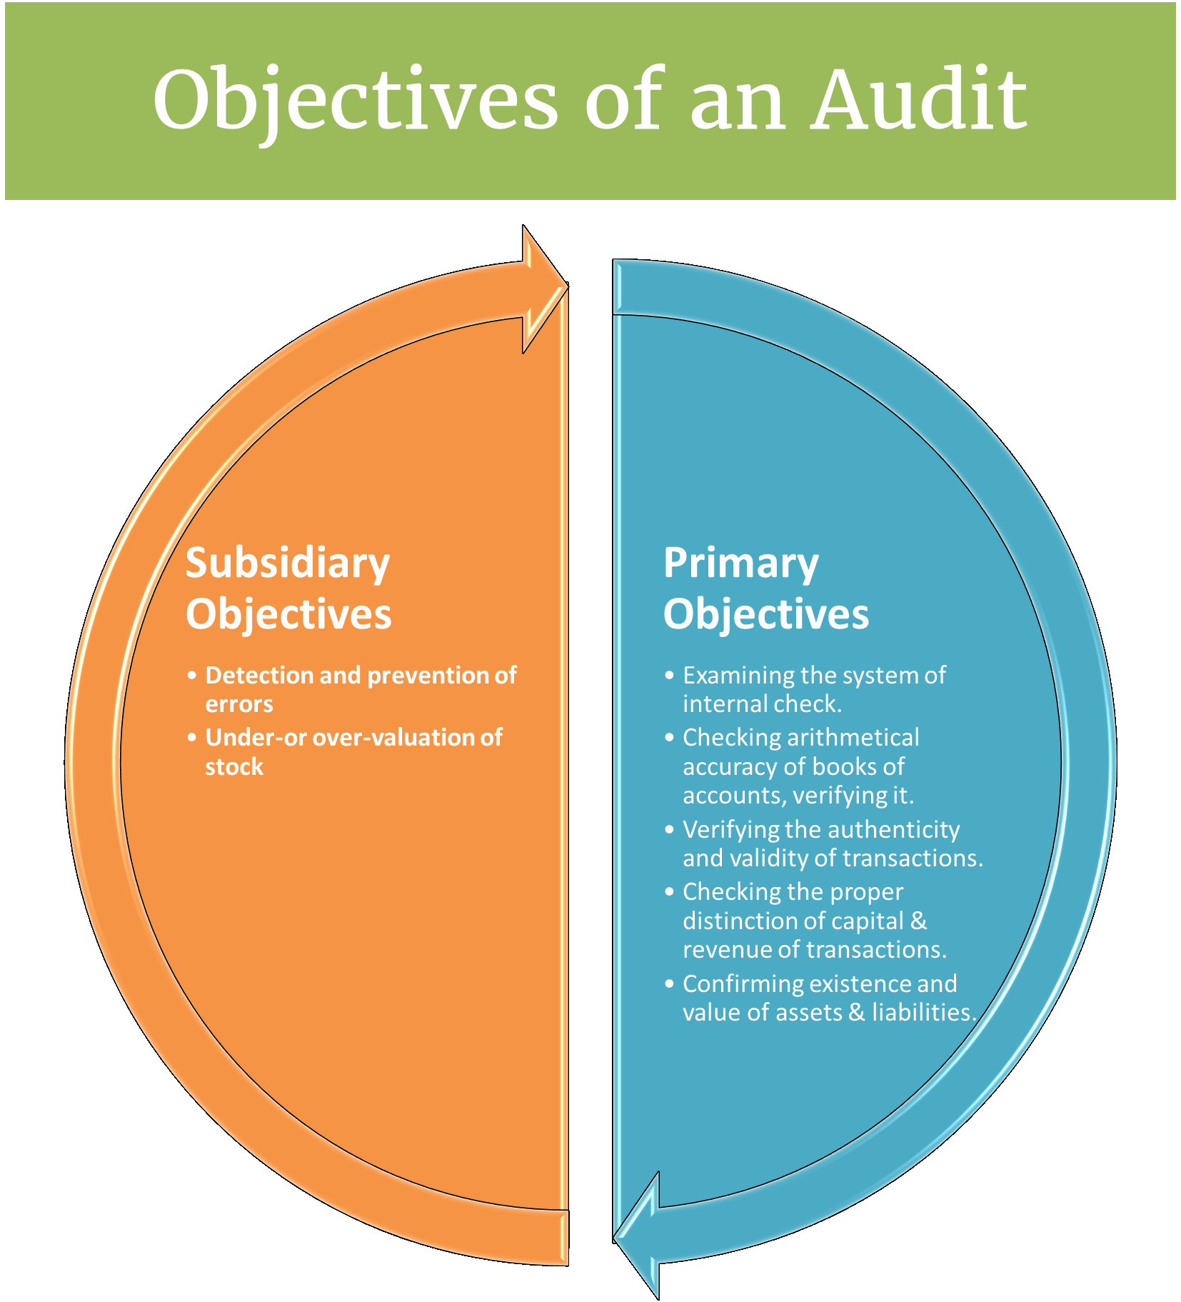
Objectives can be classified into two way such as
- Primary Objectives
- Verify the authenticity of transactions
- Verify validity of the transactions
- Checking accuracy of books of account
- Verifying postings of transactions
- Examine the system of internal check
- Verify the fairness of operating results of the firm
- Subsidiary Objectives
- Detection and prevention the errors:
Errors occurs due to carelessness, negligence, lack of knowledge. Errors are various types such as
- Errors of principle
- Errors of omission
- Errors of commission
- Compensating errors
- Detection and prevention of frauds
Frauds are mostly committed by the directions of top level management.They commites frauds by preseting mislead misstatement about company financial positions.
Some frauds are
- Misappropriation of cash & goods.
- Manipulation & falsifications of financial statements
- Deceive tax of organization.
6.3 Classification of audit
- External Audit
External audit is also called financial audit or statutory audit. External audit examinate the fairness and truth of the financial statements by an external auditor. The external audit firms offer auditing services, legal service, financial advisory. Example of external auditing services is big four audit firm KPMG, PWC, EY and Deloitte.External audit provides reasonable assurance of financial statements that are free from material misstatements
- Internal Audit
Internal audit is also called operational audit. Internal audit is an independent appraisal function established by an organization to provide assurance and effectiveness of internal controls, risk management and corporate governance. Internal audit is performed by employees of the organization who is called internal auditor.
Some reason an organization should conduct an internal audit
- Propose improvements
- Monitor effectiveness
- Make sure your business is compliant with laws and regulations
- Review and verify financial information
- Evaluate risk management policies and procedures
- Examine operation processes
- Performance Audit
Performance audit provide information about a specific unit of organization. The provides information about the economy, objectives and determine whether management objectives were achieved. They also provide recommendation to the reporting unit manager for improvement and opportunity.
- Government Audit
Government audit is conduct by an independent auditor who determine the whether the financial statement compliance with laws and regulations according to the government and authorized body ICAB.
- Interim Audit
Interim Audit is refers to the part of statutory audit, which conducted before the year end period. The primary purpose of the interim audit is to lowering the assessed risk level. Interim audit reduces the time pressure and complexity of statutory audit.
- Forensic Audit
Forensic audit is refer the examination and evaluation of a firm’s or individual’s financial statements for use as evidence. Forensic audit involves the investigative skills to whether they involve legal implications. Forensic audit also consists of
- Investigating fraud that involves of misappropriation of funds, money laundering, tax evasion
- Determination of claims of professional negligence
- Determination of the profit share of business partners
- Quantification of loss
6.4 Difference between Accounting & Audit
- Definition
Accounting is a process of recording and classifying financial positions of an organization in a systemic way to provide financial statement for decision making process.
Auditing is a process of accumulation and evaluation financial statement to determine and report on the degree correspondence between the information and established criteria.
- Purpose
The purpose of accounting is to show the performance and profitability, financial position of an organization.
The purpose of auditing is to reveal that whether the financial statement is presented fairly and true view by an organization.
- Period
Accounting is a continuous process. It records day to day transaction of an organization. Accounting start when bookkeeping ends.
Auditing is a periodic process. It starts at the end of accounting period.

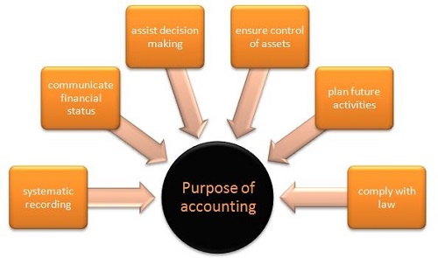
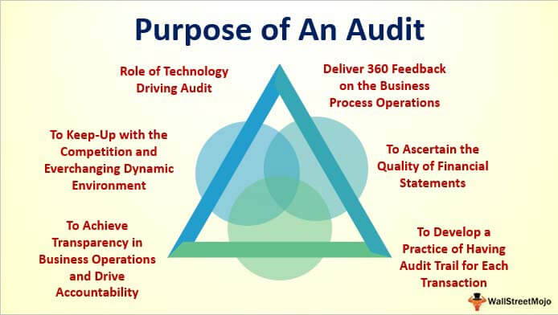
- Deliverables
The Accountant prepare journals, profit and loss balance sheet, cash flow statement and financial statements use by the management for decision making.
The auditor prepares the audit reports and provide an opinion on whether the financial statements is true or fair.

6.5 Auditing in Bangladesh
Auditing is a systematic process of evaluating and examinate the true and fairness presentation of financial statement provide by organization. Auditing of a registered company’s (under company act 1994) financial statements is compulsory in Bangladesh. Bangladesh follows International standards of Auditing guidelines in auditing. Auditing practices are also regulated by the Companies Act 1994, the Banking Companies Act 1991, the Securities and Exchange Rules 1987, the Securities and Exchange Commission Act 1993, the Insurance Act 1938, the Foreign Donations Regulation Rules 1978, and the Co-operative Societies Ordinance 1984.
In Bangladesh, audits are conducted in compliance with the requirement of companies act 1991.According to the audit law, Financial audits only can be eligible to perform by Chartered Accountants. Chartered Accountants are member of Institution of Chartered Accountants of Bangladesh (ICAB), they are qualified personnel and experts in the field of auditing and accounting. CAB operated lots of chartered accountants’ firm which provides assurance and consultancy services.
Auditor in Bangladesh conduct their auditing by following the requirement of Bangladesh Standards on Auditing (BSAs). They compare the fairness of the financial statement in accordance with Bangladesh Financial Reporting Standards (BFRSs).
6.6 Audit process and procedures
Institute of Chartered Accountants of Bangladesh is responsible for the activities of regulating of professional accountant and other matters connected therewith. ICAB recommended and provide guideline regarding with auditing in Bangladesh.
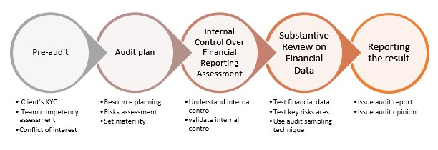
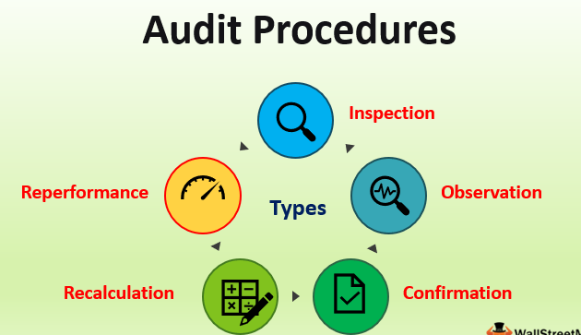

The process of auditing can be summarized by four steps
- Planning
- Collection of evidence
- Controlling and recording
- Review and opinion
6.6.1 Planning
It helps to achieve targeted goal and it provides a guideline for the process. The audit process starts with the proper plan. An efficient plan requires for auditor to envisioning the goals that to achieve and map the essential steps needed to arrive at the desired reports. In IAS,one of the most important standards of International Standards on Auditing is an audit procedure to be planned properly.
For a standard documentation, planning memorandum for clients is important. Memorandum of planning is prepared according to the audit strategy of for Planning memorandum includes
- Nature of entity’s business
- Process of conducting business
- Risk involved with their business and its effects
- Steps taken by the auditor to audit
Key factors of planning for auditing
- Assessment of risk and materiality
- Analytical review
- Test of control
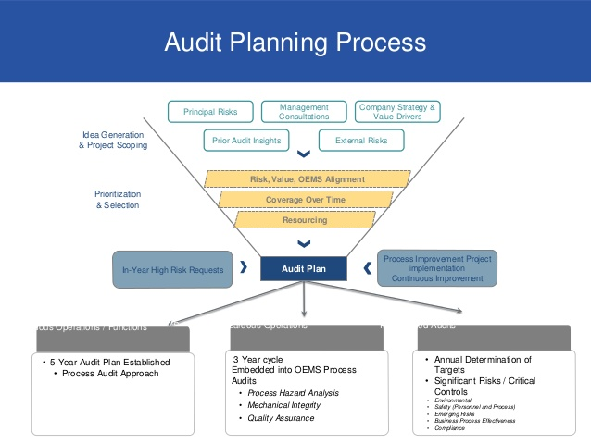
- Assessment of Risk and Materiality
Risk and Materiality are important to formulating an audit plan.
Risk
According to BSA, two standards are associated with risk:
• BSA 315: Identifying and Assessing the Risks of Material Misstatement through
Understanding the Entity and Its Environment.
• BSA 330: The Auditor’s Responses to Assessed Risks.
Some risk that include with audit
- Business risks
Business risks are exclusively associated with company and its shareholders. The factors that include with business risk can be potentially halt its activities and existence.

- Audit Risk
Audit risk are associated with an unqualified opinion due to the auditor’s intentional or unintentional inability to detect material misstatement. Three elements of audit risk
- Inherent Risk is a measure of auditor judgment of the possibility of the existence of material misstatement in the financial statements before taking the effectiveness of the internal control into consideration.
- Control Risk is a measure of the auditor’s judgment that the client’s internal control will be unable to prevent or detect a material misstatement that may occur.
- Planned Detection Risk is the audit evidence for an audit objective that will be unable to detect a material misstatement exceeding performance materiality.
Materiality:
Materiality is an information which is misstated.
Materiality can affect audit in three ways such as
- Affect to the nature and extent of the tests of detail.
- Affects decisions about adjustments of actual errors to projected errors.
- Assessing areas of significance regarding judgmental matters.
- Analytical Review
Evaluates financial information by analyzing the possible relationship between financial and non-financial data. According to BSA an auditor is required to
- Evaluate & Investigate results of analytical procedures
- Perform and design analytical procedure at the end of audit procedures
The analytical review related to the three different but inter related to the stages of an audit:
- Planning
- Extensive analytical review
- Review of accounts
- Test of Control
Test of control has been made by Bangladesh Standards on Auditing to checking the client’s internal control. Test of control is important to develop a plan. Some reasons for test of controls
- Understanding the environment and entity of organization in which it operates.
- Evaluating the design of all the controls related to the audit.
- Testing the efficiency and effectiveness of the internal control of the organization.

6.6.2 Collection of evidence
Audit evidence refers to the information that collected to review the entity’s financial statement. Some way to collecting audit evidence
- Physical examination
- Confirmation
- Inspection
- Analytical procedures
- Inquiries
- Recalculation
- Performance
- Observation
- Evaluation of Errors
Errors of financial statements found when conducting the audit must be assessed and evaluated in order to determine the impact is has on the population. Evaluation of errors is difficult for auditors.
6.6.3 Controlling and Recording
Controlling and recoding is the application of the planning stage of auditing. The collected evidence is evaluated based on those assessment and recorded.
- Assessment of Risk and Materiality
According to APM two risk are assessments
- General Risk
General risk arises from business and administrative system of entity. The assessment of general risk affected by Integrity of the management and business risk.
- Specific Risk
Two objectives of specific risk assessment
- To identify risks and overall impact of risks on particular areas of the financial statements.
- The assessment to the extent risk which can be undertaken by audit
- Materiality
The APM has provide a guideline for level of materiality. Given in below table
Amount in Taka | Profit before taxation parameters | Turnover and total assets parameters
0-5 Crores | 10% | 3.0%
5 Crores 1 to 10 Crores | 10% | 2.5%
10 Crores 1 to 20 Crores | 10% | 2.0%
20 Crores 1 to 56 Crores | 10% | 1.5%
Over 56 Crores | 10% | 1.0%

6.6.4 Review and Opinion
The last stage of audit processing is review and opinions. Auditing reports provides some checklists that should be used to review . Check lists
- Partner completion
- Audit completion
- Questionnaire on critical report
- Justification
- Questionnaire on audit standards and internal reports
Conclusion should provide for each area. The conclusion should be given from the summary sheets and the test has been performed. Each main test for a particular area should include:
- Objective of the tests
- Tasks performed
- Results obtained
- Conclusion drawn

CHAPTER 7

Audit procedure of Hoda Vasi Chowdhury and Co.

Audit procedure of Hoda Vasi Chowdhury and Co.
HVC conduct their auditing process by the following giddiness of ICAB. They mainly follow seven steps in audit procedure. Such as
- Identify overall goals
- Gather & evaluate initial information
- Assess general risks
- Assess account specific risk
- Develop efficient and effective audit plan program
- Conduct audit testing
- Evaluate and communicate audit results

- Identify overall goals:
Firm guides auditor to provide an opinion on whether the financial statement of the organization is true and fairly presented.HVC also determine that whether the financial statement reports follows the guidelines followed by the Bangladesh Accounting Standards (BAS).the following tasks performed by HVC.
- Errors
- Irregularities and other matters
- Efficiently
Errors
Errors can be occurring in many ways in accounts. Financial statements should reflect the fair view.Erros can be done in intentionally or unintentionally way. The auditors find whether it was intensionally or unintensionally.Errors can be arising for
Mistakes in processing of financial data
Mistakes in Implementation of accounting standards
Misinterpretations of incorrect accounting data

Irregularities and other matters
Irregularities is a term which can not be fit with any normal or alternative law and practices of accounting standards. Accounting irregularity can be conduct by intentionally misstatement presentation. It also can be happening by omitting information which need to be disclosed in financial statements. Sometimes risk arise from irregularity of accounting information because it cannot be detectable Reduce the irregularities and mismanagement the problem necessary steps should be taken.
Efficiency:
HVC perform their jobs efficiently and effectively. Efficient audit includes
- Manager of the organization should analyze the risk that can be involved
- An qualified and same audit group can be appointed for auditing
- The audit process should be planned on the base of risk assessment, Undetected material misstatements.

- Evaluate and gather initial information’s:
To make audit efficient and effectively they take some basic information from clients of their company.The following below information is need to be gathered
- Understanding the firm’s nature and activities
- Understanding the internal control system
- Understanding client’s expectations
- Understanding the considering materiality
Understanding the firm’s nature and activities
following data should be collected to incorporate audit report
- Administrative data and external data
- Nature of the entity
- Uses of accounting standards
- Measurement technique of financial reports
Understanding the internal control system
External auditor can know the risk from internal control system. The audit risk and material mismanagement become high the internal control fail to shown up a good internal control system.
There is a standard check list maintain by HVC to check the internal control.
- Understand and Assess Internal Auditing:
Auditor should collect enough knowledge and understand the internal audit system of the firm.A proper understanding of clients internal control nature help auditor to develop a effective plan for audting report.Coordination of external and internal auditor is need to understand the internal process of auditing.such a if firm use any specific software the external auditor can get the use and knowledge of the software from the internal auditor.
- Evaluate and Test the work of Internal Auditing:
This evaluation may include
- The internal system is performed by a qualified person
- The work has been cross checked by internal auditor
- The work is reviewed by internal auditors
- All necessary document and evidence has collected
- Unusual matters disclosed by internal auditing

- Asses general risks
Evaluating of risks help to provident the upcoming risk and exiting risk associated with client’s firm. This is the place risk evaluation's genuine worth in forestalling or limiting negative astonishments and uncovering new chances.The objectivs become more controllable when the potential risks analysis more real-time and forward-looking .For audit planning and risk assessment,some audit evidence should developed.such as
- Effectively assess the inherent risk of financial statement misstatements,
- Identify indicators of possible going concern problems
- Identifying account specific risk
- Planning an overall audit approach to provide reasonable assurance.
D.Asses of account specific risks:
The auditor should consider the risk associated the specific account of financial statements.For identifying risk associated with specific risk they can compare the previous year accounts with present year account,so they can know the deviations in the accounts specific head.Audit team can do audit program manual examination for understanding to running the subsequent estimated fluctuation examination inspectors investigate the head to decide any materiality among them. It is absolutely relying upon the examiner's aptitudes and skill that how he/she will choose the material exchanges. In any case, the more prominent the deviations among the qualities the more noteworthy the danger subsidiary.
E.Develop Efficient and Effective Audit Plan Program:
Here the auditors makes the overall strategy and planning to performed the audit process,This helps them to develop an effective response to the assessment of risk that was materially misstated.In this stage they describe what the collected on planning activities.This may include
- Financial position of the firm
- Nature of the firm
- Understanding of entity of the business
- Client’s expectations
- Internal control system
- Risk associated with the financial statement
- And finally, the audit strategy .
Audit strategy plan includes consideration of audit response to specific risk. It also helps to determine the resources required for the engagement.
Some matters should be included in audit overall plan strategy
- Applicable characteristics of the audit appointment
- Important dates for reporting and other communications
- Setting of materiality
- Initial risk assessment and whether internal controls are to be tested
- Consideration of resources available
F.Conduct audit testing:
Conducting audit testing is the part of fieldwork of audit process. Here the auditor collect evidence for working through the planning. This stage also includes interviewing the managers, employees and shareholders of the firm. Auditor reviews the client documents here and observe procedures of firm.
The very first part of fieldwork is to review the documentation. Auditors makes notes about the documentation relating notes. The documentation includes of audit notes.
Technical compliance test is important to determine that the internal IT system is configured with security policies and guidelines of the organization.
G.Evaluate and communicate audit results:
After gathering all the information and evidence of financial statement of firm by auditor, they move to the further step which is called achievement phases. The sufficiency of evidence collected is calculated by the assessments of risk of the material misstatements. Auditors evaluate the evidence to provide an accurate and valid conclusion report. After conducting the sufficiency and appropriateness of the evidence, they move to the next step.
Now, the determine financial materiality structure. And evaluate all misstatement. This stage is called completion period. Here the auditor accepts the planning materiality figure as a final or lower it.
And lastly audit gives opinion on the financial statement of firm.If they found any false statement, materially misstated and also identified any incorrect approaches they issues opinion that the financial statement is materially misstated and unqualified reports. And if all statements are truly presented by the firm the issue opinion that the financial statement is qualified.

CHAPTER 8

Findings and Recommendation

8.1 Findings
There exists no system that does not face any shortcomings and obstacle to reaching goals. During the preparation of my project report, observed some shortcomings in the audit procedures that auditors can face. Some shortcomings are
- Limitation of time
Usually the audit procedures start at the end of the accounting period.in our discussion we show there are many steps need to be done to present a fair and proper audit.so it is matter of a long time. But our auditors get very short time to provide an audit report.
- Lack of Sufficient Co-operation of the Client
Many times, the client of the organization and the employees reluctant to provide the documents needed to complete the audit. Sometimes they provide the documents in lackluster manner rather being organized. The employees of the clients also observed to be rude, unprofessional and not supportive to the auditors. Because of this the collection of audits become challenging.
- Difficulty in Issuing an Unbiased Opinion:
The auditors need to be independent in mental attitude. Sometimes the client tries to influence them to provide an opinion about their choose. Many auditors issue an unqualified opinion in order to sustain a long-term relationship with the firm.
- Lack of knowledge
Sometimes many auditors were not qualified and they had lack of knowledge on audit procedures which also create barriers to provide audit report.
- Lack of understanding audit standards and guidelines
There are many standards in audit, that are difficult to understand and apply.so when the standard is not understanded properly the audit process remain incomplete
8.2 Recommendation
I would like to establish some recommendation regarding to the solution of the disadvantage. Those recommendation solutions are not immediate but eventual. Some recommendations have been listed below
- For the lack of time, auditors fail to find enough information.so to solve this problem client of the organization can provide a small training session about their system and give a proper idea about the system before audit plan start.
- Auditing is continues learning process.so the audit firm should provide time to time training to auditor, so they can provide a reliable and effective audit report.
- Making the sampling process as detailed as possible
- Reporting about the influence and noncorporation attempts to the regulatory bodies.

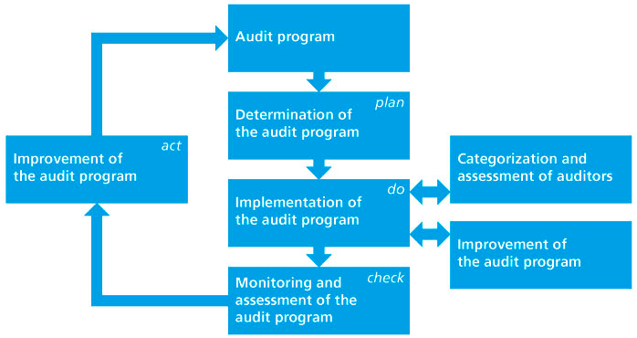

8.3 Conclusion
Accountancy is one the reputed and responsideable profession. As processing audit report an auditor maintain standards and the procedures that is guided by ICAB. This program acts a bridge to between my theoretical and practical knowledge. This also help me to understand the entire process of auditing. This enriches my knowledge and allow me to explore a dimension of experience that was unaware to me before. To make this report I give my best efforts and concern in this report, the audit procedures of HVC was presented in well manner here. They are the great example of following audit guidelines of ICAB in accurate manner. I believe this experience of making report on audit procedures will help in my future.I truly gives my thanks to United International University for this great opportunity.

Chapter 9

Appendix

Reference

Auditing. (2015, Feb 3). Retrieved from Banglapedia: http://en.banglapedia.org/index.php?title=Auditing

alam, M. (n.d.).
Alam, M. (2015). Hoda Vasi Chowdhury & Co. Chartered.

Homepage of Huda Visa Chowdhury & Co. (n.d.). Retrieved from Huda Visa Chowdhury & Co: http://www.hodavasi.com/?cmd=details&id=156

Rahman, A. (2016). Methodology, Benefits and Challenges of Auditing in Bangladesh. Retrieved from Academia: https://www.academia.edu/25527945/Methodology_Benefits_and_Challenges_of_Auditing_in_Bangladesh

