Project Report on
The impact of COVID 19 on maintaining health, hygiene, safety & welfares’ facilities in the Garments Industry of Bangladesh – A Study on AJI Group
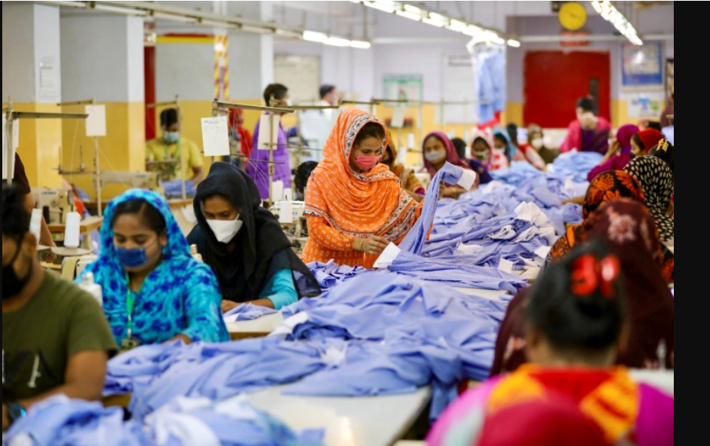
Name of the student
Dewan Anika Rahman

A Project Report Submitted to the School of Business and Economics in Partial Fulfillment of the Requirements for the Degree of Bachelor of Business Administration.
Project Report on
The impact of COVID 19 on maintaining health, hygiene, safety & welfares’ facilities in the Garments Industry of Bangladesh – A Study on AJI Group
Course code: INT 4399

Submitted To
Yeasmin Islam
Assistant Professor
School of Business and Economics
United International University

Submitted By
Dewan Anika Rahman
ID: 111 163 058
Major in Human Resource Management
United International University

Date of Submission
October 25, 2021

Letter of Transmittal
October 25, 2021
Yeasmin Islam
Assistant Professor,
School of Business and Economics
United International University
Subject: Submission of Project Report.
Dear Mam,
I am submitting my project report on “The impact of COVID 19 on maintaining health, hygiene, safety & welfares’ facilities in the Garments Industry of Bangladesh - A study on AJI Group” which is the part of the curriculum of BBA program.
I hope you found this internship report paper to be satisfactory, if you have any questions or concerns about these cases, it will be my pleasure to answer any questions you may have. I admire your full support and gracious cooperation.
I wish that you would be very pleased to accept my report and oblige thereby.
Sincerely,
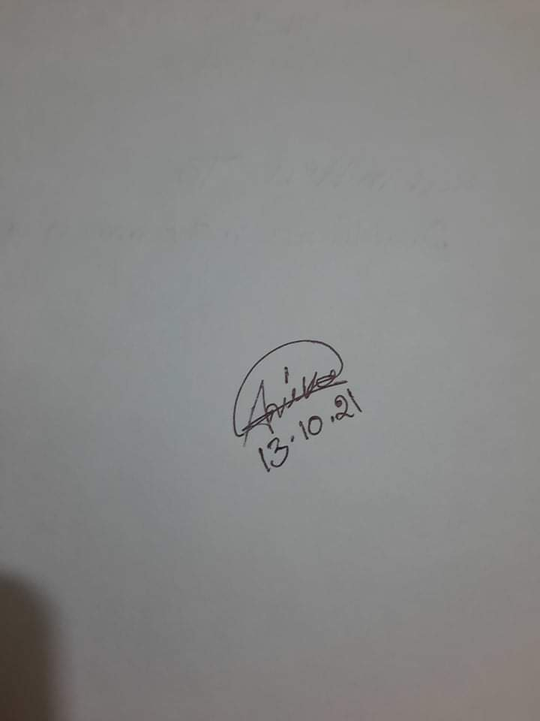
Dewan Anika Rahman
ID: 111 163 058
Program: BBA, Major in Human Resource Management
United International University

Declaration of the Student
I am Dewan Anika Rahman, student of United International University of Bachelor of Business Administration, major in HRM. I do hereby declare that the Project on “The impact of COVID 19 on maintaining health, hygiene, safety & welfares’ facilities in the Garments Industry of Bangladesh - A Study on AJI Group” is real work and has not previously been submitted for a degree or accreditation.
I also now declare that I am the only author of this project, which is being supervised by Yeasmin Islam, Assistant Professor, School of Business & Economics at United International University. This assignment was submitted as part of the requirements for my undergrad degree BBA, Major in Human Resources Management from United International University.
Dewan Anika Rahman
ID: 111 163 058
Program: BBA, Major in Human Resource Management
United International University

Acknowledgment
I would like to thank my project supervisor, Yeasmin Islam, Assistant Professor, United International University's BBA Program, for his patience and guidance in completing this report. It was a great pleasure, and I thank her for providing this topic to help me complete my graduation. She assisted me on finding various contents & issues related to this project report on time to time, and I thanked her for providing me with the best opportunity to work on such a project that will be extremely beneficial in the future. I'd also like to express my gratitude to the university and all of UIU's faculty members & batch mates for their contributions to the development of my current foundation in HR sector. I hope to continue honing my skills in this area and, one day, to be able to meet their standards.

Table of Content

Executive Summary vii
Chapter 01: Introduction
1.1 Background of the Report 2
1.2 Rational of the report 2
1.3 Scope of the report 2
1.4 Objectives of the study 3
1.5 Methodology of the report 3
1.6 Limitation of the report 4
Chapter 02: Literature Review
2.1 Human Resource Management 6
2.2 Functions of HRM 6
2.3 Industrial Relations 7
2.4 Importance of Industrial Relations and Labor Law Practices 7
2.5 Health, Hygiene and Safety in the Workplace 9
2.6 The ministry of labor law of Bangladesh during COVID 19 11
2.7 The Role of HR on Health, Hygiene and Safety Workplace 12
Chapter 03: Industry and Organization Preview
3.1 Ready-Made Garments Industry in Bangladesh 16
3.2 Organizations that will be a part of the study 17
3.3 Overview of the AJI GROUP 17
3.3.1 Mission 18
3.3.2 Goal 18
3.3.3 Strength of AJI Group 18
3.3.4 Buyers and Clients of AJI Group 19
3.3.5 Products and Production Capacity 19
3.3.6 Working Spaces 20
3.3.7 Sustainable Department of AJI Group 21
3.4 Management 21
3.5 Management Hierarchy System of AJI Group 22
3.6 Number of Employees in the HR Department of AJI Group 22
3.7 HRM Operations at AJI Group 22
Chapter 04: Analysis and Findings
4.1 Descriptive Analysis 25
4.2 Discussion 28
Cleanliness and Disinfection Measures
1. Statement: During this COVID 19 epidemic, organization’s workplace is kept clean and tidy regularly than before. 28
2. Statement: The organization has arranged more hand washing; sanitizer and disinfection spray tunnel systems for all workers and labors before entrance at the workplace since beginning of the COVID 19. 29
3. Statement: Sufficient boxes have been arranged for dumping garbage and spit at specific places in your organization. 29
4. Statement: Additional Cleaning Staffs have been hired on your organization during this pandemic situation. 30
Personal Health and Safety
5. Statement: For protective of Corona virus, organization provides face mask, hand gloves and other personal protective equipment to all workers, labors and employees before entrance of the workplace. 30
6. Statement: Infrared thermometer or thermal devices are being used for checking temperature of all workers and labors before entrance of the workplace. 31
7. Statement: Organization is using queue markers to maintain physical distance when workers must assemble in lines. 31
8. Statement: Organization have been arranged a system to avoid crowds at your workplace. ……………………………………………………………………………………………32
9. Statement: Pure drinking water facilities have been arranged for all workers more now than ever before. 32
COVID 19 awareness and Information Spread
10. Statement: New Officers, supervisors and field staffs have been appointed to ensure the health protection, awareness and for spreading information to all the workers. 33
11. Statement: New Officers, supervisors, they have organized training sessions for all workers and labors on maintaining health, hygiene and safety rules about COVID 19. 33
12. Statement: Visual instructions about COVID-19 are displayed in your factory at all. 34
13. Statement: Inspector informs to all workers about the updating information of COVID 19 and Corona effected workers through on the notice or via loudspeaker. 34
Welfare Facilities
14. Statement: First aid and immediate treatment has been arranged for all workers and labors more than ever before now. 35
15. Statement: During the pandemic situation and lockdown your organization has taken initiatives for welfare of the workers. 35
4.3 Findings 36
Chapter 05: Recommendation and Conclusion
5.1 Recommendation 39
5.2 Conclusion 40
References 41
Questionnaire and Data of Respondents 43

Executive Summary

Human Resource Management is the management of all people-related strategies adopted within a firm or Industry. It focuses on maximizing the organization's human resources and improving employee performance in order to meet the organization's goals. Practices of Industrial law and labor relationship are a part of HRM. Healthy labor relations are necessary for the growth and success. Since Bangladesh’ RMG sector is in the 2nd position in the world. So, if long-term lockdowns are maintained in developing countries like Bangladesh, unemployment and poverty could increase at an unbridled rate, along with the number of deaths due to starvation. Therefore, in view of the current reality, the Ministry of Labor of Bangladesh formulated a number of policies on compliance of industries with specific health, hygiene, safety regulations which will be overseen by BGMEA and BKMEA. In this report, the challenges of HR department of AJI Group Industrial Park on maintaining health, hygienic, safety and welfares’ facilities in garments industry of Bangladesh during this COVID situation have been analyzed.
The AJI group established itself in the ready-made garments industry and in the case of maintaining health, hygiene, safety and welfare’s facilities during this COVID 19 epidemic, their organization is now kept much cleaner as well as the HR department perform Occupational Health and Safety duties in their workplaces. According the conducting of survey analysis, some difficulties have been discussed in this report. And according to the analysis and findings, some recommendations have been provided which can be help to the challenges of the HRD of AJI Group on maintaining health, hygiene, safety and welfares’ facilities during this COVID 19.

CHAPTER 01
INTRODUCTION

Background of the Report
Organizations or Garments Industry need to be vigilant in the event of an epidemic so that unforeseen events or external crises do not affect their employees and create immediate uncertainty, an immediate threat to the overall work efficiency & effectiveness of the organization. However, as organizations or garments industry continue to adapt to the recent COVID 19 epidemic, challenges too many areas to their operations need to be indentified as well as new solutions. Therefore, a project report have been prepared by researching the current situation of the garments industries in Bangladesh and their management systems of health, hygiene, safety & welfare’s policies which is required to obtain a Bachelor of Business Administration program from United International University and as well as preparing this project report, it needs to be submitted to UIU’s respected faculty & my project supervisor.

Rational of the report
My Bachelors of Business Administration degree is being pursued at United International University in Dhaka, Bangladesh. I'm nearing the end of my Bachelor's degree program. So, it needs to do an internship or a project to complete my degree. It is a requirement of the university for students to complete their degrees. I decided to do a project on this subject because as a student of HRM and having much interested to gain deep knowledge about the industrial & labor law of Bangladesh’s garments industry since having passionate on working in garments industry. For women empowerment, manufacturing jobs, and foreign reserves, Bangladesh's economy remains heavily reliant on the ready-made garments industry. The main purpose of preparing this report & the study is to analyze & get an idea of how to the garments industry is currently managing their management systems on health, hygiene & safeties of its employees, workers & labors & what are the welfare activities they are taking for their employees, workers & labors in the wake of the recent COVID 19 epidemic, since it has a significant effect on productivity.

Scope of the report
The impact of Covid 19 on maintaining health, hygiene, safety & welfares’ policies in the Garments Industry of Bangladesh – A Study on AJI Group is the main subject of this study & the project report. This study will provide insight into the changes that have happened as a result of Covid-19, as well as the problems that each individual Garments Industry has encountered. Also, how they're dealing with the new changes for their workers & labors.

Objectives of the report
    - General Objective
The main & primary objective of this project is to analyze the impact of COVID 19 on maintaining health, hygiene, safety & welfares’ facilities in the Garments Industry of Bangladesh.
    - Specific Objective
- To know about the impact of COVID 19 in the RMG sector of Bangladesh.
- To know about the policies of Ministry of Labor of Bangladesh on compliance of industries with specific health, hygiene, safety regulations
- To get an overview of AJI Group
- To study on the steps and policies of AJI Group on maintaining health, safety and welfare facilities of all workers.
- To provide some recommendation which can be assisted to the AJI Group on protecting their staffs, workers, labors by ensuring safe working conditions.

Methodology of the report
For preparing this academic report and studying & analyzing the main topic of the report, both qualitative and quantitative data collection methods have been used like:
- Qualitative Methods:
- Interviews,
- Discussion with batch mates, observations & In home videos,
- Reading out articles, reports and books.
- Quantitative Methods:
- Conducting survey
- And Descriptive analysis.
Below is a basic description of how the overall data has been collected from various sources and utilized to prepare this project report:

    - Sources of Data Collection
All of the information for this research & study was gathered from two different sources. They are as follows: -
- Primary Sources
- Secondary Sources
      - Primary Sources of Data
The following sources have been used for collecting the primary data, include:
- Conducting a survey on ready-made garments industry (AJI GROUP Industrial Park - Savar)
- Interacting & discussions with batch mates, faculties, supervisors who are involving in the HR department.
- Observing the current scenario of garments industry during the COVID 19 epidemic & lockdown.
    - Secondary Sources of Data
The following sources have been used for collecting the secondary data, include:
- Official website of AJI Group
- Relevant reports, articles from website and online platforms.
- Various types of public documents and HR reports on ready-made garments industry.
- HR and Industrial Law & Labor Relationship books.

Limitation of the report
Although it was able to reach the main purpose of this study & report but faced some unavoidable problems & situations which are listed below:
- There were inadequate secondary data sources since COVID-19 was a new issue that occurred in 2020. For the same reason, the sources may include inaccurate, out-of-date, or incomplete data.
- Due to the corona virus, it was unable to discuss and conduct a brief interview with HR employees by physically visiting in the garments industry.

CHAPTER 02
LITERATUIRE REVIEW

Human Resource Management
Human resource management (HRM) is the administration of all people-related initiatives used inside a company. It is concerned with enhancing the organization's human resources and increasing employee performance in order to achieve the organization's objectives. HRM ensures that policies and procedures are consistently and successfully applied throughout the firm. Human resource management exists to maintain a balance between employee expectations and satisfaction, as well as an organization's profitability and ability to fulfill its goals. HRM, on the other hand, is a strategy used in practice to aim for the best use of human resources, stimulate individual development, and comply with government requirements. Human resource management (HRM) is commonly found in bigger businesses, and its primary objective is to match company goals with employee goals. Employees who will help a company achieve its goals are needed. An effective human resource management system enables an organization's workers to contribute efficiently and effectively to the achievement of the organization's goals.
Reference: Adeniji, O. &. (2012 (1st Edition)). Human Resource Management: Theory and Practices. Ota Ogun State, Nigeria: Eduactional Publishers.

Functions of HRM
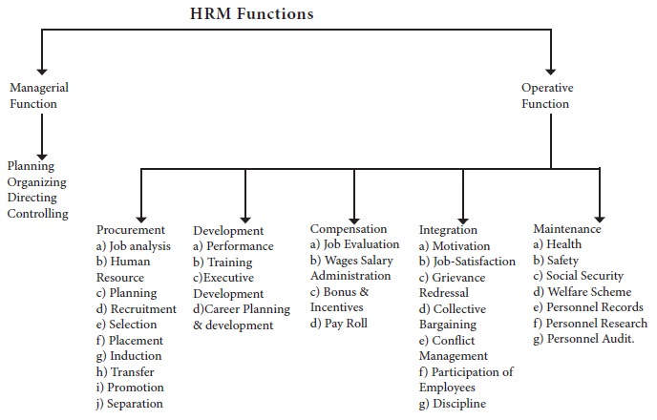

Industrial Relations
The phrase "Industrial Relations" is composed of two words: "industry" and "relations." “Any productive activity in which an individual (or a collection of individuals) is (are) involved” is defined as “industry.” We mean "the relationships that exist inside the industry between the employer and his workforce" when we say "relations." The phrase "Industrial Relations" refers to the interaction that exists between employees and management as a result of the union-employer relationship, either directly or indirectly.
Industrial relations, according to J.T. Dunlop, are "the intricate interrelationships among management, employees, and government authorities."
“Industrial relations” is defined as “the process of management dealing with one or more unions in order to establish and then implement a collective bargaining agreement or labor contract,” according to Dale Yoder.
The HR Labor Relations Manager is in charge of the industry's labor relations. They establish labor relations policies and ensure that corporate rules and procedures are followed consistently. They are also in charge of employee dispute resolution procedures, internal audits, and implementing necessary measures to resolve any difficulties with labor relations.
Referecnce: Concept of Industrial Relations. (n.d.). Retrieved from What is Human Resource.com: https://www.whatishumanresource.com/industrial-relations

Importance of Industrial Relations and Labor Law Practices

Healthy labor relations are necessary for the growth and success. Their importance can be discussed as follows:
- Uninterrupted production: The much more important advantage of industrial relations is that they assure production continuity. This indicates that everyone will be employed eternally, from management to employees and labors. The resources are utilized to the greatest extent feasible, resulting in the maximum possible production. Everyone has a consistent source of income. The seamless running of an industry is critical for a variety of other sectors, including
- Rival industries if the products are intermediates or inputs;
- Exporters if these are export commodities;
- Consumers and employees if these are mass-consumption items.

- Reduction in Industrial Despite: Industrial relations that are strong reduce the number of industrial conflicts. Disputes are the result of underlying human impulses or motives failing to obtain appropriate pleasure or expression, which can be entirely remedied by excellent workplace relations. Strikes, lockouts, go-slow techniques, and complaints are some manifestations of industrial discontent that do not emerge in an environment of industrial peace. It benefits in the promotion of collaboration and the increase of output.

- High Morale: Healthy and strong labor relations boost employee morale. Employees work hard because they feel that the interests of the company and the employees are the same, which is to increase production. Every worker and employees feels he is a co-owner of the company's profits. As a result, the boss must understand that industrial earnings are not only for him, but should be shared equitably and freely with his employees and wrokers. In other words, perfect oneness of thought and behavior is the main goal of industrial peace. It raises employees' social standing and fulfils their ego. It naturally has an effect on productivity because large accomplishments may be accomplished via strong cooperative efforts.

- Reduced Wastage: Teamwork and mutual recognition are the foundations of good industrial relations and labor law practices. It will aid in increasing output. Wastage of manpower, equipment, and machineries is kept to a bare minimum, and therefore national security interests are preserved. As a result, it is clear that strong industrial relations and labor law practices provide the foundation for increased output at a lower cost and with better profitability. It also leads to greater labor efficiency.
Reference: Importance of Industrial Relations. (n.d.). Retrieved from What is human resource. com: https://www.whatishumanresource.com/industrial-relations

Health, Hygiene and Safety in the Workplace
- Notable issues for all employers and workers
Every worker has the legal and legitimate right to health, hygiene, safety and welfare benefits at work. Health, hygiene, safety work environment must be ensured for all the workers as well as optimal workplace health and safety must be achieved through improving workplace practices. The Bangladesh Labor Law Act 2006 - ILO covers the following occupational health and safety issues:
- Health & Hygiene,
- HVAC (heating, ventilation, and air conditioning) systems,
- Artificial humidity,
- Overcrowding,
- Lighting systems,
- Fire incidents,
- Overweight,
- Safety of the structure and equipment,
- Mechanical enclosures,
- Working on or around moving machinery,
- Gases that are explosive or combustible, as well as dust,
- Warnings against hazardous washing,
- Personal protective equipment,
- Risk assessment
- And Prevention measure. (Section 51-99 of Labor Act 2006, amended 2013)

- Free protection and safety
Personal protection equipment (PPE) is required for employees in the workplace under several parts of the labor legislation. Workers must wear suitable eyewear or eye protection if there is a risk of eye injury owing to particles or fragments raised or spread during the manufacturing process, or due to excessive light or heat. The provision of protective equipment for each worker in or near the location where the job is being performed, as well as the use of equipment used in the operation or the use of any dangerous substances in the case of a malicious operation where there is a risk of physical harm, poisoning, or serious illness. It is also the employer's responsibility to report any such warnings. Regardless of whether or not personal protective equipment is given, it is the worker's responsibility if it is not utilized.
- Training
An employer is responsible for providing practical and appropriate health and safety training to its employees, as well as ensuring a safe and healthy working environment. By offering on-the-job training, a company may enhance worker awareness. It is the employer's obligation to give periodic medical treatment to the person engaged in this sort of risky activity where there is a risk of bodily damage, poisoning, or serious sickness, and to prevent him or her from working if he or she is not judged fit for the job. Employees that do this sort of activity or operate with dangerous machines must be properly trained and supervised. (Section 40 (1b), 78 (a3), 79 (c) of the Labor Act 2006, as amended in 2013)
- Inspection system for workers
Inspectors play an essential role in regulating and monitoring workplace health and safety standards under labor law & legislation. Labor inspectors have the authority to inspect any organization's compliance with the law, to examine the registration books and other papers, and to monitor the working conditions of employees hired within the preceding two months. The labor inspector has the authority to order an employer to remedy occupational hazards caused by a violation and to halt work immediately if the breach constitutes an immediate threat to the worker's health and safety. During the regular operation of any organization, an inspector may notify the owners and take samples of any object utilized or brought for use in the organization that seems to be in violation of the regulations or that might affect the worker's bodily or mental health. If an inspector feels that using any component of the organization or its equipment poses a risk to his worker's life or safety, he will notify the owner of the organization in writing and may impose a ban on the organization until necessary repairs are made. The Ministry of Labor and Employment established the Department of Factory and Establishment Inspection (DIFE), which is responsible for health, safety, and labor welfare in 23 districts around the country. DIFE is a law enforcement organization that also assists companies and employees in complying with legal requirements. (Sections 61 (2), 84 (1), 85 (3), 318 and 319 of the Labor Act 2006, as amended 2013)
Reference: Khan, P. A. (2007). Bangladesh Labour & Industrial Law (Modified 2013). Bnagladesh: Uddoyon Public

The ministry of labor law of Bangladesh during COVID 19

The Coronavirus-2019 (Covid-19) epidemic has put the government, economy and healthcare system in an unprecedented crisis. So, far no effective vaccine or treatment to deal with this virus has reached the people of Bangladesh. Therefore, adherence to social distance (e.g., home quarantine, lockdown) is being adopted as the main strategy to prevent the spread of this disease. As a result, billions of people worldwide are now living at home.
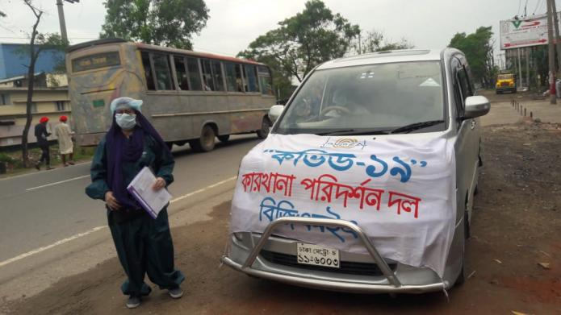
Since Bangladesh’ RMG sector is in the 2nd position in the world. So, if long-term lockdowns are maintained in developing countries like Bangladesh, unemployment and poverty could increase at an unbridled rate, along with the number of deaths due to starvation. Therefore, in view of the current reality, the Ministry of Labor of Bangladesh formulated a number of policies on compliance of industries with specific health, hygiene, safety regulations which will be overseen by BGMEA and BKMEA, as well as 23 numbers of Crisis Management Communities of Ministry of Labor. If the health, hygiene & safety rules are not followed, action will be taken against the concerned factory as per the labor law. These heath, hygiene & safety rules & policies in the workplace of garments industry are mentioned below:
- To make all the staffs & labors of garments industry more aware on the basis of training on physical distance and healthcare,
- Develop the habit of using masks.
- In all cases, masks and hand gloves should be made available to all workers as much as possible. These things are not supposed to be too expensive for a low income country so they can be easily implemented. However, it requires proper planning, preparation and at the same time proper training in their proper use.
- Change the work environment. Where necessary, clear and straightforward guidelines should be given, such as painting on walls and floors to remind people to maintain physical distance,
- The movement of workers at the beginning or end of the shift should be controlled in such a way that the workers can maintain a safe distance.
- Boundaries can be set for workers, so that their movements are limited only when necessary.
- If possible, use barricades to isolate workers in the workplace.
- There should be adequate number of entrances and exits so that there is not too much crowd.
- Provide limited working facilities to the workers. This rules & polices can reduce the risk of infection in a factory with a large workforce but limited space. However, this will reduce the overall production of the factory and the income of the workers may also decrease. But this system is at least good. As long as the long-term lockdown is not as bad as the physical distance, it is not desirable that a large number of workers suddenly fall ill at the same time and the whole factory closes. In this case, the method can bring balance.
- Ensuring adequate water, soap and general sanitation facilities for all workers and providing disinfectants. This is a very important issue to ensure personal safety in the workplace that must be complied with at all times.
- Appointment of officers to ensure “health and safety” issues.
Reference: Instructions of BGMEA to follow the hygiene rules in the factory. (2021, August 01). Retrieved from bdnews24.com.
Health and health protection. (2021, June 11). Retrieved from Mywage.org.bd

The Role of HR on Health, Hygiene and Safety Workplace
Health and safety is defined as "organized efforts and processes for detecting workplace risks and preventing accidents and exposure to hazardous conditions and chemicals," according to the Business Directory.
The HR department, as a section of an organization focused on manpower management, should also give leadership and guidance for maintaining a safety and healthy working environment for employees. It is essential for HR professionals to have a thorough awareness of how safe their workplaces are in order to ensure employee safety. The majorities of HR professionals have associated themselves with traditional manpower management tasks such as recruiting, leave management, training and development, performance management, but have forgotten the importance of Occupational Health and Safety to the employment relationship.
The HR department should perform the following Occupational Health and Safety duties in their workplaces:
- If it is thought that HR cannot manage Bangladesh Labor law act 2006 - ILO duties, an expert in this field should be hired; nevertheless, this should not absolve HR of responsibility for employee health and safety.
- Developing an Occupational Health and Safety policy according to Bangladesh Labor law act 2006 - ILO and giving training on it.
- Establishing an Occupational Health and Safety Legal Compliance Register to aid in the monitoring and evaluation of the organization's adherence to Occupational Health and Safety Statutory/Regulatory standards
- Forming an Occupational Health and Safety Committee, which will include fire marshals and first responder, as required by law.
- Identifying health, hygiene and safety risks, completing a risk assessment, and establishing an action plan are all tasks that must be completed.
- Developing an health, hygiene and safety training program that includes fire drills, refresher courses, and other activities
- Personal Protective Equipment (PPE) is provided to all employees (PPEs) and determining which PPE to use when and where might benefit from a PPE assessment
- Providing appropriate safety indicators, such as fire exits, fire points, and safety notifications on the usage of personal protective equipment (PPEs), as well as providing and maintaining adequate firefighting equipment.
- Medical Examination of Employees
- Trying to assure that the maintenance crew understands the importance of the lockout/tag out system, among other things.
Reference: Anangwe, M. R. (2018, September 06). The Role of HR in Workplace Health and Safety. Retrieved from Linked In
Khan, P. A. (2007). Bangladesh Labour & Industrial Law (Modified 2013). Bnagladesh: Uddoyon Public

CHAPTER 03
INDUSTRY & ORGANIZATION PREVIEW

Ready-Made Garments Industry in Bangladesh
Ready-Made Garments of Bangladesh
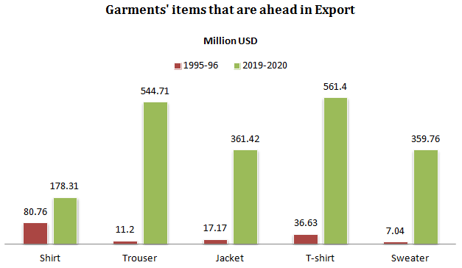
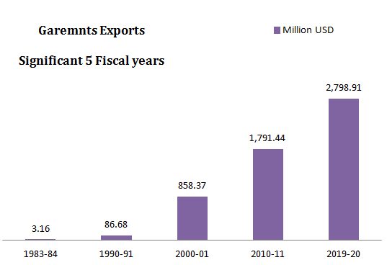
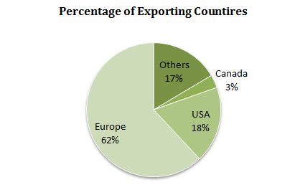
Source: EPB
In the year after independence, Bangladesh exported goods worth only 340.84 million US dollars. Of that, 90% or 310.30 million US dollars was jute & jute products. After jute, the main export products were tea and frozen food. However, the contribution of these two products to the total exports was close to a quarter of a percent.
50 years ago, the ready-made garment sector has changed the face of the country’s economy along with the export of goods. By removing jute, the product has occupied the top position of export. In the space of five decades, the garment industry has contributed in many ways, including a 96-fold increase in export earnings, employment of about 4million rural men and women, women’s empowerment, and the development of allied industries. Bangladesh is the second largest garment exporter after china. Bangladesh also tops the list in terms of the number of eco-friendly garment factories. All in all, the ready-made garment sector has become a big surprise on the golden jubilee of Bangladesh’s independence. There is a strong fear in the world market.
However, after independence, there was no mention of ready-made garments in the export list. The export of that garment sector in the last 2018-2019 financial year was 3,413million USD, which is 2lakh 90 thousand 105 core in the domestic currency. Due to the COVID 19-pandmeic situation, exports fell slightly and this amount is 2,795 million USD in the last financial year. Even then, ready-made garments accounted for 63% of the total export earnings. The share of jute and jute products has come down to 2.72%.
Reference: Karmakar, S. (2021, March 21). The big surprise is the ready made garments sector. Retrieved from ProthomAlo Online Newspaper

Organizations that will be a part of the study
For this project, I have chosen just those companies from which I will be able to obtain relevant project information via a questionnaire. From the RMGC industry, I've chosen the following organization:
- AJI Group

Overview of the AJI GROUP
The AJI group established itself in the ready-made garments industry in 1996 by creating a small sewing unite and is now known as AJI Apparels Industry Limited in various countries all over the world. In order for the ready-made garments industry to survive all over the world, they have always adhered to the principles of honesty, ethics, and integrity & business ethics. Faced with present & future challenges, they made every effort to transform the ready-made garments unit into a professional & reliable one. From the very beginning, AJI’s policy was to offer more to its customers & foreign buyers in an exceptional way. And by fulfilling this commitment, AJI is taking a place among all their customers, foreign buyers and around the world as well as in the domestic country.

M.A. Jalil Ananta
Chairman of AJI Group (AJI Apparels Industry Limited) - 1996

AJI Group’s chairman is M.A Jalil Ananta, who has prepared himself as a hard worker and visionary leader as well as being able to take AJI Apparels Industry Limited to the international Fashion arena.

Mission
To achieving maximum profit by providing best price and services to their customers and buyers by creating a pleasant, clean as well as professional environment in their garments business.

Goal
- Outsourcing
- Design and Manufacturing
- Vendor Consolidation
- Solving Technical Challenges
- Cost Reduction
- Quality Improvement
- Inventory Reduction
- Service Improvement

Strength of AJI Group
- AJI group has its corporate office in its own building at Hemayetpur near the capital city of Dhaka in Bangladesh and all its units are controlled from here.
- Each unit has a management setup for everything from sampling to fishing their products.
- The design of the garments industry and the installation of the buildings have been made keeping health and safety in mind.
- In their official hours, their own medical centre and medical teams provide free services and medicines to their employees and workers at all times.
- In terms of Social Welfare, AJI Group is far ahead of any other garment company in its activities and initiatives.
- They have Child Care centers for children of all their workers and labors, as well as ensuring that children can play and learn at free cost.
- Ethical principles are followed and applied for the export of all AJI Group’s products and services.

Buyers and Clients of AJI Group
The AJI Group works with some of the country's top retailers and buyers.
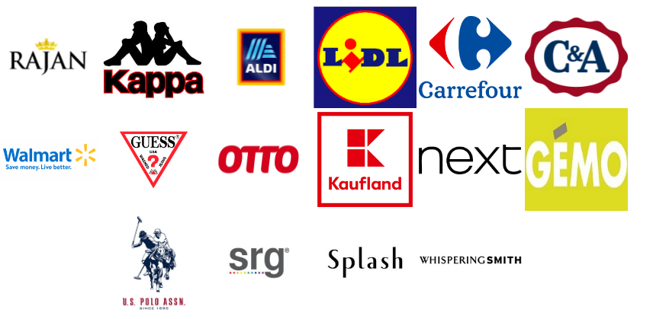

Products and Production Capacity
Sections | Quantities
Knitting | 15,000 to 16,000 kg per day
Dyeing | 14,000 to 15,000 kg per day
Flat Bed Print | 4,500 kg per day
Peach ed Fabric | 4,500 kg per day
Cutting | 48,000 to 50,000 per day
Printing | 28,000 to 30,000 pcs per day
Sewing | 4,400 to 4,500 pcs per day
Washing | 30,000 to 35,000 pcs per day
Finishing | 45,000 to 46,000 pcs per day
Packing | 44,000 to 45,000 pcs per day

Working Spaces
Building | Spaces
01  90,000 square Feet | Fabric Store, reception, medical treatment, security department. First, sewing, finishing, cutting, Corporate Office, Dining & Café.
02  92,000 Square Feet | Finishing fabric store, grey fabric store, chemical store, yarn store, Embroidery, Printing, Cutting, Finishing, Sewing, Dining & café
03  25,000 Square Feet | Child care, security camp, and ware house, Ware house, Finishing Unit, Production Control Department, Accounts Department and Compliance Department, and Accessories store.
04  27,500 Square Feet (Shade) | Dyeing Plant, Washing Plant, Fabric Finishing Unit, Laboratory Unit, Production Control Office, ETP Plant
05  22,500 Square Feet (Shade) | Circular Knitting Unit, Flat Rib, Twill Tape, Yarn Store, Grey Fabric Store

Sustainable Department of AJI Group
AJI Group has a dedicated Sustainable Department comprised of energetic, youthful, and experienced individuals that engage with international specialists & local academia. The sustainable team will be in charge of coordinating relevant actions among AJI Group Textiles' several departments:
Sustainable Teams | Working Activities
- Company Management & Admin  - Company HR and Compliance  - Marketing & Merchandising  - Supply Chain  - Chemical Store  - Production Units  - Utility & Maintenance  - Power Generation  - Effluent Management | - Sustainable Chemical Management  - Energy Efficiency  - Water and Effluents  - Solid Waste Management  - Research and Development on Sustainable Issues  - Training  - Reporting  - Audit

Management

Managing Director and Chairman of the AJI Group is in charge of the whole management. That is what distinguishes AJI from other organizations. AJI can make rapid decisions and do tasks more quickly while retaining high quality. The Managing Director of AJI has extensive expertise and experience in the knit and garment business. As a result, AJI's Managing Director has extensive understanding of the industry. The majority of AJI's employees are under the age of thirty. As AJI in the fashion industry, they are contemporary and capable of accepting new ideas. AJI is doing a fantastic job with the present situation.

Management Hierarchy System of AJI Group
Chairman
Managing Director
Deputy Managing Director
Technical Director
Executive Director
General Manager
Deputy General Manager
Assistant General Manager
Manager
Senior Officer
Officer
Assistant Officer
Trainee Officer

Number of Employees in the HR Department of AJI Group
The name of the labor department was changed to Personnel Department three or four years ago. 15 people are responsible for the department's HR operations, despite the fact that it employs over 4500 people. There is a lot of work that has to be done by five people, and they are feeling overwhelmed.

HRM Operations at AJI Group
On a broad level, it's essential to consider training requirements against the framework of corporate goals and strategies. If you don't do this, you risk wasting time and money on training program that don't help the company's cause. People may be trained in skills they already have; the training budget may be squandered on rest and recuperation sessions, in which employees are entertained but learn little in the way of required job skills or knowledge; or the budget may be squandered on glitzy hardware that meets the training director's needs but not the organization's; or the budget may be spent on glitzy hardware that meets the training director's needs but not the organization's. At AJI Group, the HR teams are involved in many HR operations such as:
- Man Power Planning
- Recruitment and Selection of potential man power
- Training Need Assessment
- Employee Motivation and Evaluation
- Practices Industrial Law
  - Government, laws, and government agencies,
  - As well as "independent" entities such as the Advisory Conciliation and Arbitration Service.
- Maintaining Industrial Labor Relations
  - Workers (informally and formally organized groups, such as trade unions, collective bargaining agent, and their representatives);
  - Employers and their managers, as well as formal organizations such as trade and professional organizations;

CHAPTER 04
Analysis and Findings

Descriptive Analysis
The ready-made garments of Bangladesh have been starting to implement additional safety measures to cope with the COVID 19 epidemic situation. In my project report, the topic is “The Impact of COVID 19 on maintaining health, hygiene, safety and welfare’s facilities in the garments Industry of Bangladesh (A Study on AJI Group).” A survey questionnaire and has been prepared by me for studying and analyzing the topic where 15 questions are included and these questions are categorized into four parts on the basis of-
- Cleanliness and Disinfection Measures,
- Personal Health and Safety,
- COVID-19 Awareness and Information Spread
- And Welfare Facilities.
The questionnaire was in Five Likert Scale which the range was 1 to 5. And for analyzing the data, some pie charts and modules have been used below.
Sample Size (n): 45 respondents were participated to conduct this survey who works in the AJI Group Industrial Park which is located at Savar, Dhaka. And the survey had been conducted through the phone call. Among them 29 respondents were Female (65%) and 16 respondents were Male (35%).
- Sample Size (n) = 45
- Male = 16
- Female = 29
Age (Male): There were 03 males between the ages of 26 to 30years, 09 males between the ages of 31 to 35years and 4 males over 40years of age.
Age (Female): There were 23 females between the ages of 26 to 30years, 02 females between the ages of 31 to 35years and 4 females over 40years of age.
Designation (n=45): Among 45 of respondents, 03 participates were in the officers ranking, 03 participates were in the Trainee officer ranking and the remaining of 39 participates were workers in the AJI Group Industrial Park.
Working Experience: All respondents had 3 to 5years of working experience in AJI Group Industrial Park.
Particulars |  | Strongly  Disagree |  |  | Disagree |  |  | Neutral |  |  | Agree |  |  | Strongly  Agree
Cleanliness and Disinfection Measures

1 | During this Covid 19 epidemic, organization’s workplace is kept clean and tidy regularly than before. | 0% |  |  | 0% |  |  | 2  (5%) |  |  | 38  (84%) |  |  | 5  (11%)
2 | The organization has arranged more hand washing; sanitizer and disinfection spray tunnel systems for all workers and labors before entrance at the workplace since beginning of the Covid 19. | 0% |  |  | 0% |  |  | 0% |  |  | 29  (64%) |  |  | 16  (36%)
3 | Sufficient boxes have been arranged for dumping garbage and spit at specific places in your organization. | 0% |  |  | 0% |  |  | 11  (25%) |  |  | 29  (64%) |  |  | 5  (11%)
4 | Additional Cleaning Staffs have been hired on your organization during this pandemic situation. | 0% |  |  | 0% |  |  | 24  (53%) |  |  | 21  (47%) |  |  | 0%
Personal Health and Safety
5 | For protective of Corona virus, organization provides face mask, hand gloves and other personal protective equipment to all workers, labors and employees before entrance of the workplace. |  | 0% |  |  | 42  (93%) |  |  |  | 0% |  |  | 03  (7%) |  | 0%
6 | Infrared thermometer or thermal devices are being used for checking temperature of all workers and labors before entrance of the workplace. |  | 0% |  |  | 0% |  |  |  | 0% |  |  | 06  (13%) |  | 39  (87%)
7 | Organization is using queue markers to maintain physical distance when workers must assemble in lines. |  | 0% |  |  | 10  (24%) |  |  |  | 02  (5%) |  |  | 30  (71%) |  | 0%
8 | Organization have been arranged a system to avoid crowds at your workplace |  | 15  (33%) |  |  | 02  (5%) |  |  |  | 28  (62%) |  |  | 0% |  | 0%
9 | Pure drinking water facilities have been arranged for all workers more now than ever before. |  | 0% |  |  | 0% |  |  |  | 0% |  |  | 28  (62%) |  | 17  (38%)
COVID-19 Awareness and Information Spread

10 | New Officers, supervisors and field staffs have been appointed to ensure the health protection, awareness and for spreading information to all the workers. |  |  | 0% |  |  | 0% |  |  | 0% |  |  | 43  (96%) |  | 02  (4%)
11 | They have organized training sessions for all workers and labors on maintaining health, hygiene and safety rules about Covid 19. |  |  | 0% |  |  | 0% |  |  | 0% |  |  | 13  (29%) |  | 32  (71%)
12 | Visual instructions about COVID-19 are displayed in the factory. |  |  | 0% |  |  | 20  (44%) |  |  | 07  (16%) |  |  | 18  (40%) |  | 0%
13 | Inspector informs to all workers about the updating information of COVID 19 and Corona effected workers through on the notice or via loudspeaker. |  |  | 0% |  |  | 12  (27%) |  | 05  (11%) |  |  | 28  (62%) |  |  |  | 0%
Welfares’ Facilities

14 | First aid & immediate treatment facilities has been arranged for all workers & labors more than ever before now. |  |  | 0% |  |  | 0% |  | 02  (4%) |  |  | 35  (75%) |  |  |  | 10  (5%)
15 | During the pandemic situation and lockdown your organization has taken initiatives for welfare of the workers. |  |  | 06  (13%) |  |  | 14  (31%) |  | 05  (11%) |  |  | 18  (40%) |  |  |  | 02  (5%)

Discussion

Statement: During this COVID 19 epidemic, organization’s workplace is kept clean and tidy regularly than before.

Figure 1.1

Statement: The organization has arranged more hand washing; sanitizer and disinfection spray tunnel systems for all workers and labors before entrance at the workplace since beginning of the COVID 19.

Figure 1.2

Statement: Sufficient boxes have been arranged for dumping garbage and spit at specific places in your organization.

Figure 1.3

Statement: Additional Cleaning Staffs have been hired on your organization during this pandemic situation.

Figure 1.4

Statement: For protective of Corona virus, organization provides face mask, hand gloves and other personal protective equipment to all workers, labors and employees before entrance of the workplace.

Figure 1.5

Statement: Infrared thermometer or thermal devices are being used for checking temperature of all workers and labors before entrance of the workplace.

Figure 1.6

Statement: Organization is using queue markers to maintain physical distance when workers must assemble in lines.

Figure 1.7

Statement: Organization have been arranged a system to avoid crowds at your workplace.

Figure 1.8

Statement: Pure drinking water facilities have been arranged for all workers more now than ever before.

Figure 1.9

Statement: New Officers, supervisors and field staffs have been appointed to ensure the health protection, awareness and for spreading information to all the workers.

Figure 1.10

Statement: New Officers, supervisors, they have organized training sessions for all workers and labors on maintaining health, hygiene and safety rules about COVID 19.

Figure 1.11

Statement: Visual instructions about COVID-19 are displayed in your factory at all.

Figure 1.12

Statement: Inspector informs to all workers about the updating information of COVID 19 and Corona effected workers through on the notice or via loudspeaker.

Figure 1.13

Statement: First aid and immediate treatment has been arranged for all workers and labors more than ever before now.

Figure 1.14

Statement: During the pandemic situation and lockdown your organization has taken initiatives for welfare of the workers.

Figure 1.15

Findings of the report
In the case of maintaining health, hygiene, safety and welfare’s facilities during this COVID 19 epidemic,
In AJI Group Industrial Park (Savar)-
- Organization is now kept much cleaner. In every floors & spaces of their organization, stairs, work stations, outdoor gardening & roads are being swept on a daily basis with also removing garbage, as well as regularly Disinfectant Spray is being used every day.
- Beside, hand washing, sanitization, disinfectant spray tunnel have been arranged which is mandatory for all visitors, workers & labors upon entering the factory.
- Now more than ever before, more bins and spit boxes have been extended to specific convenient locations. But some of the officers and worker claimed that, a special attention needs to pay to the regular cleaning system on this bins and spit boxes but which most of the time does not maintain properly.
- In the case of hiring additional cleaning staffs, most of the respondents reported that, although cleaning staffs have been employed since the time of Corona epidemic but it’s not adequate enough. As a result, there is more work pressure on other cleaning staffs to keep clean the whole factory and many times they are reluctant to work.
- Even if Face Mask is provided to all those who do not have Face Mask before entering the factory but most of workers reported that they do not receive any personal protective equipment.
- The field staffs and medical staffs regularly measure the body temperature of the workers before entering the factory.
- In the case of using queue markers to maintain physical distance, organization is using queue markers which are at least 3feet to maintain the physical distance when workers needs to assemble in lines and their field staffs are regularly monitoring to ensure that all their workers maintain the physical distance. But, some respondents claimed that, when enough field staffs are absent in the factory, physical distance (3feet) is not maintained properly.
- In the case of arranging a system of avoid crowds at the workplace, factory has been modified and reshaped their work station for the all workers with following 9.5 cubic meters of space. But, at some of the specific places like Canteen, transportation for workers, this system is not maintained properly.
- In the factory, more pure drinking water is now available than before according to the all respondents.
- Form the very beginning of the COVID 19 epidemic, their organization hires new staffs, officers and field staffs keeping in the mind the health of the worker. In addition to dispelling prejudices about the epidemic about the COVID 19 epidemic, they are raising awareness among workers in the field about protecting their health. As well as all workers, labors and employees have been trained by the HR teams, medical staffs and field staffs in weekly basis training sessions on maintaining health, hygiene and safety rules. And the training sessions held on open ground places in the factories.
- Is the case of displaying visual instruction about COVID-19, visual Instructions Display is arranged on only 2 buildings. Workers and labors have gotten the information about COVID 19 & maintaining on health, hygiene and safety guidelines from work announcements, traditional media sources and families, friends and relatives.
- In the case of getting updating information about COVID 19 and Corona effected workers through on the notice or via loudspeaker by inspectors, all workers, labors and officers, they are not getting information from the inspectors.
- More than ever before beginning of the COVID 19 pandemic situation, their organization has arranged first aid and immediate treatment facilities for their all workers and labors. And they also get free medical facilities, medicines from the medical care.
- Factory has taken much welfare initiatives during pandemic situation and lockdown, but most of the workers have been deprived from it due to the large number of workers in the factory.

CHAPTER 05
Recommendations and Conclusion

Recommendations
COVID-19's worldwide effect has shocked not only the garment industry, but the entire world. Since, Bangladesh is currently the world's second-largest apparel manufacturer, with a $20 billion industry that earns 80% of its revenue from exports. As a result, every RMG company should undertake structural adjustments to protect the sector and its stakeholders. In AJI Group Industrial Park, their HRD also should need to put up a list of realistic, innovative solutions and adjustments on maintaining health, hygiene and safety of all workers in their factory. These will assist them in ensuring their company's existence both now and after COVID-19. On the basis of analysis and findings, some recommendation are listed below which can be assisted to the HR teams on protecting their staffs, workers, labors by ensuring safe working conditions.
- AJI Group should form Trade union Community to safe working conditions and providing adequate welfare’s facilitates to all workers and labors. Form a cooperative of factories and notify one another about the government's assistance.
- The HR teams, inspectors, supervisors and trade union must support workers and provide a healthy and safe working environment in order to decrease risks and maintain protection levels.
- Communicate with the all workers, labors & ensure to understanding the clear about Corona Virus with flu or flu-like symptoms.
- Provide flu-prevention supplies, such as hand sanitizer, antibacterial soap, tissues, facemasks and trash bins.
- Encourage their workers to take preventive measures on a daily basis. When they cough or sneeze, they should wash their hands and protect their lips. Ascertain that work travel is safe and adheres to government travel guidelines.
- Post COVID-19 general safety and social distancing posters in the entrance, offices, kitchens, and other areas of the factory. They can also display it on visually with wide screen TV on their factory.
- Use newsletters to convey their intentions and actions in response to the COVID-19 outbreak. Increase public health information and knowledge about ways to stop the virus from spreading. This may be accomplished by providing training to their workers.
- Make an investment in sanitizing their workstation. Hand sanitizer should be available at the workplace's entry. Ensure that everyone who enters the building washes their hands before entering. When workers enter the plant, take their body temperature.
- Establish a contact with government departments that may place orders for personal protective equipment. Keep up with all of the government's announcements on the many ways to receive assistance.
- In the case of all workers’ welfare facilities, food and house accommodation facilities, Form a collective of factories and notify one another about the government's assistance as well as when you take initiatives for welfare of the workers they can be able to find disadvantaged workers in your factory and make a list.

Conclusion
Since Bangladesh’ RMG sector is in the 2nd position in the world. So, if long-term lockdowns are maintained in developing countries like Bangladesh, unemployment and poverty could increase at an unbridled rate, along with the number of deaths due to starvation. Therefore, in view of the current reality, the Ministry of Labor of Bangladesh formulated a number of policies on compliance of industries with specific health, hygiene, safety regulations which will be overseen by BGMEA and BKMEA, as well as 23 numbers of Crisis Management Communities of Ministry of Labor. If the health, hygiene & safety rules are not followed, action will be taken against the concerned factory as per the labor law. In the case of from beginning of the Corona epidemic and more now than ever before, AJI Group is committed to formulating and implementing all types of maintaining health, hygiene and safety policies in addition to keeping their workplace clean and tidy with the considering of practical occupational safety and health. Moreover, for the welfare of the workers and labors of AJI Group during the pandemic situation and lockdown, they implement various initiatives which are quite different from other garment industries and as well these kinds of activities on industrial labor are very beneficial for creating positive image about their garments industry and for sustainable business in RMG sector.

References

Adeniji, O. &. (2012 (1st Edition)). Human Resource Management: Theory and Practices. Ota Ogun State, Nigeria: Eduactional Publishers.
Anangwe, M. R. (2018, September 06). The Role of HR in Workplace Health and Safety. Retrieved from Linked In: https://www.linkedin.com/pulse/role-hr-workplace-health-safety-martin-rodgers-anangwe
BGMEA audit garment factories to guarantee health and safety practice. (2020, May 03). Retrieved from Textile Today: https://www.textiletoday.com.bd/bgmea-audit-garment-factories-guarantee-health-safety-practice/
Concept of Industrial Relations. (n.d.). Retrieved from What is Human Resource.com: https://www.whatishumanresource.com/industrial-relations
COVID-19 Management Guidance for factories in Bangladesh. (2020, March). Retrieved from Better Work: https://betterwork.org/portfolio/covid-19-management-guidance-for-factories-in-bangladesh/
Fathi, N. (2020). Safety First: Bangladesh Garment Industry Rebounds. Retrieved from IFC Insights: https://www.ifc.org/wps/wcm/connect/news_ext_content/ifc_external_corporate_site/news+and+events/news/insights/bangladesh-garment-industry
Hassan, Z. (2020). COVID-19:Impact on ready-made garment workers in Bangladesh. Bangladesh: Unicef. Retrieved from Unicef.
Health and health protection. (2021, June 11). Retrieved from Mywage.org.bd: https://mywage.org.bd/labour-laws/health-and-safety-at-work
HRM PRACTICES AND POLICIES IN AJI GROUP. (n.d.). Retrieved from The Lawyers & Jurists: https://www.lawyersnjurists.com/article/hrm-practices-policies-aji-group/
Humayun Kabir, M. M. (2020, July 13). The impact of COVID-19 on Bangladeshi readymade garment (RMG) workers. Retrieved from NCBI: https://www.ncbi.nlm.nih.gov/pmc/articles/PMC7454782/
Importance of Industrial Relations. (n.d.). Retrieved from What is human resource. com: https://www.whatishumanresource.com/industrial-relations
Instructions of BGMEA to follow the hygiene rules in the factory. (2021, August 01). Retrieved from bdnews24.com: https://bangla.bdnews24.com/business/article1921011.bdnews
Karmakar, S. (2021, March 28). The big surprise is the RMG sector. Retrieved from Prothomalo: https://www.prothomalo.com/business/industry/%E0%A6%AC%E0%A7%9C-%E0%A6%AC%E0%A6%BF%E0%A6%B8%E0%A7%8D%E0%A6%AE%E0%A7%9F-%E0%A6%AA%E0%A7%8B%E0%A6%B6%E0%A6%BE%E0%A6%95-%E0%A6%96%E0%A6%BE%E0%A6%A4
Khan, P. A. (2007). Bangladesh Labour & Industrial Law (Modified 2013). Bnagladesh: Uddoyon Publication.
LESSER, D. (2021, August 02). Lockdown Effects on Garment Workers, Part 2. Retrieved from Garment Workers Diaries: https://workerdiaries.org/lockdown-effects-on-garment-workers-part-2/
Miah, M. K. (2020, June 04). Human resource management during a pandemic. Retrieved from Dhaka Tribune: https://www.dhakatribune.com/opinion/op-ed/2020/06/04/human-resource-management-during-a-pandemic
ORTEGA, D. (2020, September 12). Factory Safety in the COVID-19 Pandemic: Results from the Bangladesh Garment Worker Diaries. Retrieved from Garment Worker Diaries: https://workerdiaries.org/covid-19-safety-measures/
Overview of AJI GROUP. (n.d.). Retrieved from AJI GROUP: http://www.aji-group.com/
Sultan, M. (2020, April). COVID-19 Crisis Implications for the RMG Sector: Trade Union Responses. Bangladesh: BRAC.
Workplace Health and Safety. (2021). Retrieved from WRC: https://www.workersrights.org/issues/workplace-health-and-safety/

Questionnaire and Data of Respondents

Questionnaire on “The impact of COVID 19 on maintaining health, hygiene, safety and welfare’s policies in your organization” – Ready Made Garments Industry
Dear respected respondent,
The following questionnaire is to collect information from people who are working in the garments sector. It’s about the challenges of HR department of the garments industry where they are facing on maintaining health, hygiene, safety and welfare’s policies at their workplace. The information will be kept confidential and be used only for research purposes.
Name: |  |  |  |  | Gender: |  |  |  | - Female |  | - Male
Age: | - (21-25) | 2. (26-30) |  | - (31-35) |  | - (35-40) |  |  |  |  | - (40+)
Position: | HR Managers | Officers |  | Inspector |  |  | Trade Union |  |  | Workers
Working Experience | - (0-3year) |  | - (3-5years) |  |  |  |  | - 5years more

 | Particulars | Strongly  Disagree |  |  | Disagree |  |  | Neutral |  |  | Agree |  |  | Strongly  Agree
Cleanliness and Disinfection Measures

1 | During this Covid 19 epidemic, organization’s workplace is kept clean and tidy regularly than before.
2 | The organization has arranged more hand washing; sanitizer and disinfection spray tunnel systems for all workers and labors before entrance at the workplace since beginning of the Covid 19.
3 | Sufficient boxes have been arranged for dumping garbage and spit at specific places in your organization.
4 | Additional Cleaning Staffs have been hired on your organization during this pandemic situation.
Personal Health and Safety
5 | For protective of Corona virus, organization provides face mask, hand gloves and other personal protective equipment to all workers, labors and employees before entrance of the workplace.
6 | Infrared thermometer or thermal devices are being used for checking temperature of all workers and labors before entrance of the workplace.
7 | Organization is using queue markers to maintain physical distance when workers must assemble in lines.
8 | Organization have been arranged a system to avoid crowds at your workplace
9 | Pure drinking water facilities have been arranged for all workers more now than ever before.
COVID-19 Awareness and Information Spread

10 | New Officers, supervisors and field staffs have been appointed to ensure the health protection, awareness and for spreading information to all the workers.
11 | They have organized training sessions for all workers and labors on maintaining health, hygiene and safety rules about Covid 19.
12 | Visual instructions about COVID-19 are displayed in the factory.
13 | Inspector informs to all workers about the updating information of COVID 19 and Corona effected workers through on the notice or via loudspeaker.
Welfare

14 | First aid & immediate treatment facilities has been arranged for all workers & labors more than ever before now.
15 | During the pandemic situation and lockdown your organization has taken initiatives for welfare of the workers.

Questionnaire of Google Docs
Link: https://docs.google.com/forms/d/e/1FAIpQLSerB0DuMqAxDq2wCyWtqhUM1NNWbiyDxLkhEcfJYkdZKH3Bag/viewform?usp=sf_link
