Challenges of Footwear Industry in Bangladesh

Md. Anaf Joarder

This Internship report is submitted to School of Businesses and Economics, United International University as a partial requirement for the fulfillment of Bachelor of Business Administration Degree requirement

Internship Report
On
Challenges of Footwear Industry in Bangladesh

Submitted By:

Md. Anaf Joarder
Id: 111-152-081

Submitted To:

Kawsar Ahmmed
Professor & Deputy Director- BBA Program
School of Business and Economics, UIU



Date of Submission: June 20, 2020

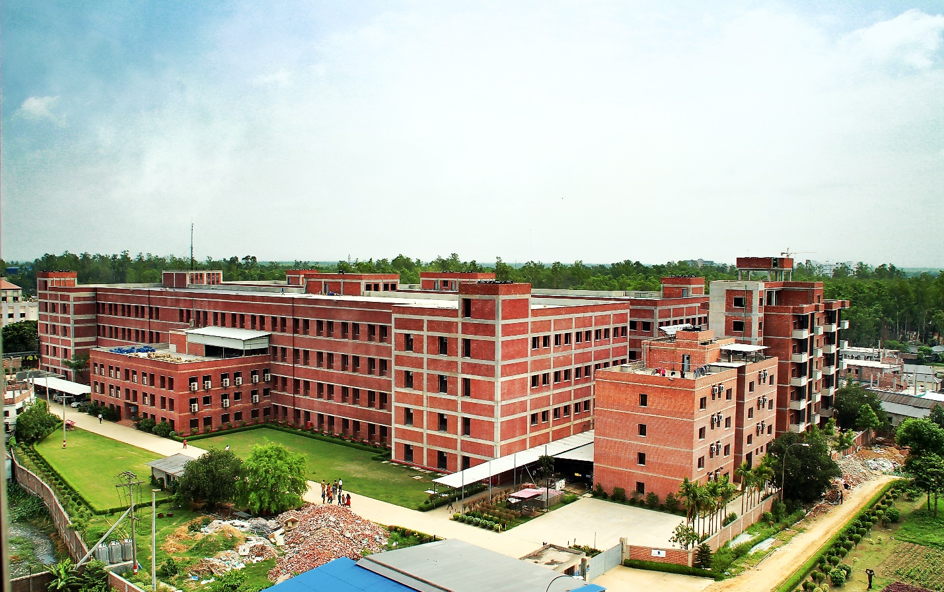

Letter of Transmittal

June 20, 2020

To,
Kawsar Ahmmed
Professor-MKT & Deputy Director- BBA
Internship Supervisor
United International University

Sub: Submission of Internship Report on Challenges of Footwear Industry in Bangladesh.

Respectable Sir,

It’s my great pleasure to presenting my Internship report on Blue Ocean Footwear Limited with gratefulness and admiration. I worked here as an intern of commercial department that’s main task is export and import related. I have completed my six months internship as per required of my BBA degree.

It has been great experience for me practically working with the organization and learning, I would like to thank you for your valuable time and helping me various stages of problems to complete this report.

Yours sincerely

Md. Anaf Joarder
Id: 111-152-081
Bachelor of Business Administration
Session: 2015-2019
Major: Marketing

Acknowledgement

First of all I would like to express my deepest gratitude to almighty Allah for giving me the strength and patience to finish this report with the time period.

I would like to thanks my internal supervisor Kawsar Ahmmed Professor-MKT & Deputy Director- BBA program at United International University for his valuable time; guidelines, appropriate suggestions, and support from time to time that are help me to finish this task.

Also I would like to thanks my organizational supervisor Mr. Shihab, Senior Executive commercial department and Mr. Mustapha Jamal, Deputy Manager commercial department of Blue Ocean Footwear Limited. They teach me practically many important tasks. I can’t actually give thanks to all people who are support me and help me to complete this report.

And obviously I want to give thanks my family members for their coordinate support. And I believe that the endeavor has prepared me for taking up new challenges.

Executive summary

One of the most traditional export items of Bangladesh is footwear. Blue Ocean Footwear Limited (BOFL) is start up amalgamation of Bangladesh footwear industry. It’s a joint venture company between Apex enterprise and Green Ocean International. BOFL introduce their journey in September 30th, 2009.

I joined BOFL as an intern under commercial department of the organization. During intern my working area was prepared the LC/Amendment opening forward letter, collect Bill of Lading, input Bill of Entry and helping hand for prepare export document.

But I completed this report that was required for BBA degree topic on Challenges of Footwear Industry in Bangladesh. This recorded explores the challenges that facing footwear Industry also organizational description. BOFL product, management workforce, mission, vision and relevant sector that is explored.

Moreover a few mistakes have been talk about the finding segment like loss of coordination between departments, experience worker which can collapse the probabilities of the business enterprise in long term period. BOFL quit has been endorsed to lessen the middleman, give schooling to the personnel and start an automated system for enhancing competency at the long term period.

Key words:

Market Challenges, Leather Industry, Export & Import, Joint venture, Supply chain Management

Table of Contents

Letter of Transmittal i
Acknowledgement ii
Executive summary iii

Chapter- 01 Introduction 1
1.1 Introduction 2
1.2 Motivation of the study 2
1.3 Objective of the study 2
1.4 Scope and limitation of the study 3

Chapter- 02 Overview of the Organization 4
2.1 An overview of Blue Ocean Footwear Limited 5
2.2 Objective of Organization 5
2.3 Industry Overview 5
2.3.1 Local Market 5
2.3.2 International Market 6
2.4 Investment 6
2.5 Core Competencies 6
2.6 Vision 6
2.7 Mission 6
2.8 Organizational Structure 7
2.9 Commitment to clients 7
2.10 Product and service of the organization 7
2.11 Management team& Workforce 11

Chapter- 03 Challenges of footwear Industries in Bangladesh 12
3.1 Challenges of the company 13
3.1.1 Technical methods and processes 13
3.1.2 Need more expert people 13
3.1.3 Political Instability 13
3.1.4 Strength and Compatibility 14
3.1.5 Supply Chain 14
3.1.6 Intermediary 14
3.1.7 Better quality of product 14

Chapter- 04 Job Description 16
4.1 Nature of the Job 17
4.2 Specific Responsibilities of the Job: 17

Chapter- 05 General Findings 19
5.1 Introduction 20
5.2 Data collection procedures 20
5.3 Findings & Analysis 21

Chapter - 06 Conclusion 23
6.1 Recommendations 24
6.2 Conclusion 25

Chapter- 01
Introduction


Introduction

The Footwear enterprise in Bangladesh has run out for the reason that colonial era, despite the fact its modernization occurred handiest in overdue 1980s. In the footwear industries raw materials facilities availability of indigenous the setting up of the industry in early 1940s in the east Bengal. The primary purpose of the production of footwear in Bangladesh was for exporting purpose.

In Bangladesh the footwear industries early improvement of degree. There starting time have no updated machine for footwear industry within the U.S.A until early 1900’s. Cottage and family stage short factories enclosed the footwear manufacturing. Bata Shoe Co, (Bangladesh) Ltd. They are the first manufacturing company and used updated machine. Bengal footwear and few of company they used supply to selected dynamic through Eastern.
Bangladesh leather are as a sub zone of footwear sector gets additionally precedence from government but this region as properly become neglected by using the own country role maker for decades. Now within the technology of globalization, no person can find an opportunity of product diversification.
Footwear sector is most conceal area of Bangladesh that identified by Bangladesh Government. Through exporting leather and leather product we earn foreign currency very year. Government also gives 15% incentive for exporting the leather product because of encouraging this sector. In Bangladesh now a days footwear industries playing vital role of the internationally market place.

Motivation of the study

Basically motivation of this study came to complete my Degree. Bachelor of Business administration is not only academic course, in real world student need to interact with customers, suppliers, profit, sell etc. through working with an Organization.

Objective of the study

The objective of this report comes in two forms;
- Primary Objective
- Secondary Objective

Primary objective:
The primary objective of this report is to complete the Bachelor of Business Administration Degree and practically known about how does the organizational activates.

Secondary Objective:

- Mainly focus on the problems of footwear industry in Bangladesh.
- To identify the role of footwear industry in Bangladesh
- To give an overview of Blue ocean footwear Ltd.
- To focus and discuss about the export and import activates of Blue Ocean Footwear Ltd.
- To focus on the core value, mission, vision and yearly profit of the organization.

Scope and limitation of the study

The scope of the study is the find out the challenges of footwear Industry in Bangladesh based on Blue Ocean Footwear Limited. For footwear industry should be improved some area of problems step by step. Also the report depth details about the various department of the organization.

Limitation of this study however I have an opportunity to only work in the commercial department. In preparing this report certain imitations were faced.

- Website has not highly sufficient information
- My report may be vary with the counsel of the efficient person of this sector
- Organization provide insufficient information because of their high restriction
- Insufficient recorded information


Chapter- 02
Overview of the Organization

An overview of Blue Ocean Footwear Limited

Between Apex Enterprise and Green Ocean International Limited is a joint venture and their sister Concern Company is Blue Ocean Footwear Limited. Mainly BOFL objective to be leading producer and exporter of fashionable leather shoes from Bangladesh.

Blue Ocean Footwear more than 36 years’ experience production of leather footwear and in Bangladesh with apex they start their manufacturing and export the product from Bangladesh. Green Ocean globally marks and they export more than ten millions pairs of footwear. Green Ocean International operate their business many countries in the world like Taiwan, China, Vietnam, Korea, Japan, Colombia and Bangladesh.

In Bangladesh Blue Ocean start the business with Apex enterprise where 49% shareholder Apex enterprise and 49% shareholder of Green Ocean International, rest of two percent hold a chines individual person. Initially they invest in Bangladesh 70 cores. Yearly BOFL export around three to four cores amount of footwear product. Mainly they produce two types of boot men’s and women’s.

They try to their best for produce quality product and they maintain the best customs art of globally.In Bangladesh their factory location East Chandra, Kaliakoir, Gazipur, Bangladesh and Head office in Bangladesh address Gulshan o1, Dhaka.

Objective of Organization

Core objectives of BOFL is manufacturing quality full leather footwear and export the product globally.

Industry Overview

Local Market

Apex Footwear Ltd, Bay, Bata is the top footwear producer in Bangladesh market. They annually produces seven hundred cores taka’s footwear product in Bangladesh. Where 45 percent of product are needed for shipment outside and rest of product they sell in Bangladesh.

The nearby market is dominated by way of small scale retail producer among them prepared retail manufacturer and distributor which include Bata (22%) and Apex Adelchi (6%) have a giant marketplace share.

International Market

Since the past few year’s footwear industries is growing day by and in globally. Here the growing demand for product is all types of footwear and comfortable footwear for all gender and ages. The international footwear market segmented by how many types of footwear and who can use the footwear. Asian countries are the major exporter of shoes in globally developed country. Leather footwear is premium products and significant market share in international market.

Japan and Germany is now the biggest marketplace for Bangladeshi shoes however US shoppers are increasingly more showing interest. With at least seven massive factories under production altogether 18 shoe and leather factories are presently there on the Export Processing Zone.

The footwear industries underneath creation consist of Korean enterprise Youngness’s footwear complicated that is stated and want to be number one and biggest in Asia. An employer of Chines as manufacturer sports clothing for different main brands where many worth of export footwear around 56 million.

Investment

Initially the company invest in Bangladesh was calculated round 70 crore tk. Among that Apex Enterprise Limited of Bangladesh contain 49% and Green Ocean International of Taiwan contain 49% share of company. Rest of 2% holds individually one person who is the director of Blue Ocean Footwear Limited.

Core Competencies

Core competencies differentiate an organization from its competition and create companies competitive advantage. BOFL core competencies their quality of product and they export all the product.

Vision

“Honest Growth”

Mission

Blue Ocean footwear’s they want to be a key production company and trade globally of fashionable leather footwear from Bangladesh.

Organizational Structure

Here I explored only the head office structure. Other department of the organization in Factory.

Commercial Department:

Commercial department task included prepared LC, Amendment, bill of lading and export import oriented. I worked commercial department six months and I learn many things. Here basically BOFL import their raw materials from many countriesand commercial department arrange the entire document. Here employees maintain a good relation with their suppliers. And Export side task is opposite of import. Here the employee arranges all the export.

Finance& Accounts:

The objectives of this department is maintain and distributing all the funds for every department when others need. The manager calculates the entire LC amount and other necessary accounts. They calculate very cost and earn of the business. Also they calculate vat, tax and pay tax to the government.

HR Management:

In head office basically they have no HR department but the director of finance who are the leading person of HR department in head office. But BOFL have HR management in their factory.

Commitment to clients
Blue ocean footwear strives to generate superior value and service for their clients. They provide the best facilities of their supplier and customer. BOFL try to fulfill their commitment to provide high quality footwear good. Also they try to maintain good communication with their clients. BOFL relay on the professionalism of their people and client’s success and respect and maintain long term relationship to clients.

Product and service of the organization

Since 2009 in Bangladesh Blue Ocean Footwear Limited started their production. BOFL received huge response from the global market that motivated them to expand their production in Bangladesh. BOFL select Bangladesh because of reducing total production cost.BOFL export their product many countries like Taiwan, Germany, Brazil, Singapore, China, and Chile. Their annual production is 2.2 million pairs of ladiesfootwear. Their annual sells record average 300 cores.

They just produce two types of footwear in Bangladesh.

- Men’s Boot
- Women’s Boot

Men’s Boot: Here I’m trying to show sample of men’s footwear of Blue Ocean that helps to realize about the product.

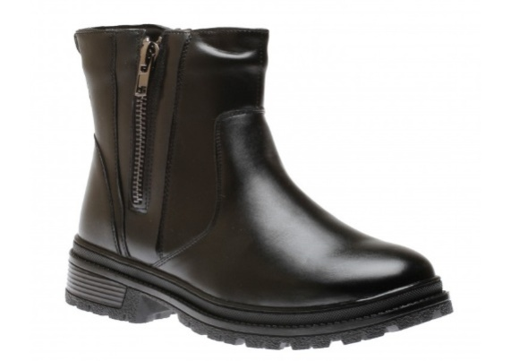

Men’s Grip 2 Black

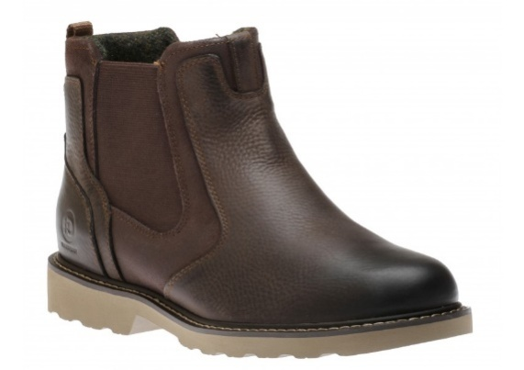

Jake Chelsea Brown

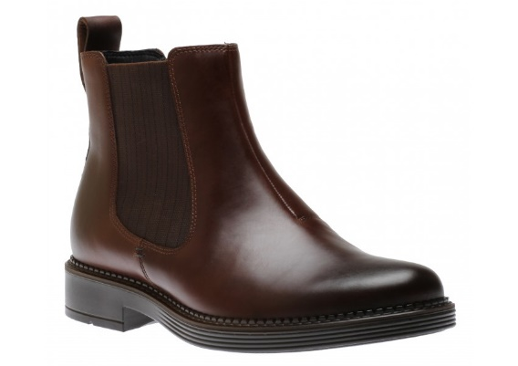

Newcastle Brown

Women’s Boot: Here some photos of women’s footwear

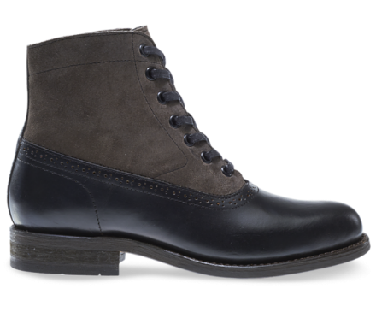

WOMEN’S MARCELLE

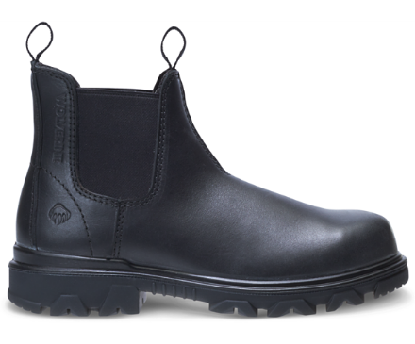

WOMEN’S I-90 EPX ROMEO BOOT

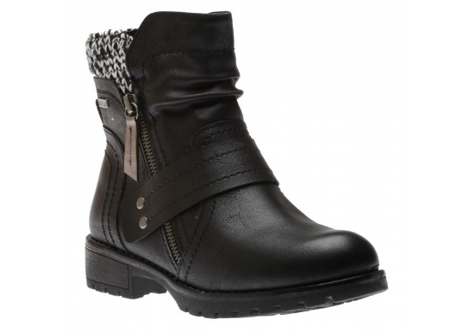

WOMEN’S BOOT BLACK

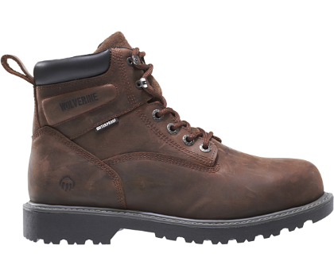

WOMEN’S FLLORHAND WATERPROOF 6” BOOT

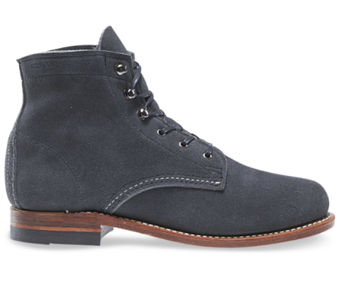

WOMEN’S ORGINAL 1000 MILE BOOT- SUEDE

Management team& Workforce

In Blue Ocean Footwear along with factory their total employee 4000 peoples. With ten directors where five person from Apex Enterprise in Bangladesh and another five person from Green Ocean International. Below name of the board of directors:

NAME | DESIGNATION |  | SHARE
Sayed ManzurElahi |  | Chairman | Apex Enterprise  49%
Sayed NasimManzur |  | Director | Apex Enterprise  49%
NilouferManzur |  | Director | Apex Enterprise  49%
Sayed GiasHossian |  | Director | Apex Enterprise  49%
Abdul MomenBhuyan |  | Executive Director | Apex Enterprise  49%
Liu Kuang- Min |  | Director | Green Ocean International  49%
Chang Chen Tsao |  | Director | Green Ocean International  49%
Chen Hung-I |  | Director | Green Ocean International  49%
Yu Cheng- Hsing |  | Managing Director | Green Ocean International  49%
Chen Shao- Tseng |  | Director | Individual 2%

Table-1: List of Directors

Chapter- 03
Challenges of footwear Industries in Bangladesh


Challenges of the company

In footwear sector is not always see you later records of reputation international marketplace for our country attitude. Reason of this is lack of era, professional employment, desirable adapting flora, andcommuniqué. Following barriers and demanding situation are front of shoes industries to adult:

- Technical methods and processes
- Need more expert people
- Political Instability
- Strength and Utilities
- Supply Chain
- Intermediary
- Better quality of Product

Technical methods and processes

The primary and essential vital thing to build world well known footwear processing plant automated technology method and process is more effective. In timean afternoon at that place may be some of new automated machine to procedure leather sector auto CAD, Automatic machine etc. So Footwear sector should undertake updatetechnology to construct their working flora. We would speak about European and North American for their updated machineries

Need more expert people

For this sector skilled manpower is essential because without skilled manpower this sector can’t expand. For our country leather sector playing a vital role. So if we want to conduct globally then skilled is must. Leather sector is not developed like other sector so people can not want to build up their career in this sector. I think in footwear industry Bangladesh need mort expert people for competing with globally.

Political Instability

To make certain stated elements, political durability is so much important. Except political durability nobody can make sure the ones multiplier to broaden our footwear industries.

Our modern political state of affairs isn’t always amiablefor growing our footwear industries. Therefore our countrywide leaders must show the importance for investing our footwear sector in Bangladesh. So when the foreign investor can realized about political instability then they show their interest for investing footwear sectors.

Strength and Compatibility

The main necessity to develop any industries strength and compatibility. In our country alike other sector of industries if the government developed strength and compatibility of footwear sector for facilities and manufacturing. Therefore our government should take a vital role for developing this area.

Supply Chain

Because of raw materials import and finished good export supply chain management is high challenge for this sector. Time to time delivery effective for every company. On my working experience I faced problem of shipment. So that I think it’s a challenge for footwear industry. Supply chain management is not that much improved in our country but they’re still trying their best.

Intermediary

On my working experience and study on this sector I find out the intermediary problem. Because in Bangladesh maximum footwear company import leather and raw materials from other country. But if they use our leather they can minimize raw materials cost. Because import is long time process and high cost. Footwear Company import raw materials because they claim in Bangladesh leather quality is not good. And some people sell our local leather to outside and again we buy it from them higher price. So I think its challenges for footwear industries.

Better quality of product

Better quality of product is an important challenge for footwear industries. If product quality is not competitive as like as other branded footwear then our local footwear can’t compete with them. But In Bangladesh Apex Footwear export 60% product in many countries. If other footwear company cannot maintain their quality its challenges for footwear industries.

Finally, I want to say that footwear sector is elevating sector of our Bangladesh that’s result of growing economy. Every partition have some challenges but this sector government attention is high and government ginner this sector. Now a days the period of making worldwide business where anybody can’t find an alternative of product diversification.

Chapter- 04
Job Description


Nature of the Job

In commercial department of Blue Ocean Footwear I have worked 6 months as an Intern. During this time I had assigned to helping hand for export and import related task.

Specific Responsibilities of the Job:

Import Database

Here I maintain the entire export file which reflects LC number, LC date, Commercial invoice, Pro-forma invoice, imported item name, Quantity, Price and additional task.

Collected Document from Bank

Getting the all import and export related document from Bank like LC, Amendment, export document, Shipping guaranty, Original document.

Collecting B/L (Bill of Lading)

Collecting the BL from the logistic company where my task was matching the invoice number, shipment date, attached stamp. Sometimes need to correction the bill of lading because of mismatching.

Collected GSP form from EPB

For exporting the product every company must collect the form from EPB. Chile form for only export for Chile, Afta and Sapta form for exporting under South Asia Country and other relevant.

Work related with Bill of Entry

I recorded the entire imported item to the Bond book. Because government rules company must show their import item details for exporting finished good.

Work related with Export Document

Also my task was export document related like export LC, TT, Cash Incentive, Shipping bill. Here I help them as co-coordinator.

GSP (Generalized System for Preference) Approval

LFMEAB (Leather and Footwear Manufacturing and Exports Association of Bangladesh) approved the GSP. After that we submit it to Export Promotion Bureau of Bangladesh for export our product

Chapter- 05
General Findings


Introduction

In Bangladesh footwear is a conventional export product. Footwear created first class leather based inside for their qualityBangladesh gain a very excellent renown worldwide. If our country use updated technology to high best shoes supply then the business expert trust that export profits from the arena can be considerable accelerated. Basically its relay on taking suitable rules at the footwear industries and government arena. The product need to be advanced to satisfy the nice requirements demanded by way of the purchasers of the global marketplace specifically of the developed world. Because of less wage command and poor legal guidelines of Bangladesh is a comparative advantage for our country in worldwide developed country.

Moreover, Bangladesh enjoys duty exemption under the Generalized System of Preference (GSP) approval from the developed country for export the item. From World Trade Organization (WTO) Bangladesh enjoy without any tariff. This is an opportunity for Bangladesh to expand export sector.

Data collection procedures
Here I complete my study based on both of data primary and secondary.

Primary Data:

- Practical working experience
- Personal administrated question to officers
- Collect data to my organizational supervisor

Secondary Data

- Official software
- Website
- Working papers
- Internet
- Previous report

Findings &Analysis

Following are the findings from Blue Ocean Footwear Limited via analysis which catchmy attention:

Intermediate Agent

Blue Ocean Footwear produced their product in many countries but they sell their product in European country through many website that is not BOFL personal. They sell their product through third party. Here the middle man take advantage from Blue Ocean Footwear only because they have no brand value in Market.

Lack of Well Trained Personnel

Restrain working in one of the skilled occupations and skilled employees are most important fundamental issues that’s BOFL facing right now but day by day trying to developed it through arrange training and meeting. Skilled personnel of Apex Adelchi Footwear Limited offer helping to the personnel of Blue Ocean Footwear Limited which is from time to time creates confusion among corporations.

Import Updated Machinery for Factory

The biggest problemis that maximum important equipment had to be imported for maintain going for continue the manufacturing and it every time and postpone the produce. Along preservation BOFL must depend on external specialist to find out the problems and that could be most ingesting also luxurious.

File Tracker Machine

Blue Ocean Footwear haven’t any types of device where they export their all data individually. So I think if they updated their automated machine they can easily track and find out the data automatically. It’s helpful because when other department ask to another department for any file or any types of data then easily can find out.

Intricate Guidelines & Regulation

Bangladesh customs and Export Promotion Bureau of Bangladesh they doesn’t updated their rules and guidelines. Because of that trading take long time. EPB sell their form manually and collect from their office. So if the government update customs and EPB then easily we can export product and time will be reduce.

Inability to coordinate among Department

Inability to coordinate among department refers the head office of blue ocean footwear located in Gulshan 01 where only three department doing work and rest of department works in the factory which located Gazipur so they face always inability of coordination. Absence of key employees in the head office tends to result of conflicts among the department sometimes.

Here the recommendation part I tried to find out few answer to the troubles that recognized though resolution provided in this part might also alter with counsel of specialist on this subject.

Chapter - 06
Conclusion



Recommendations

After finished my study on this area I would like to recommend some area of the following verity:

- Decrement the Third-party:

BOFL is an established footwear company. If they want they can create a new brand value in Bangladesh and globally rather than working with Apex enterprise or Green Ocean International.
When they trade internationally and the display is automatically create a new brand value. After they globally sell their product without any third-party

- Well skilled person:

BOFL can trained their worker and employees for how to reduce the cost and how to be cost effective. They can trained up and expand their business.

- Operate with automation:

I recommend BOFL for the automation system that helps them to find out the data easily and export related task that they doing now manually.

- Backward integration:

Beside footwear BOFL should sift of worker from other uncooked equipment for uploading. The company want to set up a behindhand connecting so that they continue the produce seasonable and the prices.

- Strength of LFMEAB:

The ability of LFMEAB is strengthening, so that the company identify and find out to authorities what the issues in modern export manner are and what ease for implement they can understand.

Conclusion

When I was join Blue Ocean Footwear Limited (BOFL) as an Intern I was not concern about what to expect from the company. But it was a good short journey for me and I gain knowledge about the organizational task and everybody was helpful. It will be opportunity to me know about the organizational culture also environment. The main competitive opportunity for Blue Ocean Footwear Limited is to work with direction of Apex Adelchiwhere the local footwear company lacks the direction and experience.

Finally it could be told that there are no effort and initiative that grow up the footwear industry for free trade until the management skilled and utilize new technologies.

References

- http://www.apexpharmabd.com
- http://www.studymode.com
- http://supernatural-tarot.com
- http://www. epb.gov.bd
- http://www.apexadelchi.com,
- Apex Footwear Limited Annual Report
- Blue Ocean Footwear Annual report
- MrMujiburRhaman, AGM Commercial of BOFL, Head office.
- Mr. Mostopha Jamal, Deputy Manager commercial of BOFL, Head office
- Mr. Kawsar Ahmed, Deputy Manager, Accounts and Finance of BOFL, Head Office

