
United International University
Internship Report
On
Managing the Integrated Marketing Communications:
A Case Study on CEMS-Global

Submitted To:
Muhammad Hasan Al-Mamun
Assistant Professor
School of Business and Economics

Submitted By:
MD. Nahidul Alam Tuhin
ID: 111 132 183
BBA Program
School of Business and Economics
United International University

Acknowledgement

Though the internship program has to be done individually for the purpose of completion of the credit hour, it is quite impossible to do it alone without the sincere and outmost cooperation of some Individuals. It is a very great and unique pleasure to me that I have got a chance to thank some Individuals for their help and encouragement to make my internship successful.

At first, I would like to express my respected appreciation to my faculty advisor Muhammad Hasan Al-Mamun, Assistant Professor, School of Business & Economics, United International University. His constant guidance and advice played the key role in making this report successful. He always gave me his suggestions that were crucial in making this report as flawless as possible. Without his kind supervision, this report would not be completed.

I must take this opportunity to thank & I am blessed to have Mr. Abu Noyem Md. Sharif, Head of Marketing, CEMS Bangladesh Limited. My heartiest gratitude to ‘CEMS-Global’ for giving me the opportunity to complete my internship in their organization & for all their supports during my internship period. Finally, I am blessed to have such wonderful people as my colleagues. Without their cooperation, I would never be able to complete my internship at the CEMS Bangladesh Limited.

Letter of Transmittal
January 29, 2019
Muhammad Hasan Al-Mamun
Assistant Professor, School of Business & Economics
United International University
Satarkul, Dhaka -1209

Subject: Submit the Internship report on ‘Managing the Integrated Marketing Communications:
A Case Study on CEMS-Global’

Dear Sir,
It is a great pleasure and privilege to present the internship report on ‘Managing the Integrated Marketing Communications: A Case Study on CEMS-Global’ which was assigned to me as a partial requirement for the completion of BBA Program. Preparing the report, I gathered lots of knowledge about many facts and insights previously unknown, and problems & prospects of IMC related activities of CEMS-Global.

Throughout the study I tried my level best to accommodate as much information and related issues as possible and tried to follow the instructions as you suggested. I tried my best to make this report as much informative as possible. I hope that it will meet your requirements and expectations. I firmly believe that this report will serve the purpose of my internship program.
I, therefore, pray and hope that you would be kind enough to accept my report and oblige thereby.

Regards,
MD. Nahidul Alam Tuhin
ID: 111 132 183
School of Business & Economics
United International University

Declaration

I am Md. Nahidul Alam Tuhin, a student of Bachelor of Business Administration (BBA) program of United International University. As a partial fulfillment of the requirement of the BBA program I have to perform the internship in exploring the activities of CEMS-Global.
I hereby declare that the report is titled as ‘Managing the Integrated Marketing Communications: A Case Study on CEMS-Global’ prepared and completed by me under the supervision and guidance of Muhammad Hasan Al-Mamun, Assistant Professor, School of Business & Economics, United International University.

Executive Summary
The number of exhibiting and event management firms in Bangladesh is increasing day by day. The competition among these firms is very acute. So they always try to distinguish themselves by providing proper messages to the people in a right way. So they are using the various Integrated Marketing Communication (IMC) tools to communicate with the clients as well as the mass people. Here the purpose of the study to evaluate the integrated marketing communication (IMC) process of CEMS-Global, a firm involved in managing exhibiting and events for the clients.

CEMS- Global is the leading exhibition organizer in Bangladesh which is running their business since 1992. They organize more than 40 exhibitions at home and abroad annually on different sectors like textile, power energy, construction related sector, food and agro based sector, medicine sector and commercial automobile sector etc. This report is mainly focused on the tools and techniques of IMC used by the CEMS Global and how effective these tools and techniques are for the company.

They used different IMC tools to give the proper messages to the desired client and also getting different ways to promote their events. They use both ATL (Above the Line) and BTL (Below the Line) processes to promote their events and now they are starting to use TTL (Through the Line) process. CEMS-Global are using different media for advertising, billboard and they organize a press conference with all media before each and every exhibition for the sake of creating the strong brand image for the clients they serve.

CEMS-Global need to focus on Television Commercials (TVC) now. New and innovative ideas and exhibitions are being launched nowadays. If they do not make them more unique from their competitors, it will be harder for their future to survive and thrive in this industry.

Key Words: Integrated Marketing Communications, Event Management Company
Table of Contents
1. Introduction 1
2. Organizational Background and Industry Perspectives 3
2.1 Overview of Event & Exhibition Management 3
2.1.1 Industry in Bangladesh 3
2.2 Company Overview 4
2.2.1 History 4
2.2.2 Profile & Services 4
2.3 The Wheel (Departments) of CEMS-Global 6
2.4 Analysis and Interpretation 6
3. Exhibitions Organized by CEMS Global 7
3.1 TEXTECH Series of Exhibition 7
3.2 DHAKA MOTOR SHOW 8
3.3 FOOD & AGRO Bangladesh International Expo 9
3.4 POWER Series of Exhibitions 10
3.5 CON-EXPO Bangladesh International Expo 11
3.6 REAL ESTATE Expo 12
3.7 MEDITEX Bangladesh International Expo 13
4. Project Flows of CEMS-Global 14
5. Broad Description of Project Flow 15
5.1 Pre-event 15
5.1.1 Research Concept 15
5.1.2 Planning, Budget & Control 15
5.1.3 Resource & Alliances 16
5.1.4 Tangible Resources 16
5.1.5 Intangible Resources 16
5.1.6 Marketing & Promotion 16
5.2 During Event 16
5.2.1 Logistic Support 16
5.2.2 On-site Management 16
5.3 Post Event 17
5.3.1 Marketing tools used by CEMS-Global for an exhibition 17
5.3.2 Advertising: 18
5.3.3 Personal selling & Direct Marketing: 19
5.3.4 Internet Marketing: 20
5.3.5 Public Relation: 21
5.3.6 Telemarketing: 22
5.3.7 Brochure: 22
5.3.8 Numbers of the Advertisement in different Media 24
My Role 25
5.3.9 Developing Advertising Messages by CEMS Global 26
5.4 Advertisement Budget Strategy of CEMS Global: 26
6. SWOT analysis 27
6.1 Strengths: 27
6.2 Weaknesses: 27
6.3 Opportunities: 28
6.4 Threats: 28
7. Findings of the Study 29
8. Recommendations and Conclusion 30
9. References 32
10. Appendix: 33

Introduction

Conference & Exhibition Management Services Ltd (CEMS) is one of the leading diversified Business conglomerates of Bangladesh. The core ideology of the company is "The most efficient platform for unlocking World-class successful event/exhibitions/seminars and conferences!"
CEMS Global has been proudly organizing exhibitions and is celebrating 27 years of inception in the year 2018. Since its inception in 1992, CEMS Global in this span of over 27 years has made a commendable presence in South & South-East Asia, South America as a Multinational Exhibition Organizer with operations in 8 countries & organizing over 40 exhibitions per annum on all important sectors of the trade and economy. Based in New York, which hosts the group’s headquarters; the branches of CEMS Global’s expanded offices are operating in the following countries: India, China, Bangladesh, Sri Lanka, Singapore, Indonesia, Brazil & Morocco.
Everyone pursues excellence CEMS’ sets itself apart by pursuing perfection! Truly successful Event Management requires knowledge, skill, finesse and creativity. CEMS brings all these attributes together to reinvent events to transform the ordinary into the extraordinary.
Properly planned, promoted and executed, clients Conventions, Conferences, Seminars, Product Launches and Exhibitions can make an organization the “force to be reckoned with” in the marketplace. Done improperly, events can damage the Company’s reputation beyond imagination. The challenge is to find the time, expertise and skills necessary to pull it off right and a client will find all those three in CEMS - Conference & Exhibition Management Services Ltd. CEMS have years of experience developing, planning, marketing, researching, orchestrating and executing events ranging from Half-Day Business Meetings to Multiple day Conferences, Seminars, Expositions and Product Launches.
The vision of CEMS is materializes of their Roadmap. They are aimed to organize exhibitions, conferences, seminars, trade shows and fairs in an innovative and unique way which can help the clients to share their vision.
The mission of CEMS is to organize world class exhibitions, conferences, seminars, trade shows, fairs and all the other activities related to event management, which help clients to grow their business and realize their corporate goals. They are excelling to develop and deliver value added services to its esteemed customers, consistently outperform its peers, build enduring relationships with its business associates and stakeholders, provide a dynamic and challenging environment for its employees and aim to achieve incremental growth of its business thereby having a positive economic and social impact on the community and the nation.

2. Organizational Background and Industry Perspectives

2.1 Overview of Event & Exhibition Management

2.1.1 Industry in Bangladesh
Bangladesh is a developing country in the world. The event management industry in Bangladesh is not yet fully developed. There are few established event management firms in the country like CEMS- Global, Asiatic JWT, LIMRA, Grey Bangladesh, Uni-trends, Bitopi, Andes, Half Stop down, Savor, Red Carpet and E3 Solution etc. These firms are dedicated exclusively to the show business events.
But, the corporate market for event management has largely been unexplored. Although there is a demand for professional event management organizations, there are few such firms that cater exclusively to this demand. The advertising firms made the most of this situation, as they took up event management as a very lucrative side business.
Bangladesh is the third world country where several SME organizations are doing their operation. But they are facing several problems. One of the major problems is the lack of opportunity to get a platform to show their products or services. An exhibition can give them the desired platform to get rid of this problem. Most of the event firms want to organize different exhibitions on different sectors. Among them, CEMS- Global has the leading position in organizing international exhibition, which running their business in different countries.
The competition between the event organizing companies in Bangladesh are very intensive. All the organizers want to touch the unexplored sector in Bangladesh to make an event successful. On the other hand, they want to distinguish their events different from the competitor. They want to make a proper way to communicate with the clients as well as the mass people. Their promotional activities are also different from the competitors. So they used different IMC tools to give the proper massages to the desired client and also getting different way to promote their event. They both use ATL (Above the Line) and BTL (Below the Line) process to promote their events and now they are starting to use TTL (Through the Line) process. There are several IMC tools like press conferences, billboard, newspaper advertisement, online promotion, TV advertisement; Brochure, Poster, Sales Promotion, Discount, Direct marketing etc. are used to make an event successful.

2.2 Company Overview

2.2.1 History
Conference & Exhibition Management Services (CEMS) - Global Established in 1992. The founder of the organization is Mr. Shahid Sarwar (CEO) and Mrs. Meherun N. Islam (President & Group Managing Director). Since its inception in 1992, CEMS, in this span of 2 decades has made a commendable presence in the region as a Multinational Exhibition Organizer with its owned operations in 8 countries & organizing over 40 exhibitions per annum on all important sectors of the trade and economy. With its Global HQ in USA, CEMS carries out its activities from CEMS-Global USA, based in New York, its offices – CEMS India, CEMS China, CEMS Bangladesh, CEMS Lanka, CEMS-Global Asia-Pacific Singapore, CEMS Brazil, and CEMS Indonesia, CEMS Morocco and over 10 Associate offices around the world.

2.2.2 Profile & Services
CEMS-Global carries out its activities from CEMS USA, based in New York, its own operated offices - CEMS China, CEMS India, CEMS Lanka, CEMS Bangladesh, CEMS-Global Asia Pacific, Singapore, CEMS Brazil, CEMS Indonesia, and CEMS Morocco and over 10 representative offices around the world. CEMS organizes over 40 exhibitions per annum on all important sectors of the trade and economy in South Asia and has a commendable presence in the sub-continent. Besides organizing Exhibitions, CEMS - Global also works as a full-fledged `Trade Promotion Agency’ assisting Companies expand their Operations and Network in South Asia and also Worldwide Trade Organizations / Associations in recognizing the ever-growing business prospects in South Asia and tap into its full resources.
With over 26 years of experience in the South Asian region, CEMS - Global can provide you with all the Information, Strategy, Marketing & Brand promotion, Franchising & Licensing opportunities in the region. CEMS facilitates to elevate brand and company’s growth potential by implementing our extensive experience and developing unique programs, practical & actionable marketing strategies to penetrate into the South Asian market and meet the business challenges. The services include:
- Marketing and Strategic Planning
- Brand Positioning & Management
- Product Development
- Concept Development
- New Channel Development
- Business Plan Development
- Market Research
- Advertising and marketing communication programs
- Advertising development and optimization
- Franchising & Licensing
- Cross-functional project leadership
- Unforeseen marketing emergencies (e.g. Product recalls, public relations, etc.)

2.3 The Wheel (Departments) of CEMS-Global
CEO

Group Managing Director

Admin Department
Co-ordination Department
Marketing Department

Creative Department
Accounts & IT Department

Team B
Team A

2.4 Analysis and Interpretation
Having an experience over 27 years in the exhibition and event industry, ‘CEMS-Global’ has become the market leader. Over the couple of decades, with strong and hard dedication, the relentless pursuit of quality, implementing the newest and modern technologies and at the same time client satisfaction, took ‘CEMS-Global’ into this position.
There were several questions raised while doing this report and the answer was given by Mr. Abu Noyem Md. Sharif (Head of Marketing, CEMS Bangladesh). According to his answer some important topics were found. We will discuss about them below.

3. Exhibitions Organized by CEMS Global

3.1 TEXTECH Series of Exhibition

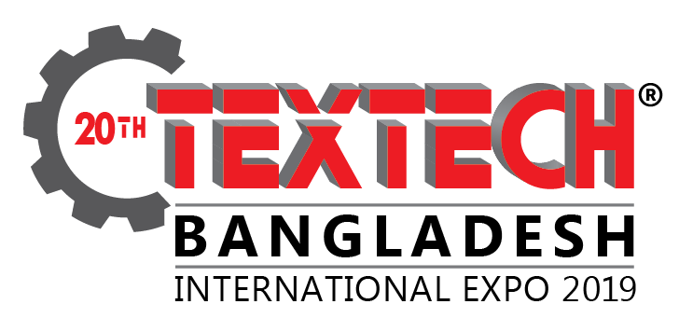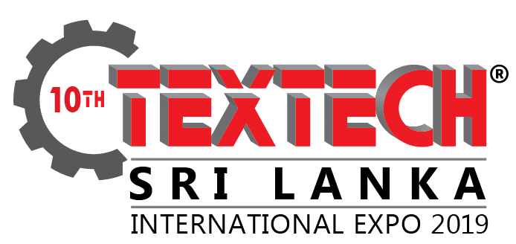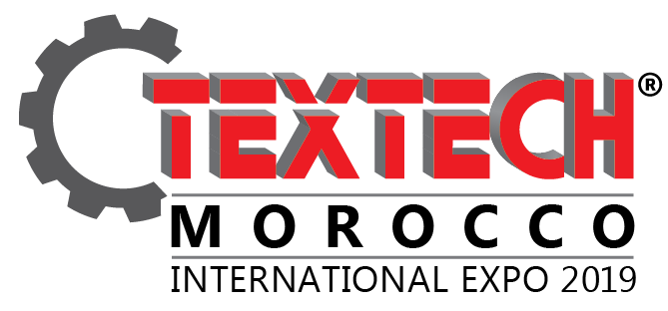
CEMS- Global’s international `Textech Series of Exhibition’ have reached its accession in popularity in south and south-east, Asia having organized extremely successful editions in Bangladesh, Indonesia, Sri Lanka and Morocco. `Textech Bangladesh’ has been serving the textile & apparel sector of Bangladesh for over a decade and apart from being the oldest and biggest textile garment technology & machinery expo of Bangladesh, it is the only international branded series of exhibition of its kind in south and south-east Asia being held in Bangladesh, Indonesia & Sri Lanka annually.
”Textech“, has created a brand in south and south-East Asia, especially in Bangladesh, as the biggest expo for the entire textile and garment industry of Bangladesh and has seen incredible growth in terms of exhibitors as well as potential visitors from the industry than any other expo ‘ever held in Bangladesh and is the oldest & first textile and garment machinery expo of Bangladesh. ‘Textech’ has been seeing an overwhelming increase in exhibitors year after year owing to delivering success to the exhibitors and attracting more visitors due to its concurrent exhibitions - “Dye+Chem Bangladesh” and “Dhaka International Yarn & Fabric Show”, also bringing world’s leading manufacturers of dyes/ chemicals and yarn/ fabric to Bangladesh under one roof.

3.2 DHAKA MOTOR SHOW

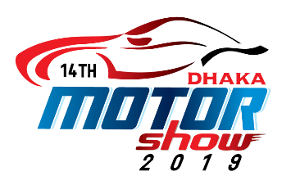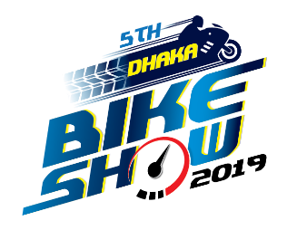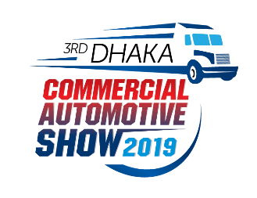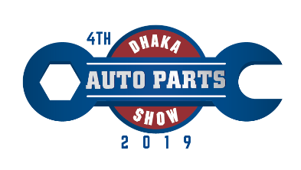
The `Dhaka Motor Show’ stands firmly as one of the flagship events of “CEMS-Global” in Bangladesh and has become an icon of the country as the one & only international automotive Exhibition of Bangladesh. With the country growing a strong middle-class segment, the rise in Sales of motor vehicles has surged to newer heights in Bangladesh, ignoring the rise in import Taxes. Bangladesh is one of a strong South-Asian nation with its growing economy and the `Dhaka Motor Show’ has also been a platform in all these years for launching of latest models of Hyundai, Mercedes, Range Rover, Mitsuoka, Toyota Prius and many others. The previous Editions have seen great successes and an enormous rise in sales of new vehicles, with CEMS-Global is changing its strategy in 2012 in highlighting and strongly backing vehicle distributors Showcasing cars / commercial vehicles for the middle/upper-middle class segment of the Population and vehicles for rural utilization, which also is one of the big and potential segments in Bangladesh. As always, the `Dhaka Motor Show’ will reveal to the country the rapid developments in the Industry and will also be a launching-pad for many new vehicles as well as new technology Components. The neat layouts of the show provide ample opportunity to the consumers of vehicles to see the latest offerings in the market as well as to the business visitor to carry out networking in a highly enabled environment. The motor show is therefore not only a networking Ground, but also a place to find business partners and strategic alliances for manufacturing, Outsourcing, sub-contracting, design and development as well as direct marketing.

3.3 FOOD & AGRO Bangladesh International Expo

CEMS Global’ brings ‘Food Pro and Agro Bangladesh International Expo’ will be a glittering showcase of the food and agro based products and service industry. It will reveal to the country, the rapid developments in the industry as well as new technology components. The neat layouts of the show provide ample opportunity to the consumers of housing to see the latest offerings in the market as well as to the business visitor to carry out networking in a highly enabled environment. The food festival and agro based products and service industry is therefore not only a networking ground, but also a place to find business partners and strategic alliances for manufacturing, outsourcing, sub-contracting, design and development as well as direct marketing. ‘Food Pro and Agro Bangladesh International Expo’ takes immense pride and gratitude in the presence of agriculture and horticulture products and equipment, poultry products, livestock products, machinery and supplies, fishing and aquaculture and other related products and services. The exhibition is going to be one of the greatest is Asia. The exhibitors and visitors are known to enjoy and have a good time at the event. The event also conducted conferences and seminar programs, adding more light to the industry. The 1st international showcase shall include food, drinks, hospitality, food service, bakery and retail industries, food, hotel, restaurant & food service equipment and machinery, supplies, and services and related technology in Bangladesh.

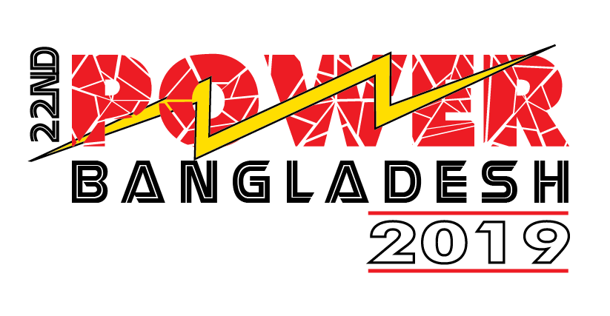
3.4 POWER Series of Exhibitions

With the great successes of CEMS-Global USA’s `POWER Series of Exhibitions’ in South & South-East Asia, CEMS-Global, having a reputation as a multinational exhibition organizer and Bringing the best trade shows on the most important industry topics for over 20 years now, has Been successfully organizing the “Power Bangladesh, Lanka Int’l Expo” in Dhaka for the last 5 Years bringing under one roof all important stakeholders of the power & energy industry of Bangladesh. CEMS-Global is pleased to once again present the `15th POWER Bangladesh 2015 International Expo’ set to once again be Bangladesh’s premier international exhibition of power Generation, and transmission, PV power, energy and renewable energy, which will bring together specialists engaging in the power engineering industry, leading manufacturers and distributors / representatives from all over the world to Bangladesh. To create more platforms for the renewable energy sector and electronics associated with power & energy, CEMS-Global has further announced well defined segments concurrent exhibitions which will be held alongside “POWER Bangladesh”, namely, “Renewable Energy Bangladesh Expo” and “Solar Power Bangladesh Expo”. “POWER Bangladesh” will provide the Exhibitors a not-to-be-missed opportunity further establish business contacts and get face-to-face and interact directly with the visiting trade delegations, industrialists, importers, distributors, agencies hence a great and only B2B platform of its kind in Bangladesh and a unique opportunity with a rapidly developing industry sector where investments are now on a rise with new industrialization making Bangladesh a very important business destination in South Asia.

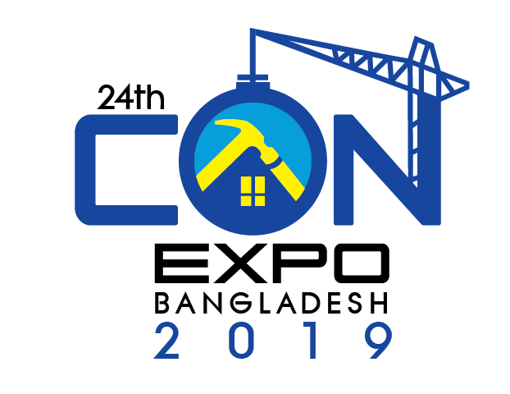
3.5 CON-EXPO Bangladesh International Expo

“CON-EXPO Bangladesh International Expo” is the glittering showcase of the construction materials, method, equipment and real estate industry. It will reveal to the country, the rapid developments in the industry as well as new technology components. The neat layouts of the show provide ample opportunity to the consumers of housing to see the latest offerings in the market as well as to the business visitor to carry out networking in a highly enabled environment. The “CON-EXPO” is therefore not only a networking ground, but also a place to find business partners and strategic alliances for manufacturing, outsourcing, sub-contracting, design and development as well as direct marketing. For 20 years, this exposition has been providing a marketing platform with buyers and sellers, and also the exposition will launch the public relations campaign as a part of our program which will give your company an added exposure, which by it would have.

3.6 REAL ESTATE Expo

Keeping in mind about the booming sector of Real Estate & the Housing Industry of Bangladesh. ‘CEMS USA’ in association with `CEMS Bangladesh’ brings “Real Estate Expo”. It will reveal to the country, the rapid developments in the industry as well as new technology components. The neat layouts of the show provide ample opportunity to the consumers of housing to see the latest offerings in the market as well as to the business visitor to carry out networking in a highly enabled environment. The “Real Estate Expo” is therefore not only a networking ground, but also a place to find business partners and strategic alliances for manufacturing, outsourcing, sub-contracting, design and development as well as direct marketing.

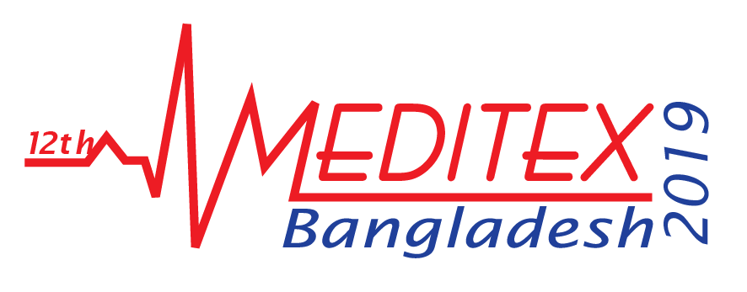
3.7 MEDITEX Bangladesh International Expo

“Meditex Bangladesh International Expo”, Bangladesh’s biggest and only international exhibition on medical equipment’s, surgical instruments, healthcare, hospital equipment and supplies will once again like its previous editions be the most prestigious, successful and exclusive international exhibition devoted to focus on the entire medical sector of Bangladesh and will be a one-stop single platform to showcase from home and abroad the latest developments and emerging technology for the medical and hospital sector of the country. Meditex Bangladesh International Expo” is the biggest meeting place ever held in Bangladesh for buyers and suppliers of medical / surgical / healthcare / hospital equipment and will also provide an interactive platform for exhibitors to generate business through displays / direct interaction and will enhance the synergy effect and attract top level professionals from the industry thus improving technology, focus and visitors of the expo. This exhibition is very important for Bangladesh and its healthcare industry as a whole as it offers an industry specific showcase of hospital, pharmaceutical and medical equipment, healthcare products, solutions and services from leading companies from across the globe. There are also opportunities for various healthcare companies and professionals in the areas of medical training, ambulance services, retirement homes, medical equipment supplies and rural health services. Bangladesh hospital expansion programs offer enormous scope for medical equipment manufacturers to penetrate the country’s lucrative hospital market, also to mention the huge government and private investments happening right now in Bangladesh to upgrade the medical and hospital sectors.

4. Project Flows of CEMS-Global

EXHIBITION
On-site Management
Marketing & Promotion
Resources & Alliances
Planning, Budget & Control
EVENT
Logistic support
Research/Concept
PRE-EVENT
POST EVENT

Feedback from Exhibitor

Event Review

Sales & Registration

Media Coverage

Promotional Activities

5. Broad Description of Project Flow

5.1 Pre-event

5.1.1 Research Concept
Research is a careful & the systematic effort of gaining new knowledge. The main objective of the research department is to investigate and develop methods, procedures, and technologies. The CEMS Global Research team takes a long research before every exhibition, about the industry, market, client, ability of the company etc.

5.1.2 Planning, Budget & Control
The first and most logical step in exhibition planning is assembling a team of people who have the necessary skills and experience. Optimally, these people should all be great team players, who can work responsibly and on their own initiative, whilst also carrying other people's interests at heart. It is good practice to make the size of planning committee relevant to the scale of the exhibition. Having an understaffed committee can lead to stress and half completed work, while an oversized committee will lead to a lack of organization and indecisiveness.
Once they have assembled the team, the next step is to appoint an exhibition coordinator. This role requires a great amount of responsibility, as most of the executive decisions will come down to the coordinator's discretion. Depending on the size of the exhibition, it might be necessary for the coordinator to appoint administrative staff or a secretary to deal with the extra administrative and clerical tasks.
An exhibition budget should be prepared through a thoughtful process involving the sponsor, planning committee and coordinator. A budget should not be seen as a financial document, but rather as a planning and management control document. It is a listing of all anticipated expenses, funding sources and projected revenue. Part of preparing a conference budget requires compiling a split folio. This is a division of expenses which lists the charges covered by the conference master account and individual guest charges, if there are to be any.

5.1.3 Resource & Alliances
CEMS Global has the resources of Tangible or intangible assets, skills, abilities etc.

5.1.4 Tangible Resources
- Financial resources
- Physical plant and equipment
- Human abilities, including experience, knowledge, skill, attitude, etc.
- Organizational abilities, including structure and processes

5.1.5 Intangible Resources
- Technological resources, including patents, trademarks, knowledge, etc.
- Innovation abilities, including facilities and employee research skills
- Reputation, including perceptions of stakeholders.

5.1.6 Marketing & Promotion
Marketing & promotional activities divided into three (03) parts.
- Sales and registration part basically do the Personal selling & direct marketing activities. Finding potential clients, make them participate in the exhibition are their main job.
- Media Coverage included Newspaper Ad, Press conference, TV Scrolling etc.
- Promotional Activities included internet marketing, billboard ad, Banner ad, Poster, Brochure, SMS etc.

5.2 During Event

5.2.1 Logistic Support
Strong logistics management is absolutely essential in delivering the business results expected from the event. CEMS Global’s in-depth event management methodology has been developed and proven over the last 24 years, and is consistently recognized as best-in-class by our clients.

5.2.2 On-site Management
On site management is the heart of effective exhibition planning. Once the site has been selected the contracts negotiated with venues and vendors, and the day of the exhibition, it is the job of the CEMS Global to attend to every detail to make certain an event runs efficiently.
- Dedicated team of event professionals.
- Full program staffing.
- Coordination of all event venues and service providers.
- Design of inventory control processes.
- Full documentation of all program activities.

5.3 Post Event
Feedback from the Exhibitor Feedback from the Exhibitor is a very important part of the exhibition management company. Because it’s helps to develop and upgrade the exhibition more effective and valuable to the exhibitor and the visitor. CEMS Global maintains its exhibitor feedback very carefully.
- Reconciliation and analysis of budget
- Compilation and analysis of all attendee evaluations
- Measure success of event.
Feedback from the Exhibitor is a very important part of the exhibition management company. Because it helps to develop and upgrade the exhibition more effective and valuable to the exhibitor and the visitor. CEMS-Global maintains its exhibitor feedback very carefully.
- Reconciliation and analysis of budget
- Compilation and analysis of all attendee evaluations
- Measure success of event.

5.3.1 Marketing tools used by CEMS-Global for an exhibition
CEMS Global is a multinational event organizer. More than 40 different exhibitions are being organized by CEMS in different countries. So there are several IMC tools are used to organize an exhibition or event successful..
For the sake of Integrated Marketing Communication they have used the following tools -
5.3.2 Advertising:
For the sake of creating the strong brand image, CEMS- Global has used different media for advertising.
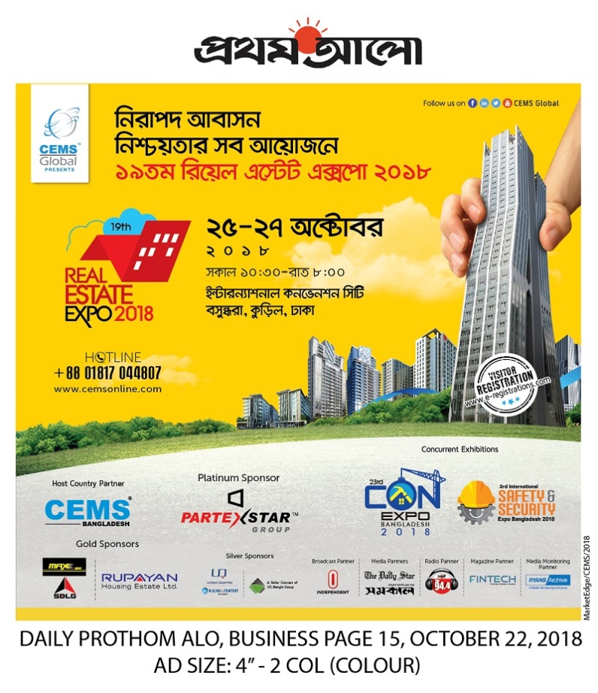
- Leading daily newspaper (The daily Prothom Alo, The Daily Star and The daily Shamakal etc. are the newspapers, where CEMS Global have a regular basis of advertising before every particular exhibition.

Figure 1: Newspaper Advertisement of 19^{h} Real Estate Expo published on The Daily Prothom Alo on 15th October 2018.
- Leading Weekly, Monthly magazine advertisements (Vromon Shongi the monthly magazine)
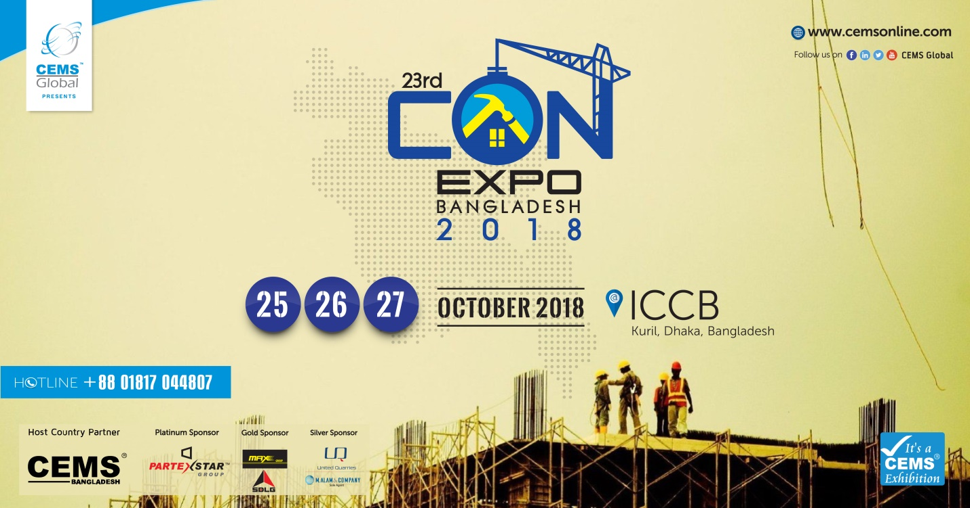
- Bill Boards at different places in Dhaka city like Banani, Gulshan, Uttara before every single exhibition.
- Postering in whole Dhaka city before every exhibition.

5.3.3 Personal selling & Direct Marketing: Mainly CEMS Global does the job of personal selling and direct marketing at a time. CEMS has a organized marketing department and there are two marketing teams consists of 4 marketing manager doing their job. The sales personnel direct contact with the customers and personally does the personal selling. At first they communicate with the client over the phone and talk about the upcoming exhibition. And for the sake of direct marketing they have visited the corporate clients and the existing clients of different exhibitions.

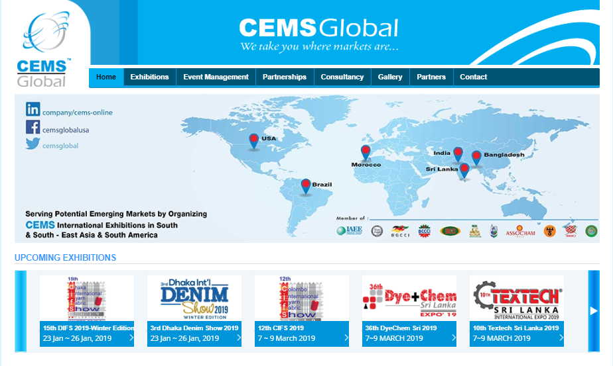
5.3.4 Internet Marketing: CEMS-Global also used the internet marketing as a tool, Integrated Marketing Communication (IMC). For that, CEMS-Global has a corporate website (www.cemsonline.com). In this website there are also different subsections of all the exhibitions. On the other hand, there are also Facebook page and event are created for every single upcoming event or exhibition.

Figure 3: Official website of CEMS Global

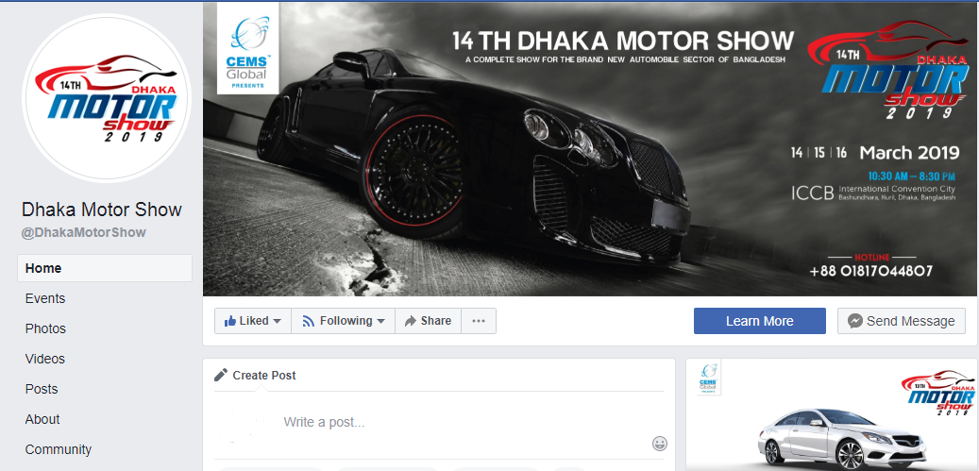
Figure 4: Facebook page of 14th Dhaka Motor Show 2019
5.3.5 Public Relation: For the sake of good public relation, CEMS Global arranges different activities. Along with every exhibition there is a relevant concurrent event is organized by CEMS Global. For example: “9th Asian International Trade and Tourism Expo 2015” have a concurrent event named “Lokoj Uthshob” and “Selfie Contest” which was highly effective to create a good relationship with the clients as well as the mass people.
CEMS- Global also sends greeting card to the client on various occasions like Eid, Pahela Baishakh, New year etc. They also provide VIP invitation cards of different exhibition to the exhibitors before every exhibition. CEMS- Global also arrange the raffle draw among the visitors of every exhibition. It helps CEMS-Global to accelerate the brand value in the highly competitive market.
Press Conference is another important tool for doing public relation. Before every single exhibition CEMS Global arrange a press conference. Press conference organized for the purposes of distributing information to the media and answering questions from reporters.
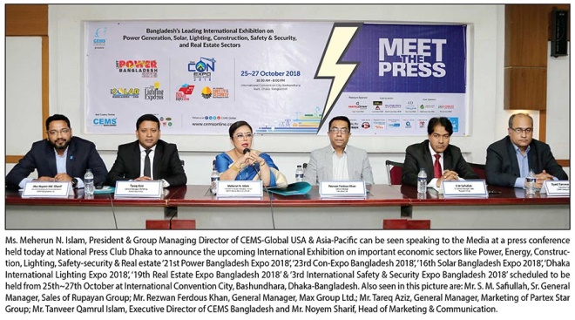
Figure 5: 21st Power Bangladesh Expo Press Conference
5.3.6 Telemarketing: In the marketing, there is a division called Telemarketing, Telemarketing executives/manager phoned different prospective client for their interest about upcoming events or exhibition from different directory. If they are clients are interested then they will set a meeting with the clients and give a detail view of the exhibition
5.3.7 Brochure: Brochure is a type of small magazine that contains pictures and information on a product or a company. CEMS Global use to publish a brochure before every single exhibition for giving the proper information about the particular exhibition. There is also an E-brochure is made for them. The brochure is given to them through mailing address or email before starting the telemarketing that they can have knowledge about the upcoming exhibition.

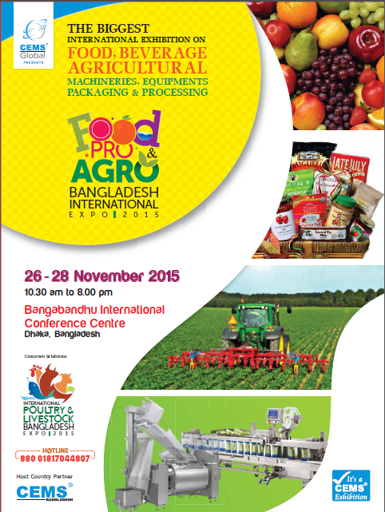
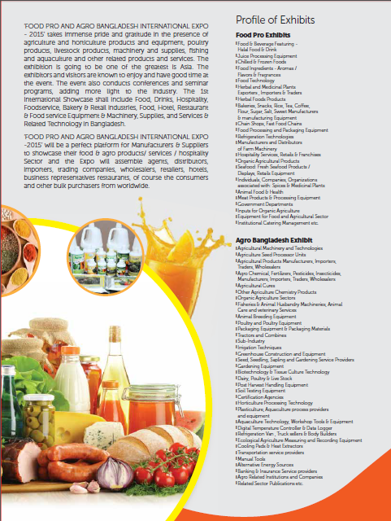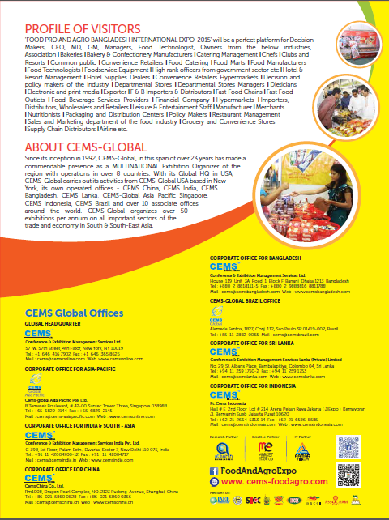
Figure 6: Brochure of Food and Agro Bangladesh Expo

5.3.8 Numbers of the Advertisement in different Media

Exhibition Name | Newspaper ad. | Magazine Ad. | Billboard | Poster | TVC | Banner
Textech Bangladesh 2018 | 10 | 00 | 05 | 30,000 | 0 | 100
Dhaka Motor Show 2018 | 08 | 02 | 05 | 50,000 | 0 | 500
Food Pro & Agro Bangladesh Expo 2018 | 10 | 03 | 06 | 50,000 | 0 | 300
Meditex Bangladesh Expo 2018 | 05 | 05 | 05 | 30,000 | 0 | 200
Power Bangladesh Expo 2018 | 10 | 08 | 06 | 50,000 | 0 | 500

Table 1: Exhibitions wise number of advertisements by CEMS Global in Bangladesh from January to November in 2018.

My Role
In according to the requirement of the internship Program, I have joined at ‘CEMS Bangladesh’ since September 01, 2018.
I was assigned to take care of all their digital media promotional marketing activities. I made creative contents/videos for their digital media promotional purpose & also worked on A2i project.
Some of my digital media promotional works for CEMS Bangladesh -
https://www.youtube.com/watch?v=mnTkFAfj3HY
https://www.behance.net/gallery/75268969/TEXTECH-Bangladesh-2019-Showreel
https://www.youtube.com/watch?v=EIwVnEVC1HA

5.3.9 Developing Advertising Messages by CEMS Global
The advertisements of several exhibitions are different. The advertisement massages are constructed according to the sector of the exhibition. CEMS-Global has a separate creative team consists of creative directors, designers, copywriters. Usually the creative team creates the advertising message according to the instruction of the marketing departments. Creative directors usually think how to make an advertisement different and creative. They take helps to the marketing team. According to their instruction the designers visualize the theme graphically and the copywriters input content of the advertisement.

5.4 Advertisement Budget Strategy of CEMS Global:
An offering’s budget is a critical factor when it comes to deciding which message strategies to pursue. Several methods can be used to determine the promotion budget. CEMS Global follows advertisement budget strategy which is:
- Objective and task method: It is more rational and ideal approach, whereby marketing managers of CEMS Global first determine what they want to accomplish (objectives) with their communication. Then they determine what activities- press advertisement, billboard, banner, sales promotions, and so on—are necessary to accomplish the objectives. Finally, they conduct research to figure out how much the activities, or tasks, cost in order to develop a budget for a particular exhibition.

6. SWOT analysis

6.1 Strengths:
- Strong brand name: CEMS-Global is a renowned brand in Exhibition Management industry in Bangladesh , they operate their corporates office more than 8 countries all around the world. Using this popular name they can easily getting client attention.
- Resource : CEMS-Global has its own plenty of resources & matarials.
- Associate: CEMS-Global always consider young employee for better, smart and fast service and they mostly prefer a multi-tasker.
- IT Partner: They have their own IT partner ‘Aamar Tech’.
- Creative partner: CEMS-Global has its own creative partner ‘Market Edge’, a sister concern of CEMS-Global. They have the best creative partner and their quality of work and excellence are classic.

6.2 Weaknesses:
- Manpower: The activities of the marketing team of CEMS-Global should be more organized. Sometimes they do their responsibilities in a very scattered way. There should be more potential member needed in the marketing department. They can recruit more potential marketing executive to get rid of this problem and I also mention their IT Team. In IT team need more potential staffs for creating their strong brand image in the exhibition industry and they should need to recruit more organized, potential and creative IT staffs for their future developments. They should need to give more attention to their IT department. Otherwise they will face big problems in their future developments.
- Position: CEMS-Global targets only Dhaka city for the exhibition. The promotional activities are also stuck in Dhaka. There are lots of SME companies are doing their business outside of Dhaka. They do not get the proper platform to display their products or services.
- TVC: As in the study found that CEMS-Global has 0% of Television Commercials (TVC). Television is the strongest medium for the sake of communicating information. So, concentration on the use of T.V. Media is necessary for CEMS-Global. Only the Television media partner is not sufficient to grab the concentration of the people. An informative TVC can help to capture the attention properly.
- High Price: To participate in CEMS-Global exhibition exhibitor has to pay some large amount of money.
- Communication Gap: Communication gap between the Visitors and the organization. Sometimes visitors know about the Exhibition but do not know who is the organizer.

6.3 Opportunities:
- Increasing sectors: Day by day increasing market rapidly. It helps to Launch new exhibition in new sectors.
- They can organize exhibitions in different potential location in Bangladesh. Such as Chittagong, Sylhet, Khulna etc.

6.4 Threats:
- Competitor: Competitor increasing day by day. And established competitors doing great than before. Competitors such as Asiatic 360, LIMRA. Saver. Half step down, ASK Communication etc.
- Limited Venues: In Dhaka City there are very limited venues for organizing such an international standard exhibition.
- Innovative Ideas: New and innovative exhibitions launching nowadays. If they do not make them more unique from other it will hard for them to survive in this industry.

7. Findings of the Study
Integrated marketing communications (IMC) emphasize the benefits of harnessing synergies across multiple media to build brand equity of products and services. Theoreticians and practitioners have embraced the concept and it is firmly entrenched in marketing. A finely crafted IMC effort can influence target audiences that would otherwise be unreachable.
CEMS- Global is the leading exhibition and event organizer in Bangladesh. They are doing their business in Bangladesh more than 27 years. They are also doing marketing communication in a better way. They use IMC tools in effective ways such as, the official website of CEMS Global is very informative and user friendly. Anyone can find proper information of any exhibition by surfing the website. Moreover CEMS Global strongly use ATL (Above The Line) and BTL (Below The Line) promotional activities which can be effective to communicate with the desired person.
But there are also some lacking of promotional activities of CEMS Global. For example: CEMS Global does not use any TV commercial. And also the post exhibition activities are very low. Post show activities help to find out the errors which help to recover it for the next time. Another thing is the Marketing and IT team of CEMS-Global is unorganized. They should enhance the potential man power of the marketing & IT team. Otherwise, they effectively use most of the IMC tools. But in this dynamic world, every day new ways of communication are inventing. CEMS Global should keep pace with this new communication. It helps to create a good brand image in this industry and makes an exhibition successful. It increased the impact of communications, made the creative ideas even more effective, and provided greater consistency in communication. In addition, it also improved the client return on communication investment.

8. Recommendations and Conclusion
The report also has shown the overall picture of the exhibition market and opportunity in Bangladesh and the Integrated Marketing Communication (IMC) effectiveness. Three months are short to understand every aspect of a company and overall market condition of this huge sector. Actually, it needs more time to determine the overall market size, conditions, opportunity, and business activities of the company. Within the short time, I have tried to show the overall scenario of this sector and the IMC effectiveness in the event organizing sector based on marketing activities of CEMS Global. So from my own experience I may suggest the following recommendations for sound and success market operation of the company:
- As in the study found that CEMS Global has 0% of Television Commercials (TVC). Television is the strongest medium for the sake of communicating information. So, concentration on the use of T.V. Media is necessary for CEMS Global. Only the Television media partner is not sufficient to grab the concentration of the people. An informative TVC can help to capture the attention properly.

- The activities of the marketing team of CEMS Global should be organized. Sometimes they do their responsibilities in a very scattered way. There should be more members needed in the marketing department. They can recruit more marketing executive to get rid of this problem.

- The master database of every particular exhibition should be updated in every year before every exhibition. It helps to widen the boundary of the exhibition as well it works as word of mouth marketing. Every year lots of new company enters in different industries. CEMS Global should follow up it properly and update the master database every month.

- CEMS Global usually sets their billboard in some particular place like Gulshan, Banani, Uttara. To create a good communication they should increase the number of billboards and try to cover the whole Dhaka city as much as possible. If the promotional budget is less than they should use poster, banner etc. instead of billboards.
- CEMS Global targets only Dhaka city for the exhibition. The promotional activities are also stuck in Dhaka. There are lots of SME companies are doing their business outside of Dhaka. They do not get the proper platform to display their products or services. CEMS Global should organize some exhibition outside of Dhaka and should do promotional activities in the whole Bangladesh which can help them to increase the brand equity. It will also help to flourish our economy as well.

- The post exhibition activities should increase a lot. CEMS usually some post activities but it is not enough to find out the errors. Measuring the advertisement budget and process, find out the effectiveness of promotional activities, getting feedback from the exhibitors etc. should be increased a lot. It can help to evaluate the effectiveness of the IMC process as well as helps to do it properly in the future.

The exhibit marketing of Bangladesh is now being increased. Exhibit marketing is a rich and versatile promotional practice that spawns new applications and has the power to adapt to changing situations. It is true that attendees at a trade show are a select audience and are more valuable than a random group of consumers or business contacts. However, trade show exhibitors must interact effectively with show visitors. Effective interaction takes planning and effort and is less common than one would think. Industry experts stress the need for a proper exhibit marketing plan. Having both a strategic exhibit marketing and tactical plan of action is a critical starting point.
Exhibit marketing has been misunderstood in the past. Newer perspectives, see its value as a vital part of the IMC process. To be successful, exhibit marketing must be firmly integrated within the IMC process and the company’s marketing strategy. It requires to properly implement the marketing strategy. Moreover, the exhibit plan objectives must integrate well with marketing plan objectives. Industry results show that successful exhibit marketers treat the activity seriously devoting much planning, training and processing time to the show. Finally, follow-up is a key differentiator between successful exhibitors and those who are not. As exhibit marketing continues to become more important in the IMC process, experienced exhibitors who act professionally will gain an advantage over those who take a more informal approach.

9. References

- Everett, Martin (“It’s no fluke: companies may not have all of its components coordinated quite yet, but integrated marketing is an idea that won’t go away,” Sales & Marketing Management, 146 (1994):
- Matthew, Gonring, “Putting integrated marketing communications to work today,” Public Relations Quarterly, 39 (1994): 45;
- Linton, I. and Marley, K., Integrated Marketing Communications (Oxford: Bulleworth Heinemann, 1995).
- Miller, Debra and Rose, Patricia, “Integrated communications: a look at reality instead of theory,” Public Relations Quarterly, 39 (1994): 13-17.
- V. Clarke, L., “PR can gain from IMC” (Letter to the editor), Advertising Age (May 16, 1994): 36.
- Mitchell, Alan, “A clear message,” Marketing (February 17, 1994): 17S.
- Aaker, D. A. (1996). Building strong brands. New York, Free Press.

10. Appendix:
Websites:
CEMS-Global website: www.cemsonline.com
- “What is IMC” available at http://www.techopedia.com/definition/26409/integrated-marketing-communications-imc (electronically accessed on July 5, 2015)
- “Importance of IMC” available at http://www.managementstudyguide.com/importance-of-integrated-marketing-communication.htm (electronically accessed on July 5, 2015)
- “promotional tools” available at http://www.managementstudyguide.com/tools-of-promotion.htm (electronically accessed on July 20, 2015)
- “Advertisement budget methods” available at www.inc.com/encyclopedia/advertising-budget.html (electronically accessed on July 20, 2015)

Basis Questions Addressed in the Study:
1. Which types of exhibition CEMS-Global Organized?
2. Why IMC is necessary for a doing successful International Exhibition?
3. How CEMS Global uses IMC tools?
4. How CEMS Global follows the steps of IMC program?
5. On which basis CEMS targeted their target audience?
6. How CEMS Global set their objectives?
7. How CEMS designs their messages?
8. How CEMS selects the channels?
9. How CEMS set their promotional/advertising budget?
10. What is the advertising procedure of an exhibition?

