UNITED INTERNATIONAL UNIVERSITY
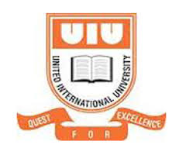
An Overview of the Education System of Bangladesh and the necessity to encourage “Creative Learning”
A report on Alokito Hridoy Foundation
By
Adiba Karim
ID: 124 171 003

A Guided Article
Submitted to the United International University
As a fulfillment of the requirement for the
Master of Science in Economics

Supervisor:
Mr. Mohammad Mokammel Karim Toufique
Assistant Professor and Coordinator
Department of Economics
United International University
Acknowledgement

A successful project can never be prepared by the single effort or the person to whom the project is assigned, but it also requires the help and guardianship of some conversant person who helps in the completion of a successful project.

With great pleasure, I express my sincere gratitude to my guide and instructor Mohammad Mokammel Karim Toufique (Assistant Professor and Coordinator of the Dept. Of Economics) with his exemplary guidance and precious suggestion, I was able to complete this article work. The help and guidance given by him time to time shall help me a long way in the journey of life on which I am about to embark. I shall also want to express my gratitude to the team of Alokito Hridoy Foundation on helping and guiding me from time to time with valuable information regarding their organization.

Lastly, I would like to thank The Almighty, my parents and friends, who directly and indirectly supported me during my research work and their constant encouragement have helped me to complete this research paper.

Abstract

In this paper, the main purpose is to express about how a revolutionizing change needs to take place in our education system. The need to minimize the practice of rote learning should be addressed by all. This method has been in practice from earlier times, however as the world is progressing further day by day, we as a nation is falling behind.

In this paper, the importance of creative learning and how this method should be adopted by our education system is mentioned. It also includes the skills set for the 21st century which should adopted by the education bodies in order to instill these skills amongst the young generation.

Apart from these aforementioned topics, names of few change makers has been stated. These change-makers are mainly focused on providing creative and inquiry- based learning to students so that they are able to stand out for themselves in this world. Amongst many change makers, this paper mentions the work structure of one such change maker, that is Alokito Hridoy Foundation. The mention of the methods that they have used in order to structure their education model has been pointed out. The organization follows the Play.Do. Ask model in providing knowledge to their students. Through this model, they have implemented inquiry-based, game-based and problem-centric learning in the school. All these methods limit the students on being dependent on rote learning and makes education fun.

The paper has been written from the help of various articles on the Education System of Bangladesh and information gathered about Alokito Hridoy Foundation.

“Children must be taught how to think, not what to think”
- Margaret Mead

- Introduction

Education is one of the basic necessities of life. Without acquiring the basic knowledge of education it would be very difficult to advance in life. Primary education is the first and the most important step in the education system, followed by secondary and higher education. Both Sustainable Development Goals (SDGs)-2030-Goal 4: Quality Education for all and Millennium Development Goals (MDGs)-2015-Goal 2: ‘Achieve universal primary education’ include the goals to achieve primary and quality education. Education plays an important role not only in escalating further educational opportunities but also in building the basic framework of life. The main key to a successful life is to acquire a sustainable education that will help to build a significant life ahead.
What will the world be, if there was no form of learning or no way of educating oneself? The world would be static and slowly become obsolete. The first idea of formal education and schools can be traced back as early as 500 AD in ancient Greece, ancient Rome and ancient Egypt, according to an article by Broom, K. “Who invented school and created standardized Education.” 14 Feb. 2018. Education of any form (formal or informal) became mandatory since then. According to the article, Education that we acquire now is termed as “Modern Education”. While there is no one to credit for inventing schools, Horace Mann (1796-1859) is considered to be the father of modern education. He believed that universal public education was extremely important. As a result, he created a number of public schools in Massachusetts and transformed to a place that other states adopted his ideas.
One might question oneself as to why education is important or what is the need to educate oneself? The most obvious answer to that is education is knowledge gain; it gives us knowledge of the world and develops in us a perspective of looking at life in different ways. From an early age, we have known that education is the backbone of a nation. Without education, the world cannot progress. Not only that, education instills moral, spiritual and ethical values into a person that helps build character which in turn influences the whole nation.

- An Overview of the Education System in Bangladesh:

Bangladesh, officially the People’s Republic of Bangladesh, is a country situated in South Asia. The capital is Dhaka along with other six administrative divisions. Bangladesh is a modern state which was established in 1971 after a long nine months’ war with West Pakistan.
Bangladesh is a democratic country where the government is elected through voting by the general people of the country. The administration of the country is divided into many parts where each sector has its own head/minister. The Ministry of Education (MoE) and the Ministry of Primary and Mass Education (MoPME) controls the entire responsibility of the education system of Bangladesh. The Ministry of Education has two divisions under its wings- The Primary and Secondary Education Division and the Technical and Madrasah Education Division. The core responsibilities of the MoE are to prepare legislation and regulations, drafts policies, provision of training to teachers and supervision of educational institutions. The MoPME is responsible for primary, secondary and non- formal education. Alongside these, the University Grants Commission plays an advisory, supervisory and regulatory role of both public and private higher education in Bangladesh.
There are approximately 146 schools (public and private) in Dhaka Division according to Dhaka Board. The main education system is divided into four levels. The first is Pre-Primary level, which consists of classes from Playgroup to Kindergarten; this is followed by the Primary level, which consists of classes from Standard 1 to Standard 8. The secondary level consists of classes from Standard 9 to Standard 12. After the completion of these levels, the next level is Tertiary Education which consists of universities. These universities are regulated by the University Grants Commission. The universities in Bangladesh are autonomous bodies which are administrated by head bodies such as Senate, Syndicate, Academic Council and many others depending on the university bodies.
At each step of the education level, students have to sit for an examination prior to qualifying for the next level. Examinations vary according to each institution. However, two mainboard examinations take place, one after the completion of Standard 10, known as the Secondary School Certificate (SSC) and another one after the completion of Standard 12, known as the Higher School Certificate (HSC). Upon the completion of these two examinations, SSC determines a place in Year 11 and 12 in the educational level and HSC determines a place in the Tertiary level of Education which consists of higher education in universities. Students are evaluated according to the evaluation chart set by the MoE.

- Figure:1: The Education System of Bangladesh

- The Primary Education:
The primary level consists of classes from Grade I to V, which lasts for five years. Before grade I, that is Playgroup to Kindergarten, is considered pre-primary level. After the completion of the primary level, students are promoted to the secondary level. However, at each level, the students have to sit for an examination for each individual subjects. After successfully qualifying in their examinations, they are then promoted to the next level, i.e. class/grade. In class 5, students have to sit for a board examination called PSC (Primary School Certificate). After successfully completing this level and qualifying in the examination, students are then promoted at the secondary level. The grading system in school is given as below.

Grading system in school
Class interval | Letter grade | Grade point
80–100 | A+ | 5
70–79 | A | 4
60-69 | A- | 3.5
50–59 | B | 3
40–49 | C | 2
33–39 | D | 1
0–32 | F | 0
Source: Academic Grading in Bangladesh, Wikipedia [https://en.wikipedia.org/wiki/Academic_grading_in_Bangladesh]

- The Secondary Education:
This level consists of classes from Grade 6 to Grade 12. It lasts for seven years and this area of study is broken down into three categories. The first category consists of classes from Grade VI- to Grade VIII which is termed as the junior secondary grade. In grade VIII, the students have to sit for a board examination named JSC (Junior School Certificate), after which they qualify for the next step, that is, Grades IX-X. After the completion of Grade X, the students have to sit for SSC. After succeeding in this exam, they move up to Higher Secondary School which is comprised of grades XI and XII respectively. The secondary education ladder ends when students qualify for the HSC examination and move up to the Tertiary level of Education.

- The Position of Bangladesh in achieving the universal primary education level (MDG- 2)

The Millennium Development Goals are targets set for the world’s LDC’s/ developing countries in order to help them grow and improve their standard of living. By enabling them to achieve those goals such countries are able to progress and improve their position worldwide. There are 8 (eight) MDGs’ amongst which their second goal is to Achieve Universal Primary Education by the year 2015.
According to the report prepared by the GED, Bangladesh Planning Commission, “Millennium Development Goals Report”, September 2015 stated that Bangladesh has succeeded in increasing access to education for all, reducing dropouts and applied a number of quality measures to improve the overall condition in the primary and secondary sector of education. Through a thorough survey, it has been seen that Bangladesh has been able to reduce gender disparity in primary and secondary school enrolment. Bangladesh has been able to achieve most of the targets of MDG. Compared to most Asian countries, Bangladesh is doing exceedingly well in reducing poverty, as well as achieving universal primary education and many more.
However, the real challenges that this country is facing includes attaining the targets of primary education completion rate and improving the quality of education. In the present scenario, it is being observed that the quantity of students is increasing as several reports suggest meanwhile the quality of education is deteriorating day by day.

- How and why are we failing with our Education System?

So, our main question is- Is quantity more important than quality?

Quantity and quality go hand in hand; quantity would naturally increase when quality increases. Education is only fruitful when it can be used appropriately rather than just encouraging rote learning for better grades and or certificates. As a result, students fail to understand the contents of what they are learning and also do not have the scope to create something on their own. This limits their creativity in many ways which stand as a big obstacle when they enter the tertiary sector of education and also reduce their employability skills. There is a quote that says “Your skills will pay your bills’’ this tells us more about how our education system should be structured for a better future in this 21st century.

It is being observed that the numbers of students are increasing whereas the quality of education provided to them is very low. According to an article by K Chowdhury, Rasheda, “Where our education system has failed”, 28 January 2018 she stated that “Education has become more or less a commodity.” She further pointed out three main reasons why we are falling behind. She pointed out that the qualities of teachers who are being appointed are chronic. These teachers are sent to classrooms without any prior training. As a result, they do not have any proper guidance and teach the students as they find appropriate. Another important drawback is the failure of appropriate governance in the educational institutions. Unfair means are adopted during class and board examinations where no steps are being taken to stop such acts. On the other hand, School Managing Committees are taken over by political interests. As a result, little or no emphasis is being given to improving the quality of education. The third drawback is the way our curriculum and examinations system is drawn. There are a considerable number of board examinations that the students have to sit for. As a result, they do not have the time to learn but memorize everything in order to pass the examinations. This, in turn, decreases their quality and understanding level of what they are learning. This statement can be better understood by the Cone of Learning by Edgar Dale. [Refer to 1.1]

The Ministry of Education along with other educational bodies understands the depth of these setbacks and as a result, they are in the process of revising the whole educational system in ways so that they can tackle all these drawbacks and help improve the quality of education provided. This is in order to change its future and achieve the goals set by the National Education Policy 2010 and Vision 2021. This year, the Finance Minister AMA Muhith has proposed BDT 53,054 crore, which is about 2 percent of the GDP for the education sector for the fiscal year 2018-2019. This is about 11.41 percent of the total outlay according to The Daily Star article, titled, “Education lacks due attention” published on June 8, 2018. However, according to another The Daily Star article, titled, “Are we giving enough priority to education?” published on June 11, 2018, the allocation for education has increased, no doubt, but when we take a closer look at the budget, it can be seen that as a percentage of the total budget, the allocation for education has in real sense decreased. In this article, Rasheda K Chowdhury, the Vice-President of the Global Campaign for Education (GCE) discussed how the size of our budget is increasing continually whereas the budget for education has decreased. Compared to last fiscal year, the allocation for education has dropped from 12 percent to 11.41 percent, whereas it should have increased since the demand for education has increased in total over the years. Due to this lack of financial aid, it has become challenging in order to provide quality education. More innovative ways such as providing digital learning, promoting inquiry-based learning, etc. are required in our education system in order for us to compete with the pace of the world.
Due to these critical drawbacks in our education system, few of the non-governmental bodies have come forward with various pilot projects in order to assist the government in bringing an effective change in the system. These changes are in compliance with the changes in what is required in the 21st century so that these children are well equipped and prepared to tackle what the world has to offer.

  - The Cone of Learning:

The cone of learning is such a model that explains the several theories that are related to instructional design and learning processes. [Source: Edgar Dale’s Cone of Experience 1960, Heidi Milia, Assistant Dean for Education Innovation]

According to a book written by Lee, S. J & Reeves, T.C (2007), “Foundations of Learning and Instructional Design Technology”, Edgar Dale was an American educator who developed the Cone of Experience. In his cone of learning, he explained how we tend to remember all that we learn through several activities. As the chart depicts, what happens in 2 weeks when we learn something. According to the educator, Edgar Dale- he discovered that we tend to remember about 10% of what we read, whereas when we hear something about the topic that we are learning about, the percentage of remembering increases to 20%. Now when we add seeing and hearing about the topic or content that we are learning about, the effectiveness of remembering increases to 50%. For example, when we learn about the solar system, if we can see what the solar system is in videos on YouTube then while hearing about them then it becomes more effective and easier for us to remember rather than just reading about them. By seeing we are visualizing them and it stays in our memory more than when we read about something. The next level according to Dale is when we talk about that particular topic and engage ourselves in a discussion. This helps us remember about 70% of what we have learned in a more effective way rather opting for rote learning. The last part that makes remembering the most effective is indulging oneself by doing something such as a dramatic presentation or by playing some games related to the topic, and then our remembrance level reaches 90% of our total learning capacity.

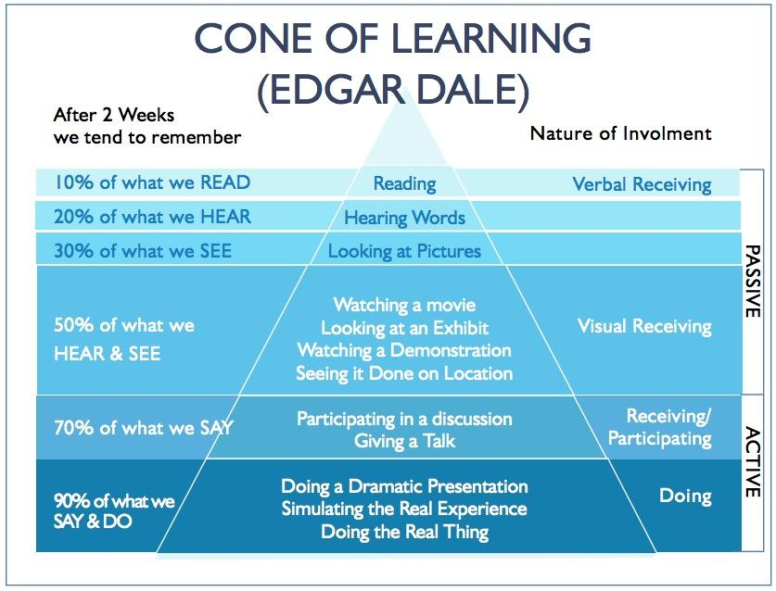
Source: Edgar Dale’s Cone of Learning. Wikicommons [http://hlwiki.slais.ubc.ca/index.php/Dale%27s_cone_of_learning]

- The Introduction of Creative Learning System in Bangladesh:
Reasons and Drawbacks

Our government, upon understanding the necessity of creativity amongst the young generation, has introduced creative learning system in 2009 in its curriculum. This is also known as “Srijonshil Shikkha” in Bangla. Through this content, the government wanted to encourage the young generation to think outside the box which would help them further in their life. The curriculum includes unseen and creative thinking questions as well as critical and analytical questions. This step was also taken in order to eradicate the practice of rote learning step by step and improve the quality of education.
According to the article of Halima Sathi, “Creative approach in the education system”, published on 17 October 2017 in Daily Observer, as the world is approaching on a faster scale, employers of companies need innovative minds in order to keep pace with the changing world. Our world is becoming more and more digitalized and needs constant innovations and creativity to grow. However, according to the writer and many other statistical references, it is being observed that our current education system is quite ill-prepared to nurture the upcoming generations of creative leaders. Our education system should be the first stepping stone in order to create such leaders. The world is changing on a regular basis and in order to keep up with it, the old established rules used by generations to educate and secure a “good paying job” are not suitable. The present and future generation need the guidance and necessary support in order to create prominent individuals for leading economies.
However, even though the introduction of this system was quite needed in our curriculum, the outcome was not exactly the result that the government expected. The reason behind this is simple: insufficient and inadequate training of the teachers. This led to improper question patterns and misleading copy checking. The most important factor was that the teachers were not able to prepare the students accordingly and thus improper guidance was given. As a result, the students were unprepared and this was partially reflected in their results. This also led to the increasing number of question paper leakage of board examinations, thus creating a pool of low-quality students. This reflects the domino effect.
This statement can be best supported by a report written by Tuhin, Haque, Islam, Rab, and Uddin, “Ambiguity in Understanding of Teachers and Students on Creative Method Effectiveness: A study on Primary Schools in Bangladesh”, 2016. In their report, they have conducted a survey for the creative method implied in primary education. From the survey, they have found that 13% of the teachers do not understand creative methods, 45% understands and 42% have a slight understanding. This sums up as that the majority of the teachers do not have the understanding of the creative method. As a result, a total of 47% teachers rely on guidebooks. This clearly draws a picture that by solely depending on guidebooks a teacher cannot fully support and guide the students since the teacher’s concept is not clear. Upon doing a survey on the students, it was found that 92% of students take help of guidebooks and practice rote learning. As a result, they are more dependent on guidebooks and are further away from becoming creative or innovative, which is a major concern here.
Upon seeing this trend in our education system and after many trial and error projects are undertaken by our government, few non-governmental organizations have stepped forward with various educational models of their own. These models are mainly designed in order to help the government to create an “Innovative and Creative ‘’ curriculum which will be conducted in the classrooms and thus help the students grow in a way that will help them think outside the box. Few of the change makers that are in the rigorous process of building an effective and progressive education system to create an innovative and intellectual generation are listed below:

1. Teach for Bangladesh:
https://www.teachforbangladesh.org/
“What they do: Around the world, Teach for All Network partners are developing leadership in classrooms and communities to ensure all children can fulfill their potential”
“The Vision: A society in which all children receive an excellent education that empowers them to realize their full potential and shape their own future through talent and hard work.”

2. Campaign for Popular Education (CAMPE)
http://www.campebd.org/page/Generic/0/3/2
“The Vision: An educated, creative, democratic, secular, humanitarian, equitable and poverty free Bangladesh promoted through education and learning for all.’’

3. Friendship NGO Bangladesh
https://friendship.ngo/what-we-do/education/
“What they do: Built and established 78 self-sufficient schools in remote areas of Bangladesh. They use innovative solutions including solar panels to generate electricity for TV monitors, use video lessons to enable children to continue their studies and many more.”

These are few of the change makers who are making an impact on the overall literacy rate of Bangladesh. As a result of their work in the field of education, Bangladesh has been able to achieve its Millennium Development Goals 2015 in increasing enrolment at primary schools (UNDP Bangladesh Report, 2015). Amongst these change makers, one of them has stepped forward in working with the curriculum as set by the government in order to help build an innovative and creative content for the students. They have focused their concentration on the rural side of Dhaka, mainly Tangail, Thus, enabling and providing an opportunity to the students of those areas to be creative leaders in the future.

A Change Maker:
ALOKITO HRIDOY FOUNDATION

Following the cone of learning by Edgar Gale as a benchmark and few other teaching-learning techniques, one non-profit organization has structured an effective and progressive educational model in order to help to learn more fun and useful. These techniques were used in order to make a classroom livelier. All the methods and techniques would engage the teachers and students in a vibrant discussion where students will be taking the lead and the teacher will only be guiding them by asking thought-provoking questions. Students will glow with curiosity while they share ideas, ask questions and some even will look up the book to find the answers or ask more questions and others will look up the Internet to add to the discussion. A vibrant, gleeful atmosphere that will come alive with curiosity, creativity, and problem-solving, is the kind of classroom that needs to happen in order to help break the monotonous teaching techniques. Sometimes the students will be playing games to learn new vocabulary, sometimes they will be sharing stories to understand a concept, sometimes they will be experimenting to discover new objects and mostly they will be cooperating and enjoying themselves. The classroom will be a world where interactions happen without any inhibitions.

Alokito Hridoy Foundation- Alokito Hridoy Primary School

2.1- Mission and Vision:
At first, what does Alokito Hridoy stands for- Alokito Hridoy stands for Enlightened Soul. This is similarly the main aim of this organization; they aim to enlighten a child’s mind, body, and soul through a holistic education system. This generation is our future. And through Alokito Hridoy, they want to create an education and schooling system that ensure quality and sustainability in order to build an enlightened generation of our country.

2.2- Alokito Hridoy Foundation’s Initiative:
Its first initiative is its pilot school- Alokito Hridoy Primary School which is situated in Tangail, Mirzapur, in a cluster of factories where the target population is the children of the industrial workers who are employed in those factories. The school first began their journey in the midst of 2015 with a total number of 110 children and 8 teachers which has now increased to 140 children with 10 teachers. The school provides added services like day care, health and well-being program, computer skills training program, teachers’ training program and breakfast and snacks to all the children.

2.3- The reason behind AHF-
In a journal called, “The present situation of the education system in Bangladesh and scope for improvement” Assistant Professor Mohit Prodan explains how memorization used as the only method has become an acceptable way of learning leading to poor critical thinking and analytical ability among students. “Teachers expect students to memorize a huge amount of data and regurgitate them during exams” (Prodhan, June 2016, p129). Therefore, the students may end up scoring good marks in the examination through rote learning but when it comes to a real-world scenario, these students are the ones who are failing miserably. This is mainly due to lack of proper knowledge and the inability to tackle real-world scenario. The learning method is mainly bookish and does not contribute to any life, social or cognitive knowledge of the children. This limits the ability of the students to gain skills that are necessary for practical life. As a result, they lack behind the 21st-century skills set. Upon seeing the quality of our education system, the minds behind AHF tried to understand how it will impact the young generation if the same methods of teaching-learning are continued without any changes. Seeing the condition of the students, they understood that it was time to bring about a change in the system, otherwise, the future of this country is in jeopardy. It is not the fact that rote learning is not needed, but along with rote learning, innovative and creative skills need to be built within the students so that these can help them in tackling the future and stand out.

2.4- What is AHF doing differently?
AHF has been successfully running a pilot school for the last two years in Tangail; where they have trained locally recruited teachers for the education model that this organization has built in order to improve the quality of the existing teaching-learning method. The model they have structured is the PLAY.DO. ASK education model. The model enables a student to learn by playing, by doing and by asking. Through this model, they have implemented inquiry-based, game-based and problem-centric learning in the school. The model implication is mainly focused on the schools in the rural side (Tangail).

Play: The model has designed a few numbers of games that are being played while the teachers introduce a new chapter. By playing such games, students are able to learn the contents of a chapter through playing and as a result rote learning is minimized. For example, Games like Hangman, Taboo, Jumping the line and many more. By playing jumping the line, a student is able to revise a whole chapter through true/false exercise. A teacher will make a question set based on true/false statements. Students will be lined up and then each student will be asked a question and if the statement is true, the student will have to jump in the “True” side and if it is false then the student will have to jump in the “False” side. This is one of the many games that are played while teaching. By this playing method, students become more energized and they learn a chapter without the needing to memorize anything.

Do: When a student is learning by doing something like Project work, presentation, group work they are involved in learning not through just book text but also through involving themselves in activities. As a result of these activities, they get to learn what they are reading through undertaking such tasks. For example, when they learn about Water pollution, they get involved in making projects based on pollution; as a result, what they have learned in the textbooks, they are able to use that in their projects. So this promotes their practical learning and makes it easier for them to remember what they have learned.

Ask: In this method, when a student is encouraged to ask questions, this increases their creative skills. It is because, the more they ask questions, the more they will have the urge to know the answers to their questions. This broadens their critical –thinking ability skills.

After a thorough process of structuring this model, the AHF team has created their benchmark based on this educational model. Teachers’ guides (TG) are made according to this model. All activities that are included in the TG’s fall under this PLAY.DO.ASK method.

2.5- Teachers’ Guide: The need for it:
Teachers’ Guides are guidelines for the teachers to follow in their classroom. So that they are aware of what activities are needed in order proceed further with the chapter they are teaching. All the teaching methods are included in the guide for the teachers to access easily. This guide gives a detailed account of examples of how these pedagogical collections can be used for different subjects, topics or themes. This creates a link between the approaches and the 21st-century skills- Social skill, problem-solving, creativity, cognitive skill and moral learning. For every chapter in English, Science, Global Studies, and Mathematics, creative teaching methods are outlined to help teachers design a more productive, interactive, and effective and fun class. The teacher’s guide is entirely in tandem with the government curriculum and the textbooks by NCTB.

2.6- Methods and Skills Set:
The Teacher’s Guide is one of the most important tools of this organization. According to this guide, a teacher gets a clear idea on how to progress further with and also provides methods on how to assess a student as well. The methods vary according to each chapter but the teachers may mismatch, add or deduct some activities as they find appropriate. However, each of these activities falls under the PLAY. DO. ASK method and after each activity students are assessed in accordance with some skills set. The skills set are as follows:

1. Moral Education: This shows how much a student has acquired moral knowledge from the chapter that they have learned. This increases their moral thinking ability and all the teaching-learning activities that are included is in accordance so that this knowledge is exercised on the students.

2. Thinking skills: Activities like debate, inquiry-based questions, brainstorming, and many more activities encourages students to think before doing their work. As a result, this improves their thinking caliber and as a result, they (students) will be able to face and solve problem-centric situations.

3. Social and communication skills: Group activities like game playing, group presentation; group project encourages students to participate as a team. As a result, this builds their social skills and helps them communicate with others.

4. Metacognitive skills: Activities, like watching educational videos and asking questions related to each chapter, enhances a student’s cognitive skills. Through self-assessment, a student is able to identify where they stand. In AHF, they give priority to building such skills. They provide the students with intellectual activities that enable a student to think outside the box. As a result, this limits their practice to rote learning. Activities include- making future wheels, flowcharts, concept maps; watching videos; playing games etc.

All the tasks and activities that are being practiced and implemented in this school are in accordance with these skills set. As a result, a thorough monitoring is done by the teachers as well as the trainers to ensure that each student is able to acquire and practice these skills in their real life scenarios.

2.6- The Teachers:
Aside from the students, one of the biggest backbone and component of this school is their teachers. The founder of this organization, Azwa Nayeem, Founder and Chairperson of Alokito Hridoy Foundation and Lecturer of Political Science at North South University, strongly believes that teachers can only shape a students’ life depending on how they design and deliver what they teach. Parents’ of course play their roles however children tend to spend long hours of their lives in schools and as a result, the teachers have to be role models in order to instill in them values that will help them shape the future of the children. As a result, AHF provides bi-weekly training to their teachers in order to help them shape and design a more effective teaching-learning environment in the school. Training is based on different topics and issues that ensure that students are able to achieve the skill sets as discussed above. Teachers are trained through demonstrations and coaching to apply different teaching approaches such as problem-based projects, making songs and jingles, inquiry-based learning, role play, games, etc. Aside from putting emphasis on the teaching-learning methods, teachers are given training on developing empathy as it creates an affirmative environment amongst all. According to Max Carver, an American Actor, “Empathy is the starting point for creating a community and taking action. It’s the impetus for creating change.” As a result, such training is designed for teachers where the teachers are given a series of tasks that help them build empathy and practice empathic approaches in classrooms. Role play is one of the techniques used in training session to help teachers mirror the feelings of the students. When the teachers internalize empathy and practices among themselves they will be able to create an improved and affirmative work environment that nurtures motivation and improves the teacher-student relationship. This method compiles to what Aristotle quoted, “Educating the mind without educating the heart is no education at all.”

2.7- Students’ Assessment:
Workbooks act as a proof of learning for the various pedagogic approaches used in class and this reflects the gradual progress of the students. As the students complete the drills and exercises in the workbooks they end up with a clearer and in-depth understanding of the lesson learned and get a gradual picture of their progress. For example, if the students are tasked to do a role play for the chapter “Disease” in their science book, as a proof of learning they will have to write the dialogues for the role-play in the workbook and then answer few inquiry-based questions as a feedback on the role-play. Such approaches ensure learning by playing, doing and asking and are linked to the workbook to assess the tangible outcome over time. Aside from this approach, regular surprise tests are taken in order to understand how the students are doing. Feedbacks are written on exam scripts, classwork and homework copies as to ensure the students that their works are observed and acknowledged. This helps the relationship between the student-teacher to grow optimistically.

2.8- Teachers’ Assessment:
Teachers’ assessment is three-pronged. It is self-assessment, student’s evaluation of students and peer evaluation (where teachers evaluate one another). This helps to get a 360- degree assessment of the teachers. The criterions on which the teachers are evaluated are communication skill, creative teaching approach, discipline, ability to empower students and to learn with them and so on. The trainers also evaluate the teachers based on their class observation on a random basis and provide them with feedback on their performance. This gives the teachers with guidelines and helps them rectify and improve their limitations.
2.9- Present Scenario of Alokito Hridoy Foundation:
Aside from the work that this organization carries out in their school, recently they have aligned with the Education Ministry in order to provide training to government schools located in Tangail, Mirpur. The education ministry approved of the Inquiry-based model that this organization has structured. As a pilot project, the ministry has granted permission to provide training to government school teachers located in Tangail to understand whether this model can be adapted and run successfully in the government schools. Currently, they are piloting the model in Holidrachala Primary Government School in Tangail. Given below is the comparative result of the students of Alokito Hridoy Primary School (AHS) and Holidrachala Primary Government School (HPGS) from standard One- Four. These results are acquired from the exam marks of English, Bangla, Mathematics, Science, Global Studies, and Religious Studies. As it can be seen that Alokito Hridoy Primary School scored comparatively higher than Holidrachala Primary Government School in respect to all the classes.

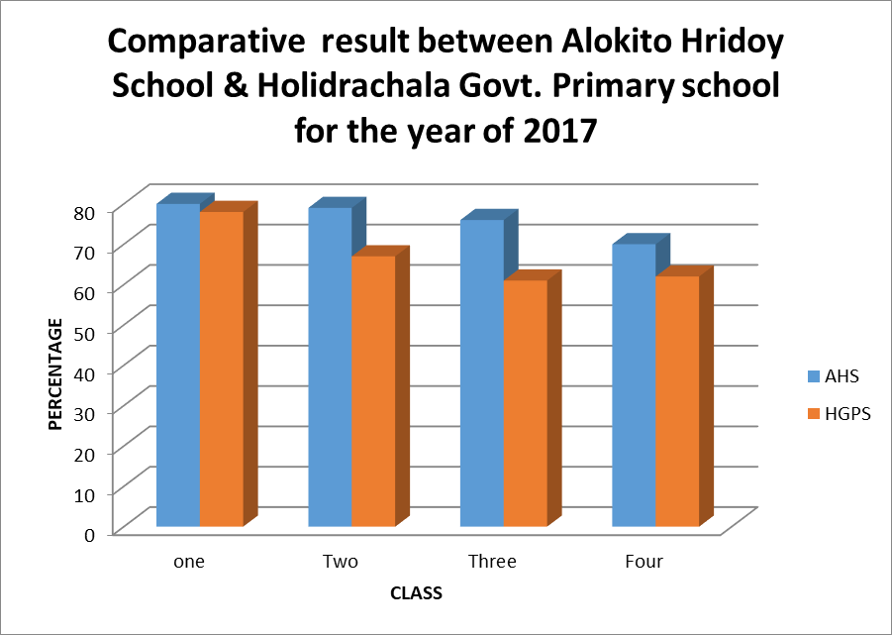
Class | AHF | HGPS
One | 80 | 78
Two | 79 | 67
Three | 76 | 61
Four | 70 | 62

Recently Access to Information (A2i) has expressed their desire to work with AHF in providing digital guidance to Alokito Hridoy School. A2i is a programme under the Prime Minister’s Office. With the support from UNDP and USAID, this programme started their journey in 2007 (Reference: UNDP Bangladesh, Sustainable Development Goals). The main theme for this program is that they are working on future education to enable shared and enjoyable learning spaces for teachers and students using different kinds of technology to ensure the future skills among the students by creating a digitally enabled classroom. It has already introduced a significant number of innovative solutions in the education sector of Bangladesh including digital content, multimedia classrooms, e-learning, etc. The team of AHF believes that their objective of transforming the current classrooms as exciting, shared learning platform for both teachers and students, introducing future skills as learning objectives in classrooms to improve the student and teacher performance are aligned with this program. And by collaborating with this program, they will be able to get closer to their goal of revolutionizing the education sector of our country.

- Conclusion:

It is time that a revolution takes place in our education system as, without it, we as a nation will fall behind. It is because the young generation is the future of this nation and without providing them with effective skills to cope with the 21st century, we as one are blindsiding them (future generation). It is quite an imperative time that changes are brought into our education system. Otherwise, the pace with the world is moving forward, we shall be stuck. Creativity amongst the young generation should be instilled from the beginning and aside from home, schools and classrooms should be an ideal place for them to blossom and gather such knowledge. Rote learning is needed, but now beside rote learning creative learning is much needed.

The government should understand the importance of such a change. And as a result, help these change-makers bring about a change in the system. An example of such an educational body that uses such teaching-learning techniques is Nalonda, which falls under Chayanot. School. Moreover, with improved learning techniques, more challenging and exciting classroom environment, the students will be motivated to learn beyond the textbook content and relate it in a more practical way with the real world. By enabling student creativity, they will be able to engage with content on a deeper level to gather a clear understanding and to able to apply it in the real world. In short, students will eventually deviate from rote learning practices and shift to a more creative, collaborative and problem-solving practice of learning which will result in their achievement of the 21st century. Time has come to a point, where it is essential to think outside the box and it should be us who should push these minds to do so. Marks and grades do not define who we are, creating and inventing does. Who doesn’t know Steve Jobs, the co-founder of Apple? Well everyone does, but what many people do not know is that he was a college drop-out. He could not complete his studies as his parents could not afford it. But it did not stop him from inventing Apple for us and now almost half of the people use his products. At the time of his death, his net worth was approximately $11 billion dollars. So who has to say that in order to do something big in life, you have to memorize your way out to achieve good marks! Being able to create something on your own can also be a way out as well.

“Imagination is the beginning of creation. You imagine what you desire, you will what you imagine, and at last, you create what you will”
– George Bernard Shaw

- REFERENCE
http://www.bd.undp.org/content/bangladesh/en/home/operations/projects/democratic_governance/access-to-information--ll-.html [UNDP BANGLADESH- Access to Information (ll)]
https://www.thedailystar.net/opinion/interviews/are-we-giving-enough-priority-education-1589257 [Are we giving enough priority to education?]
https://www.thedailystar.net/backpage/secondary-education-massive-spending-planned-skill-development-1585930 [Article on Secondary Education: Massive spending planned for skill development]
https://www.thedailystar.net/letters/training-teachers-needed-1576756 [Article on Training of teachers needed]
https://www.thedailystar.net/frontpage/primary-education-project-teachers-training-english-given-top-priority-1580767 [Article on Primary Education Project: Teachers' training in English given top priority]
https://www.thedailystar.net/opinion/where-our-education-system-has-failed-1525951 [Article on- Where our education system has failed]
https://www.thedailystar.net/frontpage/bangladesh-national-budget-2018-19-education-outlay-not-enough-1588219 [Article on Education lacks due attention]
https://lidtfoundations.pressbooks.com/chapter/edgar-dale-and-the-cone-of-experience/ [EDGAR DALE AND THE CONE OF EXPERIENCE, CHAPTER 7]
http://www.alokitohridoy.org/ [Alokito Hridoy Foundation]
https://www.nuffic.nl/en/subjects/education-and-diplomas-bangladesh/ [Education system Bangladesh]

