United International University


Thesis paper
On
Determinants of Intention toward Social business: A Case Study in Bangladesh Using SEM

Submitted to
Mohammad Ali Ashrsf, PhD
Associate Professor
Department of Economics
United International University
Submitted By
Tonwi Banik
ID: 121 151 027
Department of Economics
United International University

Data of Submission: 9 March, 2019

Abstract
Bangladesh has been faced different social and economical problems. And as social organization has greater opportunities to solve several social problems in a financially sustainable way, the significance of social organization is very high in Bangladesh. My study tried to find out the variables that affect the intention toward social business in Bangladesh. To conduct my study, 300 sample individuals were interviewed during the month of October and November, 2018. To find out my valuable findings, descriptive statistics, correlation analysis, standardized regression estimates and path analysis were employed. Research found that the Empathy, Moral Obligation, and Entrepreneurial Self-Efficacy influence the intention toward social business in Bangladesh. Thus, this paper will be very much helpful to further research on this topic.

Keyword: Social Business, Moral Obligation, Empathy, Social entrepreneurial Self-Efficacy, Social Entrepreneurial Intention.

Table of Contents
Chapter | Content | Page Number
Chapter 1 | Introduction | 4-7
Chapter 2 | Literature Review | 8-10
Chapter 3 | Methodology of the study | 10-15
Chapter 4 | Study Findings | 16-23
Chapter 5 | Conclusion and Recommendations | 24

Chapter 1
Introduction
1.1 Introduction:
In a simplest sentence, social Entrepreneurs establish or organize a social organization to solve several problems of any society. According to Muhammad Yunus, social business can be defined as: A Non-Dividend Company that is created to address and solve a social problem. A social business established based on some specific principles. These were developed by Yunus and Hans Reitz. Let’s see
- The main objective of any social business is to solve poverty or others social problem
- Trying to establish economic as well as financial sustainability.
- In any social business, any investor cannot take any dividend beyond the investment money.
- Organization profit stays with the organization for the improvement of the organization after the investment money paid back.
- Organization must be environmentally and gender conscious.
- The workers of the social organization must get the market wage and the organization must provide better working conditions
- And the last, Entrepreneurs should do all the social activities with joy. .
So unlike profit maximizing organization, the prime aim of a social business is not to maximize profit. Thus, social business is created only for solving different social problems.

  - Background of the study:
In generally, traditional profit making business organization established only for making money as their prime goal is to maximize profit. But social business organizations are created based on some specific principles and their main goal is to increase overall social welfare not to make money as the ethical ground of any social organization is very strong. Social organization is very much concern about the poor people and social organizations has greater scope to help the poor because of the strong ethical ground. So, poor people may get a better scope from the social organization to improve the living standard. And when the living standard of poor increase, the overall welfare of a country will also increases. That’s why the importance of social business is very high in developing and developed country and from the importance; different social organizations (for example, Grameen bank, BRAC, AKAS etc) are existed in our country.
1.3 problem statement of the study:
As general money making business organization organized based on profit maximizing principle, their only goal is to maximize profit and that’s why the scope to help the poor is very little. So the organization can be seen as either Immoral or Amoral but if we see it from the money making principle, then the profit maximizing motive is ethical. But social organization’s major goal is to identify the social problem and solve the problem. So, social organization’s prime goal is not to maximize profit. Thus, social organizations have more scope to solve different social problem and help the poor that may increase the overall welfare of any country. And the Research work tried to find the prime factors that influence the Intention toward Social Business in Bangladesh.

1.4 Study Questions:
Empathy, Entrepreneurial Self-Efficacy, and Moral obligation influence the Social Entrepreneurial Intention but how? And the study tried to investigate the following question to answer this question:
- What is the influence of Empathy on Intention toward Social Business in Bangladesh?
- What is the influence of Entrepreneurial Self-Efficacy on Intention toward Social Business in Bangladesh?
- What is the influence of Moral Obligation on Intention toward Social Business in Bangladesh?
  - Research Objectives:
The general objective of my study is to show the basic principles of social business and the specific objections are given below:
- Finding out the impact of Empathy on Intention toward social Business in Bangladesh.
- Investigating the impact of Entrepreneurial Self-Efficacy on Intention toward Social Business in Bangladesh.
- Examining the impact of Moral Obligation on Intention toward Social Business in Bangladesh

  - Significant of the Study:
In my study, I selected Bangladesh as a case study so that I can provide a proper understanding about the principles of social business and the factors that influence the social Entrepreneurial Intention in Bangladesh. Our country has been suffering several social and economic problems. And in this situation, the significance of Social organizations is huge to increase the welfare of poor because of its higher scope. So, social organization can play a major role to improve the overall economic condition of any country. That’s why many social organizations have been establishing since the liberation war. As a result poor people can get an opportunity to increase their social and economic welfare. So the study is very much significant to represent or find out the factors that may influence the Social Entrepreneurial Intention.
1.7 Scope and limitations:
This study focuses on social business organization or social Entrepreneurship based on Bangladesh prescriptive and that may differ from other countries. So readers will get a proper understanding about the principles of social business as well as the factors that may influence the social Entrepreneurial Intention after reading the paper
Though my study can provide well Scope to know several things about social business, my study has some limitations too. Let’s see:
- The participants of my study interviewed were not very friendly and cooperative.
- It was very difficult for my study participants to understand the study topic.
- It was very time consuming to prepare the study.

Chapter 2
Literature Review
2.1 Introduction:
This chapter will center of the research questions that were put forward in chapter one. The prime objective of the study is to investigate the variables that have an impact on intention toward Social Business .Let’s see some literature Reviews regarding social business and my study variables:
2.2 Literature Review:
According to Yunus (2007), every social organization must be set up for achieving certain goal but not to achieve personal goal. He also mentioned that social organizations should be established to make the welfare of others especially of poor people. Social organization create benefits for those whose are very much needy. .
According to Reis (1999), Social enterprise help to improve globalize economy and it’s very much significant to increase the social welfare. And organization creates an opportunity to reduce the gap between rich and poor.
Zhao and Hills found in their study that self-Efficacy influence the pro-Social behavior and Entrepreneurial behavior. And it’s clear that Self-Efficacy affect the Social Entrepreneurial Intention.
.According to the study of Vining (1989), prior Experience has a positive impact on social Entrepreneurial intentions. That means more prior experience leads to a more intention to participate in social business.
Ebreo (1989) found in his study that prior experience is an important predicts pro-Social behavior. Prior Knowledge about different social problems predicts attitudes towards social Entrepreneurial intentions (Ernst, 2011).
Hockerts (2015) found in his study that Moral Obligation makes an intention to help the poor people and it is positively related to social Entrepreneurial intentions and participate in social business.
Catford (1998) found in his study that the establishment of social organizations will be increased when social Entrepreneurs get proper support from the government and the private sector and through the support; Social Entrepreneurs get more inspiration to engage in social work. .
Douglas and Shepherd (2002) indicated that the intention to start one’s own enterprise seems to be driven by more entrepreneurial attitudes to risk as well as independence. Similarly, person leaving in societies with high level of uncertainty and that’s why individual may try to avoid risk as well as seems to be driven less available attitude toward entrepreneurship.
According to Mel gray (2003), Social Enterprise refers to an approaches that use business sense to address social goals. And the marginal activity in social work for a long time but recently social enterprise has been push into the spotlight in debates about the future of social policy and community services.
According to the Christie Gorton, to maximize their impact , every social enterprise must effectively reach and activate their target audience , but some time it may more difficult for any social business organization than traditional money making organization competing for consumer attention.
Santos (2009) said that, Social Entrepreneurship is an Entrepreneurship “addressing problems involving neglected positive externalities for society”. Some positive externalities are indeed not perceived as essential for society by a majority of the population and are not, therefore, taken into account by government.
Rahaman (1994) said that, by the new way, basic human need is to fulfill. Social organization helps to improve the economic and social growth. Social organization helps to fulfill the basic need of poor that may reduce the gap between the rich and poor in any society.
According to Wallace (19990, Social Entrepreneurs are the Entrepreneurs who take on social accountability as it relates to social development and that is totally determined by the existing political and social context .
According to Hibbert (2001), Social Entrepreneurial behavior should apply for social purpose or it means that social entrepreneurs make or generate revenues for the benefits of poor or certain disadvantaged people. So social organization is very much helpful for the poor people in any society.

Chapter 3
Methodology of the study
3.1 Introduction:
A total 300 participants were interviewed with structure questionnaires. To know the opinion of the participants about the variables, direct interviewed was taken among the patricians living in Dhaka city. SPSS 16.0 were used to analyses the data. And the data analyses were conducted based on inferential as well as Descriptive Statistics. Random sampling procedure was used to select the sample participants.
3.2 Research Framework:

In my paper, three independent variables are Empathy, Moral obligation and Self-Efficacy and the only dependent variable is social Entrepreneurial Intention.

3.3 Study Hypotheses (H):
Three hypotheses were developed to see whether the three independent variables influence the Intention toward Social Business in Bangladesh.
- Firstly, H1: Empathy affects the Intention toward Social Business in Bangladesh.
- Secondly, H2: Moral Obligation affects the Intention toward Social Business in Bangladesh.
- Finally, H3: Self-Efficacy affects the Intention toward Social Business in Bangladesh.
3.4 Operational Definition:
A social organization is an organization that is created for a social purpose or we can say, it is created to reduce several social problems and to generate social value while operating with the financial discipline, determination as well as innovation of a private sector business. Because of social organization socially disadvantaged people can get a way to make an earning source to improve their economic condition that may improve their living standard. As a result, whole economic condition of any country must improve.

3.5 Research Design for the study:
Formulation of Research Questions and Objective

Formulation of Hypothesis

Literature Review

Identifying variable and Measurement Tools

Data Collection

Primary Data: Surveying

Data Analysis

Descriptive Statistics
Standardized Regression Estimates
Correlation Analysis

Path Analysis

Data interpretation & Analysis
Findings & Discussions

3.6 Way of Data collection:
Two types of data source have been used to conduct my study. Let’s see:
- Primary Data: This kind of data can be collected by someone and this person has to have a clear plan for conducting research, including specific research questions and methodology. The data that is collected is used for its intended purpose,
- And secondary Data: This kind of data might actually be the product of other research, or might have been collected by someone else. Unlike primary data is not tightly controlled by the researcher. And the process has already happened, or the data was collected for a several purpose.
Secondary data were gathered through internet, several articles, different books and several journals to complete my paper.
3.7 Procedure of Sampling:
There are two type of sampling and the sampling procedures are as following:
- Probability Sampling: A probability sampling refers to a sampling that is one in which each people in the population has equal or at least known change of being selected.
- And Non-Probability Sampling: A non-Probability sampling refers to a sampling that some people have a greater, but unknown chance than others of selected.
To conduct my study survey, I gave 300 questionnaires to the participants and then they return back to me after fill up the questionnaires.

3.8 Data Analysis Techniques:
The data analysis procedures have been done based on both quantitative and qualitative data collection techniques. Structure questionnaires have been prepared based on a focus group discussion and the literature reviews. And from the analysis result, I found the valuable result.
Four Analysis techniques were used to analysis the data and the techniques are as followings:
- Firstly, I conducted the Descriptive Statistics.
- Secondly, the correlation Analysis.
- Thirdly, the Standardized Regression Estimates.
- And finally, the Path analysis.

Chapter 4
Study Findings
4.1 Introduction:
At first, I completed my research survey and then started to compete the data preparation. In my questionnaires, there were some basic information regarding the participants such as participant income, age, marital status, gender, level of education etc. and regarding the variables that affect the intention toward Social Business in Bangladesh. In my questionnaires, each question contains with different number range from 1 to 7 and each number represents different level of agreement. And here 7= strongly agree, 6 = agree, 5 = somewhat agree, 4 = neutral, 3 = somewhat disagree, 2 = disagree, 1 = strongly disagree.

4.2 Participants Background Characteristics:
- Majority of the participants were student and most of are male but the percentage of female are satisfied.
- Most of the respondents earn an income range from 0 to 60000.
- Most of the people have an age range from 15 to 40.
- Most of the respondents were Muslim.
- Most of the participants had an education level from secondary to Bachelor.
- And the percentage of single participants was greater but few participants were married.

4.3 Descriptive Statistics:
From the Descriptive statistics, we can get a clear understanding about the average or mean impact of the Independents variables (Empathy, Moral Obligation, and Self-Efficacy) on the dependent variables (Intention toward Social Business in Bangladesh).

Table of Descriptive statistics

 | Number of Observation | Minimum value | Maximum value | Average or Mean | Standard Deviation
Intention | 300 | 1.00 | 7.33 | 4.4500 | 1.07439
Empathy | 300 | 1.00 | 7.00 | 4.9533 | 1.32075
Obligation | 300 | 1.00 | 7.00 | 5.3942 | 1.27960
Self-Efficacy | 300 | 1.00 | 7.00 | 5.1556 | 1.19870
Total Valid Number of Observation | 300

Output interpretation is given below:
Here, the average or mean value of Social Entrepreneurial Intention is 4.4500 and it means Neutral level of agreement, the maximum value is 7.33 that represents a strongly agree level of agreement, the minimum value is 1 that represents a strongly disagree level of agreement. The total observation is 300 and 1.07439 is the value of Standard Deviation.
The average or mean value of Empathy is 4.9533 and it means somewhat agree level of agreement, the maximum value is 7 that means a strongly agree level of agreement, the minimum value is 1 that represents a strongly disagree level of agreement. The total observation is 300 and 1.32075 is the value of Standard Deviation.
The average or mean value of Moral Obligation is 5.3942 and it means somewhat agree level of agreement, the maximum value is 7 that means a strongly agree level of agreement, the minimum value is 1 that represents a strongly disagree level of agreement. The total observation is 300 and 1.27960 is the value of Standard Deviation.
The average or mean value of Self-Efficacy is 5.1556 and it means somewhat agree level of agreement, the maximum value is 7 that means a strongly agree level of agreement, the minimum value is 1 that represents a strongly disagree level of agreement. The tatal observation is 300 and 1.19870.

Short note: It represents how much the numbers of a group differ from the average or mean value of the group. And all researchers always want to get a lower standard deviation value as much as possible.

4.4 Correlation Analysis:
From the correlation analysis, we can get a clear understanding about a relationship between variables that means we can know or see whether a relationship is exist or not between variables and R value shows the whether the relationship is positive (indicated by a positive value) or negative (indicated by a negative value) and the R always shows a value between -1 and +1.
Correlation Ration
 | Intention | Empathy | Moral Obligation | Self-Efficacy
Intention | 1
Empathy | .193** | 1
Moral Obligation | .166** | .552** | 1
Self-Efficacy | .381** | .398** | .554** | 1

- **.Correlation is Significant at the 0.01 level (2-tailed).
Output interpretation is given below and form the output interpretation, existence of association between variables will be cleared.
The R value of .193 shows a positively weak relationship between Social Entrepreneurial Intention and Empathy. And the double star represents a significant (0.01 level) relationship between the variables based on a 2-tailed test.
The R value of .166 shows a positively weak relationship between Social Entrepreneurial Intention and Moral Obligation. And the double star represents a significant (0.01 level) relationship between the variables based on a 2-tailed test.
The R value of .381 shows a positively weak relationship between Social Entrepreneurial Intention and Self-Efficacy. And the double star represents a significant (0.01 level) relationship between the variables based on a 2-tailed test.
The R value of .552 shows a positively moderate relationship between Empathy and Moral Obligation. And the double star represents a significant (0.01 level) relationship between the variables based on a 2-tailed test.
The R value of .398 shows a positively weak relationship between Empathy and Self-Efficacy. And the double star represents a significant (0.01 level) relationship between the variables based on a 2-tailed test.
The R value of .554 shows a positively moderate relationship between Moral Obligation and Self-Efficacy. And the double star represents a significant (0.01 level) relationship between the variables based on a 2-tailed test.

Short note: In generally, significant represent the meaning of “importance” but Statistical interpretation represents a different meaning of the word (significant). In statistics, significant represents the meaning of “Probably true”.

4.5 Standardized Regression Estimates:
Standardized Regression Estimates table shows the Estimate value, standard Error (S.E), Coefficient Ration (C.R) and the P value.
Standardized Regression Estimates Table
Path | Estimate | S.E. | C.R. | P
Obligation Empathy | .60 | .083 | 6.609 | ***
Obligation Efficacy | .53 | .095 | 6.246 | ***
Intention Obligation | -.52 | .237 | -2.595 | .009
Intention Empathy | .38 | .168 | 2.438 | .015
Intention Efficacy | .92 | .225 | 5.304 | ****
Note: ***Sig. at p<.000
So from the table, we can see that Empathy positively influences the moral obligation and that in indicated by positive C.R value of 6.609 and Estimation value of .60.
The variable Self-efficacy positively influences the variable Moral Obligation and that is indicated by the positive value of Estimation and C.R.
The variable Moral Obligation negatively influences the variable Social Entrepreneurial Intention and that is indicated by the negative value of Estimation and C.R.
The variable Empathy positively influences the variable Social Entrepreneurial Intention and that is indicated by the positive value of Estimation and C.R.
The variable Entrepreneurial Self-Efficacy positively Influences the variable social Entrepreneurial Intention and that is indicated by the positive value of Estimation and C.R.
4.6 Path Analysis (Model Fit by SEM):
From the path analysis, we can clearly describe the directed dependencies among a set of factors or variables.
Path Diagram
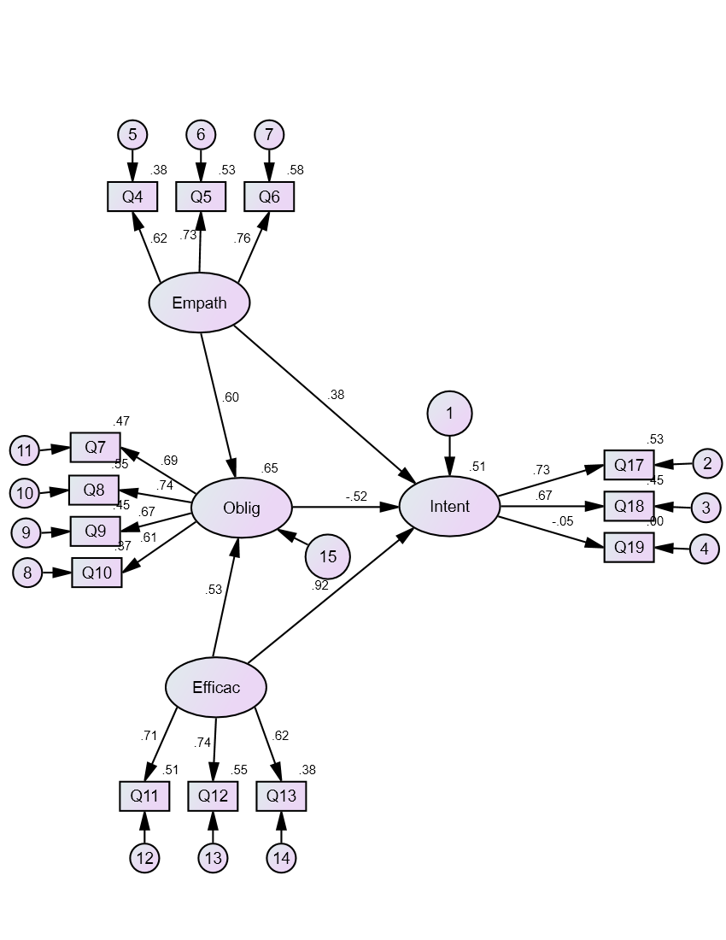

It is clear from the diagram that moral obligation shows a Non-Significant influence on Social Entrepreneurial Intention and that is indicated be a negative value of -.52. It simply indicates that people have no Moral Intention to participate in Social business that may be a major reason to establish social business organization less. Here Social Entrepreneurial Self-Efficacy shows the highest significant amount the all variables and that is indicated by a positive value of .92. Here we can also see that all questions are significant without the question number 19 (Q19) and that is indicated by a negative value -.05. So without question number 19, all questions of the study questionnaires are significant. Thus, it is clear that the hypotheses of my study are true.

Chapter 5
Conclusion and Recommendation
My study tried to find out the prime variables that affect the intention toward Social Business in Bangladesh and also find out that the independent variables of my study influence the intention toward social business in Bangladesh. And correlations exist between variables based on correlation analysis.
Our country has been faced several problems such as poverty, corruption, pollution. So, only government and profit maximizing private organization can’t solve the problems. In this situation, more establishments of social organizations are must. As social organizations have greater scope to solve the problems, the importance of different social organization is very high in all developing and underdeveloped countries. Social Organization provide different facilities to the poor and it may create an opportunities for the poor to solve their poverty problem. So government and private sectors should come forward to increase the establishments of different social business. When Social Entrepreneurs get proper support from the government and other sectors, they will be inspired more to participate in Social business or work.
People should improve their morality that may influence the Social Entrepreneurial Intention to engage in social work. So, overall economic condition will be improved when social organizations can establish and conduct its work properly. And social organizations can play a major role to improve the economic condition of needy people that may play a prime role to reduce the gap between rich and poor. So the significance of Social organizations is very high in our country.

Reference
Greg Dees. January 2009, “The meaning of Social Entrepreneurship “
James A. F. S. & Charles w. 2007. Innovative Approaches to Reducing Global poverty.
Jerr McClurg. 2007. “Toward a better understanding of social entrepreneurship: some important discussion”.
Ralph & Donald Feldstein. 2003. “Understanding social welfare”
Nichacel Chertok. 2003. “The funding Gap of investing in Social enterprise”
Paul N. Bloom. 2009. “Scaling Social Entrepreneurial Impact”
Gress Dees, Beth Battle Anderson & Jane. “Scaling Social Impact”
Lingane & Olsen. “Guideline for Social Return on Investment”
Lisa Jones & David Lehr. “A Good Business for poor people”
Muhammad Yunus. “Credit for the poor”, Harvard International Review.

