Internship Report
On
“Role of HRM in Digital Marketing”:
A Perspective on Team360 Digital Ltd.



Internship Report
On
“Role of HRM in Digital Marketing.”
A Perspective on Team360 Digital Ltd
Submitted To:
Ms. Nasrin Akter
Assistant Professor, Human Resource Management (HRM)
Department of School of Business & Economics
United International University

Submitted By:
Israt Jasim Promee
ID No: 111 141 409
BBA Program
Department of School of Business & Economics
United International University

Date of Submission:
2nd January 10, 2019



Declaration
Student Declaration
I, Israt Jasim Promee , hereby declare that the presented report of internship titled ” “Internship on Team360 Digital Limited.”: A Perspective on Team360 Digital Ltd. Is uniquely prepared by me after the completion of three months’ work at Team360 Digital Ltd.

I also confirm that the report is only prepared for my academic requirement, not for any other purpose. It might not be used with the interest of the opposite party of the corporation.

…………………………….
Israt Jasim Promee
ID-111 141 409
BBA
Department of Business & Economics
United International University

Declaration
Declaration from the Organization
It is our immense pleasure to certify that, Israt Jasim Promee, ID-111 141 409, School of Business & Economics of United International University of Bangladesh attended Three Months internship program in Team360 Digital Ltd. from 1st July , 2018 to 30th September 2018.

During internship, Israt Jasim Promee maintained a good performance in Business Analyst Team with full satisfaction to the management as well as she showed her knack for digital marketing activities.

We wish her every success & progression in her life.

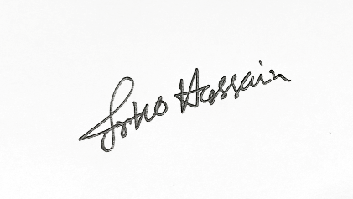
……………………………..
Sakib Hossain Arko
Head of Communications
Team360 Digital Ltd.
House: 10 (New),Road 12 (New), 31 (Old)
Dhanmondi, Dhaka.Bangladesh.

Letter of Transmission
2nd January 2019
Ms. Nasrin Akter
Assistant Professor, Human Resource Management (HRM)
Department of School of Business & Economics
United International University
Subject: Submission of the Internship Report titled “Team360 Digital Limited: A Perspective on Team360 Digital Ltd.”
Dear Madam
This is a great honour for me to existing my internship record titled “Team360Digital Limited: A Perspective on Team360 Digital Ltd.”, authorized under your supervision, as a partial requirement for the completion of INT 4399 (Internship).
This report endeavours to analyse the learnings and experiences of my three months internship period at Team360 Digital Ltd. Bangladesh. It then goes on to analyse the digital advertising communications and activations or campaigns accomplished with the aid of Team360 Digital Ltd. Bangladesh.
I am thankful to you for your kind support and supervision, in the guidance of this document and actually hope that I would live up to your expectations involving the satisfactory of my work. I tried to put my pleasant effort for the training of this report. Yet if any shortcomings arise, it will be my pleasure to reply any clarification and suggestion related to this report.
Thanking you.

Sincerely yours,
Israt Jasim Promee
ID No: 111 141 409
School of Business & Economics
United International University

Contents
Acknowledgment i
EXECUTIVE SUMMARY ii
Chapter 1 1
Introduction 1
Origin of the report 2
Scope of the report 3
Objective of the report 3
Methodology of the Data Collected and Used 3
Limitation of the report 4
Chapter 2 5
Literature Review 5
What is Digital Marketing? 6
Why does it Matter 7
Why Digital Marketing? 8
Why opt for digital marketing? 8
The importance of digital marketing for Organization 8
Different types of Digital Marketing 9
How to develop organization through Digital Marketing 10
Contribution of Digital Marketing in Organization 14
Top Digital Media Platforms in Bangladesh 15
Chapter 3 17
Industry & Organizational Overview 17
Industry Overview 18
Current profile of Leading Digital Marketing Agencies 19
Key Market Rivals 20
History of Team360 Digital Ltd: 21
Company Profile 21
Management Team 22
How Do Team360 Work 22
Team360 Digital Ltd. Specialities: 22
Our Clients 23
Organizational Hierarchy 24
SWOT Analysis 25
Some of the works 26
Future Plan of Team360 Digital Ltd. 29
Chapter 4 31
Analysis on Digital Marketing Process 31
Description about Job 32
Core Responsibility 33
Overview of My Work: 33
Meizan Fortified Palm Olien: 36
Golden Harvest: 50
Golden Harvest Agro Industries Ltd 52
Golden Harvest Ice Cream Ltd 52
Golden Harvest Foods Ltd 52
Evaluation of Israt Jasim Promee 64
Chapter 5 65
The Role of HRM in Digital Marketing 65
Strategic HR 66
Staffing and Retention 67
Recruitment: 68
Employee Policies and Procedures 69
Compensation 71
Chapter 6 72
Findings And Recommendation 72
Best Digital Marketing Strategies for HR Department 73
1. Use Social Media and Promote Openings on Social Media Channels 73
2. Know your Target Audience as Digital Marketers do 74
3. Utilize exceptional Channels to convey one Message 76
4. Keep your Website Updated 77
5. Digital Marketing Tips for Human Resource Departments 79
5. Measure Effectiveness 81
Findings I found from Team360 Digital 85
Recommendations 86
Bibliography 90
Appendix 91
List of key concept Abbreviation, Technical Terms 91
Abbreviation 92

Acknowledgment
At the very outset, I am very a good deal thankful to almighty Allah for giving me strength, braveness and capability to accomplish the internship program as well as the internship document in a scheduled time in spite of a variety of complications.
It gives me enormous pleasure to thank a large wide variety of individuals for their cordial cooperation and encouragement, which has contributed immediately or circuitously in preparing this report. First, I would like to express my gratitude to my internship supervisor Ms. Nasrin Akter for her guidance and feedback, which made the whole thing, clear to me to whole this report. At first, I was so stressed that whether I would be in a position to make a fruitful record however with his assistance, I observed a way to do the whole thing immaculately and in time. She kept me on track to complete this document and his suggestions and remarks were very dynamic in making this report as impeccable as possible.
Moreover, I have to exhibit my gratitude to my supervisor of Team360 Digital Ltd., Mr. Sakib Hossain Arko, (Head of Communication) who willingly took my responsibility and gave me lot of time and shared his working experiences with me. His guidance showed me a way now not only to understand the workplace lifestyle however additionally how to deal with all the co-workers of the organization and meet the client needs with tremendous teamwork.
I would additionally like to categorical my sincere thanks to all the employees of Business Development team, Account Management, Creative & Copywriting, Studio and Digital Services branch who helped me all through my work tenure and made my trip an unforgettable one. People from these departments helped me to gain extra practical information, which made my Internship experience greater fruitful.
A very distinct gratitude goes to my Reporting Boss, Mr. Sakib Hossain Arko for his sort aid and well timed comments regarding the recommendations and closing dates of internship completion.

EXECUTIVE SUMMARY
This internship report stresses on the work experience I have gathered as an Intern in the Business Analyst department of Team360 Digital Ltd .In this report, I generally have incorporated my experience at Team360 Digital especially marketing campaign management, lookup and development works etc. where I also have provided small print about my three months’ work experience at Team360 alongside with a complete job description where I had to work with distinct worldwide and local brands and an analysis on the roles of Digital Marketing Communications over traditional advertising which is additionally a blend of my Team360’s journey and research data.
Advertising is a large business. Concept is where the company takes the client's approach and turns it into particular ideas for advertisements-such as a sequence of advertisements providing "extreme sports" athletes for a soft-drink maker whose approach is to enter the teen market. Full-service businesses additionally cope with the placement of ads in print and electronic media so that purchasers attain their intended audiences. Whereas, digital advertising and marketing refers to any marketing delivered via media linked to internet. As digital platforms are an increasing number of incorporated into advertising plans in daily life, and as human beings use digital gadgets as an alternative of visiting bodily shops, digital advertising and marketing campaigns are turning into more widely wide-spread and efficient. By the usage of Internet platforms, organizations can create aggressive advantage through a number means. To attain the most achievable of digital marketing, corporations use social media as its primary device to create a channel of information. Through this a enterprise can create a device in which they are capable to pinpoint behavioral patterns of purchasers and feedback on their needs. Here the branch include in digital corporation are Social Media Executive, Digital PR, Web Designing and Development, Search Engine Marketing , Search Engine Optimization, Creative Designing and Application Development. The most vital component in marketing to be effective: “It has to be creative.” That will seize the attention of audiences; therefore the message is more possibly to get via consequently the fantastic use of creativity is when the companies make buyers suppose about the product or brand.
Title of the Internship Report is “Role of HR in Digital Marketing: A Perspective on Team360 Digital Ltd.” and Objectives of the Internship are to understand the requirement of employees, formulating strategies for employees, executing those strategies to achieve their HR strategies & objectives.
Main findings of this internship are given here. Agency people have to work much for uplifting a brand. There is an agency client & agency employees gap in Bangladesh, if it can be reduced, it may make the works for both the parties very easily. Again, agencies and corporates are not taking digital marketing communication seriously until now. More investments in digital media is needed which may give a better visibility of the brands and make the advertising and marketing atmosphere more delightful for HR fields which may amaze people with its’ beauty. The successful completion of this internship indicates that the future of marketing is in the hands of digital. I conclude my research by quoting again that “Brands can’t sustain without digital presence, without team efforts agencies can’t serve the brands.

Chapter 1

Introduction

Advertising is one of the major components in brand and venture interchanges, which presents records, which can likewise help, take a grand purchasing choice by methods for the clients or shoppers. In fact, intentional correspondence is the last result of publicizing, which may advance business undertaking items or contributions to the objective gathering. This intentional correspondence charms, supports and in particular it might educate and offer. At the point when this intentional correspondence is extremely viable, it achieves the customer or client and the rest of the objective of imparting is accomplished.
An outsider known as advertising organization ordinarily does publicizing. A publicizing office is an administration-based business devoted to making, arranging, and taking care of promoting for its customers. An advertisement office is autonomous from the customer and gives an outside perspective to the exertion of offering the customer's items or administrations. An organization can likewise deal with largely showcasing and marking systems and deals advancements for its customer’s .Types of ad agencies are
- Full service agencies
- Creative agencies
- Specialized agencies
- In-house agencies
- Digital agencies or new media agencies
This report is completely talking about advanced or new media organizations. There was before a period when Television was the most mainstream medium for Marketer to advance, unfurl awareness and create leads for their items however now the vogue has changed and Digital media has had its spot. Primary driver for this substitute used to be:
- Traditional strategies are costly. Contrasted with computerized showcasing channels, you could surrender spending numerous greenbacks more. In this report, an example is given dependent on this issue.
- Traditional advertising channels neglect to concede prompt remarks and surveys about who saw or heard an advertisement, and made a move. This data is amassed long after the underlying advert affect is made (and still at that point, the data are some separation from particular numbers).
Computerized displaying, on the distinctive hand, alludes to publicizing techniques that allow associations to perceive how a battle is performing progressively, for example, what is being seen, how regularly, to what extent, as legitimately as various data, for example, deals changes.

Origin of the report
The report, titled “Role of HR in Digital Marketing: A Perspective on Team360 Digital Ltd.” has been geared up to satisfy the partial requirement of my Internship of BBA Program of United International University(SOBE), supervised with the aid Ms. Nasrin Akter Assistant Professor, Human Resource Management (HRM) SOBE, United International University. I have been attached with the Digital Services department & Business Analyst Department of Team360 Digital Ltd. and I have organized this file in association with my assigned responsibilities.

Scope of the report
- The scope of the report is to make a bridge between theoretical & amp; practical studies.
- To identify the role of Digital Marketing practices in the business development
- Providing recommendations for the Team360 Digital Ltd to ensure satisfaction & reliabilities of employees as well as organization.
- To examine primary & secondary documents relating to the challenges and development of Team360 Digital Ltd.’s employees and organization.

Objective of the report
- Primary Objective:
The Primary objective of this report is to apprehend the roles of digital advertising & over the traditional marketing from the HR point of view to locate out how to convert traditional marketing employees to digital marketing process.

- Secondary Objectives:

- To know the effectiveness of digital advertising in this competitive era.
- To find out the major HR strategic choices Digital marketing
- Find out which source organizations uses more for Digital Marketing Process,
- Comparing Employee satiation in digital marketing at organization,
- To know how it contributes to the organizational success,
- To solve the arising problems of the organization, regarding which occurs by Digital Marketing in HR Department.
- So by what means can HR move from a Job Poster to Brand Builder– Through effective Digital Marketing.

Methodology of the Data Collected and Used
- Research was done by collecting information from general people of Team360 Digital Ltd. and some data were collected form internet.
- Data Type: This report will be based both on Primary and Secondary data-
- Primary Data: This study was mainly based on primary data that was collected through direct comunication. To accomplish this, I talked to every people of Team360 Digital Ltd.
- Secondary Data: The secondary data sources are:
▪ Team360 Digital Ltd. Credentials 2018
▪ Team360 Digital’s internal documents, website & Facebook.
▪ Employee service book, employee records etc.

Limitation of the report
- As this report, work conducted only for academic purpose that is why the main constrain was cost and time. For the in depth analytical purpose, adequate time is required. However, inadequate time was a major hindrance to prepare such an in-depth study.
- I got only 3 months experience with Team360 Digital Ltd. for which I couldn’t get excess to some resources which I have assume for this report.
- Resource problems: In digital marketing, every job depends on images. We cannot use every image. There are some legal issues. Sometimes we do not get the exact image what we want.
- Work limitations: There are many work limitations from client side. They have budget issues, which hamper our works as well as employee interest.
- Communication gap: There are always communication gap between creative team and content team.

Chapter 2

Literature Review

What is Digital Marketing?
Advanced highlighting incorporates all promoting endeavors that utilization an electronic contraption or the web. Organizations use advanced channels, for example, web crawlers, inte
The utilization of the Internet are not based life, email, and their sites to join with present day and planned clients. d other computerized media and mechanical mastery to encourage 'present day promoting' has given an upward push to a puzzling scope of marks and language made by method for the two speakers and experts. It has been known as advanced promoting, Internet advertising, e marketing and web promoting and these decision terms have grouped through time.

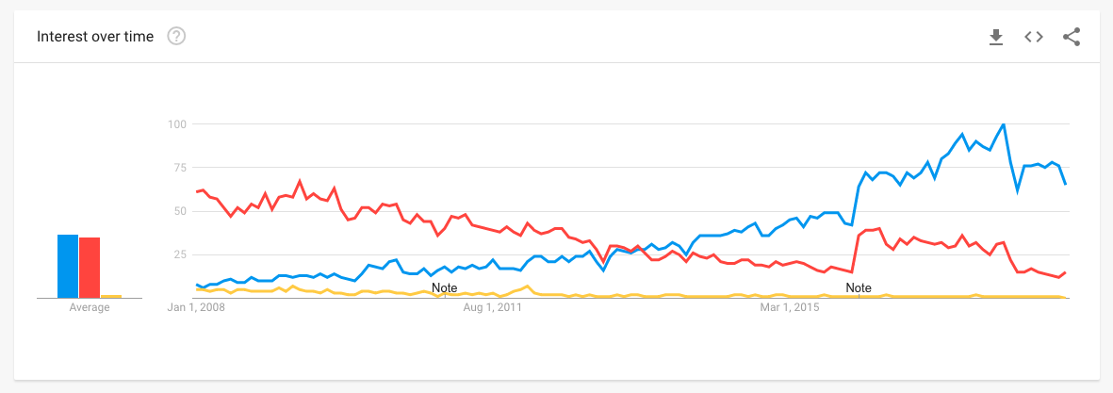
Picture 2. 1: Internet Over-Time.
As a result of the most recent discussion about the utilization of the term 'computerized promoting', we thought it is helpful to bind precisely what advanced means through a definition. Do definitions make a difference? We guess they do, given that particularly inside an association or between a business endeavor and its clients, we require intelligibility to encourage the wants and exercises that help Digital Transformation. As we will see, a considerable lot of the diverse definitions are deluding.
Come down to its least difficult frame, computerized publicizing and promoting is portrayed in my book Digital Marketing: Strategy, Implementation and Practice as just:
"Achieving marketing goals through applying digital technologies and media."
on this meaning of advanced promoting and showcasing to clarify that, practically speaking, computerized advertising comprises of overseeing unique assortments of on-line association nearness and existences, for example, association sites, cell applications, and web based life business pages. This is related to on-line interchanges methods, for example, any semblance of web index promoting, internet based life showcasing, web based publicizing, email publicizing and organization courses of action with various sites.
These procedures are utilized to control the objectives of acquiring new customers and granting contributions to exhibit customers that help advance the supporter relationship by means of E-CRM and advertising computerization. In any case, for computerized promoting to be fruitful, there is in any case a need for mix of these systems with standard media, for example, print, TV
and post office based mail as segment of multichannel publicizing and highlighting correspondences.

Why does it Matter
There is a point of convergence on advancement of stock and administrations the utilization of computerized media as a substitute than an additional all encompassing definition securing customer encounters, relationship change and focusing on the significance of multichannel coordination. In this manner, for us, the extent of the term needs to incorporate exercises over the buyer lifecycle:
Digital media and communications channels.
Digital and cell experiences such as web design and mobile apps.
Prospect and customer relationship management through advertising automation.
Digital approach and integrating multichannel communications and experiences.
Digital technologies and structures to manage all digital marketing activities.
The job of computerized structures in supporting incorporated multichannel showcasing is an important thing area of advanced promoting, yet is regularly neglected. From multiple points of view, this features that it is so important to harm down storehouses among 'computerized' and 'customary' promoting and advertising offices. Online channels can also be figured out how to direct the aggregate looking for strategy from pre-deal to deal to post-deal and further change of customer connections.

5D is of Digital Marketing
To capture the hugeness of advanced promoting to the eventual fate of advertising in any business, it's valuable to expect about what target showcase associations we have to secure and oversee. Computerized publicizing and showcasing these days are about numerous a bigger number of sorts of target advertise cooperation than site or email... It includes overseeing and tackling somewhere in the range of '5Ds of Digital' that I have portrayed in the prologue to the advanced supplant to my Digital Marketing: Strategy, Planning and Implementation book. The 5Ds diagram the conceivable outcomes for customers to collaborate with producers and for associations to reach and concentrate from their groups of onlookers in uncommon ways:
Digital Devices: Groups of onlookers venture marks as they collaborate with business sites and cell applications normally by means of a blend of connected contraptions, which incorporates cell phones, tablets, smart phones, and gaming gadgets.

Digital Platform: Most connections on these gadgets are through a program or applications from the real structures or administrations, that is Facebook (and Instagram), Google (and YouTube), Twitter and LinkedIn.

Digital Media: Exceptional paid, claimed and earned interchanges channels for achieving and alluring crowds, which incorporate promoting, electronic mail and informing, web indexes and interpersonal organizations.

Digital Information: The knowledge bunches accumulate about their objective market profiles and their associations with organizations, which currently wants to be canvassed by utilizing law in many nations.

Digital Technological Know-How: The promoting innovative information or martech stack that offices use to make intuitive encounters from sites and cell applications to in-store stands and email crusades.

Why Digital Marketing?
Customary publicizing and advertising incorporate showcasing and advancement of items and administrations on print media like flyers, blurbs, business ads on radio and TV, hoardings, dispatch loads up and distinctive expensive ways. Around then, online networking or web were never again used for advancement. Two Traditional promoting had the restricted extension and customer reach. Be that as it may, after the innovation of advanced showcasing, there are a few on-line channels through which you can advance your endeavor carefully. In the event that a business endeavor is going advanced, exclusively then it can keep on existing in this day and age.

Why opt for digital marketing?

- Interaction with the targeted audience: With digital marketing businesses can interact with their customers and engage them with valuable points to understand what their targeted audiences wish for.
- Generate more conversation: Online marketing of products and services can generate more leads and subscribers than the traditional form of marketing.
- Reduced cost of advertising: For people having small business, digital marketing is proven better and cost-effective platform than the traditional marketing.
- Customer Satisfaction and retention: Digital Marketing can be considered as real-time marketing. When business provide real-time help and solutions to their customer problems, they gain customer satisfaction and retention.
- Revenue Generation: With digital marketing techniques, higher conversations can be achieved that result in prominent revenues.
- Build Brand reputation: Digital marketing techniques help businesses to increase their customer reach and visibility. Therefore, they can build a unique identity among customers.

The importance of digital marketing for Organization

Digital advertising levels the on the net having exciting area. When it pertains to an organization’s exposure online, like opening a shop, the location is each little thing. Being conveniently apparent online, obtaining a company’s title available, and upgrading information often will bring clients to its door.
Today, the Internet is a boon that provides endless possibilities for your small, medium or massive business. Currently, extra than half of the international populace makes use of the Internet. Experts say that in coming years above 80% of the world population will be online. Therefore, digital advertising has turn out to be a quintessential part of marketing.

- Cost Effective:
Digital advertising is one of the most low-priced mediums of marketing. Traditional advertising techniques such as print, broadcast, etc. require a lot of cash and provide confined output. On the other hand, Digital Marketing is cheap; it fits all kinds and sizes of business.

- Reach Mobile Consumer:
Mobile users are growing day by using day. Currently, a giant component of grownup population uses smartphones. With digital marketing, one can easily goal their cell audience, and convert into their customers. Reaching cellular buyers is the key for business growth.

- Contents connects customers:
Digital Marketing allows you to use content to get related with customers. The gain of content material is that it allows you to talk more and express more. Hence it a superb medium to bring a clear message and entice big website visitors for the cause of growing sales.

- Get High ROI:
Return On Investment (ROI) is an essential thing in any advertising strategy. Traditional marketing strategies have low return on investment and don’t suit all sorts and sizes of business. Whereas, Digital advertising is the satisfactory method to amplify patron base and achieve excessive return on investment.

Different types of Digital Marketing
There are unmistakable sorts of computerized publicizing and promoting open, for example, Search Engine Optimization (SEO), Pay Per Click Advertising (PPC), Social Media Marketing (SMM), Content Marketing, Affiliate Marketing, and so on. You can select any sort of promoting and showcasing depending on your business compose, business size and business venture objectives.
- Tap Social Media:
Social media is on the rise. Right from teens to old aged people, all of us is on social media. You can improve the efficiency of your marketing campaign by way of exactly concentrated on your doable clients based on their age, area and interests. Moreover, it is a fantastic method to improve brand visibility and company awareness.
- Build Credibility:
Trust performs a necessary position in converting a possible client into customer. Digital Marketing strategies will help you to region your company on first web page of Search Engine Results Page (SERP). Being in the first page of Google not only establishes trust, however additionally will increase website traffic. As the result of which, you get new clients effortlessly.
- Easy to Measure Outcomes:
Results of regular marketing strategies are challenging to measure. Without understanding detailed outcome, it is difficult to gauge the success of a campaign. This is no longer the case with digital marketing. Every single digital marketing tactic you use is measurable. You can do an in-depth evaluation of current effects and first-class tune to gain any other landmark.

How to develop organization through Digital Marketing
- Increased Brand Awareness: Online life is a standout amongst the most inside your methods computerized promoting procedures used to syndicate content material and extend your business' perceivability. Executing an online life technique will considerably increase your image insight since you will allure with an expansive target gathering of people of shoppers.
To begin, make internet based life profiles for your business undertaking and start cooperating with others. Get representatives, venture accomplices, and patrons to "like" and "offer" your page. Essentially having people cooperate with your substance will expand organization acknowledgment and start constructing your acknowledgment as a business. Each distribute that is shared will be conveyed to another network of people, which can lead them to getting to be feasible clients, and the additional individuals who comprehend about your business, the better. By contributing just a couple of hours out of each week, more than 91% of advertisers guaranteed that their social promoting endeavors generously extended their presentation. There is almost certainly that by methods for just having an online networking page your maker will profit, and with regular utilize, it can create an expansive target showcase for your business.

- More Inbound Traffic: Without publicizing your business via web-based networking media, your inbound website guests is controlled to your conventional clients. The general population comfortable with your image are likely searching for the indistinguishable key expressions you effectively rank for. Without utilizing web-based social networking as a component of your publicizing technique, you will have tons additional trouble achieving everyone outside of your reliable buyer circle.Each internet based life profile you add to your publicizing and promoting blend is a passage to your site, and each bit of substance you post is each other chance to accumulate another client. Online networking is a blend of phenomenal sorts of people with different foundations and practices. With various individuals come particular needs and select methodologies of reasoning.Syndicating your substance on whatever number structures as could be expected under the circumstances allows these people to naturally achieve your business. For example, maybe any one out of a more established statistic of purchasers will look for your web webpage the utilization of a specific catchphrase on Facebook, however a millennial should start their inquiry by means of utilizing an alternate internet based life stage totally, because of the reality they scan for items certainly in an unexpected way. By advertising via web-based networking media, you can proficiently open your business undertaking to a more extensive assortment of flexible purchasers everywhere throughout the world.

- Improved Search Engine Rankings: In spite of the fact that posting via web-based networking media would potentially get your undertaking some site online movement, more exertion than that is required to see full-measure achievement. Site design improvement is extremely crucial for achieving more prominent site page rankings and getting activity to your undertaking site. While web-based social networking doesn't specifically extend web index rankings, Social Media Examiner expresses that more prominent than 58% of business people who have been the use of web based life for one year or longer still observe extended web search tool rankings. Being skilled to rank in the best positions for your key expressions will upset your guests and keep on creating pleasant outcomes for your business.
Give us a chance to confront it, each individual influences utilization of Google to find data, and they presumably won't explore past website page 1 in light of the fact that their answer generally is on the main page of results. On the off chance that your business venture site isn't positioned toward the highest point of web index results, you likely alter your site design improvement methodology.
To give yourself the top notch peril of positioning higher by means of internet based life, make high acceptable substance material that incorporates your focused watchwords. Substance, for example, web journals, infographics, contextual analyses, business data, and worker pictures will make your business' online networking profile captivating and trustworthy. When you begin posting top notch content, you will begin to develop a web based life neighborhood the place adherents will "like" and "offer" your substance. Above all, it offers you more chances to get before big business influencers who will expound on your business and give joins returned – which will help to immediately increase internet searcher rankings.
- Higher Conversion Rates: With expanded perceivability, your business great focuses more open doors for transformation. Each blog entry, picture, video, or comment may also lead watchers to your organization's web website and increment activity. Web based life showcasing lets in your business to give a fine effect through an acculturation factor. At the point when makers are intuitive by sharing substance, remarking, and posting statuses via web-based networking media, it exemplifies a brand. Individuals pick to do business undertaking with other individuals, rather than organizations.More than 51% of advertisers asserted that setting aside the opportunity to build associations with purchasers affirmed awesome outcomes in deals. The better influence you make on a guest, the more probable they are to think about your undertaking when the need for your item or administrations emerges.Studies have likewise demonstrated that internet based life has a 100% more noteworthy prompt close rate than outbound advertising. At the point when an organization is intelligent on the web, customers who watch your image's records as often as possible start to additional unquestionably have confidence the believability of your business.Individuals utilize online life stages to remain identified with their companions, family, and networks. Since individuals are as of now talking, why now not toss your image in with the general mish-mash? More perhaps than not, they will make reference to your maker to a companion when your stock or administrations are required, fundamental providing your business endeavor with social verification of its quality. As recommended by method for Social Media Examiner, around 66% of business people saw lead innovation focal points by means of the utilization of online networking stages no less than 6 hours of the week. Putting your organization in a biological community the place people are sharing, preferring, and talking, can exclusively enhance the change rates on your present movement.

- Better Customer Satisfaction :
Web based life is a systems administration and verbal trade stage. Making a voice for your venture by means of these stages is imperative in acculturating your organization. Clients regard realizing that when they set up remarks on your pages, they will get a customized reaction on the other hand than a programmed message. Being able to surely understand each comment demonstrates that you are mindful of your guests' needs and plan to give the immense experience.
Each buyer interaction on your business' web based life cash owed is a chance to freely demonstrate your empathy for your clients. Regardless of whether a man has an inquiry or an objection, web based life affirms you to address the recall the utilization of relational discourse. A maker focused on customer joy that sets aside the opportunity to form individual messages would characteristically be seen in an eminent light, regardless of whether reacting to a customer grumbling.
- Improved Brand Loyalty:
One of the significant wants of almost all gatherings is building up an unwavering client base. Thinking about that customer fulfillment and brand steadfastness normally go as an inseparable unit, it is vital to frequently connect with clients and initiate growing a bond with them. Internet based life is not simply kept to presenting your image's stock and special battles. Clients see these structures as a supplier channel where they can discuss instantly with the business.
The millennial innovation is recognized for being the most maker faithful customers of all. Conceived between the mid 1980's and the mid 2000's, recent college graduates are the greatest time in US history– and will soon certainly devour the market. Studies show that this area of clients is 62% more faithful to makers that quickly communicate with them via web-based networking media. Since these innovation locals require discussion with their brands, organizations should put in power online networking showcasing to get the enthusiasm of their most compelling buyers.
- More Brand Authority:
Consumer loyalty and brand dependability each play a stage in making your business additional definitive, however everything comes down to correspondence. At the point when purchasers see your office posting via web-based networking media, for the most part answering to customers and posting unique substance, it makes you appear more trustworthy. Frequently associating with clients shows that your endeavor thinks about consumer loyalty, and is your cost and company authority. Once you achieve a few cozy customers who are close by to answer any inquiries that they may have. Fulfilled clients are anxious to unfurl the word about a prominent item or administration and they as a rule swing to online life to express their conclusion. Having customers call attention to your business via web-based networking media will advance your business, and show new movement your expense and friends specialist. When you accomplish a couple of comfortable clients who are vocal about their awesome purchase understanding, you can give the showcasing a chance to be executed for you with the guide of genuine customers who making the most of your item or administration.
- Cost-Effective:
Web based life promoting and showcasing is perhaps the most sensible piece of a publicizing and advertising methodology. Joining and building up a profile is free for all long range informal communication stages, and any paid advancements you make sense of to make interests in are a particularly low value contrasted with various promoting strategies. Being minimum costly is such leeway since you can see a higher degree of profitability and safeguard a greater spending plan for various promoting and operational expense.
On the off chance that you decide to utilize paid promoting and showcasing via web-based networking media, always start little to perceive what you anticipate. As you develop to be more agreeable, pleasant tune your technique and endeavor developing your financial plan. Just by methods for investing a little measure of energy and money, you can broadly broaden your change charges and at last get rate of profitability on the trade you out the starting contributed.
- Gain Marketplace Insights :
A standout amongst the most important favors of online life is commercial center understanding. What higher approach to comprehend the thoughts and wishes of your customers than by method for straightforwardly talk me to them? By checking the undertaking on your profiles, you can see client' pastimes and conclusions that you may not generally know about if your business did not have an online networking nearness.
Utilizing web based life as a correlative query instrument can help accomplish measurements that will help you in understanding your industry. When you harvest an extensive after, you can utilize additional hardware to break down the socioeconomics of your customers. Another shrewd thing of internet based life publicizing is the capacity to section your substance syndication records essentially dependent on theme, and find which sorts of substance create the most impressions. These instruments supply you the ability to gauge changes dependent on posts on a significant number web-based social networking structures to find the perfect blend for producing income.
- Thought Leadership:
Posting smart and elegantly composed substance material on your online networking is a fantastic method to rise as a master and boss in your field. There is nobody approach to wind up a thought boss – it requires work that can be upheld by methods for on-line organizing apparatuses. To set up yourself as a specialist, be sure to use online networking structures and build your essence. Be informative, interface with your gathering of people, share content, and advance your power. At the point when your online life promoting effort is lined up with various publicizing endeavors, your capacities will be featured and devotees will admire you. Being in a situation to quickly associate with your customers makes a relationship that they will esteem, enabling you to develop to be a wonderful influencer in your field.

Contribution of Digital Marketing in Organization
- Branding: In the present scene, brands are worked in the computerized world. Your site shows a region to bond your message. Interpersonal organizations, online journals, and motion pictures give you an expertise to create and sharpen your voice. Computerized promoting presents a chance to extoll the benefits of your transporter to the individuals most engaged with them. With all the excellent variables of computerized promoting, organizations have a moderate method to characterize their brands without a moment's delay to customers like not the slightest bit previously.
- Visibility: On the off chance that your venture does not exist on the web in 2016, it can likewise as legitimately not exist. An endeavor with the exception of a web nearness is an undertaking that 99.9% of the world has not the slightest bit knew about. On the distinctive hand, an association with a strong advanced nearness can develop its intended interest group in strategies organizations should exclusively have longed for a long time prior. Today, it is reasonably more than likely that the larger part of customers will get their first attention to a producer on the web.
- Education: This B2B Community article notes, "Corporate chiefs reach as far as 67% of the way by means of their purchasing cycle before consenting to talk about to any sellers.”What does that let us know? It reveals to us customers (in these exact case B2B clients) swing to web to take a gander at partnerships or philanthropies before they work with them. They may moreover never again round out a contact frame—yet don't figure individuals aren't the utilization of your site, social profiles, and the various advanced insights out there to analyze more about your association.
- Access: The additional doorways you have to your association, the more individuals are probably going to come inside. That, generally, is the thing that computerized publicizing and advertising is a gathering of entryways principle individuals to explore more noteworthy about your association. A man may moreover have known about your organization previously, yet maybe it is a common social set up or an email bulletin that leads them to find your site and burrow somewhat more profound. On the off chance that that entryway was not there, they couldn't have opened it.
- Community: Most organizations have a system in locale that is important to business building—individual experts, previous customers, teams up, sellers, advisors, and so forth. Computerized publicizing and advertising offers you the possibility to develop practically identical systems on the web.
For instance, you may likewise have your Twitter circle the place you share measurements and fabricate associations with people in your industry. This can likewise prompt referrals or amazing associations that wouldn't have occurred something else. Such is the enchantment and intensity of advanced neighborhood building.
- Data: A superb aspect concerning advanced publicizing is it leaves a trail for you. These are such a significant number of examination available to show you matters like who is seeing what, what number of people were keen on a one of a kind piece content, or what email got the acceptable reaction. What's more, you can see these certainties in a split second. Computerized realities displays an incredible plausibility to break down additional about each your customers and your image, and understand new or undiscovered chances.

Top Digital Media Platforms in Bangladesh
- Facebook: Largest social media platform used by more than 67M subscribers in Bangladesh, among which more than 22M users in Dhaka alone.
- Google : Most visited website in Bangladesh with the 2nd highest digital media spend in Bangladesh
- YouTube: A YouTube channel is a Channel you can create for personal or business use. First, you have to have a personal Channel on YouTube and then, you can create your business YouTube channel.
- LinkedIn: Largest professional network in Bangladesh with 1.49M subscriber.
- Twitter: Almost non-existent platform in Bangladesh in terms of regular use. Among 1.3M subscribers, 1.1M male
- Instagram: Second largest social media platform with 1.5M subscriber in Bangladesh.
- Snapchat : An Upcoming platform with 300K accounts in Bangladesh
- Messenger: Facebook Messenger (commonly known as Messenger) is a messaging app and platform. Originally developed as Facebook Chat in 2008, the company revamped its messaging service in 2010, and subsequently released standalone iOS and Android apps in August 2011.
- Google AdWords: According to Stat Counter (2018), Google accounts for 91.81% of search engine market share worldwide. Within the UK, the difference is not significant as Google still dominates the market with 90.57% of market share. Therefore, it is safe to say that when it comes to search engine PPC, investing in Google would bring highest ROI. The P PC Online advertising of Google is called Google AdWords. Display marketing shows ads across Google Display Network in front of customers who have visited a site.

Chapter 3

Industry & Organizational Overview

Industry Overview
In easy words, digital advertising and marketing is the promotion of products or brands by using one or greater varieties of digital media. Digital marketing differs from ordinary advertising in that it includes the use of channels and methods that enable a business enterprise to analyse advertising campaigns and recognize what is working and what is not – usually in actual time. With the proliferation of smartphones, web connectivity and social networking in Bangladesh, the digital advertising and marketing industry is gaining momentum. This growth style has been surprising over the remaining few years with the wide variety of organizations and sectors investing in digital advertising and marketing increasing at a rapid pace. Even though normal advertising methods are still predominant with an excessive centre of attention of agencies on TV advertisements, billboards, and newspaper ads, the market situation is geared up to be transformed. These exclusive record ambitions to analyse the repute quo and the attainable of the digital marketing enterprise in Bangladesh. With GDP per Capita hefty increase ($1754, 2017-2018), which is rather expected to sustain over the next years as well, the buy energy of Bangladesh is increasing, especially in technological products such as Smartphones, Tablet Computers, Laptops, Smart TVs which is comforting humans to enter the Digital Frontier. Businesses are now trying to increase their communication - information, supplying and advantages over the digital media, which is developing great possibility for the humans to observe and be informative about their brands. And also, there is a develop in Ethical Consumers who likes to watch over the brands they are buying for day to day lifestyle, are very active to have interaction with their brands over the digital/social medias. There are 14 million energetic Facebook users in Bangladesh and a new subscriber is introduced to Facebook every 20 seconds. Additionally, early life include of nearly half of the country’s complete population, while 50% of the population is beneath the age of 30, making media consumption increasingly skewed closer to digital as this age group is usually involved in digital and electronics usage. These elements are increasing the credibility of digital frontiers in Bangladesh. Moreover, the upward shove of the telecom organizations and authorities spreading the advantages of third Generation network has been any other key elements in Bangladesh’s Digital Agency’s growth. According to BTCL, Bangladesh, having 131 million internet enabled cell network person and 63million internet user, the standpoint of Digital Marketing Corporation is huge. Since 2008, there have been upward push in companies that specialize in digital media carrier to all of the companies running in Bangladesh.

Current profile of Leading Digital Marketing Agencies
There are more than 50 new and old agencies working in the industry. Among which, 20 good and active agencies are:
Company | Founded
Analyzen | 2008
G & R Ad Network | 2009
19 (Nineteen) | 2009
Invento Bangladesh | 2010
Zanala Bangladesh | 2011
Solutions 360 Ltd. | 2011
Cookie Jar | 2013
Beatnik | 2013
Magnito Digital | 2013
iDigital (Impress Group) | 2013
Interspeed Marketing | 2013
Webpers | 2013
Red Orange Media & Communications Ltd | 2014
Bagher Bachcha Digital | 2014
Stratgeek | 2014
Boomerang Digital | 2014
Jarvis Digital | 2014
Taskeater | 2014
Webable | 2014
Table 3. 1 Current profile of Leading Digital Marketing Agencies

Key Market Rivals
- Analyzen: It was started as a web and mobile application development company based in Dhaka, Bangladesh. Since their beginning, they have constantly grown and excelled in services like Web based software, android and iPhone based mobile applications, game development, social media marketing and digital strategy making. Not only is Analyzen the first ever Digital Media agency in Bangladesh, it is also the first Bangladeshi Digital Agency to go global (Analyzen Singapore). They have the biggest client base in Social Media Bangladesh. Some of our clients are - Samsung Mobile, Unilever, Standard Chartered Bank, Dell, Reckitt Benckiser, British American Tobacco, Pran, Berger Paints, Cats Eye, Banglalink, Radio Foorti, QUBEE, Global Brand Pvt Ltd, Rohto Acnes.

- Cookie Jar: Cookie Jar is a sister concern of Asiatic Ltd., skilled in Content Marketing, Content Creation, Campaign Management, Facebook Advertising, Google AdWords and Google Analytics and everything with Online Advertising and Campaign Management. Currently their clients are, Telenor, Samsung Mobiles, Banglalink, Robi, Recitt Benkiser.

- StrateGeek: StrateGeek Digital is an award-winning digital marketing agency based in Dhaka, Bangladesh, that takes pride in conceptualizing and delivering some of the most ground-breaking online campaigns in Bangladesh history. Officially established in 2014.StrateGeek was previously the digital wing of Maverick Studios. As an independent SBU, the company benefits from razor-sharp industry focus, while retaining the content- production and development capabilities through partnerships with its sister concerns, Maverick Studios (maverickbd.com) and Ice9 Interactive Ltd.

- WebAble: Based in Bangladesh, WebAble is a digital creative agency delivering brand experiences. With a team of passionate marketing technologists, WebAble aims to simplify digital interactions for a select pool of ambitious clients. WebAble’s select clientele in Bangladesh includes Kaspersky, Aarong, Bay Developments, Rahimafrooz, Bangladesh Brand Forum, British American Tobacco, Bitdefender, Akhoni.com and Dell. WebAble offers digital advertising, social media marketing, web development, design and digital strategy and analytics services.

- Magnito Digital: Magnito Digital and till now it is the local market leader in the country. Recently they have acquired the contract from GrameenPhone and becoming the Digital Marketing partner of GrameenPhone. This is a tremendous success as for the first time GrameenPhone gave 100% of their digital marketing section to a local agency, which was previously Grey Dhaka’s.

History of Team360 Digital Ltd:
Team360 Digital Limited, one of the most dedicated digital marketing agencies in Bangladesh and we thrive on helping other businesses become an even bigger success. They provide end-to-end solution starting from your Business Consultancy to Branding.
Team360 Digital Ltd. is focused on creating action through intelligently designed digital solutions that broaden customer bases and deepen existing relationships with an unique strategy. Marketing creativity, experience and in-depth industry knowledge has allowed them to offer fresh, exciting campaigns that boost our client’s online presence – so no matter what your business objectives are, realize your full potential here at Digital Online Presence. Our invigorate services for 24/7 console our customers mind which is the main ambush of our team.
The year was 2011, when they aimed to work for digital marketing, e-commerce and event management programs. The stage was set for brands to take a new turn to meet the needs of the changing times.
They are a group of communication professionals who are committed to earning clients’ trust through outstanding execution and uncompromising dedication to their success.

Company Profile
Address | House: 10 (New),  Road 12 (New), 31 (Old)  Dhanmondi, Dhaka  Bangladesh
Telephone | +8801700921022  +8801700921023
Website | https://www.team360.digital/
E-Mail | info@team360.digital
Year of Establishment | 2011
Total Number of Employees | 20+
Key Service | All Kinds of Digital Marketing Solutions
Table 3. 2: Company Profile
Mission: To provide end-to-end digital solution starting from your Business Consultancy to branding which help our clients grow their businesses and realize their marketing goals.
Vision: Delivering Marketing creativity, experience and in-depth industry knowledge, which allowed us to offer fresh, exciting campaigns that, boost our client’s online presence.

Management Team

G M Rashedul Haque
Managing Director


Arman Ishtiaque Ayon
Director, Operation
Md. Tashdik Habib
Director, Marketing

How Do Team360 Work
They always stay one-step ahead of the curb. They keep a close watch on emerging social media trends to present you with a marketing strategy that tailored to Client business objectives. They put a strategy in place that works to generate awareness, boost client’s sales and establish a huge community of followers. They believe in minimizing the eﬀort from the client and maximizing the value of services delivered.

Team360 Digital Ltd. Specialities:
- Brand Identity and Development : Let us build a comprehensive foundation for all your marketing efforts - discover your business goals, define keywords, strategy and the right mix of tactics for your business niche cost-effectively, targeted and with maximum ROI.
- Video Production and Product Photography: We provide every aspect of product photography and video production, writing, directing, camera operation, audio engineering, post-production and even assistance. Live streaming is our one of the most demanded video production services.
- Graphic Design: We are a full service design and marketing agency that provides all the services that a busy marketing team needs under one roof – from quick artwork amends to logo design, brand identity and strategy, creating marketing materials.
- Digital Marketing: Let our team create and optimize your social media accounts (Facebook, Twitter, LinkedIn, YouTube etc.) and as well as supercharge your Facebook Page with fan-gate/reveal tab, lead magnets and embedded mailing list signup.
- Web Design & Development: Our expert development team works on the cutting edge of technology and best practices to make your websites that is built for performances. Our methodology is proven for each industry we serve.
- Event Management: We will obviously achieve this pre-eminent position by offering a high quality corporate event management service, which must be consisted with reliable, efficient and unique working capability.
- Strategic Media Planning: We provide creative direction to build new brands and provide existing brands with refreshed, strategic platforms; engage your audience relevant content on websites, advertising, social media, PR and other brand materials.
- Mobile Apps Design & Development: We develop the highest quality apps that are social, comply with Facebook policies, provide multiple functions to clients and apply multi-level permission. Custom Apps are made based on your brand’s requirement.





Our Clients

































Organizational Hierarchy

Managing Director

Director of Operations
Director of Marketing
Creative Department
Graphics Designers
Cartoonist
Content Creator
Video Editor
Head of Communications
Business Development Manager
Admin
Business Analyst Team
Business Development Executive
Customer Relationship Management
Logistics & Support
Human Resource

SWOT Analysis

Some of the works



Picture 3. 1: Feature Post
Feature Post: Graphical content/image/ illustration/ photo based content designed for social media with copywriting.



Picture 3. 2: Engagement Post

Engagement Post: Generally speaking, engagement on Facebook is when human beings perform moves on your Page. They may additionally like a post, click on a link or comment on an picture for example. With Facebook Insights, engagement is defined as post clicks, likes, shares and feedback.



Picture 3. 3: Creative Artwork
Creative Artwork: The expression or application of human creative skill and imagination, usually in a visual shape such as portray or sculpture, producing works to be liked specially for their beauty or emotional power.



Picture 3. 4: Motion Graphics
Motion Graphics: A lossless format for image files that supports both animated and static images.


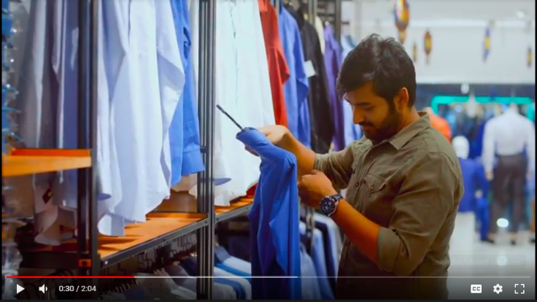

Picture 3. 5: Online Commercial Video
Online Commercial Video: Video advertising and marketing encompasses online display advertisements that have video within them, however it is usually common that it refers to marketing that happens before, for the duration of and/or after a video flow on the internet.
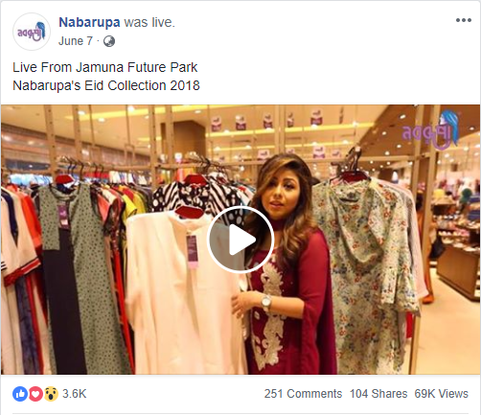
Picture 3. 6: Facebook Live Stream
Facebook Live Stream: On the surface, Facebook Live is a basic feature that offers live-streaming video competencies to users.
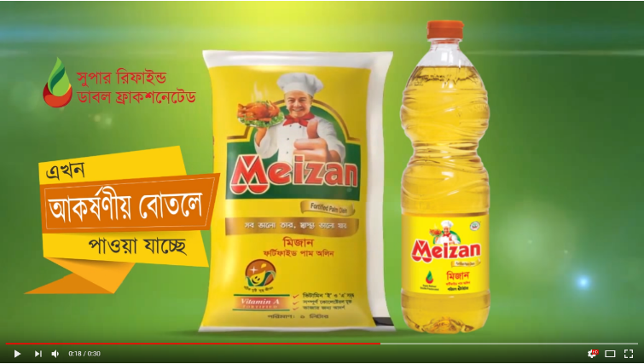
Picture 3. 7: CG Computer Graphics

CG Computer Graphics: A representation of products graphic arts, especially commercial design or illustration.


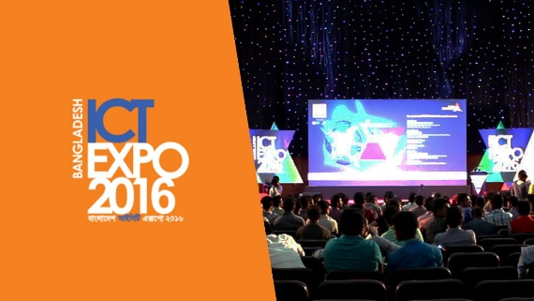

Picture 3. 8: Campaign & Events
Campaign & Events: A marketing campaign is any series of moves or occasions that are intended to reap a unique result.

Future Plan of Team360 Digital Ltd.
- They will serve all the aspects of Digital Marketing, Like Search Engine Optimization(SEO), Ad sense, Linked in page optimization, Instagram marketing, YouTube marketing, knowledge of Google address verify process etc.
- Chatbots will become more able to have “real” conversations, thus potentially improving the landscape for UX in a big way for digital marketers. They will continue to evolve into more practical, versatile tools for both businesses and consumers. The next year is a promising one in terms of integrating chatbots across many industries and platforms and by 2020 they will most likely be a normal part of the average user experience.
- They will open up a R & D Department for research tools to help them develop that understanding of their clients & employees.
- They will set an in-house training centre for the employees to develop they are skills.
- As businesses continue to their own data, they will begin to automate more of their process and become more interesting and relevant to their best customers. While chatbots today are still clumsy, they are getting better and will eventually become an expected tool for solving problems. The spirit of growth hacking will remain strong as businesses look to do more with less, leading to more technology-driven solutions to common business problems.

Chapter 4

Analysis on Digital Marketing Process

Description about Job

Business Analyst Team

I did Internship under this department. Main responsibilities of this department is fixing meeting with client, analyzing the client’s current situation, competitor’s current market scenario and making business proposal for clients according to the requirements of the clients. The whole process has steps,

- Fixing the meeting: At first, a meeting with the client is fixed.

- Meeting: A formal meeting is happened on clients given time with communication team.

- Brief: Brief is given to the analyst team by communication team after meeting with the clients.

- Analysis: A brief analysis is done on the client’s current situation, client’s competitor’s current market situation by Analyst team.

- Business Proposal: A proper business proposal is made for the clients with financial proposal as per their requirements where each detail is given and scope of work with them is described. The proposal is forwarded to the clients.
- Review: Reviewing the proposal of Team360 Digital Limited.

- Revised Negotiation: If client have any problem with proposal, we need to rewrite the proposal and make negotiation.

- Final Proposal: Proposal which finally put forward to the client by us.

- Approved: Final Proposal need to get approval from client, otherwise we will lose the client.

- Estimate Signed: It’s a contract between client and Team360 Digital Ltd.

- Payment: After signing the contract, advance payment is collected.

- Starting of work: Here all the work is started according to the contract.

- Brainstorming: As a creative advertising agency, our most important task here was to do brainstorming to generate exceptional ‘out of the box’ ideas for different brands and campaigns. For instance, to promote one of the clients, we had to find out the best digital marketing campaign using for the brand Tag.

Core Responsibility
Initially, intern’s main responsibility is to make business proposal. We usually do all kind of research for the clients. We also make financial proposal. We also fix appointments with the clients.
Specific Responsibilities of the job:
- At the very first stage, I fixed meetings with the clients. I search for those clients who are searching an agency for their digital marketing. I contact with them and take appointments so that communication team can go to the meeting and pitch that client. I also try to find those clients who can go for digital marketing. So I try to contact with them. If I get appointment, communication team do the same.

- After meeting with the client, communication team passes all the details and brief to the analyst team. They take all the necessary information and make business proposal as per client’s requirement.

- Analyst team according to the client’s budget also makes financial Proposal. Business Development Manager, Director of Operations and Head of Communications check this part.
- Analyst team also makes campaign plans, campaign proposal for the clients.
- Analyst team maintains client’s information and database.

Overview of My Work:
During my internship period, my work with Team360 Digital Limited , I have worked with several clients such as, Amari which is a five star hotel, Meizan a wing of BEOL (Bangladesh Edible Oil Limited) which is one of the leading branded oil in Bangladesh, Runners which is one of the famous automobile company in Bangladesh, Golden Harvest is a renown Agro based Food company, SCRM (Salam Steel Contast Re-Rolling Mills Limited) Best Western Plus Heritage is a resort, Bhawal Resort and Spa another resort, Chittagong Raddison Blu Bay View which is another one of the most renown five star hotel in Bangladesh, Prominent Consultant which is a Student Consultancy Firm, Star Trade which is another automobile company. These are the organizations I have worked. They used to be my clients.

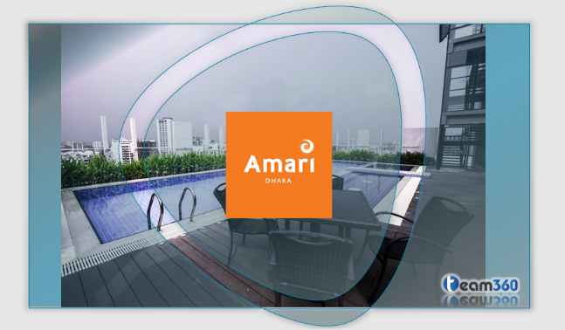

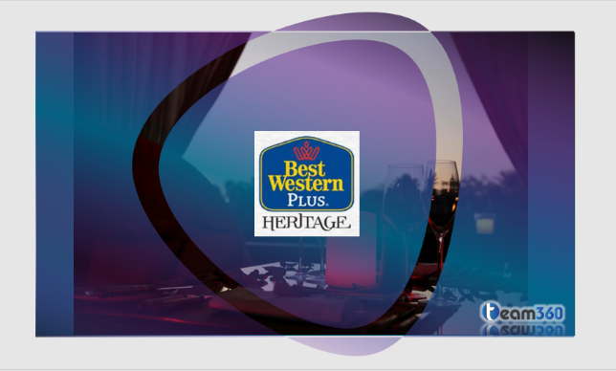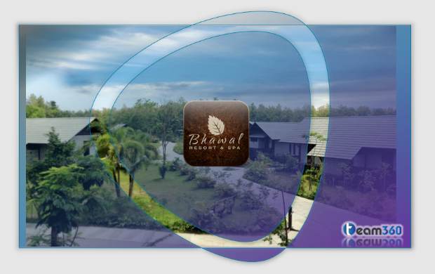





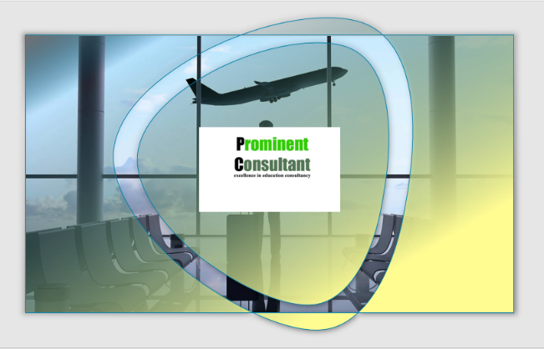



Above all the clients, I am going to describe two of my work that is “Meizan” & “Golden Harvest.”

Meizan Fortified Palm Olien:



Meizan Fortified Palm Olein, a healthier choice for the price sensitive rural consumers.
In Bangladesh total edible oil market size is 1.8 million tons/Year and rural consumption is 70% of the total consumption. However, in rural brand vs. loose is 4% – 96%. Due to the poor communication infrastructure and low per capita income, rural mass people depend on low quality and cheaper priced loose edible oil. Due to the inability of the poor to afford branded quality products loose oil became the ultimate solution which is not only harmful to health but also incurring extra costs for health hazards generated from using loose oil. BEOL did not capture this huge opportunity in rural market earlier and the rural dwellers also had a need for a healthy edible oil option which is within their reach and is available at affordable price range.
Keeping these facts in mind BEOL promotes Meizan as the only international standard super refined palm olein with added nutrition (Vitamin A, E) to keep the rural families fit and healthy.
Like Rupchanda soyabean oil, Meizan is also Vitamin A fortified. This attribute of Meizan is vital for the health condition of Bangladesh considering Meizan’s wider potential in rural areas from price point of view.



For this project, I had to analyze the current market scenario. What is the scenario of the market, right now what is the condition of the product in the market? Is it available or not? Is consumer happy with the product or not etc. these types of questions answers are found out.

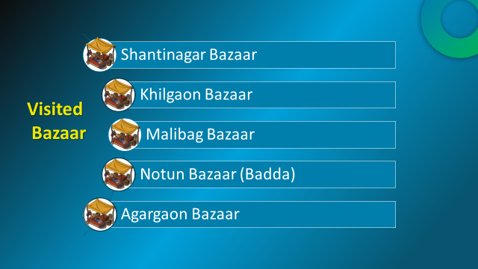
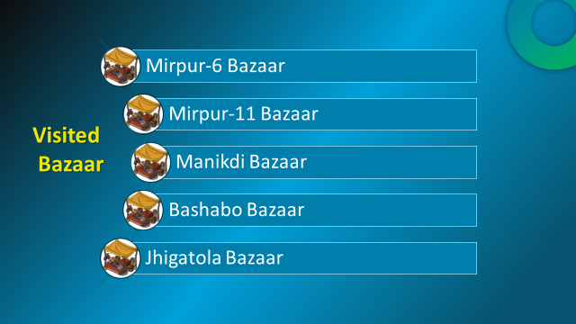

To find all the answers of the questions, these 10 bazaars had been visited.

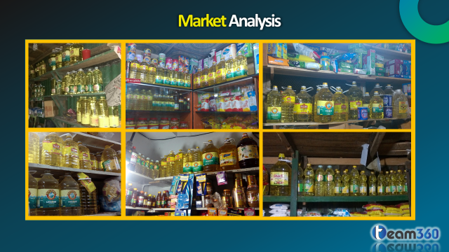

These are the pictures of those visited bazaars where the product is not found.



Being a great product, it has been always neglected just because it is palm oil. That is why Meizan has been called an Unsung Hero. Who has been serving unconditionally but never came to the limelight.


Every product has its own-targeted people who are their potential customers. For Meizan, once again targeted people has been targeted.

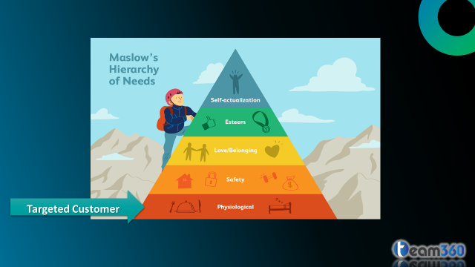

If we look at Maslow’s Hierarchy of needs, Meizan’s targeted customer belongs to physiological needs. Meizan’s targeted customers are those people whose main concern is fulfilling their basic needs. Those people who cannot afford soya bean oil or other oils they use palm oil. They purchase it from open market. They are the potential targeted people for Meizan Palm Olien.

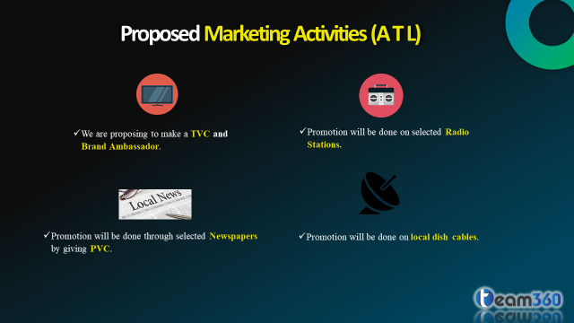

Here Marketing activities are proposed for Meizan. There are three types of marketing activities they are; ATL that is Above the Line is one of the type. Here mass media is targeted for promotions, like television, radio newspapers, and local dish cables.

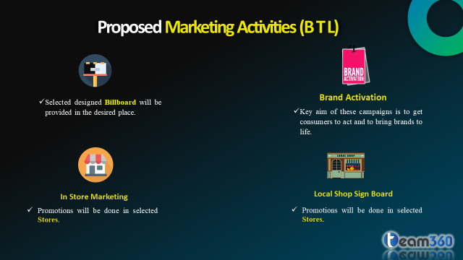
Another type of marketing activities is BTL which is Below The Line. Here used sources are billboard, brand activation, in store marketing, local shop sign board are used for promotion.

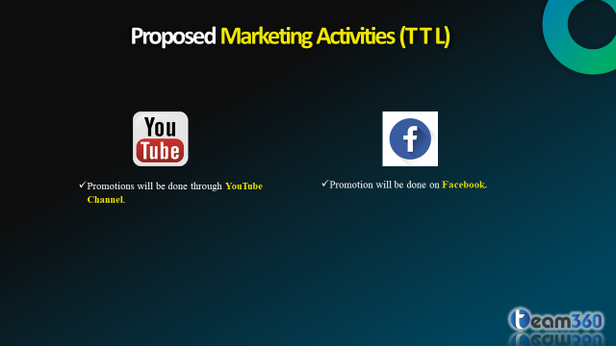

TTL is the third and last marketing activities which is Through The Line. Here promotions are done under social media like Facebook, YouTube. But the promotions can be done in Instagram, Snapchat, Twitter, Google adsense, etc.

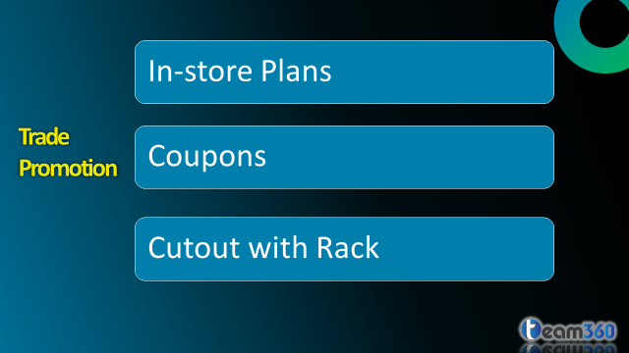

For Meizan’s promotion trade promotion has been selected. Under this promotion method In-store plans, coupons and cutout with rack has been followed. In-store plan is branding in-side of the store. Selected stores will be covered. Coupons has been distributed to the customers. Special designed cutout with rack will be placed in selected stores.

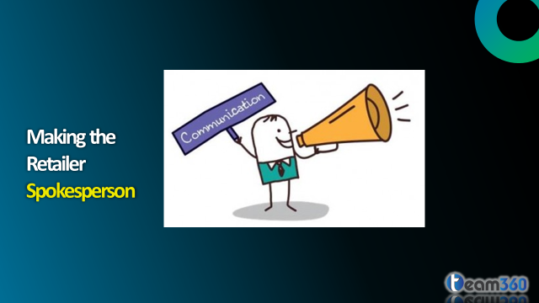
Customers purchase product from retailer. So it’s the retailer from whom customers get their product. So those retailers has been made spokesperson. So that they can motivate the customers to purchase the products.


It’s the sales department who is the reason behind the sales of the product. Sales of the product depends on the team. So the sales team should be motivated. A motivated sales team can inrease the sales.


After researching the market, I found out that the product is not available in the market. So the product availability has to be increased.

Employees has to be pushed continuously. So that they give their best in the organization.
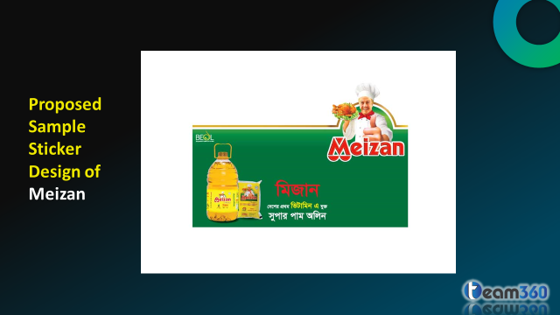

This is the sample sticker design which has been proposed to the organization. This sticker has been provided to the selected stores.

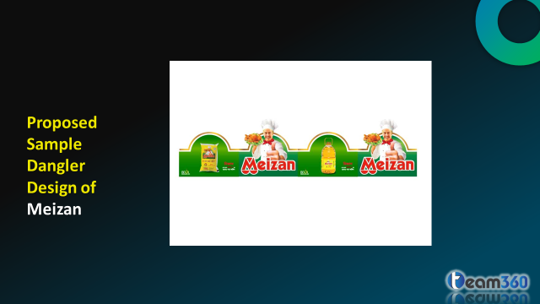

This is the sample Dangler design which has been proposed to the organization. This Dangler has been provided to the selected stores.

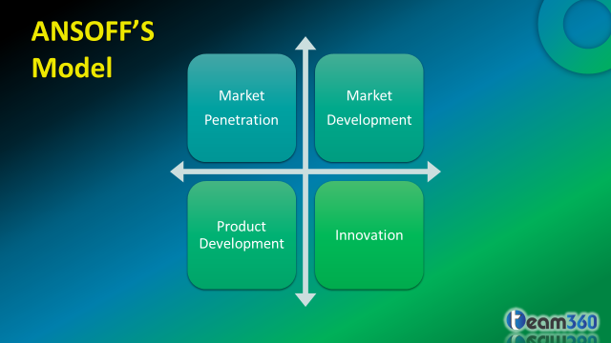
Ansoff’s Model is one of the famous model. It is used for Re-branding of an existing product. I have recommended this model for Re-Branding of Meizan Palm Olien.

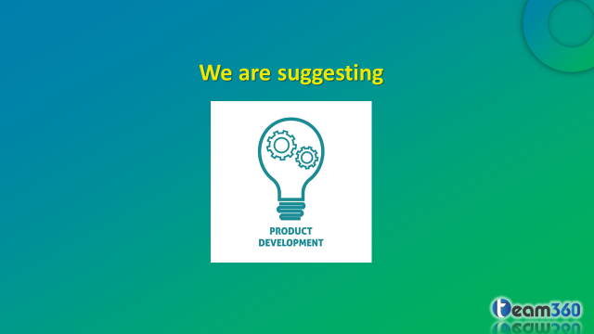

From Ansoff’s Model, I have suggested Product Development.

A sample Tetra Pack has been offered for the product package.
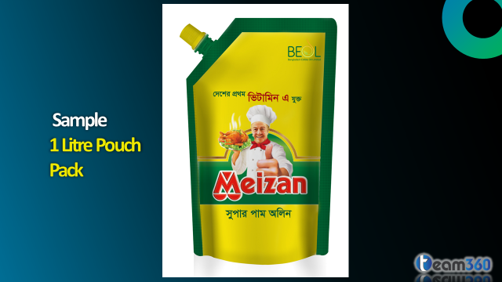

A sample 1 Litre Pouch Pack has been offered for the product’s new package.
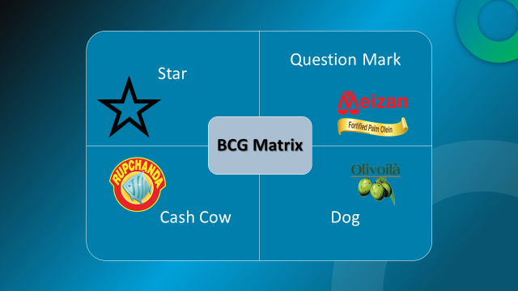

BEOL (Bangladesh Edible Oil Limited) has 5 brands Rupchanda, Kings, Olivoila, Meizan Palm Olien, Fortune Rice Bran Oil. According to BCG Matrix, Meizan’s position is in Question Mark. From question mark, Meizan can become star and from star Meizan can go to cash cow. Olivoila is also a brand of BEOL. But this product is going to be market out.

Golden Harvest:


Golden Harvest is Bangladesh’s one of the leading business groups with diversified interests in Food, Dairy, Commodity, Information Technology, Logistics, Real Estate, Aviation, Infrastructure Development and Insurance.
Golden Harvest has been a pioneering force in the frozen food sector in Bangladesh and is the country’s first company to develop its own Cold Chain network in collaboration with USAID.

Golden Harvest started its journey as a Commodity Brokerage company and later on expanded its business and is now a leading force behind various business sectors and employing over 5000 People. Golden Harvest is also the Joint Venture partner of Nippon Express, Asia’s largest logistics company with network in over 480 locations worldwide.

Golden Harvest strongly believes in giving back to the society and runs a CSR programme that includes Bangladesh Human Rights Foundation, TAC Charitable Hospital, Alvina Samdani Trust and Samdani Art Foundation that organizes Dhaka Art Summit, the largest non-commercial South Asian art dedicated event.
Golden Harvest has so many wings. They are Golden Harvest Agro Industries Ltd, Golden Harvest Ice Cream Ltd, Golden Harvest Foods Ltd, Golden Harvest Express, Golden Harvest Dairy Ltd, Fatehpur Estate Ltd, Golden Harvest Commodities Ltd, Golden Harvest InfoTech Ltd, Brain Train Studio Ltd, Golden Harvest Developers Ltd, Sonali Life Insurance Co. Ltd. Among all the sister concerns, I have worked Golden Harvest Agro Industries Ltd, Golden Harvest Ice Cream Ltd and Golden Harvest Foods Ltd.

Golden Harvest Agro Industries Ltd
Golden Harvest Agro Industries Ltd. is a publicly listed company which is one of the pioneers in Frozen Food manufacturing in Bangladesh. The brand is known, both locally and abroad, for its wide range of ready to cook frozen products.

Golden Harvest Agro Industries Ltd. takes pride in its food processing plant & supply chain. For its production and supply chain facilities the company has received many certifications including ISO 22000:2005, 9001:2008 & HACCP. The company’s supply process is linked with over 100,000 Bangladeshi agricultural partners who supply 95% of the company’s raw materials. The food processing plant is situated in Gazipur which is equipped with state of the art machineries and is maintained by a team of industry’s best professionals. Once production is completed and quality is assured, the frozen products are distributed through an extensive network of temperature controlled transportation system. The company distributes nationwide and exports to USA, Canada, Australia, Middle East and the European countries, maintaining a temperature of -18⁰ C through its cold chain network. All these ensures top quality products, farm to fork!

Golden Harvest Ice Cream Ltd
Golden Harvest Ice-Cream Ltd. is the new entrant in the Bangladesh ice-cream industry with the brand BLOOP. The ice-cream industry in Bangladesh is growing steadily at around 12% every year and has been estimated at BDT 10 billion in the fiscal year 2014-15. Golden Harvest has set up a brand new plant from Tetra Pack Sweden and is being operated under the supervision of a highly experienced Danish production manager. The brand offers around 40 various variants including sticks, cups, cones, calippo, sorbets, tubs, cakes and many more.

Golden Harvest Foods Ltd
Golden Harvest Foods Ltd. started in 2012 to cater the ever-increasing consumer market in snacks industry. From the very beginning, we have employed a simple yet very profound promise to our products standard that is, ‘We make what we share with our own children’. This is a promise we tend to keep from sourcing raw materials to packaging process, making sure high quality and standard for each of our products.
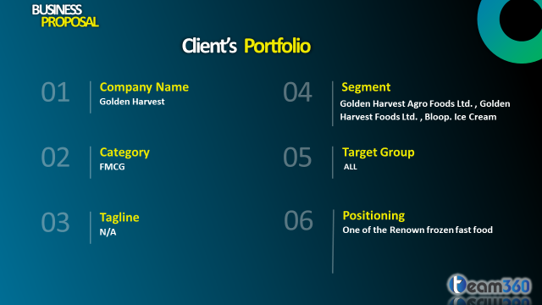
This the client’s portfolio. Here clients category, tagline, segment, target group, positioning are described.


3 (Three) types of analysis I have provided to the clients that is page analysis, Market analysis and SWOT analysis.
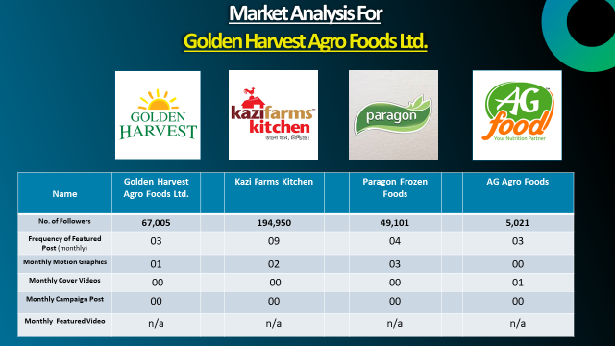
This is the market analysis of Golden Harvest Agro foods Ltd. Kazi Farms Kitchen, Paragon Frozen Foods and AG Agro Foods these are the competitors of Golden Harvest Agro Foods Ltd. Golden Harvest Foods Ltds Facebook’s page is compared with their Facebook’s page. This is how the Market Analysis is done.

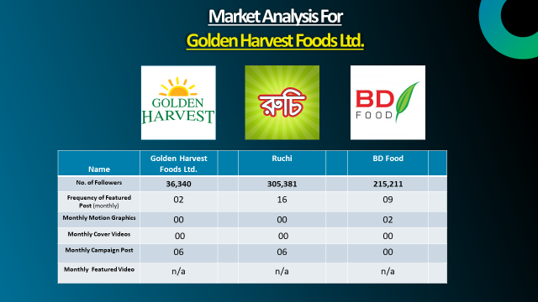
This is the market analysis of Golden Harvest Foods Ltd. Ruchi and BD Foods are the competitor of Golden Harvest Foods Ltd. Again 3 (Three) competitors Facebook page are compared with each other.
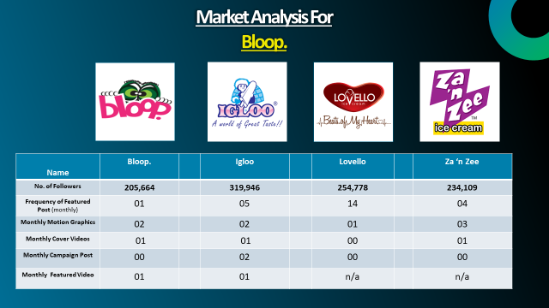
This is the market scenario of Bloop ice cream. Igloo, Lovello, za’n zee ice Cream are the competitor of Bloop. Here Bloop’s current Facebook is compared with its competitor.
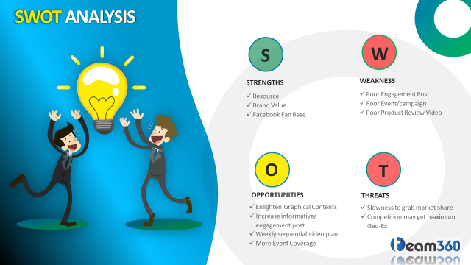

This is the SWOT Analysis of Golden Harvest. Which indicates the internal external factors of Golden Harvest.
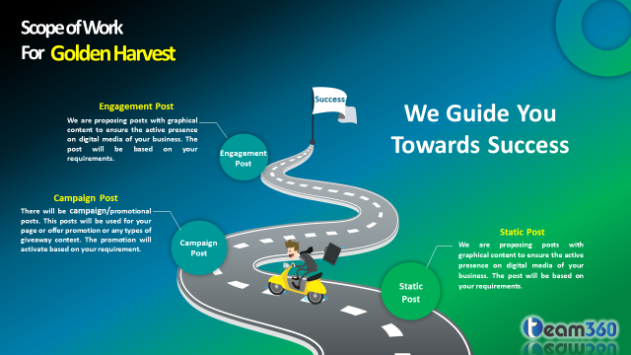
This image describes the scope of work with Golden Harvest.

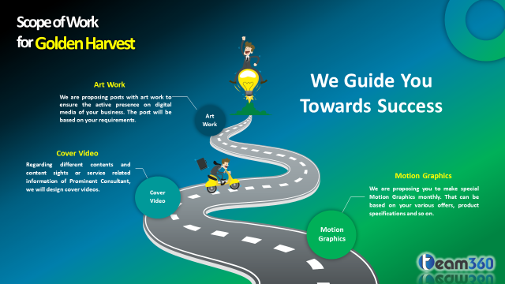

This image also describes the scope of work with Golden Harvest.
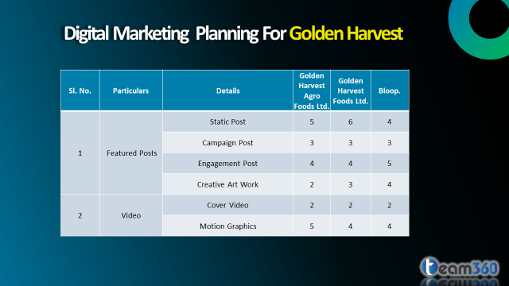

This is the Digital Marketing planning for Golden Harvest. For which Facebook page, how many post will be given that is mentioned here.
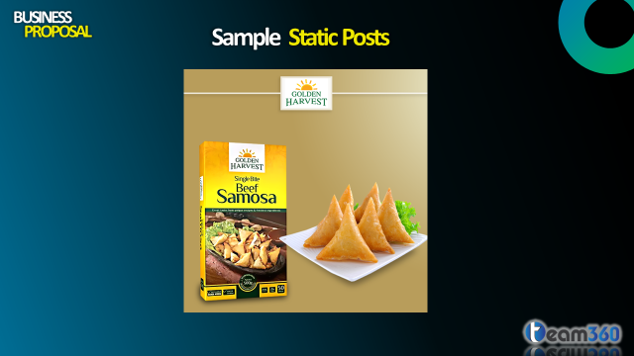
Sample Static Post has been offered to the Golden Harvest Agro Foods ltd.

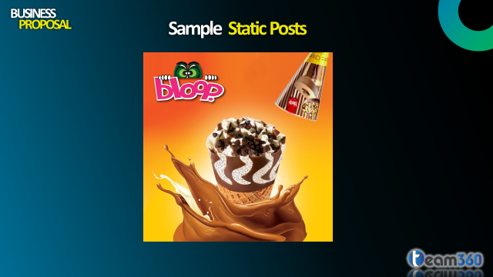
Sample Static Post has been offered to the Bloop Ice Cream.

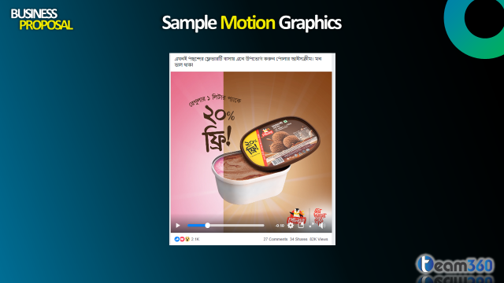
Sample Motion is provided.
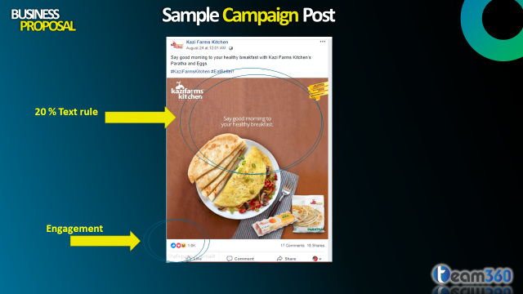
Sample Campaign Post is given.

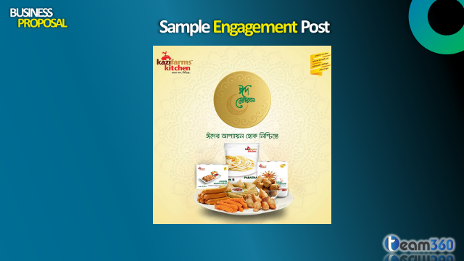
Sample Engagement Post is provided to the client.
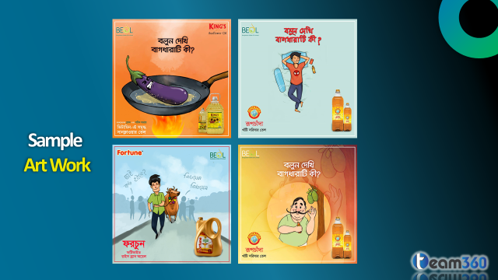
This is the sample Ark Work is given so that client can understand the work.


This is the Sample of Cover Video of Competitor.

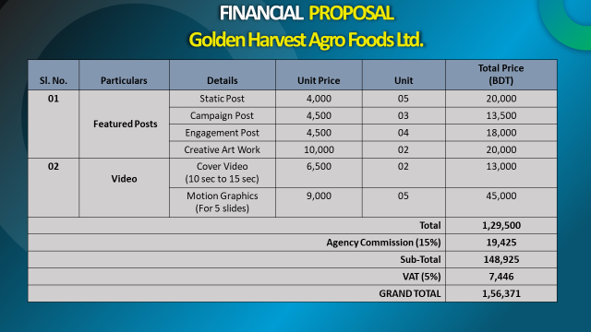
This is the Financial Proposal for Golden Harvest Agro Foods Ltd.

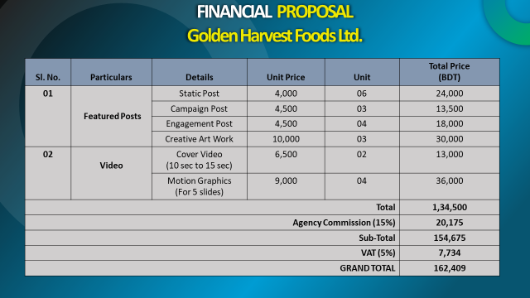
This is the Financial Proposal for Golden Harvest Foods Ltd.

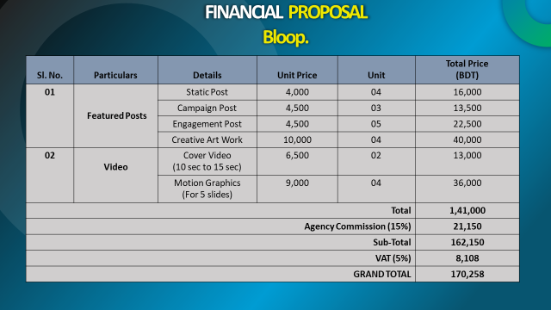
This is the Financial Proposal for Bloop Ice Cream.

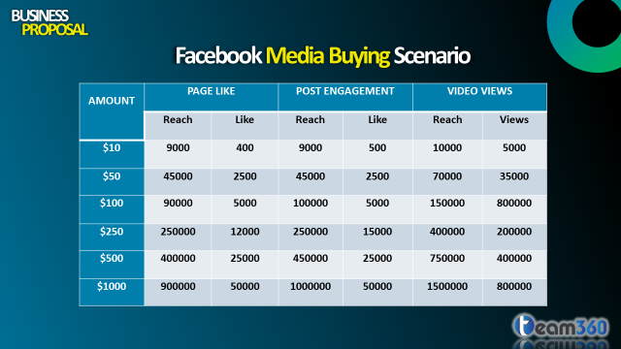

This is the Facebook Media Buying Scenario. By spending how many dollars will get how many Facebook like, what will be the reach for the each post and videos are described.

Evaluation of Israt Jasim Promee
Head of Communications:
I’m Sakib Hossain Arko, Head of Communication, Team 360 Digital Limited, evaluating performance of Israt Jasim Promee, who has done her internship under my supervision as an analyst. I am glad to make these following evaluation on her work-
- Her 1st responsibility was to analyze company’s current status on digital platform. Then compare that data with other competitors from same field. She is really good at analysis and I found her dedicated and sincere to her responsibilities.
- Her 2ND responsibility was presentation making on those clients with the analysis that the pitching team can approach for business to those companies. She maintained our company standard and her analysis made the presentation more valuable and also very resourceful for the pitching team.
- Her 3rd responsibility was to make different campaign planes for existing clients and we are really happy to inform that she helped a lot by giving different fruitful campaign planes.
- Working under pressure and meeting up the deadlines was one of her best qualities.
- She is punctual and her effort on our company progress made us proud.

Business Development Managers:
Israt Jasim Promee worked directly with Business development managers, Mahedi Hasan & Sayem Choyon. Here is our evaluation of her work-

- She worked on different campaigns both online and offline. Idea generation, presentation making, market research was her expertise.
- For different clients she made many campaign ideas and also analyze competitor’s previous campaigns. We found those really resourceful.
- Her expertise on analysis, data placement, SWOT analysis made our new and existing clients more reliable to our company.
- She made Business scopes on different companies with her dedication for work and undeniable research data.

Chapter 5

The Role of HRM in Digital Marketing

A considerable lot of the human sources (HR) administration methodologies, projects, devices and components are standard over all enterprises. This is valuable in light of the fact that there is negligible information identified with human guide inconveniences confronting the advanced media industry and there is practically zero proof based query accessible. In any case, there are some specific necessities uncommon to advanced media organizations, and some exceptional necessities for little, medium, and huge computerized media organizations.

The particular references to little, medium and monster computerized media organizations have been made inside the account segments of the guide. The estimation of the organization can have a direct affect the degree to which applications and activities are attempted. For instance, monstrous associations, for example, Google or Apple should take a key strategy in building up their way of life. Little organizations, then again, are skilled to adjust more prominent in the blink of an eye to the changing wishes of their representatives and can work cooperatively to characterize and make their own way of life.

Lamentably, there is currently not a-one-estimate fits-all technique to HR organization in associations. Given the most recent blast of the advanced media endeavor and its phase of fascination for youthful and incredibly gifted ability, the need to focus of consideration on present day and principle edge hones is basic. This guide is important to computerized media organizations all things considered. It was once intended to advise on HR thoughts and show how they are connected to the computerized media industry. The refinement in organization estimation relates more noteworthy conspicuously to the degree to which activities are done and the procedures identifying with how they are actualized.

Strategic HR
A vital draw for HR wants to be lined up with the corporate technique. Inward factors, for example, the association's central goal and qualities, items and contributions offered, directed demographic, monetary circumstance, foreseen changes, and business endeavor qualities and shortcomings should be considered. The HR vital arrangement ought to likewise think about thought on the outer surroundings, for example, the work showcase, rivalry, fate of innovation in the business, customer desires, and work portability.

The HR strategy incorporates envisioning a coveted nation for the association's future HR and carefully intending to achieve the set wants and targets. A key quality of beneficial little and medium estimated computerized media organizations is dexterity. Organizations that showcase dexterity are able to up-staff for necessary abilities as errands inspire consent to continue and then again cut back after the endeavor is finished. Organizations should represent potential turnover and guarantee that assembling proceeds in the match of a specialist flight.

Advanced media offices need to keep up their HR procedures bendy with the end goal to respond adequately and proficiently in the violent venture condition. All organizations require the ability to look at HR necessities rapidly and productively. Little computerized media bunches by have their HR arranging overseen by the proprietor or the business; making arrangements for the long haul might be troublesome basically dependent on the association's size.
Integrated
HR
Planning

Work Life
Balance
Recognition
Performance
Management
On Boarding
Recruitment
Stuffing Strategy
Employee Development
Career Mapping
Leadership Development

Staffing and Retention
Staffing is tied in with finding and keeping up fundamental advanced media ability. The accessibility of ability with the fantastic expertise blend seems to have an immediate effect on blast open doors for little to medium measurement organizations. Staffing incorporates:

After mindfully arranging work prerequisites, computerized media organizations must recognize these applicants who have aggressive understanding as legitimately as self-administration capacities and qualities that are in accordance with the organization's central goal. Small, little, and medium estimation enterprises appear to scan for workforce and the monster and vast advanced media associations appear to go through cycles of cutting back and enlisting. Notwithstanding, all computerized media bunches confront staffing difficulties.

Computerized media occupations require an expanding number of complex arrangement of aptitudes. Managers, particularly in little to medium size ventures, require a various arrangement of aptitudes including specialized, inventive, correspondence, business, and much of the time, pioneering abilities. The absence of surely knew and verbalized occupation prerequisites prompts work searcher dissatisfaction and in this manner an inadequacy for first time contestants (new alumni and globally gifted experts) to accomplish access to the work showcase.
Retention
Of
Talent

Recruitment:
The enrolling procedure alludes to the arrangement of activities used to urge qualified people to apply for a given position. Chiefs must procure solid apparatuses with the end goal to adequately target and draw in competitors. Deliberately enlisting to pull in very gifted and qualified ability expects associations to:
The computerized media venture has a tremendous dependence on migration to staff their especially ensured positions.

Medium to vast surveyed organizations show to have the capacity to deal with this given they are more prominent liable to have the sources and are less hazard loath to taking advantage of the world work showcase. This proposes little and medium estimated advanced media organizations should be aware of movement procedures, methodologies and projects to effectively make utilization of the an assortment of streams inside the gadget to meet their human helpful asset needs.

The mind boggling set of favorable position required in computerized media workers are routinely now not instructed to understudies inside a solitary post-auxiliary program. Be that as it may, half and half bundles that go ordinary teaches, for example, innovation and business undertaking are starting to rise. It is beneficial for computerized media enterprises to end up more worried in center and temporary position bundles to enable less demanding access to this ability pool.

Organizations need to make consideration of the assortment and calling conceivable outcomes the endeavor can give to understudies. Ongoing alumni regularly gather venture with bigger gatherings and afterward wind up "accessible" in the qualified work pool. In any case, little and medium measurement associations need to support more noteworthy imaginative ways to deal with industry-training joint efforts (formally and at the researcher level) that advantage each the organization and the understudy.

Little to medium estimation organizations are significantly less most likely to utilize a most recent alumni barring industry encounter; along these lines taking stage in temporary position and center applications presents researcher with the pertinent excursion required and goes about as an outing span for alumni.

Employee Policies and Procedures
Advanced media organizations need to tailor their protection arrangements and practices and configuration imaginative strategies to meet representatives' one of a kind needs, for example, working from home, inventive working environment spaces, adaptable working hours, providing time reachable to explore different avenues regarding new programming, private time on the web, and innovative wreck regions. It is essential for businesses to examine about the different group of specialists ages to accomplish observation into their own one of a kind faculty and tailor their protection approaches and methodologies to meet their interesting needs and needs. Message from the CEO
• Company history
• Mission
• Philosophy and values
• Management expectations
• Organization chart
• Performance contrast
• Compensation
• Working conditions
• Work agenda
• Overtime hours
• Recording hours worked
• Annual vacation and depart
• Breaks and meals
• Statutory holidays, absences and paid go away
• Sick go away
• Other absences
• Travel expenses
• Personal days
• Training
• Termination
• Other
• Internal policies
• Customer carrier
• Attire (dress code)
• Anti-harassment policy
• Confidentiality
• Use of tobacco, tablets and alcohol
• Non-competition clause
• Telephone calls
• Copyrights and Intellectual Property
• Communication methods • Confidentiality & Non-Disclosure
• Occupational fitness and safety
• AODA

Compensation
The staying goal of any remuneration approach is to make a vibe of consideration and decency for present day and future workers. What's more, a pay inclusion should likewise set up a harmony between satisfying laborer requests and the association's capability to pay. With the goal for compensation to end up being a fine administration device, the pay approach and types of pay must be lined up with the HR technique and the association's undertaking destinations. This will encourage the association's development and improvement.

It is crucial to decide the association's capability to pay, the measure of compensation it is sorted out to dispense for particular positions, and the remuneration at present introduced in the market. With the end goal to set up the most ideal level of value conceivable, base pay rates must be snared in understanding to the obligations and assignments related with each position and no longer to the people working in each position. Organizations can utilize techniques, for example, work order or correlation by methods for elements, which will make certain a reasonable and target assessment of each position. This technique will choose the relative charge or extremely worth of each activity in the association which can be utilized to decide the activity level.

Little gatherings that contend with bigger organizations, which are regularly proficient to offer their representatives higher pay rates, need to draw on additional unique roundabout pay choices and give an invigorating workplace. These dynamic choices can speak to monstrous cost for hopefuls. For bigger gatherings the basic HR need with regards to pay isn't simply concentrating on the money related remuneration components anyway moreover on the non-monetary perspectives. The two basic non-budgetary remuneration issues that representatives consider onconsideration are adaptability at work (i.e. work-life parity) and venture culture (i.e. quick paced, risktaking, affectionate surroundings where considerations originate from in all spots at each level).

The computerized media industry is new and dynamic with some one of a kind HR prerequisites. The main HR capacities and devices that need to be custom fitted to this undertaking are Strategic HR; Staffing and Retention; Compensation; and Orientation, Training and Coaching. The HR administration methodologies, projects, gear and systems plot in this HR data will be scattered to little, medium and huge computerized media bunches by posting it on the web and by means of various channels to every advanced medium enterprises in Canada.

Chapter 6

Findings And Recommendation

Best Digital Marketing Strategies for HR Department

1. Use Social Media and Promote Openings on Social Media Channels

• Did you perceive that 79% of people make utilization of web-based social networking channels for quest for new employment? - This may seem like a heavenly number; in any case, the plain importance and power of Social Networks make them an ideal region for people to begin hunting down befitting opening for work.

• Attracting and alluring best ability, specifically in rising markets is one of the greatest difficulties. Examining this opening in the business; Matt De Luca arranged JobNet.com.mm, or, in other words the quickest developing activity sheets in Myanmar. He makes utilization of on-line frameworks like Facebook Ads and Google AdWords to lure and utilize his customers.

• "Facebook is the most utilized advanced divert in Myanmar. This settles on it the conspicuous decision to target clients, especially for association marking purposes. It's additional inside your financial plan in developing markets. Running notices in

Myanmar may likewise be more affordable than in focused markets like the U.S. For instance, one might need to hope to spend somewhere in the range of $350 and $600 in Myanmar." Says Matt De Luca, while depicting why Facebook Ads is gainful for HRs. In fact, this is going to amazing from Digital Marketing Strategies for HR Department's point of view.

• About Google AdWords job, he includes "Google AdWords draws in neighborhood and global applicants with the jobs they're paying special mind to. For instance, having a pertinent landing page and choosing focused on advertisement key expressions for the Burmese market, for example, 'Deals Manager Yangon' will normally deliver leads from competitors associated with working in Burma as deals experts. This tends to final product in higher transformations and lessening cost-per-clicks, thusly decreasing the expense per-contract metric that HR promoting stars screen."

• Recently, Matt and his group utilized Google AdWords and Facebook Ads to lease possibility for a neighborhood refreshment organization.

• Company pages and profiles are a marvelous first introduction. People looking for an occupation, effectively comprehend about your association culture, moreover, they persuade an appear to be into what you absolutely do and what your image esteem is. The upward bump of social stages like Pinterest and Instagram as brand entrances in like manner makes them accommodating for HR Digital publicizing technique focused on showing work in a smart and appealing way.

• Facebook, LinkedIn and Twitter are a dazzling course for people to tell their mates that their business venture is in the market for new cerebrum in a particular field. Nevertheless, it's presently not just about sidekicks safeguarding each extraordinary out. More gatherings are making utilization of social channels as their organization building stages and moreover, to lease best abilities.

2. Know your Target Audience as Digital Marketers do

• Marketers have a significant understanding of their intended interest groups according to the socioeconomics, aptitudes, conduct and practices to make top notch client personas and objective messages that can ensure changes.

• HRs can utilize the equivalent way to deal with higher achieve their workers. All things considered, representatives get hold of thousands of messages every week — yet 50 percent of those, overviewed in the EMPLOYEEapp's Mobile Trends in the Workplace review said they in any case understanding unaware of what's going on.

Why? - Because the messages aren't taking advantage of their interests.

• You need to start taking in the entire part about the work force focused in the message-What rouses them? What are their destinations? What do they esteem most? What are their stresses? What budgetary and non-cash related "offers" will they respond to? How do these answers exchange from office to office-between chiefs to workers?

• Then, make utilization of this becoming more acquainted with in your HR undertakings to exact group of workers, rather than sending nonexclusive well known records to everyone. For outline, your venture announcements should be customized depending upon who the objective target group of onlookers is – Different faculty need to see how a specific information will affect them-In what way will it trade their standard work life? How might this benefit them?

• Then, use this learning in your HR activities to exact group of representatives, rather than sending nonexclusive ordinary insights to everyone. For outline, your endeavor declarations should be specially crafted depending upon who the objective target group of onlookers is – Different representatives need to see how an exact realities will affect them-In what way will it substitute their regular work life? How might this benefit them?

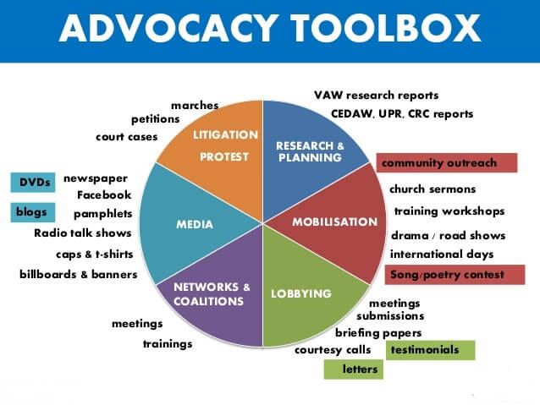
social advocacy tools to goal audiences for HRs
• While turning in the most significant and basic data, it is important for HRs to assume like Digital Marketer and utilize advanced advertising instruments and methods like Employee Social Advocacy Tools to upset business as usual and objective to have connection workforce. Social tuning in and investigation can asset HR authorities track laborer enjoyment and mediate to unwind selective issues.

3. Utilize exceptional Channels to convey one Message

• Marketers comprehend that on the off danger that they have to get the thought of their gatherings of people, they need to use in excess of one publicizing and advertising channel. A battle can't be beneficial sufficient by means of messages, bulletins and flyers alone. Advanced Marketers make utilization of a combo of media to pass on their messages-Video, Social Media, Interactive Sites, Images, messages and so forth.

• Truth be told, the top notch advertising is making your items/administrations viral-and HRs likewise utilize the plain equivalent Digital Marketing Strategy to convey messages to representatives.

• Emails aren't satisfactory to target workers In theEMPLOYEEapp contemplate, 80 percent of supervisors said they influence utilization of email to convey, yet 30 percent of individuals said they overlook messages from their manager.

• According to Wrike's 2016 Mobile Productivity Report-90% of overviewed supervisors trust a mobilephone telephone is essential to giving their employments a chance to complete.

• So make utilization of prompt messages, messages, inward informal organization, cell applications, and distinctive versatile streamlined sources to convey your messages.

• Exchange motion pictures and photographs to attract workers in releases and revelations. Start a business weblog and twofold the utilization of Facebook, Twitter, LinkedIn and exceptional degrees workers use.

• Have a framework and a voice, and have them appear in the entire thing the enterprise does.

4. Keep your Website Updated

❑ HR destinations go about as realities center focuses for new and present representatives. From big business upgrades to openings for work, your web website must mirror the current work examples and exhibit partnership news as well. It is straightforward for HRs to save every last one of their locales and net diaries legitimately refreshed.

❑ This consolidates work postings, development reports, scholarly articles and posts. Overhauling your site online through site design improvement should be a bit of your advanced publicizing approach for Human Resource.

❑ As normal, website streamlining techniques should be realized to ensure jobseekers have basic get right of passage to all the latest openings. This can be conceivable by means of capacity of crucial and mammoth catchphrase game plan, and Meta labeling.

❑ Landing site page is your opportunity to concrete the impact you've made for your organization on social pages. You need to ensure that it is remarkable and helpful. A choice numerous people will visit your site online to get additional insights on positions, your association's experience, and possibly get in contact, so guarantee the aggregate is natural and simple to use.

❑ If you have the coding limit, it is in like manner extremely helpful developing an immediate bringing in structure into the page so buyers can get in contact with you with their records quickly. People withdraw behind a likelihood if it's difficult to venture out, make your site online as obliging as could reasonably be expected.
5. Figure out how to use LinkedIn more effectively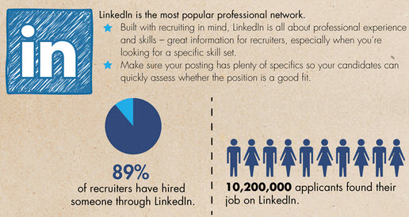
o LinkedIn is a standout amongst the most fine master web based life systems. Knowing how to utilize LinkedIn is a need to Digital Marketing Strategy for Human Resource Departments. It has transformed into the premise of Digital Marketing Strategies for HRs. LinkedIn lets in people from any industry to distribute their work history. From honors and volunteer undertakings to notification and formal CVs, LinkedIn is home to a splendid proportion of people paying special mind to work.

o Again, you similarly have the adaptability to make a Company Page on LinkedIn, or your HR group can do some plunging and see who is in the market for any new Job Opportunity, and start the enlistment technique.

o Incorporate LinkedIn in marketing your positions and set up together to do some authentic insight and bent stalking.

LinkedIn brings specialists, organizations and jobseekers on the whole in one place. Frankly, it is seen as the central center point for anyone planning to acquire or be enrolled. From simple to selective CVs and work chronicles to distinctions, LinkedIn is really a goldmine for all HR gatherings.

➢ two two Aforementioned top 5 Digital Marketing Strategies for Human Resource Departments are seen as magnificent to-Boost your Company's Branding, Alleviate the Recruitment Processes, Convey Messages, and Ensure Employee Engagement and Retention.

➢ Once, you know and put into impact these procedures you're set up to channelize human guide organization in additional awesome and result arranged way.

➢ two two On finishing up hub, I've enrolled 5 Digital Marketing Tips for HRs that you can contain in the wake of upholding over-made reference to Digital promoting Strategies for Human Resource Departments.

5. Digital Marketing Tips for Human Resource Departments

1. Get Tactical and Align HR with Marketing

• HRs are the principal factor of contact a prospect has with an organization. By being strategic in adjusting HR office to publicizing and promoting will valuable asset you see how your business undertaking is seen by method for clients, and by utilizing its workers.

• You need to use structures that activity searchers use to think about ongoing employments. These locales may also produce enormous guests for you as appropriately on the off chance that you are promoting your company on them.

• Align your organization's showcasing little print, for example, Company Description, Motivation and Reviews while agenda occupations on these stages.

2. Feature What Your Company's Culture Looks Like

• Like computerized advertisers look over purchasers, HRs moreover support faculty to "purchase" into particular activities, projects, and gain enlistments, as this associate representatives to their work in manners that are more powerful.

• One of the most grounded advantages of Digital Marketing Strategies for HR Department is its capacity to mix different mediums together to convey your message all through stand-out scopes of association.

• For model, you can implant an association video inside an occupation record to give your association portrayal a chance to be all the more tempting to forthcoming hopefuls

3. Create Emails That Actually Resonate

• Engaging forthcoming applicants by means of email that presents them loved information is moreover one of the charming advanced publicizing strategies for HR office.

• You can utilize a gadget that is easy to comprehend when expecting to make a pamphlet.

• Adriano Corso, who oversees computerized enrollment all through Asia Pacific at IBM Smarter Workforce says-"HR professionals should be in a situation to connect with their objective market sooner or later of the enlistment promoting pipe. Also, promoting mechanization devices, for example, email publicizing play a key position in enrollment."

4. Use Digital Tool To Retain Top Talent

• Once you figured out how to pass on key abilities locally available, you need to ensure they don't stop and be a piece of your rivals. This is amonsgt the quintessential Digital Marketing methods for HR office.

• Ph.D, Senior HR Director at Singapore University of Technology and Design (SUTD) says-"Dashboards give us experiences into representative socioeconomics, increment patterns, and steady loss examination. We are additionally in a situation to manage causation investigation to penetrate down into individuals issues."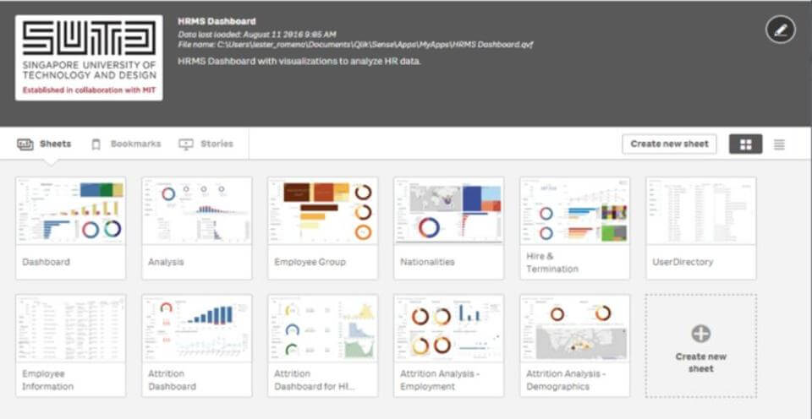

5. Measure Effectiveness

• HR groups can likewise tune and measure data to enhance enrollment, organization building, representative commitment, worker maintenance and other related procedures; as an area of Digital Marketing systems for HR division.

• Decide what measurements are basic to the normal business dreams and melody them to drive higher representative commitment and friends mindfulness.

two By following these Digital Marketing Tips for HRs and executing aforestated Digital Marketing Strategies for Human Resource Departments, you can supercharge your HR endeavors.

Need to find out about top notch Digital Marketing Strategies for HR Department-Ask me in remarks

Now, we as a whole realize that organization culture assumes a vital job in organizations tearing into out advanced changes. This is especially valid for the advertising division, which is changing at such a break-neck pace, to the point that promoting achievement currently depends intensely on help from HR to recognize and train new ranges of abilities.

On the other side, accomplishment in HR could utilize a noteworthy help from promoting, or if nothing else HR experts who think like advertisers. The opposition for the best ability is quick and enraged and, as a rule, that battleground is the social web.

This year, I have been taking a shot at an inside and out assessment of enlisting rehearses for a Fortune 500 organization. Obviously an infusion of advertising thinking could push prompt the HR change the organization needs; and I question this organization is an anomaly.

- Compete for talent the way companies compete for customers:
Today there is intense competition for the very best talent. When a high-potential employee checks out a company, the first place they go is increasingly social media platforms like Facebook and LinkedIn, or perhaps review sites like Glassdoor.

The company presence on these sites is usually owned by marketing or PR. Through my research for this project, I found that most companies take an extremely sales-oriented approach to their web presence.

But in many industries, finding the best employees might be as important as finding the best customers. Why wouldn’t we take a more balanced, recruiting-centric approach to our web presence?

- Pay more attention to user interfaces:
As part of this project, I also kicked the tires on the process for people seeking to apply for jobs at the largest tech companies. What I found across the board was a cumbersome, clunky process designed to feed information into an algorithm. The process is not human-oriented, it’s computer-oriented.

As a job applicant, I would like to fill in a few fields and then have access to a live person through chat or maybe even a live person via web video. This is a common practice in customer service. Why wouldn’t we provide the same kind of attention to people who want to work for us and lead us into the future?

- Be. More. Human:
At the end of many of my talks and articles I emphasize that in the digital age, the most human companies will win. We have fantastic opportunities to use technology to tear down barriers between people instead of erecting them.

And yet, after evaluating dozens of industry websites, on nearly every HR-oriented web page I viewed in my study, these opportunities were lost. If you have applied for a job lately, perhaps you’ve seen …

Stock photo images of perfectly diverse people jumping for joy instead of real faces and real smiles in a real workplace.
Text-heavy descriptions of what the company does instead of stories (especially videos) of how the company feels to people who work there.
A lack of the use of video “tours” as a medium to communicate the culture and values of the company.
Have you seen this cool promotion by the country of Sweden? Sweden has a phone number. You can call a toll-free number and talk to a random Swede who has volunteered to be an ambassador for the nation. Why wouldn’t we do this at a large company? If I was conflicted between an offer from Acme Pharmaceuticals and MegaSource Software, the chance to talk to a real employee might make the difference.

- Build employees’ brands to help them amplify your message:
On the marketing side, we frequently dream about networks of employees who post stories about our products, leading to massive new views to our content.

In reality, that doesn’t happen too often. Employee social sharing networks look good on paper but in reality, there has been mixed success. Who wants to post company fodder on Twitter or their personal Facebook page?

But talking about the culture at work, commenting about the pride they have in an organization, or posting photos from a company picnic … well, that’s easy to do. We should give employees the training and tools to do their very best job when creating content about the employment culture of the company.

I was recently working with a huge global tech giant and met a young lady who had started a blog on her own about how to use her company’s technology for social good. Nobody in her department even knew she had done it. Wow! How do we support a person like that, encourage her, and reward her? How could that young woman start a movement? Why wouldn’t the company amplify HER content instead of the other way around?

- Try contextual advertising:
Today any kind of marketing usually has a paid promotional component. If we are trying to attract employees instead of customers, why wouldn’t we do the same thing?

There are people talking online about their job hunting experiences all the time. It might make sense to show targeted ads that can help prospective employees with their questions and problems.

- Think strategically about touchpoints:
The buyer’s decision is a tangled mess of touchpoints. They may see ads, search online for information, and talk to friends. Marketers try to have some kind of content waiting customers at each point in the fragmented journey.

Obviously there is also a similar winding path to the employment journey. Why not consider populating those touchpoints with helpful information like we do on the marketing side? Consider adding content for each of the decision-points in a potential employee’s journey. Help them assess (and perhaps even compare) your company culture, pay, benefits, etc.

- Use influencer marketing to recruit:
We are rapidly moving toward a world in which ads are blocked or ignored, but people still love to receive information from the online personalities they love and trust.

I’ve never heard of HR using influencer marketing, but why not? When people seek information about a company, who are they most likely to listen to? How do we connect with those important online personalities in a meaningful way so that they become advocates for our company?

One tech company hired a well-known industry blogger to create content on behalf of the company. Due to the blogger’s prestigious status the company instantly gained credibility. Wouldn’t HR recruiting efforts benefit from a similar strategy?

I realize most of these ideas are untested. But at least to a marketer’s eyes, existing HR recruiting practices are so behind our digital times that there’s little to lose in trying them.

Findings I found from Team360 Digital
- Job rotation is a common thing in agency. No matter in what position an employee is working, he or she has to face job rotation. When I was working as Business Analyst, I had to do content writing.

- Measuring agency employee’s performance is too difficult. Its almost impossible to use performance measurement scale like graphics rating scale, BARS, paired comparison etc.

- It’s a 24/7 job.

- If the employee is capable enough and he or she is able to achieve the target then he or she can get frequent promotions like 2 (Two) or 3 (Three) promotions in a year.

- In agency workplace is all about creativity. Here HR has to be smart enough to understand the need of an agency. Like while picking an employee he or she have to understand how the creative people will be.

- There is no fixed office hour. Entry time is fixed but exit time is not.

- All the work is interrelated. There is no scope for a single mistake. One simple mistake can lose the project.

- Agency people have to work which is not mentioned in their job responsibilities.

- Employees get on-the-job training like job instruction training.

- In agency, there is no personal life. Employees have to choose professional life over personal life. Like 7 (Seven) days’ work, have to move anywhere in Bangladesh for offline campaign purpose, shooting purpose.

Recommendations
Around the district, offices need assistance with HR exercises, yet their encounters have been generally regulatory and consistence based. Indeed, even HR specialists who attempt their hardest to build up a key methodology battle, because of a general detach between what HR thinks the office needs, contrasted with what it very.

HR individuals dependably discuss "increasing the value of the business". While being financially mindful is unbelievably imperative, it's not by any means the only thing the CEO of an organization is searching for. They're likewise searching for somebody who sees the inventive people who make up the DNA of the business for their identity and what they can contribute.

As a HR proficient, do you realize what is expected to oblige a gathering of imaginative and ground breaking people in an innovative organization?

1. Choose whether you really require a HR group
The initial step to really understanding the esteem an office can get from HR is making sense of whether you really require HR by any means.

While extensive organizations require help to oversee individuals and projects, littler offices most likely don't and there's very little point putting resources into a major HR group. At the point when the Toyota takes care of business, why get the Rolls Royce?

Regardless of the extent of the organization, HR will be more vital if it's done well and if HR is there for the correct reasons – not similarly as paper pushers.

2. HR needs to drive the organization's own manager image

The innovative part centers such a great amount around marking and showcasing for customers, burning through many hours strategising and conceptualizing, yet once in a while do they stop and consider their own business image. Why not?

Sharpening a business mark message is the main method to help offices that are attempting to discover top ability pull in the best individuals. To do this, office HR must work nearer with the CEO and business heads to encourage make and push out their manager marking message. It's likewise up to HR to guarantee staff comprehend the purposes for building up this inward methodology, and why it's fixing to the general brand.

3. Maintenance, maintenance, maintenance:
Each business over each industry is stressed over holding staff, however for the most part this has not been a major concentration for offices. Rather, high turnover rates and occupation bouncing is being viewed as the standard, and it's perilous.

One of the greatest enlistment expenses to an office is staff turnover. This isn't really a result of enlistment organizations, however because of lost interest in preparing and advancement, lost profitability, loss of licensed innovation, and managing irritated customers who need to manage one more record chief.

The greatest oversight HR experts make isn't proactively seeing approaches to hold staff. Keeping individuals glad and drew in goes path past Friday drinks:

Execution and input: Creative ability resemble any other individual – they need steady criticism. Try not to sit tight for yearly execution surveys; make a culture of input where workers know precisely where they remain in the organization consistently.

Vocation development:According to textual style investigate from 2014, an absence of expert improvement is one of the greatest reasons for employment disappointment for advertisers. Top ability dependably have a thought of where they need to be and what they need to accomplish, and on the off chance that you can't give a pathway to development, they'll walk.

Post employment surveys: When individuals do leave, do you truly know why? Their reason may be, "I landed another position" yet for what reason would they say they were work chasing in any case? What don't you offer that another office does? Utilize a straightforward and fair post employment survey process as a temperature check for the business. Get genuine input – great and terrible – to all the more likely adjust your business to what ability needs.

4. HR doesn't generally comprehend innovative offices

It may amaze you, yet HR experts frequently don't have a clue about the jobs in an imaginative office. Certainly, they may realize the activity titles, yet they don't really comprehend what they do what's needed to enable the business to arrange for that individual's vocation direction, or supplant them when they take off.

At the point when HR doesn't comprehend the contrasts between a brand marketingperson, an item showcasing individual, an occasion coordinator and a UX proficient, they are basically propelling themselves into a managerial corner.

What they should do is get comfortable with the business. Shadow the inventive executives and get to holds with what goes on ordinary. What are their difficulties and disappointments? As a HR proficient, on the off chance that you don't see the agony purposes of the business direct, the systems you set up will be more hypothesis based, instead of created around genuine encounters special to your office.

5. Try not to smother an innovative situation:
It might sound trite, yet HR experts working in offices need to comprehend they are managing inventive individuals. In case you're an office pioneer, how regularly have you heard representatives let you know "HR simply doesn't 'get' us?"

Inventive individuals come in various bundles, and there are enormous contrasts between how HR should manage corporate and organization people. The reasoning procedure is likewise unique among little and huge organizations while presenting new approaches and projects – how would you offer these to a gathering of creatives? How would they think? What do they react to? How might you tailor the message towards the workers you need to grasp it?

I prefer not to state it, yet the discernment stays in a few offices that HR is excessively dry and consistence based. The general population you are overseeing pride themselves on being inventive, creative and ground breaking, so attempt and casing your HR approach similarly.

Following these focuses won't just enable organizations to change their view of HR, yet will enable you to make a superior, more key, vocation way for yourself.

In the wake of finishing my temporary position program at Team360, it was my acknowledgment that I was so blessed to be a piece of one of the main promoting organization of Bangladesh. Filling in as an understudy and being a piece of the Team360 family was an amazing privilege for me. In addition, the information I have procured from such association will dependably be an exercise for me. I trust that such temporary job preparing will assist me with furnishing my future profession. All the learning in Team360 amid my entry-level position would surely advance my resume and increase the value of my aptitudes with the goal that I can seek after my profession in any industry. Composing this experience report has helped me find my abilities, and inadequacies. It helped me to center in my inadequacies and take in more exercises so I can reinforce my aptitudes and learning. All the gaining from substance branch of the Team360 Digital Ltd. has given me top to bottom learning about the how business is led in this part. Amid this time, I confronted a couple of detours, yet I have figured out how to defeat them by sorting out my works and limiting oversights in transit. Temporary job residency at Team360 has conveyed what I anticipated. I accomplished everything, which I anticipated that would, and the temporary position made my experience something other than the standard scholastics.

Bibliography
(n.d.). Retrieved from https://www.beol-bd.com/brands/meizan/
(n.d.). Retrieved from http://www.goldenharvestbd.com/about/
(n.d.). Retrieved from http://www.goldenharvestbd.com/ice-cream/
(n.d.). Retrieved from https://www.ictc-ctic.ca/wp-content/uploads/2013/10/ICTC_DigitalMedia_HRGuide_EN.pdf
(n.d.). Retrieved from https://www.slideshare.net/SumairaMuzaffarAli/hrm-report-of-digital-marketing-and-advertising
(n.d.). Retrieved from https://www.smartinsights.com/digital-marketing-strategy/online-marketing-mix/definitions-of-emarketing-vs-internet-vs-digital-marketing/?fbclid=IwAR1lz5rK0rLdv_bQ28-siP8bfVRcIduqBQPXnxJX7UcOYJiHcu4Z7T1A7r8
(n.d.). Retrieved from https://medium.com/@shufemedia/importance-of-digital-marketing-in-todays-scenario-eecbef3ce481?fbclid=IwAR2WXX5hduhuZjVqaJuhPtknZqJpeP7vrRsYhN3qPA5nclLb7cmVa406kjc
(n.d.). Retrieved from https://www.digitalvidya.com/blog/top-5-digital-marketing-strategies-for-hr-departments/?fbclid=IwAR2JmSAXYs8YpbTU1eSqVi93HBBCOMBsA9AzEnt8bRaeBMguRYnBfkpKkmY
(n.d.). Retrieved from https://hbr.org/2016/11/why-and-how-hr-needs-to-act-more-like-marketing
(n.d.). Retrieved from https://www.humanresourcesonline.net/hr-can-really-make-difference-creative-agencies/
(n.d.). Retrieved from http://www.asim.rankmeup.in/blog/importance-of-digital-marketing/?fbclid=IwAR2TtbrF9Mvj0A2za-WorKJKEE1s6TQwUFfU19SElBfio6vQrbuxV5wMrlM
(n.d.). Retrieved from https://www.firstrank.co.uk/importance-of-digital-marketing-in-todays-scenario/?fbclid=IwAR3Zj_fZVrISMvvtUgMmi5yf3lgTLXQPcnJC37lD_PjFB70-cikVuhhKU9o
(n.d.). Retrieved from https://www.ictc-ctic.ca/wp-content/uploads/2013/10/ICTC_DigitalMedia_HRGuide_EN.pdf
(n.d.). Retrieved from http://www.goldenharvestbd.com/food/

Appendix

List of key concept Abbreviation, Technical Terms
- Digital Marketing: The utilization of the Internet and related advanced innovations in con-intersection with customary correspondences to accomplish promoting destinations (Chaffey and El-lis-Chadwick, 2012).
- B2B marketing: Business-to-business advertising, in some cases alluded to as "B to B", "B2B","business showcasing" or "mechanical promoting", is the act of people or association showcasing items or administrations to different organizations or associations (Hall, 2017).
- Paid Media: Known as purchased media, an immediate instalment jumps out at a site proprietor or an advertisement arrange when they serve a promotion, a sponsorship or pay for a tick, lead or deal produced (Chaffey and Ellis-Chadwick, 2012).
- Owned Media: Different types of online media controlled by an organization including their sites, websites, email rundown and web based life nearness (Chaffey and Ellis-Chadwick, 2012).
- Content Marketing: "A key showcasing approach concentrated on making and appropriating important, applicable, and steady substance to pull in and hold a plainly characterized group of onlookers and, at last, to drive gainful client activity" (Content Marketing Institute, n.d.).
- Above the line (ATL): Above The Line (ATL) alludes to limited time exercises done at full scale level. It is done at national, territorial or at greater region; level and mass gathering of people is canvassed in this sort of advancement. A brand picture is made about the organization and its item. Media, for example, TV, film, radio, daily papers, and magazines are utilized to make an effect about the organization and its item.
- Below the line(BTL): Below The Line (BTL) correspondence is offbeat in nature, done at smaller scale level and structures some portion of non-media correspondence. Measures incorporate direct mailing, dispersion of flyers, pamphlets, and utilization of sponsorships, advertising, tele promoting and purpose of offer.
- Through The Line (TTL): "Through the line" alludes to a promoting technique including both above and underneath the line interchanges. This vital methodology enables brands to draw in with a client at numerous focuses (for instance, the client will see the TV advertisement, hear the radio advert and be given a flyer in the city corner).

Abbreviation
Ad = an advertisement
B2B = Business-to-business
B2C = Business-to-consumer
PPC = Pay per click
ROI = Return On Investment
SEO = Search Engine Optimization
SEM = Search Engine Marketing
SMEs = Small and Medium Enterprises
SERPS = Search Engine Result Pages

