
Internship Report
on
Analysis of Customer Satisfaction of ‘Tourgami’

Submitted to:
Mimnun Sultana
Assistant Professor
School of Business & Economics

Submitted by:
Name: Mohammad Ali Mridul
ID: 111 181 164
Major: Supply Chain Management
Trimester: Spring 2023

School of Business and Economics
United international university
Date of submission: 19 July 2023

Letter of Transmittal

19th July 2023
Mimnun Sultana
Assistant Professor
School of Business & Economics
United International University

Subject: Analysis of Customer Satisfaction of ‘Tourgami’
Dear Ma’am,
With all due respect, it gives me great pleasure to present my internship report based on a four-month internship at the tourism and travel agency "Tourgami". This report goes into detail about my experience working for a travel and tourism company.
This report assists me in understanding more about the tourism sector of the service industry. Being new to this type of report structure is tough and interesting for me. I want to thank you from the depth of my heart for helping me all the way through, not only by giving me the concept for the report but also for correcting me in each and every area.
Please feel free to contact the following email and mobile number if anything in this report isn't understood well. Finally, I'd appreciate it if you could offer your advice on my project.

Sincerely Yours,

Mohammad Ali Mridul
ID: 111 181 164
Major: Supply Chain Management
United International University

Declaration of the Student

I, the undersigned, hereby sincerely certify that the project report is based on my own work completed during the course of our studies under the supervision of Assistant Professor Mimnun Sultana.
I assert the statements made and conclusions drawn are an outcome of my research work. I further certify that;
This report's articles are original and were created by me under the guidance of my faculty. The report has not been submitted to any other institution outside of this university for any other degree, diploma, or certificate. In preparing the report, I adhered to the university's instructions.

Mohammad Ali Mridul
ID: 111181164
Major: Supply Chain Management
United International University

Acknowledgement

I want to start by expressing my sincere gratitude to Allah for granting me the strength and dignity to complete the report in the allotted time.
My mentor Mimnun Sultana, Assistant Professor at United International University, who assisted me in organizing my full report, deserves my sincere gratitude. Her ongoing collaboration helped paved the way for the successful completion of the report.
Finally, I would like to state that I did my best to accurately prepare this report. Due to our limitations in ability and time, there may be some faults and silly mistakes. I ask for your consideration in this matter and am still learning.

Executive Summary

The purpose of the study was to investigate the factors affecting customer satisfaction, evaluate the degree of satisfaction at the moment, and suggest ways of increasing it.
The study highlighted a number of significant variables, such as service quality, personalized experiences, price, communication, and customer support that have a significant impact on customer satisfaction in the tourism business. These elements significantly influence how satisfied travellers are overall.
In general, the findings showed that a significant percentage of customers expressed high levels of satisfaction, showing that the industry is generally living up to their expectations. There are some areas that need more focus and development. Customers frequently express worries about infrastructure, information accessibility, safety and security, and cultural sensitivity.
This study identifies areas for improvement, offers useful insights into customer satisfaction in the tourism industry, and provides useful recommendations. The tourism business may prosper and establish itself as a leading sector in offering travellers extraordinary experiences by concentrating on increasing customer satisfaction.

Table of Contents
Chapter 1: 1
Introduction 1
1.1 Background of Study 2
1.2 Scope and Limitations of the Report 2
1.3 Objectives of the Report 2
1.4 Methodology 3
1.4.1 Research Design: 3
1.4.2 Likert scale and survey questions: 3
1.4.3 Research Objectives: 3
1.4.4 Collection of Data: 4
1.4.5 Analysis of Data: 4
1.5 Limitations: 4
1.5.1 Interpretation of Data: 5
1.5.2 Validity and Trustworthiness: 5
Chapter 2: 6
Organization Overview 6
2.1 Overview of the organization ‘Tourgami’ 7
2.2 Introduction 7
2.2.1 Introduction to the travel agency and its services: 7
2.2.2 Brief history and information about the agency: 8
2.2.3 Project's objectives and purpose: 8
2.2.4 Overview of the agency's structure: 8
2.3 Tour Coordination and Planning 9
2.3.1 Researching and selecting places and attractions: 9
2.3.2 Creating itineraries that match the tastes and expectations of clients: 9
2.3.3 Coordinating transportation, accommodation, and other logistical details: 10
2.3.4 Client communication during the planning process: 10
2.3.5 Tour planning challenges and issues: 10
2.4 Tour Management and Execution 10
2.4.1 On-site tour management and tour guides: 11
2.4.2 Monitoring and fixing issues that arise during tours: 11
2.4.3 ensuring consumer satisfaction and resolving issues: 11
2.4.4 In managing trips, challenges and other variables must be taken into consideration.: 11
2.5 Marketing and Sales 12
2.5.1 Summary of the firm's marketing and sales methods: 12
2.5.2 The importance of customer loyalty and repeat sales: 12
2.5.3 The significance of social media and internet presence in attracting new customers: 12
2.6 Learning and Internship Outcomes 13
2.6.1 Summary of the abilities and experience that may be gained during the internship: 13
2.6.2 Personal improvement and reflection on the internship experience: 13
Chapter 3: 15
Theoretical Overview of Customer 15
3.1 Literature Review: 16
3.2 Customer Satisfaction 18
3.2.1 Defining Customer Satisfaction: 19
3.2.2 The significance of customer satisfaction: 20
3.2.3 More potential for cross-selling and consumer engagement: 20
3.2.4 Positive Word-of-Mouth and Reputation: 20
3.2.5 Differentiation from the Competition: 21
3.2.6 Profit margin expansion and improved business performance: 21
3.2.7 Data to Support Continuous Improvement: 21
3.3 Elements influencing customer satisfaction: 22
3.3.1 Service Quality: 22
3.3.2 Personalization and Customization: 22
3.3.3 Consistency and Trustworthiness: 22
3.3.4 Response time and communication: 23
3.3.5 Empathic Insight & Emotional Connection: 23
3.3.6 Good value for money: 23
3.4 Accessibility and Convenience: 23
3.5 Attitudes of Employees and Service Culture: 24
3.6 Metrics of customer satisfaction: 24
3.6.1 Surveys: 24
3.6.2 Customer Feedback and Reactions: 24
3.6.3 Customer interviews and focus groups: 25
3.6.4 Complaints from Customers and Service Improvement: 25
3.6.5 Net Promoter Score (NPS): 25
3.7 Customer Satisfaction Enhancement Strategies: 26
3.7.1 Understanding the Needs and Expectations of Customers: 26
3.7.2 Personalize the Customer Experience: 26
4.6.2 Continuous Enhancement: 26
3.7.3 Proactive Problem Solver: 27
3.7.4 Empowerment of Employees: 27
Chapter 4: 28
Survey Findings and Interpretation 28
4.1 Survey Results and Interpretation 29
Chapter 5: 43
Tourism Industry in Bangladesh & Findings 43
5.1 DISCOVERY OF BANGLADESH 44
5.2 Introducing Bangladesh's natural beauty 45
5.2.1 Dhaka Division 45
5.2.2 Chittagong Division 46
5.2.3 Khulna Division 46
5.2.4 Sundarban 46
5.2.5 Rajshahi Division 47
5.2.6 Sylhet Division 47
5.2.7 Sylhet City 48
5.2.8 Barishal Division 48
5.3 Current Scenario of Tourism in Bangladesh 49
5.3.1 Prospects of Tourism in Bangladesh 51
5.4 SCENARIO OF FOREIGN EXCHANGE EARNINGS 52
5.5 SWOT Analysis of Bangladesh Tourism Sector 53
5.6 Ideas for Tourism Sector Development 54
Chapter 6: 56
Conclusion 56
Chapter 7: 58
References 58

Chapter 1:

Introduction

1.1 Background of Study

In order to better understand customer dissatisfaction and discover ways to address it, this paper provides a brief overview of the tourism industry's efforts in this area. An explanation of the processes involved in achieving customer satisfaction as well as methods for measuring and enhancing it.

1.2 Scope and Limitations of the Report

This study examines elements affecting customer satisfaction in the travel and tourism industry and offers suggestions for improvement. It takes into account a particular geographic area as well as customer perspectives. The survey covers a range of tourism-related topics, including service quality, cost, and communication, personalization, and customer service. Time restrictions and resource availability are two examples of limitations.

1.3 Objectives of the Report

This study attempts to measure existing levels of customer satisfaction in the tourism industry, identify variables affecting those levels, and provide practical suggestions for improvement. The goal is to provide stakeholders with useful insights and advance the industry's understanding of customer satisfaction. This study attempts to measure existing levels of customer satisfaction in the tourism industry, identify variables affecting those levels, and provide practical suggestions for improvement. The goal is to provide stakeholders with useful insights and advance the industry's understanding of customer satisfaction.

1.4 Methodology

1.4.1 Research Design:

A quantitative research design was used for this study on consumer satisfaction in the travel industry. A survey-based technique was used to gather data on visitors who had recently participated in tourism-related activities. The goal of the study was to get a detailed understanding of the elements affecting tourists' perceptions of service quality and customer satisfaction.

1.4.2 Likert scale and survey questions:

A survey questionnaire was developed to gather relevant information regarding customer satisfaction in the tourism sector. Participants were presented with a series of statements or items and asked to rate their level of agreement or disagreement. The Likert scale, consisting of a 5-point rating system, was employed as the response format for participants to express their opinions and perceptions.

1.4.3 Research Objectives:

The objectives of this report are to,
- Identify key factors influencing customer satisfaction in the tourism industry.
- Assess the current level of customer satisfaction in tourism.
- Analyze the impact of customer satisfaction on the industry.
- Propose strategies to improve customer satisfaction.
- Address customer issues and challenges in tourism.

1.4.4 Collection of Data:

Primary Source - Customers:
Customers themselves provided the majority of the study's data. Data were directly gathered from visitors who had taken part in a variety of tourist activities. To collect firsthand information and experiences from the target audience entailed conducting survey administration.
Secondary Source - Random Population:
Secondary data was gathered from a random population, including industry reports, academic studies, government publications, and other relevant sources. This additional data provided a broader context and diverse perspectives on customer satisfaction in the tourism sector.

1.4.5 Analysis of Data:

A thorough study was performed on the data that had been gathered, including data processing and cleaning. The data were summarized, patterns were found, and correlations between variables were investigated using descriptive and inferential statistical techniques.

1.5 Limitations:

The report admits the following restrictions:
- Sample bias brought on by the particular customer sample may limit how broadly the results may be applied.
- Possibility of self-reporting bias in the information gathered, which might have affected the truthfulness of the answers.
- Limited data collection in depth and breadth due to time restrictions.
- Extrinsic influences on consumer experiences, such as seasonal fluctuations or socio-political events.
- Lack of longitudinal data makes it harder to track changes over time.
- The scope of the research is impacted by resource limits, such as time, financial, and manpower constraints.
These limitations should be taken into account when interpreting the findings, and future research should address these aspects to strengthen the understanding of customer satisfaction in the tourism sector.

1.5.1 Interpretation of Data:

The study of the data showed several important conclusions, including those about the factors affecting customer satisfaction, the degree of satisfaction at present, the effect of satisfaction on the tourism sector, suggested tactics for improvement, and common customer complaints. With the use of these insights, businesses and decision-makers may improve consumer satisfaction and promote the tourism industry's sustainable growth.

1.5.2 Validity and Trustworthiness:

The study's trustworthiness and validity were ensured by different measures. The careful design of the questionnaire addressed validity. By using representative sample methods, sampling validity was attained. Statistical approaches were used for data analysis along with standardized data collection practices. To improve validity and trustworthiness, several data sources were plotted. These steps improve the reliability and accuracy of the conclusions.
This study provides emphasis the relevance of elements like service quality, personalized experiences, price, communication, and customer support in the tourism industry. The findings point out areas that need development and offer practical suggestions to raise customer happiness and promote business expansion. While acknowledging its limits, this study advances our understanding of consumer satisfaction in the tourist industry and provides stakeholders with useful recommendations for how to exceed customers' expectations and deliver memorable experiences.

Chapter 2:

Organization Overview

2.1 Overview of the organization ‘Tourgami’

This internship project's goal is to obtain experience in the operations of a traveling agency that organizes tours for individuals and groups. The firm offers a variety of services, such as itinerary planning, transportation, accommodation, meals and tour guide services, and strives to provide their clients with a wonderful and memorable travel experience. This project seeks to provide an understanding of a travel agency's day-to-day operations as well as the skills required to execute successful trips.

2.2 Introduction

2.2.1 Introduction to the travel agency and its services:

"Tourgami" is a full-service travel company that provides a wide selection of tour packages for both individuals and groups. The company specialized in arranging tours to several locations in Bangladesh, and provides adventure, cultural exploration and natural interactions.
Tourgami is a full-service travel agency that offers clients a wide range of services, such as trip planning and travel and accommodation arrangements, tour guides and events, and customer support. The agency's skilled and informed staff carefully collaborates with clients to know their travel choices and design individualized tour packages that suit to their particular demands and interests.
The tour packages offered by Tourgami include visits to both well-known tourist attractions and lesser-known spots that provide a more unique travel experience. While cultural tours emphasize local traditions, history, and culture, adventure trips include activities like hiking, kayaking, and cycling. Clients can view and discover a range of creatures in their natural settings on wildlife trips.
Overall, Tourgami is dedicated to giving its customers top-notch, enjoyable travel experiences. The company is a good choice for people and organizations looking for a dependable and complete travel agency because of its emphasis on customization, attention to detail, and dedication to client care.

2.2.2 Brief history and information about the agency:

A group of adventure lovers created Tourgami in 2021 with the goal of giving their customers best travel experiences. The organization has expanded over time and now functioning with many tourist locations around Bangladesh. The travel firm has earned a reputation for offering excellent client service and unique travelling experiences.

2.2.3 Project's objectives and purpose:

This internship project's goals are to give the intern actual travel experience in the industry and give them the skills they need to successfully design and run tours. The project's goals include gaining knowledge of how the agency operates, developing teamwork and communication abilities, and supporting in the organization's success.
Regardless of the precise goals, internship programs in the tourism industry are made to give interns a complete overview of the sector and the abilities needed to be successful in a range of positions. Interns can build a solid foundation in fields including customer service, communication, project management, sales, and marketing through practical experience and access to industry.
I may then be able to develop a fruitful and satisfying career in the tourism sector as a result.

2.2.4 Overview of the agency's structure:

The hierarchical structure of Tourgami was built to ensure effective operations and best customer service. The CEO of the company controls all operations and determines the company's strategic direction. A group of managers that supervise various facets of the agency's operations, such as tour planning, marketing, and customer service, assist the CEO. The intern collaborates closely with the tour planning team, which creates tour itineraries and manages tour logistics.

2.3 Tour Coordination and Planning

With a variety of attractions and places that provide distinctive cultural and natural experiences, tourism is a vital sector in Bangladesh. Thus, tour arrangement and planning are essential for enabling the expansion and development of this industry.
Bangladesh has a broad tourist industry that covers a range of activities like ecotourism, heritage tourism, adventure tourism, and cultural tourism. The Sundarbans mangrove forest, Cox's Bazar beach, the historic city of Dhaka, waterfalls and rivers in Bandarban, and the Srimangal tea gardens are a few of the renowned tourist destinations in Bangladesh.
The effortless and efficient operation of trips depends greatly on coordination. This includes collaborating with local communities and guide providers to guarantee that tourists are informed about local culture and customs, that the necessary safety precautions are in place, as well as any concerns that maybe come up during the trip are addressed.

2.3.1 Researching and selecting places and attractions:

Cox's Bazar, Sundarbans, Sylhet, Bandarban, Chittagong Hill Tracts, and Dhaka are just a few of the well-known tourist spots in Bangladesh. Tourgami analyzes these areas to find the top sights and activities to include in its itineraries. For instance, Cox's Bazar's long sandy beach and water games opportunities or Sundarbans' wildlife and natural beauty can be our choices.

2.3.2 Creating itineraries that match the tastes and expectations of clients:

Tourgami travel agency in Bangladesh creates schedules that match to client preferences and expectations. For instance, we might create unique tours for people who enjoy animals, culture, or adventure. We also take into account the length of the tour, the price, and the interests of our customers.
Coordination of transportation, accommodation, and other logistics

2.3.3 Coordinating transportation, accommodation, and other logistical details:

To give their customers a smooth trip, Tourgami organizes trip logistics such as accommodation, transportation, and other necessities. As an idea, we plan for local transportation, reserve suitable hotels, and plan for guided visits to tourist places.

2.3.4 Client communication during the planning process:

In Bangladesh, it is essential to have open lines of contact with clients throughout the planning phase. We update clients on the schedule, any changes to the schedule, and the status of the planning. Also, we are available to resolve any concerns and respond to client inquiries.

2.3.5 Tour planning challenges and issues:

There are several difficulties and factors to take into account when organizing tours in Bangladesh. One of the main issues is the shortage of facilities and infrastructure in some locations, which makes it unlikely to offer high-quality services. Language problems, cultural misunderstandings, and safety concerns could all be obstacles. But, by collaborating with reputable local service providers and offering best customer support, tour operators may overcome these difficulties.

2.4 Tour Management and Execution

The successful operation and management of tours is essential to Bangladeshi tourism. From Bangladesh's perspective, the following are some elements of tour management and implementation:

2.4.1 On-site tour management and tour guides:

Tourgami guarantees that all of its tour operators are knowledgeable, friendly, and experienced. Depending on the client's preferences, tour guides are available in both Bangla and English. Monitoring the performance of tour guides, ensuring that clients are receiving correct and interesting information, and handling any special circumstances that may occur during the tour are all aspects of on-site management of tours

2.4.2 Monitoring and fixing issues that arise during tours:

Bangladesh is a developing nation, and some locations may not have well-developed infrastructure. As a result, Tourgami is proactive in monitoring and resolving any problems that come up during the tour, such as delays in the transportation system or unpredictable weather. Under these circumstances, effective customer communication is equally essential.

2.4.3 ensuring consumer satisfaction and resolving issues:

Tourgami makes sure that its customers have a great and unique experience by ensuring client happiness and resolving issues. Any issues that customers could have with accommodations, transportation, or the tour schedule must be addressed. Promptly addressing issues can minimize dissatisfaction and raise client happiness.

2.4.4 In managing trips, challenges and other variables must be taken into consideration.:

Tourgami in Bangladesh take a number of factors into account when organizing tours, including language and cultural barriers as well as safety issues. The level of services that we may offer may be impacted by the lack of resources in some locations of Bangladesh. Tourgami overcame these difficulties, though, by collaborating with established local service providers, giving their staff members proper training, and providing top-notch customer service.

2.5 Marketing and Sales

Sales and marketing are essential to the success of travel companies in Bangladesh. From Bangladesh's perspective, consider the following aspects of marketing and sales:

2.5.1 Summary of the firm's marketing and sales methods:

To attract in and keep customers, Tourgami employs a variety of marketing and sales techniques. we include promoting in local region, and cooperating with other tourism firms and hotels. To advertise our services and draw clients, firm make use of online channels significantly

2.5.2 The importance of customer loyalty and repeat sales:

Tourgami is aware of the value of establishing and maintaining solid client relationships in order to increase repeat business. Our main goal is to provide clients with high-quality services that fully satisfy their needs and expectations. We offer special discount or gift item for our repeat customers.

2.5.3 The significance of social media and internet presence in attracting new customers:

In Bangladesh, tour agencies depend greatly on social media and online presence to draw in new customers. Tourgami uses a number of social media sites, including Facebook and Instagram, to advertise their services, share travel guides, and interact with their audience. To make it simple for customers to reserve our excursions and get in touch with us, we also use internet booking platforms.

2.6 Learning and Internship Outcomes

2.6.1 Summary of the abilities and experience that may be gained during the internship:

Throughout my internship in Tourgami, I obtained a variety of skills and experiences that will be helpful to my future profession. My communication, problem-solving, and critical thinking skills have improved, and these are some of the most important abilities I have acquired. I also developed technical abilities in my area of study, like project management and data analysis. I learned about the workplace culture and teamwork throughout the internship, which will be useful to me in the future.

2.6.2 Personal improvement and reflection on the internship experience:

Throughout the internship, I was compelled to think creatively and critically about challenging topics, and I developed confidence in my abilities to contribute to important projects. Personally, I discovered the value of making goals and being proactive in looking for fresh chances to improve.
Overall, this internship project is contributing to the growth of relevant skills in communication, customer service, project management, and teamwork. It gives important experience in the travel business. I learn how to work well with team members to accomplish shared objectives and acquire insight into the logistical challenges associated with organizing and carrying out tours. By working on this project, I help the travel agency prosper and give clients level best assistance and support.

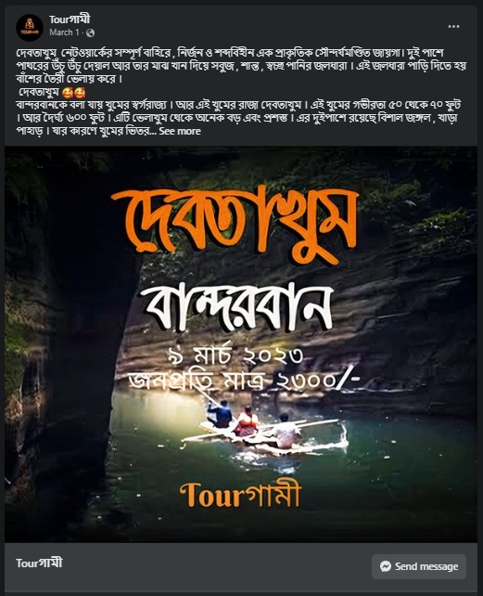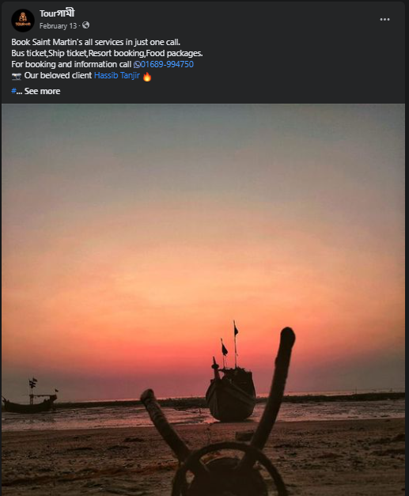

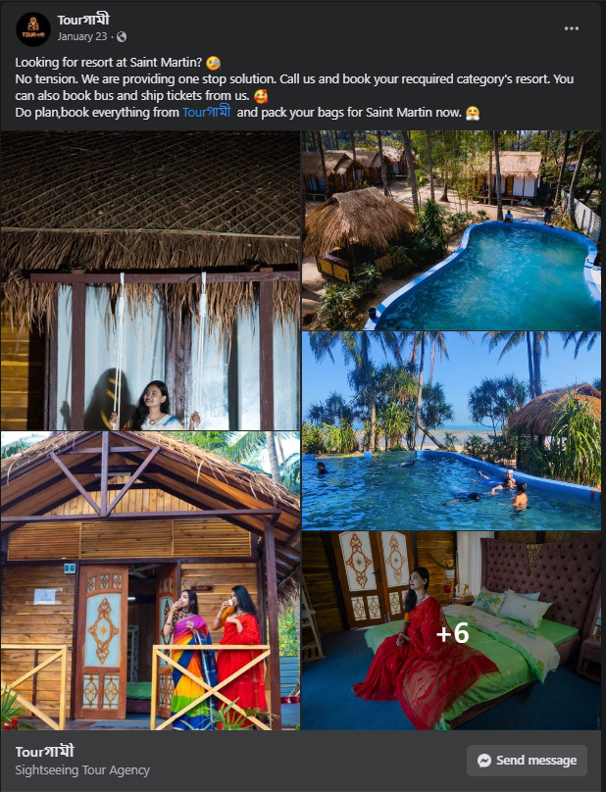
(https://www.facebook.com/photo/?fbid=219688647250535&set=a.175485445004189&__cft__[0]=AZVoO0NX_INN5MUsL4GEBd9_utGCbwnP9cLokbL1uMbCYIWntFKSMJ-JZm4spl6dftRWAe-85hgecbRolI-08A9Oq2OiKUkjDpq5mvMmMPKy3RvG82Kne7czymWBljMPt_zKnNcgItj0LqkPwZY4sHH9g2P9Cbh5w9nFE-3aHqfhJb0zgRUwVPUSWR-orPBUIcI&__tn__=EH-R)

Chapter 3:

Theoretical Overview of Customer

3.1 Literature Review:

An overview of existing work and scholarly writings on the subject of customer satisfaction in the tourism industry is given in the literature review. It looks at different research, theories, and ideas that help us understand what influences consumer happiness and what it means for the travel and tourism sector.
the literature review's main aspects include:
- Customer Satisfaction: The importance of the notion of customer satisfaction in the context of the tourism industry is emphasized and it is described in the topic. The review looks at various frameworks and approaches for measuring and evaluating customer satisfaction.
- Factors Influencing Customer Satisfaction: In the tourism sector, a variety of elements that affect consumer satisfaction are identified and examined in the literature review. These variables may include things like service quality, employee conduct, infrastructure, destination characteristics, cost, and customer support.
- Service Quality: In-depth research is done on how service quality affects customer happiness. The review looks at different criteria and metrics for determining service quality in the context of travel.
- Customer Expectations: The topic of consumer expectations and how they relate to satisfaction are explored in the literature review. It talks about how crucial it is to understand and control customer expectations in order to increase satisfaction levels.
- Impact on the Tourism Industry: The evaluation looks at how consumer satisfaction affects the tourism sector's development and success. It examines the possible advantages of high customer satisfaction levels, including repeat business, positive word-of-mouth, and customer loyalty.
- Strategies for Enhancing Customer Satisfaction: The literature review highlights the many methods and techniques used by tourism companies to improve customer satisfaction. Personalization, technological integration, personnel development, effective communication, and ongoing quality improvement are a few examples of these tactics.
The literature review serves as a foundation for the current study by integrating existing knowledge, and identifying research gaps. It provides a framework for formulating research hypotheses and guides the methods for gathering and analyzing data.
The literature review gives theoretical insights that support the study's aims and research questions, and it contributes to a thorough understanding of customer satisfaction in the tourism industry.

3.2 Customer Satisfaction

A key component of the success of companies in the service sector is customer satisfaction. Providing great service and ensuring customer satisfaction has become crucial in a market that is getting increasingly competitive and where consumers have a wide range of options. Hospitality, retail, banking, healthcare, and telecommunications are just a few of the many industries that make up the service sector. Understanding and valuing customer satisfaction is crucial for sustainability and long-term success regardless of the industry.
Customer satisfaction may be set up as how customers feel and rate the goods, services, and overall experience they have with an enterprise. It involves going above and above what the customer expects and creating pleasant feelings and unforgettable experiences. Customers who are happy with a product or service are more likely to buy from that company again, suggest it to others, and generally help a company's reputation and success.
Customer happiness is very important in the service sector. Several critical performance indicators, including revenue, customer retention rates, and brand loyalty, are directly impacted. Businesses that focus on customer happiness and consistently provide superior support have an advantage in the market.
A company's capacity to meet customers' wants and expectations is strongly correlated with its ability to satisfy its customers. It offers insightful information regarding the level of customer satisfaction, how quickly a business responds to customer complaints and the culture of the organization as a whole. It goes beyond simply a superficial measure.
Customer satisfaction is fundamentally influenced by the level of service. When clients are happy, it means that the company's services meet or surpass their expectations. It suggests that the business has successfully kept its commitments, showing competence and professionalism. Customer satisfaction is a good indicator of a company's capacity to continuously provide high-quality service, regardless of whether it relates to the timeliness of service delivery, the performance of a product, or the entire experience offered.
Customer satisfaction is a measurement of how successfully a business addresses customer problems in addition to service quality. A high rate of customer satisfaction shows that a business recognizes its customers and is dedicated to solving their issues quickly and effectively. It represents a customer-centric strategy in which consumer feedback is valued and used to enhance the entire customer experience. A business can show its commitment to customer satisfaction by actively listening to customer input and responding to their issues right away. This creates customer loyalty and trust.

3.2.1 Defining Customer Satisfaction:

In the context of the service sector, customer satisfaction refers to how customers perceive and evaluate the goods, services, and overall experience they receive from a business. It entails providing good feelings and experiences that make clients feel satisfied, fulfilled and appreciated.
Customer satisfaction includes the full customer journey, from the first contact with a firm to the support provided after the sale, and is not just based on a single interaction or transaction. It is a comprehensive evaluation of how effectively a business has fulfilled the requirements, wants, and preferences of its clients during its relationships with them.
When customers are happy, it means that their expectations have not only been met but are frequently achieved. They believe that the business has kept its promises, offered superior service, and met their needs. Several factors, including the standard of the good or service, the level of customer service, the simplicity of doing business, and the total value achieved can have an impact on customer satisfaction.
Customer satisfaction is an individual concept that varies from person to person. Each customer carries their own set of preferences, expectations, and past experiences, which determine how satisfied they feel. It is vital for businesses to comprehend their target clients in order to customize their offers and experiences to suit their unique requirements and preferences.
Companies frequently use a variety of techniques and technologies, including surveys, feedback forms, customer reviews, and social media monitoring, to assess customer satisfaction. With the use of these techniques, companies may gather quantitative and qualitative data that will help them assess customer satisfaction levels, pinpoint areas for improvement, and make wise choices that will improve the customer experience.
Brand recognition and loyalty are significantly influenced by customer satisfaction. Customers that are happy with a firm are more likely to make repeat purchases, stick with them, and refer them to others. Satisfied customers' positive word-of-mouth can have a big impact on a business's reputation, draw in fresh customers, and help it succeed in the long run.

3.2.2 The significance of customer satisfaction:

Customer retention and loyalty:
Happy customers are more likely to stick with a company and keep using its goods and services. Customer retention is crucial since it lowers retention rates and the need for ongoing attempts to attract new customers. It tends to be less expensive to keep your current clients than to find new ones. Businesses may encourage loyalty, strengthen customer relationships, and boost customer lifetime value by putting a high value on customer satisfaction.

3.2.3 More potential for cross-selling and consumer engagement:

Customers that are satisfied with a product or service are more willing to buy from the company. They are more motivated to offer recommendations, take part in surveys, and help make products and services better. Because they are more responsive to additional offerings, engaged customers can present the opportunity for cross-selling or upselling. Businesses can improve customer engagement and grab chances for growth in revenue by setting a strong emphasis on customer satisfaction.

3.2.4 Positive Word-of-Mouth and Reputation:

Happy consumers become spokespersons for the company by telling others about their good experiences. They are more likely to tell their friends, family, and coworkers about the company. Positive word-of-mouth advertising has a big impact on how potential buyers decide, which helps businesses gain new customers. Additionally, a solid reputation based on consumer satisfaction creates trust and confidence, giving the company an advantage in the market.

3.2.5 Differentiation from the Competition:

Customer satisfaction can act as an important differentiation factor in a crowded service sector. A company differentiates itself from its rivals by offering outstanding customer service and constantly meeting their needs. Customers are more inclined to choose a business that regularly satisfies their wants and delivers above their expectations. Businesses can position themselves as leaders in their fields and acquire a competitive advantage by prioritizing the demands of their customers first.

3.2.6 Profit margin expansion and improved business performance:

Positive business performance measures are influenced by customer satisfaction. Repeat business from satisfied customers enhances sales revenue. Additionally, happy customers are more likely to pay higher prices for higher quality service or an improved overall experience and are less price-sensitive. Businesses can succeed financially and sustainably by continually satisfying their customers.

3.2.7 Data to Support Continuous Improvement:

Customer feedback helps firms find areas that need to be improved by offering useful information. Customer feedback can point to service gaps. Businesses can use the information to support data-driven decisions, execute improvements, and improve their services and processes. Businesses can remain flexible and responsive to changing consumer requirements by committing to continual improvement based on feedback from customers.

3.3 Elements influencing customer satisfaction:

Many variables that affect how customers perceive a company and their whole purchase decision have an impact on customer satisfaction. For organizations to successfully satisfy customer demands and improve satisfaction levels, an understanding of these aspects is essential. Key elements that can affect customer satisfaction in the service sector include the following:

3.3.1 Service Quality:

Customer satisfaction is greatly impacted by the key component of service quality. Service that is dependable, effective, and consistent is valued by customers. Organizations are required to provide customers with high-quality services that surpass their expectations. Efficiency, responsiveness, punctuality, and attention to detail are just a few examples of the elements that affect the impression of service quality, which in turn affects customer satisfaction.

3.3.2 Personalization and Customization:

Customers like customized interactions that are catered to their unique needs and tastes. Businesses can increase customer satisfaction by providing personalized experiences that respond to their unique needs by understanding customer preferences.

3.3.3 Consistency and Trustworthiness:

Reliability is an essential aspect of customer satisfaction. Customers expect companies to constantly fulfil their commitments and support timelines. Performance of the product or service, on-time delivery, and consistent service levels are all aspects of trustworthiness. Customers feel secure in their choice when businesses regularly provide dependable experiences, which increases customer satisfaction.

3.3.4 Response time and communication:

Communication that is efficient and punctual is essential for ensuring satisfied customers. Customers value companies that respond to their questions, concerns, and criticism. Clear and timely communication develops trust. Customers may quickly get in touch with the company and obtain quick assistance because of responsiveness that extends to different ways like phone, email, live chat, and social media.

3.3.5 Empathic Insight & Emotional Connection:

Creating an emotional bond with customers can have a big impact on how satisfied they are. Customers appreciate businesses that show genuine concern for their needs as well as empathy and understanding. Positive emotional experiences are produced by empathetic interactions and compassionate problem-solving, and these experiences increase client satisfaction and loyalty.

3.3.6 Good value for money:

Customers look for good value for their money. Businesses must ensure that customers believe that the price they pay is a match for the quality and services they receive in order to engage in a fair exchange of value. By giving customers a sense that they are getting a fair return on their money, competitive pricing, transparent pricing structures, and value-added advantages increase customer happiness.

3.4 Accessibility and Convenience:

These two factors are crucial to customer satisfaction. Customers assume that firms will be simple to reach through a variety of channels, have user-friendly websites or mobile applications, and have simple payment methods. By saving clients time and effort, offering self-service choices, simple procedures, and hassle-free experiences contributes to customer happiness.

3.5 Attitudes of Employees and Service Culture:

An employee's attitude and behaviors directly affect how satisfied a customer is. Employees that are friendly, competent, and helpful create positive relationships and improve the service experience for customers. Consistent service delivery and improved levels of customer satisfaction are made possible by a customer-centric service culture that appreciates employees and prioritizes customer satisfaction.

3.6 Metrics of customer satisfaction:

For organizations to measure customer satisfaction levels and find areas for development, measuring customer satisfaction is essential. Businesses can enhance the customer experience by using effective measurements to gather vital information and make data-driven decisions. The following are common strategies and procedures used in the service sector to measure customer satisfaction:

3.6.1 Surveys:

Surveys are a common and frequently employed technique for measuring customer satisfaction. Surveys can be developed and distributed by businesses to get quantitative and qualitative consumer input. Online, email, phone, and in-person interviews are just a few of the different ways that surveys can be carried out. Questions that assess several facets of the customer experience, such as service quality, responsiveness, and overall satisfaction, are included in surveys that are properly planned.

3.6.2 Customer Feedback and Reactions:

Monitoring consumer comments and reviews on various platforms, including social media, review websites and customer groups, offers useful information on how satisfied customers are. Businesses can address issues, find solutions, and show their dedication to customer satisfaction by analyzing and acting on consumer feedback. Additionally, it shows areas that need development and assists in identifying trends and patterns in customer feedback.

3.6.3 Customer interviews and focus groups:

Focus groups and in-depth interviews are two ways that firms can get valuable feedback from customers. In order to fully investigate the experiences, perceptions, and suggestions of a small group of customers, these methods entail a direct connection with them. Businesses can gain valuable knowledge, identify unmet needs, and spot possibilities for development by conducting structured or semi-structured interviews.

3.6.4 Complaints from Customers and Service Improvement:

Tracking and analyzing complaints from customers is crucial to measuring their level of satisfaction. Businesses can discover repeating problems, understand issues, and develop efficient service recovery plans by storing and categorizing complaints. In addition to increasing customer satisfaction for the influenced customers, immediately and effectively resolving concerns shows a dedication to providing excellent customer service.

3.6.5 Net Promoter Score (NPS):

Customer loyalty and willingness to suggest a business to others are measured by the net promoter score or NPS. It involves asking the following simple question to customers: "On a scale of 0 to 10, how likely are you to recommend our company/product/service to a friend or colleague?" Customers who responded to the survey are divided into three groups: Promoters (scoring 9–10), Passives (score 7-8), and Opponents (score 0-6). By subtraction the percentage of Promoters from the percentage of Opponents, the NPS is derived. Customer loyalty and satisfaction can be measured simply via NPS.
It is necessary for organizations to choose the best measuring techniques based on their unique goals, customers, and available resources. Furthermore, tracking patterns, identifying developments, and measuring the effects of efforts on customer satisfaction levels are all made possible by enterprises' regular and consistent assessment of customer satisfaction over time.

3.7 Customer Satisfaction Enhancement Strategies:

3.7.1 Understanding the Needs and Expectations of Customers:

Businesses must have an in-depth understanding of the needs, expectations, and problem areas of their customers if they are to increase customer satisfaction. To acquire information, conduct market research, examine customer reviews, and practice active listening. Businesses may efficiently adjust their offerings to match client expectations.

3.7.2 Personalize the Customer Experience:

Customers value actions that match their unique preferences. Utilize technology and customer data to customize interactions, suggestions, and services. Adapting customer publicity, promotions, and product recommendations according to their preferences and previous actions. Customer happiness rises as a result of personalization activity, perception of value, and care.

4.6.2 Continuous Enhancement:

To increase customer satisfaction, adopt the concept of constant improvement. Analyze patterns, consider customer feedback, and identify areas that could use improvement on a regular basis. To respond to consumer issues and make data-driven decisions, implement processes and systems. To keep ahead of altering customer needs and expectations, promote a culture of learning and innovation.

3.7.3 Proactive Problem Solver:

anticipate future problems and take proactive measures to address them. Keep an eye on client feedback, spot fresh patterns, and act quickly to fix problems. To transform unfavorable views into positive ones, implement efficient service recovery procedures. Businesses may increase customer trust and loyalty by taking the initiative to solve problems.

3.7.4 Empowerment of Employees:

Give staff the resources and support they need to provide outstanding customer service. Give them resources and training to improve their knowledge and abilities. Encourage staff to make decisions on their own to enable them to quickly and effectively resolve customer issues. Employers should be thanked and rewarded for their contributions to consumer happiness. Positive customer experiences are largely influenced by engaged and empowered personnel.
The success of companies in the service sector depends heavily on customer happiness. It acts as a potent indicator of operational efficiency, customer loyalty, and general company performance. Businesses can create a great customer experience, encourage customer loyalty, and gain a competitive advantage by emphasizing customer satisfaction and putting methods to improve it.
Businesses should concentrate on addressing customer needs and expectations, providing excellent service, customizing the customer experience, building effective communication, encouraging continuous improvement, empowering employees, proactive problem solving, and creating a customer-centric culture in order to increase customer satisfaction. Businesses may improve customer experiences, improve customer relationships, and promote long-term success by putting these principles into practice.
A significant factor in the success of a business in the service sector is customer satisfaction. Businesses can create amazing experiences for customers, motivate loyalty, and stand out from rivals by emphasizing customer satisfaction and putting successful tactics into place. Investing money into improving customer satisfaction is investing money into the long-term success and profitability of the company.

Chapter 4:

Survey Findings and Interpretation

4.1 Survey Results and Interpretation

The details presented in this report are based on insights gathered through a recent survey conducted on customer satisfaction levels in the Tourism sector of the service industry. I aimed at collecting input from both our own customers and random populations – covering various aspects that contribute towards satisfying them while availing services. Our main objective was to identify strengths amid areas that need improvement within this industry – using information gathered from these different groups for comprehensive data analysis.
Our survey questionnaire was designed keeping in mind vital dimensions of customer satisfaction such as staff responsiveness, ease of access or problem resolution experienced by them. Based on their opinions within these dimensions we have summarized crucial findings that highlight significant trends driving improvements central to achieving greater standards across this industry. Visual representations like graphs have been included alongside written analysis ensuring easier interpretation. It is important to acknowledge limitations in this data such as self-reporting bias or varying experiences, however, these findings still provide valuable insights into enhancing customer satisfaction within service providers – key to informed decision-making and industry development.

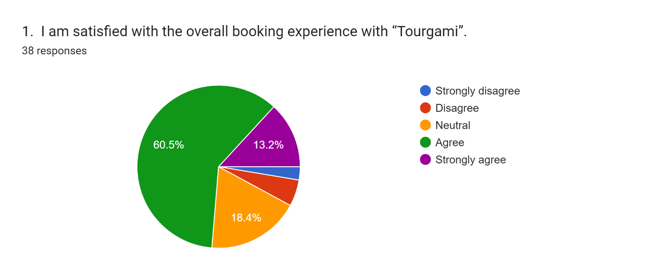
Overall, the findings indicate a generally favourable opinion of the overall booking experience with "Tourgami," since the majority of respondents either agreed or strongly agreed. It's important to take note of the issues given up by those who disagreed or strongly disagreed while looking at potential areas for improvement.

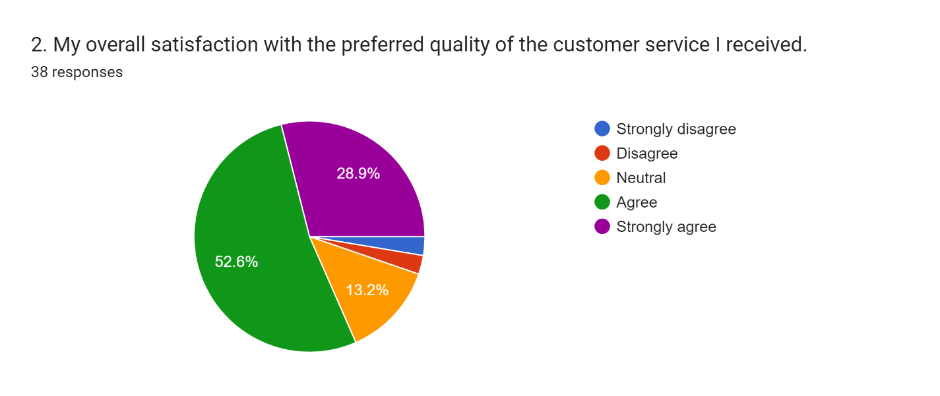
Focus on ongoing improvement in order to further increase satisfaction with the level of customer service. The knowledge and abilities of customer service employees can be improved through funding training programs. Promote proactive customized customer engagement. Implement feedback processes to collect client feedback and quickly resolve problems. To surpass expectations and encourage long-term customer happiness, strive for consistently superior customer service.

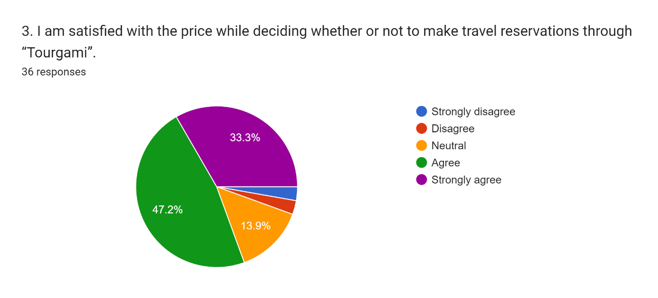
Overall, the survey indicates a mixed reaction to the cost of booking travel through "Tourgami." Despite the fact that a significant number of respondents expressed happiness or strong satisfaction. Focus on adjusting the pricing approach to further increase consumer satisfaction with the pricing of travel reservations. To ensure competitive pricing, conduct market research. To provide clients with more value, think about providing unique promotions, discounts, or bundle offers.
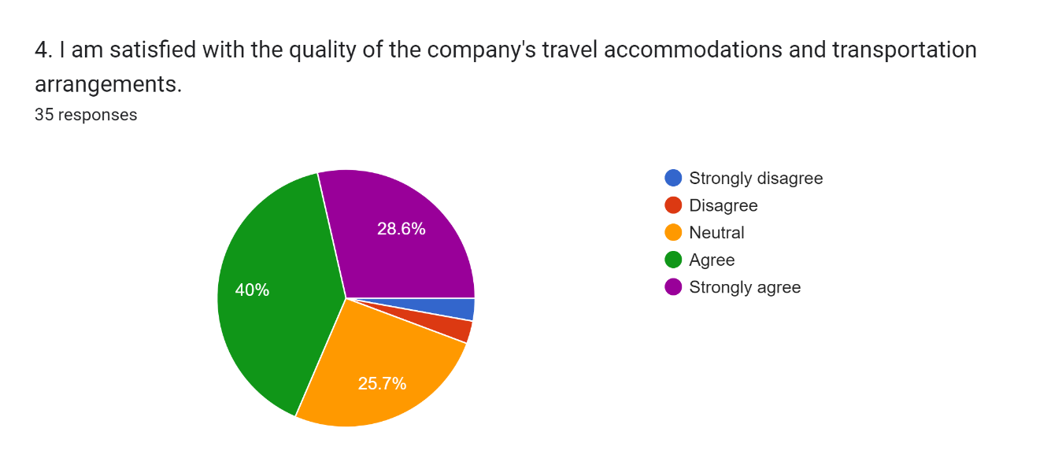
Improve Trip Accommodations and Transportation: Pay attention to consistently improving the offers to further raise consumer satisfaction with the quality of trip accommodation as well as transportation options. To ensure high standards of quality, conduct extensive evaluations of the transportation and accommodation partners. Keep a close eye on consumer feedback and respond quickly to any problems. Invest in joint ventures with established and trustworthy suppliers. Offer a wide variety of solutions that can accommodate different tastes and price ranges in an effort to go above and beyond what the customer might expect.

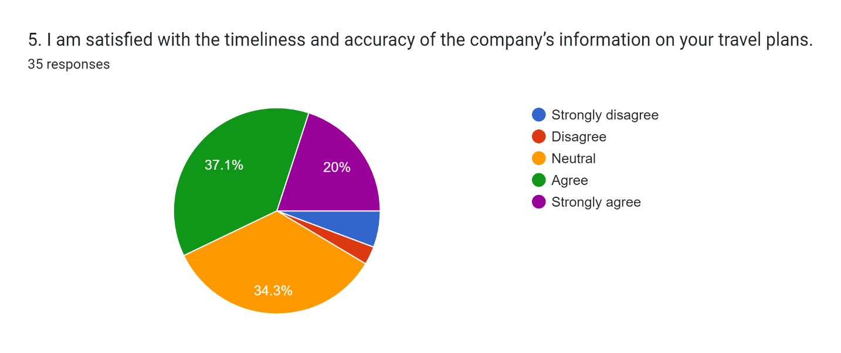
It could be beneficial for the business to address the issues brought up by those who disagreed, strongly disagreed, or are neutral with the statement in order to increase customer satisfaction in this area. Customers may have a better overall experience if travel information is updated more frequently and accurately. But the majority of the population is satisfied.

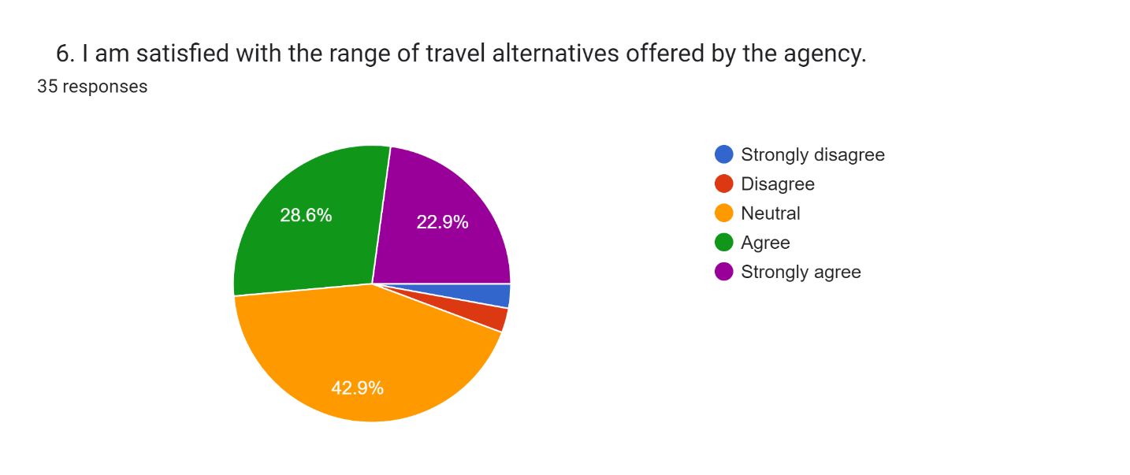
The majority of the population is satisfied. Slightly more respondents (42.9%) expressed neither satisfaction nor dissatisfaction remaining indifferent. This could signal that they are unsure of their satisfaction level with the variety of travel options or that they have a neutral opinion.
It would be beneficial for the agency to address the issues brought up by those who disagreed or strongly disagreed in order to increase customer satisfaction in this area.

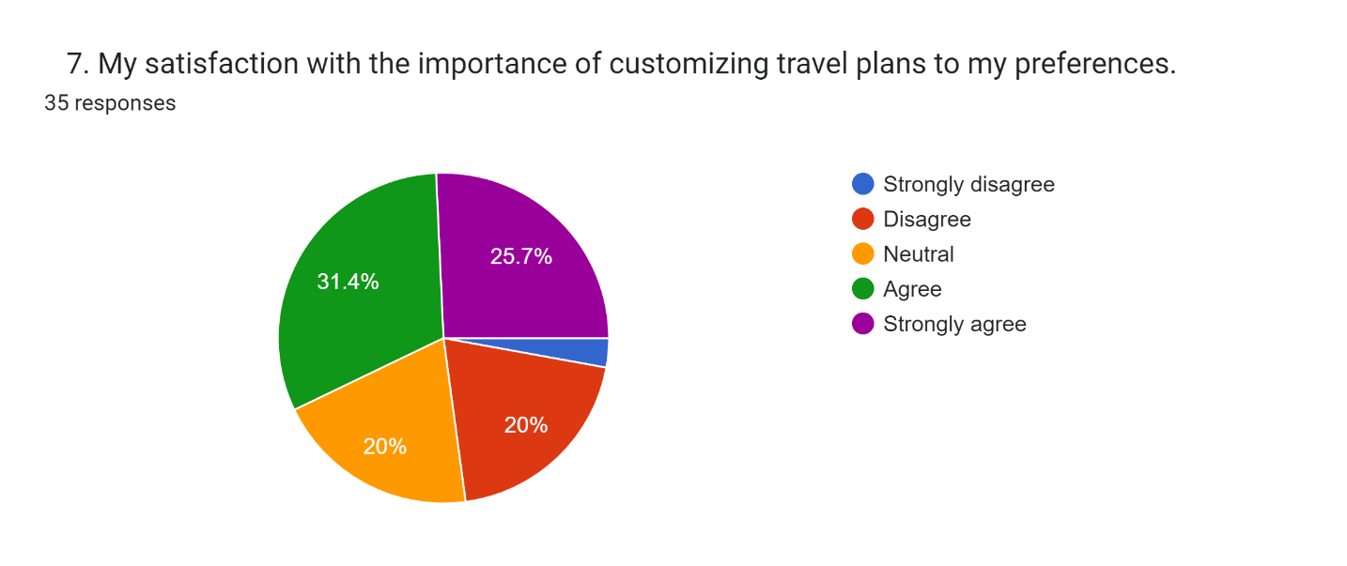
The majority of the population is satisfied. Give customers more options for personalization by taking into consideration. Describing preferences in detail, including the different types of accommodation, modes of transportation, activities for relaxation, and foods. Customers are given more freedom and authority to customize their vacation to their individual preferences.
ability to better satisfy the various wants and preferences of clients will increase as a result of offering a broader variety of customization options.

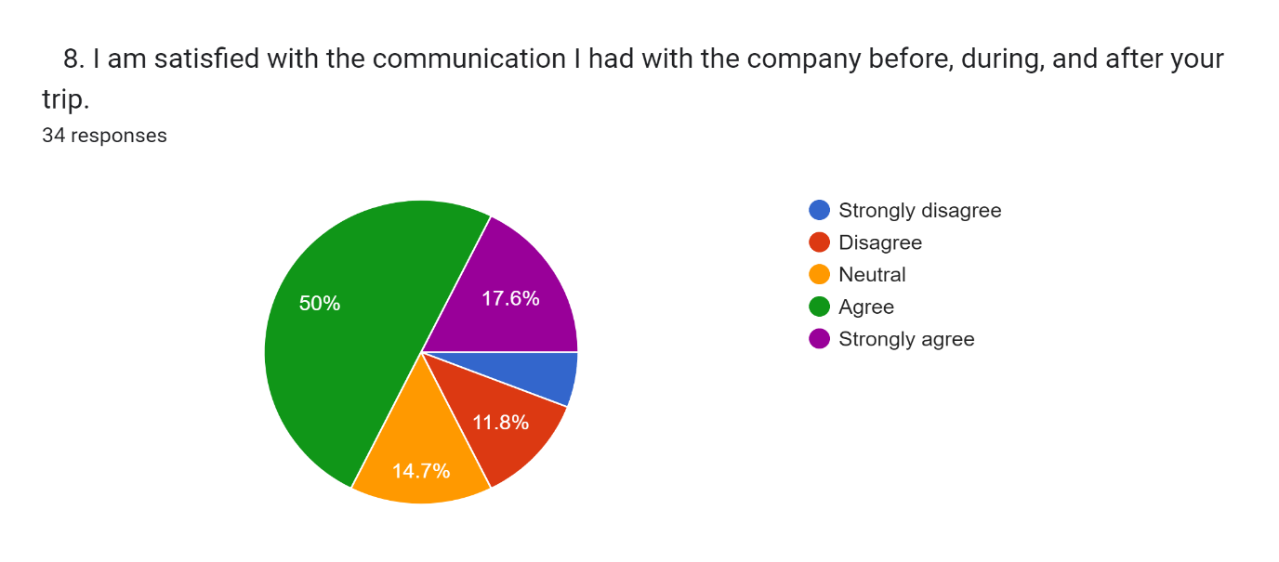
The majority of the population is satisfied. To ensure efficient and prompt communication with consumers, have to improve communication channels and procedures. As part of this, timely updates, individualized communication, and obtaining post-trip comments are all included. These upgrades will increase general consumer satisfaction and contribute to a great communication experience.

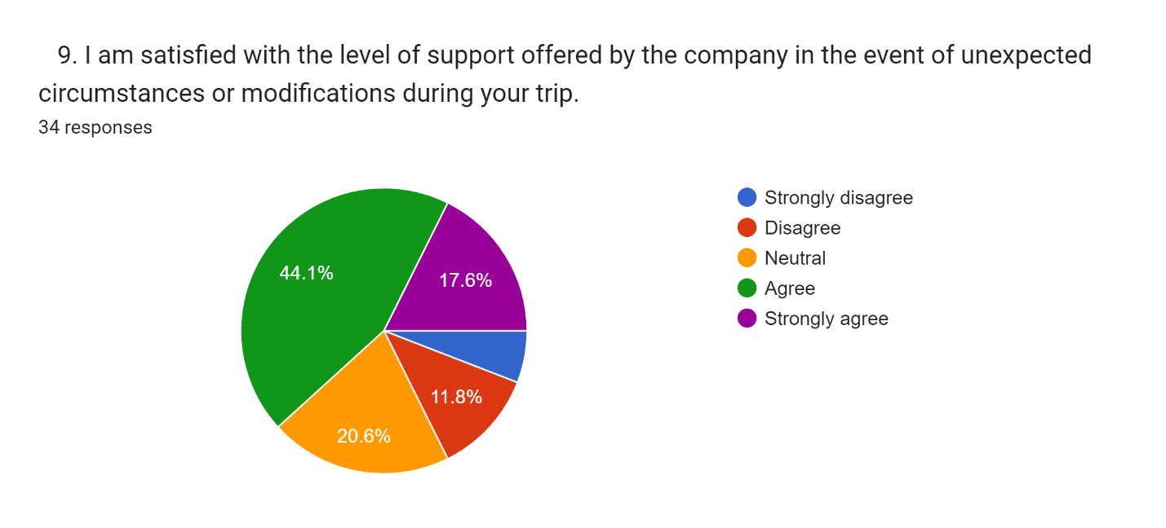
The majority of the population is satisfied.
Enhancing assistance Systems: By adopting 24/7 customer assistance, clear communication of support channels, timely response and problem resolution, proactive communication, and post-trip follow-up, have increased increase customer satisfaction under unforeseen events or revisions.

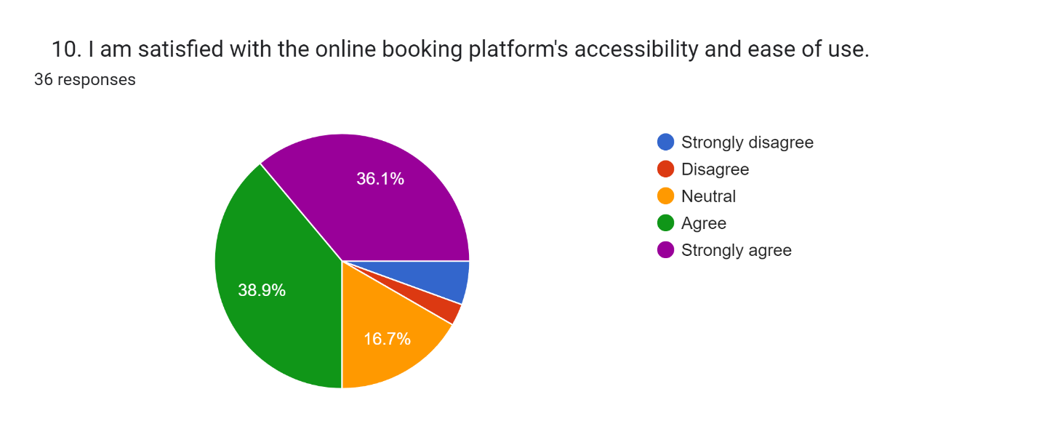

The majority of the population is satisfied.
Enhance accessibility and simplicity of use of the online booking platform by streamlining navigation, offering clear instructions and guidance, guaranteeing mobile responsiveness, and gathering user feedback for ongoing enhancements.

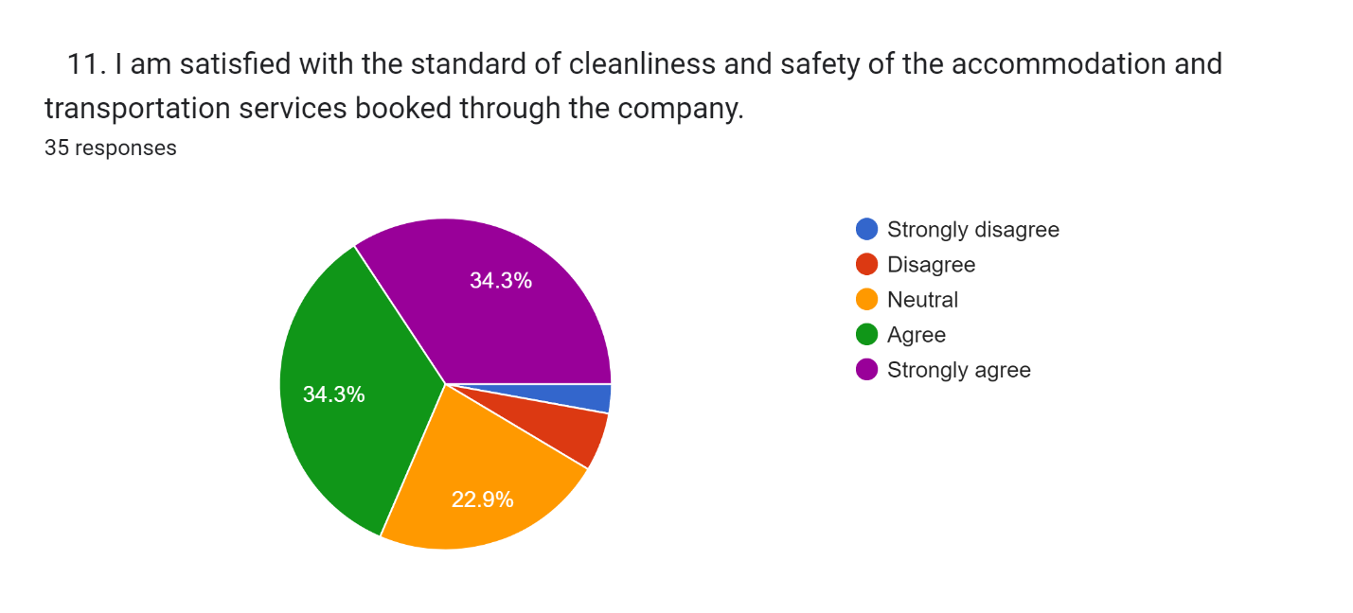
Ensure Cleanliness and Safety: Respond to customer feedback regarding satisfaction with the level of cleanliness and safety of the hotel and bus services by putting strict cleaning procedures into place, performing frequent safety inspections, and informing customers of the steps taken to ensure their safety.

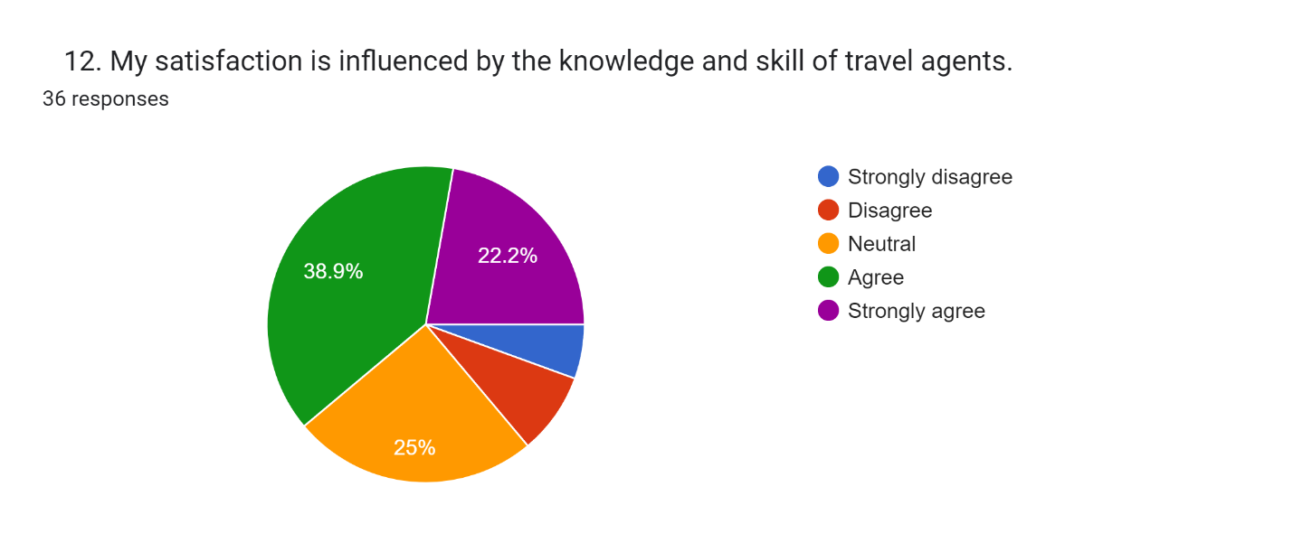
Giving travel agents thorough training and providing them with in-depth knowledge of locations, travel options, and customer service skills, can increase customer satisfaction. Customers will be given professional direction and support during their travels.

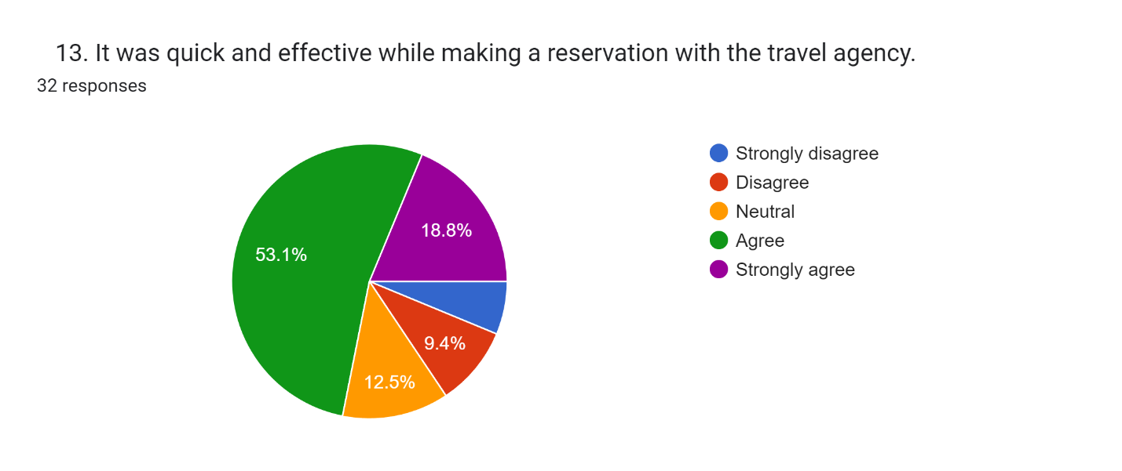
Concentrate on enhancing the reservation process' efficiency and speed to further raise the level of customer satisfaction. To make it simple and quick for customers to make bookings with the travel agency, use automated systems, streamline processes, and make sure cues and instructions are clear.

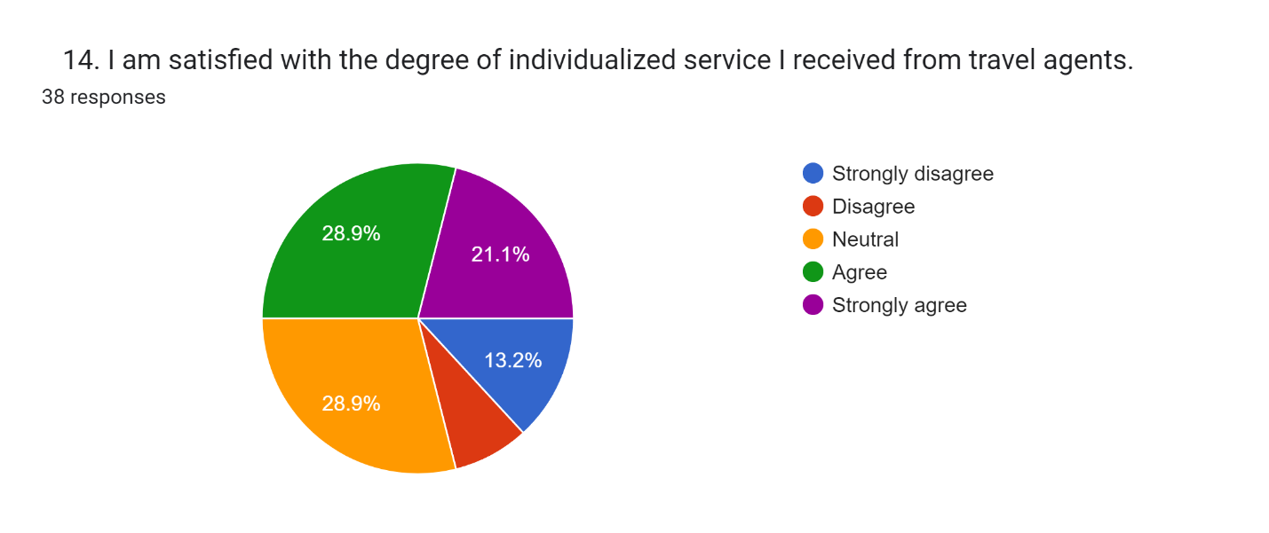
Enhance Individualized Service: Increase client satisfaction by having travel agents provide individualized, unique service. Insist on the significance of comprehending and attending to specific consumer demands, preferences, and questions. Create policies and training programs to ensure the continued provision of high-quality, personalized service.

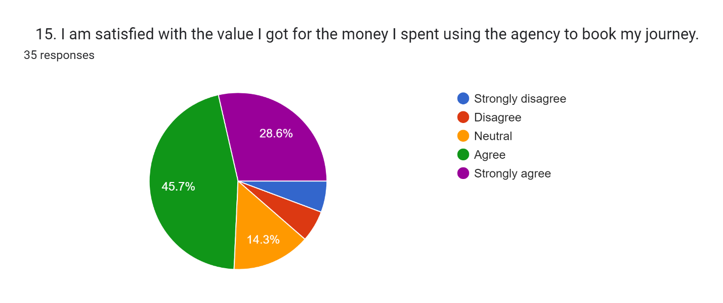
Improve Value Proposition: Pay attention to increasing the agency's overall value proposition in order to increase consumer satisfaction with the value they receive for their money. This can be accomplished by giving competitive pricing, delivering extra benefits or advantages ensuring pricing transparency, and constantly asking for consumer feedback to identify areas for improvement and value addition.

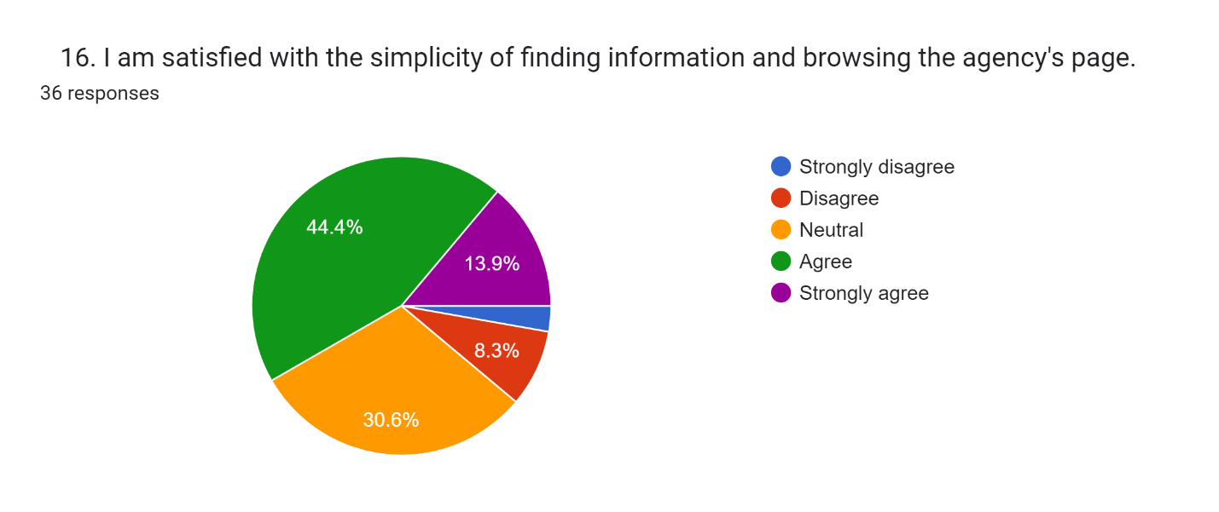
Enhance Website Usability: Take special attention to making the agency's website more straightforward and user-friendly in order to increase customer satisfaction with finding information and website browsing. To make it simpler for customers to locate the information they need quickly and effectively, streamline navigation, assuring intuitive design and search capabilities, offer simple and straightforward data, and maximize the entire browsing experience.

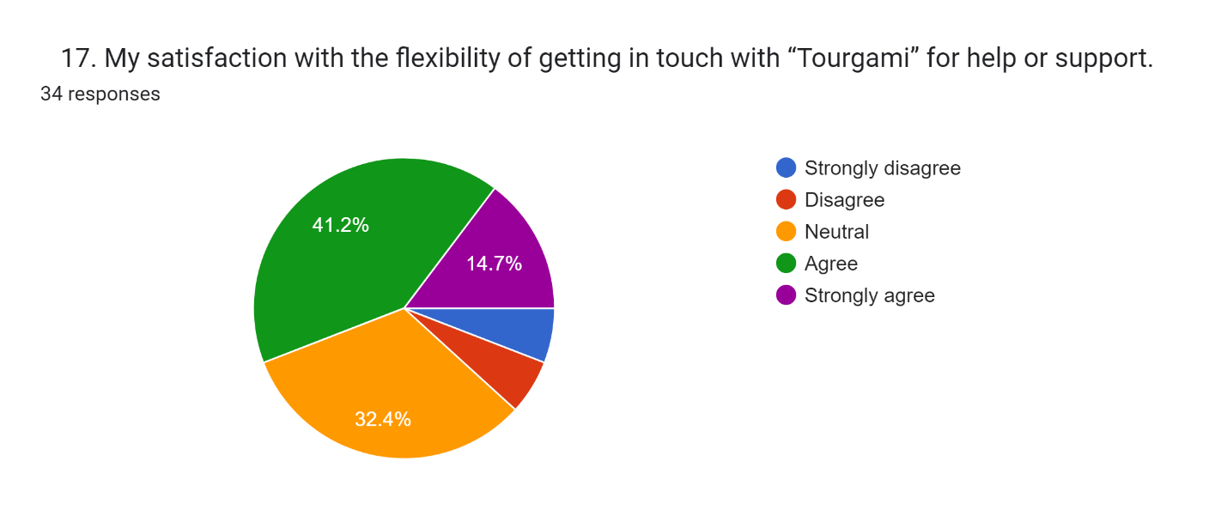
Improve Support Accessibility: Concentrate on to increasing the available channels and accessibility alternatives to increase customer satisfaction with the ease of getting in touch for assistance or support. Offer a variety of ways to communicate, including phone, email, live chat, and social networking sites. Make sure that support is available at all times to meet the diverse needs and preferences of clients.

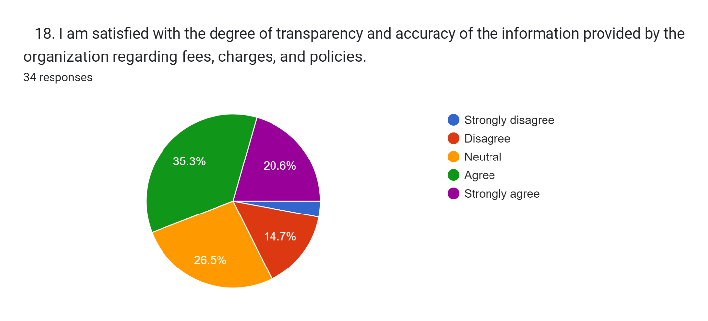
Focus on increasing interaction and distribution of data to increase transparency and accuracy, which will increase consumer satisfaction with information about fees, charges, and policies. Make sure that all pertinent information is delivered to clients in an understandable manner via a variety of channels, including the website, booking platforms, and customer support. To prevent misconceptions, give thorough explanations of all fees, charges, and policies. Maintain information accuracy by regularly reviewing and updating it, and swiftly answering any consumer issues.

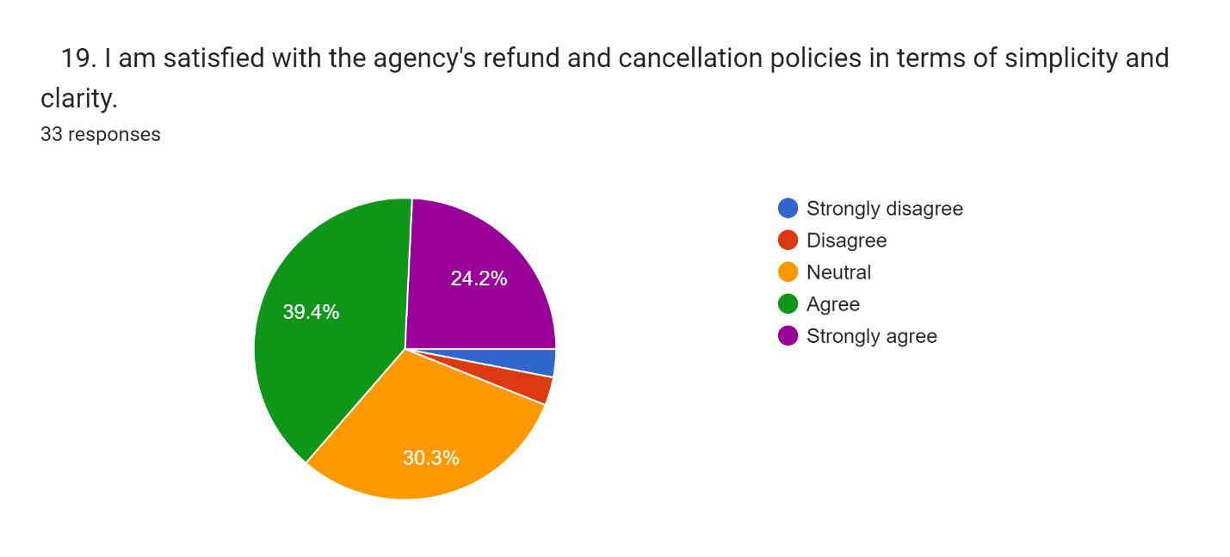
Refund and cancellation policies could be improved: Focus on making the policies simpler to understand and easier to navigate in order to increase customer satisfaction with the agency's refund and cancellation policies in terms of simplicity and clarity. Clarify the terms, processes, and time frames for refunds and cancellations while simplifying the syntax and structure of the policies. To help customers understand the policies better, give examples or scenarios. Additionally, make sure that the policies are simple to find on the website and other channels used for customer interactions.

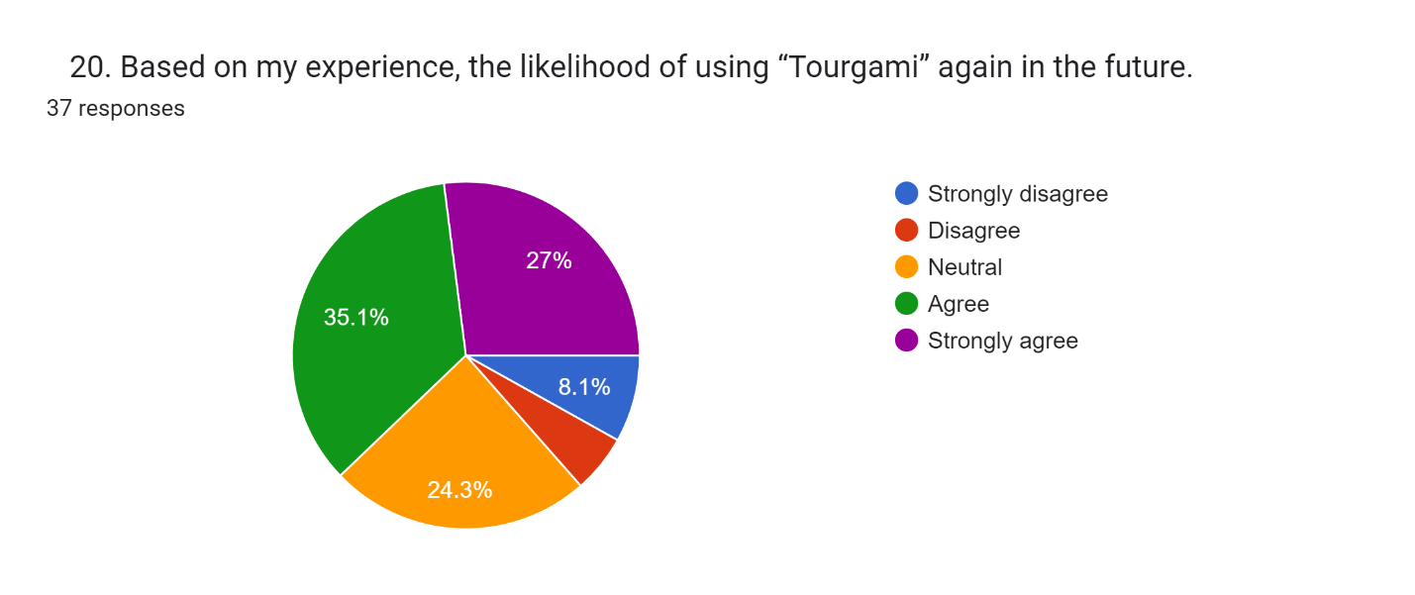
Enhance Customer Loyalty: Give attention to improving customer satisfaction and loyalty to improve the possibility that customers will use "Tourgami" once more in the future. To encourage repeat reservations, provide individualized incentives or loyalty programs. Utilize client feedback to continually enhance services to meet their changing requirements and expectations. In order to cultivate enduring loyalty and persuade clients to select "Tourgami" for their future travel requirements, offer great customer service and sustain positive relationships.

Chapter 5:

Tourism Industry in Bangladesh & Findings

People move around the world by foot, car, and airplane to see the beauty of nature that is all around them. They constantly seek out the flavor of mysterious and unexplored out of curiosity. People become depressed by their routine workloads and desire to escape the stresses of job deadlines, avoid the crowds of city life, break the monotony of typical everyday life, and so enjoy some time in a new location with cultural and natural importance. A fresh location might make one feel happier and break up their routine. A tour is a great way to expand one's knowledge. Bengal has a long history and is incredibly rich in culture, history, social values, and religion; for this reason, it is regarded as a wonderful and charming tourist destination.
Bangladesh's tourist sector has seen significant growth and is now recognized as a potential source of employment opportunities and foreign exchange revenues. Bangladesh has developed into a popular travel destination for both domestic and foreign tourists thanks to its rich cultural legacy and various natural resources. This article examines Bangladesh's tourist industry prospects, identifies its SWOT analysis's strengths, weaknesses, opportunities, and threats, and offers suggestions for further development.

5.1 DISCOVERY OF BANGLADESH

Generally speaking, Bangladeshis are straightforward people that value tradition. The people experience six distinct seasons throughout the year, each of which is unique in terms of giddiness, colour, and beauty (Akteruzzaman & Istiaque, 2009). If we look at tourism as a whole, Bangladesh should be considered one of the most beautiful nations not just in South East Asia but also globally, according to recreational opportunities. Bangladesh may not have stunning structures or architectural wonders like the Pyramids or the Taj Mahal, but it does have something distinctive to offer visitors. Pundraardhan, the oldest city, goes back to the third century BC. It has a rich heritage, culture, monuments, ancient and marvelous mosques, temples, excellent tea gardens, many historical structures, and beautiful scenery (Mollah & Hossain, 2009). From a more general perspective, tourist destinations can be grouped into three groups: archaeological, historical, and natural beauty. The extensive and fascinating tourist attractions are claimed to include beaches, archaeological sites, hills and inland areas, historical sites, religious locations, forests, and wild animals, among other things. At Cox's Bazar, there is a 75-mile-long, uninterrupted sandy sea beach. Rarely do you find a sea beach that is as straight and smooth anywhere in the globe. Bangladesh is home to strange tribal people who live in the steep Cox's Bazar and Chittagong Hill Tracts districts and have their own distinct way of life. Ancient history is also abundant in the nation. There are still many well-known structures, archaeological sites, and historical locations that serve as reminders of Bangladesh's once-brilliant civilisation. Another popular tourist destination in Bangladesh is the Sundarbans, a stunning forest with beautiful greenery. Bangladesh also has a thriving rural tourist industry. Tourists can take joy in the communities' modest way of life. For recreation, the nation has various parks. Tourists enjoy visiting Ramna Park, the Mirpur Botanical Garden in Dhaka, the Foy's Lake in Chittagong, and other sizable, medium-sized, and small parks ( Hasan & Neela, 2008). Instead of focusing on a nation's inherent charms, the tourist industry has traditionally placed more emphasis on the material conveniences it provides. This could be the cause of Bangladesh's lack of recognition on tourism maps around the world (www.discoverybangladesh.com/25k, n.d.).

5.2 Introducing Bangladesh's natural beauty

Broadly speaking, Bangladesh's tourist destinations can be broken down into three groups: archaeological, historical, and natural beauty. Buddhist and Islamic historical and archaeological sites, as well as general interest sites in the Sonargaon and Comilla regions of Dhaka, are the basis of cultural tourism in those areas.
There is also a chance that Mahastangar in the Bogra district, Rajshahi, the Shat Gombaj Mosque in Bagerhat, and the Barisal region would draw tourists. The Buddhist Vihara of Paharpur was added to the list of world heritage sites.

5.2.1 Dhaka Division

There are 38.678 million people living in the Dhaka division, which is in the country's center and has a 31119 sq km area.
These division's principal rivers are the Padma, Jamuna, Meghna, Old Brahmaputra, Dhaleshwari, Shitalakshya, Brahmaputra, Buriganga, and Arial Khan. The districts of Gazipur, Mymensingh, and Tangail are located to the north of Dhaka, as are the Madhupur and Bhawal Garhs and the Garo Hills, which are in Mymensingh district.
The capital of Bangladesh is Dhaka. The city has earned the nicknames "City of Mosques, Muslin, and Rickshaws." Through the decades, it has drawn visitors from both near and far. Dhaka, which successfully combines ancient and new architectural styles, is a fast-growing metropolitan city that is humming with activity in every aspect of life. (http://www.discoverybd.com/dhaka.html, n.d.)

5.2.2 Chittagong Division

The main seaport and second-largest town in Bangladesh, Chittagong, is located close to the Bay of Bengal. It is located 264 kilometres to the east of Dhaka and is well-known for its hilly terrain, scenic landscape, and seashore. Aulias (Muslim saints) are recognized as the town of Chittagong.
The area consistently draws tourists because of its green hills and forests, wide sandy beaches, and pleasant, temperate environment.
The Qadam Mubarak Mosque and the Shahi Jamae-Masjid are two of the city's most stunning structures. The Ethnological Museum in the Modern City, which features excellent exhibits on Bangladesh's tribal peoples, is well worth visiting. The northwest area of the British city's fairy hill offers beautiful views and refreshing breezes.

5.2.3 Khulna Division

The Khulna division is located in Bangladesh's southwest. The Sundarbans, the largest mangrove forest in the world, is located there. Khulna Division's top tourism attractions.

5.2.4 Sundarban

The largest mangrove forest in the world is called Sundarban. Sundarban is the most important part of Bangladesh's tourism industry. Every year, a sizable number of tourists from abroad travel to Bangladesh solely to see this special mangrove forest. Additionally, each year, local tourists travel to Sundarban. Great Sundarban covers an area of about 6000 square kilometers.
MAIN ATTRACTIONS: Wildlife photography, including photography of the renowned Royal Bengal Tiger, wildlife viewing, boating through the forest while listening to bird calls, nature study, meeting fishermen, woodcutters, and beekeepers, peace and quiet in the wilderness, viewing the largest mangrove forest in the world, and the breathtaking beauty. The Sundarbans, which extend 80 kilometers (50 miles) inland into Bangladesh, are the world's biggest coastal mangrove belt. However, the forests are not merely mangrove swamps; some of the last remaining stands of the powerful jungles that originally covered the Gangetic plain may also be found there.
A wildlife sanctuary since 1966, the Sundarbans are now thought to be home to 400 Royal Bengal tigers and over 30,000 spotted deer. With its wealth of large and small game, crocodiles, wild boars, deer, pythons, wild birds, and most importantly the Royal Bengal Tiger, which is clever and ruthless yet magnificent and graceful, this is undoubtedly a place for sportsmen, anglers, and photographers. Ducks, snipes, herons, coots, yellow-lags, and sandpipers are among the more timid wildlife. It is also a destination for regular tourists who want to relax or stroll around at their leisure in order to maintain their energy and feast their eyes on the abundance of beauty that nature has so kindly gifted.

5.2.5 Rajshahi Division

The town of Rajshahi is located next to the Padma River. The huge Padma is at its most active during the monsoon with its tides and waves, however in the winter it shrinks and you can sense the desert by the river. The historical and archeological sites of the Rajshahi Division include Mohastnangor, the Choto Sona Masjid, the Paharpur Buddhist Monastery, Kantajee's Temple, Ramshagar Dighi, and Shopnopuri, among others. The Borendra Research Museum is another option. The historical components of Paharpur and Mohasthangar can be found there.

5.2.6 Sylhet Division

In Bangladesh's northeast is the Sylhet Division. It is a naturally steep, forested region with well-known shrines and ox bow lakes.

5.2.7 Sylhet City

Greater Sylhet is one of Bangladesh's top tourist destinations, nestled in the gorgeous Surma Valley amid picturesque tea plantations and beautiful green tropical woods. By having a large number of terraced tea gardens, rolling terrain, and beautiful nature, Sylhet, which is situated between the Khasia and Jaintia hills on the north and the Tripura hills on the south, breaks up the monotony of this land's flatness. The Mainpuri Tribal's customary hearths and dwellings are surrounded by dense tropical trees that are home to a variety of wildlife speciesThe Surma and Kushiara rivers, which are both fed by numerous hill streams from the north and south, form the Sylhet valley. They are both lovely, winding rivers. There are many of haors, which are substantial natural depressions, in the valley. Before the Muslims conquered it, local chieftains-controlled Sylhet, which has a very interesting and varied history. Having conquered the then-Raja Gour Gobinda in Sylhet in 1303, the renowned Saint Hazrat Shah Jalal traveled from Delhi with a group of 360 disciples to teach Islam. The visitor can view tea gardens for kilometers in all directions, spreading out like a beautiful carpet over the flat terrain or on the sloping slopes.
A trip to the Sylhet tea plantation is a special one. In addition to having more than 150 tea gardens, Sylhet, the tea granary of Bangladesh, is proud to have three of the largest tea gardens in the world in terms of both area and productivity. The Shrine of Hajrat Shahjalal(R) and Hajrat Shah Poran is Sylhet City's main draw (R). The Hajrat Shahjalal (R) shrine is located in Sylhet city on top of a hill (tilla). Each day, thousands of people visit this shrine. On the Sylhet-Jaflong road, eight kilometers from Sylhet town, is the Hajrat Shah Paran (R) Shrine, which receives thousands of tourists each day.

5.2.8 Barishal Division

A division of rivers and canals is called Barishal. It is renowned for its coconut tree gardens. Thousands of coconut trees may be seen all around Barishal Division. The primary tourist destination in the division is Kuakata. You can visit Durga Sagor in Barishal town, a stunning Dighi where many seasonal visitors arrive each winter. A person can spend their free time in this lovely park by wandering about and viewing the birds. Key Tourist Attractions in the Barishal Division
Kuakata, the southernmost point of Bangladesh is home to a unique scenic beauty location known locally as Sagar Kannya (Daughter of the Sea). Excellent natural scenery, including a sandy beach, a clear sky, a vast stretch of Bay water, and an evergreen forest, can be found in Kuakata. One may observe both the sunrise and sunset from its seashore. The coconut trees enhance the seashore's natural attractiveness. Kuakata is a genuinely undeveloped beach that offers a haven for migratory winter birds, a line of coconut trees, a sandy beach along Blue Bay, and a visual feast. Every visitor's heart is touched by the forest, the colorful sails on the boats cruising the Bay of Bengal, fishing, the high cliffs, and the waves. The unique customs and costumes of the 'Rakhyne' tribal families and Buddhist Temple of about hundred years old indicate the ancient tradition and cultural heritage, which are objects of great pleasure Kuakata is the place of pilgrimage of the Hindus and Buddhist communities. In Horinghata forest sometimes the Royal Bengal Tiger is seen. Horin is a Bengali word for deer. So, name itself express why it's called Horinghata.The distinctive traditions and attire of the "Rakhyne" tribal family and the approximately one-hundred-year-old Buddhist temple reveal the long-standing customs and cultural history, which are sources of great joy. The Hindu and Buddhist populations visit Kuakata as a site of worship. Sometimes the Royal Bengal Tiger can be observed in the Horinghata forest. The Bengali term for deer is horin. Therefore, the name itself explains why it is called Horinghata.

5.3 Current Scenario of Tourism in Bangladesh

Bangladesh has the potential to develop into a popular tourist destination due to its beautiful scenery, economical services, and friendly population. The nation is still dealing with a number of issues, though, which are impeding the expansion of the tourism sector. Several of these difficulties include:
- Accommodation Issue: Bangladesh is a popular tourist destination, yet there are not enough high-quality accommodations available. To meet the growing demand, the nation must make investments in the construction of hotels and resorts of the highest international standards.
- Poor Image of Bangladesh: Bangladesh's reputation for safety and security is poor, which turns away potential tourists. In order to alter this view and sell the nation as a secure and appealing travel destination, sophisticated marketing and branding methods are required.
- Transportation Problem: Tourists have difficulties due to the nation's poor connectivity and inadequate transportation infrastructure. Accessibility for tourists will be improved by expanding efficient public transportation networks and improving road and aviation connectivity.
- Lack of Proper Publicity: The potential for tourism in Bangladesh has not been sufficiently communicated to a worldwide audience. To raise awareness of the nation's assets and draw tourists, extensive marketing campaigns are required on both a national and international level.
- Complicated Visa and Travel Formalities: Potential tourists are discouraged by the complicated visa and travel processes. More tourists will travel to Bangladesh if these procedures are made easier and hassle-free for visitors.
- Preservation of Tourism Products: The total tourism experience is hampered by the lack of initiative to preserve, conserve, and maintain the tangible tourism products, such as historical landmarks, cultural heritage, and natural resources. To draw tourists, efforts should be taken to preserve and highlight these treasures.
- Security Concerns: Tourists are concerned about the unstable political climate and frequent security incidents. The government and appropriate agencies should place a high premium on providing tourists with a safe and secure environment.
- Lack of Funding: The national budget's insufficient funding for the tourism industry limits the possibility for the sector to expand. For infrastructure development, marketing, and capacity building, enough financial assistance and investment are essential.

Despite these obstacles, Bangladesh has a great deal of potential to grow its tourism industry. The nation may develop a truly sustainable tourist business by addressing these problems and utilizing its distinctive charms.

5.3.1 Prospects of Tourism in Bangladesh

There are many different tourist attractions in Bangladesh, such as historical sites, natural beauties, dynamic cities, and festivals. The following are some of Bangladesh's top tourism sector prospects:
- Natural Beauty: Bangladesh is gifted with a variety of natural scenery, including clean beaches, verdant hills, rivers, and the Sundarbans, the world's biggest mangrove forest. These natural treasures draw tourists from all over the world who are interested in the outdoors, adventure, and wildlife.
- Cultural Heritage: Bangladesh's historical sites, old temples, mosques, and archaeological ruins all serve as reminders of the country's rich cultural legacy. Locations like Paharpur, Mahasthangarh, and Bagerhat's Mosque City provide enlightening perspectives on the nation's history and architecture.
- Festivals and Traditions: Bangladesh observes a number of vibrant holidays throughout the year, including Eid-ul-Fitr, Durga Puja, and Pohela Boishakh (the Bengali New Year). Cultural lovers are drawn to these festivals because they highlight the lively customs, music, dance, and food of the nation.
- Ecotourism Potential: Bangladesh has the potential to develop into a center for ecotourism thanks to its rich biodiversity and eco-friendly activities. For those who enjoy the outdoors, the Sundarbans—the habitat of the Royal Bengal Tiger—as well as the various national parks and animal refuges provide unforgettable experiences.
- Adventure Tourism: There are opportunities for climbing, mountaineering, and discovering indigenous people in Bangladesh's hilly regions like Bandarban and Rangamati. Adventurers can take in the natural beauty of the hills and participate in thrilling activities.
- Religious Tourism: Bangladesh is a land of religious diversity, with significant Buddhist, Hindu, and Muslim heritage sites. Places like Cox's Bazar, known for its Buddhist temples, and the Shah Jalal Mosque in Sylhet attract pilgrims and spiritual seekers.
- Medical Tourism: Bangladesh has achieved great advancements in the healthcare industry, providing top-notch medical care at competitive prices. Potential medical tourists looking for affordable procedures and procedures could come to the nation.

5.4 SCENARIO OF FOREIGN EXCHANGE EARNINGS

Any tourism organization's marketing effectiveness can be measured using the organization's revenue. Therefore, in order to have a comprehensive image of the sector's financial performance, research has focussed on BPC's earnings and their growth rate over the previous couple of years. The following table displays the revenues and growth rate of BPC, the sole government-owned travel company in Bangladesh.:
Table: Foreign Exchange Earnings from Tourism and Travels in Bangladesh
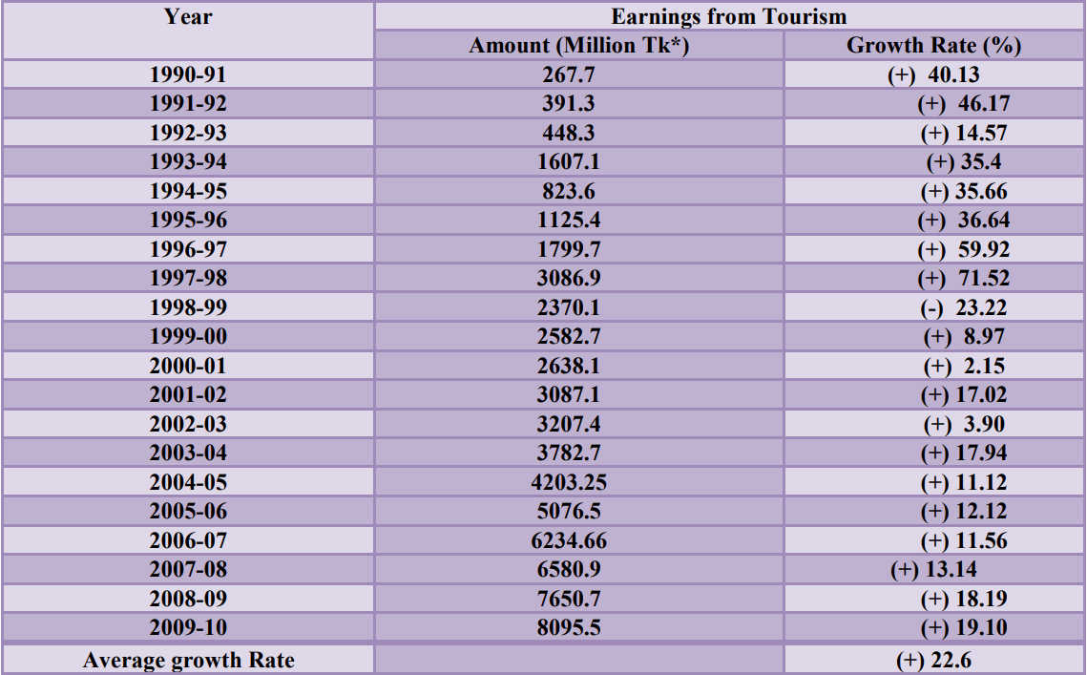
Source: Bangladesh Bank and BPC web page, available fromhttp://www.bangladeshtourism.gov.bd

5.5 SWOT Analysis of Bangladesh Tourism Sector

Strengths:  - Many natural attractions, such as hills, beaches, and woods.  - Historical landmarks and a rich cultural legacy.  - Affordable prices for services and lodging.  - Friendliness and hospitality of the locals. | Weaknesses:  - A lack of accommodations of a high adequate international grade.  - Negative perception of security and safety.  - Inadequate connectivity and infrastructure for transportation.  - Complicated visa and travel requirements.
Opportunities:  - Ecotourism and adventure tourism have untapped potential.  - Growing demand for heritage and cultural tourism.  - Increasing acceptance of medical travel.  - Improving the aviation and road networks to increase connectivity. | Threats:  - Political instability and safety worries.  - Competition from nearby nations.  - Incorrect marketing and promotion tactics.  - Destruction of the environment and climate change.

5.6 Ideas for Tourism Sector Development

The following suggestions can be taken into account in order to overcome the difficulties and take advantage of the opportunities:
- Improve Accommodation Facilities: Encourage private sector investment in the construction of resorts and hotels of the highest international standards to satisfy the growing demand for accommodation.
- Enhance Safety and Security Measures: Through efficient law enforcement and awareness efforts, strengthen security measures and guarantee the protection of tourists.
- Develop Tourism Infrastructure: To increase accessibility for tourists, make improvements to the transportation infrastructure, such as the roads, airports, and public transportation systems.
- Implement Effective Marketing Strategies: To promote Bangladesh's tourist potential and reverse the unfavorable attitude, implement intense marketing campaigns on a national and worldwide level.
- Simplify Visa and Travel Formalities: Streamline visa and travel procedures to provide a hassle-free experience for tourists, encouraging more people to visit the country.
- Preserve and Showcase Cultural and Natural Assets: Take reasonable steps to protect historical sites, cultural legacy, and natural resources so that visitors can have a genuine and one-of-a-kind experience.
- Promote Ecotourism and Adventure Tourism: Create and promote eco-friendly tourism strategies with a concentration on biodiversity preservation and attracting tourists with adventurous experiences.
- Strengthen Public-Private Partnerships: To develop and maintain tourist sites, encourage cooperation between the public, private, and local communities. This will ensure sustainable growth and the equitable distribution of advantages.
- Invest in Human Resource Development: Provide tourism industry professionals with training and capacity-building programs to improve their skills and expertise in hospitality, customer service, and sustainable tourism practices.
- Allocate Sufficient Funds: The national budget should allocate more funds for the development of infrastructure, marketing, and value addition in the tourism industry.
By putting these suggestions into practice, Bangladesh can maximize its tourism potential, draw in more tourists, and support the national economy.
Bangladesh's tourist sector has the potential to significantly boost the economy of the nation. Bangladesh has a variety of natural beauties, a rich cultural history, and economic services that can draw both domestic and foreign tourists. Bangladesh can develop a successful and sustainable tourism industry that creates jobs and earns foreign currency by solving issues and grabbing opportunities. Collaboration between the public and corporate sectors, as well as local communities, is necessary for the development of the tourism industry, as are strategic planning, financial investments, and efficient marketing techniques. Bangladesh may establish itself as a must-see location on the tourist map of the world with the right strategy.

Chapter 6:

Conclusion

In conclusion, this paper concentrated on customer satisfaction in the tourism industry with the goal of understanding the aspects impacting satisfaction and offering suggestions for development. The research's findings made clear how important factors like service quality, individualized encounters, price, communication, and customer assistance are in determining customer satisfaction levels.
Data from customers who had recently participated in tourism activities was gathered through the survey-based research design. The study of the data showed that, despite a significant percentage of customers expressing high levels of satisfaction, there were several areas that needed improvement. Safety, infrastructure, information accessibility, and cultural sensitivity were among the common complaints raised by customers.
Several methods were suggested to increase customer satisfaction. These methods included raising service quality through staff development and facility improvements, customizing interactions to suit each customer's preferences, providing competitive pricing, bolstering communication channels to deliver timely and accurate information, and ensuring efficient customer support services.
It is vital to recognize the study's limitations, such as sample bias and self-report bias, which could have impacted the results. Furthermore, time and resource limitations might have had an impact on how detailed the investigation was. To get a better grasp of customer satisfaction in the tourism industry, future studies should take these drawbacks into account and consider survey data.
In general, putting customer satisfaction first is essential for the development and success of the tourism industry. Customers who are satisfied with their experiences are more likely to come back, suggest businesses to others, and help the industry as a whole grow. Businesses in the tourism industry and policymakers can prosper in a competitive market by putting the suggested techniques into practice and taking care of customer complaints.
This study contributed to the existing knowledge of tourism industry consumer satisfaction by giving stakeholders useful information. In order to increase customer happiness, it highlights the significance of constant improvement in service quality, personalization, communication, and customer support. With these efforts, the tourism sector can promote long-term growth, draw more tourists, and position itself as a leader in offering travelers’ excellent experiences.

Chapter 7:

References

Afroz, Sajeda & Sumi, Razia Sultana (2009): “Visitors’ Preferences for selecting Tourism destination in Bangladesh”, South University Journal of Business Studies, Vol-V, No-2, July – December, (P.123-135)
Ansari, Mohammad Nayeem Aziz; Akter, Shahnaj & Huq, Muhammad Jahedul (2006): “Environmental impact of Tourism: A case study on St. Martin’s Island”, Journal of Business and Technology, Vol-01, Issue-01, January – June, (P.27-34).
Dr. Azad, Md. Abul Kalam (2005): “Role and performance of National Tourism Industry in Bangladesh Economy: A Study”, The Chittagong University Journal of Business Administration, Vol.20, (P.33-50).
Dr. Sikder, Zahed Husain & Husain, Md. Moazzam (1998):” Tourism Management and development - A study of some selected areas in greater Chittagong “, The Chittagong University Journal of Commerce, Vol.14, (P.171-186).
Dr. Azad, Md. Abul Kalam (2004): “Development of Mujibnagar Historical Tourism in Bangladesh: An Empirical Study”, the Chittagong University Journal of Business Administration, Vol.19, (P. 115-133).
Ghosh, B. 2001. Tourism and Travel Management,New Delhi: Vikas Publishing House Pvt. Ltd. Fayissa, Bichaka, Nsiah, Christian, Tadasse, Badassa(2007 ), “The Impact of Tourism on Economic Growth and Development in Africa”, Department of Economics and Finance, Middle Tennessee State University.
Hasan, Md. Kamrul & Neela, Nayeema Maswood (2008): “An Appraisal of foreign Tourists Arrival Trend in Bangladesh”, Prime University Journal, ISSN: 1995-5332, Vol-2, Num-2, July –December, (P.78-94).
Hossain,Md.Afjal and Nazmin,Sultana(2005).“Service Strategies for the Tourism Industry in Bangladesh: An empirical study”, Development Review,Vol.17.
http:// www.action for enterprise.org/example progs.htm.
http://www.indexmundi.com/facts/bangladesh/international
http://bangladesheconomy.wordpress.com/2010/04/30/mega -
http://www.discoverybd.com/dhaka.html
http://www.bangladeshtourism.gov.bd
http://www.wttc.org/
http://www.mocat.gov.bd/att_location.php?type_id=1,Retrieved on March 11, 2010.
http://www.mocat.gov.bd/images/b_map_large.jpg, Retrieved on March 12, 2010.
http://www.mocat.gov.bd/tourism_statistics.php, Retrieved on March 11, 2010.
http://www.travelspedia.com, Retrieved on March 12, 2010
Ishtiaque, Abu Naser Ahmed & Akteruzzaman (2001): “Potenga Seashore, A rising horizon for Tourism: Problems and Prospects”, The Chittagong University Journal of Commerce, Vol.16, (P.107-118).
Jahangir.Mahbub J. (1998). “Facilitation of International Travel in Bangladesh”, Bangladesh Parjatan Corporation(mimeo), Dhaka
Mahmuda Shafi. (1985). “Tourism Marketing: Pros and cons”, Tourism Recreation Research, Vol.X.No.1, Lucknow (India).
Mollah, Moniruzzaman & Hossain, Mohammed Mosaraf (2009):” Tourism Industry in Bangladesh: Problems and prospects”, Journal of The People’s University of Bangladesh, Vol-4, No-1, July (P.146-162).
Nahid, Tasmina & Islam, Nazrul (2008): “The development of Tourism Business in Bangladesh: An Analysis on the Strategic Issues and Marketing Implication”, The Business and Economic Review, Vol-1, Num- 2, August, ISSN 1994-8808, (P.135-150).
Rahman, Akhlaqur (2008): “Development of Tourism in Bangladesh”, Bangladesh Quarterly, October – December (P.69-76).
Talukder, Abu Sayeed (1984): “Development of tourism in Bangladesh: need for consumer motivation”, The Dhaka University Studies, Part-c, 5(1), (P. 83-97).
Uddin, Mohammed Asraf & Ahmed, Shaheen (2005): “Tourism in Bangladesh: Present status, Problems and Prospects”, Journal of Business Studies, Southeast University, Vol-1, No-2, July (P.143-154).

