
Internship report on Daraz Bangladesh Limited

A brief overview of Daraz Bangladesh Limited and Traffic Operations Department

Supervised By
Mofizul Hoq Masum
Asst. Professor- Accounting
United International University, UIU

Submitted By
Umaiya Sadia
ID NO: 114 151 027



Letter of Transmittal

23 May 2019
Mofizul Hoq Masum
Asst. Professor- Accounting
School of Business and Accounting
United International University, UIU
Subject: Letter of Transmittal

Dear Sir,
I am delighted and grateful to submit this Internship report titled “A brief overview of Daraz Bangladesh Limited and Traffic Operations department” as part of my graduation requirement.
While completing this project, I have tried to put my level best effort to make this paper a comprehensive one. Still this project is a shortcoming one due to several limitations as my internship duration is limited to specific tasks only and I had relatively short time to learn about other departments. Nevertheless, I have tried with my full effort to make this research a complete one. All my efforts will be fulfilled if this report is able to clarify and satisfy all the requirements sufficiently.
I would, therefore, like to submit this report to you and hope that you would show your complete kindness by accepting it. I would also like to thank you for your kind consideration.

Yours Sincerely,
Umaiya Sadia
ID NO: 114 151 027
Batch: BBA in AIS

Acknowledgment
I would like to express my regards and heartiest gratitude to Mofizul Hoq Masum, Asst. Professor- Accounting, United International University, UIU, for his continuous supervision, guidance, necessary instructions, and counseling to complete this study.
I am also grateful to everyone who helped me build this report with all their knowledge and valuable advice in preparing this report. I am grateful to my supervisor Mr. Rukesh Dutta, Head of department Mr. Barish Khandaker and my colleagues to help me learn and attain skills in such short span of time.
I again express my sincere thanks to all who have directly or indirectly cooperated me in furnishing this report.

Declaration
I hereby declare that the internship report titled “A brief overview of Daraz Bangladesh Limited and Traffic Operations department” submitted to the United International University is completed by me which is based on my practical work experience and a comprehensive study of the existing activities of different departments of Daraz Bangladesh Ltd.
I also declare that this is a record of an original work done by me under the guidance of Mofizul Hoq Masum, Assistant Professor, Accounting, School of Business and Economics, and this project work is submitted to fulfill the requirements of the award of the Bachelors degree of Bachelors in Business Administration in Accounting Information Systems. The results embodied in this report have not been submitted to any other University or Institute for the award of any degree or diploma.

Umaiya Sadia
ID NO: 114 151 027
BBA in Accounting Information System.
School of Business and Economics
United International University

Executive Summary
This internship report is based on the three months period internship program that I had successfully completed in Daraz Bangladesh Ltd under Traffic Operations Division from 03.02.2019 to 02.05.2019 as a requirement of the undergraduate program of B.B.A. in Accounting Information Systems in School of Business and Economics, United International University, Bangladesh.
The objective of the report is to provide a brief idea about the company, different functional departments and their key roles, Daraz revenue model, and how my department plays a crucial role in the process. It will also give a detailed overview of several task that were assigned to me during my internship period.
Primary data and secondary data were used to prepare this report. Primary data came from my day to day observation and interviewing employees. Secondary data was collected by Organization employee handbook, website, and relevant books. I tried to produce an unbiased report.
The Daraz Bangladesh Ltd is the largest e-commerce organizations in Bangladesh because of their high performance driven. Their exclusive employee base helps the company to achieve goals. Hence, the management development programs are introduced to enrich their employees’ skills. This report tried briefly to look on what Daraz as e-commerce firm offers, how their different generic operations are done and how traffic operations functions. This report also shows my responsibilities as an intern and my observations on current process and weakness of those. This report provides some recommendation which may help to improve their process as well.

List of Acronyms
Acronyms | Full Form
B2C | Business to Customers
BI | Business Intelligence
C2C | Customer to Customer
CS | Customer Service
E-Com | E-commerce
KPI | Key Performance Indicators
MV | Merchandising Value
SKU | Stock Keeping Unit
Traffic Ops | Traffic Operations
Table 1 List of Acronyms

Table of Contents
Letter of Transmittal 2
Acknowledgment 3
Declaration 4
Executive Summary 5
List of Acronyms 6
Table of Contents 7
Introduction 9
Objective of study 12
Methodology of the Study 12
Primary source 12
Secondary source 12
Limitation of the Report: 12
Literature Review 13
Company Overview 14
Brief Profile of Daraz- Bangladesh 14
Features 17
Mission, Vision & Company Objectives 18
Daraz Bangladesh Limited Organogram 19
Product Lines 19
Campaigns: 23
Item Lifecycle 23
Functional Departments 24
Order Process Flow 29
Uses of Digital Tools for Business: 31
Pricing & Profit calculation 32
Revenue Model 33
Projection Model for Delivery Completion 33
Accounting Model of Delivery Completion 35
Corporate Social Responsibilities 36
Internship Experience & Observation 37
Traffic Operations Department 37
Merchandising 37
Utilizing Promo tools 38
Importance of Traffic Operations 39
My Responsibilities: 40
Reviewing Products and Initiating Campaigns 40
Upload Banners and Flyers in relevant sections 46
Creating Performance Reports 50
My Experience: 53
Department, Supervisors, and Coworkers 53
Organizational Culture and Work Environment 53
Learnings from Internship Experience 53
Areas that need improvement: 54
Recommendations 56
Conclusion 57
References 59

Introduction
Bangladesh is a developing country. Our country has been successful in several industries like Agriculture, RMG, Fisheries, etc. and there are some emerging industries as well. One of these new prominent industries would be E-commerce industry. A few years back in our nation we never thought of buying anything without physically touching or viewing. We couldn't dream of that we are requesting something simply based on some photograph and data, and that thing is brought to our home by another person. But, recently, the market and people behavior has changed vastly. This happened due to the advancement of technology alongside the new business opportunity, e-commerce.
E-commerce refers to the purchasing and selling of products or services over electronic system merging a series of procedure like Electronic Data Exchange, Electronic mail, World Wide Web, Internet Applications and Network Applications. E-commerce was presented 50 years back and it continued creating new advancements and developments. A considerable number of organizations are entering the online market each year. Nowadays, individuals need more free time. They tend to get it however it is possible and that’s where e-commerce shows its charisma by saving both the most significant things which is time and money. From an online marketplace, individuals can purchase and sell their items instead of visiting the physical market.
OPERATOR | SUBSCRIBER (millions)
Mobile Internet | 75.396
WiMAX | 0.088
ISP + PSTN | 5.345
Total | 80.829
*Source (Internet Subscribers in Bangladesh, 2018)
Table 2 Ratio of Internet Subscribers in Bangladesh
So, we can see that e-commerce has great opportunity in Bangladesh. My work experience also enabled me to understand that how rapidly e-commerce is growing in Bangladesh. But it has also showed me that the customer experience is yet to be improved to reach the expectations that are not delivered. The processes are not as good as e-commerce giants like Amazon, Flipkart or Alibaba. But it is slowly improving.
The E-commerce market in Bangladesh, made a massive jump in 2017; growing at a mega rate of 70% from 2016. In 2017, the B2C E-commerce business market measure added up to USD 110-115 million (around BDT 900 crore) against the 133,571 crores total retail market.
Rocket Internet is the parent company of Daraz. They began their business in 1999 and now they have 120+ market driving ventures in 50+ nations. In late 2014, Samwer Siblings viewed Rocket Internet as a multi-billion-dollar association. The associations cordially assessed worth billion euros was around 8 in April 2015.
"We build companies” is the mission of Rocket internet. Rocket Web GMBH is world's one of the fast-paced startup creation center. This Association was set up by three siblings known as Samwer Siblings. The association's Headquarter is placed in Berlin, Germany. They have ventures running in over 50 countries. Rocket for the most part target growing nations who have developing markets like Bangladesh, Cambodia, Pakistan, Sri Lanka, etc. Rocket Internet has several child companies running in Bangladesh as of now. They are:
- Kaymu – Online C2C Shop
- FoodPanda – Online Food Delivery
- Carmudi – Online Car shop
- Lamudi– Online Real Estate
- Jovago – Online Hotel Booking service
- Everjobs - Online Job Site
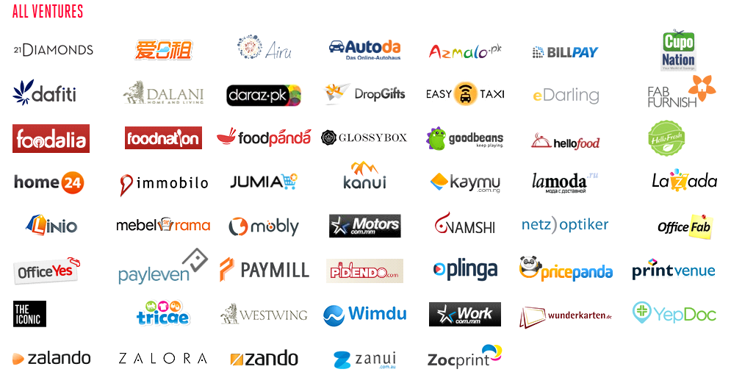
All ventures of Rocket Internet at a glance:
Figure 1 All Ventures of Rocket Internet Group
The market share of Daraz is estimated to be 40 percent. (E-Commerce Business Scenario in Bangladesh, n.d)
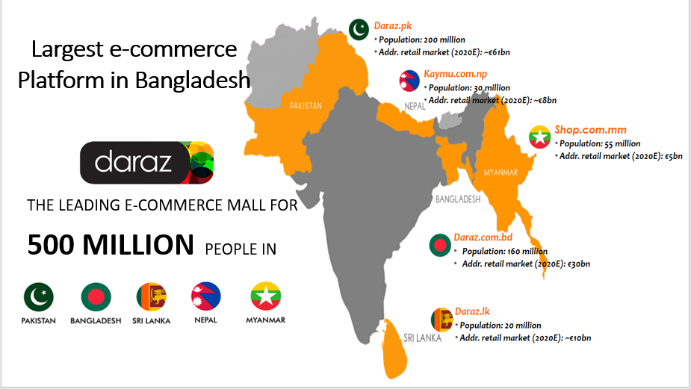
Figure 2 Daraz BD market

Objective of study
The core purpose of the report is to provide an overview of “Daraz Bangladesh Limited”, the e-commerce pioneer in Bangladesh. This report will look at their different business process and structures. This report will also provide a quick overview of the how Daraz recognizes revenue and profit. Then the report will discuss how traffic operations department is playing crucial part in different campaigns and the importance of E-commerce in growing business economy. Additionally, this report will also explain several tasks handled by traffic operations department, specifically the ones that were assigned to me.

Methodology of the Study
The study has been conducted only based on the work experience. Some data is also collected through company corporate profiles, daily newspapers, different journals & articles. The data is analyzed in aspect of Traffic Operations functions of E-commerce companies. The major limitation of the study is that most of the information were classified and there was restriction in which information I could use.

Primary source
Discussion with the supervisor, senior executives of different departments and top managers.

Secondary source
Periodic internal reports and relevant files have been used to prepare this report.

Limitation of the Report:
Few limitations I have faced while making this report.
- For many internal Data, it is not allowed to be used due to organizational policies.
- As it is a growing sector, the change in this industry is unstable and sometimes rapid. So, the findings may change in a very short time.
- Not enough report available on the current situation of e-commerce in Bangladesh.
- Limited time of the internship period is another constraint to learn in depth about different department functions of an e-commerce business.
- As part of my internship, I was only exposed to certain set of tasks which are suitable for a fresh graduate, other tasks require more training and experience which is only for the permanent employees.

Literature Review
Buffam (2012) depicted that companies that build the better e-business solutions will outperform their competitors. Companies that build the very best e-business solutions will transform themselves into zero-latency enterprises. Companies that choose not to embrace e-business, or do so ineffectively, will underperform or be driven out of business.
Turban et al. (2012) argued that following points of managerial issues are very important: Focus of Electronic commerce management; Sales promotion; Purchase process reengineering; Just-in-Time delivery; new electronic intermediary business; Provision of solutions; Business ethics.
Hoq, Kamal and Chowdhury (2012) argued that a key reason why e-commerce, especially the business-to-business segment, is growing so quickly is its significant impact on costs associated with inventories, sales execution, procurement, intangibles like banking, and distribution costs.
Chaffey (2006) dealt with strategy and applications of E-Business and E-Commerce in a logical but robust manner. He stressed that e-business and e-commerce is very important for management implications as such a bridge to link leading-edge research and professional practice is required.
The current population of Bangladesh is about 165 million, and it is 2.19 percent of the total population of the world. Also, Bangladesh is eight in the list of highest-population counties. Around 14.5 percent of the population uses the internet. About 2 million users shop online every year and growth rate is 20 percent. Dhaka reportedly ranks among most active Facebook users, and the social network’s penetration rate is at 12.7 percent. 22 million users in Dhaka are on social media. This means Bangladesh is a good market for any type of business wanting to sell online.
There are several e-commerce and online shopping companies in Bangladesh, including Daraz, AjkerDeal, Bagdoom, Bikroy.com, Ekhanei, and amikinee.com. Many companies have been developed to provide support services to e-commerce companies, such as e-Courier, Pathao, and GoFetch. Recently, there are rumors that Amazon and Alibaba are reportedly planning to create their network in Bangladesh.
The opportunities are there, and the nation is expecting a growth of around 72% over the next couple of years. Companies like Rocket Internet invested $50 million already in less than 3 years and obviously hasn't finished investing.
Let's compare the market in China and India now. E-Commerce industry contributed more than 4% in overall GDP of China, thanks to Alibaba. Indian e-commerce market is expecting to grow more than $14 bill and China is $527 bill in 2017. Bangladesh is just passing the phase what India has passed 5/6 years back.
We have seen some major players in Indian Market: Flipkart, Amazon, eBay, etc. have invested billions to develop infrastructure, merchants, and customers. More to add, India has reached the critical mass of Internet users as well. Indian govt. played a very important role too. Due to the entrepreneur-friendly environment, local companies like Myntra, Snapdeal, etc. are coming up and competing with the big giants, which is eventually helping the market to become huge for the customers. In last decade, Indian middle-class sector has grown a lot in terms of culture and purchasing power. So, this huge hungry sector of the population needs quick and easy solution for satisfying their hunger of purchase and e-commerce industry is just doing that.
Fortunately, in Bangladesh, we are observing the same trend. Our middle class is growing, and they are also hungry for new opportunities and options which can be catered by e-commerce industry. As per my research & experience with this industry, I have seen most of the e-com buyers are young executives or students. This influential group will be enriched with buying power very soon. Another important thing is, our economy is spreading not only in Dhaka or Chittagong but also in villages, small cities with proper internet connectivity. Therefore, a vast population is ready to spend their extra disposable income for online purchase more than ever. As a result, it is safe to say we are on the verge of getting that critical mass for ensuring economic industry growth.

Company Overview

Brief Profile of Daraz- Bangladesh
Bangladesh is considered as a developing country in the e-commerce industry where large global players like Amazon, E-bay, Flipkart, etc. have not penetrated yet and meanwhile, Rocket Internet Group accepted the open door to grab this prospective market. In last 5 years, Rocket Internet developed seven business organizations in Bangladesh and those are in like manner - Carmudi, Everjobs, Jovago, Foodpanda, Lamudi, Kaymu, and Daraz.
"Daraz" is Urdu word which means "Drawer". It aggressively expanded its operation in Bangladesh as Daraz.com.bd. Daraz was launched in late September 2013. Currently, Daraz e-commerce website is the top e-commerce website in Bangladesh. Among all the websites in Bangladesh, Daraz website is ranked 23rd. (Top Sites in Bangladesh, 2019)
Daraz has numerous products in its website. From the baby diapers, Daraz provides fashionable clothes, electronic products, furniture, books, groceries, home decorations, bags, watches, accessories, sports & fitness items, etc.
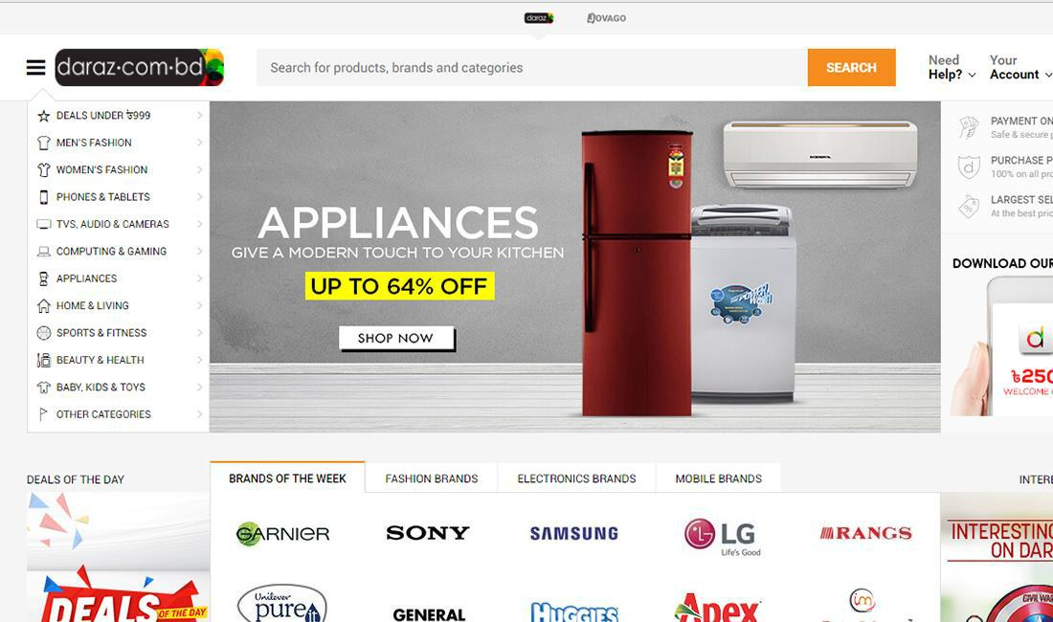
Daraz Bangladesh Limited’s Landing page:
Figure 3 Daraz.com.bd landing page

Daraz has an official FB page with more than 4 million followers (Daraz Online Shopping, 2019) People who using Facebook, can see the new offers in it. It is just like a digital marketing policy to get more customers. There is an interesting thing that Daraz is one of the online marketplaces which keeps their eyes on the SEO. So, when a customer searches on Google like “the biggest or best e-commerce sites in Bangladesh”, the name of Daraz comes first.
Daraz gives many promotional offers to the customers. These offers are given after end of each weeks or any occasions, campaigns, etc. To grab these offers, customers place orders more & more frequently. Sometimes, a certain customer may place order using his/her different emails to avail those offers.
Like other countries, Daraz provides a shopping experience that is incomparable in Bangladesh. Daraz attempts to offer the most modish, adapted and protected online shopping experience with a wide scope of brands such as Yellow, Noir, Symphony, The Body Shop, Huawei, Samsung, Walton, Aranya, 6 Degree Mobile, Shada Kalo, Apple, LG, Fastrack, MAC, Nikon, Ecstasy, Panasonic, Doors etc. are just a few of the global and local leading brands who have already set up e-stores with Daraz.com.bd with excellent sales reviews. (Daraz Bangladesh Limited Website, 2019)
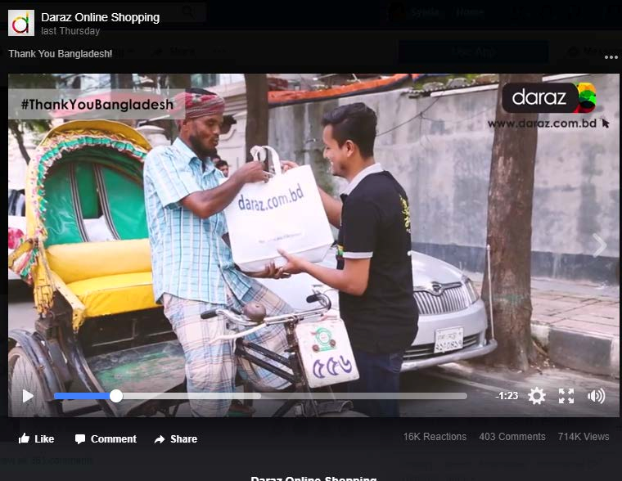
Daraz Bangladesh aiming to reach Bangladeshi peoples mind via their campaigns and promotional activities and create an image of a trusted e-shopping experience for everyone.
Figure 4 Daraz Bangladesh TVC for Thank you Bangladesh Campaign
The above is a video commercial created to empathize with the income level wise people of the country to create a sense of trust and dependable relation with the customer base. The video shows how Daraz can be a trustworthy and worthwhile shopping experience for all income level people. Additionally, it was also intended to portray Daraz’s CSR activity where Daraz employees gave away gifts to honor Bangladeshi work class people.

Features
Daraz is an online shopping portal which offers its customer base with wide variety of features.
- Extensive assortment of electronics, fashion, accessories, furniture, and grocery items.
- Direct delivery to customers preferred location at convenient time.
- Offers returns for valid issue and various reimbursement options.
- Daraz offers an exclusive shopping experience with affordable prices and quality products.
- Super suitable warranty and guarantee from the sellers.
- Constantly upgrading the product range to offer the latest gadgets and fashion styles.
- Customers can choose from online payment, internet banking or cash on delivery as they like for payment.
- Delivery is door-to-door and handled by own shipping fleet in major cities.
The Daraz business model has three advantages which directly influence its huge product assortment:
- Local stores, as well as big shopping malls, are overwhelmed by the limitation of space alongside logistical considerations. That’s why stores normally focus on one or two product categories. Daraz is a digital mall and gives the sellers the liberty to showcase as many products as they want. Since warehouse space is not as expensive, sellers can sell as many goods as they want. There is no limit.
- Daraz has thousands of sellers with new ones joining every day. All these sellers contribute to a constantly growing assortment of goods.
- Daraz generously invests in their sellers and helps them learn and grow. Thanks to training and seller education processes, Daraz sellers are constantly growing their product quality and assortment.
- Daraz stands for 100% authentic, genuine, and original products. To ensure compliance with these stringent standards, Daraz has a dedicated quality check team routinely screening sellers and products.
- Customers are protected by Daraz Purchase Protection in case their experience does not live up to Daraz standards and values.

Mission, Vision & Company Objectives
Mission:
Daraz Bangladesh aims to capture the whole market. To accomplish this mission, Daraz comes up many attractive offers for the clients. So, customers become happy getting more diverse offers and buy products with attractive prices.
According to Mr. Jonathan Doer (Co-CEO of Daraz), the mission statement is- “To provide an enjoyable shopping experience for Consumers and to grow together with our Sellers”.
Daraz continues to build a vast loyal customer base by offering largest variety of products, competitive prices, reliable fulfillment, and superior customer experience.
For the sellers, Daraz is constantly providing competitive value-added service to support scalability, expansion and integrated business solutions.
Daraz Bangladesh will achieve the mission by focusing on their core values and hiring, coaching and retaining the best people in the industry through a strong company culture.
Daraz Bangladesh is committed to create long-term growth and job opportunities in all our markets by pioneering the e-commerce development.
Vision:
The vision of Daraz Bangladesh is to be the leader in the e-commerce industry providing best products with lowest prices. The Vision statement of Daraz is “To be the most reliable marketplace and offering the best services to our customers: Consumers and sellers”.

Objectives:
Daraz intends to give the best quality items at the most competitive cost. Daraz accepts to present the most recent and requesting items for its clients. The goals of Daraz Bangladesh are to reach everywhere in Bangladesh to snatch the maximum market share of the total industry, give every necessary product to its buyers and incorporate the most noteworthy brands and dealers in Bangladesh.

Daraz Bangladesh Limited Organogram
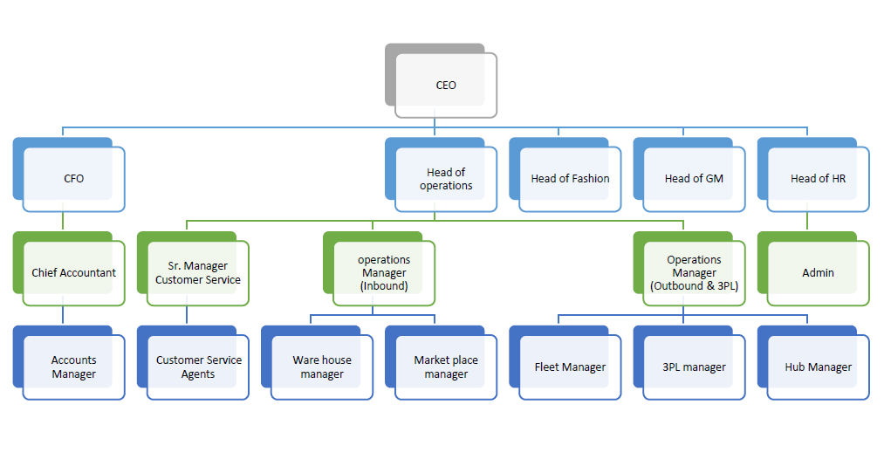
An organogram of an E-commerce firm is very different than firms of other industries. As many things are managed through online and software's, a lot of process is automated. The generalized organogram of the company is given below. Mid and Field level employees are excluded from the organogram as it is too large to fit into this report.

Figure 5 Daraz Bangladesh Generic Organogram

Product Lines
Daraz Online Shopping is a marketplace where buyers and sellers meet. Daraz gives superior collection of products to its clients. From Fashion to GM (General Merchandising) all is available on Daraz. Customers can visit their website www.daraz.com.bd and choose their preferable products without any hassle and products will be delivered within a few days.
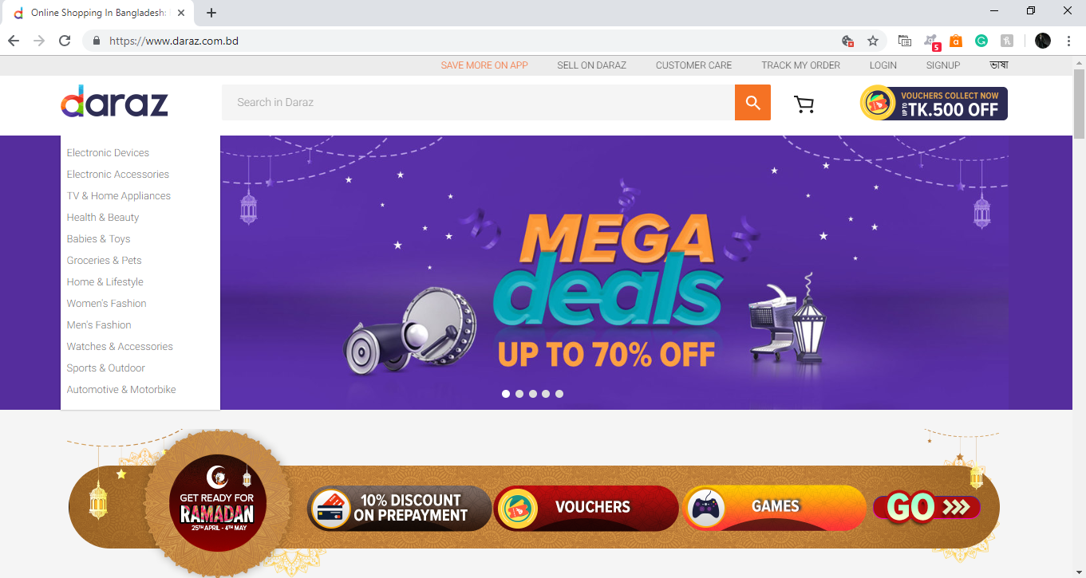
Figure 6 Daraz Bangladesh Limited's Categories of product
The figure above shows the generic categories of Daraz Bangladesh Limited.
According to Daraz Bangladesh website, (2019) The generic products lines of Daraz are given below:
Electronic Devices Category: All sorts of electronic devices for customer lifestyle such as Mobile phone, Tablets, Laptops, Desktops, Gaming Consoles, Different sorts of camera, etc. are listed under this category. Daraz Bangladesh has made corporate deals with several big brands (Samsung, Nokia, Apple, HTC, Huawei, etc.) to provide customer with authentic and best quality products.
Electronic accessories Category: Daraz also sells day to day electronic accessories as well. Basically, this category holds everything that you may need as an add-on to the electronic device category products. Such, wireless charger, headphones, power banks, sound system, home theater, smartwatch, storage devices, peripherals, camera accessories, etc. These products are supplementary to the products under Electronic Devices category and often sold along with them.
Home appliance Category: All sorts of appliances like Air cooler, Air conditioner, Televisions, Freezer, Water Purifiers, Vacuum cleaner, Refrigerator and some small appliances like cooking appliance, Blender, Beverage appliance, etc. are included in this category.
Health & Beauty Category: This category consists of the products for hair care, makeup items, fragrances, skincare, food supplements, and few general medical supplies.
Baby & Toys Category: The category focuses on the toys and baby products. Various types of games (indoor), toys and baby products like baby clothes, baby care, and baby foods are listed under this category.
Home and Lifestyle Category: This category holds all the items you may need to ease up and improve your lifestyle. Such as different types of furniture, home decoration items, stationery items, tools and equipment, and books.
Women’s fashion Category: All types of women apparels, shoes and accessories like belts, bags, etc. are listed under this category. To better serve the market this category also holds traditional apparels like Sharee, Kurti, unstitched fabric as well.
Men’s fashion Category: Similarly, to serve the male customer base, Daraz also has all sorts of men apparels, shoes, and men’s accessories listed under this category. For example, Traditional clothes like Panjabi, Dhuti; Western clothes like T-shirts, Shirts, Formal suits, Casual clothes, Shoes, wallets, etc. are included in this category.
Watches & Accessories Category: This category lists different types of watches and accessories. All kinds of watches of Different Popular Brands such as Casio, Titan, Break watch, Time Zone, etc. are available for the customers. This category also holds the shades and sunglasses for both men and women.
Sports & Outdoor: The items related to outdoor sports, fitness and outdoor activities can be found under this category. Outdoor sports apparels, sports accessories, sports equipment, exercise, and fitness equipment, bicycle, and recreational equipment for outdoor, etc. are listed under this category.
Automotive and Motor Category: This is fairly a newer category that Daraz is trying to expand with listing different automotive equipment. Such as, several motorbike dealers are listed under this category to provide customers with parts and accessories. Customers who are willing can purchase any necessary motor parts from this category as well as the whole motorbike for specific sellers.

Daraz Bangladesh also has some specialized category to fulfill the customer needs.
Digital Goods: This is also a relatively newer category built for serving growing customer needs. This category lists different types of gift cards, vouchers, rewards cards, tours, and travel packages, etc.
Grocery & Pets Category: It is another specialized category for the customers. A customer gets all the products for their everyday grocery needs. Grocery items has a large variety of dry goods like cookies, crackers, chips, rice, lentils, cooking spices, baking ingredients, fresh items like potatoes, onions, etc. Another specialized sub-section under this category are different sorts of pet foods and pet accessories.
Deals under 999 taka: This category is created to serve the customers with unique deals for everyday needs and items under this category are always priced below 999 taka. The items always rotate and every day new items are included, and few older items are excluded from this category.
Mega Deals: This category lists items which are part of promotional campaign and holds unique low-price deals just for the customers. This category can hold on to big items like tv, air conditioner as well small items.
Then there are also some specific campaign wise categories which is different each time; flash sales category, d-first category, etc. All these special categories are created to meet specific customer and promotional need. (Daraz Bangladesh website, 2019)

Campaigns:
Daraz Bangladesh Limited is aggressively acquiring and habituating Bangladeshi customers to purchase from online more and more. And one of their most effective tool is to pull customers with campaigns and lucrative offers.
Some recent Campaigns under Daraz banner:
Campaign | Dates | Description
11 on 11 | 11.11.2018 - 15.11.2018 | This is a campaign which is run on every 11 of November to create hype for Daraz’s biggest campaign FFF.
FFF | 23.11.2018 - 27.11.2018 | This is the biggest campaign for Daraz Bangladesh. This campaign is designed to provide Bangladeshi customer with world famous “Black Friday” experience.
12 on 12 | 07.12.2018 - 15.12.2018 | This campaign is focused to raise sales for the year-end and focuses of new year celebration.
Grand Grocery | 04.01.2019 - 12.01.2019 | This campaign is solely dedicated to engaging customers with purchasing grocery items from daraz in a week-long campaign and encourage online grocery shopping trend.
Valentines | 31.01.2019 - 14.02.2019 | This a campaign focused on Valentine’s day.
Bangla New Year | 28.03.2019 - 14.0.2019 | Once again, a customized campaign to serve the Bengali traditional needs.
Ramadan | 05.05.2019 - 06.06.2019 | This is the current campaign that is taking place in the name of Ramadan and with focus on Eid celebration.
Figure 7 Several recent Campaigns of Daraz Bangladesh Limited

Item Lifecycle
There are 7 important thresholds in the item lifecycle.
Invalid: An item will be invalid when the online payment does not go through.
Fraud: An item will be a fraud when finance detects it as fraudulent (e.g. mismatch between shipment location and value of goods purchased).
Canceled: An item can be canceled by the customer (e.g. wrong size) or by CS for internal reasons (e.g. customer not reachable by phone or email).
Stock Out: An item will be stock out when it is not available in Daraz’s warehouse, or if the seller/supplier is not able to source it.
Rejected: An item will be rejected when it is shipped but not delivered (e.g. customer refused to pay at delivery, item was canceled post shipment) or when delivery failed (e.g. customer’s address was not found).
Returned final: An item will be returned final when it is returned by the customer and replaced or refunded by Daraz (or being replaced or refunded).
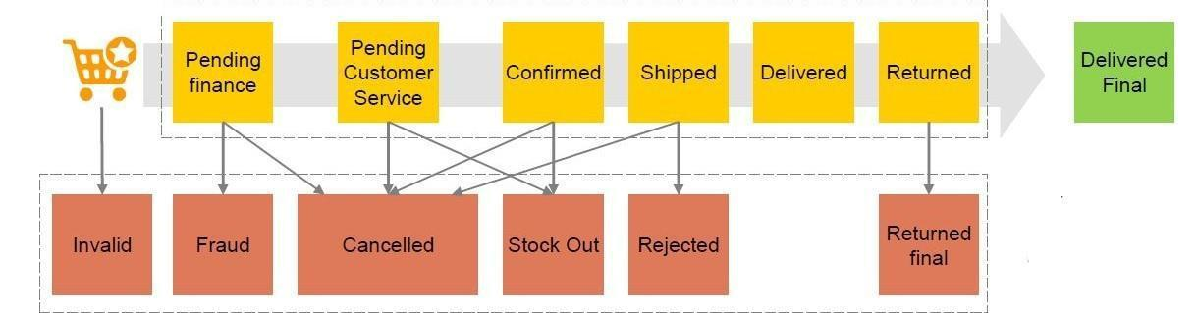
Delivered Final: An item will be delivered final when it is successfully delivered to the customer and not returned, or customer’s refund request is rejected by Daraz.
Figure 8 Item Status in Daraz Bangladesh Internal System

Functional Departments
Daraz Bangladesh has different functional departments working under the company. A brief intro to each department and their key responsibilities will be discussed below.
Acquisition
Acquisition department acquires new sellers and vendors for daraz individually and in collaboration with B2B department.
- Acquire new seller.
- Create seller agreement and finalize them as per company guidelines and best interest.
- Sometimes work as intermediary between seller and category manager.
- Helps seller to understand how daraz works and how it can be a mutually benefiting step for both parties.
Administration
This department takes care of all generic needs of the office and the employees such purchase and providing of all necessary equipment, maintenance of office, office staff, etc.
- Purchase of all equipment like laptops and accessories for employees, furniture for the offices, office stationeries, etc.
- Overseeing the office staffs.
- Administers and acquires new office and branch locations.
- Maintaining everyday office supplies.
B2B
This is a specialized department who engages to only business to bring in more sellers and/or corporate customers for the company.
- Works with big brands sellers to bring them on board.
- Deals with different big organizations to acquire corporate orders.
- Consists of highly trained executives who are experts in acquisitions and negotiations.
Business Intelligence
This department works with commercial and marketing department with everyday performance checks and builds tools for almost all department.
- Prepares daily, monthly and campaign wise sales reports to monitor performance.
- Prepare ad-hoc reports for commercial department as necessary.
- Build tools needed for other departments as they need.
- Work with project management department and top management to help speculate sales forecast, trends of sales, etc.
Category Management
For each different categories, there is a specific team which takes care of the sellers, their assortment of products, their product placement, and other necessary stuffs.
- Decides which products is suitable for daraz and works with sellers to ensure quality.
- Works with BI team to closely monitor their own sellers and act as needed.
- Works as counselor and mentor to the sellers to increase their sales and customer appreciation.
- Works with customer service and issue resolution department to resolve any dispute or concerns as quickly as possible.
- Responsible for seller product quality and sales performance.
Content
This department is responsible for maintaining and building website structure and each product placement.
- Audits and prepares content for each product and showcases them in website as per category managers instruction.
- Design campaign and regular promotional material like digital banners, flyers, etc.
- Provide correct and in details specification for each products.
- Help marketing department with some promotional material with video editing, photo editing, design, etc.
Customer Service
The customer service has several important functions.
- Communicate with customers to confirm and/or adjust orders.
- Maintain all order validation, and completion.
- Report to Issue resolution if any dispute arises.
- Communicates with customers for additional support and inquiries.
- In times of different campaigns, they also help to confirm orders, ensure payment is done and cancel orders if needed.
Finance
This department as name suggested takes care of the all financial reporting, sales reporting and reconciliation, billing, payment, and refund.
- Preparing Sales report, reconciling, billing vendors and making payment and refunds to customer and vendors as needed.
- Procurement of each asset is done by this department in collaboration with administration department.
- Preparing financial statement for shareholder, top executives, and auditors.
- Proper filing and preservation of financial activities and sales activities.
Human Resource
This department takes care of the basic HR activities.
- Hiring and training of new employees and interns.
- Employee attendance and evaluation.
- Pay scale arrangement and salary calculation.
- Maintaining employee database.
- Conduct different workshops and leadership programs with marketing department.
Information Technology
This crucial department takes care of network channels, infrastructure, provides technical solution as deemed necessary.
- Maintaining stable network and storage infrastructure needed for an online e-commerce platform.
- Provide technical support such as database solution, re-routing channels, account creation for employees, different sorts of access into servers and portals, etc.
- This department also works closely with global team to ensure proper flow of information and security of access.
Issue Resolutions
This department is consisting for highly trained customer service executive and legal advisor.
- Takes care of any disputes if arises.
- Communicates with vendor, category manager and customers as an intermediary and resolves issues quickly.
- Takes care of any legal issue generated from order mismanagement.
- Can issue refund voucher, gift cards, and coupons.
Marketing
Marketing department as name suggests takes care of all marketing activities as per need.
- Conduct promotional activities to engage and attract customers.
- Plan, design and prepare those promotional materials like offline banners, flyers, events, video commercials, etc.
- Looks after public relation such as engaging youth into activities, maintaining media coverage and preparing scripts for news publishing.
- Looks after digital marketing section like customized newsletters, Facebook marketing, SEO activities, etc.
Operations
The heart of any business is the operations department. Here the operations department is also performing some very crucial tasks.
- Stocking and maintaining inventory of all products in warehouse.
- They also take care of product delivery and return.
- Works with different vendors to maintain stocks in an optimum level.
- Central operations hub looks after branch hubs as well.
- Provide logistics for any ad-hoc operational need.
- Works with third party delivery service to reach customers outside of delivery zones.
- Maintains log of inventory and third-party transactions to help finance department.
Project Management
This department is a special department consisting of key executives from different departments who work together to build and evaluate the company’s different campaign.
- Create forecasts, trend of sales for each category and each items as per campaign.
- Build tools and rules for each campaign.
- Oversee every other department work to ensure success of campaigns.
- Works directly with CEO, COO, and global team to monitor and control campaign activities.
Traffic Ops
This department is responsible for merchandising and campaign management.
- Optimize sales of the categories through data-driven decisions & interdepartmental alignment.
- Planning yearly and monthly campaign and measure their performance.
- Helps to launch brands and product.
- Helps content department with providing information on the key products that needs focus.
- Help commercial and Finance department with creating and utilizing promotional tools such as vouchers, bundles, promo prices, etc.
- Help project management department in time of campaign to help organize website product placement.

Order Process Flow
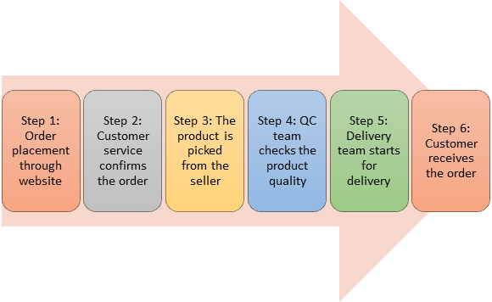
A Typical order flow can be visualized by the following figure:

Figure 9 Typical Order Process Flow
Order Placement:
Customer himself or with the help of the customer service chooses his choice of product and places order. For prepaid order, customer also makes payment at this point.
CS verification:
After placing orders, CS team receives those orders in the built-in website of Daraz named Order Management System (OMS). Then they verify & confirm those orders.
Product Collection:
Daraz doesn’t store products into their warehouse for all sellers. Those sellers who prefer to maintain stock of the product themselves, keep their products in their store or warehouse. For such case, after getting customer confirmation, Daraz notifies those sellers. Then either sellers send those products to daraz hub or daraz logistics team picks it up. For the other products which are stored already in the hub of Daraz, the orders get to delivery as earliest possible time.
QC Inspections:
Daraz quality control division cross checks products with actual order, ensuring correct items and quality of the items.
Delivery:
The outbound team of Daraz delivers the products to the customers who placed orders after the packaging of the products. It takes up to 5 working days to deliver products within Dhaka city. But outside the Dhaka, a customer gets products within 10 working days (highest). For outside Dhaka order, Daraz now has several branch hubs in several key districts. For all the other locations Daraz uses third-party logistics team to deliver products.
Return policy:
The return policy of Daraz is quite good than other e-commerce sites. A customer usually has 7 days after receiving the products if they want to return the product with valid cause. If there is an issue, they can contact Daraz about the dispute. Then the rider of Daraz come to return those products.
Refund policy:
After reaching products to the warehouse, Quality Control team checks the products for reported issue. If the complaint of the customer is valid, then customer gets refund via bKash or to their debit/credit card or as a refund voucher.
Review:
Daraz has a review team who takes the review of the products from the customers. Most of the times, customer gives positive reviews but there are few not so positive reviews as well. This helps them to keep track of product satisfaction to the customers, product rating, seller rating to ensure quality.
Payment systems:
There are multiple ways of payment systems in Daraz. Daraz follows some payment procedures like Cash on delivery, mobile banking like bKash, Rocket, and internet banking using debit or credit cards.

Uses of Digital Tools for Business:
Daraz Bangladesh uses different technical tools for different functions and purpose. Some of these major tools will be introduced below.
Seller Center: This software helps the seller to update their stocks and prices by coordinating with the contact person from Daraz. It also helps the business development team and the sales team of Daraz to coordinate the offers and keep count of the sales, stocks and manage the stocks. This tool also holds crucial specifications of each product and any change in the website related to product can be done with this tool. But this will require 24-hour lag time. Its seller module can be used by the sellers and rest is generally used by the category managers.
CRM: This software helps customer service department to cater inbound and outbound call efficiently. Also, other software is including such as Zendesk, LMS, and agent to customer communication. This is used by Issue resolution department as well.
OMS: This tool helps the category managers, BI team, Customer Service and Issue Resolution team to keep track of orders and it is integrated with delivery module for statuses.
Warehouse Module: There is a warehouse and order management system to make it easier for pickup of products, inventory and delivery process. This tool is used by operations team: Inbound, Outbound, Logistics, and Finance team.
Delivery Module: This is a separate module which tracks delivery of products with different statuses and incorporates different 3rd party logistics info as well. It helps to track the order on a step by step basis. This tool is used by outbound team, Customer Service team, Category Managers and Issue resolution team.
Cube: This tool is used by BI team to generate periodical reports and performance reports for different department. This pulls data from central data warehouse. This tool is accessible through MS Excel directly.
Google Analytics: This tool is mostly used by BI team, Marketing team, and top managers. This helps to monitor, and measure data related to website traffic.
Data Warehouse: This is main data center for all types of sales, order processing, inventory, and content data. All these data are stored here and can be accessed by different types of Cube data access. Generally, BI team and global team has the only access to this tool. This tool is highly sensitive and confidential.
Zoho Invoice: This is used the finance department to prepare different sales bills and automated sending to all vendors. This tool helps to keep track of all the receivable and billing per seller according to their monthly sales.
Tally: Only Finance department can use this highly sensitive accounting software to keep track of all the financial data like revenues, expenses and it is also used to prepare financial statements for top management.
Zoho People: This tool is used by the Human Resource team to efficiently keep track of all employee record and it is possible to conduct performance evaluation through this tool as well.

Pricing & Profit calculation
Some key facts that needs to be understood to get a better idea about Daraz’s Pricing and Profit Calculation.
Terminology | Explanation
Original Selling Price | The original price shown on the website.
Discount Value | Discount Value which customers benefit from (when applicable) on the purchase of a discounted item.
Paid Price | Final price a customer ends up paying for an item, after applying the discount value on the Selling Price.
Profit Contribution | Profit Contribution (before factoring in marketing and logistics costs) realized on the sale of an item.
Revenue from Retail Merchandise | Revenue realized on the sale of a Retail item. Is equal to its Paid Price.
Revenue from Marketplace Commission | Revenue realized on the sale of a Marketplace item. Is equal to the commissions obtained.
Figure 10 Key Financial Terminology of Daraz
The original price is the price the seller is offering for the product. During campaigns, Daraz offers various deals on products and a discounted price is offered which is basically the amount customers are paying and daraz arranges with sellers for how to split the discount cost. From that amount commission or expenses are deducted and profit is calculated accordingly. In cases of retail merchandising the revenue is basically the paid price and expenses are deducted and the overall profit is calculated. And in marketplace commission, revenue is the commission earned from the seller after sale and other expenses and tax are deducted and profit is calculated.

Revenue Model
Model | Description | Revenue | COGS | Profit Margin
Retail | Daraz acts as a retailer that buys goods from suppliers and sells them to customers. | Paid Price | Expenses | Revenue - Expense
Marketplace | Daraz acts as a platform that brings sellers and buyers together. | Commission charged to sellers. | None | Commission
Figure 11 Two Types of Revenue Model of Daraz Bangladesh Ltd.
Retail
In certain products, Daraz need to deliver it as soon as possible. And in such cases the buy those products beforehand in order to provide the customers a better service. After purchasing those products, are kept in Daraz warehouse and are delivered within one or two days of order. For example, diapers are needed to customers as soon as possible. Bringing such products from seller and delivering it would take up to 5 working days which is a very long time considering its fast delivery needed product.
Marketplace
Daraz’s main revenue is generated from commission earned from different sellers. As an e-commerce site, Daraz is affiliated with different sellers from every categories and help them reach customers through our website. When an order is placed of a seller, we bring it from them to our warehouse and deliver the product to the customers. In case of returns from customers, we bring the products and return it to the seller. The commission rate can defer according to product and seller.

Projection Model for Delivery Completion
Many business data are needed to be accessed in real time, to foster the decision-making power of users. This requires in many cases to compute estimates (e.g. of ‘delivered final’ orders), which will change through time. The majority of Daraz KPIs are built on this projection model, and most business users will only use projected KPIs.
So, in projected model right after confirming a valid order we use projection to calculate how much revenue Daraz will generate from here and how many items will be considered as delivered final. As we use projected amount, the accuracy may fall. The projection is basically calculated by last few days sales trend and so the accuracy of it is always between 50-70%.
Many of the orders may take up to 5 days to deliver outside of Dhaka and for those orders, weekly performance report will have to use projection model. Again, for those orders which are placed in the end of the month and will be delivered by the first of next month, it is also wise to use the projection model. For these kind of scenarios, the projected model is widely used among the whole organization to make any forecasts or performance report.
As Traffic ops intern, I have used projected model or operational view to organize products as per their performance and use these metrics to further analyze and select potential products for placement. Although the projected information worked but at times it went wrong, and the organization had occurred losses.
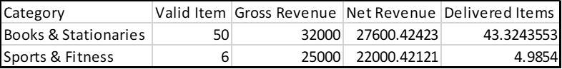
Figure 12 Sample Calculation of Net revenue using Projection Model

As the net revenue and delivered final items is based on projection, the data comes in decimal which we use as a whole number. It gives a basic overview, but the information can change within a few hours as the projection % may defer again according to the trend.

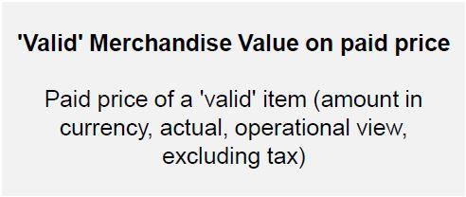

Figure 13 Merchandising Value (MV) in Projection Model

Accounting Model of Delivery Completion
Daraz also engage in financial recording (in line with IFRS standards) and data reports to meet local legal requirements and keep external stakeholders informed of the organization’s changing financial position. In the Accounting view, KPIs are used almost exclusively by Finance and Management.
According to this view, daraz recognize revenue only when an item is delivered to the final customer without any returns. This provides a more realistic overview then the operational view as all the information is accurate. And through this process, we get to know which of the product have issues and which sellers are providing the better products.
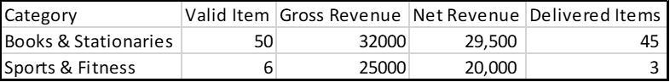
Here those orders which have successfully been completed and recognized by the systems are considered and thus it gives the most accurate data which is utmost important for Finance department to make payouts or bills.
Figure 14 Sample calculation of Net Revenue using Accounting Model
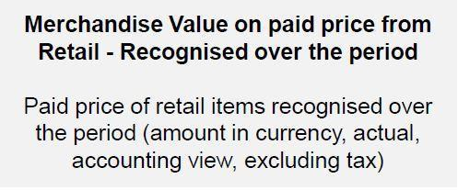
Here the information has a full value as the sales and final delivery has been done and the reports are showing accurate information. As we can see there is a slight difference in the values as I have mentioned previously that the projection is not always 100% accurate. The real amount might be different than the projected value. But to get this information we need to wait at least 10-12 days as the total delivery process takes that amount of time if a product is being delivered outside of Dhaka. So, getting hands-on quick information is rather difficult for us to get. But we use accounting view and create forecast for upcoming campaigns and projects.
Figure 15 Merchandising Value (MV) in Accounting Model
The key difference, from a Daraz standpoint, lies in the point in time at which items and orders will be recognized:
Projection Model | Accounting Model
From an Operational view, Merchandise Value of an item can be estimated at the different thresholds (‘shipped’, ‘delivered’, ‘delivered final’), as soon as an item or an order becomes “Valid’. | From an Accounting view, revenues will be recognized only when an item or an order is confirmed delivered.
Uses projection of last 3-5 days sales trend to forecast probable completion ratio of the current orders. | Only uses the number confirmed delivered items.
Easier for quick update as it uses trend and projects probable outcome of orders. | Slower method for update as it waits for confirmation of completion of the order.
Used by most of the departments of the company. | Only used by the Finance Department.
Figure 16 Differences between Projection and Accounting Model in Daraz Bangladesh Limited

Corporate Social Responsibilities
The largest e-commerce Daraz is not only selling products to the customers but also, they are working towards to contribute in the society. As the part of the CSR, Daraz has taken many initiatives. The two most significant ones are briefly explained below:
Campus workshop:
Daraz is conducting workshops in the different universities. Basically, these workshops are based on the corporate cultures. The idea is to engage young business students into business ideas, corporate culture, and expose them to real corporate world.
Daraz Future Leadership Training Program:
FLP or Future Leadership program is a very popular concept among big corporations. Daraz organizes competition program for students of universities where they must solve some real-world case studies. Based on the good ideas, a team of students win that competition. These students then are offered to work with Daraz Bangladesh for some certain projects. Based on their performance, they are often made into full-time employees. This program is often very efficient way to find a potential skilled employee for the company and as well create a platform for the young students to join companies showing their competency. (Daraz Future Leadership Program, 2019)

Internship Experience & Observation
I have been accepted as an intern of the traffic operations department of Daraz Bangladesh Ltd. I have been working there for last 3 months and have been assigned with specific tasks to help my department. Although I was responsible for those task, but my experience was not limited to those only. I learned about other task of my department, importance of all these tasks and the probable contingency plans should any issues arise. Though as a student doing major in Accounting Information Systems (AIS), I was nervous how can I utilize my academic knowledge in traffic operations department, but it turned out to be very exciting and informative experience.

Traffic Operations Department
In Daraz Bangladesh Ltd, I joined as an intern in Traffic operations department. Here, I was responsible to work with mostly Content department and Project Management department to provide support with all merchandising and campaign management. It was a great opportunity for me to work at the Daraz. I got many excellent and hardworking people at Daraz. They helped me to know the corporate culture. They trained me up to so that I can easily handle any kinds of pressure.
To be successful, unyielding contribution and dedication from each department of the organization is very much needed. To compete in the global environment and as well as in local markets the E-commerce businesses need to excel at Customer experience, service, and quality. Traffic Ops work can ensure quality and better customer experience from their part of work.
The core task of my department is to do merchandising. My department also works to develop and integrate the promo tools with existing products and campaigns.
A short overview of each task will be described below.

Merchandising
The Core idea of merchandising is to influence sales of different products of different categories based on data-driven decision and maintain interdepartmental coordination to ensure success. This process is also referred to as campaign management.
Merchandising a vast process which can be subdivided into four parts.

Planning:
Basically, Merchandising is Based on business targets, historical sales, trends & searches key sales drivers are identified in terms of categories & campaigns to be in focus around the year. Involves campaign and commercial planning on yearly, monthly and even weekly basis. Traffic operations uses a tool named Treasure bowl to perform planning, designing, initiating and closing each campaigns and commercial activities.

Execution:
Aligning the plans with marketing & commercial teams. Aligning operations & CS teams in case of mega or A+ campaigns. For a campaign, each departments participation works like a puzzle piece. Nothing is complete without a single participation and everything is interdependent. Traffic operations team senior executives ensures that all different departments are participating properly to work towards the successful achievement of commercial targets.

Performance Check:
Evaluation of campaigns & day to day business to re-plan accordingly. It is of utmost importance that every commercial activity is monitored closely and any deviation from the commercial target is dealt immediately. Traffic operations has been monitoring the performance of the commercials to ensure that targets are reached by optimizing as deemed fit.

Collaboration:
Coordination & alignment between departments through the flow of information. Merchandising is a task to accomplish commercial targets which needs all the department’s participation. It is also part of traffic operations team that a continuous and effective coordination between all relevant departments are maintained in each campaigns. These vast subdivision of tasks are conjointly taken care of by traffic operations executives, project management specialists, and other department heads.

Utilizing Promo tools
There are 4 basic promo tools that are used in our e-commerce websites which are vouchers, cart rules, bundles, and promo price. Traffic Ops takes care of these in collaboration with commercial department, marketing department, and finance department.
Vouchers are promotional coupons and store credits with various conditions. For Example, Issuing Samsung voucher which will be available for using while buying a Samsung product costing minimum BDT. 50 thousand.
Cart rules are promo tools which allows to create promotions based on a set of conditions and actions. Example: Buy from ASUS laptops on Friday, pay with City Bank AMEX card and get 10% discount.
Bundles are promo tool which allows to sell combinations of different or the same products with discount. Example: Buy 10 packs of diapers get 10% discount.
Promo Prices are tools to create promo prices for individual products for a specific time frame.
Example: Uploading promotional prices for 11/11 campaign.
Traffic Operations department regularly monitors different seller’s product quality and their performance in each campaign. This allows to choose those products and sellers which are superior in performance and use promo tools to obtain more sales.

Importance of Traffic Operations
Traffic Operations aka Traffic Ops department works under Project Management department and the primary task of the department is to cross-check the upcoming products and showcase them in the website as planned. Traffic Ops goes over products referred by both sellers and managers based on their attractiveness and current market need; prepares and designs how to place them in the websites, and timely rotates those products as per management strategy. During campaigns, the prime products are placed in different landing pages and category pages of Daraz Bangladesh website and this gives those products superior exposure to customers.

Traffic ops also looks after the quality of the product using treasure bowl. The treasure bowl is a pool of selected products and these products are checked based on their unique feature, quality of the product and based on their sales history. Then those products are sorted according to ranks and top-ranked items are placed in website as per their ranking in different places such as banners, sub-banners, flyers, category headers, etc. During campaigns, the same method is used to select which products will be displayed under specific categories and overall different pages. Those products that meet preset criteria will be approved, otherwise rejected to ensure intended quality and outcome. Additionally, Traffic ops looks after the campaign management module.
They can design, configure and lock/unlocks the campaign as per instructed. This helps to efficiently manage all the different types of campaigns.

My Responsibilities:
I joined as an intern in this Traffic Operations department and as a part of my internship period job responsibilities I was mainly assigned with doing some basic tasks that required minimum amount of training or access to company internal servers and records

Reviewing Products and Initiating Campaigns
One of the crucial task under commercial planning is to take care of campaigns effectively. Under this vast operation, I was part of the initial review of the products and starting the campaigns. The entire campaign management is controlled and monitored by a custom tool named “Treasure Bowl”. Its tool that helps the regional, local teams, managers and sellers to contribute their part of work and created and manage commercials. The planning and execution part of the merchandising process is done here in Treasure Bowl.

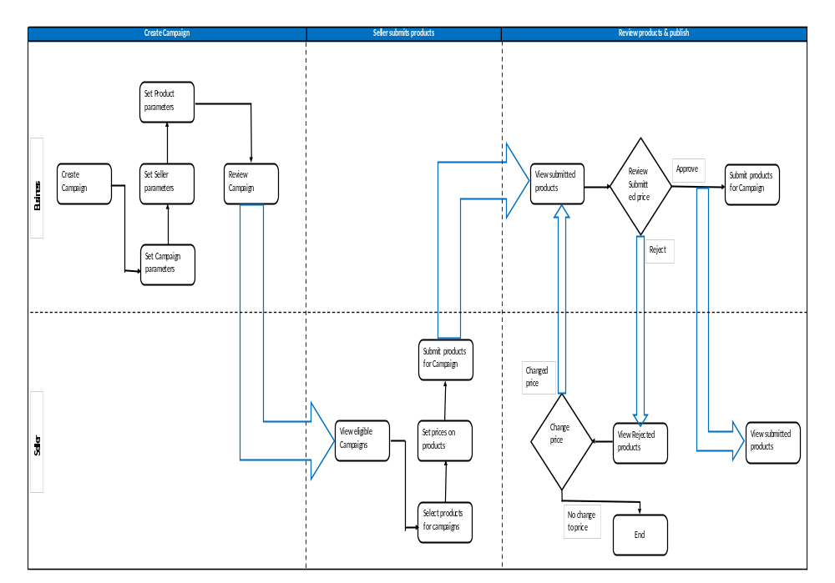
Figure 17 Treasure Bowl Overall Workflow
My job was to review the products submitted by each seller or category managers as per the preset conditions and accept or reject items. I was also responsible for starting the campaigns on timely manner.
In general, the typical process flow of the campaign initiation and product review done by Treasure Bowl is portrayed with the above figure.
The generalized steps of this task are
Step No | Assigned Personnel | Task
Step 1 | Head of Traffic Operations and Project Management | Traffic Ops create Campaign
Step 2 | Head of Traffic Operations and Project Management | Traffic Ops set Campaign Parameters, Seller parameters, and product parameters in order.
Step 3 | Senior Manager, Traffic Operations | Traffic Ops review Campaign.
Step 4 | Sellers | Sellers view Eligible Campaign.
Step 5 | Sellers | Sellers select products and prices for the campaign.
Step 6 | Sellers | Sellers submit products for campaign.
Step 7 | Senior Executives and Intern | Traffic Ops reviews submitted product and price.
Step 8 | Senior Executives and Intern | If the prices match the preset criteria, approve otherwise reject.
Step 9 | Senior Executives and Intern | If approved, the products are submitted for the campaign and seller can see those submitted products in their module.
Step 9 | Senior Executives and Intern | Or if rejected, the rejected items can be revised by the sellers and once it is revised by the seller, it returns to the step 7 again for review.
Figure 18 Steps of Treasure Bowl Campaign Initiation and Product Review
I was responsible for the steps 7 to 9. I was given access of one of the permanent employee’s account and using this I was reviewing products submitted by the sellers and starting campaigns.

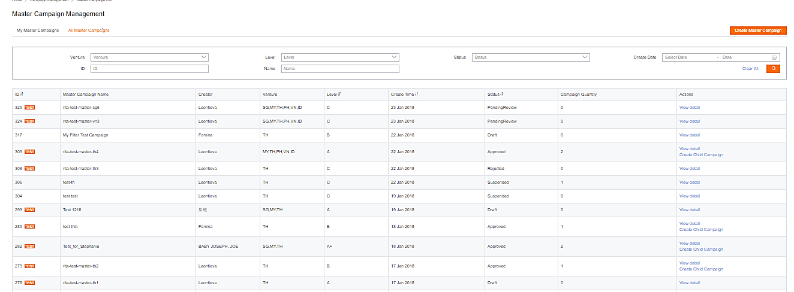
Creation of the Campaign
2) Here we can search campaigns by inputting campaign ID or using the other filters provided

1) Select the specific Master Campaign created by Project Management, should be found under “All Master Campaigns”

Figure 19 Creation of Campaigns
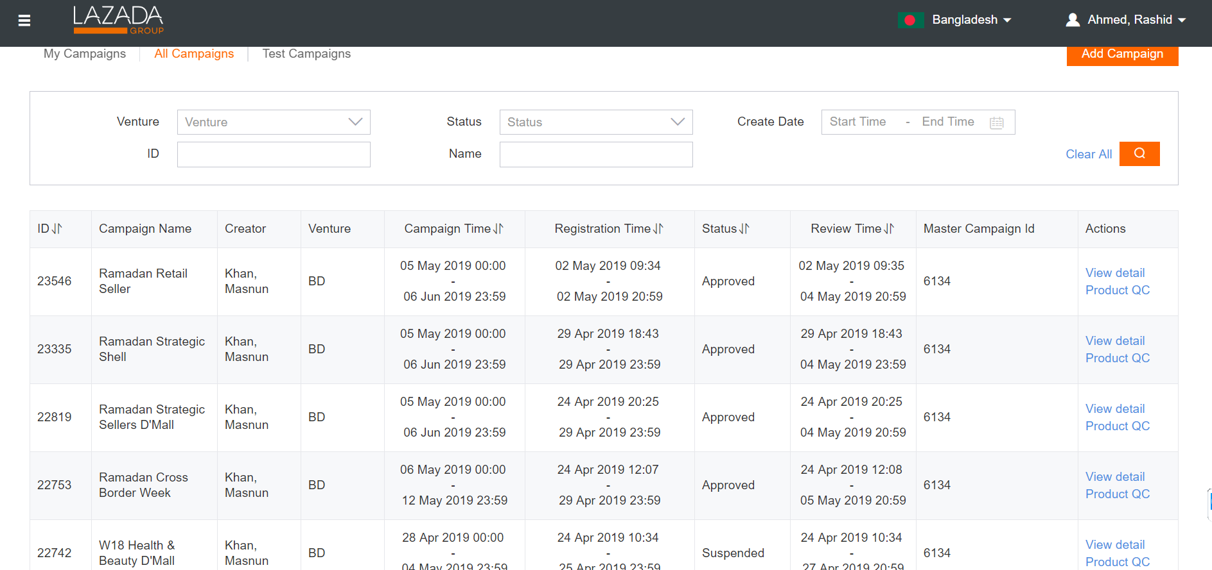
All campaign dashboard for a time frame (Sample)

Figure 20 Sample Campaign Dashboard

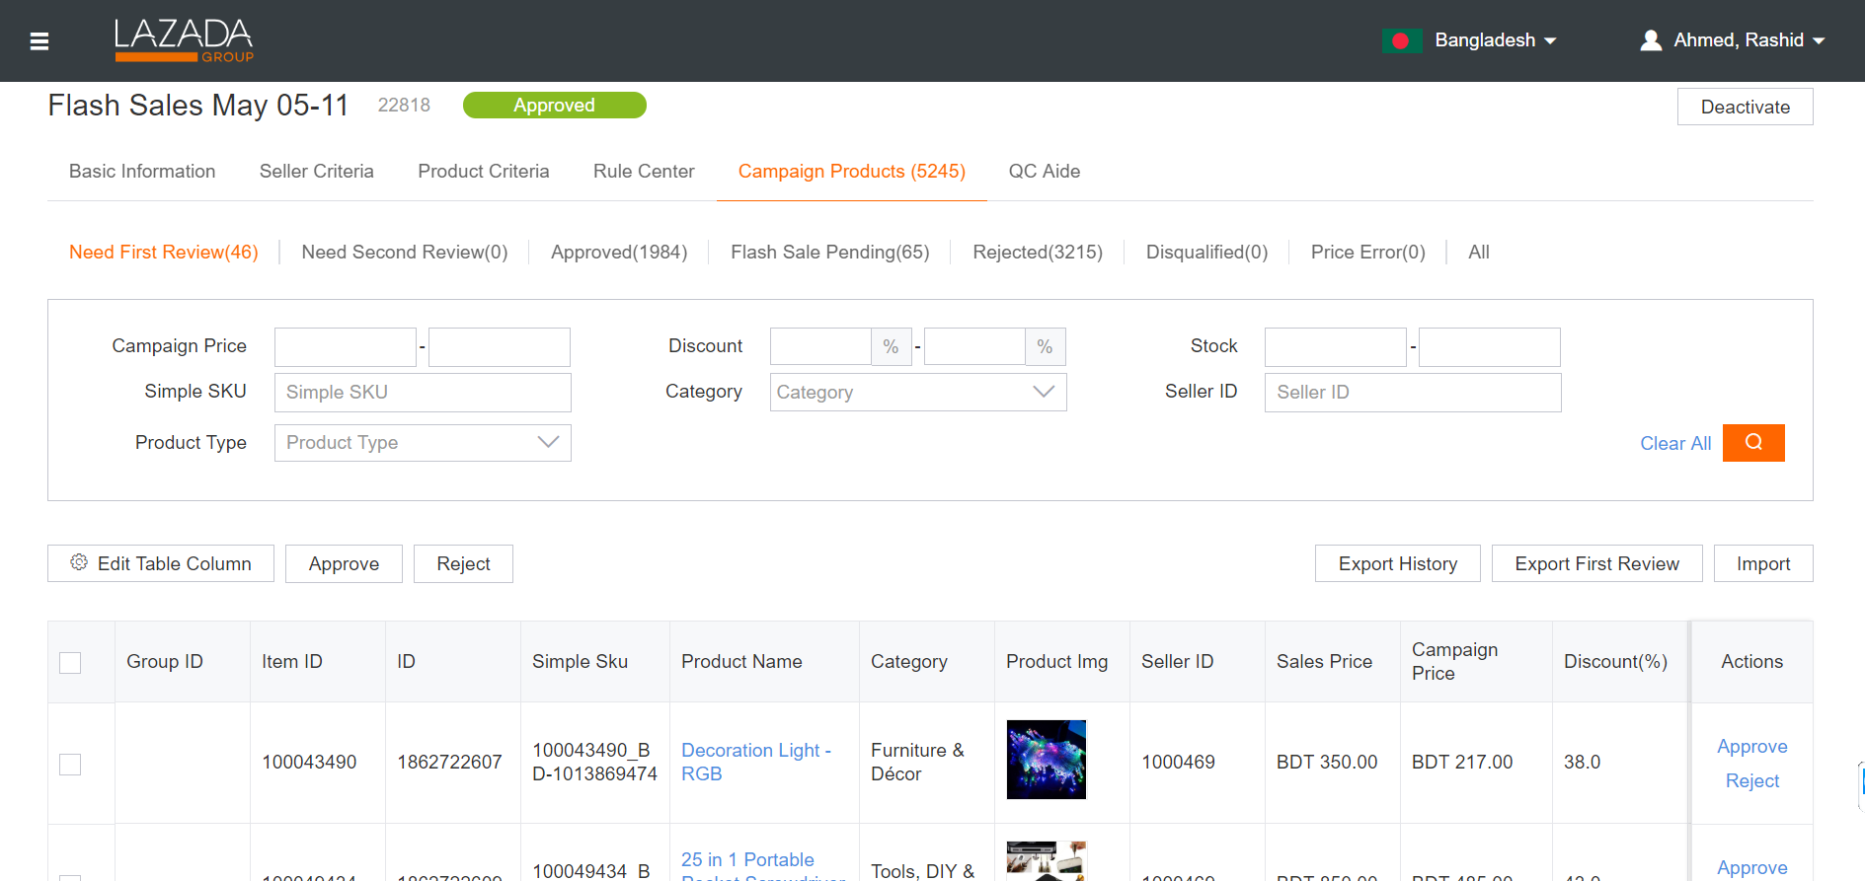
A sample of a single campaign dashboard where all the product review is done.
Products that require review will fall under this tab. Products that are not reviewed within the review window will automatically be rejected.

Approve/reject by SKU

Or tick top box to mass approve/reject all SKU on the page

Figure 21 Campaign Product Review
Few Notes on Reviewing Products:
- When we reject a submission, we need to give seller a reason why we reject their products.
- We Use filters on review page to approve/reject quicker.
- If we accidentally “Approve” an SKU, it cannot be moved to “Reject”. The only option is to “Disqualify” which blacklists the SKU from the campaign.
- If we tick and entire page to reject/approve, we make sure that all SKUs are correct.
- Seller can only submit new SKUs during “Registration Period”.
- Sellers can resubmit rejected SKUs and change price throughout the “Registration” and “Review” periods (they will typically overlap).
- After review period ends, all SKU that are not approved/rejected will be automatically rejected.

Upload Banners and Flyers in relevant sections
Another integral part of the campaign preparation is to attract customers with exclusive deals in website banners and flyers. And it is our department which uploads all approved banners in specified places.
My responsibility here was to check all the uploaded banners in the specified google sheet, make sure that those banners are approved by the senior managers and upload them in assigned places in timely manner.
Step 1 Open the google doc created for the specific campaign or commercial.
Step 2 Check if all the assigned columns are filled properly with correct and necessary
Information.
Step 3 Check the banners for correct information, design, and prices.
Step 4 Upload them using specific tool (Namely “Skyline”).
Step 5 Review all uploaded banners.
Step 6 Wait for final approval by head of traffic operations.
Step 7 Finalize uploading and make those banners visible.

Sample Google Sheet with all the information for a campaign for banner uploading
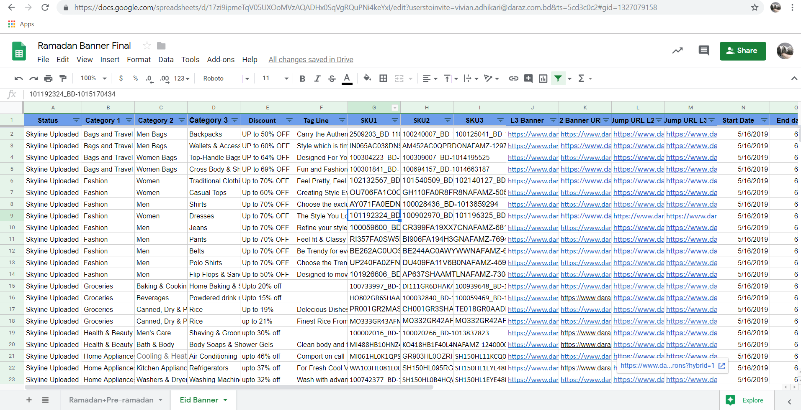
Figure 22 Sample Google Sheet with Banner link and relevant informations

You can see that this above google sheet has all the category wise products information stored and we use them to cross-check if all the information provided are correct.
Skyline Dashboard
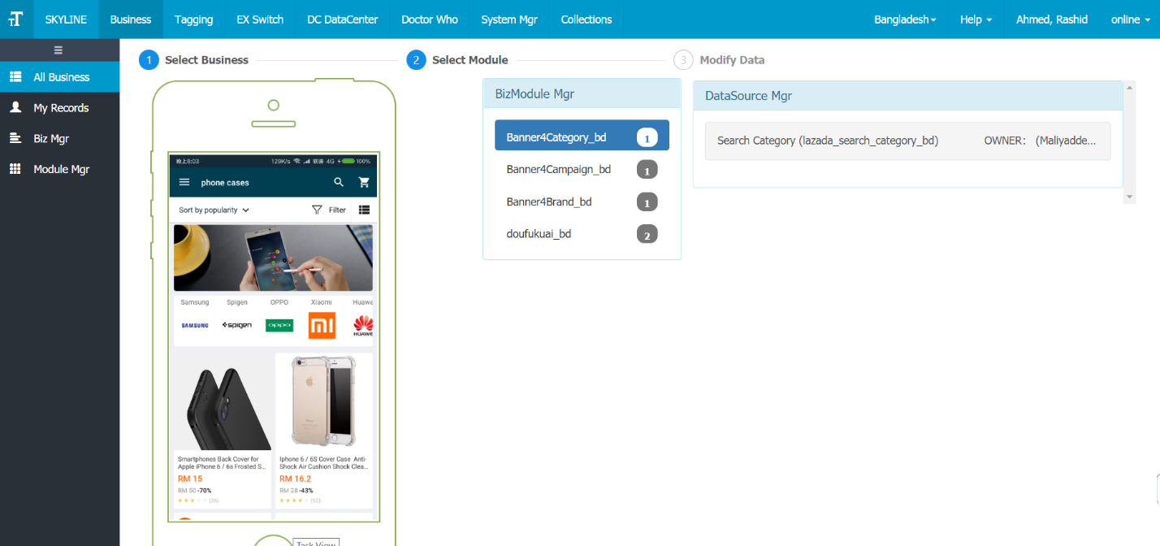
Figure 23 Skyline (Banner Management tool) Dashboard
Here in the dashboard, all the different modules for each types of banners are found. We then use the type of module we need.
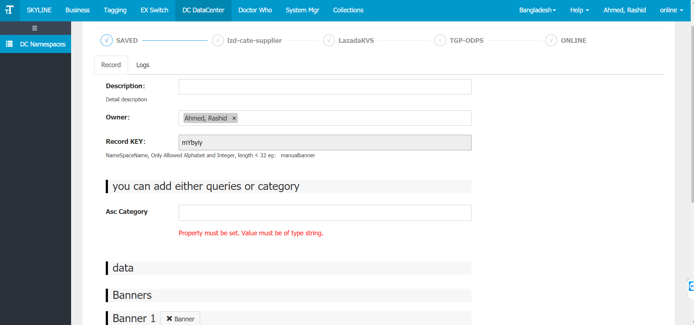
A sample banner upload form:
Figure 24 Banner Upload Form
Here is a sample banner upload form which we use to upload each individual banners in the website. When we upload them, the senior managers can cross check if everything is uploaded as per needed by using the search option.
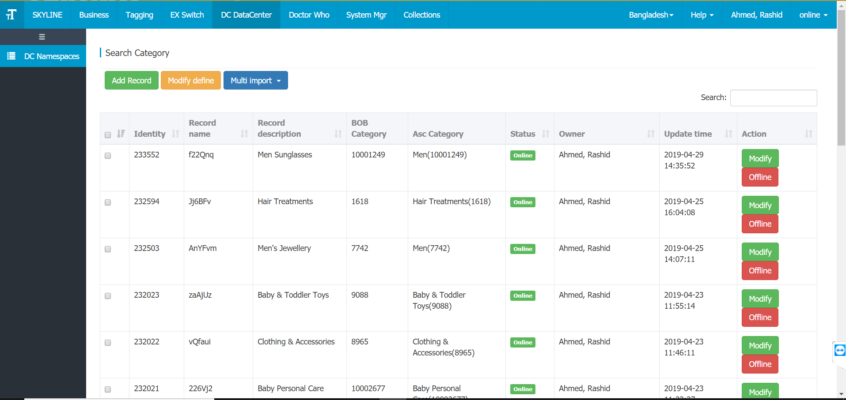
The search window of banner
Figure 25 Searching Banner

If there is any further change or correction needed, we can also view each uploaded banners info and make necessary changes.
An individual uploaded banner settings page:
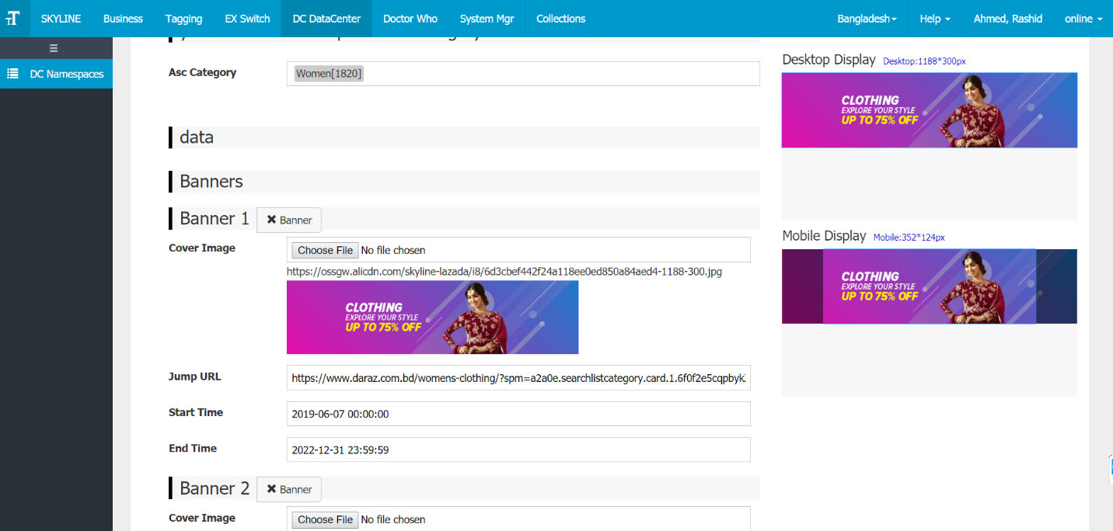
Figure 26 An Uploaded Banner settings

After all the necessary changes are made and banners are finalized by the head of traffic operations, then the banners go live.
Sample live banner for a certain campaign

Figure 27 A sample Live Banner in the website
Here is the main teaser banner for Daraz 3rd year anniversary campaign with the timeline of the campaign, and the maximum percentage of price off mentioned to attract customers on the website on the duration of the campaign.

Creating Performance Reports
As part of each campaigns, I had to do several data pulling and make certain report using MS-Excel, SQL language, and Python coding.
- Access necessary data by using SQL data retrieving code from the data warehouse and download them as “.csv” files.
- Convert the downloaded data file into MS-Excel “.xlsx” format and prepare report as instructed by the managers (No pictures shown due to confidentiality clause).
- Run python code if the file size is too big (often larger file size is used because of large amount of sales data from big campaigns. Python code helps to automate the process and reduce processing time for larger data set.
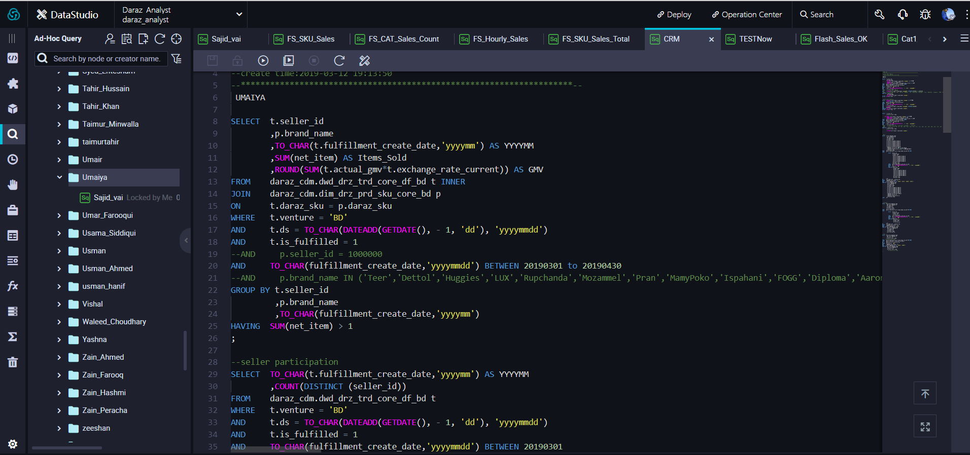
Sample SQL code for retrieving data:

Figure 28 Sample SQL data retrieving code

Here is a long code used to retrieve data from the data warehouse as per preset condition.

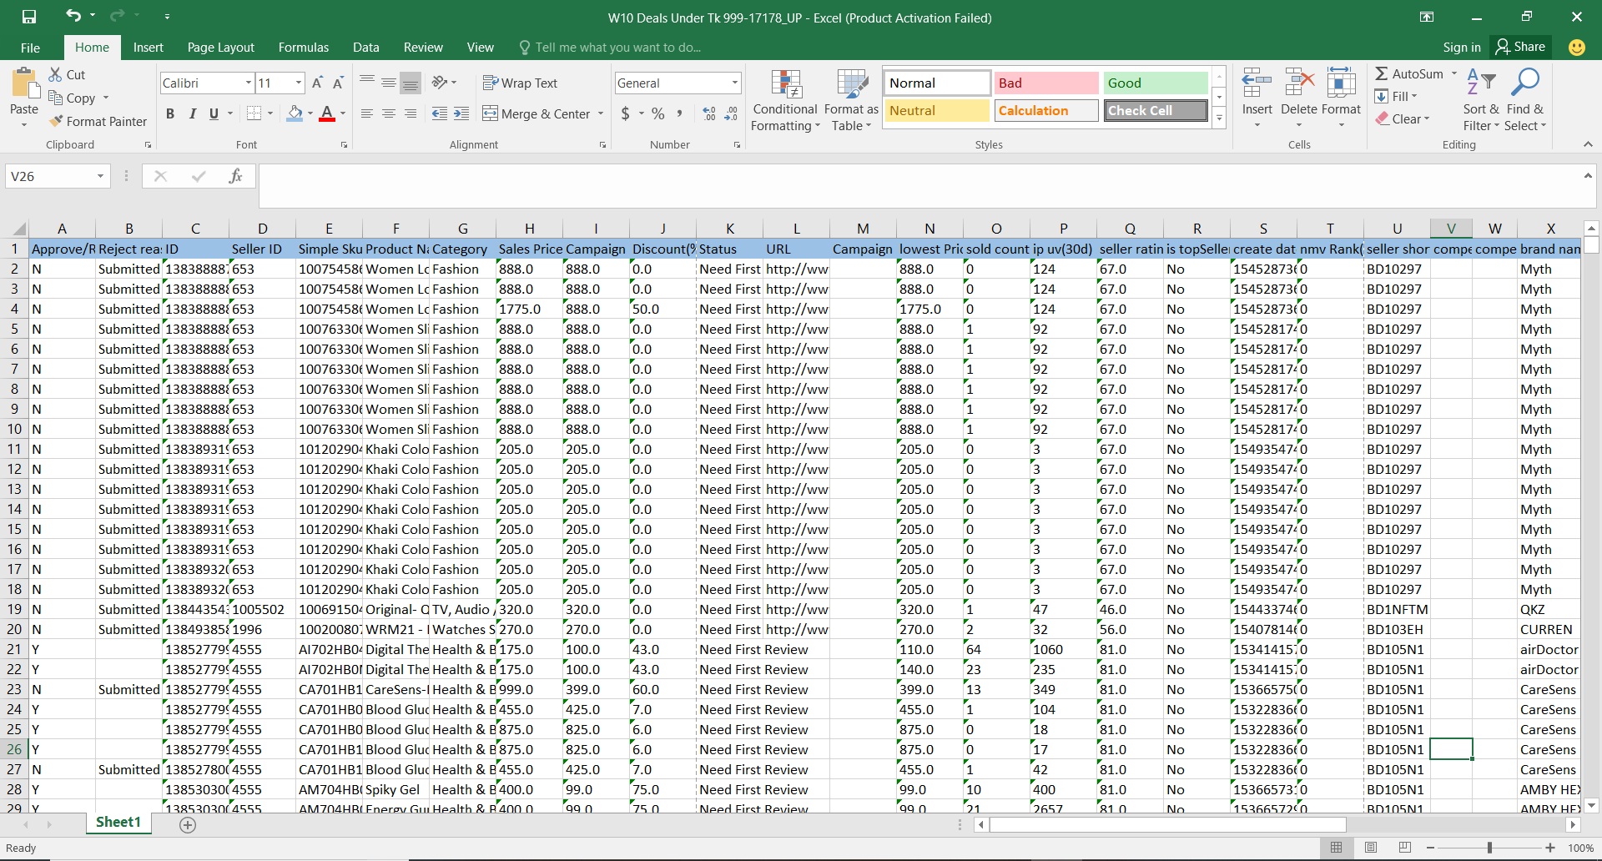
Raw Downloaded data:

Figure 29 Raw Data in MS Excel
The above figure shows the downloaded raw data where we can see that all the necessary dimension of preparing report is present such as categories, sales price, sales count, name of the item, seller name, discounted price, discount given, seller rating, creation date, etc.
These column wise information help to create the final report as needed for the commercial team.
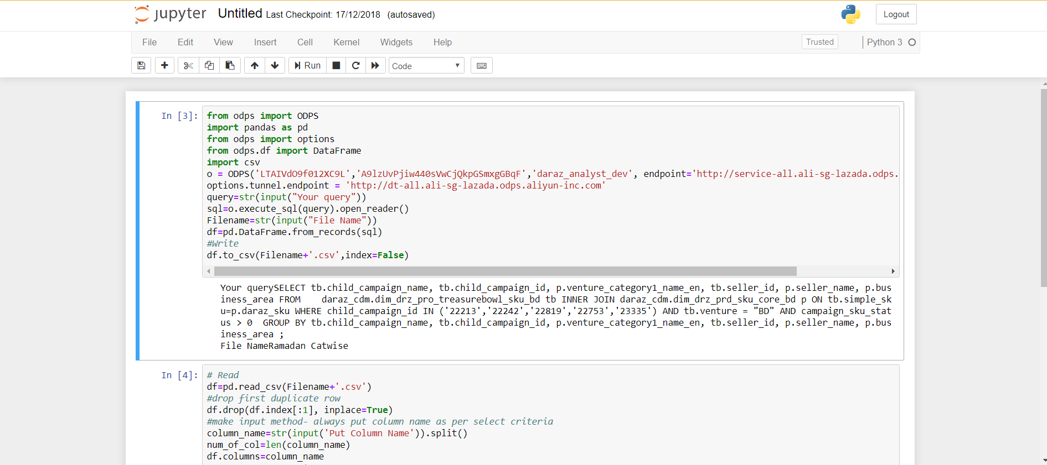
A sample python code for a larger data set

Figure 30 Automation for larger dataset using Python Coding

Each campaign requires similar reporting for performance check of the campaign and to help top managers to take necessary actions to achieve campaign goals.
Additional Tasks:
Assist department: It is also part of my job to provide support to other permanent executives with any other departmental work and complete our departmental task goals effectively.
In addition to that, it was also advised for each individual employee to come up with new ideas that will help managers perform the departmental tasks and get the target efficiently and quickly. I have helped to provide my senior colleagues with ideas to accelerate gathering information on each banner for certain campaigns.

My Experience:

Department, Supervisors, and Coworkers
I worked in the Traffic Operations department in cooperation with the Commercial team and Project Management and Business Intelligence team under the supervision of Traffic Ops team leader Mr. Rukesh Dutta. I had the opportunity to work most of my internship time directly with Specialists and Manager from my designated team. Besides that, I also got the opportunity to work with Specialists and Executives from other teams, namely Rifatul Maksud, Barish Khandaker, Rashid Ahmed, Md Shajedul Islam and Masnun Ridwan Khan.

Organizational Culture and Work Environment
Although I have been working at Daraz for only 3 months, it grew onto me and already feels like my second home. Despite the immense departmental pressure, long working hours and weak policies, I would love to work here in the long run because I find it very interesting and the people and culture here is amazing.
During my internship, I have got the chance to observe a very friendly environment at Daraz. Everyone was quite cooperative and supportive towards me. They have always guided me regarding my career plans and the corporate world.

Learnings from Internship Experience
Technical Skills
- Learned the best technical skills in Daraz would be the use and skill of MS-Excel. I never knew excel can do all those things. I have learned to use excel to create reports using pivot tables, combine separate databases outputs using formulas and MS Power BI tool.
- I was not familiar to coding languages so at the very beginning it got me worried, but my supervisor helped me through every step to learn the languages and made me interested to learn more about coding. I have used python programming to execute some automated reporting and as well as retrieve data for further analysis.
- I mostly worked on SQL platform to run the required queries, I also learned to work on “FBI” platform and “Jupyter” as well. I used these tools to retrieve data from separate databases and compile them as per need.
- I had to maintain communication with my team members and other department heads as part of my work and that made me efficient in using email communications and conversation software.
- I got used to hold meetings in Skype and “Alilang” for distant communication.
- Knowing insights of every category and creating a self-value in the organization.
People Skills
- The professional life can be very polite and realistic. It’s a very new experience to acquire all those character dimensions and way of talking. As daraz has open office policy where there is no separate boundary to communicate with everyone and the works are mostly intertwined between departments, one to one communication is done quite often. This enhanced my communication skills and helped to learn about group work.
- Interacting with the category heads and vendor managers to remind them to bring deals and handling various tricky situations made me a better person in handling person to person speaking.
Personal Development
- Time management is a crucial skill and working in a fast-paced e-commerce platform helped me improve my timely manner of work.
- The professional work hours seemed a burden at first. However, I got used to these practices over the course of time. I am now open to tasks with any time constraint and constant stress.
- I found it hard to open to my superiors as there was a feeling of wasting their time. But this flat organization surely has helped to overcome those problems.

Areas that need improvement:
Through my internship period at Daraz Bangladesh Ltd, I have observed these following concerns that needs addressing:
Limited workforce:
Recruitment and talent management department of Traffic Operations department performs their responsibilities with a smaller workforce in comparison to the assigned workload. Sometimes, it may become stressful working environment for existing employees of the department. During the time of campaigns, we had to perform a series of tasks that may have been much easier and efficient if there were larger workforce available.
Totally new environment for interns:
The Daraz Bangladesh Ltd has a very fast paced work environment which requires employee’s full effort. For the interns, it might become sometimes difficult and stressful as they are only fresh graduates and has little to no experience in corporate work process. Interns are directly absorbed into the work. As different people require different amount of time to absorb work processes, often interns make mistakes in the beginning of their work.
Individual Data Sources:
Daraz information system is yet to be an integrated database system. Sometimes in order to complete reports or tasks assigned to me, I had to access several different sources. These sources are all in separate servers and may not be updated in a synchronized way. As a result, the data might be imbalance sometimes.
Gets difficult in prioritizing work:
Our department works with different category managers, their teams, content department, and individual vendors is sometimes difficult to balance. Not all the information and materials are available in time and that makes things difficult. It becomes time-consuming and monotonous then. Sometimes there is a deadline for uploading a banner or opening a campaign page, but maybe there is one important seller who has not updated their info yet and this leads to delay in work and sometimes creates stress.
Repeated and Rigorous Workload:
The tasks associated with this department requires trial and error basis works for certain cases. It becomes exhaustive to do and redo placement and selection process if the top management changes decision and tries to customize every campaign. For example, the uploading of banners may take a long time due to repeated changes in the same products design or price update. This may become very monotonous if the seller or manager is changing info time to time.

Technical Difficulties
Daraz uses a much-secured way for communicating. All the tasks at first felt like a very long route as I had to follow all those rules via the system and server which I was not aware of. However, with the time passing those difficulties were met within a very short span of time. Learning python and SQL programming was not so easy and keeping same level of quality in case of repeated banner upload are major difficulties I faced.

Recommendations
Daraz Bangladesh is the Largest E-commerce service providers in Bangladesh. Since it has started its operation in Bangladesh, they are improving every moment. Still, it can possibly turn out to be considerably greater and better than now. While making this report I have been observed several concerns existing regarding the works of Traffic Operations department. Therefore, I want to mention some recommendation which can be applicable for Traffic Operations department as well as for other departments of Daraz Bangladesh Limited. Those are in the below –
- Daraz should update their information within the organization to make reporting and analysis easier to deliver. All the databases should always provide aligned data set, so the chances of errors are minimal.
- All the designs and plans should be predetermined and there should be minimum amount of changes from the initial plan to avoid exhaustion and time loss.
- The company needs to ensure product quality. Even if they have lower number of sellers but the product quality is good customer will shop from them longer and will not switch to other e-commerce sites easily. So, their products must be of good quality, matching their company goal. Although most of our current vendors are brand and recognized shops, there are some local vendors as well and often their products are sourced from different countries, in which case the product quality cannot be checked in those cases.
- For certain areas, specifically outside of the central district location Daraz Bangladesh is dependent on third-party logistics team for delivery where some mishaps happen due less control. Daraz needs to expand their own fleet to ensure proper delivery and reduce loss of products as well as reduce dependency on third party. There should also be agreement and penalty system between third parties and Daraz in case of any negative situation so that at least customer can be compensated for the trouble.
- Customer Service team needs to be expanded and more integrated software should be introduced to provide customers with prompt and efficient service.
- Prices should be as much low as possible with maintaining standard quality of the items. If the same product is available at lower price somewhere else, customers will leave Daraz. Also, if the quality of product is not up to par with the price then customers will lose faith.
- Both local vendors and customers need to be educated more about e-commerce and value for money. Bangladesh customer base is still at a learning phase, they are still unaware or unclear about a lot of different processes that exist in an e-commerce platform. For example, a large base of customer still feels uncomfortable to use online payment methods while it's convenient and easy to use. Also, the fact that value for money is still a crucial knowledge that is yet to be understood by the mass customer base. Many people don’t even consider that the lower price it is, the lower is the quality.
- The expectation from an employee should be specific & not more than needed. They should only focus on the points that is possible to deliver.
- Hire more workforce to ease the pressure from existing employees and prepare proper policies for employees that makes easier to work.

Conclusion
Finally, I want to finish my report with the message that Daraz Bangladesh Ltd. still has a great chance in the market to develop and acquire the maximum share of the market. From the very beginning, the company had faced many challenges and difficulties to reach today’s position. From a very small unit, it is a giant organization today.
The companies in the e-commerce industry should concentrate on quality product and quality service to take this industry towards further success. The Bangladesh government should also be considerable and cooperative to help the businesses flourish.
As Daraz Bangladesh Ltd is decentralized organization and core values are cherished by everyone within the organization, operating in dynamic situation is easier than it seems. Every department works hard and the efficient workforce with advanced technological infrastructure, Daraz Bangladesh reach top position in the Bangladesh E-commerce industry.
In this report, I have tried my level best to introduce Daraz Bangladesh Limited, their structure, their business processes, how they measure revenue and profits and how was my experience in the Traffic Ops department. While working with my team I learned that the activities/tasks of Traffic Ops department of an e-commerce business is quite unique and the skills I obtained here can surely help me in the long run. Traffic Ops is rather a newer yet often misunderstood concept department as often people only thinks of website management when they hear the term “Traffic Ops”. But it is so wide that it also covers seller performance, quality control, campaign management. It is rather a new addition to this corporate world and working for this department has its benefits. I also got to know how each categories and departments are working. The activities in my department have developed my practical knowledge and provided me an amazing experience. All these understanding that I have achieved by functioning three months, I can surely bring for the rest of my career.

References
- Internet Subscribers in Bangladesh February 2018. (2018, January). Retrieved from BTRC.GOV.BD:www.btrc.gov.bd/content/internet-subscribers-bangladesh-january-2018
- E-Commerce Business Scenario in Bangladesh. Retrieved from Brain Station 23: https://brainstation-23.com/e-commerce-business-scenario-in-bangladesh-2006-to-2018/
- Buffam, W. J. (2000). E-business and IS solutions: an architectural approach to business problems and opportunities. Addison-Wesley Longman Publishing Co., Inc.
- Turban, E., King, D., Lee, J., & Viehland, D. (2002). Electronic commerce: A managerial perspective 2002. Prentice Hall: ISBN 0, 13(975285), 4.
- Hoq, Z., & Kamal, M. (2005). Shawkat and Chowdhury, AHM Ehsanul Huda," The Economic impact of E-commerce. BRAC University Journal, 2(2).
- Chaffey, D., Hickie, S., Greasley, A., & Bocij, P. (2006). Business information systems: technology, development, and management for the e-business.
- Top Sites in Bangladesh. Retrieved from: https://www.alexa.com/topsites/countries/BD
- Daraz Online Shopping. (2017). Retrieved from Facebook Daraz Official page: https://www.facebook.com/DarazBangladesh/
- Daraz Group. (n.d.). Daraz BD. Retrieved May 2019, from https://www.daraz.com.bd/
- Product Categories. (2017). Retrieved from Daraz.com.bd: https://www.daraz.com.bd/
- Daraz Future Leadership Program. (2017, November). Retrieved from Daraz.com.bd: https://careers.daraz.com/dflp/
- Zeithaml, V., Bitner, M. J., & Gremler, D. D. (2002). Services marketing. 3rd.

