Management Accounting Practices
A Case Study on Small Scale Construction Companies
MD Naimul Islam Abir
ID- 111 143 187



United International University

Md Naimul Islam Abir
ID: 111 143 187
Major in Accounting

Supervisor :
Ziaul Karim
Assistant Professor
School of Business and Economics
United International University

Date of Submission: 21 September, 2020

Letter of Transmittal

20 September 2020
Ziaul Karim
Assistant Professor
School of Business and Economics
United International University
Subject: Submission of Internship Report.

Sir,
This is to inform you that I am submitting my BBA internship report assigned on “Management Accounting Practices- a Case Study on Small Scale Construction Companies” which was assigned to me as partial fulfillment of the program “Bachelor of Business Administration”. As I have studied various courses regarding Management accounting as part of the graduation program, I tried to imply my theoretical knowledge and comply with the practices in real-life operations. As a case study based report, I have selected two companies, Archives Solutionss and Star Delta Engineers Limited both are small scale organizations successfully running their operations in the construction Industry. This report aims to lay out a brief picture of how small-scale construction companies’ management takes place and also shows a comparative scenario between the management accounting practices between the two companies. I am highly grateful to you for your kind advice and co-operation to conduct the study. As I lack some experience, the report may contain some unexpected limitations. I hope you will not treat this kind of mistake as a major.
I would like to thank you for allowing me to work on such an important topic. I am ready to provide any further information regarding the assignment, if necessary.
Sincerely yours,
MD Naimul Islam Abir
ID: 111 143 187

Acknowledgement

At the very beginning, I would like to express my deepest gratitude to the almighty ALLAH for giving me the strength and the composure to finish the task within the scheduled time.

I pay my gratitude to my supervisor Ziaul Karim, Assistant Professor, School of Business and Economics, United International University, who has assigned me this task and instructed in the right way and given me proper guidelines for preparing this internship report.

I am grateful to my beloved parents, friends, and well-wishers for their efforts that lead me to go ahead.

Finally, I thank all the persons who have directly or indirectly contributed to preparing this internship report.

This Report is not free from limitations. There might still be some minor mistakes despite the utmost care I apologize for such errors.

MD Naimul Islam Abir

Executive summary
Management accounting is the theory based system that defines, assess, evaluate, present and transmit financial data and information to executives with the aim to achieve the mission and visions of an organization. As the corporate world is facing a constant change to survive in the competitive environment an organization must focus on their management accounting policies and practices. Here in this report we aim to compare the management accounting practices between two small scale construction companies running their operations in Bangladesh. They are- Archives Solutions and Star Delta Engineers Limited This report aims to achieve a better understanding of the Management Accounting practices in small-scale construction companies and conducting a comparative analysis between two individual companies to understand how these practices affect the company performance over time. The study will cover a time frame of overall two year period from 2018 to 2019.
There has been many studies on the cost accounting practices in the construction industry but according to the literature very few works have been done focusing on the managerial accounting practices in the small scale companies. In Bangladesh, to achieve successful completion of the projects large scale companies collaborate with the small construction companies through sub-contracting process. The purpose behind this is to diversify the working capital burden among the companies. So the small scale construction companies hold a very significant position in the construction industry of Bangladesh. Understanding how these companies manage to use the management control system to attain ultimate outcomes, can give us a better understanding of how business runs in the construction industry at large.
As a large share of the market is held by the small-scale companies in the Construction Industry in Bangladesh, studying the management control system used in these companies through two Sample Company and their process of attaining growth in the long run will give us understanding about how business runs in the practical world.
In terms of evaluating the Management practices induced by accounting information, I have use Management Control System Framework suggested by Malmi and Brown their research paper in 2008. Where the analysis focus on five separate areas -1) Planning 2) Cybernetic Control mechanism 3) Cultural Control mechanism 4) Administrative Control mechanism 5) reward and compensation system and Financial Ratio analysis along with other descriptive statistics measures.
Being a more experienced firm, Star Delta has a more structure and defined management system, where Archives Solutions is still experimenting and going with the flow with a view to find the best possible norms and management practices. Still based on corporate returns, they are doing better than Star delta. So it can be said that Archives Solutions has a prospect in future, if they can incorporate an effective and precise management control system in the organization.

Contents
Letter of Transmittal i
Acknowledgement ii
Executive summary iii
Introduction 8
Background of the Study 8
Purpose of the study 9
Primary objective 9
Specific objectives 9
Research question 9
Limitations of the study 9
Rationale of the study 10
Scope of the study 10
Structure of the Study- 11
Literature Review 12
Management accounting 12
Accounting Practices in Construction Industry 12
Small scale organizations in the construction industry 12
Management Control Systems (MCS) 13
Planning 14
Cybernetic control 14
Administrative control 14
Cultural Controls 15
Reward and compensation 15
Methodology 17
Data Collection 17
Data collection Methods 17
Research Approach 17
Justification for selected research approach 17
Sampling Process 18
Data Collection and Measuring 18
Data Analysis 18
Company profile 19
Archives Solutions 19
Star Delta Engineers LIMITED 21
Comparative Analysis 24
Quantitative Analysis-Financial performance Analysis 24
Cost Structure 25
Ratio Analysis 32
Liquidity ratio 32
Employee Turnover Ratio 33
Asset turnover Ratio 34
Budget Control 34
Efficiency Ratio 35
Financial risk Analysis 35
Debt to Equity Ratio 36
Qualitative Analysis- Management Control System (MCS) 36
PLANNING 37
CYBERNETIC CONTROLS 38
CULTURAL CONTROLS 38
ADMINISTRATIVE CONTROLS 39
REWARD AND COMPENSATION 40
Findings and Recommendations 41
Limitation of the Study 43
Scope for Further Study 43
Concluding Remarks 44
References 45

Title of the Table | Page number
Table 1: Company profile of Archives Solutions | 20
Table 2: Key Financial Information of Archives Solutions | 22
Table 3: Company profile of Star Delta Engineers LTD | 23
Table 4: Key Financial Information of Star Delta Engineering Limited | 24
Table 5: management Control System (Planning) | 38
Table 6: management Control System (Cybernetic controls) | 39
Table 7: management Control System (Cultural Controls) | 39
Table 8: management Control System (Administrative Controls) | 40
Table 9: management Control System (Reward and compensation) | 41

Title of the Figures | Page No.
Figure 1: Management Control system, MCS (Malmi & Brown, 2008) | 15
Figure 2: Evaluation of Management Control System for Comparative Analysis | 17
Figure 3: Financial performance Measure (Profit margin and ROE) | 25
Figure 4: Cost structure (2018 &2019) | 26
Figure 5: Fixed costs as percentage of Total Fixed costs | 27
Figure 6: Variable cost as percentage of Total Variable costs | 28
Figure 7: Total Cost Comparison | 29
Figure 8: Asset structure of Star Delta Engineering Ltd | 30
Figure 9: Asset structure of Archives Solutions | 31
Figure 10: Liability structure of the companies comparing 2018 and 2019 | 32
Figure 11: Current ratio | 33
Figure 12: Employee Turnover Ratio | 34
Figure 13: Asset turnover Ratio | 35
Figure 14: Efficiency ratio | 36
Figure 15: Debt to equity ratio | 37

Introduction

Background of the Study

Management accounting is the theory based system that define, assess, deliver and transmit financial data and information to executives with the aim to achieve the mission and visions of an organization. As the corporate world is facing a constant change to survive in the competitive environment an organization must focus on their Management accounting policies and practices. These policies help a company to make comprehensive and effective decisions based on financial statements and cost estimates. According to the literature, there has been many researches on the managerial accounting practices on the large scale construction companies but the small companies did not get much attention from the researchers even though they hold a large proportion of the market in the construction industry. There several valid reasons and limitations why researchers could not explore the small-scale organizations and include them in the research area. The management practices in a small company are quite different from that of a large company. This report will focus on these practices and how practices vary from company to company.
To conduct this report, I have selected to small-scale construction company running their operations in Bangladesh, based on data availability and the owners willingness to co-operate with the research requirements. The selected companies are - Archives Solutions and Star Delta Engineers Limited Archives Solutions and Star Delta Engineers Limited, Both the companies are small-scale construction companies that are successfully running their operations in Bangladesh. The area of their operations in the construction business is very much similar. These companies provide labor support and raw materials to large scale projects through sub-contract. As the capacity of these small-scale companies are less than that of the larger companies running operations in the same field, these companies tend to work on sub-contract with larger companies who take over the project and distribute the works and production requirements among small companies proportionately. The idea is to diversifying the work and capital requirements and achieve efficiency. The objective of this report is to measure and compare the management accounting practices in these small-scale construction companies. The study will cover a time frame of overall two year period from 2018 to 2019.
There has been many studies on the cost accounting practices in the construction industry but according to the literature very few works have been done focusing on the managerial accounting practices in the small scale companies. In Bangladesh, to achieve successful completion of the projects large scale companies collaborate with the small construction companies through sub-contracts with a view to diversify the working capital burden among the companies. So the small scale construction companies hold a very significant position in the construction industry of Bangladesh.
The study aims for a better comprehensive analysis of the management accounting concept in small-scale construction companies and conducting a comparative analysis between two individual companies to understand how these practices affect the company performance over time.

Purpose of the study

Primary objective
To gain understanding of the managerial accounting policies and practices in small scale construction companies in Bangladesh.

Specific objectives
- Identifying the managerial accounting policies and practices in small scale construction companies in Bangladesh.
- Conducting a comparative analysis on the managerial accounting practices in two different small scale construction companies and understanding the variation in managerial operations.

Research question
This study will focus on multiple questions and try figure out the answers of these question throughout the research process. These are-
- What are the implications of management accounting practices in Small-scale construction companies operating in Bangladesh?
- What are the magnitude and importance of these practices in their operations?
- How the selected companies are running their operations and to what extend management account is helping them in efficient decision making?

Limitations of the study

- As the small scale companies do not tend to prepare financial statements following accounting equation or double entry system, it is hard to track their ultimate profit and asset position.
- In the construction industry regular expenditure occur during the project but usually profit comes in a lump sum amount after the project is completed. It often takes years to complete a project, even some times remain unfinished.
- Due to Inadequate data provided by the companies, the comparative analysis covers a two year time frame which fails to show the complete picture.
- Data is collected through interview. Interview, description of the organization and data may have the effects of interview bias as all data has been collected from internal sources.

Rationale of the study
By conducting the study, an overall picture of how small-scale construction companies operate in the practical scenario can be drawn linking with a theoretical background in management accounting practices. As, these small scale organizations do not use double entry system or any formal accounting methods to record their financial data, bringing out or calculating the actual information to meet the purpose of the study was very hard. Because of the competitiveness of the industry, companies do not want to share their confidential financial information, which was another reason why similar studies are rare in Bangladesh. So this study is a new concept that will give us an idea about practical business operation in the small scale organizations.

Scope of the study
The study tries to attempt for a better understanding of managerial accounting policies and practices of the majority of the market share would provide a better perspective for the business heads how proper allocation of resources and financial data management can led to more efficient outcomes.

Structure of the Study-

- Introduction
- Literature Review
- Methodology
- Company Profile
- Comparative Analysis
- Findings and Recommendations
- Conclusion

Literature Review

Management accounting
Management accounting, also recognized as cost accounting, is a method through which company cost structure and actions taken for preparing comprehensive financial statements, bills, documents, and reports etc. that are evaluated for its ability to support higher-level management’s decisions in achieving organizational goals and targets. This technique involves collecting and understanding financial and pricing information, and brings out expert judgments and opinions that can be used within a corporate organization by management and executives (Kaplan & Atkinson, 2014). It concentrates on the activities that occur within and outside the organization considering the organization’s goals. From that it emerges details and estimates. Cost accounting, refers to a techniques through which financial and accounting outcomes are crucially analyzed and turned into useful information which has the ability to support the decision making processes executed by the top management and mid-level executives. ("Management Accounting Research", 2000).

Accounting Practices in Construction Industry
This report will focus on the managerial accounting in small scale construction industries. According to the definition of Encyclopedia Britannica, the construction industry is categorized as a goods producing industry as the final product of a construction project is tangible ("Service industry | economics", 2020).
Construction projects takes place in different corners of the country, sometimes in different cities or divisions. It can generate different categories of indirect and direct costs for the companies such as travel costs, transportation cost of labor, machineries and equipment, delivery of materials to the job site etc. in short, the process of work does not have any particular location and it switches places to wherever the projects take place, along with the required materials for the work to be done. Which may result into numerous indirect costs that has to be considered to understand the financial condition of the company.
Construction companies modified the profit evaluation process using Percentage of Completion Method, where revenue is calculated based on the estimated profit of a project and what percentage of that entire project has been completed by the given time period. For a project that has been completed, the amount of profit will be as stated in the contract, but often contracts are left unfinished or on hold. So the process of profit estimation for a given period of time is quite critical, so construction firms use this method for keeping accurate tracking of their expenses to explicitly identify profit and loss (Financial Management and Accounting for the Construction Industry | CFMA, 2015).

Small scale organizations in the construction industry
As per the definition of “Small and Medium Enterprise Foundation” in Bangladesh a company in the manufacturing industry would be categorized as a small scale company if it has a capital base within the range of 75 lakhs to 15 crores and an employee base of 31 to 120. (Bangladesh Bank, 2011)
It is very much necessary to understand the importance of cost accounting in small companies because around ninety nine percent of the world’s commercial population is made up by Small and Medium enterprises (Azudin & Mansor, 2018).
According to previous reports conducted analyzing the management accounting functions undertaken in SMEs, the results demonstrated that the use of management accounting in small and medium-sized companies is not only less visible, but also distinct from larger organizations working in the same industry. Based on the analysis of the small and medium-sized companies, the group of researchers explained how work atmosphere, employee base and organizational elements has an enormous impact management accounting procedure applied in small and medium-sized enterprises (SMEs). (Lavia López & Hiebl, 2014).
According to the research published by Chartered Institute of Management Accounting (CIMA), the above mentioned technique is the widely used by SMEs in UK, which includes- Product costing, Budgets for planning and control, Cost-Volume-Profit (including break-even) analysis, Capital expenditure appraisal techniques (payback, NPV etc.), Working capital measures (debtor days, creditor days, daily cash balances, stock turnover), Short-term decision support tools (relevant cost analysis; tools for dealing with risk and uncertainty), Strategic management accounting etc. (Chartered Institute of Management Accounting (CIMA), 2020)

Management Control Systems (MCS)
Implication of management accounting (MA) eventually form a management control system within the organization, and the effectiveness of the system determines profitability. In this report we will focus on how well the selected companies are performing evaluating their management control system as a conceptual framework proposed by Malmi & Brown (2008) which has been implemented in much formal system for evaluation purpose. (Malmi & Brown, 2008)
But Management Control Systems (MCS) tend to be modified by managers or owners based on the working structure of organizations sector wise. We will specifically see how these tools are modified and the extent of such modifications in the Small scale organizations in the construction industry.
MCS “are the formal, information-based routines and procedures managers use to maintain or alter patterns in organizational activities” (Simons, 2006). For the purpose of realizing the efficiency of the MA practices of the selected small-scale construction companies, their management control system will be evaluated following a conceptual framework proposed by Malmi and Brown (2008).

Figure 1: Management Control system, MCS (Malmi & Brown, 2008)
Cultural control
Clans |  | Values |  | Symbols
Planning |  | Cybernetic Controls |  |  | Reward  And Compensation
Long range planning | Action planning | Financial measurement system | Non-Financial measurement system | Hybrid measurement system | Reward  And Compensation
Administrative Control
Governance Structure |  | Organizational Structure |  | Policy and procedures

Planning
Planning sets expectations to be met for the targets and clarifies the degree of commitment and actions required by the members of the organization. Planning will also help to organize the efforts of the organizations and people by putting together a list of goals in the different areas of an organization, to make sure they support the organizational goals. Apart from setting goals for the organization to meet, management also prepare a course of action for unforeseen or contingency events which help the company to ensure a quick react at the occurrence of such events. A company without a proper set of detailed planning often has the risk of losing its’ way in the process. A well-defined planning also helps to measure the quality of process outcomes according to the initial targets.
Not only organization as a whole, planning can take place in teams with in the organization. Along with the process of planning, all team member kind of come on the same page and develop a better understanding of their responsibilities and its purpose.

Cybernetic control
Cybernetic control is defined as “a process in which a feedback loop is represented by using standards of performance, measuring system performance, comparing that performance to standards, feeding back information about unwanted variances in the systems, and modifying the system’s comportment” (Green and Welsh,1988). It helps an organization to achieve its goals.

Administrative control
Administrative control systems governs employee’s direct behaviors through the coordination of individual employees and groups, controlling their actions and how the management identifies accountability of employee behavior, and deciding whether such behaviors are to performed or not. Administrative controls basically work with the DOs and the DON’Ts defined by the management, mandatory for employees working within the organization to follow. The Administrative controls have direct effect on the culture of the organization as well.

Cultural Controls
Cultural Controls shows how the company’s management manages to create an ethical and growing organizational culture within the organization to motivate its employees toward a more productive outcomes, Promoting efficiency and effectivity. It manipulates employee behavior and tries to create a “sense of Belonging” among the employees which makes them more loyal and dedicated for the betterment of the organization. Eventually achieving their targets of growth and profit. So cultural control is one of the most significant measures of MCS.

Reward and compensation
Reward and compensation programs are designed to inspire and promote the workplace achievements of individual employees and groups within organization in a manner, so that it creates a linkage between employee’s goals and actions with those of the firm itself. Reward and compensation can be both financial and non-financial, having diversified impact on the motivational aspect of the employees. Financial rewards can be, promotion, commission or an increase in employee benefits such as transport, technology etc. for both personal and professional use. On the other hand, non-financial rewards and compensation packages include, a higher status in the workplace, security of the Job, providing employees with career advancing opportunities, decision making authority etc. Non-financial rewards tends create satisfaction among the employees whereas financial reward tends to meet their financial needs and requirements in day to day life.
While conducting the study, I will emphasize on the steps of the management control system of the sample companies, how they are performing to achieve their ultimate goals. The analysis process of the report will be observe the following diagram that I have improved for the purpose of this report-based on light of previous researches conducted in this area (Kolehmainen, 2015).

Figure 2: Evaluation of Management Control System for Comparative Analysis
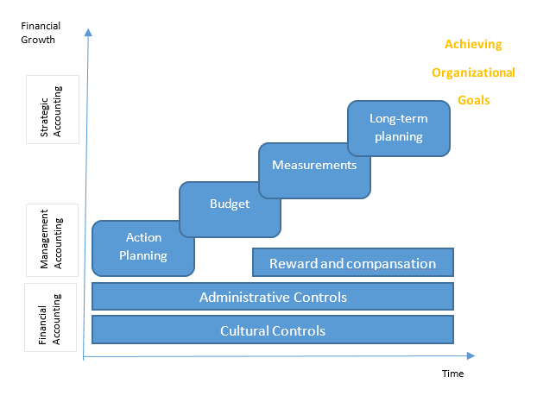
The figure has graphically represented in the very first step how Cultural, Administrative control, and reward and compensation programs creates a motivational and efficient work environment for the employees generates important outcomes from financial information. In the second step, the roles of management account starts to kick in using this financial information, management executives takes well-informed decisions and plans a course of action through budgeting and long term action planning. Measuring the outcomes with the original planning is also a part of the process. Alterations in the process take place when there is discrepancy between the planning and the ultimate output, creating scope for further planning. The overall process leads to organizational goals creating a complete picture.
The report also has a large section with ratio analysis over the financial measures of the selected companies, which is another popular Management Accounting tools which is widely used worldwide. Ratio analysis helps to bring out different characteristics of the management and accounting practices and helps to make effective decisions. Among Ratio analysis, the study will explore employee turnover ratio, asset turnover ratio, liquidity ratio, different budgetary control measures and debt to equity ratio etc. This part of the analysis will enlighten us about different management accounting aspects and management preferences of Archives Solutions and Star Delta and also help us lay out a comparative picture.

Methodology

Data Collection
Data from both primary and secondary data sources was used to conduct the study which is explained below.
Primary sources
- Personal observation of the operations conducted in the organizations
- Personal interviews with owner and managers of the selected organization.
- Financial records kept by the firms

Secondary sources
- Firm’s brochure
- Company website and online information
- Written materials provided by the company

Data collection Methods
- During the internship, most of the data was collected through observation of daily operation in the organization.
- Company provided their informally kept financial records and these records were sorted and calculated to meet the purpose of the report.
- Majority of the information used are collected through interview using a formal questionnaire (attached in the appendix)
- Secondary data is collected from company website and researches done in the similar field.

Research Approach
The research analysis will explore both quantitative analysis (Financial Ratio analysis) and quantitative measures (management control system typology by Malmi and Brown and other descriptive statistics measures).

Justification for selected research approach
Management accounting is a theory based system that aims to use quantitative financial data in practical managerial decision making. As the subject itself is a mix of both quantitative and qualitative techniques, so for a comprehensive analysis of the management accounting practices a mix of quantitative and qualitative research approach would more justified to bring out more error free outputs from the proposed analysis.

Sampling Process
To conduct the study, selective sampling approach was used because not many companies agreed to cooperate with the requirements and data support in order to pursue the research. Usually small-scale companies do not keep detailed financial information records, so supporting the research by providing data support is quite troublesome for the companies. Like the listed companies small scale firms are not legally bound to share their financial information with stakeholders. So most of the owners of the company does not like idea of sharing their confidential financial data for research purpose.

Data Collection and Measuring
The book keeping system followed in the selected companies does not follow any international accounting standards or traditional double entry system, so it was quite hard to avail required data from their financial records that can used to meet the purpose of the study. The financial data was availed from the primary sources; accounting department of the companies from the series of entries over the last two period. The required data and information to analysis the management control system framework was collected by researchers own observation during the internship period and interview with the owners or managerial executives.

Data Analysis
As this is a qualitative research stating the management practices regularly performed based on the accounting information within the small scale organizations, I will use tools of descriptive statistics such as, graphs, charts and tables etc. and MCS typology developed by Malmi and Brown, 2008 to show a comparative scenario between the companies.

Company profile

Archives Solutions
Archives Solutions is a small scale construction company that is running its business with proprietorship status. It started its operations in January 2018. So in comparison to the existing companies in the industry, Archives Solutions is a very new company. Headquarter of the company is situated in elephant road, Dhaka. It also has 2 branch office running operations in Chittagong and Payra. As a small scale company, Archives Solutions does not have the funding and operational structure to complete large scale projects on its own yet. So basically it provides labor support to the on-going large scale projects. When there is a new project about to be started, to adequately financing the working capital of the project, the managing company goes into sub-contracts with small scale companies which are responsible for supplying different production requirements such as labor, raw materials (such as cement, rod, equipment, etc.) daily to keep running the business. This is how the whole financing requirements are diversified among the small scale construction companies. Archives Solutions provides labor support to large scale construction projects. Within the year of their business being started, Archives Solutions managed to take sub-contract for 4 government-initiated infrastructure development projects among them three of the projects are related to the infrastructural development of Payra Sea Port in Patuakhali, Bangladesh. Archives Solutions is currently accommodating around 1000 labors in these on-going projects. Another portion of their income comes from renting construction equipment (such as excavator, Crane container, etc.) and assets (such as escalators, elevator, etc.) on a monthly and yearly basis. According to the characteristics of the construction business, the companies do not generate regular income flow even though it requires regular working capital to keep the business running. The companies tend to generate profit after project completion in a lump sum amount. So the profit and expense structure of a construction company is quite different from that of regular manufacturing or a service company.

Table 1: Company profile of Archives Solutions
Company name | Archives Solutions
Year of establishment | January,2018
Type of company | Small-scale Construction Company
Number of employees | 25
Initial capital | 20,00,000
Labor base | Around 1000

On-going Projects
The company has different ongoing projects taking places in different locations of the country, where it is also associated with a government project taking place in Payra port in Chittagong. A list a the major projects undertaken by the company is added below-
1. Payra Port Housing Project-2, 3 & 13
2. Bhashan Chor Project- Flood Barrier Construction

Administrative Hierarchy of Archives Solutions

The administrative hierarchy of Archives Solutions has a two tier level and is much more decentralized compared to Star Delta. The owner of the company usually communicates with Administrative manager, responsible for local office and site manager, responsible for operations the project location. Though Administrative manager and site manager has partial decision making Authority, still all kind of financial decisions and purchase orders are placed by the owner himself. The summary of financial information of the company is given below for 2018 and 2019

Table 2: Key Financial Information of Archives Solutions
Archives Solutions | 2018 | 2019
Turnover | 8.7 million | 9.3 million
No. of employees | 15 | 18
Net Income before tax | .85 million | .98 million
Net income after tax | .78 million | .87 million
Total Assets | 3.6 million | 4.8 million
Profit margin(%) before tax | 16.28% | 21%
Return on Equity (ROE) | 26% | 35%

Star Delta Engineers LIMITED
Star Delta is a medium sized engineering company which was started its operations in Bangladesh since 2004. Later on it was acquired by the Delta Engineering Group in 2011. Star Delta’s main objective is to take subcontracts from the government and construct roads and buildings for the completion of the projects. One of its ongoing project is metro rail subcontract of a section from Agargaon to Mirpur. Besides subcontracts, Star Delta also takes contracts for repairing existing structures in different industries including Oil and Gas, Petro-Chemical, Energy and Renewables, Food and Drink, and the Pharmaceutical Industry. Star Delta's dedicated and well-qualified management team has unrivaled expertise in the specialists area of rewinding and restoring industrial motor. It has vast knowledge and experience in ex-equipment that enables it to assist its clients in asset management and maintenance of their equipment. It assures that its clients comply with the latest international standards, codes and practices as well as meets with its legal obligations. They are well renowned as competitive market participants, both in terms of quality of their services and work ethics, as a proof accredited by ISO 9001, ISO 14001 & OHSAS 18001. It carries out work in a fully equipped workshop using the latest industry equipment ("Star Delta - Delta Engineering Group", 2020).

Table 3: Company profile of Star Delta Engineers LTD
Company name | Star Delta Engineers LTD
Year of establishment | 2004
Type of company | Small-scale Construction Company
Number of employees | 48
Labor base | Around 3000

Administrative Hierarchy of Star Delta Engineers LTD
The organization hierarchy of the company has only one tier and very much centralized. Almost all the employees take direct orders from the owner of the company and does not have decision rights.

The summary of financial information of the company is given below for 2018 and 2019
Table 4: Key Financial Information of Star Delta Engineering Limited
Star Delta Engineers LTD | 2018 | 2019
Turnover | 12.5 million | 15 million
No. of employees | 25 | 30
Net Income before tax | 1.68 million | 2.2 million
Net income after tax | 1.35 million | 1.74 million
Total Assets | 6.5 million | 7.2 million
Profit margin(%) before tax | 15.45% | 18%
Return on Equity (ROE) | 25% | 30%

On-going Projects
The company has different ongoing projects taking places in different locations of the country. A list a the major projects undertaken by the company is added below-
1. Ammonia/Glycol System Installation
2. Delta Engineering Turbines
3. Caledonian Cheese Plant Construction

Comparative Analysis

Quantitative Analysis-Financial performance Analysis
Archives Solutions and Star delta Engineers Limited are both successful small scale organization conducting operations in construction industry. But how well they are running their business is ultimately measured by their year-end profit structure. Construction companies do not calculate profit in the traditional method. As most of their operations are done on contractual basis and they receive payment at the completion of the projects. These often have a completion period more than a few years and sometime remain unfinished as well. So construction companies use percentage of completion method and accumulated it with estimated profit for each project. Based on the Financial Performance of the above mentioned organizations, Growth profile of Archives Solutions is much better than that of Star delta Engineers Limited, even though the former company has less experience that the later in the same area of experience (Figure 3).
Figure 3: Financial performance Measure (Profit margin and ROE)
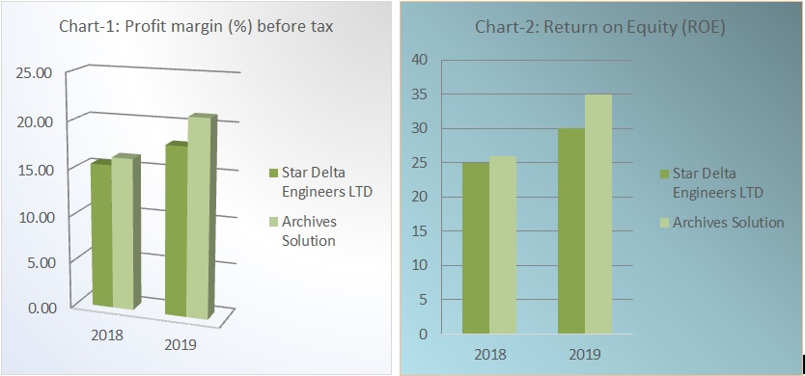
Looking at the Return on Equity (ROE) in chart-2 between the two companies Archives Solutions is generating more return on the capital invested in the organization compared to Star Delta Engineers Limited

Cost Structure
If we observe the cost structure of the selected companies, in the broad head, most of their expenditure is invested in the direct project costs. But comparing the companies we see, Archives Solutions put more emphasis on projects rather than administrative costs than Star Delta. Being a newer company depreciation cost for Archives Solutions is less than Star delta. In the first year of their operation it has only shown 1 percent depreciation as percentage of total cost.
Figure 4: Cost structure (2018 &2019)
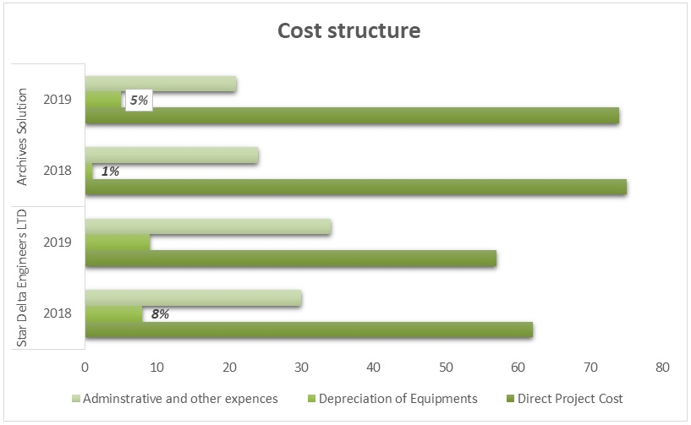
In the above Figure, the composition of costs as percentage of total cost is shown. Here, direct project costs include the costs of land, labor, machineries and equipment, travel and transportation cost, utility and power etc. Similarly Administrative costs include employee benefits & salary, office rent and utilities, maintenance, miscellaneous etc. Cost related to project tends to vary more based on the type of projects that are in operation. Administrative costs does not vary much as these are more fixed in nature.
For a more precise cost analysis for the selected organizations, their fixed and variable costs are taken under consideration. Figure-5 shows a comprehensive structure of the fixed cost as % of the total costs generated within the organizations of both companies in the year 2018 and 2019. We can see the proportion of remuneration is higher for Star Delta in comparison to Archives Solutions as they have a larger employee base working for them. In 2019, even though star delta had send more on their employees as percentage of total fixed cost, but if noticed, the yearly growth of remuneration from 2018 to 2019, was higher in case of Archives Solutions than Star Delta. It can be a result of both new recruitments or increment of current employees.
Figure 5: Fixed costs as percentage of Total Fixed costs
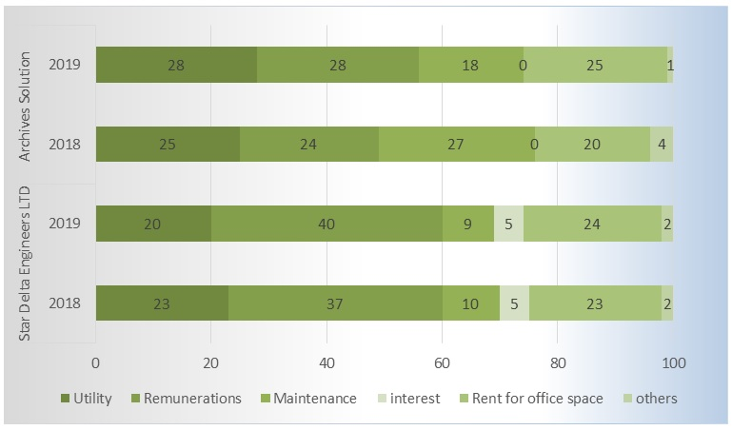
Another noticeable fixed element in the graph above that shows a huge variation for the selected companies is maintenance cost. Maintenance cost of Archives Solutions comparatively higher in comparison to Star Delta, especially in 2018. The possible reason for this can be that, as the company started its operation in 2018, most of their furnishing and renovation costs are adjusted with the maintenance costs. Utility costs were also higher for Archives Solutions comparing to that of Star Delta.

Figure 6: Variable cost as percentage of Total Variable costs
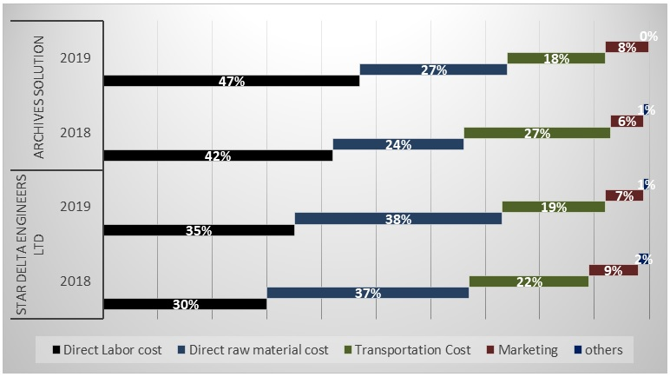
Figure 6 explains the variable cost structure of Archive’s Solutions and Star Delta showing each variable cost as percentage of the total variable cost for year 2018 and 2019. Labor costs are paid off using weekly payroll method by both the companies. But to meet the purpose of the report, weekly cost were converted in to Annual cost by accumulating payrolls for 52 weeks over the two years, 2018 and 2019 separately. In the figure above, we can see that in both the years, Direct Labor costs were higher for Archives Solutions but on the contrary, direct raw material costs were higher for Star Delta compared to the other company. Earlier in the report, I have explained that Small-scale construction companies working in the Bangladeshi Demographics has the nature of subcontracting a portion of a large project rather that doing the whole project itself. This process helps to diversify financial issues and project management loop holes, and helps in increasing efficiency. Referencing to this Solutions, through interview I have come to know that Archive’s Solutions mostly serve labor support to projects rather than supplying raw materials. Similarly, Star Delta is more focused in to constructing plants and machineries compared to Archive’s Solutions. This eventually resulted into higher Direct Raw material costs for Star Delta in comparison to Archive’s Solutions.
As the graph shows, In 2018 Star Delta was spending more on Marketing for their services compared to Archive’s Solutions. But as we can see, in 2019, Star Delta’s marketing expenditure was reduced to 7 percent from 9 percent over the year. Meanwhile, Archive’s Solutions decided to dedicate a higher proportion of their total expenditure toward marketing. As a new company entering the industry, it is a technique used by Archive’s Solutions with the concept of digitalization to grow their customer base by informing them about their arrival, services and strengths.
Transportation costs refer to the cost of transporting machineries and equipment and travelling cost of labor and employees to the project areas where ongoing projects take place. It is a very significant cost for Small-scale construction companies. Transportation Costs were higher for both the companies in 2018 compared to 2019. As it mostly depend on the demographic characteristics of the project location and mode and cost of traveling, it can be concluded that in 2019 they overtook projects nearer to the area from where supply of raw materials and labor force is provided.

Figure 7: Total Cost Comparison
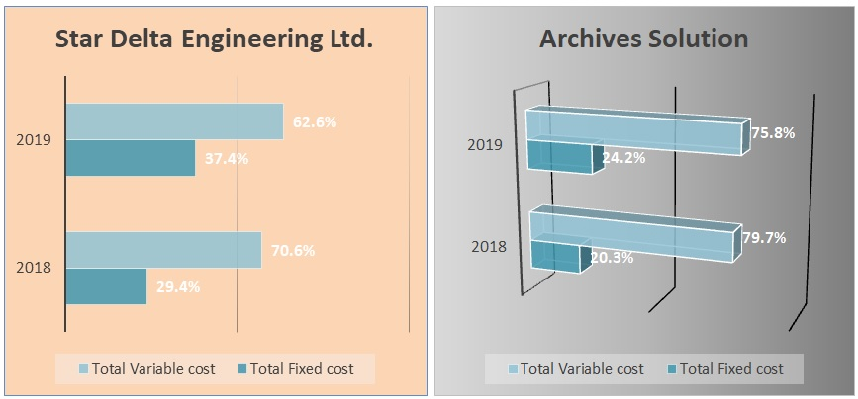
Figure 7 has graphically presented the fixed and variable cost scenario of the companies. As we can see Star Delta Engineering Limited was heavily weighted by fixed costs generated within the organization compared to Archives Solutions. The burden of fixed cost tented to increase significantly over the year from 2018 to 2019. A significant increase of fixed cost is an alarming thing for a company in operation because it tends to push the break-even point upward reducing the opportunity for profit maximization. Again, Total cost of Star Delta also showed a high growth potentials over the year which is also a bad news for the company. On the other hand, Archives Solutions has a better fixed and variable cost structure in comparison to Star Delta which may have been the reason for profit scenario for Archives Solutions represented in Figure-3. It can be said that Archives Solutions managed to make a better management accounting decisions and making effective and efficient use of opportunities to reduce cost and maximizing profit.

Asset & Liability Structure
Figure 8: Asset structure of Star Delta Engineering Limited
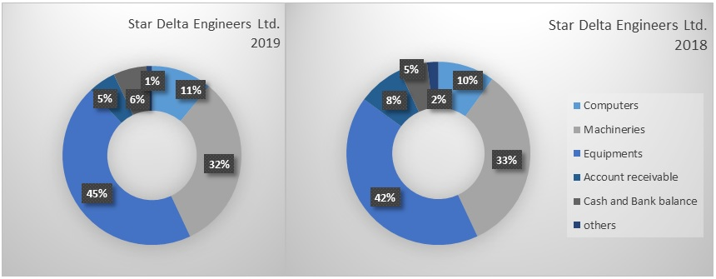
Figure 8 describes the Asset structure of Star Delta Engineering Limited for the year 2018 and 2019. We compare the information received from the Asset information received between the two years; we can see Majority of its assets are machineries and equipment, which meet the main production requirements of their construction services. The computers owned by the firm is another form of asset that also takes up a high proportion in the asset structure used by the employees who completes the administrative operations within the organization. If we look at the account receivables Star delta, had a higher amount of account receivables in 2018, which they managed to reduce by 3 percentage points by 2019, to 5 percent (initially 8 percent in 2018). This is a major accomplishment for a small-scale construction company. As these companies work on sub contract basis, often their payments from the parent companies leading the large scale construction projects remain due for a long period of time. This eventually creates obstacles for these companies to carry on their daily expenditure leading them toward heavy burden of working capital financing and increasing interest cost. Its liquidity ratio (cash and Bank balance as % of total asset) was quite low varying from 5 to 6 percent over the two year period of time.

Figure 9: Asset structure of Archives Solutions
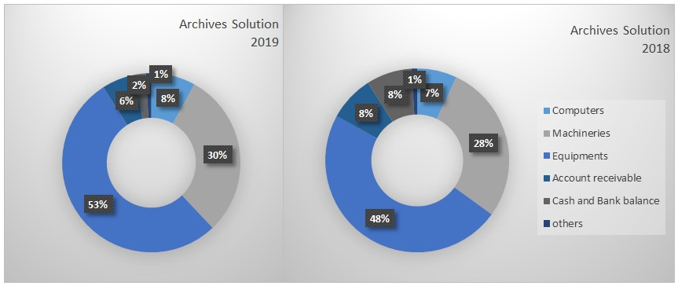
Figure 9 describes the Asset structure of Archives Solutions for the year 2018 and 2019. We compare the information received from the Asset information received between the two years, we can see Majority of its assets are machineries and equipment similar to the case of Star delta. As Archives Solutions has a smaller employee base the amount spend for computers used by administrative employees is proportionately lower compared to that of Star Delta Engineering Limited If we look at the account receivables Archives Solutions had a higher amount of account receivables in 2018, which they also managed to reduce by 2 percentage points by 2019, to 6 percent (initially 8 percent in 2018). The rate of reduction of Account receivables was lower in comparison to Star Delta. For working on a sub-contact basis, their payments that are due to the parent companies leading the large scale construction is hard to allocate for small scale construction firms. Causing working capital insufficiency and interest payment costs for loans and advances taken meet such insufficiency. Its liquidity ratio (cash and Bank balance as % of total asset) was quite high in 2018 (8 percent) but reduced significantly by 6 percentage points to 2 percent in 2019 causing a liquidity crisis for the company.
If we compare between Figure 8 and Figure 9 respectively, showing the Asset Structure of Star Delta and Archives Solutions, the asset profile of both the companies’ are heavily burdened by machineries and equipment. Comparing Employee base it is more reasonable that Star Delta has spent more on computers for the administrative use compared to Archives Solutions. Star Delta managed to reduce Account receivables faster than Archives Solutions over the two year time period which shows more efficiency in this area.
In the liquidity management area, Star Delta was more efficient comparing to Archives Solutions. It is more evident that Archives Solutions was facing a liquidity crisis in 2019 failing to respond to their emergency liquidity needs rising while conducting day to day operations.

Figure 10: Liability structure of the companies comparing 2018 and 2019
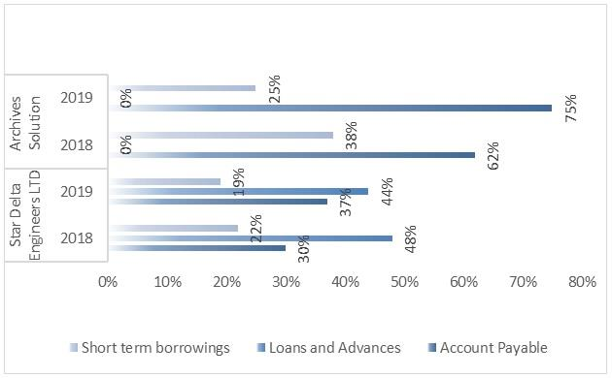
Figure 10 shows liabilities of the selected firms as percentage of total liability. As we can see from the graph, Archives Solutions does not have any long-term borrowings or loans and advances in their liability composition. Whereas Star Delta Engineering Limited is a highly leveraged company with 48 percent and 44 percent of long-term borrowing respectively in 2018 and 2019. Loans and advances of Star delta reduced by 4 percentage point with in the two year time frame. As the figure shows proportion of liability as percentage of total liability it may be misleading, and show that Archives Solutions had higher amount of account payable and short term borrowings, But in real it was the opposite. Even though the growth of account payables higher for Archives Solutions comparing to Star Delta. This can be linked to the liquidity crisis that we observed in the previous figure (cash and bank balance as percentage of total assets) in the year 2019.
Small-scale companies keep their own financial records without following international standards or double entry system. Both the companies under this study maintained their financial database using excel spreadsheets keeping record of transactions and deferred payments. So this method of financial record keeping does not give us the opportunity to check for errors using accounting equation (A= L+E), like it does in Double entry method.
Among the two companies that I have selected for the study purpose, Archives Solutions is fully fledged equity financed company while Star Delta highly Debt oriented and incurs a regular interest premium as fixed cost for the company pushing the break-even point upward.

Ratio Analysis

Liquidity ratio
Liquidity ratio helps us to evaluate liability of the firms to meet the emergency liquidity needs. We will be using current ratio to estimate the firm capacity to meet the current debt obligations without having to raise more capital from the owners of the firm.
$$current ratio= \frac{current assets}{current liabilities}$$
Figure 11: Current ratio
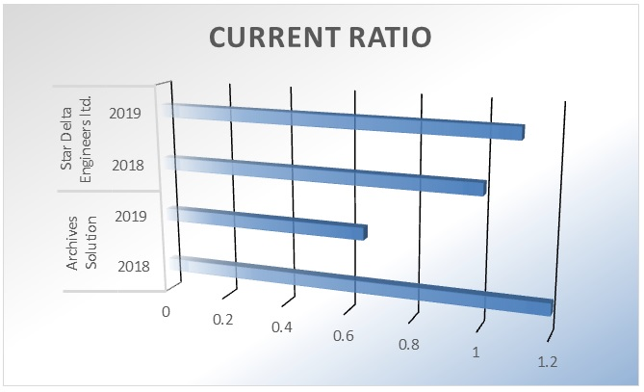
While observing the asset structure of the selected companies, we observed that cash and bank balance of Archive Solutions in 2019 was significantly low. As a result of that we can see that the current ratio (amount of current assets for each unit of current liability) of Archive Solutions was only 0.65 which was not enough to pay of its current short term debt obligations. Where in 2018 the company was quite solvent in this aspect with a current ratio of 1.2.
Meanwhile, Star Delta had a current ratio of 1 and 1.1 respectively in 2018 and 2019. Even though Star Delta is heavily debt burden and has a higher operating cost the managed to maintain a good liquid environment to meet their current obligations. Another factor for the role of adequate liquidity in the organization is that adequate liquidity helps an organization to face any unexpected crisis and unforeseen events occurring within the organization. Looking at the growth matrix of current ratio of the selected organization in the given period of time, Star Delta had an increasing growth tendency. Though Archive Solutions has an increasing trend in the given period of time, it can be assumed that the shortage of liquidity was temporary and it will be less visible in an analysis with a longer time period.

Employee Turnover Ratio
Employee turnover is calculated by dividing the number of employee who has left the company within a certain period of time (one year in our case) by the total number of employees held by the organization within the same time frame.
The equation would look like this-
$$Employee Turnover ratio=\frac{no. of employees left}{total no. of employees}$$
When a new employee is recruited company invests a lot of money for the recruitment process, training and benefiting the employee with the purpose of motivation and earning outmost loyalty. But if the switching tendency among the employees is too high, it is somewhat harmful for the company. Employee turnover ratio can tell us about the organizational culture and team spirit within the organization and teams within the organization and how welcoming they are toward the new comers.
Figure 12: Employee Turnover Ratio
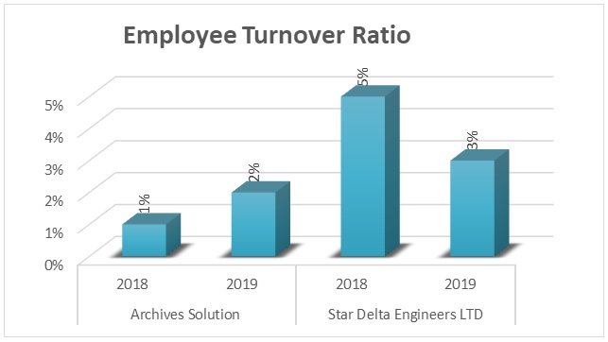
In Figure 12 we can see that Employee Turnover ratio was quite higher in terms of Star delta in comparison to Archives Solutions. Though turnover ratio for Archives Solutions had a growing tendency over the time frame, Star Delta managed to reduce employee turnover within the organization. As a new company and smaller Employee Base, it can be said the Archives Solutions is trying to enhance the work force bonding among the employees. So a growing employee turnover ratio would not be good news for the management at this point of time.
Meanwhile, with 16 years of experience in the industry Star delta has more experienced workers working within the industry and teams within the organization has stronger value. My observation was that if employees didn’t get along with the team culture, they often had the tendency to leave the organization and the management of Star Delta was somewhat negligible of the fact. Even though we can see from the graph that Star delta has managed to reduce employee turnover ratio in the recent time period showing a better opportunity for achieving effectiveness.

Asset turnover Ratio
Asset turnover gives us a clear picture of how well the companies are using their assets to generate earnings in a given period of time. Usually to calculate this ratio, the numerator used is “Net sales”, from the perspective of the construction industry; I will be using “estimated earnings” instead of net sales. Construction companies measures their earnings for a given period by adjusting project completion ratio with the estimated earning for ongoing projects.
$$Asset Turnover ratio=\frac{estimated earnings}{total assets}$$
Figure 13: Asset turnover Ratio
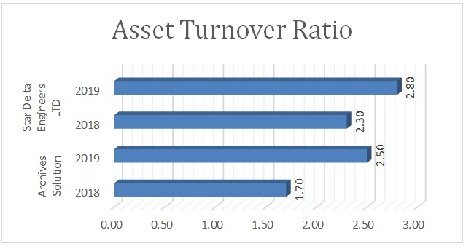
Looking at the financial information, Star Delta had higher Asset turnover compared to Archives Solutions in both financial years 2018 and 2019. But if we measure the turnover growth over the time horizon, it is evident that Archives Solutions has a better growth prospect than Star Delta.

Budget Control
Budget control is another popular management accounting technique that is widely used to measure the planning and budgeting capability of the firm’s management and their capacity to execute these budgets. There are multiple control ratios that are widely use, here I will be using Efficiency ratio, based on data availability.

Efficiency Ratio
Efficiency ratio tells us the firm’s capacity to efficient management of their planned working hours and makes good use of it. If the results are 100 percent or more it proves the firms efficiency to go as planned.
$$efficiency ratio=\frac{standard working hours }{actual hours worked } ×100$$

Figure 14: Efficiency ratio
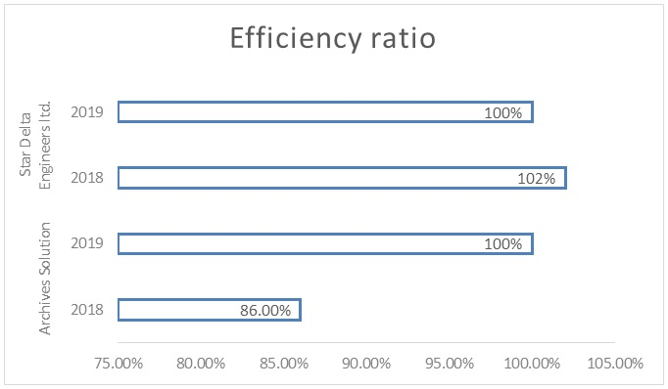
If we observe the graph we can see that in 2018 Archives Solutions failed to fulfil the standard working hours. But in 2019, they overcame the problem and managed to efficiently complete the working hour as per their annual plan. The reason behind the slack period in 2018 was the delay of projects in hand to start due to administrative bindings. Coming to Star Delta, in 2018, there was requirement for over-time to complete projects in hand and in 2019 they managed to meet their working hours perfectly.

Financial risk Analysis
Financial risk helps to visualize risk element faced by the business due to managerial decisions. There are multiple popular leverage ratios that are generally used to measure prevailing risk in an organization. We will be using leverage ratios to measure the risk factor prevailing in the selected companies Archives Solutions and Star Delta Engineering Limited

Debt to Equity Ratio
Debt equity ratio is calculated dividing total debt y total equity. It measures the unit of debt for each unit of equity in the organization. The higher the debt to equity ratio, the higher the risk.
Figure 15: Debt to equity ratio
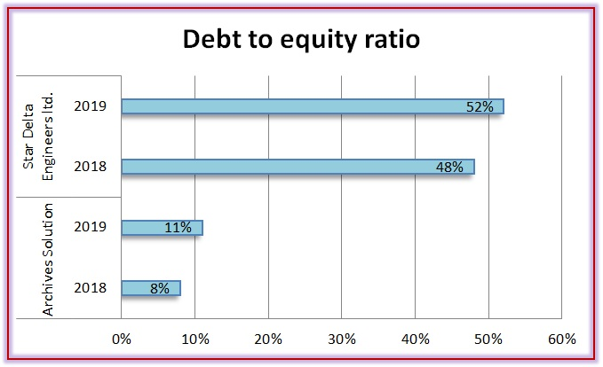
If we look at figure 15, we can see that Archive Solutions has 8 percent and 11 percent debt to equity respectively in 2018 and 2019 which is significantly lower than that of Star Delta. The reason behind this is, Archive Solutions is fully fledged equity financed company and only had a few short term borrowings from their suppliers. Meanwhile, Star Delta is heavily debt oriented and pays regular fixed annual in order to pay of the interest and installment payments incurred by long term loan and advances.

Qualitative Analysis- Management Control System (MCS)
Coming to the Non-financial measures or the management norms within the organization that has resulted into the profit scenario in Figure-3, the observation concludes that the strength of the MCS in both the companies were quite low, basically as for their size. Small scale companies often does not focus on management as they have fewer no. of employees, and they are often managed by the entrepreneur/owner himself with support from the accounting information. So mostly the owners are accountable for the practices within the organization.
In Figure 5, there is an additional element in Star Delta which is Interest premium, paid by the company for loans and advances from various sources taken to bear company operation and project costs. But Archives Solutions does not have any leverage from external sources, rather it is completely self-finances. So Archives Solutions does not have bear any regular interest costs in comparison to Star Delta.
In the figure below, the management control system of the companies are briefly discussed based on the data and observation received from the interview.

Table 5: management Control System (Planning)

PLANNING
 | Long term | Action planning
Archives Solutions | No. | Yes.  Planning for the upcoming project which will take place within 3-6 months. Recruiting labor, importing raw material and necessary equipment to support the upcoming project.
Star delta Engineers Limited | Yes. | Yes  Working on the planning of constructing a manufacturing plant in the food and beverage industry. Basically focusing of land development and infrastructural base. No planning for machinery or labor force.

Archives Solutions does not have any long term planning, may be because it’s been only two years that it has started its business in the industry and still in the process of figuring out which areas of construction business will be their ultimate focus. Meanwhile they are providing labor support to large scale companies rather than taking over a whole project by itself. Star delta Engineers Limited has years of experience in the industry giving full support in construction of plants and installation of machineries. So they have organization goals that defines where they what to be in the long term.

Table 6: management Control System (Cybernetic controls)

CYBERNETIC CONTROLS
 | Budget | Financial Measurement System | Non- Financial Measurement System | Hybrid Financial Measurement System
Archives Solutions | Prepares a budget for each project and ensures continuous follow up during the project. | Regular follow up of cash flow, monthly profit and loss statement, profitability assessment for each project. | No | No
Star delta Engineers Limited | Besides preparing budget for each project separately, also formulates annual and quarterly budgets. | Prepare cash flow and profit and loss on monthly basis and also forecast pricing decisions based on their historical data. | No | No

As both the companies are small scale companies, no of them tend to use Non- Financial Measurement System and Hybrid Financial Measurement System. But they have a structured financial performance Measurement System. Star delta Engineers Limited tends to take the advantage of their experience and forecast the pricing of the upcoming projects on the basis of their historical data which helps them to prepare budgets and contingency plans.
Table 7: management Control System (Cultural Controls)

CULTURAL CONTROLS
 | Clans | Values | Symbols
Archives Solutions | It aligns with the values within the organization. | There is a good team spirit as the number of employee is very low, a spirit of unity works with in the organization. | No specified code for formal attire is present. Visiting cards with designation is issued.  Digital key pass for each employee is given which is required to enter the office premises.
Star delta Engineers Limited | If someone doesn’t comply with the team values, often tend to leave the job. | Employee turnover is low, as the employees are working with the company for a long period of time, the firm managed to create an efficient culture. | Maintaining Specific codes for formal attire is mandatory. Employees are given ID cards and visiting cards as a symbol of the firm.
For Star Delta, the employee base is higher and it has been in the operation for a longer period of time in comparison to Archives Solutions, it made their cultural values stronger and the bond among long term employees has strengthen team values within the organization. Archives Solutions is growing as a company with fewer employees but still managed to grow a strong team spirit forming a better organizational culture.

Table 8: management Control System (Administrative Controls)

ADMINISTRATIVE CONTROLS
 | Governance Structure | Organization Structure | Policies and procedures
Archives Solutions | Regular follow up of working hours through digital pass for record keeping of entrance and exit. No formal meeting and keeping of minutes. | There is a two tier hierarchy in the organizational structure and follows a proper monitoring system. | Company has their own documents and bills with printed initials, for any trading or billing process. Employees are not granted permission to make any purchase without owner’s approval.
Star delta Engineers Limited | Even though working hour is not strictly followed, they organize meeting on a weekly basis and keeps minutes of meeting. | Even though the employee base is larger, there is layered organizational structure. Employees are directly monitored by owner and manager. | There is no formal form for operations. All kind of purchase and contracts are conducted by owner himself.
Both the companies heavily rely on their owner for every decision that is made in the company, so majority of the decisions are centralized. In case of Achievers Solutions, it is seen that employees tend to do what they are told without much involvement in the decision making procedure, so they have no schedule for follow ups and regular meetings. In case of Star delta, though it is also centrally powered, weekly meetings take place to follow up the team works and interconnectivity of the teams.
Table 9: management Control System (Reward and compensation)
REWARD AND COMPENSATION | Archives Solutions | Star delta Engineers Limited
 | Company bares the communication cost on their personal telephone. | Provides lunch once a week during weekly meeting.
Both the companies follow labor law specifications regarding holidays and working hour. Archives Solutions keeps digitally induced records of the working hours of their employees and also provide telecommunication allowance for their employees as a form of reward and compensation plan. Star delta arranges weekly meeting to follow up their work and boost the organizational culture, and provides free lunch once a week to reward their employees.

Findings and Recommendations

To draw a complete picture of the management accounting practices of the selected companies Archives Solutions and Star Delta, empirical data was gathered through personal observation and interview process. For analyzing the profit and return scenario, I analyzed financial data kept by both the companies covering recent two years’ time period 2018 and 2019. Among two companies Archives Solutions is new in the industry with a life time of two years and Star delta has been in the business since 2004. Even though there was a huge gap in relative experience, Archives Solutions did not lack behind in business. Rather, it was seen that profit and ROE growth rate was higher for Archives Solutions during the two year horizon.
In terms of cost structure Star Delta is spending more on their Administrative operations comparing to Archives Solutions, while their main earnings are generated from project returns. Archives Solutions is directing most of their resources in the completion of the project in hand. May be which one of reason of their higher rate of returns.
Comparing the fixed costs of the selected companies we can say that Archive’s Solutions need to reconstruct or narrow down their maintenance and utility costs, to reduce the fixed cost burden and increase profit for the firm. As a more established and experienced company Star Delta has managed to control their fixed costs as comparison to Archive’s Solutions. Keeping control of the fixed cost Structure is very necessary as it tend to shift the break-even point (BEP) upward for an organization with an end result of profit reduction.
The cost structure showed us that Star Delta had higher proportion of fixed assets compared to Archives Solutions. Which may be one of the reason why Archives Solutions managed to maintain a higher profit margin than Star Delta in the given time period. Higher fixed cost tend to push the break-even point upward and reduced profit opportunities for the organization. Archives Solutions had higher variable costs directly linked with the project expenditure and eventually it turned out to generate more revenue.
Financial ratio analysis is a widely used management accounting tool that helps us to analyze different aspect of the company and helps to take management decisions. Observing the financial information of the Archive Solutions and Star Delta, we can say that these two companies needs improvement and to be more organized in different managerial aspects for higher growth potentials. Liquidity ratio showed us that Star Delta is much more organized and well planned in terms of liquidity management and has the capability to meet any short term debt within the given time frame. Archive Solutions is currently facing liquidity crisis which may be a temporary crisis the management is facing, and this may not have significant effect in the long term.
Financial risk is a very important element that represents the firm’s ability to conduct an efficient management process. If financial risk is high, the chances of the firm to be a defaulted increase which is a quite alarming news for a small scale company. Debt equity ratio was higher for Star Delta ranged from 48 percent to 52 percent over the two year time period. Though the firm is heavily burden by debt, still the debt had an increasing pattern. Fir the rising debt they are paying a very high amount of interest payment (included in fixed cost) on a regular basis which is pushing their break-even point even higher losing the opportunity of higher profit. It is highly recommended that Star Delta should take necessary steps to reduce their debt burden. Archives Solutions is a fully equity financed company, so their financial risk was quite low.
Employee turnover ratio showed us that Star Delta has a strong culture and team spirit within the organization which worked negatively for the firm as newly recruited employees often find it difficult to comply with the organizational norms and tend to leave if a thing doesn’t go smoothly. But it was also evident that the experienced employees are very much loyal to the firm and helps to maintain efficiency in day to day work, also maintains a good team spirit. The management of Star Delta is not bothered by the high employee turnover ratio though it is unnecessarily increasing their indirect cost in the form of recruitment costs and training purpose.
Asset turnover ratio shows that Archives Solutions a being a new company in the industry has a better growth prospect in terms of asset turnover ratio compared to Star Delta in the year 2018 and 2019. Asset turnover ratio how well a firm utilizes its assets to generate revenue, one of the primary goals of an organization. In this area, Archives Solutions has a higher growth potential.
While evaluating the budgetary control imposed by the management it was observed that Archive Solutions was a little behind the schedule due to project delay and managed to use only 85 percent of the budgeted work hours for production purposes. It seemed to overcome the slack in 2019 made use of total work hours. Star Delta has shown consistency in this area.
In terms of evaluating the Management practices induced by accounting information, I have use Management Control System Typology proposed by Malmi and Brown in 2008. Where the analysis focus on five separate areas -1) Planning 2) Cybernetic Control 3) Cultural Control 4) Administrative Control 5) reward and compensation system.
In the planning section, the study found that as new company Archives Solutions does not have any structured plan for the long term, but have well-structured action plan to efficient project management. Having more experience Star delta has well structure long term and action plans and also uses their historical data set for forecasting project cost and contingencies.
As in the small scale companies the owner are the ones playing managerial roles, measuring cybernetic control becomes quite critical, because there ultimate goal is profit maximization. Budgeting is very important part of management control system. Though Archives Solutions prepare separate budgets for each project, unlike Star Delta they do not prepare annual and quarterly budgets. Archives Solutions has regular cash flow records kept through excel spreadsheets and also prepares profit and loss statements for internal decision making purpose. While Star delta is somewhat more organized than Archives Solutions, prepares semi-formal financial statements updated monthly and annually.
Star Delta being in the operations for a longer period of time, has stronger and defined cultural values in organization. They have strict protocol for formal attire and ID cards that employees must follow. Meanwhile the management of Archives Solutions does not mind semi-formal attire, they are okay if the employees are comfortable and efficient during their working hours.
The Administrative operations are more centralized in Star Delta compared to Archives Solutions, evident by- fewer tiers in management hierarchy, Owners Approval for every purchase and billing decisions etc. Both the companies execute reward and compensation plans based on their own flexibility.
Being a more experienced firm, Star Delta has a more structure and defined management system, where Archives Solutions is still experimenting and going with the flow with a view to find the best possible norms and management practices. Still based on corporate returns, they are doing better than Star delta. So it can be said that Archives Solutions has a prospect in future, if they can incorporate an effective and precise management control system in the organization.

Limitation of the Study
- Due to time constraints, the study only managed to cover two year time period and failed to bring out long term outcome in the analysis.
- The sample size only had two companies and failed to capture the diversified management characteristics through the research
- Small-scale companies do not follow any international standard accounting system or traditional double entry mechanism, rather uses excel spreadsheets to entry the transactions with date and additional comments. This made it very difficult to track and categorize income & cost, asset & liability and profit etc.
- As all the financial information was brought under immense data sorting process, the data used in the research may not be 100 percent error free.

Scope for Further Study
The study was conducted based on the management accounting system of small scale companies. This area of research has not been explored much due to several limitations such as, data unavailability, lack of uniformity in data and cooperation by the organizations. But if these limitations could be managed, there is a very vast scope for research in this area. Small and medium sized companies hold majority of the market share in the construction industry in Bangladesh. Being able to understand the management viewpoint, their strength, where they lack expertise etc. of these companies will help us to find out more constructive ways to get over these problems and increase productivity in the mass level. Again, Construction industry is another area which is received limited attention from the researcher worldwide because of the uniqueness of the product and service and production process. The research only covered 2 year time frame and only two companies due to time constraints. Accumulating all these variability together, increasing the sample size and covering a longer time period this research has the scope to unleash various unknown characteristics of the management in small-scale construction companies.

Concluding Remarks

In the competitive business world, it is very important that companies have a strong management control system to be able to measure their performance and perceive how efficiently they are achieving their organizational goals. Small scale organizations in Bangladesh like Archives Solutions and Star Delta does not keep structured accounting record keeping system, which may hinder their journey toward organizational goals. This study has scope for further research increasing the sample size and time horizon of the analysis.
Archives Solutions, even though it is a very new company managed to earn a decent profit and bring competition for the existing firms operating in the same industry. Their management control system very much sorted and synchronized. But there is always scope for improvement, Archives Solutions needs to give attention in their liquidity management, decentralize their system, strengthen their organizational culture etc.
Meanwhile, Star Delta Engineering Limited being a more experienced company in the industry compared to Archives Solutions, has a stronger organizational culture and loyal employee base. The factor that is pulling them back is the high leverage in the financial system. It should try to reduce its dependency on debt to carry on the operational and project costs making better use of profit opportunities. Both the companies are quite successful in their area of operation and has a high growth potential escalating the scope of their business in Bangladesh Construction Industry.

References
Azudin, A., & Mansor, N. (2018). Management accounting practices of SMEs: The impact of organizational DNA, business potential and operational technology. Asia Pacific Management Review, 23(3), 222-226. doi: 10.1016/j.apmrv.2017.07.014
Bangladesh Bank. (2011). Small & Medium Enterprises (SME) credit policy and programmes. Retrieved from https://www.bb.org.bd/sme/smepolicye.pdf
Chartered Institute of Management Accounting (CIMA). (2020). Management Accounting Practices of (UK) Small-Medium-Sized Enterprises (SMEs). CIMA. Retrieved from https://www.cimaglobal.com/Documents/Thought_leadership_docs/Management%20and%20financial%20accounting/ManagementAccountingPracticesOfSmall-Medium-SizedEnterprises.pdf
Financial Management and Accounting for the Construction Industry | CFMA. (2015). Retrieved 21 July 2020, from https://www.cfma.org/content.cfm?ItemNumber=3378
Green, Stephen & Welsh, M. (1988). Cybernetics and Dependence: Reframing the Control Concept. The Academy of Management Review. 13. 10.2307/258578.
Kaplan, R., & Atkinson, A. (2014). Advanced management accounting (9th ed.). Harlow, Essex: Pearson.
Lavia López, O., & Hiebl, M. (2014). Management Accounting in Small and Medium-Sized Enterprises: Current Knowledge and Avenues for Further Research. Journal Of Management Accounting Research, 27(1), 81-119. doi: 10.2308/jmar-50915
Management Accounting Research. (2000). Management Accounting Research, 11(1), 167. doi: 10.1006/mare.2000.0123
Malmi, T., & Brown, D. (2008). Management control systems as a package—Opportunities, challenges and research directions. Management Accounting Research, 19(4), 287-300. doi: 10.1016/j.mar.2008.09.003
Service industry | economics. (2020). Retrieved 16 March 2020, from https://www.britannica.com/topic/service-industry
Star Delta - Delta Engineering Group. (2020). Retrieved 21 July 2020, from http://www.deltaenggroup.com/service/star-delta/
Kolehmainen, P. (2015). management accounting small construction companies- A comparative case study. Retrieved from https://helda.helsinki.fi/bitstream/handle/10138/157798/kolehmainen.pdf;jsessionid=E81CA25B109CF3B73186D1ABBBC70040?sequence=3
Simons, R. (2006). Levers of control. Boston, Mass.: Harvard Business School Press.

