Internship Report
On
Bookkeeping Practice of Goama

(A Singapore based Gamification Company in Bangladesh)




Md Ashraful Haque

This report is submitted to the school of Business and Economics, United International University as a partial requirement for the degree fulfillment of Bachelor of Business Administration

“Bookkeeping Practice of Goama
(A Singapore based Gamification Company in Bangladesh)”

Bookkeeping Practice of Goama
(A Singapore based Gamification Company in Bangladesh)

Submission made to
Dr. Mofijul Hoq Masum (FCMA)
Associate Professor (AIS), &
Director (IQAC)
School of Business & Economics (SoBE)

Submission made by
Md Ashraful Haque
114 212 006
Bachelor of Business Administration in Accounting Information System
Registration Trimester:3rd Trimester 2024


Submission date: 22nd November 2025

Letter of Transmittal
22nd November 2025
Mofijul Hoq Masum
Associate Professor
School of Business & Economics (SoBE)
United International University, United City, Madani Ave, Dhaka 1212
Dear Professor,
As per the degree completion requirement, and the completion of my internship at GoGames Bangladesh Limited (Goama), an internship report has been prepared as part of my final thesis to complete my last course ‘Internship’ (AIS 4441). The duration of this internship was three months (From 7th of November 2024 to 15th of February 2025). The purpose of this report is to descriptively present my internship experience at Goama, the application of various theoretical course knowledge into actual workplace, observe if their practice aligns with the IAS and IFRS guidelines, skills I had to apply to solve challenges faced during these three months, and how I have managed to overcome them. The report also focuses on the bookkeeping practices of Goama as a group.
Every company has their own unique way of working around the guidelines provided by IAS and IFRS and Goama also has their own ways which are aligned with IAS and IFRS guidelines.
As any report, this report contains information that were mostly taken from my observations and may contain bias and leaves scope for scrutiny. In such cases further discussions from your end is always appreciated, and gladly wait your assent.

Kind regards

Similarity Index Certification
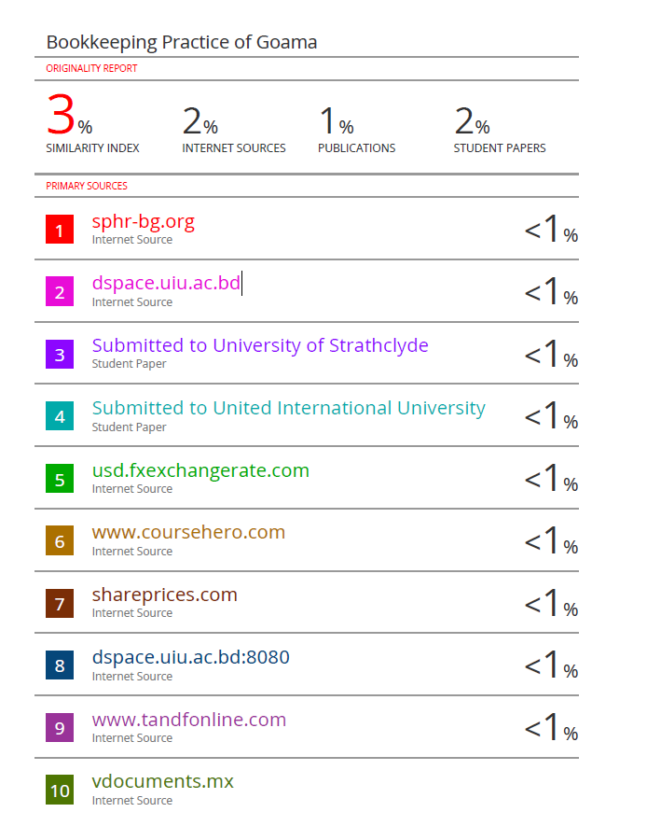

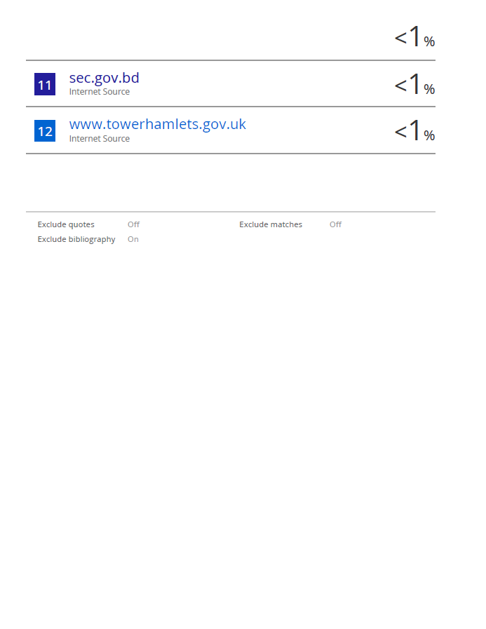

Students Declaration

I, Md Ashraful Haque, hereby declare that this internship report was titled Bookkeeping Practice of Goama (A Singapore based Gamification Company in Bangladesh), was prepared by me, and is submitted for grading as part of the degree completion requirement Bachelor of Business Administration in Accounting Information System at Unted International University.
I further clarify that this work has not been published previously for similar degree from this or any other educational institutions. All the information subject to references has been duly cited as per APA 6th guidelines using Charles Darwin University’s ‘Quick Guide to APA Referencing’ as the basis of citations.
Date: 22nd November 2025

Organisational Evidence
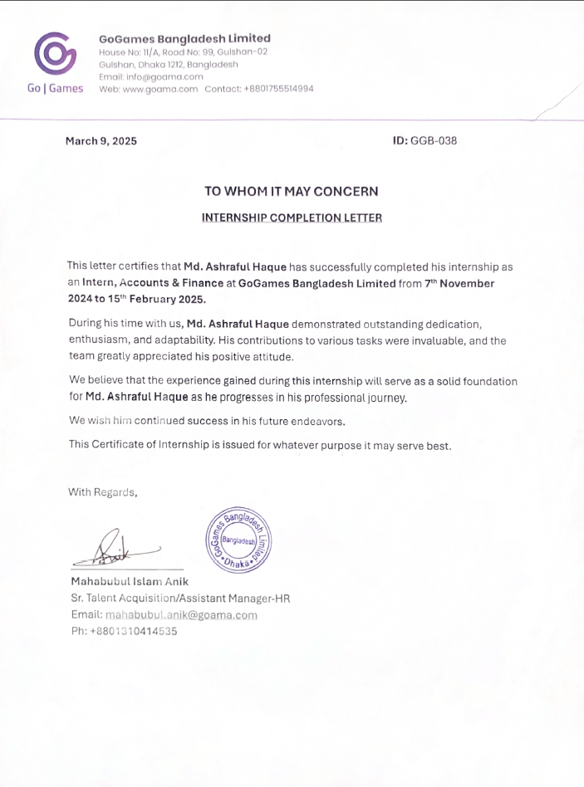

Gratitude

The promising resolution of this internship process, and the progress of the concluding report, marks a triumphant accomplishment, of the guidance received from the United International University faculties and my supervisor at GoGames Bangladesh Limited (Goama), who has shaped my knowledge in professional accounting and in both theory and practice. The report was prepared with a purview of transparency, professional integrity, and accuracy at its core.
My sincere gratitude towards GoGames Bangladesh Limited (Goama), to provide me an opportunity to engage, learn and grow as an ‘Accounts and Finance Intern’ and to demonstrate my ability to grasp the complexities of modern-day accounting, maintained fully through software such as QuickBooks and solve issues that disrupts the process, and ensure smooth operational efficiency.
A great respect to my supervisor Arafat Mahmood, Finance Manager, for his patience with me regarding my unwavering determination to learn until I fully grasp the concepts, and always eager to answer my ‘why’s’ and ‘how’s’. His leadership has helped me understand the magnitude of ‘trying to solve yourself, before asking for assistance’ in great depth as true mastery is only achieved when mistakes are also made along the way.
A very deep appreciation to the United International University AIS faculties for always entertaining my curious mind with appropriate answers, and my academic supervisor, Dr. Mofijul Hoq Masum, Associate Professor, for shaping me, and my knowledge base from the very beginning till the end of my journey at the university. With his guidance on rigorous practice, discipline, and sincerity, I was able to shape myself both as a person and as a professional.
Md Ashraful Haque
Accounts and Finance Intern at GoGames Bangladesh Limited (Goama)
22nd November 2025.

Business Review

The report is prepared as part of the Bachelor of Business Administration in Accounting Information System degree completion requirement of United International University and pertaining to the internship period of three months at Go-Games Bangladesh Limited (GBL), a sister concern of Goama. as an Accounts and Finance Intern. The primary purpose of the internship was to gain proficiency in a cloud-based accounting software (QuickBooks Online - QBO) to assist the department of Accounts & Finance of Goama in fixing their books and reconcile all their banks.
The core duties were to assist the finance manager with bank reconciliation, which required invoicing and billing to related parties, and correcting prior errors. A significant amount of time was invested in understanding and correcting previous entries as these entries did not contain enough information in their descriptions to understand the purpose of these entries and how to correct them with proper information. The mismatch between QBO entry date and bank statement date also further complicated the process of resolution. Minimising these inaccuracies and inconsistencies were the primary goal in mind as resolving these issues would create transparency and make them easily interpretable by the auditors and employees in the future.
Goama is a B2B “Gamification” service provider and has few revenue models. The company being headquartered in Singapore, strives to align their books in accordance with IAS and IFRS as the company makes all its tax returns in Singapore. The company has four (SGD, USD, BDT, and MMK) used by the parent and all its subsidiaries respectively and uses USD as its presentation currency.
The lack of the payroll add-on leads to heavy reliance on manual journaling for employee salaries, which prevents these payables to show up in the aging summary, thus creates operational inefficiency. The company also uses manual journaling for VAT and Tax compliance, which is offered by other software companies operating in this industry, therefore is a challenge for its users to quantify the benefits gained and lost using QBO. The company also does not have any allowance for bad debts.
Based on the findings and recommendations, the company should invest in the QBO payroll add-on, integrate with a NBR approved local company to automate the local VAT and Tax compliance, to fully utilise the benefits offered by could base accounting software. Although not mandatory but keeping an allowance for bad debt was advised as a precautionary measure to mitigate any future loss.
The internship provided both parties (the intern and the company itself) the opportunity to grow, as the company provided professional development and the internship duties provided the company a strong compliance of bookkeeping process.
Key Words: Bookkeeping, QuickBooks, Foreign exchange, Separate Business Unit, Group of company.

Contents
Letter of Transmittal IV
Similarity Index Certification V
Students Declaration VII
Organisational Evidence VIII
Gratitude IX
Business Review X
Chronological order of Charts XIV
Chronological order of Tables XV
Chronological order of Equations XVI
Acronyms & Abbreviations used XVI
Part 1: Preface 1
I.1 Context 1
I.2 Objectives 2
I.3 Rationale 2
I.4 Scope & Limitations 3
I.5 Defining the Key Terms 4
I.6 Methodology 4
Part 2: Goama, and QuickBooks Usage Trends 6
2.1 Analysis of the Company (Goama Group) 6
2.1.1 Goama’s History 6
2.1.1.1 Trends and Growth 7
2.1.2 Product / Service / Customer mix 8
2.1.3 Company Operations / Activity 8
2.1.4 Company S-W-O-T 11
2.2 Industry Analysis 12
2.2.1 Brief overview of the accounting practices using software in Bangladesh. 12
2.2.2 General trends, digitalization, use of software, automation, remote accounting. 12
2.2.3 Industry S-W-O-T 13
Part 3: Professional Work Placement 15
3.0.1 Designation, Duties, & Responsibilities 15
3.0.2 Training & Development 16
3.0.3 Contribution to Organization / Operations 16
3.0.4 Evaluation 17
3.0.5 Skills Applied 17
Part IV: CONCLUSIONS AND KEY FACTS 19
4.1 Findings 19
4.2 Key understanding & Recommendations 23
4.3 Conclusion 24
Reference 26
Appendices (N/A): 27

Chronological order of Charts

- Chart 1 – How invoicing & billing works
- Chart 2– How accrued revenues are booked according to IAS 18
- Chart 3 - Demonstration of how a clearing account works to resolve issues arising from foreign currency.

Chronological order of Tables
- Table – 1 (Company SWOT).
- Table – 2 (Comparison of features among various accounting software).
- Table – 3 (Industry SWOT).
- Table – 4: Functional and Presentation currency.

Chronological order of Equations
As this is a descriptive study no equations were necessary for use

Acronyms & Abbreviations used

- IAS – International Accounting Standard.
- IFRS – International Financial Reporting Standards.
- Goama/GPL – Goama.
- GoGames/GBL – GoGagmes Bangladesh Limited.
- MCL – Miaki & Co. Ltd.
- MML – Miaki Myanmar Limited.
- NDA – Non-Disclosure Agreement.
- QBO – QuickBooks Online.
- FS – Financial Statements.
- FY – Fiscal/Financial Year.
- USD – United States Dollar
- SGD – Singapore Dollar
- BDT – Bangladesh Taka
- MMK – Myanmar Kyat
- MYR – Malaysian Ringgit

Part 1: Preface

Context

General-Bookkeeping is the initial process of recording any transaction that any business organisation must maintain to use the data for every other use such as reporting, analysis, budgeting, and forecasting. It helps an organisation to have data that has accuracy, transparency, and compliance with ‘International Accounting Standards’ (IAS) audit ready information for decision makers (both internal & external). The integration of accounting software such as QuickBooks, Xero, Tally, Zoho Books are a few examples of how these software helps an organisation to switch from manual bookkeeping to an automated system which minimises human error.
The objective of this report is to understand the bookkeeping process of Goama. (GPL) and all her subsidiaries maintained by the ‘Accounts & Finance’ department. As an intern for three months, I had the opportunity to maintain the books of a group of company with three subsidiaries. My role was to assist the finance manager primarily with bank reconciliation as it also required me to book other necessary transactions such as invoicing and billing.
QuickBooks is a cloud based, widely used, accounting software for multinational companies. The primary focus is to learn about QuickBooks, use of QuickBooks in maintaining the daily bookkeeping process of Goama and her subsidiaries separately, and as a group, findings, learning outcomes, and finally an assessment of the practice and its alignment with the relevant IAS.

Objectives

As an ‘Accounts & Finance Intern’ at Go-Games Bangladesh Limited, which is one of the subsidiaries of Goama, my role was to learn how to use QuickBooks online to ensure accuracy and minimise previous errors made in the financial year 2023 – 2024 before submitting the financial statements, generated by the software, for the year end audit of ‘Fiscal year 2023-2024’.
Therefore, the report focuses on the following key objectives:
- To focus on the learning outcome and skill development.
- To learn about the software and how it solves the dual entry bookkeeping process internally.
- To reconcile with bank provided statements as the primary base for each entry, correction, or deletion (including billing and invoicing).
- To correct and resolve challenges faced during entry.
- To evaluation of company practice with relevant IAS.

Rationale

Bookkeeping is considered the backbone of any business for proper maintenance of their accounts. The qualitative characteristics of relevance and faithful representation relies solely on the proper maintenance of daily bookkeeping, as without non erroneous data would eventually lead to a complete, clear, consistent, and accurate financial information.
Hence, without the appropriate bookkeeping a company can-not expect to possess financial information that is understandable, relevant, comparable, and verifiable for the purpose of financial reporting, which is the final step of a complete accounting cycle.
In Goama (Gogames), I was given the position of an Accounts intern for my relevant academic background in ‘Accounting Information System’ in particular. The process of acceptable accounting practice learned throughout my university degree was necessary to maintain the books of the group of company.

Scope & Limitations

Goama is a private limited company and are not required to publish or disclose their audited financial statements. Therefore, the scope of this report only covers the bookkeeping of Goama as a group and the bookkeeping of all her subsidiaries as ‘Separate Business Units’ (SBU’s). They have an extremely strict policy of maintaining confidentiality related to their business operations and their finances.
Due to the Non-Disclosure Agreement (NDA) clause of the company all financial information related to Goama and her subsidiaries cannot be presented in this report. The report will be available in the university’s public domain (DSpace), therefore even if an NDA is approved, availability of my report on any publicly available domain will dishonour the NDA.
Even though my duties during the internship period was encompassed all the activities (except for salaries of GBL) the finance manager must deal with, and I was also given access to various confidential documents (such as google sheets, excel workbooks to book provisions for revenue and expenses), ‘Audited Financial Statements’ of previous years; I am unable to present and include any of these information in my report due to my contractual bindings with GoGames Bangladesh Limited, and in turn Goama.

Defining the Key Terms

Gamification - "the use of game design elements in non-game contexts" – (Groh 2012).
Consolidation – Combining all financial information into a single coherent one.
Bookkeeping – The process of identifying, categorising, each transaction that provides valuable financial information to the stakeholders.
Exchange rate – A rate that is used to settle a transaction between two parties operating in different economy using different currencies.
Bank reconciliation – The process of matching bank book with cash book of an organisation.

Methodology

Data design
The data required for preparing this report was collected using both primary and secondary methods of data collection. As there are no quantitative data used, most of the information and data were collected by primary method.
Primary Data – Almost all the data for this internship report was collected from actual work experience, observation, and conversations with the finance manager during work.
- Work was mostly from home, therefore most data about the company were collected during google meet meetings, and at times over a phone call, or text message using WhatsApp with the Finance manager.
- Financial data were mostly observed and understood by thoroughly examining the QuickBooks Online software.
Secondary Data – The information pertaining to the company analysis and Industry analysis were collected from the following sources.
- History – Company website.
- Trend and growth – Audited financial statements.
- Product, service, customer mix, and company operations – Company website.
- Industry Analysis – Gemini Flash 2.5.
Research Tools – Tools used for this research are Tables, Charts, Microsoft Word, QuickBooks Online, Gemini Flash 2.5.
Confidentiality notes:
The Audited financial statements were used to write the trend and growth sections, but the actual numbers were not presented, and supporting documents for these percentages cannot be presented in this report due to the confidentiality (NDA) agreement between Goama and myself. Therefore, the data does not contain any values deriving from the actual audited financial statements.

Part 2: Goama, and QuickBooks Usage Trends

Analysis of the Company (Goama Group)

Goama’s History

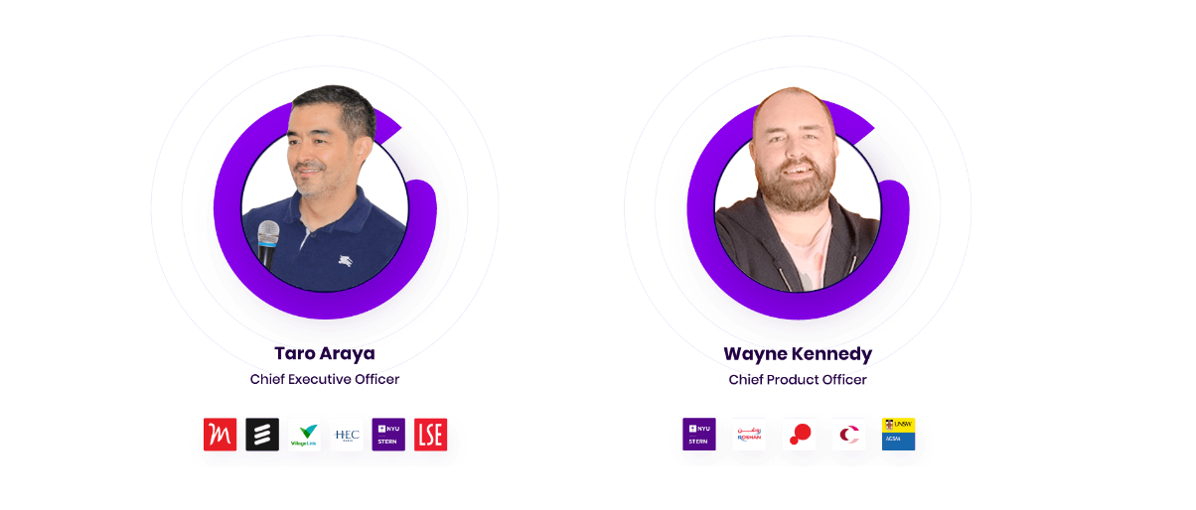
Goama is a private limited company based in Singapore. The company was founded in 2018 by its two founding members Taro Araya and Wayne Richard Kennedy. Goama provides gamification services to various organisations with a vision to integrate mobile game apps into various business’ own apps to enhance the user engagement. Since its inception the company has expanded its business into many parts of the world such as Asia, Europe, and significantly in Latin America. As the growth of the company increased, the necessity to create additional subsidiaries under Goama became necessary to smoothen the operational process, which would be overly complicated as the company has major investments in three (Bangladesh, Myanmar, and Dubai) regions and these investments are represented by the full ownership of GBL, MCL, and MML. Therefore, Goama is not concerned about these companies making profit or not, but it considers the consolidation of its revenue and expenses, to determine the financial position of Goama group singular unit.
Increasing revenue or profit individually is not the primary goal of these companies as stated above, but to assist in the daily operational efficiency is the driving factor behind the creation of these subsidiaries. Therefore, regardless of where an employee is employed (GBL, MCL, or MML,) all their work eventually necessitates the consolidated operational efficiency of Goama.

2.1.1.1 Trends and Growth

Goama since its inception has been growing significantly with a 20.71% growth in 2020, 1.03%in 2021, 2.66% in 2022, and a decline of 1.14% in revenue, according to their audited statement of comprehensive income. Due to some policy changes in the hosting country online gaming platform revenue recognition, the company faced difficulty in the financial year 2022 – 2023, as they could not recover a big portion of their revenue from their ventures in the South-East Asia region.
The market share of Goama has been increasing since 2019 as their only source of revenue at the end of 2019 financial year was service income. The market share was expanded in various countries such as Bangladesh, Cambodia, Malaysia, Mexico, Myanmar, and several other countries which reflects the 20.71 increase in their revenue at the end of financial year 2020.
Goama initially started with a handful of employees back in 2018. Since then, the company has hired employees from various countries.

Product / Service / Customer mix

Goama is a service-oriented casual e-sports platform and primarily offers ‘Gamification’ services to various organisations. Goama has a vast collection of retro arcade type games which they offer their clients to use to enhance their marketing campaigns. Hence, their primary customers are also other business organisations, therefore they offer mostly Business to Business (B2B) services.
Most of the business organisations these days have their own websites or applications (apps) for various purposes such as ordering and payment, customer support, cataloguing, and other purposes (traffic generation, promotion etc). These websites are often designed in a manner to obtain and retain existing visitors with and objective to boost sales.
Goama offers these business organisations to integrate gamification models to attract new visitors (potential customers) and retain the existing customers by giving rewards and prizes (which can be designed specifically to client needs) to these digital users through Goama games daily with tournaments with live leader boards, which in turn creates a competitive scene and a shared social community such as other multiplayer games. The objective is always directed towards boosting revenue for the client.

Company Operations / Activity

Goama as a company has five separate operations from which their revenue is generated. These operations are discussed in detail below:
- Direct Carrier Billing (DCB) – The DCB section of Goama consists of paid subscriptions to Goama (GoGames) game library for a fee charged directly from a user’s cell phone balance. Players can play games in this platform to compete with other players and compete for the prize pool (Mobile phone, Bike, Laptop, or points reward which can be cashed out).

The goal is to create a competitiveness among the users, increase engagement, and boost revenue through user subscription. To boost user subscription exciting physical prizes are offered to the winners with active subscription.

For example, in 2025, GBL has launched an online gaming platform named ‘Kheli’ where users can pay a weekly or monthly subscription and compete for the physical prize offered to winners. These operations are not the primary source of revenue for the company; they merely act as the brand promotion.
These operations may have the element of tournaments; it is categorised as DCB because the only source of revenue from these operations are the subscription fees paid by users.

- Paid Tournament – A significant portion of the revenue comes from paid tournaments hosted by Goama games in various countries by their respective tournament managers, who work with Goama on a commission-based system. These tournaments are hosted on clients’ apps to boost user engagement. Clients also receive a portion of revenue based on agreed terms. Goama hosts these tournaments in five regions now of which Bangladesh is one of them.

- Fixed Fee Model & Branded Games – The fixed fee model and branded games are the operations that Goama primarily focuses on, as these models generate most of the revenue. The gamification model that Goama provides through branded games to many B2B organisations are categorised in their income statement as Fixed Fee Model, which Goama’s official website also mentions gamification and branded games.

Both fixed fee model and branded games are services given to other business organisations to boost revenue, brand image, and promotion through customer engagement. But these two operations are not the same in terms of their delivery.

The fixed fee model is generally an add on feature in a client’s app or website that aims to promote brand image through interactive tournaments hosted by Goama with exciting physical (mostly) or digital prize pools.

The branded game consists of games developed by Goama to be customised to clients’ preferences with an aim to boost client’s brand. It contains client’s logo, brand name, and any element that has the potential to enhance the product or service position in the customer’s mind.

The operations for both models, therefore, are somewhat similar in their method of goal attainment, but are dissimilar in terms of delivery.

- In App Advertising – Revenue generated from users who play for free. All the visitors can play the games free of charge, without entering any tournament. Goama utilises In-App advertising revenue by placing advertisement on the ‘Free-To-Play’ games.

Company S-W-O-T

Table – 1 (Company SWOT)
Strength  - One of the market leaders in platform gamification.  - Has global presence.  - Uses accounting software for bookkeeping.  - Strong internal control in QuickBooks online. | Weakness  - Low visibility in Bangladesh.  - Erroneous and inconsistency in bookkeeping using QuickBooks online.  - Need trained personnel to maintain bookkeeping in QuickBooks online.
Opportunity  - Increase market share in Bangladesh.  - Boost revenue from DCB and Paid tournaments.  - Integrate other add-ons (payroll) to enhance the process of bookkeeping.  - Potential to tap into the education sector of Bangladesh. | Threat  - Compromise of confidential financial information.

Industry Analysis

Brief overview of the accounting practices using software in Bangladesh.

The use of accounting software in Bangladesh is growing. Businesses having complex financial operations tend to use various software based on their needs. Even though many businesses like sole-proprietorships and partnerships maintain their bookkeeping manually using spreadsheets the usage of software integrated with spreadsheets are increasing.

General trends, digitalization, use of software, automation, remote accounting.

According to a report Generated by Google’s AI (Gemini Flash 2.5), it was found that SME’s and start-ups tend to use cloud-based software for fast and economically efficient bookkeeping process. Among these are Tally-Prime (international), Iquidy (Local), Financify (Local), QuickBooks (international), Zoho-Books (international), and Odoo (international). Among these platforms the most popular is TallyPrime.
The table below (Generated by Gemini) shows the trend of usage based on organisational needs.
Table – 2 (Comparison of features among various accounting software)
(Gemini Flash 2.5, 2025).
Among these platforms the most popular is TallyPrime in Bangladesh.

Industry S-W-O-T

Table – 3 (Industry SWOT)

Strength  - Tally – Excellent for large hybrid needs as it has all addons included.  - Iquidy – Only software with automated VAT, Mukhak 6.3 support.  - Financify – Small business focused.  - QuickBooks – Strong core accounting features. | Weakness  - Tally – Core accounting features are generic.  - Iquidy – Lack of multicurrency support is a disadvantage to MNC’s in Bangladesh.  - Financify – Lacks payroll & HR.  - QuickBooks – Manual VAT and Tax tracking
Opportunity  - Tally – On premise servers for extremely sensitive data can be capitalised to gain market share from organisations with strict data sovereignty requirements.  - Iquidy – Leverage its expertise on local compliance to expand market share in Bangladesh.  - Financify – Can integrate Payroll system to expand market share in Bangladesh.  - QuickBooks – Introduce VAT and Tax compliance tailored to local compliance would add more value to its full payroll and time tracking system. | Theat  - Tally – Cloud based competitors focused on capturing Small and Medium Enterprise market share.  - Iquidy – Expertise on local VAT and Tax compliance can be introduced by competitors.  - Financify – Competitors like QuickBooks already offers more features (Payroll).  - QuickBooks – Competitors like Iquidy offers more regarding Tax compliance as VAT and Tax compliance in Bangladesh is overly complex.

**Due to the complicacy in retrieving data related to accounting practices in similar businesses, the industry analysis comprises of accounting software industry in Bangladesh

Part 3: Professional Work Placement

Designation, Duties, & Responsibilities

I started working at Goama as a ‘Accounts & Finance’ intern, with a background in Accounting Information System, I had to work directly with the Finance manager, Arafat Mahmood. He was also my supervisor for the whole internship period of three months. He had to train me on QuickBooks, an accounting software, as the company’s whole book-keeping was maintained through this software.
As an intern my first task was to learn how to use and learn how to navigate inside the software, how to create ledger accounts as well as sub-ledger accounts, supplier and customer accounts, and the creation and recording of various customer invoices and supplier bills. The most important duty every month was to reconcile each bank account with the QuickBooks ledger accounts. All these duties were aimed at assisting my supervisor (also the Finance head) in day-to-day account maintenance of Goama and all its subsidiaries.
During my internship period at Goama, I was responsible for bank reconciliation, assist in preparing salary sheet Miaki & Co. Ltd, and creating invoices for all customers and book bills for suppliers.
The salary preparation for the employees of GBL were not part of my duties as the information related to salaries of GBL are only available to the finance manager and the executive, thus it was their responsibility to prepare the salary sheet for GBL. My duty was to only reconcile the total salary paid with salaries payable.

Training & Development

The primary focus of my supervisor was to train and develop me as a fully-fledged accountant by the time I have completed my internship. The training included the following:
- Learning the company’s accounting software and become efficient in navigation.
- How to prepare salary sheets for employees each month.
- Use Brio-HR (HR software of Goama) to identify and book expense claims made by the employees.
- Solve inconsistencies arising due to exchange rates (QuickBooks vs Bank).
- Internal Audit
- QuickBooks Online bank reconciliation.

Contribution to Organization / Operations

The book of accounts of Goama was disorganised before I had joined. The entries that existed prior to my joining were inconsistent from each other, as there was high level of inaccuracy in the dates at which they were booked and the dates those entries were paid. There was often a mismatch between the date QuickBooks entry date and the date reflected on the bank statements. The descriptions for those transactions were also unclear which became evident during the audit period, as the auditors were having difficulty in matching the transactions with the bank statements.
My personal goal as an intern was to minimise this mismatch and inaccuracies as much as possible as make the book of accounts clear, transparent, and easily interpretable by the auditors and all future employees, who might join the Finance team. The goal was fuelled by the challenges that I faced during my first one and a half month as an intern.

Evaluation

Self-evaluation on performance
Great thinker from various times have stated the erroneous nature of self-judgement, as it always contains bias. In his book ‘On the Genealogy of Morality’ Nietzsche writes “We are unknown to ourselves, we men of knowledge—and with good reason. We have never sought ourselves—how could it happen that we should ever find ourselves” (Nietzsche, 1887) implying the skewness of self-judgement as the one judging is also the one being judged.
Plato conferred “The worst of all deceptions is self-deception”, while Aristotle came up with “The friend is another self”, and to sum up these two philosophers Jung concluded quoting “We cannot see our own unconscious; we can only infer it by observing others. We always need another person to discover ourselves”.
All these great thinkers have warned us about the deception of self-evaluation; therefore, it is never wise to judge one’s own work, and the best mirror we can find are the ones who closely observe us. Hence, I would refrain from judging myself based on my performance, as it always will be biased.

Skills Applied

To ensure the quality and efficiency of my work I had to apply these following skills:
- Adaptability – My work was mostly remote, and I never had to work from home before. The idea of a place being both my workspace and my entertainment was incredibly challenging, which I still have a hard time to internalise, yet I had to be adaptable to make sure it does not hamper my duties and responsibilities.
- Time Management – There was no specific time (for example 9 to 5) to complete tasks. The official office hours were 9am to 5pm, but the intensity of work was never high, therefore the availability of me was required anytime during the day and office hours. Therefore, I had to manage my time very efficiently to be available for work at any time, yet the working hours never exceeded the company policy of 8 hours daily.
- Attention to detail – For every accountant attention to the slightest detail such as transaction dates, calculations of monetary amounts (to the closest decimals, especially for foreign currencies) are crucial in maintaining the book of accounts as per the Materiality principle of accuracy and completeness to be able to maintain full disclosure in the financial statements. Therefore, the inaccuracies in recording process of the transactions were the first challenge I had to fix, and with the help of my supervisor I was able to fix all the inaccuracies of the financial year 2023 – 2024.
- Determination to solve problems – At Goama, every day I was faced with a new issue. These issues were sometimes simple to solve, but sometimes because of lack or prior information, were exceedingly difficult to solve. As a person I do not like leaving problems unresolved, therefore, at Goama I was able to utilise this personal mindset to solve most of the issues I was faced with.

Part IV: CONCLUSIONS AND KEY FACTS

Findings

Goama as a group is a small company therefore there are less complications in maintaining their books. They always try to align their bookkeeping with relevant IAS and IFRS standards. Yet there were a few mismatches as stated earlier, and those errors leave scope for misunderstanding and clarity.
- Invoicing and Billing: Goama and all its subsidies maintain their invoicing through the QuickBooks internal system, and every invoice is sent to the customers directly from the software.
On the other hand, bills from suppliers are does not have an automated system therefore every bill has to be either provisioned or booked as they incur. The problem with booking as they incur can be challenging if bills paid, are not incurred in that month. Some bills found with insufficient documentation, which also sometimes made it difficult to identify the month in which the expense had occurred, and the reliance on the finance manager here becomes the only solution, which takes away the freedom to work as a bookkeeper independently without any assistance.

Chat -1 – How invoicing & billing works
- Payroll Management: Goama does not use the payroll addon in QuickBooks as it is an optional feature and therefore, payrolls are managed through journal entries. But there are difficulties in maintaining the payroll through journaling, as an accountant must consistently check the salaries payable in the balance sheet, to ensure whether a salary is still payable or not. The reason for this is the liabilities created through journal entries does not show up in accounts payable aging summary (unless it is created under accounts payable with a supplier name), which is a very efficient tool offered by QuickBooks to check on payables.
- Heavy reliance on journal entries: In GBL many payables and receivables (mostly intra company payables and receivables) are booked through journal entries. Although journal entries are the pillars of accounting, in QuickBooks it is advised to use journal entries only for adjusting entries and corrections.
Due to the lack of QuickBooks internal system for tracking ‘Accrued Liabilities’ and Prepaid expenses, the reliance on journal entries cannot be avoided, and every month the prepaid expenses and accrued liabilities needs to be checked within the balance sheet and make necessary adjustments. Although the recurring journal entry makes it easier to adjust any accruals, the heavy reliance on manual journal entries loses the purpose of using an accounting software to automate these complex processes.
- Provisions: Provisions for revenue are not provisioned as per IAS 37 guidelines, as provisions can only be made for outflow of resources, therefore, no provisions for bad debt are kept thus no provisions affect the company’s net realisable revenue.
For expenses, the provisions are made according to past four months average if the actual amount cannot be estimated with reasonable accuracy. Any provision made, is always revised as it occurs.
Provisions for Gratuity, and provident funds are always adjusted at the end of the financial year.
Provisions for fees related to legal and consultancy are booked every month with a fixed value and are revised as they incur.
- Accruals: Revenues that are accrued are maintained in compliance with IAS. Any orders received from a customer is booked in the balance sheet under ‘Orders Booked but not delivered yet’ account with invoices crediting this account and are only debited on the month of service by manual journal entries by crediting the respective revenue line in the Profit and loss statement.
Accrued liabilities (such as accrued expenses/payables) are booked directly by billing. But for salaries journal entries are used as the company does not have subscription for the payroll add-on service.

Chat -2 – How accrued revenues are booked according to IAS 18

- Bad debt estimates: The company does not keep any provisions for bad debt, and bad debt is only recognised when an invoice (revenue) is paid. Most of the bad debt arises from the transactions fee occurred on the customers end, which reduces the amount received in the bank. There was only one incident where one customer did not clear their dues, and the amount was fully written off during the audit. As a result, the company does not keep any estimates regarding bad debts.
- Foreign exchange policy: Goama and her subsidiaries have different functional currencies as following:

Table 4: Goama Group’s Functional & Presentation currency
Company name | Functional currency | Presentation currency (Company) | Presentation currency (Group)
1. Goama. | Singapore Dollar (SGD) | United States Dollar (USD) | United States Dollar (USD)
2. GoGames Bangladesh Limited | Bangladesh Taka (BDT) | Bangladesh Taka (BDT) | N/A
3. Miaki & Co Ltd. | United States Dollar (USD) | United States Dollar (USD) | N/A
4. Miaki Myanmar Limited | Myanmar Kyat (MMK) | Myanmar Kyat (MMK) | N/A

The financial statements of these companies are prepared in their respective functional currencies, but at every month end these currencies are converted to presentation currency during the monthly consolidated financial reports for the management.
During booking of invoices and bills, the exchange rate is determined by the software (QuickBook) itself and is not edited. After the payment of any of these invoices or bills the exchange rate is edited to match the actual monetary amount received or paid to match with the bank statements. During the month end reporting closing rates are determined by either Banks (TransferWise Bank Singapore) exchange rate, or Google exchange rate.
Sometimes and issue arises where calculating exchange rate becomes complex and time consuming to calculate. For example, if a supplier is paid with (MYR) Malaysian Ringgit but the amount is paid from a USD account from Goama, then QuickBooks records these transactions based on Goama’s system currency (SGD) and the exchange rate only shows SGD converted to MYR. To resolve this issue, the finance manager came up with a clever solution and created an artificial clearing account which serves as an intermediary between these three currencies (USD > SGD > MYR). These clearing accounts are SGD currency Cash in Hand Accounts. Bills are first paid using these clearing accounts and QuickBooks interna exchange rate is used. Then, a transfer is made from the actual bank account from which the payment is made into that clearing account and the exchange rate is matched with the SGD amount QuickBooks chose to initially pay that bill.

Chart 3 - Demonstration of how a clearing account works to resolve issues arising from foreign currency

Key understanding & Recommendations

Goama is a small start-up company, and their book of accounts are being maintained in a manner that complies with International Accounting Standards (IAS) and International Financial Reporting Standards (IFRS) as the company relies on their Audited Financial Statements to attract new investors, and even sometimes customers as some international customers require companies audited financial statements to ensure its ability to operate and be able to provide service as a going concern (IAS 1). It is not economically feasible to comply with every standard given by IAS or IFRS, but the company tries to oblige as much as possible ensuring efficient use of company resources.
Therefore, as per my observations some key recommendations for Goama and its subsidiaries are as follows.
- As the company is growing, it should invest in the payroll management QuickBooks software offers, to minimise its reliance on journal entries to record expenses related to salaries and manual adjustments every month.
- For VAT and Tax compliance the company can integrate QuickBooks with (NBR) National Bureau of Revenue approved software providers to calculate and prepare their Mushak 6.3 forms. Although the company pays a significant amount to a local supplier to resolve these issues, if GBL ever expands it would be advised to automate this process.
- Even though the company does not incur much bad debt, it should make an account for some allowance with reasonable estimates to mitigate any future losses arising due to a customer not being able to pay their dues.
They crucial decision here for the management, is to conduct a cost-benefit analysis, to ensure efficient utilisation of company resources, by considering each opportunity cost.

Conclusion

The internship experience at GBL (Goama) was an excellent opportunity to learn, adapt, grow as a professional aspiring to become one in this industry. Working as an intern was always intriguing as the challenges faced in these three months were consistent every day and was solved with utmost dedication to resolving the issue. The difference between theoretical knowledge gained from the university courses, and its application in practise was understood, which would not have been possible without seeing theory in practice.
These three months, from an employee perspective was an opportunity to learn and adapt, but as from my personal perspective, it was a challenge I had to face and resolve. By the end of my internship, I was able to resolve all the issues related to bank reconciliation, maintain a format in which every bill is booked with sufficient information for anyone to understand the actual date and purpose of these bills or expenses. Which will be followed in the future days.
There are some key recommendations that the company must focus on if they are to fully utilise the purpose of using accounting software, which is to automate the process of bookkeeping and generating reports. Although the these are not complex enough due to the volume of transactions an accountant must deal with every day, but with growth, volumes are meant to increase, thus the reliance on automation becomes essential over manual fixes.
Apart from the few recommendations, Goama as a group, tries to maintain their books aligned with IAS and IFRS, mostly because it is a Singaporean company, and for tax purposes, all their statements must be aligned with related IAS and IFRS, and they have indeed grown significantly after I have joined in terms of bookkeeping.
Goama not only helped me to grow in profession, but also allowed me to contribute a better bookkeeping process throughout the group of companies. Therefore, the growth on both sides were mutual.

Reference

- Aristotle. (2009). Nicomachean ethics (W. D. Ross, Trans.). The Floating Press. (Original work published ca. 350 BCE).
- Gemini Flash 2.5. (2024). A comprehensive analysis of accounting software adoption and market dynamics in Bangladesh. [Large Language Model Report]. Retrieved from Gemini Flash 2.5.
- Groh, F. (2012). Gamification: State of the art definition and utilization. Proceedings of the 4th Seminar on Research Trends in Media Informatics. 39-46.
- International Accounting Standards Board. (1998). Provisions, contingent liabilities and contingent assets (IAS 37). Retrieved from <https://www.ifrs.org/issued-standards/list-of-standards/ias-37-provisions-contingent-liabilities-and-contingent-assets/>
- Jung, C. G. (1981). The archetypes and the collective unconscious (R. F. C. Hull, Trans., 2nd ed., Vol. 9, Part 1). Princeton University Press. (Original work published 1959).
- Nietzsche, F. (1994). On the genealogy of morality (C. Diethe, Trans.; K. Ansell-Pearson, Ed.). Cambridge University Press. (Original work published 1887).
- Plato. (2000). Cratylus (B. Jowett, Trans.). In J. M. Cooper (Ed.), Plato: Complete works (pp. 101–156). Hackett Publishing. (Original work published ca. 360 BCE).

Appendices (N/A):
As this is a descriptive study, no survey(s) were conducted to collect the primary data; as direct work experience, and observations were the sole basis of primary data collection.

