United International University

INTERNSHIP REPORT
On
General Activities and Performance of Premier Bank Ltd.


Submitted to:
Shakila Aziz, CFA
Assistant Professor
School of Business & Economics
United International University

Submitted By:
Muhammad Farhan Amin Shohan
ID: 111 151 142
Program BBA
Date of Submission: 26 August, 2019
Letter of transmittal

26 August 2019
Shakila Aziz, CFA
Assistant Professor
School of Business & Economics
United International University

Subject: Submission of Internship Report on “General Activities and Performance of Premier Bank Ltd.”

Dear Sir,
With due respect I would like to say that it was a privilege and great pleasure for me to submit my internship report titled “General Activities and Performance of Premier Bank Ltd.” which has been prepared as a part of my BBA program requirement.
During preparation of the report, I have tried my level best to make it rich covering the all concerning matters. I believe the report will at least give you a brief picture about the topic which will also showcase that I have acquired the valuable experiences through this internship under your astute supervision.
Thank you for encouraging me for working on this interesting topic. Kindly accept my report and oblige thereby.

Sincerely Yours,
Muhammad Farhan Amin Shohan
ID: 111 151 142
Program BBA
United International University
Acknowledgement

At First, I would like to show my gratefulness to Almighty Allah for helping me to fulfill the report in the right time frame. I would also like to thank my respected faculty Shakila Aziz,CFA, Assistance Professor, United International University, for helping me to complete my report by guiding me in every occurring problem. He provides me solutions to make my report as correct as possible. My sincere appreciation goes to my supervisor Mr. Noor-A-Kawsar, Deputy Manager, at Premier Bank Ltd., for providing me with some work related knowledge. His guidance and co-operation helped me a lot to earn my experience. And I would like to say that I have tried heart and soul to prepare this report accurately. However there might be some errors and mistake so I seek your kind consideration as I am in the process of learning. Last but not the least, I am grateful to United International University which is the reason I am standing here on the precipice of earning my bachelor degree successfully.

Executive Summery

Premier bank limited is the leading private commercial banks in the country. It serves the nation from last 20 years. It has the largest participants amongst its peer group. Premier Banking is available for selected clients only. Chief bank restricted is one of the driving private commercial banks within the nation. It is serving the country from final 20 a long time. It has gotten to be the biggest competitors among its peer group. Customer fulfillment could be a degree of how items and administrations provided by a company meet or outperform client desire. It is seen as a key execution marker inside a trade. So, assessing the level of client fulfillment really makes a difference to degree an organization’s position in trade. I’ve calculated the Client Fulfillment List by utilizing SERVQUAL instrument having the explanations on benefit quality measurements through confront to confront interviews with the accountholders of the bank. Their assertions (concur & emphatically concur) with the articulations touching the cut off and it is considered as fulfilled in this ponder. Premier Banking is a division of Commonwealth Bank and its services are provided by Premier Banking Relationship Managers who are representatives of Commonwealth Bank. Financial planning, superannuation plans and advice on some categories of insurance products will be provided by Commonwealth Financial Planners who are Representatives or Authorized Representatives of Commonwealth Financial Planning Limited.
On the premise of conducted Key Witnesses Interviews, the quantitative think about result and my perception I accept that designating more representatives beneath Common Keeping money office, keeping up time spaces for each client to serve, setting up of electronic calling machine for cash counter and client benefit, setting up of inquiry work area, substitution of center managing an account computer program by way better one, customary course of action of worker preparing workshops, naming female workers, etc. will offer assistance to extend the fulfillment level of the clients of the bank.

Table of Contents
Part 1: Introduction of Report 8-10
  - Introduction 9
  - Origin of Study 9
  - Objectives of study 9
  - Significance of Study 10
  - Methodology of study 10
  - Limitations 10
Part 2: A Brief Organizational overview of Premier Bank Ltd. 11-18
2.1 History 12
2.2 Slogan 12
2.3 Vision 13
2.4 Mission 14
2.5 Values 15
2.6 Strategies & Priorities 16-17
2.7 Confidence 18-19
Part 3: Premier Bank At a Glance 19
Organogram 20
Part 4:Rtio Analysis 22
Ratio Analysis 23-36
Part 5: My work as intern in Premier Bank Ltd. 37-42
What I work to do 38-42
Part 6: SWOT Analysis 42
SWOT Analysis at a Glance 43-44
Part 7: Findings Recommendation and Conclusion 46-47
Findings 46
Recommendation 46
Conclusion 47
Bibliography 48

Part 1: Introduction of Report

  - Introduction:
This report is all about the internship program. Here, the report is assigned to me as I am a student of United International University and complete my Bachelor of Business Administration degree. I have done this internship program under the honorable faculty member Mrs. Shakila Aziz. For this internship program, I have completed it in Premier Bank Ltd. The duration of this internship program is from 15th June, 2019 to 28th august 2019.

1.2 Origin of the study:
According to the requirements of the university course guidelines, an internship program requires a student to fulfill it. For this program, I have joined Premier Bank Limited to complete this three months internship program. In Premier bank, I am appointed as internee under “General activity and performance” department. Due to the requirement of the university, I have prepared this report and it helps me a lot to know about the bank.

1.3 Objective of the study:
The main purpose of this report is to research about the general activities of the company and how they manage policies while doing this work. In banking corporation, it is very important to maintain policies otherwise it might create problem. The objectives are described below:
- To know about the daily operations of the banking corporation
- To know about the whole banking procedure of the bank
- To research about the banking system and which one they follow
- To mark about the significant role of the general activity department in the whole organization
- Along with that, to evaluate the importance of the department and how it helps Premier Bank to secure its position in current market.

1.4 Significance of the study
Generally, the main purpose of this internship report is to achieve practical corporate life experience. This course is designed in such a way that they get to know about the corporate environment. Through this program, they ensure that students can apply their theoretical knowledge in real life and to know how one should behave in corporate life. In corporate life, a student first time gets the experience to work in a company or bank. With the help of this program, a student also gets to know about whether they are perfect for corporate job or not. Along with this, they also get to know about the whole procedure of the company which helps them to get job in later life.

1.5 Methodology of the Study:
This study utilized the quantitative research methodology. In order to investigate the credit policy, accounting information were derived from annual reports of the Premier Bank Limited for the last five repeated years. It used synthesized information collected from Annual reports, journal.

1.5.1 Primary Sources:
- Taking to the organization employees
- Direct Observation
- Interviewing Chief Financial Officer
1.5.2 Secondary Sources:
- Company Websites
- Annual report
- Revise of relevant files
- Official records

1.6 Limitations:
This report is conducted to know about the banking procedure of Premier Bank Ltd. I am a student of Finance and have completed my internship program in Premier Bank Ltd. While preparing this report I need to face some limitations which are described below:
- To prepare the report, time is very limited.
- For this report, I need some data but it can’t be provided because of organization security.
- Sometimes, some useful data are so wide that it can’t be included on report.
- Along with this, this report is done on a very small scale.

Also as Motijheel branch of Premier Bank is so much rush in every time even after the closing time of the bank, it was so hard to collect information from the officers

Part 2: A Brief Organizational overview of Premier Bank Ltd.
2.1 History:
Premier bank is considered as one of the best bank for its services among all other banks. This bank started its journey in 1999 on June 10. When a bank wants to start its journey, they need to follow Companies act 1994. Along with this, they also need to get permission from Bangladesh Bank which is the central bank of Bangladesh. Bangladesh bank gave license to Premier bank on June 17, 1999. The main branch of Premier bank is in Banani which is considered as one of the prime location for business.
2.2 Slogan:
The main motto of Premier bank limited is to “Service First”. Here, they believe that customers are valuable and it is important to serve them at first. When the customers get service in right time, they will be the loyal customers of the bank.

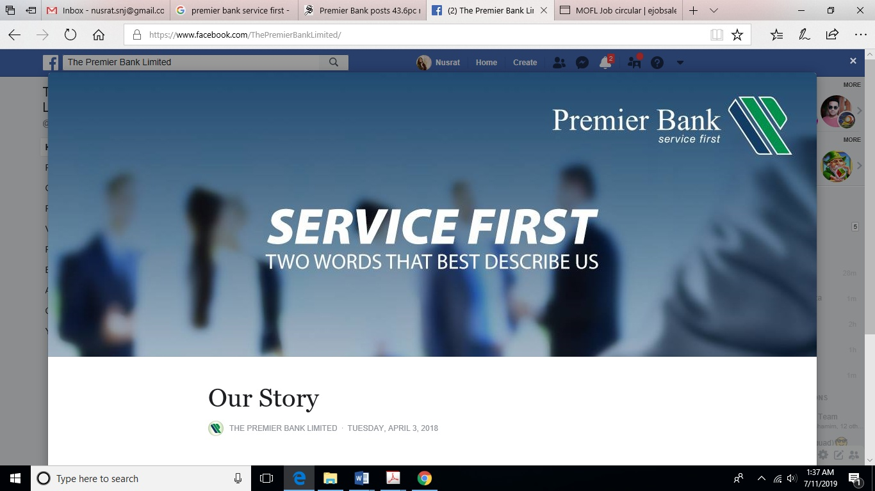

2.3 Vision:
The vision of Premier bank limited is to achieve the top position among all the banks in Bangladesh. Along with this, they also want to be top in customer service.

2.4 Mission:
Each and every organization set mission for their company. They set mission so that they can maintain the daily activities which will ultimately lead to achieve the ultimate vision of the company. The mission of Premier bank limited is described below:
- As they believe in service, they give most priority to their customers. They ensure that customers would get the proper service.
- Along with this, they make sure that customers would find that the environment of this bank is good. It will help them to satisfy that their hard earned money is in right place.
- In banking corporation, employees need to deal which lots of tasks. For this reason, it is important to receive all kind of modern technology which will help to accelerate the work process.
- In an organization, it is inevitable to maintain transparency and ethical standard. In this case, Premier bank always try to maintain it with their customer.
- The main reason for an organization is to earn profit. Apart from that, premier bank try to be socially responsible by giving educational loans to the students.

2.5 Values:

Service First:
The core value of Premier bank is to serve their customers. So, they always try to serve their customers as early as possible so that they don’t need to wait.
Easier banking:
Now a day, life is too busy for both employees and customers. Here, they try that baking process for the customers should be easier so that they do not need to face any hard situation.
Better relationship:
Premier banking always focuses on creating better relationship with their customers. When customers would have better relationship with them, customers would be satisfied. Through better relationship with customers, an organization would be able to achieve goals.
Assured confidentiality:
For financial institution, it is important that they give proper confidential to the information of their customers. They need to make believe their customers that their money and all the information are safe.
Good Corporate Governance:
In this case, the directors of Premier bank ensure that all kinds of activities will be done according to the rules and regulation of the Central Bank.
Corporate citizenship:
In this world, every organization needs to maintain it for the welfare of the society. For this reason, they pay tax and try to create awareness about the environment. Along with this, they also maintain laws and regulation.

2.6 Strategies & Priorities:

2.6.1 Strategies

Be Pro-active:
Here, the employers make sure that employees are active in their office time which will help to serve the customers in a better way. Along with this, they also ensure that all the employees are working in a proper way.
Begin with the end in mind:
The daily activities of bank are really hectic. For this reason, it is really important that all the employees start their work at office time. They should not be late while serving their customers. If they are late in work, they might lose customers.
Put First Things First:
In a banking corporation, there are lots of works which need to be done within a certain period of time. In this case, employees need to do the most important task at first and then start the less important task.
Think win win:
Here, it means that they should ensure benefits in all kinds of human interactions. In this way, employees will be optimistic and hopeful.
Seek first to understand and then be understood:
All the customers expect a certain amount of service from their bank. For this reason, employees at first need to understand what customers want from them and then provide them services according to their expectation.
Synergy:
It means working together to achieve goals. When an organization wants to be successful, all the departments of the organization need to work together. With the help of all the employers and employees, it is possible to execute the plan and achieve the desired position.
Care and Share Alike for the Society:
Premier bank is considered as one of the most famous banking corporation in Bangladesh. They believe in caring and sharing for the society. For this reason, they try their best to provide services to the less privileged ones so that it might help them to develop their life a little bit.

2.6.2 Priorities

- The main vision of Premier bank is to achieve the highest position among all other banks in Bangladesh.
- This organization believes in service. They want to provide the best services to their customers.
- Here, they also want that their asset quality has to be best in the industry.
- To achieve organizational goals, they ensure that Return on Assets (ROA) should not be less than 2%.
- To make the financial situation stronger, they work hard that Return on Equity (ROE) should not be less than 50% otherwise it might affect the situation.
- As this organization core believe is customer service, the employees always try to understand their customers need. Along with this, they also research about what customers want from the bank.
- While doing the banking activities, employees have to be always updated regarding the regulation.
- Along with this, they also need to research about the new technology which can be introduced in banking system.
- In USA, CAMELS rating is used to know about the whole condition of the bank. Here, Premier bank wants to rate best under CAMEL rating.
- An organization can’t be valued by it net income instead of it is valued by their shareholders and employees. For this reason, it is crucial to give proper return to their shareholders for their investment. For the employees, they want to make give them job security, salary, facilities and respect. While working in this organization, employees should feel proud.

Corporate Information

Registered Name of the Company
The Premier Bank Limited
Legal Form
A scheduled commercial bank incorporated on June 10, 1999 as a Public Limited Company under the Companies Act, 1994 and Bank Companies act, 1991.
Registered Office
Iqbal Centre (4th Floor), 42 Kemal Ataturk Avenue, Banani
Dhaka-1213. Tel 9887581-4, Fax: 8815393, 9889153

Timeline & Milestones
Date | Details
15 June 1999 | First Meeting of the Board of Directors
17 June 1999 | License issued by Bangladesh Bank for commercial banking
26 Oct. 1999 | Formal Launching of banking business
21 June 2003 | Establishment of own Training Institute
03 Aug. 2003 | Introduction of Real Time Online Banking
16 Oct. 2003 | Commencement of Islamic Banking Business from IBB, Mohakhali
22 Jan. 2004 | Pioneering VISA Credit Card among the local banks
30 Jan. 2006 | Launching of SMS Banking Service
05 Aug. 2006 | Launching of CMS Banking Service
01 Feb. 2007 | Publication of Prospectus
18 Mar. 2007 | Subscription Opened
22Mar. 2007 | Subscription Closed
23 Apr. 2007 | Lottery for Allotment of Shares
16 May 2007 | Listing with Chittagong Stock Exchange Limited
23 May. 2007 | Listing with Dhaka Stock Exchange Limited
27 May. 2007 | Trading of Shares on DSE & CSE
28 Oct. 2007 | Launching of Premier ATM Services
28 Oct. 2007 | Introduction to Premier Visa Debit Card
12 Apr. 2008 | Introduction of Bank’s Own Remittance Software (DRUTI)
19 Oct. 2008 | Purchase of DSE Membership
20 Apr. 2009 | Dividend Approved by 9th AGM (First after the IPO)
26 Oct. 2009 | Completion of 10th Glorious Years of Banking Services.
17 Nov. 2009 | Purchase of CSE Membership
01 Dec. 2009 | Commencement of Brokerage Operation
17 May 2010 | Remittance Deal with Grameen Phone
23 June 2010 | Incorporation of Premier Bank Securities Limited – Subsidiary of Bank
18 Sep. 2010 | Migration to Centralized Core-Banking Software
07 Oct. 2010 | Live Operation of Bangladesh Automated Cheque Processing System
25 Nov. 2010 | Launching of Platinum Dual Currency MasterCard
21 Aug. 2011 | Establishment of Bank’s own DR (Disaster Recovery) Site
26 Sep. 2011 | Launching of Premier Mobile Remittance Service with Grameen Phone
20 Feb. 2012 | Launching of Premier Money Transfer Company Ltd. (PMTCL, a 100% subsidiary of Bank) in London, UK
29 Aug. 2013 | Incorporation of Premier Bank Foundation
19 Nov. 2015 | Launching of Premier Direct (i-Banking, SMS Banking & e-statement Service)
15 Oct. 2016 | Up gradation of CMS (Prime 4.0) System & Launching EMV Chip Card

2.7 Confidence:

- The short and the long-term to prospect our in bank is boundless.
- We have right and the workable policies in place.
- The bank is the supported by rock hard capital foundation.
- Strong divergence by business, topography and products enhance up our tactical benefit.
- A risk organization and submission culture
- A durable focus in quality control
- A energetic Board of Executives
- A knowledgeable of Management Team
- A prodigious human resources.

Part 3: The Premier Bank Ltd. at a glance
Organizational Hierarchy:
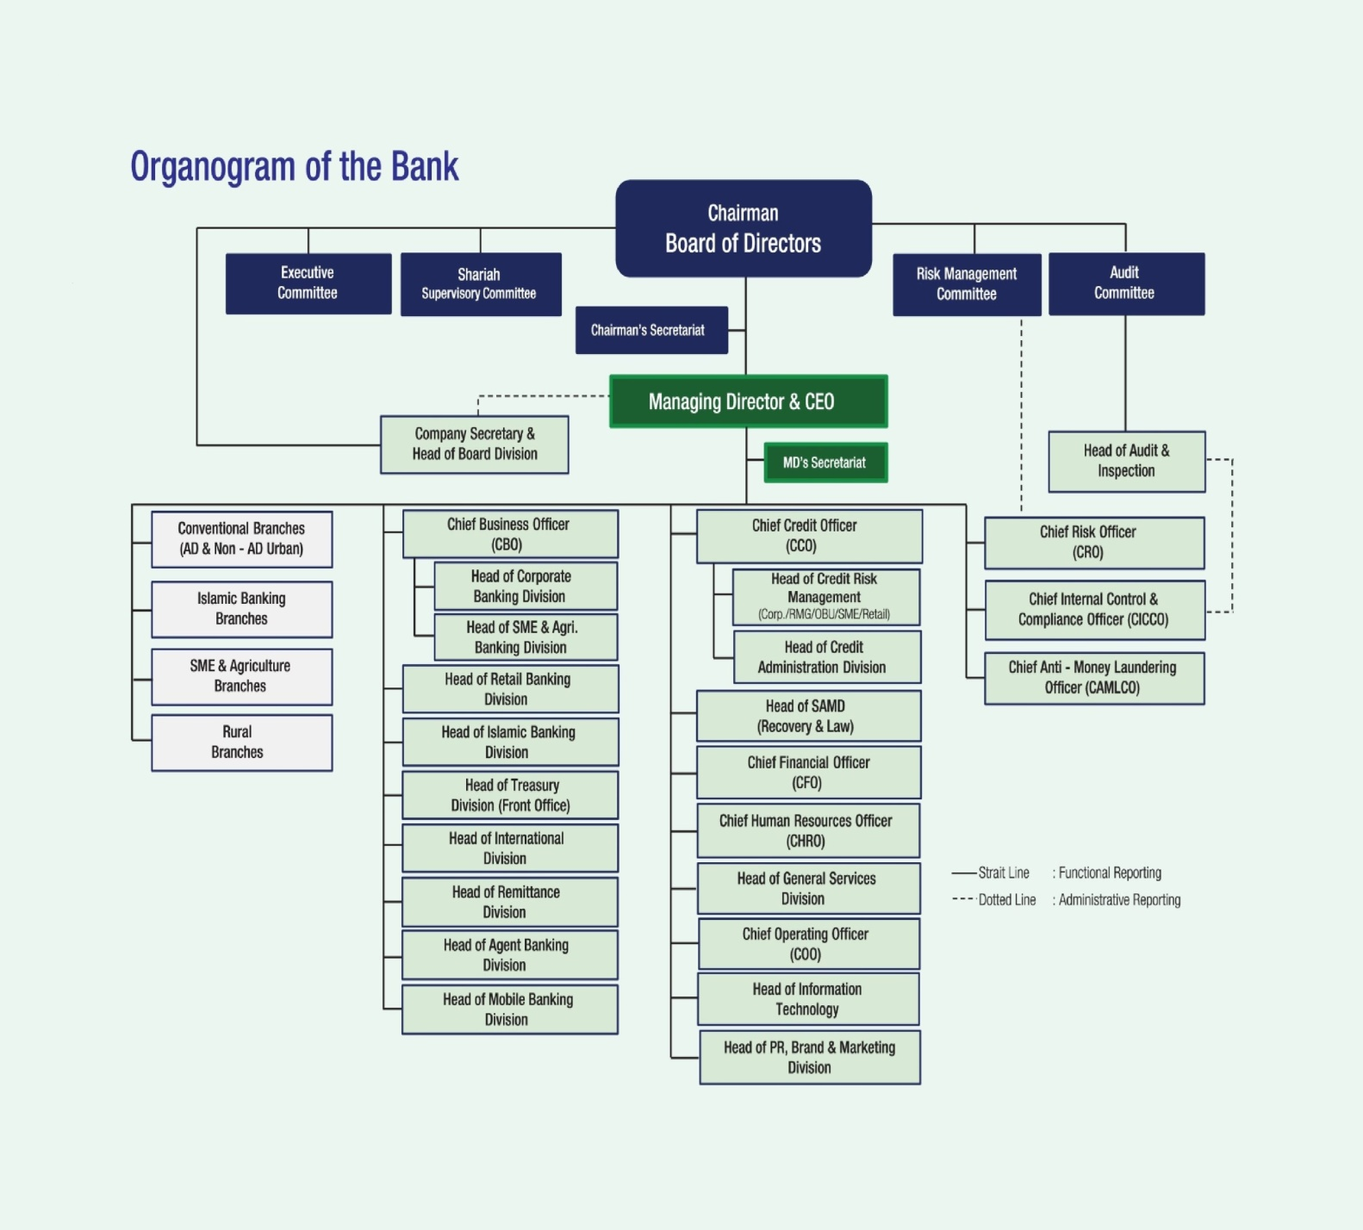
The whole procedure is maintain in every branch. Day to day maintain the procedure in every branch.Premier Banking is available for selected clients only. Premier Banking is a division of Commonwealth Bank and its services are provided by Premier Banking Relationship Managers who are representatives of Commonwealth Bank. Financial planning, superannuation plans and advice on some categories of insurance products will be provided by Commonwealth Financial Planners who are Representatives or Authorized Representatives of Commonwealth Financial Planning Limited

They gained the rate AA+ which is too good for the banking sector. Premier bank services the customer first that’s why they maintain their reputation in the banking sector.
We saw the image thet the last year they got the rate and also the 2nd last year. Even this year they hope that their rate is AAA which is the great in banking industry. So lets hope for the best for their banking rae of their industry.


Part 4: Ratio Analysis

Ratio Analysis:
At first we analyze the audit report and it has the information for ratio analysis. In here all amount are in Million.

 | In Million
 | 2018 | 2017 | 2016
BALANCE SHEET
Assets:
Property, Plant and Equipment, Net | 2,336.80 | 2,370.50 | 2,406.10
Assets Under Construction | 500 |  | 1,088.00
Investment | 24,169.70 | 22,334.50 | 22,471.10
Intangible Asset | 5,278.80
Non-current Asset | 32,285.30 | 24,705.00 | 25,965.20
Inventory
Accounts Receivable | 12,075.30 | 9,442.80 | 5,758.40
Advance, Deposit and Prepayment | 144,884.70 | 126,448.30 | 107,965.40
Loan to Sister Concern
other current asset | 13,214.50 | 10,242.10 | 4,856.30
Cash and Cash Equivalents | 13,673.40 | 11,338.10 | 10,035.10
Current Asset | 183,847.90 | 157,471.30 | 128,615.20
Total Asset | 216,133.20 | 182,176.30 | 154,580.40
Equity and Liability:
Share Capital | 8,000.80 | 6,957.20 | 6,820.80
Share Money Deposit
Reserve | 123.1 | 134 | 173.6
Revaluation Reserve | 4,733.90 | 3,981.10 | 3,342.00
Retained Earnings | 2,559.10 | 2,086.70 | 1,578.20
Shareholders' Equity | 15,416.90 | 13,159.00 | 11,914.60
Long-term Loan | 104,141.00 | 86,233.10 | 4,869.80
Other Non-current Liability | 9,000.00 | 7,000.00 | 6,000.00
Non-current Liability | 113,141.00 | 93,233.10 | 10,869.80
Short-term Loan | 14,732.80 | 15,084.40 | 81,593.30
Long-term Loan- Current Portion | 10,055.50 | 9,082.70 | 7,487.10
Accounts Payable | 3,378.20 | 2,093.20 | 1,679.80
Accrued Expense | 8,161.70 | 6,649.50 | 6,305.80
Loan from Sister Concern | 51,247.10 | 42,874.40 | 34,730.00
Current Liability | 87,575.30 | 75,784.20 | 131,796.00
Total Equity and Liability | 216,133.20 | 182,176.30 | 154,580.40
Error | 0 | 0 | 0
INCOME STATEMENT
Sales | 16,491.70 | 12,236.80 | 10,259.60
Cost of Goods Sold | 10,678.90 | 8,261.50 | 7,518.40
Gross Profit | 5,812.80 | 3,975.30 | 2,741.20
Operating Expense | 5,025.10 | 4,351.10 | 3,897.10
Operating Profit | 787.7 | -375.8 | -1,155.90
Non-operating Income | 5,246.80 | 4,696.10 | 4,476.10
Net Operating Profit | 6,034.50 | 4,320.30 | 3,320.20
Financial Expense
Provisions | 2,270.00 | 1,125.00 | 1,001.10
Pre-tax Profit | 3,764.50 | 3,195.30 | 2,319.10
Income Tax Expense | 1,537.60 | 1,286.60 | 731.9
Net Profit | 2,226.90 | 1,908.70 | 1,587.20
CASH FLOW STATEMENT
Fund From Operation | 2,226.90 | 1,908.70 | 1,587.20
Change in Inventories | 0 | 0 | 0
Change in Accounts Receivable | -2,632.50 | -3,684.40 | -5,758.40
Change in Accounts Payable | 1,285.00 | 413.4 | 1,679.80
Cash Flow From Operation | 879.4 | -1,362.30 | -2,491.40
Cash Dividend |  | -682
Capital Expenditure
Free Cash Flow | 879.4 | -680.3 | -2,491.40

Liquidity Ratio: Liquidity ratio defines how the institute to compensate debt responsibility and his capacity estimate metrics which comprise current ratio, quick ratio.
Current Ratio: Current ratio reproduces the institute’s capacity to compensate both short-long term debts.

Formula: current asset/ current liability

Year | 2018 | 2017 | 2016
Current Ratio | 2.1 X | 2.1 X | 0.9 X

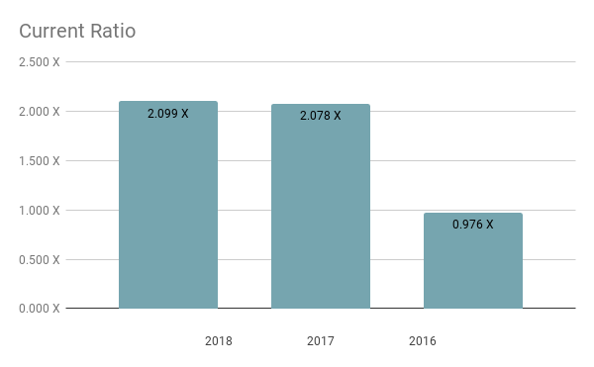

Implication: In 2018, 2017 and 2016 the ratio was good with 2.09, 2.07 and 0.9. So that we can that increase the capability to compensate short-term and long-term Obligation.
Quick Ratio: It redirects the capability of institute’s whether it has adequate short-term benefit to protect when it expresses instant liability.
Formula: (current asset – Inventory)/ Current Liability

Year | 2018 | 2017 | 2016
Quick Ratio | 0.4 X | 0.4 X | 0.2 X

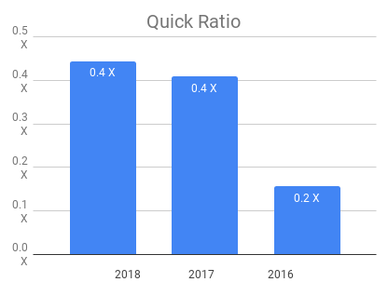

Implication: Institutes with acid -test ratio was average. The ratios is less than 1. So, the institute has capability to protect instant liabilities.
Net Working Capital Turnover: It designates bank’s proficiency in spending its working capital.
Formula: Net Sales/ Ang. Net W.C

Year | 2018 | 2017 | 2016
Net working capital turnover | 44.5% | 44.8% | -2.1%

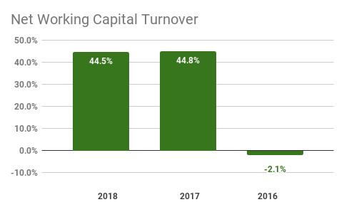
Implication: In last two year performance is good enough. It efficient to pay off its current liability. In 2016 has the problem but they overcome on that.

Cash Conversion Cycle:

Formula: (inventory/cost of goods sold) *365+ (account receivable/net sales)*365+ (account payable/ cost of goods sold)*365)*

Year | 2018 | 2017 | 2016
Receivable collection period | 150 | 187 | 122

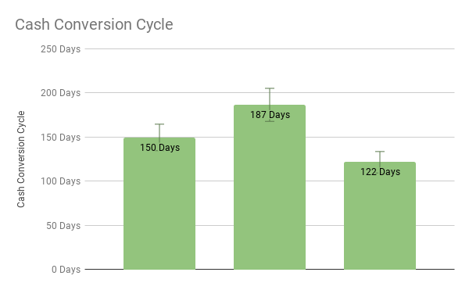
In Premier Bank’s report, there is no inventory because its service provider Institute. For that reason, measured by COGS and we saw that the 2017 has the highest period and 2018 has the 150 days
Other Ratios:

Receivable Turnover: It shows the capability to measure efficiency in covering credits and in gathering liability on conferring this credit.
Formula: credit sales/ avg. receivable

Year | 2018 | 2017 | 2016
Receivable Turnover | 1.4 | 1.3 | 1.8

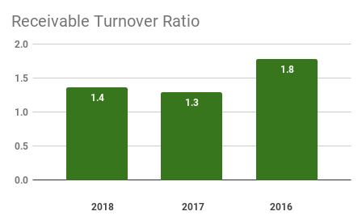
Implication: In 2016 and 2017, Receivable ratio is 1-8 & 1.3 times and 2018 it is 1.4 times which stipulates credit sales in effort. We all know, decreasing credit sales is good for the Institute.
Receivable Collection Period: It is period of time through the liability and credit sales is finished and the days when fee is received from credit sales.
Formula: 365/receivable turnover

Year | 2017 | 2016 | 2015
Receivable collection period | 264 | 278 | 202

In 2018 collection period is 264 days which is better for company but 2016 it decreased 14 days and 2017 has 278 days and 2016 has 202 days which specifies that additional day’s requisite to collect receivable.
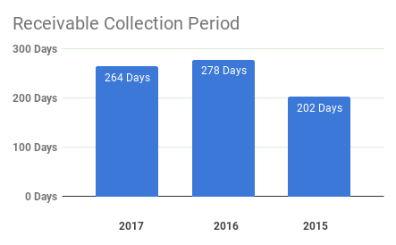

Payable collection period: It is number of bases reserved by company to compensate its account payable.
Formula: 365/ payable turnover ratio.

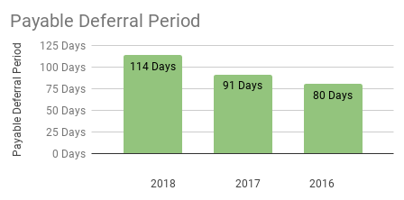

In 2018 the chat shows that the collection day is 114 days. And 2017 and 2016 has 91 and 80 days. So last three years period are increasing.
Inventory Turnover: It replicates ratio for period of time which indicates how proficiently inventory to accomplish by equating cost of goods sold. We already saw that there is no Inventory and inventory also that’s why I cannot measure this Turnover.
Profitability: It examines the difference public division on their capacity of profitability ratios.

Return on Asset: It’s a proportion which reproduces how effectiveness administration can be done
Produce pays in evaluation among nobles in the same industry.
Formula: Net Profit/ Total asset
Year | 2017 | 2016 | 2015
ROA | 0.01030 | 0.01048 | 0.01027

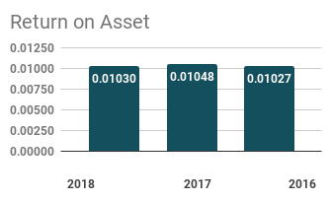
Implication: Here we calculate ROA by separating Net income by total asset; we discover net income from income statement which is described on an annual report.
Return on Equity: It shows the ratio that we depositors charity to measure how a company pay is refunded as shareholder equity.
Formula: Net profit/ Shareholder Equity

Year | 2018 | 2017 | 2016
ROE | 14.4% | 14.5% | 13.3%

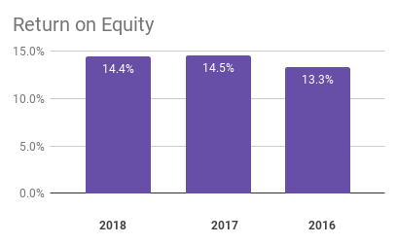

Implication: ROE is highest at the year of 2016. It specifies at the year 2017 their speculation was more active than the other year.2016 drop miserable but at the year of 2017 ROE also increase. In 2018 ROE are similar to 2017

Operating Profit Margin: It shows the operational proficiency of the firm and its capability to protect the expenses in operating system.
Formula: operating income/ net sales

Year |  | 2018 | 2017 | 2016
Operating  Margin | profit | 0.31815 | 0.38377 | 0.43628

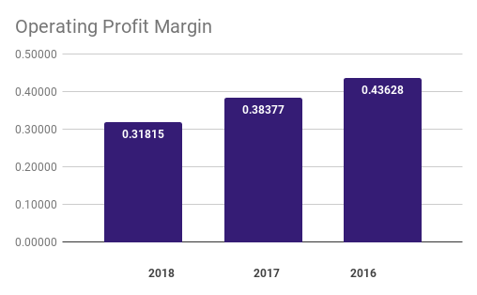

Implication: A advanced operating margin is more fortunate associate with a lower ratio because this shows that company is made enough money from its constant operation to compensate for its adjustable price as well as its fee price.
Net profit margin: It shows the overall proficiently in functioning to the commercial and used to estimate connection between net profit and sales.
Formula: Net profit/ Sales

Year | 2018 | 2017 | 2016
Net Profit Margin | 13.5% | 15.6% | 15.5%
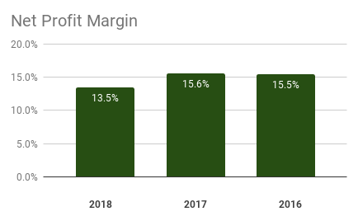
Implication: In 2018 the result was 13.5%, on the other-hand in 2016 & 2015 the net
Profit Margin was 15.6% and 15.5%. Between the years in 2017 and 2016 the company had a comparatively good profit margin in percentages and oppositely in 2018 net profit margin was relatively lower than others.

Gross profit Margin: It indicates how to measure the percentage of gross profit in comparison to sales.
Formula: (revenue- cogs)/revenue
Year | 2018 | 2017 | 2016
Gross profit margin | 32.2% | 32.5% | 26.7%

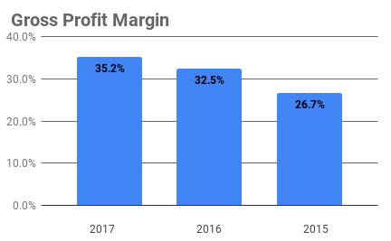
Implication: It shows gross profit margin is quite good in that ratio and growth is increasing day by day.

Part 5: My work as intern in Premier Bank Ltd.

5.1 Introduction:
At the time of internship period I did work for different departments even though I was assigned to Premier Bank Ltd. As I was assigned to Premier Bank Ltd. I had some responsibility to fulfill for that department. This section was different and the learning process is broadly opened. In Premier Bank Ltd. I worked for loan processing and overall banking department for different sector.

5.2 Opening the Account
My first activity is opening account and provided that services to the consumers. It is the important matters in General Bank. In that service bank always strain to satisfy their customer. d From June 15, 2019 to August 15, 2019 different kinds of account unlocked. How many account were unwrapped in that period those are given bellow-
- CD -115 Account
- SB-67 Account
- SND -7 Account
- DBS-19 Account
- MIS-3 Account
- MSS-67 Account
- FDR -203 Account
For Individual Savings Account / Current Account in Personal Name -
- A photocopy of applicant’s National ID card duly attested by the account opening officer after seeing the original copy
- An introducer must (who have an account in Premier Bank Limited at any branch) verify with signature, and a/c name and number
- Two copies passport size photo of applicant (must be attested by introducer) and one copy passport size photo of Nominee (must have attested by customer)
- Special instruction (in case of Joint A/c) i. e. mode of account operation may be specified by customer.

For Current Account in Business Name: -
Proprietorship business
- TIN number
- An introducer’s (who have an account in Premier Bank Limited) verification
- Seal of the candidate required
- Trade license

- National ID card of the person who will operate the a/c
- Current Account for Limited Companies: -
- Power of attorney
- Perseverance of the board of directors.
- Verification of the person/ persons who will operate the A/c
- Certificate of origination of business
- Certificate of combination.

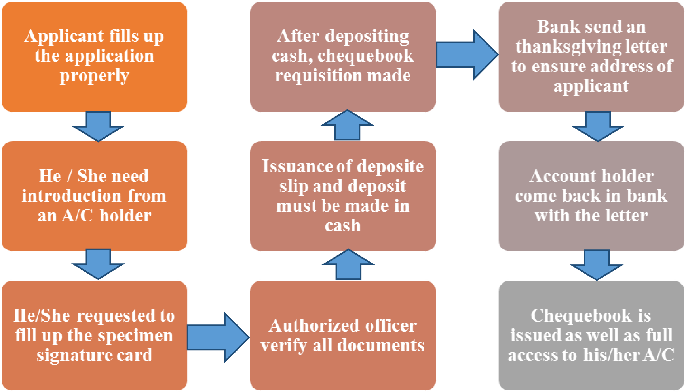

There are many work I am doing as my supervisor instructions. We all know that the bank work similar to another bank. Every bank sector has the same working procedure. The my part of work are—

- Requisition slip collecting through receive cheque
- Receive cheque book
- Deliver to another party with cheque book



- Conversation with Clients
- Inward Dispatch maintain (I had to maintain those documents by recording in inward dispatch with serial number and date)

Serial no | Date of  receipt | Ref no | Date | Sender’s name | subject | remark | Received by(Full  Signature)

- Issuing and proceeding a pay order
- Working on Debit Card
- Putting seal on the clearing cheque.
- Moreover I composed many letter for head office other branch and for other organization.
- Preparing voucher for branch purpose.

Learning Corporate culture
I learned office behavior, working under pressure, time to work within office hour and how to handle clients according to situation.

Communication Skill
The Bank highly accentuate on communication, they have to advance in different forms of communication.

Work Experience
Deprived of any query I have attained a big knowledge from my Internship Program. This experience indications me the upcoming career achievement. If I appointed the bank job, work will help to solve numerous difficulties which I erudite that experience. I am appreciative to all staffs who facilitated me and trained me all pointed work.

If Redo the internship what would have been done differently:

- First I would try to focus more on my work so that I make little mistakes.
- I would prefer a little more work will be given to me.
- I would try to learn things more deeply.
- As right now I am not that much friendly with every one of my office, next time I would definitely try to communicate more.

Part 6: SWOT Analysis

;

SWOT Analysis at a glance:

Strength  - Powerful Board of Director  - Renowned Rating Committee  - Motivational Analyst Team  - Trustable Partnership   | Weaknesses  - High Turnover Rate  - Lack of Benefits  - Lack of promotion  - Inexperienced Departments  
Opportunities  - Increasing Markets  - Increasing Awareness   | Threats  - High Competition  - Government Intervention  

SWOT Examination may be a basic but valuable system for analyzing your organization's qualities and weaknesses, and the openings and dangers simply confront. It makes a difference you center on your qualities, minimize dangers, and take the most noteworthy conceivable advantage of openings accessible.

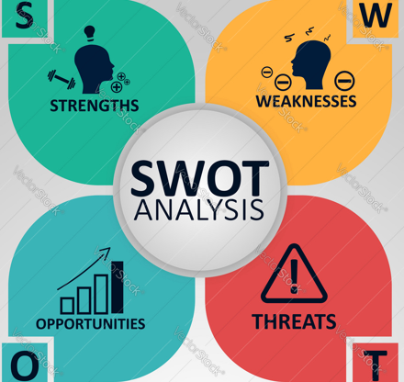

Strengths:
- We square measure prepared to reply awfully rapidly as we've got no bureaucratic procedure, and no want for higher administration approval.
- We square measure prepared to supply particular client care, since the current bit of labor implies that we've got parts of time to commit to customers.
- Our lead consultant incorporates a strong title inside the market.
- We can correction course rapidly on the off chance that we find that our offering isn't operating.
- We have moo overheads, in this manner we'll supply sensible cost to customers.

Weakness:
- We have a little employees, with a shallow skills base in several areas.
- We square measure liable to important employees being sick or going away.
- Our income are unreliable within the early stages.

Opportunity:
- Our sector is increasing, with several future opportunities for achievement.
- Local government desires to encourage native businesses.
- Our competitors is also slow to adopt new technologies.

Threats:
- Improvements in innovation may alter this showcase past our capacity to adapt.
- A little alter within the center of expansive competitor might wipe out any advertise position we accomplish.

Part 7: Findings, Recommendation and Conclusion

Findings:

- When customer opening a new account, they did not get the whole document, like the document bank need. For that it creates problem sometimes to the officers.
- In the online banking system, the Premier Bank is not so fluent that’s why sometimes when customer commands through the online its delay from the server. So, it disappointed the customer.
- The Premier Bank’s server down sometimes but when it occurs when the customer want to know the immediate account condition. It hazards sometimes very badly.
- The branch of Premier Bank have not enough employee so that they cannot serve the service properly. All that reasons their general banking activities hampers.
- They cannot provide any training to their interns an d the supervisors have not enough communicate to their employees
- Premier bank’s ATM booth are very limited.
- ATM booth machine does not work properly for that the customer complain and it sometimes happen, and the customer bothered.
.

Recommendation:

- Premier Bank have to make more space for them who are doing the internship program.
- If the Online Banking of Premier Bank works properly then office working does not waste the time
- Premier Bank can arrange the program or event to provide motivation for their employees and customers.
- For reducing the crowding environment, the bank authority should increase the manpower.
- The bank would maintain computer and electrical equipment such as A/C and generator backup more efficiently.
- Premier Bank should be including Mobile banking in their bank services.
- Scanner uses on writing of Pay Order and FDR.

Conclusion:

Premier Bank is the private sector commercial bank in Bangladesh, and they are trying to provide best performances to the customer. Their main moto is service first so that they always try to give the services first to the customers. To investigate the opportunity and learn from the level of client fulfillment of Premier Bank Ltd, I prepared this report which could be a portion of scholarly internship program. Certainly, I have reached to a firm and concrete conclusion. The report given comprehensive data on the region of Whole show in Premier Bank Ltd.’s client benefit. It pointed to deliver superior overview of service quality affirmation. Premier Bank Ltd. may be a strong, forward looking present day bank with a record of sound execution. The bank appears to have sensibly palatable level of satisfaction towards the clients. Superior benefit quality and building great relationship with customers is the proverb of this bank. My perception makes me conviction that in the event that Premier Bank Ltd. follows the discoveries and suggestions portrayed over, it'll be able to achieve competitive advantage among other banks. The discoveries from this report will offer assistance Premier Bank Ltd. to be more effective and progress client benefit. Although Premier Bank Ltd is one of the most promising banks in Bangladesh, since a very long time Premier Bank Ltd has been trying to run the business successfully. When I was doing my internship program, I think I gained the most exclusive experience in my work team. Premier bank is the leading and increasing growth day by day.
Bibliography:

- Leonard, K. (2017, November 21). Five Successful Bank Business Strategies. Retrieved from https://smallbusiness.chron.com/five-successful-bank-business-strategies-2628.html

- Retrieved from http://premierbankltd.com/pbl/

- Lesikar & Pettit (2003). Documentation and the Bibliography. Business Communication (6th ed.). Delhi. A.I.T.B.S. Publisher & Distributo

- Related links. Retrieved from https://www.bb.org.bd/fnansys/interestlending.php

- S.N. Ghosh, Jagadish C. Shukla Das, Mahbub Ahmed: Choice of Banks, Customer Service & Credit policy, Bureau of Business Research, University of Dhaka

- (2016, December 4). Human Resource Management Practices of Premier Bank. Retrieved from https://www.assignmentpoint.com/business/human-resource-management/human-resource-management-practices-of-premier-bank.html

- ABA Banking Journal. Retrieved from https://books.google.com.bd/books?id=Dt0iAQAAMAAJ&q=premier+bank+works+process&dq=premier+bank+works+process&hl=en&sa=X&ved=0ahUKEwjAlK-AzZ7kAhVKcCsKHV5RDTMQ6AEINjAC

- The World Bank Group Sanctions Process and Its Recent Reforms. Retrieved from https://books.google.com.bd/books?id=lIYFpwQw_-cC&pg=PA1&dq=premier+bank+works+process&hl=en&sa=X&ved=0ahUKEwjAlK-AzZ7kAhVKcCsKHV5RDTMQ6AEIUzAH#v=onepage&q=premier bank works process&f=false

- Retrieved from http://premierbankltd.com/pbl/premier-bank-10th-foundation-training-course-for-mto/

