Exploring the Travel Industry: An Internship Experience at Travel Bright

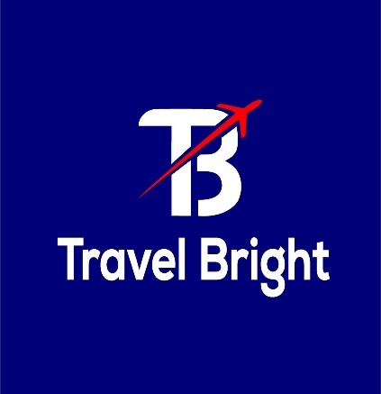

Md Nadim Mahamud

This report is submitted to the School of Business and Economics, United International University, as a partial requirement for the degree fulfillment of the Bachelor of Business Administration.



School of Business and Economics
United International University

“Exploring the Travel Industry: An Internship Experience at Travel Bright”

Submitted to:
Dr. Md. Shariful Alam Professor
School of Business and Economics

Submitted by:
Md Nadim Mahamud
ID: 111193066
Major: Marketing

Date of submission: August 9, 2025

Letter of transmittal

August 9, 2025

Professor
School of Business and Economics
Subject: Submission of Internship Report on “Exploring the Travel Industry: An Internship Experience at Travel Bright.”
Dear Sir, it is a great pleasure that I submit my internship report titled “Exploring the Travel Industry: An Internship Experience at Travel Bright.” I have completed my internship tenure at Travel Bright in sales, marketing & brand Management. I worked very diligently and did my best to follow all the guidelines provided by my supervisor to meet the internship course requirements and prepare the report.
The internship has provided me with valuable insights into maintaining external communications and allowed me to apply the theoretical learning of my undergraduate degree. I want to thank the Corporate Communications and Sustainability team of Travel Bright for their support and guidance throughout my internship. My next professional phase will be much improved by the knowledge I gain from this department.
I truly appreciate your great advice and continuous backing during my internship. I would like to hear any comments or recommendations you may have regarding this internship report. I admire your tireless backing.
Sincerely,
Md Nadim Mahamud
ID: 111 193 066

Declaration of the student

I, Md Nadim Mahamud, ID: 111193066, a student enrolled in the Bachelor of Business Administration undergraduate program majoring in Marketing at United International University, hereby declare that I have completed a four-month internship at Travel Bright. The internship took place from 9th November to 31st March. During this period, I had the opportunity to work in corporate communications and contribute to various projects.
I would like to express my gratitude to the entire team of Travel Bright for providing me with an enriching learning experience. I herewith affirm that the information provided in this declaration is accurate and truthful. So primary and secondary information is included here.

Sincerely,
Md Nadim Mahamud
ID: 111 193 066
Major: Marketing
School of Business & Economics
United International University

Acknowledgement

I would like to thank Allah for all of His favors and devotion in my life. For their unconditional support and affection, my parents have my eternal gratitude. Without their assistance and direction, I could not have progressed to this point. They helped me throughout my academic career in ways that are priceless and cannot be repaid. I am very thankful to have Md. Shariful Alam, sir, as my internship supervisor. He is one of the most supportive faculty members I have encountered during my undergraduate journey. I had done a course under his guidance, and I am truly grateful for his mentorship throughout my undergrad journey. My deepest appreciation goes to Prof. Dr. Kawsar Ahmmed, Sir, and Nasrin Akter, Miss. These talented individuals at UIU have been a constant source of support for me, and I will forever be grateful to them for their guidance in my marketing learning. When I first joined as an intern at Travel Bright, I initially had concerns about adjusting to the corporate culture. But some people made this transition smoother for me. I will always be grateful to some of the people of Travel Bright. They are:
- Md Arifur Rahman (CEO of Travel Bright)
- Raisul Islam Sazal (Executive Business Development)
- Showghat Rhythm (Head of Marketing)
I will never forget the way they helped me during my internship. Insights into corporate culture and sales operation functions were among the priceless lessons and memories that were shared with them. They all served as mentors, and I was happy to help out when I could. I was pleased to be chosen as an intern, and the lessons I learned from this experience will surely be the most beneficial aspect of the start of my corporate career.

Executive summary

Over the past 20 years, Bangladesh's travel agency sector has grown steadily, driven by rising middle-class incomes, increased internal travel, and growing interest in foreign travel. The sector has been recovering despite the difficulties posed by the COVID-19 pandemic, thanks to revived traveler interest and ongoing digital transformation among agencies.
This report highlights my internship experience at Travel Bright, where I served as an intern in the Sales, Marketing & Brand Management department. The primary objective of my internship was to gain practical knowledge of sales strategies and internal processes that support sales efficiency.
This internship report outlines my professional journey at Travel Bright, providing a comprehensive overview of the company and the travel industry, along with my hands-on experiences in sales and operations. By presenting the internship, the report analyzes the company's operations, growth trends, history, and product line, all of which are supported by a thorough SWOT analysis. It also looks at aspects unique to the sector, such as its scale, economic impacts, technical developments, competitive rivalry, and threats from substitutes. My job in the sales, marketing & brand management department is examined, with a focus on duties like managing customer relationships, implementing sales strategies, and overcoming obstacles in the real world. The report's conclusion provides a review of the abilities and information acquired, highlighting the internship's value to my professional and personal progress.
Keywords: Travel industry, sustainability, SWOT analysis, sales strategies.

Table of contents for internship
Table of Contents
Letter of transmittal 3
Declaration of the student 4
Acknowledgement 5
Executive summary 6
Table of contents for internship 7
CHAPTER I: INTRODUCTION 9
1.1 Background of the Report 9
1.2 Objectives of the Report 9
1.3 Motivation of the Report 10
1.4 Scope and limitations of the Report 10
1.5 Definition of Key Terms 11
CHAPTER II: COMPANY AND INDUSTRY PREVIEW 11
2.1 Company Analysis 11
2.1.1 Trend and growth 13
2.1.2 Customer mix 13
2.1.3 Service mix 14
2.1.4 Operations 15
2.1.5 SWOT analysis 16
2.2 Industry analysis 17
2.2.1 Specification of the industry 17
2.2.2 Size, trend, and maturity of the industry 17
2.2.3 External economic factors 19
2.2.4 Technological factors 21
2.2.5 Barriers to entry 21
2.2.6 Supplier Power 22
2.2.7 Buyer Power 23
2.2.8 Threat of Substitutes 24
2.2.9 Industry rivalry 25
CHAPTER III: INTERNSHIP EXPERIENCE 26
3.1 Position, duties, and responsibilities 26
3.2 Training 27
3.6 Contribution to departmental functions 30
3.7 Evaluation 30
3.8 Skills applied 31
3.9 New skills developed 31
3.10 Application of academic knowledge 32
CHAPTER IV: CONCLUSIONS AND KEY FACTS 33
4.1 Recommendations for improving departmental operations 33
4.2 Key understanding 33
4.3 Conclusion 34
References 35
Appendix 36

CHAPTER I: INTRODUCTION

Background of the Report

My time working as an intern in the sales, marketing & brand management sector of Travel Bright, a developing travel firm, served as the basis for this internship report.
Hands-on exposure to sales and business processes in a competitive and dynamic market was the goal of the internship. Travel Bright is the perfect place to learn how a contemporary company modifies its tactics to satisfy market needs because of the travel agency industry's quick evolution brought on by shifting consumer preferences and fierce competition.
The report focuses on the tasks I completed during my internship, the main duties I was given, and the lessons I learned. In addition to helping me understand market dynamics and sales tactics, the internship gave me knowledge about customer relations and operational effectiveness.
This report seeks to record my hands-on learning, examine the difficulties experienced, and emphasize my contributions to the company's goals. The internship has provided a thorough understanding of sales operations in a changing sector by mixing theoretical knowledge with practical experience.

Objectives of the Report

This report's goal is to describe my experience working in the sales, marketing & brand management of Travel Bright. It intends to:
- Apply theoretical knowledge to practical sales and operations strategies.
- Acknowledge market dynamics and the sales cycle.
- Underline the efforts done to enhance sales efficiency.
- Analyze the primary takeaways, difficulties, and development of career throughout the internship.
- An overview of the duties and skills acquired in the travel sector is included in this report.

Motivation of the Report

My goal in writing this internship report is to reflect on and consider the real-world experience and practical knowledge I acquired while working as an intern at Travel Bright, a trustworthy travel company in Bangladesh. Making the connection between theoretical information and real-world industry practices was crucial for me as a student pursuing academic knowledge in business and tourism. With its extensive range of services, including airline tickets, visa processing, and personalized vacation packages, Travel Bright provided a great opportunity to watch how a contemporary travel agency operates and learn about client management, customer service, marketing tactics, and daily business operations.
The purpose of this research is to examine the agency's internal operations, assess its standing in the tough travel sector, and identify important takeaways and opportunities for professional growth. By addressing the gap between classroom concepts and fieldwork experience in the travel and tourism industry, this report also aims to advance academic knowledge.

Scope and limitations of the Report

Scope:
This report details my experience working as a sales, marketing & brand management intern at Travel Bright. It focuses on recognizing market trends and sales tactics. The report offers a useful viewpoint on the travel business by highlighting the activities completed, knowledge acquired, and contributions made to the organization's goals.

Limitations:
The short period of internship prevented a more thorough investigation of long-term tactics and their results. There were restrictions on access to some significant strong information and strategic plans.
The report's exclusive focus on sales, marketing & brand management limits its ability to provide information about other organizational functional areas.

Definition of Key Terms

GDS: Global distribution system
IATA: The International Air Transport Association

CHAPTER II: COMPANY AND INDUSTRY PREVIEW

Company Analysis

Travel Bright is a full-service travel agency that provides families, corporate companies, and individuals with a variety of travel-related services. Founded with the goal of making travel easier and facilitating stress-free, worldwide movement, Travel Bright has gradually established a solid reputation for dependability, effectiveness, and individualized care.
Overview and history:
Travel Bright is a travel and tourism company located in Gulshan 01, Dhaka, founded in 2018. This company has made a name for itself in the travel sector under the direction of CEO Mr. Arif Rahman. After initially focusing on visa consulting services for student and medical travel, Travel Bright quickly changed its attention to visit visas, with a particular emphasis on processing applications for first-world countries like the USA, Canada, the UK, Australia, Schengen, and Turkey. The agency offers both domestic and foreign clients a comprehensive travel solution by arranging airline tickets and premium holiday packages in addition to visa services. Travel Bright's clientele ranges from private individuals to businesses and non-governmental groups. The majority of the clients are reliant on social media. In the travel and tourist industry, Travel Bright presents itself as a trustworthy partner for both businesses and non-governmental organizations. It collaborates with organizations such as Swiss Contact, Zaika Bangladesh, Edu.co, Action Aid, and Food for Hungry. Travel Bright is incorporated into the travel operations of these business and non-governmental organizations, which include extensive visa processing, airline ticket reservations, and holiday packages. The team that handles booking airline tickets for the agency ensures that both domestic and international travel run smoothly. Due to their experience, they are able to negotiate favorable prices and offer their customers the greatest offers available. Their premium vacation packages further demonstrate this guarantee of value, as they are customized to meet customers' spending limits without compromising on quality.
Travel Bright is a startup company with 13 talented members who strive to maintain the highest levels of client service at all times. They embrace the newest trends and technologies to assure efficiency and dependability. Travel Bright offers one of the most thorough approaches to visa documentation assistance. With the help of a committed legal advocate, the business offers clients full support with visa applications, including notary services. This end-to-end solution guarantees consumers a hassle-free experience by streamlining the intricate visa application process.

Trend and growth

The revenue growth (as a percentage) over time is displayed in the above chart, which shows Travel Bright's growth trend from 2018 to 2024. The trend is broken out as follows:
Steady Growth: Every year, revenue growth rose steadily.
Major Jumps: Between 2020 and 2021, there was a notable increase from 40% to 50%, and between 2022 and 2024, there was an increase from 70% to 100%.
Acceleration Phase: Starting in 2021, the trend points to quick growth, which could be brought about by more effective marketing, a larger clientele, or a wider range of services.

Customer mix

Since its launch in 2018, Travel Bright has developed a diverse but targeted customer base. The following segments are the agency's primary clients.

NGO and Development Sector Professionals:
A significant number of Travel Bright's clients include people connected to both domestic and foreign non-profit organizations (NGOs). For training, workshops, conferences, and field trips both nationally and beyond, these clients usually need airline tickets and travel plans.
Corporate Clients:
In addition to NGOs, the organization provides vacation packages and business travel management to workers from corporate offices and global corporations. In order to keep to demanding deadlines, corporate clients frequently favor broad itineraries and specialized services.
Leisure Travelers:
A portion of Travel Bright’s customers are families, couples, and individuals seeking holiday packages to popular regional and international destinations.

Service mix
In order to satisfy the demands of a broad range of customers, including business clients, individual travelers, and NGO professionals, Travel Bright provides a wide range of travel-related products and services. Among the agency's primary services are:
Air Ticketing Services:
All major airline tickets are booked and issued for both short-haul domestic travel and long-haul international travel.
Holiday Packages:
From low-cost trips to luxury vacations, Travel Bright specializes in creating personalized vacation packages based on personal interests. Travel Bright guarantees its customers a seamless, trustworthy, and fulfilling travel experience, whether they are traveling for business or pleasure.
Visa Processing Assistance:
Travel Bright provides advice on the necessary paperwork and application forms for different nations. By providing professional advice on documentation, application processes, and embassy requirements for different countries, their visa processing company ensures that tourists have a minimum of pressure.

Operations

Travel Bright is a travel agency based in Bangladesh that takes a simplified approach to providing dependable and effective travel solutions. The organization's activities are planned to serve a wide range of customers, including corporations, NGOs, and individual tourists. The following are the primary elements of its daily operations:
Air Ticketing Operations:
- Booking & Reservation: The agency uses Global Distribution Systems (GDS) like Amadeus or Galileo to check availability, reserve, and issue both domestic and international air tickets.
- Fare Comparison & Customer Support: To offer the most economical solutions customized to the needs of the client, travel experts compare airline fares, routes, and timings.
- After-Sales Support: To guarantee client satisfaction, ticket rescheduling, cancellations, and refund processing are handled effectively.

Holiday Package Management:
- Package Design: Travel Bright designs both fixed and customized vacation packages that include lodging, transportation, meals, and activities.
- Coordination of Suppliers: To ensure seamless travel experiences, the operations team works with lodging facilities, tour operators, and transportation providers both domestically and abroad.
- Customer Briefing: Prior to departure, clients receive guidance on their itineraries, travel regulations, and necessary preparations.

Visa Processing Service:
- Document Collection & Review: Staff help customers gather and verify the necessary documents based on embassy requirements.
- Application Submission: The agency assists in submitting visa applications and scheduling embassy appointments.
- Status Monitoring: Travel Bright tracks application progress and updates clients about their visa status.

SWOT analysis
This is a basic data visualization chart that illustrates Travel Bright's SWOT analysis. The SWOT analysis identifies the company's opportunities, threats, weaknesses, and strengths.
Travel Bright uses SWOT analysis since it helps determine the company's external opportunities and threats in addition to its internal strengths and weaknesses.

SWOT analysis of Travel Bright

Strengths | Weaknesses
- Diverse Service Offerings: To meet the various demands of its clients, Travel Bright offers a broad range of travel services, such as holiday packages, visa processing, and airline tickets.  - Experienced Staff: The organization has staff members who are informed and focused on the needs of the client, which improves service quality and client happiness.  - Established Market Presence: Since going into business in 2018, Travel Bright has established a solid reputation, especially with corporate clients, nonprofit organizations, and individual tourists. | - Limited Online Presence: Travel Bright's online booking and digital marketing infrastructure is quite small when compared to its larger rivals.  - Small Team Size: The agency may find it difficult to handle high customer volumes or scale up during periods of strong demand if it has a small crew.  - Lack of Global Partnerships: Their ability to offer worldwide travel offers may be hampered by the absence of solid partners.
Opportunities | Threats
- Digital Transformation: Putting money into a strong website, mobile application, and digital marketing could greatly increase exposure and client interaction.  - Corporate Travel Management: Increasing B2B offerings for corporate customers may guarantee repeat business and enduring alliances.  - Partnerships and Collaborations: Increasing package diversity and competitiveness may be achieved by forming alliances with hotels, airlines, and other service providers. | - High Level of Competition: There are a lot of well-established and up-and-coming companies in Bangladesh's travel market that provide comparable services at affordable prices.  - Political or Economic Instability: Travel demand and corporate operations may be directly impacted by any changes in the political or economic environment.  - Travel Restrictions and Pandemics: Travel reservations and income may be significantly impacted by future travel restrictions or international health emergencies.

Industry analysis

Specification of the industry

Travel Bright operates within the travel and tourism industry of Bangladesh, a sector that has experienced steady growth over the past decade. The industry encompasses a broad range of services, including transportation, hospitality, and travel facilitation. Travel agencies like Travel Bright play a critical role in connecting individuals and organizations to both domestic and international travel opportunities by offering end-to-end services.

Size, trend, and maturity of the industry

Size of travel industry:
Bangladesh's travel and tourism operation is a rapidly expanding industry that makes a substantial economic contribution to the nation. Before the COVID-19 epidemic, the travel and tourism sector contributed around 4.4% of Bangladesh's GDP, and it is still growing and recovering, according to the World Travel & Tourism Council (WTTC). Every year, millions of local and foreign tourists make use of the services offered by tour operators, hotels, airlines, and travel agencies. When it comes to flights, visas, and vacation packages, Bangladeshi tourists are looking for expert travel assistance. With well-liked travel locations like Cox's Bazar, Sylhet, and Bandarban, the domestic tourist industry is also expanding. In the upcoming years, it is anticipated that Bangladesh's travel and tourism sector will expand considerably.
Trends in the Travel Industry:
Bangladesh's travel and tourism industry is at an interesting inflection point, recovering from setbacks but also gearing up for significant growth and transformation. International arrivals rose strongly in 2023, with ~650,000 foreign tourists, a 23% increase over 2022, surpassing pre-COVID levels. Global travel dynamics, changing consumer behavior, and technology breakthroughs are all contributing to the travel agency industry's rapid evolution. Travelers are increasingly looking for customized travel packages that fit their tastes, wallets, and lifestyles, making this one of the most important trends. The sector is also changing as a result of digital transformation; travel firms now use mobile apps, online booking platforms, and virtual tours as routine tools to interact with customers and optimize workflows. Additionally, the growth of ecotourism and sustainable travel is a reflection of passengers' growing environmental consciousness, which has led travel agents to provide eco-friendly travel destinations and responsible travel options.
The use of data analytics and artificial intelligence (AI) is another trend that helps agencies anticipate travel trends and enhance customer experience. Lastly, as a result of the post-pandemic recovery, travelers are placing a higher priority on safety, health regulations, and destination dependability, which has resulted in an increase in last-minute reservations and flexible cancellation policies. These patterns point to a change in the travel agency paradigm toward one that is more tech-driven, customer-focused, and flexible. Because of increased money and easier access to hill stations, beaches, and festival locations, a growing middle class is encouraging local travel. Cultural and historical tourism (such as living-heritage tours and artisan workshops) is becoming more popular due to UNESCO monuments and thriving cultural practices.
Maturity in the travel industry:
Bangladesh's travel sector is now in its early stages of development. Despite the recent considerable growth in domestic travel, particularly among middle-class tourists, the industry still lacks the structural maturity seen in more mature travel markets. The industry's advancement is still limited by issues with infrastructure, uneven service quality, a lack of integrated digital platforms, and the difficulty of obtaining a visa for foreign visitors. However, the business is gradually changing as a result of the government's implementation of the Tourism Master Plan, which has increased investment in tourist destinations and increased digital use by travel firms. The travel sector in Bangladesh could develop into a more developed one if these initiatives are maintained.
Innovation, digital adoption, and value-added services are increasingly more important drivers of the sector's growth than new competitors. Customers have high expectations, and factors like pricing, customization, and service quality affect their loyalty. Traditional travel agencies must constantly adjust by improving their online presence and providing personalized experiences in order to stay competitive in the face of the growth of online travel platforms and self-booking trends. The industry's general structure and operations point to a mature and stable stage of its lifecycle, even though there is still opportunity for expansion, particularly in expert sectors and developing destinations.

External economic factors

Bangladeshi travel companies work in a dynamic economic climate, and a number of external economic factors have a big impact on their expansion, sustainability, and profitability.
Airfare and Fuel Prices: The cost of jet fuel has a direct impact on the cost of airline tickets. Airlines pass on the expense of rising global fuel prices to their passengers, which raises airfares and lowers demand. Consequently, this impacts travel agencies' ticket sales and profitability.
Inflation and Cost of Living: In Bangladesh, rising inflation impacts consumer purchasing power and raises operating expenses (office rent, utilities, salaries, etc.). Families prefer necessities over optional expenses like leisure vacations as living expenses grow.
Exchange Rate Fluctuations: The cost of overseas travel is directly impacted by the value of the Bangladeshi Taka (BDT) in relation to major foreign currencies like the USD or EUR. Because outward travel is more expensive when the taka is weaker, demand is decreased.
GDP Growth and Economic Stability: The travel industry benefits from an expanding economy. In recent years, Bangladesh's GDP has grown steadily, which has increased consumer confidence and expenditure, particularly on business and leisure travel.
Employment and Income Levels: More people can afford to travel when employment and income levels are higher. People's capacity and inclination to spend money on vacations or business travel declines when unemployment increases.
Bank financing and interest rates: Exorbitant interest rates might deter borrowing and cut into business travel spending. Additionally, when borrowing prices are high, consumers are less likely to use credit cards or loans for personal travel.
Investment in Tourism and Infrastructure Development: By enhancing accessibility and comfort for tourists, economic policies that encourage investment in tourism infrastructure (such as highways, hotels, and airports) can have a good impact on the travel agency industry.
Taxation and Government Incentives: Prices are impacted by travel-related taxes, such as service fees or VAT on tickets. On the other hand, agencies can prosper if the government offers incentives or subsidies to encourage travel.

Technological factors

Digital Transformation: Digital platforms are being adopted by Bangladesh's travel sector more and more. Today, agencies sell airline tickets, hotel reservations, and vacation packages mostly through websites, smartphone applications, and online booking platforms. This change improves client reach and convenience.
Payment Systems Online: More consumers are booking travel services online as a result of the ease and security of transactions made possible by the growth of digital payment gateways like SSLCommerz and mobile banking platforms like bKash, Nagad, and Rocket.
Digital marketing and social media: Facebook, Instagram, and YouTube are frequently used by travel firms for lead generation, client interaction, and promotions. This is now a major factor in attracting new clients.
Automation & CRM Tools: Client relationships are maintained, and booking and follow-up procedures are streamlined by agencies using CRM tools and automated communication (such as email/SMS marketing).
Global Distribution System (GDS): Agencies can access real-time airline inventory and make quick reservations by integrating with GDS systems such as Amadeus, Sabre, or Galileo. This improves operational efficiency.

Barriers to entry

Intense Competition: There are a lot of companies in Bangladesh that provide comparable services, such as airline tickets, visa processing, and tour packages. Established companies with loyal customers are competitive with newcomers.
Requirements for Capital Investment: Establishing a travel agency frequently necessitates a large initial outlay of funds for marketing, licensing, office setting, booking systems, and occasionally GDS (Global Distribution System) access. This can be difficult for small business owners.
Issues with Regulation and Licensing: A significant obstacle to entry is obtaining the required permits from organizations such as the Ministry of Tourism, the Civil Aviation Authority of Bangladesh (CAAB), and IATA (for ticketing), which can be difficult and time-consuming.
Credibility and Brand Awareness: Consumers typically favor trusted agencies. In a sector where dependability is essential, particularly for visa and international travel services, new enterprises may find it difficult to establish trust and brand identity.
Infrastructure for Technology: These days, a lot of well-known firms depend on advanced websites, mobile apps, and booking engines. In terms of efficiency and customer service, newcomers who lack digital expertise or technology resources may fall behind.

Supplier Power

In the travel industry of Bangladesh, supplier power refers to the influence that key service providers such as airlines, hotels, tour operators, visa centers, and transport companies have over travel agencies. In this sector, supplier power is moderate to high due to the following reasons:
Fewer Choices for Airlines: Due to the small number of domestic and foreign airlines that operate in Bangladesh, these carriers have a lot of power. They have direct control over booking systems, commissions, seat availability, and ticket structures, all of which have an impact on what travel agencies offer.
Providers of Hotels and Accommodations: Hotels and resorts can affect pricing, seasonal availability, and corporate contracts, particularly in well-known locations like Cox's Bazar, Sylhet, or Dhaka. During busy times, travel agents frequently have little negotiating leverage.
Global Distribution Systems (GDS) dependence: For real-time ticket booking, travel agencies depend on GDS platforms such as Amadeus or Sabre. Due to the restricted customization options and subscription costs associated with these systems.
Embassies and Visa Processing Organizations: Services pertaining to visas are essential for international travel. Travel agencies' activities may be impacted by embassies or visa facilitation centers' tight documentation requirements or delays, particularly if they are not directly affiliated with these entities.
Local and international tour operators: For events, transportation, and logistics, agencies that offer packaged trips frequently rely on outside tour operators. These vendors have the power to set prices and availability, particularly for well-known foreign locations like Dubai, Malaysia, or Thailand.

Buyer Power

The ability of consumers (individuals, businesses, NGOs, etc.) to affect costs and service standards in the travel sector is known as buyer power. Buyer power is regarded as great in Bangladesh for a number of reasons:
Intense Rivalry Between Travel Companies: Customers have a variety of options because numerous organizations provide comparable services, such as processing visas, booking tickets, and vacation packages. They have more negotiating leverage since they can quickly go to a competitor.
Sensitivity to Price: The majority of Bangladeshi consumers are quite price conscious. Customers may switch providers for even minor differences in airfare, package prices, or visa costs, which forces travel companies to lower their margins and provide discounts.
Availability of Online Platforms: Consumers can now use online travel websites and applications to compare costs and services. They have greater power and are less reliant on conventional travel agencies as a result of this transparency.
Personalized Service Request Customers have the capacity to demand flexibility and added value from travel firms because many of them want bespoke services (such as personalized itineraries, assistance with visas, and hotel selection).
Low Cost of Switching Buyers can easily switch agencies with little to no penalty because most travel services are not very different, which gives them even more leverage.

Threat of Substitutes

The threat of substitutes refers to the possibility that customers may choose alternative ways to fulfill their travel needs without relying on traditional travel agencies. In Bangladesh, the threat of substitutes is moderate to high due to the following factors:
Online platforms for booking travel: Nowadays, a lot of consumers choose to book flights and lodging directly through airline websites or online marketplaces like Booking.com, Agoda, and Skyscanner. There is less need for travel agents thanks to these platforms' frequent competitive pricing and discounts.
Direct Reservations for Hotels and Airlines: More and more people are making direct reservations with hotels and airlines, particularly for short journeys. In particular, for basic hotel reservations and airline tickets, this circumvents agencies and diminishes their function.
Do-it-yourself Vacation Planning: Many tourists, particularly young people, prefer to plan and organize their vacations independently because they can obtain information through YouTube, blogs, social media, and travel forums. Full-service travel agencies are being threatened by this self-service strategy.

Industry rivalry

The level of competition between current competitors in the travel business is referred to as industry rivalry. Industry competition is severe in Bangladesh because of a number of related factors:
Large Number of Competitors: There are hundreds of travel agencies operating across Bangladesh, such as Akashbari Holidays, Go Zayaan, TBD Holidays, and IATA-accredited companies. The high number of players intensifies competition for customers.
Low Product Distinction: It is challenging to differentiate from the competition because most travel firms provide identical core services, including arranging hotels, vacation packages, visa help, and airline tickets. Price consequently takes precedence over all other competitive factors, lowering company margins.
Low Customer Loyalty: In this sector, customers frequently move suppliers based on availability and price rather than loyalty. Because agencies must constantly market and provide attractive bargains to keep clients, this raises competition.

CHAPTER III: INTERNSHIP EXPERIENCE

Position, duties, and responsibilities

Position: Sales, Marketing & Brand Management
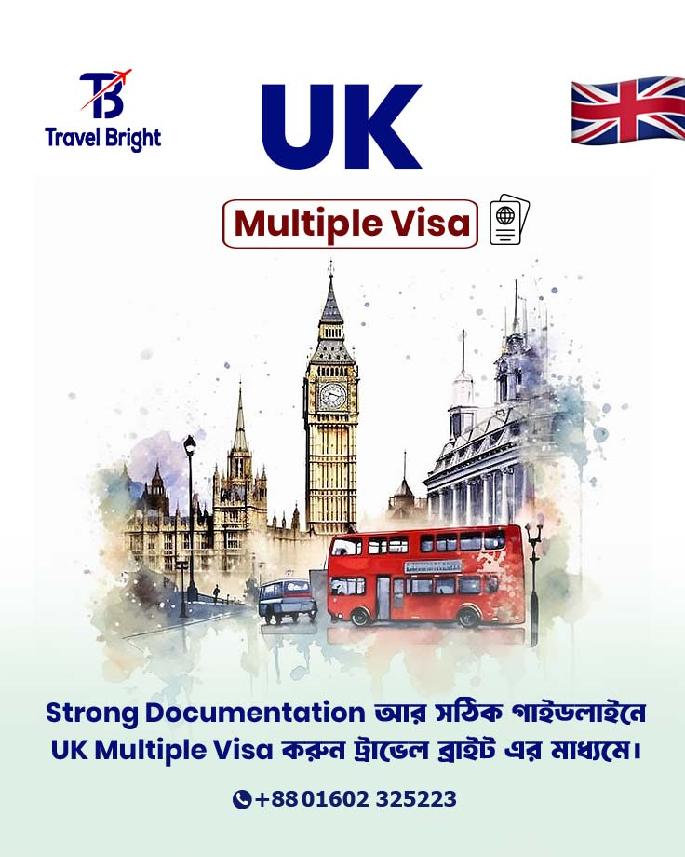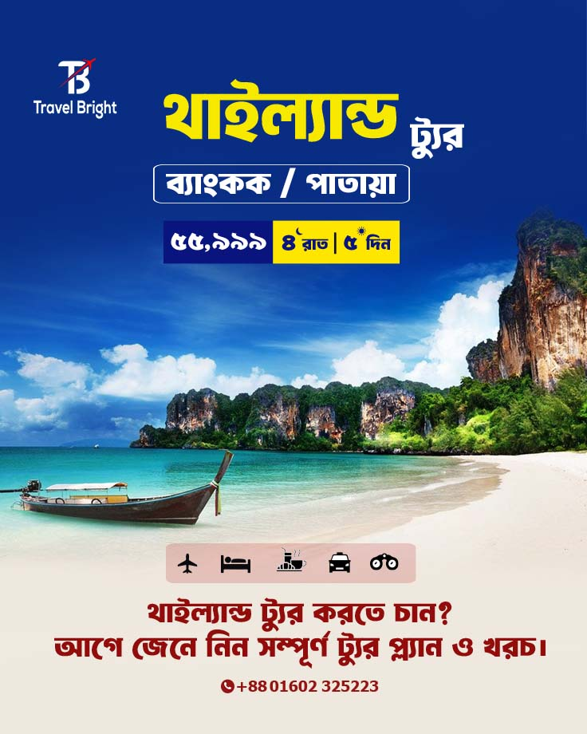
My responsibilities and duties Contain: Travel Bright's department of marketing hired me as a marketing Intern. My superior, Raisul Islam Sajal, gave me an overview of my responsibilities at the company at the outset. For the first two weeks, he assigned me simple, minor chores to assess my skills and talents. I worked on data entry, lead management, and client communications throughout this time. In addition, I collaborated on content creation and branding with the social media team. I was assigned certain tasks after the first two weeks, one of which was data entry on Google Sheets, where I documented customer communications for future use. My primary responsibility was telesales, which included contacting prospects, responding to their inquiries, keeping them informed, and turning prospective leads into customers. I was able to keep thorough records and have a methodical communication style because of these assignments. Creating content and branding on social media was one of my main contributions. I helped the graphic designer finish the designs and produced material for the business's daily social media posts. I was also given the task of writing the script and filming Travel Bright's introductory video by my boss. I created the first draft, took my supervisor's recommendations into consideration, and made sure the finished video matched the company's branding goals.

Besides the previously mentioned, I actively participated in corporate sales by going to various offices and non-governmental organizations with my supervisor for vendor enlistment. In addition to updating the vendor database, I helped gather the paperwork required for visa processing. was entrusted with overseeing the office's physical clients. They were informed of the requirement's primary details. helped resolve the questions.
I completed a number of HR-related duties in addition to my primary duties, such as publishing job openings on social media, contacting applicants, and setting up interviews in accordance with management directives. As my internship came to a conclusion, I gave a new marketing intern training by going over lead management, the telesales process, and daily operational duties. I also assisted with visa documentation procedures while I worked at Travel Bright, creating invitation letters, cover letters, and other documents required for visa applications. In order to provide clients with accurate and up-to-date information.

Training

Product training: on my first day of work, which involves learning about the product or service in order to understand its features, advantages, and special selling factors. This facilitates sales efforts and helps prospective customers understand the value of the product.
Sales techniques: Include instruction on how to overcome objections and cultivate relationships with customers, as well as how to prospect, generate leads, cold call, negotiate, and close agreements.
Using Portals: I got a chance to use various kinds of portals like Fly Hub and Flight Expert to search the flights of national & international airlines, then compare the fares before giving the customer the best deal.

- Interaction with Supervisors and Coworkers:

During my internship at Travel Bright, my interactions with my supervisor, Raisul Islam Sazal, and other coworkers were incredibly beneficial and cordial. During the first two weeks of my training in the telesales department, my supervisor was one of the most significant helpers in my learning process. Every time I made a mistake, my supervisor was patient with me and encouraged me to maintain my confidence. He was very approachable and did not hold back when offering suggestions for enhancements I could make to increase my performance. He helped me get better at being on time because I struggled to be on time throughout the first few weeks. Additionally, my coworkers were a huge assistance to me during my internship. Along with providing me with basic information like booking tickets and obtaining a visa, they also gave me some advice on how to adapt to corporate culture. They were always the first to step in and get me out of problems when I got into trouble or messed up my job. It was difficult to manage clients because of their diverse behaviors. Strong communication skills and tolerance were needed because some of them were demanding, impatient, or unsure of what they needed. It is daunting to be the youngest person in the office, but my boss and coworkers made me feel valued and at ease. They had always been receptive to inquiries and faced difficulties in their position. My internship with Travel Bright was a worthwhile learning experience because of the supportive atmosphere and helpful criticism.
- Experiences to Encounter the Difficulties:
Throughout my internship, I had to tackle several challenges that required a lot of work and flexibility. I first struggled to complete my daily responsibilities on time. It took some getting used to because I had never worked in a setting with such strict schedules before. I occasionally had trouble getting to work on time, and my health started to deteriorate after just a few days of employment. However, I deliberately tried to get better by watching and learning. A significant obstacle I encountered was multitasking, which includes finishing tasks as assigned, updating leads, managing social media, assisting colleagues, and attending lectures. In the beginning, all of this seemed and sounded overwhelming. Knowing that I needed to improve my efficiency, I began making a list of tasks, organizing my day, and establishing objectives to complete projects ahead of schedule. I get better and more comfortable performing multiple tasks at once the more I do these. Other difficulties came from using tools and technology I wasn't accustomed to. With the help of my coworkers and supervisor, this slowly took shape. Due to my initial lack of awareness, there were problems with the information I had to supply on the visas. I made mistakes, but rather than dwelling on them, I made repairs and took advice from others on proper protocol. I started writing down some crucial issues that needed to be addressed during my downtime in the office so that I wouldn't make the same mistakes twice. These notes quickly proved to be quite helpful, and I was able to improve and make changes. I overcame all of those obstacles by taking initiative on my own, asking for assistance when necessary, and working tirelessly. This experience in the workplace taught us how to be flexible, manage our time, and never stop learning. I discovered that I had significantly grown both professionally and personally by the end of the internship.

- Differences Between Experiences and Expectations:

The fact that Travel Bright eventually approved my internship request into their marketing division made me really happy. At the time, I believed that I understood every marketing word and that the jobs would be very simple for me. In my view, an internship entails light labor that may be completed with ease. But as I quickly discovered, the business world and the workplace were far more difficult than I had first imagined. My expectations were very different from the reality of working in the marketing department. When I first arrived, I discovered that the hours were set: 9:30 am to 6:00 pm. I had assumed that the workplace would be flexible. For me, this was a big adjustment. I had assumed that interns would have a more flexible schedule, but I quickly adapted to getting up at 7:30 am and traveling to the workplace, where I was unable to leave until 6:00 pm. There was a lot of strain at work, and it was much more difficult than I had anticipated to manage the burden every day. The tactics and duties I had to undertake as a marketer were very different from what I had learned at university, despite my belief that my understanding of marketing would be helpful. My success was mostly due to my academic knowledge; the practical portions of the job proved to be far more challenging and required abilities that needed to be further developed. I believed that I could be easy for people and that everything would work out. Nevertheless, I struggled with certain parts of interpersonal connections; everything had to be done at a level of professionalism, communication, and teamwork.

Contribution to departmental functions

  - Sales Support: Helping the team with everyday duties such as creating estimates, proposals, and sales presentations in order to expedite the sales process.
  - Customer data management: This is the process of keeping customer databases current and correct so that the sales team can target leads and cultivate relationships.
  - Market research: This is the process of gathering information about prospective clients, unexplored markets, and rival tactics in order to improve sales techniques.

Evaluation

My daily tasks included attending the weekly management team meeting and updating the supervisor on my progress. These gatherings offered a chance to discuss market trends, client needs, and the present need for travel services. Participating in conversations allowed for the acquisition of important decision-making and strategy-development experience. All things considered, my internship at their company gave me the opportunity to work with many departments, such as marketing, sales, human resources, and visa processing. By generating leads, interacting with clients, producing content for social media, or handling corporate sales duties, I did my best to be an active contributor to the company. I made every effort to contribute to Travel Bright while working to become a better version of myself in these areas.

Skills applied

- Communication skills: Persuasive, polite, and clear writing and speaking. Active listening: Recognizing the wants and needs of the client.
- Empathy: Responding professionally and thoughtfully to issues or concerns.
- GDS: Knowledge of Amadeus, Sabre, and Galileo for reservations is necessary for GDS (Global Distribution Systems).
- Using CRM software: Keeping track of client information and correspondence.
- Online booking resources: Making use of websites such as airline portals, Booking.com, and Expedia.

New skills developed

I had the chance to learn a number of new skills during my internship at Travel Bright, which improved my professional skills and comprehension of the sector. These consist of:
- Communication and interaction with clients:
learned how to interact with clients in a professional manner via email, phone, and in person.
gained expertise in responding to customer inquiries about booking processes, visa regulations, and trip packages.
- Purchasing airline tickets:
understood the procedures for managing bookings, applying fare restrictions, and checking seat availability.
- Negotiation and sales skills:
observed and practiced presenting vacation packages to customers in an eye-catching and convincing way.
- Digital tool use:
enhanced my ability to communicate with clients and preserve records utilizing Google Sheets, Microsoft Excel, and WhatsApp Business.
learned how to handle the agency's Facebook page and answer questions from clients.

Application of academic knowledge

I feel privileged to have had some of the best faculty teach me marketing at United International University. I benefited from their teaching style during my internship. The following are the courses and subjects, if I had to list them:

Business Communication (BUS 2112): I now have the ability to communicate effectively both internally and externally thanks to this course. Additionally, I learned how to write official emails and other communication strategies that were really helpful.
IBS 3121: International Business: This course's concepts and subjects pertaining to international business enabled me to investigate corporate policies.
MIS 2218: Advanced Business Computer Applications: Acquiring Microsoft Here, Excel's pivot table, regression, and bar chart features helped me prepare the report.
MKT 3336: Marketing Management: My comprehension of business models was assisted by the core concepts and knowledge in marketing management.

CHAPTER IV: CONCLUSIONS AND KEY FACTS

Recommendations for improving departmental operations

The following suggestions are made to strengthen departmental processes in order to improve a travel agency's overall efficiency, service quality, and client satisfaction:
Boost Communication Across Departments: To guarantee flawless service, schedule frequent coordination meetings between the teams handling tickets, visas, and trip packages.
To keep track of client updates and progress, use a centralized communication platform (like Microsoft Teams or Slack).
Enhance Client-Handling Practices: To guarantee accuracy and consistency, create consistent checklists for various services (such as booking a trip or obtaining a visa).
After services are provided, introduce feedback forms for assessing customer satisfaction and pinpoint areas in need of development.
Present Performance Measures: For every department, establish quantifiable KPIs (Key Performance Indicators), such as booking volume, successful visa rate, or response time.
To monitor advancement and pinpoint problems, conduct performance evaluations every month.

Key understanding

Application of Travel Services in the Real World:
By managing real-time client demands, including hotel reservations, tour planning, visa processing, and airplane bookings, I gained an understanding of how travel firms operate beyond theory. I realized that each service has to be customized to each customer's particular interests.
Technology's Function in Operations:
I was aware of how Excel, email systems, digital communication platforms, and GDS (Amadeus) were used in daily operations. These tools decrease manual labor and boost efficiency.
Comprehending Airline and Visa Policies:
I acquired hands-on experience with visa procedures, embassy regulations, and airline restrictions for various locations. This knowledge enabled me to assist the team in appropriately guiding clients.

Conclusion

I gained invaluable exposure to the real-world applications of sales and marketing in the travel sector during my demanding and rewarding time at Travel Bright. I gained vital professional skills and a greater comprehension of the industry by overseeing important tasks and participating in the business's operations. In addition to expanding my knowledge, this internship has given me the confidence I need to take on new challenges. I am appreciative of the advice I still receive and the degree of confidence that was put in me to carry out important duties from a dynamic work environment.

References

Bangladesh Investment Development Authority (BIDA). (n.d.). Tourism Sector Overview. Retrieved from https://bida.gov.bd
International Air Transport Association (IATA). (n.d.). About IATA. Retrieved from https://www.iata.org/en/about/
Ministry of Civil Aviation and Tourism, Bangladesh. (n.d.). Tourism Master Plan Summary. Retrieved from https://mocat.gov.bd
Travel Bright. (2018). Facebook profile. Retrieved from https://www.facebook.com/travelbrightaviation
Travel Bright. (2019). LinkedIn profile. Retrieved from https://bd.linkedin.com/company/travel-right-aviation-ltd
UNWTO – United Nations World Tourism Organization. (2022). Tourism Data Dashboard. Retrieved from https://www.unwto.org/unwto-tourism-dashboard
World Travel & Tourism Council (WTTC). ((2023)). Economic Impact Report - Bangladesh. Retrieved from https://wttc.org

Appendix

Work Experience Certificate
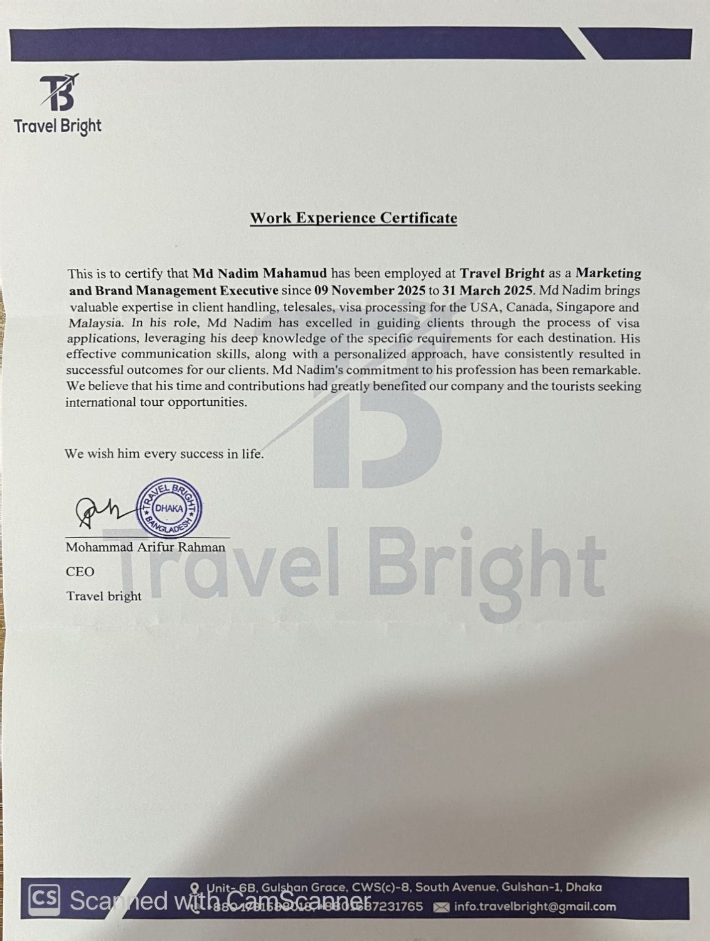

Offer Letter
