Internship Report
On
JAST Marketeers
Topic Name: Recruitment and Selection process




Course Title: Internship
Course Code: INT 4399

Prepared For
Piana Monsur Mindia
Assistant Professor
School of Business & Economics (United International University)

Prepared By
Robin Karmakar
111 161 180

Submission Date:
19th February, 2021

Letter of Transmittal
Date: 19th February, 2021
Piana Monsur Mindia
Assistant Professor
School of Business & Economics (United International University)

Subject: Submission of Internship Report on “Recruitment and Selection practices in JAST Markeeters.”
Dear Mam,
With great pleasure I hereby submit my internship report on "HR functions (Recruitment and Selection practices) of JAST Marketeers." The report has been completed by the information that I gathered from the major courses on Human Resource Management which I have completed during my MBA as well as from my internship period in JAST Marketeers.
As a requirement of preparing an internship report based on the practical knowledge in an organization, I selected Recruitment as my core concentration along with few other HR functions that I have come across during my internship program. I have tried my level best to complete this report meaningfully and correctly, as much as possible. I hope this report will reflect on the contemporary issues on the Human Resource Management that are being Practiced by this organizations in our country.
Thank you.
Sincerely yours,
___________________
Robin Karmakar
ID: 111161180

Acknowledgement
First of all I want to thank to my honorable faculty Piana Monsur Mindia, Assistant Professor of UIU and United International University for giving me the opportunity to do this internship. I would like to thank JAST Marketeers Management committee and HR department for letting me do the internship at their HR Division Head office.
Also I’d like to thank the CEO Alfi Bappy for helping me for the Internship Purpose and HR Executive & Admin Monir uz Zaman Sir, my internship supervisor for guiding me with the completion of this report and HR Division for keeping me under their supervision and provide me with all the necessary information which has helped me in the completion of this report. I would also like to thank all the officials of JAST Marketeers HR Department for allowing me to be an internee at their organization and help with necessary information.

Executive Summary
JAST Marketeers Company is a new and growing company in Bangladesh. It has started its operation from November 2019. This company is providing several kinds of services now for customer satisfaction. I am doing my Internship in there and I have chosen my topic and topic name is “Recruitment and Selection.” Also I have done covering other functions as well.
The report holds the summary of HR practices by JAST and how it’s important for improving its manpower. And HR practices are very important for JAST and any other organization and its gain the competitive advantage over the competitors.
In this report, the first chapter includes about report introduction, report objectives and how limited the information for working and restrictions. The second chapter includes about organizations introduction or history, their mission, vision and what is their structure or how it is structured by them and their communication. The third chapter is briefly discussed about JAST and other organizations HR practices and what I have learnt in their organization. In the end, I have given analysis about what I have found or errors and some recommendation though I am not worthy of giving suggestions.

Contents
Acknowledgement iv
Executive Summary v
Chapter 1 1
1. Introduction: 1
1.2 Origin of the Report 1
1.3 Objectives of the Report 1
1.4 Methodology 2
1.5 Limitations of the Work 2
Chapter 2 4
2.1 Introduction of JAST Marketeers. 4
2.1.1 History. 4
2.1.2 Mission, Vision & Values 5
2.2 Products and Services of JAST Marketeers. 6
2.3 Organizations Structure. 7
2.3.1 ORGANOGRAM 8
Chapter 3 9
3.1 What is Human Resources Management? 9
3.2 Human Resources Functions. 10
3.3 JAST Marketeers HR functions: 12
3.3.1 Recruitment and Selection: 12
3.3.2 Training and Development: 13
3.3.3 Compensation and Rewards: 14
3.3.4 Performance Management: 14
Chapter 4 15
Analysis 15
Findings 21
Chapter 5 22
Recommendation 22
Conclusion 22
Bibliography 23
Appendix 24
Questionnaire 24
Other Essential Documents: 26

Chapter 1

1. Introduction:
I have selected “Recruitment and Selection” Process by researching in “JAST Marketeers” Banani, Dhaka. This is totally a new company. I tried to integrate my theoretical knowledge and combine with practical examples as observed during my Internship. I have tried to cover all the major functions of Human Resources Management- planning, recruitment, selection, compensation and benefits, training and development convey my understandings of the different functions of Human Resources Management through this report. At the end of this report I have given some information about the existence of this company. I have also provided some Conclusion and Recommendation based on my knowledge which I gathered during my internship.

1.2 Origin of the Report
The report is mainly prepared for the purpose of Internship, United International University by discussing with company employees (JAST Marketeers) and mainly with Executive, HR & Admin, Monir uz Zaman Sir. I have gained a lot of information by working with their environment and about their HR functions and also I had a great opportunity to have an in depth knowledge of HR and Management area.

1.3 Objectives of the Report
The main objectives of this report are to gain a proper and enhanced knowledge about “Recruitment and Selection practices” in JAST Marketeers. And in the end it will come out the different function of HR and with the view of how the organization is focusing of different process of Recruitment and Selection. Also we will see about employee’s satisfaction, skilled, different methods and organization growth.
- Primary Objectives:
- To know about all kind of HR functions and analyze it and their link specially Recruitment and Selection and Training and Development.
- To enhance my experience.
- Secondary Objectives:
- To know daily practices of HR in this organization.
- To know about what kind of problems their employees are facing.
- About employees satisfaction.
- To recommend necessary steps for overcoming the problems.

1.4 Methodology
I have worked hard for getting all kind of information in this organization. But all information can’t be given because of some rules, regulation and other factors of this organization. Though they helped so much but I gave the information little because of their short time of starting.

- Primary Source
- I have done a face to face conversation with relevant officer in this organization.
- Taking interview with Executive of HR.
- Observe other employees.
- Secondary Source
- Annual report of JAST Marketeers.
- Internal files of this organization.

1.5 Limitations of the Work
Though I have tried my best to this report perfect by giving proper and adequate information still I had to pass through some limitations which were inevitable. I have provided much information by discussing with HR Executive & admin, but there has lot of limitations.
- Website Issues: As this is totally new Company, they didn’t create their website because its take some time to establish the website and give information into it. Though they want to create it in short time, but I only get 3 months to know them.
- Lack of Information: Website is not the major issue, though I get the information from organization beloved person Executive, HR & Admin Monir Uz Zaman sir. But I didn’t get all of their information because of short time, also for the Pandemic issue.
- Time Limitation and Corona Pandemic: Internship is 3 month, but due to some problem it exceeds to 2 months. So there was a lack of time to know everything. Experience which I gathered is also not beyond my expectations.

Chapter 2


2.1 Introduction of JAST Marketeers.
JAST Marketeers is totally a new company, Started from October 2019, establish in Road 3 Banani. This is basically third party and corporate type of company. They take order from first party and give products to second party. Initially this company was proprietor type, they have partner but it is not formed as Limited yet. There are 160 Distribution point for this new company. Almost 2000+ employees are working in this organization.

2.1.1 History.
JAST Marketeers is third party organization. First they get link with FMCG companies and now they are connected with Telco companies. Now two types of distribution house respectively FMCG and Telco they are following. Those following FMCG and Telco companies are:
FMCG Companies:
- Marico Bangladesh (Lalmatia, Mohammadpur)
- Reckit Benckiser BD (Lalbagh)
- NZD Diary Bangladesh (Razabazar)
- Hemas (Uttarkhan)
- Transcom Beverage Ltd. (Pepsi- Uttakhan & Uttara Sector
Telco Companies:
- Robi Axiata Ltd (Dhanmondi)
- Robi Axiata Ltd (Adabor)
- Robi Axiata Ltd (Sutrapur)
- Robi Axiata Ltd (Elephant Road)

2.1.2 Mission, Vision & Values
Vision:
In JAST Marketeers our vision becomes “We pick quality product for you”.
Mission:
To achieve our Vision, Our mission is to create skillful employees and makes a large amount of customer and their satisfaction.
Core Values:
JAST wants to hold the following value:
- Creating an honest, open and enabling environment.
- Have strong customer focus and relationship and giving best services.
- Work as a team to serve the best products for satisfaction.
- Value and respect people and make decisions based on merit.
- Responsible, trustworthy, and law-abiding in all that we do.

2.2 Products and Services of JAST Marketeers.
JAST Marketeers have few their own product. Mostly they deliver the product by knowing the customer insight. They have their official Facebook page.
JAST Marketeers has particularly sales point (Shop) for every house in their respective place. And to make more profit DSR frequently visit market to enhance the number of Customer.
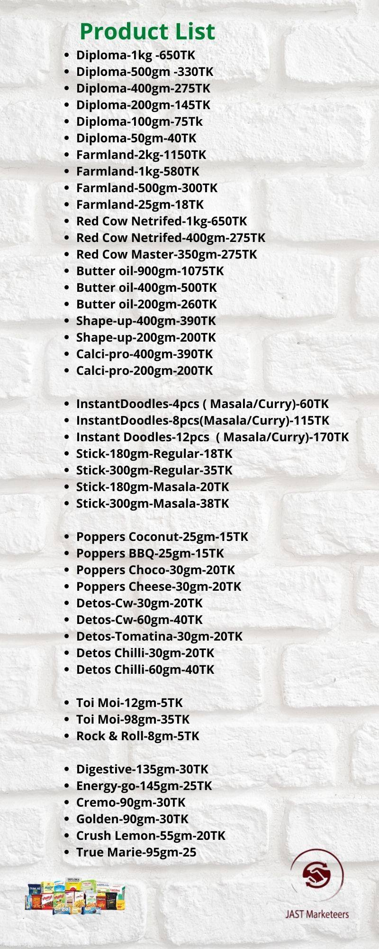

2.3 Organizations Structure.
There is basically a structure from four types of structure in any organization, Functional, Divisional, Flat, and Matrix Structure. JAST follows Functional type of structure and breaks up a company and based on the specialization of its workforce. Dividing the organization into departments consisting of marketing, sales, and other operations and give them proper right to take decisions and doing other activity.
Organizational structure of JAST and designation are in ascending order:
Top Management | Chairman.  Board of Director.  Managing Director.
Executive Level Management | Senior President.  Assistant President.
Mid Level Management | Manager.  Assistant Manager.
Junior Level Management | Officer.  Junior officer.  Assistant officer.

2.3.1 ORGANOGRAM


Chapter 3


3.1 What is Human Resources Management?
Human resource Management is a strategic approach to the effective management. In an organization or company HR helps to grow their business with a competitive advantage. It is designed to maximize employee performance in service of an employer’s strategic objectives.
Human Resources and all things are related with each other in a company. For growing competitive advantages, human role is very important in a company, that shall be competitive than the company will be competitive automatically.

3.2 Human Resources Functions.
There are so many functions in HR. And every organization has their own way to follow every function. There are basically some functions which is necessary for Human Resources as well as for their Organization.
Some functions are:
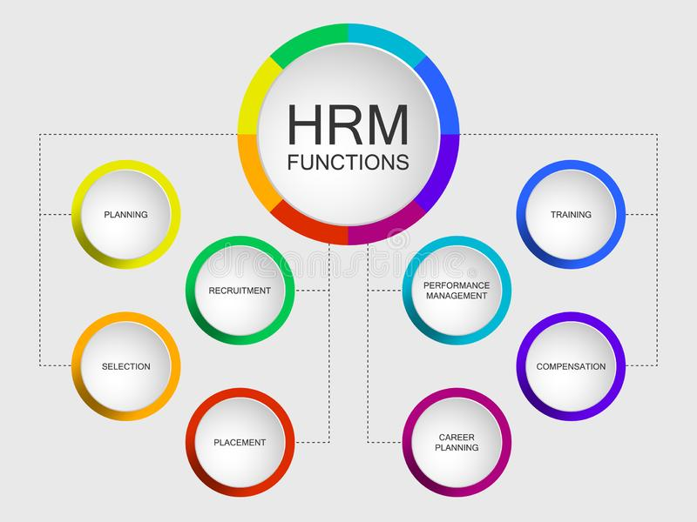
- HR Planning: Planning is the first thing for a HR and foremost job for HR analysis or organizations for getting success. There can be both long term and short term. Planning for growing the growth, duties, responsibilities for others, recruiting talent, training in a perfect time, giving rewards and others all are part of the Planning. Recruiting the best employees and training for best employees is also great part for the HR planning.
- Benefits & Compensations: Benefits and Compensation comes from the profits cutting the cost. Though it is an expensive for organization, but this is the right for the employers. And HR role is to pay and giving benefits who is good and has dedications for their organization. It can also boost for their employees.
- Rewards: Giving reward is kind of giving motivation to everyone. Reward is basically meant for everyone to go higher and taking the organization higher. It’s like employees are being appreciated for their work. And it also creates positive behavior for everyone. There are so many reward giving for employees based on their work and performance management.
- Training and Development: Training and Development is a part of organization growth by developing the selected employees. After all, the success of organization depends on how much the employees are trained. Although new employees have to know first and acquire the company knowledge and skill shall be there for performing the organization job. And for doing the efficiency or productivity job they also need some training for that. In that case HR plays a crucial role for training and developing their employees and creates healthy organizations.
- Recruitment and Selections: This is totally a primary functions for HR for recruiting the best employees and achieve the Organizations best goals. Hire for the right employees for the right position makes organization much competitive than others and increasing growth. Interview is a process of selection a best employees. Here HR can predict the right employees by judging or following others Criteria. Also employees can get the minimum satisfactions offer for them to grow their career.
- Performance Management: Effective performance measure can help to achieve the organization goal and also employees will be competitive. There are lots of measuring methods that can be observing, 360 degree and many more. Performance management is not for only employees, also for team, management and whole organization. Best employee can get reward if their performance is good.
- Safety and Health issues: Every organization has their own methods for following safety issues and it is organized by authority. It is all about for employee’s safety. Giving safety for the employees can get increase the growth of the company because employee will think that they have the safety for them as well as for their family. It will be satisfied for them.

3.3 JAST Marketeers HR functions:
JAST is totally a new company. As they are new to their field, they don’t want any lack to their corporate field. They have so many employees in different distribution point. There are so many functions they follow but below I am giving most focusing HR functions for increasing their better growth in the future.

3.3.1 Recruitment and Selection:
In this Organization HR find out the demand of HR resources in future. So there are some steps JAST follows for better future of this organization.

Steps of Recruitment of JAST:
- Requisition of recruitment: There are so many distribution point in this organization. From every distribution they prefer some employees which can be new for their career in Head office or HR executive. Executive & HR admin who is in the corporate office raise the requisition of recruitment through the prescribed requisition of recruitment and completes the formality like approval of Managing Director.
- Attracting Applicants: JAST use internal and external both ways to attract the employees. That can be from referral from current employees or advertisement. They use mostly BDjobs for attracting new employees.
- Receiving Applicants: HR of this organization takes resume and other certificate from those applicants who are interested within a period of time.
- Sorting of CVs: The CV sorting out is very important part for choosing people in the organization. HR of JAST does it for decreasing of wasting time and choosing experienced people. They first do CV listing then they see some potential by searching some fact like their grade, experience, skill and other factor. After that they call those employees who have skill.
- Informing Candidates: After that, HR calls those employees for written exam and interview as well.

Steps of Selection of JAST:
This process is all about choosing the best from everyone. HR of JAST has some pattern for selecting the best employees. Those are:
- Group Interview: After selecting the Candidate, they officially call them for interview. And in that case, there are some upper level employees who keep them in a room and take the interview. And from that who has skill get to know about written exam.
- Reference Check and Background: When talents competency matches with role profile, HR budget, then educational documents, previous employment certificates and all other documents checked by HR admin.
- Final offer and Job selection: Based on Other information and reference check, the candidate is selected for appointment. The appointment letter includes:
- Job title. 2. Salary. 3. Nature of Appointment. 4. Place of posting. 5. Date.

3.3.2 Training and Development:
There are some methods which can be boost to employee’s skill. JAST follows some:
- Training: JAST have some way to give train and develop the employees like combinations of lectures, hands on exercise, videos, simulations and individuals/group based assignments. It can be both formal and informal training for the employees. Informal training can be classroom-based, instructor, e-learning courses. Informal can be watching you-tube videos, educational blogs, self study and others.
- On the Job Training: There is no time for JAST to train every employee. So this method can be the way to train when you are inside the organization it is like practical training while working or doing any task. It is a basic training like operating a new machine, or learning a analysis that can be HR practices, financial practices or others analysis.
- Self Study: Self study can helps to grow up employee’s career. Here the study can be reading, writing, researching and also outside the work hour. The subject is not like always for the organization related, for knowledge gaining related too. They can be motivated if they are independent.
- Job rotations: For gaining new skills or understanding the proper situations, job rotations is important. Employees could volunteer for this role. The goal is rotate the task and roles to gain something new or have a chance to practice.
- Coaching: Coaching is another method to improve skill and knowledge. This method is typically involved with upper level management working one and one with experience employee. In this way, they typically know various types of topics. Though is has some cost and time consuming, but it helps him/her to know many things and build their career.

3.3.3 Compensation and Rewards:
There are some methods which JAST are following for giving those benefits to employees:
- Base pay: Minimum amount of salary which shall be given after a period.
- Commissions: This is basically product based.
- Overtime pay
- Bonuses
- Merit pay
- Meal Allowance

3.3.4 Performance Management:
There is some performance measuring methods JAST follows for better future:
- Management by Objectives (MBO): This is an especial methods where managers and employees both sit together and identify, plan, organize and communicate during this appraisal methods.
- 360 degree Methods: This methods is using by getting feedback from all over the company like managers, peer, group and customer feedback. This method is not only eliminating bias but also give a clear idea of individual’s competence.
- Behavioral Anchored Rating Scales (BARS): This method brings both qualitative and quantitative benefits for appraisal. BARS give a exact behavior to a employees and exact ratings for considering those behavior.

Chapter 4

Analysis

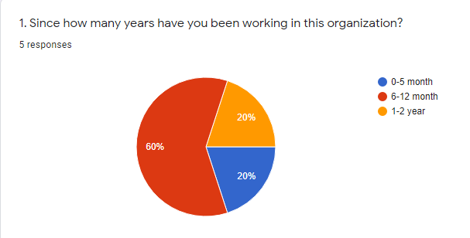
- Though JAST has established November, 2019, they are creating day to day activities daily. Here I have asked few employees who said 60% and 20% are working recently and 20% are working from the starting of the organization.
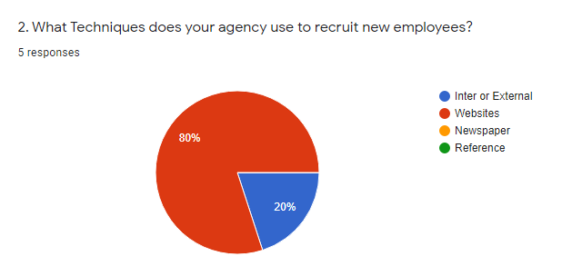
- JAST recruit their employees mostly approximately 80% from website like BDjobs.com. And rest like 20% recruit from Internal or external methods.
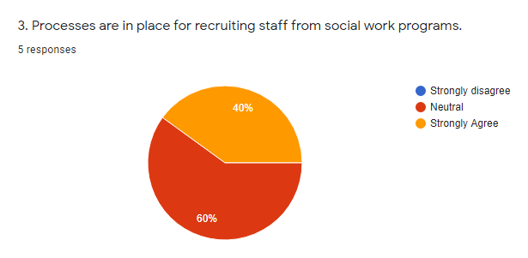
- JAST officially wants to work socially. And for getting better experience they recently hired employees. Though 60% didn’t want to talk with that matter, but 40% are strongly agree for this.
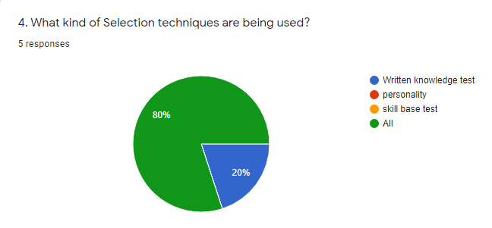
- After selecting the employees, JAST take exams for verifying the employee. It can be many ways. But 80% are saying JAST verify them by written test, personality, skill base test.
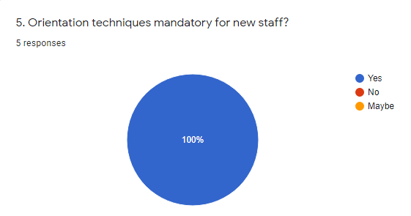
- After recruiting and selecting the best employees, JAST keep sure that all of their new employee’s orientation shall be perfect. And 100% are saying they agree with that.
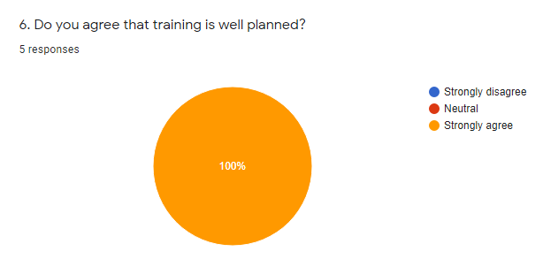
- For future growth well skilled employee is needed. And in that case 100% are saying that in their organization training is well planned for everyone. And all of them are agree with that.
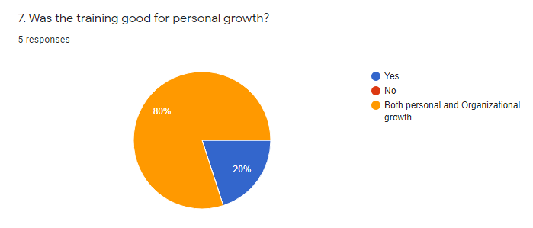
- JAST doesn’t give training all of their employees. But if there is potential, they give the training. And 80% are saying that training gives for both personal and organizational growth.
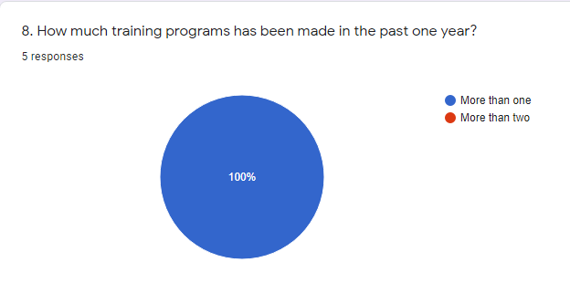
- JAST gives training to their employees approximately two in every year.

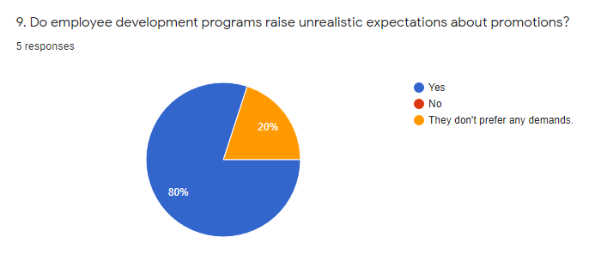
- After the development program for upper level employees, those employees expect some expectations about their promotions or other benefits. 80% employees are saying so. But 20% is saying they don’t prefer any demands.
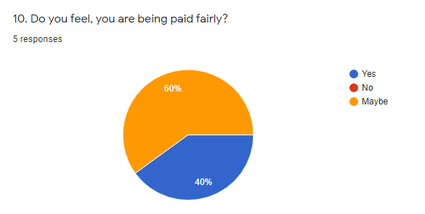
- 60% of JAST employee’s expectations more salary and they prefer more but 40% saying they are okay with that salary.

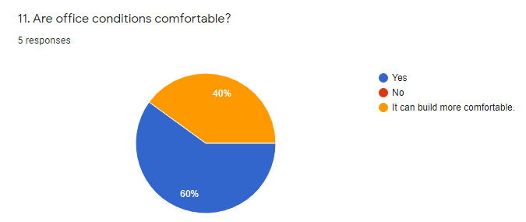
- JAST is a corporate office. And they want their environment comfortable and cool. So 60% are saying their environment is comfortable but 40% wants to build more comfortable day by day.
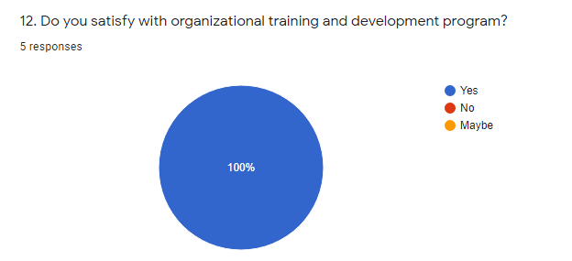
- JAST employees are satisfied with their training and development methods.

Findings
In this company I have found so many pros and cons which can be both good and bad for this company.
- JAST Marketeers is a third party organization, they give products taking help with first party and give good quality products by those ordering.
- The organization is basically started reward system for their employees who have ability and dedication for their organization.
- JAST Marketeers has valuable customers as they are third party organization, and they always provide good quality products.
- Performance appraisal is based on various methods, and after a certain period I hand over to upper management.
- The organization employees have well friendship with upper and lower employees.
- Sometimes it got late to provide products, and then they give gifts to those employees.
- JAST environment is friendly and upper employees can take decision all their own.
- JAST follows 360 degree, MBO, BARS methods for performance management.

Chapter 5

Recommendation
Nothing is perfect. So for better improving they have some lack in their organization. Though I’m not worthy of giving suggestion for them, I think if they follow about their mistakes and makes better solution they will achieve more growth for their company and more respect for them.
- Though they have good friendship between upper and lower level employees, they need to improve better communication with each other.
- Their tools of doing task shall be more improved.
- Job advertisement should be in every media. They only give ad in BDJob, they should use various Newspaper and others media.
- In orientation, they shall be more specific and fun not boring and connection of senior and junior shall be accurate and friendship.
- Guideline from senior to junior is also important.
- I have worked in Head Office, office space is big but their receptionist is very poor that shall be improved.
- Safety and security need to improve more for employees.
- Training shall be taken after exact period in every time.
- JAST shall take medical test to their all employees as well their mew recruit employees

Conclusion
For the future organization needs JAST Marketeers has their own style for HR practices or function designed to attract, obtain, and train and other facilities. Though by focusing those practices and improving from their mistakes and taking new steps they can successfully continue organizational operation, they need to improve more and more. To increase the productivity of an organization effective and dynamic recruitment and selection and other functions as well.
The analysis of this report shows some positive practices which are need to improve for conducting successfully. HR Executives of JAST Marketeers are now expanding to work beyond the boundaries of contract and policies to contribute directly to the operation and success of the business.

Bibliography
AIHR(Digital). (n.d.). A full guide to Compensation and Benifit.
Chand, S. (n.d.). Steps in Human Resource Planning (explained with diagram).
hr-guide.com. (2015). Compensation(Outline and Definitions).
L, S. (September 28, 2020). Top 10 functions of an HRM. olx People .
Miech, C. (September 10, 2019). tracktime24. 10 core functions of HRM .
Process. (May 11, 2020). 6 Practical Performance Appraisal Methods for the Modern Workforce (With Examples).
VALAMIS. (February 4,2020). 11 Employee Development Methods.
Whatishumanresource.com. (n.d.). What is Human Resource. Website for students .

Appendix

Questionnaire
Q1. Since how many years you have been working in this organization?
- 0-5 month
- 6-12 month
- 1-2 years
Q2. What Techniques does your agency use to recruit new employees?
- Internal or External source
- Website
- Newspaper
- Reference
- Other
Q3. Processes are in place for recruiting staff from social work programs.
- Strongly Disagree
- Neutral
- Strongly Agree
Q4. What kind of Selection techniques is being used?
- Written knowledge test
- Personality
- Skill test
- All
- Other
Q5. Orientation techniques mandatory for new staff?
- Yes
- No
- Maybe
Q6. Do you agree that training is well planned?
- Strongly Disagree
- Neutral
- Strongly Agree
Q7. Was the training good for personal growth?
- Yes
- No
- Both personal and organizational growth
- Other
Q8. How much training programs has been made in the past one year?
- More than One
- More than Two
Q9. Do employee development programs raise unrealistic expectations about promotions?
- Yes
- No
- They don’t prefer any demands
Q10. Do you feel you are being paid fairly?
- Yes
- No
- Maybe
Q11. Are office conditions comfortable?
- Yes
- No
- It can build more comfortable
Q12. Do you satisfy with organizational training and development program?
- Yes
- No
- Maybe

Other Essential Documents:
- Company Name: JAST Marketeers.
- Company Address: House 87, Road 3 block f.
- HR Executive & Admin name: Monir uz Zaman. (Cell: +880 1727-008511)
Internship Certificate: (I have applied before ending my Internship course for submitting here.)
