Internship Report on LankaBangla Securities and Overall Preview of Stock Market


Dewan Mushfiqur Rahman
ID: 111 181 017

This report is submitted to the school of Business and Economics, United International University as a partial requirement for the degree fulfillment of Bachelor of Business Administration

Internship Report On LankaBangla Securities Limited and Overall Preview of Stock Market

Submitted To:
Dr. Md. Qamruzzaman
Associate Professor
School of Business & Economics

Submitted By:
Dewan Mushfiqur Rahman
111 181 017
Major: Finance
Trimester: Spring”22

School of Business and Economics

United International University

Date of submission: 4th June, 2022

Letter of Transmittal

Date 4th June, 2022
Dr.MD. Qamruzzaman
Assosiate Professor,
School of Business and Economics
United International University

Subject: Internship report on LankaBangla Securities and Overall Preview of Stock Market.

Dear Sir,
With due respect, I am particularly pleased to present my internship report, which was covered my four month (one month extended by the company) internship at LankaBangla Securites Ltd (Trade execution and Business Development Department). The report includes in detail about my experience in a brokerage house and my knowledge about overall stock market which I got from working in a brokerage house. I am thankful to you from the depth of my heart supporting me from the start to the end, and give me feedback about my mistakes and correcting me in every part of the reports. Without your direction and inspiration this report cannot be done.
I have put my best efforts to make this report; it is very likely that the report may have some mistakes and absence of information which are unintentional.

Sincerely yours,

_______________
Dewan Mushfiqur Rahman
ID: 111 181 017

Certification of similarity index

This is to certify that this report is a product of my sole learning and experience throughout my internship. The similarity level for the entire thesis is less than 10% with any available documents related to this topic.

Declaration of the student
I Dewan Mushfiqur Rahman, hereby declare that the report entitled “Report on LankaBangla Securites and Overall Preview of the Stock Market” based on my own work to fulfill of the requirement of Bachelors of Business Administration Department carried out by me under the guidance of Dr. MD Qamruzzaman. I further declare that the work reported in this project has not been submitted and will not be submitted for any degree or diploma in this institute or any other institute or university.

Sincerely Yours,

_______________
Dewan Mushfiqur Rahman
ID: 111 181 017

Acknowledgement

I wish my thanks to my faculty for introducing to me this amazing report: Overall preview of stock market. Through this report writing, I got an opportunity to collect more in depth knowledge about stock market and techniques which are usually used in stock market.

Abstract/ Executive summary

This report is interpreting the performance of one of the top brokerage house in Bangladesh and also the stock market preview. As an intern my duties and responsibilities in the company like execution trading, payment & receive and customer service. The report will say the stock market industry as a whole and also tell my learning’s which I get like technical analysis, some trading psychology and trend of the industry.
In the first chapter I have discussed about the origin, objective and limitations of the report. In the second and third chapter I tried to give the preview of LangkaBangla Securities Limited and Bangladesh Capital Market. These chapters are the main part of this report. And in the last part is all about my internship experience and the last chapter, there is some recommendations for LBSL and conclusion of the report.

Table of contents for Internship
Table of Contents
Letter of transmittal i
Certification of similarity index i
Declaration of the student ii
Acknowledgement iii
Abstract/ Executive summary iv
Table of contents for Internship v
List of Figures 1
List of Abbreviation 1
CHAPTER I: INTRODUCTION 3
I.1 Background of the Report 3
I.2 Objectives of the Report 3
I.3 Motivation of the Report 3
I.4 Scope and limitations of the Report 3
I.5 Definition of Key terms 3
CHAPTER II: COMPANY PREVIEW 4
2.1 Company Analysis 4
2.2 Industry analysis 15
CHAPTER III: INTERNSHIP EXPERIECNE 19
4.1 Position, duties, and responsibilities 19
4.2 Training 20
4.3 Contribution to departmental functions 20
4.4 Skills applied 20
4.5 New skills developed 20
4.6 Application of academic knowledge 21
CHAPTER IV: CONCLUSIONS AND KEY FACTS 22
5.1 Recommendations for improving departmental operations 22
5.2 Conclusion 22
Reference 22

List of Figures

Figure 1.1: Revenue Growth
Figure 1.2: Cost of Service
Figure 1.3: Gross Profit Growth
Figure 1.4: Net Profit Growth
Figure 1.5: ROA
Figure 1.6: ROE
Figure 1.7: EPS
List of Tables
Table 1.1: Gross Profit Calculation
Table 1.2: Net Profit Growth
Table 1.3: Ratio Calculation

List of Abbreviation

LBSL: LankaBangla Securities Limited
DSE: Dhaka Stock Exchange
CSE: Chittagong Stock Exchange
BSEC: Bangladesh Stock Exchange Comminssion
CDBL: Central Depository Bangladesh ltd
BMS: BO Management System
OMS: Order Management System

CHAPTER I: INTRODUCTION

Background of the Report
The report is about the overall preview of the stock market and this industry’s view, the mechanism of a brokerage house that run the stock market and also providing an about the brokerage houses how they work and their investors behavioral aspect.

Objective of the Report
The purpose of the report to give an idea about overall stock market and its business process and the experience of working in a brokerage house and also give a brief about the whole business and its calculation trend.

Motivation of the Report
My academic purpose and requirement.

Scope and Limitation of the Report
As an intern I am unable to collect some news which can not be accessible for me, as it is all about stock market and its brokerage houses so it was difficult to collect some information which are determined by the higher authority cannot be disclosed to us. So it is difficult to me to give the information about LankBangla securities fully transparent.

Definition of Key terms
Brokerage House: A brokerage firm or brokerage company is something that works as a middleman between buyers and sellers to complete a transaction for stock shares, bonds, options, and other financial instruments in exchange of fixed commission rate per transaction.

CHAPTER II: COMPANY PREVIEW

Company Analysis

- Overview and history

Our scrupulous investment in time and labor to create a better investment pathaway for you in the bangladesh stock market has made us become the equity brokerage house in the country.

LankaBangla Securities started as Banik Bangladesh Securities Ltd in 1997 with our activites confined only withtin the Chittagong Stock Exchange (CSE) Ltd. A year later, we made a step ahead and introduced ouselves to the Dhaka Stock Exchange (DSE). Its rebranded itself as LankaBangla Securites Ltd.in 2005 following a restructuring of the company.

At LankaBangla Securites Ltd., they specialize in developing the country’s most efficient stock brokerage workforce with unmatched skills and consummate perfectionism. Also, in whichever coner of the country you are or whichever geographical loaction you are in, we have got you covered as you could find our branches spread in the leading cities and townships countrywide.

LankaBangla are the leader in terms of customer transactions,service and their belif towards the company. That is why the company crowned as the largest and No. 01 broekreage house 12th consecutive time in DSE and 13th in CSE.

Our ability to meet the demands considering every client’s time horizon, goals and risk tolerance have made us settle relations with thousand of clients not only retail but also institutional clients all over the world.

Vision Mission and Core Values
Vision:
To become the most efficient and unique platform for Bangladesh capital market by connecting people globally in order to bring out of underlying economic growth of the country.
Mission:
- Cost effective and efficient brokerage platform
- Build a trust and commitment based relationship with the clients
- Create a hub of international investment
- Uphold the integrity of the capital market.
- Continuously on a process of improvement
- One-stop service with state of the art of technology.

Core Values:
- Service Excellence: ability to serve consistently to the client in a proper manner and also meet their expectations.
- Integrity and Professionalism: never compromise with the quality assurance.
- Teamwork
- Understanding and Approachable
- Energy and Action
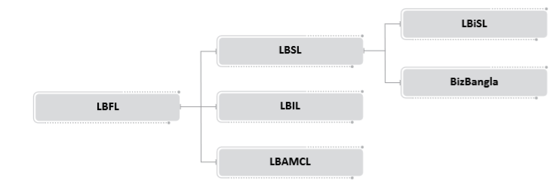

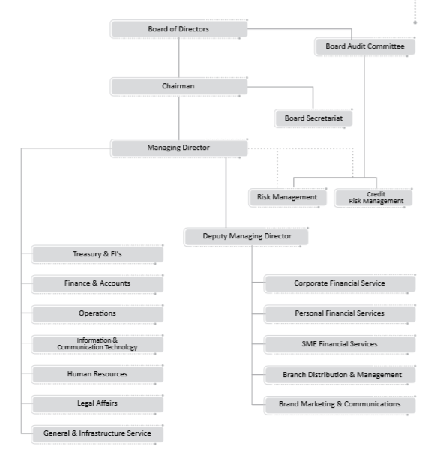
- Organogram of LBFL

- Trend and Growth

Here we have calculated the company’s gross profit and it’s growth along with revenue growth and cost of service. Then in this part I have shown the net profit growth of the company along with ROA, ROE and EPS. These data are collected from the annual report of the company to determine its growth in the stock market as brokerage house performer.

Table 1.1: Gross Profit Calculation
Particulars | 2016 | 2017 | 2018 | 2019 | 2020
Total Revenue | 1,232,997,619 | 2,115,040,272 | 1,824,261,261 | 1,370,253,350 | 1,151,170,490
Cost of Service | 487,182,588 | 443,010,888 | 516,010,560 | 505,604,083 | 343,156,692
Gross Profit | 745,815,031 | 1,672,029,384 | 1,308,250,701 | 864,649,268 | 808,013,799

Figure 1.1: Total Revenue

Figure 1.2: Cost of Service

Figure 1.3: Gross Profit

Net Profit Growth:
Year | Net Profit
2016 | 148,846,554
2017 | 821,864,830
2018 | 284,722,233
2019 | 125,376,374
2020 | 138,698,843
Table 1.2: Net Profit Growth

Figure 1.4: Net Profit Growth

 | 2016 | 2017 | 2018 | 2019 | 2020
ROE | 0.03642 | 0.17714 | 0.05782 | 0.025028 | 0.026912
ROA | 0.01492 | 0.076152 | 0.025572 | 0.012127 | 0.012917
EPS | 0.63 | 3.05 | 1.06 | 0.46 | 0.54
Table 1.3: Ratio Calculation

Figure 1.5: ROE

Figure 1.6: ROA (Return on Equity)

Figure 1.7: EPS (Earning Per share)

- Customer Mix

In LankaBangla Securitues there are every age of people as our customer or clients, but if we going for the majority then mostly there are middle aged people who trade every day. Now if we look into the client portfolio of the company according to the socioeconomic factors then there are mostly high assets total people, and then there are some people who have idle money in their account. There are some other people like retired government officers who have handsome amount of pension money in their bank account are also in the client portfolio of the company. There are also some people who are foreign returns looking for some investment opportunities, and they stock market as a better place for investment.

- Product/Service Mix
Brokerage Services: LankBangla ensures their clients customer that they can trade from any geographical location. Because the client can place their orders means buy sell orders through mail, phone call and online software. They can apply to the IPO from LBSL software. Through LankaBangla’s software a client can appy for any kind of transaction related to stock market. The one and only vision of LBSL is to give their client the most comfort to stay in stock market and able to execute any kind of activites related to the capital market.
Financial Portal: A full-fledged financial portal in Bangladesh which provides all the Stock Market info in single click. One can easily go for a company’s financial or fundamental analysis with some important measurements like EPS, P/E ratio, Profit growth, Paid up capital amount, authorized capital amount etc. which are pretty much important data for an investor before making investment decisions and also it has a technical analysis page where investors can see the technical chart of the company with candle sticks and also apply important indicators to forecast the share value or we can say it is very easily predict the share upcoming movements. The vision is to help investor community to analyze and investment decision efficiently.

Trade Express: It is the app service which has provided by LankaBangla Securities to their customers to execute the trade from anywhere in the world. This is the web trading stage which is equipped for trading in multi exchanges at the same time. The investors can trade in both of exchanges by this app service. It gives them the real time data during trading hour so that they can place their buy sell order at the correct time with a correct price. Investors or clients are getting flexible trading through android, IoS and Laptop or Desktop from anywhere and everywhere.


I-Broker: It is the stage where investors can open their BO account or Beneficiary Owners Account from their home or any other comfortable place. It has also other options like apply for IPO and get upcoming IPO related news.

OMS (Order Management System): LankBangla securities is the first brokerage firm to launched their own software to execute order of their client. Through this software trader can execute clients trade in a most efficient manner and also able to see both CSE and DSE in the same screen. Even the clients are pretty much comfortable with OMS software.
- Operations
In LalnkaBangla Securities there are total 19 branches all over the country where 16 are main branches and 3 are the extensions. These branches execute the day to day trading and each of the branches has their own accounts department where clients payments and receives has done.
For international clients who did foreign trade are handled by the corporate branch. Only that has the right to do foreign trade which are actually not that vast so that it is only handled by only one branch.
Then there are back offices in few branches who are doing some other business activities such as settlement, compliance, finance, marketing, CDBL relation maintaining, IT and lastly Loan department.

- SWOT Analaysis

Strength:
- LBSL has the good capital strength and parental support with institutional shareholding, support from home and abroad.
- Experienced top management supported by strong mid and front tier personnel.
- LBSL brand value creates a great impact to the client and service seekers of stock market.

Weakness:
- Relatively higher administrative expenses compared to other brokerage firms.
- The numbers of clients are not increasing in a significant number.
- Their main consumer base are middle aged people.
- They are not advertising their new services to the public.
- People awareness about stock market.

Opportunity:
- With their brand value or name they can broadening their services to all oever the people in Bangladesh.
- Their corporate customer or institutional investors are mostly from the world class organization people.
- As the generation has revolutionized in the digital system day by day so it will be a great opportunity to LBSL to advertise and explore their services and make aware of stock market.
Threats:
- Losing customers can be one of the biggest threats for LBSL.
- The new entrants or we can say other brokerage houses are also advancing their services and focusing on getting big.
- Economic distress can be a big threat for LBSL to sustain with existing customers and getting new customers.

Industry Analysis
- Specification of the industry

If we started to talk about the stock market industry then we have to talk about the entire Bangladesh stock market as whole. In stock market all the trading, transactions are executed by the brokerage firms. There are more than 300 brokerage houses in this industry. There two major sides where trades are executed which are DSE and CSE controlled by the government regulatory body BSEC.
The regulatory body takes final decisions to keep the market steady, ensuring investors fund for long term, keep the market out of volatility as much as possible. Suppose recently the market going down for couple of days then they decided to give the lower circuit to 2% which means a share cannot be sold less than 2% from its current price. This decision will keep the market index a little safer and also ensure to refrain from the free fall.
This decision shows that how sensitive they are towards their industry to save it from any bad situation. So the industry always tries to keep it a safe place for individual investors to make investment. Although the big players are the manipulators of the market, they can play this role either as a bull or as a bear for their own benefit. But still it is the beauty of the market, working here and accepts these challenges are fascinating to keep the market on and also make investors who invest in the market in proper manner makes them financial literate and independent.

- Size, trend and the maturity of the industry
The market size, trend and maturity of the industry depend on its day to day trade which is measured by the index points of the market. At present in DSE the listed companies are 406 and from those 406 companies 374 are also listed in CSE.

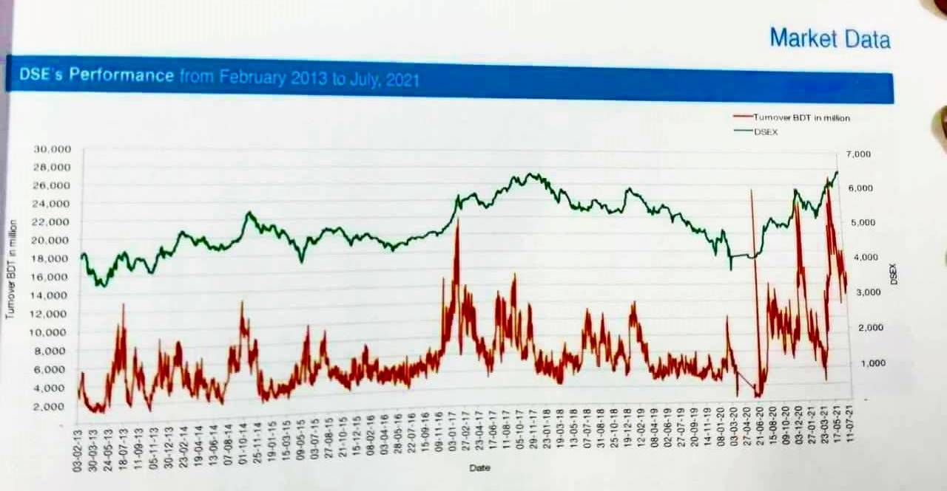
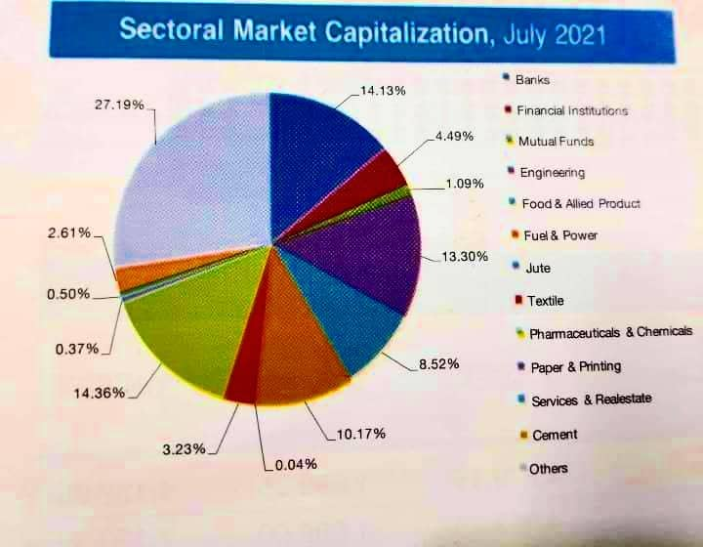

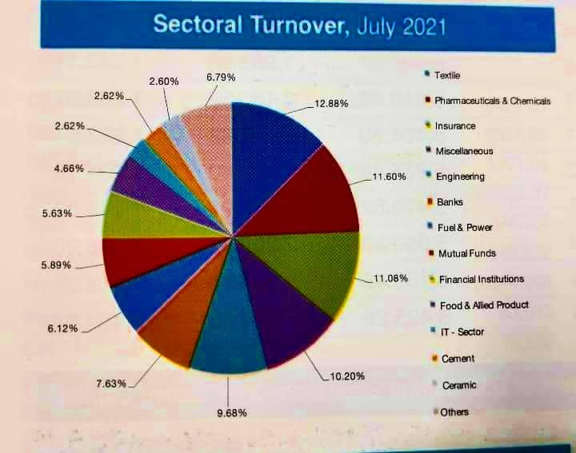

- External Economic Factor
Generally stock market and economic performance are aligned, the external economic factors which are mostly related to market is a nation’s GDP (Gross Domestic Product), exchange rate, interest rates. By when a country’s GDP is growing it means that the individual businesses are growing their business by producing more and expanding their business activity and increases business valuation which results to stock market gains.
Export Imports are affected by the exchange rate which ultimately effects the stock market. Usually it indicates that exchange rates play one of the significant role in affecting performance of the stock market. There is a both positive and negative relationship between the exchange rate and stock prices. Suppose if the dollar prices appreciate against taka in international market means falling exchange rate which reduces the demand of exports but the demand for imports will increases as the dollars are overvalued so it will be earning for the company and ultimately increase the prices of the stocks.
Lastly the deposit interest rates and stock prices relations are negative, interest rates represent the opportunity cost for investors in the equity market. Increase in interest rates leads to investor to hold the money or cash into the bank deposit to get enough interest rather than invest in stocks or other interest bearing securities.
- Technological factors
The industry highly depends on computers, trade software, internet banking, digital booths and to mention latest addition the industry also have engaged mobile banking, MFS, trading apps as well.
- Barriers to entry
There are no certain barriers to enter into this industry except some regulatory requirements. The regulatory bodies are BSEC (Bangladesh Stock Exchange and Commission) and Bangladesh Bank. For making profit from this industry then you must have smart networking circle in between listed companies banks and market makers.
- Buyer Power
In this industry the buyers are the clients or the general investor who are actual target people of the market. The general investors or clients can switch their brokerage firm according to their service requirements. But usually clients used to trade with their familiar traders so they don’t want switch much because of the strong relationship with the traders.
- Threat of Substitutes
There is no such threat of substitute in this industry only if the country’s economy doesn’t disrupt. General people might go for FD (Fixed Deposit) but it will be really rare for the people who want to invest to do business in share market.
- Industry rivalry
In our country the rivalry is high in this industry because there are so many brokerage firms who wants collect good amount of client for their brokerage firm. So everyone try to be very competitive to collect fund from the general people. We can take some top brokerage firms names that are playing an excellent role in this market.
- LankaBangla Securities Limited
- UCB Capital
- IDLC Securities Limited
- Royal Capital
- EBL Securities Limited

CHAPTER III: INTERNSHIP EXPERIENCE

Position, duties, and responsibilities
I worked as an intern in business development department, under this department from the very beginning my duties were BO account opening then after couple of days I worked in the accounts department. Then I have switch to daily trading after one month of doing accounts department chores.
So my responsibilities were:
- BO account opening procedure in i-Broker, explaining clients what are the documents they need to open an BO account.
- Attending clients to brief our services like opening BO account both in online and offline.
- In accounts department, receiving and payment entry of client money in our bluechip software. Sometimes both the receives and payment done manually and sometimes it has also done in through online. Both services are available
- On the daily trading side, I used sit in front of our OMS software and execute clients buy and sell orders.

Training
In LankaBangla I got training from my seniors and also super seniors who are professional and experience traders. They used to teach me about our OMS software and how to execute the orders. They also teach me some fundamental things like high paid up capital shares and low paid up capital shares and also some technical analysis.

Contribution to departmental functions
In my whole internship time used to sit more often in accounts department and trading department. So if anyone in the office was absent I used to sit in their place do their works which was also a great experience for me. My daily works directly create impact in the operations and business development department.

Skills applied
First of all my extra-curricular activity helped me a lot to communicate with everyone in the office with a proper manner. Then my soft skills which are MS word and excel knowledge helped me a lot to do some particular works.

New skills developed
As I was in the principal branch so I got chance to learn so many things, there are some fundamental things which a trader must know before trading like marginable shares and non-marginable shares.
High paid up capital shares and low paid up capital shares. High paid up Capital Company’s share outstanding is much more than low paid up capital shares. Usually high paid up shares are safe to invest.
Some technical analysis skills of mine has developed, though I knew some of them before enter into LankaBangla but after entering there, I have learned how to interprets those tools and indicators and which indicators or tools needs to be applied to understand or predict the share future movements. Some indicators are:
RSI (Relative strength index): The relative strength index (RSI) is a momentum indicator used in technical analysis that measures the magnitude of recent price changes to evaluate overbought or oversold conditions in the price of a stock.
MACD (Moving Average Convergence): Moving average convergence divergence (MACD) is a trend-following momentum indicator that shows the relationship between two moving averages of a security’s price. The MACD is calculated by subtracting the 26-period exponential moving average (EMA) from the 12-period EMA
Bollinger Band: A Bollinger Band is a technical analysis tool defined by a set of trendlines plotted two standard deviations (positively and negatively) away from a simple moving average (SMA) of a security's price, but which can be adjusted to user preferences.

Application of academic knowledge
Some of the fundamental analysis which are applied in this market was relatable to my academic knowledge.
EPS (Earning per Share): Earning per share determines a company’s profitability, this figure says how much earning can be created for an investor per share. A high EPS suggests that the company’s share will be more valuable.
P/E Ratio or Price Earnings Ratio: The price-to-earnings ratio (P/E) is one of the most widely used tools by which investors and analysts determine a stock's relative valuation.
Record Date & Ex-Dividend Date: The record date, or day of record, and the ex-dividend date of a stock are both important dates relating to stock purchases, reporting, and the dividend payout process. These dates determine which investors will receive dividends. The other two dates in the process are the declaration date (the day the dividend is announced) and the payable date (the date dividends are distributed).

CHAPTER IV: CONCLUSION AND THE KEY EFFECTS

Recommendations for improving departmental operations
The market has already changed and also its culture and its technical things and market has already shifted in a new generation with every departments. But LBSL still working with their old employees who don’t have much efficiency in the technical sides. Nowadays the youths are interested into the market so a youth investor needs another youth trader to make him or her understand the market.
The market is getting competitive day by day so if they want to sustain in this market with the upcoming challenges they need to take some tough calls.

Conclusion
LankBangla Securities are the one of the top securities house in Bangladesh. So it was a great opportunity to learn the capital market from the best brokerage house in Bangladesh. Working in a brokerage firm gave me a great learning over the financial and economic position of our country. And also it gives me a learning that how to convince people for fund to invest in stock market and make them understand that it si not a place of gambling, it is a place of calculated prediction.

Reference
https://www.tbsnews.net/economy/stock/lankabangla-tops-2020-brokers-list-islami-bank-securities-top-stock-dealer-181264
https://www.thedailystar.net/business/economy/news/bangladesh-capital-market-looking-back-and-forward-2967001
https://www.lankabangla.com/investor-relations/#annual-report
https://marketpulse.lbsbd.com/Home/UrlView/4206

