Internship Report On
Building Customer Relationship at the X Ceramic Group


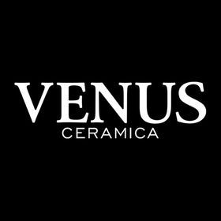



Internship Report on
Building Customer Relationship at the X Ceramic Group

Prepared By
Md. Ahasanulla Sarker
ID: 111 143 160

Supervise by
Dr. Kawsar Ahmmed
Associate Professor, School of Business Economics (SOBE)
BBA- Major in [Marketing]
Date of Submission: 26-01-2019

Letter of Transmittal
26 January, 2019
Dr. Kawsar Ahmmed
Associate Professor
School of Business Economics
United International University
Dhaka
Subject: Submission of Internship Report
Sir,
This is the report on Building Customer Relationship at the X Ceramic Group (VENUS Ceramica) that is the requirement for fulfillment of my graduation. It is my pleasure to present it before you.
I have tried my level best to follow your guidelines on my report. I have collected all the information that is necessary for the report. I am thankful to you for your guidance. I hope you will appreciate my effort.
Sincerely yours,



Md. AhasanullahSarker
ID: 111 143 160
Acknowledgement
First of all, I would like to thank the Almighty for giving me the knowledge .After that I would like to thanks to my honorable Supervisor Dr. Kawsar Ahmmed for his guidance and counseling during, preparing the internship report.

I would like to give a special thanks to Md. Sufeaun Badsha, Deputy Manager HR & Admin, for giving me the opportunity to do internship with X-Ceramics group. I would like to express my gratitude to Mr. Khaledur Rahnman, Junior Assistant Vice President and Md. Amirul Islam, Senior Manager, whose cooperation and guidance have made this project as proximate to perfection. I would also like to thanks my organizational colleagues for their sincere cooperation during the completion of my internship.
I would also like to express my gratitude to Mr. Mahir Mazhar, Managing Director of X- Index Group. My sincere thanks goes to various personnel I had contacted for completion this internship report.

Executive Summary

The report mainly focuses on the relationship building with the customer of Venus. This report is prepared for the requirement of BBA Program of United International University. This report designed for the expression of the experience I gathered while working as an Intern in the X-Index group. Through the Intern period, I learned how to analyze the benefits of Customer relation.
In particular, this report is based on the several factors that impact on the marketing relationship including reciprocity, empathy, symmetry, cooperation and two-way communication. Based on the Venus Ceramics, these elements are studied and examined how they are practiced in the said company in building the relationship.
Due to work in X-Index Group, I developed my skills on Customer Relationship. I acquire knowledge on how to develop customer relationship. My concern was understood the benefits of the customer relationship, and implement them in my work.
As an intern through I have faced tough duty while doing intern, but I have learned a lot of things which will help in my future corporate or professional life that will help me to do better in my future career.

Keywords: Customer Relationship, Relational Symmetry, Two-Way communication, Reciprocity, Cooperative, Empathy, Venus Ceramic.

Contents
Chapter 1: Introduction 1
Introduction 2
Objective of Report 2
Scope and limitation of study 3
Significance of Study 3
Chapter 2: Overview of the Organization 4
X Index Companies Overview 5
Vision of X Index 6
Values of X Index 6
X Ceramics Group 7
Literature Review: 9
Importance of Building Customer Relationship 10
How to build up a Customer Relationship 11
Theoretical framework of building customer relationship 12
Chapter 3: Internship Experience at VENUS 16
Introduction 18
Advantage of VANUS Ceramics: 19
Product Category or Series 20
The price list of VENUSCeramica 25
Population and Sample Size 29
Data Collection Procedure 29
Data Analysis 29
Findings 29
Recommendation 31
Conclusion 31
Reference 32

Chapter 1: Introduction

Introduction
Ceramics industry is one of the growing industries in Bangladesh. There are so many different ceramic industries are manufacturing and exporting ceramics. This sector is growing fast and develops an image globally.
X ceramics is one of the biggest porcelains and ceramic tiles manufacturing company right now in Bangladesh. The company is located at Sreepur, Gazipur on 75 acres of land. To fulfill their growing target & demand for its popular line of products, the company is equipped with four operational production lines.
This report contains the basic concept about the building customer relationship. I have tried to cover the basic information about building the customer relationship of X ceramic group. I tried to introduces X index and its sister concerns. This report aims to reflect the overall experience which I gathered working with X ceramic.

Objective of Report
There are two objectives:
- General &
- Specific
General Objective:
This report is prepared to fulfill the requirement of the degree. To fulfill this I have worked on building customer relationship in at Venus ceramic.
Specific Objective:
More specifically, this study entails the following aspects:
- Examine the influence of symmetry in customer relationship
- Examine the influence of Two-Way Communication in customer relationship
- Examine the influence of Reciprocal Marketing in customer relationship
- Examine the influence of Cooperation Marketing in customer relationship
- Examine the influence of Empathy in customer relationship

Scope and limitation of study
The reason of the study is to understand customer relationship, & building customer relationship of X- Index group. The report covers the basic information about the customer relationship, which is created by X-Ceramics. The main focus was how they create strong and sustainable customer relation with their clients.
Though it was an Internship, that’s why I had a limited access toward the clients of Venus (Wing of X- Ceramics). Moreover, X-ceramics introduced a new brand (Venus), so that they have limited clients. Another limitation was, Venus just targeted upper people class, so that I didn’t get the opportunity of studying middle- and lower-class target market.
Significance of Study:
Customer relationship opens a scope of maintaining a sustainable and profitable relationship with the customer. This study will help the concerns, to understand the customer relation and also give them the basic idea of, how should a customer relationship build. It also reveals them to understand a giant company, and their customer relationship process.

Chapter 2: Overview of the Organization

X Index Companies Overview
X Index companies is top private sector in ceramic business sector in Bangladesh across:-
- Agro industry
- Poultry nutrition and Farming
- Fish feed
- Real-Estate and Construction
- Architecture and Engineering
- Ceramics
- Energy
- Healthcare sectors
Company believes, it has important part to play in economic role for development of the people of Bangladesh. X Index Architects Limited established back in the year 1977. Since then, they have developed so many other business sectors and achieved great successes. They achieve this through their experience having & successful and innovative step.
They haveenjoyed paramount trust and confidence of their customer& clients in division and districts in Bangladesh through providing international standard and quality products and professional services. X Index companies one of the benevolent employers in the country with a young, trained and well experienced work-force.

Vision of X Index
Their vision is to build one of the best regional business houses for all their stakeholders and generate opportunities for young Bangladeshi to realize their potential.

Values of X Index
The values of X Index companies are very important to their business sectors. They have given different values to their customer, employees, shareholders and others.
- Customer Focus
- Human Resource
- Shareholder Interest
- Social Responsibilities
Their business perspective processes products and services are focused to the needs of our customer. They take utmost care for retention, training and growth of their pool of human talents. The interest of their shareholders is supreme and whatever they keep it in mind. They recognize them responsibly towards their community, environment and resources.

X Ceramics Group
X Ceramics Ltd was establish in 2008 & was introduced to the market as the brand ambassador of a popular Italian ceramic’s tiles brand. Their main vision of this business venture was set-forth focusing on the ever growing & delivering demand of the south-east Asian market. In a short period of time X Ceramics made its mark in the market and since then have introduced popular brands offerings a wide range of quality tiles to many satisfied customers all over Bangladesh.
X ceramics limited is one of the biggest ceramic tiles manufacturing company right now in Bangladesh. It is establishing its manufacturing factory which is located in Sreepur, Gazipur on 75 acres of land. Modern machinery, technology used in this factory and world class technical system. There are 4 different brands in X ceramic group: -
- X Monica Ceramics
- Monalisa Ceramics
- Alexander Ceramics
- Venus Ceramica

There are 16 stages of manufacture process of X Ceramics: -

Raw Material
Feeder Box
Conveyer belt
Ball Mill
Blender
Spray dyer
Silo
Press
Dryer
Glaze line
Print
Kiln
Polish
Package
Store
Market

Literature Review:
Building Customer Relationship:
Customer relation is the process which a business develops and establish and maintain relationship with their customers.
Business is absolutely essential that we need to develop effective customer relationship. Customer relationship also allows business to develop long term relationships and new customers while helping streamline corporate performance. Customer relationship management incorporates commercial client-specific strategies via employee training, marketing planning, relationship building and advertising.
Customer relationship core strength is an ability to glean insight from customer feedback to create enhanced. And create solid and focused marketing and brand awareness. The main motivating factors for the development of more innovative customer relationship management strategies are web technologies and focused on customer’s loyalty.
Amy Cross said that- “Customer relationship marketing is a technique based on client relationship and customer loyalty. ‘’
Using customer data and Feedback Company utilizing this marketing strategy develop long term relationship with customer and develop laser focused brand awareness. Customer relationship marketing varies greatly from the traditional transactional marketing approach that focuses on increasing individual sales number.
According to Nicole LaMarco- “The way business relates to its customer, client and patrons is known as customer relationship.”
Some companies hire people specifically to manage how the company interacts and communicate with people. The goal is to retain existing customer to gain new ones by providing the best service.

Importance of Building Customer Relationship
Importance of building customer relation is very essential factor for an organization for the development. Powerful customer relationship is essential to business success. Just like personal relationship. It is important to cultivate and nurture customer relationship. When organizations develop strong relationship with their customer, it can lead to loyal clients.
There are so many reasons for building a customer relationship management. Customers are the main focus of all business, developing a healthy relationship with them. Which is crucial to the success of the business? There will be good times and bad times, maintaining a healthy customer relationship with all our clients.
Customer relationship management helps business build relationship with their customer that, in turn, creates loyalty and customer retention. Customer relationship management tool creates a simple user interface for collection of data that helps business recognize and communicate with customers in a scalable way.
Customer relationship is built on trust and confidence, quality service the business provides to customer and the commitment to serve. Trust is the first word that came to mind whenever relationship is present.
The benefits of building customer relationship management:
- Better client relationship for long term
- Increased revenue and profitability
- Greater staff and customer satisfaction
- Improved efficiency in serving clients
- Improved ability to cross sell

How to build up a Customer Relationship
There are many different ways to build a strong customer relationship. Based on the size of the company allows us to reach people at more personal level than big businesses which turns into strong relationships with customers.
To create customer relationship and keep them strong we must do all we can to engage customers. There are five ways to build customer relationships and keep them coming:
- Communicate as a key to any good relationship; communication is an essential way to build customer relationships.
- Exceed expectations our customers expect great products or services from us.
- Asking for the Feedback.
- Showing the appreciation.
- Communication through email
- Rewarding our best customer
- Survey our customers and get their opinions
- Real time video chat for customer support.

Theoretical framework of building customer relationship
Some major factors we need to evaluate and focus while we build a strong customer relationship; we need to give priority to those factors:
- Symmetry
- Two-Way communication
- Reciprocal marketing
- Cooperative marketing
- Empathy

Symmetry
Marketing symmetry is conceptualbusiness-related framework which seeks to capture the present condition of our product or services by identifying the tangible and intangible elements.Marketing symmetry is consumer centric business.which is every element addressing the consumer or client as a self-entity. Marketing symmetry leans toward a qualitative assessment of the business as opposed to the quantitative nature of something like a pricing strategy.
The marketing symmetry is proportional to our business strategy as it shows you a relational review of our product or services. The 05 elements which explain, feelings know and Promise all respond and conform. The statements we need tocreate for our business vision, mission and goals.
Two-Way Communication
Two-way communications are a form of transmission in which parties involved transmit information. Two-way communication has also been referred to as interpersonal communication.
A cycle of communication and two-way communication are actually different things. Two-way communication involves feedback from the receiver to the sender. This allows the sender to know the message was received accurately by the receiver. Communication is also negotiated which means that the sender and receiver listen to each other, the message then gathers information to respond. One person is sender which means they send a message to another person via face to face, email, telephone etc.
Reciprocal Marketing
Reciprocal marketing happened when companies are interested to go market and know each other’s products or services.Company need to do something free for customer.The company also need to do the percentage of these customers which are reciprocate by buying from that company.
Reciprocity refers to the practice of exchanging items with others companies. Reciprocity canhappen whenan individual, company or country levels or organization may grant privileges to another.

Cooperation Marketing
Cooperation marketing is an agreement to combine marketing efforts. Complementary companies as well as direct competitors can create effective and mutually beneficial cooperation marketing campaigns.
So basically, cooperation marketing means a team which is responsible for measuring how to get the organizations desire customer and measuring what kind of advertising and messaging tactics will appeal to them or by which a corporation or organization or company attracts potential customers. Every departments of cooperation marketing are ones who control the message and public image of the organization. The goal of the cooperation marketing team is to think the strategy which is suitable for attracting the valuable customers.
Some major faces we need to focus on cooperation marketing:
- Need to focus on company’s identity
- Need to focus on communication
- Need to focus on corporate image
- Need to focus on organization reputation
Cooperative marketing is a marketing where people helping people or companies helping other companies. Basically,it’s when individuals, whole sellers or companies come together to combine their marketing efforts to increase mutual benefits or profits by reducing costs, economic scale or increase the collective bargaining value to get a better price for their products or services.

Empathy
Empathy means the ability to understand and share the feelings of one another.So basically, empathy is the capacity to understand or feel about the situation Empathy is the experience which helps to understand other persons emotions, feelings and ECT. Empathy facilitates helping behaviors that come from within rather than being forced so that people behave in a more compassionate manner.

Chapter 3: Internship Experience at VENUS

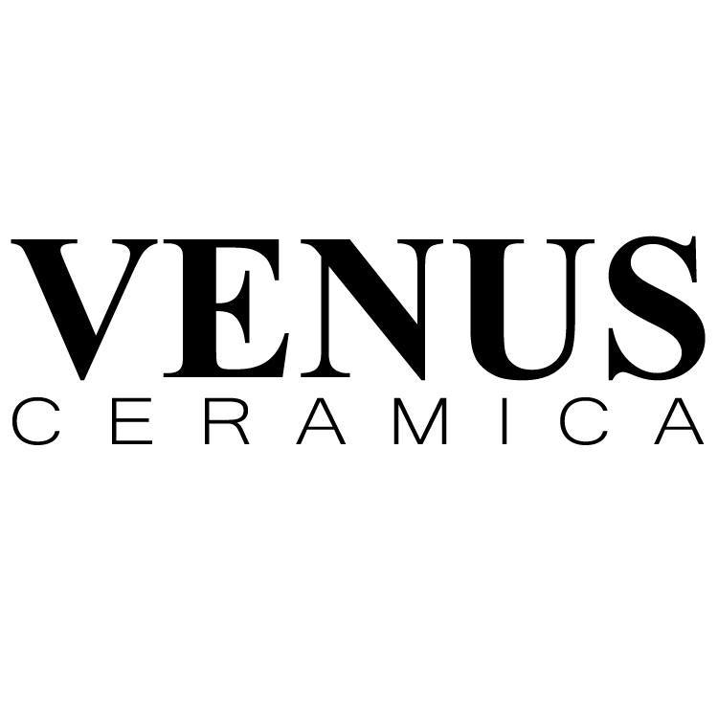

Introduction
Venus Ceramica is established in 2018, a concern of X ceramics limited has already carved out a place for itself in the market, in a short span of time because of its unique quality, exclusive design, large size and specialty of the products.
Venus range of tiles is an in-house creation after long R & D research and development involving various local and international technical teams from Italy and Spain.
Venus motto is to deliver the Latest class of tiles to the discerning customers worldwide.
To meet the increasing demand of the consumer all over Bangladesh and ensure highest quality Venus has installed 4 separate lines for production so that all variants of tiles are always available in the market. With 100% imported raw materials and modern machineries run under the direct supervision of highly experienced foreign technical and engineers as well as a fully equipped studio for design and development.
Venus has ensured that it can rapidly adapt to the ever-changing tastes and choices of consumer and continuously provides superior tiles with superb technical experience in physical construction and design. With advanced Mechanisms and technology, we offer quality tiles that are of Italian and Spanish Standard but to our precious Bangladeshi consumer are very much affordable. Our mission is to ensure that consumer even in the remotest areas are provided with high quality, affordable, aesthetically appealing designs and various sizes of tiles for a comfortable hygienic and fashionable of living.
“VENUS Luxury Lifestyle” a collection of continues analyzing the relationship between imagination and reality. Their passion for something different is everywhere in our life, in the air, in the street in people hearts.

Advantage of VANUS Ceramics:
- Venus products are highly durable
- Its no-toxic
- Its high Resistance
- Adoptable
- High traffic Sustainable
- Eco friendly
- Admirable design/highly acceptable in Italian & Spanish design
Best quality products manufactured by Venus style and designed in Spain and Italy. Stone Shield layer gives high resistance with scratch proof protection. Venus will keep you away from traditional look to Ariston-Create look which feels you proud. Venus manufactured of high-quality ceramics exclusive design, sophistication and classicism.
Category | Product code
Stone Rustic | VSR-10
Sparkly Crystal | VSC-20
Sugar Lapato | VSL-30
Lapato | VL-40
Carpet | VC-50
Ultra-Polished | VUP-60
Natural Rock | VNR-70
Product Category or Series: - There are seven (07) types of product or category in Venus ceramics.

There three (03) different sizes are availed in their production and basically Venus is newly launched so that only this different size they manufacture. The size are-
Serial Number | CM | INCH | FIT
1 | 60X30 | 24X12 | 2X1
2 | 60X60 | 24X24 | 2X2
3 | 120X60 | 24X48 | 4X2

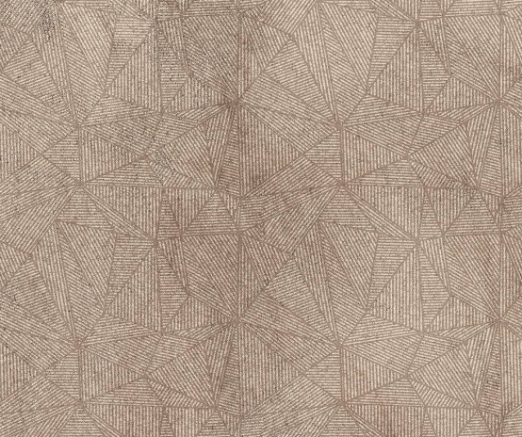



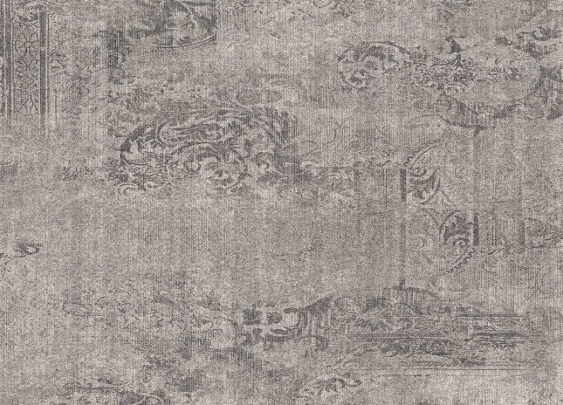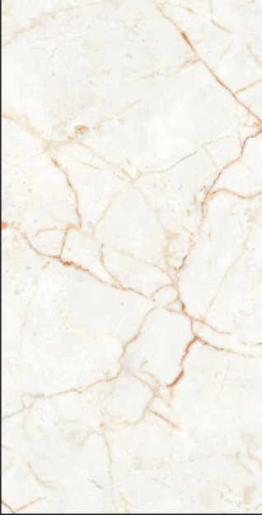


What are the different types of tiles?
There are six different types of tiles in Venus Ceramica:-
- Porcelain tiles
- Vitrified tile
- GVT
- PGVT
- Homogeneous tiles
- Rustic tile
- Marble
- Granite
Ceramic tiles: - Ceramic tiles are made from natural clay. Which is mixed with water and molded. Creatoeaand apply a glaze to help and protect it from water and scratches. After this the fire the clay in a kiln to harden it.
Porcelain tiles: - Porcelain tiles are ceramic tiles. Which is commonly used to cover floors and walls with a water absorption rate of less than 0.05%.
Vitrified Tiles: Vitrified tile are very similar to ceramic tiles.These types of tiles are made with slightly different elements. The clay is mixed with quartz and feldspar before it is fired in kiln. These extra ingredients melt, creating a glass element inside the tile. This glass component makes the vitrified tiles very hard and resistant to any type of absorption.
Homogeneous tiles: -Homogeneous tiles areone kind of ceramic tile. Thesetypes of tiles are composed with fine porcelain clays but fired at much higher temperatures than ceramic tiles.

What are glazed Vitrified (GVT) tiles?
GVT have a glaze surface. GVT offer a huge rangeof variety of design, art work and surface. This can also a costly process but the cost is dropping as digital printing techniques.
What is a Polished Glazed Vitrified Tiles?
It is a layer of liquid glass added to GVT, which also makes them less slip resistant and scratch resistance compared to unpolished glazed vitrified tiles.
What is Sugar Polished tile?
With a matt finish this white sugar porcelain tiles have inkjet print quality. Which produces a high definition image that thoroughly covers the tile and result in a natural authentic look?
What is Lapato Polish Tile?
Is an Italic word for semi polished/honed? Or we can call it light call it light polish work.

Price List of VENUS (Per SFT)
Size | SL | Category | MRP
30X60 cm | 1 | Stone/ Rustic | 143
30X60 cm | 2 | Sparkly Crystal | 143
30X60 cm | 3 | Sugar Lapato | 149
30X60 cm | 4 | Lapato | 143
30X60 cm | 5 | Carpet | 176
30X60 cm | 6 | Ultra-Polished | 143
30X60 cm | 7 | Natural Rock | 171
The price list of VENUSCeramica: VENUS has three(03) different sizes in their product category so that they have different pricing strategies for different sizes and the list of VENUS Price is:

Price List of VENUS (Per SFT)
Size | SL | Category | MRP
60X60 cm | 1 | Stone/ Rustic | 138
60X60 cm | 2 | Sparkly Crystal | 138
60X60 cm | 3 | Sugar Lapato | 143
60X60 cm | 4 | Lapato | 138
60X60 cm | 5 | Carpet | 171
60X60 cm | 6 | Ultra-Polished | 138
60X60 cm | 7 | Natural Rock | 165

Price List of VENUS (Per SFT)
Size | SL | Category | MRP
60X120 cm | 1 | Stone/ Rustic | 286
60X120 cm | 2 | Sparkly Crystal | 275
60X120 cm | 3 | Sugar Lapato | 275
60X120 cm | 4 | Lapato | 275
60X120 cm | 5 | Carpet | 297
60X120 cm | 6 | Ultra-Polished | 275
60X120 cm | 7 | Natural Rock | 286

Patented Technology used in Venus Ceramica
Venus ceramic use STONE SHIELD patented technology in their production. By using this technology, the MOH (Mode of Hardness) will increase brings the product in high level of quality. X ceramic ltd they first innovate this technology in Bangladesh and their latest brand Venus ceramics they apply this.
Product Highlights
- Lasts for Ever
- Vitrified Body
- Anti-Scratch
- Tested for 5000 + revolution by PIE method
- Group- 7in the MOH Scale
- Digitally printed designs to suit different requirements
Technology
A unique glaze composition applied on the surface of a vitrified tile body which ensure resistance to day to day scratches and wear & tear when applied in any high traffic area. This enables retain the original design printed on the surface of the tile therefore the aesthetics of the tile.
Comparative Analysis
Compared with any homogenous, Gres-porcelain, Soluble Salt or Polished Glazed Vitrified tile which when applied in mid to High Traffic loses the upper glazer with scratches coming up ultimately resulting in a dirty badly look.

Application Areas (any high traffic areas)
- Hospitals
- Shopping Mall
- Airport
- Schools & Colleges
- Offices
- Hotels
- Restaurants
Advantage of STONESHIELD
- Anti-scratch surface there by increasing the life of the tile. Same look and feel of the tile after applying in high traffic areas.
- Compared to any homogenous tiles, gres porcelain tiles the STONESHIELD tile can undertake 10 times more revolutions therefore having a10 times more life.
- Cost effective considering the long life of the tile.
- Minimum normal cleaning maintenance required.

Population and Sample Size:
Background of the Study
The internship program which is necessary to complete the BBA program exercise a significant importance as it enables a student to familiar with the practical business activities. The student work closing with the people of an organization and learn about the function of that organization. This program enables a student to develop his analytical skills and scholastics attitude.

Data Collection Procedure

The primary sources are a follow:
- Face-to-Face conversation with clients visited the showroom.
- Practical with experience in the different markets
- Relevant field study as provided by officer concern
Data Analysis:
I took data from the valuable clients of Venus, through verbal discussion. Moreover, I get information through practical work experience, which I stored in written form, and after that, those data analyzed informally. On the basis of on the data I collected, I reach on some findings.
Findings:
- The clients are very curious about the new launched Brand of X-Ceramics (Venus), which helps Venus for creating new scope in customer relationship.
- Customers are very satisfied about the premium quality of the product, for which they repeat their busying behavior.
- New innovation of Stone Shieldtechnology, which was the first in Bangladesh, is attracted more clients, which create a large portion of new customers.
- Though they produce premium product, by these, they are capturing more customer, with other 3 supporting brands.
- The actual target market of Venus is Upper class people of the society, so that it is helping X- Ceramics to capture new market, and create strong relationship.

Discussion:
I worked as intern with Venus Ceramica which is a wing of X-Ceramics. Though-out internship period I gather experienced and knowledge and also develop my skills. First of all it gives a overall knowledge about corporate culture. I developed my knowledge on marketing through working in marketing sector.
By working I have learned how to behave in corporate culture. I learn how to communicate with the clients and also learn punctuality and time management. It helps me to manage my stress and also learn the emotional intelligence; I also captured the corporate politics, which will help me in my future professional life.
By working I have learned the program of excel, how to prepare a chart of maintain information of clients and their information. I have learned how to fix corporate meetings and dates and develop the communication. Most important things which I have learn is how to manage and peruse the clients.
I have learned the ceramic sectors advantage and disadvantage, what technology they use and how the manufacturing process have done. I can differ the product and can evaluate the durability and usability. I can understand which one are which company’s tiles.

Recommendation

So, from my recommendation I can say that X ceramic group is one of the establish organization. It is very difficult to recommend on any aspects of the company but I have tried to give the proper recommendation about the cooperation marketing, empathy, reciprocal marketing and others. I have pointed out some important points which is given below:
- They should open more showrooms in other zone of Dhaka.
- They recruit more employees for their corporate marketing.
- They need to develop their strategy to communicate and purse the clients.
- They need to develop their product size gap which is a major issue.
- They need to develop their tanning facilities and focus on the corporate strategy.
- They need to provide the customer feedback within the time.

Conclusion:
Throughout the work in my internship period I gathered much information about the ceramic industry. Moreover, I learned how a business needs to run. It gives me great lesson about customer relationship and the basic information about the sale. After working with Venus, I figure out the opportunity of the business and the threads too. On the basis of my experience I provided some suggestion through my report. In the end I would like to say, itwas a great experience.

Reference

Reference

(13.11.18) Customer Relations: Definition & Concepthttps://study.com/academy/lesson/customer-relations-definition-lesson-quiz.html

(13.11.18) what is Customer Relationship Marketing? https://www.ngdata.com/what-is-customer-relationship-marketing/
- (18.11.18) https://smallbusiness.chron.com/customer-relations-43230.html
- (26.11.18) https://www.entrepreneur.com/article/282364
- (02.12.19) X-Monica https://xceramics.com/
- (05.12.19) X-Index https://www.index-companies.com/

Appendices

