Monitoring System for ICU Patient with Heart Disease

Nasirul Amin
Student Id: 011 141 049
Abdur Rahman
Student Id: 011 141 122
Sadia Afrin
Student Id: 011 141 157
Nushrat Kamal
Student Id: 011 141 158
Summer 2018 Thesis Report

A project in the Department of Computer Science and Engineering presented
In partial fulfillment of the requirements for the Degree of
Bachelor of Science in Computer Science and Engineering


United International University
Dhaka, Bangladesh
October, 2018
Declaration
We, Nasirul, Abdur, Sadia, Nushrat, declare that this project titled, Monitoring System for ICU Patient with Heart Disease and the work presented in it are our own. We confirm that:
- This work was done wholly or mainly while in candidature for a [BSc]* degree at United International University.
- Where any part of this Project has previously been submitted for a degree or any other qualification at United International University or any other institution, this has been clearly stated.
- Where we have consulted the published work of others, this is always clearly attributed.
- Where we have quoted from the work of others, the source is always given. With the exception of such quotations, this Project is entirely our own work.
- We have acknowledged all main sources of help.
- Where the Project is based on work done by ourselves jointly with others, we have made clear exactly what was done by others and what we have contributed ourselves.

Nasirul Amin
Student ID: 011 141 049
Computer Science & Engineering
_______________________________________
Abdur Rahman
Student ID: 011 141 122
Computer Science & Engineering
________________________________________
Sadia Afrin
Student ID: 011 141 157
Computer Science & Engineering
________________________________________
Nushrat Kamal
Student ID: 011 141 158
Computer Science & Engineering
________________________________________
Certificate

I do hereby declare that the research works embodied in this Project/project entitled “Monitoring System for ICU Patient with Heart Disease” is the outcome of an original work carried out by [Nasirul, Abdur, Sadia, Nushrat] under my supervision.

I further certify that the dissertation meets the requirements and the standard for the degree of [BSc] in Computer Science and Engineering.

Dr. Hasan Sarwar
Professor Department of CSE, UIU
________________________________________

INDEX
Table of Contents
INDEX 5
Chapter One: 7
Introduction 7
Introduction: 7
Abstract: 8
Objectives: 9
Social Feasibility: 10
Chapter Two: System Analysis 11
Background Research: 11
Mobile Applications: 12
Terminology: 16
Literature Review: 17
Features List: 17
Chapter Three: System Design 18
Diagram: 18
Flow Chart: 18
Methodology: 19
Ux Design: 19
Data Collect: 20
Parametres: 22
Algorithm Design: 23
Database Design: 26
Chapter Four: 27
Development and Deployment 27
Tools: 27
Platform: 27
Chapter Five : Demostration 28
Screenshots: 28
Website: 28
Mobile Applications: 32
Chapter Six: 34
Future Work and difficulties 34
Problem faced: 34
Future Work: 34
Chapter Seven: 35
Pros And Cons 35
Pros: 35
Cons: 35
Chapter Eight: 37
Constraints 37
Constraints: 37
Chapter Nine: 38
Conclusion 38
Conclusion: 38

Chapter One:

Introduction

Introduction:

- Approximately 17.9 million people died from Cardio Vascular Disease in 2016, representing 31% of all global deaths. Of these deaths, 85% are due to heart attack and stroke.
- Therefore, it is necessary that we find methods to prevent these deaths by proper treatment and monitoring.
- Experts and researchers suggest that monitoring and tracking patient’s symptoms on everyday basis can prevent any further medical emergencies of ICU patients.
To reduce the number of deaths from occurring and predicting the condition of ICU patients we have come up with a system that would provide a feasible solution to our problem.

Abstract:

- The changing landscape of medical benefits and risks creates new challenges for all stakeholders in health care. We offer examples of different medical interventions to help illustrate the complexity and diversity of considerations that define the trade-offs between benefits and risks for each patient. As more information becomes available at all stages we now have a better chance of predicting an ICU patient’s health condition and provide them with the necessary treatments. This system will play a central role as an authoritative voice to take the decisions necessary to keep up with the patient’s health state.
- Today, in our world, heart diseases is the number one major cause of death.
- There is a lack of effective analysis tools to discover hidden relationships between symptoms.
- The objective of this research work is to predict severity of a heart patient of ICU more accurately.

Objectives:

To identify patients in critical condition and make a decision based on the patient’s data analysis. This can be achieved by a monitoring system. Since monitoring devices are widely available, this health monitoring system becomes inexpensive and available.

- Effective to monitor patients remotely.
- Easy to use and accepted by patients.
- This system will remove the need of papers in the intensive care unit.
- Based on the input data, doctors will be able to receive a prediction that will tell them on what should be done to the patient.


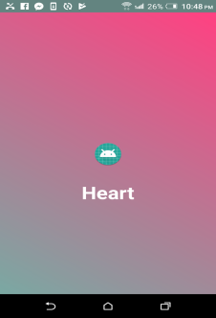




Social Feasibility:

Social feasibility is a study of how one interacts with another in a system or organization.
It is also known as social impact analysis. This process provides framework for analyzing and incorporating the design and delivery of projects.

The proposed system would be acceptable by the doctors and nurses since it is faster and easy to use and better than ordinary registration process and management in the following issues:

- Faster than other manual systems.
- Database keeps records and is always updated.
- Time saving.

Chapter Two:

System Analysis

Background Research:

- We worked with ICU patient of National Heart Foundation Mother and Child (Mirpur1).
- The patients were from infants to young children.
- It took a long time to make a decision to treat a patient.
- Our decision table helps doctor to treat patient quickly. Less time is wasted searching through the mass amount of information.
- We did some research on websites and mobile applications and we found several applications that diagnosed patients with heart disease but there was none that focused on ICU patients with heart disease.

Mobile Applications:

- Remote patient monitoring:
Monitor patient’s activity. This app works in two modes. The caregiver can track their patient’s activities and get notified if their patient is leaving or reaching defined areas. It also monitors heart rate. It takes advantage of built- in- sensors of android power devices to monitor patient’s activity. The caregiver can simply add their patients by scanning their QR codes and start tracking their activity.

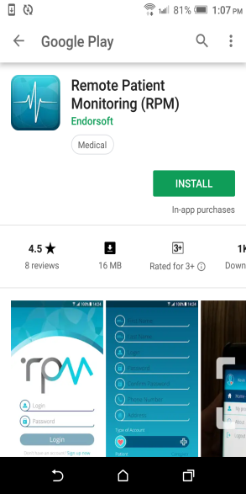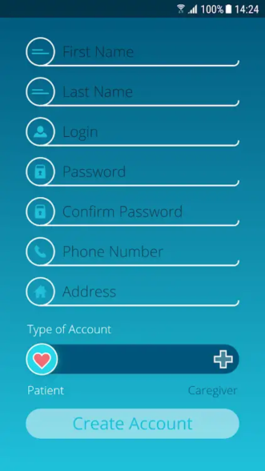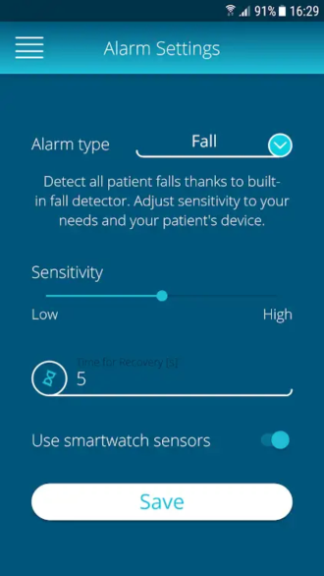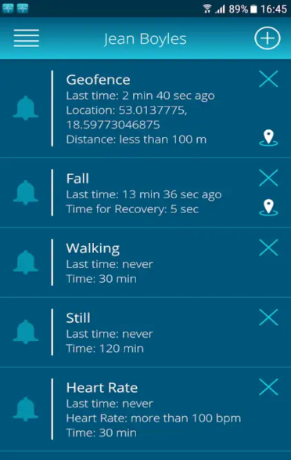

- Medopad patient monitoring:
This app monitor vital signs, patients can receive medication reminders, log symptoms. This app can help manage a range of conditions and monitor patient’s health by tracking daily activities.

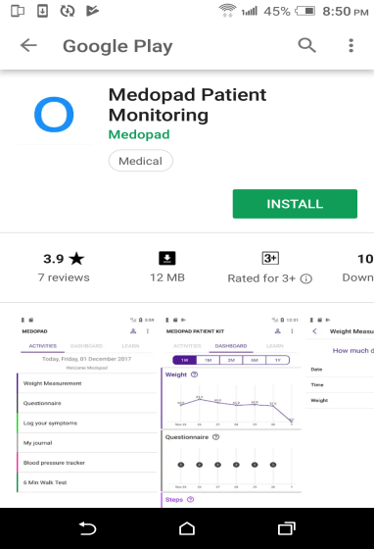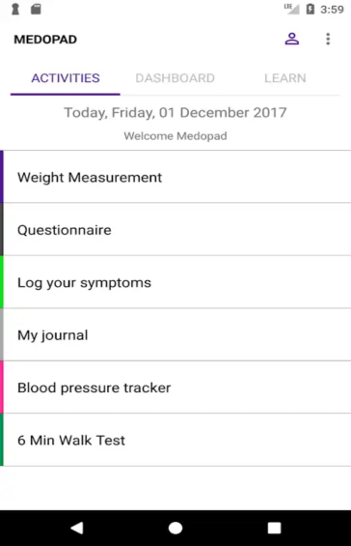
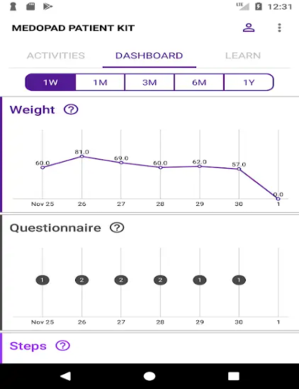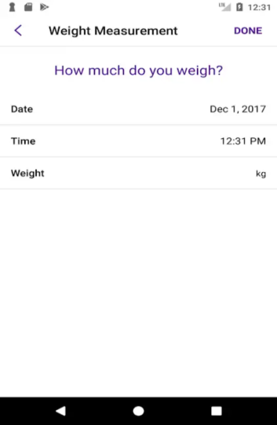

- Heart rate monitor:
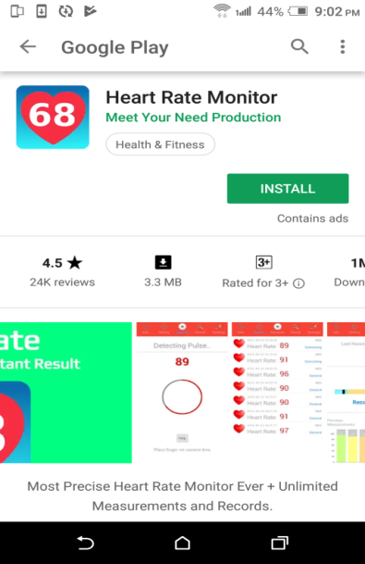
- Simple system monitor:

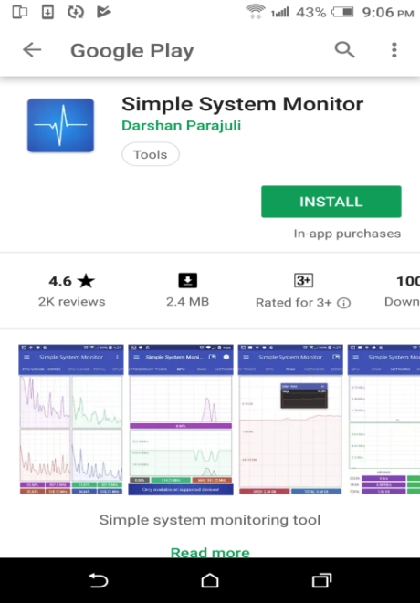

- The National Telehealth Policy Center:

This sites collect data and other information in one location and electronically transmits the information to the health care such as monitoring centers, hospital etc and by analyzing this data the doctors then give medication to their patients.
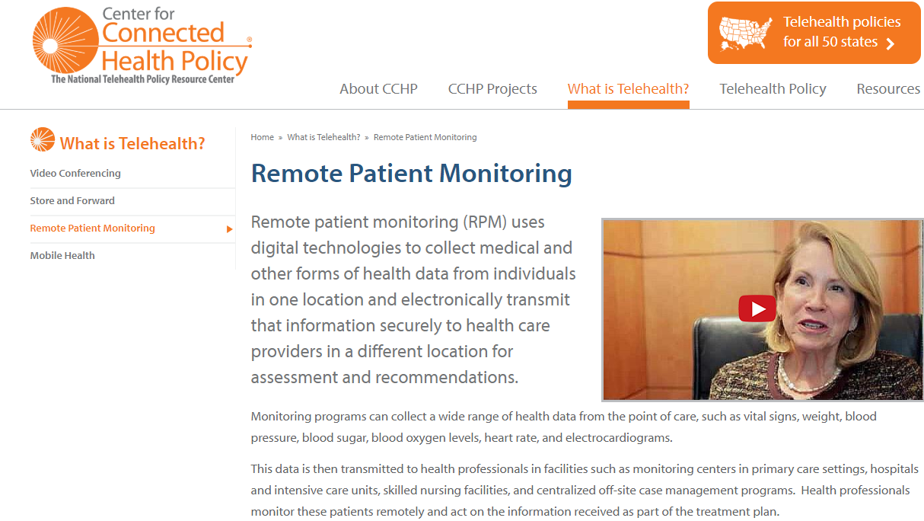

Terminology:

- The nine terms are as follows, HR/mt. ABP – S, Temperature - P, and CVP, the other agents are SpO₂, PH, PCO₂, PO₂, and HCO₃.
- HR/mt stands for Heart Rate per minute. This shows thenumber of times your heart beats per minute.
- Peripheral Temperature is for the temperature in the peripheral area of the patient.
- SpO₂ means oxygen saturation in the blood
- PH, PCO₂, PO₂, and HCO₃ are all related to bodies acidic and alkaline levels
- ABP – S refers to Arterial Blood Pressure systole. The pressure of the circulating blood flowing inside arteries.
- CVP is central venous pressure.

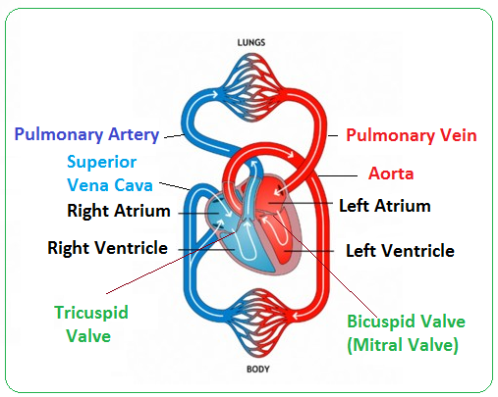

Literature Review:

- We found 2 articles that had very few similarities to our work.

1. Association of Telemedicine for Remote Monitoring of Intensive Care Patients(ICU) With Mortality, Complications, and Length of Stay – Their study shows work on a workstation provided with real-time vital signs with graphic trends; audiovisual connections to patients' rooms; early warning signals regarding abnormalities in a patient's status
2. Impact of the Pulmonary Artery Catheter in Critically Ill Patients - This study includes patients who are in intensive care unit (ICU), admitted with advanced heart failure, or diagnosed with acute respiratory; and studies that reported death and the number of days hospitalized or the number of days in the ICU as outcome measures.

We found several other studies on ICU patients with other diseases but there was not any particular study that associated work on ICU patients with heart disease .

Features List:

This system consists of the following features:
- Physician can monitor daily progress of a patient.
- Make decisions through an automated data analysis of patients.
- Flexibility in the monitoring system.

Chapter Three:

System Design

Diagram:

Flow Chart:
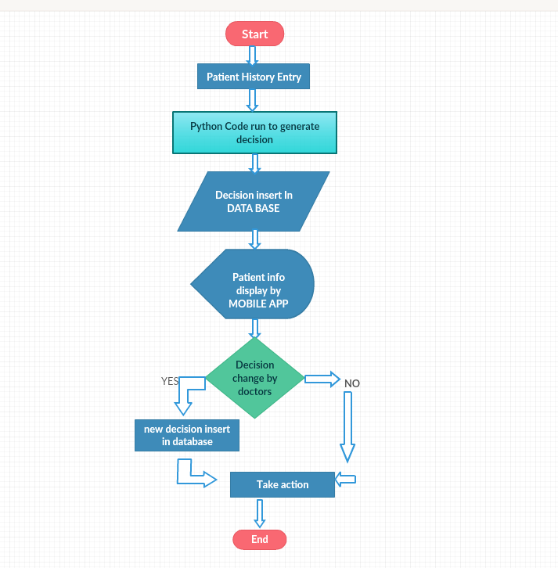

Methodology:
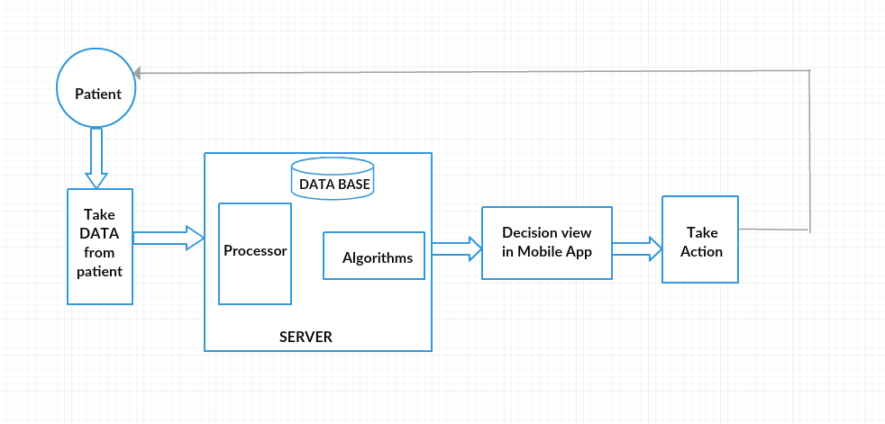

Ux Design:
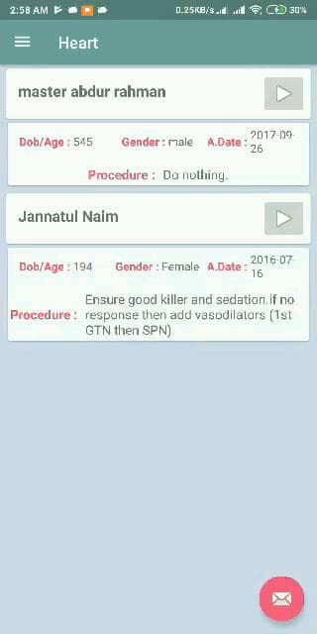

Data Collection:
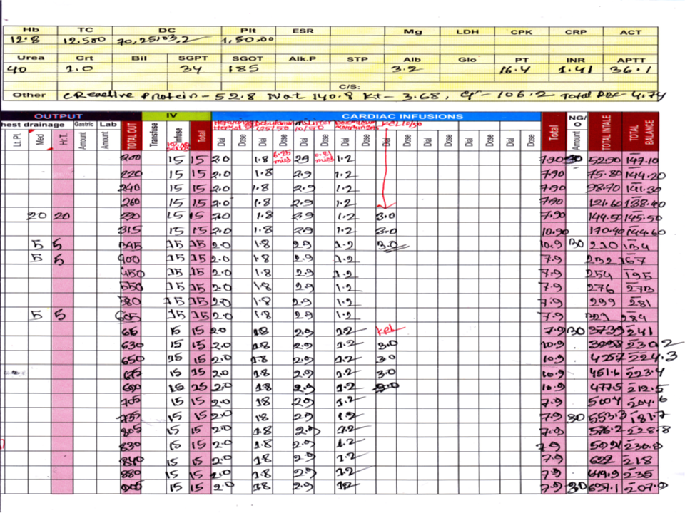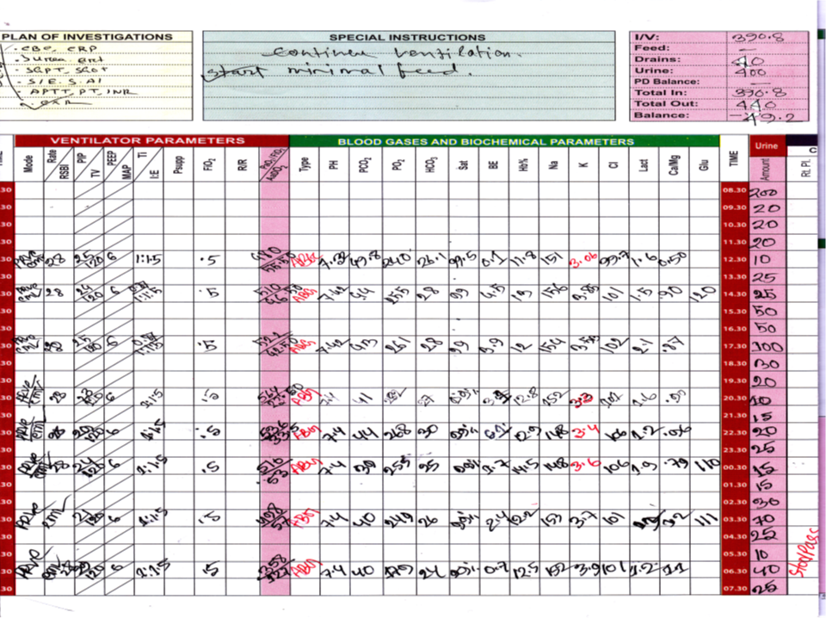

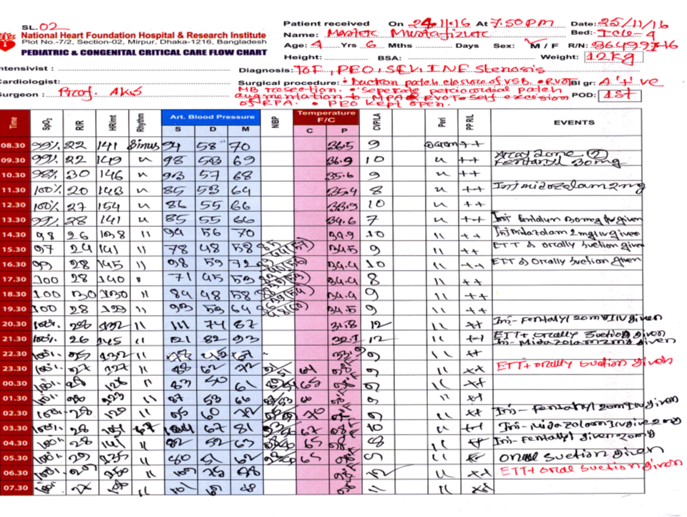

Parameters:

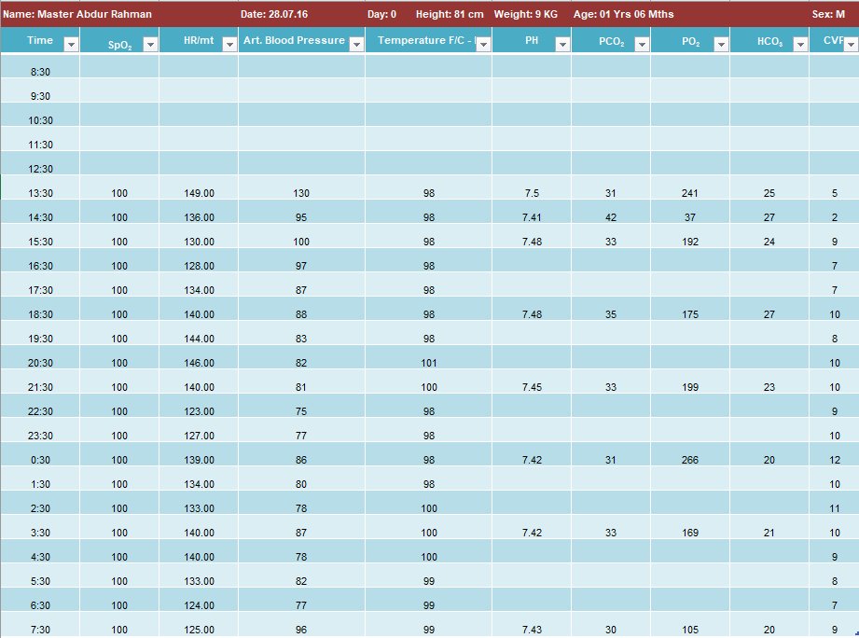

Algorithm Design:

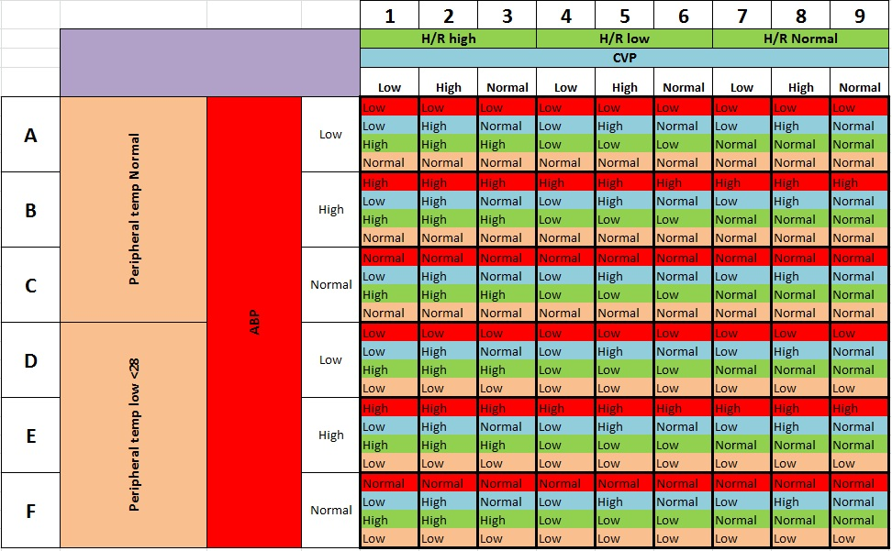

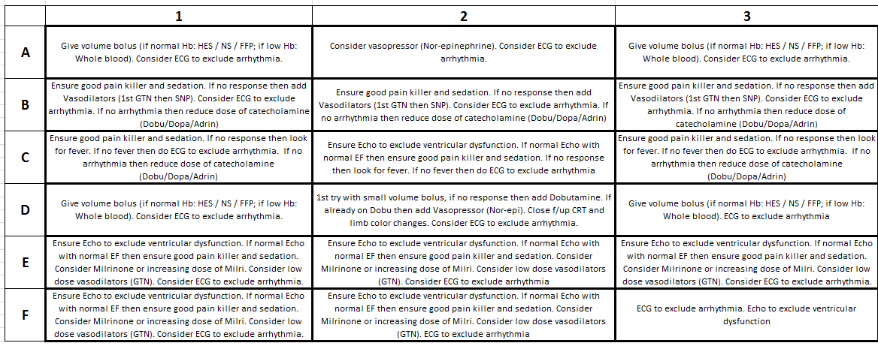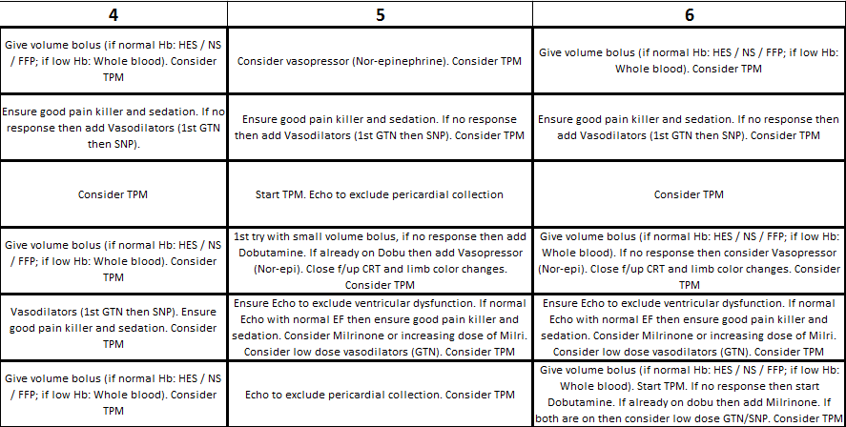

Treatment based on the decision algorithm
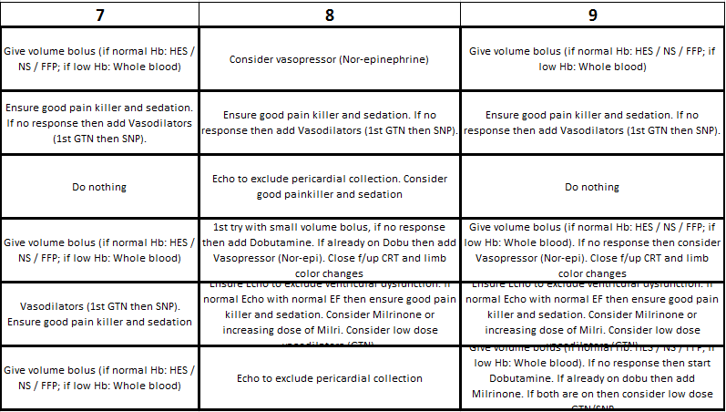

Database Design:

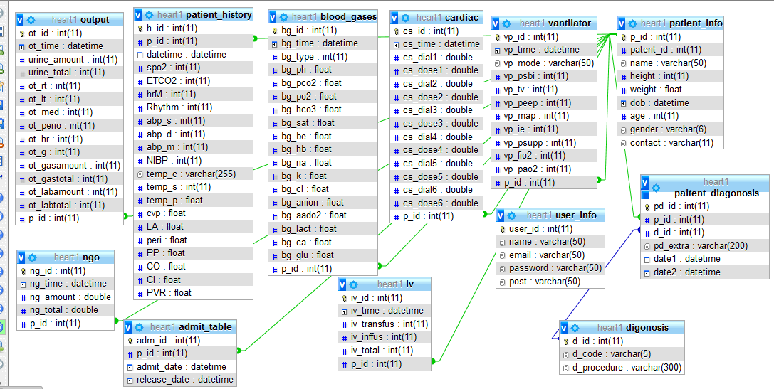

Chapter Four:

Development and Deployment

Tools:

- Android Studio
- Xampp
- Visual studio code

Platform:

- PHP
- CSS
- Python
- Android
- Java

Chapter Five :

Demostration

Screenshots:

Website:


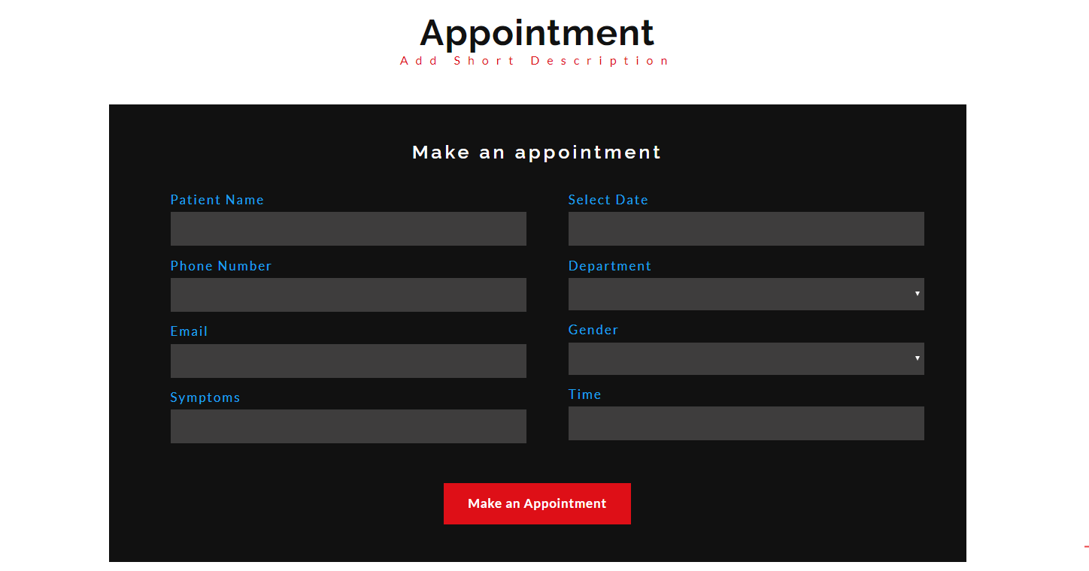


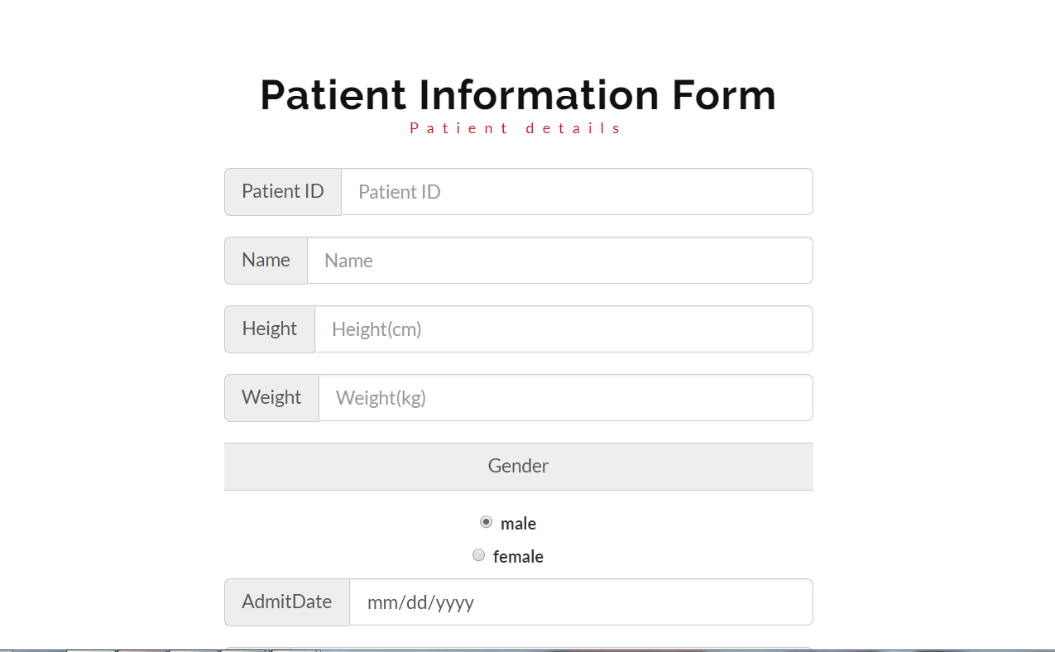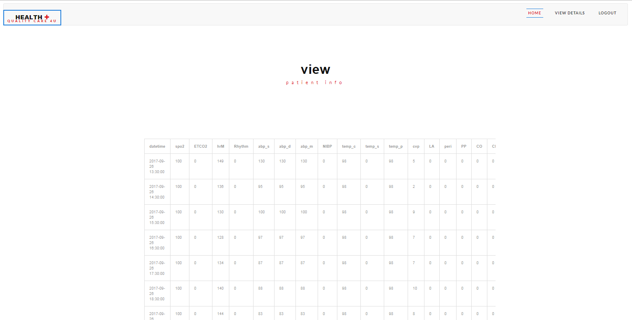

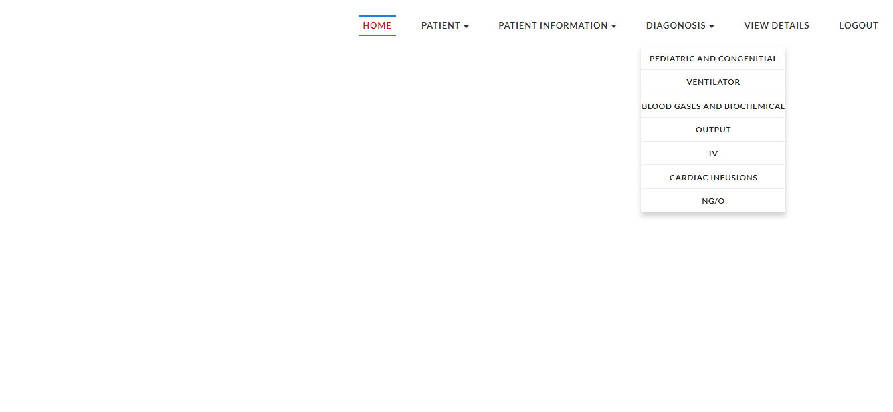
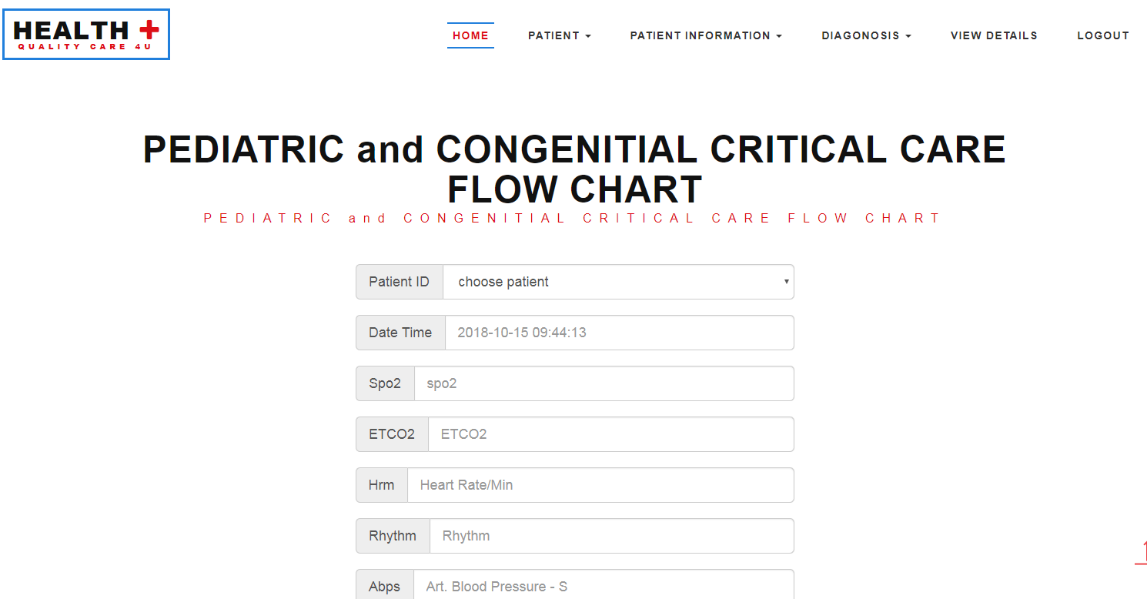

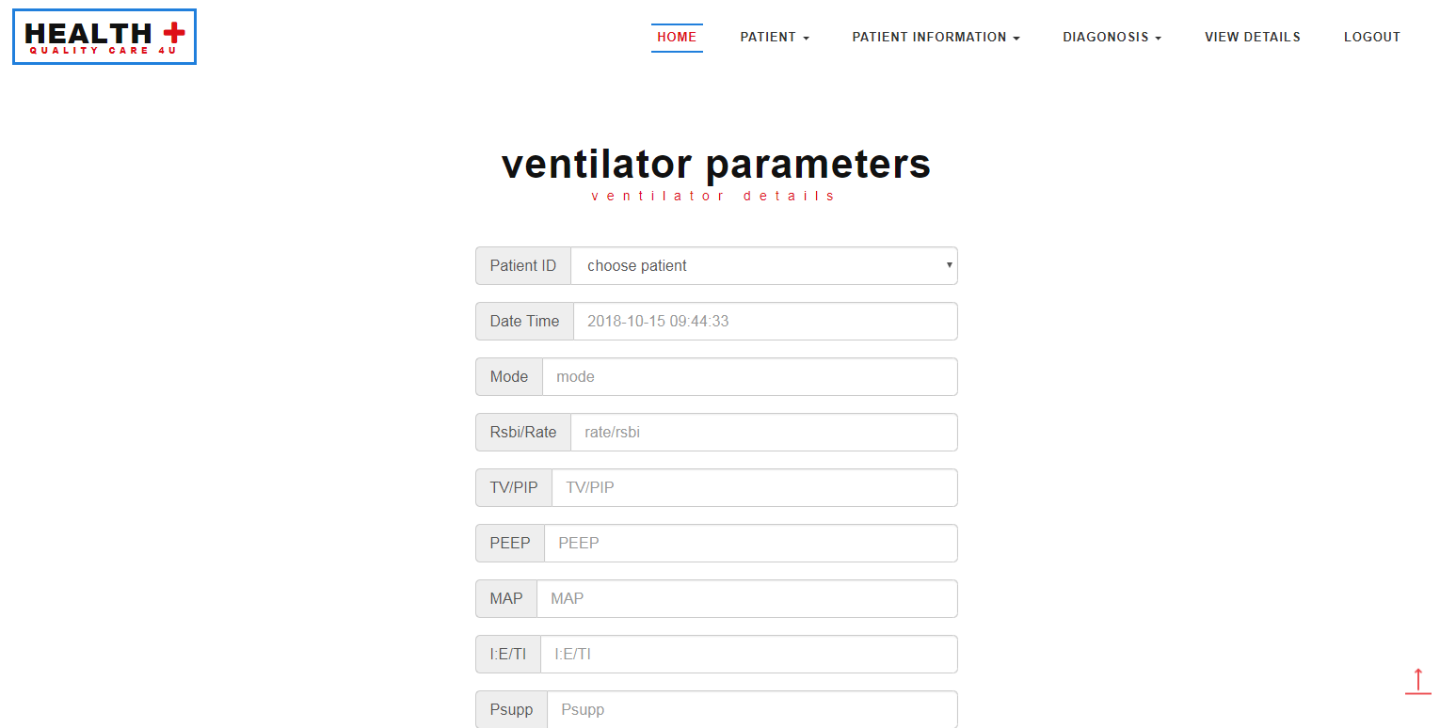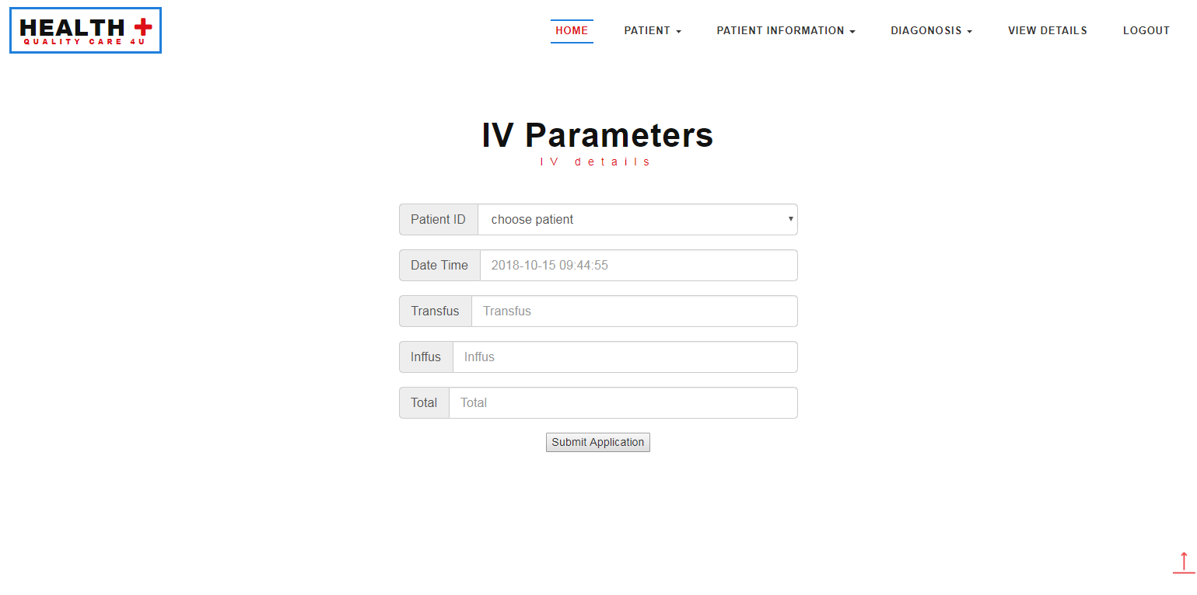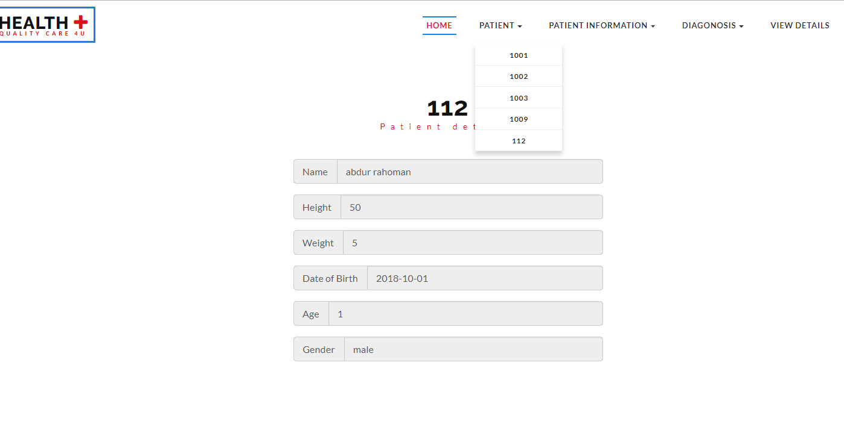

Mobile Application:

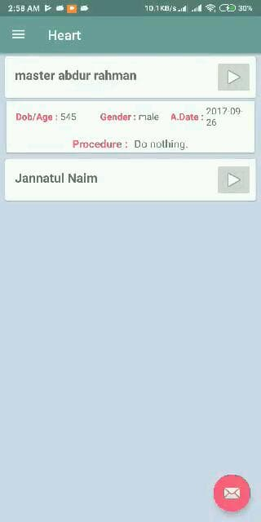

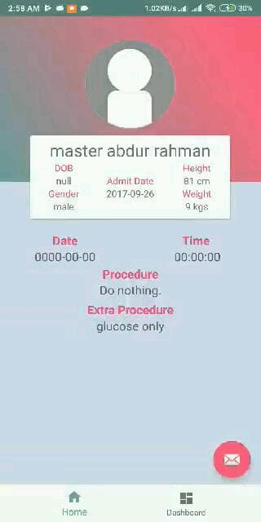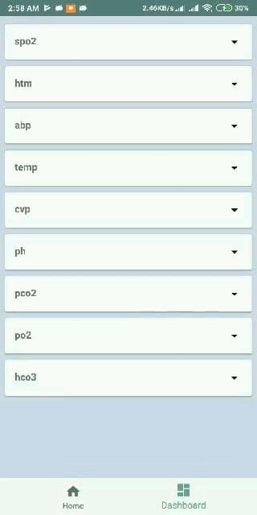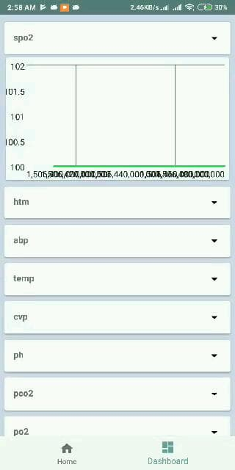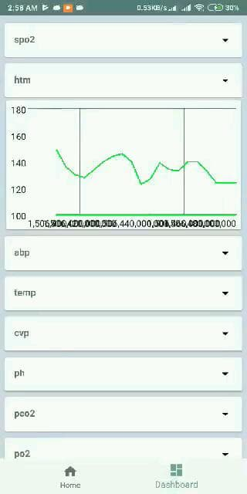

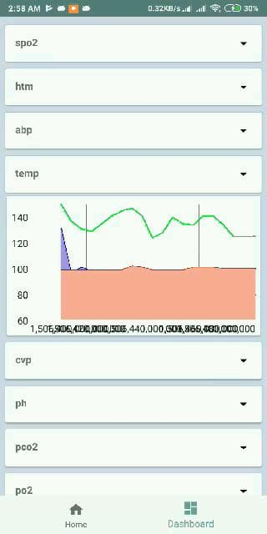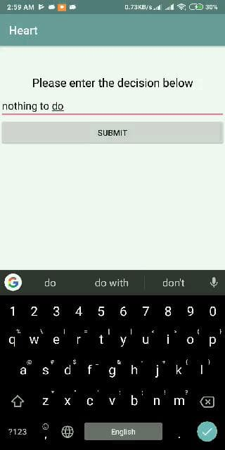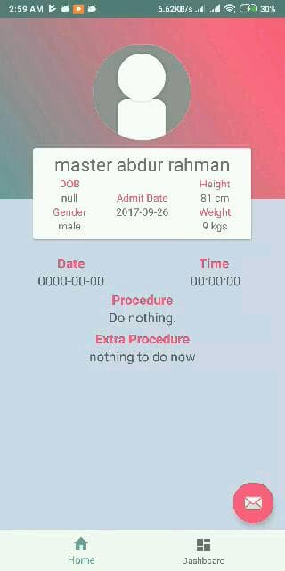

Chapter Six:

Future Work and Difficulties

Problem faced:

- There is a higher chance of network downtime
- data loss due to issues with Wi-Fi hotspot stability
- Ensure that there is no false abnormal detection
- Choosing important parameters
- Making decision for individual parameter was difficult
- CVP value categories needed to be normalized
- Ages required normalization

Future Work:
In future we will try to resolve some issues and add new features that will be helpful to the doctors and the nurses.

- Decision should be based on more parameters.
- Improve mobile application so that the doctor and nurses can use it more easily.
- Visually monitoring patient.
- Machine learning algorithms can be implemented on real-time data to make early prediction if the patient’s health will deteriorate or not.

Chapter Seven:

Pros And Cons

Pros:

- The doctors can immediately treat their patients by analysing their data.
- Not time consuming
- Easy and flexible

Cons:

- If there is some mismatch of data then there will be some loss of information.
- A good knowledge before using it.

Chapter Eight:

Constraints

Constraints:

- The system would not share data with other users.
- The server must be responsive enough to receive the updated data and send decision to the doctor.

Chapter Nine:

Conclusion

Conclusion:

- Our system provides information about the patient’s health status such as the heart beat rate, ECG, patient history and it is all stored in the server.

- The system works on both Android and Web platform and it shows how we have implemented our features to satisfy the system requirements.

