A Project Report on “The Influences of Islamic Banking on Bangladesh Economy”



Submitted To
Nusrat Farzana
Assistant Professor
School of business and economics (SoBe)
United International University

Submitted By
Arafat Rahman Tanjil
ID: 111 142 151
School of business and economics (SoBe)
United International University

Date of Submission: 2nd January 2019
Letter of Transmittal
To,
Nusrat Farzana
Assistant Professor,
School of business and Economics (SOBE)
United International University

Subject: Submission of Internship Report on “The influences of Islamic Banking on Bangladesh economy”
Dear Madam,
I would like to thank you for giving me opportunity to create the Project report on this point "The influences of Islamic Banking on Bangladesh economy". I have made the report featuring most of the impacts of Islamic Banking on Bangladesh economy and investigate it from business and financial perspective.
I have attempted my best to make the report excellent and assemble significant data for preparing a total report. Without the correct guidelines from you, it would be so hard for me to create the report.
I trust, you will assess my report, considering all the impediments and mistakes of the report, and truly believe that you will find the project report very fascinating and instructive.
Thank you.
Sincerely yours,
Arafat Rahman Tanjil
ID: 111 142 151
School of business and economics (SoBe)
United International University

Acknowledgement
First of all, I express to my gratitude to Almighty Allah who gives me the ability to complete the Project report within the projected time schedule.
I would also like to thank my respected project instructor Nusrat Farzana, Assistant Professor, United International University (UIU) for all the valuable advice and support she provided to me and without her help it would be so hard for me to prepare my project report.
A lot of Banks Official who helped me to gather information, my heartfelt gratitude goes to them. They helped me a lot to prepare this report and this report is a synopsis of my recent learning from the Project on “The infulences of Islamic banks in Bangladesh economy”

Thank You All.

Table of Content
Abstract 1
Chapter one: Introduction
1.1 Background of the report: 3
1.2 Objectives of the Study: 3
1.3 Scope of the report: 3
1.4 Methodology of the Study: 3
1.5 Data collection: 4
1.6 Limitations of the report: 4
Chapter Two: Development of islamic Banking in Bangladesh
2. Shares of Islamic Banking Market in Muslim Majority Countries 6
2.1 Background of Islamic Banking in Bangladesh 6
2.2 Principle Reasons to Establish Islamic Banking System 10
2.3 Primary goals of Islamic economy 11
2.4 Overall Banking Context of Bangladesh 12
2.5 Expansion of Branches 13
Chapter Three: Analysis of the influences of Islamic Banking
3. Development of the economy of Bangladesh by Eight Islamic Banks 15
3.1 Mobilization of Deposits 16
3.2 Sorts of Deposits 17
3.3 Investments made by Islamic Bank during DECEMBER 2017 18
3.4 Sector Wise Investment of Islamic banks 19
3.5 Remittances Mobilized by the Islamic Banking Sector 20
3.5 Corporate Social Responsibility (CSR) 22
Chapter Four
4. Findings of the report 24
Chapter Five
5. Conclusion 26
References....................................................................................................................28

Abstract
This project paper introduces the influences of Islamic banks to the economy of Bangladesh. The report examines sites, articles as well as writings of various authors and annual reports of various Islamic Banks. Key discoveries of this report show the diverse regions of financial development in Bangladesh by Islamic banks like creating work opportunities, creating business enterprise, reinforcing rural economy, disparaging moral managing an account, advancing environmental protections and green HRM and Green Banking, boosting industrialization, building up the SMEs, aiding global exchange, winning foreign settlement, and building framework of the nation. This report also recognizes Islamic banking’s commitment to Corporate Social Responsibility (CSR) and in addition a critical commitment to the national benefit.

During the most recent 3 eras, Islamic banking has turned into a rising and extending representativeness in Bangladesh. The general effect of Islamic banking in Bangladesh economy is that it has turned out to be satisfactory to the ordinary people, as well as to the elite of the nation comprising top class professionals of industry and business. Everyone these days highly admit that Islamic Banking is a reliable substitute to the conservative western present Banking.

The establishment of interest free and equity based financing by the Islamic banking framework, depends on the standards of Islamic Shari'ah. The point of Islamic banking isn't just the end of interest based exchange, yet it’s the foundation of justice and equity free from all sort of misuse. The financial framework might have the capacity to advance equity. As the almighty Allah says, “So that wealth is not concentrated among the rich” (Sura Hashor- 7).

Economic Advancement means to modifications that influence a local economy’s capability to create prosperity for local populations. The economic advancement of Bangladesh might be recognized through a various types of pointers, including Gross domestic product (GDP) development, reduce un-employment, poverty issues, human services, education,, work for environment, Social service exchange and trade and so on. This report recognizes that during most recent thirty years, Islamic banking has subsidised in enhancing Bangladesh economy by generating constructive developments to all of its financial pointers.

Chapter 1
Introduction

  - Background of the report:
In today's economy, banks are the essential financial institutions. Currently, they are occupied with value creating exercises by guaranteeing continuous supply of financial resources and furthermore help to accelerate the pace of economic development process. Regarding deposit collection, investment, and foreign trade business the Islamic Banks of Bangladesh have taken the situation of being the leading banks. Islamic Banking has been relentlessly working their banking activities and to provide productive banking service to enhance the economic development of the nation in Shariah compiled way from the incorporation in 1983.
  - Objectives of the Study:
This project report is directed to research and clarify the influences of islamic banking on Bangladesh economy. All the more particularly, this report will explain most of the contribution performed by islamic banking in Bangladesh that helps to build the economy strong.
The objectives of this report are as follows-
- To understand how Islamic banks help to the world’s economy.
- Different Islamic banks that are performing banking activities according to Islamic Shariah in Bangladesh.
- The sectors where to invest more to improve an economical condition.
- Some Graphical views at the analysis of Islamic banks in support of their contribution.
  - Scope of the report:
While preparing my project report, I came to know a lot of functional activities that are performed by the Islamic banks in Bangladesh. I have known how they are playing a vital role to generate our GDP and also known how their work helps to the nation.
  - Methodology of the Study:
This is a distinct study which has utilized generally the secondary information. Yearly reports of the said bank and supporting distributed and unpublished materials have been used to extricate the data related with the impacts of the islamic banks to the economy of Bangladesh.
  - Data collection:
Collecting information is very crucial part of a report. I know that if I choose any wrong sources, my report might be misguided. So I have collected all the info very carefully. I have collected information from two main sources.

a. Primary sources:
- I have communicated with various officials of Islamic banks.
- Collected a lot of brochures and relevant files from different Islamic banks.
b. Secondary sources:
- Websites of Islamic banks Bangladesh
- Annual reports
- Different 'Procedure Manual', published by various Islamic banks of Bangladesh.

  - Limitations of the report:
I have faced a lot of difficulties while creating this report. Some of the major limitations are given below:
- Most of the official do not disclose information because I am unknown to them.
- Large scale analysis is not possible due to constraints & restrictions posted by the banking authority.
- Lack of sufficient books, papers and journals etc.
- In many cases, up to date information may not be available
- Because of the limitation of information, some assumptions were made.

Chapter 2
Development of Islamic Banking in Bangladesh

2. Islamic Banking Market in Muslim Majority Countries
Though every one of the 56 countries OIC nations have practiced Islamic finance, the Middle East, South-East Asia and South Asia Muslim dominant nations have developed as the main Islamic money related Industry focuses. Iran and Sudan have embraced completely Shariah-complaint money related frameworks. based on 2012 information, among other real Muslim nations, Islamic banking share of the overall industry of aggregate banking industry in Kuwait is over 60% taken after by Saudi Arabia (33%), Qatar, UAE, Malaysia and Bangladesh (20%) and Syria, Bahrain, Yemen and Jordan
(10%) Nations having underneath 10% Islamic banking piece of the overall industry incorporate Egypt, Turkey, Pakistan and Indonesia. The Muslim majorities countries who are following Islamic finance are given below:
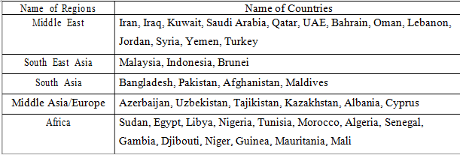
Table: Major Muslim countries offering Islamic Finance

2.1 Background of Islamic Banking in Bangladesh
Bangladesh is the third greatest Muslim country on the planet in which 90 percent of the populace has a place with the Muslim conviction. The all-inclusive community of this country is significantly devoted to the Islamic way of life as respected in the Blessed Qur'an and the Sunnah. Regularly, it remains a profound cry in their spirits to diagram their economic lives according to the impression of Islam. Premium based banking in the Muslim world including Bangladesh is a frontier heritage. After the Second World War, while outskirts control left Muslim states climbed a demand among the nationals to create a nation with the musings of Islam. This asks for was the fundamental main impetus behind the establishment of Islamic banks among the OIC countries. The development of Islamic banking got vitality with the establishment of Islamic Development Bank (IDB) which is considered as an achievement occasion since all the part law making bodies of OIC appreciated its esteem. The occasion is likewise considered as an official affirmation of Islamic banking by all the taking an interest governments. (Huq M.A-2011)
In August 1974, Bangladesh, addressed by the author of the nation Bangabandhu Sheik Mujibur Rahman, marked the agreement of Islamic Development Bank and submitted itself to update its economic monetary framework according to Islamic Shari'ah.
In January 1981, President Ziaur Rahman while watching out for the third Islamic Summit held at Makkah and Taif proposed, "The Islamic countries should develop an alternate banking arrangement of their own remembering the true objective to energize their trade and business."
In November 1982, a task of IDB visited Bangladesh and exhibited unmistakable interest in setting up a joint endeavor Islamic bank in the private portion. They found that a significant proportion of fundamental work had quite recently been capable and Islamic banking was in a readied for provoke introduction. The national bank of Bangladesh, Islamic Economic Research Bureau (IERB), and Bangladesh Islamic Bankers' Association (BIBA) made immense responsibilities in the convergence the developmental periods of Islamic bank in the country. As a course of action of this overall development, Islamic banking was set up in Bangladesh as in front of timetable as in 1983, the Islami Bank Bangladesh Confined is the essential Islamic bank in South East Asia.
Islam contains expansive revelation on the diverse piece of development. The key of Islam, for instance, aqidah (conviction and certainty), ibadah (venerate and zakah) and akhluk (significant quality and ethics), muamalaat (trades and contracts) and husn-e-muasharat (way and dignity) being Islamic legal code are not expose to change, their sign in helper locales like economics, business and other common activities would require versatility and development as demonstrated by existence. This is encapsulated in Islamic shari'a which is fundamental to the chart of Islam. Islam incorporates an increasingly broad essentialness getting a handle on the taqwa (God mindfulness) estimation.
The Islamic Shari'ah attempts to help social welfare. Banking tries will continue expanding the welfare of the accomplices and society. Banking division displayed social trustworthy methodology as opposed to profit boosting one, which makes wealth and openings for work for the nation. Islamic banking calls for selective necessities and good direct by the two credit pros and borrowers. The people who are hitched to western banking may take practices regarding welfare from the Islamic banking framework. Islamic banking is a financial system whose point is to satisfy the lessons of the Holy Quran, work on standards of Shari'ah entirely keeping away from enthusiasm including benefit and misfortune sharing and straightforwardly required with core values and social justice. "Islamic bank is a financial establishment whose statutes, rules and strategies expressly express its promise to the standards of Islamic Shariah and to the restricting of the receipt and instalment of enthusiasm on any of its activities" – OIC
The Third World creating nation like Bangladesh faces a great deal of difficulties including poverty, overpopulation and vulnerability to environmental change. Bangladesh has additionally been diminished its reliance on outside stipends. Then again, Bangladesh could draws in outside direct investment. It is noted by the international network for its encouraging on Human Development record. Bangladesh is recognized as a Next Eleven economy after BRICS by Goldman Sachs.
Poverty, unemployment, hunger, poor health, lack of education and gender discrimination are the significant problems in Bangladesh. It is a thickly populated nation, and in this manner, it is hard for the administration to give sufficient nourishment, garments, haven, wellbeing, and instruction for its residents.
Banking in the today's world has received many developments. However, exceptionally later and most astounding advancement has been the system of Islamic banking. A bank is a financial establishment where individuals secure their cash and utilize this organization as a wellspring of conceivable back. Banking in the frame in which it exists now-a-days is similarly of late source. Prior to the coming of current banking, coordinate back, where the proprietor of capital arrangements specifically with the client of capital, was the standard method of transference of assets from savers to financial specialists. These days, banks are associations occupied with different capacities i.e., accepting, gathering, exchanging, paying, loaning, contributing, managing, trading, and adjusting cash and claims to cash both locally and internationally.
Bangladesh is a nation experiencing tremendous social, political, economic and natural issues and these issues should be tended to for the general development of this nation. In any case, the economic development is one of the prime elements, which can resolve a large number of its present issues. Bangladesh has been confronting extreme economic issues; this nation has a for each capita pay of just US$923 (Bangladesh service of fund 2013) sustaining 160 million individuals with a real estate parcel estimating 147570 square kilometres is extremely testing having a yearly spending plan of US$28.52 billion.
This nation is attempting to meet the fundamental requirements for its citizens. The development of business divisions and open market economy has made an awesome open door for Bangladesh for its development. The commitment of the banking part is assuming critical part in the development of this nation. Be that as it may, the development of Islamic banking in Bangladesh has included another stature in the banking part. The part of Islamic banking is by all accounts gloriously outperformed among every one of the Banks in Bangladesh amid most recent three decades.
It is frequently argued by some western researchers that the Islamic worldview bolsters an attitude and esteem system which ascribes little significance to singular execution and obligation, adequacy and productivity or material prosperity. Muslim are more worried about the life in the hereafter. They belief in a sort of destiny and this parts lead altogether to a fatalistic demean of which genuinely hinders economic development. (Volker Nienhaus: 2006)
Economic Advancement is an expansion of social arrangement; ascending movement of the whole society. “Economic advancement is the process of creating wealth through the mobilization of human financial capital, physical and natural resources to generate marketable goods and services.”- American Economic Advancement Council (1984)
Islamic banking are turned into the quickest developing fragments in the international financial system. Islamic banks indicated more grounded versatility amid the worldwide financial emergency because of their tying down in the genuine economy and banning from putting resources into financial subordinates. Worldwide financial emergency reasons for avarice, enthusiasm, betting, hypothesis and defilement. Part of hypothesis is the arrangement of the emergency. Moral disappointment is the unrivalled root of the emergency. Intrigue is the base of all abuse.
In general, Islam restricts all types of economic exercises which it seems to be ethically or socially corrupting or unsafe to others. The key manage of Islamic banking is the preclusion of charging premium, theory, authoritative vulnerability and exchanges that turn out to be worthwhile to one gathering to the detriment of other. As per the shari'ah law, one isn't permitted to profit from cash, to be required with liquor, betting and erotic entertainment. So, riches is to be produced just through genuine exchange and interest in resources seeking after shari'ah standards.
Nowadays, minimum 430 Islamic banks and 10,000 Branches are giving their banking administrations under Islamic structure more than 75 countries of America, Europe, Africa, and Asia. In 2008 the degree of the worldwide Islamic banking industry was assessed $820 billion. The proportion of the business crossed $1.6 trillion by 2012.
To understand the Islamic banks' commitment to Bangladesh's economic development, a brief overview of the country's overall banking environment in relation to the Islamic banking system is needed. Before the end of Walk, in 2013, there were 8 undisputed Islamic banks and 15 conventional banks with 20 Islamic bank branches and 25 Islamic banking banks working in Bangladesh. From that moment, 23 banks have considered about 800 Islamic bank branches with a work of $ 0.023 million, working one after the other and five other banks are being prepared. Despite the limitation of the new license controller, activity has increased to 20% per year. Business observers believe that if this pace of development continues, the Islamic banking system in Bangladesh will become uninterrupted in the standard 2025 banking system. (Huq, M.A- 2011)

Principle Reasons to Establish Islamic Banking System
There are for the two important reasons to build up Islamic Banking framework:
- Shariah
- Socio-monetary
a) To check inflation,
b) To do justice to the investors,
c) To expand the speculation,
d) To handover funding to the specialists,
e) To secure the hoarders,
f) To diminish the pay discrimination,
g) To full usage of remote cash or outside capital,
h) To guarantee legitimate supply and dispersion of merchandise/wealth,
I) To expand the financial improvement of poor people,
j) To alleviation the poor people from abuse,
k) To stretch out the hands to the gainful area,
l) To stable the price hike.

Primary goals of Islamic economy
The destinations of Islamic economy are as under:
- To set up Adl (equity), to accomplish Hasanah (great) and Falah (welfare) in this life and the existence in hereafter.
- To set up Ihsan (benevolent lead or graciousness) in monetary issues.
- To set up Maroof (appropriate or great acts, organizations) in monetary life.
- To dispose of Munker (malicious, wrong or harmful practices from financial life).
- To free the humankind from un-needed weights and shackles and to make life less demanding for them.
- To accomplish greatest monetary development.
- To boost work to guarantee appropriate circulation of riches in the general public.
- To accomplish widespread training.
- To empower collaboration in the general public.
- To favouring the weaker segments of the general public to set up them throughout everyday life.

Overall Banking Context of Bangladesh

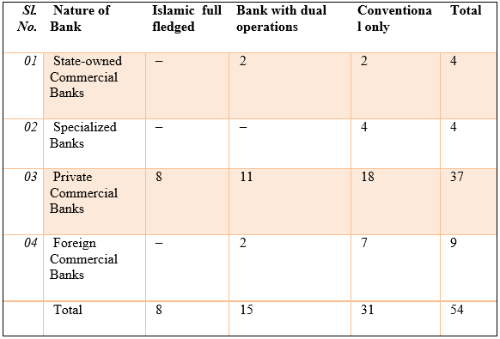
- Eight Islamic Banks are providing Islamic banking services in Bangladesh, They are:
- Union Bank Limited.
- Social Islami Bank Limited (SIBL),
- Islami Bank of Bangladesh Limited,
- First Security Islami Bank Limited,
- ICB Islamic Bank,
- Al-Arafah Islami Bank Limited,
- Shahjalal Islami Bank Limited,
- Export Import Bank of Bangladesh Limited (EXIM BANK)

Branch Expansion
Branch numbers in the Islamic banking sector (adding Islamic branches of traditional banks and wickets) stayed at 1126 towards the finish of the year inside the investigation, with 1112 before the finish of the last quarter and 1051 before the finish of the past year. September 2016 before the finish of December 2017, in the Islamic banking division, 8 undisputed Islamic banks had 1082 branches, 9 traditional business banks had 19 and 7 customary banks had 25. The offer of worldwide branches of Islamic banks among every one of the banks in the program represented 11.52% before the finish of the year being referred to. Here are the fundamental information from their branches:
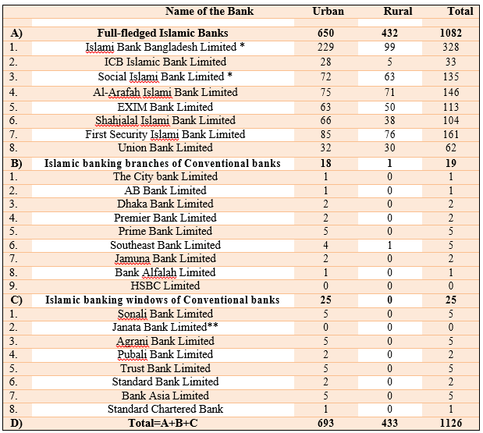
Number of Bank Branches of Islamic Banks (December, 2017)

Chapter 3
Analysis of the Influences of Islamic Banking

Development of the economy of Bangladesh by Eight Islamic Banks
The Islamic banking system has tripled since 2007, with an 11.5% CAGR and during this period the takaful segment has been multiplied by 5 with a 19.35% gross annual growth rate. The Islamic banking now becomes a fundamental imperative with a market share of more than 15% worldwide in more than twelve nations. Islamic banking, surprisingly, attracted the attention of Islamic and modern business analysts. In 1993, Parker notes, the presentation of Islamic banking philosophies by several Western financiers have presented optimistic results showing that Islamic banking executives can operate successfully in created countries and other countries, with little respect for religious boundaries.

The presentation of an interest-free and value-based Islamic banking framework has proved to be of significant importance for the domestic banking sector, which has continued to show solid growth since its inception in 1983, alongside the development of the economy, as demonstrated by the expansion of market share, but also the activation of deposits and supporting of important areas of Bangladesh economy.

This project study reviews the progress made by the Islamic banking sector in the December 2017 quarter. By the end of September 2017, 8 undisputed Islamic banks are working with 1,082 branches out of a total of 9,774 banking sector branches; Moreover, 19 Islamic banking units of nine modern profitable banks and twenty-five Islamic banks of eight profitable banks offer Islamic budget administrations too in Bangladesh. At the last of year, December 2017, investments, deposits, and remittances from the Islamic banking sector increased by 2.30%, 4.22% and 11.42%, gradually and decreasing by 18.05%. Last quarter. The Islamic banking sector was responsible for almost 1/5th of the total banking sector for investments and deposits towards this quarter end.
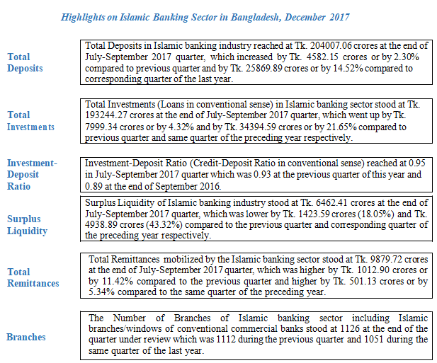

3.1 Deposits Mobilization
The number of total deposits in the Islamic banking sector remained in Tk. 204007.06 crore towards the end of December 2017, which was higher than 4582.15 crore (2.30%) and Tk. 25869.89 crore (14.52%) separately if matched to the earlier quarter and the comparative quarter of the previous year. Of the total deposits, the on-demand store was Tk. 23742.04 crore and the store time was Tk. 180265.02 crore. The total deposits of Islamic banks responsible for 22.79% of all banks during the reporting period. The total deposits of the eight major Islamic banks accounted for 94.90% of deposits in the Islamic banking sector. The deposits of 8 major Islamic banks remained in Tk. 193601.39 crore at the end of September 2017. From all the Bangladeshi Islamic banks, IBBL responsible for the majority of deposits (35.02%) [Chart 1],Followed by FSIB Ltd. (14.21%), Al-Arafah Islami Bank Ltd. (12.07%), Exim Bank Limited. (11.74%), Social Islami Bank Limited. (9.73%), Shahjalal Islami Bank Ltd. (6.68%), Association Bank Ltd (4.90%), Islami banking branches (2.95%), Islami banking windows (2.15%) and ICB Islamic Bank Ltd (0.54%).
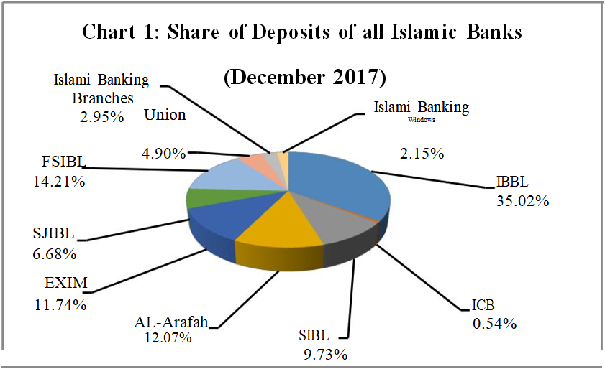

3.2 Sorts of Deposits
The Islamic Banking industry offers various sorts of deposits, Mudaraba Term Deposits earned the most elevated position (47.96%) [chart-2] taken after by Mudaraba Savings Deposits (MSD) (18.55%), Different deposits (15.71%), Mudaraba Special Savings pension/profit) Deposits (8.77%), Al-Wadeeah Current account Deposits (4.22%), Mudaraba Special Notice Deposits (3.79%), Mudaraba Savings Bond (0.78%) and Mudaraba Hajj Deposits (0.20%) and so forth.
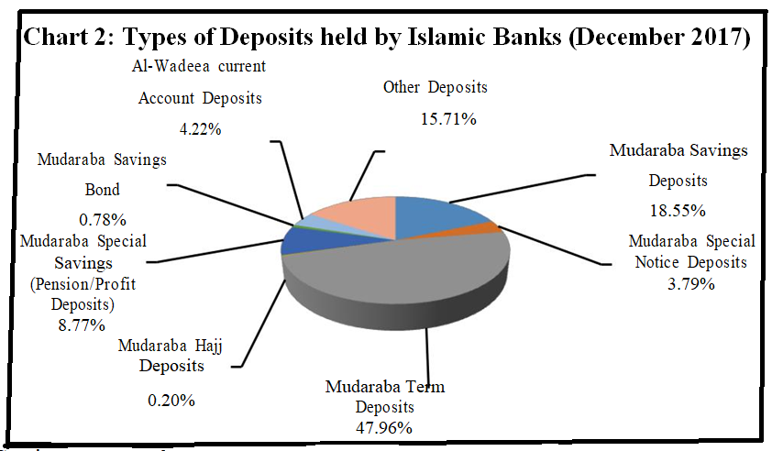

3.3 Investments made by Islamic Bank during DECEMBER 2017
The total investments measurement in Islamic Banking industry came to at Tk. 193244.27 crores toward the last of December 2017. The investments expanded by 4.32% and 21.65% separately when contrasted with the past year. In Bangladesh economy, the investment of Islamic banks represented 24.22% share among all banks.
From the Islamic bank’s total investments, 95.05% was prepared by 8 mature Islamic banks, 2.86% by the planned banks' and the rest 2.09% by the other banks' Islamic banking windows. As on account of investments, Islami Bank Bangladesh Ltd. achieved the most noteworthy investments share which was 35.36% at the last of December 2017, (graph 3). The investment share prepared by other Islamic banks involved FASB Ltd (13.38%), EXIM Bank Ltd. (12.11%), Al Arafah Islami Bank Ltd. (11.45%), SIBL (9.91%), Shahjalal Islami Bank (7.59%), Union Bank (4.78%), Islami banking branches (2.86%), Islami banking windows (2.09%) and ICB Islami Bank Ltd (0.47%).
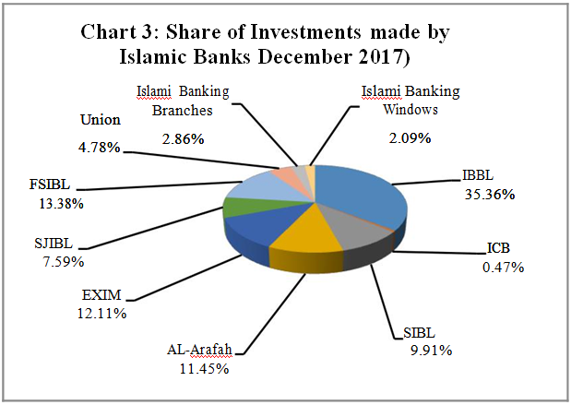

3.4 Sector Wise Investment of Islamic banks
From the Chart of islamic bank’s sector-wise investment, it may be seen that Islamic bank’s invested more in the Small and Medium Enterprises - SME sector from all other sectors which remained at 28.55% (Graph 4) toward the end of the December 2017. The following position was involved In terms of professional career and Business sector (27.52%) trailed by Mechanical sector (24.89%), Others (8.45%), Land (6.54%), Horticulture (1.79%), Transportation (1.42%), Power, Gas and Water supply (0.75%) and Destitution Mitigation (0.10%).
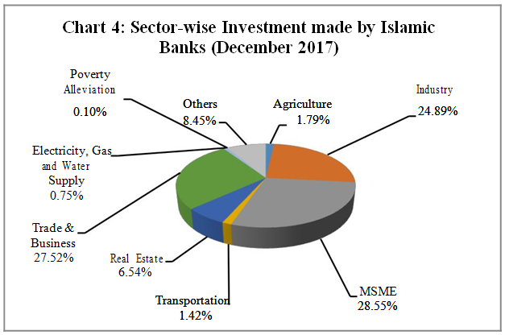

3.5 The Mobilization of Remittances
The industry Islamic Banking of Bangladesh is assuming a crucial part in gathering outside settlements and dispensing the similar exchanging among recipients over the nation. During December 2017 measure of remittances came to at Tk. 9879.72 crores. From the Bangladeshi Islamic banks, IBBL involved the best position (60.94%) in regard of settlement gathering toward the end of December 2017.The settlement shares of other Islamic banks involved SIBL (16.74%), Al Arafah Islami Bank Ltd. (14.49%), FASB Ltd (2.96%), Union Bank Ltd (1.91%), EXIM Bank Ltd. (1.36%), Shahjalal Islami Bank (0.88%), Islamic banking branches (0.61%) and Islamic banking windows (0.11%).
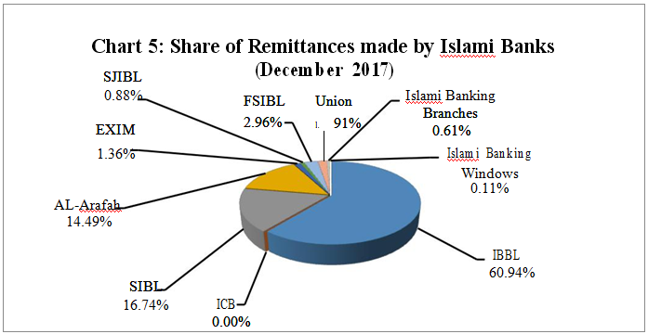
The Islamic Banking Industry represented 36.14% share of settlements gathered by the whole banking industry. Settlement accumulations of every single scheduled bank, every Islamic bank and Islamic banking branches/windows of ordinary banks are given in graph 6.
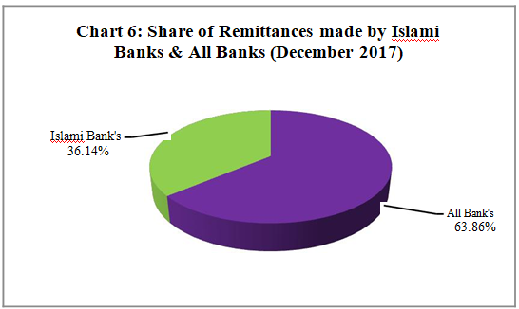

3.5 CSR- Corporate Social Responsibilities performed by Islamic Banks
The Islamic banks of Bangladesh works different types of social projects as part of CSR exercises. Among the ways of CSR exercises performed by Islamic banks are Zakat, payment fees (punitive expenses of defaulting investors) and sharia have provided various sorts of income. These assets are donated between several kinds of development, providing for various Bangladesh NGOs. Islamic banks help the poor and people who is living in extreme poverty, remain outside the traditional banking framework; banks conduct financial exchanges based on human needs and undertake productivity initiatives or exercises to reduce poverty. Spending on CSR expenses decreased by 16.57%. By the last of December 2017, the total spending on the Islamic banking sector's CSR exercises remained at 43.51 billion Czech crowns, or 4,000 billion kroner. 60.08 Crore and Tk. 48.59 crore in the earlier quarter and in progress before December 2016 respectively.

Chapter 4
Findings of the Study

Findings of the report
At this point, it is shown that Islamic plays a great role in the economy of Bangladesh. All the sectors needed to improve are contributing by Islamic banking. The findings of the report are listed below:
- The Eight major Islamic banks are opening branches at various remote places in Bangladesh. A lot of Bangladeshi people are being benefited for it.
- The total deposits of the 8 most important Islamic banks represented 94.90%.
- The investment of Total 8 Islamic Banks in the SME sector was the most noteworthy from all other sectors which remained at 28.55% toward the end of the December 2017.
- For the investment in MSME there are various sectors that get the benefit such as Mechanical sector, Land, Horticulture, Transportation, Power, Gas and Water supply and Destitution Mitigation.
- The share of remittance collected by Islamic Banks are Playing great role in Bangladesh economy.
- Islamic banks carry out different kinds of social projects under Corporate Social Responsibility (CSR) exercises such as Zakat, pay charges for late fee.
- Islamic banks helps to reduce Unemployment in Bangladesh.
- Providing supports to various NGO’S in Bangladesh.
For all the ways above how Islamic banks of Bangladesh are contributing, I strongly express that Islamic Banking is developing the economy of Bangladesh.

Chapter 5
Conclusion

Conclusion
The Qur'an shares the principle that "wealth should not only flow among the rich" (59: 7). According to Ibn Al Quyayyum, "Shari'ah is based on the wisdom and welfare of the peoples of the world, and henceforth, this well-being lies in complete justice, mercy, well-being and wisdom: all that from justice to oppression, from mercy to harshness, from well-being to misery and from wisdom to madness has nothing to do with sharia ".
We need a broad public awareness and support to correct Islamic banking Framework as the Muslim nations are the first user for generating a specific change.
M. N. Huda, Professor, said: "The Islamic banking system has won the theoretical war and must now manage profit management on the basis of profit-sharing and loss of interest" (1983)
The eight full-fledged Islamic banks of Bangladesh, whose limited points of assistance are insufficient to meet the demand for market compression. As the banking sector now had an ideal number of banks, the controllers felt it was unwise to include other banks to the Islamic framework. Even the conventional banks including two foreign banks, who provides interest, were attracted in launching Islamic banking tasks in Bangladesh. In any case, this double bank routine is anything but a development of Bangladesh. This is a line of action approved by sharia law and present in several parts around the world.
The Islamic banking system is highly growing frameworks of the economy of Bangladesh. A renowned magazine called The Economist describes from the perspective of Islam: "In the past, global human progress has resulted in the eminent thinking of modern culture and education of Muslims Al-Andalus and the world today can consider the possibility that the Islamic banking system is a blessing of Islam from the Islamic world"
When we arrived the second era of the 21st century, the potential of Islamic banks in the world in general and Bangladesh in particular was considerable. In a concentrated world, the fittest will survive, the better will sign and Allah will help those who helps to maximize their efforts.
Reference
(1)Annual Report 2015, 2016 & 2017, Important 8 Islamic Banks Bangladesh Limited.
(2)Websites of Bangladesh bank on Islamic bank report, December 2017 Quarter of Bangladesh bank.
(3)Guidelines for Islamic Banking, Bangladesh Bank, November 2016.
(4)Rakib Abdur, Principals Practices of Islamic Banking. Dhaka February 2017.
(5)Nabil Nassief, Islamic banking around the world, Discussant views of Dr. M. A. Hamid. October 1989.
(6)Chapra M. Umar, Alternative visions of international monitory reforms. Islamic Banking and Finance: Current developments in Theory and Practice. August, 2000.
(7)Muhammad Al-Tahir Ibn Ashur, Treatise on Maqaside al-Shari’ah.
(8)Huq M. Azizul, (2011) Status of Islamic banking in Bangladesh: promising agenda for the 21st century, workshop on Islamic trade finance, July 2011.
(9)Rahman, Md. Mahfuzur & Rahman B M Habbur. Islamic Financial System and Selected Islamic Economics Issues. (December 2007).
(10)Akkas, Dr. S. M. Ali. Analyzing Causes and Consequences of global financial crisis 2008-09: Is Islamic banking remedial Option.
(11)Sarker, Abdul Awwal. Recent Global Financial Crisis and its Islamic Solution.
(12)30 years in Universal Welfare, our story, 2013, published by PRD, Islami Bank.

