Project Report Title: Mobile Banking – A Bangladesh Perspective 
Supervisor Name: Nusrat Farzana
Assistant Professor

Student Name: Anik Mandal ID-111133057

School of Business & Economics
United International University

Date of Submission – January 15, 2019

Letter of Transmittal
January 15, 2019
Nusrat Farzana
Assistant Professor
School of Business & Economics
United International University
Dear Madam,
I, the student of School of business & economics, United International University, was assigned to submit a project report on “Mobile Banking – A Bangladesh Perspective’’ under your supervision.
I tried my best to maintain your instructions and remarks very carefully while preparing this Project report. I gave my best to follow your schedule, format and discipline.
I tried to consider maximum information on Mobile Banking – A Bangladesh Perspective to this report paper. The process of doing this report was excellent. I learned lots of information, knowledge and skill during doing of the report. I would like to express my heartiest gratitude to you for your tiresome effort for me, which provided me with the opportunity to prepare my report. I can learn many things when made this report paper.
Thank you for your consideration
Sincerely yours,
Anik Mandal
ID – 111133057
United International University

SUPERVISOR’S DECLARATION
This is to certify that the Project report on “Mobile Banking- A Bangladesh Perspective” is prepared by Anik Mandal for the fulfillment of the BBA program from United International University, Bangladesh. This report is an original work completed under my supervision and is free from plagiarism.
He is permitted to submit the Report.
Supervisor
Nusrat Farzana
Assistant Professor
School of Business & Economics
United International University

 |  | Table of Contents
 |  | Executive Summary
1. |  | Introduction | 01
1.1 |  | Origin of the Report | 01
1.2 |  | Objectives of the Report | 01
 | 1.2.1 | Main Objectives | 01
 | 1.2.2 | Specific Objectives | 01
1.3 |  | Methodology | 02
1.4 |  | Limitations | 02
2. |  | Mobile Banking Current Situation | 03
2.1 |  | Mobile Banking in Developing Countries | 04
2.2 |  | Mobile Banking in Developed Countries | 05
2.3 |  | Mobile Banking Model | 06
2.4 |  | Mobile Banking procedure | 06
2.5 |  | Mobile Banking Pros & Cons | 08
3. |  | Mobile Banking Scenario In Bangladesh | 11
4. |  | Findings & Recommendations | 23
5. |  | Conclusion | 25
6. |  | References | 27

Executive Summary
The subject of the project Paper is “Mobile Banking- A Bangladesh Perspective.” Since the main objective of this project paper is to find out the current scenario & future expectations of mobile banking in Bangladesh. I am very much concern to submit the data and information as practical as possible so that i can fulfill all requirement of this project paper.
During prepare this project paper; i tried to give my best effort to make it effective. Specific sections are given much more priority like; the literature section & the analysis sections, the comments regarding those analyses, my recommendations and how i have analyzed the future expectations of mobile banking in Bangladesh on the context of its current scenario. I have taken help from websites and newspapers.
So far i have gathered some information from websites to get my findings and to draw a well-defined summary about the problems and prospects of mobile banking in Bangladesh. Moreover i have mentioned the overview of the mobile banking operation in Bangladesh.
From the analysis, i have found some points they should be focused on how much lacking have. Based on the findings i own judgment through the recommendation part and how i have analyzed the mobile banking scenario in Bangladesh.
For to reliability and efficiency, i have collected the secondary data to develop this report paper. I have taken help from various websites. I believe that who will read this report paper; s/he can know as well as about the mobile banking in Bangladesh as well as in the other countries of the world.

Chapter 1: introduction

Cellular or mobile banking is a time period used to consult structures that permit customers of a monetary group to behavior some of economic transactions through a mobile tool such as a cell phone or tablet.
Mobile banking differs from cellular bills, which contain the use of a mobile device to pay for goods or offerings either on the point of sale or remotely, analogously to the usage of a debit or credit card to impact an ethos payment.
The sooner cell banking services had been offered over sms, as service called sms banking. With the creation of smart phones with wap aid permitting the use of the cellular web in 1999, the primary european banks began to offer cellular banking on this platform to their customers.
Cell banking has till these days (2010) most usually achieved via sms or the cell web. Apple’s preliminary success with iphone and the rapid growth of telephones primarily based on google’s android (running machine) have led to growing use of special client applications, called apps, downloaded to the mobile tool. With that said, improvements in web technology inclusive of html5, css3 and javascript have visible greater banks launching cell internet based totally provider a to complement native packages. A current examine (might also 2012) with the aid of mapa research indicates that over a 3rd of banks have cell device detection upon traveling the banks’ fundamental website. Several of things can take place on cellular banking precise website or offering a menu of cellular banking alternatives for the user to select from.
  - Origin of the Report
This report Paper has been prepared as a part of fulfillment of BBA program at United International University. The report paper titled, “Mobile Banking – A Bangladesh Perspective” is being assigned by my supervisor. I have collected all the required information from the websites. I have tried my best to combine and relate the information with the concept of the report paper.
1.2 Objectives of this report
1.2.1 Main Objectives
My main objective is to know about the mobile banking scenario & Its future prospects in Bangladesh.
1.2.2 Specific objectives
My specific objectives are-
- To gather information about mobile banking scenario in Bangladesh.
- To find out the problems & prospects in mobile banking.
- To justify importance of mobile banking & find out the future trends.
1.3 Methodology
I have used mainly secondary data sources for this report paper. The data has been collected from the websites, some other reports & journals on mobile banking.
Thus, the following sources of information have been used:
- Mobile banking scenario in developed & developing countries.
- Mobile banking process.
- Mobile banking services.
- Rules & regulations on mobile banking.
- Security challenges in mobile banking.
- Future prospects of mobile banking.
1.4 Limitations
My report covers the overall mobile banking perception in Bangladesh. However, i faced some problems in preparing this report.
- Inadequacy of information
- Time limitations
- Lack of reliable sources
- Restricted access

Chapter 2: Mobile banking current situation

Using cellular apps evolved with the aid of excessive street banks has grown to be the leading manner clients control their ordinary price range. This cultural shift has led to mobile banking eclipsing computer net as well as local branch visits. After a number of years of limited functionality, cell banking apps now offer a collection of offerings for customers and maximum banking establishments now have some form of cell app presenting. Customers are capable of view statements, pay bills, deposit cheques and make transfers to any bank account at the same time as on-the-cross – without the need to go to a local branch. Whether or not it’s developed in-house or with the assist of third-birthday party providers, the growth of cellular device ownership has sparked persisted developments in the banking enterprise to make sure that their apps offer the best carrier to their customers.
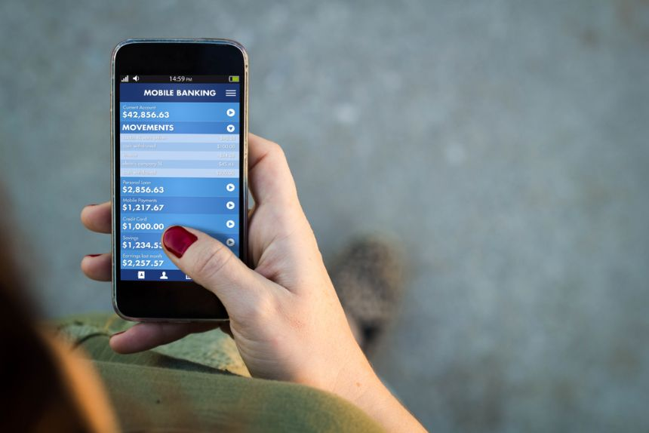
2.1 Mobile banking scenario in developing countries
Mobile banking is turning into increasingly more famous in countries of the third world, at the same time as in advanced international locations nearly all and sundry have financial institution bills, most effective a small a part of the populace in underdeveloped nations has access to banks (English-online.at, n.d.). In mobile banking a person who wants to send cash does so via sending the amount via text to the receiver’s cellphone variety & the person that gets the money is going to a licensed nearby keep that and withdraws the cash (English-online.at, n.d.). There are numerous examples for cell banking within the third global - Hospitals in tanzania send money to ladies so that they can pay for the bus fare to the health center, in afghanistan the government pays its policemen by cell smartphone, coffee plantation proprietors in east africa send employees their money through text (English-online.at, n.d.). Cell banking has emerge as popular wherein there are few banks but in which the majority have a mobile phone- the ability marketplace is specially massive in south the us in which handiest 35% of the human beings have financial institution bills but 90% have cellular phones (English-online.at, n.d.).
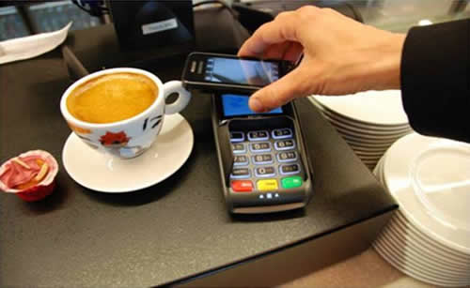
2.2 Mobile banking scenario in developed countries
As virtual banking matures, banks want to work to discover new methods to engage customers; A bi intelligence observe located that 83% of respondents use mobile banking, indicating that the plateau isn't because of declining hobby, however as a substitute near ubiquity, wherein boom is coming greater from clients new to banks instead of the ones new to mobile offerings (Toplin, 2018). Clients are the usage of digital banking greater than ever — ultimate yr, wells fargo counted 5.9 million digital customer interactions, up from 3. 8 million in 2013, whilst physical interactions declined ordinary as a result, firms need to shift their technique to cell banking, and awareness on how they could exceptional use it as a dating-building tool, due to the fact all their customers have it, instead of disregarding it as a baseline necessity (Toplin, 2018). In bi intelligence's cell banking aggressive facet have a look at, 83% of respondents said they use cellular banking and banks are investing in cellular banking abilities at unheard of tiers: bank of the USA tripled its 2015 mobile banking budget in 2016, and maintained it through 2017, for example (Toplin, 2018). The document facilitates channel strategists pick out which functions they need to consciousness their interest on, and allows them to see how they compare to rival banks in presenting those features that have a look at makes use of extraordinary statistics from the bi insiders panel (biip), an distinctive on-line network of 17,000 of readers from all around the global (Toplin, 2018).

2.3 Mobile banking model:
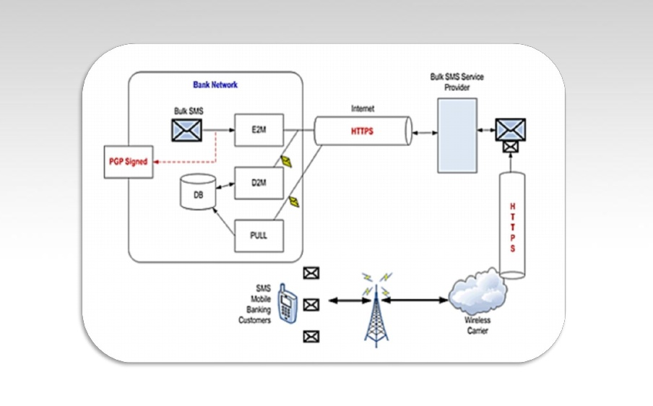
Cellular banking refers to provision and availment of banking and monetary services with the assist of mobile telecommunication devices. The scope of provided services may encompass centers to conduct financial institution and inventory marketplace transactions, to administer debts and to get right of entry to custom designed data. Consistent with this model cell banking may be stated to encompass three inter-associated concepts: i. mobile accounting ii. mobile brokerage iii. cell financial information offerings.
most offerings within the classes specified accounting and brokerage are transaction based. The non-transaction-based services of an informational nature are however vital for conducting transactions – as an instance, balance inquiries is probably wished before committing a money remittance. The accounting and brokerage services are therefore provided invariably in mixture with statistics offerings. Records services, however, may be provided as an unbiased module. Mobile banking will also be used to help in business conditions as well as economic.

2.4 Mobile banking procedure
Maximum banks offer cellular banking services. Given that the cell telephone is the maximum effortlessly handy and extensively used device amongst clients, it's miles convenient for them to carry out banking transactions through this medium. Comply with these steps to activate cell banking.
Registration : a few banks require the patron to sign up for cell banking by way of filling up a registration shape and filing an identity evidence with the shape to a financial institution branch.
Cellular banking app : the customer is required to down load the financial institution’s cell banking application from the app save, primarily based on the make and model of the cellular smartphone they use.
Activation technique : the cell banking utility downloaded needs to be activated by using following a few easy steps. Some banks allow the patron to set a cell banking pin, others send a default mpin as an sms. The mobile banking pin should be entered every time the consumer desires to get admission to mobile banking offerings.
Login : after activation and entering the mobile banking pin, the customer needs to apply his internet banking log-in id and password to access the account.
Protection : each bank has distinct protection functions to make sure that customers have a safe, comfy and problem-free cell banking enjoy. There may be brought authentications such as otp, grid-based totally authentication, and many others.
the patron’s cell variety have to be registered with the financial institution a good way to get entry to cellular banking facility. To ensure safety, it's miles beneficial to now not use the same pin for mobile banking in addition to atm transactions.
Mobile banking services
Standard cellular banking services may additionally consist of: account statistics 1. mini-statements and checking of account history. 2. alerts on account hobby or passing offset thresholds. 3. tracking of terms deposits. 4. get entry to loan statements. 5. get admission to card statements. 6. mutual funds/ equity statements. 7. insurance policy management. 8. Transaction v funds transfer between the customer’s related money owed. 9. paying 0. 33 events, consisting of budget invoice bills and 1/3 party fund transfers. 10. test far off deposit investments 11. portfolio control offerings. 12. actual-time stock fees. 13. personalized signals and notifications on protection expenses.
Guide to reputation of requests for credit score, inclusive of loan approval, and insurance insurance. 1. test (cheque) ebook and card requests. 2. trade of statistics messages and e-mail, such as grievance submission and monitoring. 3. atm 4. vicinity content material services 5. general data including weather updates, news. 6. loyalty-related offers. 7. area-based totally services. A reporter by means of the united states federal reserve (march 2012) located that 21% of mobile telephone proprietors had used cell banking in the past 12 months. Based on a survey performed through forrester, cellular banking could be attractive particularly to the younger, greater “tech-savvy” consumer section. A third of cellular cellphone customers say that they may don't forget doing a little kind of monetary transaction thru their mobile phone. However maximum of the users are interested by appearing fundamental transactions together with querying for account stability and making bill price.
Rules & regulations
Following numerous years of deliberations and advert hoc permissions on mfs, the branch of foreign money control and fee systems of bangladesh financial institution issued “suggestions on cell economic offerings (mfs) for the banks” on 22 september 2011 which were in the end amended on 20 december 2011. A modern-day model can be located at the bangladesh financial institution internet site http://www. Bangladesh-financial institution. Org beneath the rules and guidelines segment. These suggestions kingdom that most effective a bank-led model might be authorized. For bangladesh bank this means that a consumer’s account, termed "mobile account", will relaxation with the financial institution and may be on hand through the patron’s cellular tool. This cell account will be a non-chequing account labeled one by one from a general banking account. The hints permit the following offerings, situation to particular bank proposals to and clearances by way of bangladesh bank:
- disbursement of inward overseas remittances.
- cash in/out the usage of cell account thru dealers/bank branches/atms/mno’s stores.
- individual to business payments (utility bill bills or merchant bills).
- business to person payments (earnings disbursement, dividend and refund warrant payments, seller bills).
- government to man or woman payments (aged allowances, freedom-fighter allowances, subsidies).
- character to government payments (taxes, levy bills).
- p2p.
- different bills (microfinance, overdraft facility, coverage premiums, deposit pension scheme deposits).
2.5 Mobile banking : Pros & Cons
Benefits of mobile banking
A mobile charge carrier with the intention to emerge as appropriate within the marketplace as a style of price the following situations have to be met:
a) simplicity and usefulness: the m-fee utility ought to be person friendly with little or no getting to know curve to the client. The customer should additionally be capable of customize the utility to in shape his or her comfort.
B) universality: m-bills carrier ought to offer for transactions among one client to another purchaser (c2c), or from a business to a client (b2c) or between organizations (b2b). The coverage ought to encompass domestic, local and international environments. Payments should be possible in terms of each low value micro-bills and excessive value macropayments.
C) interoperability: improvement should be based totally on requirements and open technologies that permit one implemented system to engage with other structures.
D) safety, privacy and agree with: a purchaser must have the ability to accept as true with a cellular charge application provider that his or her credit score or debit card data won't be misused. Secondly, while those transactions turn out to be recorded patron privateness should not be misplaced within the feel that the credit histories and spending patterns of the client have to no longer be brazenly to be had for public scrutiny. Mobile payments ought to be as nameless as cash transactions. Third, the system need to be foolproof, proof against attacks from hackers and terrorists. This may be supplied the use of public key infrastructure protection, biometrics and passwords integrated into the mobile price answer architectures.
E) cost: the m-bills have to no longer be more expensive than existing fee mechanisms to the quantity viable. A m-fee solution should compete with different modes of charge in phrases of price and convenience.
F) pace: the rate at which m-payments are completed need to be suited to customers and traders.
G) cross border payments: to come to be extensively conventional the m-fee software should be available globally, phrase-huge.
Security challenges of mobile banking
2012 is the yr that cellular devices will be placed to the take a look at. Both mcafee and kaspersky assume a large boom in the wide variety of malware assaults on cell devices due to the growing wide variety of gadgets and packages hooked up on it. The cell working structures may be very well examined for flaws to make the most (gtisc 2011; kempenaar 2012). What introduced cellular devices to the factor that they've end up objectives? A few years in the past nobody had heard of malware for cell devices. The unexpected upward push has numerous reasons.
One is the increasing homogeny of cell gadgets in terms of the operating structures going for walks on them. In the beyond, while mobile platform uniformity used to be a assignment due to the huge form of devices (schwiderski-grosche & knospe 2002; jürjens et al. 2008), it would no longer have been possible to launch large scale assaults. Now we see that there's a pass closer to homogeny revolving round some center working systems for cell devices (windows mobile, android and ios).
The second one reason is the accelerated use of those gadgets. Mobile gadgets, like phones, have emerge as a herbal extension in their customers. They're using it for studying emails, doing their banking, sharing documents and tune, staying in touch with their cherished ones and ordering things on-line. It has become the gateway to the world for most people as it's miles to be had 24/7 because of “constantly-on” fast internet access. The change of user behaviour in combination with the growing homogeny, makes focused on the devices and their customers more and more attractive to cyber criminals (gtisc 2010). Despite the fact that cellular devices rival private computer systems in processing electricity and memory, they nevertheless have several constraints (e. G. Battery quandary, small monitors) which means conventional security features are hard to put into effect (e. G. Antivirus, firewall).

Chapter 3: Mobile banking scenario in Bangladesh

In advance this century, the mobile smartphone have become the primary communications generation to have more customers in developing countries like bangladesh. With the aggregate of two maximum latest technological advancements – internet and cell phone, a new provider (cellular data provider) is hence enabled and the first such wireless internet industrial transaction is completed by using the banking enterprise (barnes and corbitt, 2003). Banking thru cellphone has been common in advanced international locations for years. The actual ability of “m-banking” can be to make primary monetary services greater available to millions of negative people. The perfect banking surroundings is taken into consideration a key pillar in addition to an enabler of monetary increase (koivu 2002). With the continuously emerging wave of statistics driven economic system, the banking enterprise in bangladesh has necessarily found itself not able to withstand technological indulgence. The want for convenient methods of accessing financial resources past the conventional norms has seen the recurrent enlargement and modernization of banking styles. And given the large demand for finance orientated offerings, establishments beside the historic banks have joined the fray in an try to grab a chunk of the perceived cake of opportunity within the banking enterprise.
Overall mobile phone services in Bangladesh
Mobile banking is emerging very high in our country. There are now various uses of it. Plane ticket, mobile top-up, train ticket, bus ticket, salary disbursement, merchant banking, foreign exchange etc are growing through it. People are now more being reliable into it and trying to take it as an important media in their life.
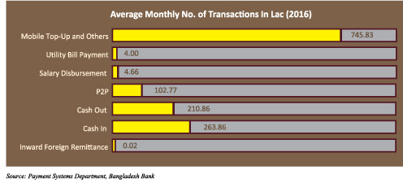

Banks who are providing mobile financial services
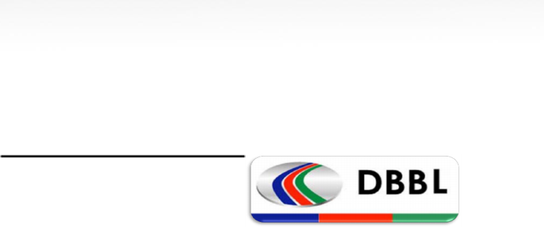
Dutch bangla bank (DBBL) -
- Customer Registration
- Cash-in (cash deposit)
- Cash-out (cash withdrawal)
- Mobile Top-up
- Person to Person Transfer (P2P)
- Foreign Remittance
- Salary Disbursement
- Balance Inquiry
- Bill Payment
- Merchant Payment
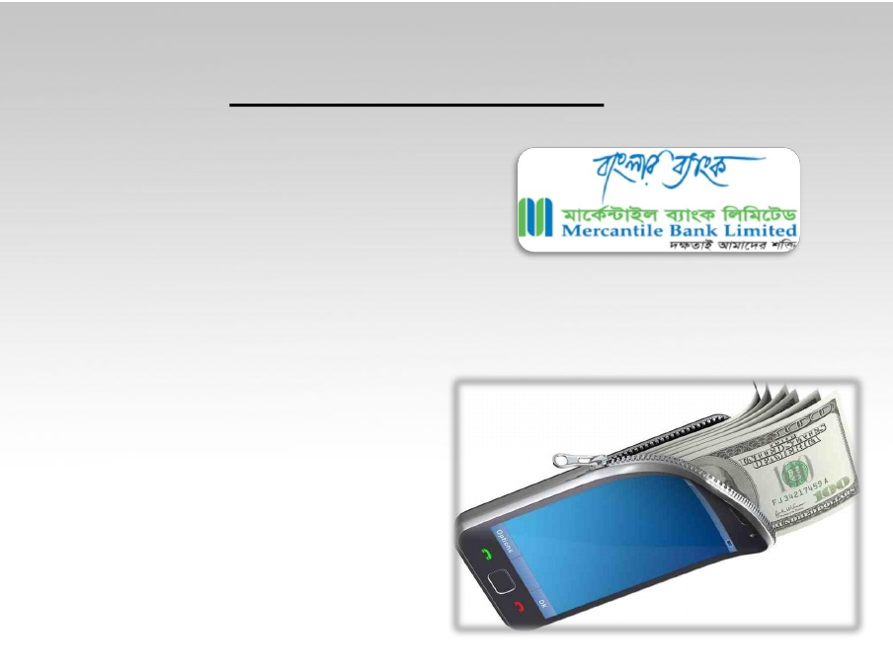
Mercantile bank limited –
- Access to account balance
- Last 3 transaction inquiry
- Cheque status inquiry
Prime bank limited –
- Fund Transfer
- Utility Bill Payment
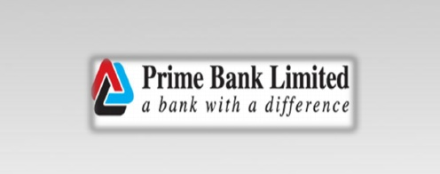
- Merchant Payment
- Inward Foreign Remittance Disbursement
- Balance Inquiry
- Mini Statement
Trust bank limited –
- Account Registration
- Cash Deposit & Withdraw
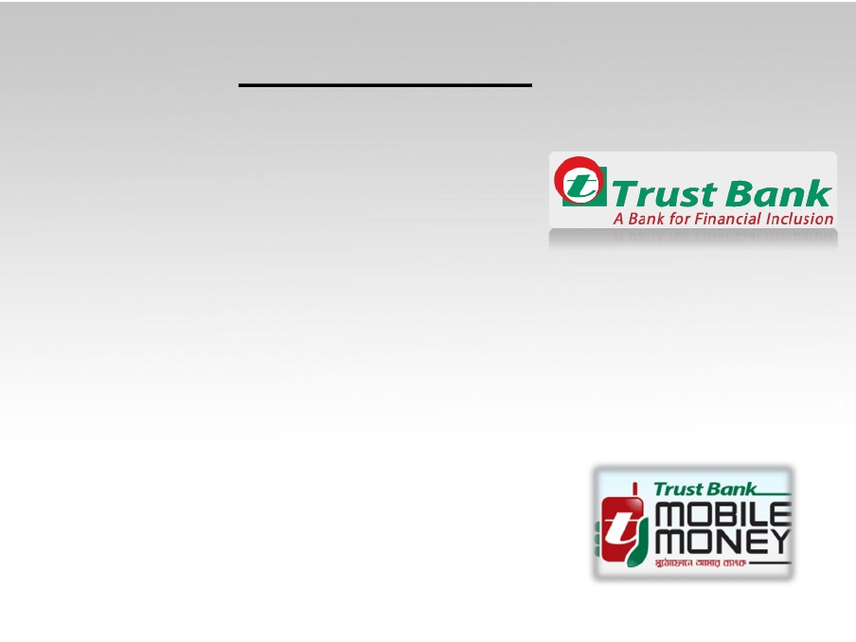
- Account to Account Money Transfer(P2P)
- Person to Business Payment(P2B)
- Business to person payments(B2P)
- Government to Person Payments(G2P)
- Top up(Airtime recharge)
- Utility Bill Payment
- Metlife Alico Insurance premium payment
- Balance Inquiry
- PIN Change
- Transaction History
Eastern bank limited –
- check account balance,
- fixed deposit details,
- cheque status,
- loan details.
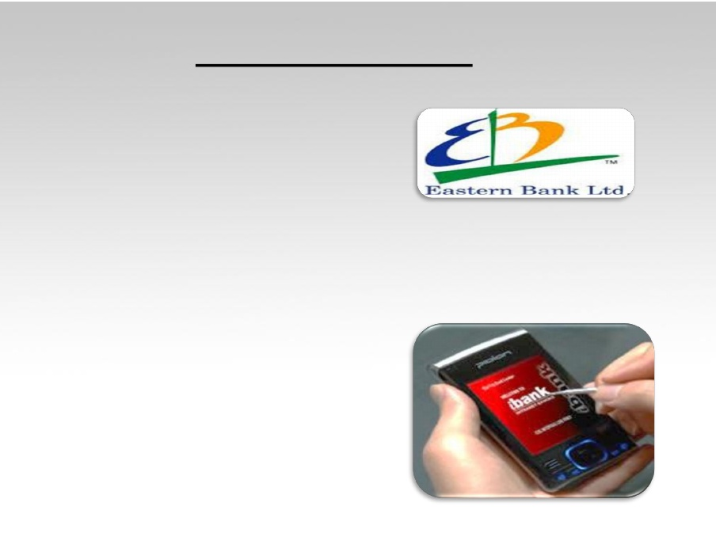
In addition, customer will automatically receive following alerts on regular basis:
- Cheque Stop
- Cheque Clearing
- Account Status
- Change Account
- Balance Change
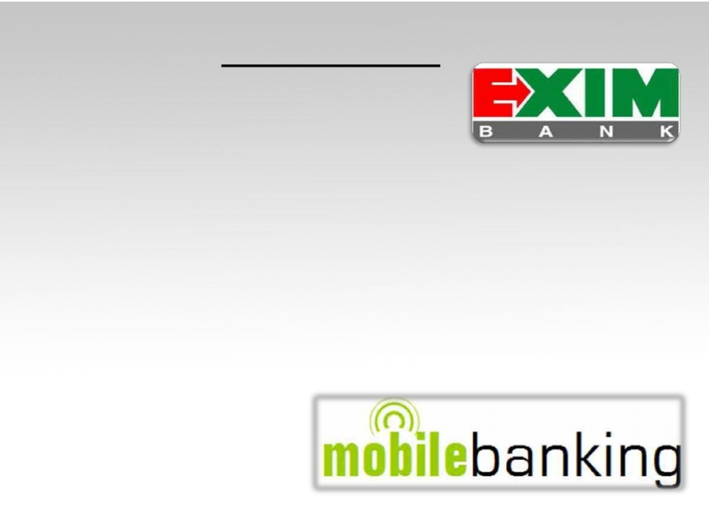
Exim bank –
- Balance Enquiry
- Mini Statement
- Help Service
- Account Information
- With a very short time customer will get a message with the requested information
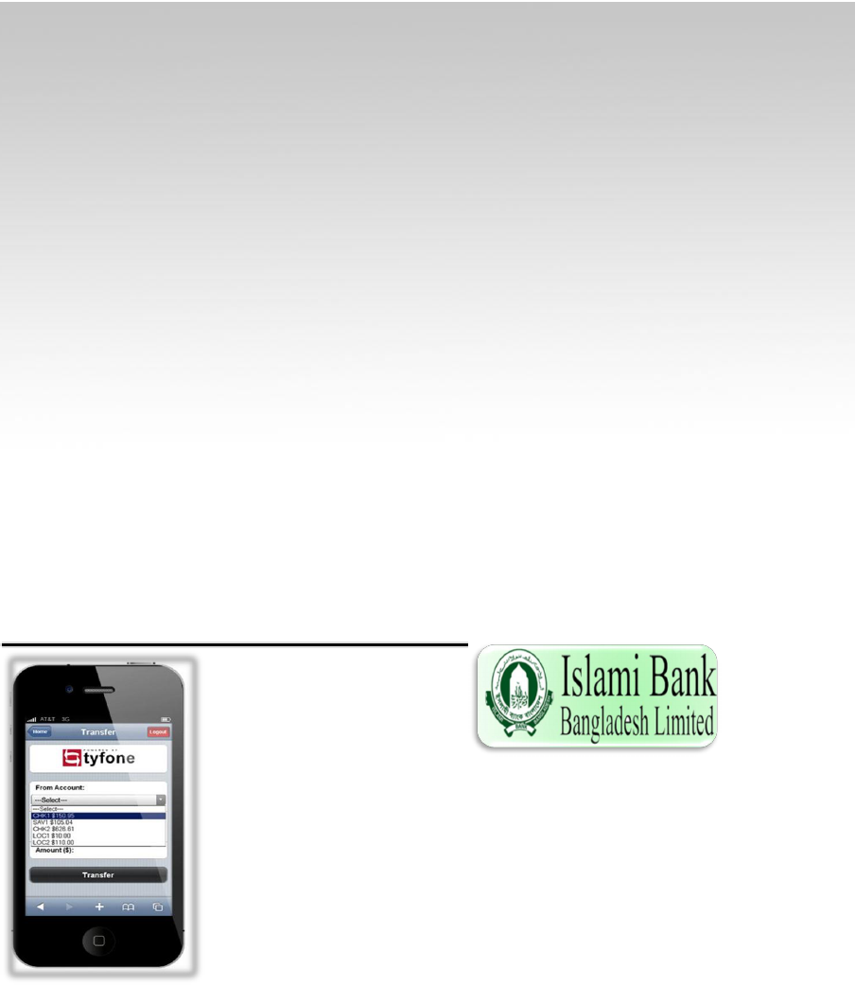
Islami bank Bangladesh limited –
- check account balance,
- cheque status,
- loan details.
- Cheque Clearing.
- Account Status.
Costs
Approximately 53% of mfs customers do not incur any expenses to tour to an mfs agent factor; while most effective 23% of the financial institution account holders’ can go to their bank branches with none price (Alam, 2017). On the other hand, 61% of financial institution account holders should spend extra than bdt 10 to journey spherical trip to go to a financial institution branch, but simplest 23% mfs users need to spend that quantity to visit an mfs agent factor (Alam, 2017).
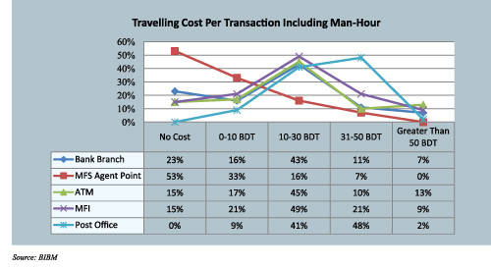
Pricing
Five of the mfs providers are presenting coins-in at both an agent or financial institution branch free of charge; for those companies that fee for cash-in the prices range from 0. 5 – 1% & coins-out expenses at agent points variety from 0.8% to 1.85% of the entire amount (Alam, 2017). Unlike other markets wherein p2p transfer charges often range based totally on the dimensions of the transaction, all the carriers surveyed in bangladesh charge a flat price ranging from bdt 3 to bdt 5 & invoice and merchant payments are loose to the consumer across the carriers highlighted, even though the gathering agreement fee paid through business receiving these payments degrees from 0. 25% to 2% (Alam, 2017).
Competition and Market Share
To calculate the current market percentage of mfs carriers Alam (2017) considered 16 factors like general mfs debts, quantity of marketers, overall wide variety of transactions and extent of transactions. In case of range and extent of transactions all offerings (cash in, cash out, p2p, cellular top-up, inward remittance disbursement, profits disbursement, etc.) supplied through the mfs carriers are also evaluated by Alam (2017).
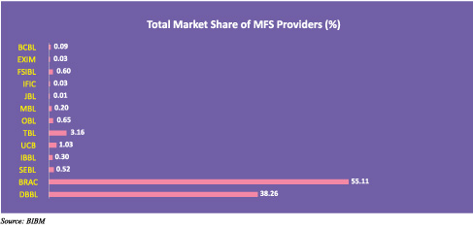
Bkash (brac financial institution) currently dominates the mfs space accounting for 55.11% of the marketplace accompanied through dbbl (38. 26%) & the remaining 11 providers with stay services currently account for around 6. 63% of the total marketplace share (Alam, 2017). The point of interest of those key gamers have been on expanding their outreach via utilization of current resources (i. E. Atms, branch places of work) and the purchase of retailers throughout the us of a (Alam, 2017). Bkash has performed a extensive function in developing the market and constructing recognition to the quantity that some humans seek advice from ‘bkash’ to intend all cell economic offerings, market percentage by agent and clients are proven in the figure under (Alam, 2017).
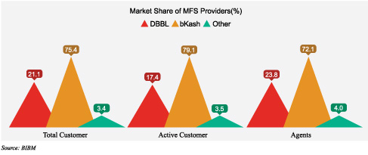
The boom of the marketplace has in large part benefited from home remittances; the maximum popular transaction sorts are cash-in (42. 46% of total transactions), cash-out (37. 28%) and man or woman to character (p2p) transactions (16. 53%) (Alam, 2017).
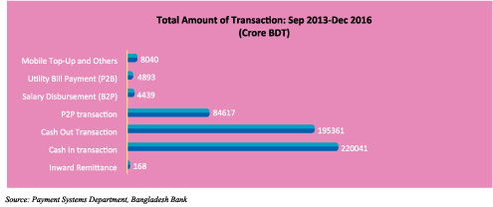
Perceptions of users about MFS
Via big margins, mfs users agreed that the offerings are available, secured, easy, and convenient, as may be visible inside the relevant graph; even though a majority of respondents (90%) cited that mfs isn't always cost effective, which shows that the value of mfs stays a concern for majority of the customers (Alam, 2017).
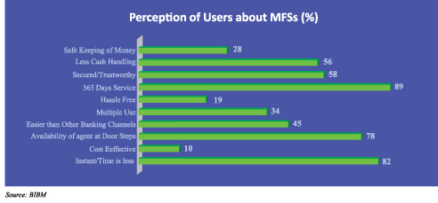
Agent networks
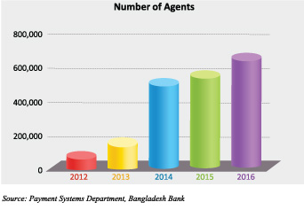
Alam (2017) studied maximum of the vendors provide a fee starting from bdt 20- 25 to retailers for signing up new customers which changed into higher than bdt 50 two years in the past. This graph highlights the speedy growth of this area in a completely quick time (Alam, 2017).
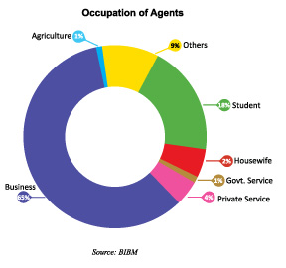
Alam (2017) conducted on the end of 2016 overall wide variety of retailers have been 7,10,026. It is seen that the majority of agents in bangladesh are not one-of-a-kind, many dealers represent a couple of providers; therefore, the real quantity of sellers is probable a great deal much less than the mentioned general (Alam, 2017). Alam (2017) also observed that on a median one agent affords services to 1. 85 vendors; as a end result the range of general precise sellers could genuinely most effective be 3,83 3,797. In phrases of agent numbers, bkash is the market leader, followed via dbbl; it's far seen that simplest 2% agents are lady and 49% sellers are running inside the rural regions (Alam, 2017). From the previous graph Alam (2017) mentioned that maximum of the agents are commercial enterprise guy (65%) and they may be supplying mfs as their secondary enterprise. A number of students is also engaged in this service (18%) & The earnings level of the dealers are shown within the following discern by Alam (2017).
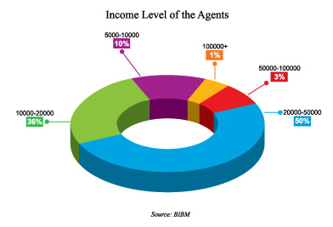
General pleasure of marketers with respect to financial and social parameters is shown inside the graph; it's far seen that social protection and customer dealing with is a splendid task for them but considering all factors agents are located very satisfied regarding their commercial enterprise (Alam, 2017).
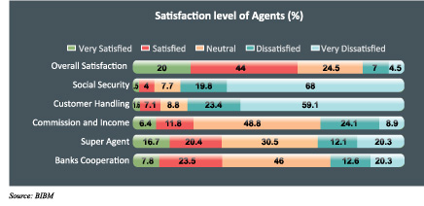
Impact of MFSs on economic addition
In terms of demographic penetration, the number of monetary get right of entry to points according to 100,000 people is measured & the graph ‘demographic penetration of banking services’ also indicates the contribution of mfs on financial inclusion (Alam, 2017).
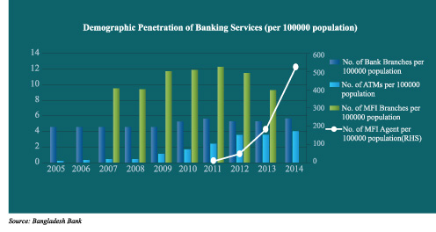
Opportunities
High market: there is a huge market place for Mobile banking in Bangladesh. The service provider can enhance education schism for their agent People so that they can be more educated in this area. They can also train them and create job opportunities. They can also create place for new service and products introduction by this they can enhance the innovation area in this sector. Now, more People are engaging to mobile banking that means there are more place for opportunity is being introduced which can be a great assets for the people of our country. And also giving other new services and products can help them to rise.
Partnership enhancement: the more market will grow there will be more opportunities for partnership enhancement between different mfis. People will get more options for using it and it can get a huge rise up. Then there will be more opportunities for more business as well as clients integration with those mfis. People will get opportunity to get themselves involved with other sort of services and it will create more place for market. Then more mfis will be interested to give that sort of services. There will be competitive advantage into the market and it will ultimately help the consumers.
New products and services: there have more options for innovation in this area & it will create more service and products opportunity for consumers. Already in Bangladesh it is being used in vast areas. Such as- merchant banking, shopping, remittance, p2p, airplane ticket purchasing, paying bills etc. More & more place are being developed to enhance the area & there is opportunity for it.
Cost deduction: studies found many of the lower income people are not interested with mobile banking as they find it costly compare to the traditional one but if awareness can be risen, and service cost if deducted lower associated with mobile banking & this sector people can get themselves involved with this type of banking.
Challenges
As there is opportunity there is some challenges also. They are-
Social crimes & fraud cases: there are some social crimes & fraud cases are happening on the emerged of cyber or mobile banking. People using mobile banking as a sort of medium of sending black money to the other countries which are ultimately going to money laundering. On the other hand, security breaches are be broken by the hackers & the pin of the customers are being stolen. For that people are losing control in their account & hacking their money is occurring. Recently Bangladesh Bank losses huge amount through cyber hacks. Criminals using mobile banking for payment of arm dealers & using it for human trafficking & social crimes.
No proper human guidelines: though Bangladesh bank has emerged rules & regulations, there are still loopholes onto it. Criminals are using those holes for fraud crimes. There is no also proper qualified body who will look up onto it so there are no proper tracking can happen.
Certain participation into the market: there should be equal playing field. It is very sad but there have to face lots of problem & hazards for a new comer to enter into the market. Thats why they dont feel interested. But, there need equal opportunity so that new comers can come & showcase their service & innovation into the area.
Incapability: there is still problem to move money from one carrier to another mfis account such as (rocket to brac bank). It needs to decrease so that clients can move money from one to another.
Link between btrc & Bangladesh bank: there should be proper guidance & coordination between btrc & Bangladesh bank to run this sector more smoothly & organised way.
Software development: high tech software is needed for this sector so that the fraud cases can be limited. To run those software quality people also needed. Cyber security is a world issue. So Bangladesh also need to cop up with other countries to face the problem.

Mobile banking in Bangladesh : Future
EXPECTATIONS AND THE FUTURE
There is a huge future growth for it in bangladesh. Like USA, Bangladesh can come up with new technology like mobile phone in future to grow & sustainable development for this sector. People can come up with new ideas with the grow of the technology.
In this regard, it will grow up countries economy when more & more people will involve to it. Innovation & services will emerge a whole new plan & idea for the people. Life style will be much more easier & cost like travelling will be lower. People can be emerged with remittance & that will increase our economy. In health care it can be revolutionary change. Farmers can get their earnings & garments workers can get their salaries & payments through it. Ultimately scenario of Bangladesh will be shining high & high.
Technology rising is important but crime is concern. So more innovative people in this area can change the problem. Digital tools development, software program, tracker is needed for that concern. Bangladesh police, Bangladesh bank, btrc, cyber crime unit can play vital role on this regard.

Chapter 4: Findings & Recommendations

Findings
I used various ways to establish the effect of mobile phone banking on traditional banking. This included; establishing the new products and services established as a result of mobile phone banking and their influence on traditional banking, looking in into trends of adopting mobile phone banking among customers and banking institutions, and finding out the challenges affecting mobile phone banking and how they influenced traditional banking transactions.
Recommendations
After completion of the study, the following recommendations come out –
- The government need to have a clear regulatory framework so one can enhance the extent of self assurance amongst banking institutions in the new generation . This will growth the degree of adoption among clients in addition to banking institutions.
- With the hurdles concerned in cell telephone banking it is not viable for banking institutions to replace conventional banking; it's miles consequently advocated that banking institutions reconsider investing in danger and compliance capabilities to store them on essential losses specifically loss due to robbery of records and fraud. This may boom the extent of consider amongst clients and cellular banking retailers as a way of revolutionizing the manner banking is achieved. Additionally, it would encourage clients to growth their deposits as well as coins withdrawals which signify conventional banking.

Chapter 5: Conclusion

Conclusion
Mobile telephone banking can be said to have converted the manner banking activities are undertaken. This has been through advent of new services and products that as according to those take a look at findings encompass coins transfers, payment of payments and account statements and deposits. Despite the fact that such improvements may not have replaced traditional banking, they need to a few extent stimulated the way conventional banking is undertaken. Mobile cellphone banking may be said to be increasing banking transactions, one might consequently conclude that most this boom in transactions is more associated to the ones which can be related to cellular smartphone banking alternatively than traditional banking. There may be evidence that conventional banking is still taking location especially for deposits and withdrawals from bank accounts . This can be a great sign that mobile telephone banking isn't changing conventional banking however instead editing the method.
Cellular telephone banking is faced with myriad of demanding situations as hooked up on this have a look at. The various common demanding situations encompass community disasters, lack believe for sellers entrusted to do cell telephone banking on behalf of banking establishments. In a scenario, where banks find demanding situations of mobile phone banking, it's miles possibly that clients will pick conventional banking manner as a result implicating an increase in transactions.

Bibliography

References
Ahmed, Rayhan, Islam, Mahjabin, S.M. Sohel, Shah Johir, Md. Ariful, Samina, 2012. Problems And Prospects Of Mobile Banking In Bangladesh. International Journal Of Capacity Building In Education And Management, 1, 43-62.
Goyal, Pandey, Batra, Vishal , Dr.U.S., Sanjay, 2012. Mobile Banking in India: Practices,Challenges and Security Issues. International Journal of Advanced Trends in Computer Science and Engineering, Volume 1, No.2, 1-11.
Nabi, Taukder, saha, Md. Golzare, Md. Sanaullah, Prajna Paramita, (2012). Mobile Financial Services in Bangladesh. In An Overview of Market Development. Dhaka, Bangladesh, July. Bangladesh Bank: Research Department. 1-28.
Islam, Md. Shahanur, 2013. Mobile Banking: An Emerging Issue in Bangladesh. ASA University Review, Vol. 7 No. 1, 1-8.
Alam, M. (2017). An Exploration Of The Booming Mobile Banking Market In Bangladesh. [online] FinTech Magazine. Available at: http://www.fintechbd.com/an-exploration-of-the-booming-mobile-banking-market-in-bangladesh/ [Accessed 24 Jan. 2019].
Ashraf, Imran, (2012). Mobile Banking Security. In A security model. The Hague, The Netherlands, April. Vrije Universiteit: Imran Ashraf. 1-70.
English-online.at. (n.d.). Mobile Banking on the Increase in Developing Countries. [online] Available at: https://www.english-online.at/news-articles/business-economy/mobile-banking-in-developing-countries.htm [Accessed 24 Jan. 2019].
Toplin, J. (2018). Mobile banking is more important than ever. [online] Business Insider. Available at: https://www.businessinsider.com/mobile-banking-is-more-important-than-ever-2018-1 [Accessed 24 Jan. 2019].

