An Internship Report On
Employee Motivation through Human Resource Practices in Social Islami Bank Limited


Submitted To
Prof. Dr Abu Saleh Md. Sohel-Uz-Zaman
Professor,
Department of Business Administration
United international university
Dhaka, Bangladesh

Submitted By
Taslin Afrose Auntra
ID: 111 131 179
BBA program
School of Business & Economics
United international university

Submission Date:
26th December 2018
Letter of Transmittal

26th December 2018
Prof. Dr Abu Saleh Md. Sohel-Uz-Zaman
Professor,
School of Business & Economics,
United international university

Subject: Submission of Internship Report on Social Islami Bank Limited.

Dear Sir,
With due respect, I would like to inform you that, it is a great pleasure for me to submit the internship Report on “Employee Motivation through Human Resource practices in Social Islami Bank Limited”. It is a fulfilment of the requirement to achieve BBA degree from united international university. I have put my best effort to make this report specific and coherent.
It has been bright and enlightening experience for me to get a chance as an intern in Social Islami Bank Limited. It proved a great learning source that helped me to experience the real critical situations inside of a bank.
I would like to share my sincere recognition to you for your kind guidance to prepare this report. The guidelines you provided to me was really so helpful for me.
I have followed all the steps you given to me what need to exist in a well prepared report and I will be highly grateful if you accept my internship report.

Yours sincerely,
…………………………………
Taslin Afrose
ID: 111131179
BBA Program,
School of Business and Economics.
United international university.

Declaration of student

I do hereby notify that the internship report on “Employee Motivation through Human Resource Practices in Social Islami Bank Limited” has been prepared by me as it is part of internship formalities. It is partial fulfillment of requirement to achieve the Bachelor of Business administration (BBA) program to submit an internship report.
I was motivated and directed by my supervisor Prof. Dr Abu Saleh Md. Sohel-Uz-Zaman, Professor, School of Business and economics, United International University, Dhaka.

Yours sincerely,
……………………………….
Taslin Afrose
ID: 111131179
BBA Program, School of Business and Economics.
United International University.

Acknowledgement

I am expressing my heartfelt gratitude to the Almighty Allah, as I finished my internship report in the appropriate time and for his special kindness to give me the opportunity to complete the internship report successfully.
I also need to pay May extraordinary thanks for the support of some kind-hearted individuals who have genuinely helped me to finish the report. I would like to convey my gratitude to our honorable faculty, Prof. Dr Abu Saleh Md. Sohel-Uz-Zaman, Professor, United International University. Who has provided me with advice for making this final report and also provided me the format to make this report effectively. I wanted to give my warm-hearted thanks to the Human Resources department of Social Islami Bank Limited for giving me the opportunity to do the internship in Social Islami Bank Limited. Also thankful to SIBL which has provided me with information, sufficient data and cooperated me for the complete of this report successfully.
I am also thankful to each and every employee of the department and Md. Jiyauddin (Manager, SIBL Branch) for his kind collaboration regarding the report. My specials thanks and most profound respect to Musharraf Hossain (second officer, SIBL Branch) for his sincere advice, constant encouragement and support in my internship program. Without his it would not possible for me to complete this difficult task.
I am very much thankful to all of me collogue and employ for their cordial support, valuable advice and helping me to prepare this report with important information and data. I am thankful to the other officials and friends who help me to prepare this report to give their valuable suggestion, information and support.
Finally, I am showing my respect to my entire family members, especially to my mother and father for their support and inspiration to execute my study.

Executive summary

The report shares to the three-month working experience on Social Islami Bank Limited (SIBL). I had placed at Gulshan Branch of SIBL. This report gives a proper idea of the HR practices to motivate the employees of the Bank. SIBL began to work in 5th July 1995 and is into its business task on 22nd November to give selected service facilities to its customer and to fulfill the needs of the customers to take care of the demand of banking service all over Bangladesh.
During the limited time of SIBL's Human resource management, the bank had been generally acclaimed by the business network from independent company people to the high multinational company for forward-looking business outlook and innovative financial solution.
I've divided the study between several chapters. At first, I am going to share the basic introduction of making this report. Secondly, I will share an overview of social Islami bank limited, and then I'll discuss on how and which procedures Social Islami Bank Limited applies to motivate their employees in the bank.
At the end of my report, I'll share some recommendation where I have experienced difficulties inside the management of employees. Hopefully, all of that situations can be improved with the recommendations.

Table of Content
Chapter One: Introduction
1.1 Background of the Report 2
1.2 The Scope of the Report 2
1.3 Objectives of the Report 3
a. Primary Objective 3
b. Secondary Objective 3
1.4 The Methodology of the Report 3
a) Primary Sources: 3
b) Secondary Sources: 4
c) Information analysis methods: 4
1.5 Limitations of the report 4

Chapter Two: Literature Review
Literature Review 6
2.1 Human Resource Management 6
2.1.2 The Objectives of HR Practice 6
2.1.3 Functions of Human Resource Management 7
2.1.4 Welfare of Employees in HRM 7
2.1.5 Recruitment and Selection Process 8
2.1.6 Benefits/ Incentives/ Remunerations 8
2.1.7 Retention 8
2.1.8 Skills Management 8
2.1.9 Training and Development 9
2.2 Motivation in Human Resource Management 9
2.2.1 Significance of Motivation 10
2.2.2 Lack of Motivating Factors 11

Chapter Three: An Overview of SIBL
3.1 Social Islami Bank Limited Profile 13
3.2 Vision 14
3.3 Mission 15
3.4 Values 15
3.6 HR Message To The Fresher's 16
3.7 Products and Services of SIBL 17
Products and services of SIBL 17
3.8 Organogram of Social Islami Bank Limited 18

Chapter Four: Analysis and Findings
4.1 HR Division of Social Islami Bank Limited 20
a. HR Policy Section 21
b. Recruitment and Selection Section 21
c. Transfer and Posting Section 22
d. Employee Welfare Section: 22
e. Training and Development Section: 22
f. Disciplinary Action Section: 23
g. Miscellaneous Section: 23
4.1.1 Human Resource Standards Followed By SIBL 23
1. Mutual trust 23
2. Leadership 23
3. Personal development 24
4. Employment conditions 24
5. The right individuals in the right place 24
6. Work safety 24
8. Corporate Social Responsibility (CSR): 24
4.2 The Procedures of Human Resource Division to Motivate Employees 24
a. Compensation 25
b. Motivation through Incidental advantages 25
c. Promotion System 25
d. Posting and Transfers 25
e. Non-Monetary Incentives 25
f. Job Status 26
g. Health Care 26
h. Income Continuation 26
i. Job Security 26
j. Duration of Work 27
k. Training Facilities 27
l. Paid Leave 27
m. Working Environment 27
n. Participative Management System 27
o. Team Work 28
p. Senior's Behavior 28
q. Participation in Decision Making 28
r. Occupational Stress 28
4.3 Findings of the Report 29

Chapter Five: Recommendations and Conclusion
Recommendations 31
Conclusion 32
References

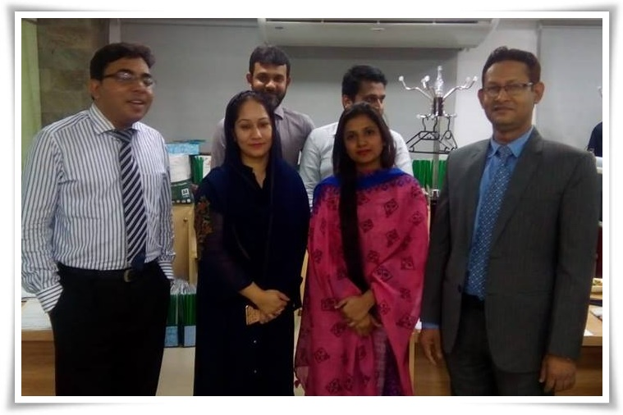
Chapter 1
Introduction

1.1 Background of the Report
Banking is now an indispensable part of our economic system. Nowadays the banking system plays a consequential role in economic life. There is no doubt that the world of work is swiftly changing due to technology, globalization, and deregulation. As part of an organization, HRM is also enabled to deal with effects of the changing world of work.
Now it is a big challenge for the HRM to support the organization by providing the perfect human resources for a suitable position in the shortest possible time. And it is quite difficult to motivate them for the work to use different HR practices.
Proper HR Practice planning and design that plan is the task that requires more focus and advancement. Equal opportunity and sourcing is also an essential part. During my internship at Social Islami Bank Limited, I got the opportunity to know about how SIBL motivated their employees to use different kinds of HR Practice. Moreover selecting HR practice and attracting the employee using those Practices in time is a challenge.
The internship program at Social Islami Bank Limited (SIBL) has given me the opportunity to know about organizational behavior through the corporate environment. It also has given me a notion of office environment through increasing practical knowledge. My experience includes with Human Resources department under HR Practices related work on SIBL and in this regard, I have selected the topic how Social Islami Bank Limited (SIBL) motivates employee through their HR Practices.” To prepare an Internship Report.

1.2 The Scope of the Report
The scope of the report is to share all the information of my internship experience on Human resource practices of Social Islami Bank Limited. The report will provide a detailed image of the bank so that any reader can get theoretical idea of the bank, its services and so on. The Human resource activities part can help students and faculties to how the bank recruit and select candidates. These knowledge can help students when they will search job and they also can be able to compare the knowledge shared by me with their course knowledge. The recommendation at the end will help the SIBL HR manager, if he thinks it useful, to improve the HRM process and activities of SIBL.

1.3 Objectives of the Report
Managing the human resource in an organization is so important because employees are the main resource who will always generate revenue and showcase the reputation of the organization if they are properly managed.
Similarly, the objectives of the report is very important as it shows a summary of what the report is based on. The objectives of my report are:

Primary Objective
- To fulfil the partial requirement for the accomplishment of BBA program under united international university.
- To prepare an internship report based on my internship experience.

Secondary Objective
- To present a short overview of SIBL.
- To describe the Human Resources practices of Social Islami Bank Limited.
- To know the different practices of the Human Resource Department to motivate the employees of SIBL.
- To find out problems and recommend steps to overcome the problem and make possible improvement for the future.
- The objective of the report would conduct my carrier towards success in my future.

1.4 The Methodology of the Report
Methodology shows the theoretical analysis of the methods that are used in the report. This report is made of using information from two sources. The sources are:

Primary Sources:
- Formal and informal communication
- Practical work experience as an intern
- Website of SIBL
- Lankabangla.org

Secondary Sources:
- Annual report of SIBL
- Articles/ leaflets of SIBL
- Working papers
- Office files

Information analysis methods:
Both qualitative and quantitative information is used to analyze the primary and secondary information and this information are presented here by MS WORD and MS EXCEL.

1.5 Limitations of the report
I have found a lot of limitations during my internship program and the time of gathering information for the report. The difficulties I face while creating my internship report are listed below:
- Too much work pressure exist because this is a real bank and the employees have to perform their job responsibilities and deals face to face with the daily customers/clients. Managing information in the meantime, was difficult.

- Only three month of internship is not enough to create such an informative report.

- The Social Islami Bank Limited strictly control some information in secrecy. I am not permitted to share them.

- This report is done only by published data.

However, Somehow I had recovered the limitations and gather facts as hard as I can work.

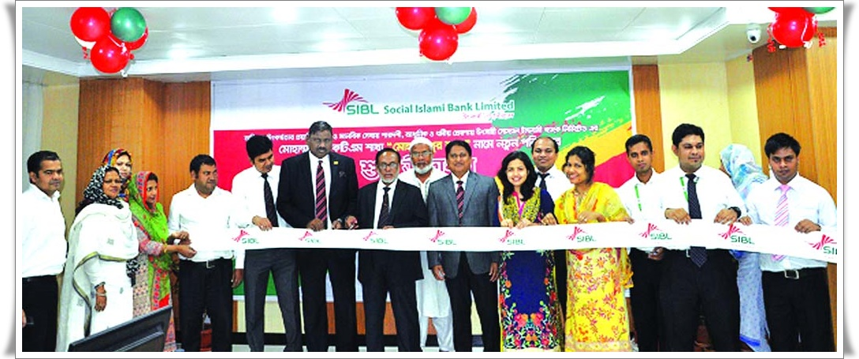
Chapter 2
Literature Review

Literature Review

The report is created with a lot of information of how SIBL motivates their employees through the Human resource practices. But it could be hard to understand without the basic knowledge of what Human resource management and motivation is, the objectives of HRM, The functions of HRM, how HR manager motivates their employees and so on. At this chapter, I would like to share some basic idea on HR practices and Motivation before going to the straight-forward business related term.

2.1 Human Resource Management
According to Tracey (2016), Human resource management (HRM) is referred to as the way toward managing employees in an organization. HRM incorporates recruitment of individuals, training of individuals, salary and benefits settings, and also management and execution management. This is the motivation behind why HR managers in some worldwide organizations are called people Managers or people Empowering influences and the procedure is called people management. The HR managers deal with the connection between satisfying employees’ desires and accomplishing management purposes.

2.1.2 The Objectives of HR Practice
The significant objective of HRM is the advancement and management of learning, abilities, innovation, aptitude, and talent to utilize them at their best. In this manner, the HR division is an essential department of the organization, guaranteeing the ideal utilization of employees and the organization's prosperity. Strategic management is targeted at making the ability to understand the direction of the organization. (Angelo & Griffin, 2008)

2.1.3 Functions of Human Resource Management
HRM has a few fields. According to Raymond (2018), Workforce management in HRM is employee management and is centered on organizations job analysis, recruiting, selecting, training and improvement, presentation and introduction, exchange, advancement, remunerations and employees profitability. HRM, for this situation, is gone for guaranteeing employee development, advancement, and viability, which positively affect the effective improvement of the organization. The improvement of new abilities, payments of salaries, motivating employees, providing incentives, travel policies, and strategies are additionally part of HRM in faculty management (Dessler, 2012). The functions of HRM are:
- Job analysis and design
- Recruitment and selection
- Compensation management
- Industrial law and labor relations
- Performance appraisal
- Training and development )

2.1.4 Welfare of Employees in HRM
Employee welfare in the organization is very important for HR manager (Battisti, 2005). Employee welfare in HRM has several factors and it is centered on guaranteeing great work conditions at the working environment including various administrations, for example, food and house security, Health security, social security, safety security, and medical support.

2.1.5 Recruitment and Selection Process
Since employees are the backbone of the organization (Dessler, 2012) shared in his book named Human Resource Management that Recruitment and selection strategies are a key component of HRM. Staff can be recruited at various dimensions and in various ways. Campus selection strategies are a contracting methodology speaking to the enrollment of the best ability at the campus fresher. Another enrollment system is when situation specialists pick potential employees from databases. The principle ventures of the procuring procedure incorporate choosing from various applicants, settling on the compensation and benefits, making an offer and marking an agreement.
(DeNisi, Griffin, 2008)

2.1.6 Benefits/ Incentives/ Remunerations
Employee benefits, additionally called incentives, are remunerations other than the compensation given to employees to enhance employees' financial circumstance. Such incentives might be given of a house, health protection insurance, retirement pension, vacation, sick leave, benefit sharing, financing for higher studies, and other particular incentives (Parker, Owen, 2010).

2.1.7 Retention
Another key segment of HRM is retention techniques. This implies guaranteeing that the employee has the privilege to take salary payment and work to the HR office and get respect decently. The HR manager must have an arrangement for finding an answer and should help settle the issue.

2.1.8 Skills Management
HRM incorporates skills management which implies the improvement and compelling utilization of representative aptitudes. Employees need to record and refresh their aptitudes frequently with the goal that the skills management is viable. The consequences of the evaluating procedure are held in a database where they can be investigated. In the event that employees have any absence of aptitudes required to perform the activity, the HR manager can devise a self-awareness intend to fill the gaps of abilities and train employees.

2.1.9 Training and Development
Training and development is compulsory part of HRM. Making training and improvement designs at an organization is gone for enhancing the performance of employees in organizations.

2.1.10 Performance Appraisal
HR managers manage performance appraisal, which is a strategy for assessment of the employees' total works in organizations (Angelo and Griffin, 2008). Assessing performance enables employees to control and deal with their career improvement. To assess a representative work, HR managers have first to gather, investigate and record data around an employee execution and its incentive to the organization. Performance appraisal mirrors the accomplishments and disappointments, the solid and powerless qualities of a representative. Efficiency isn't the main thought considered while evaluating a representative's execution.

2.2 Motivation in Human Resource Management
(Likert, 1961) has explained motivation plays a vital role in management. Motivation is an effective instrument in the hands of the management in encouraging the workforce. It is the significant assignment of each manager to encourage his subordinate or to make the will to work among the subordinates. It ought to be recalled that the employee might be massively fit for doing some work, nothing can be accomplished if he isn't willing to work. The production of a will to work is motivation in the basic.

Motivation is an imperative capacity which exceptionally manager performs for activating the employee to work for the achievement of destinations of the bank. Issuance of effectively thought out instructions and requests does not imply that they will be followed. A manager needs to make fitting utilization of motivation to enthuse the employees to achieve them. (Blunt and Martha, 2010) Effective motivation succeeds in picking up an assurance to see that the objectives is performed proficiently and effectively.

With the end goal to propel employees to work for the bank's objectives, the managers must decide the thought processes or needs of the employees and give a domain in which proper motivations are accessible for their satisfaction. Battisti (2005) suggests that if the management is effective in performing these responsibilities; it will be fruitful in enhancing the willingness of the employees to work. This will build the proficiency and effectiveness of the bank. There will be a better use of assets and employees capacities and limits.

2.2.1 Significance of Motivation

- Motivation includes getting the individuals from the team to pull weight effectively, to give their dependability to the team, to do legitimately the reason for the association. The accompanying outcomes might be normal if the employees are appropriately motivated. (Hackman JR, 2006)

- There will be an expansion in the amount and nature of services and products. Wastage and scrap will be less. Better nature of items will likewise expand the general population picture of the business. (Blunt & Martha, 2010)

- The rates of work's turnover and the relationship among the employees will be low.

- Hackman (2006) shared employees will, in general, be as proficient as conceivable by enhancing their abilities and information with the goal that they can add to the advancement of the association. This will likewise result in expanded efficiency.

- The number of objections and complaints will descend. The mishap will likewise be low.

- There will be great human relations in the association as grinding among the workers themselves and between the workers and the management will diminish.

- The workforce will be better fulfilled if the management gives them chances to satisfy their physiological and mental needs. The workers will coordinate deliberately with the management and will contribute their most extreme towards the objectives of the undertaking. (Battisti, 2005)

2.2.2 Lack of Motivating Factors
- The HR manager must have the capacity to deal with the group effectively and viable. The manager isn't permitted to have any bias while managing employees in an organization. (White, Carol-Ann) Victimization employees by HR managers can result in wearing down, more regrettable worker confidence and in some cases in claims against the organization.

- Employees additionally ought to keep away from having a negative state of mind or avoiding work. Employees should realize that if any negative mentality is enlisted, they will experience issues breaking that recognition and working effectively to achieve the organization's objectives.
(White, Carol-Ann 2015.)

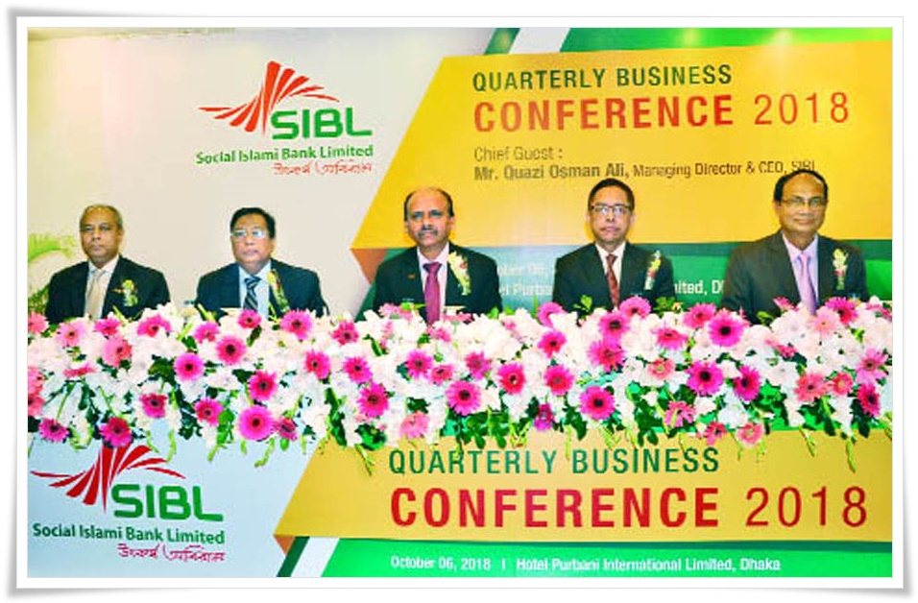
Chapter 3
An overview of Social Islami Bank Limited

3.1 Social Islami Bank Limited Profile
The SOCIAL ISLAMI BANK LTD (SIBL), a second-generation commercial bank, working since 22nd November 1995 dependent on Shariah' Standards, has now 150 branches everywhere throughout the nation with two subsidiaries - SIBL Securities Ltd. and SIBL Investment Ltd. Focusing on destitution, SOCIAL ISLAMI BANK LTD is for sure an idea of 21st century participatory three segment banking model in one. In the formal segment, it fills in as an Islamic participatory commercial bank with human face way to deal with credit and banking on the benefit and loss sharing. It has a Non-formal banking division too with the casual fund and venture bundle that engages and adapts genuine poor family and make neighborhood salary openings. The bank has another part to adopt the deliberate area and management of Waqf, Mosque properties and has presented money Waqf system without precedent for the historical backdrop of banking. In the formal corporate division, this Bank, among others, offers the most exceptional banking administrations through opening of different kinds of store and venture accounts, financing exchange, giving letters of certification, opening letters of credit, gathering of bills, renting of hardware and buyers' tough, enlist buy and portion deal for capital merchandise, interest in minimal effort lodging and management of genuine bequests, participatory interest in different mechanical, agrarian, transport, instructive and wellbeing ventures et cetera. (Source:
www.siblbd.com/)
The Bank has taken a recharged drive going for solidifying its business in more engaged regions covering SME and Agro-back with accentuation on looking for the elective conveyance channel under which SMS banking and portable based settlement installment systems and by step by step acquainting the equivalent with disperse the SIBL administrations to the doorsteps of the clients. The Bank has just presented Internet Banking and propelled some new items to reinforce its business. The Products are “Sommridhir-Sopan, Sonchoy-Protidin, Swopner-Shiri, Shukher-Thikana, Sabuj-Chhaya, Sabuj-Shayanho, Subarno-lata, Suborna-rekha, Sanchita and so on and Zameel ATM card.
SIBL is a pioneer in presenting internet banking among all the Islami Banks of the nation with cutting-edge banking programming. The best in class banking programming empowers the Bank to give any branch constant banking administration to the customers. SIBL is bolstered by center banking arrangements and our items and administrations are emphatically supported by IT foundation, which is updated and developed a ceaseless premise.

SIBL has set its procedure to change over the entirety of its banking exercises from the conventional branch-based banking system to a perfect mixture of both Central processing unit (CPU) and effective activity of the branch that depends on the cutting edge substance of banking.

The Bank is running its installment system effectively through BACPS, BEFTN under BACH with the end goal to help its organizations in various measurements. By embracing BACH System according to rules of Bangladesh Bank, SIBL guarantees security, wellbeing and bother free quicker transactions from end to end. Besides, the Bank is effectively receiving administrative rules on IT risk management.

SIBL is very aware of its social business obligations and is continually endeavoring to take an interest in the different social program in the nation under its CSR portfolio giving uncommon accentuation on wellbeing, living space, and instruction. The Bank guarantees to give a superior coordinated thought of formal, casual and intentional banking in a similar stage. SIBL has its interesting element to assemble capital through Money WAQF program.

SIBL lays accentuation on business creating, condition well-disposed and green banking constructed speculation keeping an eye in light of impartial dispersion of assets over geological domain for reasonable development of the macro economy of Bangladesh.
The Corporate Governance system in SIBL guarantees straightforwardness and responsibility at all dimensions in directing business. The Bank's constant exertion has been to build the investors' esteem and to be esteemed as a consistent association.

3.2 Vision
The vision of Social Islami Bank Limited is to decrease the poverty dimension of Bangladesh. In this, the idea and belief of 'Cooperating for a peaceful society" are constantly held high. To convey forward this announcement, the workforce of Social Islami Bank Limited is saturated with the most astounding level of energy, enthusiasm, and power to serve the country.

3.3 Mission
  - To presenting creative Islamic Banking products.
  - To provide an ideal profit for investors.
  - To build up three division banking model.

3.4 Values
- Technology
Present day life is technology subordinate - we continue searching for the most recent development to give the best in simplicity to our customers.
- Security
Clients must feel secure with every one of our items and administrations - we continue guaranteeing it.
- Straightforwardness
Staying straightforward in all demonstrations is a goodness that manufactures trust - SIBL sticks to it.
- Accountability
To be responsible is to be dependable or more any doubt - SIBL is obediently there.
- Religious-ness
SIBL upgrades the monetary prosperity as to the happiness of religious morals.
- Advancement
SIBL employee's psyches and eyes are always open to the development in the personal satisfaction to advance further benefits for the administration takers.
- Flexibility
Flexibility prompts better understanding and more prominent satisfaction - we seek after quality.
- Efficiency
Efficiency infers flawlessness in any job done - SIBL endeavors to render full satisfaction with it.
- Honesty
To be honest, at all-time is suggested by all the sacred writing – SIBL adheres to this incentive in the entirety of our administration arrangement.

3.6 HR Message to the Fresher's
One should be over-fastidious with respect to career selection. The career that is picked first will be the entryway of future bearing towards progress. Along these lines, it is smarter, to begin with, a famous learning environment, which will guarantee a smooth career movement. Social Islami Bank Limited gives such learning environment, career development technique, the degree for development of individual gifts. SIBL offers a phenomenal environment and competitive compensation incentives in a way that dependably coordinates their employees' wants. In a trade of all the previously mentioned, SIBL search for people with quality instruction, team-soul, drive for expert perfection, inventive methodologies who can, thusly, create the coveted outcome.

3.7 Products and Services of SIBL
Products and services ape very important part to whom an organization earns their profit. It plays a very important role for any organization. The products and services of social Islami Bank Limited are given below:

Products and services of SIBL

Loan and Advance products
- Financing Working Capital
- Financing Commercial and Trade
- Financing Long term Capital
- Financing Retail Customers
- Financing Agriculture
- Financing Export and Import
Retail customer Loan Products
- House Loan
- Education Loan
- Personal Loan

Deposit Products
- Current Accounts
- Savings Accounts
- Special Notice Deposit Accounts
- Term Deposit Accounts
- Premium Term Deposit Accounts
- SIBL Security and Financing Services
- Remittance Service
- Locker Service Cards
- Credit Cards
- Debit Cards
- Treasury Service
Services
Products

Chart 2: Products and services of SIBL

3.8 Organogram of Social Islami Bank Limited

Chart 3: Organogram of Social Islami Bank Limited

Chapter 4
Analysis and Findings

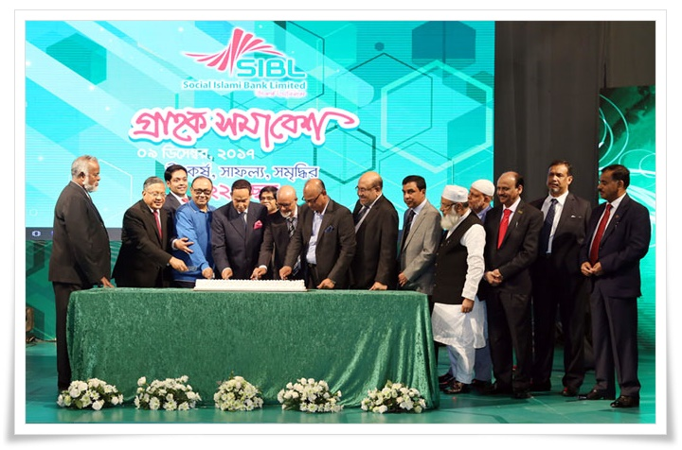

Human resource management division (HR Division) of Social Islami Bank Limited use various motivational factors to make employees engaged and to increase the productivity to achieve organizational goals and objectives. Motivation plays a vital role to fulfill the banks objectives. At this chapter of my internship report, I would like to share a broad analysis of the process or procedures of SIBL to motivate their employees to perform their responsibilities in Social Islami Bank Limited. At First, I am going to share a review of the HR Division of SIBL and at the Second, I will share the all the motivational factors used by SIBL to motivate or encourage their employees.

4.1 HR Division of Social Islami Bank Limited
HR Division has an exceptionally indispensable impact for any bank. Social Islami Bank Constrained has additionally such a division for arranging and development of HR of the Bank. The HR Division of the Bank includes the accompanying sections:

Chart 4: Sections of HR Department of SIBL

HR Policy Section
With no legitimate HR Policy, the employees of any bank are not motivated to achieve their organization's goal. SIBL has an administration job for the Employees where a few approaches are taken for powerful administration for HR. In the meantime change of employee-accommodating arrangements are going ahead as a constant process.

Recruitment and Selection Section
Recruitment is a fundamental work of running the issues of a bank. Basically, two sorts of employees are enrolled experienced employees from different banks and new employees for section level. Most importantly advertisement is given in the national dailies for recruitment then by the accompanying ways the applicants are chosen and appointment letters are issued to them. These clear recruitment system motivate the employees and they get the idea that if they are eligible for a post, they will be recruited.
1. Selection techniques for Section – For Fresher’s
- Welcoming Applications
- CV Screening
- General written Test
- Personal interview
- Selection and appointment letter
- Medical Examination
- Joining
2. Selection techniques – Experienced Applicants
- Welcoming Applications
- CV Screening
- Personal interview
- Selection and Offer letter
- Appointment letter
- Medical Examination
- Joining

Transfer and Posting Section
Each bank initiates employees to fill the need of that Bank. Subsequent to joining the HR Division, the employees are presented on different Branches and Bureaus of Head Office dependent on their insight, expertise, and competency. As per the orders of the main brunch of SIBL's, those employees who have passed more than 3 (three) years in a solitary place are required to transfer complete an alternate branches/offices, Other than that, for an inward arrangement of the bank transfer and posting can take place. SIBL HR Division has such a Transfer and Posting Section for this reason. A fair and clear transfer and posting encourages employees to improve their day to day performances. (Report, 2017)

Employee Welfare Section:
As described in the Annual report 2017, there is also an Employee Welfare Section which takes care of the employee benefits such as incentives, leave, Social Protection, LFE, Settlement of Retirement benefits, reassignment and so on. When these facilities are providing by the bank, there is a little chance to leave the job if anyone gets appointed to SIBL.

Training and Development Section:
Training makes a man impeccable in his expert zone. The hypothesis of the correct man in the perfect place ought to be pursued (Aksu, 2015). The aim is to develop a talented workforce for the Bank who will lead the bank towards development. Diverse kinds of In-house, out-house training/workshops have orchestrated the employees throughout all the year. Training and Development Section of the division evaluate training needs and gives training offices to the employees of the Bank. Well knowledge and training of work makes the employees motivated to accomplish their daily responsibilities effectively and efficiently.

Disciplinary Action Section:
Every employee of the bank must need to keep the principles and directions of that bank. However, if any employee disrupts the guidelines and controls and the expert does not make any regulatory move against him/her, the other employees won't take the principles and directions seriously of that bank. That is the reason, a solid disciplinary action section is here in SIBL to deal with such sort of unrestrained exercises. Proper discipline creates an affection to the banks in the employee’s mind and motivate them not break any rules and guidelines of the bank.

Miscellaneous Section:
Other than all, the standard employment of SIBL has some different miscellaneous occupations require to be performed. For doing such kind of employments Miscellaneous Section has been framed.

4.1.1 Human Resource Standards Followed By SIBL
SIBL pursues seven Human Resource Standards that are described in its Annual report 2017, which shapes its HR policy:
- Mutual trust
Employees and staffs should be communicated with each other by showing respect and co-operate each other.

- Leadership
The steady enhancement and development of managers, concentrated focus on leadership and group execution, accomplishing an outcome.

- Personal development
The personal development of employees prompts the development of the bank.

- Employment conditions
SIBL's employment position in the Bangladesh market is very competitive and targeted at ideal individual execution and personal development.

- The right individuals in the right place
Persistent development and development will be maintained by the bank in all phase of the job of all employees.

- Work safety
Job safety, health security, and prosperity are central issues for each employee in each department and in each working position.

- Corporate Social Responsibility (CSR)
It is an imperative part at the beginning stage.

4.2 The Procedures of Human Resource Division to Motivate Employees
The Human Resource division of Social Islami Bank Limited has to perform a lot of duties to motivate their employees from the beginning of the recruitment process to their retirement plan (Cook and Hunsaker 2006). The bank also set a lot of rules and regulation to motivate the employees so that they can increase their efficiency and effectiveness at work and can achieve the banks objectives. All the procedures to motivate the employees of SIBL, performed by Human Resource Division are sharing below:

Compensation
Employee compensation of SIBL alludes to all types of pay or rewards going to employees and emerging from their employment. Employee compensation in SIBL is two types.
- Direct Compensations: Compensation, monthly salaries, rewards, benefits, and incentives.
- Indirect Compensations: paid protection, excursion .and so on.

Motivation through Incidental Advantages
Non-monetary benefits offered to the employees of SIBL outside their wages and compensations. It includes using the bank's car, cost account the chance to purchase organization products and take services at a diminished rate. Private health benefits, canteen provides foods. A portion of these benefits, for example, the bank's vehicles don't get away from the tax net.

Promotion System
The HR Division promotes an employee based on their performance which includes various benefits of Social Islami Bank Limited. If there is a particular fair promotional strategy in the Bank that will prompt the better motivational factor for the employees. (Cook and Hunsaker, 2006)

Posting and Transfers
In Social Islami Bank Limited, there is some particular system for posting and transfer. There are some written guidelines for posting and transfer that has to fulfill by an employee who needs a posting or transfer. These guidelines positively motivate the employees. (Cook and Hunsaker 2006)

Non-Monetary Incentives
Parker & Owen (2006) explained in the Ivey Business journal that nonfinancial incentives are the type of kids' tuition facilities, Medical facilities, employee's transportation facilities, and mosque facilities and so on. Likewise, go about as an imperative determinant of employee's job satisfaction what motivates them to perform their job responsibilities effectively.

Job Status
Job status is additionally a critical determinant of the motivation and it directly impacts on employee’s motivation (Hunsaker, 2006). SIBL holds various job statuses for their employee what also describes the job responsibilities.

Health Care
This factor looks at the degree to which an employee is happy with health care benefits and incorporates the nature of the health benefits, the extent of the business' commitment to the arrangement and the expense to the employee of the health care benefits. SIBL provides health insurance facilities also.

Income Continuation
This factor looks at the degree to which an employee of SIBL is happy with the benefits that give financial safety if the employee is disabled because of an accident or weakness or loses his or her job, unfortunately. Except for long-term inability, these are lawfully required benefits that are properly supported by the bank to its employee which comprise social security, employee' compensation, and unemployment compensation.

Job Security
Job security alludes to the nature of the job that is whether a job is permanent or impermanent. Job security goes about as a vital determinant of motivating the employees. The more the job security the better the job satisfaction and the other way around.

Duration of Work
Hunsaker (2006) suggested that the working hour that is the length of work acts an essential determinant of motivation for the employees. Such a length of work must be sensible. In a few associations, employees need to work past the typical term which unfavorably influences their job satisfaction and demotivates them to perform their responsibilities daily.

Training Facilities
Training is broadly considered as an essential part for improving employee’s expertise and learning. It is the process of helping an individual for building up his productivity and effectiveness at work by enhancing refreshing proficient learning and expertise. Such training facilities go about as a vital determinant for the motivation of an employee in Social Islami Bank Limited.

Paid Leave
Any leave from the office with full pay goes about as an immediate impact at work motivation of the employee (Cook & Hunsaker, 2006). Then again, leave without pay forces an unfavorable effect at work motivation of the employee. SIBL provides two times paid leave in a year to its employee.

Working Environment

The working environment must be amiable to the employees. Any horrible working environments will antagonistically influence the employee and they become more demotivated to perform efficiently. The working environment of Social Islami Bank Limited is very eco-friendly and the employees are highly educated what always provide a positive impact on the employee's motivation at SIBL.

Participative Management System
Participative management system where each officer can take part in the decision-making process positively motivates the employees. The more nearness of participatory management system in SIBL enhances the motivation level and the other way around.

Team Work
Teamwork additionally goes about as an imperative determinant of motivating an employee. On account of teamwork at SIBL, the coordinated exertion of the employee can be guaranteed.

Senior's Behavior
Warm friendly behavior of the seniors toward their youngsters additionally positively motivates the employees in SIBL. While working inside a team in social Islami Bank Limited, the senior's behavior is very friendly with their subordinates what motivate the subordinates greatly.

Participation in Decision Making
Participation of the employees in the decision-making process of Social Islami Bank Limited is another imperative determinant of motivating the employees. The more participation of the employees in the decision-making process, the higher the motivation level will be.

Occupational Stress
Often, the encouragement of an employee to perform his work is disturbed by occupational stress. Generally, occupational stress has a huge unfriendly effect on their job satisfaction. In addition, employees with lower occupational stress ought to have higher job satisfaction what motivates them to achieve the daily objectives of Social Islami Bank Limited.

Findings of the Report
After analysis the motivation factors performed by Human resource division of Social Islami Bank Limited, I have highly satisfied with their motivation procedures but still some lacking’s are also found, what I would like to share at my finding of the report. They are listed below:
- In some division, the senior's behavior isn't agreeable towards the fresher’s.
- Low level and mid-level managers don't have any chances to provide their ideas in the decision-making process of the bank.
- To take care the employee rights, there are very few, even some branches have only one Collective Bargaining Agent (CBA).
- Posting and transfer strategy are not performed according to the SIBL rules. Often some Posting and transfer to the countryside creates dissatisfaction in the employees, some had left jobs in this reason.
- No approved training school owned by the bank.
- The employees cannot apply for the loan before two to three years of service performed in the bank.
- There are no transportation facilities for the juniors or fresher’s who has to perform the most tiresome works in the bank all day long.
- Social Islami Bank Limited does not publish any job satisfaction review.
- No health-care insurance facilities are given by the bank towards the employees.
- A few branches outside Dhaka don't have a reasonably decent working environment.

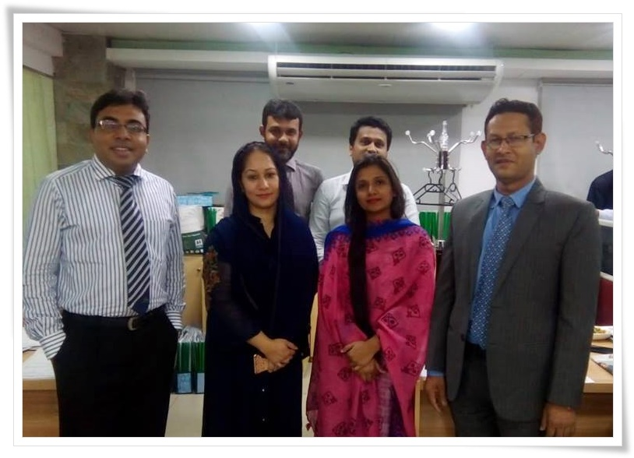
Chapter 5
Recommendations and Conclusion

Recommendations
To guarantee appropriate clients loyalty, benefit, chronicle, per annum target objective and for some other vital points of interest for service satisfaction is relies upon the motivation of the employees. HR of the SIBL ought to entirely direct the motivational factors to their employee's so that they can get the job satisfaction. In this short period of the 12-week internship program, I personally observe some shortcoming of social Islami bank ltd.
At this chapter, I want to suggest some solutions based on my theoretical knowledge to improve the problems that I had shown before in the findings of the report. This suggestion will help to improve the conditions and works for the betterment of the company. Human resource managers of Social Islami Bank Limited have to pay attention carefully at this solutions if possible to improve their employee motivation strategy more.
- SIBL should prepare its new employees from expert training schools like Bangladesh Bank, Bangladesh Institute of Bank Management (BIBM) or they should build a specialized training center to train and motivate their new employees
- Officials who are engaged with Client Administrations ought to be prepared legitimately. Since some time employees can't give legitimate solutions to client problems.
- The allowances provided for the house rent should be revalued according to the present market conditions.
- SIBL should create a completely computerized banking exercise, online websites, and portals to get all the notices to create a hassle-free salary withdrawal situation for the employee and achieve consumer loyalty.
- Participation in the decision making of each level manager ought to be guaranteed.
- Employees ought to have the chance to vote in favor of choosing their own CBA pioneer.
- The number of employees needs to be enhanced.
- Loan methodology need to be adaptable for the employees. For example, Vehicle credits, house credits, SME credits, marriage loans and so on.
- Social Islami Bank should create a trade union who always work for the employee's satisfaction and their rights.
- Lobbying in the recruitment process ought to be diminished.
- Survey on employee motivation ought to be directed by the HR division based on one year or a half-yearly basis.

Conclusion
Employee motivation is the dimension of vitality, responsiveness, and innovativeness that an organization's workers convey to their jobs. Regardless of whether the economy is developing or shrinking, discovering approaches to persuade employees is dependably a Human Resource division's concern. Contending speculations stress either incentives or employee association (strengthening). Employee motivation can some of the time be especially risky for small companies. The proprietor has frequently invested years assembling an organization hands-on and along these lines thinks that it’s hard to designate significant obligations to other people. However, business owners ought to be aware of such traps: the impacts of low employee motivation on independent ventures can be destructive. Such issues incorporate complacency, lack of engagement, even far-reaching dissatisfaction. Such states of mind can cumulate into emergencies.
Social Islami Bank Limited gives a perfect environment to employee motivation: employees see the consequences of their commitments straightforwardly. Criticism is quickly taken into consideration. An expert working and motivated workforce of SIBL additionally liberates the directors from everyday errands for considering long-term development. Besides, the substantial and enthusiastic reward of SIBL helps retention of attractive employees. Individuals thrive in innovative work environments and need to have any kind of effect. In a perfect world, very much organized reward and acknowledgment projects can build their motivation For SIBL — however, the work circumstance additionally itself will give them a sentiment of achievement.
References
Data from head office and executives of SIBL.and Annual Report “Social Islami Bank Ltd” Financial year 2016-2017.
Human Resource Management –Gary Dessler, 2012, 12th edition, Part-four, p.p-410-490.
Human Resource Management Policy and Practice: http//www.citehr.com/research.php?
Raymond A Noe, Fundamentals of Human Resource Management, 2018, English: Seventh edition, New York, N.Y.: McGraw-Hill Education

J. Richard Hackman, Oldham GR. Motivation through the design of work: Test of a theory. Organizational Behavior and Human Performance. 2006: 16: 250-279. Edgar Pierce Professor of Social and Organizational Psychology, Department of Psychology, 33 Kirkland St., Harvard University, Cambridge, MA 02138
Aksu, A. A. (2005). Defining training needs of five-star hotel personnel: an application in the antalya region of Turkey. Managerial auditing journal, 20(9), 945-953.
Battisti, Pete. "Reward to Motivate." Walls & Ceilings. December 2005.
William R. Tracey, Human Resources Management & Development Handbook, 3rd edition, 2016
Angelo W. DeNisi, Ricky W. Griffin, Human resource management ​3rd Edition, 2008, Published from: Boston : Houghton Mifflin Co., c2008.
Frase-Blunt, Martha. "Driving Home Your Awards Program." HRMagazine. February 2010.
Parker, Owen. "Pay and Employee Commitment." Ivey Business Journal. January 2010.
"Providing Opportunities to Grow." Computer Weekly. 7 February 2016.
White, Carol-Ann. "Expert's View on Managing Demotivated Employees." Personnel Today. 15 November 2015.
K.Aswathappa, 2006, Organizational Behaviour- Text, Cases and games, Himalaya Publishing House
Curtis w. cook and Phillip L.Hunsaker, 2006, Management and Organizational Behaviour, Macgraw-Hill Irwin

